Urban sustainability knowledge, information and data sources across EEA/ETCs – working paper

Version: 3
Date: 15/9/2022
EEA activity: ETC Sustainability Transitions, Task 2.4.1

Author: Vuokko Heikinheimo
From: Finnish Environment Institute SYKE

Contributors: Yu-Yi Huynh, Stefan Kuhn
From: ICLEI – Local Governments for Sustainability

EEA Task manager: Ivone Pereira Martins

Contents
Contents 2
Key messages 3
1 Introduction 4
2 Methodology 4
2.1 Building blocks of urban sustainability 4
2.2 Types of available information 6
2.3 Mapping existing information and ongoing work 6
2.3.1 EEA database 6
2.3.2 ETC tasks and deliverables 6
2.3.3 Cross-ETC workshop 7
3 Results: urban sustainability information and data sources across EEA - ETCs 8
3.1 Existing urban sustainability information at EEA 8
3.2 Urban sustainability information in ETCs 11
3.2.1 Overview of work done in past ETCs 11
3.2.2 Relevant tasks in ongoing ETCs 11
3.2.3 Cross-cutting themes and identified gaps 14
3.3 Reflections from the workshop 16
4 Recommendations for improving the traceability of urban sustainability information 16
4.1 General 16
4.2 Establishing a cross-ETC urban group 16
4.3 Recommendations regarding the webpages 17
References 18
Annex 1: Summary tables 19
Annex 2: Related documents 21
Annex 3: Curated lists of urban information and data 22

Key messages
- A wealth of information and data relevant for urban sustainability is being produced in European Topic Centers (ETCs) complementing the existing pool of available information at EEA.

- More data and information exist related to topics linked to EU-policies and related legislation requirements (e.g., air quality), and topics where remote sensing techniques can be used to produce Europe-wide locally relevant data (e.g., land use).

- Building blocks of urban sustainability from EEA’s conceptual framework for urban environmental sustainability were found useful when identifying relevant information and data. Topics related to environmental quality, built environment quality, adaptive capacity, and efficient material use and zero waste are covered across multiple ongoing ETCs.

- Topics related to social and environmental justice, sustainable mobility, ecological multifunctionality, green and blue infrastructure, sustainable urban agriculture, housing quality, renewable energy, green economy, public open space, participation and empowerment, are covered to some extent in ongoing work, but not extensively.

- Relevant building blocks of urban sustainability not covered in current ETCs include integrated planning and collaborative and community-led initiatives. These should be considered when planning future work.

- Across ongoing ETCs, the lack of coordination in facilitating access to and disseminating urban information was considered as a major technical gap related to urban information.

- New EEA webpages (to be launched in 2023) should consider a more nuanced and systematic way of tagging urban sustainability information and data, and active content curation to present the broad scope of urban sustainability information and enhance the findability of relevant information to diverse end-users.

- An informal cross-ETC “Urban” group facilitated by ETC-ST has been established to support information sharing and collaboration across ongoing ETCs. This group will promote a join understanding of urban environmental sustainability across ETCs, facilitate join communication and support upcoming efforts in EEA, e.g., related to the webpages and SOER2025.

- Areas for further exploration include further categorizing the existing information, collaboration with the EEA web-team regarding data tagging and webpage development and exploring collaboration and co-creation opportunities with new external stakeholders (e.g., local governments). Prioritizing stakeholder interaction is one challenge to address.

Introduction
Robust data and evidence are needed to support urban sustainability transitions (EEA, 2021a). In recent years, the European Environment Agency (EEA) has undertaken a range of activities related to urban environmental topics and developed a conceptual and analytical framework to support future assessments (EEA, 2021a, 2021b). These activities and outputs on urban environment are presented on a dedicated webpage at https://www.eea.europa.eu/themes/sustainability-transitions/urban-environment, among other relevant information. An updated EEA webpage will be launched in 2023. The aim of the new webpage structure is to gain more integrated and impactful online presence and to enhance the usability of the web contents, also regarding urban sustainability information (According to a presentation by the web project team in June 2022). This working paper aims to inform the process of gathering relevant information and data on urban sustainability across EEA and European Topic Centers (ETCs), and to inform the ongoing webpage development regarding the urban sustainability topic.

EEA’s flagship report on urban environmental sustainability published in 2021 (EEA, 2021a) already contains an overview of EEA’s activities on the urban environment (Table 1.2 in EEA, 2021a) and a review of the available knowledge base relevant to urban environmental sustainability (Table 1.3 in EEA, 2021a), where the focus was on possibly relevant data sources, indicators and case studies generated by projects affiliated with the European Commission (e.g., Eurostat, Horizon 2020 projects) as well as other European organizations and initiatives on sustainable development. Work related to urban sustainability continues in the new European Topic Centres (ETCs) that started in 2022. ETC on Sustainability Transitions (ETC ST) has a dedicated task for consolidating the understanding of urban sustainability information across all EEA-ETCs which builds upon EEA’s previous activities on urban environmental sustainability.

This working paper reports the findings from ETC ST Task 2.4.1 about the mapping of existing urban sustainability information and data sources and their traceability across EEA- ETCs. First, the task was further defined among the ETC ST urban sustainability task team. Next, relevant contact people in other ongoing ETCs were identified and contacted. In parallel, the task team conducted an initial scan of existing information across the EEA webpage and ETCs action plans. An online workshop was organized on the 1st of June 2022 where the results of this initial scan were presented to other ETCs representatives. Final mapping of existing urban sustainability information and data sources across all EEA -ETCs was conducted after the workshop, and feedback was requested from ETC contacts. The results regarding existing urban sustainability information and data sources and recommendations for improving the findability of such data are presented in this working paper and its attachments (see Annex 1-3).

Methodology

Building blocks of urban sustainability
EEA’s conceptual framework for urban environmental sustainability (EEA, 2021a) was used for structuring and summarizing urban sustainability information and data sources in this task. The conceptual framework provides the overarching definition and structure for EEA’s understanding of urban sustainability. It describes the components and outcomes for urban sustainability, and the components needed to support sustainable transitions in European cities (Figure 1.1). The framework provides EEA and other actors in the field of urban sustainability a tool to assess the complexity of urban sustainability issues in a structured and integrated manner.

The conceptual framework consists of four key components: context, lenses, building blocks and enabling factors. For full definitions, please refer to the Urban sustainability in Europe report series (EEA, 2021a). In this task, we use primarily the building blocks of urban environmental sustainability to structure the analysis. Building blocks refer to key qualities that contribute to urban environmental sustainability. A different set of building blocks are needed in cities depending on their context (the range of physical, social, and institutional characteristics that create the and shape the settings in a city) and enabling factors (forces that act as drivers or barriers to a transition). A full list of the identified building blocks is available in the EEA’s urban sustainability report, Figure 2.4 (EEA, 2021a), and in Annex 1. The identified building blocks offer a comprehensive, yet granular and tangible set of concepts to use when identifying information and data relevant for urban sustainability.

Figure 1.1 EEA’s conceptual framework for urban sustainability
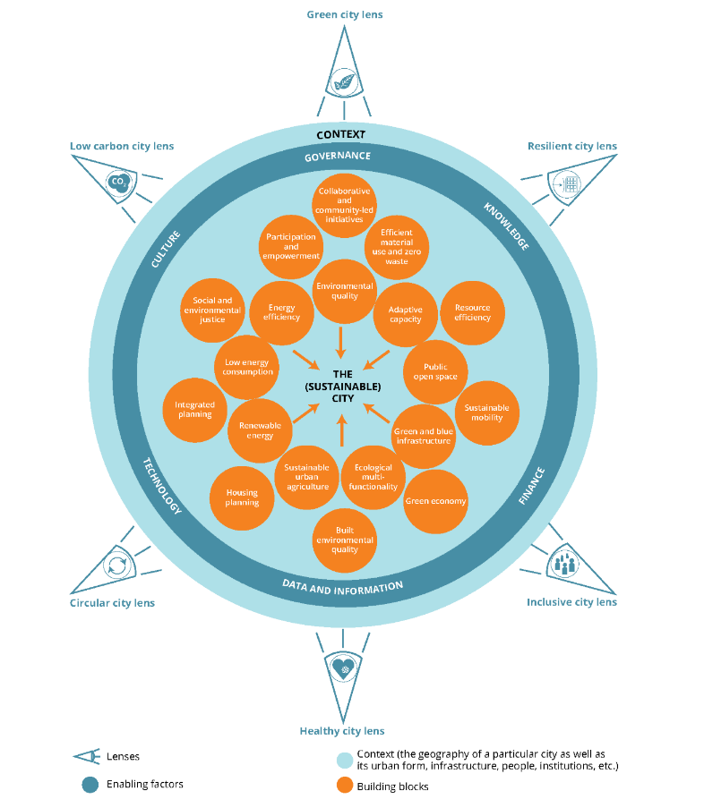
Source: (EEA, 2021a)

Types of available information
EEA hosts a variety of information and data ranging from web content, briefings and reports to tabular data, maps, and graphs. In this task, we considered the following content types:
- Data visualization / Map / Graph
- Web page
- News / Article
- Briefing
- Data
- References and links
- Glossary term
- Publication / Report
- Indicator assessment
- Data provider (organisation)
- Country profile
- Other
- Video
For simplicity, content types available in the EEA search catalogue were re-classified into the above content types. See Annex 1, Table 1.2 for reference. One item might be categorized into several content types (e.g., both “data visualization” and “publication / report” if the visualization is linked to a publication).

Mapping existing information and ongoing work

EEA database
A search of the full EEA database available at https://www.eea.europa.eu/themes was conducted to get an overview of available urban sustainability information and data with the search word “urban”. The search reported in this working paper was conducted on the 10th of August 2022. Additional exploratory searches were conducted using keywords derived from conceptual framework for urban sustainability. The search was restricted to English content. The search results were downloaded as csv-files for further analysis. A curated list of existing information and data relevant for urban sustainability by the EEA was compiled based on the database search, discussions in the workshop and additional information gathered by the task team.

ETC tasks and deliverables
A brief overview of work done in the past ETCs was done by summarizing information about published ETC reports available at https://www.eionet.europa.eu/etcs/all-etc-reports. Action plans of ongoing ETCs were scanned to identify tasks and deliverables relevant for urban sustainability. ETC action plans detailed in Table 2.1 were acquired from the EEA in Spring 2022.

Table 2.1 ETC Action plans that were reviewed for tasks relevant for urban sustainability

ETC name and abbreviation | Action plan document name | Date
ETC on Climate Change Adaptation and LULUCF (ETC CA) | OCP/EEA/CAS/21/002-ETC CA, Work programme 2022, Action plan 2, V. 1.0 | 28.2.2022
ETC on Circular Economy and Resource USE (ETC CE) | OCP/EEA/CAS/21/006-ETC CE Action Plan 1, V. 1.0 | 20.12.2021
ETC on Climate Change Mitigation (ETC CM) | OCP/EEA/CET/21/003-ETC CM, Action Plan 2022, Version 2.1, | 12.01.2022
ETC on Data Integration and Digitalisation (ETC DI) | OCP/EEA/CAS/21/004-ETC/DI, Action Plan 2022-1 | 31.01.2022
ETC on Human Health and the Environment (ETC HE) | OCP/EEA/CAS/21/005-ETC/HE, Work programme 2022, Action Plan | 27.01.2022
ETC on Biological Diversity (ETC DB) | OCP/EEA/NSS/18/001-ETC/BD, Work programme 2022, Action plan 2022, V. 1.3. | 20.01.2022
ETC on Inland, Coastal and Marine Waters (ETC ICM) | OCP/EEA/NSS/18/002-ETC/ICM, Work programme 2022, Action plan 2022-1, v. 1.0 | 27.01.2021
ETC on Sustainability Transitions (ETC ST) | ETC ST Action plan 2022. Revision 1. | 28.6.2022

An initial scan of the ETC action plans was done using a simple keyword search (“urban”) and browsing through the task titles for topics related to urban sustainability. An additional scan was conducted by following interlinkages among relevant tasks, and further keyword searches based on the building blocks of urban sustainability, followed by a more thorough reading of the action plans by the task team. Feedback from ETC contacts was requested in the workshop on the 1st of June 2022, and via email after the workshop. Final listing of relevant tasks is based on the keyword searches, and reading the action plans, as well as feedback from ETC contacts in the workshop and via email after the workshop. Summary of the topics covered in the action plans was done using the building blocks of urban sustainability as a framework.

Cross-ETC workshop
A cross-ETC sensemaking workshop “Mapping urban information across ETCs” was organized on Wednesday the 1st of June 2022 at 11-13 (CEST) online via Teams specific to ETC ST task 2.4.1. The workshop gathered a small group of expert participants from other ETCs for a facilitated discussion. These experts are ETC task managers and experts who are working on topics relevant to urban sustainability (e.g., buildings and housing, energy efficiency, data integration, air pollution, noise...). This event was a part of a series of workshops organized as part of the ETC ST task 2.4 on urban sustainability. The overall objective of the workshop was to make sense of urban sustainability information and data sources across ETCs, in particular:
- Understanding what information (reports, briefings, data, indicators) have been produced and are being produced in ETCs on urban sustainability.
- Identifying the gaps in urban information, and challenges related to the traceability of urban information in ETCs (and EEA)
- Kicking off the cross-ETC collaboration on urban sustainability
In the workshop, ETC ST presented the results of the initial scanning of urban information to the other ETC participants who then validated and complemented the findings with their updates. After the workshop, the participants had an opportunity to review the revised urban information mapping and provide feedback.

Results: urban sustainability information and data sources across EEA - ETCs

Existing urban sustainability information at EEA
Urban sustainability is a cross-cutting topic and thus linked to various thematic areas covered by the EEA. At the time of writing, “urban sustainability” is thematically categorized under “sustainability transitions” on the EEA web catalogue. However, also other topic categories include relevant information for urban sustainability. A simple keyword search reveals the wealth of information related to urban sustainability available across different topics. See Annex 2 for detailed list of search results. A keyword search with the search word “urban” conducted on 10 August 2022 returned 2610 records. Majority of these results, 46 %, were data visualizations, infographics, maps, or graphs (Figure 3.1). Miscellaneous web pages accounted for 13 % of the search results, news /articles accounted for another 11 % of the search results. Publications /reports and briefings altogether constituted 11 % of the search results. Data (at EEA and external links) accounted for 6 % of results.

Figure 3.1 Number of items that appear with search term ”urban” in the EEA catalogue per content type.
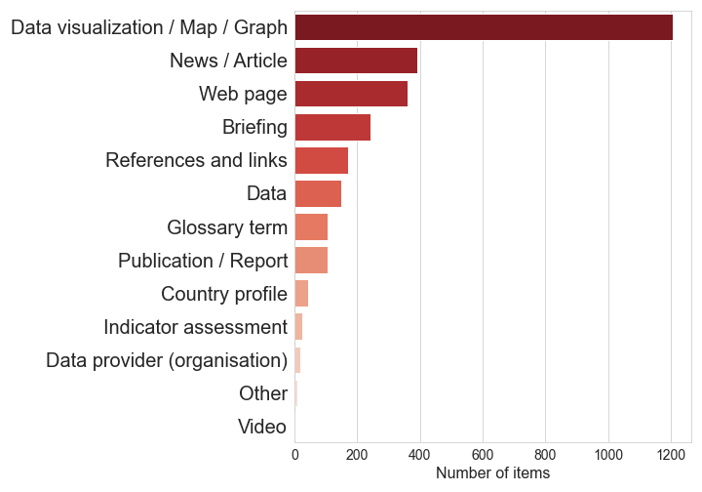
Note: One item can belong to multiple topic categories.

Source: (EEA, 2022)

In terms of topics covered across the search results for “urban”, “air pollution”, “sustainability transitions” and “land use” were the most frequent topic categories among all types of results (Figure 3.2). Topics might also be combined; “Air pollution” was frequently combined with “environment and health”, “climate change mitigation”, and “transport”, among other less frequently mentioned topics. “Sustainability transitions” was combined with a variety of topics including “land use”, “environment and health”, “water and marine environment”, “climate change adaptation”, “biodiversity – ecosystems”, “resource efficiency and waste” as well as “transport”. “Land use” was used as a topic in combination with “biodiversity – ecosystems”, “soil”, “climate change adaptation”, and “agriculture”, among others.

Figure 3.2. Number of items that appear with search term ”urban” in the EEA catalogue per topic and content type .

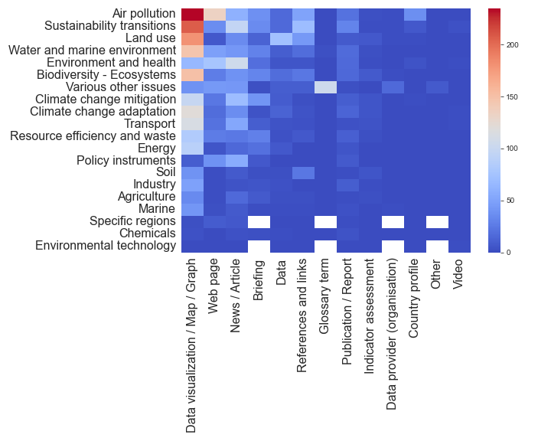
Note: One item can belong to multiple topic categories.
Source: (EEA, 2022)

Same topics remain prominent when zooming into data, briefings, and publications / reports (Figure 3.3). Most of available data are related to “land use”. This includes various data sets from the Copernicus Land Monitoring services such as the Corine Land Cover data, Urban Atlas data and derivate data products. “Climate change mitigation”, “air pollution”, “sustainability transitions”, “biodiversity - ecosystems” as well as “water and marine environment” are prominent topics in published briefings and reports.

Earliest publication that appears in the search catalogue is from 2002, and the earliest data are from 2005 (Figure 3.4). High number of briefings issued in 2015 is related to the SOER 2015 report (The European environment – state and outlook) (EEA, 2015), and high number of briefings issued in 2016 and 2018 are related to the Annual Indicator Report Series (AIRS) (EEA, 2018).
Figure 3.3. Number publications/reports, briefings and data that appear with search term ”urban” in the EEA catalogue per topic.

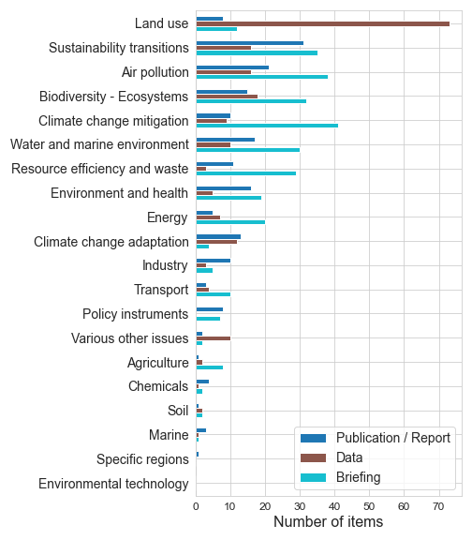
Note: Topics are ordered by the sum of publications/reports, data and briefings. One item can belong to multiple topic categories.

Source: (EEA, 2022)

Figure 3.4. Number publications/reports, briefings and data that appear with search term ”urban” in the EEA catalogue per year.
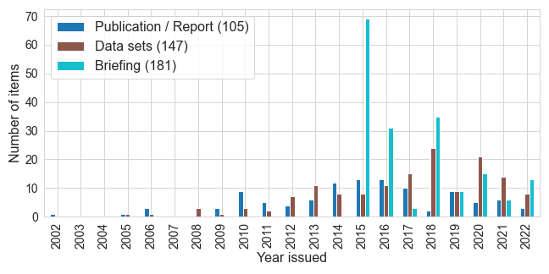

Source: (EEA, 2022)

Full list of the search results, and other identified content are provided as Excel Spreadsheets as detailed in Annex 2. Furthermore, curated lists of identified information and data are available in Annex 3.

Urban sustainability information in ETCs

Overview of work done in past ETCs

EEA’s previous work on urban environmental sustainability was advanced with multiple external and internal actors since 2017. This included EEA’s framework contract with Collingwood Environment Planning and London School of Economics to develop the conceptual framework, the topical knowledge production in EEA-ETCs ongoing at that time (except for ETC-ICM), and continuous feedback and inputs from the Urban Stakeholder Group.

Overall, several topics related to urban sustainability have been advanced in various European Topic Centers that have already completed their work: Urban land use and land cover in the European Topic Centre on Urban, Land and Soil Systems (ETC/ULS), Air quality and climate change mitigation have been prominent topics in past ETC work via European Topic Centre on Air pollution, transport, noise and industrial pollution (ETC/ATNI), European Topic Centre on Air Pollution and Climate Change Mitigation (ETC/ACM), European Topic Centre on Air and Climate change (ETC ACC), and European Topic Centre on Climate change mitigation and energy (ETC/CME). Efficient material use and green economy topics have been covered in European Topic Centre Waste and Materials in a Green Economy (ETC/WMGE). All published ETC reports are available via: https://www.eionet.europa.eu/etcs/all-etc-reports. Overview of EEA’s activities on the urban environment, also including inputs from past ETCs, has been summarized in the urban sustainability report (Table 1.2 in EEA, 2021a).

Relevant tasks in ongoing ETCs
This section highlights relevant tasks for urban sustainability across ongoing ETCs as identified from the action plans. Results are also available as a separate Excel spreadsheet (Annex 2).

ETC on Climate Change Adaptation and LULUCF (ETC CA)
Ongoing work in the ETC CA links widely to urban sustainability. Urban adaptation has a dedicated task (task 2.3.11) that will contribute to the 2024 Urban Adaptation Report and organizing the 2022 Urban Resilience Forum. This task also contributes to maintaining and updating urban contents of the European Climate Adaptation Platform (Climate-ADAPT) which is a central hub for information related to climate change adaptation across Europe. Overall, ETC CA delivers the following contributions to urban-relevant information on Climate-ADAPT:

• Supporting developments of the Climate-ADAPT platform: database content, case studies, webpage updates (task 2.3.7)
• Updating European climate change and impact indicators (task 2.3.1.1)
• Increased presence of the social / just resilience topic on Climate-ADAPT (task 2.3.4)
• Revision of ecosystem-based approaches content (task 2.3.5)
• Maintenance and update of Climate and Health Observatory (task 2.3.6)
• Recommendations for connecting Climate-ADAPT information with Destination Earth and the Adaptation Digital Twin (task 2.3.10)
• Maintenance and update of urban content on CLIMATE-ADAPT database (task 2.3.11): Urban Adaptation Map Viewer and Urban Adaptation Support Tool in particular.
Other deliverables from ETC CA relevant to urban sustainability include EEA Briefing on Just Resilience (task 2.3.4), EEA-Lancet Countdown climate change and health report (task 2.3.5), and indicators and reports on the economics of adaptation (task 2.3.8). Furthermore, tasks related to food production and (urban) agriculture (task 2.2.2 on LULUCF supporting datasets and activities in collaboration with ETC DI), and renewable energy (2.2.3 climate impacts on biomass production) are thematically linked to the building blocks of urban sustainability.

ETC on Climate Change Mitigation (ETC CM)
ETC CM offers cross-cutting knowledge on climate change mitigation and adaptation:

• Task on energy efficiency in buildings (2.4.5) will produce working papers on energy efficiency in public buildings, and on maximizing building energy performance at reduced environmental impacts. This task will also provide input to ETC CE task on sustainable building system and support on the cross-ETC urban sustainability work lead by ETC ST.
• Work related to climate change mitigation and adaptation in land management will produce relevant information related to LULUCF reporting (task 2.2.1) and supporting datasets (2.2.2.).
• A tableau dashboard with end-user greenhouse gas emissions per EU Member state (task 2.1.4.1) will improve the understanding of greenhouse gas and air pollution emission trends from the end-user perspective (instead of sectoral perspective). The presented end-user methodology is applicable to GHG and air pollutants allowing combined climate and air pollution assessments.
• Transport-related work on emissions and fuel quality (section 2.5.)

ETC on Data Integration and Digitalisation (ETC DI)
ETC DI contributes to several data integration and digitalization efforts that support work on urban sustainability. Many tasks build upon work done in previous ETCs (ETC ULS, ETC ATNI) and link to work in other ongoing ETCs (ETC BD, ETC CA, ETC CM, ETC ST, and ETC HE in particular). Tasks described in ETC DI work package 1 offer cross-cutting support to data flows and data quality assurance. For example, Task 1.2.1 supports ETC HE in setting up an improved air quality data monitoring system. Regarding thematic integration detailed in ETC DI work package 2, the following tasks are especially relevant to urban sustainability:

• Landscape fragmentation (task 2.2.10)
• Land Degradation Neutrality platform (task 2.2.11)
• Support to climate adaptation data extraction (task 2.2.13)
• Following up on the needs of Land Information System for Europe (task 2.5.1)
Tasks related to data intelligence described in ETC DI work package 3 offer generic support to urban sustainability information and data. Work on air quality monitoring data (task 3.1.3), the development of a machine learning approach to estimating missing data in road noise maps (task 3.2.3) and indicator development on habitat connectivity /coherence and restoration potential (task 3.2.4) are particularly relevant.

ETC DI provides cross-cutting support to Copernicus Land Monitoring Services (CLMS) as detailed in work package 4 of the action plan. Several tasks are related to quality control of deliverables and user support and uptake. These CLMS-related tasks are especially relevant for urban sustainability:

• Urban Atlas 2021 quality control (task 4.1.6)
• Impervious built-up (IBU) layer 2018 quality control (task 4.1.8)
• Enhancing EEA and ETC uptake of CLMS (task 4.3.1)

ETC on Human Health and the Environment (ETC HE)
ETC HE produces cross-cutting information related to health and the environment. Most of the work on health-related environmental pressures (Action 3.1) and environmental impacts on health and well-being (Action 3.2) are relevant in the urban context, especially those related to light pollution (task 3.1.0.1), air quality and noise pollution, and combined exposure to environmental and social stressors.

Air quality -related tasks in ETC HE builds on previous work in ETC ATNI. Work on spatial air quality data (task 3.2.1.3) will, e.g., deliver updates to air quality maps and updates to the methodology behind the European city air quality viewer and its use in city ranking. Tasks related to Air quality indicators and assessments (task 3.2.2) will produce automated Eionet reports on air quality (3.2.2.1 subtask 1), briefing on Europe’s air quality status 2022 (3.2.2.1. subtask 2) and Eionet report and briefing on the health impacts of air pollution in 2020.

Work related to noise pollution in ETC HE will result in several reports and data sets, such as outlooks on population exposed to noise in 2022 and in 2030 (considering road traffic noise, rail traffic noise and aircraft noise both inside and outside urban areas; task 3.2.5.1.), and spatial data on noise for the Health Atlas (task 3.2.6.1 subtask 1), and combined noise and air pollution impact maps (task 3.2.6.1. subtask 2). Furthermore, there is a specific task on children’s exposure to outdoor air pollution (task 3.2.6.2.) that will result in an ETC working paper, and potentially EEA online report later in 2023.

Furthermore, tasks related chemical impacts on ecosystems (task 3.2.8.1), and soil pollution (task 3.2.9.1) – both in collaboration with ETC BD – will provide up-to-date evidence on complex issues regarding human health and the environment also relevant in the urban context.

ETC on Circular Economy and Resource USE (ETC CE)
Topics covered in ETC CE (industrial transformation, waste legislation, material flows and sustainable resource use) offer cross-cutting knowledge relevant for urban sustainability from the perspective of circular economy. Relevant tasks include work on the sustainable building system (task 4.1.4.1) to inform further activities on buildings and the environment, and work on waste prevention that will contribute to an EEA report on the topic (task 4.2.1.1). Furthermore, ETC CE has a dedicated task on support to the work on urban sustainability among other cross-ETC collaboration (task 4.0.3.2).

ETC on Sustainability Transitions (ETC ST)
ETC ST has a dedicated task on urban sustainability (task 2.4), and this working paper is one of the deliverables from that task. ETC ST also includes other cross-cutting task relevant (but not limited) to urban topics. Other activities in ETC ST provide methodological and conceptual expertise, for example, on sustainability indicators (task 1.1), transformative social innovation (task 2.2), participatory foresight (task 3.1), and stakeholder engagement (4.2). Applying these in urban sustainability context, together with other ETCs, can benefit from and create an added value for EEA's urban sustainability work.

ETC on Biological Diversity (ETC DB) – ending in 2022
ETC BD produces cross-cutting information to support green infrastructure planning and fostering biodiversity in urban regions, ranging from dataflows to ecosystem assessments and support to restoration needs and targets. Task related to the Biodiversity Information System for Europe (BISE) has a specific focus on urban context through the integration of European Urban Biodiversity Index (EUBI) and city results in BISE (task 1.2.9.1).

ETC BD is ending in 2022 and has already produced several reports regarding urban biodiversity. Existing reports are available via: https://www.eionet.europa.eu/etcs/all-etc-reports .

ETC on Inland, Coastal and Marine Waters (ETC ICM) – ending in 2022
Relevant tasks for urban sustainability in the ETC ICM action plan include:

- Urban waste water map viewer (task 1.1.2.1)
- Data on multiple pressures and cumulative effects of human activities in the marine environment (task 1.2.1.2)
- Environmental and socio-economic benefits of bathing waters and potential interference arising from cyanobacterial blooms (task 1.2.8.1)
ETC ICM is ending in 2022 and has already produced several reports regarding coastal areas and marine ecosystems relevant for urban sustainability. Existing reports are available via: https://www.eionet.europa.eu/etcs/all-etc-reports.

Cross-cutting themes and identified gaps
Topics covered in ongoing ETCs touch upon most of the building blocks of urban environmental sustainability (see section 2.1 for definitions). Figure 3.1 visualizes the building blocks covered across several ETCs, individual ETCs and those building blocks not identified from the reviewed action plans of ongoing ETCs.

The following building blocks are covered in several ongoing ETCs: environmental quality, built environment quality, adaptive capacity, as well as efficient material use and zero waste. Tasks related to (built) environmental quality include, e.g., work on air and noise pollution, soil pollution, ecosystem restoration, and impervious built-up areas. These tasks are tightly linked to data and information, namely data products related to Copernicus Land Monitoring Service (CLMS). Adaptive capacity is most visible through work related to the Climate-ADAPT platform, and other activities related to climate change adaptation and mitigation. Overall, ongoing ETCs are producing a wealth of relevant information in the forms of briefings, reports, data sets, data visualizations and events related to these topics.

Building blocks that are covered, or at least mentioned, in individual ongoing ETCs include social and environmental justice (in ETC CA), ecological multifunctionality, green and blue infrastructure, sustainable urban agriculture (mentioned in ETC HE), low energy consumption (ETC CE), housing quality (both in ETC CE), renewable energy (ETC CE), sustainable mobility (mentioned in ETC CM). Public open space can be seen included in some of the land use and land cover -related tasks in ETC DI but was not specifically highlighted as a focus in the most recent action plan. Green economy be linked to topics in ETC CE and has been covered more widely in ETC WGME that ended in 2021. Participation and empowerment is embedded in ETC ST through participatory foresight activities and stakeholder engagement. However, the original definition of this building block refers to all sectors of society including citizens and this aspect is not represented in ongoing work. To be noted that these building blocks might be embedded in the details of other ongoing tasks but were not captured in this overview.

Figure 3.1 Treemap illustration of building blocks of urban environmental sustainability identified in the action plans of ongoing ETCs
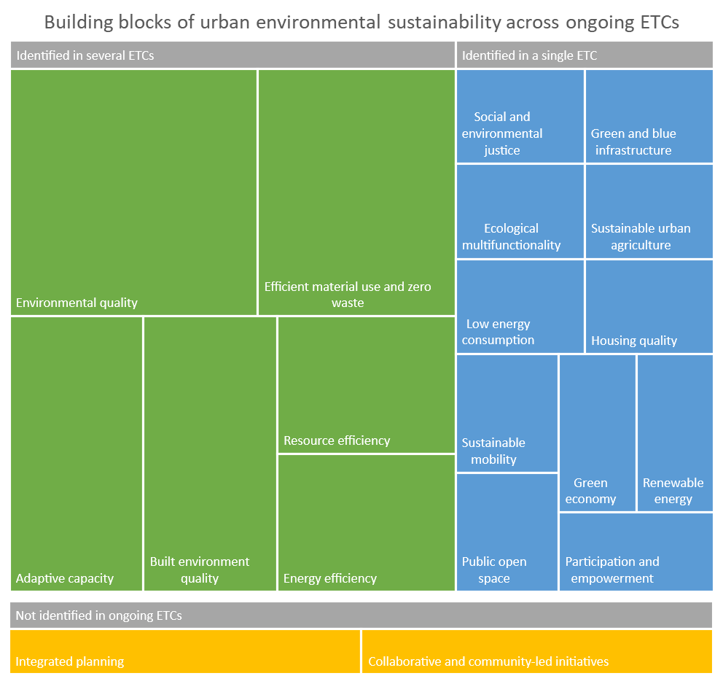
Note: Size of the box is proportional to the number of ETCs where this building block was identified (ranging from 1 to 5), except for those building blocks not identified in any action plan.

Source: ETC action plans (see Table 2.1). See Annex 1, Table A1.1 for source data of this graph.

Two building blocks were not unambiguously identified as distinct topics from the action plans of the ongoing ETCs: integrated planning, and collaborative and community-led initiatives. Overall, these building blocks are more related to governance and alternative ways of knowledge-generation and co-production and might merit further attention in the future.

Reflections from the workshop
In the cross-ETC workshop, both topical and technical gaps regarding urban sustainability information were identified. Besides some limited work in ETC CM and ETC ATNI, a data gap in the transport/mobility topic was identified. The participants also pointed out that governance-related topics were lacking in ongoing work.

Technical gaps identified include the lack of coordination in facilitating access and disseminating urban information. While ETC ST has prepared an overview of urban information at ETCs and EEA, and ETC DI coordinates the data integration, there is no systematic approach in updating these overviews and supporting end-users in finding the information. The diversity of end-users, including both internal (ETCs and EEA) and external stakeholders (e.g.,EU institutions and bodies, countries, umbrella organizations of cities and local governments), poses a challenge in organizing the information on the website.

Participants found it difficult to find the right page for urban sustainability information via EEA’s homepage. While tags and keywords are helpful – and they should be made better use of - their scope and logic (i.e., what would be clear for the end-user) should be evaluated for the urban information. Participants also proposed strengthening the link between EEA’s conceptual framework for urban sustainability and the way of organizing the urban information on the website (e.g., using the lenses and building blocks as categories).

With the support of the participants, a Teams channel under EEA’s Teams space was set up to facilitate knowledge exchange between ETCs beyond the workshop.

Recommendations for improving the traceability of urban sustainability information

General
This report presents a cross-cutting overview of existing and ongoing information and data relevant for urban sustainability across EEA/ETCs. Such effort is not feasible to conduct repeatedly, and there is thus a need for ways to improve the traceability of urban information in the knowledge generation process across EEA/ETCs. A way forward is to establish mechanisms that make sure new information and data are tagged in a meaningful way and added to the ‘pool’ of existing urban sustainability information on a regular basis. Content curation will be needed, but there are also more automatic ways to improve the traceability of thematic information in online portals, such as the EEA webpage.

Establishing a cross-ETC urban group
As ‘urban’ cuts across all environmental topics, the continuation of a cross-ETC working group exchanging their work and findings with urban relevance would facilitate sharing relevant information and fostering collaboration. This group could later work together on possible cross-ETC tasks, sharing work on a common study, indicator set, or other product. To do that, each ETC would need to have the same task (but with different subtasks) set up in their respective Action Plans.

A cross-ETC Teams channel has been established under the EEA’s Teams organization in Q2/ 2022 to facilitate continuous knowledge exchange related to urban sustainability across ongoing ETCs. ETC ST is facilitating this collaboration, and active participation across all ETCs in the knowledge exchange via the Teams space and e.g., regular workshops should be included into the respective action plans.

Recommendations regarding the webpages
The new EEA webpage structure is currently being developed. The new webpage design will include, e.g., topic pages, new search features, a new data hub etc. (as described in a presentation by the Web project team from 20th June 2022). It seems that urban sustainability will have a dedicated topic page in the new webpage structure. To ensure the findability of urban sustainability information in the new webpage structure, there is a need for 1) a more systematic way of tagging content 2) active content curation of the webpages 3) clear definition of the user groups for the provided information.

Despite a dedicate topic page for urban sustainability, special attention needs to be given the systematic tagging of content to ensure that the broad scope of relevant topics is captured. To enhance the findability of relevant information in the search algorithms and to facilitate further content curation, a set of meaningful tags/keywords specific to urban topic should be established. Keywords derived from EEA’s framework for urban environmental sustainability could serve as the basis for such tags. However, the keywords should avoid any jargon and use informal language while capturing the complexity of urban sustainability phenomena. Based on the discussions in the workshop, and practical experimentation with various keywords, the building blocks of urban sustainability presented in EEA’s urban sustainability report appear as a useful set of concepts to use as the basis for tagging urban sustainability information and data. In comparison e.g., to the ‘lenses’ (such as “green city”, “circular city”, etc.) in the conceptual framework, the building blocks are more tangible and can be linked to distinct policy topics relevant for local governments.

Content curation of a thematic webpage presenting urban sustainability information is also important. In addition to manually selecting and highlighting relevant information and data, it is important to make the provided information as accessible and understandable to different user groups when presenting and summarizing the information on the webpages. For example, the use of approachable language and avoiding excess use of EEA-specific abbreviations makes the information more approachable to different audiences.

Furthermore, impactful online presence of urban sustainability information requires the consideration of diverse end-users ranging from EU institutions and bodies dealing with urban issues, decision-makers and administrators to scholars, experts and local actors. The diversity of end-users poses a challenge in organizing the information on the website. The solutions should remain attentive and flexible to the different groups of users. For example, for academic audiences, clear instructions on how to refer to information and data (preferably using a persistent object identifier) enhance the reusability and findability of the content. For local governments and planners, the user needs might be different. User-oriented design and tailoring the websites to serve the needs of the end-users would require further investigations of the varying use-cases and needs. Better understanding of the different needs and trends can be built using automatic (user-data from the website) and non-automatic (dialogue in the Urban Stakeholder Group, cross-ETC Urban Group, Eionet...) approaches.

References
EEA, 2015, SOER 2015 — the European environment — state and outlook 2015, European Environment Agency (http://www.eea.europa.eu/soer) accessed 21 August 2022.
EEA, 2018, Annual Indicator Report Series (AIRS) — in support to the monitoring of the 7th Environment Action Programme, EEA Report No 19/2018, European Environment Agency, Copenhagen, Denmark, Luxembourg: Publications Office of the European Union (https://www.eea.europa.eu/airs).
EEA, 2021a, Urban sustainability in Europe - Avenues for change, Publication No 6/2021, European Environment Agency (https://www.eea.europa.eu/publications/urban-sustainability-in-europe-avenues) accessed 6 July 2022.
EEA, 2021b, Urban sustainability in Europe - Learning from nexus analysis, Publication No 7/2021, European Environment Agency (https://www.eea.europa.eu/publications/urban-sustainability-in-europe-learning) accessed 6 July 2022.
EEA, 2022, ‘Global search and catalogue’ (https://www.eea.europa.eu/themes) accessed 19 August 2022.

Annex 1: Summary tables
Table A1.1 Building blocks of urban environmental sustainability and the number of identified tasks in each ETC action plan.

Building block | ETC CA | ETC CM | ETC CE | ETC DI | ETC HE | ETC ST | ETC BD | ETC ICM | Total  tasks | Total ETCs
Environmental quality | 2 | 0 | 0 | 5 | 12 | 0 | 1 | 2 | 22 | 5
Adaptive capacity | 15 | 1 | 0 | 1 | 0 | 1 | 0 | 0 | 17 | 3
Built environment quality | 0 | 0 | 1 | 3 | 8 | 0 | 0 | 0 | 12 | 3
Efficient material use and zero waste | 0 | 1 | 2 | 0 | 1 | 0 | 0 | 2 | 6 | 4
Social and environmental justice | 4 | 0 | 0 | 0 | 0 | 0 | 0 | 0 | 4 | 1
Resource efficiency | 0 | 1 | 2 | 0 | 0 | 0 | 0 | 0 | 3 | 2
Energy efficiency | 0 | 1 | 1 | 0 | 0 | 0 | 0 | 0 | 2 | 2
Green and blue infrastructure | 0 | 0 | 0 | 2 | 0 | 0 | 0 | 0 | 2 | 1
Ecological multifunctionality | 2 | 0 | 0 | 0 | 0 | 0 | 0 | 0 | 2 | 1
Sustainable urban agriculture | 0 | 0 | 0 | 0 | 1 | 0 | 0 | 0 | 1 | 1
Low energy consumption | 0 | 0 | 1 | 0 | 0 | 0 | 0 | 0 | 1 | 1
Housing quality | 0 | 0 | 1 | 0 | 0 | 0 | 0 | 0 | 1 | 1
Sustainable mobility | 0 | 1 | 0 | 0 | 0 | 0 | 0 | 0 | 1 | 1
Public open space | 0 | 0 | 0 | 1 | 0 | 0 | 0 | 0 | 1 | 1
Renewable energy | 0 | 0 | 1 | 0 | 0 | 0 | 0 | 0 | 1 | 1
Green economy | 0 | 0 | 1 | 0 | 0 | 0 | 0 | 0 | 0 | 1
Integrated planning | 0 | 0 | 0 | 0 | 0 | 0 | 0 | 0 | 0 | 0
Participation and empowerment | 0 | 0 | 0 | 0 | 0 | 1 | 0 | 0 | 0 | 0
Collaborative and community-led initiatives | 0 | 0 | 0 | 0 | 0 | 0 | 0 | 0 | 0 | 0

Note: Some building blocks might be embedded in the details of other ongoing tasks but were not captured in this overview. Green economy was counted once for ETC CE, while it can be loosely linked to several tasks in that ETC.

Source: Interpreted from ETC action plans by ETC ST 2.4 task team.

Table A1.2 Content types in the EEA search catalogue, reclassified content types used in this report and count of search results per original content type.

Original content type | Reclassified content type | Sum
Data visualisation | Data visualization / Map / Graph | 791
Web page | Web page | 343
News | News / Article | 299
Map (image) | Data visualization / Map / Graph | 224
Briefing (all) | Briefing | 181
Graph (image) | Data visualization / Map / Graph | 177
References and links | References and links | 171
Data (at EEA) | Data | 110
Glossary term | Glossary term | 106
Publication / Report | Publication / Report | 105
Article | News / Article | 92
Briefing (Country) | Briefing | 62
Country profile | Country profile | 44
Data (external links) | Data | 38
Indicator assessment | Indicator assessment | 23
Data provider (organisation) | Data provider (organisation) | 19
Catalogue / listing | Web page | 12
Map (interactive) | Data visualization / Map / Graph | 7
Infographic | Data visualization / Map / Graph | 7
Reporting obligation | Other | 5
Video | Video | 4
Website main section | Web page | 3
Legislation (Data reporting) | Other | 2
Data receiver (Reportnet client) | Other | 1

Annex 2: Related documents
Documents detailed in Table A3.1 are delivered as separate attachments to this working paper. These documents contain existing information and data, and ongoing work in ETCs related to urban sustainability.

Document name | Description
UrbanInformation_in_ETC_ActionPlans_2022.xlsx | Result of scanning ETC action plans: list of tasks relevant for urban information in each ETC and related building blocks. This spreadsheet also contains the modifiable version of Figure 3.1.
UrbanInformation_EEAcatalogue_search_10AUG2022.csv | Original search results from the EEA search catalogue with the search word “urban”. The search was conducted on 10th of August 2022.
UrbanInformation_AdaptationIndicators_2021.docx | Word document containing a list of indicators related to (urban) adaptation. The list was acquired from Jaume Fons-Esteve on 7 June 2022. Indicators were developed in 2021 in a task lead by Aleksandra Kazmierzack (EEA).

Annex 3: Curated lists of urban information and data
This annex presents curated lists of urban information and data relevant for urban sustainability that were identified during this process. Please refer to documents detailed in Annex 2 for exhaustive results for “urban” contents in the EEA search catalogue.

Data and indicators are detailed in two separate tables depending on their source URL. Table A2.1 presents resources available via https://www.eea.europa.eu/data-and-maps/*. These indicators are often accompanied with a separate indicator assessment report or briefings, and the details of related of related publications are also presented. These resources have been identified by the ETC ST task team, and through personal communication via email with Jaume Fons-Esteve (Jaume.fons@uab.cat) on 7th of June 2022 when he delivered a list of dashboards available at the EEA related to urban sustainability. Table A2.2. presents other data and indicators that were identified as part of ETC ST Task 2.4. These data and indicators are available across various dashboards and web map applications related to the EEA, such as the Copernicus programme website or Climate-ADAPT platform.

EEA publications (reports and briefings) relevant for urban sustainability are presented in Table A2.3. Majority of these publications are already identified in the current urban sustainability webpage. However, there are also additions to the contents on the webpages. Please also refer to the document “UrbanInformation_EEAcatalogue_search_10AUG2022.csv” detailed in Annex 3 for an extended list of publications related to urban sustainability.

Table A2.1 Data and indicators related to urban sustainability that available as EEA dashboards and data viewers

Title | Link to the dashboard | Related publication
Land recycling and densification | https://www.eea.europa.eu/data-and-maps/dashboards/land-recycling | https://www.eea.europa.eu/data-and-maps/indicators/land-recycling-and-densification/assessment-1
Imperviousness and imperviousness change in Europe | https://www.eea.europa.eu/data-and-maps/dashboards/imperviousness-in-europe | https://www.eea.europa.eu/data-and-maps/indicators/imperviousness-change-2/assessment
Impact of soil sealing in Functional Urban Areas, 2012-2018 | https://www.eea.europa.eu/data-and-maps/data/data-viewers/impact-of-soil-sealing-in
Landscape fragmentation in Functional Urban Areas | https://www.eea.europa.eu/data-and-maps/data/data-viewers/landscape-fragmentation-in-functional-urban
Land take in Functional Urban Areas, 2012-2018 | https://www.eea.europa.eu/data-and-maps/data/data-viewers/land-take-in-functional-urban | https://www.eea.europa.eu/data-and-maps/indicators/land-take-3/assessment
Land take in urban floodplains, 212-2018 | https://www.eea.europa.eu/data-and-maps/data/data-viewers/land-take-in-urban-floodplains | https://www.eea.europa.eu/data-and-maps/indicators/land-take-3/assessment
Land take in urban protected areas, 2012-2018 | https://www.eea.europa.eu/data-and-maps/data/data-viewers/land-take-in-urban-protected | https://www.eea.europa.eu/data-and-maps/indicators/land-take-3/assessment
Land use efficiency in Functional Urban Areas | https://www.eea.europa.eu/data-and-maps/dashboards/land-use-efficiency-in-functional
Urban Green Infrastructure, 2018 | https://www.eea.europa.eu/data-and-maps/dashboards/urban-green-infrastructure-2018 | https://www.eea.europa.eu/publications/who-benefits-from-nature-in/who-benefits-from-nature-in
Urban tree cover | https://www.eea.europa.eu/data-and-maps/dashboards/urban-tree-cover | https://www.eea.europa.eu/publications/who-benefits-from-nature-in/who-benefits-from-nature-in

Table A2.2 Data and indicators related to urban sustainability available via various web-platforms
Title | Link to the resource | Platform
Corine land cover data (CLC 1990, CLC 2000, CLC 2006, CLC 2012, CLC 2018 + related change layers.) | CORINE Land Cover — Copernicus Land Monitoring Service | Copernicus programme /EEA
European Air Quality Index | https://airindex.eea.europa.eu/Map/AQI/Viewer/ | EEA
European city air quality viewer | https://www.eea.europa.eu/themes/air/urban-air-quality/european-city-air-quality-viewer | EEA
European Climate and Health Observatory | https://climate-adapt.eea.europa.eu/observatory | EEA
Eurostat Urban audit | https://ec.europa.eu/eurostat/web/cities/data/database | Eurostat
Land cover and land cover changes in European cities in 2012-2018 | https://land.copernicus.eu/dashboards/lc-lcc-fua-2012-2018 | Copernicus programme /EEA
Urban Adaptation Map Viewer | https://climate-adapt.eea.europa.eu/knowledge/tools/urban-adaptation | Climate-ADAPT/EEA
Urban Adaptation Support Tool (UAST) | https://climate-adapt.eea.europa.eu/knowledge/tools/urban-ast/step-0-0 | Climate-ADAPT/EEA
Urban Atlas (2006; 2012; 2018) | https://land.copernicus.eu/local/urban-atlas/ | Copernicus programme /EEA
Urban waste water treatment Map | https://www.eea.europa.eu/themes/water/european-waters/water-use-and-environmental-pressures/uwwtd/interactive-maps/urban-waste-water-treatment-maps-3 | EEA

Table A2.3 EEA publications (reports and briefings) related to urban sustainability.

ID | Title | Link
Briefing no. 15/2021 | Who benefits from nature in cities? Social inequalities in access to urban green and blue spaces across Europe | https://www.eea.europa.eu/publications/who-benefits-from-nature-in/
EEA Report No 06/2021 | Urban sustainability in Europe – Avenues for change | https://www.eea.europa.eu/publications/urban-sustainability-in-europe-avenues
EEA Report No 7/2021 | Urban Sustainability in Europe – Learning from nexus analysis | https://www.eea.europa.eu/publications/urban-sustainability-in-europe-learning
Report no. 15/2021 | Air quality in Europe 2021 | https://www.eea.europa.eu//publications/air-quality-in-europe-2021
EEA Report No 13/2021 | Trends and Projections in Europe 2021 | https://www.eea.europa.eu//publications/trends-and-projections-in-europe-2021
- | Urban sustainability in Europe – A stakeholder-led process | https://www.eea.europa.eu/publications/urban-sustainability-in-europe-a
EEA Report No 16/2020 | Urban sustainability in Europe – What is driving environmental change? | https://www.eea.europa.eu/publications/urban-sustainability-in-europe-what/
Briefing no. 03/2021 | Urban Sustainability in Europe – opportunities for challenging times | https://www.eea.europa.eu/publications/urban-sustainability-in-europe/urban-sustainability-in-europe
EEA Report No 1/2021 | Nature-based solutions in Europe: Policy, knowledge and practice for climate change adaptation and disaster risk reduction | https://www.eea.europa.eu/publications/nature-based-solutions-in-europe
EEA Report No 19/2020 | Transport and environment report 2020 – Train or plane? | https://www.eea.europa.eu/publications/transport-and-environment-report-2020
Briefing no. 01/2021 | Rail and waterborne — best for low-carbon motorised transport | https://www.eea.europa.eu//publications/rail-and-waterborne-transport
Briefing No 26/2020 | Digital technologies will deliver more efficient waste management in Europe | https://www.eea.europa.eu/publications/digital-technologies-will-deliver-more
Briefing no. 22/2020 | A framework for enabling circular business models in Europe | https://www.eea.europa.eu/publications/a-framework-for-enabling-circular
Briefing No 32/2020 | EU renewable electricity has reduced environmental pressures; targeted actions help further reduce impacts | https://www.eea.europa.eu/publications/eu-renewable-electricity-has-reduced
Briefing no. 28/2020 | Growth without economic growth | https://www.eea.europa.eu/publications/growth-without-economic-growth/growth-without-economic-growth
Briefing no. 21/2020 | Health risks caused by environmental noise in Europe | https://www.eea.europa.eu/publications/health-risks-caused-by-environmental
EEA Report No 13/2020 | Trends and projections in Europe 2020 - Tracking progress towards Europe's climate and energy targets | https://www.eea.europa.eu/publications/trends-and-projections-in-europe-2020
EEA Report No 9/2020 | Air quality in Europe — 2020 report | https://www.eea.europa.eu/publications/air-quality-in-europe-2020-report
EEA Report No 12/2020 | Urban adaptation in Europe: how cities and town respond to climate change | https://www.eea.europa.eu/publications/urban-adaptation-in-europe
EEA Report No 21/2019 | Healthy environment, healthy lives: how the environment influences health and well-being in Europe | https://www.eea.europa.eu/publications/healthy-environment-healthy-lives
Briefing No 6/2020 | Cutting greenhouse gas emissions through circular economy actions in the building sector | https://www.eea.europa.eu/publications/cutting-greenhouse-gas-emissions-through
EEA Report No 23/2019 | The sustainability transition in Europe in an age of demographic and technological change | https://www.eea.europa.eu/publications/sustainability-transition-in-europe
Briefing no. 03/2020 | The case for increasing recycling: estimating the potential for recycling in Europe | https://www.eea.europa.eu/publications/the-case-for-increasing-recycling
Briefing no. 02/2020 | Europe’s consumption in a circular economy: the benefits of longer lasting electronics | https://www.eea.europa.eu/publications/europe2019s-consumption-in-a-circular
EEA Report No 4/2020 | Bio-waste in Europe – turning challenges into opportunities | https://www.eea.europa.eu/publications/bio-waste-in-europe
EEA Report No 25/2019 | Drivers of change of relevance for Europe's environment and sustainability | https://www.eea.europa.eu/publications/drivers-of-change
EEA Report No 1/2020 | Is Europe living within the limits of our planet? - An assessment of Europe's environmental footprints in relation to planetary boundaries | https://www.eea.europa.eu/publications/is-europe-living-within-the-planets-limits
EEA Report No 19/2019 | Assessing air quality through citizen science | https://www.eea.europa.eu/publications/assessing-air-quality-through-citizen-science
EEA Report No 22/2019 | Environmental noise in Europe - 2020 | https://www.eea.europa.eu/publications/environmental-noise-in-europe
EEA Report No 24/2019 | Floodplains: a natural system to preserve and restore | https://www.eea.europa.eu/publications/floodplains-a-natural-system-to-preserve-and-restore
EEA Report No 18/2019 | The first and last mile – the key to sustainable urban transport | https://www.eea.europa.eu/publications/the-first-and-last-mile
Briefing no. 14/2019 | Construction and demolition waste: challenges and opportunities in a circular economy | https://www.eea.europa.eu/publications/construction-and-demolition-waste-challenges
Briefing no. 5/2019 | Urban waste water treatment for 21st century challenges | https://www.eea.europa.eu/publications/urban-waste-water-treatment-for
EEA Report No 9/2019 | Sustainability transitions: policy and practice | https://www.eea.europa.eu/publications/sustainability-transitions-policy-and-practice
Briefing No 1/2019 | Tools to support green infrastructure planning and ecosystem restoration | https://www.eea.europa.eu/publications/tools-to-support-green-infrastructure
EEA Report No 24/2018 | Europe’s urban air quality – re-assessing implementation challenges in cities | https://www.eea.europa.eu/publications/europes-urban-air-quality
Briefing No 19/2018 | Mapping Europe’s ecosystems | https://www.eea.europa.eu/publications/mapping-europe-s-ecosystems
EEA Report No 22/2018 | Unequal exposure and unequal impacts: social vulnerability to air pollution, noise and extreme temperatures in Europe | https://www.eea.europa.eu/publications/unequal-exposure-and-unequal-impacts
Briefing No 10/2018 | Land systems at European level – analytical assessment framework | https://www.eea.europa.eu/publications/land-system-at-european-level
EEA Report No 1/2017 | Climate change, impacts and vulnerability in Europe 2016 -An indicator-based report | https://www.eea.europa.eu/publications/climate-change-impacts-and-vulnerability-2016

