The EEA cordially invites you to the webinar
HOW WILL THE EGD WORK FOR CITIES? – THE VIEW OF POLICY MAKERS
As part of the EEA urban Stakeholder meeting
Europe after 2020 – the green transformative role of cities
2 Dec at 14:20-16:00 on Teams
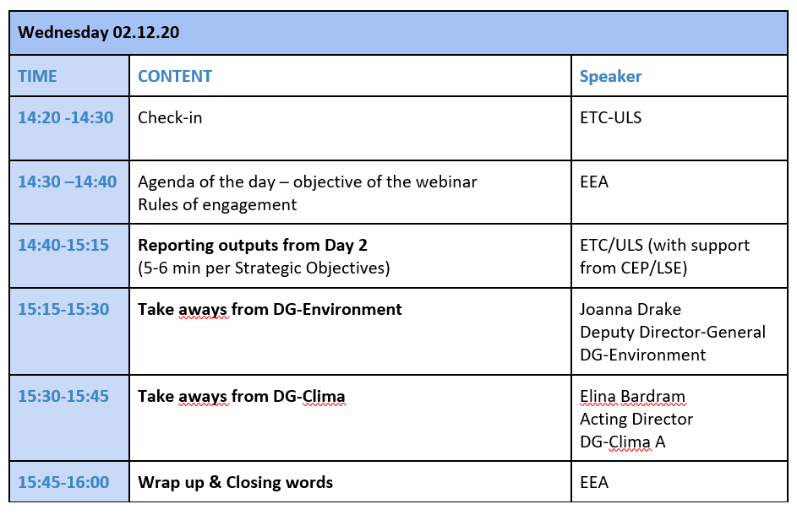
We look forward to welcoming you at the webinar

