The EEA cordially invites you to a facilitated stakeholder debate on
LOCALIZING EEA STRATEGIC OBJECTIVES
As part of the EEA Urban Stakeholder Meeting
Europe after 2020 – the green transformative role of cities
1 Dec at 14:20-16:45 on Teams
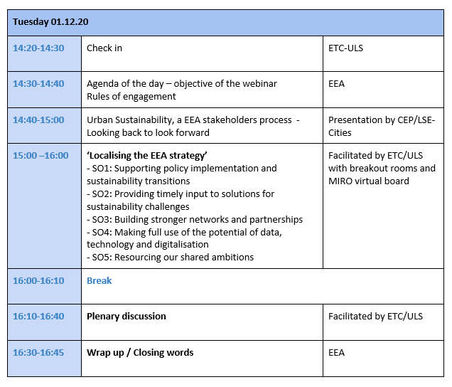
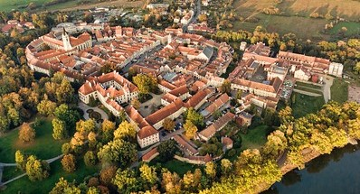
We look forward to welcoming you to the webinar

