The EEA cordially invites you to the
URBAN/POLICY SCIENCE DIALOGUE WEBINAR
As part of the EEA Urban Stakeholder meeting
Europe after 2020 – the green transformative role of cities
30 November 15:50-17:30 on Teams
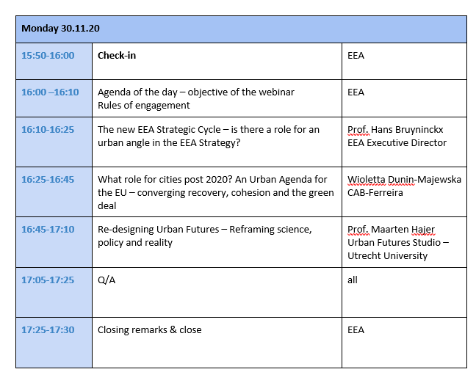
We look forward to welcoming you to the event.
