Initial results of the SENSE survey October 2014
We have now received feedback from our current survey on SENSE. Before further analysing the outcome and how to respond to that, we would like to present some initial results and comments:

- The balance between the technical and environmental thematic content?
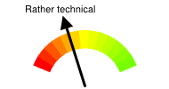

The material provided was of help?
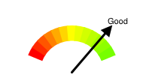
Note: While the feedback on the materials provided was seen as good, we have also received indications that it might have been slightly too technical.

Simpler schema and DCAT made it easier to provide the info?
Note: The impression is that most people agree on that aligning with current standards is good, and we see that the metadata web-tool has been of use.

Focusing on metadata over further describing indicators?
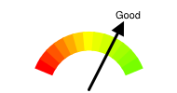
Note: More than a majority of positive responses, but at the same time we get indications that while it might have been a good move now, in the long run there is still a strong need for further harmonisation work between the different indicator models.

Training needs?
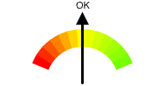
Note: No strong needs for training expressed, although a general wish for workshops, and capacity building for both, technical and thematic, communities.

Align with open data standards or use special approach for SENSE?
Note: There seems to be a strong agreement on the alignment with standards.

7a) Interest in using information from neighbouring countries or EEA?
Note: A clear interest in the data is shown.

7b) Open Data initiatives relevant for environmental data?
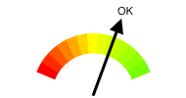
Note: Agreement not that significant as expected.

7c) Open Data published, and in online catalogue?
Note: It would be further of interest if DCAT or even DCAT-AP is used (connection to question 6).

7c) Involvement in linked data activities and their relevancy?
Note: The adoption of linked data does not yet yield a green light here as not everyone is doing work in the Linked Data area. Still more than half of the responded indicate that they are already involved in Linked Data activities (beside SENSE).

