20 February 2007

DRAFT for comments

Headline indicators of Biodiversity & Ecosystems: reflections from SEBI2010, Natura2000 assessment, PEEN/CoE, TEN-T and LEAC and some proposals

(JLW & SSP)

Preliminary remarks:

High level indicators are essential for communication and policy debate. However, whatever their intrinsic quality, high level indicators represent only average situations, averages which generally doesn’t correspond to any real case. This question is currently discussed in France, where exist a strong disagreement of people at the Consumer price index: when the overall official indicator tells that prices are quite stable, individual perceptions may tell a different story (or different stories). This results in particular from the weight in the index of food fresh products (produits frais) and rental of apartments (in Autres services on the table below), two items which represent an important share of popular households’ income.

INSEE, the French statistical office is well aware, since long of this difficulty, which may jeopardise its professional credibility. Therefore, the composition of the overall index (ENSEMBLE, on the table below) is split between its main components and commented. Variants are published as well (e.g. normalised for European comparisons or without tobacco for the indexation of salaries, or split between broad social categories or calculated with different base years). See Annex

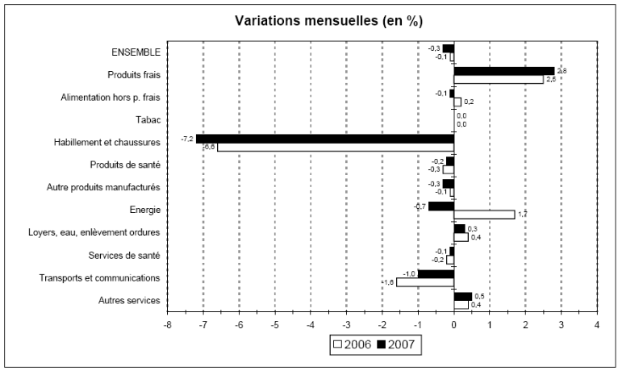
Table 1: INSEE, France, Consumer price index January 2007 / 02-21-2007

This decompostion is the minimum which should be done with all headlines indicators – which is done sometimes but not always.

But this is not sufficient: it helps in understanding the problem but doesn’t help so much in proposing a realistic Consumer price index – based on the same sound methodological bases – for any particular household or social group, corresponding to their own perception. Therefore, INSEE has decided to launch on 27 February 2007 an interactive web page for simulating anyone customised consumption price index.

http://www.insee.fr/fr/indicateur/indic_cons/indic_sip.htm

In conclusion, 3 fully consistent approaches of the Consumer price index co-exist now:
- The total/overall one, based on the national accounts, the main one used in macro-economics and modelling;
- Sub-indicators by types of products;
- A tool for simulating anyone customised consumption price index.

In the paper below, a similar approach is followed as much as possible for defining headline indicators for biodiversity and ecosystems. Decompositions are proposed in every case.

Possibilities of customisation are expected to be outcomes of the current development of the LEAC QUERY TOOL / OLAP CUBES for the EEA website.

Introduction

A flow of reflections has taken place these last 2 or 3 years on the ways of assessing biodiversity and ecosystems at the European (and even Pan-European) scale. The close coordination within BSS between the Biodiversity group (supported by ETC/BD) and the Spatial analysis group (supported by ETC/LUSI) has produced several outcomes from a spatial analysis perspective. We propose now to finalise and present as a first coherent set of high level indicators:
- Pressure:
  - Intensive land use temperatures over designated areas (from urban, transport and intensive agriculture)
  - Overall landscape fragmentation (effective mesh size)
- State:
  - Trends in extent of selected biomes, ecosystems and habitats
  - Change in average patch size of natural/semi-natural areas (quadratic average)
  - Rivers fragmentation
  - Landscape ecological potential and integrity
  - Ecosystems change in the specialisation grade of species groups/communities
- Impacts:
  - Ecosystem services
- Response:
  - Coverage of protected areas
  - Consumption of natural/semi natural land cover within designated natural areas
  - Environmental protection expenditure for nature conservation (SERIEE)

This list is non exhaustive. With the exception of ecosystem services – the central topic of EURECA, the European Ecosystem Assessment 2011/2012, all these indicators can be produced in 2007, many of them existing so far.

The proposed indicators are modifiable in their calculation; they can be downscaled and decomposed. They allow covering the (D)PSIR chain with an appropriate focus on STATE.

In addition to the classical OECD criteria (adopted for the EEA Core set of indicators), the prososed headline indicators meet two important conditions:
- Non-ambiguity: they correspond fairly to the intuition or common sense of the naïve user;
- Adaptability: they are transparent in their methodology, subject to decomposition analysis and ideally modifiable, allowing the more skilled users understanding which the key drivers are and testing variants (with different weights to the explicit or implicit components of the indicator) within the same conceptual framework.

Only the 6 underlined indicators are detailed below. The others exist or will be presented soon (rivers).

- Intensive land use temperature over designated areas (Natura2000, CDDA, others) DPSIR: PRESSURE

Purpose/rationale: measure the pressure resulting from intensive use of land inside and in the neighbourhood of designated areas – starting with Natura 2000 sites. This stress (noise, air, water, and soil pollution, frequentation…) is proportional to the size of the source and decreasing with the distance from the source.

Definition: the temperature of intensive land use expresses the potential stress of artificial land (urban fabric, economic and transport infrastructures) and of intensive agriculture (arable land and permanent crops) in a given place, in relation to its local importance as well as its presence in the neighbourhood. The temperature over a given object (e.g. a natural area) is proportional to the size of the source and inversely proportional to the distance from the source.

Calculation: the temperature of a given variable (population, land cover of any given CLC class or group of classes) is computed for a grid-cell of any regular grid as the sum of the value in the cell (e.g. 17 ha of urban fabric) plus the value in the neighbouring cells divided by the square of the distance to the central cell, an iteration being done as far as a radius or span chosen according to the landscape dynamics analysed. A similar computation is repeated fir each cell of the grid. The formula used for weighting neighbouring cells (so-called “bi-weight”) is:

w = (1 – (d/R)²)²

The weight of the neighbours of a given cell can be visualised as a hill:

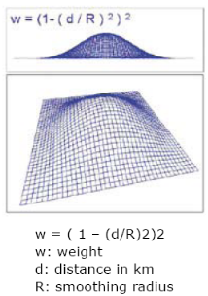

For a given variable, the value in each cell is its potential in the neighbourhood (of e.g. 5, 10, 20 km) or its temperature: the more and the closer, the warmer… Similar neighbours increase the potential (even though the value within the central cell is low); opposite neighbours dilute the potential (even though the value within the central cell is high).

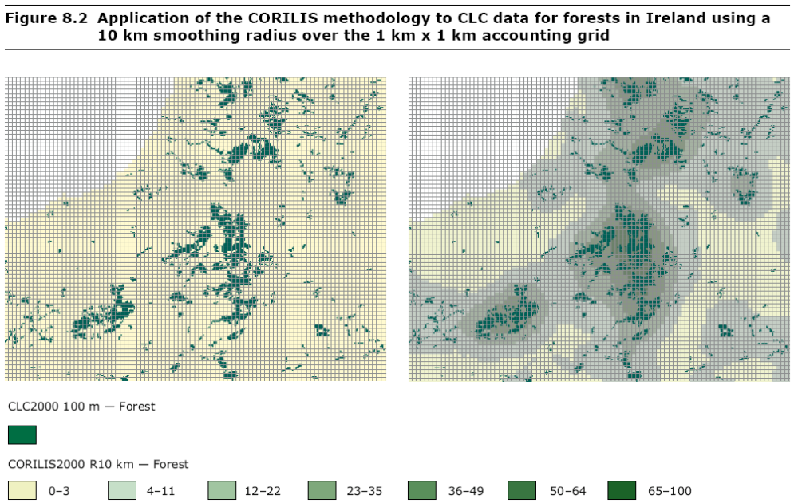

Figure 1 : illustration of CORILIS

The temperature of intensive land use over a given Natura 2000 site is computed as a mean: the total value of the smoothed values divided by the surface of the site.

For each N2000 site the format of the indicator (MEAN value is):
Sum of each cell weighted by the temperature index (1 to 100) and divided by the total surface of the site.

Figure 2: From CLC urban land cover and Natura 2000 to urban temperatures
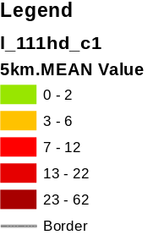

Figure 3: Example of urban temperatures over Natura 2000 sites (5 km smoothing radius, mean value in the sites, background map of CLC/CORILIS 1)

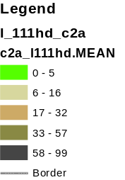

Figure 4: Example of intensive agriculture temperatures over Natura 2000 sites (5 km smoothing radius, mean value in the sites, background map of CLC/CORILIS 2A)

Discussion: the interpretation of the indicator (mean value) is straightforward for small to medium sites (< 10 km²). More difficult to interpret for very large sites when only a small part has a high temperature: the indicator expresses then a higher mean value for the entire site.

Possible solutions:
- Assess separately the sites according to their size (3 classes)
- Use the MAX value: it leads to obvious overstatement for large sites

Example of calculation, MEAN value (fictitious example)

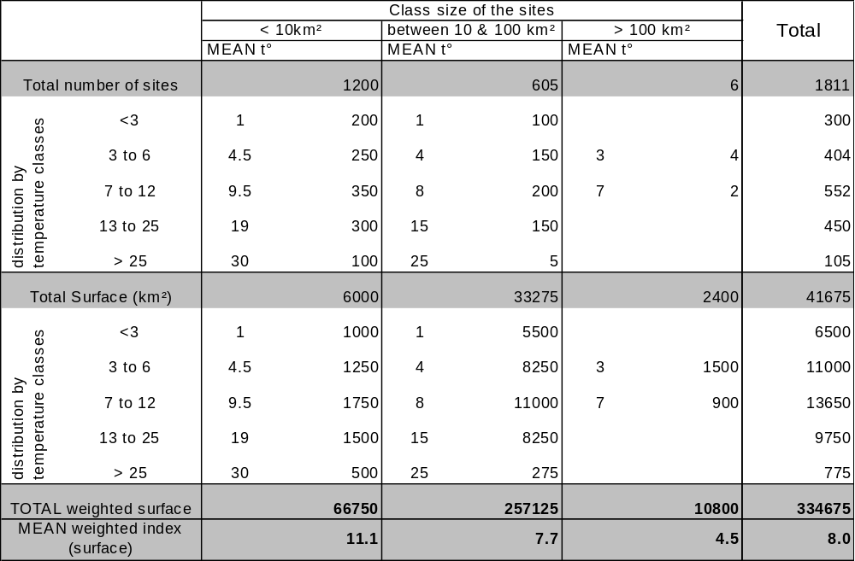

Table 1: Fictitious example: mean temperatures by sites size classes

Adaptability/ decomposition:

The temperature of intensive land use over designated areas (Natura2000, CDDA, others) can be computed with different horizons
In addition, the general indicator can be decomposed
By size classes (see above) for which different specific risk thresholds can be fixed.
By type of source of temperature generating a permanent stress:
- urban temperature
- intensive agriculture temperature

Managed land such as forests, pastures or mosaic agriculture may locally generate a similarly “hot” temperature when they are intensively cultivated. In other conditions, their temperature is “cool or negative”, it is not a stress but, instead, a support to neighbouring designated habitats.

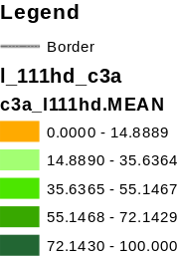

Figure 5: Example of forest temperatures over Natura 2000 sites (5 km smoothing radius, mean value in the sites, background map of CLC/CORILIS 3A)

Natural land temperature is as well “cool or negative”. Typically, the “green background index” (GBI), which measures the potential of landscapes of supporting ecological connectivity, adds altogether the temperatures of managed and natural land.

Change in temperature of intensive land use over designated natural areas

The calculation is the same as previously by weighting, each hectare pixels of the map by its temperature (1 to 100), adding all the values for a given area and divided by its surface (see methodology and discussion above). The indicator is obtained by the difference of temperature between two dates.

The change in temperature indicator can be split between urban land use and agriculture land use. If relevant, managed land (forest, pasture, mosaics…) can be integrated as well.

- Change in average patch size of natural/semi-natural areas (quadratic average) DPSIR: STATE

Purpose/rationale: this indicator shows up the degradation of landscapes and ecosystems when their size decreases by fragmentation by roads or conversion to artificial and other intensively managed areas. The size is supposed to be correlated to the resilience of the ecosystems and to their capacity to host a range of species. Intuitively, a large area split in two equal parts is a large damage, much larger than a small piece cut apart or larger that the split of a small area.

Definition: For a given region/ country, the change in average patch size is the difference between two dates in their mean value, calculated as their quadratic mean.

Calculation: The Quadratic Mean or Root Mean Square (RMS) is the square root of the mean square value of a variable. In other words, the root mean square is a statistical measure of the magnitude of a varying quantity. It can be calculated for a series of discrete values or for a continuously varying function. Formula:

Quadratic Mean or Root Mean Square = SQRT ((X₁)² + (X₂)² + (X₃)² +........+ (X_{n})² )

where X = Individual score and n = Sample size (number of scores or units)

With this type of average, the size of the individual objects matters as much as their number; it matches the first condition of non-ambiguity: in most cases, strong fragmentation of the larger areas matters more than fragmentation of small ones. In a majority of cases, results with the RMS are more satisfactory than with the Arithmetic average; sometimes they are equivalent, in no case less good. See Annex 1

Discussion:
The choice of the quadratic mean result from the fact that the indicator commonly used, based on the arithmetic average of the areas, doesn’t discriminate adequately between large and small changes. Let’s assume a country with 2 natural areas, one very large (10000 ha) and one very small (10 ha). The average size of the patches is (10000+10)/2 = 5005 ha. If the large area is split by 2, the mean value will become (5000+5000+10)/3 = 3336.7 ha; if the small area is split instead, it will become (10000+5+5)/3 = 3336.7 ha as well; and when a corner of the large area is partitioned by 20 ha: (9980+20+10)/3, the same amount… In these 3 cases, the indicator doesn’t express what is expected by the user. If the smaller area was to disappear, the indicator would rise up to 10000, which is not a helpful signal (Annex 1 presents various configurations and the resulting bias, which suggests not using the arithmetic average). In fact, some of these biases would be minimized with a larger statistical population, but the size effect would remain. The reason is that we have at least 2 populations, the large areas and the small areas; and more if we consider that “large” has not necessarily the same meaning for a forest or a wetland.

One remaining difficulty with the use of the quadratic mean is with the mere disappearance of small areas (smaller than the arithmetic average) which pushes up the indicator. This can be neglected when dealing with a large number of areas but it may be a problem with a small number of units and a high standard deviation. One remark is that even in that case, the distortion is less important with the quadratic mean than with the arithmetic average. A second remark is that this highlights again the multimodal character of the distribution: averaging large areas with small areas is to some extent arbitrary and should be kept to the purpose of a high level indicator only.

Adaptability/ decomposition: the indicator can be decomposed
- By classes of size (e.g. large, medium and small), in order to capture specific trends and avoid some bias mentioned previously.
- By broad habitat types (proxy: land cover types)

Implementation: immediately with CLC1990 and 2000; update with CLC2006; retrospective analysis (back to 1975) for European coasts and 4 PHARE countries

- Landscape ecological potential and integrity: (A) Net land ecological potential and (B) Integrity of the Land Ecological Potential, and (C) Consumption of ecological potential by artificial development and net conversion to intensive agriculture

Purpose/rationale: The ecological integrity of landscape can be measured at the macro scale by the difference between the gross ecological potential (+) and the stress from intensive land use (-):
- The gross ecological potential can be assessed from (1) areas of high ecological interest or value and (2) landscape characteristics favourable to nature.
- The stress from intensive land use can be assessed from (3) the temperatures of intensive land use (urban and intensive agriculture) and (4) landscape fragmentation.

(1) Areas of high ecological value: Designated areas for nature protection don’t exist in isolation. They are created for local protection purposes (within their boundaries) as well as core areas influencing their neighbourhood and in many cases corridors or nodes of ecological networks. Symmetrically, the long term sustainability of many high value habitats depends on their exchanges with their environment and/or similar habitats.

Therefore, the areas of high ecological value to consider are not only the sites themselves but buffer zones as well (see definition of the ecological networks, CoE…). The buffers should reflect an influence which is proportional to the size and inversely proportional to the distance from the border of the designated area. This is the temperature of designated areas or their potential in the neighbourhood. By analogy to CORILIS, the database of smoothed values of designated areas of High Ecological Value (HEV) is called NATURILIS.

Even though nature protection has not yet achieved all its objectives, the areas of high ecological value are defined, in a first instance, from the designated areas: Natura2000 sites, EMERALD sites, CDDA national designations, international designations. This restrictive approach, based on the designation value, bears the advantage of a broad consensus on the designated sites and consequently on available databases.

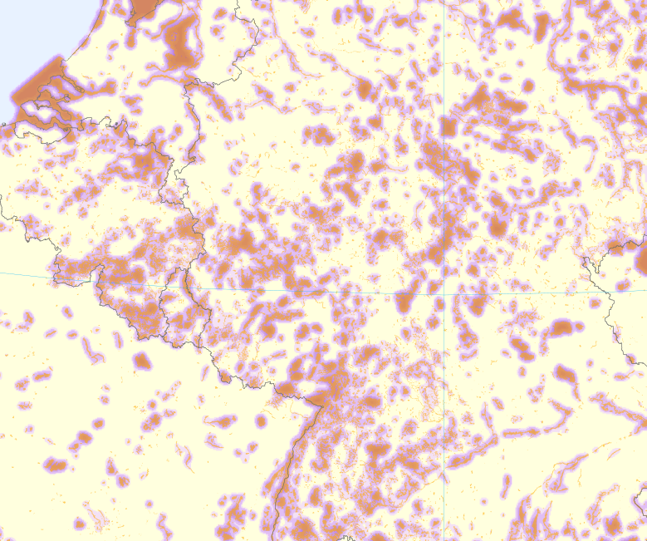
Figure 6: natural potential or high ecological value (e.g. >8%) in a neighbourhood of 5 km of Natura2000 sites (in orange) is displayed in grades of purple.

(2) Landscape characteristics favourable to nature: Agro-systems with pastures and/or mosaics of parcels, forests and other semi-natural or natural dry land, wetlands and water bodies are land cover types generally favourable to nature. They may be or not designated and protected for their natural value. This Green Background Landscape is a natural asset in its own as well as an important component (with rivers) of the connectivity between areas of high ecological interest.

A Green Background Index (GBI) can be mapped from a selection of CLC classes; it is a modifiable map:
- The selection of elementary classes can be modified; the standard map is based on CLC classes 2B, 3, 4 and 5 (see annex);
- Smoothing is processed with different radius (standards radius of 5, 10 and 20 km, or another distance according to needs);
- The green background index is expressed as a value between 0 and 100; a map of the GBI can present continuous (stretch) values or refer to any appropriate thresholds.

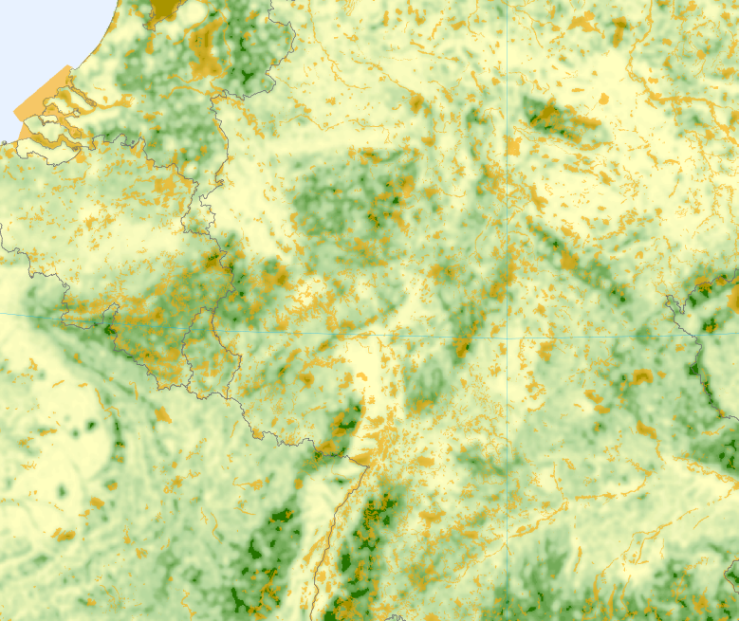

Figure 7: the Green Background Index, as a measurement of the potential landscape connectivity of Natura2000 sites (in orange) is displayed in grades of green

The maps of high ecological values (HEV) and green background index (GBI) can be combined for producing a map of the ecological land infrastructure: appropriate threshold values have to be introduced for each of these two maps, in order to define core areas (where designated areas are bufferised, possibly agglomerated and weighted) and land potentially connecting these core areas – so-called green background landscape. When completed with river corridors and artificial barriers, the map provides a proxy of the backbone of the ecological networks as defined in the PEEN programme.

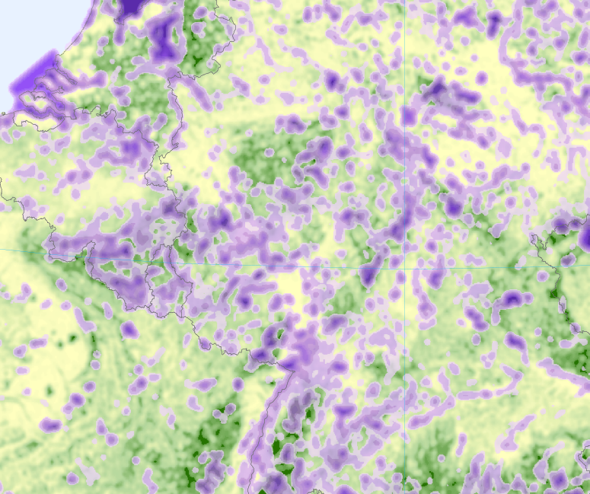

Figure 8: Ecological land infrastructure combining core areas (in grades of purple, >4%) and potentially connecting landscape as Green Background Index (in grades of green)

(3) Temperatures of intensive land use (urban and intensive agriculture): the cumulated temperature of urban/artificial areas and intensive agriculture is, by definition the complement of the Green Background Index

TempU+TempAgr = Temp (U+Agr) = 1 – GBI

In other terms, low GBI values correspond to high temperatures, and vice versa.

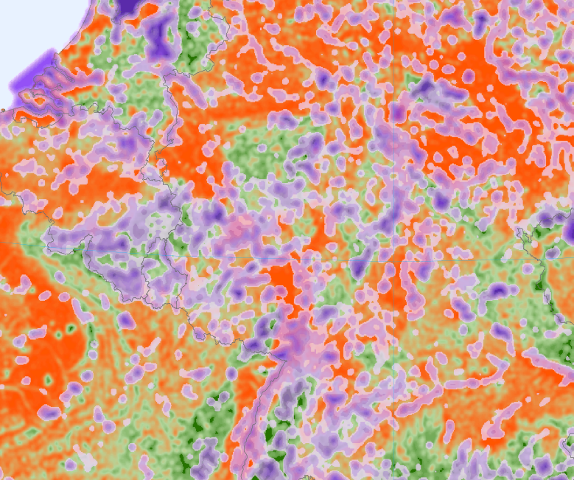

Figure 9: High ecological value (purple, core areas >4%), Green Background Index/ Intensive land use temperatures (from green to red)

Indicator: Net Land Ecological Potential (DPSIR: STATE)

LEP = HEV+GBI

The addition of the intensity of nature protection (important in Europe, resulting from scientific as well as political recognition) and the capacity of the landscape of supporting nature gives the measurement of a land ecological potential. The LEP is a STATE indicator which is the algebraic sum of 3 components: the designation value (+), the favourable landscape character (+) and the stress from urban and intensive agriculture land uses (-).It varies between 0 and 200. The decrease of the indicator reflects a degradation of the land potential, the increase an improvement.

(4) Landscape fragmentation: in addition to the degradation by consumption and intensive use, the ecological landscape is disrupted by artificial barriers (linear or areas) which reduce habitats resilience with no proportionality to the surface covered. The combination of land ecological potential and an appropriate indicator of fragmentation (LF) results in an indicator of land ecological integrity.

Several indicators of fragmentation can be computed. From ongoing discussion, two indicators are favourites for tests:
- Change in average patch size of natural/semi-natural areas (quadratic average) (see above)
- Effective Mesh Size (Jaeger, J. Landscape ecology 15: 115-130, 2000) – available at ETC-LUSI. The indicator would be interpreted in this case as a distress characteristic assigned to ecological potentials.

Figure 10: Fragmentation by roads (ESRI) and artificial areas (CLC2000) of the land ecological potential

Indicator A: Integrity of the Land Ecological Potential (DPSIR: STATE)

LEI = LEP – LF

Indicator B: Consumption of ecological potential by artificial development and net conversion to agriculture (DPSIR: STATE)

The indicator is computed on change data. The artificial development is calculated as the sum of the LEAC flows LCF2+LCF3. The net conversions of semi-natural and natural land to agriculture (conversion minus withdrawal of farming) is calculated considering only intensive agriculture with the flows LCF511, 521 & 53 (+) and LCF6 (-). The flow pixels are weighted by the ecological land infrastructure index.

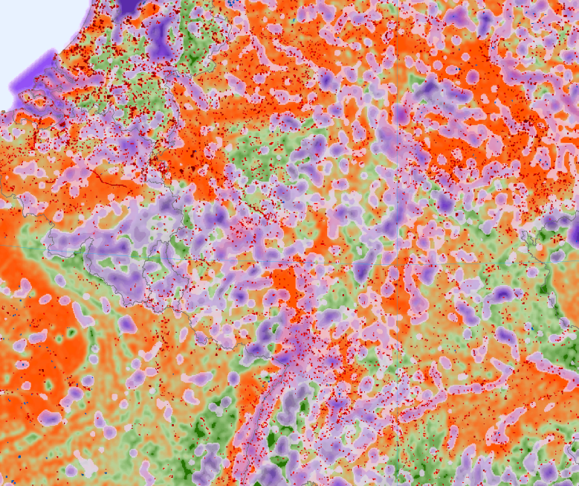
Figure 11: Consumption of land ecological potential by urban sprawl (red pixels) and conversion of natural land to agriculture (blue pixels) 1990-2000 (CLC/LEAC)

The Consumption indicator has been tested for the axis (2 x 10 km and 2x2 km) of the TEN-T extension to the East and South, 2006, separately for the Green background and the Core areas of natural potential.
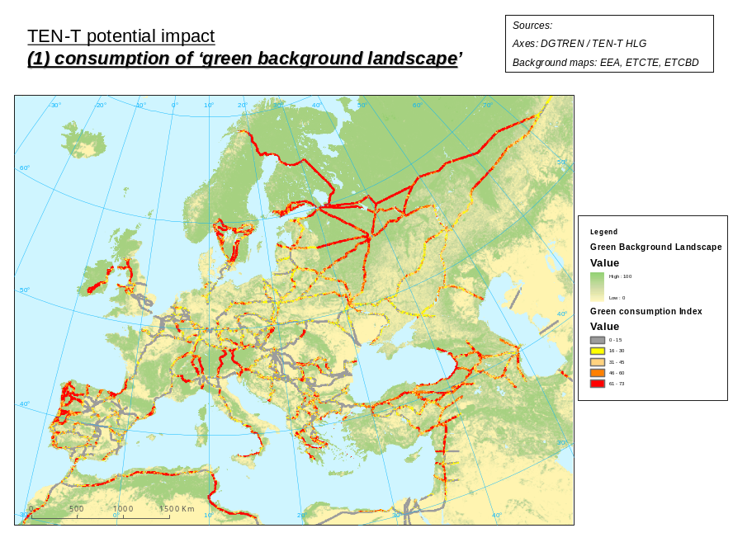
Figure 12: Consumption of GBI by TEN-T

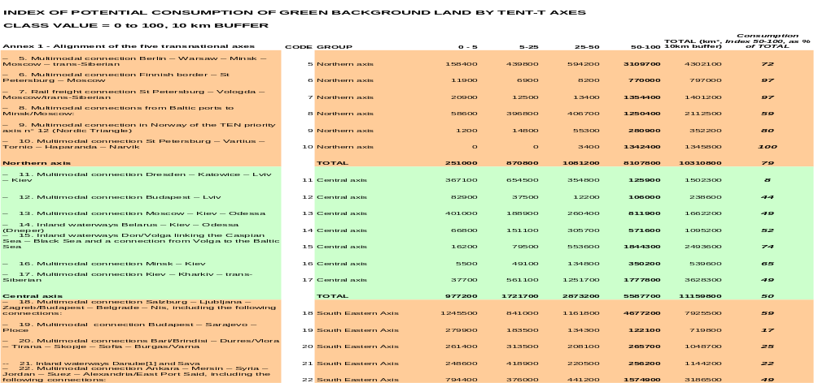
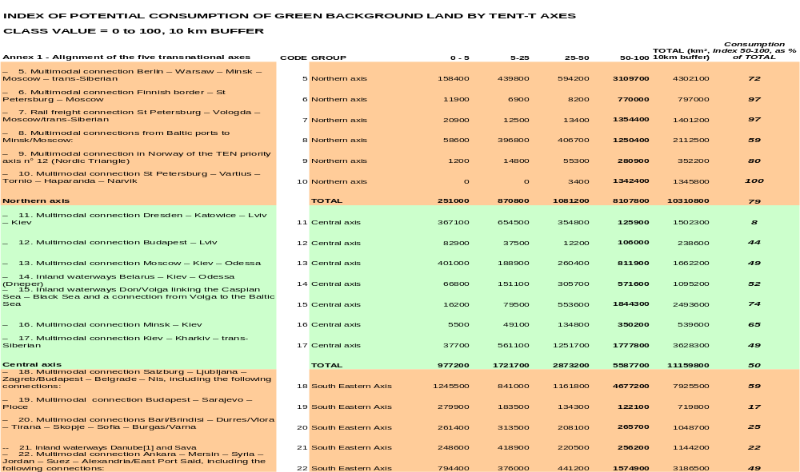
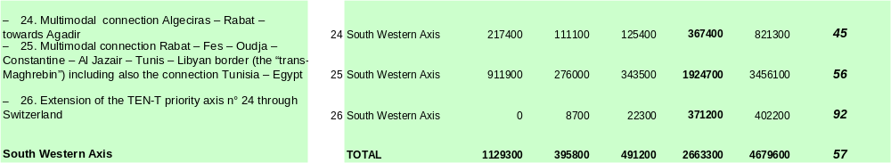

Table 3: Consumption of Green Background Land (GB Index) by TEN-T Axis

Figure 13: Consumption of core area of high natural potential (NATURILIS) by TEN-T Axis (2km buffer)

Discussion, adaptability

Due to their construction, the two indicators of stress and consumption are highly modifiable:
- Choice of designated areas according to levels of enforcement
- Adjustment of the GBI to specific questions (e.g. according to the preferences of groups of species or “ecological profiles”) by introducing weighting factors for one or the other source, or by changing the composition of the cluster of sources of temperatures.
- Adjustment of GBI to regional conditions – where forests of poplars, eucalyptus and in some cases coniferous when planted in conditions far from climax, can be highly managed and therefore excluded – can be addressed
- Selection of land uses considered as stressors: urban areas and sprawl, transport networks not captured in land cover data bases, intensive agriculture with variable definitions…

Because of this modifiability, the overall indicators – which are subject to the common critic of hiding differences and in some cases giving poor or inadequate results in local conditions – can be accepted as headline indicators at the European scale.

Some possible improvements have to be considered.

LCF81 Water body creation (over natural land) could be considered in the intensive land uses.

The rivers – treated separately – still need being integrated to land in the connectivity assessment.

Another possible improvement relates to the buffering of roads and urban areas; this is commonly done but subject to the critics mentioned in the discussion of the urban ‘temperatures’ indicators (fixed buffers…).

Another solution could be computing the stress indicators in an approach of ‘temperatures’. This could lead to the definition of another indicator as the difference in each grid cells between the ecological land infrastructure index (+) and the stress from artificial land use (-). This indicator would have the characteristic of an Overall land ecological temperature. The Overall land ecological temperature could be combined with a fragmentation indicator (patch size, MEFF size…) for producing a more comprehensive Landscape ecological support capacity or Landscape ecological integrity.

Implementation:

The main gap in data availability relates to the update of transport networks databases; for a while, the consumption indicator will be produced from land cover monitoring only. The other elements of the indicator can be implemented now.

- Ecosystems change in the specialisation grade of species groups/communities (preliminary draft) DPSIR: STATE

Note: The increase of the number of species in a given area can be understood as the consequence of the improvement of the environmental conditions and an indicator of biodiversity or as an indicator of the state of the ecosystem. In the first case, an increase of the indicator is generally associated with a positive value; in the second case, an increase can reveal a decline in ecosystem health and the number needs to be combined with the characteristics of the species and meta-populations.

Purpose/rationale: one aspect of ecosystem health is revealed by the change in specialisation grade of species communities; with time, ecosystems tend to host specialised species, better adapted and more productive. These species being less adaptable tend to be replaced by generalist when ecosystems are evolving fast.

Definition: ratio, within a group or community of species, between specialist and generalist species. A specialist species survives in a limited number of biotope types; a generalist species can live in a large number of biotope types. The ratio decrease indicates a degradation of the ecosystems.

Calculation: detailed calculation is presented in Biotope use and trends of European butterflies, C. van Sway, M. Warren and G. Loïs, Journal of Insect Conservation (2006). A biotope profile is calculated for each species by counting the number of biotope-mentions
(= biotope mentioned in a country), and then calculating the percentage of biotope-mentions for each biotope (the biotope profile). The threat status is considered as well.

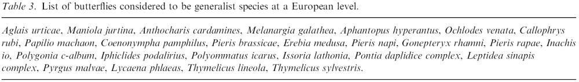

Discussion: still experimental but publications (PhD thesis, scientific papers). One particular advantage of the method, which is that the indicator reacts in the same way all kind of groups or communities when ecosystems are under stress, needs confirmation.

Adaptability/ decomposition: scales?

Implementation: A first test at the European scale is feasible now from existing atlases and red books (butterflies, birds, plants…?), with a 50x50 km resolution.

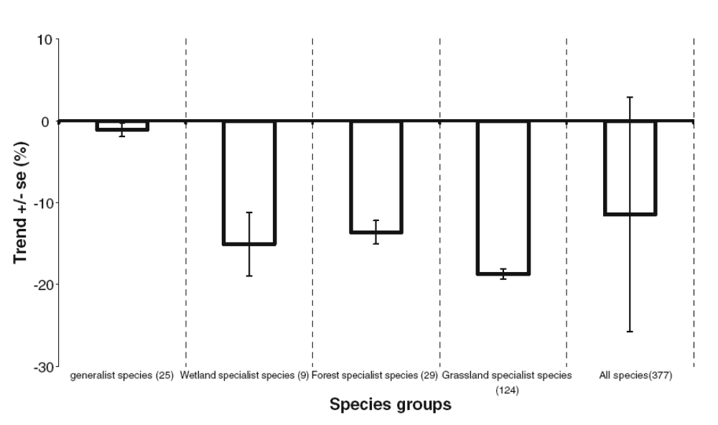
Figure 14 European trends of selected species groups (butterflies) according to broad biotope classes and specialism.
Source: Biotope use and trends of European butterflies, C. van Sway, M. Warren and G. Loïs, Journal of Insect Conservation (2006)

A useful comparison can be established with the results for species and the so-called MEFF (Effective Mesh Size) indicator of fragmentation (ETCTE/LUSI and Jaeger) and correlations searched, from a static as well as a dynamic perspective.

Implementation at more detailed scales can be foreseen using data from official monitoring and participative science.

- Consumption of natural/semi natural land cover within designated natural areas (DPSIR: RESPONSE)

Purpose/rationale: measure the effectiveness of measures of nature protection or/and management inside designated areas.

Definition: The consumption of natural/semi natural land cover inside designated natural areas is the amount taken by urban development, agriculture and water body creation. This first indicator is easily produced from the Land Cover accounts (LEAC) database where the flows describe the processes (the uses) that create the change in cover. It is mainly relevant for the internal change of natural areas. Fixed buffers can be used as well for analysing neighbouring influence; due to some arbitrary in the definition of a buffer, proportional buffers may be preferred (see below).

Calculation The indicator is easily produced from the Land Cover accounts (LEAC) database where the flows describe the processes (the uses) that create the change in cover. The main flows used for calculating the indicator of change in land cover are the following:
Consumption of natural land by urban sprawl (LCF2+LCF3/ Natural land)
Consumption of natural land by conversion to agriculture (LCF5/ Natural land)

In the table below, consumption is not referred to designated areas but, instead, to the sum of CLC forest and other semi-natural and natural land, incl. wetlands and water surfaces.
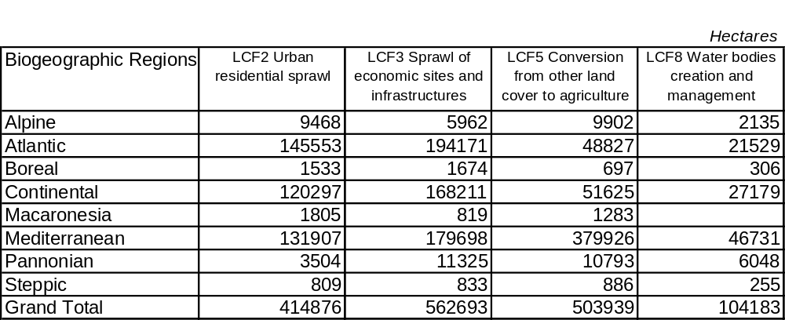

Table 2: Consumption of land cover of semi-natural and natural areas, 24 countries, 1990-2000
(source: LEAC)

Discussion: The meaning of natural land consumption within an area (designated area of CLC unit) is clear: it is a direct measurement of the effectiveness/efficiency of nature protection policies and an indication of an additional pressure. : if the indicator is stable (no change), the policies work; if it reveals a consumption of protected land/ habitats there is a problem; (and so good if nature expands against artificial). This is a response indicator.

From a pressure perspective, the meaning of the indicator is not that clear. The pressure, i.e. by urban and roads results from their existence in the area or its neighbourhood; the change in urban/ road land cover is the variation of the pressure, not the pressure itself which is resulting from the total amount, i.e. the stock (and the additional pressure from the change will to a large extent depend on the initial situation). Therefore, the use of change in land cover as a pressure indicator is misleading.

The indicator is sometimes used for buffer zones around sites; it is considered as a measurement of the change in the potential pressure on the designated sites which are surrounded by the buffers. This second use is subject to a consensus on:
- the size of the buffers around the target areas;
- the relation between the additional land cover and the permanent pressure in the neighbourhood.

In the temperature methodology, proportional buffers are established around sources; not targeted areas. The variation of the indicator is directly linked to the source. Therefore, this solution is more appropriate when considering surrounding pressure.

Adaptability/ decomposition: The indicator can be immediately implemented using the LEAC database and tools. Due to the low capture of roads by CLC, the indicator can be improved by adding data on the new roads developed.

The indicator can be adapted to regions where forest plantations have a negative effect, due to the replacement of high value natural habitats (e.g. peatbogs, heathland) or/and by the intensive cultivation of short term productive trees (poplars, eucalyptus, in some cases coniferous when planted in conditions far from climax).

When mosaic agriculture has a high nature value because of its specific patterns and natural inclusions, the same indicator can be implemented as well.

- Expenditure for nature protection (DPSIR: RESPONSE)

Expenditures for nature protection are one module of the so-called satellite accounts of environmental protection and management expenditure of the SNA93, the UN System of National Accounts. They are part of the SEEA2003, Chapter 5 “Accounting for economic activities and products related to the environment”. The methodology is directly derived from the SERIEE handbook developed by Eurostat and tested in several European countries (as well as in Canada, Australia…).

Typically, the satellite accounts present, in a coherent way with the main national accounts, expenditures by broad social functions (Health, Social Protection, Education, R&D, Environment…). The environment is subdivided between Water protection and management, waste management, protection of the ambient air quality, protection of soil… nature protection. The expenditures are assessed according to common rules:
- They are exhaustive, including government services, education and research for the domain; ancillary products used for the function are also accounted.
- Current expenditures are distinguished from capital expenditures; the latter include the net formation of capital as well as the purchase of non produced assets such as land.

Due to these rules, comparisons can be done with the results of the national accounts (e.g. % of expenditure compared to the GDP) as well as between functions (e.g. between Education and Environment, or between Water and Waste). Note that as in any functional approach, overlaps exist between the sets of accounts (e.g. environmental research will be accounted 2 times); therefore, the individual satellite accounts cannot be added.

The regular production of Expenditure accounts for nature protection should be considered in the context of the ESEA (European strategy on environmental accounting) and delegated to Eurostat.

Adaptability/Decomposition:
Details of the definitions of the SERIEE in relation to Nature are in Annex 4.

ANNEXES

Annex 1 : INSEE, France, Consumer price index January 2007 / 02-21-2007
- Information Rapide, full version in French (.PDF, 127 KB)
- Methodology (.PDF, 122 KB)
In January 2007, the consumer price index for all households in the whole of France fell by 0.3% (+0.2% in December 2006, -0.1% in January 2006). Its annual change was +1.2% after +1.5% in December.
In January, the fall of consumer price index resulted from opposite movements. Prices of clothing and footwear, and prices of other manufactures showed a drop due to winter sales. Was added a fall in the price of energy and transport and communication.
Conversely, prices of other services and of fresh produce increased.
The price index adjusted for seasonal variations was stable.
The HICP fell by 0.4% (+1.4% year-on-year).
The underlying inflation indicator was up 0.2% (+1.4% year-on-year).

Summary table
 | jan 2006 | dec 2006 | jan 2007 | change in 1 month | change in 1 year
Consumer price index (CPI). 1998 = 100
All households. All metropolitan France
(mainland + Corsica) plus overseas départements
Total (00 ET) | 112.9 | 114.73 | 114.34 | -0.3 | 1.2
Total seasonally adjusted (00 C) | 113.4 | 114.87 | 114.84 | 0.0 | 1.2
Food (4000 E) | 114.7 | 116.14 | 116.49 | 0.3 | 1.6
Tobacco (0221 E) | 178.5 | 178.81 | 178.80 | 0.0 | 0.2
Manufactured goods (4033 E) | 99.8 | 100.85 | 99.45 | -1.4 | -0.4
Energy (4007 E) | 134.6 | 134.57 | 133.64 | -0.7 | -0.7
Services (4009 E) | 115.9 | 118.81 | 119.08 | 0.2 | 2.8
Food incl. Tobacco (4014 E) | 120.6 | 121.97 | 122.31 | 0.3 | 1.5
Manufactured goods incl. Energy (4015 E) | 106.0 | 106.86 | 105.52 | -1.3 | -0.5
Manufactured goods excl. Apparel and footwear (4016 E) | 100.3 | 100.11 | 99.83 | -0.3 | -0.5
Total excl. Rentals and Tobacco (5000 E) | 111.5 | 113.20 | 112.76 | -0.4 | 1.1
Total excl. Energy (4017 E) | 111.3 | 113.22 | 112.86 | -0.3 | 1.4
Total excl. Tobacco (4018 E) | 111.8 | 113.59 | 113.19 | -0.4 | 1.3
Urban households headed by manual or clerical worker
All metropolitan France (mainland + Cors
Total excl. Tobacco (4018 D) | 111.7 | 113.57 | 113.21 | -0.3 | 1.4
Total (00 D) | 113.4 | 115.25 | 114.89 | -0.3 | 1.3
Underlying inflation
All households. All metropolitan France
(mainland + Corsica) plus overseas départements
Total "underlying" (4022 S) | 110.8 | 112.17 | 112.34 | 0.2 | 1.4
Harmonized French consumer price index (HCPI)
2005 = 100.
All households, metropolitan France
(mainland + Corsica) plus overseas départements
TOTAL HCPI (00 H) | 100.60 | 102.39 | 102.00 | -0.4 | 1.4
Codes between brackets correspond to groupings used in economic analysis. They are utilized in the detailed tables of the Informations Rapides on consumer prices and in the downloadable monthly files.
Source: INSEE
Annex 2

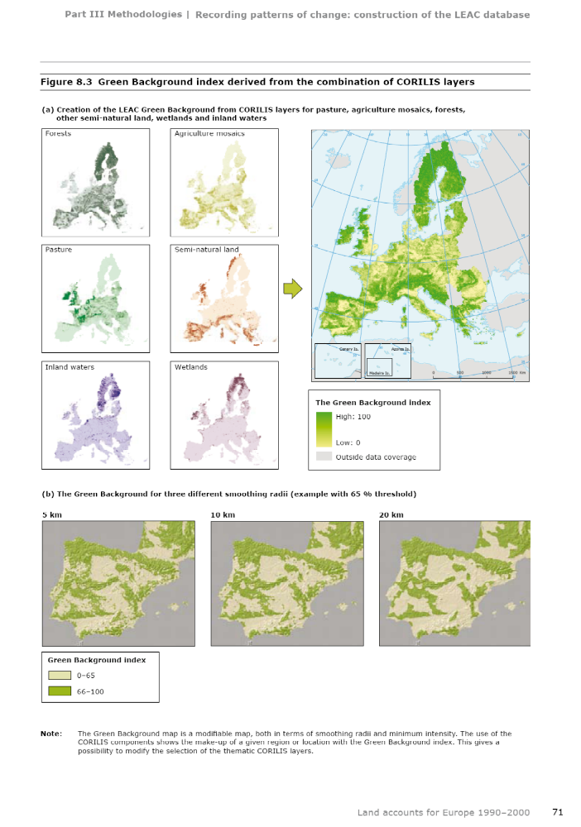
Annex 3: Comparison between Arithmetic average and Quadratic mean results

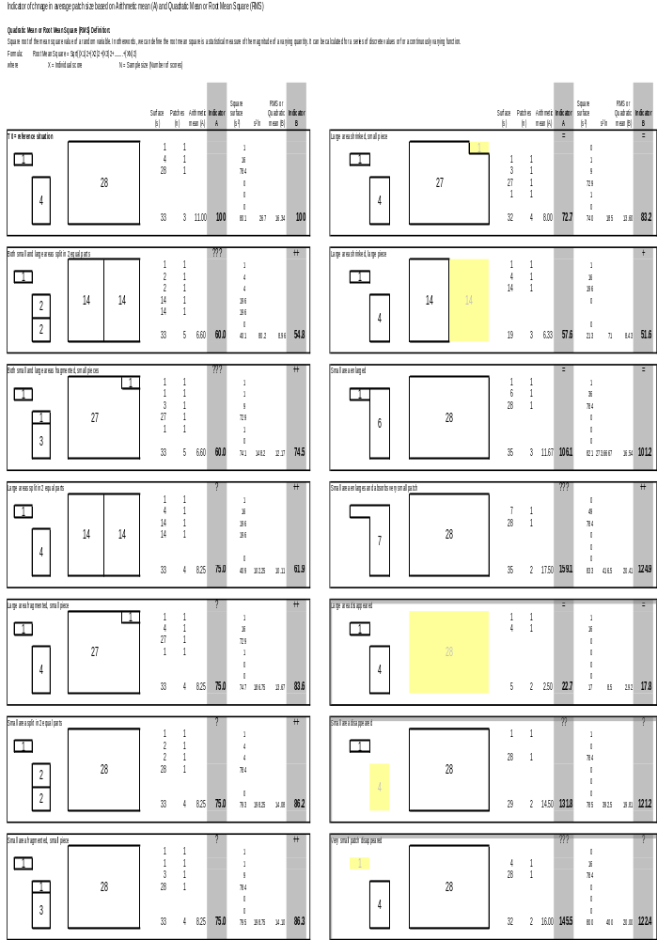
Annex 4
SERIEE: Classification of environmental protection activities

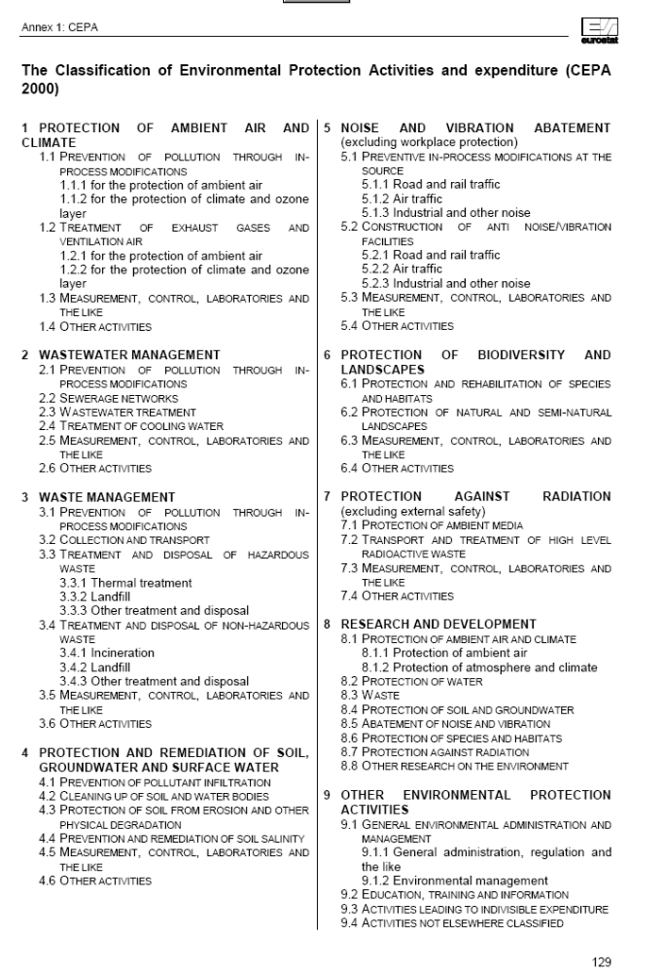
SERIEE: Definition of expenditures of protection of biodiversity and landscapes

6 PROTECTION OF BIODIVERSITY AND LANDSCAPES

Protection of biodiversity and landscape refers to measures and activities aimed at the protection and rehabilitation of fauna and flora species, ecosystems and habitats as well as the protection and rehabilitation of natural and semi-natural landscapes. The separation between ‘biodiversity’ and ‘landscape’ protection may not always be practical. For example, maintaining or establishing certain landscape types, biotopes, eco-zones and related issues (hedgerows, lines of trees to re-establish ‘natural corridors’) have a clear link to biodiversity preservation.
Excluded is the protection and rehabilitation of historic monuments or predominantly built-up landscapes, the control of weed for agricultural purposes as well as the protection of forests against forests fire when this predominantly responds to economic reasons. The establishment and maintenance of green spaces along roads and recreational structures (e.g. gulf courses, other sports facilities) are also excluded. Actions and expenditure related to urban parks and gardens would not normally be included but may be related in some cases to biodiversity – in such cases the activities and expenditure should be included.

6.1 PROTECTION AND REHABILITATION OF SPECIES AND HABITATS

Activities and measures aimed at the conservation, reintroduction or recovery of fauna and flora species, as well as the restoring, rehabilitation and reshaping of damaged habitats for the purpose of strengthening their natural functions. Includes conserving the genetic heritage, re-colonising destroyed ecosystems, placing bans on exploitation, trade, etc. of specific animal and plant species, for protection purposes. Also includes censuses, inventories, databases, creation of gene reserves or banks, improvement of linear infrastructures (e.g., underground passages or bridges for animals at highways or railways, etc.), feeding of the young, management of special natural reserves (botany conservation areas, etc.). Activities may also include the control of fauna and flora to maintain natural balances, including re-introduction of predator species and control of exotic fauna and flora that pose a threat to native fauna, flora and habitats.
Main activities are the management and development of protected areas, whatever the denomination they receive, i.e. areas protected from any economic exploitation or in which the latter is subject to restrictive regulations whose explicit goal is the conservation and protection of habitats. Also included are activities for the restoration of water bodies as aquatic habitats: artificial oxygenation and lime-neutralisation actions. When they have a clear protection of biodiversity purpose, measures and activities related to urban parks and gardens are to be included. Purchase of land for protection of species and habitats purpose is included.

6.2 PROTECTION OF NATURAL AND SEMI-NATURAL LANDSCAPES

Activities and measures aimed at the protection of natural and semi-natural landscapes to maintain and increase their aesthetic value and their role in biodiversity preservation. Included is the preservation of legally protected natural objects, expenditures incurred for the
rehabilitation of abandoned mining and quarrying sites, re-naturalisation of river banks, burying of electric lines, maintenance of landscapes that are the result of traditional agricultural practices threatened by prevailing economic conditions, etc. For biodiversity and landscape protection related to agriculture, the identification of specific state aid programmes to farmers may be the only data source available. Protection of forests against forest fires for landscape protection purpose is included.
Excluded are measures taken in order to protect historic monuments, measures to increase aesthetic values for economic purposes (e.g., re-landscaping to increase the value of real estates) as well as protection of predominantly built-up landscapes.

6.3 MEASUREMENT, CONTROL, LABORATORIES AND THE LIKE

Measurement, monitoring, analysis activities which are not classified under the preceding items. In principle, inventories of fauna and flora are not covered since they are classified under protection of species.

6.4 OTHER ACTIVITIES

All other activities and measures aimed at the protection of biodiversity and landscape. It includes administration, training, information and education activities specific to the domain, when they can be separated from other activities related to the same domain and similar activities related to other classes.

