GLOBCORINE

Products Description Manual






Milestone | Final meeting
Authors | Pierre Defourny, Sophie Bontemps, Eric van Bogaert
Distribution | Authors  ESA : Olivier Arino

Table of contents
Acronyms 4
Applicable documents and references 5
1. Product summary 6
1.1. General content 6
1.2. Data Source 7
1.3. Data access 7
2. Product nomenclature 8
2.1. File Name Nomenclature 8
2.2. Geographic Location information 8
2.3. Algorithmic Description 9
3. Product Specifications 11
3.1. GlobCorine urban sprawl indicator content 11
4. Data Policy 13

Acronyms
CLC | : Corine Land Cover
ENVISAT | : ESA Environmental Satellite
FR | : Full Resolution
FRS | : Full Resolution Full Swath
MC | : Mean Compositing
MERIS | : Medium Resolution Imaging Spectrometer Instrument (http://envisat.esa.int)
ROI | : Region Of Interest
TOA | : Top Of Atmosphere
TS | : Technical Specification

Applicable documents and references

Applicable Documents
[AP-] GLOBCORINE, Technical Specification, 2.0.

References

European Environment Agency. 2000. Corine Land Cover technical guide – addendum 2000. Technical report 40, Copenhagen, 105 pp (http://www.eea.eu.int)
European Environment Agency. 2006. Urban sprawl in Europe. The ignored challenge. Copenhagen, ISBN 92-9167-887-2, ISSN 1725-9177, 56 pp.
European Topic Centre on Terrestrial Environment. 2007. Urban morphological zones 2000, version F1v0. European Environment Agency, Copenhagen.
Vancutsem, C., Bicheron, P., Cayrol, P. and Defourny, P. 2007. Performance assessment of three compositing strategies to process global ENVISAT MERIS time series, Canadian Journal of Remote Sensing, 33, 492-502.

Product summary

General content
The GlobCorine urban sprawl indicator has been generated over the period between December 2004 and June 2006, covering the CLC2000 area. It approximately extends from 35°N to 75°N and from 15°W to 35°E, as illustrated in Figure 1.
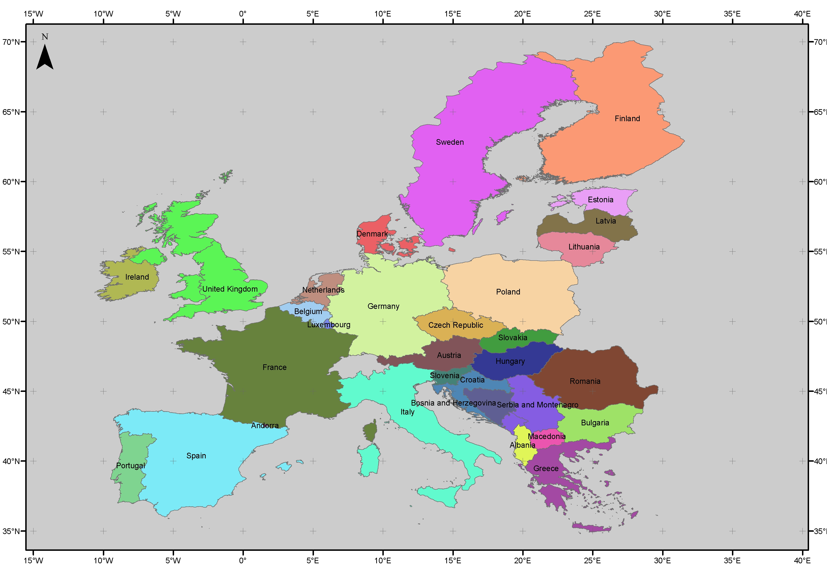
Figure 1: European extent of the GlobCorine urban sprawl product
Urban sprawl is commonly used to describe physically expanding urban areas. The European Environment Agency has described sprawl as the physical pattern of low-density expansion of large urban areas, under market conditions, mainly into the surrounding agricultural areas (EEA, 2006).
The GlobCorine urban sprawl indicator is derived from an automated supervised classification of the areas surrounding the urban zones in 2000. The classification has been performed on a MERIS annual mosaic.
The product is available in the GeoTIFF format and stored in a zip archive named “GlobCorine_UrbanSprawl.zip” enriched with additional files.

Data Source
The GlobCorine urban sprawl product is based on the same dataset than the GlobCover Land Cover map.
The GlobCover project used ENVISAT’s Medium Resolution Imaging Spectrometer (MERIS) Level 1B data acquired in the Full Resolution mode with a spatial resolution of 300 meters. For the generation of the Level 1B data, the raw data acquisitions have been resampled on a path-oriented grid, with pixel values having been calibrated to match the Top Of Atmosphere (TOA) radiance. The GlobCover project benefited from 19 months of MERIS global Fine Resolution Full Swath (FRS) data, from December 2004 until June 2006.
Further information about the ENVISAT MERIS Mission is available at the MERIS home page ENVISAT MERIS Mission (http://envisat.esa.int/object/index.cfm?fobjectid=1665).

Data access
The GlobCorine products are available though the following access point:
- xxx

Product nomenclature

File Name Nomenclature
The GlobCorine urban sprawl indicator name follows the general nomenclature (Table 1):
GLOBCORINE_IND_[YsYsYsYsMsMs]_[YeYeYeYeMeMe].tif
Field | Signification | Value
GLOBCORINE | Project Acronym | GLOBCORINE
IND | Indicator Name | URBAN
YsYsYsYsMsMs | Start Year (YsYsYsYs) and start month (MsMs) of mosaic | 2004-12
YeYeYeYeMeMe | End Year (YeYeYeYe) and end month (MeMe) of mosaic | 2006-06
Table 1: GlobCorine urban sprawl product name nomenclature

Geographic Location information
The Table 2 list the parameters used for the projection processing of the GlobCorine urban sprawl product.
Field | Description
Projection | Plate-carrée
Reference ellipsoïd | WGS 84 (R_{e} =Equatorial Radius= 6378,14km; R_{p}=Polar Radius=6356,76 km)
Angular pixel resolution | Res_{deg}= 1/360 degree
Kilometric pixel resolution | height: 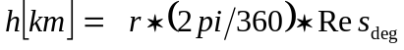  width :  with 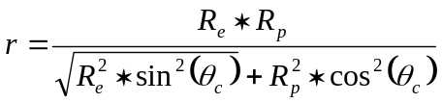  and 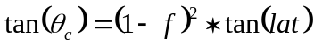  and 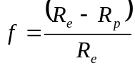  (h is variable between 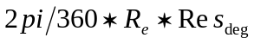 at the Equator and 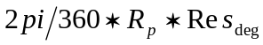 at the Pole)
Upper Left corner of Upper Left pixel | Upper Left corner of Upper Left pixel longitude: -180° E  Upper Left pixel of Upper Left pixel latitude : 90° N
Table 2: GlobCorine product geographic location information

Algorithmic Description
Table 3 presents a summary of the methodology used to produce the GlobCorine urban sprawl indicator. The classification algorithm is exhaustively described in the GlobCorine TS document [AP-].
Processing step | Algorithmic description
Pre-processing level  Step 1: annual syntheses production | The daily images are composited into MERIS FRS annual syntheses, through a Mean Compositing (MC) algorithm (Vancutsem et al. 2007). The status of each pixel is validated and daily surface reflectance values are averaged for a period of one year. This step results in MERIS FRS annual syntheses, organised by tiles (5° * 5°).
Pre-processing level  Step 2: European mosaic production | MERIS FRS annual syntheses are merged to produce a MERIS FRS annual mosaic. The GlobCorine area is covered by 80 tiles (10 horizontal tiles x 8 vertical tiles)
Classification level  Step 0: Study area delimitation | Areas that could be subject to the urban sprawl phenomenon are identified, based on the “urban morphological zones” produced by the European Environment Agency (European Topic Centre on Terrestrial Environment, 2007). A buffer of 2 km is applied to these urban morphological zones, defining the study area of this application.  The MERIS FRS annual mosaic is masked with this study area.
Classification level  Step 1: ROI definition | Regions of Interest (ROI) are derived from the CLC2000 map, using the classes 111 “continuous urban fabric” and 112 “discontinuous urban fabric” of the Corine legend (European Environment Agency, 2000).
Classification level  Step 2: spectral unsupervised classification | An unsupervised spectral classification is performed in each ROI to delineate several clusters representative of the urban class.
Classification level  Step 2: spectral supervised classification | Each of these clusters is then used as a training dataset in a second supervised spectral classification. The supervised classification allows identifying the pixels newly associated with urban uses inside the study area.  The spectral supervised classifications are achieved with several error thresholds.
Table 3: Summary of the GlobCorine urban sprawl detection methodology

Product Specifications

GlobCorine urban sprawl indicator content
The GlobCorine urban sprawl product is available in a zip archive containing:
- The GlobCorine urban sprawl indicator
The urban sprawl areas are presented according to a scale of certainty, this scale depending on the error threshold used in the supervised classification (cf. 2.3). The product shows the areas that were classified as urban in 2000 (pixels coded with the value “4” in the product) and the new areas that were detected as urban in 2006 (pixels coded with the values “1” to “3” in the product, as detailed in Table 4.
NB_LAB | LAB | Color
1 | Area of urban sprawl between 2000 and 2006 (low level of certainty)
2 | Area of urban sprawl between 2000 and 2006 (medium level of certainty)
3 | Area of urban sprawl between 2000 and 2006 (high level of certainty)
4 | Urban areas in 2000
NoData | Non urban areas
Table 4: GlobCorine urban sprawl nomenclature
The GlobCorine urban sprawl product is provided in a GeoTIFF format, as single-band and RGB files.
The delivered products have the following nomenclature:
- GLOBCORINE_URBAN_200412_200606.tif: product as a single-band file
- GLOBCORINE_URBAN_200412_200606_Color.tif: product as a RGB file
The description of the single-band format is given hereafter in Table 5. In the RGB format, the change indicator is presented in a coloured version, each band of the file standing for the R, G and B values of the color code. The specification of this color version is described in Table 6.
Parameter | Description | Type | Range
Object ID | The value corresponding to the number of class (not related to the legend) | BYTE | [0 4]
Value | The class value corresponding to the associated legend | BYTE | [1 255]
Count | The number of pixels in the corresponding class | BYTE | [0 10⁹].
Table 5: Specifications of the GlobCorine urban sprawl product single-band file

Parameter | Description | Type | Range
Object ID | The value corresponding to the number of class (not related to the legend) | BYTE | [0 255].
Value | The class value corresponding to the associated legend | BYTE | [0 255]
R | The value corresponding to the Red color code | BYTE | [0 255]
G | The value corresponding to the Green color code | BYTE | [0 255]
B | The value corresponding to the Blue color code | BYTE | [0 255]
Table 6: Specifications of the GlobCorine urban sprawl product RGB file
- The GlobCorine urban sprawl indicator legend
It is presented in an Excel file named “GlobCorine_UrbanSprawl_legend.xls”, described in Table 7.
Field | Signification | Value
Value | This field indicates the ID value for the considered class | [1 4]
Label | This field describes the thematic content for the considered class | String
Color Red | This field indicates the Red color code | [0 255]
Color Green | This field indicates the Green color code | [0 255]
Color Blue | This field indicates the Blue color code | [0 255]
Table 7: Description of the Excel file associated with the urban sprawl product
- A quicklook of the GlobCorine urban sprawl indicator
It is presented as a file named “Preview.jpg”.

Data Policy
The GlobCorine products are made available to the public by ESA. You may use the GlobCorine Products for educational and/or scientific purposes, without any fee on the condition that you credit ESA and the ESA GlobCorine Project, led by UCL-Geomatics, as the source of the GlobCorine products:
Copyright notices:
Source Data: © ESA / ESA GlobCorine Project, led by UCL-Geomatics.
Image: © ESA / ESA GlobCorine Project, led by UCL-Geomatics.
Should you write any scientific publication on the results of research activities that use GlobCorine products as input, you shall acknowledge ESA and the ESA GlobCorine Project led by UCL-Geomatics in the text of the publication and provides ESA with an electronic copy of the publication (due@esa.int).
If you wish to use the GlobCorine products in advertising or in any commercial promotion, you shall acknowledge ESA and the ESA GlobCorine Project, led by UCL-Geomatics and you must submit the layout to ESA for approval beforehand (due@esa.int).

