LEAC2006 Update
A. Introduction and Background: Progress (5 pages)
- From 2006 to 2006!
- Land
- concepts of LC, LU
- ecosystem services
- Ecosystem capital (potential degradation)
- Land cover stock and flow accounts concept
- And landscape/ecosystem potential (CORILIS, LEP, GLI), DLT new types?
- 2006 update, more countries and new data sources
- Land accounts in SEEA revision
- International classification of LU and land cover
- Land and ecosystem services
B. Land Cover Change 1990, 2000, 2006 – main findings (15pages)
- Main balances
- SOER2010 results/analysis
- Overall land
- Country profiles
- Pressure on N2000
C. Methodologies (15 pages)
- Basic accounts
  - Reminder/reference to previous report/classifications
  - Framework
  - Implementation at 1ha, 1km, groupings (DLT etc)
  - Tools and tutorials
- Supplementary accounts
  - CORILIS, diffuse pressure/influences
  - DLT
  - GLI
  - LEP
  - Ecotones
D. Prospects (10 pages)
- Land cover in SEEA revision
- standards
- Possible SEEA LC accounts
- From land cover to ecosystem accounts
- Carbon, water, biodiversity, integration....
- Assessing ecosystem potential

Part 3 Land Cover Accounts for Europe: Methodological Developments

3.1 Introduction
In our report of the land cover changes across Europe 1990-2000 we described the methodologies underpinning their construction. The same methods have been used for this update although there have been some refinements. For transparency we describe more fully here how the current set of accounts was produced and any changes we made to the way data were processed.

3.2 Building the Accounts Database
Although the land cover data used to produce CLC1990, CLC2000 and latterly CLC2006 are fully geo-referenced and co-registered so that change could be mapped accurately, further processing is required to create the Land and Ecosystem Account database (LEAC) that is the basis of the work reported here. As we noted in our earlier report (EEA, 2006, Part 8) this involved the creation of a system of spatial grids, starting from the 100m x 100m CLC raster files which have then been assimilated statistically into successively larger grids at 1km x 1 km, 5km x 5km and 10km x 10km resolution; the 5- and 10km grids were created using the CORILIS methodology described in Part 1. The important point to note, however, is that the statistical assimilation of data at these different scales differs from cartographic generalisation in the sense that it preserves the original values rather than assimilating small land cover objects into the larger ones. Although the accounting grid may have a resolution of 1 km x 1 km, the 100 m resolution of the underlying CLC data and thus the properties of the underlying CORINE vector data are retained by the approach. Thus all the analyses presented are consistent even through the scale of the basic accounting unit may change.
The accounting grid used for the LEAC work is the same one as used in the 1990-2000 analysis. This was based the recommendations of a workshop on European reference grids which was part of the INSPIRE initiative. Since then the grid has become an agreed European Standard. The grid is made up of about 4.5 million 1 km x 1 km cells, each of which can hold a data record in the LEAC database. The approach used to build this information resource is shown in Figure 3.1.
>>>>Insert Figure 3.1 about here
The basic CORINE mapping for all three time periods (1990, 2000 and 2006) consists of a vector data set which shows the boundaries of the various interpreted land cover parcels for the various survey dates. The methods underpinning CORINE are fully described elsewhere. From these data raster maps were created at 100m and these data used to record the stock of each land cover type within each 1km x 1km cell. This was done by superimposing the 1 km x 1 km cells onto the underlying raster, and calculating the extent of each cover type and the change observed between the three CORINE images. The full process is illustrated in Figure 3.1. The important feature to note is that the calculation of stock and change reflects the actual data contained in each cell, and no generalisation is involved in the calculation of the resulting statistics even though the resulting maps and takes are based on the 1km accounting grid. The records are formed by identifying the relationships between cover elements at CORINE level 3 between the three image dates via a transition matrix that can be used to code up the exchanges between the land cover types for each cell.
Figure 3.1 provides a worked example, showing how the database stores the stock of each cover type and calculates the changes over a given time period. The particular strength of this approach is that the records can be grouped for analytical or reporting purposes in a consistent way. The aggregation of data is achieved by assigning each cell in the accounting grid to different analysis and reporting units, according to where they are located in the various administrative levels in the NUTS hierarchy, or other physical divisions. This is the technique used to produce the zonal account discussed in Part 2 of this document.
>>>>Insert Tables 3.1 and 3.2 about here
Table 3.1 shows the additional data associated with each cell in the accounting grid that can be used to aggregate the basic stock and change data, and Table 3.2 give the definition of the elevation zones applied to the zoning. Together these define the set of Land and Analytical reporting Units (LARU) used in LEAC. The new attributes added since the earlier accounting report, are cities... are there any more? [new ECRINS-catchments??] Future additions will include... The LEAC data are now available as data cubes that can be opened in EXCEL; the LAUR can be used to define the structure of pivot tables for the display of information and the construction of accounts tables (see Appendix A for details of data access).

3.3 Mapping Potentials and Indicators
The CORILIS methodology was described in the introduction to this Report and has been used as part of the analytical framework for the accounts in Part 2. In this section we focus more on the underlying the methods of this ‘potentials mapping’ approach. For although the application of the basic CORILIS methodology has remained the same, since the earlier publication of the accounts for 1990-2000, the some of the key mapping outputs used in association with the LEAC data have been refined and modified. New indicators related to ecological potential and ecotones have also been produced. The major developments have surrounded the mapping of the ‘green background’, first described in EEA (2006).

3.3.1 The Green Background Index and Landscape Ecological Potential
The Green Background Index [or is it Landscape?] is proposed as an indicator map which shows the spatial variations in 'ecological potential'. It is based on the spatial distribution of pasture, agriculture mosaics, forests and other semi-natural or natural land, open spaces, wetlands and water bodies. The CORILIS smoothing algorithm has been applied to each point on each of the maps, so that the area of each cover type within a fixed radius can be calculated. The mapped layers are then added together to produce the smooth surface representing the density of ‘green’ cover. Although the smoothing radius can be fixed at any value, for the purposes of the LEAC analysis XXkm was used
The Green Index,, bow called formally the Green Background Index is a continuous variable with values ranging from 0 to 100. For mapping, the output can be modified in a number of ways, using for example, different thresholds can be used to indicate the areas of highest ecological potential. In the earlier publication we showed how the green background index could be mapped using different thresholds. Given the availability of CLC2006 data it is now possible to calculate the change in the index. Some of these techniques have been used already in the context of changing urban and agricultural potentials discussed in Part 2. Similar techniques can be applied to the Green background Index (Figure 3.3)
>>>>Insert Figure 3.2 about here.
Although the Green Background Index can be used as a stand-alone indicator, current work involves its integration with several other metrics to develop a more comprehensive measure of Landscape Ecological Potential (LEP). The latter is based on a combination of measures (see Figure 3.4)
>>>>insert Figure 3.4 about here
The LEP is formed by combining information about land cover, the density of the green background, the density of NATURA 2000 sites, with measures of fragmentation. The latter has been assessed using a method based on the calculation of ‘Effective Mesh Size’ (MEFF) derived from TeleAtlas Roads and CLC data (Figure 3.5). MEFF attempts to measure the barriers to biodiversity represented by built structures; the MEFF value can be interpreted as the expected size of the area that is accessible when starting a movement at a randomly chosen point inside the reporting unit (in our case 1km grid) without encountering a physical barrier. So the higher MEFF value the less fragmented area around.
>>>>insert Figure 3.5 about here
The final value of the LEP Index for a given reporting unit is the quadratic mean of the various data layers shown in Figure 3.4. Figure 3.6 and 3.7 show the calculation of the LEP using the CLC2006 data and the new MEFF product, and the changes observed since 2000
>>>>insert Figure 3.6 and 3.7 about here

3.3.2 Dominant Landscape Index
Zonal accounts using the Dominant Landscape Types (DLT) for Europe have been presented in part 2 of this Report. As noted in the introduction a new map has recently been produced as a result of some draw-backs associate with the original version. The old classification of types relied on calculation of the mean + standard deviation for the entire European dataset, which were then used to define the most important or distinctive ‘dominant’ land covers in each 1km cell, and the various sub-dominant types. This introduced some local irregularities in to the classification and so a new approach using a per-pixel classification method has been developed. The approach is comparable to the proportional membership techniques used more widely in remote sensing and image interpretation (Campbell, 2006). Using these methods a more transparent and robust classification of dominant land cover has been produced, which does not force 1km cells into landscape classes to which they do not rightly belong.
>>>>Insert Figure 3.8 about here [method of defining DLT...]
The method used to define the DLTs is documented in Figure 3.8. It involves a rule based procedure that first assigns dominance on the basis of the land cover class that exceeds 51% of the 1km x 1km cell.....[not sure Ifollow the methodology in the papers....- can we clarify?]. Figures 3.9 and 3.10 illustrate the resulting DLT maps using the 51% and 34% rules. [So which do we use?]
>>>>Insert Figures 3.9 and 3.10 [DLT maps for 51% and 34%]

3.3.2 Ecotones
An ecotone is a transition area between two different ecosystems, along which species often mix and interact. This can produce an edge effect along the boundary line, with a greater than usual diversity of species of species operating the large number of ecological niches. They often contain species common to the communities on both sides of the transition and any include a number of species able to colonize and specialise on such transitional areas. It is widely acknowledged that diversity and density of species is often higher at such transitions compared to the neighbouring habitats. As a result they are high interest for biodiversity.
Ecotones can vary in width and also differ in their distinctiveness. Thus they can appear on the ground as a gradual blending of the two communities across a broad area, or as a sharp boundary line. This makes their detection particularly difficult. The resolution that is available using the sources of CLC data means that small linear features cannot be easily detected or mapped; often they contribute to one of the mixed classes. However, it is possible to get some insight into the types of boundary zone that might exist and the density of ecotones by looking at the junctions between the land cover elements that make up the land cover image. Work is currently underway to examine whether these data provide an additional layer of information use to improve correlations between land and biodiversity data. The approach is illustrated in Figure 3.11.
>>>>Insert Figure 3.11 about here
At the most detailed level of mapping land cover, there are 44 classes. This potentially defines 924 ecotonal types ((44 x 44)/2)-44). For analysis these have been grouped hierarchically following the same approach used for the classification of different levels in the hierarchal land cover classification system. The aggregation approach and the definition of types is described in Figure 3.11. These types can then be mapped.
The final inset map in Figure 3.11 shows a compilation of various forest Ecotones hotspots across Europe using the CLC2006 data. They have been overlaid onto a the GBI background to indicate where the two influences might be strongest. This kind of analysis is useful in highlighting areas of high natural-landscape diversity. Areas of multiple Ecotones hotspots (including the circled regions in Southern France) would potentially indicate high levels of species biodiversity. He links between these measures of landscape structure and biodiversity are currently being tested.

3.4 Tools and tutorials
The LEAC data presented in this report can be accessed in a number of ways. The most direct is via the on-line, interactive viewer which provides tools for the production of accounts, maps, tables and graphical output. An example of the output that can be produced using this viewer is shown in Figure 3.?
>>>>insert Figure 3.? about here
A guidebook is also available [is this for public consumption?]
What more should go in here?
Hyperatlas?
Quickscan?

Table 3.1: The land analytical and reporting units coded into the LEAC database
Administrative units

NUTS 0 (countries)
NUTS 1
NUTS 2
NUTS 3
Cities
Geographic regions

Regional sea basins (according to international conventions on sea)
Coastal zones (High and low coast, inland)
Mountain areas (Massifs)
Urban morphological zones
Biogeographic regions (according to Natura 2000)
Land cover units (Corine land cover)
Land cover intensity in neighbourhoods (CORILIS modifiable layers)
Dominant land cover and landscape type areas
Elevation (lowland, upland, mountain)
Others???
Table 3.2: Definition of altitude classes used in LEAC
Lowland: all land below 200 m; lowland can be subdivided between coastal zone (10 km strip from the coastline) and low inland.
Upland: all land above 200 m and lower than 500 m, as well as up to 1 000 m when the average slopes in the 1 km² grid cells is < 2 % (i.e. a plateaux surface).
Mountain: all land above higher than 1 000 m as well as land between 500 m and 1 000 m, when the average slope in a 3 km x 3 km grid cells is > 2 %.

Figure 3.2: Change in GBI – Map like this one but for GBI?
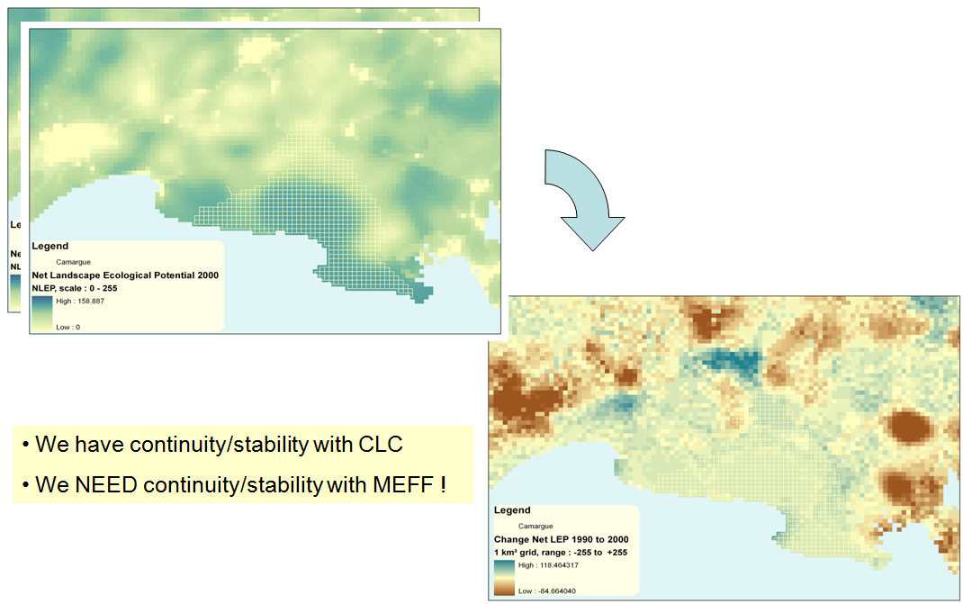
Figure 3.3
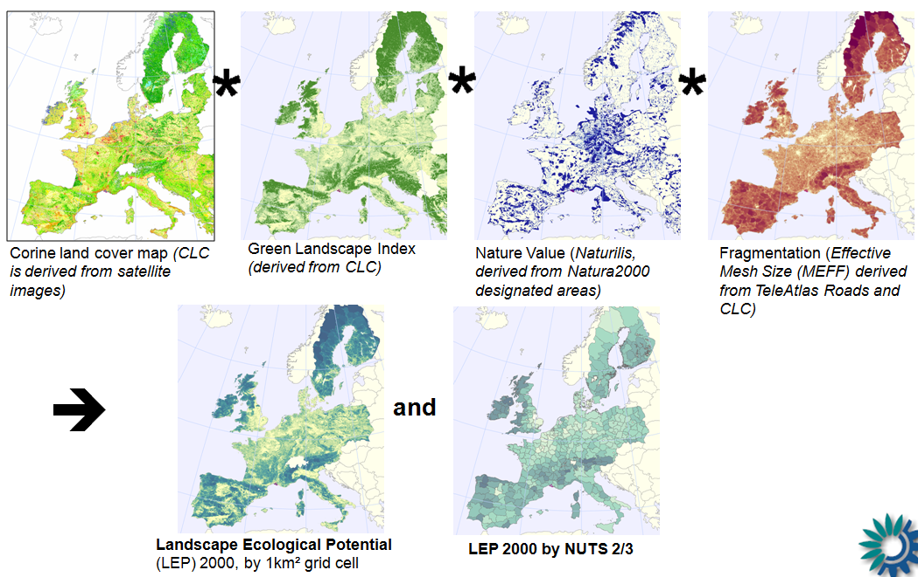

Figure 3.5
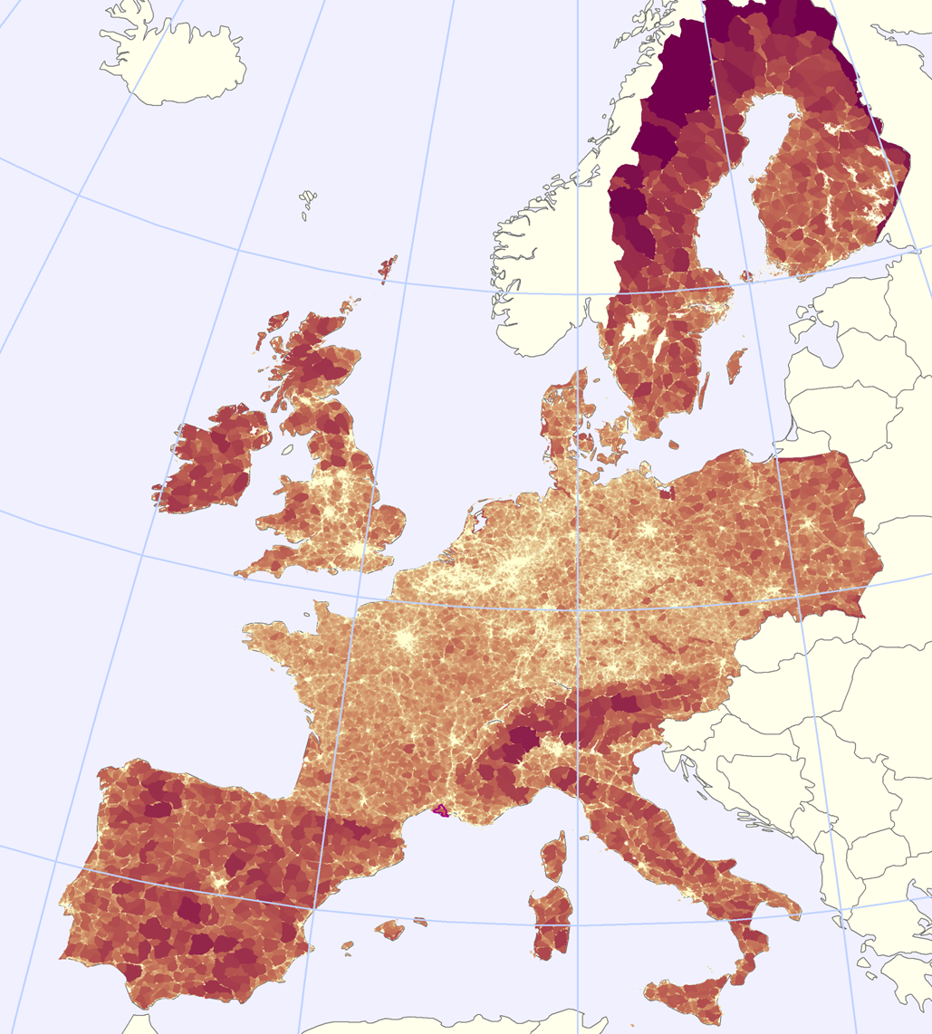
Figure 3.6 map like this for 2006
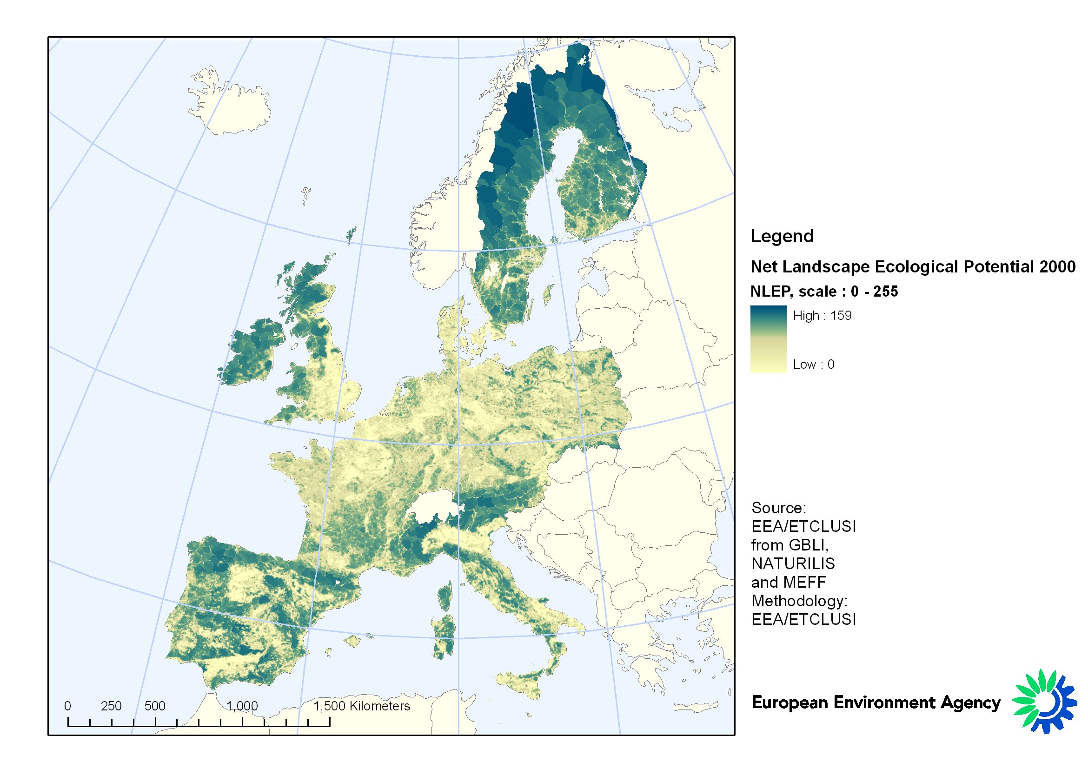

Figure 3.7 Map lke this for 2000-2006
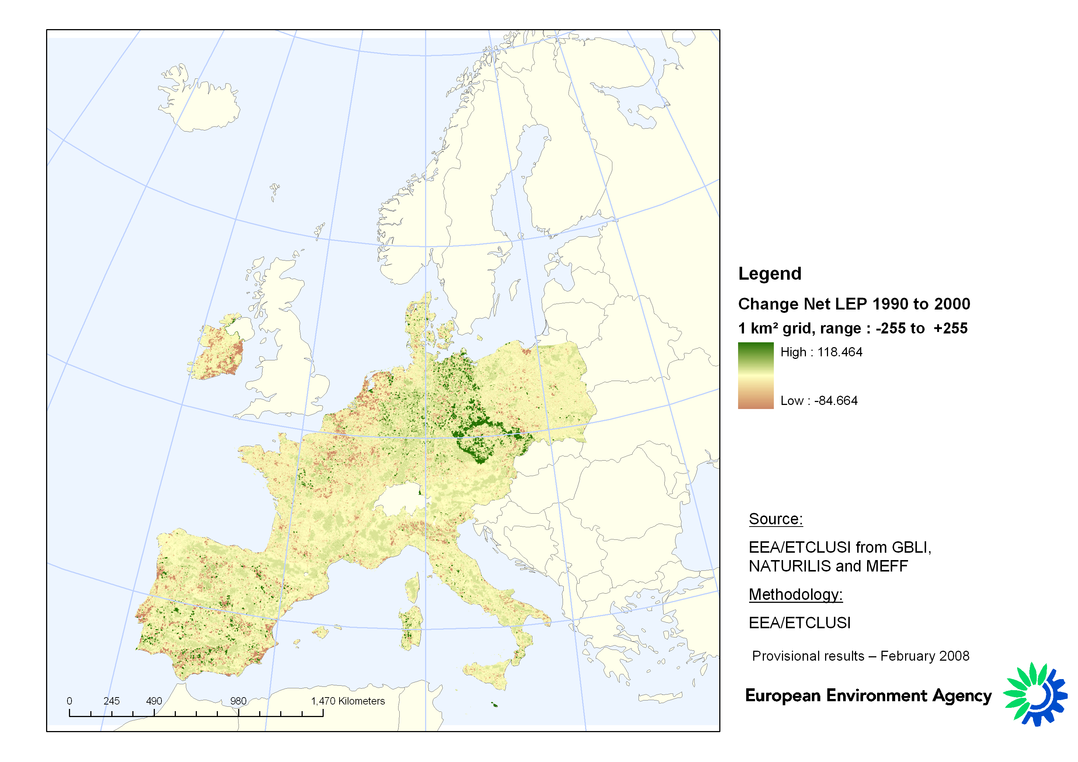

Figure 3.8 - Method of assigning DLT using Dominant land cover Needs redrawing and explaining as flow diagram?

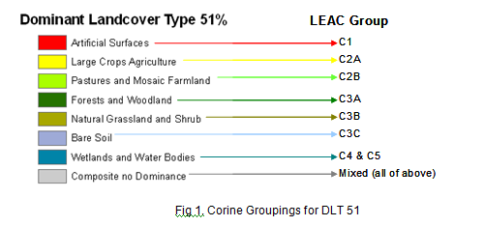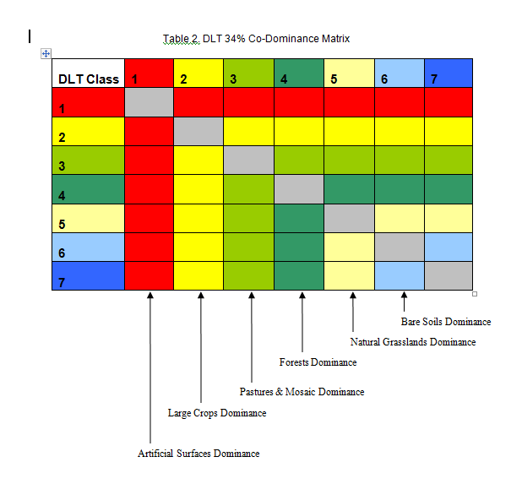

Figure 3.9 DLT – 51% rule
Figure 3.10 DLT using sub-dominant rule

Figure 3.11: Ecotones
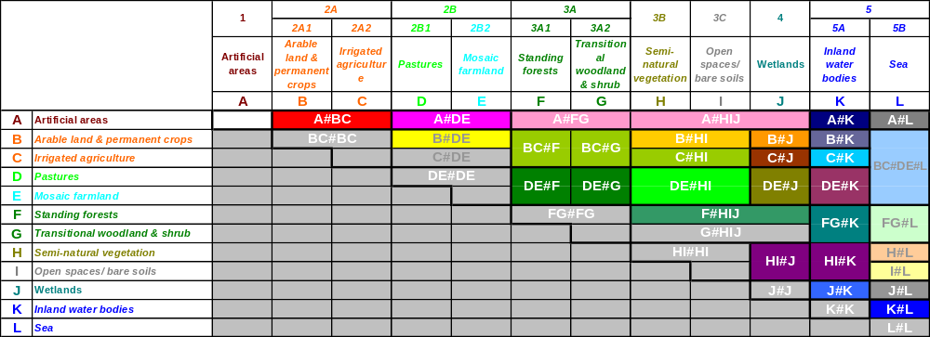
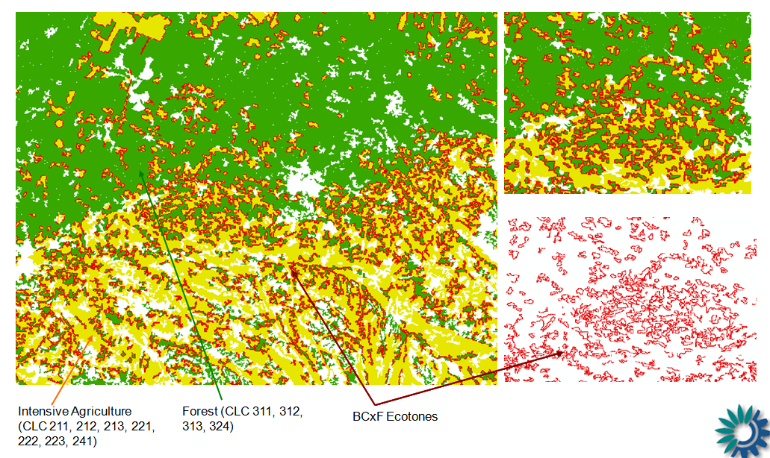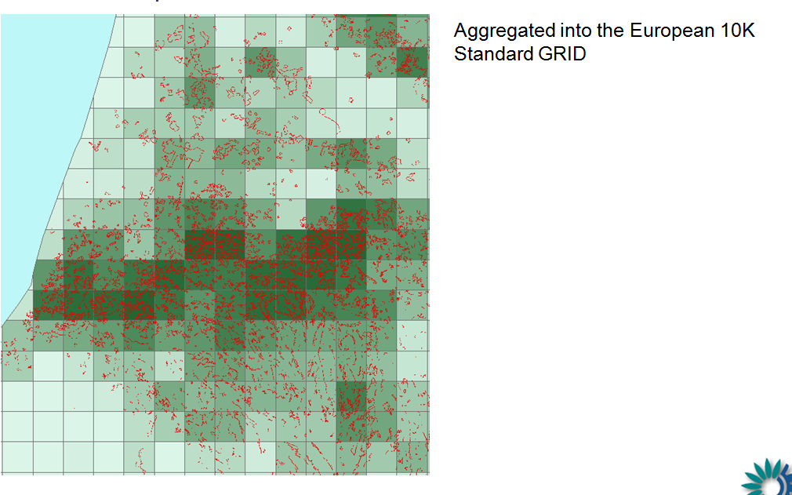
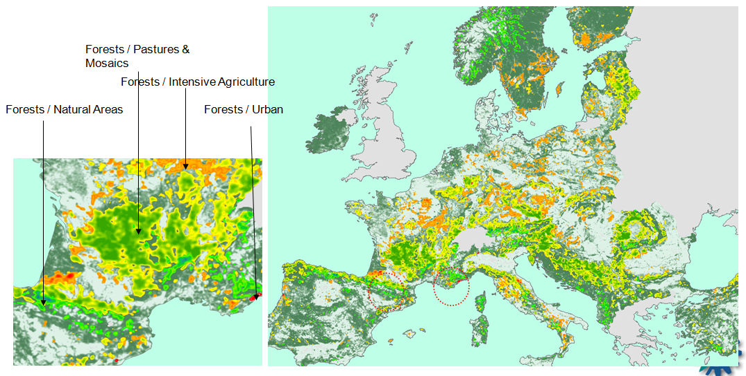

Figure 3.?
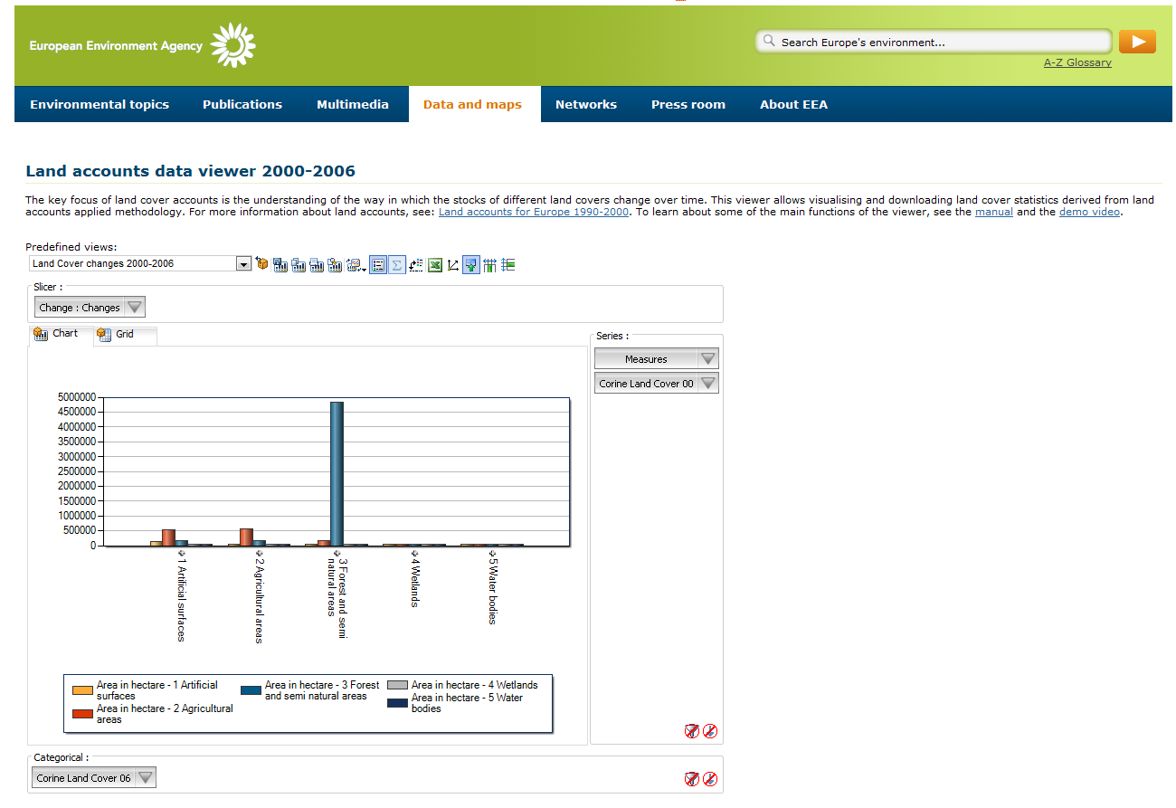

Part 4: Prospects

4.1 Introduction
Although the accounting approach described here has been developed by the EEA to address problems in the European context, an additional major impetus has also been the contribution that the work could make to the general problem of environmental accounting in the international arena. The links between LEAC and the on-going revision of the System of Integrated Economic and Environmental Accounting (SEEA) by the UN Statistical Division was discussed in Part 1. In this final Part of this Report we consider what has been achieved in Europe from this broader perspective, and explore what and ecosystem accounts would look like as part of the revised SEEA, and what prospects there are for moving towards a framework that is supported by a suite of internationally recognised standards.

4.2 LEAC and the SEEA Revision
The UN and the World Bank launched the first System of Integrated Economic and Environmental Accounting in 1993 as a response to recommendations of the 1992 Rio conference on Sustainable Development. In order to steer the process of developing this system the UN ‘London Group’ was set up in 1994, based on a joint initiative of Statistics Canada and Eurostat. Experimental work then followed in both Europe and elsewhere and as a result a first revision was published in 2003 (SEEA, 2003).
In 2006 the UN Statistical Commission took the decision to raise the status of the SEEA to the level of an international standard. It therefore created an expert committee (UNCEEA) to steer the process of making a further revision. The plan is to publish the first volume in 2012, which will focus on hte issues related to establishing the methods dealing with core environmental resource accounts (e.g. water, land and air) as a statistical standard. The second volume, which will deal with non-standard issues such as ecosystem services and their valuation, will follow in 2013. Eurostat and the European Environment Agency represent Europe on both the UNCEEA and the London Group, and so the work described here can be used to test concepts and demonstrate approaches.
The SEEA revision process has seen some substantial achievements in terms of implanting better methods of linking environment and economy. Three key areas can be identified, namely: those dealing with environmental protection and management related expenditures; material flow accounts; and, input-output analysis (NAMEA, National Accounting Matrix including Environmental Accounts). NAMEA is a statistical information system designed to combine national and environmental accounts in a single matrix which can sit alongside the more conventional national monetary accounts as a set of ‘satellite’ tables. The accounts are designed to describe selected aspects of the interrelationships between the natural environment and the economy, such as the consequences that the physical demands that the economy places on the environment. These accounts are used, for example, to examine the use of material and energy by the economy ‘decoupled’ from economic growth.
Accounts for environmental expenditure, material flows and input-output analysis based on the NAMEA have been published on a regular basis since the early 1990s in several European countries, although in none of them are implemented as part of a core, regular European accounting programme. However, these areas have now been acknowledged as priorities in the European Strategy for Environmental Accounting, and Eurostat is working to implement them.
Despite the achievements noted above, it is now clear that in terms of developing and fully integrated picture of the inter-linkages between environment and economy, more work needs to be done. Not only does the growth of GDP need to be decoupled from material and energy use, in the sense that outputs should require progressively reducing resource inputs, additionally the level of wider environmental impacts generated by economic activity also needs to be reduced. This is the concept of “double decoupling”. To track this aspect of the link between environment and economy, then additional new types of accounting system are required, and it is in this area where the current EEA effort is most relevant.
The new perspective brought about the need to ‘double decouple’ results in a shift of focus in accounting systems away from the economic viewpoint, towards one that considered ecosystems in a more general sense. The economic viewpoint is one that concentrates mainly on direct economic resources and their depletion. The ecosystems viewpoint starts from the position of needing to understand and characterise the dynamics of a coupled ‘socio-ecological system’ (ref...), in which physical environmental impacts are equivalent to the degradation of natural capital and related aspects of human well-being. From this perspective ‘degradation’ is not simply damage to ecological function but also the loss of the capacity of ecosystems to renew themselves and so sustain the output of goods and services need by people. Since such outputs are not often associated with markets, but rather public goods, these accounts have to go beyond the simple valuation of the products of nature. They have to record in some way, the over-use of ecosystem capital for final consumption in the economy, the lack of investment in nature when ecosystem functions are eroded, and the fact that such actions result in a concealed ecological debt for future generations (Figure 4.1).
>>>>>Figure 4.1 about here
The limitations of the current System of National Accounts, to deal with the impacts of economic activity on nature have been widely debated. Problems include the inability of these accounts to deal with non-market or public goods, the lack of attention to well-being; the inappropriate use of financial accounting valuation methods; and the over-dependence on macro-indicators, such as GDP which given a narrow view of national wealth. As a result of the wider recognition of these failures, policy makers, international organizations, NGOs, and the business sectors are demanding looking to develop alternative approaches. Recent attempts include the ‘Genuine Savings’ initiative of the World bank, the discussions initiated by the European Commission in relation to ‘Beyond GDP’, Stern Report on the Economics of Climate Change by Stern, in the UK; the G8+5 and Germany TEEB initiative (The Economics of Ecosystems and Biodiversity); the Stiglitz/Sen/Fitoussi Report on.... in France.
>>>>>Figure 4.2 about here
One way of characterising the relationship between the SEEA and the SNA in terms of this ecosystems perspective is shown in Figure 4.2. The SEEA are satellite accounts in the sense that they are not part of the SNA, but they are not less important. For the ambition is that they should provide aggregate indicators of the state and condition of our natural capital that can be used alongside traditional economic measures like GDP, to make a more complete assessment of our wealth.
The development suggested in Figure 4.2 is that the SEEA satellite should in the future achieve a similar level of priority to GDP in decision making. To do this, there three things are needed: first, the establishment of timely physical and monetary aggregates from satellite accounts that can then be considered alongside GDP to describe the changes in our natural capital; second, clarification and communication of methodological and conceptual contributions that the two accounting approaches provide, which might be lost in any attempt to integrate them technically; and third, recognising the distinctive but complementary contributions that each of them bring in the decision making arena. The accounting approach described here for land, and its planned development by the EEA to provide a more comprehensive set of ecosystem accounts is an attempt to put in place some of the new aggregate measures that the revised SEEA could in the future deliver.
>>>>Insert Figure 4.3 about here
As contribution to the development of the new SEEA standard, work at the EEEA has been exploring what a fully fledged ecosystem capital accounting framework would look like, and how it would be linked to environmental accounts of economic sectors (see Figure 4.3). As this figure indicates it would consist of a combination of monetary and non-monetary (physical accounts), including tables giving physical accounts or balances, ecosystem services, the measurement of ecosystem capital, and the various sector accounts..... [discuss figure a little.]
In order that this framework can be developed, however, approaches to developing accounts for the basic physical and biological [ecological?] balances are needed, along with indicators describing the changes in ecosystem capital. The aspiration to develop these components has formed the basis of the so-called Fast Track Implementation of Simplified Ecosystem Capital Accounts for Europe now being undertaken by the EEA. Its design and the role that land accounts lay in this approach is described below.

4.3 Standards for the Classification of Land Cover and Ecosystem Services
For a robust system of integrated environmental and economic accounting to be developed a number of standards are required. Recent work at the EEA has looked at standards for land cover classification and standards for the classification of ecosystem services.

4.3.1 Standards for the classification of land cover
As part of its work towards establishing the SEEA as an international accounting standard, it has worked on the problem of developing a robust system for the classification of land cover. Any candidate system must meet a number of criteria, including:
- That it must be capable of characterising land cover change in ways that clearly link to the processes driving those transformations.
- That they must be easily connected to land use statistics in order to facilitate the eventual integration of land use data with information about socio-economic activities.
- That they should support the construction of ecosystem accounts so that the close connection between land and natural capital can be described and represented effectively.
- That it should be sufficiently flexible to support a range of applications and easily implemented using a diverse range of data sources.
- That it is easily translatable into other land cover nomenclatures or legends, and in particular the LCCS-based classifications used in international programmes such as those of IGBP, DISCover, MODIS land cover products, FAO-Africover, Global Land Cover, ESA GlobCover..., IPCC and the EU CORINE Land Cover.
- That it can be easily refined using hierarchical methods so that different levels of detail can be provided in ways that are relevant to different types of application.
Using these criteria as a guide, an initial proposal has been made in terms of an exhaustive list of 14 non-overlapping categories headings for land plus one for ‘coastal water bodies’ and one for ‘sea’² (Table 4.1); a full description of the classes is given in Appendix B.
>>>>Insert Table 4.1 about here
It is not appropriate here to discuss in detail the development of this international standard. Rather the main interest is to consider how it relates to the land cover classification system used in the European work, and show that the approach has the potential to link with these wider international systems. Land cover classification is essentially a modelling exercise in which the biophysical characteristics of land and sea are used systematically to develop a useful set of classes or legend. The outcomes of such exercises should be assessed in terms of the underlying logic and the fitness of the classification for the purposes that it has been developed.
>>>>Insert Table 4.2 about here
The broad correspondence between the proposed SEEA classes and the nomenclature used to classify CLC data is shown in Table 4.2. [Discuss??]. Apart from the correspondence between the classes a key test of the effectiveness of the potential linkage between the two classifications is in terms of the extent to which they can capture the processes of land cover change and allow the accurate translation of statistics between systems. Using the basic classes of the draft SEEA classification shown in Table 4.1 is possible to define eight land cover flow classes. These are also shown in Table 4.1. Using this system a test has been carried out using the CORINE land cover database for 1990-2000, for 25 European countries, designed to compare the estimates of of change obtained using a detailed computation based on the 44 CLC classes (ie. level three in the classification system) with the direct calculation of change based on SEEA-LC 16 classes. The average loss [difference?] (i.e. difference in estimates?) observed was small, namely around 1.7%. The larges difference was 6.8% is for urban internal changes (most of them being due to the non-recording of the flow from “construction” to the various built-up classes). In addition about 5% of internal agriculture conversions were lost in the translation process. The conclusion that we draw from these work is that even though the SEEA classification is at a draft stage, it is fit for the purpose of accounting land cover change, and that the land classification system used for the European work is sufficiently flexible and robust to also integration with these emerging international standards.

4.3.2 Standards for the classification of ecosystem services
In addition to the development of standards for the classification of land cover, the revision of the SEEA would also require some agreement about the nomenclature and definition of ecosystem services. With this issue in mind the EEA has developed a proposal that has now fomally been submitted to the UN Statistical Division for a ‘Common International Classification of Ecosystem Services’ (CICES).
The aim of the CICES initiative has been to develop a flexible structure for classifying ecosystem services that links the categories that are being discussed in on-going international initiatives such as the MA follow-up, TEEB, and the functional groupings for economic sectors currently being considered in the SEEA revision. In proposing a common structure the aim has not been to put forward a new scheme that replaces existing typologies, but to provide a consistent standard that allows the translation between different systems. The context in which this work is set is illustrated in Figure 4.4. As indicated, it has close connections with the classification of land cover.
>>>>Insert Figure 4.4 about here
Given the involvement of the EEA in the SEEA revision process, the development of the CICES draft standard has taken account of the need to link service classes to the particular groupings used in the various international standard classifications for products and activities. Thus a prerequisite of the design has been that the groupings should initially be generic and amenable to further sub-categorisation to produce a nested, hierarchical structure. It attempts, where possible, to use terminology and definitions around which consensus currently exists. However, from the discussion that have emerged around the standard it is clear that while the system will benefit the SEEA revision process, the classification may be more generally useful as a way of comparing and integrating the wider body of on ecosystem services more concerned with the problem of valuation and assessing the links between services and underlying biophysical processes.
The CICES classification approach is based on the widely accepted definition of ecosystem services as the contributions that ecosystems make to human well being, and the general categories introduced in the MA. The classification also seeks to distinguish 'services' from 'benefits'. Thus a benefit is seen as a component of human well-being (e.g. health) while a service is anything that may change the level of that benefit (e.g. air quality, food supply). For the purposes of the classification the term 'ecosystem services' refers to both 'goods' and 'services', although the distinction between the provisioning theme on the one hand, and the regulating and cultural themes on the other, can be used to separate the two sets of ecosystem outputs.
>>>>Insert Tables 4.3 and Table 4.4 about there
Table 4.3 shows the suggested correspondence between the major service themes covered by CICES and the so-called ‘functions of natural capital’ described in SEEA2003. Although the terminology differs it is clear that there is a good read-across conceptually between the different groupings. It is proposed that in revising the SEEA approach these new groupings are used to reflect the more general framing of ecosystem services that is now being used in wider literature.
Table 4.4 shows the suggested structure for CICES built up around these three major thematic areas. A hierarchical structure is proposed to take account of the different levels of thematic and geographical scales used in different studies. This approach, it is suggested enables summaries of service output at different levels of generality to be constructed, a feature that is difficult to accomplish using present systems. The full CICES classification is given in Appendix C.
In order to test the robustness of the approach two areas have been considered. First the ease of integration with other international ecosystem service initiatives. Second, the ease of linkage between the ecosystem service categories in CICES and existing standard classifications of economic activities and products.
Table 4.5 shows the cross-reference between the CICES Themes and Classes and the categories of the 2003 SEEA model and the service breakdown suggested in TEEB. The relationship to the SEEA was noted above. In relation to TEEB, the work suggested that it is relatively easy to nest the TEEB categories into the nine classes proposed as the basis for CICES. The important feature to note, however, is that in naming the latter an effort has been made to use a generic terminology that can identify groupings that can progressively be refined according to the interests of the user. Thus potentially, the TEEB categories ‘raw materials’, ‘genetic’, ‘medicinal’ and ‘ornamental’ resources could be sub-classes of the CICES ‘materials group’. The main discontinuity with the suggested TEEB classification is in the treatment of so-called ‘habitat services’. The importance of ecosystems in maintaining the gene-pool and life systems is mentioned in the current SEEA, and included within the ‘Service Function’. While TEEB chooses to identify them as a distinct service grouping at the highest level, the draft classification presented here suggests they are part of the regulating and maintenance theme. It is suggested that they form a sub-class that captures aspects of natural capital that are important for the regulation of the ‘biotic’ environment (e.g. pest and disease control, pollination, gene-pool protection etc.).
The second test of the robustness of the CICES system was made by attempting to cross reference the different categories to existing standard classifications for activities and products used in the System of National Accounts, namely: the International Standard Industrial Classification of All Economic Activities (ISIC V4), the Central Products Classification (CPC V2), and the Classification of Individual Consumption by Purpose (COICOP).
The work showed that cross-tabulation for each of them are possible and that the approach potentially offered a way of identifying the ‘final outputs’ of ecosystems, and thus potentially helps overcome the problem of ‘double counting’ in valuation studies. It was also apparent that the linkages between ecosystem services and activity and product classifications helped to define the ‘concrete outcomes’ sought by the EPA in its 2009 report (EPA, 2009). However, it is also clear that further work is probably needed in terms of developing the CICES as a standard, in order to overcome some obvious complexities. These arise, for example, from the fact that some product and activity classes can potentially be linked to more than one ecosystem service group at the higher levels in the classification. This problem may be resolvable by allowing additional levels to be defined in the product, activity and service hierarchies.
An additional issue that needs to be addressed in developing the application CICES is that since products and activities depend on the combination of natural and human capitals, the ‘links’ between ecosystems and economic sectors is complex. Use of the cross-tabulation would seem to imply the need to develop some method of weighting to indicate the relative strengths of the different kinds of capital input to each product and activity. This could be achieved by constructing some kind of ‘production function’. These production functions would have to be tailored to the particular application, but would seem to be vital if the aim of better understanding the links between economy and environment is to be achieved. They may also need to take account of the scale at which a given ecosystem service operates.
Finally, the extent to which non-renewable, mineral outputs should be excluded fromt he classification needs to be considered further. If ecosystems are defined as the interaction between living organisms and their physical environment then it is generally argued that ecosystem services have to be traceable back to some living process (i.e. dependent on biodiversity) (cf. Fisher and Turner, 2008). Any set of international standards would have to be clear about how abiotic outputs from ecosystems are to be handled.

4.4 From Land Cover to Ecosystem Accounts
In the final parts of our earlier Report on the land accounts for Europe 1990-2000, we emphasised the need to develop the linkages between land and ecosystem accounts further. The developments in the land account area that are described here now show that the concepts have moved from the theoretical stage through to application. The regular updating of land accounts for Europe is now possible operationally. The current focus is now to develop this work further in the context of a more comprehensive ecosystems framework. As has been argued above this will involve the development of methods for ‘ecosystem capital accounting’. This approach is based initially on the construction of physical accounts targeted primarily at specific outcomes, such as the measurement of ecosystem degradation, and then the better understanding of how this relates to their capacity to continue delivering services in a sustainable way. As part of the EEA’s contribution to developing this capital accounting approach, it has developed a ‘fast track implementation’ initiative, designed to provide a critical test of the concept.

4.2.1 The Fast Track Accounting Framework
The fast track initiative of the EEA is based on a number of requirements, including: that the work should be outcomes oriented, so that the relevance of the approach to solving current problems can be established quickly; and that it should be based on existing data, so that results can be provided in a timely fashion in order that strategic decisions about the future can be made quickly. The overall aim is to develop a measure of net ecosystem potential that can be used to make an overall diagnosis of the state of heal of our natural capital base. The conceptual framework for the Fast Track Initiative is shown Figure 4.5.
>>>>Insert Figure 4.5 about here
>>>>Insert Figure 4.6 about here
The principle is that if the overall extent of the degradation of natural capital can be measured, then the costs of that consumption can be calculated in terms of what it would take to restore or maintain the either the original level of ecosystem functioning or its restoration to some more enhanced state as defined by societies various management or policy targets. The fast track approach starts from the proposition that this overall measure of the potential (status) of natural capital can be based on an aggregation of a number of measures. Six basic indicators supported by accounts have been suggested (Figure 4.6). From bottom of the figure (the outcome) to the top they are: accounts of ecosystem health, for establishing the diagnosis; basic physical accounts of stocks and flows by ecosystem type; basic physical accounts of ecosystem services; basic physical flow accounts of sectors (MFA, NAMEA); measures of environmental protection and resource management expenditure accounts. The six indicators proposed are:
- Landscape index, based on measures derived from land cover, the richness of semi-natural habitats and their fragmentation in the landscape.
- Carbon/Biomass index: describing ecosystem productivity and net source/storage of carbon
- Water index: documenting the available [ecological?] water resources in terms of quantity & quality, across river basins.
- Biodiversity index: describing long term species trends.
- Dependency index: describing the artificial inputs into different economic sectors, in terms of say fertilisers and other chemicals, irrigation, energy, work, and other subsidies.
- Health index: describing the health of human populations as well as wildlife and plant populations.
>>>>>Insert Figure 4.6 about here
For the fast track implementation, land, water and carbon/biomass and biodiversity indices will be computed as a priority (Figure 4.6) because it is felt that they can be implement most rapidly using existing data resources, and they can also provide an early diagnosis in a number of different situations. The accounting approaches being currently explored in each of the priority fast track areas is described below.

4.4.2 Carbon
The aim of the ecosystem carbon accounts is to calculate the Net Ecosystem Carbon Balance (also called Net Biome Production, or Net Biomass Production). This is an index discussed widely in the literature, and several procedures have been put forward for its calculation. The approach being adopted by the EEA reflects this work, but also takes account of the information available at pan-European scales. Thus we use data for earth observation satellites for the calculation of NDVI and NPP, as well as official harvesting statistics, and coefficients from global balances or derived from in situ monitoring. The goal is to construct accounts for the period 1999 through to 2009.
>>>>insert Table 4.5 about here
The algorithm used to make the calculation of the net Ecosystem Carmon balance is summarised in Table 4.5. An estimate of the supply of biological carbon (Ecosystem Primary productivity, EPP) is made by subtracting the level of soil respiration from an initial estimate of NPP derived from remotely sensed data, and then adding in to the balance the left-over’s from forestry and agriculture, as well as manures and organic fertiliser inputs and the effects of any change in land cover. On the consumption side the total removals are found by aggregating removals due to harvest, grazing and felling with losses due to leakage, erosion emissions and fires. Once again the removals will be estimated using remotely sensed data, but the losses will be approximated using coefficients derived from the literature and other sources.
>>>do we have any mapped products to go in figures??
The balance will be provided for countries, regions and different land cover types, as well as the standard accounting grid. The data will be made available through an OLAP cube to report results by geographical breakdowns and to prepare datasets for input into HyperAtlas.
A novel aspect of this work will be the use of Harmonic ANalysis of Time Series (HANTS) to look at phonological change in the vegetation cover and detect departures from standard trajectories resulting form events such as felling, harvest or fires.
>>>do we have any mapped products to go in a figures??

4.4.3 Water
No information

4.4.4 Biodiversity
It is proposed that a biodiversity index can be calculated using the Article 17 reporting data for Europe. The European Directives for Habitats (92/43/EEC) and Birds (79/409/EEC) requires its signatories to undertake a number of commitments in relation to biodiversity. Article 11, for example, requires Member States to monitor the habitats and species listed in the annexes, and Article 17 requires a report to be sent to the European Commission every 6 years in a standardised format (Figure 4.7).
>>>>Insert Figure 4.7 about here
A major part of the Article 17 Report is an assessment of the conservation status of all the habitats and species that occur within their territory, both within and outside of the Natura 2000 network. The aim of the Article 17 reporting process is to assess the conservation status of species and habitats using a standard methodology that will allow aggregation and comparisons between Member States and biogeographical regions. The assessment of conservation status assigns species or habitats to the categories: ‘favourable’, ‘unfavourable-inadequate’ and ‘unfavourable-bad’ according to a defined set of criteria. The report also asks the member states to make an assessment of future prospects. These data may be used as the basis for the construction of a biodiversity index.
>>>>Insert Figure 4.8 about here
An overview of the methodology being developed to calculate the biodiversity index is shown in Figure 4.8. It is based on the construction of a Bayesian Belief Network (BBN) that allows different components of the Article 17 data to be combined with other data sources to calculate the final biodiversity index on a probabilistic basis. This technique allows the assumptions behind the index to be fully transparent. Thus the species data on present status, relating to range, population and habitat is equally weighted and combined into an index of ‘present status’. This is then combined with the assessment of future prospects to form the finalised Article 17 index; present and future prospects are again equally weighted in the calculation. Since the Article 17 data is available on a 10km x 10km grid basis for the whole of Europe, this defines the spatial resolution of the underlying biodiversity data.
For the final calculation the Article 17 index is linked with an assessment of the landscape structure in each 10km grid cell, based on the data for ecotones derived from the analysis of the boundaries between land cover types defined in the CLC 2006 dataset (see section 3.3.2). The final index also includes a measure of the way the ecotones are changing over time, and takes account of the proportion of specialist and generalist species in each 10km cell.

4.4.5 Assessing Ecosystem Potential
Do we have any notes on this?

4.5 Maintaining Land and Ecosystem Accounts
The CORINE Land Cover project currently covers XXX European countries, and will be udated on a 5-year basis, with a gap of around 2 years between the image acquisition and the publication of the results. The availability of new sources of earth observation data, such as GlobCover based on MERIS data, now makes it possible for additional strategic monitoring to be undertaken, and a more ‘real-time’ picture established.
The GlobCover initiative (Arino, 2007), has resulted in the production of a global land cover map at 300m resolution using MERIS data acquired between mid 2005 and mid 2006. At the international scale these data have updated other comparable global products, such as GLC2000 which has a much coarser spatial resolution of 1 km. The GlobCorine project has built on this success and is now delivering a customised product for Europe that is consistent with the CORINE Land Cover data used in the previous accounting work (see Bontemps et al. ???).
The GlobCorine project aims to make the use of the MERIS time series for frequent land cover monitoring at the pan-European scale using automated classification procedures. The 300m resolution of GlobCorine will not identify landscape patterns as precisely as the CORINE, but it will shorten the time between data acquisition and publication, and it will expand the geographical coverage. The result is that a more frequent monitoring of some of the more important land cover change processes will be possible, that can then be confirmed by the more periodic and more detailed mapping of CORINE. As a result the land and ecosystem accounting approach developed by the EEA is moving towards a fully operational system.
The potential use of GlobCorine data for maintaining the land accounts has emphasised the importance for achieving consistency between the major international systems for land cover mapping. Work in this important area has also progressed since the publication of the 2006 Report, and in the final part of this document we consider the general issue of consistency of approaches with international initiatives in more detail.
Other datasets?

4.5 Conclusion

Table 4.1
LC01 Built up and associated areas
LC02 Rainfed annual crops
LC03 Irrigated agriculture, rice fields
LC04 Permanent crops, agriculture plantations
LC05 Mosaic agriculture
LC06 Grassland and herbaceous vegetation
LC07 Forests
LC08 Transitional woodland
LC09 Shrubland, bushland, heathland
LC10 Sparsely vegetated areas
LC11 Bare land
LC12 Permanent snow and glaciers
LC13 Open wetlands
LC14 Inland water bodies
LC15 Coastal water bodies
LC16 Sea
Potential classification of land cover change processes:
LF01 | Urban sprawl
LF02 | Land cover rotation within urban areas
LF03 | Conversion of land to agriculture
LF04 | Land cover rotation within agriculture
LF05 | Conversion of land to forest
LF06 | Land cover rotation within forested land
LF07 | Water bodies management
LF08 | Change due to natural and multiple causes

Table 4.2: Correspondence between SEEA-Land Cover and the CORINE Land Cover Nomenclature
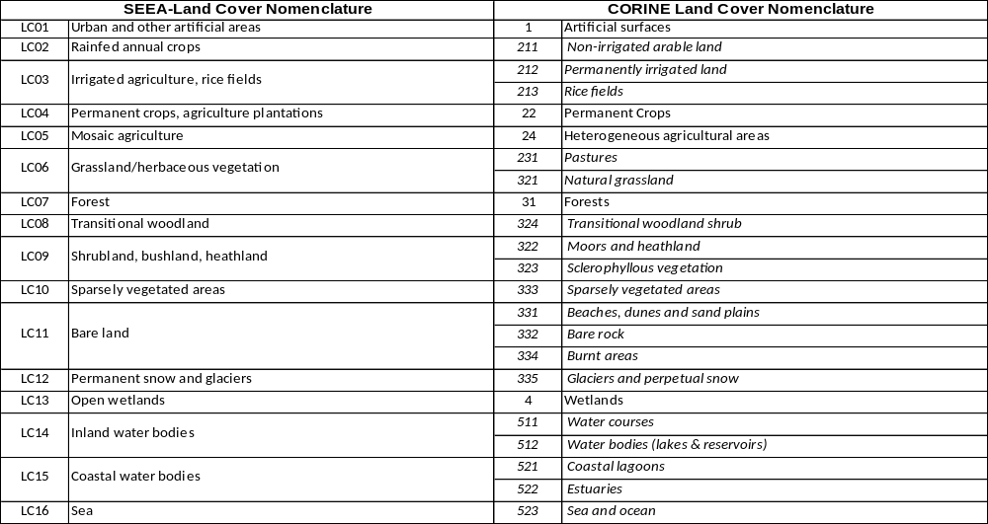

Table 4.3:
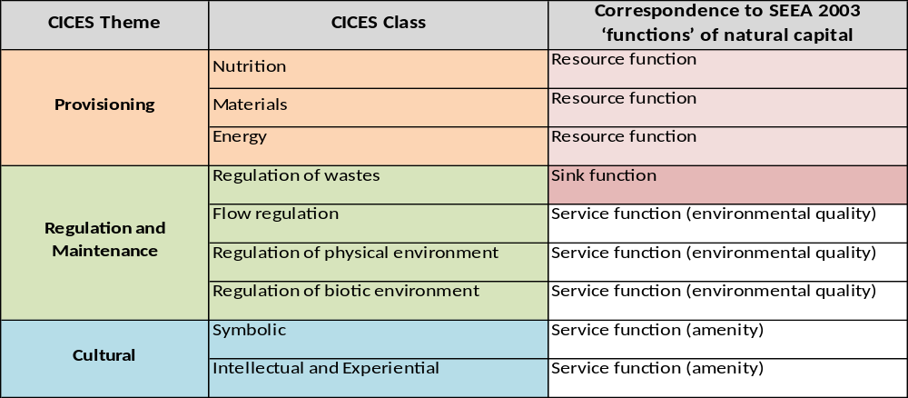
Table 4.4
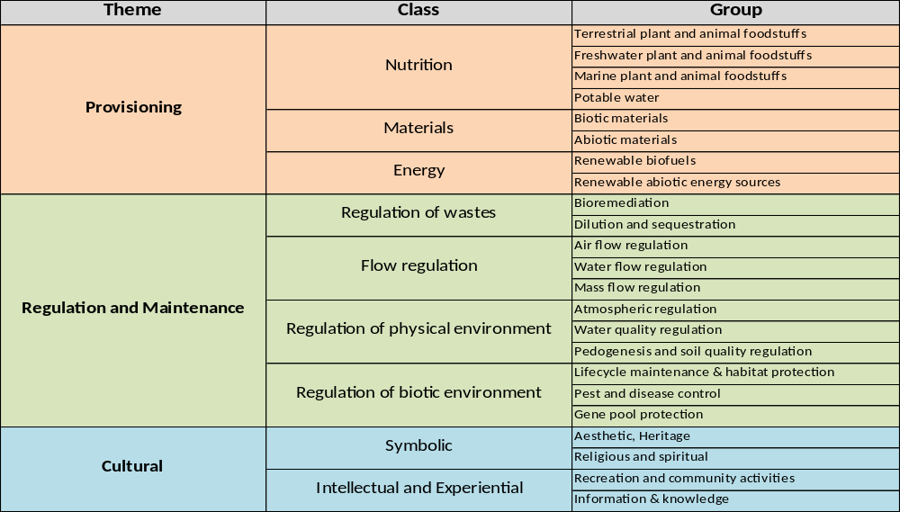

Table 4.5: Draft classification of ecosystem goods and services for CICES and its relationship to other classification systems
SEEA 2003function | CICES Theme | CICES Class | TEEB Categories
resource | Provisioning | Food & Beverages | Food | Water
resource | Provisioning | Materials | Raw Materials | Genetic resources | Medicinal resources | Ornamental resources
resource | Provisioning | Energy
sink | Regulating and Maintenance | Regulation of waste assimilation processes | Air purification | Waste treatment (esp. water purification)
service | Regulating and Maintenance | Regulation against hazards | Disturbance prevention or moderation | Regulation of water flows | Erosion prevention
service | Regulating and Maintenance | Regulation of biophysical conditions | Climate regulation (incl. C-sequestration) | Maintaining soil fertility
service | Regulating and Maintenance | Regulation of biotic environment | Gene pool protection | Lifecycle maintenance | Pollination | Biological control
service | Cultural | Symbolic | Information for cognitive development
service | Cultural | Intellectual and Experiential | Aesthetic information | Inspiration for culture, art and design | Spiritual experience | Recreation & tourism

Figure 4.1
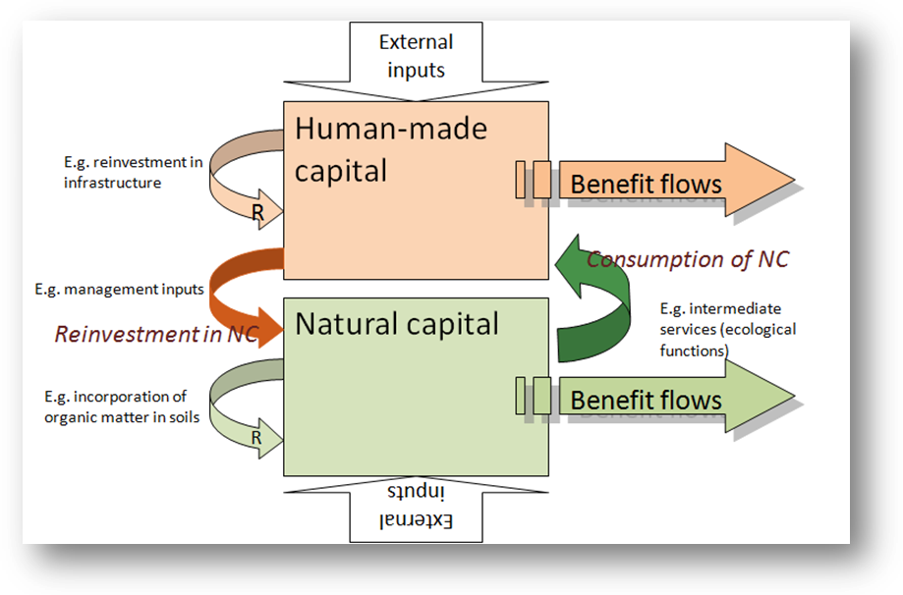

Figure 4.2 Redraw this to include land cover?

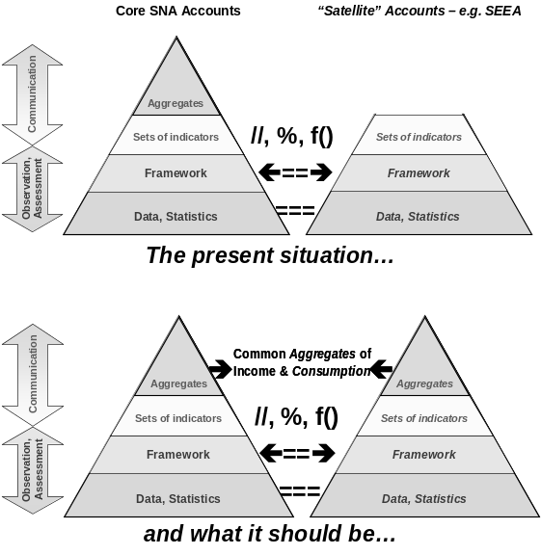

Figure 4.3 Proposed structure and design of national, satellite and ecosystem accounts

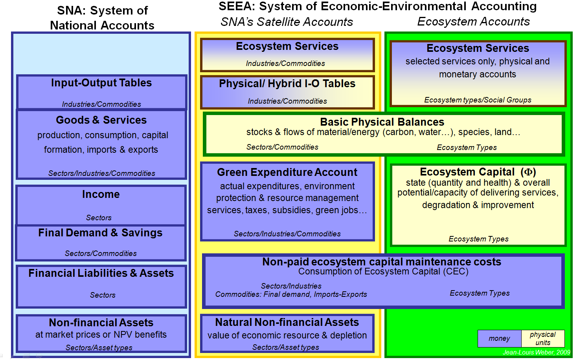
Figure 4.4: Conceptual framework for development of a common classification of ecosystem services
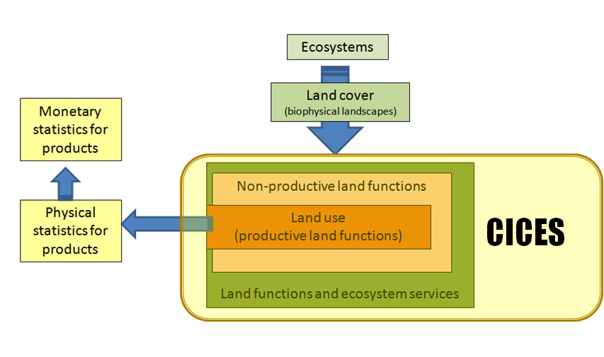

Figure 4.5: Conceptual Framework for the Fast Track Ecosystem Capital Iniative.
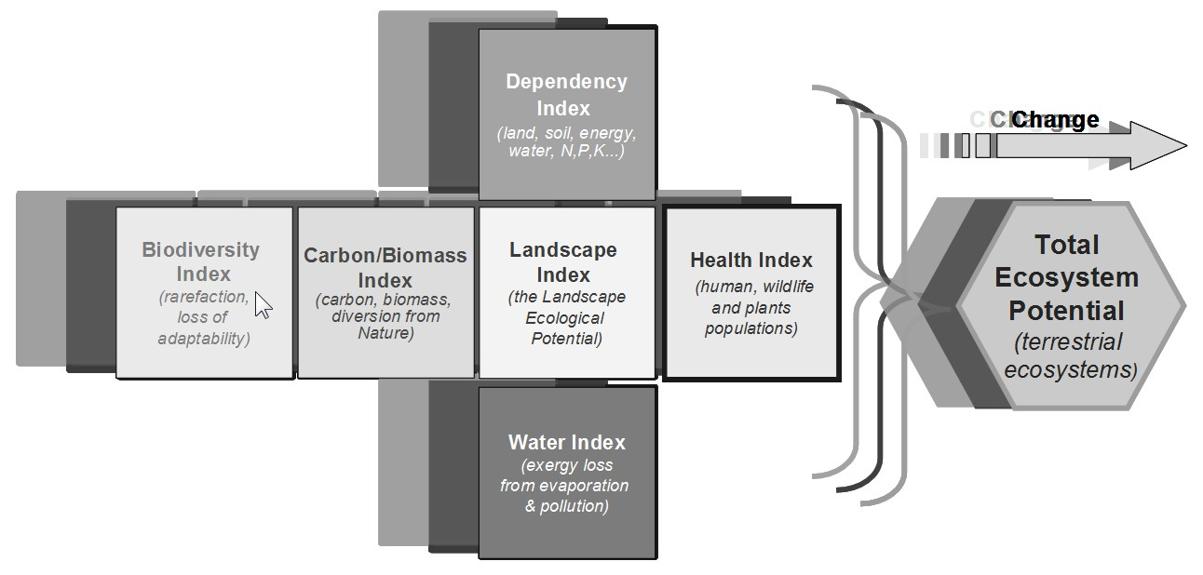
Figure 4.6
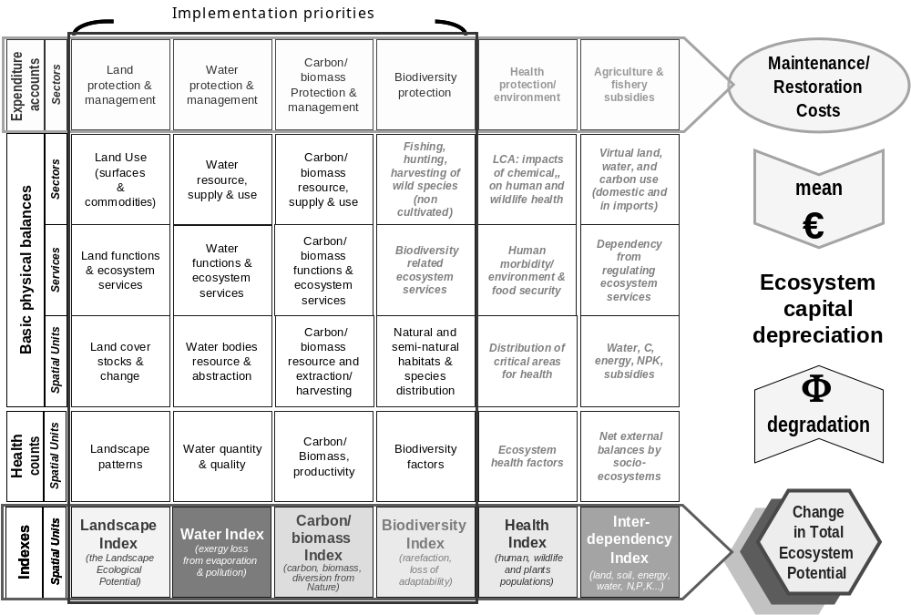

Figure 4.8: Proposed methodology for calculation of biodiversity index.
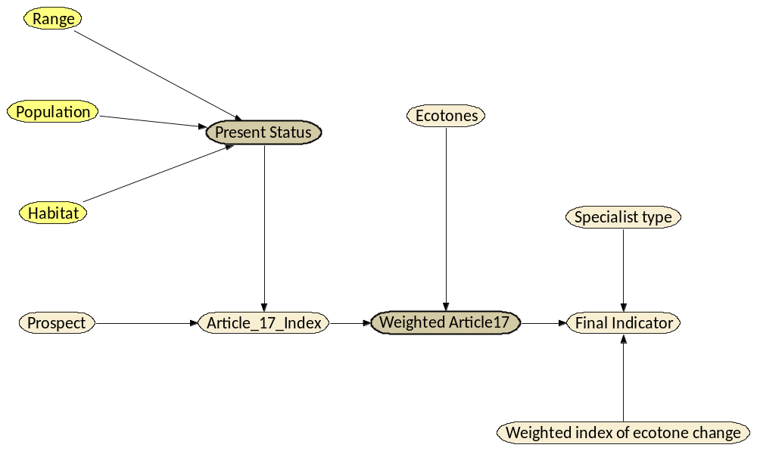
Figure 4.7 Article 17 biodiversity data
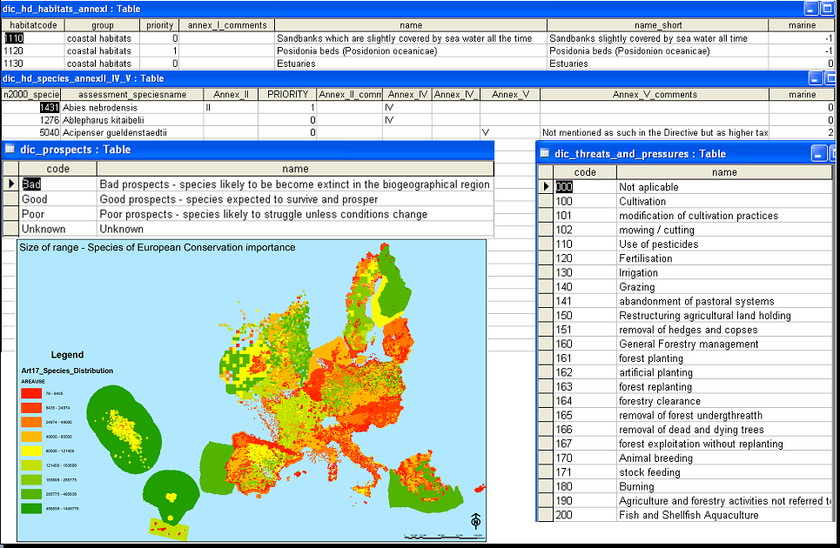

Reference to INSPIRE standard grid?
CORINE methodology
http://www.eea.europa.eu/themes/landuse/interactive# and http://dataservice.eea.europa.eu/PivotApp/pivot.aspx?pivotid=501
http://www.eea.europa.eu/data-and-maps/data/land-cover-accounts-leac-based-on-corine-land-cover-changes-database-1990-2000/leac-methodological-guidebook/leac-methodological-guidebook/
All need references!
Based on: Weber, JL (2010) Land cover classification in the revised SEEA.
Ref to UN docs and updated cices site?
They could, for example, be included as a sub-class of the CICES ‘materials’ category, which at its highest level could split biotic and abiotic materials.

