5.1 Doñana case study

5.1.1 Description and history of the area
The Doñana coupled social-ecological system (SES) (South-West Spain) covers an area of 3.120 km², more than one third of which is protected. Doñana encompass two important protected, the Doñana National Park and the Doñana Natural Park, unified in 2005 in the Doñana Natural Area. It embeds other smaller protected sites and is also protected through international agreements (Ramsar Site, Reserve of the Biosphere).

Doñana consists of a wide system of marshes, dunes and beaches, associated with the coastal dynamic of the Guadalquivir River’s mouth, sometimes referred to as the Doñana fluviolittoral system (Fig…) (Montes et al., 1998). It embeds four main types of ecosystems at the ecodistrict scale: the coastal system, the aeolian sheets of sand dunes and two wetland ecosystems: the Guadalquivir River Estuary (36 km²; 77 km long; tidal influence: 110 km from the river mouth) and the Doñana marsh (original surface: 1.663 km²), which is the flood plain of the Guadalquivir river.

Fig… The Doñana fluviolittoral Ecosystem of Doñana: ecodustrict and main protected areas.
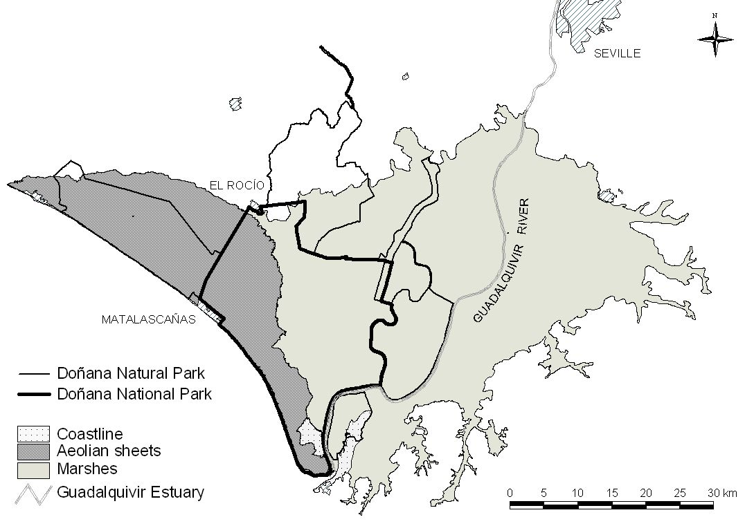

Because of its historical context of isolation and its privileged location (interface between the Atlantic and the Mediterranean, between Europe and Africa), Doñana constitutes a unique wetland ecosystem performing diverse ecological functions: major stopover point in the migration route of birds moving between Europe and Africa, habitat provision for emblematic, endemic, threatened and flag species, such as the Iberian lynx and the imperial eagle, etc. Doñana is currently considered to be one the most significant wetlands in Western Europe (Fernández Delgado, 2005).

The Doñana SES embeds 12 municipalities of three different provinces of the Andalusia region, summing 174.000 inhabitants (Lomas et al., 2007). Well-being and local economy in all these municipalities largely depend on the ecosystem services provided by the Doñana fluviolitoral ecosystem. Main traditional economic activities in this region have been extensive cattle farming, forestry and agriculture (grapevine, orchards and cereal), together with diverse subsistence uses such as hunting, fishing and picking up goods. Currently, agriculture and tourism are the main sources of income related to Doñana’s ecosystem services.

Table… General view of the Doñana SES
Characteristics | Description
Location | Andalucía Region, South-West Spain
Spatial extent | 3.120 km²
Biophysical system of reference | Doñana fluvio-littoral ecosystem (212.000 ha)
Municipalities | 12 mun.: Lucena, Moguer, Almonte, Hinojos, Pilas, Villamanrique, Azanalcázar, Puebla del Río, Isla mayor, Lebrija, Trebujena
Human population | 174.172 inhabitants; Density: 56 inhabitants / km²
Natural protected areas | Doñana Natural Area (National Parc + Natural Parc), Ramsar Site, Biosphere Reserve
Wetland ecosystems | Guadalquivir River estuary (3.600 ha, 77 km long, tidal influence of 110 m from the river mouth) and marsh (166.300 ha)
Main ecosystem services | Agriculture, cattle farming, tourism, research, clean water, flood prevention, sedimentary balance, refugee for biodiversity
Other ecosystem services | Fishing, seafood, environmental education, nutrient cycling
Characterization of economic system | Disaggregated by municipalities (to be added up)
Characterization of political and administrative institutions | Local: Doñana protected area, Patronato, municipalities.  Reg./Nat.: Andalucía Government; Ministry of the Environment  International: European Union, United nations
Characterization of culture | Religion: Christian Catholics; main cultural events: El Rocío pilgrimage, Saca de yeguas
Environmental problems and disturbances | Floods, diseases outbreaks, droughts, oscillations of agricultural subsidies and market prices
Methodology used in this work | Maps, bibliography revision, statistical data, interviews

Doñana has historically been subject to a wide range of traditional economic uses coupled to local ecosystem’s dynamics (Rodríguez Merino & Cobo García, 2002). This allowed its inhabitants to obtain diversified flows of ecosystem services at the same time ecological functions were preserved. Multiple land uses in adaptive mosaics has been the dominant landscape management model in Doñana until a few decades ago. While many wetlands were largely desiccated in western European countries during the 18th and 19th centuries in order to control malaria and increase land productivity, large-scale territorial transformation arrived late to Doñana. Although decision makers conceived Doñana to be a marginal land that had to be drained and converted into a more economically productive area, all trials of reclamation in the 19th century failed due to lack of technology, access roads and investments (González Arteaga, 1993).

Transformations and drivers of change in Doñana in the 20th century
At the first decades of the 20th century, Doñana was an almost unique case of wetland conservation in the European context. It remained as a feeble populated and almost isolated area, without any important access road. Ecosystem services were obtained through a small scale subsistence economy based on multiple land uses. This situation started to change by 1929, with different management policies that aimed to increase the added value (in market terms) of ecosystem services. This aim was accomplished through land reclamation and the development of intensive agriculture, the settlement of forest plantations (eucalyptus and pine-trees) for wood and pulp production, and beach tourism. These policies resulted in both economic development and ecological degradation, affecting ecosystem functioning all four main ecosystems of Doñana. (Montes, 2000). Market integration and the intervention of the State are among the most powerful drivers o change in Doñana during the 20th century (Ojeda Rivera and Moral Ituarte, 2004; Gómez Baggethun and Kelemens, In press).

Development and growth
Until 1927, the Doñana marsh fully maintained ecological health and integrity, remaining as a non converted ecosystem. The marshes were resilient to secular human interventions and small scale disturbance (cattle farming and slash and burn), and ecological functions were preserved. Between 1929 and 1956, private companies drained large areas of the marshes in order to cultivate rice. The transformation process continued through reclamation performed by the State during the 1956-1978 period, when the upper and part of the lower marsh was drained for further agricultural purposes. In the same period, the State implemented an extensive forest plan to replant the aeolian mantles with eucalyptus, destroying more than half of the cork tree forest (Montes, 2000). The Plan Almone-Marismas, a major project to irrigate crop with groundwater was planned in the 60’s and implemented in the 70’s leading to the settlement of 8.000 ha of permanently irrigated lands. Hydrological regulation functions such as aquifer recharge were affected due to both high evapotranspiration rates of eucalyptus plantations and over-extraction from the aquifer for irrigation purposes (Custodio, 1995).

In the coastal system, urban development projects in the coast were deployed since 1969 in the context of a national strategy to increase revenues from beach tourism. The beaches of the area were declared of national interest for tourism, resulting in the major urbanization of Matalascañas. Further urbanisation plans of the beach during the 90’s finally failed after the 1st Sust. Dev. Plan of Doñana was approved in 1993.

Although the transformation of the estuary of Doñana started in the 19th century, this process was accelerated in the 20th century as the Guadalquivir River branches were progressively channelled in order to shorten the navigation distance to Sevilla (Menanteau, 1984). The second half of the 20th century thus coincides with a deep transformation process involving the simplification of ecosystems by management strategies that aimed to increase productivity by the enhancement of intensive mono-functional land uses (rice, eucalyptus plantations, urbanisation for tourism, etc).

Conservationist policies
In the 1960’s, as a response to this fast transformation process, European institutions and conservationist organizations promoted policies to preserve remaining sites with high value for biodiversity conservation. Since the declaration of the National Park in 1969, protected areas in Doñana have been extended up to now through the declaration of new protection categories and through the enlargement of the existing protected areas (table….) As natural capital and non converted areas have become scarcer in European countries, the social perception of Doñana has dramatically changed during the last few decades.

Table… Declaration of protected areas in Doñana since 1964
Year | Event / Conservation figure | Protected area (ha) | Increase in total prot. area (ha) | Total protected area (ha)
1964 | Doñana Biological Reserve | 6.784 | 6.784 | 6.784
1969 | Doñana National Park (DNP) | 34.625 | 27.841 | 34.625
1779 | Enlargement of DNP | 50.720 | 16.095 | 50.720
1980 | Doñana Reserve of Biosphere | 77.260 | 26.540 | 77.260
1982 | Ramsar Site | 50.720 | 0 | 77.260
1988 | ZEPA | 50.720 | 0 | 77.260
1989 | Buffer zone for DNP (Doñana Natural Park) | 53.709 | 27.169 | 105.765
1989 | Brazo del este river branche (Paraje Natural) | 1.336 | 1336 | 105.765
1991 | Reserva Natural Concertada de la Cañada de los Pájaros | 5 | 5 | 105.770
1997 | Doñana Natural Parc | 53.835 | 126 | 105.896
2000 | Reserva Natural Concertada de La Dehesa de Abajo | 617 | 617 | 106.513
2001 | Monumento Natural Acantilado del Asperillo | 11,85 | 0 | 106.513
2001 | Declaración del Monumento Natural Acebuches del Rocío | 0,64 | 0 | 106.513
2002 | ZEPA enlargement | 104.555 | 0 | 106.513
2004 | Enlagement of DNP (also adjustments in the Doñana natural park | 54.250 | 3.858 | 110.043

Conservationist policies entailed the prohibition of most socio-economic activities within the protected areas except those related to ecotourism and a few traditional uses, affecting provisioning services and the stakeholders whose livelihoods depended on them. As a consequence, during the last few decades Doñana has been subject to increasing subsidies in order to attenuate social conflicts emerging in relation to conservationist restrictions. Following Ojeda Rivera (1993), the permanent flow of subsidies, often unrelated to the existing local socio-economic tissue, has derived in the establishment of a subsidized culture in Doñana that discourages initiatives for endogenous development.

The implementation of strict conservation strategies in Doñana had thus different effects. On one hand, they have managed to slow down the ecological degradation process, for instance achieving to stop the urbanization of the coast, the further reclamation of remaining natural marshes, and the development of linear infrastructures with high impact on habitat fragmentation. On the other hand, it has affected some traditional uses as well and thus the local ecological knowledge related to them.

5.1.2 Basic accounts

Land-use cover change accounts

Table… Changes in land-cover in the 1956-2006 period
Land cover (has) | 1956 | 1977 | 1988 | 2006
Artificial | 138 | 501 | 1092 | 1219
Water infrastructure | 0 | 0 | 164 | 291
Urban | 138 | 501 | 928 | 928
Agricultural areas
Aquiculture | 0 | 0 | 3608 | 3482
Rice fields | 5040 | 27740 | 40751 | 40751
Irrigation lands |  | 23407 | 45193 | 45182
Non-irrigated land | 6922 | 14770 | 18581 | 14913
Greenhouse agriculture | 0 | 0 | 162 | 154
Drained marsh | 54743 | 41894 | 15033 | 10189
Salines | 156 | 930 | 1304 | 1304
Natural areas
Marsh water flows | 5734
"Lucios" (shallow, seasonal lakes) | 6417 | 546 | 565 | 565
Restored marshes | 0 | 0 |  | 7952
Non-transformed marshes | 77508 | 46300 | 30205 | 30783
Fluvial beaches | 1371 | 4711 | 3288 | 2885
Water courses and estuarine | 5740 | 4315 | 4303 | 4706
Other | 1810 | 431 | 1494 | 1494
TOTAL | 165579 | 165579 | 165579 | 165579
Source: Modified from Zorrilla, 2006.
Water accounts
Overall, changes in the original marsh (estimated around 1500 km2, see Fig.) at the beginning of 20th century have led to the current 270 km2 of shallow water (lost of 82%). In addition to wetland area reduction, tidal influence, one of the main inundation drivers, was also limited by the construction of a wall along the Guadalquivir River (Fig.). As a consequence, the marsh became isolated from the estuary, loosing both the influence of tidal flow and of river discharges (García Novo, 1997).

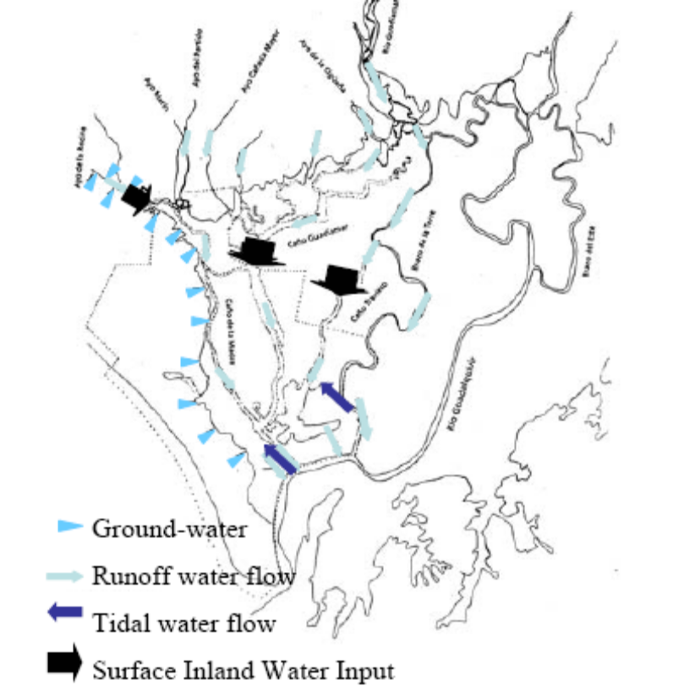
Figure_. Water inflows at the early XX century in Doñana (Díaz-Delgado et al., 2006)

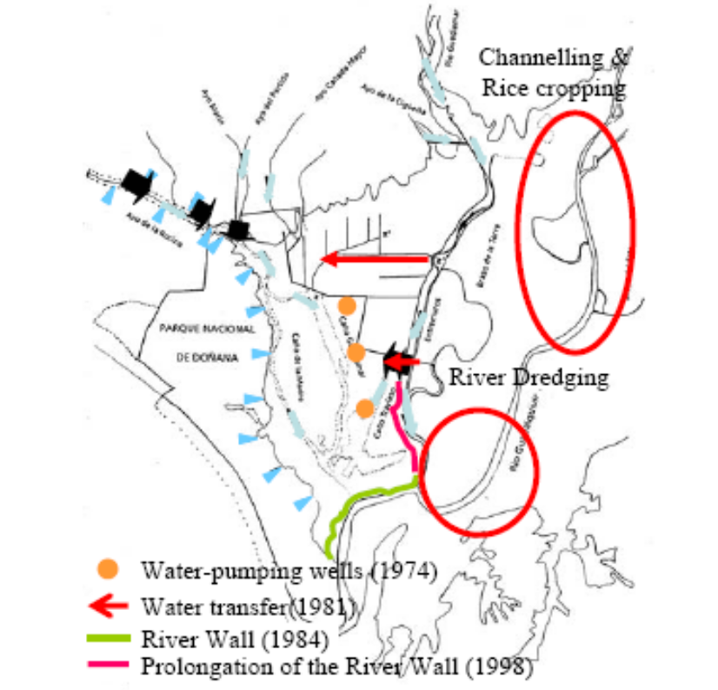
Figure_. Doñana marshes after 1998 (Díaz-Delgado et al., 2006)

SEE DÍAZ ET AL 2006

Species accounts
Important species of waterfowl to be found in the marshes and ponds include the marbled teal (Marmaronetta angustirostris), seen occasionally, the red crested pochard (Netta rufina) and the coot (Fulica atra). The crested coot (F. cristata) has become scarcer, while the gallinule (Porphyrio porphyrio), which takes refuge in the dense fringe of water plants, has become a very frequent sight in recent years. Some wandering specimens of the glossy ibis (Plegadis falcinellus), unseen since the 1960s, started to reappear in the 1990s and soon began to nest, beating the record in 2004 with a breeding population estimated to be at least 1,100 pairs over six colonies (one in the managed site of Cerrado Garrido and the rest in the Doñana Marshes) (García-Novo and Marín Cabrera, 2006).

5.1.3 Ecosystem Distress Syndrome Diagnostic

Loss of wetland ecosystems

The polderisation of the marsh started in 1928, and in 1998, 70% of it had been converted to monofuntional land uses for agriculture. During the period 1928-1934, the marsh of the left side down the river was drained and turned into crops. In 1958, the construction of a barrier isolated the marsh from several smaller water courses (Valverde, 2004). In 1966, the construction of another barrier almost isolated the marsh from the estuary’s most important river branch (Brazo del Este), leading practically to the loss of its functioning (Barrera et al., 1984).

Other disruptions of the hydrological dynamics include the channelling of the Guadiamar River and the Cigüeña water course which eventually lead to the isolation of 25.000 ha of the marsh between 1947 and 1977 (Ministerio de Asuntos Sociales, 1989). The mine spill of 6 hm3 of toxic mud in Aznalcoyar in 1998 affected 4.634 ha of the marshes. As a response to this ecological crisis, two important restoration projects took place starting a period of marsh restoration through two large projects: the Guadiamar Green Corridor and the Doñana 2005, the latter with a budget of above 98.000.000 €.

Figure … Natural capital loss in the Doñana marsh since 1928.
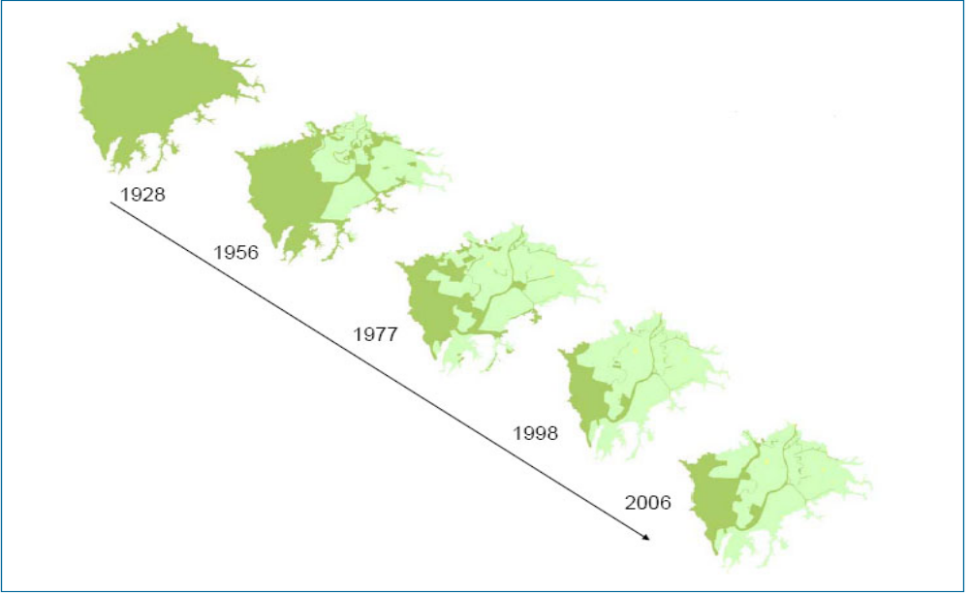
Source: Lomas et al., 2007 (drafted after Zorrilla, 2006).

The channelling of the Guadalquivir rivers’ estuary started in 1795 with the aim of facilitating navigation. It continued during the 19th century and was accelerated since 1926. We can highlight 8 main modifications of the estuary, which all together have reduced its length from 125 to 77 km (Menanteau, 1984). The river flow has speeded up increasing the sediment load and disrupting several hydrological regulation services such as the sedimentary balance, the erosion control

Table... Transformation and rectification of the Guadalquivir estuary
Year | Consequences
1795 | Isolation of first branches (Río Viejo).
1816 | Corta el meandro de El Borrego, que circunda Isla Cristina (en el Brazo de la Torre) y desvía el flujo fluvial al brazo central, aislando el Brazo de la Torre, que ya sólo recibiría aportes del Guadiamar.
1888 | Construction of the Casa Riera channel between the Guadiamar and the Guadalquivir rivers.
1926 | Isolation of Los remedios and La Tablada areas
1951 | The river do not pass anymore through Seville, which become isolated from the floods
1971-  1972 | Construction of the Sevilla-Bonanza navigation channel

Sedimentation /erosion

The sediment load to the marshes has increased dramatically due to loss of vegetation cover and land cover change towards agriculture. Sedimentation rates has raised from filling rates of less that 1 mm/ y during the last 2.500 years, to 3-6 mm/y during the last 50 years (Rodríguez Ramirez et al. 2005). The water storage capacity of the marshes has been reduced by 26 hm3 in the last 50 years.

Box … Increased sedimentation rates and erosion of resilience in the marsh
Sedimentation rates in the Doñana marsh have increased dramatically during last few decades, producing resilience loss and undesired regime shifts in ecosystems. Some drivers of this process can be traced back to afforestation practices led by the romans in the Guadalquivir river basin. Nevertheless, sedimentation/erosion problem in the Doñana marsh is primarily the consequence of relatively recent events, namely, 1) channelling of the water courses discharging at the march and consequent speeding up of water flows, 2) land use change to agriculture entailing removal of vegetation cover, 3) Removal of grapevine and orchard plantations upwards the marsh promoted by subsidies.
Increased sedimentation is causing the loss in the heterogeneity in the topography of the marsh (reference), leading to the loss of habitats suitable for diverse plant species. This homogenisation reduces response diversity when facing perturbations (droghts, floods, grazing) and thus erodes resilience to buffer disturbance. Seed banks of the soil are considered as key ecosystem components for the resilience of the marsh (reference), due to their capacity to survive after severe drought or floods and to regenerate the pastures of the marsh. Increased sedimentation is contributing to bury the seed bank at a depth they can not germinate, leading to loss of vegetation cover. As vegetation decreases, phosphorus is increasingly released to the water, leading to regime shifts from clear water states to turbid water states. The latter stable state can be considered a less desired one from ecological and economic perspective, as the capacity to provide ecosystem services declines (refugium for biodiversity, clean water, etc.)

Fragmentation
The drainage of the marshes has caused loss of ecological interactions: the length of dykes and artificial levees in the Doñana wetlands has increased from 25 to 110 km between 1956 and 2006 (to be developed).

- Biodiversity indicators

- Population health

5.1.4. Maintenance and restoration costs
The budget designated to the conservation of Doñana biodiversity (only species) is one of the most important of all National Parks in Spain (Martín –López et al. submitted). During the 3-year period 2004-2006, nearly 7.9 € million was dedicated to species conservation. Of this, about 5.1 € million was provided by the Spanish Ministry of Environment, and 2.8 € million by the Department of Environment of the Andalusian government. Despite this significant spending, only a fraction of species conservation needs were funded because resource distribution was skewed toward very few species (Fig. _).
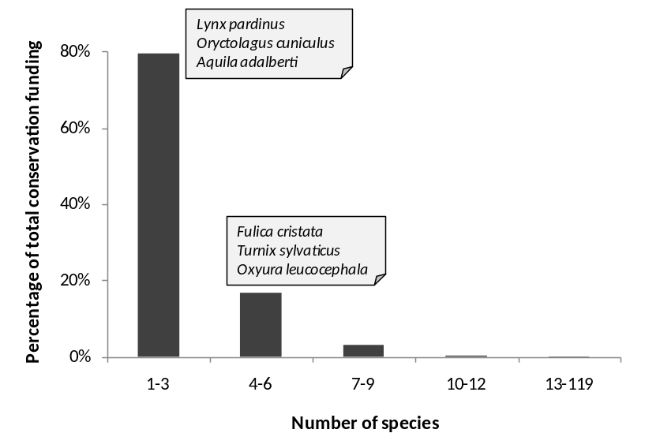

Regarding research funding for biodiversity, nearly 2.9 € million was dedicated to scientific research of biodiversity in the Doñana NPA during 3 years: 2004-2006. Of this, 41.0% was provided by the Spanish Ministry of Environment; 34.2% by the Department of Environment of the Andalusian government, 18.6% by the Spanish Ministry of Education and Science; 5.5% by the Department of Education and Science of the Andalusian government; and 0.7% by the European Union (Martín-López et al., submitted).
In contrast, higher budget is invested on wetlands restoration projects. The Spanish Ministry of the Environment launched the Doñana 2005 Project in 1998 with the final goal to restore the Park's hydrology (Saura Martínez et al., 2001) as a basis for conservation. It comprises six key interventions addressing specific problems: controlling aquifer overexploitation, building the sewage treatment plant of El Rocío village, reshaping drainage channels entering the Park, recovering degraded areas and purchasing abandoned agricultural lands to restore them, and providing menaced Imperial eagle and Iberian lynx populations with a suitable hunting ground (García-Novo et al., 2007). The average budget spent between 1998 and 2005 on this restoration project was € 83.5 million (UNEP, 2007; http://www.unep-wcmc.org/sites/wh/donana.html). The hydraulic modification of El Partido stream to abate transport of sediments into the Marsh, along with the ecological restoration of its watershed, is the most complex intervention of the Doñana 2005 Project. It has been undertaken by watershed authority (Confederación Hidrográfica del Guadalquivir) belonging to the Spanish Ministry of Environment, with an estimated budget of M€7.85 (García-Novo et al., 2007).
Concerning the water quality and quantity research, it is interested to note that the Spanish Geology and Mines Institute (IGME) has invested about 1.9 € million during the last seven years in the research of the aquifer of Doñana (Almonte-Marismas) (Mediavilla et al., ppt)

Box… Hidden costs related to ecological degradation: the case of sedimentation
Orchards and grapevines constitute beside cereals, the basis of traditional sustainable agriculture in Doñana. These secular plantations constitute multifunctional land-covers, as beside provisioning services, they perform important cultural (e.g. aesthetic value) and regulating services, especially preventing soil erosion.
At present, Common Market Organizations are subsidizing the removal of grapevine and orchards in the river-basins upwards the marsh, contributing to further increase in erosion and sedimentation rates. Inadecuacy of Doñana’s traditional agriculture to compete and create profit in liberalised markets is alleged as the main reason for conducting this policy. Nevertheless, its economic rationality would probably be challenged if externalities and restoration costs related to sedimentation/erosion problems were fully considered in decisison making.

5.1.5 Selected socio-economic indicators

Population
The population of the Doñana SES was of 174.172 at year 2005. The Doñana SES has historically been a feeble inhabited area. This can be partly explined dde to difficulties to colonise the territory of the marsh, and partly because the latifundium as dominant property system rendered limited rights to the inhabitants to profit from natural resources.

The Doñana SES had a population 69.517 inhabitants in 1900. This population has been continually growing since 1910 and at present (2005) there are 174.172 inhabitants. This mean a population growth at a rate of 1,43% /year between 1900 and 2005. First large trial of colonisation started in the 19th century, but it was not before the first decades of the 20th century that these trials succeeded. This became possible once the availability of technology and investments permitted the drainage of the marsh and the settlement of crops, especially rice fields.

Table… Population growth in Doñana in the 1900-2005 period.

Doñana SES | 1900 | 1920 | 1940 | 1960 | 1981 | 2000 | 2005
Almonte | 6 917 | 7 967 | 8 964 | 11 538 | 12 959 | 17 444 | 19 641
Hinojos | 2 058 | 2 401 | 2 908 | 3 278 | 3 130 | 3 556 | 3 726
Lucena del Puerto | 1 456 | 1 526 | 1 589 | 1 703 | 1 870 | 2 237 | 2 283
Moguer | 8 455 | 8 028 | 6 821 | 7 222 | 10 004 | 14 389 | 16 961
TOTAL HUELVA | 18 886 | 19 922 | 20 282 | 23 741 | 27 963 | 37 626 | 42 611
HUELVA province | 258 143 | 331 527 | 375 180 | 404 517 | 418 584 | 458 998 | 483 792
Aznalcázar | 1 795 | 1 870 | 2 454 | 3 038 | 2 871 | 3 518 | 3 692
Isla Mayor |  |  |  |  |  | 6 057 | 5 853
Lebrija | 10 997 | 12 012 | 14 536 | 20 937 | 24 744 | 24 172 | 24 866
Pilas | 4 251 | 5 616 | 6 145 | 8 604 | 9 835 | 11 289 | 11 918
Puebla del Río (La) | 2 841 | 2 740 | 5 085 | 12 612 | 13 602 | 10 688 | 11 326
Villam. de la Condesa | 3 079 | 3 362 | 3 146 | 3 392 | 3 225 | 3 805 | 3 826
TOTAL SEVILLA | 22 963 | 25 600 | 31 366 | 48 583 | 54 277 | 59 529 | 61 481
SEVILLA province | 552 455 | 704 344 | 957 362 | 1 244 153 | 1 478 311 | 1 734 917 | 1 813 908
Sanlúcar de Barrameda | 23 883 | 27 103 | 32 848 | 40 335 | 48 496 | 61 966 | 63 187
Trebujena | 3 785 | 4 247 | 4 799 | 5 591 | 6 187 | 6 937 | 6 893
TOTAL CÁDIZ | 27 668 | 31 350 | 37 647 | 45 926 | 54 683 | 68 903 | 70 080
CÁDIZ province | 450 837 | 549 710 | 590 211 | 812 680 | 988 388 | 1 125 105 | 1 180 817
TOTAL SED | 69 517 | 76 872 | 89 295 | 118 250 | 136 923 | 166 058 | 174 172

Modified from Lomas et al., 2007. Source: Spanish Statistic Institute (INE).

Although population has grown in every municipality of the Doñana SES since 1900, this growth has been uneven when different municipalities are compared. As shown in fig… population growth has been especially fast in San Lúcar de Barrameda, while municipalities such as Pilas or Hinojos show very moderate growth.

Figure … Population growth in the municipalities OF THE Doñana SES since 1900

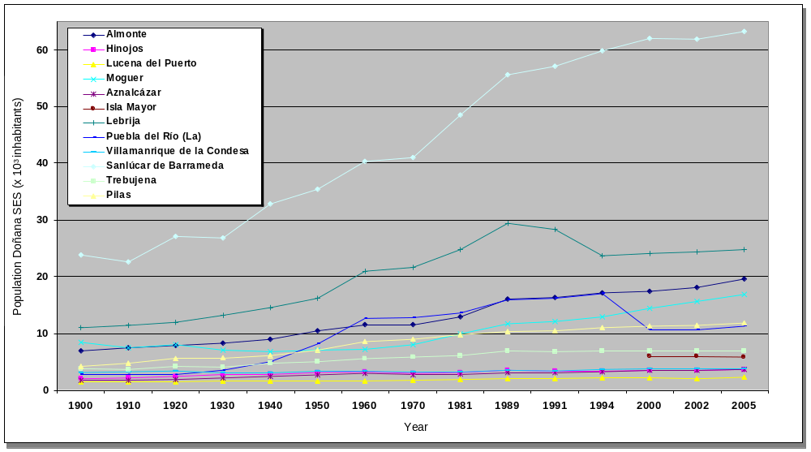

Modified from Lomas et al., 2007. Source Andalusian Statistics Institute (SIMA).

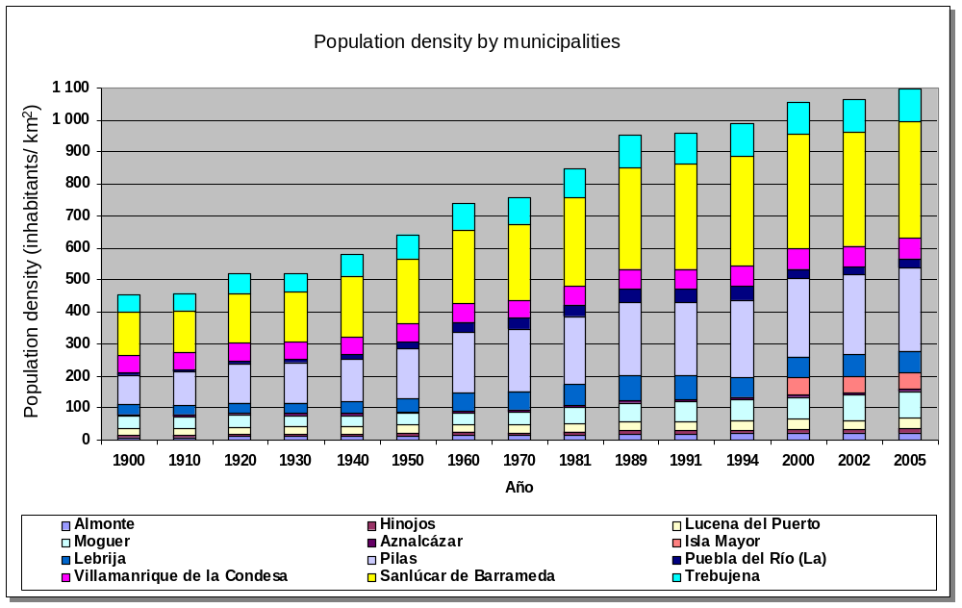

Natural capital dependent economic sectors
Economic activity in the Doñana SES has been continuously growing from the 1980’ to the present. Employment in Doñana, which until a few decades ago depended completely on nature, is still strongly dependent the natural capital and ecosystem services of the marsh, estuary, coast, and dunes ecosystems. The rate of employment (tasa de actividad) population that is officially employed increased from being 80% at the beginning og the 1980’ to about 60% in 2001.

The main economic sectors depending on ecosystem services are agriculture, fishing and acuiculture, cattle farming, forestry, salines and tourism. Nevertheless, more recently industry and housing are gaining weight as economic sectors in Doñana.

Agriculture
Traditional agriculture consists on grapevine, orchards and cereals. Although these crops are still important, rice fields, which started to be cultivated at the end of the 1920’s has now become the largest agricultural sector in Doñana. In the 1960’s and 1970’s the Plan Almonte-Marismas promoted the conversion of marsh to intensive irrigated agriculture. The so called “new agriculture”, of rice fields, strawberry and other fruits and vegetables is now the engine of the economy based on agriculture. While agricultural surface in Doñana has been increasing all alonmg the 20th century, some traditional crops such as the grapewine are reducing their surface.

Table…Crop types and relative importance
Crop types | Surface (ha)
Rice | 28 922
Orchards | 14 755
Cereals | 11 477
Industrial crops | 9 034
Fodder crops | 6 181
Fruits and vegetables | 5 463
Vineyards | 5 343
Strawberry | 4 536
Tuber crops | 1 031
Raspberry | 545
Leguminous | 396
TOTAL | 87 683

Source: Dpto. de Estadística de Sevilla y Huelva. Consejería de Agricultura y Pesca. (2001)

Municipality | Cereals | Leguminous | Tuber | Industrial | Raspberry | Fodder | Total
Aznalcázar | 5 265 | 0 | 0 | 4 155 | 0 | 5 328 | 14 748
Pilas | 256 | 3 | 0 | 264 | 0 | 5 | 528
La Puebla del Río | 702 | 5 | 41 | 870 | 0 | 15 | 1 633
Isla Mayor | 220 | 0 | 0 | 200 | 0 | 450 | 870
Villamanrique de la Condesa | 637 | 63 | 704 | 845 | 0 | 0 | 2 249
Almonte | 1 530 | 294 | 63 | 1 060 | 10 | 217 | 3 174
Bollullos Par del Condado | 326 | 5 | 18 | 303 | 0 | 6 | 658
Bonares | 425 | 5 | 10 | 110 | 125 | 15 | 690
Hinojos | 787 | 7 | 4 | 375 | 0 | 25 | 1 198
Lucena del Puerto | 327 | 3 | 19 | 145 | 120 | 56 | 670
Moguer | 251 | 6 | 89 | 110 | 250 | 39 | 745
Palos de la Frontera | 1 | 0 | 61 | 0 | 0 | 0 | 62
Rociana del Condado | 750 | 5 | 22 | 597 | 40 | 25 | 1 439
TOTAL | 11 477 | 396 | 1 031 | 9 034 | 545 | 6 181 | 28 664

Source: Departamento de estadística de la Consejería de Agricultura y Pesca.

Cattle farming
Cattle farming is an ancient practice in the Doñana. The quality of the marsh pastures has been acknowledge since the arabs controlled this territory one thousand years ago (González Fáraco, 1991).

Table…
MUNIPALITY | Donkeys | Birds | Sheeps | Horses | Goats | Mules | Caws | Pigs
Almonte | 98 | 63 600 | 3 473 | 4 388 | 1 252 | 780 | 6 900 | 210
Hinojos | 22 | 350 000 | 1 597 | 766 | 470 | 80 | 4 070 | 2 012
Isla Mayor |  |  |  | 370 |  | 12 | 2 179
La Puebla del Río | 27 | 31 000 | 4 542 | 539 | 125 | 42 | 431 | 800
Lebrija | 67 |  | 799 | 527 | 2 455 | 92 | 12 800 | 27 177
Lucena del Puerto | 11 | 29 000 | 225 | 207 | 500 | 64 | 1 363 | 12
Moguer | 31 | 120 000 |  | 845 | 1 004 | 102 | 902 | 465
Pilas | 26 | 45 000 | 219 | 444 | 144 |  | 85 | 326
Sanlúcar de Barrameda | 174 | 107 000 | 4 223 | 2 216 | 1 366 | 260 | 3 246 | 162
Trebujena
Villamanrique de la Condesa | 23 | 218 000 | 783 | 421 | 1 525 | 88 | 5 899 | 580
TOTAL | 479 | 963600 | 15 861 | 10 723 | 8 841 | 1 520 | 37 875 | 31 744

Source: Censo Ganadero (1999). Unit: Number of animals

Fishing
Table… Number of fishing boats by municipalities depending on the estuary
MUNICIPALITY | Number of fishing boats
Trebujena | 90-110
Isla Mayor | 60-80
Lebrija | 15-25
Coria del Río | 10-15
Los Palacios y Villafranca | 4
Jerez de la Frontera | 1-2
Sanlúcar de Barrameda | 1-2
Source: Silva García (2005)

Table… Number of licences for seafood extraction by municipalities
Municipality | Licences
Pilas | 71
Sanlúcar de Barrameda | 33
Almonte | 18
Villamanrique de la Condesa | 15
Hinojos | 8
Source: Collado Vallejo (2005)

5.1.6 Ecosystem services
The ecosystems of Doñana perform a diversified flow of ES, from the local (sense of place, hunting, picking up goods, local ecological knowledge) to the national and international scale (carbon sequestration, refugee for biodiversity, research and tourism). The relative importance of each of these services depends thus on the scale at which they are enjoyed (Hein et al., 2006), but also in the valuation criteria (weather it is economic, socio-cultural ecological or other).

Most significant marketed ES in Doñana in terms of income are agriculture and aquiculture, beach and nature tourism, science and environmental education (table…). Provisioning services include agriculture (rice, strawberry, fruits, orchards, vineyards, cereals), and in a smaller extent cattle farming, fishing, seafood, aquiculture, forestry products (wood, pines, scent, honey), and hunting. Most of them are provided outside the protected areas, due to strict restrictions in extractive uses. Most significant cultural service is eco-tourism, but science and environmental education are also important indirect sources of income.

Table… Physical measurement of some ES in the Doñana wetlands (preliminary results).
ES | Quantities
Agriculture | 641.947 ton /y
Cattle farming | 41.205 animals
Fishing | 3.373 tons/ y
Tourism | 4.092.379 visitors / y
Environmental Education | 7 large projects
Refugee for biodiversity | 4.000 recorded sp.

Concerning non marketed services, the most significant in the Doñana wetlands are those related to ecological regulation, main regulating services performed by the marsh are sedimentary balance, flood prevention, nutrient cycling, waste treatment and refugium for biodiversity. In the case of the estuary, nursery and food web maintenance, waste treatment are erosion control are the most significant, Non marketed socio-cultural services include landscape beauty and traditional ecological knowledge, which is being lost as traditional economic activities depending on nature are declining. Spiritual services are also important in Doñana, due to El Rocío pilgrimage that attracts 2 million visitors every year.

Table…Degree of integration in markets of the ES of Doñana
Carrier |  | Service-type |  | Category |  | Service | Full | Partial | None
Production | 1 | Provisioning | 1.1 | Food | 1.1.1 | Hunting |  | X
Production |  |  |  |  | 1.1.3 | Fishing | x
Carrier |  |  |  |  | 1.1.5 | Livestock |  | X
Carrier |  |  |  |  | 1.1.5 | Agriculture | x
Production |  |  | 1.2 | Materials | 1.2.4 | Fiber crops | x
Information | 2 | Socio-Cultural | 2.1 | Recreational | 2.1.2 | Ecotourism |  | X
Information |  |  |  |  | 2.1.3 | Landscape beauty |  | X
Information |  |  | 2.3 | Didactic | 2.3.1 | Education / interpretation |  | X
Information |  |  |  |  | 2.3.2 | Scientific research |  | X
Information |  |  |  |  | 2.3.3 | Traditional Ecological Knowledge |  |  | x
Regulation | 3 | Regulating | 3.1 | Cycling | 3.1.1 | Soil retention & Erosion control |  |  | X
Regulation |  |  |  |  | 3.1.2 | Hydrological regulation |  |  | X
Regulation |  |  |  |  | 3.1.4 | Pollination for useful plants |  | X
Regulation |  |  |  |  | 3.1.5 | Climate regulation |  | X
Regulation |  |  | 3.2 | Sink | 3.2.1 | Soil purification |  |  | X
Regulation |  |  |  |  | 3.2.3 | Water purification |  |  | X
Regulation |  |  | 3.3 | Prevention | 3.3.2 | Pest prevention |  |  | X
Regulation |  |  |  |  | 3.3.3 | Invasive species prevention |  |  | X
Regulation |  |  |  |  | 3.3.4 | Air quality |  |  | x

Table… Detected economic value of some ES in Doñana
Type of ES | Total annual value (2006 €) | Source
Provisioning services
Agriculture | 239 982 510
Sustainable crops | 31 102
Cattle | 69 445 529
Crayfish fishing | 2 811 378
Coastal marine resources (inshore and offshore fishing) | 11 431 027
Estuary fishing | 13 076 100
Wedge shellfishing | 1 407 164
Beekeeping in National Park | 127 221
Pine cone harvesting | 92 160
Other forest resources | 66 405
Total PS | 338 439 700

Regulating services
Grazing | 12 598
AIS control | 85 505 | García-Llorente et al. (submitted)
Other regulating services | 26 004 344 | Martín-López et al. (2007)
Total RS | 26 102 447

Socio-cultural services
Beach tourism | 5 940 623
Cultural tourism | 21 011 629
Nature tourism | 36 741 776
Aesthetic values (conservation) | 85 840 612 | Martín-López et al. (2007)
Total CS | 206 062 000
Detected Economic value | 570 604 646

Table… Methods and sources used for the ES valuation

ES | Type of Value | Type of ES | Source and Method of Estimation
Provisioning | Consumptive direct use value | Crops | Agriculture and Fisheries Statistics Yearbook of Andalusia
Provisioning |  | Cattle | Agriculture and Fisheries Statistics Yearbook of Andalusia
Provisioning |  | Cattle | Annual Reports of Activities of Doñana National Park
Provisioning |  | Fish | Agriculture and Fisheries Statistics Yearbook of Andalusia
Provisioning |  | Coastal resources | Annual Reports of Activities of Doñana National Park
Provisioning |  | Beekeeping | Annual Reports of Activities of National and Natural Park
Provisioning |  | Forest resources | Annual Reports of Activities of National and Natural Park
Regulation | Indirect use value |  | Contingent Valuation (WTP)
 |  | Control of Alien Invasive Species | Annual Reports of Activities of National and Natural Park
 |  | Grazing | Annual Reports of Activities of Doñana Natural Park
Cultural | Non-consumptive direct use value | Recreational-Tourism | Travel cost method
 |  | Religious values | Contingent valuation (WTP)
 |  | Religious values | Travel cost method
 |  | Scientific values | Contingent valuation (WTP)
 |  | Scientific values | Doñana Biological Station Annual Plans
 |  | Educational values | Contingent valuation (WTP)
 | Existence value | Aesthetic and spiritual value | Contingent valuation (WTP)

References (in progress)

Barrera, M., Camacho, J., Cañabate, J. P. & Roth, J.C. 1984. Estudio ecológico y problemática actual del Brazo del Este. En: MOPU. Zonas húmedas de Andalucía. Dirección General de Medio Ambiente. Madrid: 77-85.

Collado Vallejo, J. 2005. Marisqueo tradicional de la coquina (Donax trunculus) en el litoral de Huelva. Páginas 746-752 en J. M. Morales, A .J. Mata, A. Rodríguez, y C. J. Revilla. Acuicultura, Pesca y Marisqueo en el Golfo de Cádiz. Consejería Agricultura y Pesca. Sevilla.

Custodio, E. 1995. La explotación de las aguas subterráneas y su problemática asociada. In: VI Simposio de Hidrogeología: 297-313. Hidrogeología y recursos hidráulicos. v. XX.

Custodio, E., Manzano, M., Dolz, J. y Montes, C., 2005. El agua en Doñana: una perspectiva general. Fundación Doñana 2005. Documento elaborado para el PDSDII.

Custodio, E., Dolz, J., Manzano, M., Alcalá, F.J., 2005. Recursos del agua de la comerca de Doñana. Fundación Doñana 21.

Custodio, E., 1992. Comportamiento y papel de las aguas subterráneas en Doñana: consecuencias de las extracciones. Universidad Hipanoamericana de Santa María de la Rábida. Mesa redonda: Cambios sociales y ecológicos en Doñana y su entorno.

Díaz-Delgado, R., Bustamante, J., Pacios, F. and Aragonés, D. 2006. Hydroperiod of Doñana marshes: natural or anthropic origin of inundation regime? In Proceedings of the 1st GlobWetland Symposium, organised by ESA and Ramsar Convention. Frascatti, Italy, 19-20 October.

Fernández Delgado, C. 2005. Conservation Management of a European Natural Area: Doñana National Park, Spain. In: Groom, M.J., Meffe, G.K. and Carroll, C.R. (Eds.), Principles of Conservation Biology, Sinauer Associates, Sunderland, Massachusetts.

Gallart, F., Benito, G., Martín-Vide, J.P., Benito, A., Prió, J.M. y Regüés, D. (1999). Fluvial geomorphology and hydrology in the dispersal and fate of pyrite mud particles released by the Aznalcollar mine tailings spill. The Science of the Total Environment, 242, 13-26.

García-Llorente et al. (submitted)

García Novo, 1997. The ecosystems of Doñana Nacional Park. In: García-Novo, F., Crawford, R.M.M. and Díaz Barradas (editors). The ecology and conservation of European dunes. Universidad de Sevilla, Sevilla, pp. 97-116.

García Novo, … Marín Cabrera…, 2006.

García-Novo et al., 2007

Gómez-Baggethun, E and Kelemens, E, (In press). Linking institutinal change and the flows of ecosystem services. Case studies from Spain and Hungary. In: Kluvánková-Oravská, T., Chobotova, V., Jílková, J., Sauer, P. (editors) Institutional Analyses Of Sustainability Problems, THEMES 2007, proceeding book.

González Arteaga, J. 1993. Las marismas del Guadalquivir: etapas de su aprovechamiento económico. C.P. Antonio Cuevas, Puebla del Río, Sevilla.

González Arteaga, J. 2005. El arroz en las marismas del Guadalquivir. Evolución y problemática actual. Secretariado de publicaciones de la Universidad de Sevilla, Sevilla.

González Faraco, J. C. 1991. La evolución de los usos tradicionales en los espacios naturales protegidos: estudio de la ganadería caballar en el Parque Nacional de Doñana. Vida Silvestre, 69: 9-15.

Hein, L., van Koppen, K., de Groot, R.S. and van Ireland, E.C. 2006. Spatial scales, stakeholders and the valuation of ecosystem services. Ecological Economics 57: 209-228.

Lomas, P.L., Gómez-Baggethun, E., Martín-López, B., Zorrilla, P., Sastre, S., García-Llorente, M., Borja, P. and Montes, C. 2007 (Internal repport). Hacia la elaboración de un modelo de gestión sostenible en la Comarca de Doñana. Informe Final del Proyecto. Universidad Autónoma de Madrid, Madrid.

Martín –López et al. submitted

Mediavilla et al., ppt

Menanteau, L. 1.984. Evolución histórica y consecuencias morfológicas de la intervención humana en las zonas húmedas: El caso de las Marismas del Guadalquivir. En: MOPU. Zonas húmedas de Andalucía. Dirección General de Medio Ambiente. Madrid: 43-76.

Montes, C., 2000. The Guadalquivir River Basin and the Doñana Wetlands, Southern Spain – the potential for achieving “Good Water Status” through integrated management of multiple functions and values. In: WWF (Ed.) “Implementing the EU Water Framework Directive: A seminar series on water”. WWF Fresh Water Program, Copenhagen.

Montes, C., Borja, F., Bravo, M. and Moreira, J.M., 1998. Doñana: una aproximación ecosistémica. Sevilla, España: Consejería de Medio Ambiente.

Ojeda Rivera, J. F., 1987. Ordenación del Territorio en Doñana y su entorno próximo (Almonte). Siglos XVIII-XX. Monografia nº 49 MAPA. ICONA, Madrid.

Ojeda Rivera, J.F. 1993. Doñana: esperando a Godot. Sevilla, España: Instituto de Desarrollo Regional, Universidad de Sevilla.

Ojeda Rivera, F. and Moral Ituarte, L. 2004. Percepciones del agua y modelos de su gestión en las distintas fases de la configuración de Doñana. Investigaciones Geográficas 35: 25-44.

Rodríguez Merino, E-E, and Cobo García, D. 2002. Actividades tradicionales. In: V. García Canseco (Ed.) Parque Nacional de Doñana. Canseco Editores, SL, Madrid.

Rodríguez-Ramírez, A., F.Ruiz *, L.M.Cacer es , J.Rodrıguez Vidal , R.Pino , J.M. Muñoz, 2003. Analysis of the recent storm record in the southwestern Spanish coast: implications for littoral management The Science of the Total Environment 303 (2003) 189–201.

Rodríguez Ramírez, C. Yañez Camacho, C. Gascó, Clemente Salas, L. Antón, M P., 2005. Colmatación natural y antrópica de las marismas del parque nacional de Doñana: implicaciones para su manejo y conservación. Revista C.&G.

Saura Martínez et al., 2001

Siljeström, P.; Clemente, L. y Rodríguez Ramírez, A. (2002). Clima. En: Parque Nacional de Doñana (CANSECO Eds.), 43-56.

Silva García, A. J. 2005. La actividad pesquera en el estuario del río Guadalquivir. Páginas 365-398 en J. M. Morales, A .J. Mata, A. Rodríguez, y C. J. Revilla. Acuicultura, Pesca y Marisqueo en el Golfo de Cádiz. Consejería Agricultura y Pesca. Sevilla.

Valverde, J. A., 2004. La aventura de Doñana. Cómo crear una reserva. Quercus (Ed.), Madrid.

Vanney JR. L’hydrologie du Bas Guadalquivir.Serv .Publ. Dpto.Geograf. Aplic., CSIC, Madrid. 1970. (176 pp).

Zorrila, P., 2006. Pérdida de capital natural en a marisma de Doñana.

