Camargue: a Socio-Ecosystem in continuing change
Preamble: Camargue seen from Europe or the LEAC story
Land cover accounts can give a first useful picture of Camargue and its recent evolution. This picture presents the park in its (land cover) environment and offers gateways to the broad European picture as well as to other sites with which comparisons are fruitful. These accounts being based on a grid (on the following maps, a 1 km2 gird is used) they are an efficient framework for integrating socio-economic statistics and ecological monitoring data.
First, the Corine map:
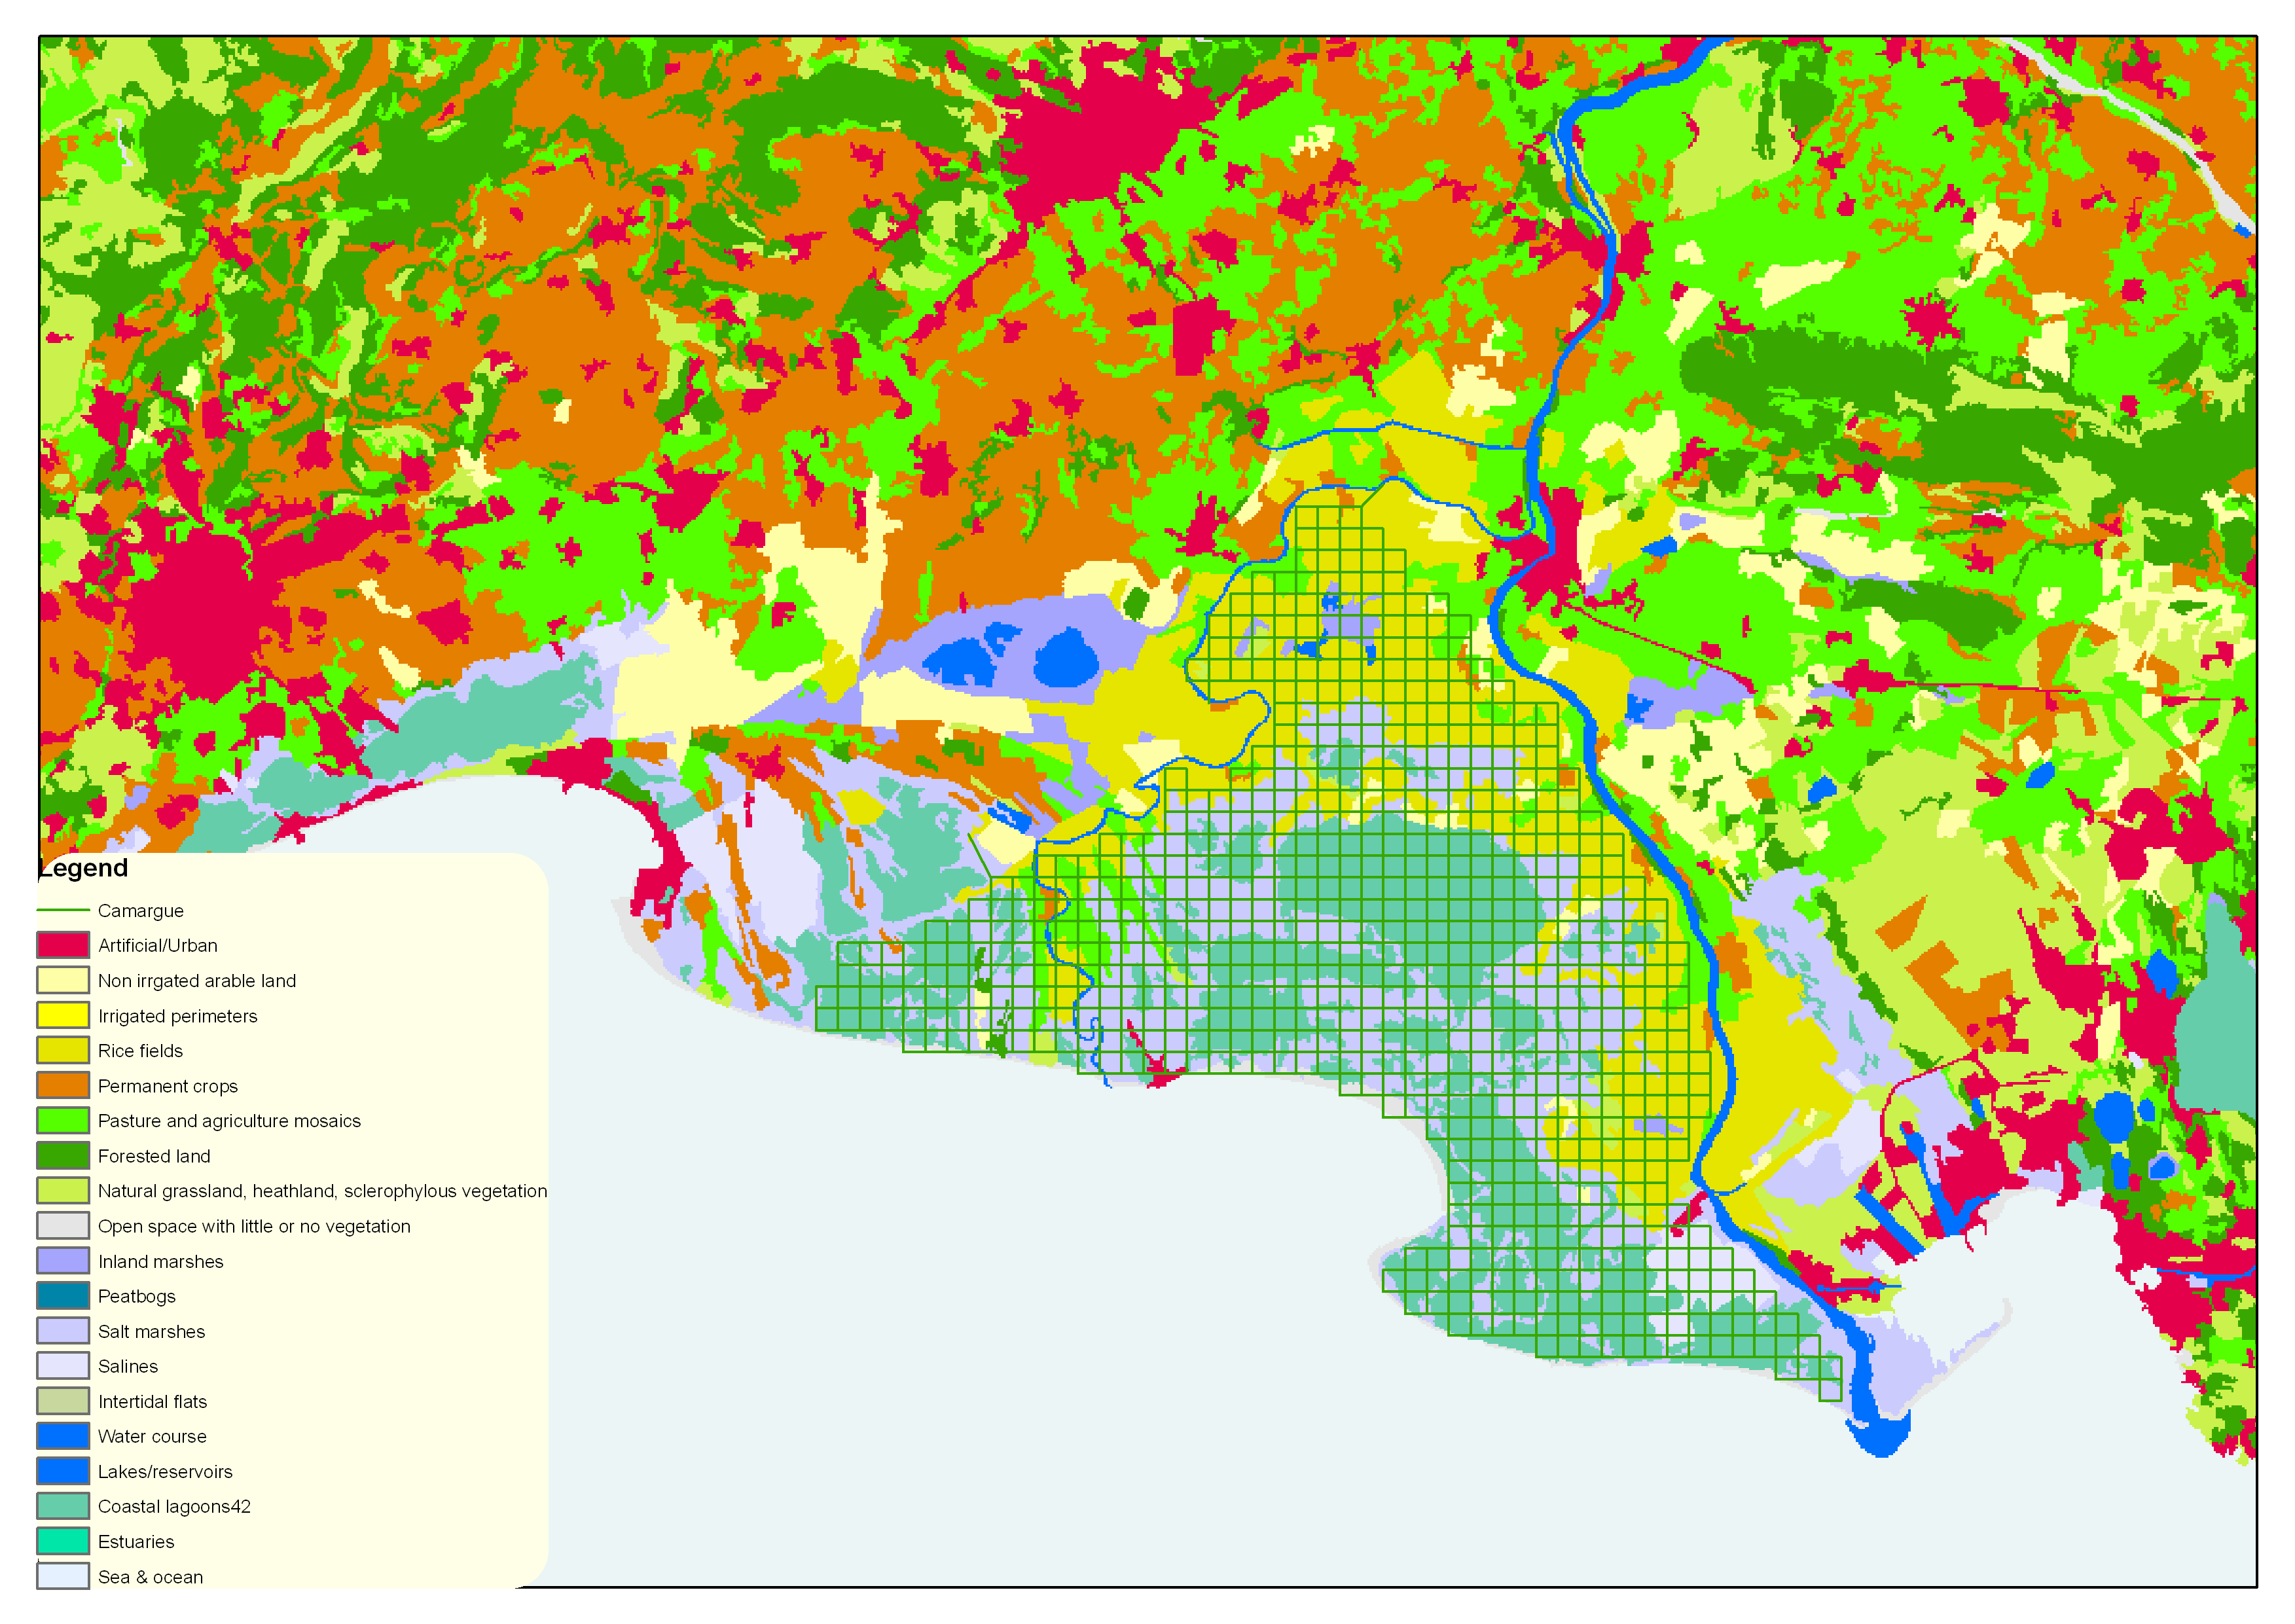
Figure 5.3.1 Camargue land cover; CLC2000
The same tables as produced for the whole Mediterranean basin can be established for the site. They tell about:

Land cover
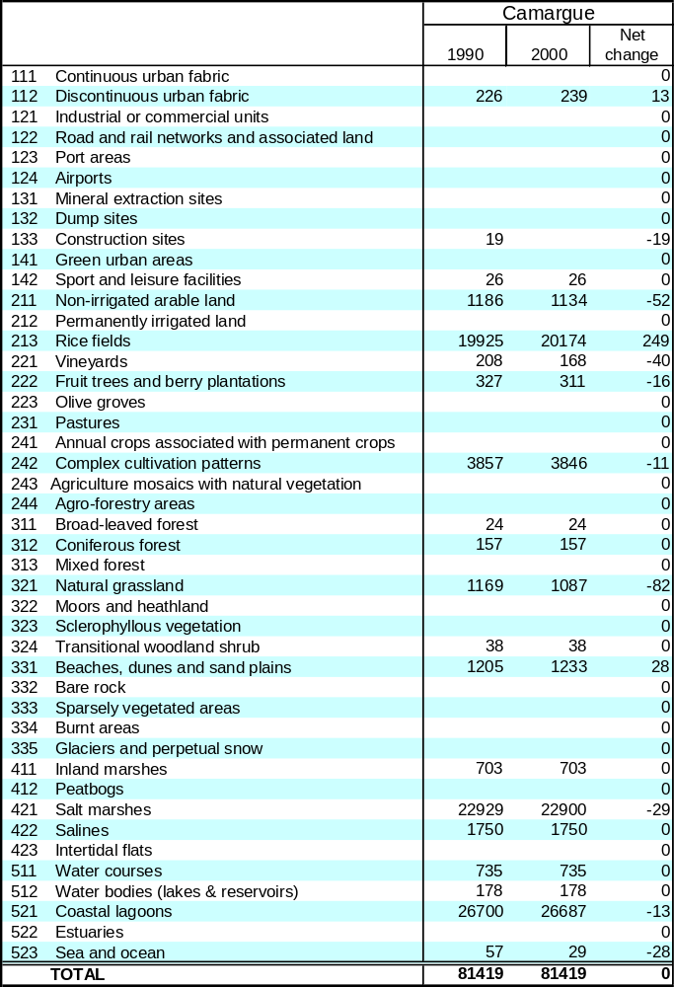
Land cover flows 1990-2000
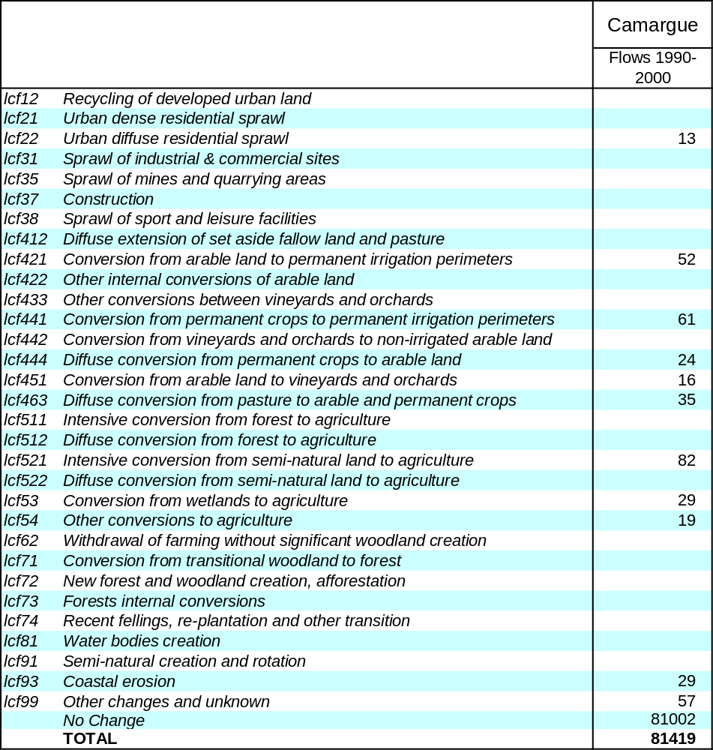

These flows can be mapped as well:
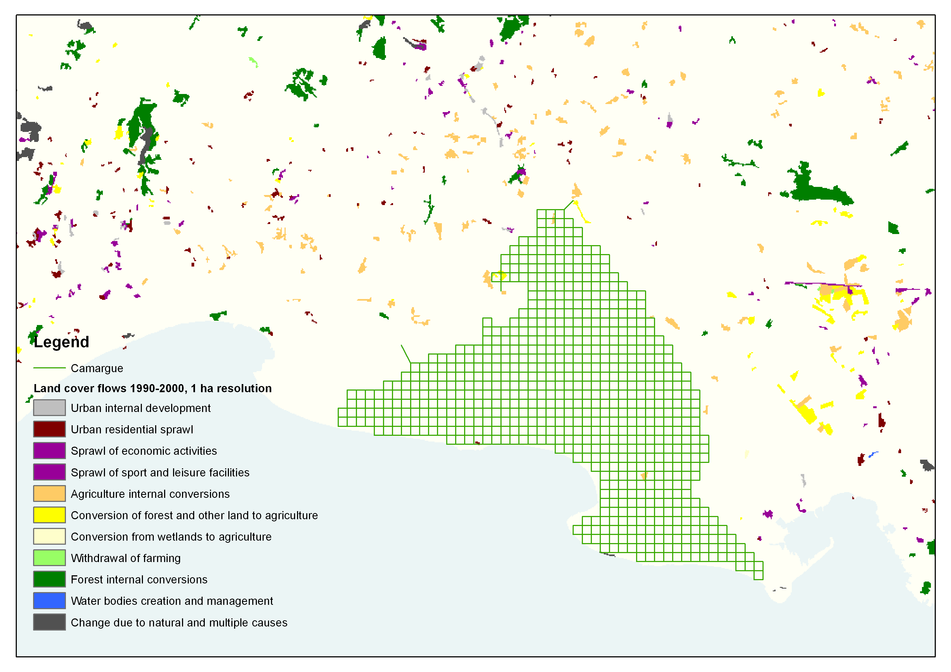
And land and ecosystem physical aggregates:
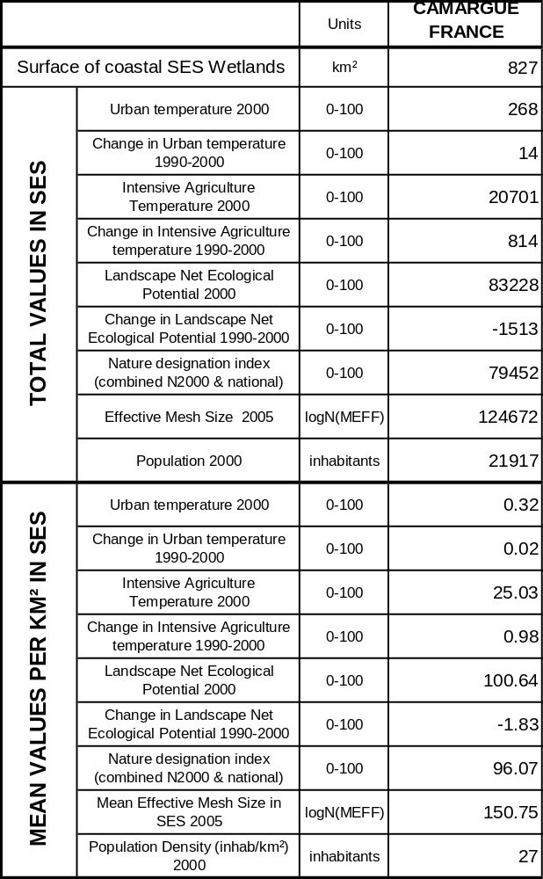
Which can be mapped with the same 1km² grid
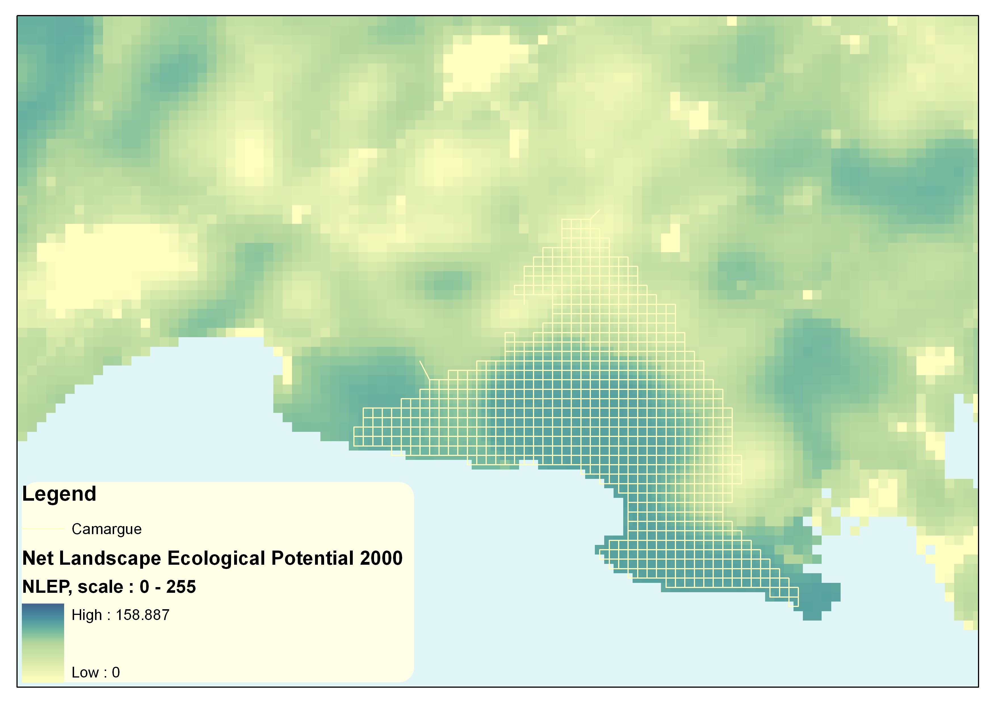
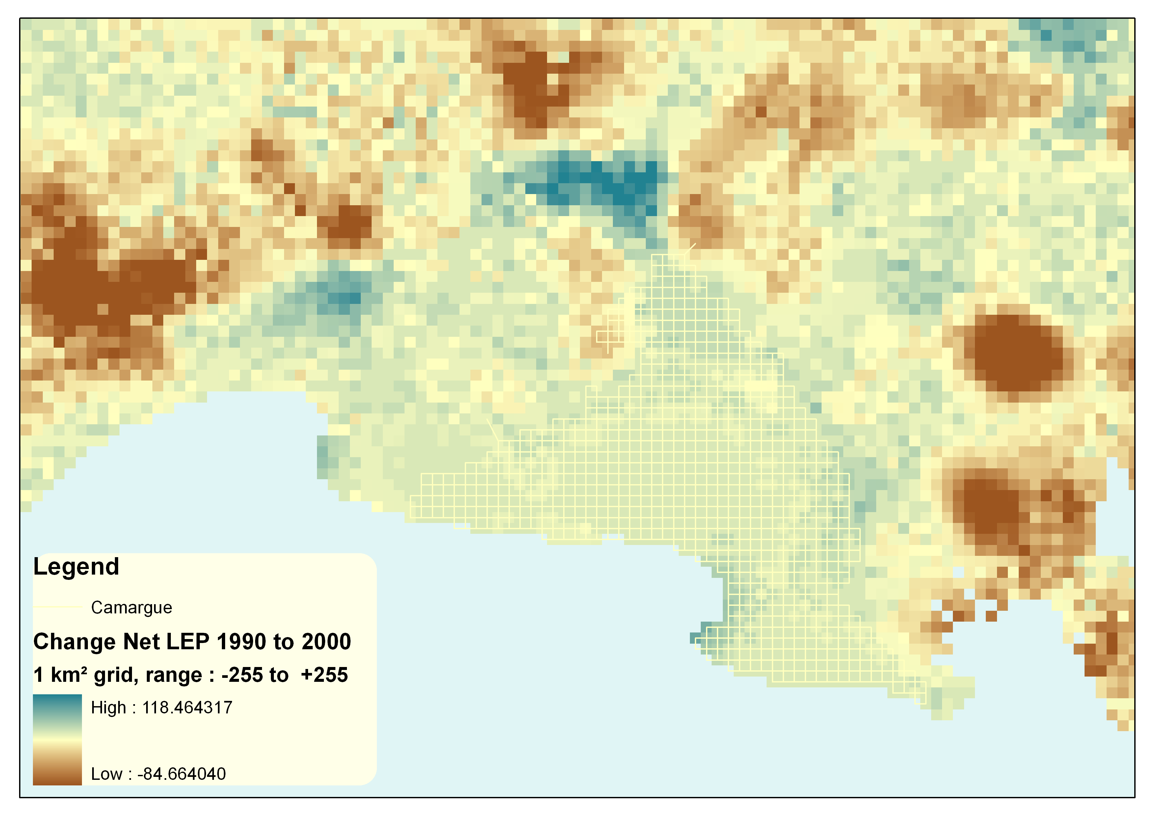
Introduction: Getting into the Camargue socio-ecosystem
The Camargue –also identified to the Rhone delta, is a Socio-Ecosystem (SE) located in the southern Mediterranean France. The whole deltaic system covers an area of 145 km² of which 15% is under different protection figures (Tamisier and Dehorter, 1999). A general description of its key features is highlighted in table 1.

Table 1. General view of the Camargue Socio-Ecological Services (SES).
Characteristics | Description
Location | Bouches du Rhône department, Provence Alpes Côtes d'Azur province, South-east France
Spatial extent | 145.000 ha
Biophysical system of reference | Rhone paleo-deltaic system (145.000 ha)
Municipalities | 5 (Arles, Port St Louis, Stes Maries de la Mer, Aigues-Mortes)
Human population | 72.097 inhabitants
Main natural reserves (public ownership) | Camargue National Reserve, Scamandre Reserve, Impérial Malagroy, la Palissade
Natural protected areas (mainly over private lands) | Camargue Natural Regional Parc, Ramsar and Biosphere Camargue Reserve, Camargue Gardoise Natura 2000, Camargue Natura 2000
Wetland ecosystems | Vaccarès system (bracksih); Salineworks (hipersaline) ; Aigues-Mortes wetlands-Vigueiras-hunting marshes (freshwater wetlands)
Main ecosystem services | Agriculture, cattle farming, tourism and recreation, research, water purification, refugee for biodiversity, hunting
Other ecosystem services | Fishing, sea food, education, nutrient cycling
Characterization of economic system | Market globalised economy (salt), subsidized agriculture (rice, dry crops)
Characterization of political and administrative institutions | Local: Natural Regional Parc, Syndicates, Majors. Reg./Nat.: Direction de la Nature, MEDAD. International: EU, UN
Religion practices | Christians and Muslims
Environmental problems and disturbances related to human appropriation of provisioning services | Floods, diseases outbreaks, oscillation of ecosystem products prices
Ecosystem disturbances related to human activities | Loss and degradation of wetlands
Methodology used in this work | Maps, bibliographic revisions, statistical data, interviews

Mathevet, 2000. Perennou & Aufrey, 2007.

The Camargue consists on a variety of ecosystems defined by the submersion/drying out water dynamic and the west/east gradient of sand/clay soils. These factors, coupled with the connection to fluvial and/or marine waters, define the two main ecosystem functional units: a fluvial-riparian fresh water wetland system in the upper Camargue (920 km²) and a marine-riparian wetland system in the central and southern parts of the Camargue, with brackish and salty waters (with an area of 410 km²) (Figure 1).

Figure 1. Land use and protection figures in the Camargue SE
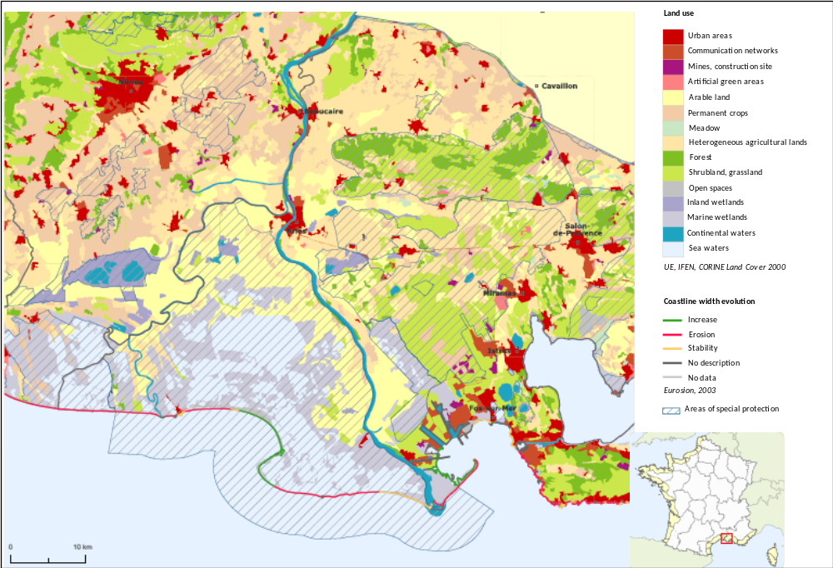
From Observatoire du Littotal web ressources
Because of its variety of habitats, water availability, connection with the Mediterranean landscape and as part of the ecological corridor for European migratory birds, the Camargue performs a series of key ecological functions: habitat provision, specific diversity maintenance (birds, insects, and amphibians), water purification and nutrient cycling (Isenman, 2004). From these ecological functions, humans have traditionally derived a number of important environmental services that are still highly demanded into the regional and local economy: high primary productivity and agriculture production (i.e. rice production), maintenance of fresh water hunting marshes for the selling of lucrative hunting access, water purification (with a number of local biological purification plants based on water filtration through Phragmites roots), fishing, salt production and tourism derived income (Mathevet, 2000; Perennou & Aufrey, 2007).

Such environmental services are thus driven by past and present human ecosystem management, which have transformed the Camargue ecosystem functional units into different socio-ecosystems used by local and regional inhabitants for the provision of specific environmental services: the fluvial-riparian unit is now composed of fresh water wetlands for hunting purposes – with a saline concentration of <5g/l, covering an area of 350 km² and maintained through a strong water inflow control, natural freshwater wetlands –covering 70 km²- and rice and dry agriculture areas in the Rhone flood plain –covering 500 km²; the riparian-marine unit is now composed of brackish natural wetlands -160 km²- and salt works –covering an area of 250 km² (Tamisier & Dehorter, 1999). Such ecosystem transformation rate and associated economic and biodiversity accounting issues are the central issue of the present chapter, as we shall discuss next.

Transformations and drivers of change in the Camargue in the late 19th and 20th century.
The main hydrological interventions that shaped the Rhone delta as is known at present occurred along the second half of the 19th c. A first dyke was built between 1856 and 1859 to isolate the southern wetlands from marine water inflows; a second series of dykes were built between 1859 and 1869 to fix the two main Rhone streams and protect lowlands from floods. Such intervention reduced river water and sediment inputs and stopped the geomorphologic changes of the whole Rhone delta. Nevertheless, the driving forces of these fluvial engineering interventions were to obtain agricultural and urban lands, what has lead to a gradually more complex socio-ecosystem.
Agriculture first started through vineyard production with a peak of 3.600 ha in 1890. Rice cultivation started in 1900 with a heterogeneous total surface evolution during the 20th century depending on a variety of contextual conditions (see figure 2). It is important to note that this rice surface fluctuation has not provoked a decrease in the total agricultural area, which has maintained a surface above 50.000 ha since 1984.
Figure 2. Rice crops cultivated surface evolution.
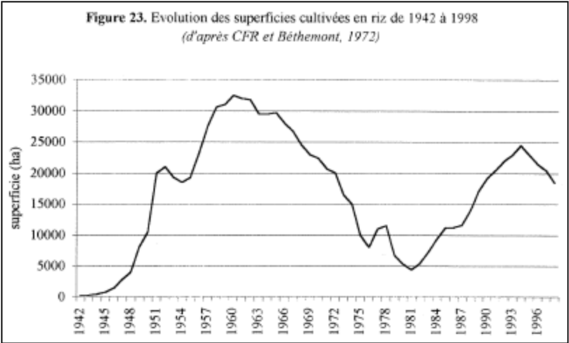
C.F.R., 2000.
Salt production started in the Vaccarès lake in 1855 but stopped after it was sold and converted into a National Reserve in 1928. It was not until 1960 that salt works increased its surface reaching almost 21.000 ha in 1984 (Table 4).
The 1928 National Reserve of Vaccarès was the first attempt to value and protect the Camargue ecosystem specific diversity. Since then, and particularly after the 1950’s, a number of protected areas have been declared, under a variety of management regimes and institutions, frequently overlapping to each other (see table 2).

Table 2. Main protected areas in the Rhone delta and creation year.
Year | Conservation figure | Public Protected area (ha) | Protected figure over protected and private lands (ha)
1927 | National Reserve of Camargue | 13.000
1962 | Impérial Malagroy | 2.700
1971 | Tour du Valat |  | 1.100
1975 | Ginès et Saint-Germain | 200
1978 | La Palissade | 700
1981 | Consécanière | 700
1983 | Ligagneau | 450
1986 | Camargue Ramsar declaration |  | 75.000
1986 | Camarge Natura 2000 SPA |  | 114.000
1989 | l'Étourneau | 450
1987 | They du Levant et le Mazet | 150
1994 | La Fromagère | 145
1994 | Scamandre Regional Reserve | 220
1996 | Petite Camargue Ramsar declaration |  | ?
2006 | Petite Camargue Natura 2000 SPA |  | ?
Total (ha) |  | 18.715 | 190.100

Modified from Tamisier & Isenman, 2004

Nevertheless, strict protection covers only 19.000 ha, whereas the rest of the Camargue natural and human managed areas are protection schemes that negotiate management regimes with private landowners, the main actors of the Natura 2000 network in the Camargue.

Basic Land Ecosystem Accounting for the Camargue SES

Human driven land use changes and ecosystem services in the Camargue respond to a productive approach linked to a specific socio-economic context. Such interrelation sets the general scene for the application of the LEAC methodology: how to quantify the tradeoffs between biodiversity, economic ecosystem services and land use to prospect possible links with past, present and future ecosystem management policies (Table 3).

Table 3. Historical evolution of the coupled socio-ecosystem.
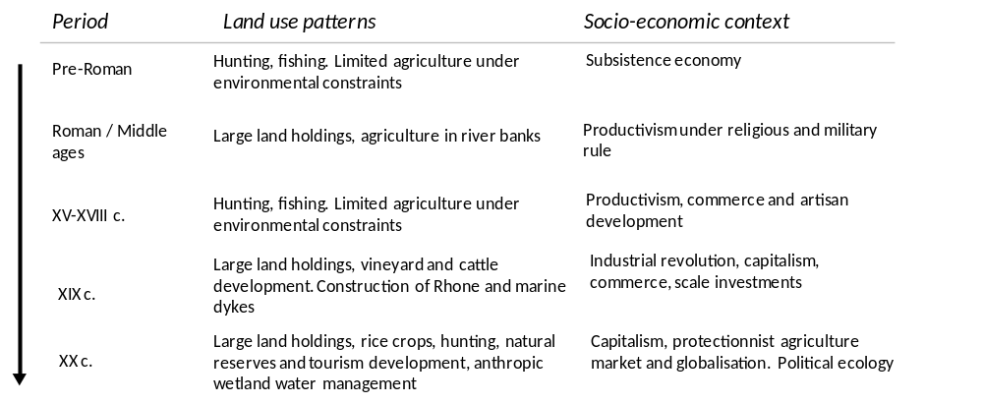
Mathevet, 2000

Land cover accounts
Main land use changes in the Camargue took place between 1953 and 1975 (figure 3) driven by the increase in rice crops, salt works and industrial areas (table 4). From 1942 to 1984, 72 km² of lakes, 13 km² of forest, 150 km² of marshes and 186 km² of heathlands were transformed into human managed areas (Tamisier, 1990).
Figure 3. Natural capital loss in the Camargue marshes since 1942.
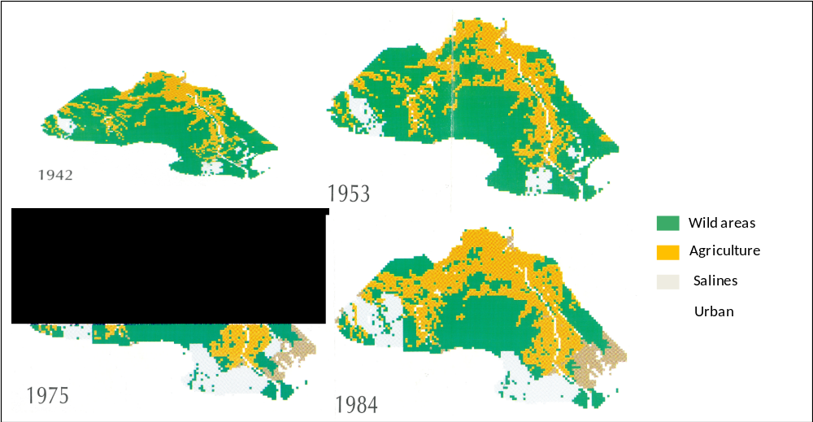
Tamisier, A. 1990
This loss of natural capital has been directly associated with the development of 80 km² of industrial areas, 100 km² of rice, 80 km² of dry crops and 153 km² of salt works (see Box 1). The table below present those surface changes in detail.

Box 1. The Camargue dramatic wetland loss during the “Trente Glorieuses”.
After the end of the Second World War, and all along the national economic growth period named as the “Trente Glorieuses” (1950-1980), the Camargue wetland system got progressively dried, and transformed into urban, industrial and agricultural areas. Between 1942 and 1984, 40.000 ha of natural wetlands were lost (Figure 3). The transformation of natural wetlands into rice and dry crops, cattle farms, saltworks and industrial areas was never assessed under a comprehensive accounting framework. Ecosystem functions and services got disturbed and degraded for the profit of few provisioning services. The dramatic relevance of such change arises because of the lack of methodological reviews on ecosystem accounting changes: the only research work developed under a time series approach was developed by A. Tamisier in the 1980’s (Tamisier, 1984). Until now, no other research works had dealt with the need to adopt an ecosystem accountability under a strong spatial and timely basis.

Table 4. Changes in land cover in the 1942-2005 period.
Land cover (ha) | 1942 | 1953 | 1976 | 1984
Water bodies (lakes, reservoirs) | 21675 | 21200 | 14500 | 14450
Salt marshes | 7650 | 6475 | 3175 | 3025
Heathland (sansouïre), grassland | 33875 | 27825 | 15500 | 15200
Inland marshes | 29375 | 29950 | 19625 | 18625
Forest | 4425 | 4200 | 3375 | 3100
Salines | 5625 | 6875 | 22150 | 20950
Agriculture | 33950 | 19850 | 42950 | 41975
Industrial | 575 | 650 | 5825 | 8550
Rice | 300 | 20000 | 8500 | 10000
other | 7550 | 7975 | 9400 | 9125
Total | 145000 | 145000 | 145000 | 145000
Lemaire et al., 1987.

Water accounts

As discussed above, the most important hydrological management actions took place from the mid 19th c. onwards (Bethemont, 1972), with the final result of fixing the Rhone river main streams migration and to protect lowlands from floods (Figure 4).

Figure 4. Rhode delta transformations.
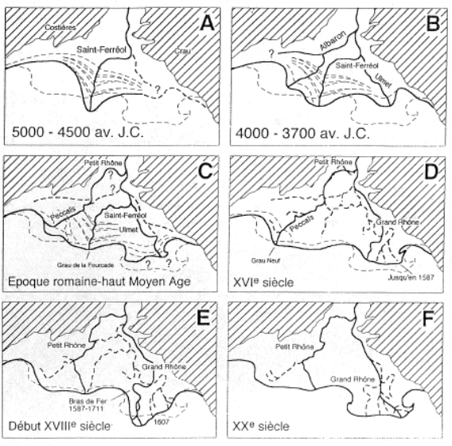
Bethemont, 1972

In addition to the wetland reduction by land use changes, the hydrological interventions greatly reduced tidal and marine influence to marshes, and water and sediments inputs associated with seasonal floods (figure 5).

Figure 5. A) Water natural inflows at the early 19th century. B) Hydrological fluxes disturbances after main hydrological works in the late 19th c. and early 20th c.
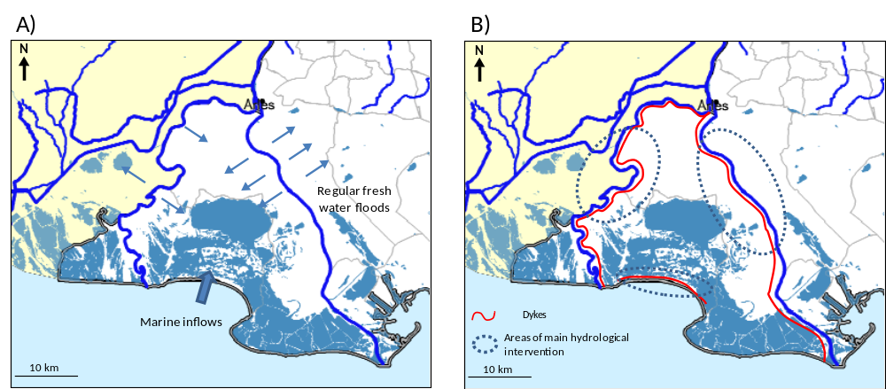

The lack of comprehensive statistics makes difficult to assess the net annual loss of nutrients and sediments once brought by floods. Moreover, the existence of dense network of canals connecting the upper wetlands to both Rhone streams, have introduced a great human driven variability for key ecological factors like water level and hence salinity (PNRC, 2004). Therefore, the variable seasonal water needs of rice crops and hunting marshes private lands –under private lands- determines the net freshwater inflow from the Rhone canals to the Camargue wetlands what defines at last the saline concentration and the presence of saline or fresh water dependent communities in the Camargue (Figure 6).
These population dynamics has introduced a degree of complexity to the management of the Camargue socio-ecosystem, where the lack of a comprehensive accounting of the real tradeoff between biodiversity changes and ecosystem services is one of the main medium and long term threats for its economic and ecological management.
Figure 6. Coupled variations between fresh water inflows, wetlands salinity, rice cultivation and communities specific diversity changes.
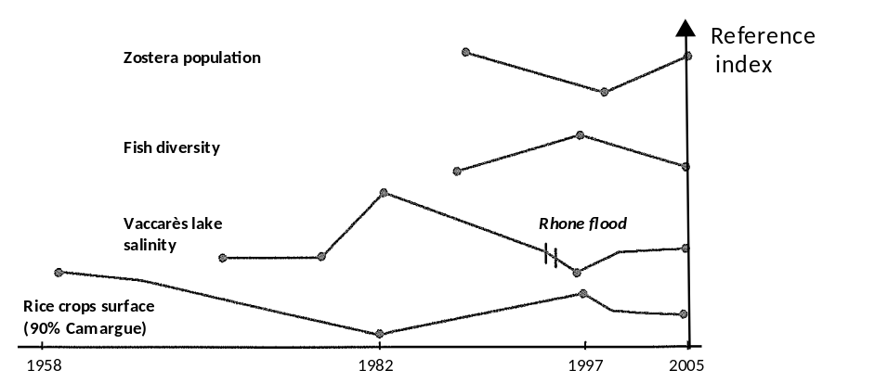
Perennou & Aufrey, 2007
Another important issue related to wetland services and water accounts is pesticide used for rice cropping, which pollutes water. Indeed, the Camargue wetlands and specially the Vaccarès lagoon system is polluted by –mainly- four herbicides; pretilachlor, bentazone, oxadiazon and MCPA. Different research works have dealt with the description and modeling of its life cycle, its behavior in the wetland system and bio-chemical degradation in (see Comoretto et al., 2007a and 2007b for France; Nakano et al., 2004 for Japan).

What’s the role played by the Camargue wetland ecosystem functions in degrading such pesticides? The answer is complex because of the different physic-chemical characteristics of such complex compounds. For instance, while MCPA and bentazone herbicides are soluble in water and do not get absorbed by organic matter, pretilachlor and oxadiazon present just the opposite physic-chemical behavior. Different ecosystem functions will then influence each of them. We adapt Comoretto et al. (2007a) research work, to understand how ecosystem functions have developed the ecosystem service of water depuration for these four pesticides (see Table 5).

Table 5. Wetland functions implicated in the ecosystem service of water purification through herbicide degradation.

wetland habitat |  | water bodies | water bodies | water bodies | soils | inflow average concentration (µg/l) | outflow average concentration (µg/l) | concentration reduction (µg/l)
 | wetland function | dilution | volatilization/ photodegradation | biodegradation | sediment sorption | inflow average concentration (µg/l) | outflow average concentration (µg/l) | concentration reduction (µg/l)
Pesticide | pretilachlor |  |  | x | x | 7,3 | 1,9 | 5,4
Pesticide | bentazone | x | x |  |  | 7,3 | 1,9 | 5,4
Pesticide | oxadiazon |  |  |  | x | 7,3 | 1,9 | 5,4
Pesticide | MCPA | x | x |  |  | 7,3 | 1,9 | 5,4

Modified from Comoretto et al., 2007a
The average inflow (ditches) and outflow (lwetlands) concentration of pretilachlor, bentazone, oxadiazon and MCPA was measured. The different ecosystem functions were able to reduce the initial herbicide pollution from 7,3µg/l to 1,9µg/l what supposed a decrease in 74% of the agricultural water herbicides pollution .

Species accounts
Species population changes from 1975 to 2000 shows a complex pattern (Figure 7). Indeed, species responds to a number of external stressors that are defined by their autoecology. Birds, fishes, amphibians, mammals are all respondent to a specific array of socio-ecosystem dynamics that may or may not converge. Birds’ population dynamics for example, are subject to a number of complex responses to environment variability: land use patterns and management practices –hunting, cropping- may have a comparable influence to population size than wintering survival rate (Barbraud and Hafner, 2001). Indeed, while ducks and coots seem to be highly affected by hunting activities (Tamisier and Dehorter, 1999), and purple/grey herons affected by reed bed harvesting, their population may vary in turn by other environmental stressors like the wintering survival rate above mentioned. This results in a varied population change (Figure 7). Another example is the Flamingo’s case: the knowledge on Flamingos’ autoecology and its associated habitats within salines areas has oriented strong conservation efforts towards protecting such nesting and feeding habitats, of a valuable economic productivity too, what has finally resulted in an increase and stabilization of its population. While the link between land use patterns, ecosystem services provision, agri-environmental policies and species’ population dynamics it is still a challenging debate, more examples on populations’ decrease or increase by direct land use changes may help understanding the issue. This is the case of sheep versus horse or bull populations. While sheep are still abundant in other nearby wetlands, specific land use and cattle choices in the Camargue have almost totally precluded such specie from that area.
Figure 7. Selected species population fluctuations between 1975 and 2000.
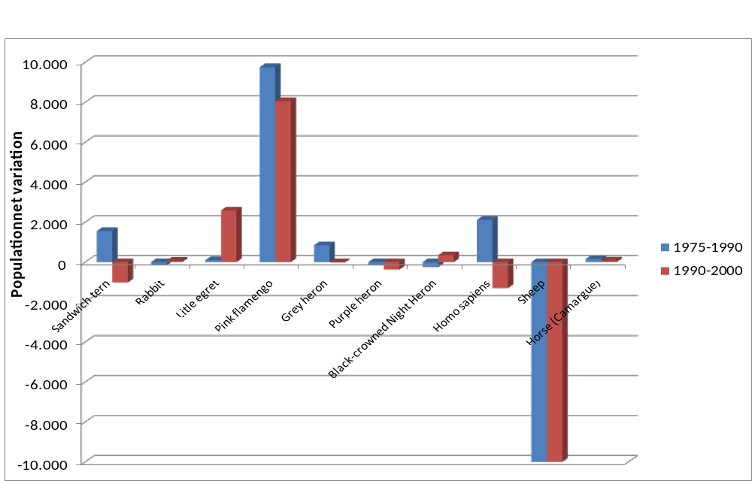
Tour du Valat data

Ecosystem services of the Camargue SES

As we have argued in the present report, the Camargue SES has undergone important mutations in the last century. Hydrological management, agriculture, salt works and industrial development in one side, versus strict conservation reserves in the other side, have been the main drivers of change of the Camargue SES.
As a result of such opposite land use patterns, and the derived user groups interests, the intellectual knowledge, statistics and scientific capital have remained sectorial: conservation groups have remained attached to the monitoring of specific communities or general land use change analysis, while user groups attached to main economic activities have not interacted actively with the scientific community in terms of continuing data sharing and communication. At the regional level, statistics and monitoring have remained at a descriptive level, and scattered between institutions and organizations.
The LEAC methodology and the analysis of ecosystems as complex open social-ecosystems are indeed revealing the need of such transdisciplinary approach, both in terms of monitoring, institutional synergic work and scientific research.
Therefore, data availability is good in terms of physical measurement of ES (Table 6) but extremely scarce in terms of economic concrete ES value (Table 7). Data on conservation expenses for the Regional Parc of Camargue are on the contrary available (Table 8).
Table 6. Physical measurement of some ES in Camargue wetlands (and coastal waters for fishing)
ES | Qantities
Rice | 120.000 t
Dry crops | 15.000 t
Vineyard (grapes) | 3.100 t
Cattle farming | 23.000 animals
Fishing (Camargue coast) | 4.000 t
Tourism | 500.000 visitors/yr
Refugee for biodiversity | 5684 recorded sp.
Sustainable crops (reed bed) | 3.500 ha
Hunting (ducks) | 150.000 preys
Salt production | 800.000 t

Regarding economic value, deeper problems arise, like the existence of a strong black market economy for getting access for hunting into private fresh water marshes (see Box 2).

Table 7. Recorded economic value for some Camargue ES.
ES | Annual value € (2000)
Provisioning services
Rice | 32.931.849
Dry crops | 2.798.889
Vineyard (grapes) | n.d.
Cattle farming | n.d.
Fishing (Camargue coast) | n.d.
Sustainable crops (reed bed) | 960.512
Hunting (ducks) | See Box 2
Salt production | n.d.
Regulating services
Refugee for biodiversity | n.d.
Water purification | n.d.
Socio-cultural services
Tourism | n.d.

Table 8. Overall budget of the Natural Regional Parc of Camargue
 | 2005 | 2006 | 2007 | 2008
Staff and other fix costs | 1 490 000 € | 1 600 000 € | 1 650 000 € | 1 600 000 €
Field actions’ budget | 254 000 € | 760 000 € | 790 000 € | 1 020 000 €
TOTAL | 1 744 000 € | 2 360 000 € | 2 440 000 € | 2 620 000 €

Box 2. The black market economy surrounding hunting permits.
Private landowners in the surrounding of the Vaccarès central lake maintain artificial freshwater wetlands all along the year for ducks. Foreign hunters get access to such private artificial freshwater wetlands after paying an important stumpage fee, not declared to the authorities. This hunting access informal stumpage fee represents an important source of income in the rural Camargue (Mathevet, 2000). Besides, hunting is strongly affecting duck populations and behavious (Mathevet & Dehorter, 1999). The lack of comprehensive statistics and a robust LEAC accounting prevents the implementation of effective policies to control hunting derived income and duck’s population loss.

This problematic is more urgent in the present deep integration of Camargue ES in the local, regional and national markets (Table 8). Recent ecosystem disturbances, like the high PCB concentrations found in the whole Rhone river catchment basin that have provoked the ban of fishing in all Rhone associated fresh waters, have not been coherently quantified in terms of economic and ecological functions impacts (SIEAU, 2008). This in turn, implies that preventive and corrective policies are less effective.Other cases may support such urgent need to implement a comprehensive LEAC methodology in the Camargue: to protect heron populations, the farmers have received important economic subsidies to support a heron nesting oriented management of reed beds. Results have not still been quantified, and the cost-effectiveness of such policies needs to be assessed to spread in the region.
Besides, recent fluctuations in salt price are driving new land use changes, and the Company of the Salines –in east Camargue- is preparing to transform part of its salt works in natural areas while converting another part of it into urban areas (J.-P. Taris, Sansouïre Foundation Executive President, pers. comm.). Agreements between local public and private institutions have been achieved, but although such issues are deeply embedded into LEAC issues, the land use agreement has precluded such analysis.
Table 8. Degree of integration in markets of the Camargue ES.
Carrier |  | Service-type |  | Category |  | Service | Full | Partial | None
Production | 1 | Provisioning | 1.1 | Food | 1.1.1 | Hunting | x
Production |  |  |  |  | 1.1.2 | Salt production | x
Production |  |  |  |  | 1.1.3 | Fishing | x
Carrier |  |  |  |  | 1.1.4 | Livestock |  | X
Carrier |  |  |  |  | 1.1.5 | Agriculture | x
Production |  |  | 1.2 | Materials | 1.2.4 | Fiber crops | x
Information | 2 | Socio-Cultural | 2.1 | Recreational | 2.1.2 | Ecotourism |  | X
Information |  |  |  |  | 2.1.3 | Landscape beauty |  | X
Information |  |  | 2.3 | Didactic | 2.3.1 | Education / interpretation |  | X
Information |  |  |  |  | 2.3.2 | Scientific research |  | X
Information |  |  |  |  | 2.3.3 | Traditional Ecological Knowledge |  | x
Regulation | 3 | Regulating | 3.1 | Cycling | 3.1.1 | Soil retention & Erosion control |  |  | X
Regulation |  |  |  |  | 3.1.2 | Hydrological regulation | x
Regulation |  |  |  |  | 3.1.4 | Pollination for useful plants |  | X
Regulation |  |  |  |  | 3.1.5 | Climate regulation |  | X
Regulation |  |  | 3.2 | Sink | 3.2.1 | Soil purification |  |  | x
Regulation |  |  |  |  | 3.2.3 | Water purification |  | x
Regulation |  |  | 3.3 | Prevention | 3.3.2 | Pest prevention |  |  | X
Regulation |  |  |  |  | 3.3.3 | Invasive species prevention |  |  | X
Regulation |  |  |  |  | 3.3.4 | Air quality |  |  | x

Under the present context, highly relevant studies appointing at what policies would be more effective –40.000 ha of natural areas under private management could be bought at a cost of 3.812 €/ha, a total 150 million € cost under 1991 land and money values (Tamisier, 1991)- cannot bet effectively assessed. Moreover, the Camargue case study clearly shows that the lack of a LEAC comprehensive approach leads to unavoidable land use, biodiversity management, and regional sustainable development inaccurate sectorial policies.

Refereneces:

Barbraud, C. & Hafner, H. 2001. Variation des effectifs nicheurs de héron pourpré Ardea purpurea sur le littoral méditerranéen français en relation avec la pluviométrie sur les quartiers d’hivernage. Alauda 69 373 :380.
Bethemont, J. 1972. Le thème de l’eau dans la vallée du Rhône : essai sur la genèse d’un espace hydraulique. University of St Etienne, St Etienne.
C.F.R. 1995. Du débouché à la culture : le riz. ITCF – Centre Français du riz, Arles.
Comoretto, L., Arfib, B. and Chiron, S. 2007a. Pesticides in the Rhone river delta (France): Basic data for a field-based exposure assessment. Science of the Total Environment 380 124:132.
Comoretto, L., Arfib, B., Romain, T., Chauvelon, P., Pichaud, M., Chiron, S. and Höhener, P. 2007b. Runoff of pesticides from rice fields in the Ile de Camargue (Rhône river delta, France): Field study and modeling. Environmental Pollution 20 1:8.
Isenmann, P (Ed.). 2004. Les oiseaux de Camargue et leurs habitats. Une histoire de cinquante ans 1954-2004. Buchet/Chastel, Paris.
Lemaire, S., Tamisier, A. & Gagnier, F. 1987. Surfaces, distribution et diversité des principaux milieux de Camargue (France). Évolution para analyse des photos aériennes (1942-1984). Rév. Écologie et Terre (Terre et Vie), issue 4 : 47-56.
Mathevet, R. 2000. Usages des zones humides camarguaises: Enjeux et dynamique des interactions Environnement/Usagers/Territoire. Unpublished PhD. University of Lyon, France.
Perennou, C. & Aufray, R. 2007. L’évolution de la Camargue depuis 60 ans: synthèse des données quantifiées. Unpublished report. Tour du Valat. Le Sambuc, France.
Parc Naturel Régional de Camargue (PNRC). 2004. Étude hydraulique et hydrobiologique des canaux de Camargue. Unpublished report. PNRC, Arles.
Systéme d'Information sur l'Eau - SIEau - du bassin Rhône-Méditerranée. 2008. Information available at http://www.rhone-mediterranee.eaufrance.fr/milieux-continentaux/pollution_PCB/index.php.
Tamisier, A. 1990. Camargue : Milieux et paysages. Évolution de 1942 à 1984. CNRS, Montpellier.
Tamisier, A. 1991. La Camargue, Mythe et réalité. Procedures of « Demain, quel littoral ? ». Conservatoire du littoral, Assemblée Nationale, 12-13 June 1991, Paris.
Tamisier, A. and Dehorter, O. 1999. Camargue, canards et foulques. Centro Ornithologique du Gard, Nîmes.

