- Summary accounts of stocks & flows of land cover of European Mediterranean wetland socio-ecosystems

The European Mediterranean is covered now with Corine land cover. 1990 and 2000 are the base years; in addition a special inventory of the 10 km coastal strip has been carried out for 1975 (under projects LaCoast/JRC and Eurosion/DG Environment & EEA). Corine being currently updated for 2006, a 30 years perspective will be given with this medium resolution database. The chapter will present and comment LEAC type accounts and derived aggregates of ecosystem integrity: flows 1990-2000 for the SES wetlands mapped as explained in Chapter 3, grouped by NUTS1, land cover and land cover change 1975-1990-2000 for the 10 km coastal strip and aggregated indicators for SES wetlands grouped by NUTS2.

  - Land cover stocks and flows (LEAC), 1975, 1990, 2000
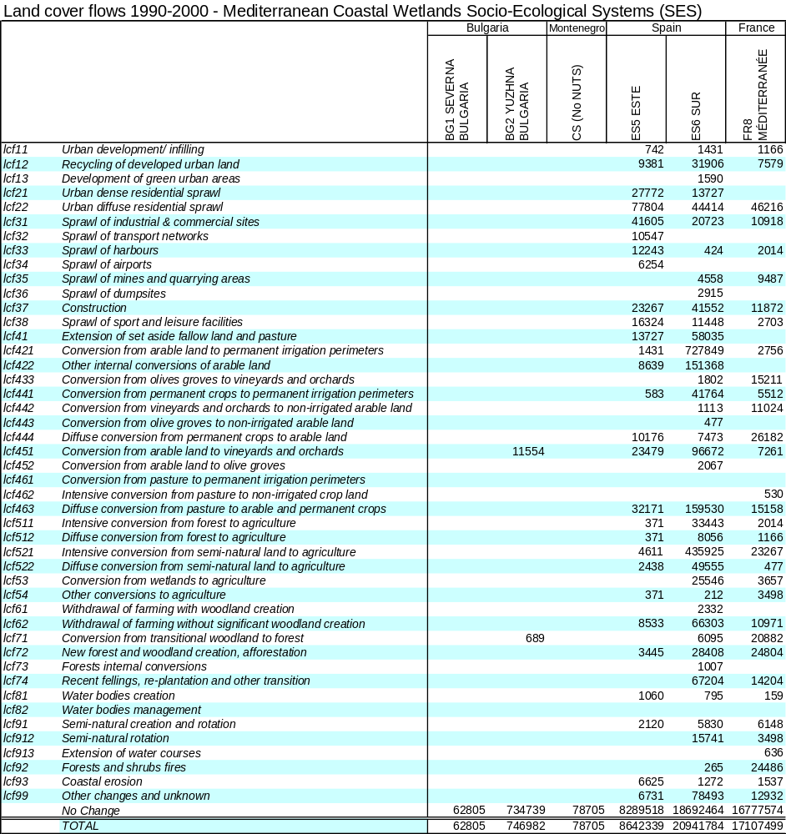
Table 4.1 (A) Land cover flows 1990-2000 in European Mediterranean wetlands

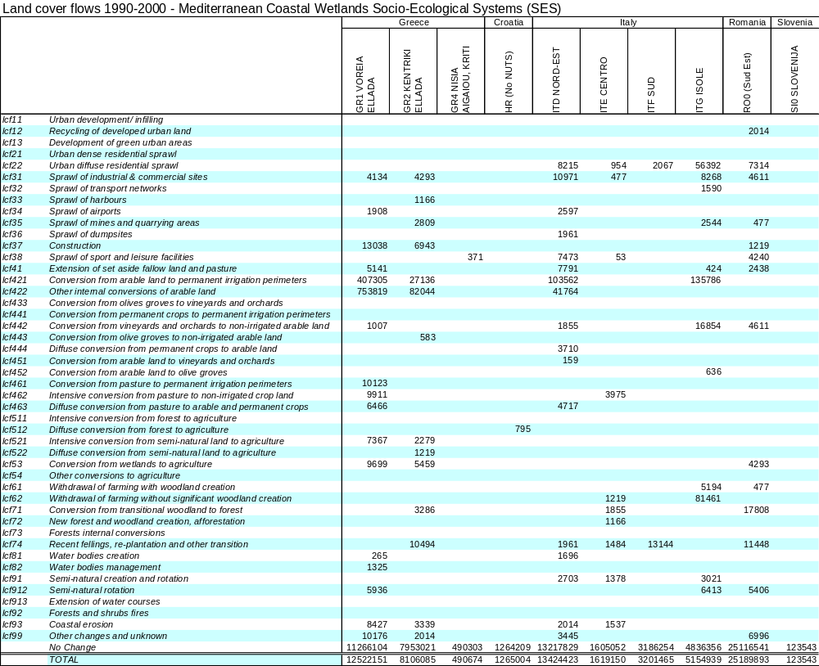
Table 4.1 (B) Land cover flows 1990-2000 in European Mediterranean wetlands

The table of flows accounts refers to the land cover accounts methodology published by the EEA. Flows group the 1936 possible 1 to 1 individual changes of the Corine matrix according to a limited number of processes which can be understood and interpreted. If necessary, flows can be cross analysed with land cover types. The results here are presented by NUTS 1, an administrative breakdown mostly used for land planning. The structure of the data base where land cover and change are gridded at resolutions of 1 hectare x 1 hectare, and then aggregated into 1km x1 km for fast calculations and integration with other types of data (socio-economic statistics, meteorology etc…).

The tables are expressed here in hectares. They show on the average limited changes but, in some regions, significant conversions which may impact the integrity and health of the wetlands.

Urban sprawl (residence and infrastructures) is noticeable during that period in Mediterranean wetland SES of Spain as well as (to a minor extent) in France and Italy.

The extension of irrigation perimeters (lcf421) which are often in competition for water with wetlands is very important in the South of Spain, in Greece and North East Italy.

Conversion of wetlands to agriculture (lcf53) is more limited but still taking place, which is somehow surprising for ecosystems widely protected. It is going together with a continuation of the conversion of other natural or semi-natural land to agriculture. The phenomenon in costal areas has been analysed as an indirect consequence of urban sprawl over crop land, which pushes farmers to cultivating marginal land for maintaining their activity in the area.

Socio-ecosystem wetlands and/or natural parks where forest is a significant land cover show up an important rotation of felling and plantation. The apparently balanced situation should be scrutinized regarding risks of impoverishment of the habitats.

  - Land cover flows, stocks and change (LEAC), 1975, 1990, 2000 – 10 km coastal strip

A large part of European wetlands are located alongside the coast, particularly in the Mediterranean. The analysis of the land cover flows on the coastal strip from 1975 is therefore of high interest.

On interesting finding is that when comparing the 2 periods 1975-1990 and 1990-2000, the speed of land cover changes has slowed down in France and in Italy but oppositely has increased in Spain.

Detailed tables present the results. Although the fact that the 1975 inventories follow the Corine methodology, they don’t present the same detail. Therefore, separate analysis of change has to be carried out for the 2 periods. As well, more detail is available for wetlands in 1990 and 2000. The tables are:
- Table 4.2 Land cover flows 1975-1990-2000
- Table 4.3 Land cover 2000 and 1990 (Corine land cover)
- Table 4.4 Land cover 1990 and 1975 (Source: Lacoast and Eurosion)
- Table 4.5 (A) Land cover 2000 – with details for wetlands
- Table 4.5 (B) Land cover 1990 – with details for wetlands

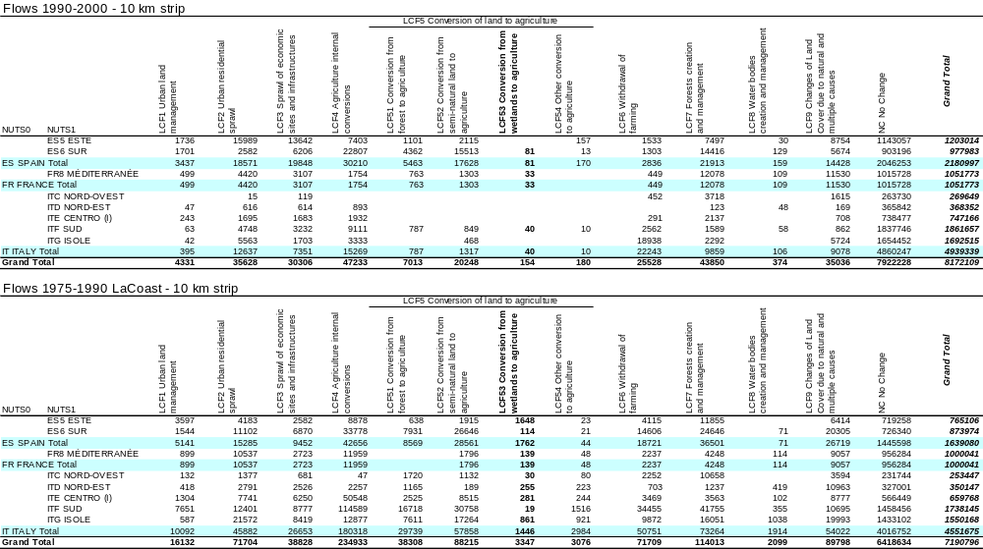 Table 4.2 Land cover flows 1975-1990-2000 in European Mediterranean coastal strip

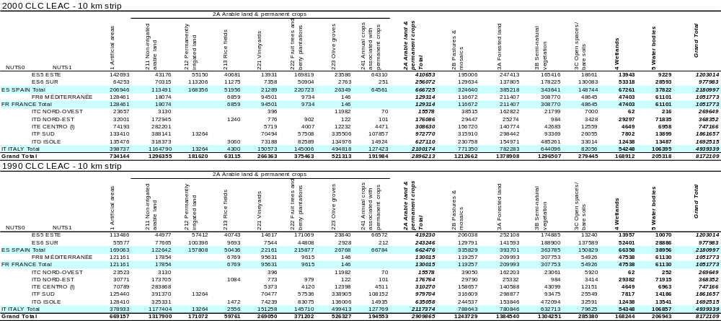 Table 4.3 Land cover 2000 and 1990 in European Mediterranean coastal strip (Corine land cover)

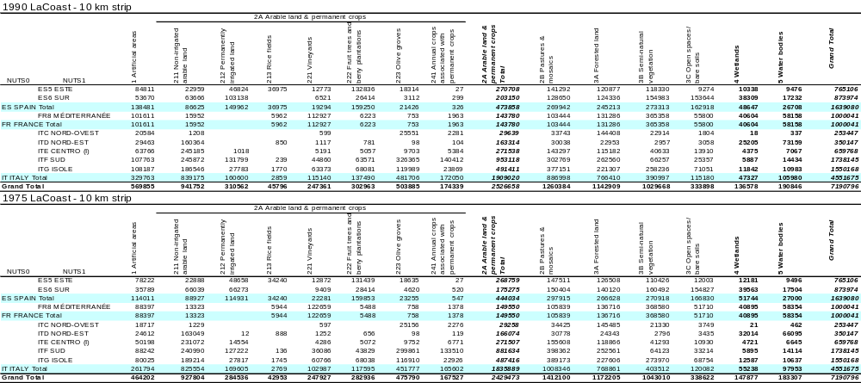Table 4.4 Land cover 1990 and 1975 in European Mediterranean coastal strip (Source: Lacoast and Eurosion)

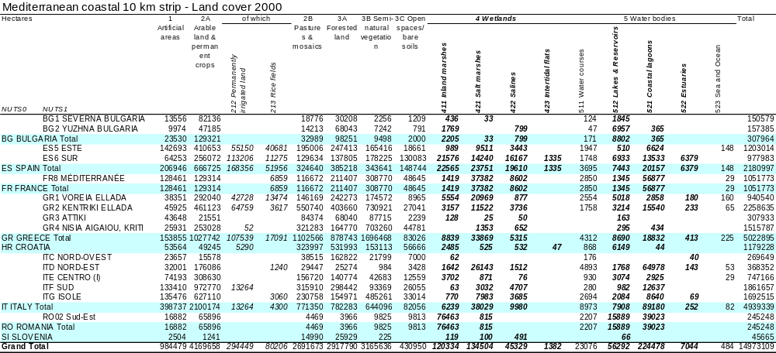Table 4.5 (A) Land cover 2000 in European Mediterranean coastal strip – with details for wetlands

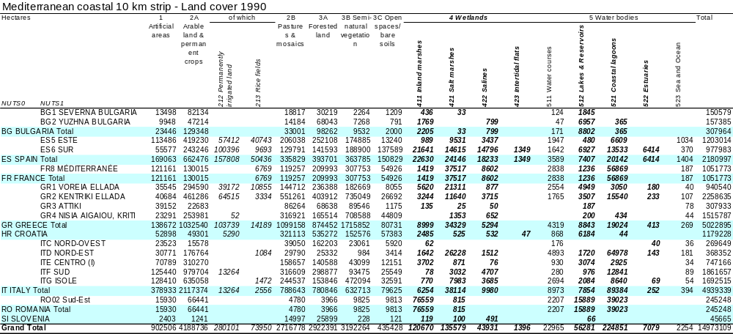Table 4.5 (B) Land cover 1990 in European Mediterranean coastal strip – with details for wetlands

  - From land cover to ecosystem and ecosystem services accounts

    - Aggregated landscape physical indicators (state and change 1990-2000)

In addition to monitoring (and accounting for) land cover change, Corine land cover has been used for spatial modelling in order to assess landscape potentials for supporting biodiversity and pressures on these landscapes. For this kind of macro assessments, the focus is on the importance (or weight, potential, temperature, influence, attraction …) of geographical objects on the land that they cover as well as in their neighbourhood. Technically, maps are derived from land cover and other maps by smoothing the real value within a grid (commonly 1km² grid or 1 ha for some applications), giving them a value to neighbouring grid cells decreasing with the distance from the core cell. A formula commonly used shrines the neighbouring values with the square of the distance between cells, the calculation being limited to a span of 5, 10 or 20 km. The methodology is detailed in the EEA report 11-2006, “Land cover accounts for Europe 1990-2000”. Smoothed layers of Corine land cover have been computed for 1990 and 2000 and are disseminated by the EEA dataservice under the acronym of CORILIS. On particular mathematical property of the CORILIS layers is that they are additive, the total of the values of the different classes expressed in %age being 100 in each and every grid cell.

Using the same reference grid, similar computations can be made for any variables such as various zonings (e.g. nature protection) or statistics (e.g. population).

The indicators used in ecosystem accounting are first of all strictly based on Corine/CORILIS. They are principally:

- Urban temperature, which describes the pressure of urban and artificial land use within and in the neighbourhood of an ecosystem.
- Intensive agriculture temperature, the same for broad pattern arable land and permanent crops.
- The total of the 2 indicators is the temperature of intensive land use. Its supplement to 100 is called the Green Background Landscape Index (GBLI) which maps and measures the landscapes more favourable to nature, because of their own naturalness (forests, wetlands…) or their capacity of supporting ecological networks (pasture and mosaic agriculture). GBLI is as well the sum of the corresponding Corine/CORILIS classes and can be decomposed if there is any need to set aside a particular class (e.g. plantations of eucalyptus, intensively managed large pasture areas…). Simple (but reproducible and modifiable), GBLI is a first proxy of landscape potentials related to nature.

One limitation of GBLI is that it is based on satellite images (which allow exhaustiveness and repetitive monitoring) which ignore the local complexity of landscapes and the richness of the biodiversity that they host. In order to overcome the difficulty, an indicator is produced on the basis of the information collected for nature conservation. At the macro level, a first simple indicator reflect the designation of areas for European or national protection: this is the result of intensive field work by scientists and political action environmental agencies involving significant budgetary costs. There is there therefore a serious presumption that the designated areas have a high ecological value. Technically, various designation maps are merged (to bypass heterogeneity resulting from political strategies) and smoothed to reflect some importance of these areas in their neighbourhood. The dataset is named NATURILIS.
Adding GBLI and Naturilis gives a better picture which reflects various situations such as:
  - green landscape which is designated : the highest value
  - green landscape which is no designated because of more common habitats: some value anyway given by GBLI but less than the previous case
  - intensively used landscape (low GBLI) where niches host rare or endangered species, and which are therefore designated for conservation: their value is captured by the NATURILIS index.
  - intensively used landscape which are not designated and which are considered as having a lower ecological value

In this approximation process, an important element is still missing and relates to the functioning of landscapes. The solution is to incorporate an adequate indicator of fragmentation. The solution currently used is the measurement of the Effective Mesh Size (MEFF). The MEFF value can be interpreted as the expected size of the area that is accessible when starting a movement at a randomly chosen point inside the reporting unit (in our case 1km grid) without encountering a physical barrier. So the higher is the MEFF value, the less fragmented is the area around.

When combining GBLI, NATURLIS and MEFF, we get an aggregate which captures important aspects of ecosystem integrity. This aggregate is named Net Landscape Ecological Potential (NLEP). It can be monitored and produce a first overall assessment of the ecosystems condition.

Of course, not all important aspects are incorporated at this stage and the indicator has to be supplemented with 4 other indicators (and accounts) : a species based indicator (designated areas may face changes), an indicator of net primary productivity, an indicators of river ecosystems and an indicator taking stock of the small features not observed by satellite imagery. Elements of such indicators are presented in the local case studies.

These are macro indicators, which implementation has started at the European scale and which could be implemented at the global level in the context of the global Earth observation programmes. They can be as well downscaled to the regional and local levels and provide important gateways between the levels of policy framing and assessment and the levels of action.

    - Result for the Mediterranean Wetlands (state and change 1990-2000)

Maps and tables […]

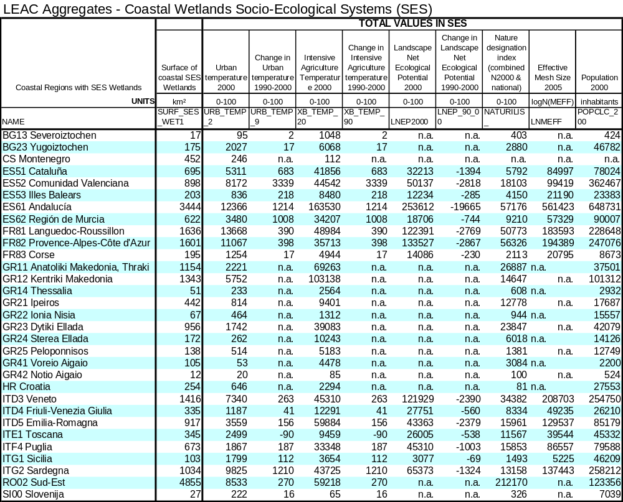
Table 4.6 Physical aggregates from land and ecosystem accounts – total values by NUTS2

The absolute values of the indicators can be presented by grid cells. An example is presented below for LNEP and Change 1990-2000 in LNEP. This presentation shows up the spatial distribution of the indicator.

In that sense, a gateway between the meso and micro scales is established. Of course, not all details are given in each grid cell, an aggregate instead. But this grid-cell aggregate has a meaning for the local actors:
- it allows comparing the local situation to its environment;
- it helps in comparing any local case with similar cases elsewhere in Europe;
- the change has a strong overall meaning, would it be the pressure from the neighbourhood (so-called temperature) or the resulting state summarised by LNEP.

And of course, these aggregates are meaningful for framing policies and assessing their implementation.

The maps below, where an overlay of socio-ecosystem wetlands boundaries has been made show clearly important differences in Socio-Ecological Systems (SES) ecological potential, resulting in particular from the importance of rice fields. The evolution of the indicator indicates an important intensification of land use in SES in Spain, less in France.
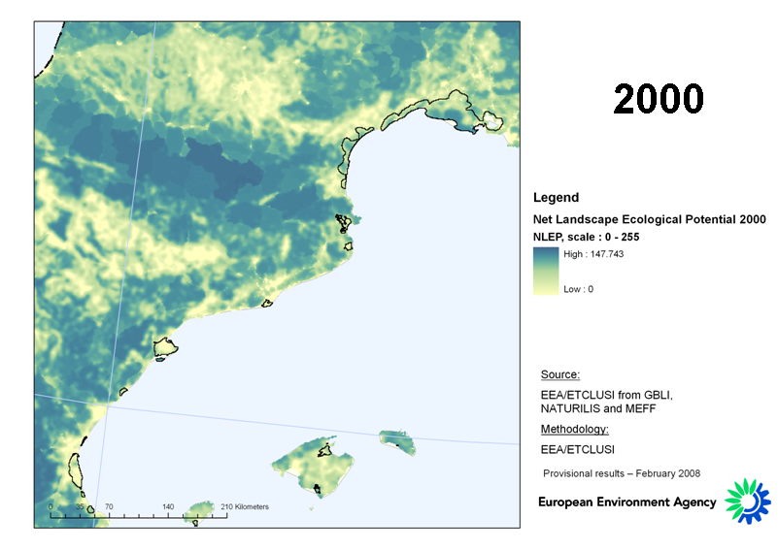
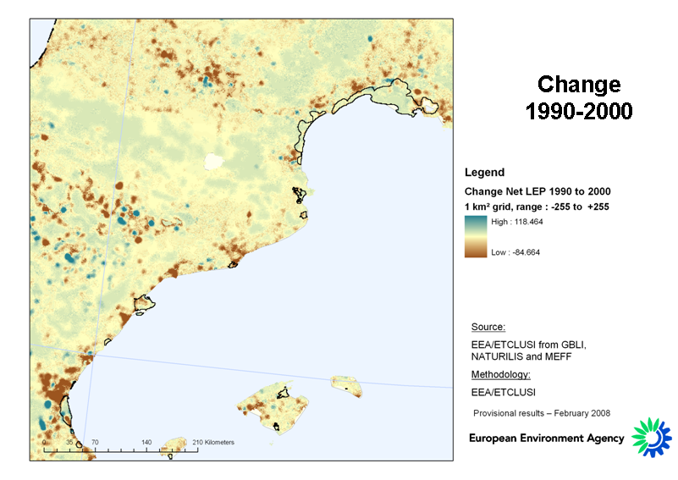
Figure 4.1 Landscape Ecological Potential 2000 and change 1990-2000 – North West Mediterranean – overlay of socio-ecosystem wetlands boundaries.

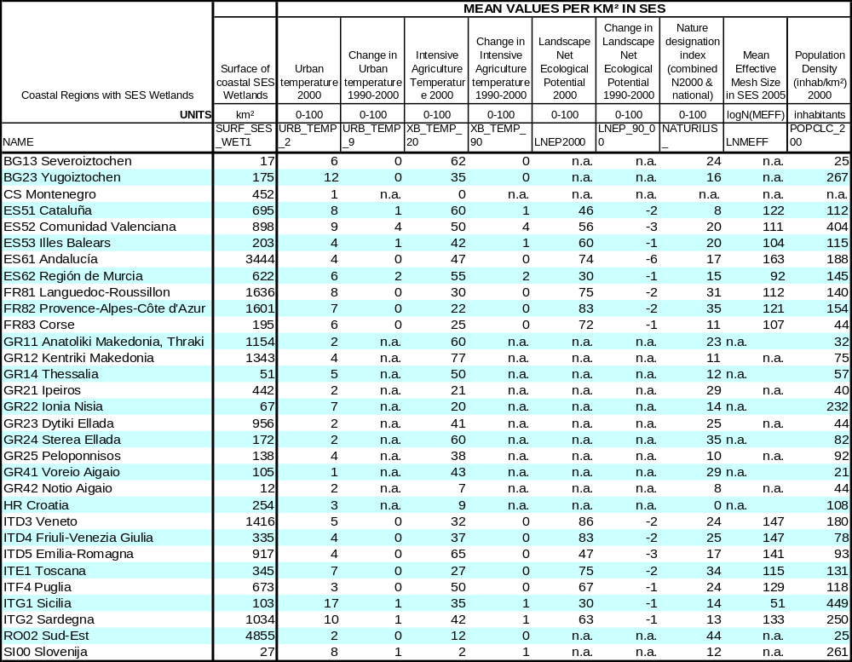
Table 4.7 Physical aggregates from land and ecosystem accounts – Mean values by NUTS2

Table 4.7 compares the mean values of the indicator (as Total Value/ SES surface) in NUTS2. The slow degradation of the ecological potential due to SES wetlands is general. The results of Table 4.7 are illustrated by the following maps:
- Figure 4.2 Mean Pressure/Temperature from Intensive Agriculture over SES Wetlands, 2000 and Change 1990-2000
- Figure 4.3 Mean Pressure/Temperature from Urban land use over SES Wetlands, 2000 and Change 1990-2000
- Figure 4.4 Population density in SES Wetlands
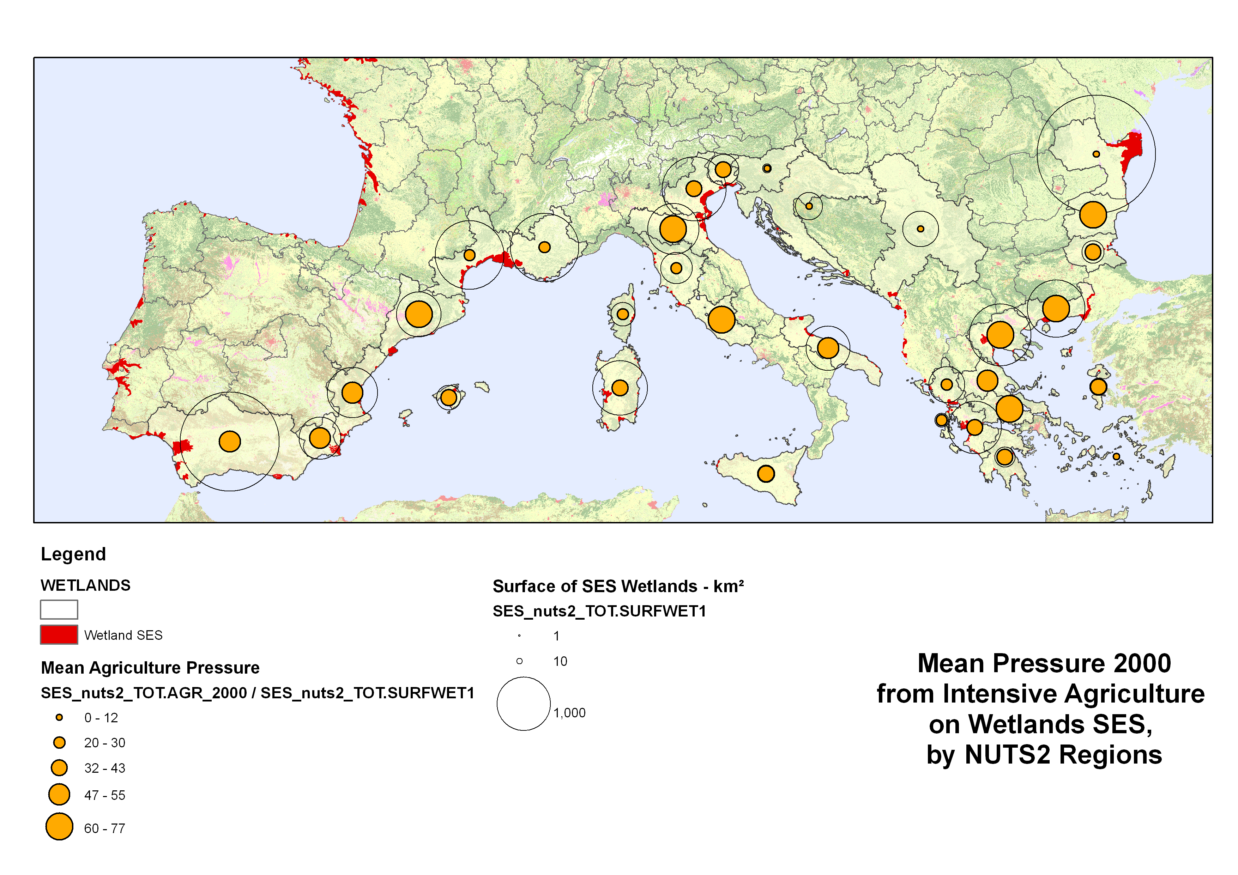
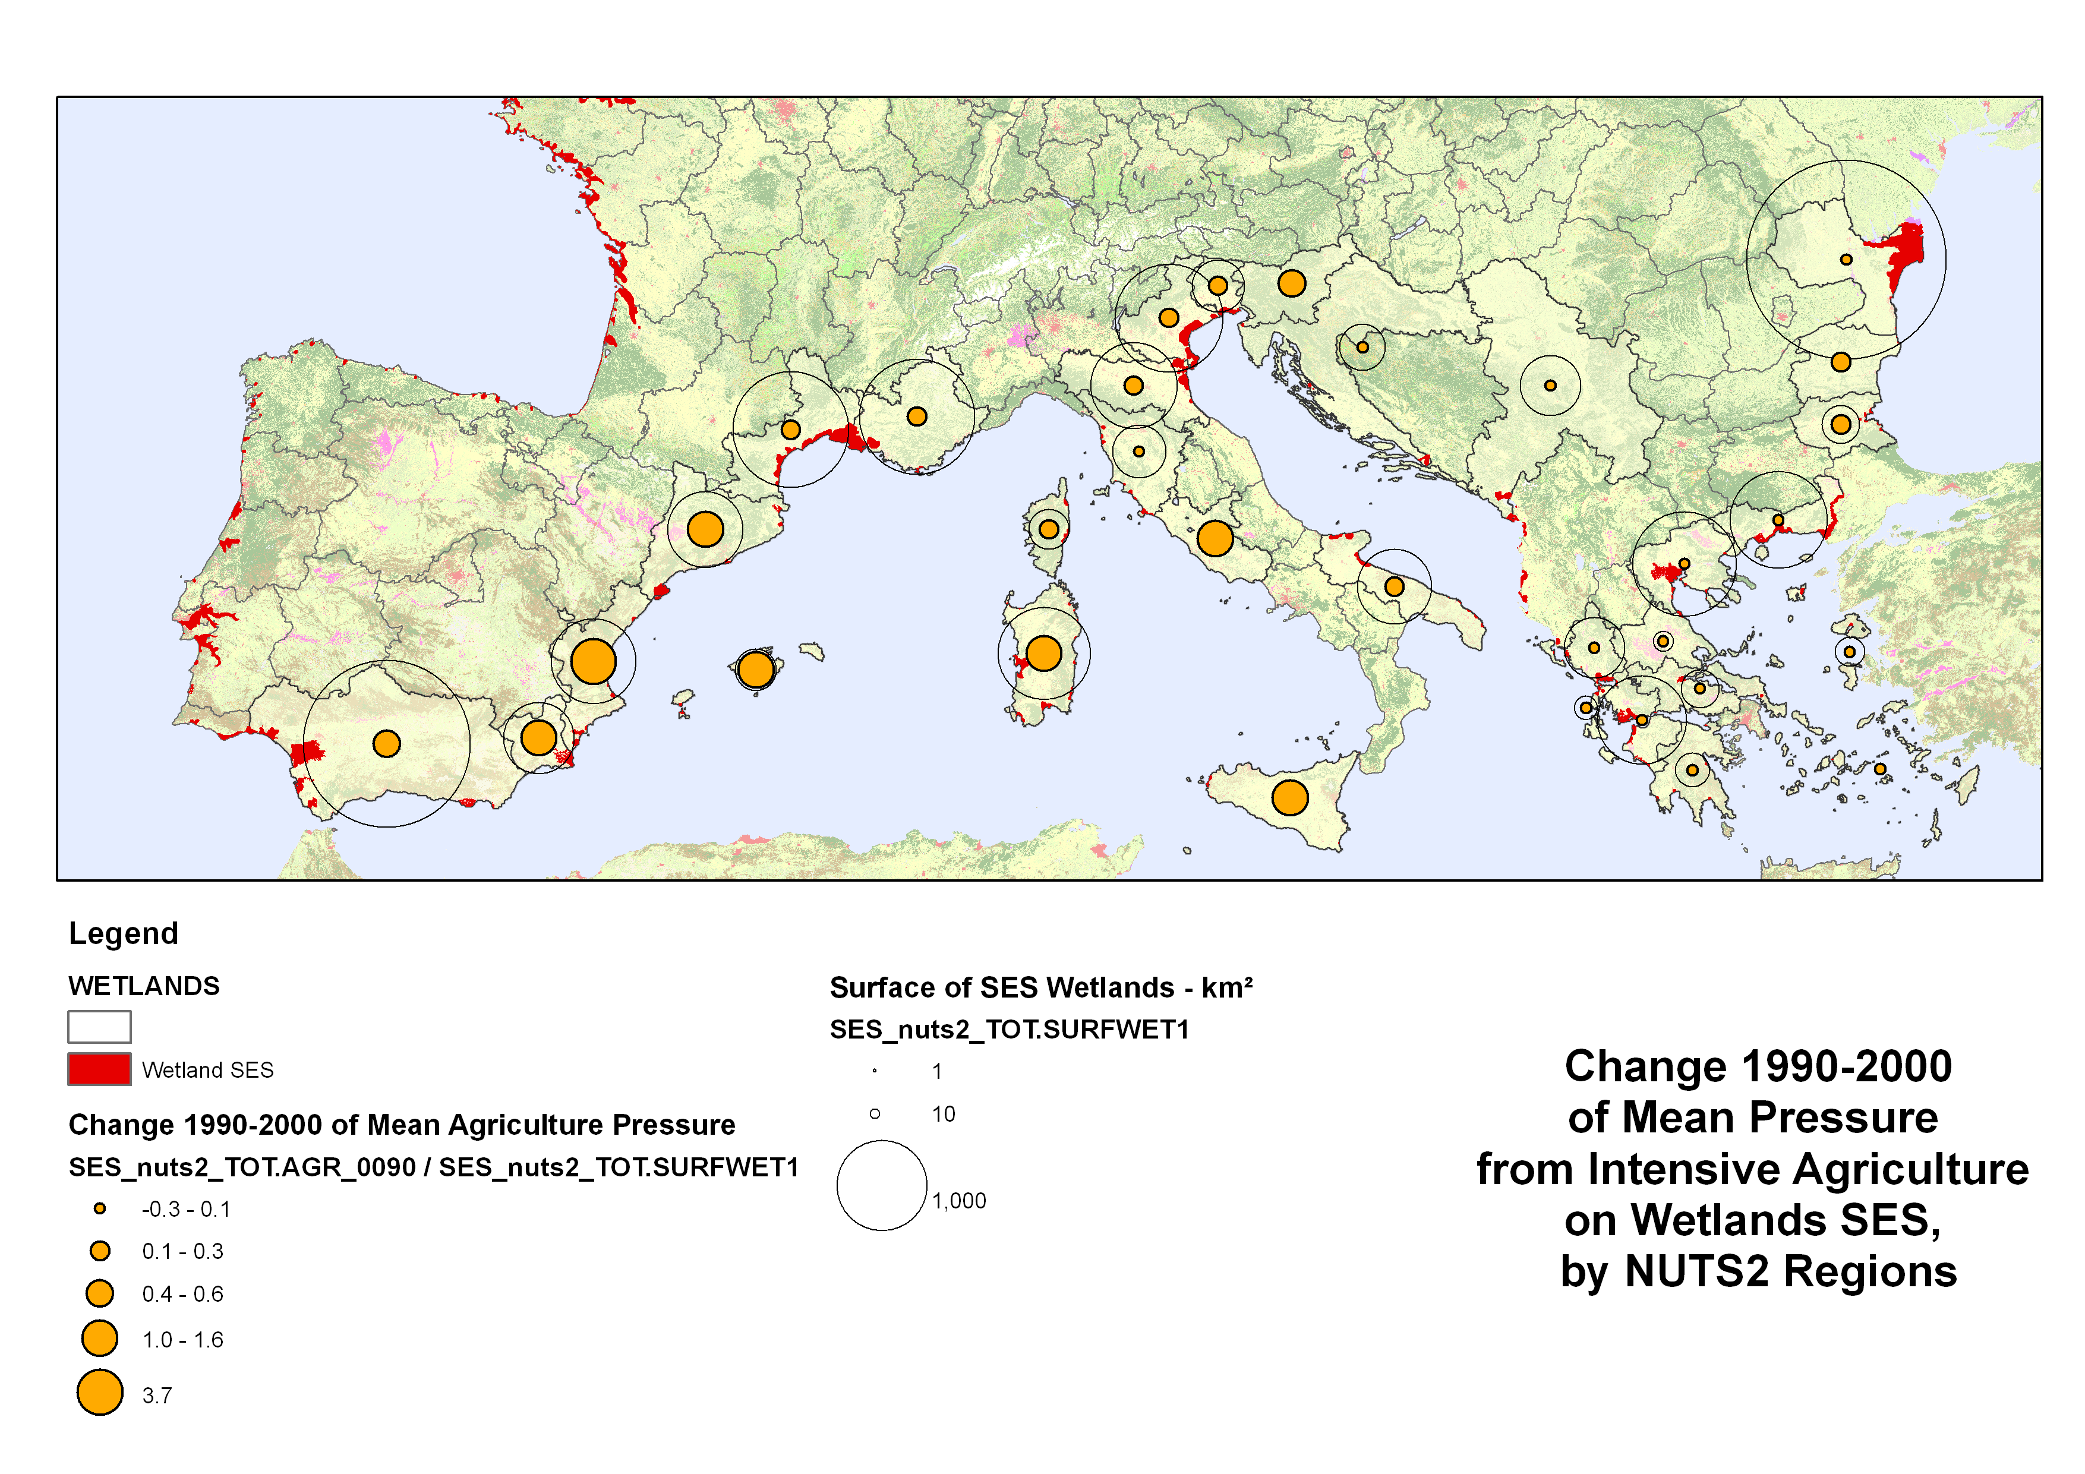
Figure 4.2 Mean Pressure/Temperature from Intensive Agriculture over SES Wetlands, by NUTS2, 2000 and Change 1990-2000
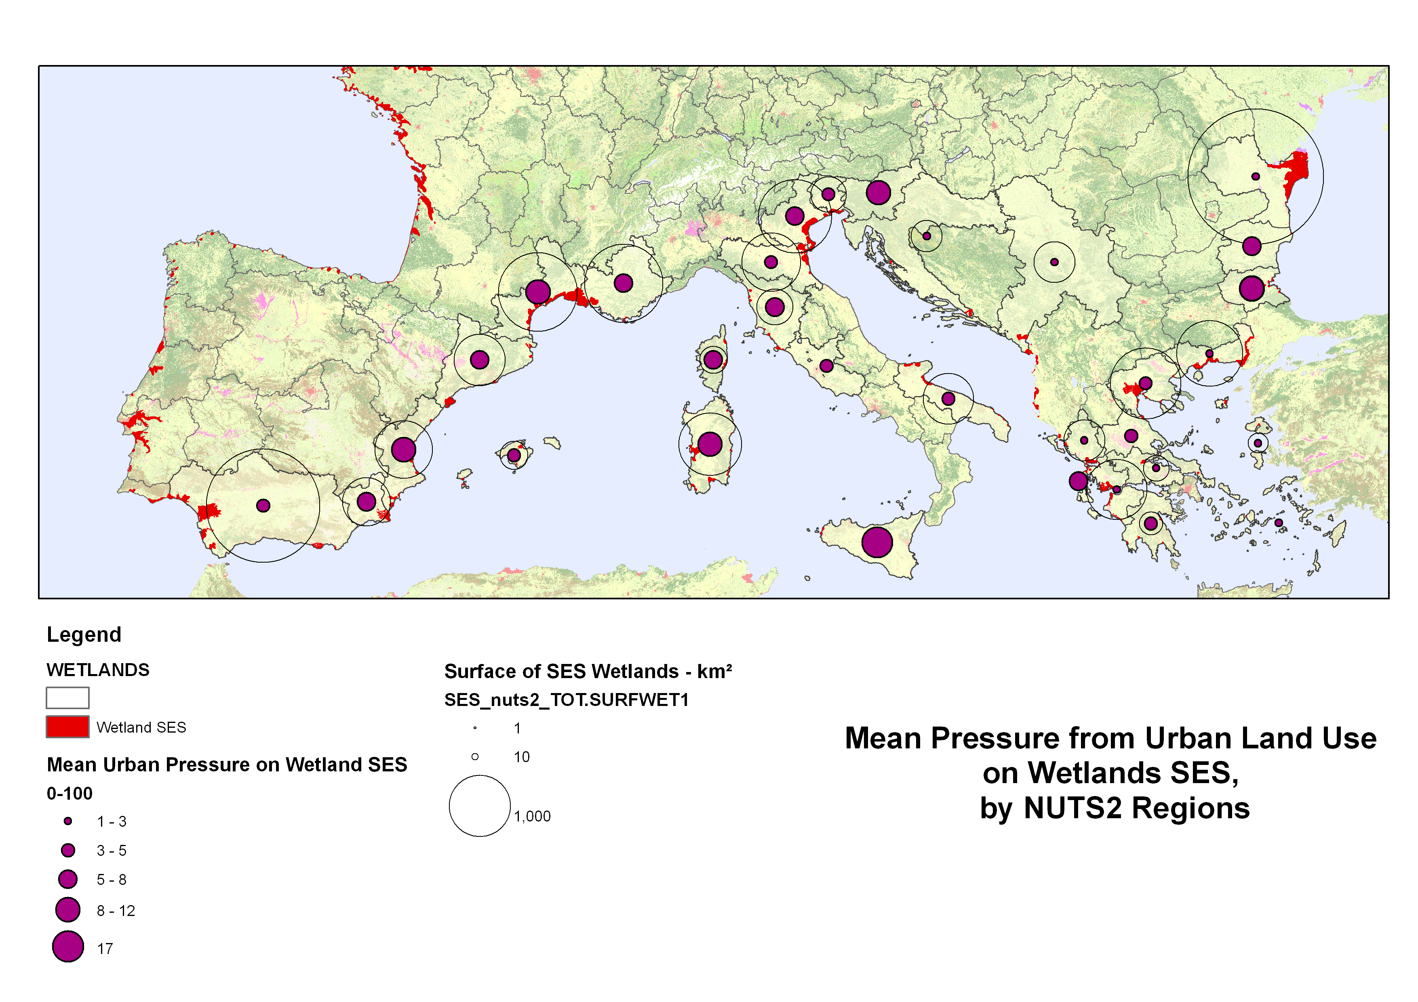
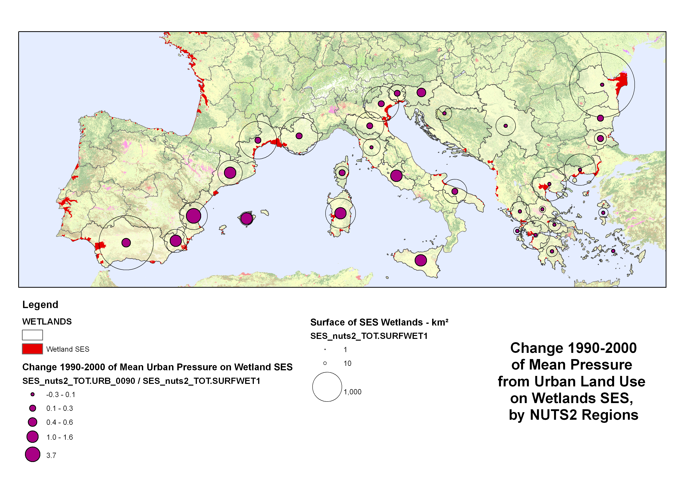
Figure 4.3 Mean Pressure/Temperature from Urban land use over SES Wetlands, by NUTS2, 2000 and Change 1990-2000

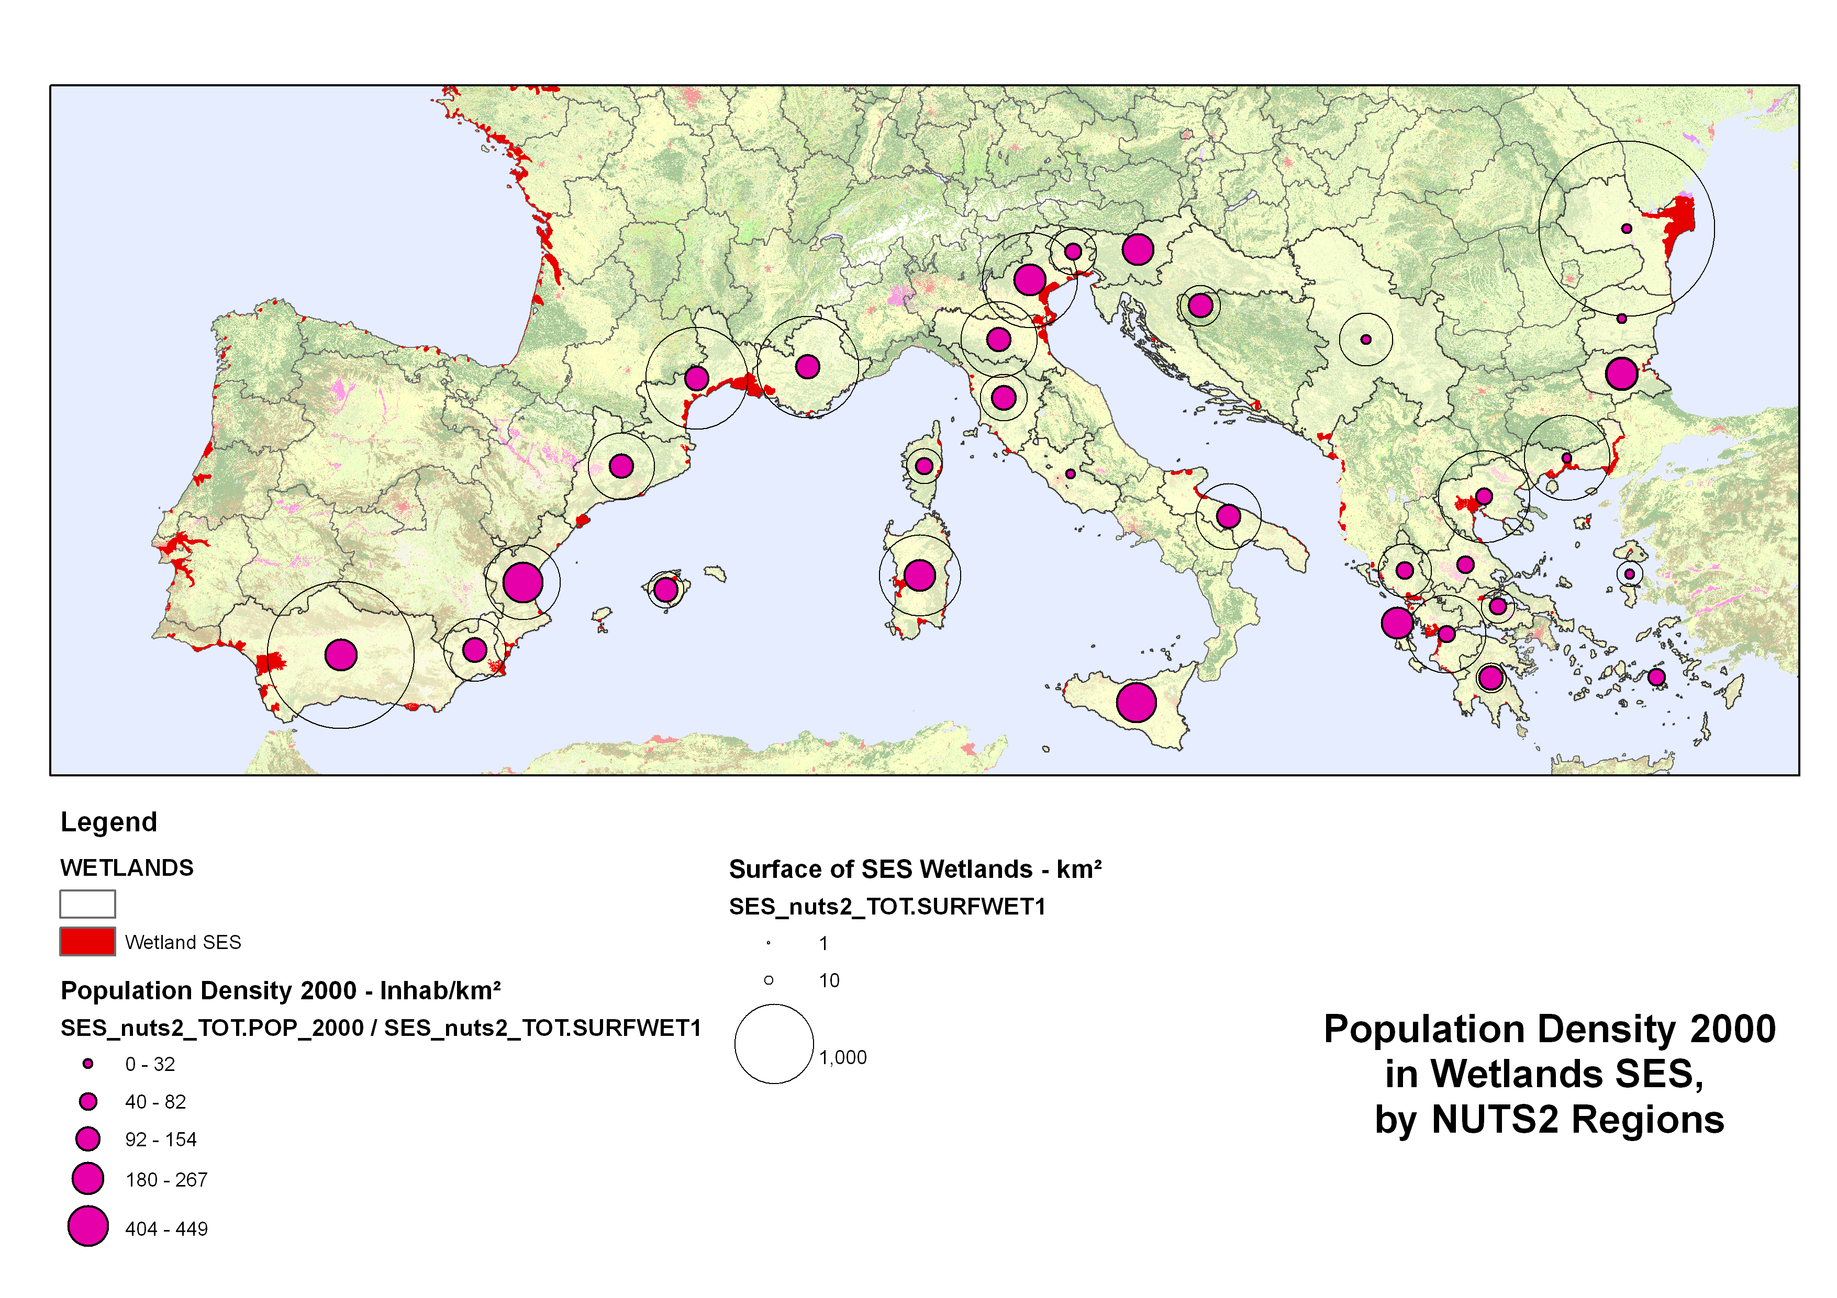
Figure 4.4 Population densities in SES Wetlands, by NUTS2 – 2000

Comments: increase of intensive agriculture and urban “temperatures” (combined pressure within the wetland systems and in their neighbourhood) – in particular in West Mediterranean.
[…]

  - Further accounting for ecosystem health/resilience at the Mediterranean meso scale

- Landscape micro and linear features, ecotones
- Resilience of species communities: specialism index, biodiversity intactness
- NPP and HANPP

Physical accounts as a basis for computing maintenance and restoration costs […]

  - Land cover, land use and practical assessment of ecosystem services

Biodiversity supports ecosystem resilience ecosystem functioning and therefore possible services

The assessment should distinguish between ecosystem services according to their dependence from biodiversity:
- Closely dependent (products of family agriculture, picking plants, some recreation and regulation services)
- Dependent on a longer term (e.g. intensive agriculture or forestry, fish farming)
- Not directly dependent from biodiversity (e.g. extraction of salt in wetlands)

Services are services to people, of given socio-economic groups, somewhere. Measuring ecosystem services in physical steps leads to produce this kind of matrix (or tensor, more than 2 dimensions matrix).

This spatial and multidisciplinary approach is necessary in order to streamline the issue of “benefits transfers” from particular local case studies to overall assessments. This is a step necessary for avoiding double counting of services and for giving more credibility to shadow pricing […].

