Copenhagen, 4 October 2010

Land cover classification in the revised SEEA

Outcome paper
(draft for discussion)

Jean-Louis Weber, EEA

Land cover accounts and land classification have been addressed in the 13th London Group meeting in Brussels, 2008 which has concluded in the need for two position papers to be prepared, on land use and land cover classification. These papers have been drafted respectively by FAO and by the EEA and submitted to the 14th meeting in Canberra, 2009. The present outcome paper from the London Group introduces and presents the proposed Land Cover Nomenclature to be adopted in the revised SEEA.

The theoretical distinction between land cover and land use is well established. Land Cover refers to the observed physical and biological cover of the Earth's land as vegetation or man-made features. Land Use reflects the total of arrangements, activities, and inputs undertaken in a certain land cover type (a set of human actions). The social and economic purposes for which land is managed (e.g., grazing, timber extraction, conservation) is a land use characteristic.

The discussions in Canberra resulted in the following positions:
- Land use has to be defined in the SEEA in the sense of the conventional agriculture and forestry statistics which currently record the productive land use only. Therefore, the current FAO classification fits the most SEEA requirements and has just to be supplemented details for urban and other artificial land uses. The UNECE classification of land use was recommended as the basis for achieving quickly such enlargement. Other land use functions (or land functions) which deliver non-productive ecosystem services may co-exist on the same parcel of land will be recorded separately.
- Land cover nomenclatures or legends result from classification processes combining visible attributes of land selected according to landscape characteristics, policy or research purposes and data sources (administrative data, sampling or remote sensing). Land cover being altogether the observed image of ecosystems and of the effects of land use, practical classification may put the emphasis either on vegetation forms or on landscape features shaped by land use. Therefore, producing a detailed multipurpose nomenclature is not an option. The general approach by FAO is that of a Land Cover Classification System (LCCS) made of a set of consistent rules and a software tool allowing the production of consistent classifications in a variety of different conditions. This is the basis of land cover classification. Considering the international standard for environmental accounting, the opinion was to limit it to a set of circa 15 classes. This solution meets the requirements of international comparability and allows straightforward translation into the main land cover nomenclatures currently used. It allows as well further coherent developments of disaggregated nomenclature classes, fit for particular conditions.

The conclusions of the Canberra meeting have been presented to the UNCEEA in June 2009 in the document:
“ Land Cover and Land Use Classifications in the SEEA Revision, ESA/STAT/AC.189, UNCEEA/4/11, discussion paper drafted by Xiaoning Gong (FAO) & Jean-Louis Weber (EEA), Fourth Meeting of the UNCEEA , 24 - 26 June 2009, UN Headquarters, New York
http://unstats.un.org/unsd/envaccounting/ceea/meetings/UNCEEA-4-11.pdf ”.
It contains in particular an illustration of the relation Land Use-Land Cover and their connection respectively to economic statistics and to ecosystem accounts.
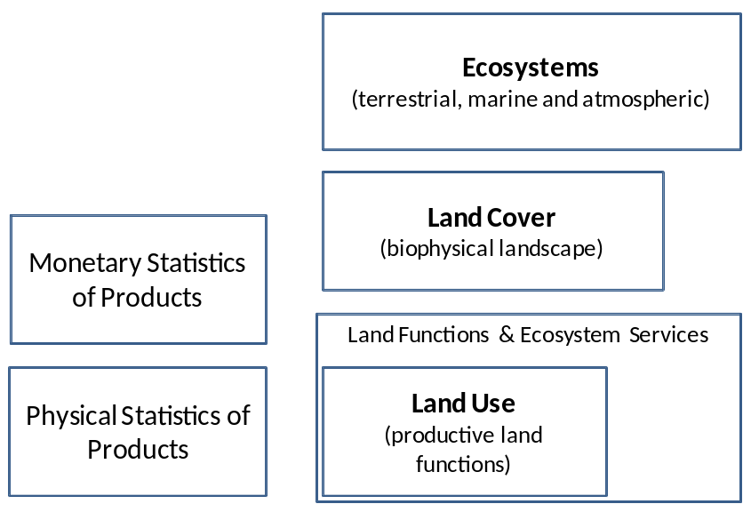

The various papers discussed so far are listed in annex. They present reflexions on land classification which will only be summarised below. The annex presents as well the bibliography of the main reference documents.

- Characteristics of the SEEA Land Cover Nomenclature
The SEEA-LC has to be:
- Fit for accounting for land cover change: the analysis of change between two dates has to inform clearly of the main processes taking place as well as of their meaning regarding the socio-economic drivers. Unnecessary detail in natural land should be avoided when change between these classes are not likely to happen. Instead, direct information on urban sprawl (and the main types of land consumed), intensification of agriculture, afforestation and deforestation have to be easily readable. It includes requirements of IPCCC in accounting for “activities” and “conversions”, when land cover data is used as a proxy of land use.
- Easy to connect to land use statistics in order to facilitate joint uses. This is in particular important when addressing climate change issues like carbon release and sequestration from agriculture land and the establishment of carbon balance integrating agriculture yields by types of crops and for forestry.
- Easy to connect to ecosystem accounts. Because ecosystem are diverse and their dynamics influenced by a variety of human and human factors, impacts are to be analysed by places. The land cover classification, which plays a major role in connecting (via land use) socio-economic statistics and ecosystem accounts, needs to support data collection in detailed grids.
- Prone to support feasible applications. It has to be easy to implement with various data sources: administrative data and surveys, area sampling and remote sensing. From an international standpoint, the possibility of implementing swiftly land cover accounts on the basis of the Global Earth observation by satellite programmes is an important point to consider.
- Simple to translate into other land cover nomenclatures or legends. By keeping the number of classes limited, most issues are avoided as shown in the correspondence tables below. In particular, the SEEA-LC nomenclature should be usable with LCCS-based classifications use in international programmes ( IGBP DISCover, MODIS land cover products, FAO-Africover, Global Land Cover, ESA GlobCover...), IPCC and the EU Corine Land Cover. The translation possibility is important for those countries which have developed detailed land cover maps at the national level or in an international context (Africover, Corine...).
- Easy to detail further on. The first way of detailing is by implementing the LCCS classification rules for a given purpose; the hierarchical approach and the combination of “classifiers” allows reaching the highest level of detail. This can be done where it is useful and feasible, avoiding in that way overloading data collection programmes. Another way is to combine the basic LC classes with bio-geo-climatic zoning (“ecozones”, biomes, “life forms”...) in order to differentiate e.g. forest or shrubs types... (this is the approach chosen by IPCC/ ALU-LULUCF, which use currently a classification of 6 classes and could immediately benefit from SEEA-LC).

- SEEA-LC
The proposed SEEA-LC nomenclature meets the requirements above, as §3 below will explains it. SEEA-LC is presented as a flat comprehensive list of 15 non overlapping headings for land plus one for the Sea. The labels are kept short. Definitions and explanatory notes are simple, and refer to more detailed documentation, mostly FAO LCCS metadata and Global Land Cover Network reports, and Corine land cover technical reports, where the various notions are detailed, commented and illustrated. Lookup tables are established with the existing land cover “classifications” (legends, nomenclatures) presently in use at the international level. The case of forests classification is discussed and the SEEA-LC solution justified. As an illustration of the way SEEA-LC could be detailed in the case of Europe.

Table 1: SEEA-Land Cover nomenclature
LC01 Built up and associated areas
LC02 Rainfed annual crops
LC03 Irrigated agriculture, rice fields
LC04 Permanent crops, agriculture plantations
LC05 Mosaic agriculture
LC06 Grassland and herbaceous vegetation
LC07 Forests
LC08 Transitional woodland
LC09 Shrubland, bushland, heathland
LC10 Sparsely vegetated areas
LC11 Bare land
LC12 Permanent snow and glaciers
LC13 Open wetlands
LC14 Inland water bodies
LC15 Coastal water bodies
LC16 Sea

Table 2: SEEA-LC: Definitions and explanatory notes
Codes and Labels | Definitions | Main features & comments
LC01 Built up and associated areas | All developed land, including human settlements and infrastructures. It includes continuous and discontinuous urban fabric, industrial, commercial and transport units, mine, dump and construction sites and urban green areas. | Urban areas are made of areas sealed by buildings, roads and other infrastructures combined with vegetated areas and water surfaces. The intensity of soil sealing – or reversely the greenness – is a quality attribute of LC01.  Urban fabric is mainly covered by dwellings and buildings used by public and private utilities. It includes their connected areas (associated land, streets and approach road network, parking-lots, small recreation areas). Discontinuous urban fabric is recorded when soil sealing is > 30%.  Industrial, commercial and transport units are mainly covered by economic activities and transport infrastructures (road, rail, air and water) and associated land. It includes industrial livestock rearing facilities.  Mine, dump and construction sites  Artificial areas mainly occupied by extractive activities, construction sites, waste dump sites and their associated lands.  Urban green areas are vegetated artificial features associated to urban areas. It includes green or recreational and leisure urban parks and sport and leisure facilities.
LC02 Rainfed annual crops | Arable land under a rotation system used for annually harvested plants and fallow lands, which are not permanently irrigated. | Land cultivated for cereals, vegetables, fodder crops, root crops and. Includes cultivation of flowers, aromatic, medicinal and culinary plants and nurseries of fruit trees. Cultivation can take place open field, under plastic or glass green houses. It includes fallow land when their duration is <3 years. It does not include permanent pastures.
LC03 Irrigated agriculture, rice fields | Cropland areas permanently or periodically irrigated, using a permanent infrastructure (irrigation channels, drainage network). Includes flooded crops such as rice fields and other inundated croplands. | Most of these crops cannot be cultivated without an artificial water supply. Associated irrigation channels are included but this class excludes drainage network intended to dry up damp soils. LC03 does not include sporadically irrigated land and abandoned rice fields.
LC04 Permanent crops, agriculture plantations | All surfaces occupied by permanent crops, not under a rotation system. Includes ligneous crops of standards cultures for fruit production such as extensive fruit orchards, olive groves, nut groves, shrub orchards such as vineyards, industrial crops and specific low-system orchard plantation, espaliers and climbers. | LC04 includes fruit trees associated with permanently grassed surfaces and recently abandoned orchards where characteristic plantation structures (alignments, espaliers and climbers) are still visible.
LC05 Mosaic agriculture | Areas of annual crops associated with permanent crops on the same parcel, annual crops cultivated under forest trees, areas of annual crops, meadows and/or permanent crops which are juxtaposed, landscapes in which crops and pastures are intimately mixed with natural vegetation or natural areas. | Mosaic agriculture includes:  Annual crops associated with permanent crops on the same parcel or located along the border of the parcels, the occupation rate of non-permanent crops being more than 50 %.  Complex cultivation patterns made of the juxtaposition of small parcels of diverse annual crops, pasture and/or permanent crops. They include scattered houses and gardens located in such patterns.  Land principally occupied by agriculture interspersed with significant natural areas (including wetlands and water bodies).  Agro-forestry areas, made of annual crops or grazing land under the wooded cover of forestry species.
LC06 Grassland and herbaceous vegetation | Pastures and semi-natural and natural grassland. Pastures are agriculture areas with dense grass cover, of floral composition dominated by graminacea, not under a rotation system. Semi-natural and natural grassland are unmanaged areas often situated in areas of rough, uneven ground... They are often grazed, which contributes in maintaining the botanical diversity. | Pastures are permanently used (at least 5 years) for fodder production. Includes natural or sown herbaceous species, unimproved or lightly improved meadows and grazed or mechanically harvested meadows as well as areas with hedgerows (boscage).  Semi-natural and natural grassland are generally characterised by low productivity with exceptions such as productive alpine grassland which are classified in LC06 because they are far from farms and/or crops. Sparsely vegetated areas such as steppes are part of LC06.
LC07 Forests | Areas occupied by forests and woodlands with native or exotic coniferous and/or deciduous trees and which can be used for the production of timber or other forest products. | Forest areas have a canopy closure of 10 to 30 % at least. Forest trees are according to climatic conditions higher than 2 to 5 m. LC07 includes non-managed and managed forests, and plantations. Land with bamboo and palms can be classified as forest provided that height and canopy cover criteria are met. New plantations and recent felling areas are recorded under LC08 “Transitional woodland”. Therefore “forest land” is the sum total of LC07 and LC08.
LC08 Transitional woodland | Areas with natural transition processes, forests recovering from fire and climate accidents as well as forest land under active management (recent felling and new plantations). Bushy or herbaceous vegetation with scattered trees typical of woodland degradation or of forest regeneration or re-colonisation are transitional woodland. | LC08 includes woody mattorals which are pre- or post-formation of forest with crown cover density less than 30 % of the surface; sparsely wooded grassland (<30%), recent felling and new plantations; open clear-felled or regeneration areas at re-growing transition stage; early stages of re-colonisation of abandoned farmland by forests. “Forest land” is the sum total of LC07 and LC08.
LC09 Shrubland, bushland, heathland | Vegetation with low and closed cover, dominated by bushes, shrubs and herbaceous plants (minimum height of 0.3 m), dwarf forest trees with a 3 m maximum height in climax stage, bushy sclerophyllous vegetation areas, herbaceous or bushy savannas, or pre-desert scrub. | LC09 includes vegetation with low and closed cover, dominated by bushes, shrubs (heather, briars, broom, gorse, laburnum, etc.) and herbaceous plants (minimum height of 0.3 m). This class records areas of shrubby vegetation at climax stage of development including dwarf forest trees with a 3 m maximum height in climax stage. It includes as well evergreen sclerophyllous bushes and scrubs which compose maquis, garrigue, mattoral and phrygana, altitude shrub formations such as paramo, fern, bromeliaceous formations. It excludes bushy or herbaceous vegetation with scattered trees typical of woodland degradation or of forest regeneration or re-colonisation are transitional woodland recorded in LC08.
LC10 Sparsely vegetated areas | Open area with little vegetation. The ground cover is greatly dominant. The vegetation is scattered and composed by herbaceous or ligneous (shrub and tree) vegetal formations which coverage does not exceed 25 %. | LC10 includes all sub-desert steppes such as the biome of Sahel and the overall transitional area with desert. All high altitude sparsely vegetated areas, steep slope are included in this class.
LC11 Bare land | Natural and non-built-up land surface covered with little or no vegetation (i.e. less than 1 to 5% vegetative cover): burned areas, bare rocks, bare soils, land covered by sand including dunes and beaches. | Bare land includes beaches, dunes, and sandy lands, burned areas, abandoned extraction sites, beds of stream channels with torrential regime. Sparsely vegetated areas, such as steppes, badlands, and scattered high-altitude vegetation are recorded with LC06 Grasslands.
LC12 Permanent snow and glaciers | Areas that are naturally covered by glaciers, snow, and ice. These should cover at least 80% of the surface of the total area. | Snow and ice are defined as “perennial” or “perpetual” when covering the surface for more than nine months in each year.
LC13 Open wetlands | Non-wooded and non-forested areas under or covered by water, which are flooded or likely to be so over a large part of the year by fresh, brackish or saline, or stagnating water, bearing a vegetation cover of the low shrub, semi-woody or herbaceous type (bogs and marshes) and occupied by intermediate zones between the solid and liquid state. | Open wetlands include blanket or raised peat lands, such as peat bogs (moors); salt marshes, mud flats, and salicornia meadows in the Mediterranean zone; wet tundra, temporarily inundated, treeless flood region with arctic climate and vegetation and mires; moors; intertidal flats and salines (salt pans), active or in process of abandonment.  Rice fields and temporarily flooded meadows, although “wetlands” in the ecological sense are not recorded in LC12 but with agriculture land covers.
LC14 Inland water bodies | Natural or artificial water courses, without vegetation cover, including lakes, reservoirs, rivers, brooks, streams, ponds, inland canals, dams, and other land-locked (usually freshwater) waters. | Hydroelectric facilities are not part of inland waters but recorded as build up infrastructures.
LC15 Coastal water bodies | Coastal lagoons and estuaries | Coastal lagoons are stretches of salt or brackish water in coastal areas which are separated from the sea by a tongue of land or other similar topography. These water bodies can be connected to the sea at limited points, either permanently or for parts of the year only.  Estuaries are the mouths of rivers within which the tide ebbs and flows. This heading includes: the water and the channel bed with the fringing vegetation zone. It excludes bays and narrow channel, fjords or fiards, ryas and straits (class LC15) and fringing vegetation along the estuary channel bed.
LC16 Sea | Zone seaward of the lowest tide limit. | Sea area is not recorded as such but as the counterpart of conversions such as harbour or marinas constructions, coastal erosion and accretion.

- Correspondence of SEEA-LC and international nomenclatures of land cover & land use
The nomenclatures selected for the look-up exercise is limited to those presently in use on the international scene. As there is no formal LCCS legend, several applications will be kept: IGBP DISCover (which is the reference classification for the MODIS global land cover maps), GlobCover of ESA (the most recent developed application of LCCS), then the European Corine land Cover (EEA’s 35 countries) and LUCAS (EU27) and the North American Land Change Monitoring System (NALCMS).
Separately correspondence between SEEA-LC and FAO and IPCC land use classifications is presented. LC to LU correspondence has not the same meaning than LC to LC’s. In principle LCxLU should be presented as a matrix where land use(s) is (are) distributed according to the various covers where they take place. For example, fuel wood can be shopped from forests or from hedgerows or isolated trees in pastures; sheep or goats can graze pastures as well as natural grassland, shrubland or even forests. This theoretical distinction is not always followed for practical reasons. Land use strictly speaking is recorded by statistics (crops, farm surveys, area sampling). Because of the complexity of the issue, land use is generally not mapped with the same detail as land cover. When the geographical detail matters, land cover is often used as a proxy of land use. An example of this practice can be seen in the LULUCF report of IPCC: the Chapter 3 Afforestation, Reforestation and Deforestation includes a section 3.4.2 Monitoring Land-Cover Change where issues related to the various methodologies are discussed (see paragraph 4, below). However, only a short list of land cover is presented with reference to LCCS for additional land cover details.
  - Correspondence between SEEA-Land Cover and main global land cover classifications
Table 3: Correspondence between SEEA-Land Cover and IGBP Discover
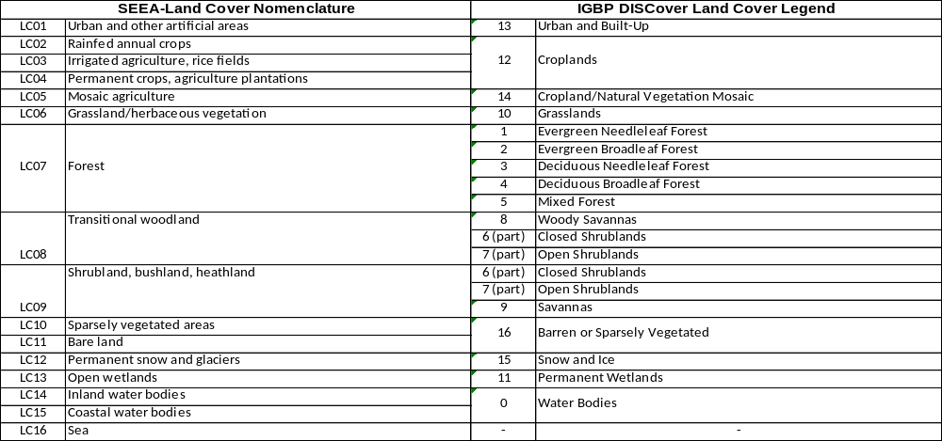
Table 4: Correspondence between SEEA-Land Cover and the GLOBCOVER LCCS based Global Legend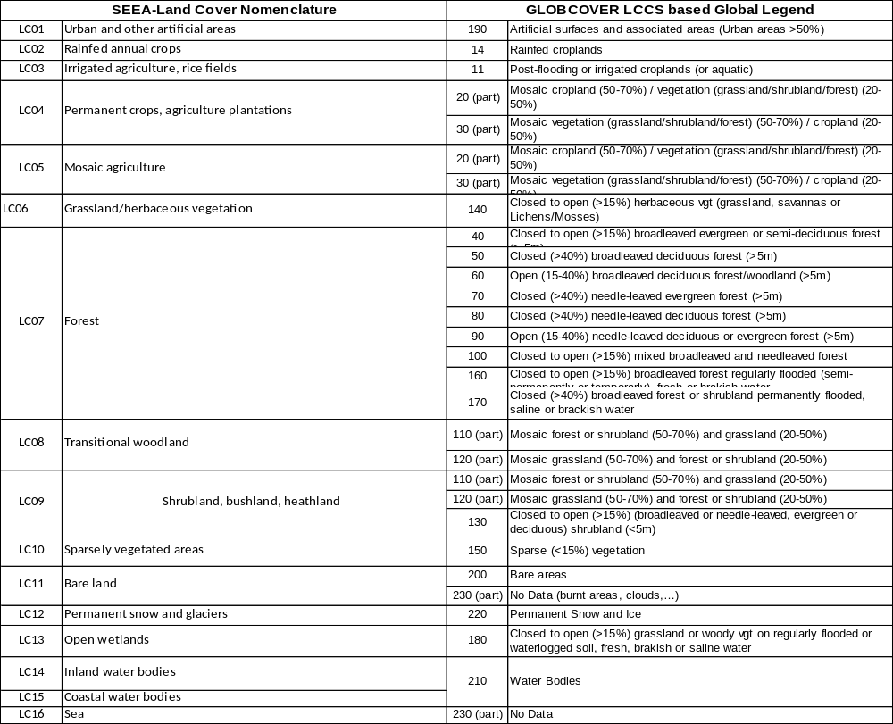
Table 5: Correspondence between SEEA-Land Cover and the LUCAS 2008 Land Cover Nomenclature
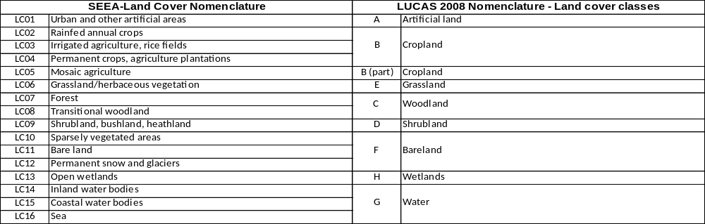
Table 6: Correspondence between SEEA-Land Cover and the CORINE Land Cover Nomenclature
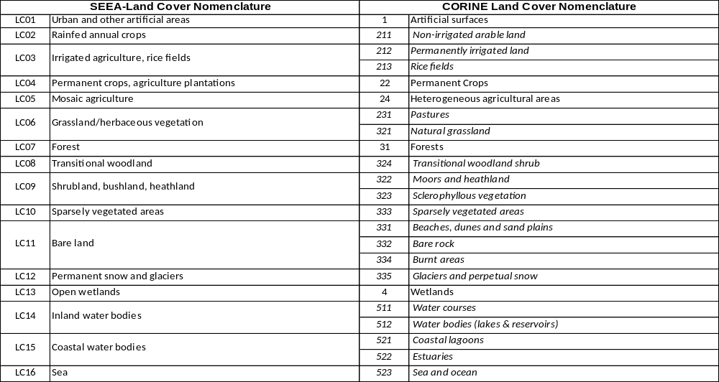
Table 7: Correspondence between SEEA-Land Cover and the North American Land Change Monitoring System (NALCMS) Nomenclature
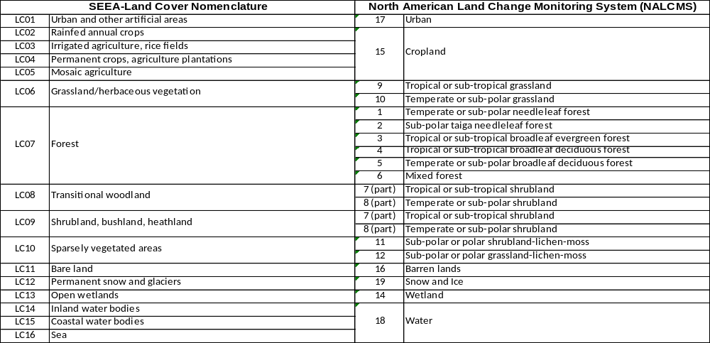

  - Indicative correspondence between SEEA-Land Cover, FAO based SEEA-Land Use and IPCC classification for LULCF
Table 8: Indicative correspondence between SEEA-Land Cover and SEEA-Land Use
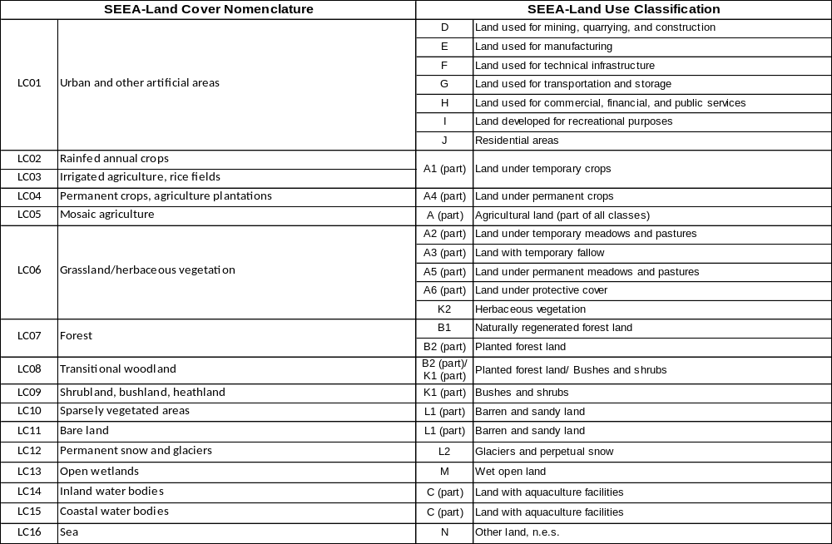
Table 9: Indicative correspondence between SEEA-Land Cover and IPCC Land Use/Cover Classification
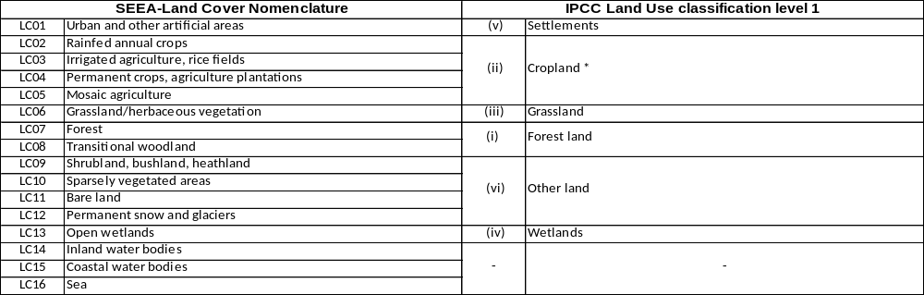 * the additional distinction between "cropland" and "agro-forestry" corresponds approximately to resp, LC02+03 and LC04+05

- Discussion of main issues and their solution
  - Justification of the selection of specific classes for the international standard
Land cover classification is a modelling exercise in which landscape bio-physical characteristics are combine in view of producing a useful nomenclature or legend. The quality of the outcome should be assessed from both considering the formal logics of the process of classification and the fitness for the purpose of classifying. Several land cover classifications for example pay more attention to formal aspects or particular details of stocks description than to land cover change monitoring. The problem is particularly accurate when describing forests. The point is raised in the IPCC Report on Good Practice Guidance for Land Use, Land-Use Change and Forestry. The focus of LULUCF is clearly change monitoring and they note that current definitions of forests pose problems when assessing land cover change. The two de facto standard are the land use criteria of FAO which states that forest land corresponds to a trees’ crown density of 10% and the IGBP DISCover standard of 60%. In the first case of low density, the transposition of the land use criteria (to be monitored by field surveys) to land cover monitoring by satellite results in important confusions of forests and shrubland and even agriculture. The 60% criteria create symmetric issue: dense forests are for sure better monitored but a large part of the forest is ignored and deforestation likely to be seriously underestimated. A recent report in Conservation Letters focuses on the weak definitions of “forest” and “forest degradation” in the global climate change agreements and concludes that REDD will fail with the current definition of “forest”.

SEEA-Land Cover proposes a two steps solution to this serious issue. The first one is to describe forest cover with two classes only at the global scale: LC07-Forests and LC08-Transitional Woodland. LC07 retains a crown cover of 30%, which can be detected with medium/high resolution satellite images. This is still a restrictive definition of the forest territory which needs to be completed by the areas which are closely linked to forests of standing trees, because they are still under forestry management (recent felling and new plantation) or because a natural transition from forest (forest degradation) or to forest (colonisation by trees) is taking place. From a static point of view, such areas are shrubs, more or less woody and classified either with them or with forests, according to conventions. If land cover is monitored from a dynamic perspective on an annual basis, such transitions can be detected and the land cover survey can supply the required information. This is the reason of the creation of class LC08-Transitional Woodland. The second steps related to the distinction between the degree of management of forests and the isolation of the industrial plantations (poplars, eucalyptus, palm trees as well as coniferous trees in some managements systems...) which doesn’t support usual ecosystem functions of forests, are biologically poor and sometimes degrade the environment. Earth Observation by satellite can provide useful information only with high resolution satellites; despite fast progress, it is likely that many years are still necessary before considering a global monitoring. The other way of recording plantation is land use field surveys; in that case, the higher richness of the information has a counterpart in terms of lower scale. It is therefore not proposed to introduce now the distinction between natural and managed forests at level 1 of SEEA-Land Cover but to let it open to regional or national subdivisions.

In the case of forests, several subdivisions (level of the nomenclature) are therefore left open. Two typical option are, for example:

Option a
LC071a Broadleaves deciduous forest (typical of tempered climate)
LC072a Broadleaves evergreen forest (typical of equatorial climate)
LC073a Mixed semi-deciduous forest (typical of tropical climate)
LC074a Coniferous (or needleleaves) forest (typical of boreal climate, taiga)
LC075a Mixed coniferous forest (typical of transitions between taiga and tempered climate forests)
LC076a LC075 Mangroves
or
Option b (the BDOT solution)
LC071b Dense forest
LC072b Open forest
LC073b Gallery forest
LC074b Forest plantations
LC075b Mangroves

In addition to LC08 Transitional woodland, 3 other land cover classes have been selected for LEAC-LC “level 1” because their visibility is important for environment and climate change policies. They are:
- LC03 Irrigated agriculture, rice fields: they matter from two standpoints, water resource use where such land cover ranks number one, emissions of methane, a powerful green house gas and conservation of wetlands, a composite ecosystem to which they contribute positively according to the Ramsar international Convention.
- LC10 Sparsely vegetated areas: observation of desertification.
- LC12 Permanent snow and glaciers: observation of effects of climate change.
Oppositely, because the distinction poses theoretical as well as monitoring problems in many regions of the Globe, the commonly use distinction between pastures and natural grassland has not eben retained.

  - Capacity of SEEA-LC to capture main land cover changes
Another important capacity of SEEA-Land is its capacity of capturing land cover change in general. Land cover change results from land use and natural phenomenon. Its observation is scale dependant and aggregation. An excessive aggregation of the primary data used leads to ignoring changes supposed to be “internal” to broad classes. For example, recording in the same class cropland and rangeland would lead to hiding important aspects of agriculture intensification when pasture start to be cultivated. The international standard should make sure that according to the best monitoring practices, the main land cover changes are properly captured.
Land cover changes are named conversions in the IPCC/LULUCF guidelines. They look like that:
FF = forest land remaining forest land
LF = lands converted to forest land
GG = grassland remaining grassland
LG = lands converted to grassland
CC = cropland remaining cropland
LC = lands converted to cropland
WW = wetlands remaining wetlands
LW = lands converted to wetlands
SS = settlements remaining settlements
LS = lands converted to settlements
OO = other land remaining other land
LO = lands converted to other land

In its report on Land Accounts for Europe 1990-2000, the EEA propose the definition of flows of consumption and formation of land cover. The land cover accounts are computed on the basis of the detailed level of CORINE which is made of 44 classes. The elementary flows are then aggregated with no consolidation in a nomenclature where coexist, as for the IPCC conversion, changes between classes and internal changes. SEEA-LC can support the following land cover flow classes:

LF01 | Urban sprawl
LF02 | Land cover rotation within urban areas
LF03 | Conversion of land to agriculture
LF04 | Land cover rotation within agriculture
LF05 | Conversion of land to forest
LF06 | Land cover rotation within forested land
LF07 | Water bodies management
LF08 | Change due to natural and multiple causes

A test has been carried out with the CORINE land cover database 1990-2000 (25 European countries) to compare the amount of change obtained from the detailed computation (44 classes) with the direct calculation from the SEEA-LC 16 classes. The loss is fairly small, of 1.7% on the average. The larger loss (6.8%) is for urban internal changes (most of them being due to the non-recording of the flow from “construction” to the various build-up classes. Circa 5% of internal agriculture conversions are lost as well. For the other classes, losses range from 2% down to 0. The conclusion is that SEEA-LC is fit for accounting land cover change.

- Conclusion

The 7 characteristics of SEEA-Land Cover presented in paragraph 2 can guide summarizing the discussion:

- Fit for accounting for land cover change? Yes, as shown in paragraph 4.
- Easy to connect to land use statistics? Fairly well. As expected, the difficulty is with mosaic agriculture, an important landscape type as well as a constraint when working with satellite images – but a class not so much relevant for land use. The forest breakdown of SEEA-LC forests into SEEA-LU classes brings expected additional information. Considering IPCC/LULUCF at the global scale, SEEA-LC could supply important support.
- Easy to connect to ecosystem accounts? It is early to discuss the issue. We can however notice that the correspondence with the more “biological” land cover classifications of IGBP and GlobCover is quite good for the natural classes, which would allows cross analysis.
- Prone to support feasible applications? Although some differences exist with the GlobCorine classification the main features are the same. GlobCorine has been used as a feasibility test of the nomenclature for Europe and its neighbourhood. There is certainly room for improvement but the first tests for 2006 and 2009 are definitely encouraging. Research on change detection is ongoing in Europe in relation to CEOS. The possibility of producing a land cover classification in the middle of the year following data collection is demonstrated. This resource is available worldwide.
- Simple to translate into other land cover nomenclatures or legends? The tables in paragraph 3 show the full picture. Difficulties are unavoidable; they are not so many. In most cases, differences are not contradictions but different emphasis on the main character; generally “more vegetal” vs. more “more anthropogenic”.
- Easy to detail further on? Certainly. Because SEEA-LC is prone at been implemented with geo-referenced data, a large range of monitoring data can be integrated in order to enrich the analysis as well as fix the issues discussed above.

Annex

Main references
- LCCS and applications
Land Cover Classification System (LCCS): Classification Concepts and User Manual, Antonio Di Gregorio & Louisa J.M. Jansen, FAO, http://www.fao.org/docrep/003/x0596e/x0596e00.htm
FAO/ Global Land Cover Network series at http://www.glcn.org/pub_3_en.jsp
GlobCover: ESA service for Global Land Cover from MERIS, Olivier Arino et. al. http://dup.esrin.esa.int/files/project/131-176-131-25_2007510152426.pdf
European Space Agency Ionia GlobCover Portal at http://ionia1.esrin.esa.int/
GlobCover Products Description and Validation Report, P. Bicheron, P. Defourny, C. Brockman, M. Leroy et. al. MEDIAS 2008, http://ionia1.esrin.esa.int/docs/GLOBCOVER_Products_Description_Validation_Report_I2.1.pdf
Report on the Harmonization of Global and Regional Land Cover Products, M. Herold and C. Schmullius, GOFC-GOLD Report no 20, 2004 (contains LCCS translations to several legends including IGBP, CORINE2000, IPCC, GLC2000...) http://www.fao.org/gtos/gofc-gold/docs/GOLD_20.pdf
Translating and Evaluating Legends Using the UN Land Cover Classification System (LCCS), M. Herold, R. Hubald and A. Di Gregorio, GOFC-GOLD Report no 43, 2009, http://nofc.cfs.nrcan.gc.ca/gofc-gold/Report%20Series/GOLD_43.pdf
A comparison of the IGBP DISCover and University of Maryland 1 km global land cover products, M. C. Hansen and B. Reed, Int. j. Remote Sensing, 2000, vol. 21, no. 6 & 7, 1365–1373, http://glcf.umiacs.umd.edu/library/pdf/ijrs21_p1365.pdf
- CORINE Land Cover technical reports
CORINE Land Cover, Methodology and Nomenclature, by Y. Heymann, M. Bossard, Ch. Steenmans et al, Commission of the European Communities, Dec. 1994, http://www.eea.europa.eu/publications/COR0-landcover
CORINE land cover technical guide – Addendum 2000, by M. Bossard, J. Feranec, and J. Otahel, Project manager: Chris Steenmans, EEA Technical report No 40, May 2000, http://www.eea.europa.eu/publications/tech40add

Corine land cover update 2000 - Technical guidelines, by George Büttner, Jan Feranec, Gabriel Jaffrain et al., Technical report 89, EEA & JRC, http://www.eea.europa.eu/publications/technical_report_2002_89

The thematic accuracy of Corine land cover 2000 - Assessment using LUCAS (land use/cover area frame statistical survey), by George Büttner and Gergely Maucha, EEA Technical report No 7/2006
http://www.eea.europa.eu/publications/technical_report_2006_7

CLC2006 technical guidelines, by G. Büttner, A. Sousa et al. EEA Technical report No 17/2007 http://www.eea.europa.eu/publications/technical_report_2007_17

- Other classifications
GlobCorine – A joint EEA-ESA project for operational land dynamics monitoring at pan-European scale, S. Bontemps, P. Defourny , E. Van Bogaert, J.-L. Weber, O. Arino, 2009, http://dup.esrin.esa.int/files/project/131-176-149-30_2009512133843.pdf
IPCC Special Report on Land Use, Land-Use Change And Forestry , 2001 http://www.grida.no/publications/other/ipcc_sr/?src=/climate/ipcc/land_use/index.htm
Good Practice Guidance for Land Use, Land-Use Change and Forestry, IPCC Task Force on National Green House Gas Inventories, 2003 http://www.ipcc-nggip.iges.or.jp/public/gpglulucf/gpglulucf.html
North American Land Change Monitoring System (NALCMS) http://www.cec.org/Page.asp?PageID=924&SiteNodeID=565&AA_SiteLanguageID=1
See also the USGS Land Cover Institute (LCI), http://landcover.usgs.gov/index.php, http://landcover.usgs.gov/landcoverdata.php
Land accounts for Europe 1990-2000, EEA Report No 11/2006 drafted by R. Haines-Young, and J.-L. Weber, European Environment Agency (2006). http://reports.eea.europa.eu/eea_report_2006_11/en

- The London Group and UNCEEA papers
Land Cover Classification for Land Cover Accounting, LG/14/9, position paper drafted by Jean-Louis Weber (EEA), 14th Meeting of the London Group on Environmental Accounting, Canberra, 27 – 30 April 2009, http://unstats.un.org/unsd/envaccounting/londongroup/meeting14/LG14_9a.pdf
Land Use Classification, LG/14/10, position paper drafted by Xiaoning Gong, Lars Gunnar Marklund, and Sachiko Tsuji (FAO), 14th Meeting of the London Group on Environmental Accounting, Canberra, 27 – 30 April 2009, http://unstats.un.org/unsd/envaccounting/londongroup/meeting14/LG14_10a.pdf
Land use classification proposed for SEEA, LG/15/8/1, drafted by Xiaoning Gong (FAO), 15th Meeting of the London Group on Environmental Accounting, Wiesbaden, 30 November – 4 December 2009, http://unstats.un.org/unsd/envaccounting/londongroup/meeting15/LG15_8_1a.pdf
Land cover classification proposed for SEEA, LG/15/8/2, drafted by Jean-Louis Weber (EEA), 15th Meeting of the London Group on Environmental Accounting, Wiesbaden, 30 November – 4 December 2009, http://unstats.un.org/unsd/envaccounting/londongroup/meeting15/LG15_8_2a.pdf
Land Cover and Land Use Classifications in the SEEA Revision, ESA/STAT/AC.189, UNCEEA/4/11, discussion paper drafted by Xiaoning Gong (FAO) & Jean-Louis Weber (EEA), Fourth Meeting of the UNCEEA , 24 - 26 June 2009, UN Headquarters, New York http://unstats.un.org/unsd/envaccounting/ceea/meetings/UNCEEA-4-11.pdf

Acknowledgements. This paper has benefited from the advices and the review of Gabriel Jaffrain, geographer at IGNFI. The professional experience of Gabriel in Europe with the EEA and its ETCLUSI, as well as in Africa, Colombia, Caribbean and Central America, in land cover mapping as well as accounting has been a precious contribution. The proposed SEEA land cover nomenclature has been tested with the support of the European Space Agency in the GlobCorine project for Europe and its neighbourhood, 2006 and 2009. GlobCorine has made possible analysing feasibility issues in the perspective of a global classification for land cover accounting.
This formulation is borrowed from the IPCC glossary of the “Land Use, Land-Use Change and Forestry” webpage. http://www.ipcc.ch/ipccreports/sres/land_use/index.php?idp=13. Similar definition is proposed by FAO (e.g. in Land Cover vs. Land Use, Antonio Di Gregorio, FAO – Global Land Cover Network, Global Land Use Data Workshop, Vienna 22 – 23 May 2008
LCCS, under the label of “LCML” (for Land Cover Meta Language) is currently undergoing the approval process to become an ISO standard as a framework to classify land cover and compare systems internationally.
GlobCover is a joint project of the European Space Agency with FAO, UNEP, IGBP, EC-Joint Research Centre, the European Environment Agency and GOFC-GOLD (a FAO-ESA partnership for forest monitoring).
http://www.reddmonitor.org/wordpress/wp-content/uploads/2009/09/2009-Putz-Conservation-Letters-on-REDD.pdf
BDOT stands for « Base de Données de l’Occupation des Terres 1992-2002 » (Land Cover Data Base) implemented in Burkina Faso.
http://www.ipcc-nggip.iges.or.jp/public/gpglulucf/gpglulucf_files/Chp3/Chp3_1_Introduction.pdf
http://www.eea.europa.eu/publications/eea_report_2006_11

