Map 2: Core areas of nature protection and green background landscape

2(a) | An important group of core natural areas is made of the ones which are designated for protection under international, European or national programmes. Enlarged with buffer zones, these designated core areas can be mapped: large individual zones or agglomerated clusters of smaller ones (in tints of purple on the map). A large part of these core areas are settled in a “green” context which is essential for their sustainability.  Map 2(a) considers potentials of landscape connectivity. Map 2(b) illuminates fragmentation effects by highways and major roads. In many cases, possible communication between natural core areas is impaired or blocked.  A similar analysis could be carried out for the rivers where dams block the circulation of migratory fish species and other biological components as well as of sediments. This adds to the blockage of the riparian circulation by roads and cities, numerous alongside rivers in Europe.
2(b)
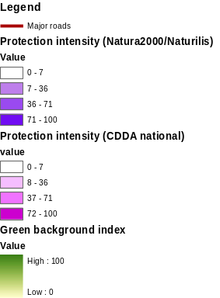

The methodology used for buffering considers the presence of protected zones in a given grid cell of 1 km² as well as in its neighbouring cells, with a maximum radius of 5 km. An index of protection intensity in the neighbourhood can be computed and used for mapping core areas. Smoothing methodologies for spatial analysis are explained in Land accounts for Europe 1990-2000, EEA Report N° 11/2006, Copenhagen - ISSN 1725-9177.

