Minutes of work meeting 7 August 2018 –

Forest Information System for Europe (FISE)

Location: Bucharest, Eau De Web
Timing: 07.08.2018 14:00 – 18:00
Participants:
- Annemarie Bastrup-Birk – EEA
- Miruna Badescu, Adriana Baciu, Valentin Popescu, David Ichim - EdW

Agenda
- Web design for the upcoming portal
- Progress on the FISE website and training on content management

Minutes
- Miruna, Valentin: presentation of the FISE portal web design, along with its current structure
- Discussions on the incipient design and on the front-page configuration:
  - Rotating banner will present announcements, short stories, a welcome message to the FISE website on top of the photos.
  - Below the rotating banner small size boxes, similar with WISE marine website, will present the top sections (the upper menu, map, etc.)
  - Below those icons, 2-3 user stories will be presented in medium boxes. A first suggestion for a story: “Forests and water - Ecosystem services”
- Logo: similar to the WISE Marine, where there are symbols for biodiversity and the industries done on marine. Same idea might be used here: biodiversity and elements from the European Forest Ecosystem (report #5 2016 from the EEA website)
- Colours: Change the yellow from the top - EdW to propose alternatives
- “Data” section to have an entry page with description, the main part now would be the NFI faceted search (maybe some map, too, but that’s for Tracasa to say) and then maybe links to other data portals (e.g. FAOSTAT)
- “Countries and regions” section
  - FISE will use macro regions and biodiversity regions – FISE will have different types of regions in the website
  - Country pages will mainly have to be contributed to by the countries. We’ll present a pre-cooked search (country selected) from the NFI data; further content will be added by the countries.
  - Countries content will be factsheets for each country, while the ‘Regions’ will be for now information on the two conventions: Carpathian Convention and Alpine Convention
- “Indicators” section – EDW presented the BISE proposal for managing (figure 1 below) and showing the indicators; Annemarie says this is a good start for this section.
  - Annemarie will work on selecting indicators that will be displayed, as in WISE Marine.
  - EdW will propose an implementation for storing, harvesting and displaying indicators
- Types of user needs in FISE:
  - Exploratory – user stories as a focus point
  - Data, maps, indicators – search, visualisation and download

A training session on the content upload in the FISE portal followed, with hands-on exercises. For the content upload activities, there is an incipient version of the user manual that presents the main functionalities and will be progressively updated to include more descriptions on how the website content can be managed and administered.
Discussions on what a user story presented on the portal will consist of, ideas:
- Introduction - overview of the data maps we have
- Question – the main question which is relevant for users
- Answer – the assessment obtained from the datasets in direct connection with the question
- More information: What would be the threats for it

Presentation of the NFI search from the demo server in EDW. There is good progress on this activity, the search selection of parameters has been improved, much easier to use.
The last version of National Forest Inventories provided by JRC will be re-imported. The search can provide added value for the FISE project, as means of gathering together and easy retrieval of existing information on the web. This can be a good starting point for the Countries section of the FISE portal.
The main purpose of the FISE website should be to have a transversal approach and not to repeat what has been done before, or to replicate already existing information on other sites and initiatives. Having a retrieval point for existing information is a good approach, this will serve the purpose of coupling thing together.
The improved website design for FISE website is planned to be available in mid-September.

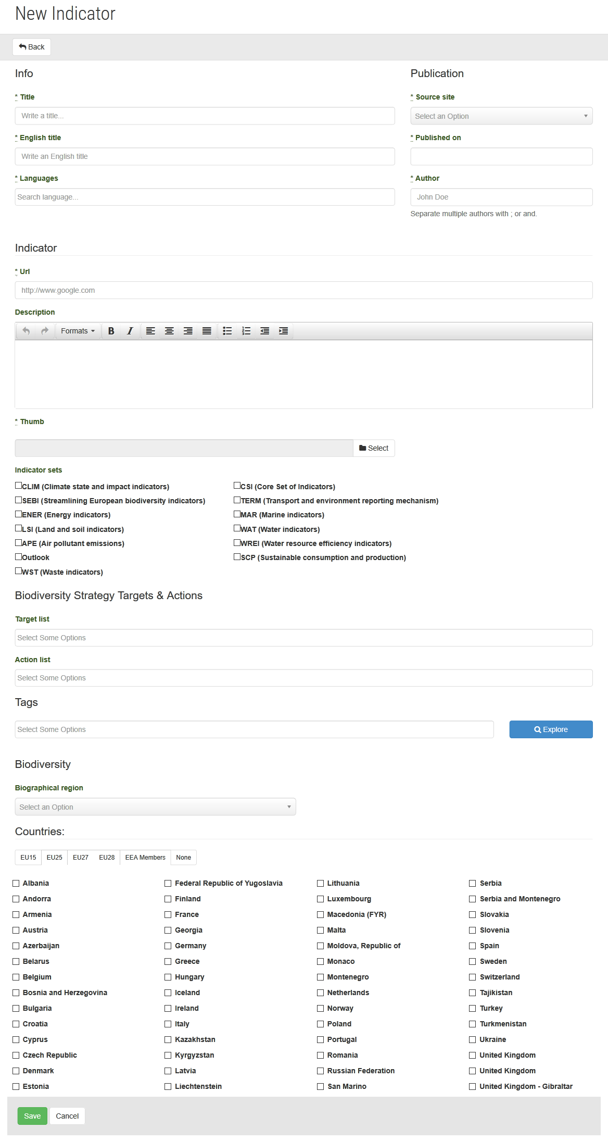
Figure 1 - Local indicators in the BISE Catalogue

