Minutes of work meeting 8 August 2018 –

Forest Information System for Europe (FISE)

Location: Bucharest, Eau De Web
Timing: 08.08.2018 10:00 – 18:00
Participants:
- Annemarie Bastrup-Birk – EEA
- Miruna Badescu, Alexandru Medesan, Andrei Duhnea, Adriana Baciu – EdW
- Iratxe Fernández – Tracasa – call on Skype

Agenda
- 10:00 – 12:00 - Discussion on maps, datasets and future meetings – skype conference
- 13:00 – 17:00 - Discussion on NFI search

Minutes

10:00 – 12:00 - Discussion on maps, datasets and future meetings – skype conf with Tracasa
Iratxe, Tracasa: Koldo, has been analysing the datasets received from JRC but, for the moment, due to his absence, we do not have conclusions available. Tracasa must ensure a backup person for the activities on FISE as we are already preparing for the NRC meeting in September.
Discussion on upcoming meetings:
- 06th or 07th Sept 2018 – Skype meeting
There is need for further discussions on usage of received maps in FISE (maps either delivered by JRC or EEA’s existing maps). We have agreed for an upcoming meeting in September, including Bernd (JRC) to discuss this issue. We must also have something to show for this meeting so that suggestions can be steered for future work (from small details like filters to bigger issues). This meeting will also result in integration of Tracasa’s work into the FISE portal in preparation for the NRC Forest meeting.
- 17-18.09.2018 – NRC Forest meeting at EEA
On 17.09.2018 there is a 30 minutes session in the meeting agenda for the presentation of the FISE project progress. EdW and TRACASA will present their current results in a 15 minutes session each. This presentation will be a very important moment for the dissemination of the FISE project objectives to the NRC community (ministry people with forest focus, but also biodiversity and other environment issues) and for the buy-in of the community and countries whose representatives are present. We must motivate the countries to contribute in FISE project. We should present things like: NFI, NFI search, CLC with forests.
- 28.09.2018 – Standing Forestry Committee, Brussels DG AGRI - potential meeting
There is a potential opportunity for FISE project to be presented during the Standing Forestry Committee (SFC) meeting, to disseminate the FISE objectives and to also present the way in which FISE can provide added value for the forest field.
Details, ideas for the meeting:
- SFC members are forestry people so, for them, the added value and transversal/integration issues are very important: forestry and water, forestry and biodiversity etc.
- Participation of EdW and Tracasa is to be decided together with Peter Loeffler.
- Suggestion for the presentation session (max 40 min) – we shall have a live demo session with the results we have reached so far as the people in the room already know the initiative and some of the results from JRC regarding FISE.
- This demo to stakeholders will provide early feedback and ideas.

Tracasa should also provide input for the Architecture document, to be delivered by end of August. The document is technical and shows the architecture of the solutions we are proposing, how they communicate, code repository and other technical details involved in the project. EdW and Tracasa will be detailing their part of the architecture based on the technology used for their implementation and then they will collaborate on common sections: data protection, security etc.

13:00 – 17:00 - Discussion on NFI search
EdW: We have taken the NFI data, analysed it, imported it in a database and constructed the mechanism for its retrieval through the search functionality. We have constructed the DB based on the structure of the centralised excel file. The search mechanism is based on searching the metadata provided with the NFI repository: keywords, country, data type (raster/sample), year of publication, year/interval of data collection, NUTS level, language, etc.
These parameters + keywords are used to filter the search results. The tool will not allow free text search (content of the files), it is of relevance to retrieve information based on the metadata that the data/documents are tagged with.
Annemarie: this represents the added value for what we are doing for FISE. We can now ask also the data owners: FRA and FAO about how do they see our initiative as we are using their data and what do they further suggest as stories on processing the data.
Bernd (JRC) extracted the tables from the existing statistics and then described them with metadata, meaning that it is easier to retrieve meaningful results out of the queries in NFI search based on country/topic/indicator/keywords etc.
Suggestions: The retrieved data should also be displayed in tabular form. We shall also think of ways to make the user experience very simple in retrieving the information, not an overwhelming one.
“NFI search” name can be misleading, Annemarie suggests changing it. We need a new name for the search, since the data is not only National Forest Information and this can mislead the user.
Annemarie suggestions in renaming some of the filters used as search criteria:
- Sample based => statistics
- Raster based => maps
Taskman tickets under https://taskman.eionet.europa.eu/issues/95628
Discussion on search/retrieval of forest maps and finding a way of corelating the search with the map we will have on FISE, seeing the results on FISE map. The layers can also be downloaded as results of search.
“Countries and regions” section of the portal
For this section of the portal, we can present a precooked search for the selected country when the users are navigating to the “Countries and regions” section of the portal. Users will see the search results using the selected country as search criteria, as agreed with Bernd.
Annemarie: good approach, but final decision depends also on what the Commission wants to access in this area: key issues, some statistics ready and maybe some stories ready. EEA usually lets countries fill in what they consider to be relevant on their country pages.
“Glossary” discussion
Annemarie: We shall create the list of keywords and the other relevant keywords and include them in our FISE glossary starting from the existing forest glossaries.
Need of correlation between the terms used in the “NFI search” and the ones used in the portal. We should use the same terms, so users will not be confused.
Edw: After the creation of the unique list of terms used in additional info (metadata, tagging) and keywords, the list will be sent to us. The list of terms will be also sent to Bernd for confirmation.
FISE Glossary will be a “living” thing, it will allow updates on terms, adjustments.
Indicators section and datasets discussion
List of indicators relevant for FISE selected by Annemarie. The indicators will have links towards the original sites of the organisations for full information. Also, the indicators in the list should allow grouping based on their originating initiative. We will put also Global Forest Watch indicators in the FISE indicators list.
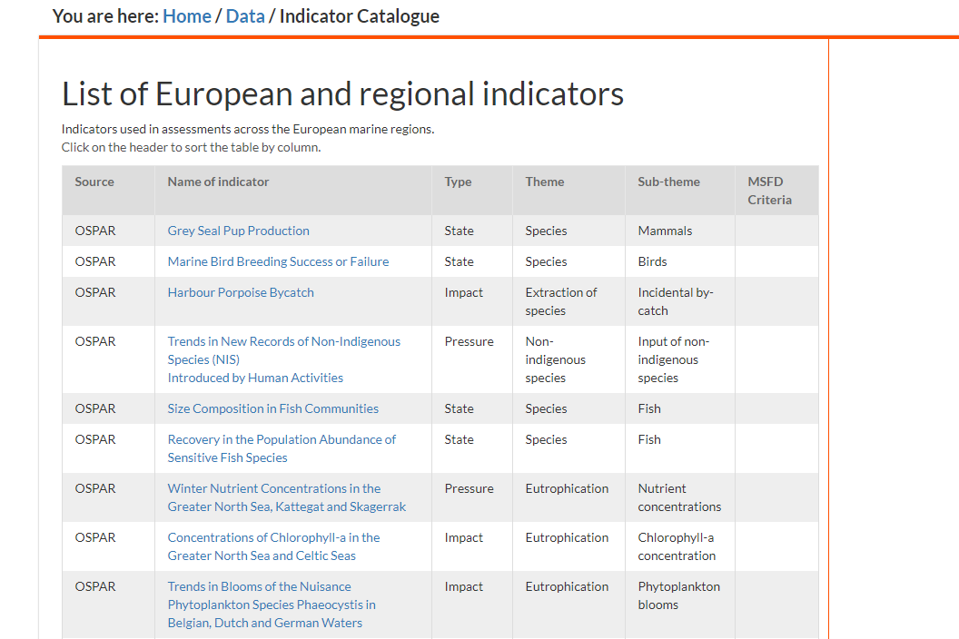
Figure 1 - GFW indicators
CAP indicators should be taken into consideration, also. Annemarie will prepare the list of indicators for FISE.
EdW presented the way Digital Agenda displays indicators and various other features: evolution, trend, comparisons etc. Along this, there is a feature of data download in various export formats. Data can be displayed also tabular, below the graphs. We shall start from this model and come up with a visualization for FISE.
In case we need to publish indicators which are not (clearly) published somewhere else, there is a possibility to build a container in FISE, similar to the one in BISE, where the indicators are described and tagged according to the FISE taxonomy.
Another idea that to consider is the way snippets of visualizations and indicators are presented in FISE.
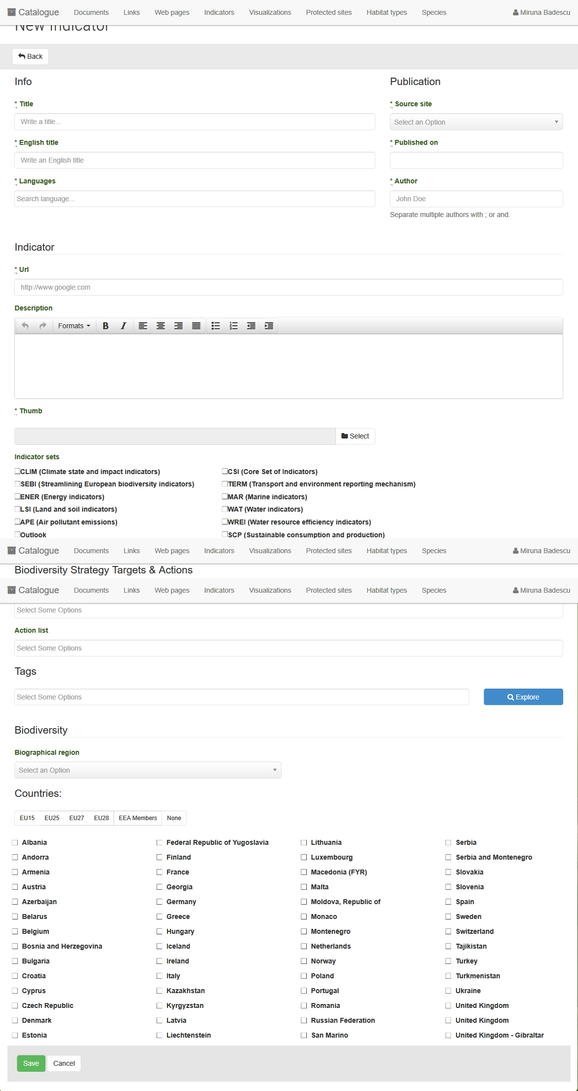
Figure 2 - Indicator structure in BISE
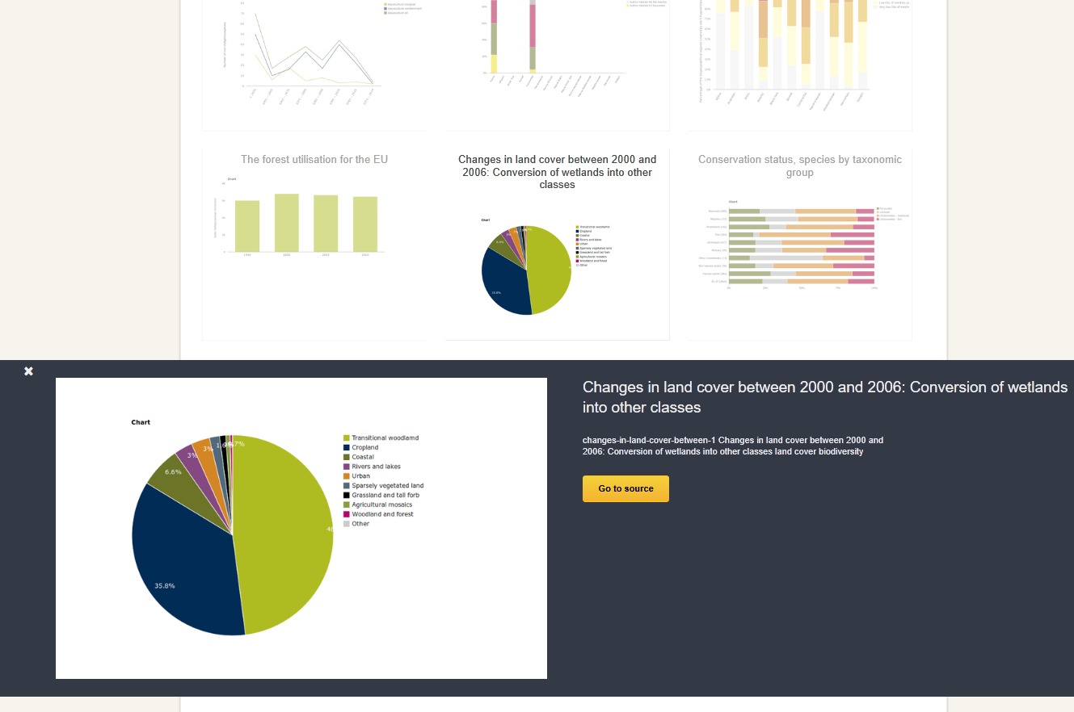
Figure 3 - Showing of figures and indicators automatically harvested from the EEA website into BISE
Datasets:
- Ecosystem services: use the Forest ecosystem map to see what services can we use.
- Forest ecosystem condition indicators – JRC is leading this initiative and there are also EEA people involved. Verify with Tracasa if they are using it or not.
- European Vegetation database http://euroveg.org/eva-database
- Flood plain forest - HRL combined with soil map and flood plain and geology …
- LULUCF – member states reporting. It is aggregated information. Link and document have been uploaded in the EIONET FISE project library .
- EEA watershed map and the sub-basins map https://www.eea.europa.eu/data-and-maps/data/european-river-catchments-1
- COPERNICUS EU Hydro https://land.copernicus.eu/pan-european/satellite-derived-products/eu-hydro
Actions:
  - List of indicators grouped by source – Annemarie and EdW
  - Suggestions about the LULUCF data visualisation - EdW
  - During the NRC meeting, there should be a discussion with Peter Loeffler on how to better target what FISE needs. We must also contact the organisations that own the data and inform them that we are using their data – this task should be discussed with Bernd, JRC. - all
  - ‘Related items’ functionality to be implemented in the portal – it will increase the easy retrieval of information on specific topics: reports, indicators, graphs … - EdW
  - A meeting about maps could take place in the EEA with 2-3 people that handles maps and Tracasa – all

