Minutes of work meeting 16 October 2019 –

Forest Information System for Europe (FISE)

Location: European Environment Agency, Copenhagen
Timing: 16.10.2019 9:00 – 12:30
Participants:
- DG Environment: Cristina Brăilescu
- JRC: Bernd Eckhardt
- EEA: Annemarie Bastrup-Birk, Sebastien Petit
- Eau de Web: Miruna Bădescu, Tiberiu Ichim, Mihai Măcăneață
- Tracasa: Koldo Goñi Iza, Miguel Villafranca Artieda

Agenda
- Review of the work done so far by Eau de Web and Tracasa
- Input from DG Env/EEA/JRC for the developments

Minutes
1) Eau de Web presentation:
- The work discussed at the meeting 5/9 is being carried out in terms of web design, creating the portal backend in Plone 5 and implementing tiles for data retrieval and visualizations. Demo portal at https://demo-forests-p5.eea.europa.eu
- A technical meeting took place on the 15/10 in the EEA, where the technical aspects of the portal implementation and data retrieval from geo-databases have been agreed upon with the EEA team, based on a proof of concept made by Eau de Web
  - All thematic websites will share the same “portal toolkit” and split the costs of making and maintaining the portals. Data will be kept in the EEA dataservice and used for various graphical representations in FISE, BISE, WISE, ClimateAdapt and Energy Union
  - Graphs, charts in geodatabases can now be retrieved and displayed via dynamic tiles, used to build factsheets around the portal
- Once we have the approval from DG ENV for the web design, EdW will develop a branding manual, including logo; currently in the process of making the design now “pixel perfect” – align on the right colours
- Next focus will be on the search function – we need to agree on how to develop this further. Idea to separate the NFI from other data into separate tabs and ask users to choose the country first
2) Tracasa presentation:
- Advances on the web application and a step back on content. Currently need to solve and validate the basic forest area issue
- Step 1: map creation
  - Concentrate on the forest basic information
  - The content following the concept note from 2019-09-20 will be used
  - For forest area, use the files provided by the JRC, both CLC and HRL
  - Forest cover change is still in progress, not shown during the meeting
- Step 2: web applications development
  - Playing with end user functionalities with test data structure
  - Will work on integration of maps on the EEA services discomap and discodata; use the REST SQL endpoint for all tabular data in both the portal and map viewers
  - Working on improving the data integration solution and visualisations into the portal pages. Integration with ESRI considered as adequate after technical discussions
  - The maps and visualizations will process parameters e.g. Romania map with multiple layers taken directly from the portal – how to zoom in and out, click on a link to display full screen etc.
  - Web applications should follow the standards for web apps included on EEA’s portals (DIS2 governance - Jan Bliki) that also apply to FISE
3) Discussions on country pages:
- Definition of the format for the country pages discussed and agreed with the participants (figure from the flipchart below)
- Maps integrated from the EEA service will be provided at country level and NUTS3 level
  - Forest area information
  - Forest area change based on CLC to have the time series as in the MAES
  - Presenting both CLC and HRL Forest layers (relevant for the current discussion at European level on reforestation and afforestation)
- Important to flag the data sources for each country – link to country NFI data on the portal and on the country fact sheet
- Forest patches: draw pie chart per region as % of total area (forest area or country area?)
- Then group the patch classes into three categories:
  - small patches <25ha
  - medium patches 25-10.000 ha
  - large patches >10.000
- Produce a map of small patches – patch classes only on fact sheet. For each group, sum the total area covered and figure out the percentage of total forest area they represent.
- For the map, stick to showing the only small patches percentage, and colour the regions accordingly. No charts on the map itself.
4) BACK TO PORTAL CONTENT
- “Knowledge” should refer to research projects and studies e.g. EFI SINCERE, EUFORGEN, LIFE projects
- “Tools”: include JRC Guidos tools, applications developed by JRC and others
- Background maps: Cristina showed interest in displaying companion background layers to the NUTS-based statistics. A button will allow users to switch backgrounds on and off. The layers used will be:
  - For CLC-based statistics, the CLC layer for that year, showing only the 3 forest classes
  - For HRL-based statistics, the HRL layer for that year as-is
  - Add EU28 average and total to the data tables showing in the map
- More text on the factsheets - ABB/EEA task
5) Other
Next year Version 2 of FISE prototype will focus on forest biodiversity using existing information at the EEA:
- Art 17
- Protected forest areas (Natura 2000 and CDDA)
- Forests in water protection areas
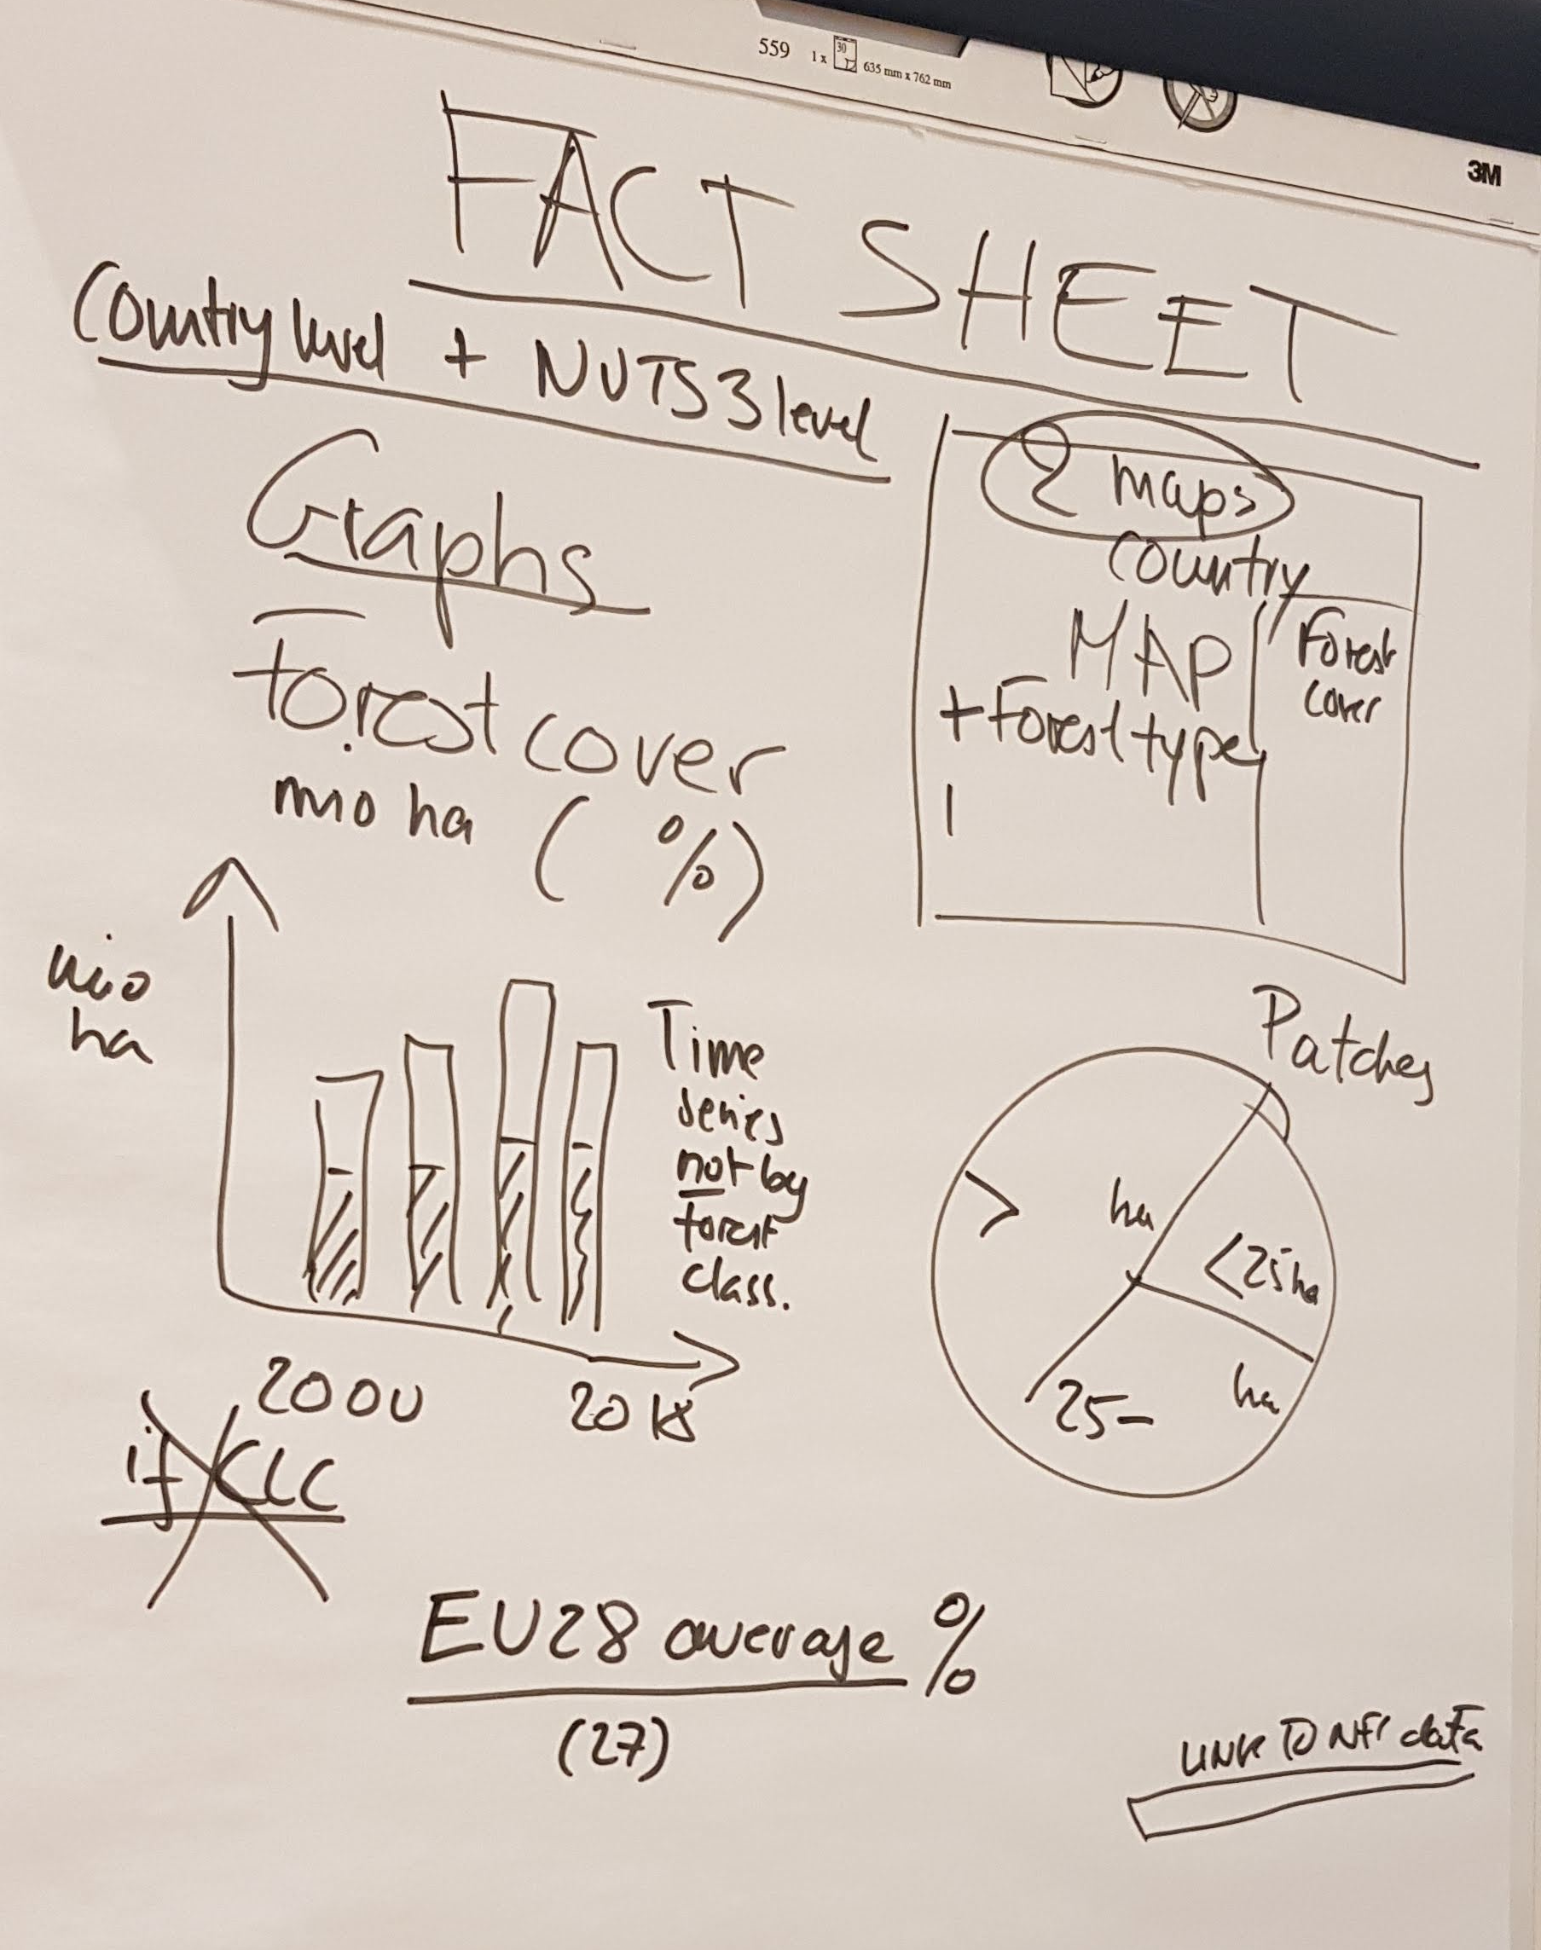
Figure 1 – Country factsheet

