|  |  |  |
| --- | --- | --- |
|  | https://encuentra.tracasa.es/sites/TCSA_Comunicacion/Imagen%20Corporativa/09%20-%20LogoTracasa_png.png |  |

EUROPEAN COMMISSION

DG ENVIRONMENT, Directorate D - Natural Capital

ENV.D.1 – Land Use and Management

Eau de Web: Specific Contract no 070202/2018/776035/SER/ENV.D.1

Under Framework Service Contract N° EEA/IDM/17/002/1

TRACASA: Specific Contract no 070202/2018/777685/SER/ENV.D.1

Under Framework Service Contract N° EEA/IDM/15/016

IT consultancy services on matters related to FISE transfer, IT infrastructure and web portal

Project Mid-term Progress Report

**Forest Information System for Europe**

Reporting Period *27/02/2018* to *20/12/2018*

Date: 20/12/2018

Doc. Version: 1.0

**Document Control Information**

|  |  |
| --- | --- |
| **Settings** | **Value** |
| **Document Title:** | Project Progress Report |
| **Project Title:** | Forest Information System for Europe |
| **Document Author:** | Adriana Baciu, Eau de Web |
| **Project Owner:** | Peter Loeffler, DG Environment |
| **Project Manager:** | Miruna Bădescu, Eau de Web |
| **Doc. Version:** | 1.0 |
| **Sensitivity:** | Public |
| **Date:** | 20/12/2018 |

**Document Approver(s) and Reviewer(s):**

NOTE: All Approvers are required. Records of each approver must be maintained. All Reviewers in the list are considered required unless explicitly listed as Optional.

|  |  |  |  |
| --- | --- | --- | --- |
| **Name** | **Role** | **Action** | **Date** |
| Peter Loeffler | Project Owner | *<Approve / Review>* |  |
| Beate Werner | Business Manager |  |  |
| Miruna Bădescu | Project Manager |  |  |

**Document history:**

The Document Author is authorized to make the following types of changes to the document without requiring that the document be re-approved:

* Editorial, formatting, and spelling
* Clarification

To request a change to this document, contact the Document Author or Owner.

Changes to this document are summarized in the following table in reverse chronological order (latest version first).

|  |  |  |  |
| --- | --- | --- | --- |
| **Revision** | **Date** | **Created by** | **Short Description of Changes** |
|  |  |  |  |
|  |  |  |  |
|  |  |  |  |

**Configuration Management: Document Location**

The latest version of this controlled document is stored in <https://projects.eionet.europa.eu/fise-project/library/3.-execution/> .

TABLE OF CONTENTS

1. Project Overview 4

1.1. Executive Summary 4

1.2. Project Stakeholders 4

1.3. Milestones and Deliverables 6

1.4. Project Plan (per Work Package) 7

1.4.1. Portal implementation and layout 9

1.4.2. Data and sources – Data search (formerly NFI Search) 11

1.4.3. Maps and graphs 13

1.4.3.1. Tools and procedures used for project implementation 14

1.5. Project Milestones 15

1.6. Budget and Costs 15

1.7. Project Resources 15

2. Project Details 16

2.1. Scope Changes 16

2.2. Major Risks and Actions Taken 17

2.3. Major Issues and Actions Taken 19

2.4. Other On-going and Planned Actions 20

2.5. Tickets for FISE Development and transfer of FISE to EEA 20

3. Appendix 1: References and Related Documents 23

# Project Overview

## Executive Summary

The main goal and long-term vision for the Forest Information System for Europe (FISE) is to provide target groups with comprehensive forest data and information on a single website featuring a user-friendly interface. The FISE portal aims to provide better forest data and statistics compared to what is currently on the market, offering a consistent line of generic products and customisable output formats (map overlays, data sets, customisable graphs, downloadable pdf fact sheets etc.), addressing all aspects and parameters to reflect the holistic understanding of forest ecosystems and management advocated in the EU Forest Strategy.

By developing FISE, DG Environment aims to accomplish the following overall objectives:

* Provide **enhanced forest information** togather vital information on forest ecosystems conditions and monitor the relevant trends for informed policy decisions, funding and management.
* **Sustainable forest management**,to encourage forest management practices which preserve and enhance all forest ecosystem functions and services. Main actions include work on criteria and indicators for sustainable forest management and sustainable biomass; promote the wider use of forest management plans and the integration therein of ecosystem approaches and biodiversity concerns.
* **Valuing forests** tohelpidentify, value and include the full value of forests into statistics, accounts, decision-making and payments to forest owners. Main actions include MAES-Forests, payment for ecosystem services in forests.
* **Integration** of the forest environmental needs in the various policy objectives and initiatives of DG ENV and the Commission at large.  Forests are affected by a number of policies and decisions, and their main tasks are achievable only if our objectives are sufficiently reflected across all relevant policies.

The FISE project is implemented with the involvement of EEA and through the following two contracts:

1. Eau de Web: Specific Contract no 070202/2018/776035/SER/ENV.D.1

Under Framework Service Contract N° EEA/IDM/17/002/1

1. Tracasa: Specific Contract no 070202/2018/777685/SER/ENV.D.1

Under Framework Service Contract N° EEA/IDM/15/016

The two contractors are collaborating and contributing to the fulfilment of the FISE objectives.

## Project Stakeholders

|  |  |
| --- | --- |
| **Project Due Date** | 31/12/2019 |
| **Project Steering Committee (PSC)** | **Project Owner (PO):** Peter Loeffler – DG ENV |
| **Business Manager (BM):** Beate Werner – EEA |
| **Solution Provider (SP):** Miruna Badescu – acting as proxy – EdW |
| **Project Manager (PM):** Miruna Badescu - EdW |
| **Maps Manager**: Sebastien Petit - EEA |
| **Business Implementation Group (BIG) / User Representatives (UR)** | Beate Werner – EEA (formerly AnneMarie Bastrup-Birk – EEA)  Bernd Eckhardt, Peter Vogt – DG JRC |
| **Project Core Team (PCT)** | Adriana Baciu, Tiberiu Ichim – EdW  Iratxe Orbe, Koldo Goñi Iza – Tracasa |

Project Charter can be found here: <https://projects.eionet.europa.eu/fise-project/library/1.-initiating-phase/fise-project-charter>

Project Concept paper (contains Business Case) can be found here: <https://projects.eionet.europa.eu/fise-project/library/1.-initiating-phase/fise-concept-paper>

## Milestones and Deliverables

|  |  |  |  |  |  |
| --- | --- | --- | --- | --- | --- |
| **ID** | **Milestone / Deliverable Name** | **Target Delivery Date** | **Actual Delivery date** | **Status** | **Comments** |
| D1 | Web portal design up and running | Jun 2018 | Jun 2018 | achieved | The FISE portal has been setup and available in demo version on the demo servers. It has been created using the first layout proposal. |
| D2 | First test version of the infrastructure | Sep 2018 | Sep 2018 | achieved | The first version of the infrastructure is already online, available for testing. Feedback has been collected from the stakeholders and functionalities are being adjusted and enhanced. NFI Search has been implemented with the existing data, more than one map has been constructed. |
| D3 | Publication of the first prototype of the web portal | Feb 2019 | Feb 2019 | on-going | Activities are progressing for the publication of the first prototype of FISE, layout has evolved and functionalities are being enhanced based on the feedback received. |
| D4 | Final prototype ready and operational | Dec 2019 | Dec 2019 | planned | All activities regarding FISE will be finished, the portal will be publicly available online to all users |
| D5 | Project charter | May 2018 | May 2018 | achieved | Available in the project library |
| D6 | IT governance reports: Architecture overview and Operational model | Jul 2018 | Aug 2018 | achieved | Available in the project library |
| D7 | Kick-off meeting for the planning phase | Apr 2018 | Apr 2018 | achieved | Available in the project library |
| D8 | Development handbook and plans | Jun 2018 | Jun 2018 | achieved | Available in the project library |
| D9 | Detailed development work plan with tasks, iterations and releases | Jun 2018 | Jun 2018 | achieved | Available in the project library |
| D10 | Minutes of Meetings after each meeting and/or evaluation cycle with the agency or DG ENV | On-going | On-going | on-going | Available in the project library |
| D11 | Bi-Monthly progress status reports | On-going | On-going | on-going | Progress status report every 2 months |
| D12 | Mid-term project progress report | Dec 2018 | Dec 2018 | on-going | This document |
| D13 | Report of the conducted tests of the system including documentation of amendments to solve the problems | Dec 2019 | Dec 2019 | planned |  |
| D14 | Project-end review meeting | Dec 2019 | Dec 2019 | planned |  |
| D15 | Final report (December 2019) | Dec 2019 | Dec 2019 | planned |  |
| D16 | Operational software, commented and documented source code(s), quality assurance in the source code repository | Dec 2019 | Dec 2019 | planned |  |
| D17 | Closed tasks on the centralised tasks list | Dec 2019 | Dec 2019 | planned |  |

## Project Plan (per Work Package)

|  |  |  |
| --- | --- | --- |
| **1.1** | **Workpackage** | **Task 1: Support the FISE transfer from JRC to EEA** |

This workpackage covered the activities related to the transfer of information from JRC to EEA and the contractors in the initial stages of the project as JRC was the institution that started the work on the first version of FISE. The exchange of information and knowledge on the platform took place, with involvement of experts from all implicated parties: JRC, EEA, Eau de Web, Tracasa,

Status: closed

|  |  |  |
| --- | --- | --- |
| **1.2** | **Workpackage** | **Task 2: Develop a prototype IT infrastructure for organising, sharing and publishing forest data and information through the FISE web portal** |

This workpackage covers the activities related to the implementation of the IT infrastructure of the FISE platform, identification of relevant content and import of the existing data into the database and repository. This implies also the work related to the spatial datasets, construction of maps and visualisations of the relevant data.

Up to the time of this report, the first version of the infrastructure has been constructed covering all the main functionalities of the FISE platform: portal, GIS infrastructure and Data Search (NFI). The first version of the platform is online, for the stakeholders to test and provide feedback and suggestions on further work needed in this project.

The FISE infrastructure is owned by the EEA and uses the following EEA infrastructure:

* CMS: Plone 4.3.7
* Database: ZODB 2.13
* Maps: ArcGIS via EEA web map server
* User authentication via EIONET LDAP accounts

FISE platform is built on EEA infrastructure, we keep our focus on reusing existing solutions as much as applicable and extending the existing ones for custom needs of FISE.

All FISE components mentioned below, are now up&running in the test version:

* **Portal** [**demo-forests.eea.europa.eu**](https://demo-forests.eea.europa.eu/):
  + Complex CMS with collaborative tools and workflow system – Plone CMS
  + Various existing features: easy customization of appearance, flexible publishing workflows, through-the-web management, various data types, search, syndication, etc.
  + Expandable with new types of content, as needed
* **Search functionality** [**http://nfi-search.dev.eaudeweb.ro/**](http://nfi-search.dev.eaudeweb.ro/) **:**
  + Extended search functionality that retrieves reports, datasets/statistics, raster data, etc. based on their metadata. It uses the repository created for FISE and datasources from JRC
  + Implemented custom for FISE
* **Maps and graphs** [**http://eea.maps.arcgis.com/home/webmap/viewer.html**](http://eea.maps.arcgis.com/home/webmap/viewer.html) **:**
  + Visualisation tool for GIS relevant data to the forest field
  + Visualization tool for existing tabular data, time series for such datasets etc.

Bimonthly, JRC delivers an updated centralisation of existing data on forests collected from relevant sources and institutions. Each datasource is recorded and is described by metadata (title, country, year of collection, year of publication, owner of the information, keywords, topics etc.). These data records and the data sources received are being constantly updated in the FISE repository and used for the Data (NFI) search functionality described below.

Status: On-going

|  |  |  |
| --- | --- | --- |
| **1.3** | **WorkPackage** | **Task 3: Develop the FISE web portal** |

This workpackage gathers the activities related to the implementation of the FISE web portal and its dedicated modules for content visualisation. FISE portal is available online for testing purposes and also for collection of feedback from stakeholders and the user community. The visual theme of the portal has been constructed iteratively using prototyping and mock-ups and enhancing it with the suggestions received. We present below the homepage and other pages of the FISE portal:

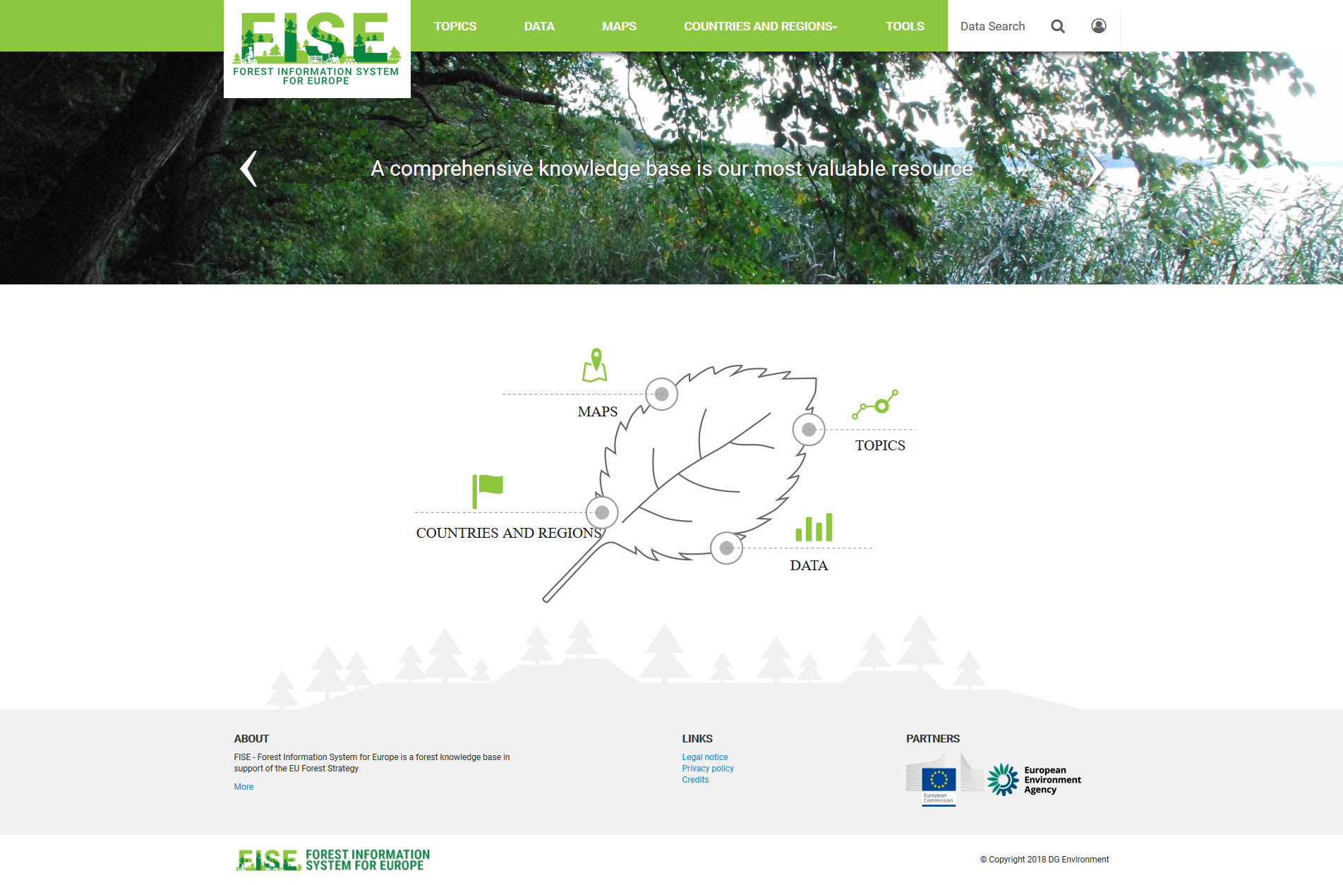

Figure - 1 FISE homepage

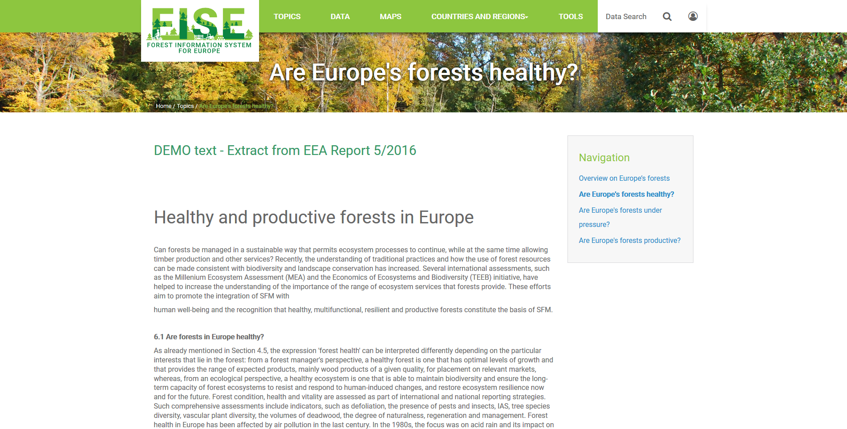

Figure - 2 FISE portal page

The content of the portal consists of:

* General and basic information accessed as answers to general questions regarding the state of forests
* Forest topics including health, production, pressures and ecosystem services
* Forest data and maps to be downloaded
* Indicators (currently not visible): indicators sheets / fact sheets
* Interactive tools and resources (apps)

**Main components of FISE:**

* Portal
  + Main entry point for retrieval of FISE information and content. Main section of the portal: Topics, Countries and Regions, Data and Maps
* Data Search (formerly referred as National Forest Inventory Search) functionality
  + Tool that will assist the users in easy retrieval of National Forestry Inventory datasets and information, along with other datasets and information available on forestry
* Maps and Graphs
  + Visualization tool for GIS data relevant to the forest field
  + Visualization tool for existing tabular data, time series for such datasets etc.

**Main Functionalities of FISE:**

* Database search functions
* Map based search functions
* Download of the data
* Viewer – tables, graphs, maps

### Portal implementation and layout

During the reporting period, we have constructed iteratively the layout and the logo of the FISE platform. There have been three iterations for layout and logo versions and, for each step, our experts have consulted the users for feedback related to suggestion of improvement to better represent the portal objectives.

For the logo construction, we’ve collected feedback in three stages and now the logo respects the guiding lines received regarding to insertion of images/symbol that represents:

* + Forest/trees - put more types of trees (formerly were more coniferous) and made them more heterogeneous
  + Water - present in the form of a lake
  + Wood production – lodges and a vehicle
  + Commercial value for the forests – line of trees that are evolving/growing
  + Forest fires – a burnt tree trunk
  + Climate – clouds and rain
  + Biodiversity – birds
  + Value for humans, leisure – girl on a bike

The latest version of the logo that has been proposed for the FISE website is presented below and will be implemented in the portal during the following period.



Figure - 3 FISE 3rd logo proposal

The hierarchical structure of the FISE portal has been constructed and discussed and adjusted according to the user’s review.

* **Homepage structure**:
  + Menu area - logo, easy navigation from the portal menu
  + Rolling banner - presenting short welcome messages for the visitor, announcements, conferences, reporting news
  + Navigation area - emphasis on main sections/structure of the portal
  + Stories area - will advertise the relevant stories of the moment
  + Footer area - Contact, About, Partners, etc.
* **Main sections**:
  + Topics - general information on forests: EU Forest Strategy, initiatives, stories
  + Data and maps - knowledge base and visualization tools for harmonized information
  + Indicators (section is not visible at the moment, decision on its publication will be taken at later stages) - area dedicated to indicators: indicators sheets / fact sheets
  + Countries and regions - knowledge base on country level, partially automatically collected from existing EU and international Forest related reporting: Art 17 forest data, NFI search per country, LULUCF data etc.
    - Regional Page: EU28 and EEA 39 at this moment with content extracted from EEA data sources and visualizations: visualization of Article 17 data at EEA 39 level, combined view for annual felling
  + Tools – section that may contain interactive tools and resources

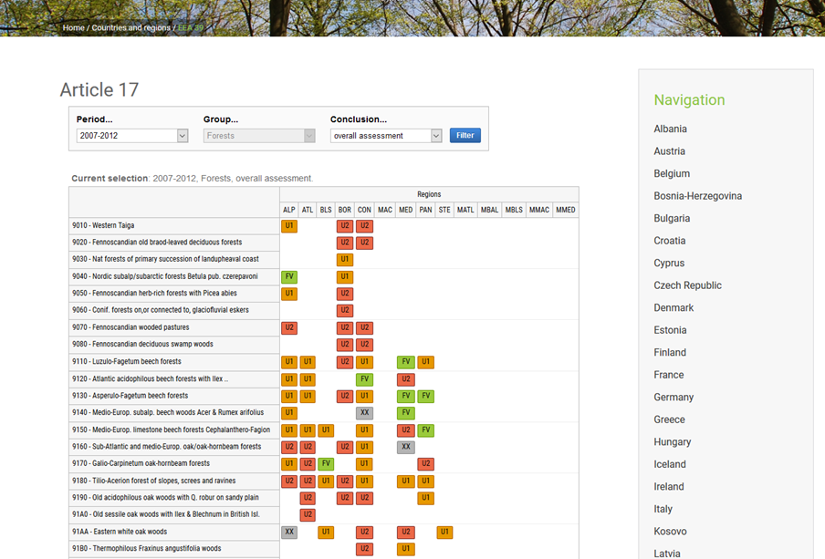

Figure - 4 Article 17 data presented within FISE

[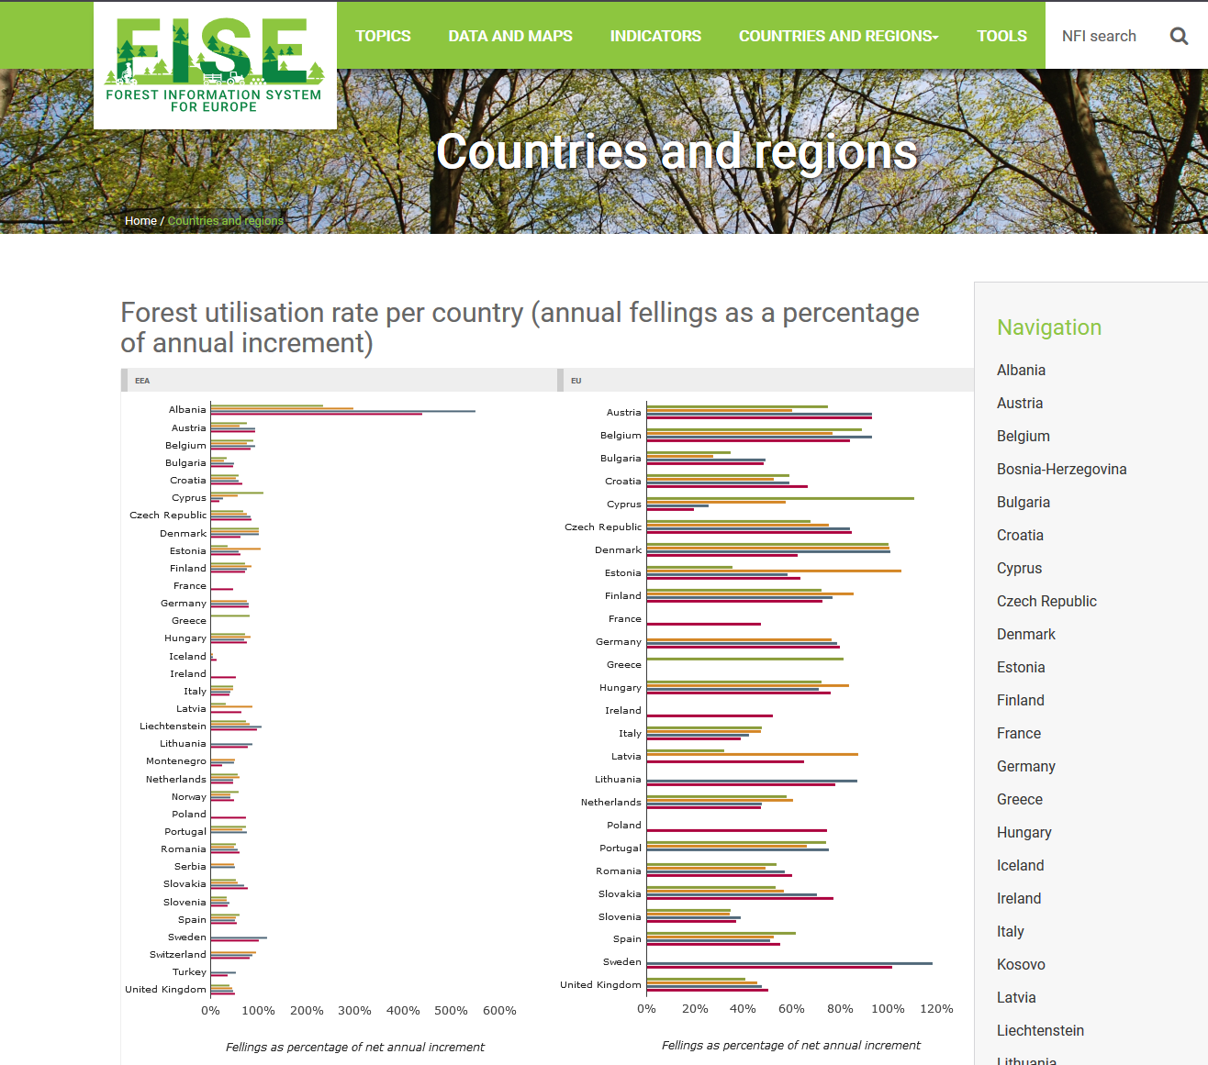](https://demo-forests.eea.europa.eu/countries-and-regions)

Figure - 5 Display of embedded graphics

### Data and sources – Data search (formerly NFI Search)

* Many official data to choose from:
  + Forestry statistics/data from FAO/FRA, UNECE, Forest Europe, Eurostat etc.
  + National Forest Inventories (collected with the help of JRC)
  + Data from EU reporting exercises (Nature Directives, LULUCF, CAP, EFFIS etc.)
  + Copernicus layers (HRL Forests, tree cover density)
  + ICP Forests data – not available yet, to be discussed between EEA and ICP
* Currently more than 2500 resources (datasets, maps, reports, documents etc.) and counting…
* The search looks in the resources’ metadata (country/region, resource type, topic, keywords etc.)
  + Manually associated by the JRC, i.e. common nomenclatures
  + Meaningful results

Data search can be performed based on:

* Keywords and/or free text – once the user start typing in the search field, a list of keywords will be available for selection or the user can type its own search terms.
* Filters – various filters are available for filtering the results: topics, countries and regions, NUTS levels, year of publishing and/or collection, raster/sample based datasources, format of the file (documents, tabular data, raster etc.)

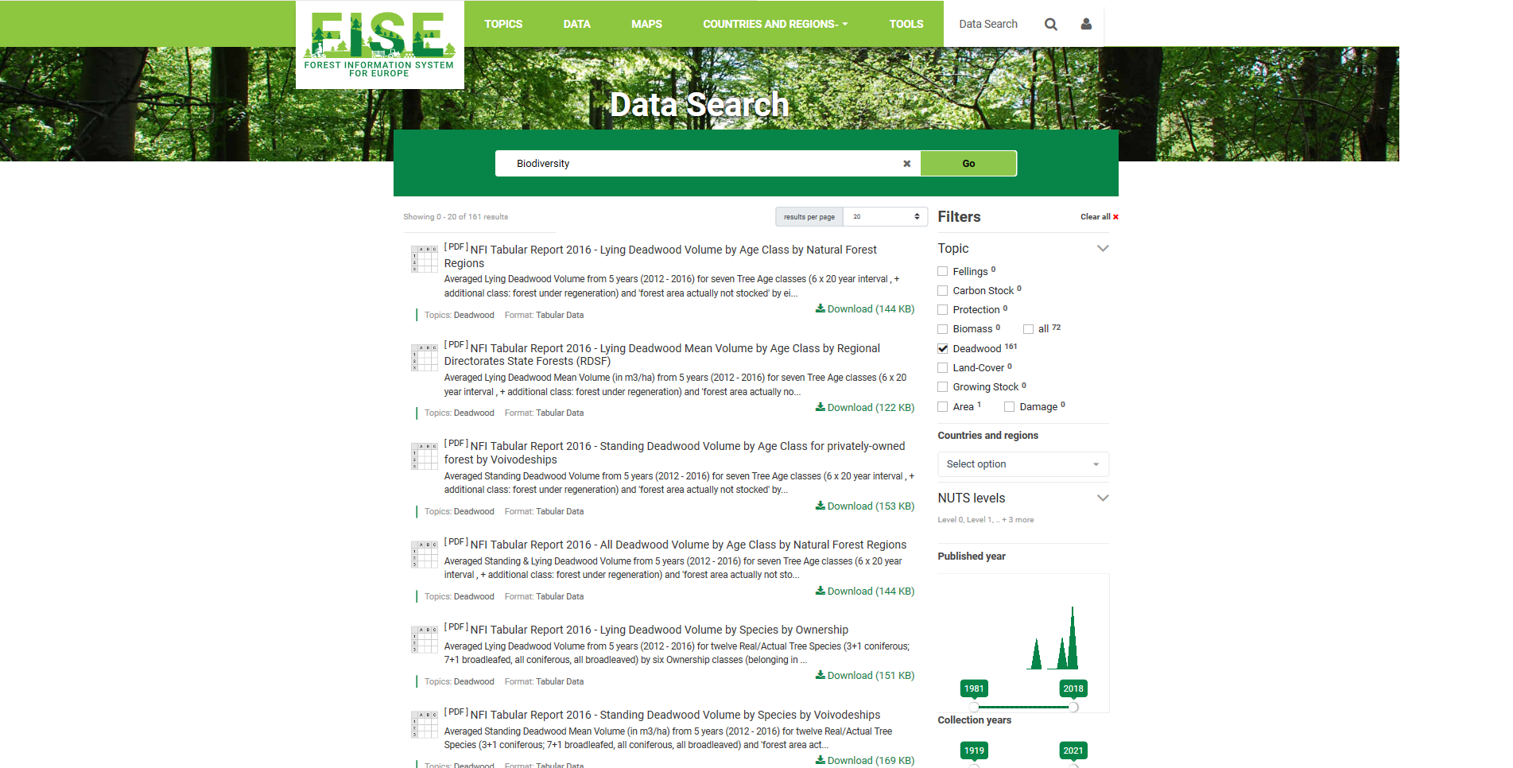

Figure - 6 Data search interface

The results can be further inspected in terms of metadata associated with them and can be downloaded for further use.

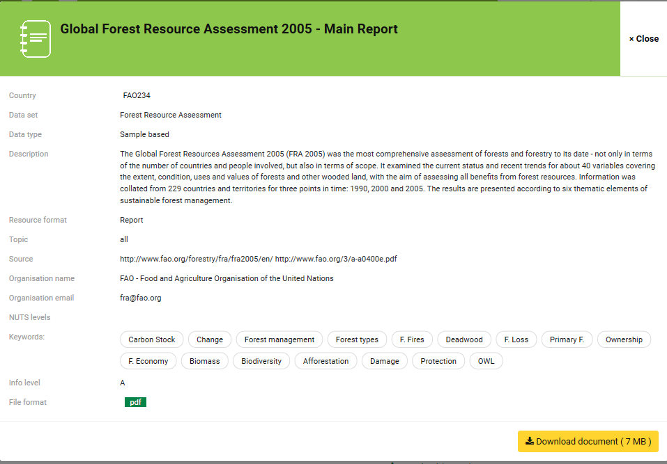

Figure - 7 Detail page for a search record

### Maps and graphs

This component of the FISE platform is in the scope of Tracasa’s experts and the following activities have been performed:

* Forest species distribution in Europe: <http://eea.maps.arcgis.com/home/webmap/viewer.html?webmap=e1591f2176b3406f861b4fd19ecbf99f&extent=-37.7071,26.0114,75.7597,69.8903>
* Forest Resources Assesment (FAO)
* Tree cover density by tree type
* EFFIS statistics up to 2016: <http://eea.maps.arcgis.com/home/webmap/viewer.html?webmap=7148a53bce434f0e94dcd078ba22f5a3>
* CDDA Forest protection webmap: <http://wab.discomap.eea.europa.eu/webappbuilder/apps/150/>
* Carpathian Convention webmap: <http://wab.discomap.eea.europa.eu/webappbuilder/apps/151/>

Status: On-going

|  |  |  |
| --- | --- | --- |
| **1.4** | **Workpackage** | **Task 4: Contract and project management** |

The objective of the project management activities is to plan, organise, secure, and coordinate the project resources and communications towards the agreed project objectives, absorbing the managerial work so that the team can focus in providing value in the technical expertise field.

This workpackage gathers together the activities related to Project and Contract Management. Project management responsibilities are ensured by Eau de Web for the FISE project.

AS FISE is being managed under the AGILE PM2 Methodology, the project has successfully passed through 01. Initiating and 02. Planning phases and continues with 03. Executing and 04. Monitor & Control phases where the project manager is closely following the activities that are performed, the resources involved and continuously evaluates the status of the project.

During the 01. Initiating phase, the kick-off meeting took place in the EEA and also the Project Charter has been elaborated and approved by the Project Steering Committee.

After the acceptance of the Project charter, Eau de Web, in collaboration with Tracasa, started the elaboration of the Project Workplan, Project Handbook documents describing in detail the timeline of the project, its deliverables, the roles and persons involved in the project activities etc. Meanwhile, the technical team started to draft the Architecture overview document and also initiated discussions with the customer, EEA and DG ENV, and JRC domain experts to better understand the requirements and to detail them for the software developers. A series of meetings took place, either face-to-face or via skype, meeting’s minutes are available on the project libraries (EIONET repository or Taskman wiki and tickets).

We will mention in this report 2 important meetings for FISE:

* [NRC Forest Meeting](https://forum.eionet.europa.eu/nrc-forests/library/nrc-forests-copenhagen-17-18-september-2018/presentations) that took place in 17th- 18th Sept 2018 in the EEA and was the first time that the FISE platform has been presented to the Member States representatives;
* Standing Forestry Committee meeting on 28th Sept 2018 at DG AGRI, presentation of the FISE portal and feedback collection from stakeholders and policy makers

#### Tools and procedures used for project implementation

The project manager will ensure the consistent use of:

* EEA Taskman [1] by all team members to track and document the progress of the work
* EEA Github[2] repository for delivering and maintaining all the developed software code
* EEA Taskman to document and store all relevant project documents, reports and minutes
* EIONET project library[3] to store important project documents and reports, datasets etc.

All deliverable project reports prepared by the project manager will be reviewed by our business analyst or technical lead before submission.

The existing Taskman custom queries will be used to monitor and optimise the flow of work:

* Monitor 1: Work In Progress (goal: keep WIP low at 2 per employee, reduce task-switching)
* Monitor 2: Awaiting Feedback / User Acceptance (goal: fast feedback loop)
* Monitor 3: Unfinished/Abandoned Work (goal: start finishing and stop starting, reduce waste)
* Monitor 4: Work with near/past deadline (goal: make fair use of deadlines / remove deadline if possible and use priorities)
* Monitor 5: Most probably obsolete (goal: get rid of them / invalidate / keep only if really worth it)

Status: On-going

## Project Milestones

|  |  |
| --- | --- |
| **Milestone and related activities** | **Status** |
| Web portal design up and running - Static portal with design | ✅ |
| First test version of the infrastructure | ✅ |
| First prototype ready for testing | On-going |
| Final prototype ready and operational ready at the end of the contract | Planned |

## Budget and Costs

We present below the status of the allocated and consumed effort for this project extracted at 17/12/2018.

Eau de Web:

|  |  |  |  |
| --- | --- | --- | --- |
| **Type of activity** | **Allocated Person-days** | **Consumed Person-days** | **Balance** |
| Business analysis, system architecture | 60 | 15 | 45 |
| Web development, testing and documentation | 899 | 264 | 635 |
| Training | 0 | 0 | 0 |
| Meetings, discussions, travel (6 meetings in the EU envisaged) | 70 md + travel expenses | 8.5 | 61.5 |
| Project management | 100 | 41.5 | 58.5 |
| **Total** | **1129** | **329** | **800** |

Tracasa:

| **Type of activity** | **Allocated**  **Person-days** | **Consumed Person-days** | **Balance** |
| --- | --- | --- | --- |
| Mapping | 240 | 113.7 | 326.3 |
| Charting | 200 |
| Training | 0 | 0 | 0 |
| Business analysis | 30 | 0.3 | 29.7 |
| QA/QC | 30 | 0 | 30 |
| Meetings, discussions, travel | 30 | 13 | 17 |
| **Total** | **530** | **127** | **403** |

## Project Resources

The following resources are involved for the successful implementation of this project:

**Eau de web:**

* Project Manager(s): Miruna Bădescu, Adriana Baciu (backup)
* System architect(s), business analysts:
  + Cornel Nitu (senior architect, full stack web developer, Python-based frameworks)
  + Sorin Stelian (senior architect, full stack web developer, Python-based frameworks)
  + Tiberiu Ichim (senior architect, full stack web developer, Python-based frameworks)
* Web developer(s):
  + Cornel Nitu (full stack web developer Python-based frameworks)
  + David Bătrânu (full stack web developer Python-based frameworks)
  + Tiberiu Ichim (full stack web developer Python-based frameworks)
  + Olimpiu Rob (full stack web developer Python-based frameworks)
  + Andrei Duhnea (full stack web developer Python-based frameworks)
  + David Ichim (Plone, Javascript, databases, web development)
  + Krisztina Elekes (Plone, Javascript, databases, web development)
  + Diana Boiangiu (Python-based frameworks, Javascript, databases, web development)
  + Ariel Pontes (Python-based frameworks, Javascript, web development)
* Designer(s): Valentin Popescu, Raluca Comanescu, Mihai Măcăneață
* System administrator(s)/DevOps: Anton Cupcea, Andrei Buzoianu
* Quality assessment(s): Bogdan Ciobanu, Eduard Fironda

**Tracasa:**

* Project Manager
  + Irathe Orbe - Project manager, GIS developer - ArcGIS
* GIS developer(s)
  + Vicente Urdánoz - GIS developer - ArcGIS, Tableau
  + Leire Leoz - GIS developer - ArcGIS
  + Koldo Goñi - GIS developer - ArcGIS, Tableau, FME
  + Mikel Gonzalez - GIS developer - FME, ArcGIS
* Web developer(s)
  + David Ramírez - GIS developer - ArcGIS, FME
  + Kristian Bergstrand – FME developer – FME
* Quality assessment:
  + Josu Ramirez- GIS developer, ArcGIS

**EEA:**

* Business Manager:
  + Beate Werner / Andrus Meiner
* Solution Provider:
  + Miruna Badescu (acting as proxy)
* Maps Manager:
  + Sebastien Petit

**JRC:**

* Domain expert(s):
  + Bernd Eckhardt
  + Peter Vogt

# Project Details

## Scope Changes

Up to this moment, there are no scope changes for this project.

|  |  |  |  |  |  |  |  |  |  |
| --- | --- | --- | --- | --- | --- | --- | --- | --- | --- |
| **ID** | **Category[4]** | **Title** | **Description** | **Status[5]** | **Action Details**  (effort & responsible) | **Size[6]** | **Priority[7]** | **Approval decided by** | **Actual Delivery Date** |
|  |  |  |  |  |  |  |  |  |  |

## Major Risks and Actions Taken

The following risk rating matrix is used:



Figure - 8 Risk Rating Matrix tool

| **ID** | **Risk Description & Details** | **Status** |  | **Likelihood**[8] | **Impact**[9] | **Risk Level**[10] | **Risk Owner** | **Risk Response Strategy[11]** | **Action  Details** |
| --- | --- | --- | --- | --- | --- | --- | --- | --- | --- |
| 1 | Not sufficient support from the European Commission |  |  | 1 | 5 | 5 | PO | Avoid | Establishment of a working group who will closely follow the project and disseminate its results to stakeholders. |
| 2 | No sufficient capacities at the EEA |  |  | 3 | 5 | 15 | BM | Reduce | Look for forest experts with European expertise to cover the period of absence of a Business Manager |
| 3 | Not entirely transparent collaboration with partners resulting in duplication of access to the same data source leading to inappropriate resource efficiency and confusion of users |  |  | 2 | 4 | 8 | PO, BM | Avoid | Organise online and face-to-face meetings, send status updates and engage partners in technical discussions about each relevant topic |
| 4 | Changes in the scope will have a direct influence on the project timeline and budget |  |  | 1 | 4 | 4 | PM | Transfer or Share | Those changes should be done with caution. It is the responsibility of the PM (helped by the BM) to accept the changes and escalate them to the PSC if necessary. |
| 5 | Data sources to integrate in FISE are not available in due time or do data is not retrievable |  |  | 2 | 4 | 8 | PM, BM | Reduce | EEA/JRC will first try to make data available in the needed formats. If this will not be possible, data availability should be planned for the future and alternatives should be presented by the SP (EdW and Tracasa) |
| 6 | The required deadlines are too tight |  |  | 2 | 3 | 6 | PM | Reduce | Start functional design and development activities as soon as possible.  Apply agile methodology and obtain customer feedback early during the project.  Involve a project manager with technical skills to offload analysis and coordination tasks from the technical team.  Involve full-time senior developers with good management skills and for the entire duration of the project. |
| 7 | Slow decision making on beneficiary side. No clear and transparent decision making process & escalation in place. Unclear responsibilities regarding change management and decision making process. |  |  | 2 | 3 | 6 | PO, BM | Transfer or Share | Engage the Business Manager is clarifying the requirements  Organise online and face-to-face meetings  Provide frequent online prototypes of the entire portal and the different components |

## Major Issues and Actions Taken

|  |  |  |  |  |  |  |  |  |  |  |
| --- | --- | --- | --- | --- | --- | --- | --- | --- | --- | --- |
| **ID** | **Category** | **Title** | **Description** | **Status[12]** | **Action Details** | **Urgency[13]** | **Impact[14]** | **Size[15]** | **Target Date** | **Issue Owner** |
| 1 | Business | Official data | MS have requested us to use only officially reported data | Resolved | The data that will be presented in FISE will only be official data reported by Member states either at European level as well as international level. No interpretation or comparison for the data will be done. | 3 | 4 | 1 | 2018 | EdW, Tracasa, JRC |
| 2 | Human Resources | Business Management | The initially appointed business manager will not be available for a 6 months period | Resolved | EEA appointed a new business manager for this project. | 4 | 4 | 2 | Oct 2018 | EEA |

## Other On-going and Planned Actions

|  |  |  |
| --- | --- | --- |
| **Actions** | **Due date** | **Who & Comments** |
| First prototype ready for testing | Feb 2019 | Eau de Web, Tracasa, EEA |
| Final prototype ready and operational ready at the end of the contract | Dec 2019 | Eau de Web, Tracasa, EEA |

## Tickets for FISE Development and transfer of FISE to EEA

We present below an aggerated situation of the existing tickets in Taskman for the implementation of FISE:

|  |  |
| --- | --- |
| **Status/Description** | **Sum of Spent time** |
| **Acceptance/Demo** | **208,5** |
| [FISE Plone portal] Create and implement final version of the logo | 50 |
| [FISE Plone Portal] Implement visualisation tool for Land Transition Matrix | 44 |
| [FISE Plone portal] Styles for the Plone administration areas | 74,5 |
| [FISE Plone portal] Web design for the FISE website | 40 |
| **Accepted in Queue** | **982,75** |
| [FISE data] User stories to present in FISE | 410,75 |
| [FISE Plone portal] Add several TinyMCE styles | 4 |
| [FISE Plone portal] Create simplified header/footer for the map | 8 |
| [NFI search] Implement front-end Search functionality | 508 |
| [NFI search] Issues with the second version of the NFI dataset | 52 |
| **Closed** | **1903,25** |
| Analysis, project management and documentation during the planning phase | 240 |
| [FISE data] Create sample viewer | 15,5 |
| [FISE data] EFFIS statistics up to 2016 | 23 |
| [FISE data] Forest Resources Assesment (FAO) | 0 |
| [FISE data] Forest species distribution in Europe | 7,25 |
| [FISE data] NFI Data | 6 |
| [FISE data] Second dataset from JRC: selection of datasets as provided by Forest Europe | 28 |
| [FISE data] Wood Energy data | 23,5 |
| [FISE Plone portal] Cleanup and reorganize javascript and css resources | 48 |
| [FISE Plone portal] Create a schematic, very simple layout for FISE | 48 |
| [FISE Plone portal] Create initial website structure | 103 |
| [FISE Plone portal] Create orchestration for the FISE portal | 28 |
| [FISE Plone portal] Create svg graphic for frontpage | 4,5 |
| [FISE Plone portal] Docker fise image fails to build | 12 |
| [FISE Plone Portal] Dynamic matrix implementation | 48 |
| [FISE Plone portal] Embed, collect and display Article 17 data in FISE portal pages | 12 |
| [FISE Plone portal] Feedback and adjustments for the portal | 9 |
| [FISE Plone portal] Finish frontend architecture for FISE | 20,5 |
| [FISE Plone portal] Install new work in progress website at demo-forest.eea.europa.eu | 20 |
| [FISE Plone portal] Investigate performance issues of demo site from prod1aws | 3,75 |
| [FISE Plone Portal] Land transition matrix 4.1 table styling | 64 |
| [FISE Plone portal] Move demo site to prod1aws from staging1 | 32 |
| [FISE Plone portal] Move site to CPH Rancher environment | 12 |
| [FISE Plone Portal] Plone matrix data integration | 16 |
| [FISE Plone portal] Upgrade demo site to TinyMCE 4 | 8 |
| [FISE Plone portal] Web design implementation | 228,75 |
| [NFI Search] - Searching by multiple words keyword returns more results then expected | 32 |
| [NFI search] Add models to Django Admin | 6 |
| [NFI search] Analisys of the NFI dataset received from JRC | 21 |
| [NFI search] Backend endpoints for search API | 34 |
| [NFI search] Batch import system | 8 |
| [NFI search] Containerization setup and deployment on EEA staging environment | 56 |
| [NFI search] Create search endpoint | 16 |
| [NFI search] Define application models | 10 |
| [NFI search] Define the database structure | 16 |
| [NFI search] Define the technology for harvesting/storing/presenting FISE data | 24 |
| [NFI search] File download API | 8 |
| [NFI search] Filter search results by publication/collection year | 8 |
| [NFI search] Frontend project setup | 12 |
| [NFI search] Identify or develop PDF table extraction tool | 4 |
| [NFI search] Implement Fron-End structure of components | 20 |
| [NFI search] Implement front-end design | 92 |
| [NFI search] Import data | 60 |
| [NFI search] Mockups for the NFI search | 16 |
| [NFI search] Modify db schema to fit Django's usual structure | 4 |
| [NFI search] Setup the project structure | 32 |
| Analysis, project management and documentation during the initiation phase | 232,5 |
| Establish new FISE project name | 0 |
| Preparation of Architecture overview for FISE | 20 |
| Presentation of FISE during the SFC meeting | 12 |
| Presentations during the NRC Forests Meeting 17-18 September and Standing Committee Meeting 28 September | 99 |
| **In Progress** | **459** |
| [FISE data] Establish the list of datasets to include in FISE and end product | 63 |
| [FISE data] FISE-Showcases | 92,75 |
| [FISE data] Forest on Protected sites | 56 |
| [FISE data] Life Programme projects | 15,25 |
| [FISE data] Map of Forest Certification | 18 |
| [FISE data] Spatial Data Analysis | 0 |
| [FISE data] Tree cover density by tree type | 45 |
| [FISE Plone portal] Editing support for portal pages | 0 |
| [FISE Plone portal] First version of the FISE portal | 0 |
| [NFI search] FISE application for the NFI data | 24 |
| [NFI search] Search facets aggregation hinting | 16 |
| Meetins and project management during the execution phase | 129 |
| **New** | **88,75** |
| First prototype of the web portal | 0 |
| [FISE data] Cover density & forest type statistics by nuts(0-3) | 5,5 |
| [FISE data] Fresh Water Quailty related to Forest | 19,25 |
| [FISE Plone portal] Devise GEMET integration with FISE data | 6 |
| [FISE Plone portal] Short description for the Data Search functionality | 0 |
| [NFI Search] Feedback for NFI search from the meeting on 17 Oct 2018 | 50 |
| Proposal for wireframes for LULUCF matrix | 8 |
| **WIP-debt: On Hold** | **53,5** |
| [NFI search] Integrate GEMET forestry concepts | 22 |
| Cross-section meetings | 31,5 |
| **Grand Total** | **3695,75** |

Useful information on Taskman

|  |  |
| --- | --- |
| Opening a ticket for FISE - Development and transfer of FISE to EEA | <https://taskman.eionet.europa.eu/projects/fise-dev/issues> |
| Tickets closed during the reported period: | 51 |
| Tickets on-hold: | 2 |
| Tickets in progress | 17 |
| Tickets in Acceptance/Demo | 4 |
| New Tickets | 7 |
| Invalid Tickets | 0 |

# Appendix 1: References and Related Documents

|  |  |  |
| --- | --- | --- |
| **ID** | **Reference or Related Document** | **Source or Link/Location** |
| 1 | [FISE Project Handbook](https://projects.eionet.europa.eu/fise-project/library/02.-planning/fise-project-handbook) | <https://projects.eionet.europa.eu/fise-project/library/02.-planning/fise-project-handbook> |
| 2 | Project Charter | <https://projects.eionet.europa.eu/fise-project/library/1.-initiating-phase/fise-project-charter> |
| 3 | FISE Project Workplan | <https://projects.eionet.europa.eu/fise-project/library/02.-planning/fise-project-workplan> |
|  | Project folder/repository | <https://projects.eionet.europa.eu/fise-project/library> |
| 4 | EEA online tool for organisation of tasks and activities – Taskman | <https://taskman.eionet.europa.eu/projects/fise-dev> |

1. https://taskman.eionet.europa.eu/projects/fise-dev
2. <https://github.com/eea>
3. <https://projects.eionet.europa.eu/fise-project/library/>
4. Categorize the changes. Examples of categories are: new requirement, technical, issue or risk related, business improvement, etc.
5. The Change Status can assume the following states: Submitted; Assessing; Waiting For Approval; Approved; Rejected; Postponed; Merged; Implemented
6. Size represents the effort related to the change implementation and the possible values are: 5=Very high; 4=High; 3=Medium; 2=Low; 1=Very low
7. Priority is a numeric value given to a project change to classify its relative importance in comparison to other changes and the possible values are: 5=Very high; 4=High; 3=Medium; 2=Low; 1=Very low
8. A numeric value denoting the relative probability that the risk should occur.
9. A numeric value denoting the relative severity of the impact of the risk if it should occur.
10. The risk level is the product of the likelihood and impact (RL=L*I).
11. The possible risk response strategies are: Avoid/ Transfer or Share/ Reduce / Accept.
12. The issue status can be any of the following: Open; Postponed; Resolved; Closed.
13. A numeric value denoting the urgency of the issue. The possible values are: 5=Very high; 4=High; 3=Medium; 2=Low; 1=Very low.
14. A numeric value denoting the severity / impact of the issue. The possible values are: 5=Very high; 4=High; 3=Medium; 2=Low; 1=Very low.
15. Issue size represents the effort related to the issue resolution. The possible values are: 5=Very high; 4=High; 3=Medium; 2=Low; 1=Very low.