Review of JRC/EEA EU-level HNV Farmland methodology
Expert workshop to review outcome of tests to improve the JRC/EEA HNV farmland methodology
14 October 2019 at Environment Agency Austria; Spittelauer Lände 5, 1090 Vienna
Final revised agenda
Introduction:
The expert workshop will review concrete proposals for improving the current JRC/EEA approach for estimating the distribution of High Nature Value (HNV) farmland at European level. This will focus on three different aspects:
a) How to use national and biodiversity data sets that are comparable to EU approach for improving the HNV Corine Land Cover (CLC) selection rules per environmental zone or in individual countries.
b) Whether EU level data sets on agricultural land use intensity (e.g. livestock density, N-Balance) could be used for refining CLC rules for locating EU HNV farmland in a probabilistic approach.
c) Comparison of analysis of Copernicus High Resolution Layers (e.g. the Grassland HRL) with the current EEA/JRC HNV distribution estimate, plus review of other satellite data opportunities

Revised agenda:
09.30 Welcome and introduction (Chair: J-E Petersen, EEA)
09.45 Session 1: Review of country level work on HNV farming / farmland
09.45 Presentation by P. Pointereau, Solagro, on identifying HNV farmland in France
10.10 Presentation by UBA Vienna (M. Weiss) on outcome of review of available national data for refining rules on for selection of CLC classes by biogeographic region, followed by discussion (Rapporteur: Yanka Kazakova, Bulgaria)
11.20 Brief coffee break
11.30 Session 2: Comparison of analysis of HRL grassland data with current HNV ‘map‘; review of satellite data opportunities - presentation by GISAT (Tomas Bartalos) followed by discussion (Rapporteur: Gebhard Banko, UBA Vienna)
12.45 Lunch break
13.45 Session 3: Options for including a land use intensity dimension into the spatial representation of HNV farmland
Review of results based on JRC CAPRI model (n.n., UBA Vienna + EEA), followed by discussion (Rapporteur: Clunie Keenleyside, UK))
15. 40 Coffee break
16.00 Summing up by organisers and concluding discussion
16.45 End of workshop
List of participants (status of 10/10/19):

Participants from EU level organisations (not reimbursed):
European Environment Agency: Jan-Erik Petersen
EU Joint Research Centre: by remote connection only
ETC ULS staff (at Environment Agency Austria): Elisabeth Schwaiger, Gebhard Banko, Michael Weiss, Andreas Littkopf
GISAT, Czech Republic: Tomas Bartalos

Country experts:
Clunie Keenleyside, IEEP, UK, Ckeenleyside@ieep.eu
Daniel Fuchs, PAN GmbH Germany, daniel.fuchs@pan-gmbh.com azvan Popa <razvan@fundatia-adept.org
Philippe Pointereau, Solagro, France, philippe.pointereau@solagro.asso.fr
Yanka Kazakova, University of National and World Economy, Bulgaria yanka.kazakova@gmail.com

Background: summary of recent work as reviewed at 2017 workshop on HNV farmland
The 2017 workshop began with an introductory session that reviewed EU level perspectives and the current JRC/EEA methodological approach as well as the work on identifying HNV farmland and farming systems in different countries (Germany, Italy and Romania). All workshop presentations can be found under: https://projects.eionet.europa.eu/ecosystem-capital-accounting/library/hnv-expert-workshop-_-vienna-12-june-2017
One key challenge in the comparison of the current JRC/EEA HNV farmland data set with similar national or European data sets is the need to ensure comparability of the underlying HNV concept and the ecological definition of what constitutes ‘high nature value’ with the original JRC/EEA approach. For example, the use of the ‘HNV farmland’ concept would imply a focus on the spatial delimitation of areas of farmland with a high nature value character, whereas the ‘HNV farming’ concept can be considered to focus on identifying where farming approaches are favourable to high nature value. In addition, national approaches can vary in the ecological threshold they apply for identifying what is ‘high nature value’ as the ecological and farming context varies from country to country. The potential differences and overlaps between the different concepts as well as national and European definitions are set out in Figure 1 below.
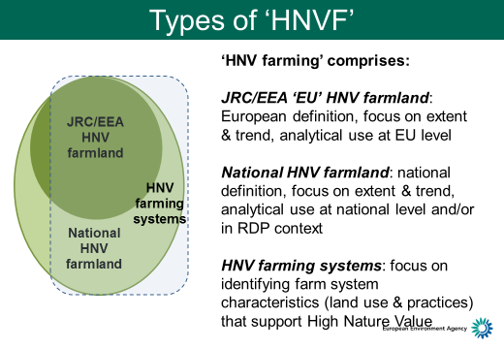
Figure 1: Commonalities and differences between different types of HNV farming
– a conceptual comparison

