### Developing ecosystem service classification(s) for ecosystem accounting – taking stock & moving forward

**DRAFT TECHNICAL BACKGROUND DOCUMENT – PLEASE DO NOT CIRCULATE FURTHER**

**Expert Workshop**

**Wageningen University, Netherlands, 17-18 November 2016**

**Draft technical notes to support the discussion**

### The expert workshop is organized as part of a process guided by UNSD to develop a multi-purpose international classification of ecosystem services (ES) (or a modular system of explicitly connected classifications) to support implementation of ecosystem accounting as described in the SEEA Experimental Ecosystem Accounting (SEEA-EEA).

### Starting from the three classification systems potentially useful in an SEEA context – CICES, FEGS-CS, and NESCS – participants will discuss the principles and definitions underlying these three classification systems, in order to arrive at a shared conceptual understanding on how to classify ecosystem services for ecosystem accounting. The meeting will also review other purposes for ES classification(s) and possible structures classifying ES for ecosystem accounting purposes. The workshop is intended to determine a way to agree on, or create, an internationally shared multi-purpose classification of ecosystem services (or a modular system of explicitly connected classifications). [*Note: these terms are open to interpretation*]

The objectives of the Wageningen Expert Workshop are as follows:

1. To review current experience in developing and applying ES classifications to assess how current approaches meet or fail to meet the needs of ecosystem accounting as well as related mapping and assessment applications. This exercise will include a first comparison of CICES, FEGS-CS, and NESCS.
2. Based on previous discussions and the comparison of CICES, FEGS-CS, and NESCS, develop a common understanding of the conceptual foundation for ecosystem services classification, to be used in the compilation of SEEA Experimental Ecosystem Accounts (including key objectives, definitions, and principles or criteria).
3. Discuss a possible structure, or at least the necessary elements, of the classification of ecosystem services for ecosystem accounting, what a modular system could look like (based on agreed criteria and principles) and relations with other classifications used in official statistics. This also needs to review practical implementation requirements and measurement issues, as far as they relate to design decisions.
4. Agree on the next steps and required research for developing a multi-purpose standardized, international ES classification (or modular system of explicitly connected classifications), including for the SEEA Experimental Ecosystem Accounting.

The following sections present key concepts and comparative material for the three current ecosystem services classification systems, and review selected methodological questions that are meant to be discussed at the Expert Workshop.

The context for the review of these systems is the SEEA Experimental Ecosystem Accounting (SEEA EEA). Figure 1 below shows the conceptual structure of SEEA-EEA as described in the draft Technical Recommendations that are under elaboration[1]. This figure makes clear that ecosystem service accounts are part of the overall system of ecosystem accounting. It also highlights the two components (Figure 1, elements 2b & 4, and possibly 3) that require a functioning ecosystem service classification for their implementation. The outcome of the expert workshop is expected to contribute to parts of the technical recommendations that deal with issues related to ecosystem service classifications.

**Figure 1: Conceptual structure of ecosystem accounts as proposed by SEEA EEA**



**Supported by ES classifications**

**Section 1 Introduction to and comparison of CICES, FEGS-CS, & NESCS**

This section sets out key characteristics of the three ES classification systems in a comparative manner in an overview table, and presents selected diagrams that describe the respective conceptual models to provide a conceptual comparison.

Table 1: Comparative overview of current ecosystem service classification systems

|  |  |  |  |
| --- | --- | --- | --- |
| **Characteristic** | **CICES** | **FEGS-CS** | **NESCS** |
| **Origin / custodian** | EEA & University of Nottingham | US-EPA - ORD | US-EPA – ORD, OW, OAR |
| **Purpose & use context** | ‘Multi-purpose classification’ of potential final ES for accounting, assessment etc. | Classification system focused on final ecosystem goods and services (FEGS) (for measuring) stocks | Classification system focused on final flows of ES by flexible “Use-User” combinations |
| **Main conceptual model** | Cascade model | Environment + Potential Beneficiary = FEGS | ‘Blue-green’ diagram; Four-Group structure |
| **Structure / design** | Hierarchical, developed on basis of 3 of 4 MA ES categories | Matching hierarchies of Environments and Beneficiaries yields a matrix of feasible types of FEGS | Nested hierarchies in each Group; linking across Four-Group structure essential |
| **Current use / users** | Adopted for EU ecosystem accounting work; used by many research teams, mainly in Europe | EPA pursuing metrics and indicators for ecological measures using FEGS-CS; US NSF-funded Air Quality & ES work across many envts. | Developed for work by US-EPA, proposed / adopted by current USGS-led research initiative on natural capital accounting |
| **Links to other classifications** | Inspired by work under MA & TEEB, a translation tool exists to those classifications | Embedded land and beneficiary classifications | Embedded land and beneficiary classifications (NAICS “plus”), intentionally modular |
| **Other information** | Currently under revision based on extensive user survey | Online user tool; FEGS-CS Revision product in 2018 | ‘Summary’ doc and ‘Guidelines for Use’ forthcoming |

Note: ‘ORD’ stands for Office of Research and Development, ‘OW’ for Office of Water, and ‘OAR’ for Office of Air and Radiation.

Further details on CICES can be found under: [www.cices.eu](http://www.cices.eu)

Information on FEGS-CS is provided under: <https://cfpub.epa.gov/si/si_public_record_report.cfm?dirEntryId=257922>

Information on NESCS is available under: <https://www.epa.gov/sites/production/files/2015-12/documents/110915_nescs_final_report_-_compliant_1.pdf>

Key conceptual diagrams for all three systems:

The following diagrams show the main conceptual model(s) underpinning each of the three systems. These provide of course only a snapshot, further material is being prepared.

1. ***Figure 2: the*** ***CICES ‘cascade model’*** – this aims to show the entire chain of processes from the underpinning ecosystem structures and processes to socio-economic goods and benefits and illustrates where the CICES ecosystem service classification is considered to sit in the cascade.

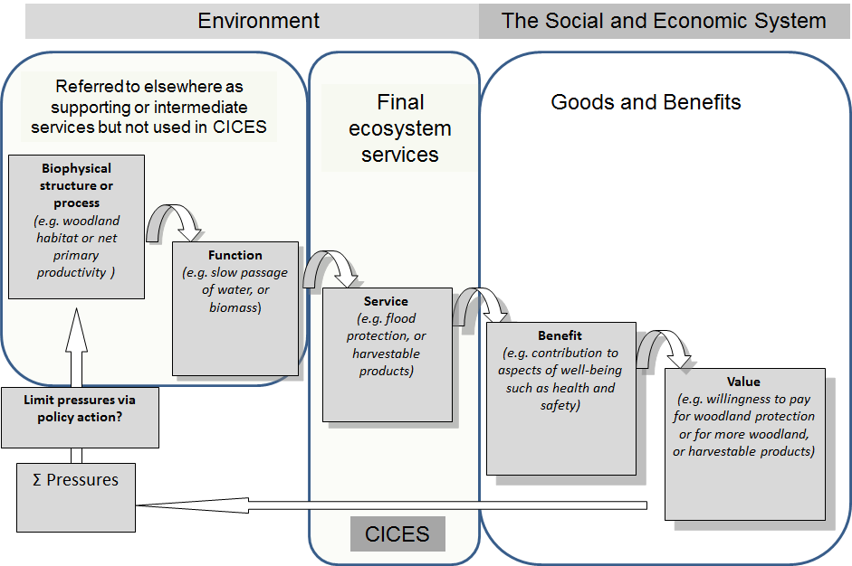

1. ***Figure 3: the*** ***FEGS-CS identification process*** – this shows the conceptual underpinning of the three operational steps used in FEGS-CS for identifying final ecosystem goods and services (i.e. ‘FEGS’).



1. ***Figure 4: the NESCS ‘blue-green diagram’*** describes how economists would add “natural capital” to standard economic production thinking.

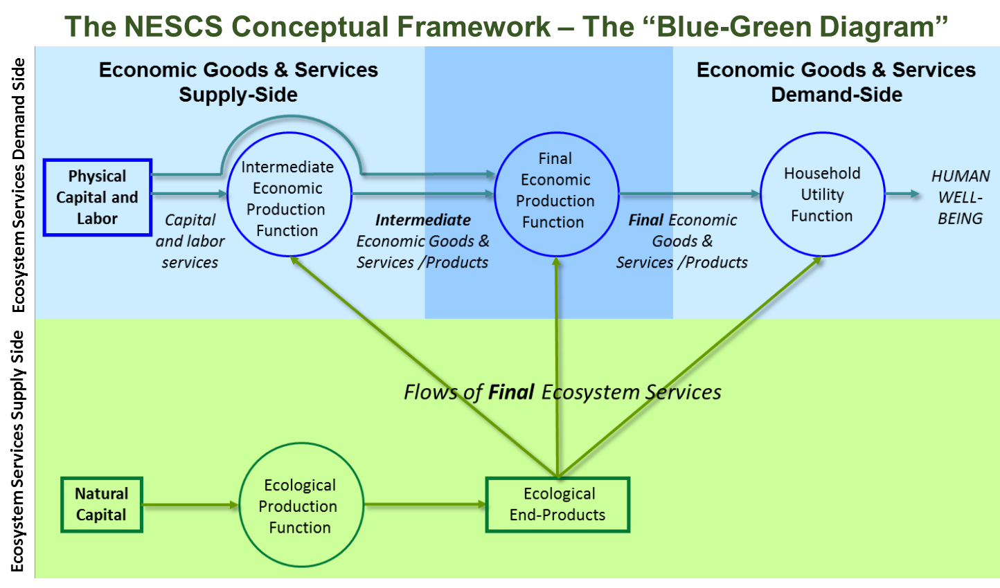

1. ***Figure 5: the*** ***NESCS four-group structure*** illustrates the four components that the NESCS system is comprised of & that together are used to identify flows of final ES.

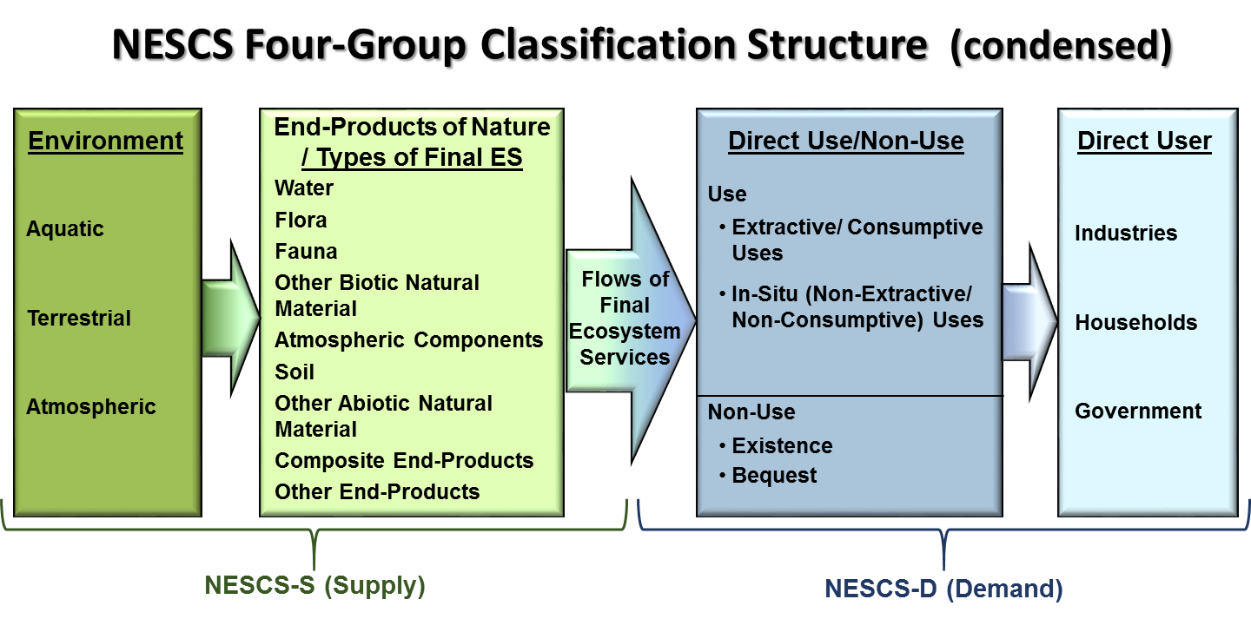

Comparative diagrams that aim to show links and differences between the three systems:

Figure 6 shows assumed analytical connections between components of SEEA-EEA (identified by their specific numbering in Fig. 1) and classifications and other tools that support the implementation of individual component accounts (blue bubbles & dashed box). Below that is a conceptualised representation of the range of classifications and other instruments that are covered or encompassed by the classification systems discussed.

[ *Note: this diagram is still under development / discussion.* ]

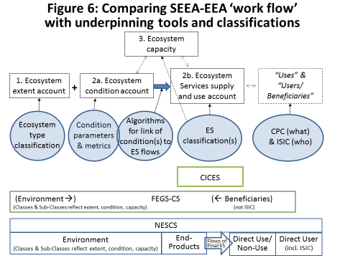

Further diagrams will aim to provide additional comparison between the FEGS-CS approach, the four-group structure of NESCS with the thematic coverage of the types of ecosystem services covered by CICES against the backdrop of SEEA concepts. These will become available for use during the workshop itself.

**Section 2 Objectives, principles and criteria for classifying ES for ecosystem accounting**

There are a number of sources that can be used to develop objectives, principles and criteria for a classification system of ecosystem services for ecosystem accounting, e.g.:

* The SEEA EEA handbook and the related draft technical recommendations at: <http://unstats.un.org/unsd/envaccounting/workshops/ES_Classification_2016/SEEA%20EEA%20Tech%20Rec%20Consultation%20Draft%208.1%20Dec2015%20final.pdf>
* The ‘Best Practice Guidelines for Developing International Statistical Classifications’, (A. Hancock, 2013) – see annex 2 for an extract.
* The draft summary paper of the UNSD expert meeting on ecosystem service classification in New York, June 2016, available under: at  <http://unstats.un.org/unsd/envaccounting/workshops/ES_Classification_2016/Towards%20a%20Standard%20International%20Classification%20on%20Ecosystem%20Services%20-%20Final%20report%20for%20consultation.pdf>
* Reflections on essential issues for ecosystem service classification provided by Carl Obst in advance of the 2016 UNSD expert meeting in New York – see annex 2A recent paper prepared for the London group meeting in Oslo – available under:<http://unstats.un.org/unsd/envaccounting/londongroup/meeting22.asp>

All this material together covers many pages, so it is essential to summarise key points. The bullet list below provides an extract of the summary of key outcomes of the UNSD expert meeting on ecosystem services classification(s) on 20-21 June 2016 in New York, as provided by Anton Steurer at the UNCEEA meeting in June 2016:

* **ES = *final*, i.e., benefit humans but classification lists *potentially final* as real use is context dependent**
* ***Intermediate* ES problematic term - different meanings**
* **Classifications modular (separate classifications for ES, assets, users)**
* **Separate classification for abiotic (e.g., subsoil)**
* Initial ideas to further improve CICES identified, timing should include testing ***the future revised classification*** andto align timing with SEEA EEA revision
* Next steps are testing existing classifications, clarifying terms, agreeing on principles for revised classification, developing and testing a revised classification

Carl Obst, the editor of the SEEA EEA handbook, provided a useful brief discussion paper on issues relevant for designing an international classification of ecosystem services for ecosystem accounting in advance of that meeting. Please find below a copy of a key section:

**Developing an international classification for ecosystem services for environmental-economic accounting**

Comments – Carl Obst, 16 June, 2016

The following comments and observations are intended to support discussion at the upcoming meeting on a classification for ecosystem services to be held in New York on 20-21 June. I’m sorry I won’t be able to attend but wish you well in the discussions.

**Core framing issues**

1. While in much of the discussion the focus has been on the CICES, FEGS-CS and NESCS classifications, there seems to be a general lack of clarity on the role of classifications for SEEA type / national accounting exercises. The following are my thoughts on this issue.

a. We need to establish the relevant measurement concepts and then use classifications to provide the detail to analyse these concepts. It may be that discussion of classifications helps to define the measurement boundaries for a given concept but, in the final phase, the concept and associated measurement boundary must be set first before a classification can be finalized. In the situation here, we ultimately need an agreed definition/boundary for ecosystem services and then a classification can be established which, in effect, identifies different types of ecosystem services within the agreed boundary.

b. Three distinct classifications are relevant for ecosystem accounting

i. Classification of ecosystem types – recognizing that ecosystem assets are quasi-producing units in the ecosystem accounting framework then a classification of different types of producing units is needed.

ii. Classification of ecosystem services – here the accounting logic is that the ecosystem services are the production of ecosystem assets – in effect sales by a producer. We could lump all types of ecosystem services together without distinction in the same way as all products (goods and services) from production by economic units could be grouped together. But it is meaningful to record different types of ecosystem services and this is the role of the classification.

iii. Classification of user/recipient – The production of ecosystem services reflects a transaction between a producing ecosystem asset on the one hand and a recipient or user on the other. For “final ecosystem services” the user is an economic unit, household/individual or society generally. It would be useful for these users to be classified following the classifications used in the SNA – either by institutional sector or by economic activities (ISIC). A convention to treat use by society as use by general government would be consistent with the SNA. For intermediate ecosystem services the transaction is between a producing ecosystem asset and another ecosystem asset (the convention suggested/implied here is to ignore transactions internal to a single ecosystem asset which is also the starting convention for national accounts). The relevant classification of these ecosystem asset “users” is the classification of ecosystem types as above.

The extracts above clarify a number of important points that have been under discussion, for example that ES classification(s) can also include potentially final ES and that different component accounts of SEEA EEA are expected to be underpinned by their own specific classifications (as far as necessary).

Building on the material above as well as the Best Practice Guidelines for Developing International Statistical Classifications (Hancock, 2013) we propose a set of eight key principles to be considered in building ecosystem service classification(s) for ecosystem accounting in the bullet list below:

* Enable focus on final ecosystem services but include potentially final ES
* Devise structure and guidance to users in a way to avoid double counting, i.e. categories should be mutually exclusive
* Provide clear and precise definitions of categories and individual ES
* Ensure that the classification covers all possible units of the items classified
* Facilitate aggregation to higher-level categories in the set-up of the classification
* Ensure full compatibility with, and links to, related statistical classifications (e.g. ISIC)
* Ensure time-series comparability between different versions over time
* Consider ease of use and ease of maintenance in the design of the classification

Hancock (2013) provides a longer list of principles (see annex 1) but the criteria listed above were chosen as they appeared the most relevant and measurable ones. Expert Workshop participants could review the list above and discuss the resulting list in relation to the three current ES classification systems.

**Section 3 Key conceptual or methodological issues to be reviewed**

This section sets out key conceptual or methodological issues that merit further detailed review. The list of issues below is not meant to be exhaustive, but these issues have frequently been discussed at recent meetings on ecosystem accounting and related classifications.

Please provide feedback on the methodological issues set out below or to add to this list.

1. Previous meetings have talked about the need for a multi-purpose classification or a [modular] system of explicitly connected classifications. But what is a ‘multi-purpose’ classification? And how to interpret the concept of a ‘modular structure’ for classifications? Figure 8 aims to illustrate these concepts and Figure 9 applies them to two existing ES classification systems. Do these diagrams make sense to you and would you have any suggestions for further improvement?

[ *Note: diagram 9 is still under development / discussion.* ]

Figure 8: A conceptual representation of ‘multipurpose and ‘modular’

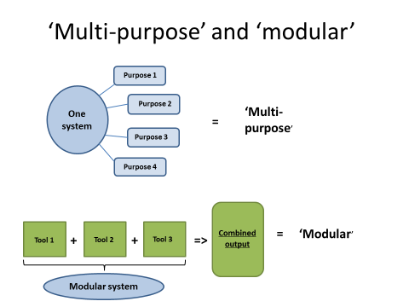

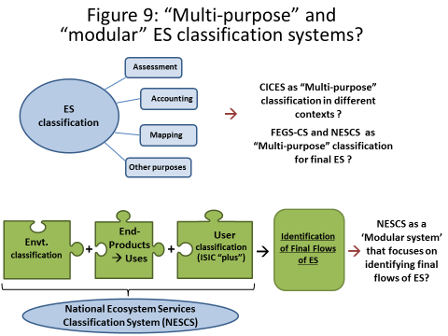

1. The concept and use of ‘ecological production function(s)’ (EPF) appears central to identifying the contribution of ecosystems to socio-economic benefits. It is also put forward as being essential for identifying the contribution of ecosystems to final socioeconomic goods and services, for example to measure the contribution of nutrient cycling or photosynthesis to the production of agricultural crops. In this case production functions for the ecosystem contribution are essential for identifying final ES (instead of just taking total crop output as proxy measure for ES, which often is current practice). However, its practical applications raises a number of questions:
   * Does it refer to ecosystem functioning as a whole or does it refer to individual flows of services?
   * What is the meaning of the term EPF in different contexts (e.g. as part of bio-physical modelling or to attribute a share of the value chain as in national accounting) ?
   * Should we consider it as an expression of ‘real’ biophysical flows or should we use it in a pragmatic fashion for dividing up the contributions of nature and those of economic actors to joint outputs (in a kind of virtual reality) ?

An extract from a paper to a recent meeting of the London group in Annex 2 provides further background to the questions raised above. Do you have any feedback on either?

1. Aggregation – this is an important function of any classification, in particular for statistical purposes. What are the potential solutions or approaches for implementing it in an ES classification context?

In the development of CICES it was assumed that aggregation is an important function for an accounting approach (it also makes great sense in many other analytical contexts). Hence CICES is built on a hierarchical structure that is meant to allow horizontal aggregation from lower level categories to groups and sections. NESCS also enables some aggregation in the sense that in each of its four major groups (see Figure 5 above) aggregation is possible to a certain degree. A similar approach was taken in FEGS-CS.

In the recent informal CICES consultation there was feedback that explored this issue; with some suggesting that the ability to sum up ‘horizontally’ and ‘vertically’ across categories would be helpful. However, the latter does not appear feasible as one would compare ‘apples with oranges’. This means that provisioning services are fundamentally different by nature from cultural services and even in each of these larger sections one can have classes that represent very different processes.

Nevertheless vertical aggregation could become feasible in two different ways. The first option would be to convert all ES into outcomes that can be measured by a common currency, e.g. via monetization. Then vertical aggregation in terms of that common currency would be possible.

A potential technical solution could be to add virtual tags or classifiers to each cell at class type level. With the right software tool it would then be possible to sum up different categories independent of the location of the cell. The key issue in this regard is what are the classifiers meant to be, should they indicate origin by ecosystem type, end use or the type of ecosystem service (as proposed in CICES)? This solution could become complicated very quickly and would require a lot of investment of time for development and maintenance. It may thus be better to combine an ES classification with other classifications of key attributes in a modular fashion.

Feedback would be appreciated on whether this issue is sufficiently important to merit further investment to develop such tagging to allow flexible aggregation.

1. Application of the environment-economy boundary in different contexts (SEEA conform uses, ecosystem assessment, Cost-Benefit-Analysis, other ?)

Given that it would be possible to discuss this endlessly, perhaps a pragmatic solution could be to go back to Figure 1 and agree the scope and content of the different accounts. However, a key issue that needs to be addressed is that ecosystem accounting is also applicable to human managed systems and not just ‘natural ones’. All ecosystems are potentially covered by ecosystem accounting – the issue of ‘joint production’ then needs to be resolved if we want to disaggregate nature’s contribution.

In the SEEA-EEA, the critical point in the chain of flows between human well-being and ecosystems for accounting purpose is the point where the ecosystem services ends and the benefits begins.

1. The definition of ‘benefits’ – this is an essential concept in the process of identifying final ecosystem services and is subject to different interpretations. Can this be further clarified at the workshop?

In the SEEA-EEA, “benefits” refer to goods and services that are ultimately used and enjoyed by people and which contribute to individual and societal well-being. Benefits are distinguished from ecosystem services (which contribute to the generation of benefits) and from well-being (to which benefits contribute).

Two broad types of benefits are described in the SEEA-EEA

* SNA benefits encompass the products (i.e. goods and services) produced by economic units within the production boundary defined by the SNA. SNA benefits include goods produced by households for their own consumption.
* Non-SNA benefits are not generated by economic production processes, as defined by SNA. Rather, they encompass ecosystem services that do not contribute to the production of SNA goods and services.

f) Underlying principles and rules for delineating classification categories, in such a way that aggregations and delineation are based upon similarity criteria which are meaningful for analysis and comparison.

1. Other topics?

**Section 4 Next steps toward a shared (system of) ecosystem service classification(s)**

This section aims to address the question of what are the next steps to take toward a shared (system of) ecosystem service classification(s). It thus serves for overall documentation of points of agreement and outstanding conceptual differences and is divided into four sub-sections.

1. What are the points of agreement?

[*Note: a draft list of points of agreement will be tabled at the workshop itself.* ]

1. What are the outstanding conceptual differences?

[*Note: a draft list of outstanding conceptual differences will be tabled at the workshop itself.* ]

1. What are next steps in shared testing and comparison of existing ecosystem service classifications (as a case study exercise) ?

Identification of case study areas and logistical and methodological preparation of comparative work between the three respective systems in these case studies. Technical discussions so far have identified the following key components for review (more may follow):

* Ecosystem units (~ecosystem types within a spatial grid) to be covered– there will be a great mixture of those in most case studies and we would like to focus on the ones that are most common or most comparable.
* Categories of potentially final ES [Core Set] to be covered as a minimum set – for CICES this would mean to select ES classes from all three main sections (provisioning, regulation & maintenance, cultural).
* Comparing definitions or metrics that are used for describing / quantifying these ES; and identifying what their functional characteristics would be w.r.t condition
* Compare approaches for identifying beneficiaries / users to support comparability of results between the three ES classifications.

This exercise needs to be embedded in the SEEA EEA structure. So one additional question for comparison could be whether one can build a full set of account using the different systems – and whether the structure is plausible and feasible in the context of these systems.

Does the above appear to be a promising way forward? What would be the particular value of such an exercise of cross-reading and establishing correspondence between the final services defined in CICES, FEGS-CS and NESCS. Is it important to pursue it?

1. What are next steps to take in an institutional UNSD context ?

* Should we convene further expert meetings?
* Which (UN-CEEA) expert bodies should review interim outcomes?

The SEEA EEA Technical Committee under the auspices of the UNCEEA who will oversee the revision process of the SEEA-EEA.

* Are studies to be commissioned? By whom and what are the associated resource requirements?
* Have we arrived at solid interim conclusions that indicate that further testing and case study comparison [see c) above] should take place first before a further conceptual review is meaningful?
* Do current ES classifications offer a good working solution, or is it important to develop them further for SEEA EEA implementation? If not, are there other priorities to be pursued?

**Annex 1:**

**1.1 Extract from paper on UNSD principles for statistical classifications**

*Note: this material has been extracted from a comparative paper on ecosystem service classifications developed by Michael Bordt (version of 7 July 2016)*

According to the United Nations Statistical Commission (Hancock, 2013):

*“A statistical classification is a classification having a set of discrete categories, which may be assigned to a specific variable registered in a statistical survey or in an administrative file, and used in the production and presentation of statistics.”*

The purpose of an international statistical classification is to provide a standardized and consistent approach to classifying statistical data, with the objective of (a) supporting the compilation of statistics that are reasonably comparable between countries and (b) providing linkages to national (or existing) classifications for the same characteristics (adapted from Hancock, 2013).

Hancock (2013) further outlines ten “Principles to consider when developing an international statistical classification”. The following is an interpretation of these principles in the current context (direct quotes are from Hancock):

1. **Custodians**: Custodianship generally resides with the United Nations Statistics Division (UNSD). UNSD is required to present the proposed classification to the Expert Group on International Statistical Classifications to ensure best practices have been observed and that it is coherent with related classifications.
2. **Conceptual Basis**: The conceptual basis is a description of definitions, concepts and principles that guide categorization, structuring and interpretation. In terms of ecosystem services, this would also require a definition of the scope of classification. That is, a sufficiently detailed definition and description that would allow users to decide if (a) a candidate unit was indeed an ecosystem service and (b) where to assign it in the classification structure.
3. **Classification structures**: This refers to whether a classification is flat or hierarchic. In a hierarchic classification, statistics assigned to more detailed levels can be aggregated to higher levels. In terms of ecosystem services, this requires consideration of the “kinds” of services, units of measure and whether measures (monetary or physical) can and should be aggregated.
4. **Classification types**: This distinguishes between international and country-specific classifications. An international classification provides a common framework for collecting and organizing information. That is, it should accommodate country-specific requirements even though all requirements may not be applicable to all countries.
5. **Mutual exclusivity**: Categories in a classification must be mutually exclusive. That is, any unit should only be classified to one category. “A classification with categories which are not mutually exclusive will confuse users and not enable the statistical classification to be accurately and consistently used.” In terms of classifying ecosystem services, this suggests that sufficient detail is required to ensure a common interpretation of the service,(its origin and its user) thus avoiding different interpretations in different contexts.
6. **Exhaustiveness**: A classification should be exhaustive for all possible units that the classification represents. That is, within the scope defined in the conceptual basis, all types of ecosystem services should be accommodated.
7. **Statistical balance**: This refers to the balance between the size and homogeneity of categories. To support aggregations (i.e., tabulation), it is best to have homogenous categories of similar size.
8. **Statistical feasibility**: It should be “possible to effectively, accurately and consistently distinguish between the categories in the classification on the basis of the information available”. Detailed coding tools (definitions, classification flow charts) are required to support effective classification.
9. **Classification units/statistical units**: The classification unit is the basic unit to be classified. Statistical units are the units of observation for which data are collected or derived. For ecosystem services, the classification unit and statistical unit are both an ecosystem service. Further specifying the unit of measure, which for ecosystem services vary greatly, would facilitate data collection and classification.
10. **Time-series comparability**: Comparability over time can be managed using correspondences that link versions over time.

Based on:

Hancock, A. (2013). Best Practice Guidelines for Developing International Statistical Classifications (No. ESA/STAT/AC.267/5). New York, NY: United Nations Statistics Division. Retrieved from <http://unstats.un.org/unsd/class/intercop/expertgroup/2013/AC267-5.PDF>

1.2 **Reflections paper by Carl Obst on essential issues for ecosystem service classification in advance of the UNSD expert meeting in New York**

**Developing an international classification for ecosystem services for environmental-economic accounting**

Comments – Carl Obst

16 June, 2016

The following comments and observations are intended to support discussion at the upcoming meeting on a classification for ecosystem services to be held in New York on 20-21 June. I’m sorry I won’t be able to attend but wish you well in the discussions.

**Core framing issues**

1. While in much of the discussion the focus has been on the CICES, FEGS-CS and NESCS classifications, there seems to be a general lack of clarity on the role of classifications for SEEA type / national accounting exercises. The following are my thoughts on this issue.

a. We need to establish the relevant measurement concepts and then use classifications to provide the detail to analyse these concepts. It may be that discussion of classifications helps to define the measurement boundaries for a given concept but, in the final phase, the concept and associated measurement boundary must be set first before a classification can be finalized. In the situation here, we ultimately need an agreed definition/boundary for ecosystem services and then a classification can be established which, in effect, identifies different types of ecosystem services within the agreed boundary.

b. Three distinct classifications are relevant for ecosystem accounting

i. Classification of ecosystem types – recognizing that ecosystem assets are quasi-producing units in the ecosystem accounting framework then a classification of different types of producing units is needed.

ii. Classification of ecosystem services – here the accounting logic is that the ecosystem services are the production of ecosystem assets – in effect sales by a producer. We could lump all types of ecosystem services together without distinction in the same way as all products (goods and services) from production by economic units could be grouped together. But it is meaningful to record different types of ecosystem services and this is the role of the classification.

iii. Classification of user/recipient - The production of ecosystem services reflects a transaction between a producing ecosystem asset on the one hand and a recipient or user on the other. For “final ecosystem services” the user is an economic unit, household/individual or society generally. It would be useful for these users to be classified following the classifications used in the SNA – either by institutional sector or by economic activities (ISIC). A convention to treat use by society as use by general government would be consistent with the SNA. For intermediate ecosystem services the transaction is between a producing ecosystem asset and another ecosystem asset (the convention suggested/implied here is to ignore transactions internal to a single ecosystem asset which is also the starting convention for national accounts). The relevant classification of these ecosystem asset “users” is the classification of ecosystem types as above.

c. Some notes on these points

i. These three classifications are distinct in accounting terms. That is, while there may be relationships between them that emerge – i.e. there are combinations (or “triplets”) that happen more often than others (e.g. forest/timber/forestry unit), national accounting does not require that the triplets be known before the classification is established. One might argue that to establish the relevant classes you need to map out the combinations but that is a question of how you delineate the classes not a question of the role/nature of the classification itself.

ii. The scope of the classification of ecosystem services need not be, and indeed, should not be, necessarily limited to final ecosystem services. Whether a given type of ecosystem services is final or intermediate – any single transaction must be one or the other – depends on the type of recipient not on the type of service. This is exactly the way in which the Central Product Classification (CPC) is used in the national accounts. A single product type (e.g. bread) may be final (if purchased by a household) or intermediate (if purchased by a restaurant).

iii. Further on this point, it may be the that scope of the classification at this stage is limited to the types of ecosystem services that are final, but this should be taken as implying the classification itself is only relevant for classifying final ecosystem services.

iv. The set of economic units (including households and individuals) who receive ecosystem services may be collectively termed beneficiaries. As a corollary, the ecosystem accounting model considers that these (final) ecosystem services are inputs to the supply of benefits – SNA and non-SNA. SNA benefits are those goods and services already recorded in the SNA, i.e. they are within the SNA production boundary (and as a result can be classified using the CPC). Non-SNA benefits are new (wrt SNA) but even still, final ecosystem services are contributions to these benefits.

v. For each final ecosystem service there must be an associated (and distinct) benefit and a corresponding beneficiary. This is particularly important to reinforce when considering the description of services and benefits and when considering valuation.

**Other issues**

d. Determining the treatment of specific flows can be difficult. Six examples come through in the discussion that has been held – crops, carbon sequestration, biodiversity, cultural services, open space and abiotic services. The treatment in each case might be determined in response to two questions:

i. What is the nature of the contribution of the ecosystem – ie. what did the ecosystem do to produce the services that is reflected in the transaction between the ecosystem asset and the recipient?

ii. To what extent is the ecosystem service already captured in the existing production recorded in the SNA?

e. The second question is important if the objective is integration with the national accounts. Since ecosystem accounting implies an expansion of the production boundary, then treating something that is already included in the production boundary (e.g. crops) as ecosystem services could be considered double counting. If no integration is anticipated then this question is less relevant.

f. There is some consideration of the extent of human inputs as being a criteria to consider. I think this is a red herring – the issue is whether things like cultivated biological resources are already in the scope of the CPC and the production boundary of the SNA. To the extent that they are, then the scope of ecosystem services needs to exclude these products.

g. There has been some discussion on ecological production functions and I think an issue here is that the accountants (me at least) have used the term too loosely. The intent for me was to suggest that the ecosystem accounting framework provides a means by which a more complete set of inputs to the production of outputs can be recorded. Thus for example, pollination by wild pollinators can be recorded as an input to the production of crops, in addition to fertilizer, fuel, etc.

h. A key objective of a classification of ecosystem services should be establishing a more common language around types of ecosystem services. I suspect there is a considerable variability in what is meant/interpreted when someone says they are measuring water regulation services, for example.

i. A transaction in ecosystem services need not imply physical flows between supplier (ecosystem asset) and the recipient (beneficiary). The classification of ecosystem services should therefore focus on describing what is being transacted rather than trying to make connections to physical movement or lack thereof.

j. I can’t see a reason why a classification of ecosystem services that is used for accounting would not equally be used for mapping, valuation, cost benefit analysis and testing of scenarios. I’d note that I think the same classification would apply irrespective of the variables or measures being considered. Perhaps the issue here is more around scope of the classification.

k. I have no particular preferences concerning the structure of the classifications I would just like there to be distinct classifications for different concepts. We should recognize that to a far greater extent than in economic statistics there will be secondary and other production from individual ecosystem assets. Consequently, imagining there would be a nice diagonal through a supply table is not realistic. Indeed, a number of ecosystem services will be produced through more than one ecosystem type working together.

l. Provisioning, regulating and cultural services is quite useful for conveying the scope of final ecosystem services. My concern is not these high level classes but that what is placed under these categories can vary considerably. Indeed, I suspect that many cultural services are in fact benefits. Of course, since these broad categories emerged from the MA in which ecosystem services equalled benefits this wasn’t a problem.

m. In the notes for Session 5, point g asks about double counting. It would be useful to be clear what is meant by double counting. Is it the distinction between final and intermediate, is it the difference between ecosystem services and benefits, or something else. In concept, there is no reason for double counting to emerge as an issue for accounting purposes providing the measurement boundaries and definitions are clearly established.

n. I’d like to suggest that it would be beneficial to include sink services explicitly in the discussion. This would include the service that the atmosphere provides as the recipient of GHG emissions for example.

**Annex 2: Extract from paper for recent London group meeting**

**Methodological issues for ecosystem service accounting in SEEA-EEA**

**– some reflections building on EU experience and a recent CICES survey**

Jan-Erik Petersen, European Environment Agency, and

Roy Haines Young, University of Nottingham

**……**

1. **The ecological production function concept**

This is a key conceptual construct in SEEA-EEA (see also Obst et al., 2015) that is meant to ensure that only contributions from ecosystems are measured that are not already in the economic realm. It assumes that bio-physical models and data are available that allow separating out the contributions of ecosystems from the human input (e.g. labour, energy) to joint production process. It is particularly discussed in the context of provisioning services but is likely to be relevant to other types of ecosystem services as well. Two concerns have arisen in considering its application in a European context, related to its conceptual premise and its practical application.

Conceptually, it appears very difficult, if not impossible, to allocate a percentage ‘contribution’ to individual elements of one system if they are all required for that system to function. Figure 2 shows a couple of examples where intuitively or on the basis of established research the concept does not appear to work. The examples shown relate to the functioning of a car (which parts contribute which share to its speed or energy?) and to long-standing insight into the agronomic production process (the so-called ‘Liebig law’) – do fertilisers and water both contribute 30% of total crop output when they could both be the one limiting factor, if reduced to [close to] zero ?

In practical terms, a review of ecosystem service accounting approaches in Europe shows that it appears difficult to find the data that are required for identifying the share of different production factors. As illustration, table 2 lists the ecosystem services and associated measurement units that are proposed for implementation in phase 2 of the EU KIP INCA project.

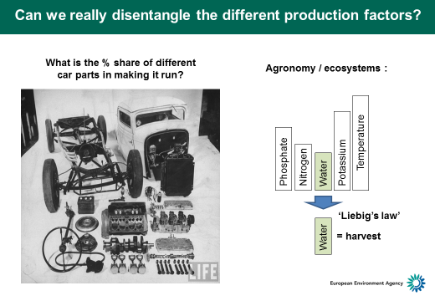

***Figure 2: Reflections on the production function concept***

Nevertheless, the question of attributing a production share to different components or stages in economic production processes must have been tackled in economic analysis or accounting contexts before. It would be useful to understand what conventions are applied in such cases. Where is that documented or explained?

There is also output from bio-physical research (e.g. on the energy input-output ratio in different farming systems) or environmental impact assessment (e.g. life-cycle assessment approaches) that potentially allows developing proxy approaches for estimating the total contribution from ‘nature’. These would not necessarily represent ‘reality’ (due the complexity of real-life systems and data gaps, and given the conceptual concerns expressed as such) but could be a basis for developing rules of thumb (or even more elaborated conventions) to be applied for estimating the ‘contribution of nature’.

Overall, it seems that more work has to go into finding a convincing approach for applying the ecological production function concept in an SEEA-EEA context (if all can be convinced). However, even if it is possible to develop standard assumptions for the contribution of nature in different contexts it would seem advisable to keep these rules as simple as possible - as the investment priority would seem to be to expand the existing set of ecosystem services that can be calculated rather than improving existing ecosystem service calculations forever (if a harvest approach with some deduction for human input would suffice).

Table 1: Ecosystem services accounts to be developed in the EU KIP-INCA project

|  |  |
| --- | --- |
| **Service** | **Physical unit** |
| **Provisioning services** | |
| Crops | Harvest (ton per ha) |
| Timber | Timber growth and harvest (ton per ha) |
| Marine fish | Catch (ton per fishing zone) |
| Water | Water abstraction for public, industrial and agricultural use (m3 per unit area) |
| Livestock | Amount of animal feed (grass) provided |
| **Regulating services** | |
| Pollination | Share of the crop harvest pollinated (ton per ha) |
| Erosion control (soil protection) | Avoided erosion in ton/ha/year compared to bare soil |
| Water purification | Removal of in-stream nitrogen (ton per km river) |
| Air filtration | Deposition of air pollutants (ton per ha) |
| Carbon sequestration (in vegetation and soil) | C sequestration in ton/ha/year |
| Flood control | Land area protected |
| **Cultural services** | |
| Recreation | Number of visits in ecosystems (person-days) / ha, include budget for surveys in some countries |
| Tourism | Number of overnight stays generated per ha/year |

1. <http://unstats.un.org/unsd/envaccounting/workshops/ES_Classification_2016/SEEA%20EEA%20Tech%20Rec%20Consultation%20Draft%208.1%20Dec2015%20final.pdf>