Service Contract 3436/R0-Copernicus/EEA.59142

Task 7: Support to the exchange with ISO standardization group

Version 1.0

11.12.2023

By
Julián Delgado Hernández (CNIG)

Table of Contents

1 Introduction 3
2 Overview of ISO standards on geographic information 4
3 Land Cover and Land Use ISO standards 8
3.1 ISO 19144-1 Classification system structure 8
3.2 ISO 19144-2 Land Cover Meta Language 10
3.3 ISO 19144-3 Land Use Meta Language 15
3.4 ISO 19144-4 Registration and implementation aspects 19
4 Advisory Group 13 on Land Cover and Land Use 21
5 On-going work 22
6 Conclusions 24

Introduction
ISO standards are worldwide known and used for many information disciplines. The ISO Technical Committee 211 works in the field of standardization of digital geographic information. In 2009 a first version of ISO 19144 was published to standardize the land classification and description.
The latest ISO 19144-2 ‘Land Cover Metalanguage’ internal version has been prepared during recent years with active participation from EAGLE partners and demands a final consolidation towards the end of 2022.
From the last period of 2022 and following years 2023, and possibly 2024, there exists the ISO compromise to finalize the definition of ISO 19144-3 ‘Land Use Metalanguage’ and start with the ISO 19144-4 ‘Registration and Implementation Aspects’.
Participation of EAGLE partners in ISO working groups are considered fundamental to ensure a satisfactory technical and conceptual connection between EAGLE developments and ISO principles. This participation helps in the identification of potential gaps between both approaches and possible requirements identification for ISO standards on land cover and land use information from Copernicus Land Monitoring Service.
This report collects technical documentation about ISO 19144 standards series and describes the work of EAGLE members during the contract period.
Disclaimer for readers: This document contains original ISO images and working material for standards development. They have been used only to describe needed concepts in the document without any intention to replicate or duplicate published or unpublished ISO material.

Overview of ISO standards on geographic information
ISO is a global network of national standards bodies. ISO members are the foremost standards organizations in their countries and there is only one member per country. Each member represents ISO in its country. Individuals or companies cannot become ISO members lonely, but there are ways that you can take part in standardization work. They can be nominated by their national standardization body and participate in the standard creation process, being expert on committees, working groups, advisory groups, or standardization projects.

Members
There are three member categories. Each enjoys a different level of access and influence over the ISO system. This helps to be inclusive while also recognizing the different needs and capacity of each national standards body. Full members (or member bodies) influence ISO standards development and strategy by participating and voting in ISO technical and policy meetings. Full members sell and adopt ISO International Standards nationally. Correspondent members observe the development of ISO standards and strategy by attending ISO technical and policy meetings as observers. Correspondent members that are national entities sell and adopt ISO International Standards nationally. Correspondent members in the territories that are not national entities sell ISO International Standards within their territory. Subscriber members keep up to date on ISO’s work but cannot participate in it. They do not sell or adopt ISO International Standards nationally.
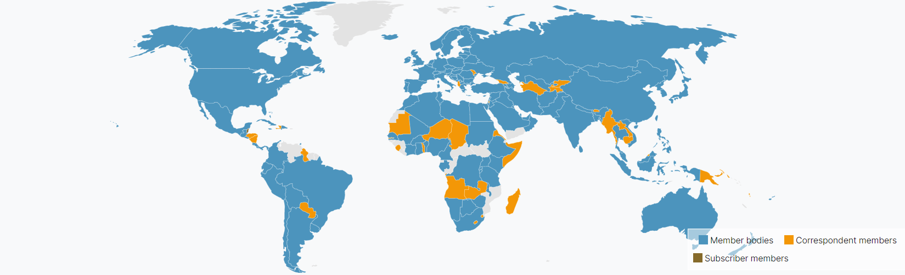
Geographic distribution of ISO members at global level.

Standards Developing
ISO standards development is a building and iterative process where technical experts participate, evaluate and vote until the achievement of the most suitable standard for the complete community. Each ISO deliverable is assigned to a standards development track. This track determines the timeframe of the project (18, 24, or 36 months) as it passes through the various stages to publication.

- Proposal stage (10): The first step is to confirm that a new International Standard in the subject area is really needed. A new work item proposal (NP) is submitted to the committee for vote. This stage can be skipped for revisions and amendments to ISO standards that are already published.
- Preparatory stage (20): Usually a working group is set up by the parent committee to prepare the working draft (WD). The group is made up of experts and a Convenor (project leader). Successive WDs can be circulated until the experts are satisfied that they have developed the best solution they can. The draft is then forwarded to the group’s parent committee who will decide to continue the process.
- Committee stage (30): Optional stage. During this stage the draft from the working group is shared with the members of the parent committee. If the committee uses this stage, the committee draft (CD) is circulated to the members of the committee. Successive CDs can be circulated until consensus is reached on the technical content.
- Enquiry stage (40): The Draft International Standard (DIS) is submitted to ISO Central Secretariat by the Committee Manager. It is then circulated to all ISO members who then have 12 weeks to vote and comment on it. The DIS is approved if two-thirds of the Participating members are in favour and not more than one-quarter of the total number of votes cast are negative. If the DIS is approved and no technical changes are introduced in the draft, the project goes straight to publication. However, if technical changes are introduced, FDIS stage is mandatory.
- Approval stage (50): This stage will be automatically skipped if the DIS has been approved and no technical changes are introduced. However, if the draft incorporates technical changes following comments at the DIS stage the FDIS stage becomes mandatory. If this stage is used, the Final Draft International Standard (FDIS) is submitted to ISO/Central Secretariat by the Committee Manager. The FDIS is then circulated to all ISO member for an 8 week vote. The standard is approved if a two-thirds majority of the Participating members is in favour and not more than one-quarter of the total number of votes cast are negative.
- Publication stage (60): At this stage the secretary submits the final document for publication through the Submission Interface. Only editorial corrections are made to the final text. It is published by the ISO Central Secretariat as an International Standard. Committee Managers and project leaders get a two-week sign off period before the standard is published.
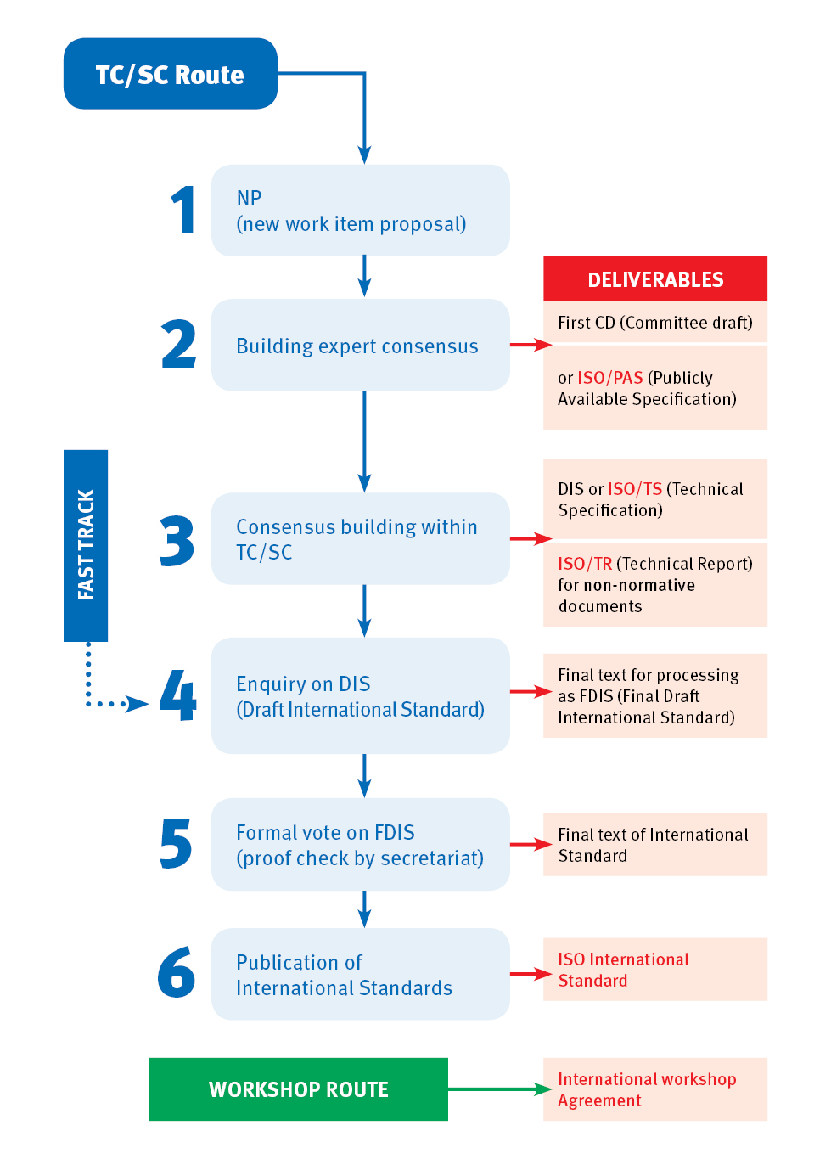
Iterative evolution of ISO deliverables

Additionally, all of the ISO family of standards are reviewed every 5 years to ensure they are relevant to today’s marketplace. It may be to simply encompass new technologies and processes that were not previously available. Firstly, there is an agreement on the need for revision, following a systematic review used to identify weak points and areas for improvement within the standard.

Structure
The ISO standards making process is handled by various Technical Committees (TC). Each one drives the standardization and comprise experts from the national committees.
ISO/TC211 is a standard technical committee formed within ISO, tasked with covering the areas of digital geographic information and geomatics. It is responsible for preparation of a series of International Standards and Technical Specifications numbered 19100. ISO/TC211 aims to establish a structured set of standards concerning objects or phenomena that are directly or indirectly associated with a location relative to the Earth.
These standards may specify, for geographic information, methods, tools and services for data management, acquiring, processing, analysing, accessing, presenting and transferring such data in digital / electronic form between different users, systems and locations. Land Cover and Land Use information has been always taken into account with particular references and normative that will be described in following chapters.
Participating members in ISO/TC211 vary from the global ISO memberships. Only those national standardization bodies addressed to this committee can participate actively in the standards developing on geographic information.
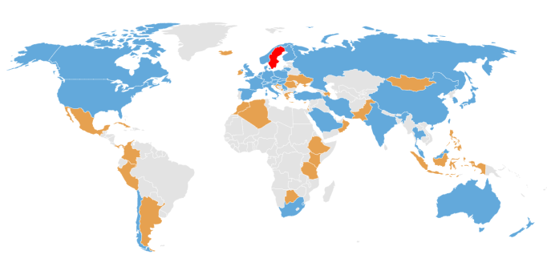
Geographic distribution of ISO members of TC211. Participating members (in blue), observing members (in orange), Secretariat (in red).

The work within ISO/TC211 is done in working groups, each with a specific focus. Land Cover and Land Use information had been addressed to WG7:
WG 7 on Information Communities focuses on standardization issues related to conceptual modelling of geographic features including the documentation of geographic features in feature catalogues, dictionaries, and registers. The work includes standardization of application schemas in specific domains (e.g. land administration domain model, land cover, etc.). The working group also addresses issues about metadata for the description of geographic information resources (data and services), ontologies in order to support the Semantic Web, and addressing as a mechanism for georeferencing geographic features.
When a new work item is confirmed, it is addressed to the WG most thematically closed, and it is the time to establish a project that deals with the standard development. Each project is chaired by a Project leader and supported by a set of WG experts. Any participant interested to contribute in the development needs to be proposed by its national standardization body. Time frame for a project depends on the complexity and maturity of the topic, with a limit from 18-36 months. A complete list of on-going projects on geographic information standards and their status can be find at https://committee.iso.org/sites/tc211/home/projects.html

Land Cover and Land Use ISO standards
ISO standards dealing with Land Cover and Land Use information are managed by ISO/TC211 WG7 under the ISO 19144 standards series.

ISO 19144-1 Classification system structure
This International Standard defines structure for a classification system together with the mechanism of defining and registering classifiers. There are many possible application areas, so there can be no single classification system that will fit all purposes. Methods for defining classifications are highly scope dependent, and the classifiers used for a particular application may not be suitable for all situations. This International Standard defines the fundamental guidelines for classification systems, so that particular classification systems can be developed following it in a structured way.
A classification system can be used as a criterion to subdivide any geographic area into smaller units, each of which will carry a class identifier that classifies and identifies it with respect to its neighbouring areas. A classification system works by successively decomposing the total space considered until reaching smaller units with similar properties that can be classified under the same classifier value.
A classification system consists of a set of classifiers, which can be of very different types depending on the field of application, such as characters, algorithmic results for class values. But all of them must be properly defined for their correct use. The successive parts of the standard deal with the specific definition of classifiers for each of the application areas. Treating classifiers as registry items makes them easier to define, maintain, and apply.
A classification is an abstract representation of real-world geographic features through the use of classifiers. A classification is a systematic framework of classes, with names and definitions, and relationships between them, which must necessarily guarantee independence with respect to the scale of representation and independence to the origin sources.
- Independence with respect to the scale of representation, it means that the classes of all the levels of the classification system can be used in any level of geometric detail or scale.
- Independence with respect to the sources of origin, means that the classes of the system are independent of the source of the original data used for the acquisition of the information.
The values of the classes must be mutually exclusive, avoiding dualities in the classification, and they can be structured according to hierarchical or non-hierarchical schemes.
A legend is the application of a classification to a specific area, using a defined representation scale and a specific data set. A legend therefore contains a subset of all possible application system classes and is dependent on the scale and data origins.
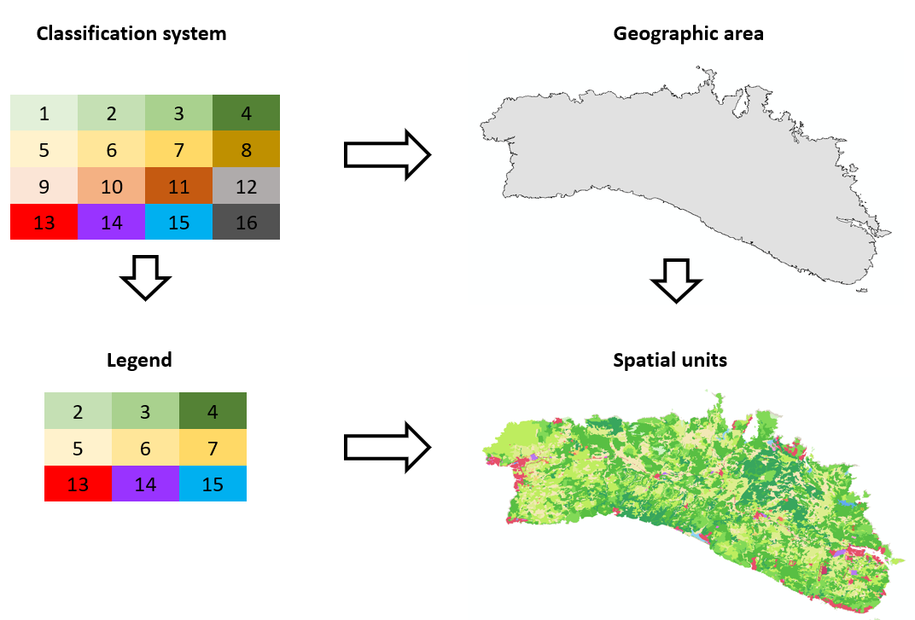
An example of a legend derivation from a classification system is shown in the previous figure. When a classification system is applied to a given geographic area, only a subset of the system's classes will occur in the actual data. With this subset of classes the spatial units will be classified. Specifically for this example, the classification system has 16 classes, of which only 9 of them will be used in the legend, classes 2, 3, 4, 5, 6, 7,13, 14 and 15.

Spatial units are classified using classifiers. The name, identifier, definition and description of a classifier, as well as the relationship between classifiers, can be recorded. To do this, this International Standard uses schemas for registries conforming to ISO 19135 and will use conforming from ISO 19144-4. The registry schema has been extended to include a subtype of RE_Register for a legend class registry (CL_ClassificationRegister), a subtype of RE_RegisterItem that corresponds to an item of legend class (CL_ClassificationLegendItem) and an item rule (CL_ClassificationRuleItem), and subtypes of RE_ItemClass corresponding to an item class of the legend class (CL_ClassificationLegendClass) and a class rule (CL_ClassificationRuleClass).

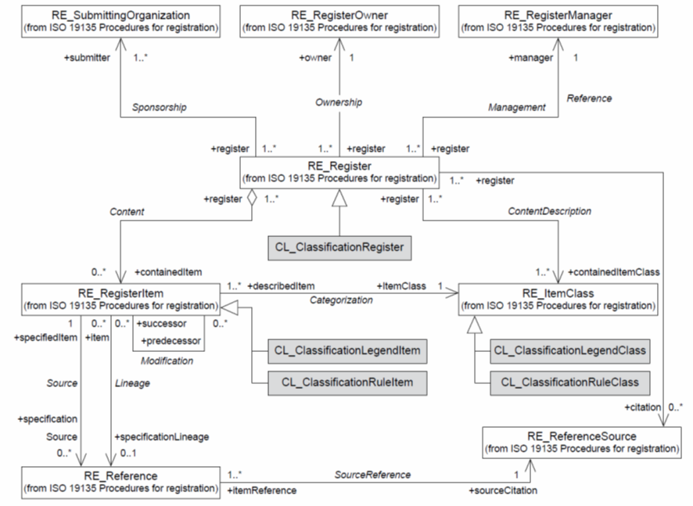
Classification register schema showing added classes. © ISO 2022 – All rights reserved
The result of a classified area is a partition of space that can be represented as a discrete coverage of values, CV_DiscreteCoverage, described in ISO 19123. A classification system, like a function, is capable of providing class values ​​for each position in the land.
CV_DiscreteCoverage can be based on different geometry types (e.g. points, polygons, raster cells, etc.) and the classification systems are applicable to all of them. However, surface representation is the most common to use, so CV_DiscreteSurfaceCoverage and its subtype specially defined in these regulations, CL_ClassifiedSurface, will be used to indicate a discrete surface classified by a classification system.
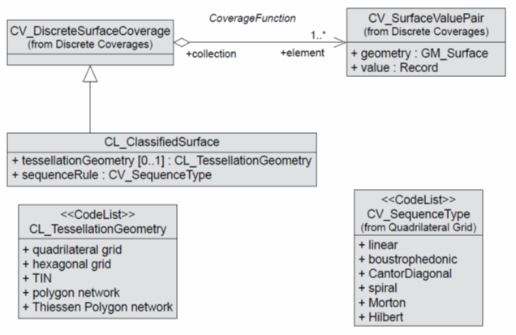
Discrete surface coverage types. © ISO 2022 – All rights reserved

CL_DataSet is the data set classified by a system, which is made up of collations of classified data, CL_ClassificationCollection, according to CL_ClassifiedSurace.
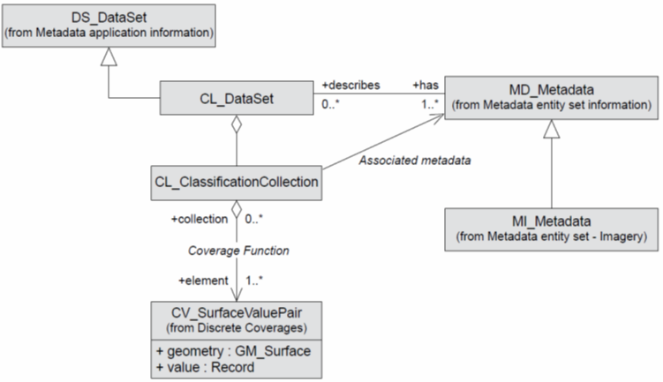
Classification data set content elements. © ISO 2022 – All rights reserved

ISO 19144-2 Land Cover Meta Language
The objective of this International Standard is to make it possible to compare existing land cover classification systems, without the need for editing or replacing original data. Also, this standard can complement the development of future classification systems that can offer more reliable collection methods for particular national or regional purposes.
The effective evaluation of the land cover and the ability to study its changes are essential in many fields of work. However, the available information is highly conditioned by its origin, extraction and classification methodology, and the local characteristics of the land where it was obtained. There is a gap at global level, for efficient comparison between different land cover classification systems.
Classification systems always have a set of their own classes necessary to classify the land where they have been created. Each class has a definition that makes it unique, within the classification system and outside when compared to classes in other systems. Even if two classes have the same name, in different systems, they will not be the same unless they have the same definition. Relating classes of different systems is the main challenge of the objective of this standard.
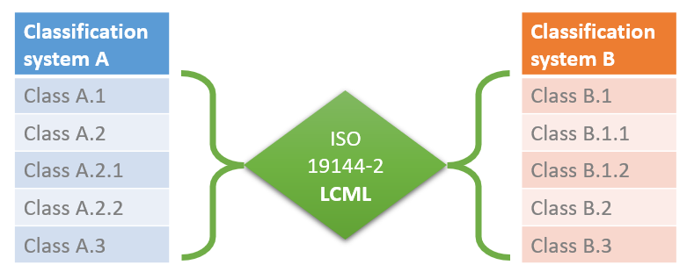
Graphical example of relation of classes from different classification systems

This ISO 19144-2 Standard provides a metalanguage, expressed as a metamodel that allows describing different classification systems for land cover (Land Cover Meta Language, LCML). This metalanguage establishes a set of objects and rules to describe land cover features based on their physiognomy, which can be also part of classes in land cover legends. This methodology provides a framework for comparison between different systems and nomenclatures, thus improving the harmonization and integration of spatial data sets.
This metalanguage is not a description of a particular nomenclature, nor is it a description of a specific set of classes, nor is it intended to replace any existing classification system. It is already accepted and recognized that there are a large number of well-established land cover classification systems in different countries and regions, and that they cannot be easily changed.
According to LCML principles, a concrete class of land cover, extracted from any classification system, can be described by means of a metalanguage object, which is formed by the combination of a set of independent elements, with possible attributes or characteristics if necessary. These independent elements refer to the physical characteristics of the land cover present in any type of land.
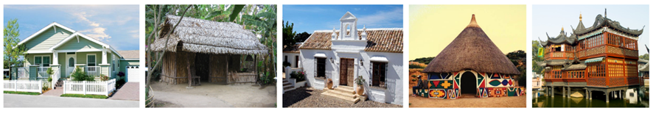
Independent physical land cover elements or characteristics be the height of the vegetation, type of leaf, fragmentation of the rocks, persistence of water, material of artificial objects, etc. They are always recognizable in any land on the planet, even if they have a different value. The previous images show an example of the different types of buildings throughout the world, all of them are constructions (land cover element) but have different physical characteristics able to describe them.

The high-level structure of the LCML consists of the relationships between the LC_LandCoverClassificationSystemMetaLanguage object and the aggregation of a set of LC_LandCoverClassDescriptor objects. The LC_LandCoverClassificationSystemMetaLanguage object is a description of a land cover classification system as represented by the UML class LC_LandCoverClassificationSystem. The individual LC_LandCoverClassDescriptor objects can be serialized to produce LC_LandCoverClass(s) which correspond to individual classes in a land cover classification system. On the other hand, LC_LandCoverClass is a subtype of CL_LegendClass as defined in ISO 19144-1.
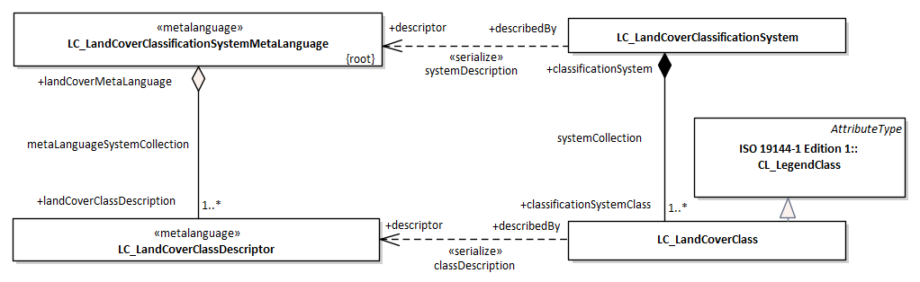
High level structure of the Land Cover Classification model. © ISO 2022 – All rights reserved

For example, CORINE Land Cover would be an LC_LandCoverClassificationSystem, and each of its classes would be an LC_LandCoverClass. The description of the CORINE Land Cover classification system by this standard would require the formulation of an LC_LandCoverClassificationSystemMetaLanguage composed of a detailed set of LC_LandCoverDescriptors with the thematic content on CORINE Land Cover classes.
LC_LandCoverDescriptor objects are made up finally by LC_Element objects, however their composition is guided and conditioned by some aspects. LC_Elements can be spatially arranged in many different ways, so the LC_HorizontalPattern object is used to describe these various spatial distributions in the horizontal plane. Also, LC_Element objects can be vertically overlapped in different strata, these are managed through the LC_Stratum object. And the LC_Element object itself can be related to other objects of the same class through different spatial and temporal presence relationships, for which the use of the LC_ElementHorizontalArrangement and LC_ElementRelationInSameStratum object are used. Following diagram specifies the complete set of aspects, characteristics and related values considered for the composition of LC_Element objects in LC_LandCoverDescriptor objects.
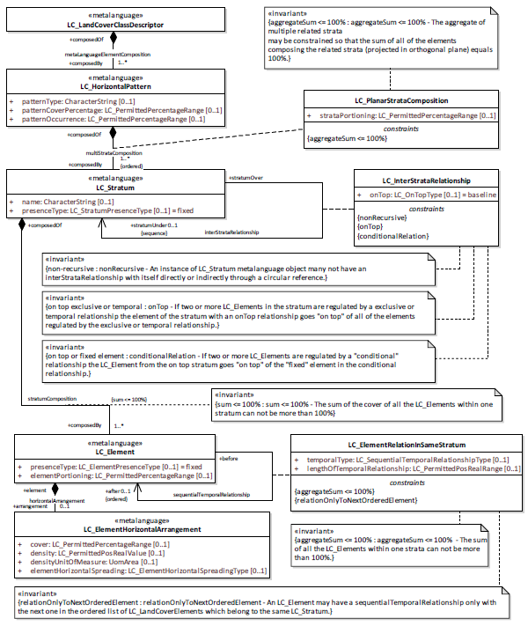
Land Cover Meta Language object structure © ISO 2022 – All rights reserved

The purpose of the LC_Element object is to describe the elements that represent the land cover, which can be classified into very different subtypes depending on their nature, physiognomy and appearance. There are two general object types, LC_VegetationElement and LC_AbioticElement to describe vegetation and elements in non-vegetation areas, respectively. Both of them are successively subdivided in LC_Element subtypes.

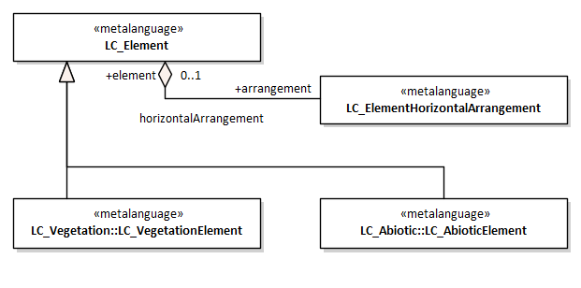
Subtypes of LC_LandCoverElement. © ISO 2022 – All rights reserved

LC_VegetationElement is mainly subdivided by its growth typology LC_GrowthForm, developed in detail for woody, herbaceous, lichen and algae vegetation.
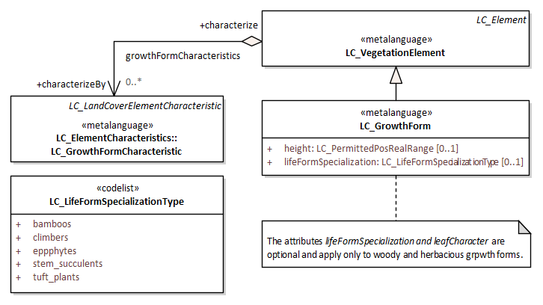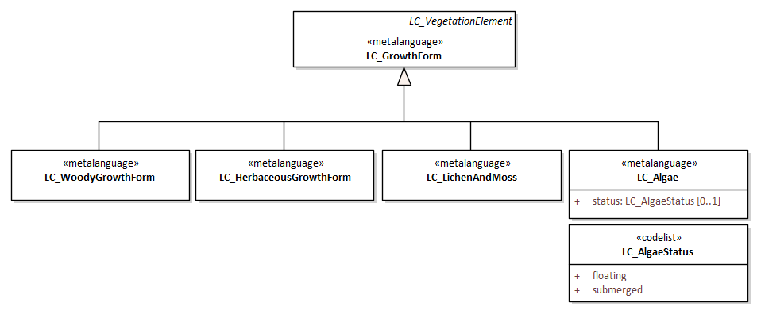
LC_VegetationElement subtype (left) and LC_GrowthForm subtypes (right). © ISO 2022 – All rights reserved

The elements LC_WoodyGrowthForm, LC_HerbaceousGrowthForm, LC_LichenAndMoss and LC_Algae have their own diagrams and elements where their characteristics are collected to describe the land surface. They are not included in this summary.
On the other hand, LC_AbioticElement is subdivided according to its nature into LC_ArtificialSurfaceElement, LC_NaturalSurfaceElement and LC_WaterBodyAndAssociatedSurfaceElement.
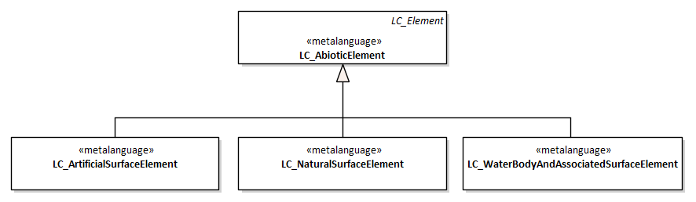
Subtypes of LC_AbioticElement.© ISO 2022 – All rights reserved

The LC_WaterBodyAndAssociatedSurfaceElement element has its own diagram and elements where its characteristics are collected to describe the land surface. They are not included in this summary.
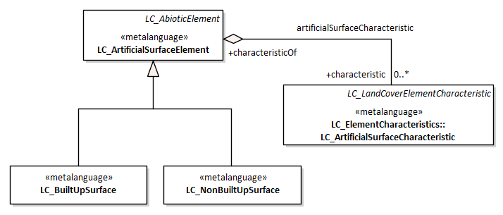
Subtypes of LC_ArtificialSurfaceElement. © ISO 2022 – All rights reserved

The LC_BuiltUpSurface and LC_NonBuiltUpSurface elements have their own diagrams and elements where their characteristics are collected to describe the land surface. They are not included in this summary.
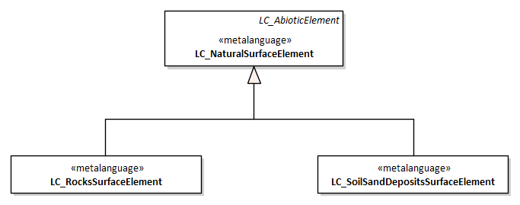
Subtypes of LC_NaturalSurfaceElement. © ISO 2022 – All rights reserved

The LC_RockSurfaceElement and LC_UnconsolidatedSurfaceElement have their own diagrams and elements where their characteristics are collected to describe the land surface. They are not included in this summary.

ISO 19144-3 Land Use Meta Language
In parallel with land cover, the aim of this International Standard is to make it possible to compare existing land use classification systems, without the need for editing or replacing the original data. This enables comparisons of land use classes to be made regardless of mapping scale, land use type, data collection method or geographic location.
Classification systems of land use are even more heterogeneous than land cover around the world, and there is a need for their comparison, integration and homogeneity that can be taken into account throughout a Land Use Meta Language (LUML). Land use classes expressed according a LUML elements can be compared and assessed in a conform way. It provides a common reference structure for the comparison and integration of data for any generic land use classification system but does not intend to replace those original classification systems.

The high-level structure of the LUML consists of the relationships between the LU_LandUseClassificationSystemMetaLanguage object and the aggregation of a set of LU_LandUseClassDescriptor objects. The LU_LandUseClassificationSystemMetaLanguage object is a description of a land use classification system as represented by the UML class LU_LandUseClassificationSystem. The individual LU_LandUseClassDescriptor objects can be serialized to produce LU_LandUseClass(s) which correspond to individual classes in a land use classification system. On the other hand, LU_LandUseClass is a subtype of CL_LegendClass as defined in ISO 19144-1.
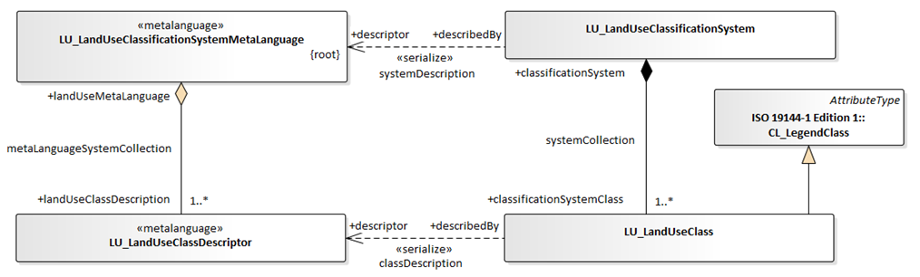
High level structure of Land Use Classification Model. © ISO 2022 – All rights reserved

There is a clear relationship between Land Cover and Land Use, just considered in fact many existing land use classifications based even on land cover information. However, the two concepts deal with different aspects and must be well separated concepts. Sometimes land cover is the result of some aspects of land use at a certain moment in time, and other times land use is conditioned by the present land cover. Particularly important are the dependencies of this standard with ISO 19144-2 LCML and codelist coming from other normative.
It is proposed a combined land cover and land use (land characterization) top level meta model that routes the integration of concepts from both separate meta languages without changing previous standard considerations.
The combined Land Cover Land Use structure allows for the relationship between elements, arranged through strata and horizontal patterns, land use functions and actions (explained afterwards). Specific characteristics such as relationship type, time length, etc. may be applied to these combinations as specified attributes in LU_LandCoverLandUseRelationship.
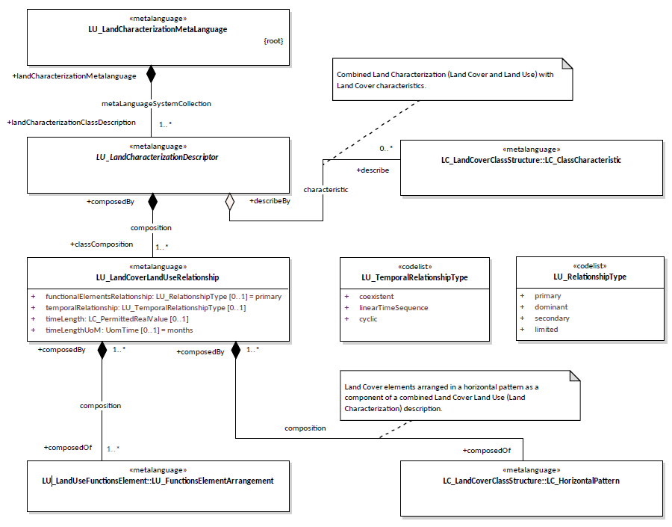
Combined Land Cover and Land Use model. © ISO 2022 – All rights reserved

The LUML is a meta language itself and must be able to describe a wide variety of land use classification systems alone without land cover aspects. Each class in a land use classification system may be expressed using the basic element objects defined in the LUML.
Land Use components of the schema are based on a interaction between “Functions” and “Activities” concepts:
- “Function” refers to a wide range of purposes or establishment types applied in the land.
- “Activities” refer to what actually takes place in physical or observable terms on the land defined under a specific function.
As it is present in the previous diagram a LU_LandUseClassDescriptor is composed by LU_FunctionsArrangements. Downdwards, a land use arrangement is consequently composed by LU_LandUseFunctionElement together with LU_ActivitiesArrangement. This modeling alternative provides concepts and characteristics about Functions and Activities in a comprehensive way. Both functions and activities are subdivided in subtypes.
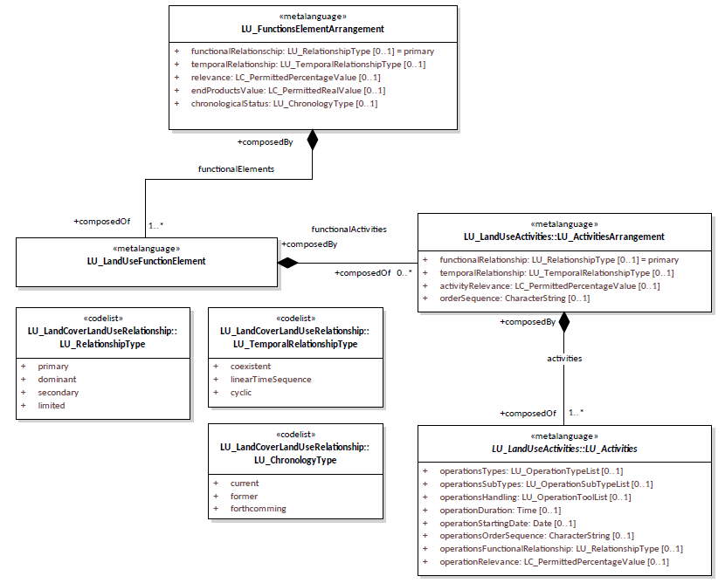
Functional and Activities arrangements. © ISO 2022 – All rights reserved

Five main function types are shown and listed below. Most cases the land is defined by multi-functions and single function elements can be linked between them-selves with a specific relationship by LU_FunctionsArrangements.
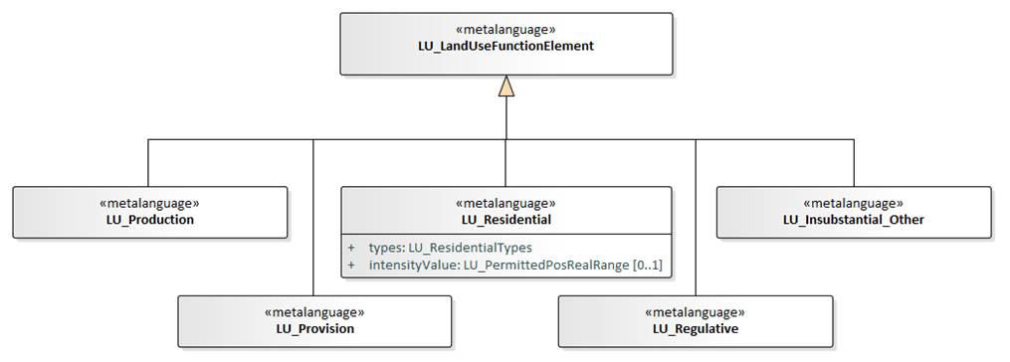
Proposed subtypes of LU_LandUseFunctionalElements. © ISO 2022 – All rights reserved
More subtypes and attribution are not included in this summary.

Six main activities types are shown and listed below.
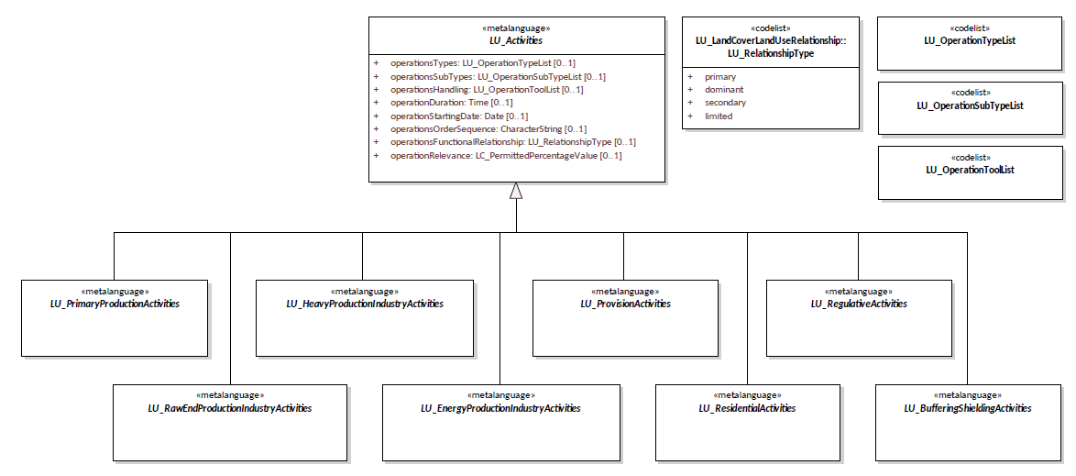
Proposed subtypes of LU_LandUseActivities. © ISO 2022 – All rights reserved
More subtypes and attribution are not included in this summary.

ISO 19144-4 Registration and implementation aspects
This standard has been proposed as a complement of previous ones in order to manage appropriately all lists and listed items of land cover and land use in a registry. This part of ISO 19144 will specify the procedures for registration of legend and application schemas expressed using the metalanguage described in other parts of ISO 19144. It also specifies the procedures for registration of code lists and characteristics that may be used to extend the metalanguages. This part also describes implementation aspects such as the expression of the instantiation of the metalanguages in UML and XML.
Registration provides the mechanism to manage changes to the code lists and characteristics that apply to the elements in the land use and land cover metalanguages. The basic elements of the language may be extended, but not changed.
Currently only the structure of the register is proposed, not its contents. A user such as a national body or other organization would establish their own instance of the register. This would allow for a more detailed description of a classification system and therefore a better comparison between different systems. Several national bodies or organizations might also set up equivalent registers for their own use. This standard, and their extensions, have to be in accordance with the rules of ISO 19135-1 Geographic information — Procedures for item registration — Part 1: Fundamentals.
NOTE: Following schema description corresponds only with the design proposal for LCML. It needs to be updated to incorporate LUML register elements.
The register schema is derived from the register schema in ISO 19135 and is shown in the next figure. The register schema is extended to include a subtype of RE_Register for a LCML and LUML register (LC_LCMLRegister), a subtype of RE_RegisteredItem corresponding to LC_ClassCharacteristicDescriptorItem, LC_ElementCharacteristicDescriptorItem and LC_ElementDescriptorItem. A subtype of RE_ItemClass corresponding LC_ClassCharacteristicDescriptorClass, LC_ElementCharacteristicDescriptorClass and LC_ElementDescriptorClass.
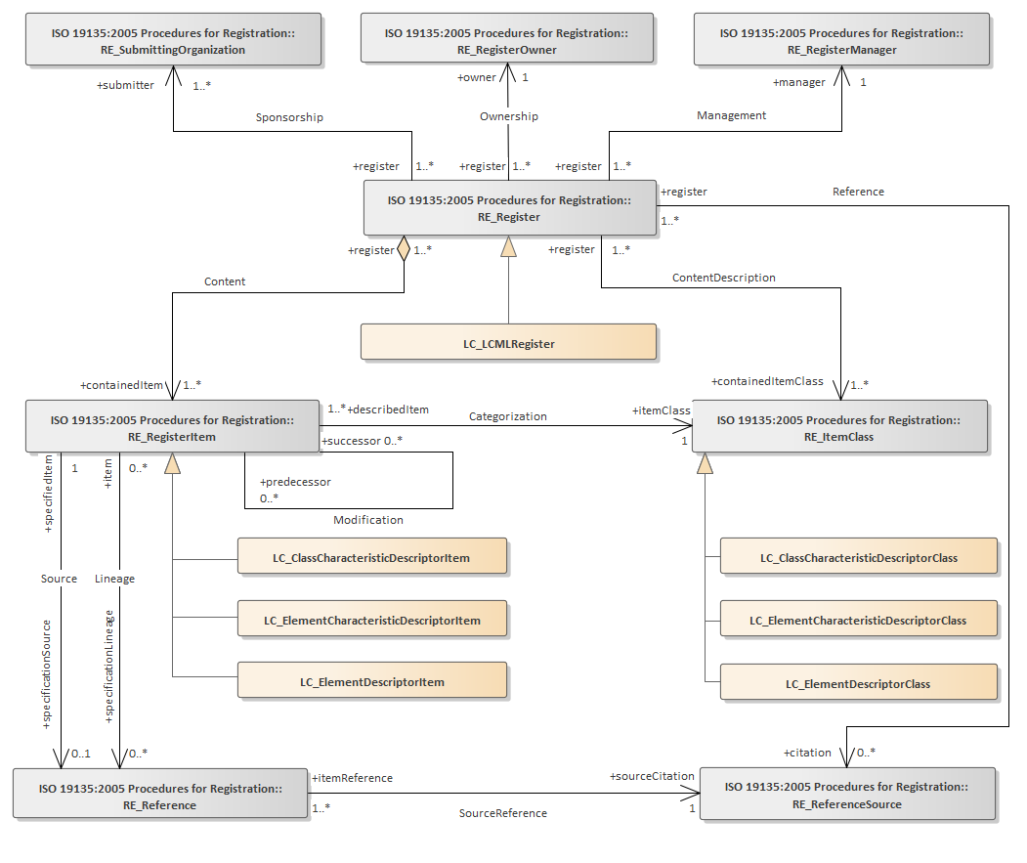
LCML register schema. © ISO 2022 – All rights reserved

This diagram needs to be updated to incorporate LCML and LUML register elements. Proposed attribution of register elements has been proposed but not included in this summary.

Advisory Group 13 on Land Cover and Land Use
Land cover and land use are some of the primary measures driving climate science and are critical for addressing many of the UN Sustainability Goals and International Conventions of the UN system i.e. UNFCCC, UNCBD, UNCCD and the UN Forum on Forest.
The Land Cover Land Use Advisory Group was established by ISO/TC211 plenary resolution in December 2020 to advise the committee on the application and implementation of the standards on Land Cover Land Use. The group is led by the Food and Agriculture Organization (FAO) of the UN and works in coordination with other transnational organizations and to coordinate with the context of broader UN initiatives for this purpose.
Summary of AG13 Terms of Reference
- AG LCLU advises ISO/TC 211 on the application and implementation of the standards on Land Cover Land Use in the UN and other transnational organizations and to reach out to the context of broader UN initiatives for this purpose.
- Comprise the ISO/TC 211 Chair, the working group convenor of WG7, and each P-and O-member and A-liaison can nominate experts in the group.
- AG LCLU shall remain in existence while the 19144 suite of standards are evolving and until a possible higher level coordination committee on Land Cover Land Use is established in cooperation with the UN and other transnational organizations. (likely a minimum of 36 months).
- The AG LCLU recognises the intricate relationship between LC and LU and their interdependency.
- The AG LCLU will advise ISO/TC 211 on the application and implementation of the ISO/TC 211 standards on Land Cover Land Use in the UN and other mature LCLU initiatives from other international stakeholders worldwide.
- The AG LCLU shall ensure that the ISO/TC 211 LC and LU initiatives and evolving standards are brought to the attention and discussed with other UN agencies involved with the SDG’s and those agencies’ which utilize LC and LU indicators and also report, in a reciprocal way, with the broader UN-GGIM framework.
- Specifically, the AG LCLU will capture user requirements and provide feedback before proceeding with a work to generate outreach resources. Including creating awareness, enabling education and training, facilitating adoption and implementation, The AG LCLU will furthermore, capture user requirements and feedback and generate outreach resources. It will also focus on attracting participation in and grow the community of advocates for the evolving 19144 suite of standards.
At the date of this report, AG 13 has no project addressed, has no precise decision made, and maintains periodic meetings in order to know and present different initiatives on land cover and land use worldwide.
The EAGLE approach was presented by the team during the AG13 meeting on 21st September 2022 and the presentation file was circulated to all the attendees.

On-going work
Participation of EAGLE members was initiated in previous standard development stages and is active in the current groups. EAGLE members are part of ISO/TC 211 Working Group 7, Advisory Group 13, and they are appointed to be participants in the development and revision of ISO standard in land cover and land use.
Coloration within ISO working groups is considered fundamental to ensure a satisfactory technical and conceptual connection between EAGLE developments and ISO principles. This participation also helps in the identification of potential gaps between both approaches and possible requirements identification for ISO standards on land cover and land use information from Copernicus Land Monitoring Service.
As it has been commented before the ISO standards development is a building and iterative process to look for the most suitable standard. Each ISO deliverable is assigned to a standards development track. This track determines the timeframe of the project (18, 24, or 36 months). Additionally, every standard needs a revision for actualization every 5 years to update the standard content to the most recent technology and amend those weak points. During the last years, and coming ones, it has been done and planned several ISO projects to develop and review the previously described land cover and land use standards.

Standards calendar
ISO 19144-1:2019 — Classification System Structure developed the first version in 2009, with a technical corrigendum in 2012. There is not a project team running for its revision nowadays, however this standard needs to be revised, at least to remove what will be redundant with other parts and separate any reference to registration material. This work is planned for 2024 and 2025.

ISO 19144-2:2012 — Land Cover Meta Language (LCML) developed the first version several years ago and published in 2012. Standard revision started in 2020, which has been accomplished in mid-2023 and will be published in early 2024.
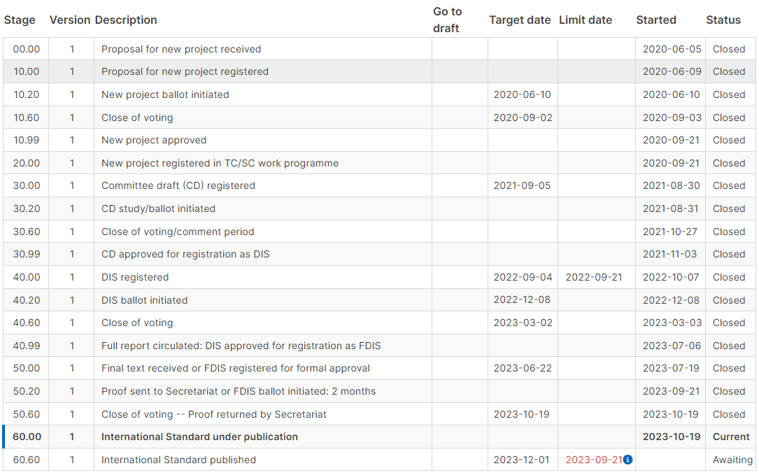
ISO 19144-2 revision calendar proposed
ISO 19144-3 — Land Use Meta Language (LUML) is being developed since September 2020, however the workload in the revision of ISO 19144-2 provoked overcome the first calendar estimation for land use standards. The project leader and working team decided to restart the work in order to complete a Technical Specification that requires shorter calendar milestones. This specification version started in 2022, which will be accomplished in mid-2024. Draft Technical Specification has been issued for public ballot in December 2023 or early 2024.
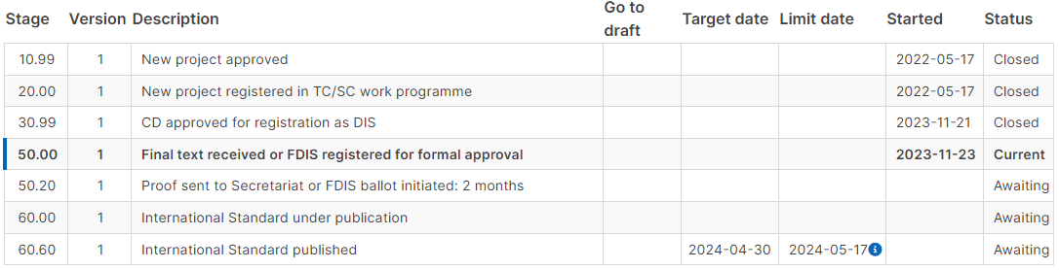
ISO 19144-3 calendar proposed

ISO 19144-4 — Registration and implementation aspect is planned to be started in a formal procedure after finalization of parts 2 and 3. This work is planned for 2024 and 2025 for getting and final International Standard. Tasks started by a ‘Preliminary Working Item’ in 2023 but actual work has been proposed to 2024 looking for use cases, applications, examples of registration, technologies, etc. open to the group experts.
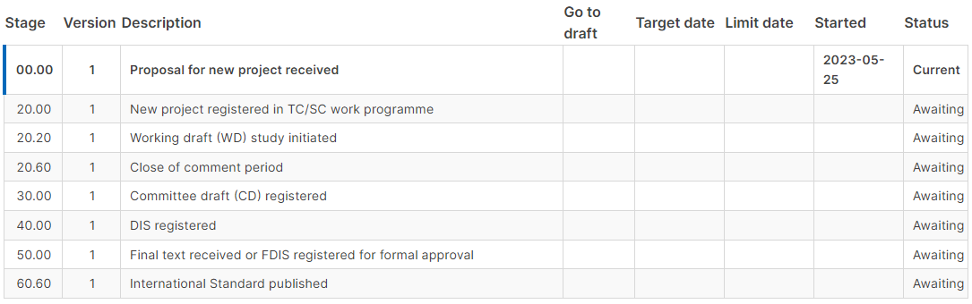
ISO 19144-4 calendar proposed

Conclusions
Main conclusion has been known from the beginning and commented sometimes during this document. Participation of EAGLE partners in ISO working groups is important to ensure a satisfactory technical and conceptual connection between EAGLE developments and ISO principles. This participation also helps in the identification of potential gaps between both approaches and possible requirements identification for ISO standards on land cover and land use information from Copernicus Land Monitoring Service.
EAGLE members work in ISO groups requires broad knowledge in the matter and skills to detect connections and omissions between initiatives. Main work is done as revision of internal technical project documentation, modification proposals and active participation in meetings. Editor team is composed of project leader and UN FAO experts. EAGLE members as the rest of technical members of the project are not able to edit directly documentation and models. They are edited by the Editor team.
The work intensity of a standard development depends on the calendar, deadlines and phase state, and it could be specially demanded in periods before open balloting. Following lines list the ISO meetings happened during the contract periods with EAGLE members’ participation.

ISO/TC 211 Working Group 7
- 23th November 2022. Project team meeting ISO 19144-3 LUML
- Internal commenting collection for draft version of ISO 19144-3 LUML
- 17th January 2023. Project team meeting ISO 19144-3 LUML
- 14th February 2023. Project team meeting ISO 19144-3 LUML
- 23rd February 2023. Project team meeting ISO 19144-3 LUML
- 2nd March 2023. Project team meeting ISO 19144-3 LUML
- 14th March 2023. Project team meeting ISO 19144-3 LUML
- 16th May 2023. Project team meeting ISO 19144-2 LCML
- 20th September 2023. Project team meeting ISO 19144-3 LUML and ISO 19144-4 Registration

Advisory Group 13 on Land Cover and Land Use
- 6th December 2021
- 1st March 2022
- 10th May 2022
- 21st September 2022
- 17th May 2023
- 15th September 2023
- 5th December 2023

Current land cover and land use CLMS products are essentially developed in two thematic approaches. Classification codes (i.e. traditional CORINE Land Cover, Urban Atlas, Coastal Zones, etc.) or degree intensities (i.e. High Resolution Layers, CLC-Core grid).
Classification classes or codes are part of a classification system that can be described according to ISO 19144 part 2 and 3. Degree intensities are the functional mechanism to account for the presence of characteristics in a piece of land. These characteristics also respond to a class or parameter that can be part of a classification system able to be described into ISO 19144 standards. It must be remembered that ISO 19144 part 2 and 3 standards are metalanguages for thematic content and not data models for functional data representation.
The unique product with broader thematic content is EAGLE data model and accompanied philosophy. It is needed to remember that EAGLE works not only as a metalanguage of land cover, land use and characteristics, EAGLE also proposes a functional way to implement the thematic content via vector, raster and grid representation.
It has been detected a need to explore and deep into a new EAGLE modelling compliant with ISO 19144 standards in terms of thematic content, but not belonged with functional representation. Compliance with a standard can be tackled in very diverse views. To ease the current implementations of CLMS products based in EAGLE, it would be recommended that this compliance would be dealt from the conceptually point of view, adapting data model and concepts without changing its implementation. This work would require additional tasks to future collaborations.

https://www.iso.org/members.html
https://www.iso.org/stages-and-resources-for-standards-development.html
https://www.iso.org/deliverables-all.html#IS
https://committee.iso.org/home/tc211
https://committee.iso.org/sites/tc211/home/about/p--and-o-members.html
https://committee.iso.org/sites/tc211/home/about/working-groups.html
Based on ISO 19144-1:2009 Geographic information — Classification systems — Part 1: Classification system structure
Based on ISO/TC 211 N 5811 Text for DIS 19144-2 Geographic information — Classification systems — Part 2: Land Cover Meta Language (LCML)
Based on ISO/TC211/WG7 N 427 ISO 19144-3 Working Draft Geographic information — Classification systems — Part 3: Land Use Meta Language (LUML)
According to ISO/TC211/WG7 N 427 ISO 19144-3 Working Draft
ISO/TC 211/WG 7 N 314 Classification Systems Standing Document. Preparation for 19144-4
ISO/TC 211 N 5505 Terms of Reference for Advisory Group on Land Cover and Land Use
https://sd.iso.org/projects/project/81259/overview ISO Portal identification required
https://sd.iso.org/projects/project/85091/overview ISO Portal identification required
https://sd.iso.org/projects/project/87033/overview ISO Portal identification required

