Service Contract 3436/R0-Copernicus/EEA.59142

Deliverable D3-2 (Task 3): Concept for a bar coding review and acceptance process

Version 1.1

06.10.2023

Concept for a bar coding review and acceptance process

Introduction
A key purpose of the EAGLE concept is to semantically describe and decompose the information content of spatial data, and to make it semantically analysable and comparable and in a machine readable manner.
The EEA´s CLC+ Core System is a platform where spatial data with environmentally relevant content is uploaded. The uploaded data may have a pan-European, national or regional spatial extent.
Within this platform the technical preconditions for the semantic decomposition have been implemented, to not only collect data itself, but also to store and provide it in a semantically comparable and machine readable manner. The process of uploading data into CLC+ Core in combination with the semantic decomposition is called “ingestion”.
The semantic part of the ingestion is called “bar coding”, where the uploaded data are described content-wise by using the EAGLE ontology, to generate a semantic representation according to the class definitions of the ingested data.
During the bar coding step, all relevant elements are to be selected from the EAGLE matrix. Class by class, these elements are coded to determine their role (and their relation to each other) as mandatory, optional or excluded by definition.
To streamline the process of manifold ingestions and to guaranty a certain level of “uniformity” of the bar coding results, it is considered necessary to have a Bar Coding Review and Acceptance Process (RAP).
This document contains outlines and recommendations of such a procedure.

Organisational Scenarios

Scenarios
For the bar code reviewing, several scenarios are thinkable, how to organize and schedule such a review process. Also, it is recommended to offer a kind of help desk, where upcoming questions (of individual or general character) can be answered.
Scenario 1:
All incoming bar code results and questions are collected over a certain time period (rather long, e.g. one year). Afterwards, in a defined time frame (e.g. x weeks/months) answers and review feedback are given to all accumulated questions and bar code results ‘en blocque’, channelled by EEA to EAGLE and back to user.
Scenario 2:
A permanent instance is established, where all incoming ingested bar code results and also upcoming questions can be responded to immediately on demand, channelled from EEA to EAGLE side and back to user.
Scenario 3:
Incoming bar code results are collected over time (like Scenario 1), but review process is initiated after semi-long period (e.g. 6 months). In the meantime, throughout all year, a kind of helpdesk is established, where immediate or short term questions about bar coding (or even any matter related to EAGLE concept) can be answered within a couple of days.

The process of bar code review needs some planning, regarding personnel resources to work through the review steps. The latter Scenario 3 seems to be the best viable solution for the matter, as a compromise between instant answers on urgent matters and mid-term scheduled feedback on bar codes.

A suitable and scalable level of service is suggested in this regard. Agreement shall be met on the time interval of collecting bar code results, and the time frame when to answer it (minimum time between a bar code being created and being sent for review; minimum/maximum time for review feedback).

FAQ
Over time, some frequently asked questions and given answers channelled through the system can be of repetitive relevance also for other user. So a searchable repository of questions&answers would be helpful to buffer initial questions. This repository can grow over time, and needs to be maintained by either EEA o EAGLE staff.
Such FAQ webspace should be connected both with the CLC+ Coe platform as well as from the EAGLE webpage. On the FAQ web space, also eventual changes in the bar coding rules or publishing of new matrix/model versions can be communicated.

Procedural Steps for Review of Bar Coding Result
For a coordinated procedure we take a few working steps into consideration.
- EEA personnel tracks the incoming bar coded ingestions (is this already the case / foreseen at EEA?)
- An uploaded and ingested dataset gets a flag, when bar coding is finished and ready to be fed into the review process.
- EEA staff (suitably role, responsible for monitoring the CLC+ Core usage, with admin rights) decides, when an ingested bar coding result shall be added to the to-do-list of review items.
- Then it is channelled to members of EAGLE group as thematic reviewing experts. These experts could also be briefed and educated by EAGLE experts. This is to be decided.
- The review process should be done at least in a 4-eyes review, meaning that a bar coding result passes two persons desks, before a final feedback is given.
- A talk-back-channel directly to the ingester about the bar coding result, which is standing for debate, would be useful to keep sequence of steps small and efficient.
- The final feedback loop goes back to EEA staff in principle for sign-off based on expert comments.
- After final approval of EEA staff (under consultation with EAGLE), the reviewed bar coding result goes live on the CLC+ Core platform.
To some extent, it is thinkable to have an automated process that tackles generic logics between bar coded elements. However this needs further preparation in the setup of such logic rules. Some standardized fundamental sets of bar coded fragments (thematic template) can be part of this.

Feedback Loop for Bar Coding
The procedure of bar coding review can be done based on the ingestions that have been provided by users on the CLC+ Core platform. Through the download function, a copy of the bar coding result can be generated in form of a CSV file (or another excel-readable table). In that excel table, comments can be made, and alternative bar coding value can be suggested. After an internal feedback loop within EAGLE group (contact persons and involved contributors still tbd) the commented bar coding excel sheet can be returned to the original “ingestor” for a consolidation round. After agreement, the new / confirmed bar coding result can be – if necessary – uploaded again to the CLC+ Core platform to replace the old bar coding ingestion.

Functionalities for Review of Bar Coding Result
The bar coding review procedure needs some functionalities to facilitate the exercise.

“Show Input Reference” Function
Tthe reviewer should be able to quickly find the textual class definitions of the nomenclature, according to which the ingested classes (to be reviewed then) have been bar coded. This can be solved by providing a hyperlink to the documentation of the targeted nomenclature.

“Portrayal/Display” Function
Show the bar coding result in an overview manner, including all EAGLE elements (with and without assigned bar code value). For simply showing the bar coding results to the reviewer, showing all used matrix elements with their assigned bar code values (see Figure 1). It can be done by downloading a bar code resume (like at the moment in form of an excel sheet), or can happen online through a user interface.
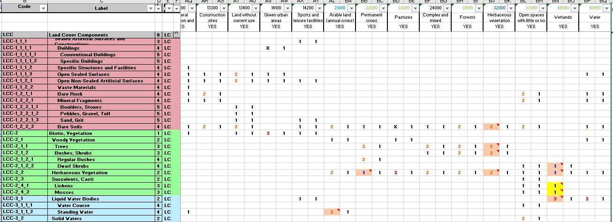
Figure 1: Overview function of all elements with assigned BCVs within a bar code result

“Comparison-Display” Function
Display at least two – better more - bar code results in parallel beside each other (then only elements with assigned BCVs), for a quick visual catch of similarities and differences between bar code ingestions. This is also helpful for normal ingestion or extraction procedures. (see Figure 2).
Have the possibility of cross-checking the targeted bar code result (being reviewed) with other already approved results, or with a thematic master/default bar coding example.
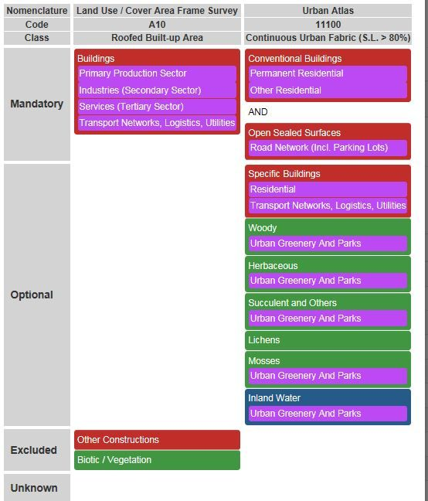
Figure 2: Screen Shot from older EMPACT Tool (EAGLE Matrix Population and Comparison Tool), showing two decomposed classes side by side.

“Filter” Function
To select particular assigned bar code values, and show only bar coded matrix elements respectively hide all other matrix elements without any assigned BCV.
This function will ease the browsing through the bar code result (matrix), without the need to scroll up and down (passing the majority of blank and not used matrix elements (for that particular class).

“Edit” Function
To change BCV for matrix elements, respectively assign a bar code value to non-coded element.
Question is here also: shall the reviewer actually be mandated to add/change/delete a BCV, or shall he/her just mark them to be altered, make recommendations?

“Typo error check” Function
To avoid the entries other than from the list of possible BCVs (X, 1, 2, 3, 4, 5). The reviewer – in the action of editing a BCV – should only be able to select from a predefined list of eligible BCVs, e.g. from a programmed/determined drop down list.

“Tagging” Function
For each given BCV to “confirm”, “change”, “delete” BCVs. Can be done with fixed values from a short code list.

“Comment” Function
Tto add free text for explanation of editing action (change / add / delete BCV).

“Save” Function
To store the reviewed (confirmed, edited or commented) version of bar code result.

“Track/ChangeLog” Function
Tracking which BCV have been/should be added/changed/deleted from reviewed bar code result.

“Feedback Channel” Function
Enable the reviewer to contact the bar coding person for feedback loop, e.g. for questions about the bar coding result and how BCV decision was made.

Setup of Tool for Review of Bar Coding Result
To perform the review of bar code results, a tool is needed to load in the BCV of one class, several classes, all classes of a dataset, or also classes from different datasets. The objective of such a tool is to help the review and acceptance process, to judge and compare BCVs of "similar" classes.
The tool for bar coding review procedure can be either a programmed functionality embedded within the CLC + Core platform, or through a downloaded Excel Sheet.
Advantage for platform based tool:
- Can probably be well connected to the ingestions interface
- Results don´t need to be exported from platform (no media break)
- If programmed well, also visual comparisons of bar code results in parallel beside each other could be facilitated
Disadvantage for platform based tool:
- Additional programming effort needed

Advantage for excel sheet export as tool:
- No need for new programming, tool already in place
- Filter function can be easily applied
- Bar coding results can be displayed through copy & paste of exported bar code columns by hand
OR
- Bar coding results could be selected prior to export, and then already are contained in one same excel sheet for all exported bar code results.
Disadvantage for excel sheet export as tool:
- Media break, export-import steps are needed to get results outside the CLC+ Core system and back inside again.

Reviewing staff at EAGLE side
It is still to be decided and agreed upon who exactly will do the review from EAGLE group. It is recommended to give this task to people of longer experience regarding the EAGLE developments. What also needs to be decided is the time frame (counted in days from exposure of the candidate item to the review process), within which a review process should be finished and closed.
The reviews are then delegated to a pool of EAGLE review experts, who organize the task among themselves, depending of colleagues availability in the requested review time window.
The faster the review is expected to be finalized, the more expert are probably needed to be part of such an expert pool.
Further, it could be structured in a way of having a “first row” staff to do the scheduled work, and some fall back personnel in case of holidays/ illness leaves / non-availability etc.

Conclusions, to be decided
EEA is invited to decide on:
- maintenance and monitoring of the bar coded ingestions (on CLC+ Core side)
- tool to use for the review procedure
- timeframe and offered service of review and feedback procedure (see scenarios)

