EEA/DIS/R0/22/007

Task 2: Support to the maintenance of the EAGLE website

Identification of most relevant EAGLE material

Final draft
version | Date | status | notes
1 | 30/11/2022 | First draft | Internal
2 | 10/01/2023 | Second draft | EEA comments
3 | 02/03/2023 | Third draft | Internal EAGLE
4 | 15/03/ | Final draft
5 | 25/4 | Revised version | Ana Sousa, Tobias Langanke
6 | 09/08/2023 | Corrected version | EAGLE
7 | 06/10/2023 | Final draft v2 | EAGLE
8 | 30/10/2023 | Final draft v3 | Ana Sousa & Tobias Langanke
9 | 15/11/2023 | Final draft v4 | EAGLE

HOME - intro
EAGLE – Eionet Action Group on Land monitoring in Europe
Since 2008, the EAGLE Group has been developing a solution and proof of concept to support the semantic and technical framework of a European harmonised information management capacity for land monitoring.
The EAGLE Group is a self-initiated and open group of land monitoring experts from different European Environment Agency (EEA) member countries, mostly – but not only – in their roles as Eionet members. Thus, the EAGLE Group brings together knowledge and experiences from existing land cover (LC) and land use (LU) classification approaches and initiatives, in a bottom-up approach.
EAGLE is acknowledged by the Copernicus Land Monitoring Service (CLMS) as an instrumental and crucial component to support a general shift of focus from classification to characterisation, which led to EAGLE compliance being enforced in new CLMS products.
The EAGLE concept is explicitly mentioned in the Copernicus Work Programmes as an essential pillar to support the challenging new use cases of the 2nd generation of CORINE Land Cover (CLC), also known as CLC+. The EAGLE concept is now operationally implemented as a central component of the CLC+ implementation, to guarantee a standardized integration approach for different LC/LU products.

The CONCEPT

Introduction and context
All land monitoring nomenclatures are tailored to a particular purpose or scope, even if they are intended to address a general user community. Each nomenclature has therefore a different thematic focus and is influenced by certain factors such as minimum mapping unit, number of classes, number of hierarchical levels. These factors result in varying depth and thematic differentiation among existing nomenclatures.
The work of the EAGLE Group does not aim at creating yet another new nomenclature or classification system, but to provide a tool to address the ambiguity within nomenclatures or the comparability between them, regarding the terms and definitions they apply. The fundamental idea is to have such a tool as a semantic centrepiece and vehicle to allow comparisons and translations between different nomenclatures (see Figure 1).
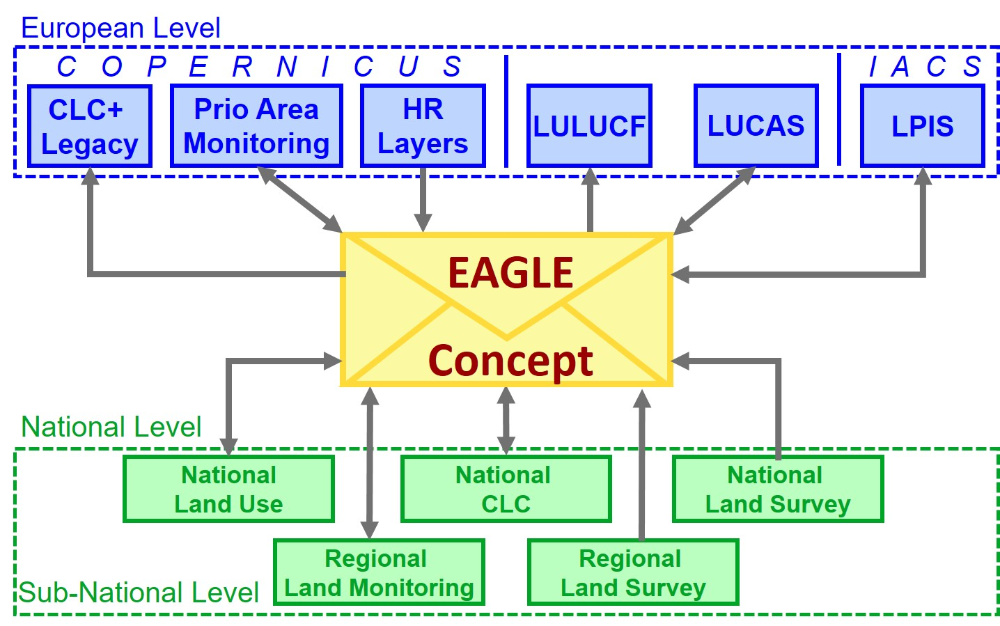
Figure 11 EAGLE concept as a semantic centrepiece and vehicle to allow comparisons and translations between different nomenclatures.
Classification systems use in their definitions either similar terms (e.g., “forest”) which have different meanings (e.g., tree covered area / area under forestry use or not), or differing terms (e.g., “urban fabric”/“built-up area”) that may or may not stand for the same thing (e.g., all settlement areas/only sealed areas). In addition, many nomenclatures contain a mix of land cover and land use terms (even within a class). As a result, such nomenclatures struggle to describe the entirety of the Earth’s surface without ambiguity or vague class assignments which can lead to misunderstandings in information content, both on the data producer side as well as on data users.
Similarly, assigning one single class label can lead to loss of information regarding the heterogeneity or individuality of classified land units. In such cases, using a single class label to assign land units to a specific class (e.g., energy production), can result in neglecting additional observations (e.g., grassland vegetation, or extensive grazing) about that same land unit. In cases where a nomenclature foresees only one class label to be assigned, it creates a trade-off dilemma between choosing one type of information (e.g., LU) and losing the other (e.g., LC) and vice versa.
The challenge is particularly obvious for more complex landscape situations where multiple phenomena exist. Depending on the purpose of a nomenclature, certain landscape aspects are highlighted by some classification systems, while they can be considered as not relevant by others.
The solution for such dilemma is the paradigm shift from classification to characterization, as briefly illustrated in Figure 2.
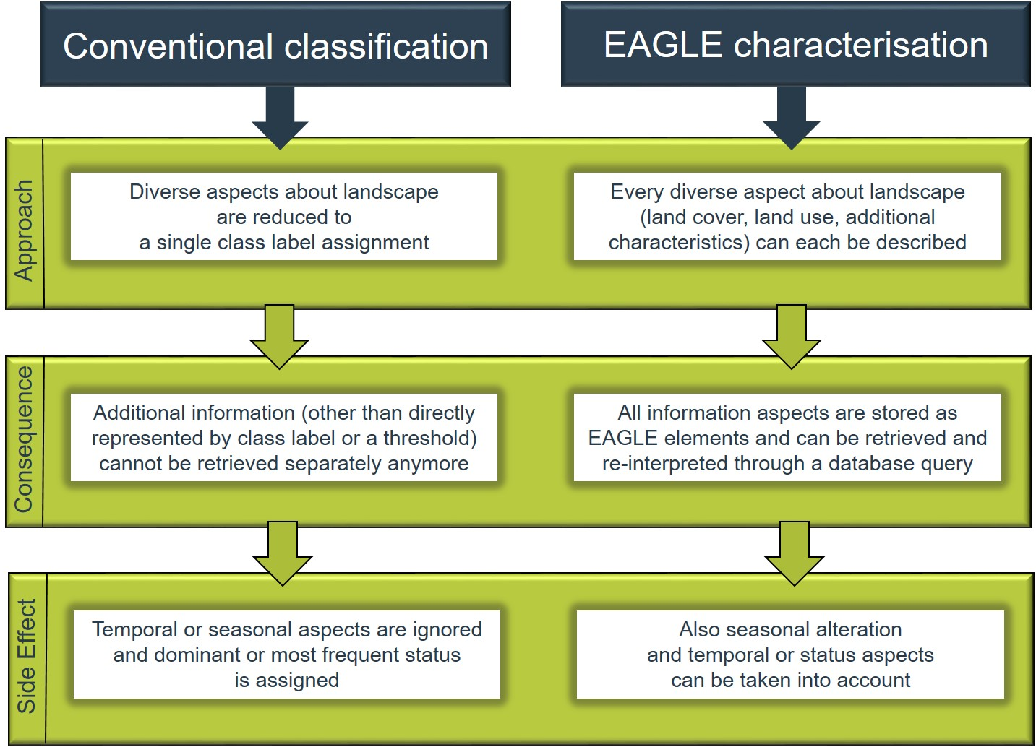
Figure 2: Different approaches of conventional classification (left) and object-oriented characterization (right) of landscapes and their consequences regarding information capture and storage.

Vision: Paradigm shift from classification to characterization
For the vision of a harmonized European framework for land monitoring, the following key points are being implemented:
- A single data model for the integration of land information from various sources acting as a centrepiece of integration applicable at EU, national and subnational levels;
- A descriptive vehicle for semantic translation / equivalence and comparison between different nomenclatures and class definitions to facilitate information exchange among them;
- A common basis for data collection and design of harmonized mapping guidelines for land monitoring initiatives.
The implementation of the EAGLE concept constitutes a paradigm shift when capturing information about landscapes, moving away from classification to an object-oriented descriptive characterisation of landscapes that allows the storage of multiple information instead of single class labels only.
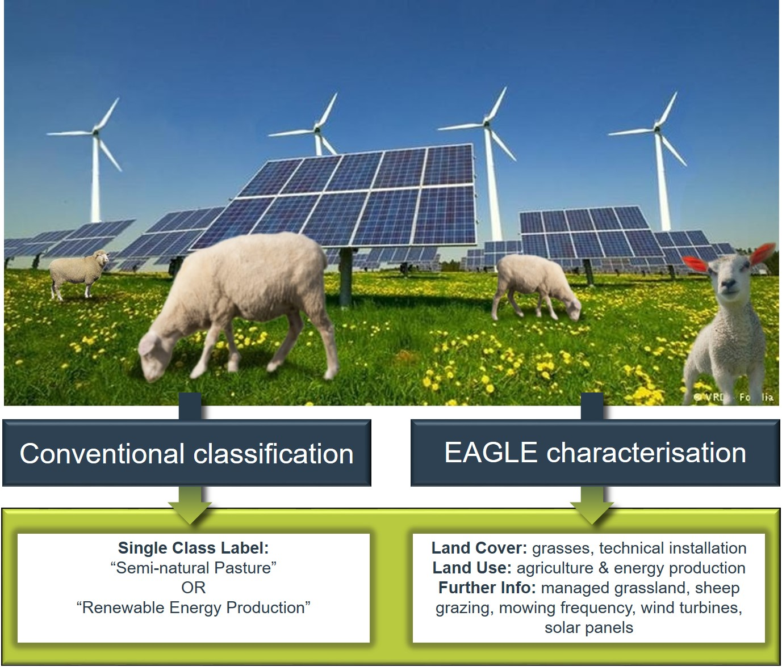
Figure 3: Example 1 for different information content between conventional classification approach versus object-oriented EAGLE characterisation.
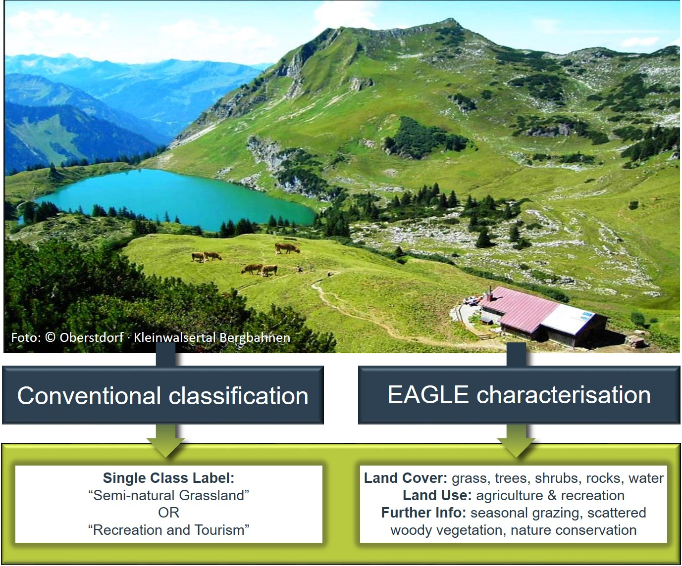
Figure 4: Example 2 for different information content between conventional classification approach versus object-oriented EAGLE characterisation.

Deploying the concept
The deployment of the EAGLE concept allows various approaches. Below the four main scenarios for deployment are described:

- A primary application involves the semantic analysis of classes, to grasp the importance/nature of each element and the role in the broader LC/LU classification system they constitute (Figure 5).

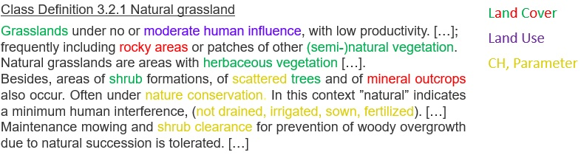
Figure 5 Example of semantic analysis of class definition through decomposition, highlighting landscape elements by their componential type: Land Cover (LC), Land Use (LU), Characteristics and Parameters (CH).

- The semantic analysis facilitates comparison and translation/equivalence among different classification systems. When two or more given class definitions are decomposed with the EAGLE concept as the same semantic “cookbook” ontology, similarities and differences in the landscape “ingredients” can be better identified, and easily visualized or used for further machine-aided processes.

- Another application is the utilization of the EAGLE as a mapping tool for the description and characterization of specific land units, incorporating real world features as they appear in the landscape (Figure 6).

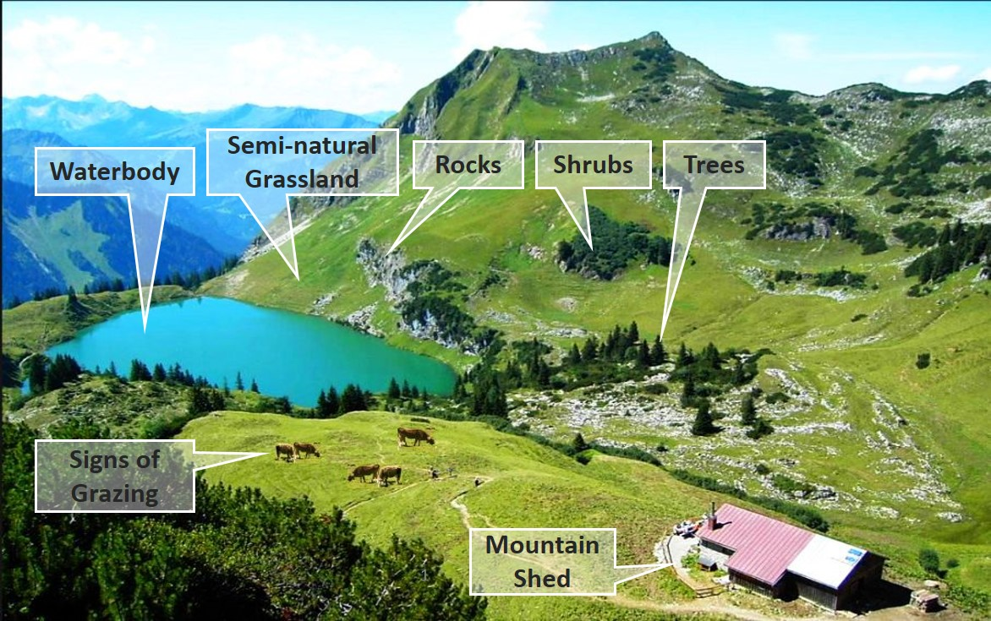
Figure 6 Decomposition of complex real world landscape situation which can be captured with EAGLE concept as a mapping tool (adapted from © Oberstdorf – Kleinwalsertal Bergbahnen).
- When new classification schemes are about to be devised, the EAGLE concept can be used for the design of new class definitions and nomenclatures. Here, the developers can choose within the contents of the EAGLE concept as a “reference” inventory and select the needed elements for the semantic design of classes.

Technical implementation / manifestation of the EAGLE concept
The design of the EAGLE concept was based on a set of criteria developed during a number of research projects and user engagements involving:

- Clear separation between the themes LC and LU, plus further land characteristics
- Comprehensive coverage of the LC and LU themes
- Object-oriented description and characterisation of land units instead of classification
- Inclusion of seasonal phenomena
- Scale independency
- Support for backwards compatibility of timelines in land monitoring

The technical manifestation of the EAGLE concept has two forms, the EAGLE matrix, and the Unified Modelling Language - UML model.

A more complete explanation of the EAGLE model elements with their definitions is provided in the form of explanatory documentation including details about the thematic meaning and hierarchical order of the elements. It can be downloaded from the Document Archive page.

EAGLE matrix
The EAGLE matrix provides an inventory/catalogue of all elements that represent real world objects and observable phenomena. It is structured in three main blocks:

- LAND COVER Components – LCC, subdivided into 3 parts, Abiotic, Biotic and Water (e.g., woody vegetation, rock material and water, respectively)
- LAND USE Attributes– LUA (e.g., forestry, residential use, industrial sites, etc.)
- LAND CHARACTERISTICS - LCH (e.g., land management type, spatial pattern, (bio)-physical characteristics, parameters, ecosystem types, status, etc.).

The matrix is structured in a hierarchical manner from top to bottom, starting with coarse and more general aspects (“parent” elements), subdivided into subtypes (“child” elements) down to six hierarchical levels (“grandchildren”, “great grandchildren”, etc.).

The elements of the LCC and LUA blocks are hierarchically structured below their main and only headings “Land Cover Components” and “Land Use Attributes”. Each of the LCC and LUA elements can stand alone and speaks for itself, independent from other matrix elements.

The elements of the LCH are also hierarchically structured. In contrast with the other two blocks, the LCH block is subdivided into several segments with headings and sub-headings, to facilitate a thematic orientation within the entire LCH block. Additionally, the association of a LCH element to a LCC or LUA element becomes obvious, or even is required. For instance, the element “Broad Leaved” from the LCH sub-heading “Leaf form” needs to be put into context by relating it to a LCC element as “woody vegetation” (or its subtypes). Another example would be the spatial characteristic “mosaic pattern” which is contextualized when related to an agricultural cultivation form e.g. “arable crop land”.

Figure 7 shows a reduced and simplified illustration of the EAGLE matrix, with all elements arranged in a horizontal form and hierarchically structured from top to bottom. For better readability of this illustration, this figure only shows a selection of segments and levels of the matrix; lower levels and other details have been blurred out for the sake of conceptual clarity. The entire matrix is larger in its full extent, both in vertical and horizontal direction.
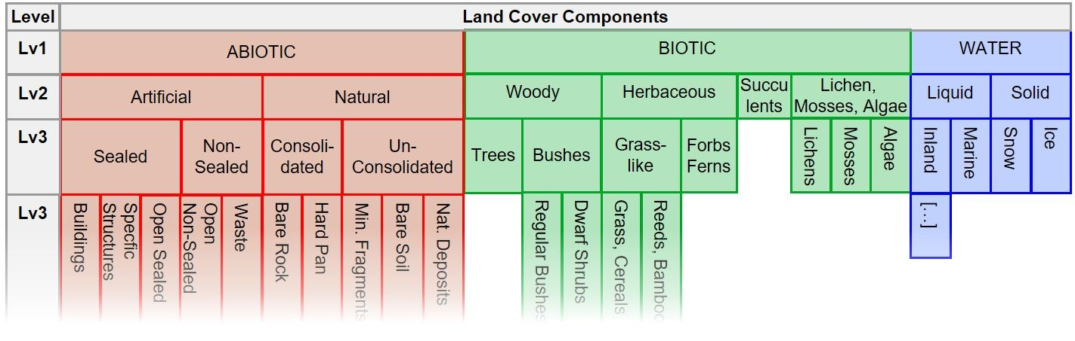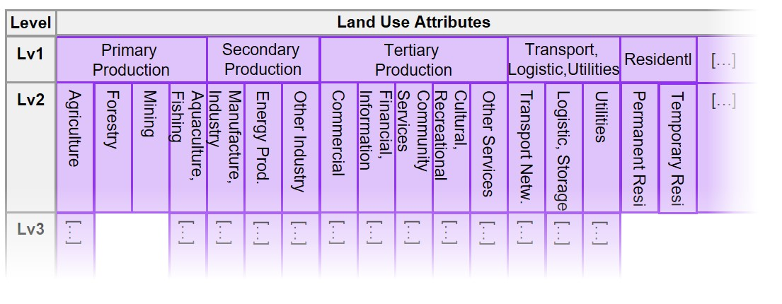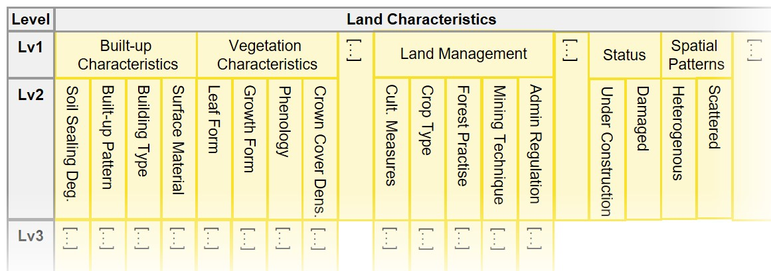
Figure 7 The EAGLE Matrix in horizontal form with the three blocks LCC, LUA, LCH. All three blocks are shown here for illustration reasons below each other, but normally are arranged sideways next to each other.
The EAGLE matrix itself is presented in an Excel cross table and is available from the Download archive page.

EAGLE data model
The EAGLE data model is written in UML (Unified Modelling Language). The central object of the EAGLE data model is the Land Unit (or multiple units). The Land Unit is the mapped object, which carries the geometry of the Land Unit and represents a homogeneous piece of land that is delineated and distinguished from its geographic neighbours. The Land Unit is then populated with content by a composition of one or several Land Cover Components (LCC) to describe the land cover within the geometry of the Land Unit. In addition to the LCCs, the Land Unit can be enriched by Land Use Attributes (LUA). Each selected LCC, as well as the entire Land Unit, can be further described with Land Characteristics (LCH) ( Figure 8).
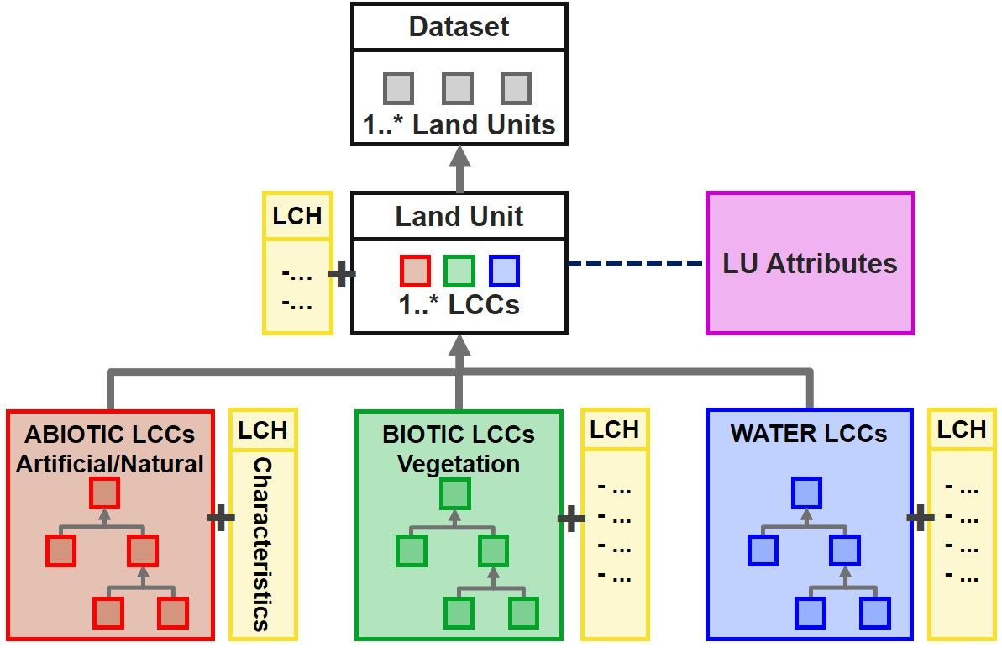
Figure 8 Simplified structure of the EAGLE UML data model, with a Land Unit as a geometric instance of a “Dataset”, being composed of “Land Cover Components”, enriched by “Land Use Attributes”, and further described by “Land Characteristics”.

The EAGLE UML model is available from the Download archive page.

Bar-Coding

The use of EAGLE to describe a specific land use or translate a certain dataset class requires a standardized interpretation of the multiple elements in the EAGLE matrix. The bar-coding approach is proposed as a systematic method to widely apply the EAGLE concept appropriately.

Specifically, the ‘bar-coding’ method consists of selecting and assigning a value (BCV) to relevant LCC, LUA and LCH elements from the EAGLE matrix to describe a class. The aim of bar-coding is to enable the creation of a standardized and concise representation of the class using a sequence of numerical codes.

During the bar-coding exercise of a particular class or landscape, the various class elements get assigned a certain bar code value (BCV) according to their importance and logic relationship within a given class definition. The resulting sequence of numerical codes assigned to the matrix elements serves as a (unique) descriptive summary of the class.
Table 1 lists all the BCV options, and the correspondence between the code assigned to an EAGLE matrix element and its presence in the semantic definition or in the landscape reality. For instance, based on a given LU/LC class definition, the BCV express whether the coded elements must (or can) be present in the semantic or landscape reality, and how many of them with the same assigned BCV.

Table 1 List of Bar-code value description. The BCVs define the role of EAGLE matrix elements to fulfil a given mapping criteria, class definition or landscape situation.
Bar-code Value (BCV) table
Value | Description | Examples
X | Element is excluded by definition | Figure 10, the CLC “Natural grassland” definition specifies a “not irrigated” land as a requirement, therefore the “irrigation” element is coded with “x”
1 | Optional element; it can occur as frequent or typical, but it is not mandatory | Figure 10, the CLC “Natural grassland” definition specifies “bare rocks” as a frequent element, but not mandatory: therefore “bare rocks” is coded with “1”.
2 | Selective mandatory element; EITHER/OR logic, at least one or more of the elements with assigned BCV 2 must be present | Figure 9, “Grazing” and “mowing” are indicated as possible characteristics (LCH) of “managed grassland”. The uncertainty on the type of management is expressed assigning the code “2” to both elements: at least one of the two management practices is implemented.
3 | Cumulative mandatory element; AND-logic, all the elements with assigned BCV 3 must be present all together | Figure 9, all the LCC and LUA elements are coded with “3” since, considering the landscape elements of the image, are all mandatory.
4 | Paired mandatory element; at least two of the elements with assigned BCV 4 must be present | It is required to code complex definitions. In figure 11, the CLC “Complex cultivation pattern” definition requires at least 2 cultivation types among arable crops, pastures, and permanent crops, consequently these three Matrix elements are coded all with “4”.
5 | Exclusive mandatory element; NOTHING-BUT-logic, it allows only one element with the assigned BCV 5 and excludes any other element from its parent matrix block | The code 5 is used when the matrix element has a full equivalence to a certain class or land unit definition. In figure 11, the CLC “Dump site” definition is clear on the exclusivity of the required land use type, consequently the LUA “dump site” is coded with “5”.
.
The bar-coding approach streamlines a harmonized systematic process of creating machine readable and formalized representations of landscape situations or LC/LU classes, breaking them down to a handful of landscape descriptors for each class with respect to the landscape situation. The bar code results can range from rather simple to very complex constellations of matrix elements. By providing such a predetermined descriptive inventory in the form of the EAGLE matrix, it becomes easier to semantically express the content of classes and to make comparisons of those class definitions within or between classification systems. The bar coding method helps to identify and visualize commonalities, differences, overlaps and gaps between different class definitions.
When applying the bar-coding method, the user can decide which EAGLE elements to select and which role (mandatory, optional, excluded) for each bar-coded class, according to the targeted definition. For each bar-coding exercise, the relevance and the role of each matrix element can be decided.
From the LCC and LUA blocks, all elements on all levels can be used for bar coding; in the LCH block, the headings are not foreseen to be bar-coded, as it does not make sense to say “Cultivation Practice is mandatory” for a class given definition, but rather what kind of Cultivation Practice – e.g. “crop rotation” – must be present.

Below are four examples on the bar-coding decomposition, showing only the EAGLE elements from the matrix which have been assigned to each situation; one from an existing landscape type (Figure 9) and the other three from a given textual class definition (Figure 10, Figure 11, and Figure 12).

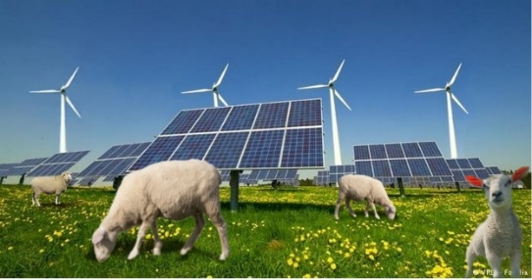 | 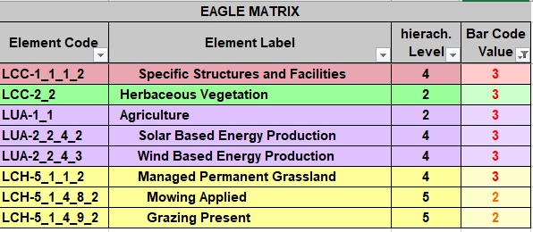
Figure 9 Example of how to decompose and bar-code a complex landscape situation: Pasture grassland combined with Renewable Energy Production. All elements assigned code “3” are mandatory all together; elements coded with "2" are selective mandatory, meaning at least one or more of them must be present.

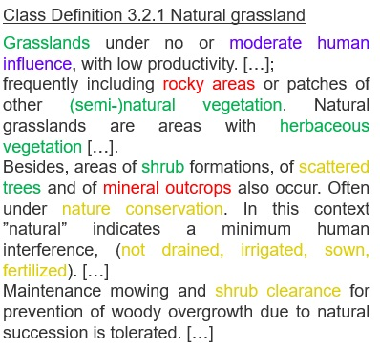 | 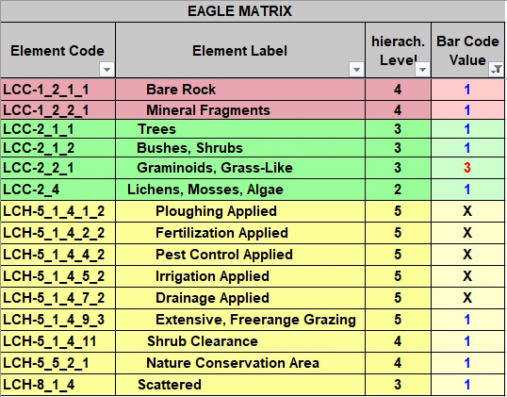
Figure 10 Example of bar-coding decomposition of the textual CLC class definition “Natural Grassland”. Mandatory elements are coded with “3” and must be present all together, optional elements which frequently or typically (but not necessarily) can occur are coded with “1”, and elements excluded by definition are coded “X”.
Class definition CLC 2.4.2 Complex cultivation patterns  Mosaic of agricultural land parcels of at least two of the following three cultivation types: arable crop land, pasture [herbaceous vegetation] and permanent crop land [woody vegetation];  Mosaic of parcels of permanent crops (fruit trees, berry plantations, vineyards and olive groves);  Agricultural mosaics with scattered houses, or garden huts, situated in proximity of rural or urban settlements and used for growing agricultural crops, fruit, and vegetable for own consumption;  Hobby/city/kitchen gardens primarily for agricultural production use;  Vineyards, intermixed with other cultivation types in mosaic pattern. | 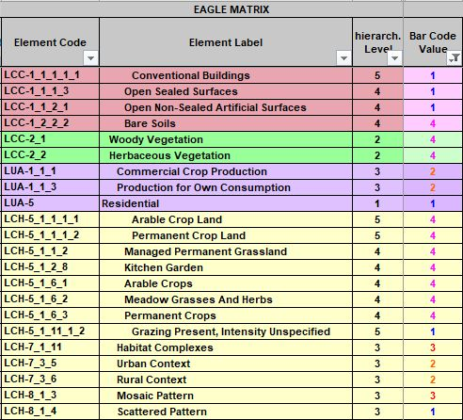
Figure 11 Example of bar-coding decomposition of the textual CLC class definition “Complex Cultivation Pattern”. Selective mandatory elements are coded with “2” and at least one of them must be present, optional elements which occasionally can occur are coded with “1”, paired mandatory elements where at least two of them must be present in any combination are coded “4”.
Class definition CLC 1.3.2 Dump site  dump sites of public, industrial, communal waste; waste rock after processing of various raw materials; waste sewage sludge; pools of liquid waste from chemical processes;  associated land of mines where barren materials are dumped (coal tips, slag dumps).  Includes: line vegetation belts, part of buffering zones around dump sites;  buildings, transport networks including parking lots [open non-sealed areas] associated with dump site;  non-vegetated slag heaps.  Excludes: abandoned, reclaimed or reconverted former dump sites.  Not applicable for: water treatment plants | 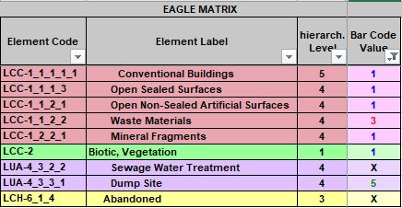
Figure 12 Example of bar-coding decomposition of the textual CLC class definition “Dump site”. Cumulative mandatory element is coded with “3” and must be present, optional elements which occasionally can occur are coded with “1”, exclusive mandatory is LUA “dump site” which is coded with BCV “5”, Land use type water sewage plant and abandoned status are excluded by definition.

The Bar-Code manual is available from the Download archive page.

Use Cases of EAGLE Concept
Several use cases of the EAGLE concept have evolved around the domain of land monitoring, both at national and European levels. In many countries, the EAGLE concept has contributed to the development of mapping approaches, which draw their conceptual design from the EAGLE model.
Besides already existing use cases, of which a few are mentioned here below, the land monitoring community is invited to make use of the EAGLE concept according to their own purposes and user needs.

Prime use case: CORINE Land Cover second generation (CLC+)
Currently, the most prominent implementation use case at pan-European level is the development of the second generation of CORINE Land Cover (referred to as CLC+). The EAGLE Data Model with its ontology, functions as the central semantic dictionary and translates all ingested input data into the CLC+ Core database in a harmonized and machine-readable manner (Figure 11).
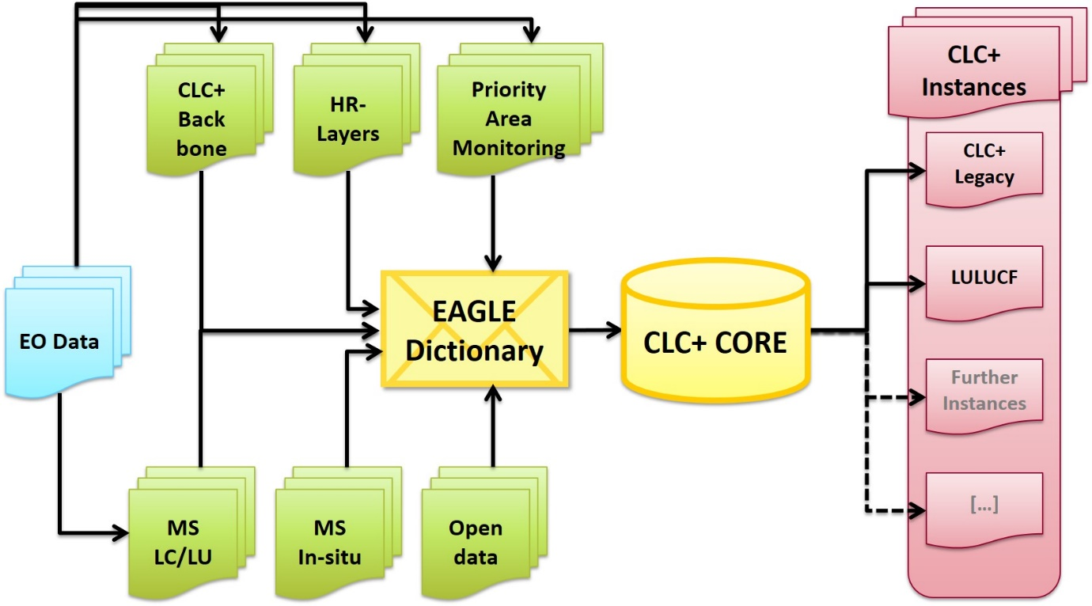
Figure 13 Data flow schema towards and from the CLC+ Core

Context
In 2018 the European Environment Agency (EEA) determined to develop a conceptual strategy and design associated with the technical specifications for a new series of products within the CLMS portfolio, which should meet the current and future requirements for European LU/LC monitoring and reporting obligations.
Conceptual Background
Unlike the traditional CLC approach to update a single vector map every 6 years, CLC+ second generation is a system that contains two main components, the CLC+ Backbone (a geospatial land cover information component), and the CLC+ Core, which is a database/web application component for handling thematic data from existing initiatives e.g., CLMS products, Member States data, open data. In this sense the CLC+ system aims to be a versatile supplement to the traditional CLC providing options for expert users to create, via the CLC+ Core, their own grid-based data products (CLC+ Instances), offering greater agility and flexibility in supporting various EU land monitoring policies, such as LULUCF.
The foundation of the CLC+ Core database lies in the EAGLE concept, where classification is transformed into landscape characterization. This transformation facilitates the harmonization of LC/LU information and allows the extraction of the CLC+ instance based on diverse ingested inputs. The EEA and the EAGLE group are collaborating in developing the CLC+ Core system.

Further details about the implementation process of CLC+ product suite can be found in the CLC+ dedicated page under the Pan-European products section of EEA´s land monitoring service.

Further use cases of EAGLE concept

Enhancement of CORINE Land Cover nomenclature guidelines
A systematic analysis of the Corine Land Cover (CLC) Nomenclature Guidelines has been performed through semantic decomposition of the existing CLC class definitions regarding their information content about LC, LU, and further land characteristics/parameters/thresholds. Based on this, the textual document has been restructured with subchapters, where:
- a class is applicable for/not applicable for certain landscape situations and examples,
- a class includes/excludes certain LCCs or LUAs
The result can be found in the Nomenclature Guidelines.

INSPIRE data specifications
During the implementation process of the European INSPIRE directive, some EAGLE members were involved as national experts in the elaboration of the data specifications for the INSPIRE themes Land Cover and Land Use. Through exchange between the two thematic working groups, EAGLE members took care of a clean separation and unravelling between the themes LC and LU.

On one side, the EAGLE UML data model carries an anchor to the UML model from the data specifications on the INSPIRE theme Land Cover. Both UML models are connected on the level of the LandCoverUnit/LandUnit. The code list of “Pure Land Cover Components” (INSPIRE PLCC) from these data specifications fall back to and can be mapped with the EAGLE Land Cover Components (LCC).

On the other side, the Land Use Attributes (LUA) from the EAGLE concept relate to the "Hierarchical INSPIRE Land Use Classification System” (HILUCS) from the data specifications of the INSPIRE theme Land Use (Figure 12).

These connections between the two UML models make the EAGLE model INSPIRE-compliant.
Still, both models (INSPIRE and EAGLE) function also as stand-alone models, independently from each other. While the INSPIRE directive handles the themes LC and LU separately from each other, in the EAGLE model content-wise both themes are separated but can be combined with each other to describe nomenclature classes or individual land units.

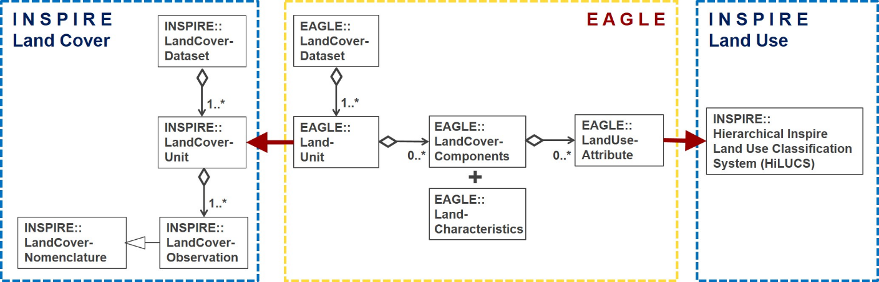
Figure 14: Connections between EAGLE UML data model and INSPIRE data specifications for Land Cover (left side) and Land Use (right side) which make the EAGLE model INSPIRE-compliant.

Consistency analysis of CLMS Riparian Zones nomenclature
The nomenclature of the Riparian Zones product has been checked for its consistency regarding the structure and hierarchy as well as the class definitions themselves. The result was a refined nomenclature.

LULUCF
The EAGLE group indirectly supports the EEA in their greenhouse gas (GHG) reporting related activities, specifically around reporting for the Land Use, Land Use Change and Forestry (LULUCF) sector. In this context, the EAGLE Group is involved in supporting the development of the CLC+ Core based CLC+ LULUCF Instance. This work focusses on the use of the EAGLE concept to semantically decompose the definitions of the 6 major LULUCF categories by applying the taxonomy of the EAGLE model vocabulary.

Review of Feature type catalogue of national mapping agency (Germany)
A semantic analysis with the EAGLE matrix was applied to the feature type catalogue (GeoInfoDok ATKIS/ALKIS) of the German land surveying authorities (AdV). Using the EAGLE bar-coding method, the definitions of all feature types and attributes were semantically described with respect to their thematic content.
Based on the results, two new separate nomenclatures on LC and LU were designed to disentangle the mixing of those to themes within the current ATKIS/ALKIS nomenclature.

EAGLE Matrix Bar Coding exercises on national levels
In selected countries the definitions of national nomenclatures have been decomposed by bar-coding method with an older version (2015) of the EAGLE matrix: Hungary, Netherlands, Spain, Germany, Austria, Bulgaria/Romania cross-border region, Switzerland, United Kingdom. In some of these cases, the national data is already operationally used to derive national CLC data, as in Spain and Germany, among others.

Relation with ISO standards series 19144 and FAO`s LCCS
The EAGLE concept is not a formal standard; however, it can take over a standardising role when describing landscape, especially in the European context. In the international context, a standard for a Land Cover Meta Language (ISO 19144-2 LCML) has been established, basically driven by FAO. This standard is currently under revision, partly because it still contains some land use terms, that are about to be removed for consistency reasons. Further, a new ISO standard 19144-3 for land use is in the making. As a future ISO project idea, a standard 19144-4 for “Registration and Implementation Aspects” is envisaged, however not much has been concretized yet. To support the ISO standard series of 19144, some EAGLE group members in their role as associated thematic experts are involved to optimise the content of the ISO standard 19144 components.
The FAO´s LCCS (Land Cover Classification System) was used as a conceptual input and predecessor for the ISO standard 19144-2 LCML (Land Cover Meta Language), which is why it is also mentioned here.
The FAO LCCS is a hierarchical and dichotomous classification approach. It works by going down on a decision tree of its predefined classes and subclasses. Once a certain information is not given along that path, the user is “stuck” in the hierarchical approach, not being able to continue with the classification downwards within the hierarchy. Also, LCCS mixes LC with LU aspects within its nomenclature. LCCS takes a certain perspective of FAO´s application needs and is therefore tailored to a particular purpose.
The EAGLE concept follows a more flexible and application-neutral approach. It clearly separates LC from LU aspects, and it solves the dilemma of predefined dichotomy while it works with parallel and independent descriptions of LCC, LUA and LCH, which can be brought into relation to each other (mandatory or optional combinations of those elements).
The main difference between LCCS and EAGLE concept is of structural nature, meaning that LCCS is a classification system with predefined classes and modules, while the EAGLE concept is an object-oriented characterisation approach with more descriptive flexibility.

Archive / Download page
[notes: The new CLMS portal will have a download/archive page offering the possibility to download the latest version of the reference EAGLE material tools and documents e.g., matrix, UML and previous versions.
Content to be organized in the archive:
- Previous version of main documents, matrix, uml, … [CLMS EAGLE downloads]
- Old documents: Grid approach, CIGAR, …; [eionet page]
- meeting references. [eionet page]
- tools: EMPACT, EAGLE GIS database? [eionet page]
While the rest of documentation is not foreseen in Copernicus, could be a cloud space located in EIONET FORUM, to be agreed.]

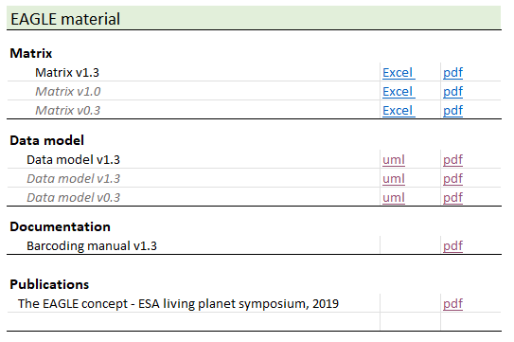
Figure 15 Example of download archive section, including publication item.

Publications
[Notes: Due to the limited number of items, is suggested to include a section “Publication” in the download page see previous chapter.]
The EAGLE concept - A vision of a future European Land Monitoring Framework
Arnold, S., Kosztra, B., Banko, G., Smith, G., Hazeu, G., Bock, M., Valcarcel-Sanz, N. (2013): The EAGLE concept - A vision of a future European Land Monitoring Framework.
In: Lasaponara R., Masini N., Biscione M. (Editors): EARSeL Symposium proceedings 2013, "Towards Horizon 2020". The original publication can be found in the EARSeL symposium´s proceedings of 2013 under this link.
The EAGLE Concept [@ Living Planet Symposium 2019]
Arnold, S., Smith, G., Bock, M. (2019): The EAGLE Concept – Applications of an object-oriented data modelling approach for land cover and land use.
Abstract for ESA Living Planet Symposium (LPS) 2019, 13. - 17. May 2019, Milano, Italy.

The EAGLE Group was created within what was the Eionet National Reference Centre on Land Cover now replaced by the Eionet Group Land Systems (Thematic Group support to Copernicus Land)

