EEA/DIS/R0/22/007

Task 2: Support to the maintenance of the EAGLE website

Identification of most relevant EAGLE material

Final draft
version | Date | status | notes
1 | 30/11/2022 | First draft | Internal
2 | 10/01/2023 | Second draft | EEA comments
3 | 02/03/2023 | Third draft | Internal EAGLE
4 | 15/03/ | Final draft

HOME - intro
EAGLE – Eionet Action Group on Land monitoring in Europe
Since 2008, the EAGLE Group has been developing a conceptual solution and proof of concept to support the semantic and technical framework of a European harmonised information capacity for land monitoring.
The EAGLE Group is a self-initiated and open group of land monitoring experts from different European Environment Agency (EEA) member countries , mostly – but not only – in their roles as Eionet members. Thus, the EAGLE Group brings together knowledge and experiences from existing land cover (LC) and land use (LU) classification approaches and initiatives in a bottom-up approach.
Meanwhile, EAGLE is acknowledged by the Copernicus Land Monitoring Service (CLMS) as an instrumental and crucial component to support a general shift of focus from classification to characterisation, and EAGLE compliance is enforced in all newer CLMS products.
The EAGLE concept is also explicitly mentioned in the Copernicus Work Programmes as essential pillar to support the challenging new use cases of the 2nd generation CORINE Land Cover (CLC), also known as CLC+ system. The EAGLE concept is now becoming real as central instrument within the CLC+ Core implementation, to guarantee a standardized integration approach of different LC/LU products.

The CONCEPT

Introduction and key messages
All land monitoring nomenclatures are tailored to a particular purpose or scope, even if they are intended to address a general user community. Each of them has a different thematic focus and depth regarding content details and will be controlled by a range of external factors.
The work of the EAGLE Group is not aiming to create a new nomenclature or classification system, but it rather addresses ambiguity within nomenclatures or the comparability between them, regarding the terms and definitions they work with. Many classification systems use either similar terms which have different meanings, or differing terms that stand for the same things. In addition, many nomenclatures contain a mix of land cover and land use terms within a single class, while such nomenclatures struggle to describe the entirety of the Earth’s surface without ambiguity or vague class assignments that lead to misunderstandings in information content.
Also, nomenclatures that work with singular class labels suffer from the loss of information about the heterogeneity or individuality of the classified unit.
In such cases, once a given observation (e.g., LU type) or a parameter threshold is chosen to determine the assigned class label (e.g., industrial use), any other observations (e.g., vegetation covered roof) about that same land unit are not considered relevant anymore and are thus not represented explicitly in that same dataset.
This means, that when working with a single class label, there is usually a trade-off between choosing one type of information (e.g., LU) and losing the other (e.g., LC).
The challenges around having to choose a single class label assignment are particularly relevant for complex landscapes. The classification system can require prioritizing some elements rather than others or grouping them differently depending on the purpose.

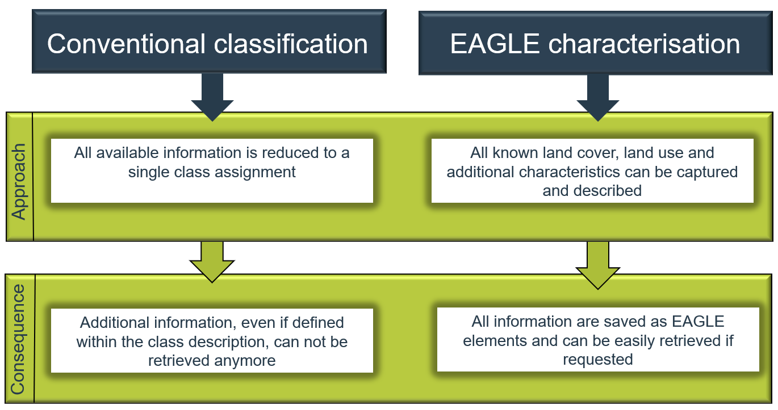
Example of complex landscape
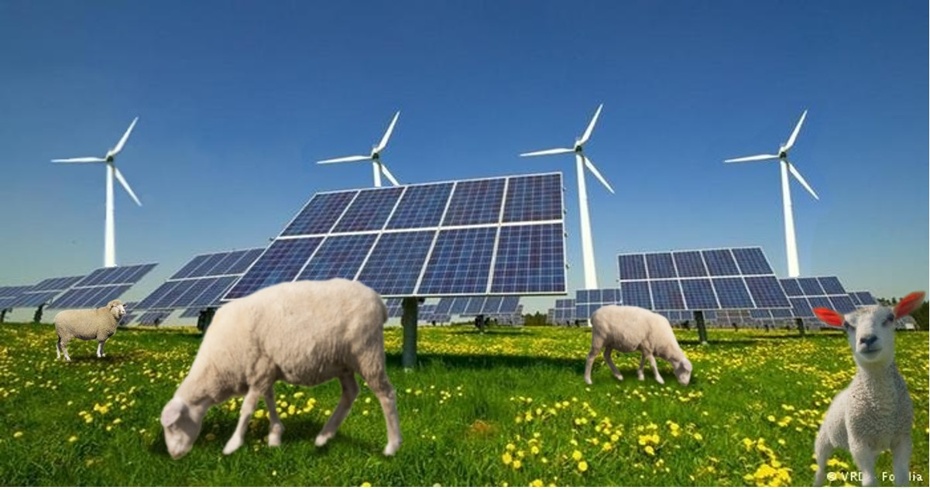
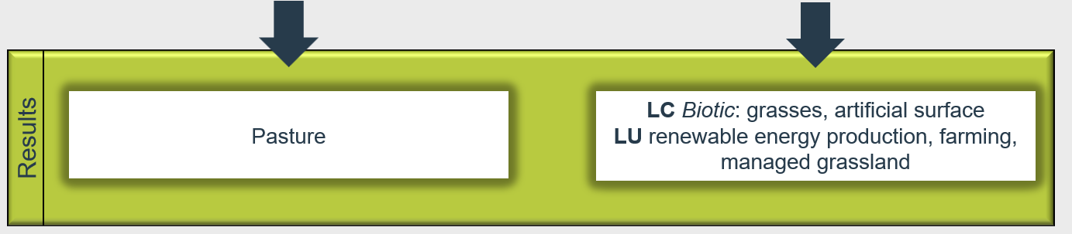

Example of complex landscape
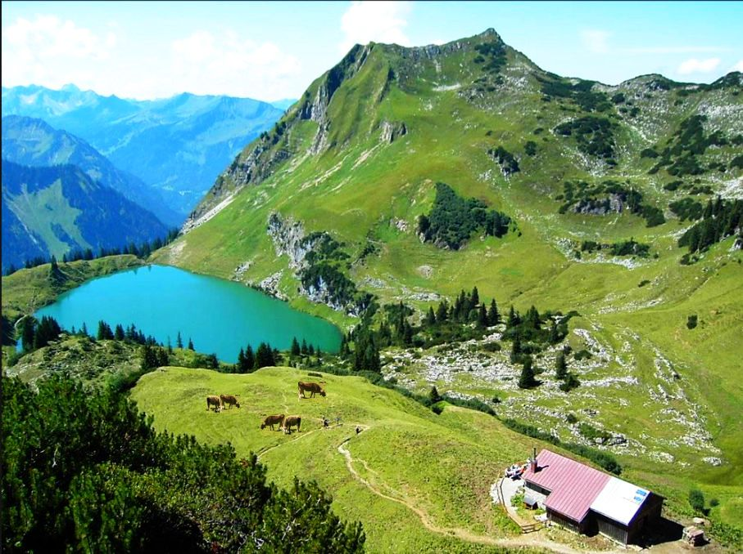
Foto: © Oberstdorf · Kleinwalsertal Bergbahnen 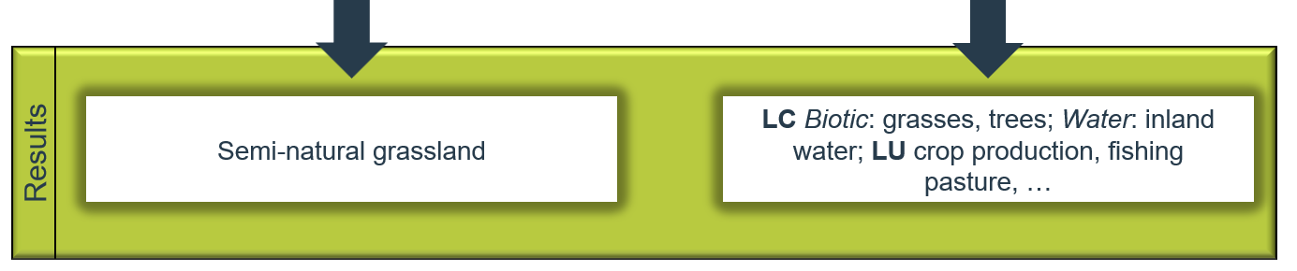

Figure 1 Comparison of EAGLE and conventional classification approaches and examples.

The vision/philosophy behind the EAGLE concept therefore addresses the following key points:
- Paradigm shift from classification to characterisation,
- A framework for the integration of LC and LU information from various sources into one single data model,
- Applicable at both national and EU levels, being the centrepiece of semantic integration,
- A vehicle for semantic comparison and translation between different nomenclatures to facilitate exchange between them.
- Implementation as a data collection and mapping guideline for national land monitoring initiatives.
- Can be a coherent common data framework for individual Copernicus products (CLC and CLC+ suite, HRLs, Urban Atlas, and other thematic products).

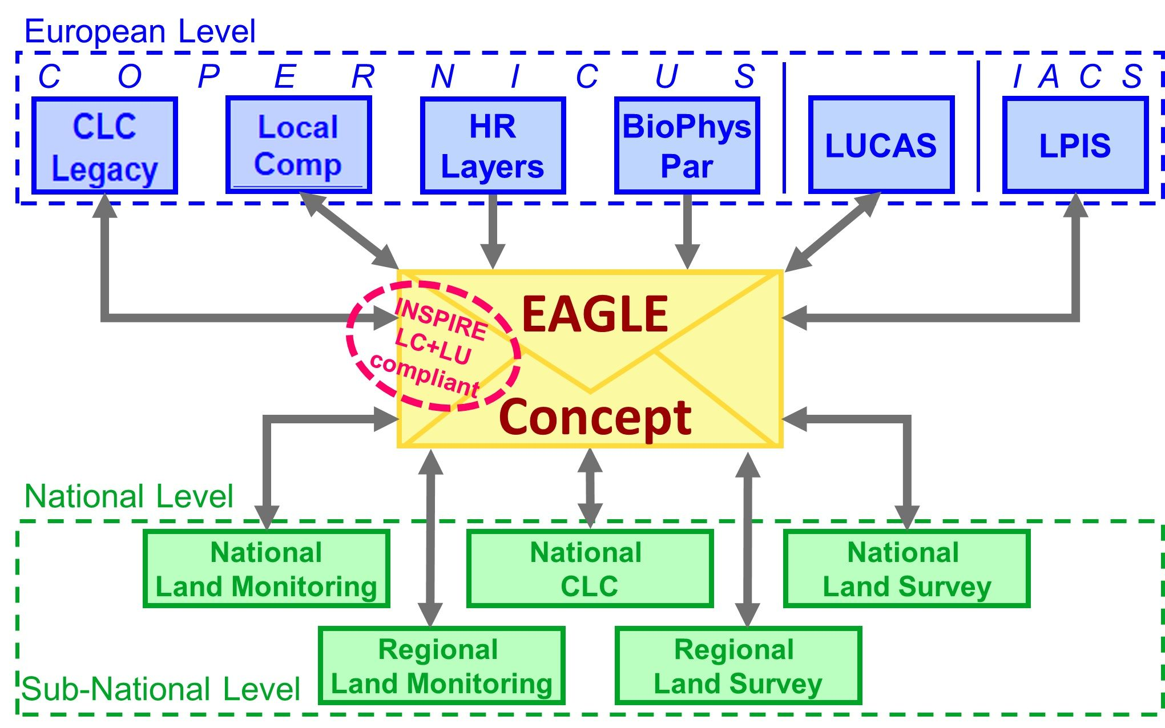
Figure 2 EAGLE concept as a semantic centrepiece and vehicle to allow comparisons and translations between different nomenclatures
The EAGLE concept is also INSPIRE compliant thus all LC and LU elements from the EAGLE model are consistent with the code list of the “Pure Land Cover Components” (PLCC) from the data specifications of the INSPIRE theme Land Cover and the "Hierarchical INSPIRE Land Use Classification System” (HILUCS) from the data specifications of the INSPIRE theme Land Use. The EAGLE concept is not an attempt to create yet another new classification system! Instead, it aims to be a descriptive vehicle for the transformation of thematic LC and LU information between class definitions of different existing classification systems.
Also, it can be used to capture and store descriptive information about real world features (e.g., during a mapping campaign) in a semantically structured manner resulting in a flexible and sustainable end product.
Further, when new classification schemes are devised, the developers can choose from the entire EAGLE matrix as a “reference” catalogue to select the needed elements. Here, it can also be helpful to work with intermediate classes, for instance, on the way from the more detailed national input data to generalized target classes of CLC+ Instances.
The rich attribution of landscape units by the characterisation and parameterisation of a broad range of elements provides a powerful and flexible system to support multiple uses and applications.
In short, the four main scenarios for deploying the EAGLE concept are:
- Analytical decomposition of class definitions (Figure 3)
- Semantic comparison or translation between different class definitions
- Descriptive and object-oriented characterisation of real-world land units (Figure 4)
- Design of new class definitions by selecting necessary elements.
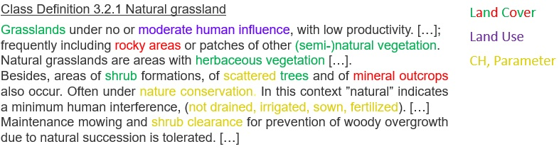
Figure 3 Example of class decomposition, highlighting EAGLE elements by their component type Land Cover (LC), Land Use (LU), Characteristics and Parameters (CH)
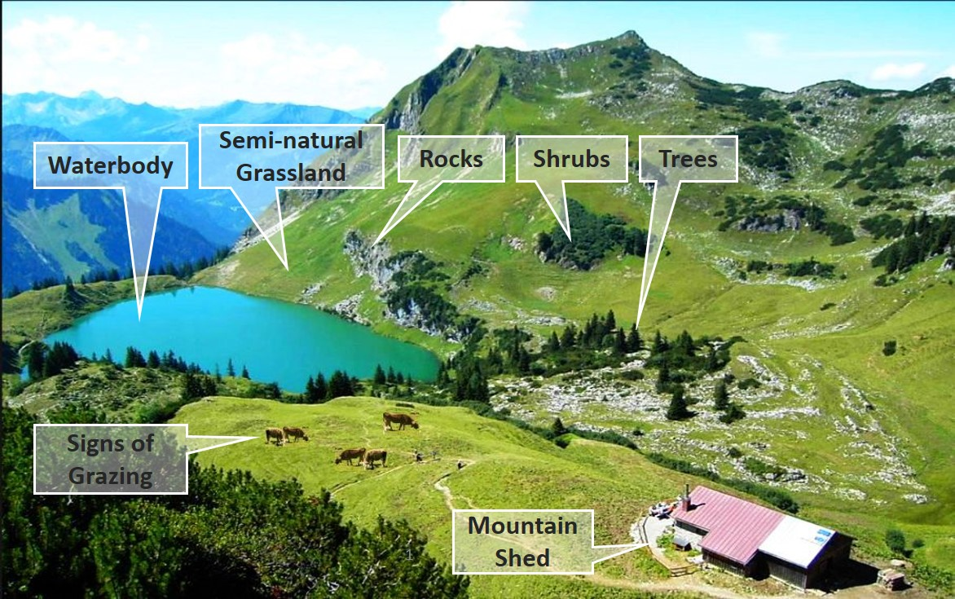
Figure 4 decomposition elements from a complex landscape (adapted from © Oberstdorf – Kleinwalsertal Bergbahnen)
The design of the EAGLE concept was based on a set of criteria developed during a number of research projects and user engagements:
- Clear separation between the themes LC and LU, plus further land characteristics
- Comprehensive coverage of the LC and LU themes
- Object-oriented description and characterisation of land units instead of classification
- Inclusion of seasonal phenomena
- Scale independency
- Support for backwards compatibility of timelines in land monitoring

Explanatory documentation
A more complete explanation is provided in documentation including details as the thematic meaning and hierarchical order of the EAGLE elements expressed by the two forms of the EAGLE concept, the EAGLE matrix, and the EAGLE data model.
Link to the document

The matrix
The EAGLE matrix provides an inventory / catalogue of all elements that can be used to describe the land surface. The list of elements can be used for analytic decomposition of class definitions and semantic translation between nomenclatures, and for the design of new class definitions. It is structured in three main blocks:

- LAND COVER Components – LCC, subdivided into 3 parts, Abiotic, Biotic and Water (e.g., woody vegetation, rock material, water respectively)
- LAND USE Attributes and – LUA (e.g., forestry, residential use, industrial sites, etc.)
- Further LAND CHARACTERISTICS - LCH (e.g., land management type, spatial pattern, (bio)-physical characteristics, parameters, ecosystem types, status, etc.).

The EAGLE matrix itself is presented in an Excel cross table form [link]

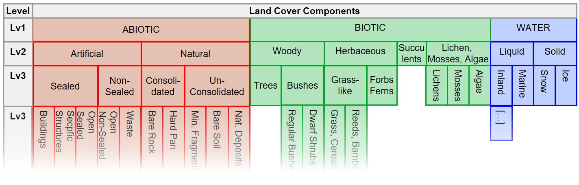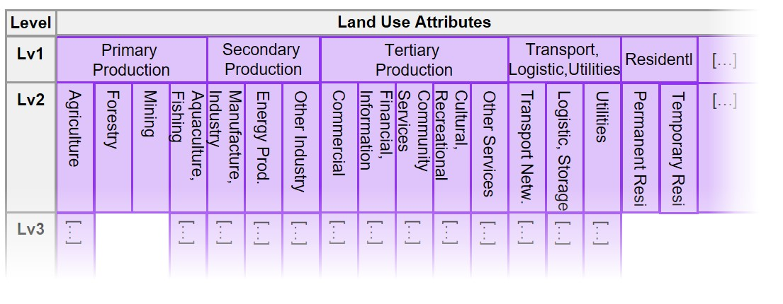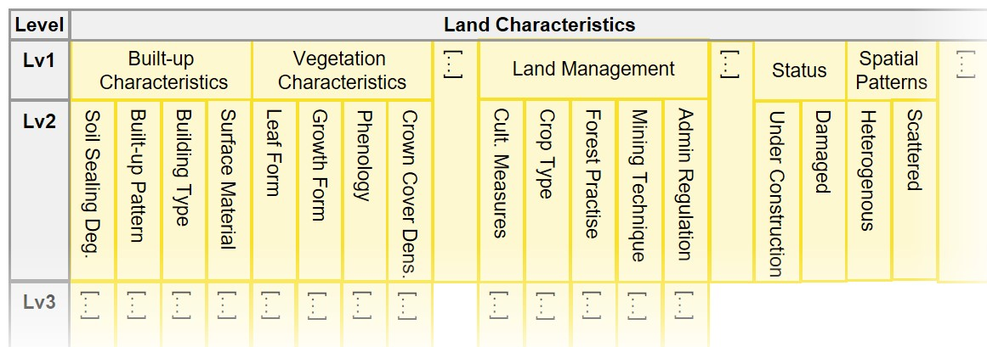
Figure 5 The EAGLE Matrix as an Excel Sheet with the three blocks LCC, LUA, LCH. All three blocks are arranged alongside each other in the matrix from left to right but are shown here for illustration reasons below each other. This figure only shows selected segments of the matrix, lower levels of detail are left out. The entire matrix is larger in its full extent, both in vertical and horizontal direction.

Link to latest version of the matrix; picture

Bar-Coding
The process of selecting the relevant LCC, LUA and LCH elements from the matrix for a class is referred to as ‘bar-coding’. Each element can be coded with one of seven values (Table 1), such as mandatory, optional, or excluded by definition. This creates a sequence of coded values called a "bar-code”. When using the matrix as a decomposing tool to record a certain class or describe a surface unit the following steps should be used:
- Start by selecting one or more LC components from the LCC block,
- Continue by attaching some LU information from the LUA block,
- Finalize (if needed) by adding further characteristic information on landscape from the LCH block.

Table 1 Bar-coding definition table
Bar-code table
Value | Description
X | excluded by definition
1 | typical, o can occur but not necessarily mandatory
2 | selective mandatory, at least one (or more) of the 2-coded elements must be present
3 | cumulative mandatory, all the 3-coded elements must be present
4 | two out of 4-coded elements must be present
5 | 100% exclusive coverage of the area by selected element
6 | exclusive mandatory (“Highlander”-value), only one of the 6-coded elements is allowed

The bar-coding decomposition aims at cataloguing all elements from a given class definition independently from scale or spatial resolution, by their importance (e.g., mandatory or optional element) and their relation to each other. Below an example on the bar-coding decomposition from an existing landscape (Figure 6) and from a given class definition (Figure 7).

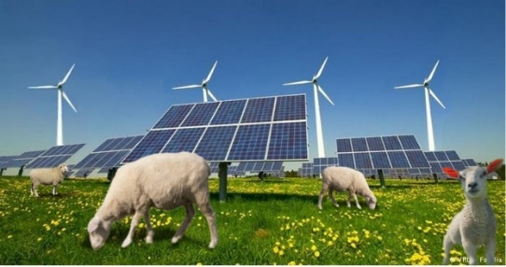 | 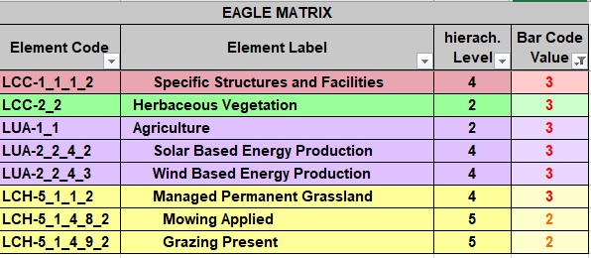
Figure 6 Example of bar-coding decomposition of the elements from a complex landscape

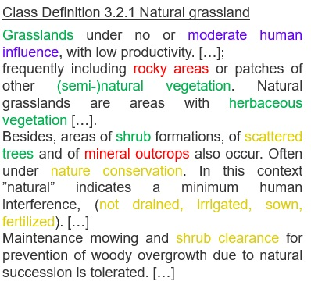 | 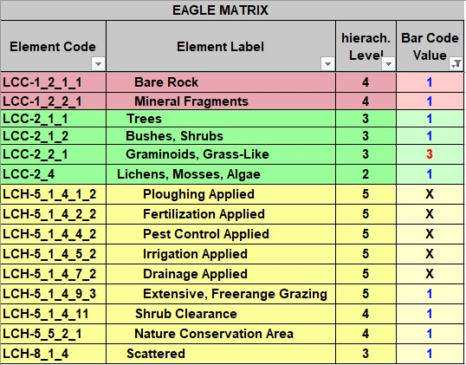

Figure 7 Example of bar-coding decomposition of the elements from a class description

Link to latest version of the doc; picture?

EAGLE data model
The EAGLE data model is written in UML (Unified Modelling Language). The central object of the EAGLE data model is the Land Unit (or multiple units). The Land Unit is the mapped object, which carries the geometry of the Land Unit, representing a homogeneous piece of land to be delineated and distinguished from its geographic neighbours. The Land Unit is then content wise populated by a composition of one or several Land Cover Components (LCC) to describe the land cover within the geometry of the Land Unit. In addition to the LCCs, the Land Unit is further enriched by Land Use Attributes (LUA). Each selected LCC, as well as the entire Land Unit, can be further described with Land Characteristics (LCH).
The EAGLE UML data model has an anchor to the UML model of the INSPIRE theme Land Cover, which is part of the INSPIRE data specifications on LC. This technical connection, together with content-wise consistency between the EAGLE elements (LCCs & LUAs) and the INSPIRE data specifications on LC and LU, guarantee the EAGLE model to be INSPIRE-compliant. Still, both models (INSPIRE and EAGLE) function also as stand-alone models, independently from each other. While the INSPIRE directive handles the themes LC and LU separately from each other, in the EAGLE model both themes are brought in direct relation to each other.
The scenario of a particular land unit being described with the model can instead also apply for the semantic class definition of a given nomenclature.

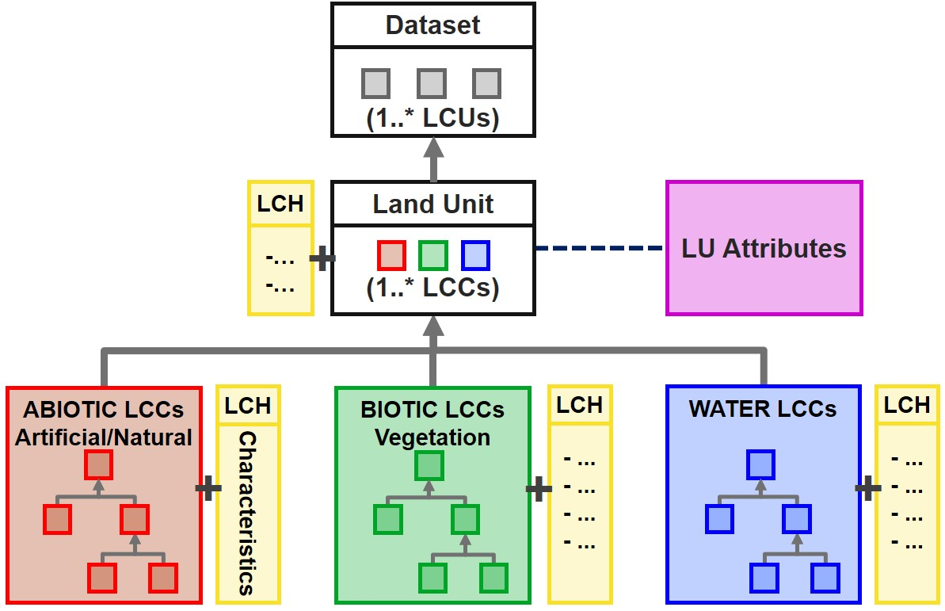
Figure 8 Simplified structure of the EAGLE UML data model, with a Land Unit as a geometric instance of a Dataset, being composed of Land Cover Components, enriched by Land Use Attributes, and further described by Land Characteristics.

Link to latest version

Use Cases of EAGLE Concept

The EAGLE concept has been published in several versions, and several use cases have evolved around the domain of land monitoring, both on national and European levels. In many countries, the EAGLE concept has contributed to the development of mapping approaches, which draw their conceptual design from the EAGLE model.
Besides already existing use cases, of which a few are mentioned here below, the community is invited to make use of the EAGLE concept according to their own purposes and user needs.

CORINE Land Cover second generation (CLC+)
Currently, the most prominent implementation use case on a pan-European level is the development of the second generation of CORINE Land Cover (referred to as CLC+) system. The CLC+ CORE platform functions as the thematic “engine” of the CLC+ product suite. The EAGLE Data Model, respectively its ontology, functions as the central semantic dictionary and translates all ingested input data into the CLC+ CORE system in a harmonized and machine-readable manner.
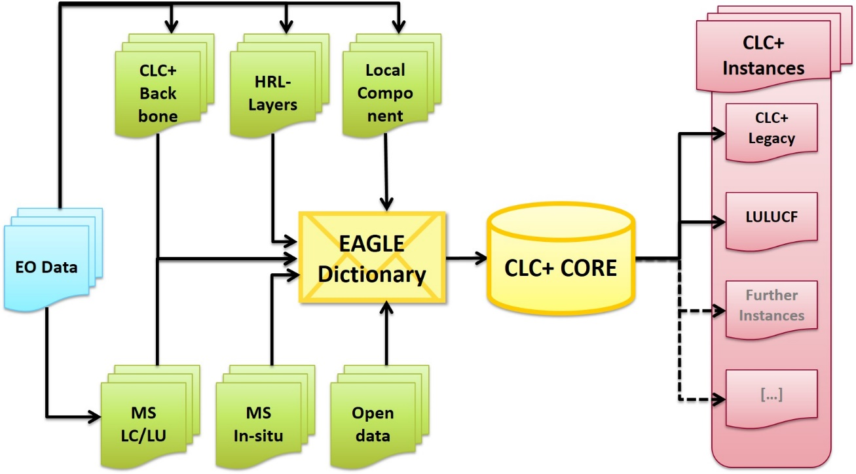
Figure 9 Data flow schema towards and from the CLC+ CORE data integration and extraction platform (DIEP)

Context
In 2018 the EEA and European Commission DG Internal Market, Industry, Entrepreneurship and SMEs (DG GROW) determined to develop a conceptual strategy and design associated with the technical specifications for a new series of products within the CLMS portfolio, which should meet the current and future requirements for European LU/LC monitoring and reporting obligations.

Conceptual Background
Unlike the traditional CLC approach to update a single vector map every 6 years, CLC+ second generation is a system that contains both a geospatial land cover information component., CLC+ Backbone (BB), and a database/web application component for handling thematic data from existing initiatives e.g. CLMS products, Member States data, CLC+ Core. In this sense the CLC+ system aims to be a generic multipurpose successor of traditional CLC providing options to derive tailor-made products (CLC+ Instances), to foster the bottom-up approach from Member State´s side and to be more agile and flexible in supporting several EU land monitoring policies, e.g., LULUCF.
The CLC+ Core database is based on the EAGLE concept which embodies the paradigm shift from predetermined classification to feature-oriented characterisation and description of landscape, allowing the harmonization of LC / LU information from different sources. It has been realized by EEA in cooperation and consultation with the EAGLE group.

Implementation steps
The CLC+ development process is subdivided into several stages, where each step is connected to the design and production of land monitoring products and tools. In this process, besides the conceptual outlines delivered by EAGLE, the work of technical implementation is executed by service providers, who have formed a commercial consortium.
The first technical implementation step was the production of the pan-European Land Cover product CLC+ Backbone, which was followed by the CLC+ Core implementation.
Further details about the implementation process of CLC+ product suite can be found in the CLC+ dedicate page under the Pan-European products section of EEA´s land monitoring service.

Enhancement of CORINE Land Cover nomenclature guidelines
A systematic analysis of the Corine Land Cover (CLC) Nomenclature Guidelines has been performed through semantic decomposition of the existing CLC class definitions regarding their information content about LC, LU and further land characteristics / parameters / thresholds. Based on this, the textual document has been restructured with subchapters, where:
- a class is applicable for / not applicable for certain landscape situations and examples,
- a class includes / excludes certain LCCs or LUAs
The result can be found in the Technical Library of this CLMS, or to Nomenclature Guidelines document directly.

INSPIRE data specifications
During the implementation process of the European INSPIRE directive, some EAGLE Group members were involved in the elaboration of the data specifications for the INSPIRE themes Land Cover and Land Use. Related to this work, a modelling link connection was created between the INSPIRE data specification on land cover and the EAGLE UML model. More details about the technical connection between the INSPIRE LC data specifications and the EAGLE model are addressed in the paragraph about the EAGLE UML model, respectively in the downloadable EAGLE UML model chart.

Consistency analysis of Copernicus Riparian Zones nomenclature
The new nomenclature for the Copernicus Riparian Zones product has been checked for its consistency regarding the structure and hierarchy as well as the class definitions themselves.

LULUCF
The EAGLE group supports the EEA in their greenhouse gas (GHG) reporting related activities, in particular around reporting for the Land Use, Land Use Change and Forestry (LULUCF) sector. In this context, the EAGLE Group is involved in supporting the development of CLC+ Core based CLC+ LULUCF Instance. This work focusses on the use of the EAGLE concept to semantically decompose the definitions of the 6 major LULUCF categories by applying the taxonomy of the EAGLE model vocabulary.

Revision of Feature type catalogue of national mapping agency (Germany)
A semantic analysis with the EAGLE matrix was applied to the feature type catalogue (GeoInfoDok ATKIS/ALKIS) of the German land surveying authorities (AdV). Using the EAGLE bar-coding method, the definitions of all feature types and attributes were semantically described with respect to their thematic content.
Based on the results, two new separate nomenclatures on LC and LU were designed to disentangle the mixing of those to themes within the current ATKIS/ALKIS nomenclature.

EAGLE Matrix Bar Coding exercises on national levels
In selected countries, where national data is operationally used / can be potentially used to derive European CLC like products, the definitions of some national nomenclatures have been decomposed by bar-coding with the EAGLE matrix.

Relation with ISO standards series 19144
The EAGLE concept is not a formal standard; however, it can take over a standardising role when describing landscape, especially in the European geographic context. In the international context, a standard for a Land Cover Meta Language (ISO 19144-2 LCML) has been established, basically driven by FAO. This standard is currently under revision, partly because it still contains some land use terms, that are about to be removed for consistency reasons. Further, a new ISO standard 19144-3 for land use is in the making. The EAGLE concept is represented by EAGLE group members who are helping to optimise the content of the ISO standard 19144 components.
The FAO LCCS (Land Cover Classification System, developed by FAO) is a hierarchical and dichotomous classification approach. It works by going down a decision tree of its predefined classes and subclasses. Once a certain information is not given along that path, the user is “stuck” in the hierarchical approach, not being able to continue with the classification downwards within the hierarchy. Also, LCCS mixes LC with LU aspects within its nomenclature. LCCS takes a certain perspective of FAO´s application needs and is therefore tailored to a particular purpose.
The EAGLE concept follows a more flexible and application-neutral approach. It clearly separates LC from LU aspects, and it solves the dilemma of predefined dichotomy while it works with parallel and independent descriptions of LCC, LUA and LCH, which can be brought into relation to each other (mandatory or optional combinations of those elements).
The main difference between LCCS and EAGLE concept is of structural nature, meaning that LCCS is a classification system with predefined classes and modules, while the EAGLE concept is an object-oriented characterisation approach with more descriptive flexibility.
The FAO´s LCCS was used as the basis for the original ISO standard 19144-2 Land Cover Meta Language, that is why it is also mentioned here.

Archive / Download page
[notes: The new CLMS portal will have a download/archive page offering the possibility to download the latest version of the reference EAGLE material tools and documents e.g., matrix, UML and previous versions.
Content to be organized in the archive:
- Previous version of main documents, matrix, uml, … [CLMS EAGLE downloads]
- Old documents: Grid approach, CIGAR, …; [eionet page]
- meeting references. [eionet page]
- tools: EMPACT, EAGLE GIS database? [eionet page]
While the rest of documentation is not foreseen in Copernicus, could be a cloud space located in EIONET FORUM, to be agreed.]

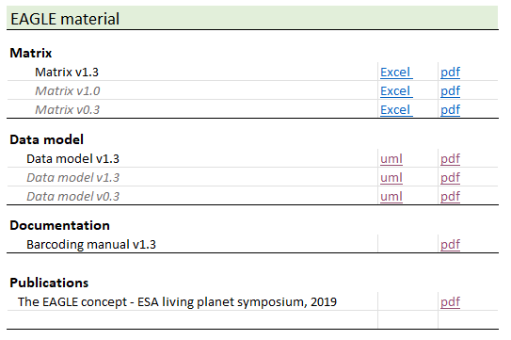
Figure 10 Example of download archive section, including publication item.

Publications
[Notes: Due to the limited numerous of items, is suggested to include a section “publication” in the download page see previous chapter.]
The EAGLE concept - A vision of a future European Land Monitoring Framework
Arnold, S., Kosztra, B., Banko, G., Smith, G., Hazeu, G., Bock, M., Valcarcel-Sanz, N. (2013): The EAGLE concept - A vision of a future European Land Monitoring Framework.
In: Lasaponara R., Masini N., Biscione M. (Editors): EARSeL Symposium proceedings 2013, "Towards Horizon 2020". The original publication can be found in the EARSeL symposium´s proceedings of 2013 under this link.
The EAGLE Concept [@ Living Planet Symposium 2019]
Arnold, S., Smith, G., Bock, M. (2019): The EAGLE Concept – Applications of an object-oriented data modelling approach for land cover and land use.
Abstract for ESA Living Planet Symposium (LPS) 2019, 13. - 17. May 2019, Milano, Italy.

The EAGLE Group was created within what was the Eionet National Reference Centre on Land Cover which has now been replaced by the Eionet Group Land Systems (Thematic Group support to Copernicus Land)

