EEA/DIS/R0/22/007

Task 2: Support to the maintenance of the EAGLE website

Identification of most relevant EAGLE material

Final draft
version | Date | status | notes
1 | 30/11/2022 | First draft | Internal
2 | 10/01/2023 | Second draft | EEA comments
3 | 02/03/2023 | Third draft | Internal EAGLE
4 | 15/03/ | Final draft
5 | 25/4 | Revised version | Ana Sousa, Tobias Langanke
6 | 09/08/2023 | Corrected version | EAGLE
7 | 06/10/2023 | Final draft v2 | EAGLE

HOME - intro
EAGLE – Eionet Action Group on Land monitoring in Europe
Since 2008, the EAGLE Group has been developing a solution and proof of concept to support the semantic and technical framework of a European harmonised information management capacity for land monitoring.
The EAGLE Group is a self-initiated and open group of land monitoring experts from different European Environment Agency (EEA) member countries , mostly – but not only – in their roles as Eionet members. Thus, the EAGLE Group brings together knowledge and experiences from existing land cover (LC) and land use (LU) classification approaches and initiatives in a bottom-up approach.
Likewise, EAGLE is acknowledged by the Copernicus Land Monitoring Service (CLMS) as an instrumental and crucial component to support a general shift of focus from classification to characterisation, and so compliance with EAGLE is enforced in new CLMS products.
The EAGLE concept is explicitly mentioned in the Copernicus Work Programmes as an essential pillar to support the challenging new use cases of the 2nd generation of CORINE Land Cover (CLC), also known as CLC+. The EAGLE concept is now operationally implemented as a central component of the CLC+ implementation, to guarantee a standardized integration approach of different LC/LU products.

The CONCEPT

Introduction and context
All land monitoring nomenclatures are tailored to a particular purpose or scope, even if they are intended to address a general user community. Each nomenclature has therefore a different thematic focus and is influenced by certain factors such as minimum mapping unit, number of classes, number of hierarchical levels. These factors result in differing depth and thematic differentiation among existing nomenclatures.
The work of the EAGLE Group does not aim at creating yet another new nomenclature or classification system, but to provide a tool to address the ambiguity within nomenclatures or the comparability between them, regarding the terms and definitions they apply. The fundamental idea is to have such a tool as a semantic centrepiece and vehicle to allow comparisons and translations between different nomenclatures (see Figure 1).
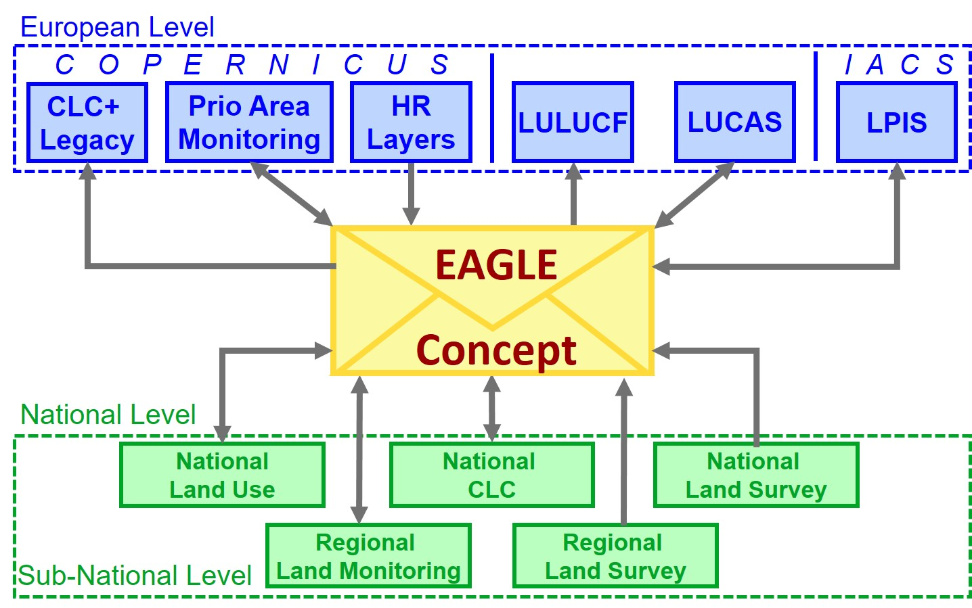
Figure 1 EAGLE concept as a semantic centrepiece and vehicle to allow comparisons and translations between different nomenclatures.

Classification systems use in their definitions either similar terms (e.g., “forest”) which have different meanings (e.g., tree covered area / area under forestry use or not), or differing terms (e.g., “urban fabric” / “built-up area”) that may or may not stand for the same thing (e.g., all settlement areas / only sealed areas). In addition, many nomenclatures contain a mix of land cover and land use terms (even within a class). As a result, such nomenclatures struggle to describe the entirety of the Earth’s surface without ambiguity or vague class assignments which can lead to misunderstandings in information content, both on the data producer side as well as on data users.
Similarly, assigning one single class label can lead to the loss of information regarding the heterogeneity or individuality of classified land units. In such cases, using a single class label to assign land units to a specific class (e.g., energy production), can result in neglecting additional observations (e.g., grassland vegetation, or extensive grazing) about that same land unit. In cases where a nomenclature foresees only one class label to be assigned, it creates a trade-off dilemma between choosing one type of information (e.g., LU) and losing the other (e.g., LC) and vice versa.
The challenge is particularly obvious for more complex landscape situations where multiple phenomena exist. Depending on the purpose of a nomenclature, certain landscape aspects are highlighted by some classification systems, while they can be considered as not relevant by others.
The solution for such dilemma is the paradigm shift from classification to characterization, as briefly illustrated in Figure 2.
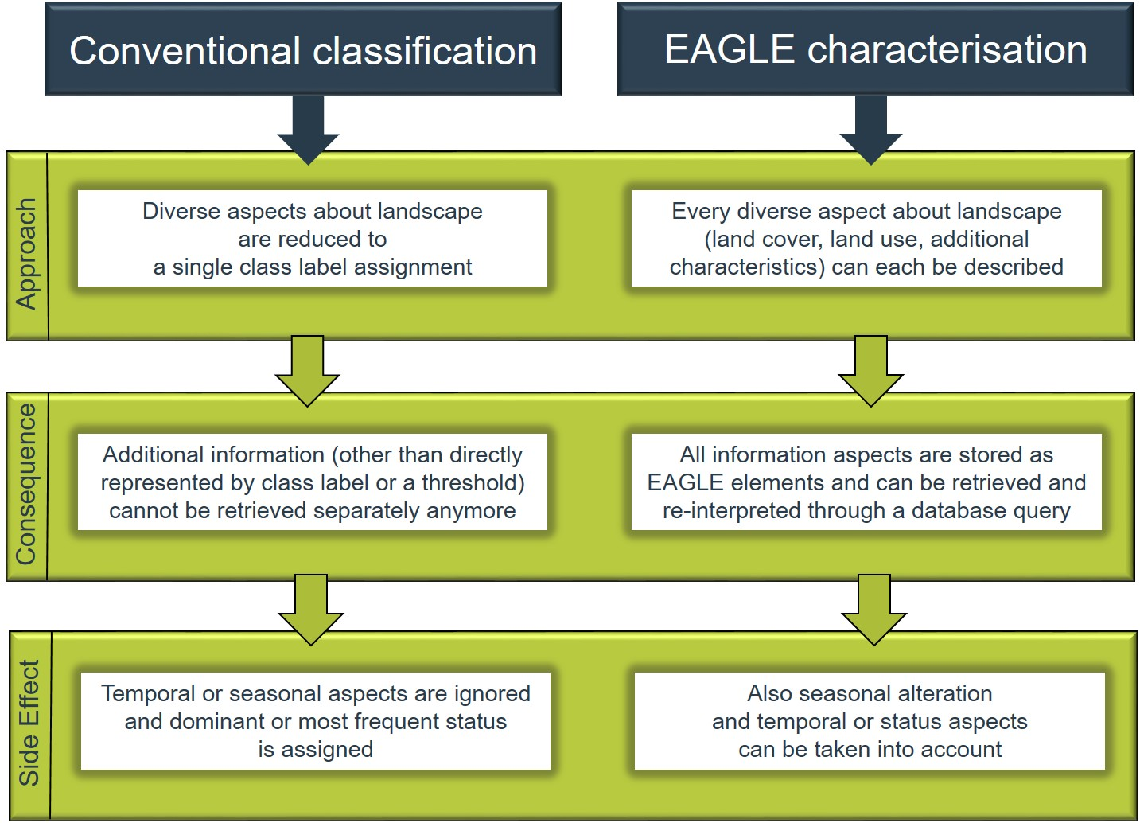
Figure 2: Different approaches of conventional classification (left) and object-oriented characterization (right) of landscapes and their consequences regarding information capture and storage.

Vision: Paradigm shift from classification to characterization
For the vision of a harmonized European framework for land monitoring, the following key points are being implemented
- A single data model for the integration of land information from various sources acting as a centrepiece of integration applicable at EU, national and subnational levels,
- A descriptive vehicle for semantic translation / equivalence and comparison between different nomenclatures and class definitions to facilitate information exchange among them;
- A common basis for data collection and design of harmonized mapping guidelines for land monitoring initiatives.
The implementation of the EAGLE concept constitutes a paradigm shift in providing information for land monitoring methods, moving away from classification to an object-oriented descriptive characterisation of landscapes that allows the storage of multiple information instead of single class labels only.
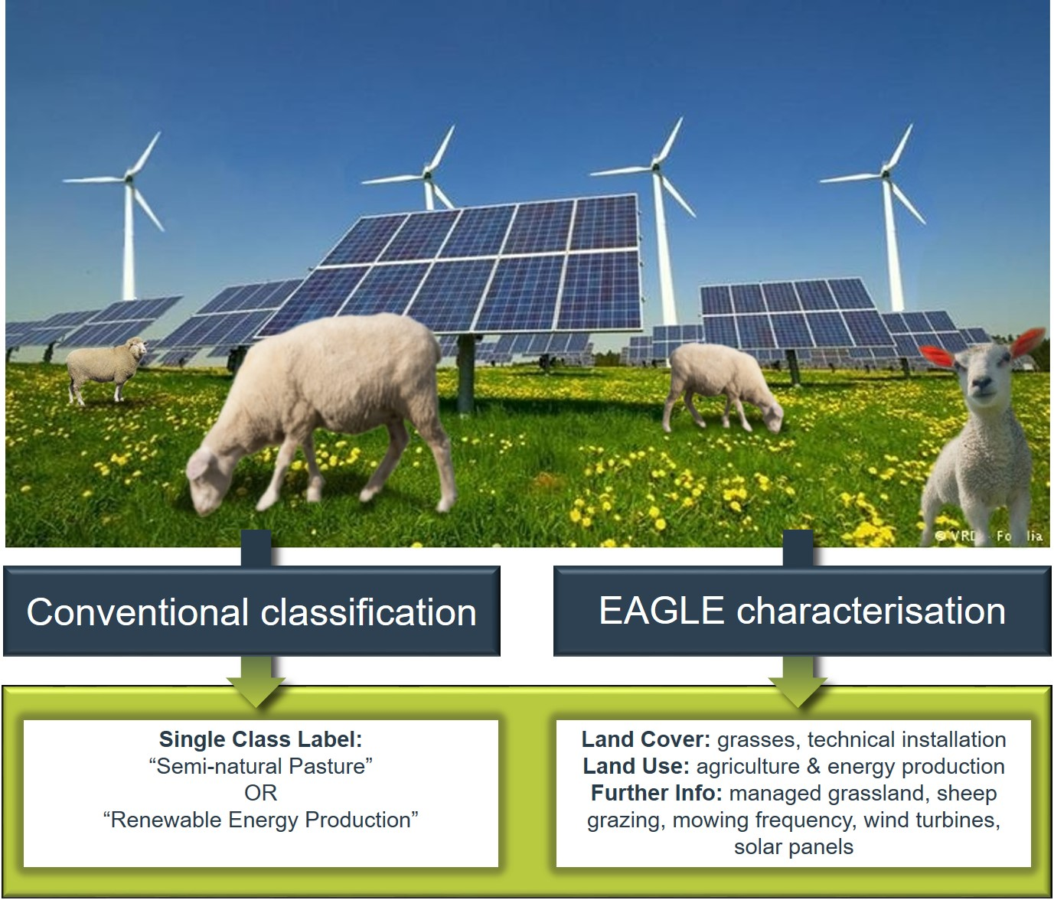
Figure 3: Example 1 for different information content between conventional classification approach versus object-oriented EAGLE characterisation.
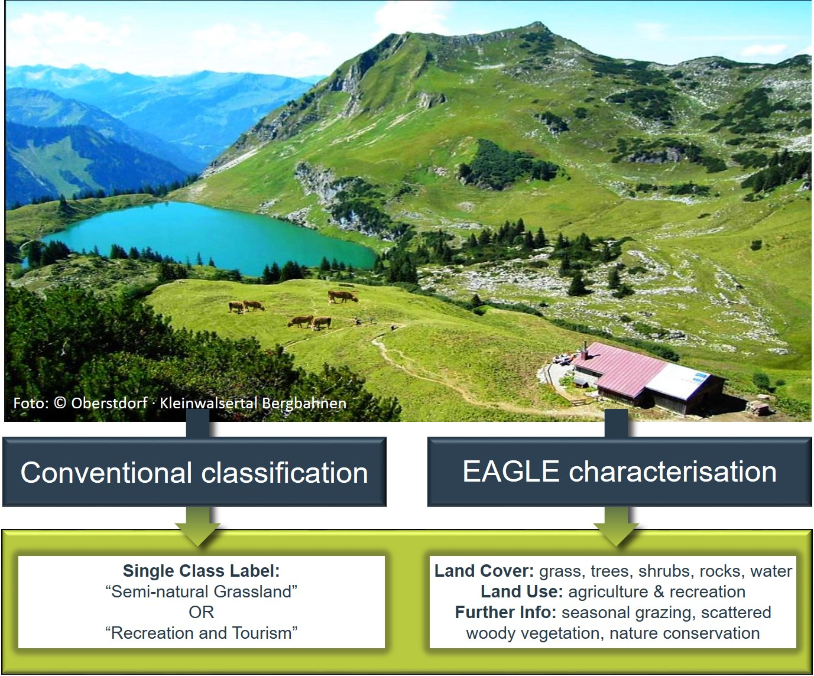
Figure 4: Example 2 for different information content between conventional classification approach versus object-oriented EAGLE characterisation.

Deploying the concept
The deployment of the EAGLE concept allows various approaches, and it is continuously improved. Here below the four main scenarios for deployment are described:

- A primary application involves the semantic analysis of classes, to grasp the importance / nature of each element and the role in the broader LC / LU classification system they constitute (Figure 5).

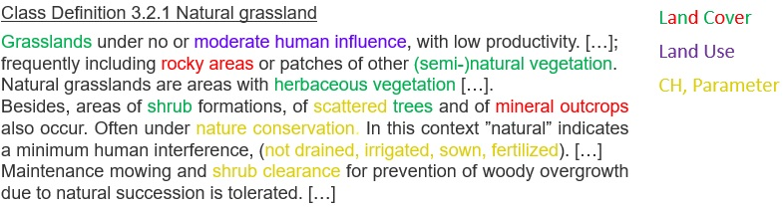
Figure 5 Example of semantic analysis of class definition through decomposition, highlighting landscape elements by their componential type: Land Cover (LC), Land Use (LU), Characteristics and Parameters (CH).

- The semantic analysis facilitates comparison and translation / equivalence among different classification systems. When two or more given class definitions are decomposed with the EAGLE concept as the same semantic “cookbook” ontology, similarities and differences in the landscape “ingredients” can be better identified, and easily visualized or used for further machine-aided processes.

- Another application is the utilization of the EAGLE concept as a mapping tool (for the description and characterization of specific land units, incorporating real world features as they appear in the landscape (Figure 6).

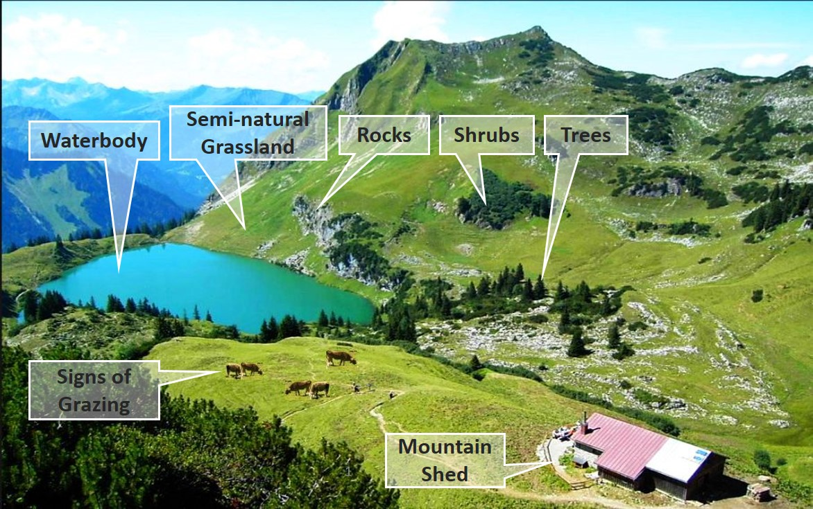
Figure 6 Decomposition of complex real world landscape situation which can be captured with EAGLE concept as a mapping tool (adapted from © Oberstdorf – Kleinwalsertal Bergbahnen).
- Further, when new classification schemes are about to be devised, the EAGLE concept can be used for the design of new class definitions and nomenclatures. Here, the developers can choose within the contents of the EAGLE concept as a “reference” inventory and select the needed elements for the semantic design of classes.

Technical implementation / manifestation of the EAGLE concept
The design of the EAGLE concept was based on a set of criteria developed during a number of research projects and user engagements involving:

- Clear separation between the themes LC and LU, plus further land characteristics
- Comprehensive coverage of the LC and LU themes
- Object-oriented description and characterisation of land units instead of classification
- Inclusion of seasonal phenomena
- Scale independency
- Support for backwards compatibility of timelines in land monitoring

The technical manifestation of the EAGLE concept has two forms, the EAGLE matrix, and the Unified Modelling Language - UML model.

A more complete explanation of the EAGLE model elements with their definitions is provided in the form of explanatory documentation including details about the thematic meaning and hierarchical order of the elements. It can be downloaded from the Document Archive page.

EAGLE matrix
The EAGLE matrix provides an inventory / catalogue of all elements that represent real world objects and observable phenomena. It is structured in three main blocks:

- LAND COVER Components – LCC, subdivided into 3 parts, Abiotic, Biotic and Water (e.g., woody vegetation, rock material and water, respectively)
- LAND USE Attributes– LUA (e.g., forestry, residential use, industrial sites, etc.)
- LAND CHARACTERISTICS - LCH (e.g., land management type, spatial pattern, (bio)-physical characteristics, parameters, ecosystem types, status, etc.).

The matrix is structured in a hierarchical manner from top to bottom, starting with coarse and more general aspects (“parent” elements), which subdivided into subtypes (“child” elements) down to 6 hierarchical levels.

In the LCC and LUA blocks, every entry is an information-carrier - like a large code list - and can be worked with, regardless of its hierarchical level.

The LCH block is more diverse in information content and has many more headings and sub-headings, which are not information-carriers directly. Here, the hierarchy is installed to basically bring a meaningful order to the number of content-carrying LCH elements - like chapters and subchapters in a book.

Figure 7 shows a reduced and simplified illustration of the EAGLE matrix, with all elements arranged in a horizontal form and hierarchically structured from top to bottom. For better readability of this illustration, this figure only shows a selection of segments and levels of the matrix, lower levels and other details have been blurred out. The entire matrix is larger in its full extent, both in vertical and horizontal direction.

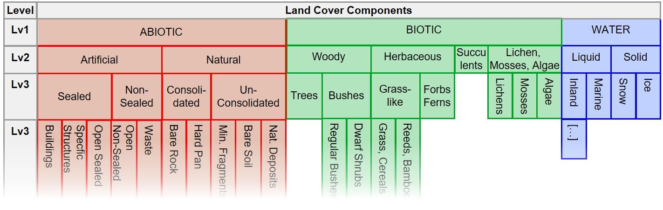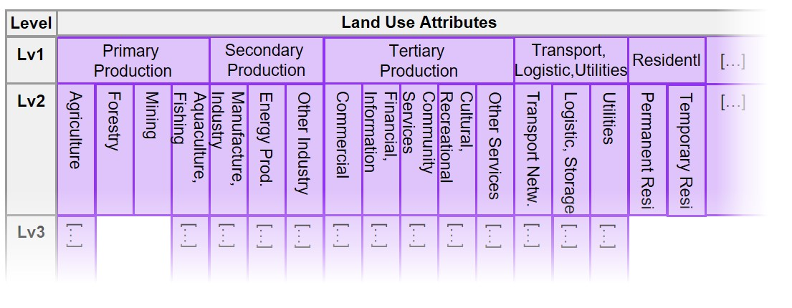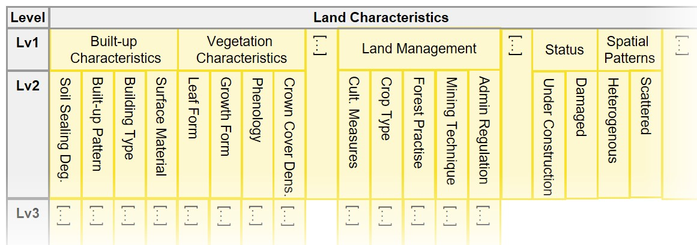
Figure 7 The EAGLE Matrix in horizontal form with the three blocks LCC, LUA, LCH. All three blocks are shown here for illustration reasons below each other, but normally are arranged sideways next to each other.
The EAGLE matrix itself is presented in an Excel cross table and is available from the Download archive page.

EAGLE data model
The EAGLE data model is written in UML (Unified Modelling Language). The central object of the EAGLE data model is the Land Unit (or multiple units). The Land Unit is the mapped object, which carries the geometry of the Land Unit and represents a homogeneous piece of land that is delineated and distinguished from its geographic neighbours. The Land Unit is then populated with content by a composition of one or several Land Cover Components (LCC) to describe the land cover within the geometry of the Land Unit. In addition to the LCCs, the Land Unit can be enriched by Land Use Attributes (LUA). Each selected LCC, as well as the entire Land Unit, can be further described with Land Characteristics (LCH) ( Figure 8).

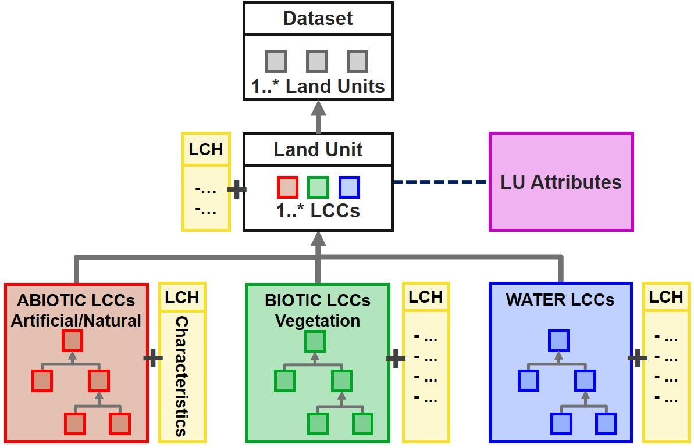
Figure 8 Simplified structure of the EAGLE UML data model, with a Land Unit as a geometric instance of a “Dataset”, being composed of “Land Cover Components”, enriched by “Land Use Attributes”, and further described by “Land Characteristics”.

The EAGLE UML model is available from the Download archive page.

Bar-Coding
The ‘bar-coding’ method is referring to the process of selecting and assigning a value to relevant LCC, LUA and LCH elements from the matrix to describe a class. The aim of bar-coding is to create a standardized and concise representation of the class using a sequence of numerical codes.

During the bar-coding exercise for a targeted class or landscape situation, these elements get assigned a certain bar code value (BCV) according to their importance and logic relationship within a given class definition. The resulting sequence of numerical codes assigned to the matrix elements serves as a descriptive summary of the class.
This bar-coding approach streamlines the process of representing complex information about different LC/LU classes, making it easier to handle and to compare among them and with other classification systems. When working with the bar-coding exercise, different classes require the EAGLE elements to take different roles, according to the targeted definitions. Similar class definitions should reflect in also similar bar-coding results.
Below are two examples on the bar-coding decomposition, showing only the EAGLE elements from the matrix which have been assigned to each targeted situation, one from an existing landscape type (Figure 9) and another from a given textual class definition (Figure 10).

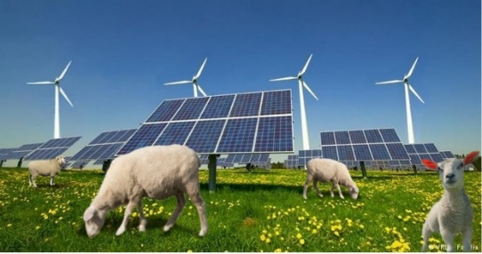 | 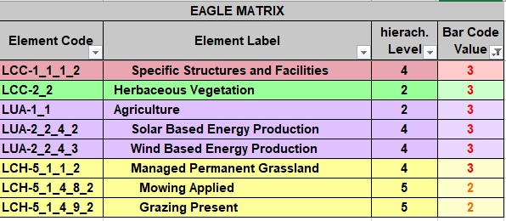
Figure 9 Example how to decompose and bar-code a complex landscape situation: Pasture grassland combined with Renewable Energy Production. All elements assigned code “3”, are both present and mandatory, and elements coded with " 2" are optional but must have at least one present.

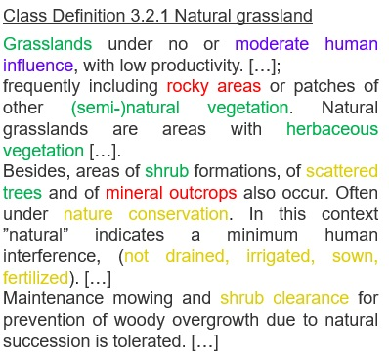 | 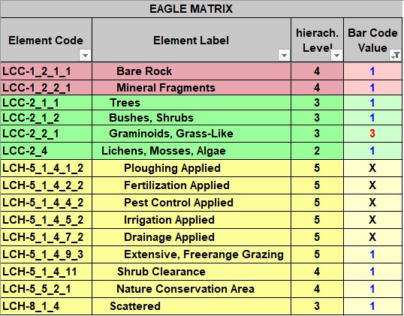

Figure 10 Example of bar-coding decomposition of the textual CLC class definition “Natural Grassland”. Mandatory elements are coded with “3”, typical but optional elements are coded with “1”, and elements excluded by definition are coded “X”.
The Table 1 below illustrates all the BCV options, and the correspondence between the code assigned to an EAGLE matrix element and its presence in the semantic or in the landscape reality. For instance, based on a certain LU/LC class definition, when three elements are coded in the matrix with the value “2”, it signifies that at least one of them must be present in the semantic or the landscape reality.
Table 1 List of Bar-code value description. The BCVs define the role of EAGLE matrix elements to fulfil a given mapping criteria, class definition or landscape situation.

Bar-code Value (BCV) table
Value | Description
X | Element is excluded by definition
1 | Optional element, it can occur as typical, but it is not mandatory
2 | selective mandatory element, EITHER/OR logic, at least one or more of the elements with assigned BCV 2 must be present
3 | cumulative mandatory element, AND-logic, all the elements with assigned BCV 3 must be present
4 | Paired mandatory element, at least two of the elements with assigned BCV 4 must be present
5 | Exclusive mandatory element, NOTHING-BUT-logic, practically allows only the one element with assigned BCV 5 and excludes any other element from its parent matrix block
.
The Bar-Code manual is available from the Download archive page.

Use Cases of EAGLE Concept
Several use cases of the EAGLE concept have evolved around the domain of land monitoring, both at national and European levels. In many countries, the EAGLE concept has contributed to the development of mapping approaches, which draw their conceptual design from the EAGLE model.
Besides already existing use cases, of which a few are mentioned here below, the land monitoring community is invited to make use of the EAGLE concept according to their own purposes and user needs.

Prime use case: CORINE Land Cover second generation (CLC+)
Currently, the most prominent implementation use case at a pan-European level is the development of the second generation of CORINE Land Cover (referred to as CLC+). The EAGLE Data Model with its ontology, functions as the central semantic dictionary and translates all ingested input data into the CLC+ core database in a harmonized and machine-readable manner (Figure 11).
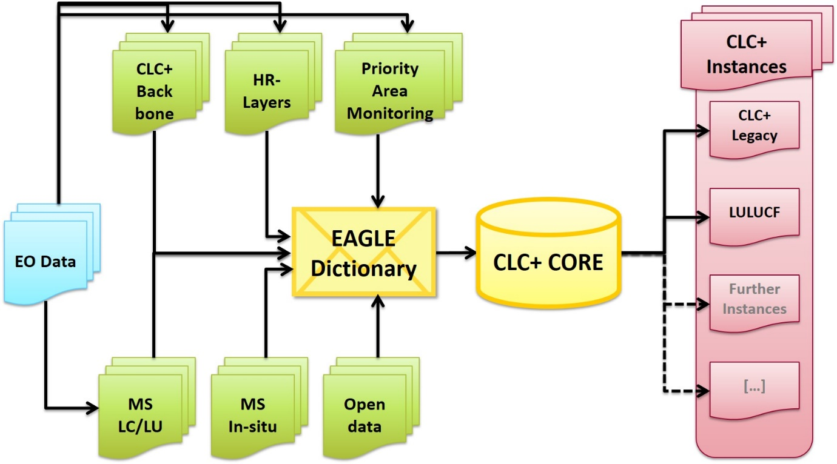
Figure 11 Data flow schema towards and from the CLC+ Core

Context
In 2018 the European Environment Agency (EEA) and the European Commission DG Internal Market, Industry, Entrepreneurship and SMEs (DG GROW) determined to develop a conceptual strategy and design associated with the technical specifications for a new series of products within the CLMS portfolio, which should meet the current and future requirements for European LU/LC monitoring and reporting obligations.
Conceptual Background
Unlike the traditional CLC approach to update a single vector map every 6 years, CLC+ second generation is a system that contains two main components, the CLC+ Backbone (a geospatial land cover information component), and the CLC+ Core, which is a database/web application component for handling thematic data from existing initiatives e.g., CLMS products, Member States data. In this sense the CLC+ system aims to be a versatile successor of the traditional CLC providing options for expert users to create, via the CLC+ Core, their own grid-data based products (CLC+ Instances), offering greater agility and flexibility in supporting various EU land monitoring policies, such as LULUCF.
The foundation of the CLC+ Core database lies in the EAGLE concept, where classification is transformed into landscape characterization. This transformation facilitates the harmonization of LC/LU information and allows the extraction of the CLC+ instance based on diverse ingested inputs. The EEA and the EAGLE group are collaborating in developing the CLC+ Core system.

Implementation steps
The CLC+ development process is subdivided into several stages, where each step is connected to the design and production of land monitoring products and tools. In this process, besides the conceptual outlines delivered by EAGLE, the work of technical implementation is executed by service providers.
The first technical implementation step was the production of the pan-European Land Cover product CLC+ Backbone, which was followed by the CLC+ Core implementation.

Further details about the implementation process of CLC+ product suite can be found in the CLC+ dedicated page under the Pan-European products section of EEA´s land monitoring service.

Further use cases of EAGLE concept

Enhancement of CORINE Land Cover nomenclature guidelines
A systematic analysis of the Corine Land Cover (CLC) Nomenclature Guidelines has been performed through semantic decomposition of the existing CLC class definitions regarding their information content about LC, LU and further land characteristics / parameters / thresholds. Based on this, the textual document has been restructured with subchapters, where:
- a class is applicable for / not applicable for certain landscape situations and examples,
- a class includes / excludes certain LCCs or LUAs
The result can be found in the Nomenclature Guidelines.

INSPIRE data specifications
During the implementation process of the European INSPIRE directive, some EAGLE members were involved as national experts in the elaboration of the data specifications for the INSPIRE themes Land Cover and Land Use. Through exchange between the two thematic working groups, EAGLE members took care of a clean separation and unravelling between the themes LC and LU.

On one side, the EAGLE UML data model carries an anchor to the UML model from the data specifications on the INSPIRE theme Land Cover. Both UML models are connected on the level of the LandCoverUnit/LandUnit. The code list of “Pure Land Cover Components” (INSPIRE PLCC) from these data specifications fall back to and can be mapped with the EAGLE Land Cover Components (LCC).

On the other side, the Land Use Attributes (LUA) from the EAGLE concept relate to the "Hierarchical INSPIRE Land Use Classification System” (HILUCS) from the data specifications of the INSPIRE theme Land Use (Figure 12).

These connections between the two UML models make the EAGLE model INSPIRE-compliant.
Still, both models (INSPIRE and EAGLE) function also as stand-alone models, independently from each other. While the INSPIRE directive handles the themes LC and LU separately from each other, in the EAGLE model content-wise both themes are separated but can be combined with each other to describe nomenclature classes or individual land units.

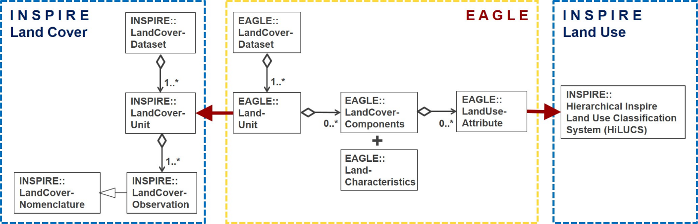
Figure 12: Connections between EAGLE UML data model and INSPIRE data specifications for Land Cover (left side) and Land Use (right side) which make the EAGLE model INSPIRE-compliant.

Consistency analysis of CLMS Riparian Zones nomenclature
The nomenclature of the Riparian Zones product has been checked for its consistency regarding the structure and hierarchy as well as the class definitions themselves. The result was a refined nomenclature.

LULUCF
The EAGLE group indirectly supports the EEA in their greenhouse gas (GHG) reporting related activities, specifically around reporting for the Land Use, Land Use Change and Forestry (LULUCF) sector. In this context, the EAGLE Group is involved in supporting the development of the CLC+ Core based CLC+ LULUCF Instance. This work focusses on the use of the EAGLE concept to semantically decompose the definitions of the 6 major LULUCF categories by applying the taxonomy of the EAGLE model vocabulary.

Review of Feature type catalogue of national mapping agency (Germany)
A semantic analysis with the EAGLE matrix was applied to the feature type catalogue (GeoInfoDok ATKIS/ALKIS) of the German land surveying authorities (AdV). Using the EAGLE bar-coding method, the definitions of all feature types and attributes were semantically described with respect to their thematic content.
Based on the results, two new separate nomenclatures on LC and LU were designed to disentangle the mixing of those to themes within the current ATKIS/ALKIS nomenclature.

EAGLE Matrix Bar Coding exercises on national levels
In selected countries the definitions of national nomenclatures have been decomposed by bar-coding method with an older version (2015) of the EAGLE matrix: Hungary, Netherlands, Spain, Germany, Austria, Bulgaria/Romania cross-border region, Switzerland, United Kingdom. In some of these cases, the national data is already operationally used to derive national CLC data, as in Spain and Germany among others.

Relation with ISO standards series 19144 and FAO`s LCCS
The EAGLE concept is not a formal standard; however, it can take over a standardising role when describing landscape, especially in the European context. In the international context, a standard for a Land Cover Meta Language (ISO 19144-2 LCML) has been established, basically driven by FAO. This standard is currently under revision, partly because it still contains some land use terms, that are about to be removed for consistency reasons. Further, a new ISO standard 19144-3 for land use is in the making. As a future ISO project idea, a standard 19144-4 for “Registration and Implementation Aspects” is envisaged, however not much has been concretized yet. To support the ISO standard series of 19144, some EAGLE group members in their role as associated thematic experts are involved to optimise the content of the ISO standard 19144 components.
The FAO´s LCCS (Land Cover Classification System) was used as a conceptual input and predecessor for the ISO standard 19144-2 LCML (Land Cover Meta Language), which is why it is also mentioned here.
The FAO LCCS is a hierarchical and dichotomous classification approach. It works by going down on a decision tree of its predefined classes and subclasses. Once a certain information is not given along that path, the user is “stuck” in the hierarchical approach, not being able to continue with the classification downwards within the hierarchy. Also, LCCS mixes LC with LU aspects within its nomenclature. LCCS takes a certain perspective of FAO´s application needs and is therefore tailored to a particular purpose.
The EAGLE concept follows a more flexible and application-neutral approach. It clearly separates LC from LU aspects, and it solves the dilemma of predefined dichotomy while it works with parallel and independent descriptions of LCC, LUA and LCH, which can be brought into relation to each other (mandatory or optional combinations of those elements).
The main difference between LCCS and EAGLE concept is of structural nature, meaning that LCCS is a classification system with predefined classes and modules, while the EAGLE concept is an object-oriented characterisation approach with more descriptive flexibility.

Archive / Download page
[notes: The new CLMS portal will have a download/archive page offering the possibility to download the latest version of the reference EAGLE material tools and documents e.g., matrix, UML and previous versions.
Content to be organized in the archive:
- Previous version of main documents, matrix, uml, … [CLMS EAGLE downloads]
- Old documents: Grid approach, CIGAR, …; [eionet page]
- meeting references. [eionet page]
- tools: EMPACT, EAGLE GIS database? [eionet page]
While the rest of documentation is not foreseen in Copernicus, could be a cloud space located in EIONET FORUM, to be agreed.]

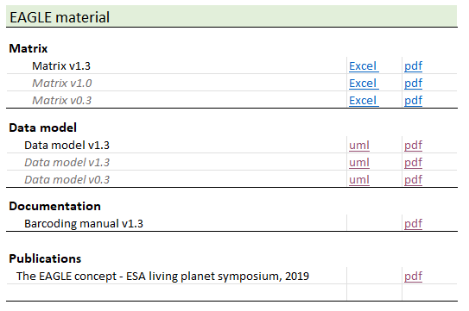
Figure 13 Example of download archive section, including publication item.

Publications
[Notes: Due to the limited number of items, is suggested to include a section “Publication” in the download page see previous chapter.]
The EAGLE concept - A vision of a future European Land Monitoring Framework
Arnold, S., Kosztra, B., Banko, G., Smith, G., Hazeu, G., Bock, M., Valcarcel-Sanz, N. (2013): The EAGLE concept - A vision of a future European Land Monitoring Framework.
In: Lasaponara R., Masini N., Biscione M. (Editors): EARSeL Symposium proceedings 2013, "Towards Horizon 2020". The original publication can be found in the EARSeL symposium´s proceedings of 2013 under this link.
The EAGLE Concept [@ Living Planet Symposium 2019]
Arnold, S., Smith, G., Bock, M. (2019): The EAGLE Concept – Applications of an object-oriented data modelling approach for land cover and land use.
Abstract for ESA Living Planet Symposium (LPS) 2019, 13. - 17. May 2019, Milano, Italy.

The EAGLE Group was created within what was the Eionet National Reference Centre on Land Cover now replaced by the Eionet Group Land Systems (Thematic Group support to Copernicus Land)

