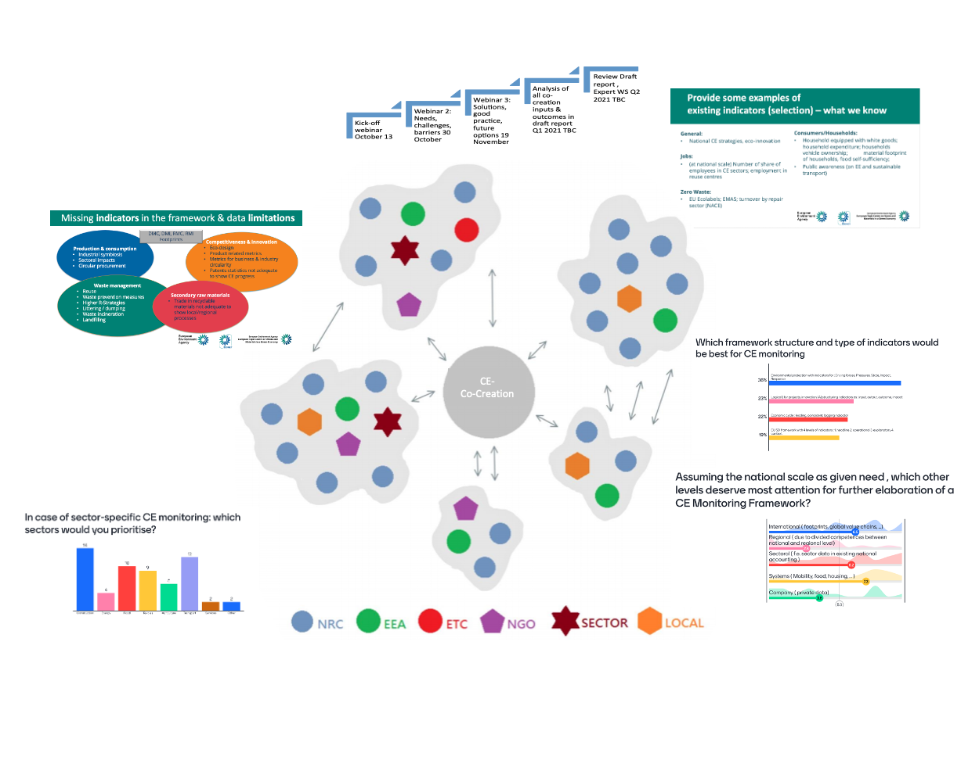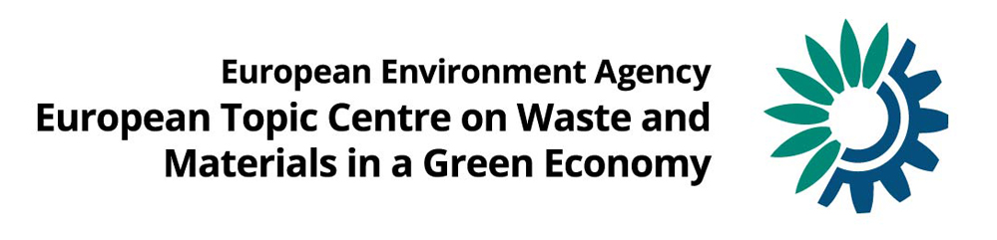

Co-creation process on circular economy monitoring:

*Overview of interactive activities and outcomes*

*Reflections on the links to the Bellagio Principles*

*June 2021*

Authors:

Theo Geerken (VITO); Bettina-Bahn Walkowiak (WI); Dirk Nelen (VITO)

ETC/WMGE consortium partners: Flemish Institute for Technological Research (VITO), CENIA, Collaborating Centre on Sustainable Consumption and Production (CSCP), Research Institute on Sustainable Economic Growth of National Research Council (IRCrES), The Public Waste Agency of Flanders (OVAM), Sustainability, Environmental Economics and Dynamic Studies (SEEDS), VTT Technical Research Centre of Finland, Banson Editorial and Communications (BEC), The Wuppertal Institute for Climate, Environment, Energy (WI), Slovak Environment Agency (SEA)

Cover photo © iSTOCK (1059713466)

**Legal notice**

The contents of this publication do not necessarily reflect the official opinions of the European Commission or other institutions of the European Union. Neither the European Environment Agency, the European Topic Centre on Waste and Materials in a Green Economy nor any person or company acting on behalf of the Agency or the Topic Centre is responsible for the use that may be made of the information contained in this report.

**Copyright notice**

© European Topic Centre Waste and Materials in a Green Economy (2019)

Reproduction is authorized provided the source is acknowledged.

More information on the European Union is available on the Internet (http://europa.eu).

European Topic Centre on Waste and Materials

in a Green Economy

Boeretang 200

BE-2400 Mol

Tel.: +32 14 33 59 83

Web: wmge.eionet.europa.eu

Email: [etcwmge@vito.be](mailto:etcwmge@vito.be)

Contents

Authors and acknowledgements 4

1 Introduction 5

1.1 Background 5

1.2 Compendium and links to the Bellagio Principles 6

1.3 Approach and structure of this analytical report 6

2 Inputs and outcomes of interactive events 7

2.1 Kick-off webinar 7

2.1.1 Questions and answers about the co-creation process 7

2.1.2 Status of national and regional circular economy monitoring frameworks 8

2.1.3 Countries’ views on most important issues to be addressed 8

2.1.4 Outcomes from the webinar chat 10

2.2 Webinar 2: needs, challenges and barriers to circular economy monitoring 10

2.2.1 Highlights of the collective homework assignments for Webinar 2 11

2.2.2 Country presentations and discussions/chat during webinar 2 14

2.3 Webinar 3: Solutions, good practice and options for circular economy monitoring 18

2.3.1 Highlights of collective homework assignment for Webinar 3 18

2.3.2 Country presentations and discussions/chat during Webinar 3 21

2.3.3 Poll questions to participants and the results 25

3 Learning regarding contents 27

3.1 Reflections on needs, challenges and barriers to circular economy monitoring 27

3.2 Reflections on solutions, good practice and options for circular economy monitoring 28

4 Learning regarding the co-creation process 31

4.1 Reflections from country participants 31

4.2 Reflections from the organising ETC 31

5 Analysis of Bellagio Principles in relation to the co-creation process 33

6 Expert workshop 37

6.1 Key learnings from the co-creation process (including poll questions) 37

6.2 Bellagio Principles and co-creation process 39

6.3 Revision of the EU circular economy monitoring framework 40

6.4 Follow-up and closing 40

References on the wiki 41

# Authors and acknowledgements

Authors

Theo Geerken (VITO)

Bettina Bahn-Walkowiak (WI)

Dirk Nelen (VITO)

Support

Peder Jensen (EEA)

Nora Brüggemann (CSCP)

Bart Ullstein (BEC)

Evelien Dils (VITO)

Acknowledgements

We want to thank all participants for their contributions and valuable inputs to the joined Eionet/EEA/ETC co-creation process on circular economy monitoring.

Version history

| Version | Date | Author | Status and description | Distribution |
| --- | --- | --- | --- | --- |
| 1.0 | 29 march 2021 | TG and BBW | Pre-draft for ETC/EEA review | To DN for review |
| 1.1 | 1 april 2021 | TG, BBW, DN | Draft deliverable | EEA and ETC co-creation writing team |
| 1.2 | 28 april 2021 | TG,BBW, DN | Second Draft | EEA |
| 1.3 | 29 april 2021 | TG,BBW, DN | Draft to participants | Co-creation participants, EEA, ETC |
| 1.4 | 28 may 2021 | TG | Including expert Workshop and handling of comments received from countries | BEC for English edit |
| 1.5 | 8 june 2021 | TG | Final version after English edit | EEA |
| 1.6 | 10 june | TG | Final for Eionet Forum | EEA Eionet forum |

# Introduction

The transition to a greener and more circular economy has been a European policy priority for several years. The Circular Economy Action Plan of 2020 underlines the ambition. The following EEA initiatives are meant to support the transition process:

* Bellagio Process on circular economy monitoring principles (EPA network);
* Enhancement of EEA indicators on circular economy (ETC/WMGE);
* Explorative work on novel data streams (FWC);
* Co-creation work – knowledge sharing of monitoring experience (ETC/Eionet).

The scope of the present task was to report on the co-creation process that was undertaken at the end of 2020. The co-creation process was organised to identify:

1. best practices on monitoring strategies, data sources and target setting; and
2. areas of circularity measuring and monitoring that remain challenging and require additional investment.

The co-creation process partially built on the work done during the Bellagio Process/Initiative which was run in parallel. This ETC report presents and documents the evidence gathered throughout the co-creation process as well as providing a retrospective analysis of the links to the Bellagio Principles.

## Background

The co-creation process on national circular economy monitoring, with the participation of the EEA, the ETC/WMGE and 16 Eionet countries, started in 2020. Countries involved are in different stages of development and implementation of national circular economy monitoring: both frontrunners and starters joined, sharing views and information.

Through three interactive webinars (October–November 2020) countries provided inputs through presentations on:

* the status of national circular economy monitoring and the issues they would like to see addressed during the process;
* needs, challenges and barriers to circular economy monitoring;
* solutions, good practice and future options.

The ETC.WMGE and EEA organised the process of gathering participants for the co-creation process and speakers for the webinars. Countries provided national presentations and inputs for discussion through homework assignments. Furthermore, a wiki site was created on which the ETC/WMGE, EEA and countries could store and share relevant literature on topics deemed important for circular economy monitoring, together with summaries and key messages. Participants received compact pre-information about questions from presenters to allow for preparation. The ETC/WMGE actively contributed to the identification of literature to feed the wiki, and prepared assignments and topical questions to stimulate the co-creation of insights during the webinars. A summary of progress on the co-creation process was presented at a webinar of the NRC Resource Efficiency and Circular Economy on26 November 2020. Two participants from the co-creation process presented their experience of the usefulness of such a co-creation process. One of the objectives of the process is to create personal learning experience for participants. What exactly participants have learned at the end of the process very much depends on their professional background and level of experience in the field of circular economy monitoring. While such individual learning experience is valuable details were not gathered from participants and are therefore not reported.

*Figure 1.1 The co-creation process*

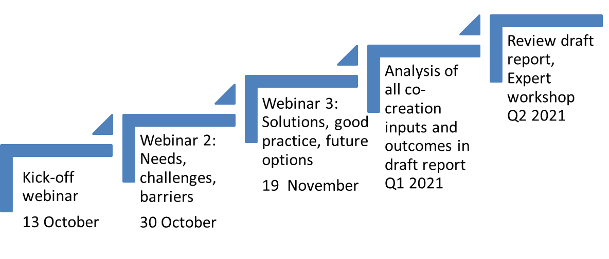

## Compendium and links to the Bellagio Principles

This report aims to create a compendium that covers the variety of inputs received (presentations, discussions, answers to three homework questions and poll questions) during the co-creation process. An additional goal of this report is to add a reflection on the links that can be identified to the Bellagio Principles for circular economy monitoring.

## Approach and structure of this analytical report

All co-creation process inputs and contributions have been analysed and the corresponding findings and outputs are reported in Chapter 2 according to the interactive events that took place:

Table 1.1 Overview of webinars and contributions

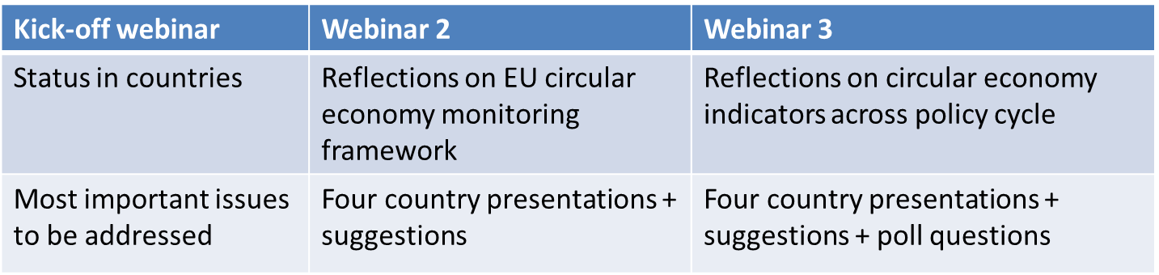

In Chapters 3 and 4 the learnings on contents and the co-creation process itself are described. An analysis on the links to the Bellagio Principles is provided in Chapter 5.

The literature gathered for the wiki and corresponding short ETC/WMGE assessments can be found in the references section of this report, and on the wiki on the Eionet Forum.

# Inputs and outcomes of interactive events

## Kick-off webinar

A kick-off webinar was held on 13 October 2020, with the following objectives:

* to inform participants about the co-creation process steps and its relation to other EEA work;
* to explain the roles of all participants;
* to receive questions about and suggestions for the co-creation process from participants;
* to learn about the status of national or regional circular economy monitoring;
* to get an overview of participants’ expectations for issues to be addressed during the co-creation process;
* to receive inputs on willingness, ability and availability to present in either Webinar 2 and/or Webinar 3;
* to show participants how to find the wiki site on the Eionet Forum;
* to assign homework projects for all participants for Webinar 2;
* to start the interaction.

The results: the kick-off webinar recording, all slides presented and the literature overview are accessible for all participants at <https://projects.eionet.europa.eu/circular-economy-monitoring-co-creation-process-2020/library>.

Table 2.1 Agenda of Webinar 1, 13 October 2020

|  |  |
| --- | --- |
|  | Kick-off Co-creation process |
| 9.50–10.00 | Arrival and technical check-in |
| 10.00–10.05 | Welcome, context of circular economy monitoring and status of ongoing EEA/ETC activities (Peder Jensen / Daniel Montalvo, EEA) |
| 10.05–10.20 | The co-creation process in practice (Theo Geerken, ETC/WMGE) |
| 10.20–10.40 | Questions and answers, and gathering of further suggestions for the co-creation process |
| 10.40–10.50 | Presentations from country/region representatives (max. 5 mins. each) |
| 10.50–11.00 | Next steps (e.g. preparation for Webinar 2) |

The main outcomes from the kick-off webinar are presented in the paragraphs below.

### Questions and answers about the co-creation process

1. What is the relationship between this co-creation process on circular economy monitoring, the Bellagio Declaration and the recently started update of the EU circular economy monitoring framework? Participants perceived an overlap in contents and also saw the need for including different groups of participants.

The Bellagio Process was originally planned as a physical meeting condensed in a face-to-face event of three days in May 2020 to deliver the Bellagio Principles for Circular Economy Monitoring, analogous to the 1997 Bellagio Principles for Sustainable Development Monitoring. Due to the COVID pandemic, the new Bellagio Process was held online and took longer than originally planned. It aimed to generate principles for monitoring the transition to a circular economy, including indicators and data. The present co-creation process is about learning in an interactive, mutually beneficial way from activities and experience at national and regional levels. Needs, barriers, challenges, solutions, good practice and future options will be discussed, while learning and engagement will benefit from collective activities during the webinars.

There is no formal connection between this co-creation process and the update of the EU circular economy monitoring framework. By joining the co-creation process, country representatives can benefit their own future national activities and may feel better prepared to provide input to EU Bellagio Principles for Sustainable Development Monitoring circular economy monitoring processes. The EEA’s expectation is that the Bellagio Declaration may play a more important role for input to the European Commission, also due to the direct involvement of the Directorate-General for the Environment (DG ENV).

1. Why choose a co-creation process?

This type of co-creation activity was chosen as a result from the renewed EEA/Eionet strategy that gives more importance to interactive co-production of insights. In a more traditional way of working, a consultant, an ETC or the EEA would do analytical work and produce a written report based on a survey or on desktop work, and then invite all EEA countries to comment on that report. In a co-creation process. however, a subgroup of EEA countries participates on a voluntary basis, and performs some collective activities to produce insights, with support from the EEA and the ETC. It is expected that a co-creation process is a more engaging way of creating a common and shared outcome.

1. What is the final product?

The final result will consist of shared and individual learning during and after the interactive events. Tangible outputs will be put on the wiki site (webinar recordings, presentation slides and literature) as well as in an ETC/Eionet report which serves as a compendium. The insights gathered are also meant to shape future EEA work on circular economy monitoring.

1. Which circular economy definition is used?

It is proposed that the EU definition from 2015 Circular Economy Action Plan (CEAP) is used:

*‘The transition to a more circular economy, where the value of products, materials and resources is maintained in the economy for as long as possible, and the generation of waste minimised, is an essential contribution to the EU's efforts to develop a sustainable, low carbon, resource efficient and competitive economy’.*

### Status of national and regional circular economy monitoring frameworks

The following conclusions can be drawn from the participants’ presentations:

* France adopted its first circular economy monitoring framework, containing 10 key indicators in 2017 and is working on an update to be published soon;
* Spain decided to use the EU’s circular economy monitoring framework as a basis, complemented by an indicator on greenhouse gas emissions from the waste sector;
* Flanders-Belgium published a monitoring framework in 2018 and is now working now produce real data by the end of 2021;
* all other participating countries have indicators relevant to the circular economy, but not in the form of a comprehensive set covering different aspects of a circular economy;
* several countries have taken the decision to develop a circular economy monitoring framework, which are currently at different stages of development.

### Countries’ views on most important issues to be addressed

All countries were asked to present their current status on circular economy monitoring in two or three slides, the issues they consider most important to be addressed during the co-creation process and their interest in presenting in the next two webinars or expert workshop. All slides from the country presentations are available on the wiki and the most important issues to be addressed are shown below as a list.

**Participants’ expectations and preferred issues to be addressed in the co-creation process, as presented during the kick-off webinar:**

* availability of and access to data on the use of secondary materials by industry;
* availability of and access to data on higher circularity strategies, the so-called inner circles – refuse, rethink, reduce, repair, refurbish, remanufacture, etc.;
* how to bring together and manage data from different stakeholders in a safe and collaborative way;
* indicators to monitor the impact of circular economy policies;
* comparability – finding common indicators with relevant data sets;
* learn from colleagues about their ongoing activities and lessons learned, including in the light of the upcoming EU circular economy monitoring framework;
* develop a common understanding of the circular economy and what should be measured;
* discuss the status of reporting on other indicators, for example footprints, remanufacturing and repair and environmental impacts, and how to evaluate policy progress;
* Kosovo considered their Sustainable Development Week (KSDW) 2020 to be important. Since 2018 the objective of the KSDW has been to advance public dialogue and seek effective ways of promoting sustainable development on one hand, and green economic growth on the other. In 2021, the Ministry of Economy and Environment, EU Special Representative/EU Office in Kosovo, GIZ Kosovo, Balkan Green Foundation (BGF) and the Institute for Development Policy (INDEP) will jointly coordinate and finance the activity;
* developing a shared set of indicators of resources, their effects, and for the process for getting there;
* availability of and access to comparable data across countries;
* generate insights on which institutions are the source of information for the development of indicators;
* how to connect with the institutions that are source of information: should this be voluntary or are there laws or regulations;
* defining the best approach for indicator development and establish sets of circular economy indicators – identifying relevant political questions, defining sets of indicators with methodologies, identifying data gaps and specific indicators for each set, etc.;
* how to develop indicators showing the positive effects of a circular economy, not just the progress towards the goals;
* how to develop indicators that would (try to) show the connection between economic activities (+ funds allocated to certain priorities) and their effects on the environment/nature;
* how to monitor different activities which also contribute to progress in the transition to a circular economy – for example, networks and initiatives;
* Slovenia considered their Strategic Research and Innovation Partnership – Networks for the transition into circular economy to be important. It connects Slovenian business entities, educational and research institutions (RDIs), non-governmental organisations (NGOs) and other interested parties with the state and aims to establish new value chains according to the economic principles of closed material flows (<https://srip-circular-economy.eu/>);
* considering consumption aspects: renewable/non-renewable materials;
* the inclusion of indicators for other activities involved in the circular economy: water services, waste treatment, remediation and other waste services and rental companies;
* connection with other relevant targets and indicators, for example the UN’s Agenda 2030 Sustainable Development Goals (SDG’s);
* develop the EU monitoring framework for circular economy.

From this list, interest was highest in:

* the link to the SDG’s, other indicator frameworks and the comparability/complementarity of indicators;
* developments in the EU circular economy monitoring framework;
* how to access and process the basic data needed for circular economy indicators, either from public and private sources;
* indicators to measure progress such as process indicators or activity indicators ­ (faster moving) explanatory ones that show whether circular economy processes are taking off or not rather than (slow moving) macro indicators.

### Outcomes from the webinar chat

Relevant outcomes from the webinar chat were the following.

1. Quite some opinions and discussion about the needs, relevance, possibilities and feasibility of footprint indicators as well as a suggestion to use already available tools such as the raw material consumption (RMC) indicator from Eurostat.
2. Links to a recent Estonian study about circular economy indicators (<https://ringmajandus.envir.ee/sites/default/files/Strateegia%20-%20fotod/1.2%20Ringmajanduse%20indikaatorid%20l%C3%B5pparuanne%20050719.pdf>)

and the corresponding data sheets (<https://ringmajandus.envir.ee/sites/default/files/Strateegia%20-%20fotod/3%20Indikaatorite%20andmefailid%20050719.zip>).

The link to France’s ten key circular economy indicators (<https://www.statistiques.developpement-durable.gouv.fr/10-indicateurs-cles-pour-le-suivi-de-leconomie-circulaire-edition-2017>).

The country representative indicated that the survey-based car sharing indicator will be discontinued in the next update.

1. Support for the idea of an international platform that would bring together all circular economy indicator work and data from different organisations across the world – the Organisation for Economic Co-operation and Development (OECD), the UN, EC/Eurostat, EEA, etc.

## Webinar 2: needs, challenges and barriers to circular economy monitoring

As part of the co-creation process, a second webinar was held on 30 October 2020.

The results: a webinar recording and all the slides presented are available at <https://projects.eionet.europa.eu/circular-economy-monitoring-co-creation-process-2020/library>

Table 2.2 Agenda of Webinar 2, 30 October 2020

|  |  |
| --- | --- |
|  | Needs, challenges, barriers |
| 10.00–10.10 | Introduction and context setting (Peder Jensen, EEA). |
| 10.10–10.25 | Highlights of collective homework assignment and questions and answers (Bettina Bahn-Walkowiak, ETC/WMGE). |
| 10.25–11.55 | Presentations on challenges and gathering of suggestions from the audience:  **–** **Kosovo:** the challenge of going from waste to circular economy indicators (Tafë Veselaj);  **– Poland:** challenges in the process of developing circular economy indicators for sustainable production and consumption (Ewa Dziobek);  **– France:** the challenge of indicators for a functional economy (Chrystel Scribe);  **– Netherlands:** the challenge of indicators for circular economy transition monitoring (Aldert Hanemaaijer). |
| 11.55–12.00 | Closing and next steps (Theo Geerken, ETC/WMGE) |

### Highlights of the collective homework assignments for Webinar 2

A special feature of the co-creation process was that the participating countries also provided content for the webinars and contributed to the entire process through homework assignments. The purpose was to complement and reinforce the collective learning process by giving countries that could not or did not want to present at the three webinars the opportunity to participate interactively.

For Webinars 2 and 3, homework questions were given to participants and several responses were received. It should be noted, however, that the conclusions and insights presented here rely on the responses given by eight and five country representatives respectively. Even though the number of responses do not allow quantitative analysis, the homework assignment did provide relevant inputs. Countries have made an interesting and worthwhile contributions to the systematisation of the overarching questions of the co-creation process on the EU circular economy monitoring framework.

The questions, as well as the answers of the participants, are summarised below.

In preparation for the webinar on needs, challenges and barriers to circular economy monitoring, the following homework question was given.

* **Homework Question 1: What is your assessment of (a) missing elements and/or (b) limitations in the current EU circular economy monitoring framework to monitor the circular economy?**

Responses were received from eight countries ([1]). As a first step, clusters of answers were identified. The statements and proposals of the countries were then assigned to specific circular economy framework domains and, as a third step, some general conclusions were developed.

The analysis of this open question revealed five types of contents in the country responses:

1. missing indicators;

2. missing domains in the circular economy framework;

3. specific requirements for measuring/data limitations;

4. cross-cutting challenges; and

5. informational needs.

An overview is provided in Table 2.3 and the proposals for additional indicators have been classified in the domains of the EU circular economy monitoring framework (Fig. 2.1).

Table 2.3 Missing elements in the circular economy framework, requirements for measuring and current data limitations

| **1. Missing elements in the circular economy framework: indicators on…** | **2. Missing elements in the circular economy framework: by domain (society, economy, policy)** | **3. Requirements for measuring/data limitations** |
| --- | --- | --- |
| Direct material consumption (DMC); Direct material input (DMI), Raw material consumption (RMC), Raw material input (RMI) → Eurostat indicators  Footprint indicators (material, carbon, biodiversity)  Eco-design (including re-design, research and development and overall product lifespans)  Industrial symbiosis (plants)  Sectoral impacts  Reuse and waste prevention measures as well as indicators for the higher R strategies (e.g. rethink, refuse, repair, remanufacture, reuse)  Magnitude of littering/dumping  Waste incineration, material leakages  *Status quo* of landfilling  Scale of circular procurement  Product related circular economy metrics  Balanced set of indicators for aggregate materials flows and single substance flows  Others, such as use of energy resources, renewable energy, carbon dioxide (CO2) emissions | **Society:**   * Consumption sphere (→ products, packaging put on the market) * Societal behaviour (e.g. citizens choices for alternatives, using repair) * Stakeholders’ engagement in the circular economy process * Education (change of curriculums, new items in relevant programmes)   **Economy:**   * Circular economy innovation concept not comprehensive/detailed enough * Circular economy investment based on too narrow a circular economy definition * Business operations (e.g. numbers of enterprises facilitating recycling, extending product lifecycles; numbers of enterprises with a circular economy strategy, turnover of new circular economy industries)   **Policy:**   * Policies implemented and intended to increase circular economy efficiency (measures, instruments, governance, strategies) * Nexus to other policy fields (for example, climate) even though the circular economy is an horizontal policy covering multiple sectors and actors | **Requirements:**  Comparability of data and data sources between Member States  Efficient ways of data collection (e.g. using generalisation in home composting rather than collecting data from municipalities who have to ask citizens for them )  Important that Eurostat indicators be developed by all European countries  **Limitations:**  Patent statistics not adequate to show circular economy progress  Trade in recyclable materials not adequate to show local/regional processes  Time lags due to infrequent and late updates of macro indicators  Comparability of circularity data from business and industry  Global industrial supply chains not reflected in national resource flow monitoring |

*Source: Compiled on the basis of country responses to homework Question 1*

The necessary multi-actor collaboration across the value chains and governance levels, and the reduction of dangerous chemicals in circular economy cycles were both identified as examples of specific **cross-cutting challenges** that are not easily caught in a monitoring framework.

Beyond the development of a circular economy framework, which is equipped with specific indicators, two countries drew attention to **further informational needs** such as on potential funding for circular economy activities, and guidelines to accelerate and better communicate circular economy processes on national or local levels.

Figure 2.1 Clustered proposals for indicators in the four circular economy monitoring framework dimensions

*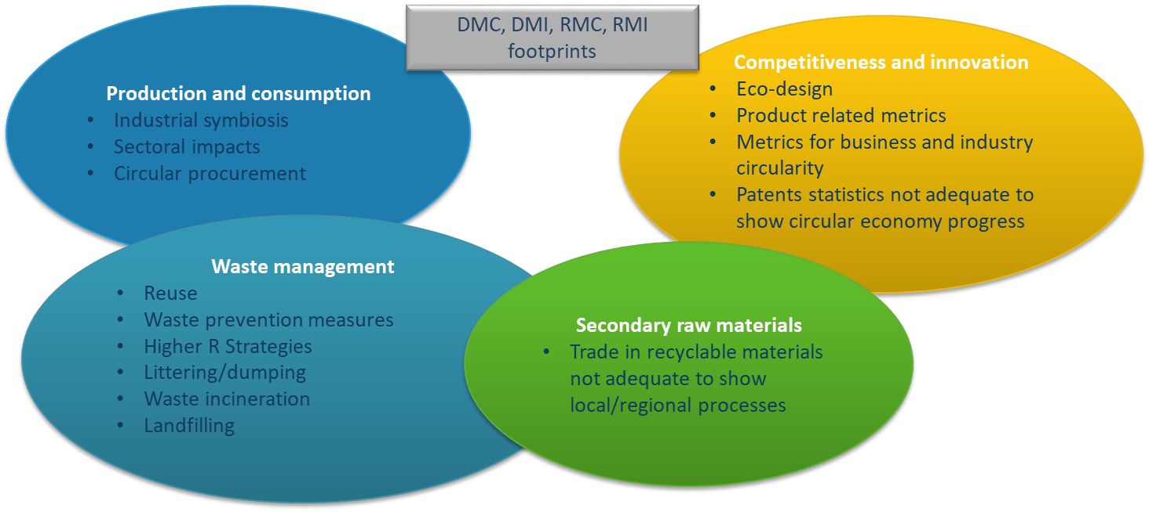Source: Compiled on the basis of country responses to homework Question 1*

The co-creation process participants also provided general assessments of the current state of the EU circular economy monitoring framework. It was acknowledged that the framework helps to better integrate material flow and waste statistics, and also enhances the communication between different policy Directorates General in the EC. Further, it was recognised that most of the EU circular economy framework indicators are available for all countries, together with time series. However, there appeared to be a consensus that the circular economy framework is currently too strongly focused on the product end-of-life (EoL) stage such as on waste and on recycling, and therefore not oriented enough on circularity. Furthermore, it was claimed that current indicators are macro ones, while changes, which are important for implementation, at the micro level – the local level, business, industrial sectors and consumption behaviour for example – are pre-eminently visible before they become measurable at macro level. The framework is as yet insufficiently equipped to depict a real and up-to-date picture of a circular economy. In addition, it was mentioned that the framework does not yet include overarching targets by which circular flows could (and should) be influenced in order to allow economic development to respect the limits of the planetary boundaries, similar to the vision of a greenhouse gas neutral EU. Consequently, a number of measuring issues are not adequately addressed which is also linked to data limitations (Table 2.3).

Summarising the results as bullet points, it can be stated that:

* waste-related indicators are covered best, even though waste incineration and landfill would make the overall picture more complete despite not being considered as contributing to a circular economy (Flanders);
* the EU framework is very much a macro-level indicator framework whereas changes towards a circular economy will be noted earlier at lower levels;
* the EU framework is about materials and waste; there is too little about products – eco-design, product environmental footprint (PEF) method and all possible circular economy strategies that apply to products such as lifetime extension, reuse and sharing – only repair refers to products;
* the availability of the data across countries is not yet been secured;
* there is a general impression that consumption aspects are covered poorly;
* specific types of indicators are missing: DMC, RMC, footprints;
* a link to climate is missing;
* the engagement of particular stakeholder groups, such as business and citizens, is missing;
* private investment in the circular economy is covered poorly as too are innovation aspects.

After the presentation of homework results at Webinar 2, the question of whether these missing elements could somehow be linked to the Bellagio Principles was raised. EEA responded that , despite the fact that the Bellagio and the co-creation processes run in parallel, cross-fertilisation would be good. In the last chapter of this report the links to the Bellagio Principles are analysed.

Another question raised was about the surprising missing element of packaging waste in the EU circular economy monitoring framework. This is an example of an indicator for the consumption domain for which actual data are available.

### Country presentations and discussions/chat during webinar 2

* **Kosovo: The challenge of going from waste to circular economy indicators (Tafë Veselaj)**

Tafë presented the triple challenge that Kosovo is facing:

* improving the waste management system;
* making the transition from waste management to a circular economy;
* having an indicator to measure progress.

Municipal waste deposition is still rising, there is limited infrastructure for waste separation and while the number of illegal dumpsites is decreasing this issue remains still relevant. The circular economy was not treated as an explicit topic within environmental policy, but in the draft strategy to 2030 there are four strategic objectives for circularity, though with limited funding: circular economy public awareness and education, waste prevention and reuse, and recycling.

**The overall challenge is** the collaboration and partnerships between government, business and civil society to move the circular economy from just an idea to action at scale.

**Questions from Kosovo to the webinar participants:**

1. What would be the most appropriate model for the implementation of a circular economy in countries that are in the process of the transition from waste management to circularity? Any suggestions for indicators to monitor that?

2. Could we save time and efforts by jumping to a circular economy rather than first making the waste management system much better and only then start moving towards circularity?

3. Would it be better to develop a specific strategy and action plan for a circular economy, or should the concept be included in sectoral strategies, such as for waste, water, nature, etc.?

**The suggestions or comments given were:**

* try to determine and address the biggest barrier first – budget, awareness or illegal dumping;
* use the stick-and-carrot method: introduce a landfill ban entering into force within five years, while at the same time sponsoring innovation to create solutions;
* introduce a higher landfill tax to generate money for solutions;
* do not focus too much on quantities of recycling; quality aspects are also very important especially, for instance, for plastic recycling;
* any ideas from other countries how to combat illegal dumpsites? Kosovo explained that they just made the lowest governance level, municipalities, formally responsible to work on compliance. This has already reduced the number of illegal dumpsites from around 2,500 to 1,500 in a short time.
* **Poland: challenges in the process of development of circular economy indicators for sustainable production and consumption (Ewa Dziobek)**

Poland faced several (remaining) challenges when developing the Polish Circular Economy Roadmap.

1. Selection of priority sectors for transformation towards a circular economy in Poland. Based on material and energy consumption as well as waste data, Poland selected five focus sectors: construction, energy, the chemical industry, the agri-food industry, and mining and quarrying.
2. Convincing stakeholders that the circular economy is more about new business models and organisational solutions and less about technology. Technology is needed but of itself is definitely not enough to enhance the uptake of circularity. What is additionally needed is attention on the organisational aspects, new business models and industrial symbiosis.
3. Convincing local administrations that circular economy is not about waste management but about resource management. Poland carried out a survey on circular economy-related initiatives across all regions as waste management is delegated to the regions. From that survey, it appeared that most regions are still focussing on waste management only, with some circular economy elements added to that. When it comes to dedicated circular economy plans only one region had a proposal.
4. The circular economy is not primarily about increased competition but instead focuses on cooperation within value chains. Poland is convinced that the transition to a circular economy could benefit from bringing stakeholders from research, business, NGO’s, universities and administrators together and developing programmes or joint initiatives in specific clusters and regional projects. Poland would like EU structural funds in the context of regional policy to focus more on circular economy and value chain approaches, and less on waste management.

**Question from Poland to the webinar participants:**

Do you agree that cooperation within value chains is one of the key factors for success in implementing a circular economy, and if so, can you provide examples how to create/support it, by, for example, creating networks like clusters (Key National Waste Management and Recycling Cluster in Poland*) or consortia of scientists and economy leaders (Highway to Technology, and Innovation Institute IATI**)?

*www.klasterodpadowy.com **iati.pl.

**The suggestions or comments given were:**

* bring product designers in contact with the real waste operators to learn about their problems and possibilities;
* create a companies-for-companies initiative where each company organises a visit to their place showing how they handle issues such as design, waste management and business models. Of course, special attention should be given to not sharing confidential issues with competitors in the same sector;
* for future research programming, you might be interested in the CICERONE initiative. Feel free to have a look at <http://cicerone-h2020.eu/objectives/>. The resulting Strategic Research and Innovation Agenda is available at <http://cicerone-h2020.eu/outputs/>;
* how did you create a sharing economy indicator? It is counting the number of initiatives/activities for sharing systems;
* what makes the mobility indicator such a challenge as we would expect enough data to be available for the mobility system? It is mainly at the level of consumer acceptance for which data is lacking;
* do you take dangerous chemicals into account in the context of the circular economy? In REACH policy yes, but not yet in the circular economy, where the attention is mainly on critical materials.
* **France: the challenge of indicators for a functional economy (Chrystel Scribe)**

France published its set of ten key indicators for a circular economy in 2017 and is currently in the process of updating them. Details are downloadable from [10 indicateurs clés pour le suivi de l’économie circulaire - Édition 2017 | Données et études statistiques (developpement-durable.gouv.fr)](https://www.statistiques.developpement-durable.gouv.fr/10-indicateurs-cles-pour-le-suivi-de-leconomie-circulaire-edition-2017).

France covers circular economy aspects related to three specific areas – waste management, supply from economic stakeholders, and consumer demand and behaviour). Within these three areas, there are seven pillars and one of them is the functional economy which is the subject of the challenge to be discussed. As an illustration of functional economy, France used a car-sharing indicator with data available from a survey carried out in 2016, but the next survey will only be done in 2021, so every five years. This means data is not available for supporting a annual indicator. There is an option to include the same survey question in an annual survey but to do so the question must be considered very relevant by a committee as there is a limit to the total number of questions. For the ongoing update, France is considering an alternative indicator showing the number of supported projects on a functional economy by the French Environment and Energy Management Agency (ADEME). For this indicator, the limitation is that not all projects will reach market readiness, and also there may be many more projects ongoing in society that do not receive support from ADEME. Ideally, an indicator should allow for building time series and thereby facilitate monitoring, and also allow for international comparisons. So, the challenge of covering the functional economy remains.

**Questions from France to the webinar participants.**

Q1: Would it, in your opinion, be easier to get data on the functional economy from the consumer/user side or from the producer side?

Q2: Any thoughts/ideas for quantifying the benefits of a functional economy in terms of saved resources?

**The suggestions or comments given were:**

* from the consumer side, you can use the budget enquiry survey but unfortunately this is not available for all EU countries and is only done every five years;
* from the producer side, you may consider the functional economy to be reflected in the share of the tertiary sector in your national economy, showing the growing trend of share-of-service sectors in your economy;
* who decides about allowing a question into a survey; Is it only a budgetary issue? The number of questions is limited in a survey, there is a commission that judges the relevance of all proposed for questions, of course not forgetting that existing questions also serve other useful indicators. Adding one question would mean removing another;
* the best way would be to create a new indicator based on existing data;
* comment: be aware that increased car sharing may also mean less use of public transport;
* it is easier to get data on the functional economy from the provider side rather than the consumer side, simply because there are much less;
* could we not ask companies for more information on saved resources by supplying a simple calculator? Companies should not be overloaded with requests for data;
* what do you ask for in your industrial symbiosis survey? How many resources are being saved? How many industrial symbiosis projects are ongoing? This is based on a study by ADEME, details can be shared with participants on request.
* **Netherlands:** **The challenge of indicators for monitoring the transition to a circular economy (Aldert Hanemaaijer)**

The Netherlands Environmental Assessment Agency (PBL) is currently working on a report on the circular economy covering trends in material resource use, waste and related environmental and socio-economic effects. The report also describes current activities within society, as well as the government's interventions that promote the transition to a circular economy (policy and process indicators). With those elements it covers the categories of indicators recommended in the Bellagio Process. This presentation focuses on the last category. As macro indicators may change slowly, the underlying trends in society that reveal indications of a more circular economy are important to monitor for policy purposes. A framework developed for innovation systems will be combined with the so-called X-curve concept for transitions. Indicators included will cover knowledge development, knowledge exchange, entrepreneurship, market formation and mobilising means as well as overcoming opposition.

Nonetheless challenges remain.

* Data are often not available in current statistics, generating a need for:

– new research such as monitoring progress with respect to policy instruments;

– new methods that allow for integrating bottom-up/company data and web scraping for, for example, the number and share of circular economy companies, employees and added value;

– new statistics such as attitudes of consumers and businesses to a circular economy.

* Tension between relevant, accepted, credible, easy and robust (RACER) criteria and room for experimentation:

– especially for indicators on the transition process: not always easy and robust

**Questions from the Netherlands to the webinar participants.**

1. Is it possible to develop a shared set of indicators for the process?
2. How can data comparability be assured across countries?

**The suggestions or comments given were as follows.**

The circular economy framework is probably based on the Functions of Innovation Systems Framework ([2]) from the University of Utrecht, but it does not yet completely cover the transition to a circular economy as reported by the Drift Institute in their 2017 State of the Transition report ([3]). Are there any plans to widen the PBL framework? PBL launched an activity to write an article with several transition experts to cover both the theoretical and practical aspects of this transition.

How do you monitor the supported circular economy projects, on a yearly basis? The agency that runs the research programmes has a good overview of research projects that are circular economy related.

There is indeed a tension between allowing experimental indicators and international comparability. Is there any experience in this group in using the number of (digital) product passports, which contain information about product composition and instructions for its end-of-life handling, as an indicator? This could be an interesting new option.

* **Presentation of homework questions from all Webinar 3 participants:**

1. Choose one circular economy policy objective, for example circular economy related jobs, zero final waste, less dependency on natural resources, the circular economy’s contribution to climate change, etc.
2. Provide some examples of existing and potential options for indicators useful across the policy cycle – agenda setting, policy formulation, decision making, policy implementation and policy assessment.

Inspiration may be found in: Eurostat, 2017, *Manuals and guidelines - Towards a harmonised methodology for statistical indicators, Part 3: Relevance for policy making*, available at <https://ec.europa.eu/eurostat/documents/3859598/8071770/KS%20GQ-17-007-EN-N.pdf/7d34c904-2d07-4e71-bd6f-8fe9ee373b60>.

Figure 2.2 The policy cycle



Source: Eurostat

## Webinar 3: Solutions, good practice and options for circular economy monitoring

The third webinar in the co-creation process was held on 19 November 2020.

The results: a recording of the webinar and all slides presented are available at <https://projects.eionet.europa.eu/circular-economy-monitoring-co-creation-process-2020/library>.

Table 2.4: Agenda of Webinar 3, 19 November 2020

|  |  |
| --- | --- |
|  | Solutions, good practice and future options |
| 9.30–9.40 | Introduction and current status of co-creation process (Peder Jensen, EEA) |
| 9.40–9.55 | Highlights of the collective homework assignment and questions and answers (Bettina Bahn-Walkowiak, ETC/WMGE) |
| 9.55–11.35 | Presentations on solutions, good practice and future options. Gathering suggestions from the audience  – **Estonia**: Study on mapping circular economy indicators in Estonia (Mihkel Krusberg)  – **Spain**: circular economy deal ‘España Circular 2030’ (Carmen Durán)  – **Germany**: The use of footprint indicators in circular economy monitoring (Philip Nuss)  – **Belgium / Flanders**: Development of a circular economy monitor in Flanders (Luc Alaerts) |
| 11.35–11.50 | Short interactive group surveys (Dirk Nelen and Nora Brüggemann, ETC/WMGE) |
| 11.50–12.00 | Closing and next steps (Peder Jensen, EEA) |

### Highlights of collective homework assignment for Webinar 3

As preparation for Webinar 3, the following homework question was given:

* **Question: 1. Choose one circular economy policy objective; and**

**2. Provide some examples of (a) existing and (b) potential options for circular economy indicators useful across the policy cycle.**

Responses were received from five countries (**[4]**). The responses were first analysed by policy objective and information on existing and proposed indicators. Then the proposals for new indicators were assigned to different policy-cycle phases (Figure 2.2). The five respondents chose different policy objectives: employment, zero waste, climate change, strategies and empowering consumers. Four of these policy objectives included specific suggestions for extended and new indicators. The fifth objective, the circular economy’s contribution to climate change, was mentioned but not elaborated further.

**Circular economy strategies:** The number of existing and upcoming national circular economy strategies is monitored at the European Circular Economy Platform ([5]). Eco-innovation performance and outcomes are also measured at the EU level ([6]). However, less information is available on the local strategies of regions and municipalities.

Future option for indicators:

Better information on circular economy strategies at all levels is needed, including sub-national and local strategies.

**Jobs (employment):** the numbers and share of people employed in economic sectors of which the performance is assumed to have particular circular economy objectives, such as, amongst other, repair services and recycling activities, are collected at the national level, but are incomplete when it comes to employment at subsidiary levels and in the non-profit sector. There is also a lack of a clear definition of circular economy sectors; circular economy activities are widespread and the present use of the NACE ([7]) codes provides too generic definitions. Therefore, the current scale of the collaborative and second-hand economies and their contributions to the sectoral gross domestic products (GDP’s) or national GDP is practically unknown. The lack of information also applies to companies that are committed to reducing their use of materials, by extending the life of products and re-use. The indicators currently in place may, therefore, underestimate the real size of the circular economy.

Options for future indicators:

* extend the NACE codes;
* include qualitative aspects in measuring employment;
* link number of added jobs to government subsidies.

**Zero final waste:** there is information on EU ecolabels, the number Eco-Management and Audit Scheme (EMAS) certified enterprises and the turnover by repair sectors (NACE). The (environmental) cost reduction from resource efficiency or circular economy activities is, however, a widely unresearched field.

Options for future indicators:

* durable products by innovative domestic collaborative economy platforms;
* number of start-ups that promote business models that contribute to shared mobility, as an alternative to material consumption by citizens;
* share of collaborative economy in sectoral GDPs;
* employment in collaborative economy undertakings;
* cost reduction as a result of resource efficiency activities.

**Empowering consumers:** there are statistics on household expenditure, such as vehicle ownership and white goods. Less frequently available are data on material footprints of households or, for example, food self-sufficiency. Many countries conduct surveys on public awareness.

Options for future indicators:

* purchase of used products – reuse indicators;
* purchase of products with a longer lifespan and a willingness to take them for repair, if needed;
* scale of product sharing;
* network of repair services – size, purpose and frequency of use;
* familiarity of consumers with existing circular solutions such as reuse centres, car sharing, tool workshops and sharing.

Being aware that five countries represent a small sample of potentially numerous perspectives for assessing and monitoring circular economy practices and performance in countries, the answers were positioned in the policy cycle (Figure 2.3) to illustrate where in the cycle the responding countries think additional monitoring efforts should be prioritised, namely in the policy assessment stage. In summary, the respondents’ impression is that the EU and EU Members States are currently not in a good position to adequately assess how many people the circular economy sector employs, how many consumers undertake circular economy activities or choose circular economy supporting products, how many old or new businesses take up circular economy business models, or what contribution the sector and the activities make to economic development or environmental relief. There is clear demand to develop better indicators, statistics and reporting mechanisms to draw a clear picture.

Figure 2.3 Future indicators for a circular economy in the policy cycle

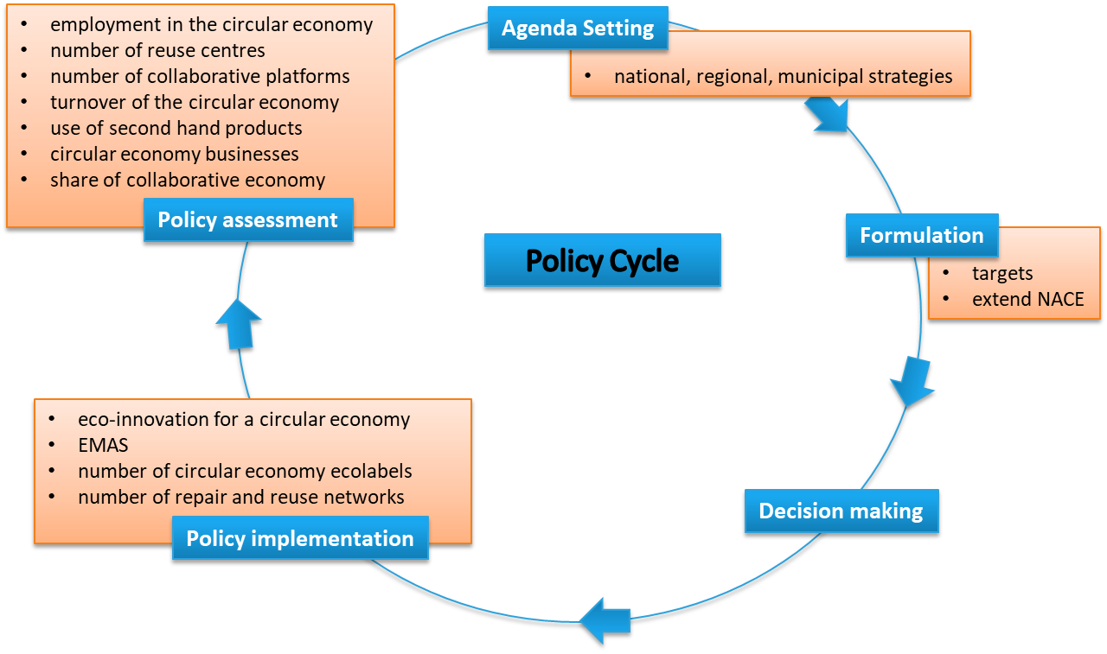

*Source: Illustrated on the basis of country responses to homework Question 2*

In response to the question about available relevant national or other studies, especially on the inner circle – reuse, repair and remanufacturing, even if not fully available in English, a number of suggestions came in through the chat:

* Environmental effects of the collaborative economy available at https://trinomics.eu/project/the-environmental-impacts-of-the-collaborative-economy.
* A study on economic activities in relation to the circular economy available at <https://www.sepe.es/HomeSepe/que-es-el-sepe/comunicacion-institucional/publicaciones/publicaciones-oficiales/listado-pub-mercado-trabajo/economia-circular.html>.
* A Finnish report with an English abstract on the reuse of certain materials in Finland available at <https://circhubs.fi/wp-content/uploads/2018/06/SYKEra_19_2018.pdf>.
* A Flanders-Belgium survey that estimated a level of reuse of approximately 33 kilograms per inhabitant: <https://ce-center.vlaanderen-circulair.be/en/publications/publication/13-reuse-the-understudied-circular-economy-strategy>.
* The Ellen MacArthur Foundation Circularity Indicators Company-level Methodology available at <https://www.ellenmacarthurfoundation.org/assets/downloads/insight/Circularity-Indicators_Methodology_May2015.pdf>.

### Country presentations and discussions/chat during Webinar 3

* **Estonia: study on mapping circular economy indicators in Estonia (Mihkel Krusberg)**

Estonia is working on a circular economy Strategy and Action Plan, expected to be published in 2021. In that context, Estonia performed a study to look at potential indicators which is available at https://ringmajandus.envir.ee/index.php/en/creating-strategy-and-action-plan-circular-economy-estonia.

In total, 29 circular economy indicators, organized into a framework of four categories, were selected as promising:

* input indicators (6), such as early stage investment in waste and recycling;
* activities (9), such as EU ecolabels
* output (6), such as the number of startups in shared-mobility business models;
* results (9), such as share of the collaborative economy in sectoral GDP’s.

Estonia proposes using nine criteria, validity, relevance, consistency and reliability, measurability, clarity, comprehensiveness, cost-effectiveness, comparability, long term stability, to select circular economy indicators – more than the five RACER criteria ([8]).

**Question from Estonia to the webinar participants:**

How to start and make progress with regards to the development of a national circular economy monitoring framework? For example, mapping indicators first or strategy or something else?

**The suggestions or comments given:**

* one of the recommendations from the homework is to look for employment data in sectors relevant to the circular economy;
* in an ideal, theoretical approach, one would first think about what we want to monitor and then look for the required data, but in practice one often starts with an analysis of what is available can be of use, and then see what is missing! The EU circular economy monitoring framework explicitly started off looking for available, useful data and indicators;
* why did you choose the logical framework – input, activities, output and results? It was a recommendation from the Technopolis study ([9]) that Estonia commissioned. In general, it is good to think about the framework first and then feed it with purposely selected indicators;
* The framework-first approach also contributes to the discussion about data, it shifts attention from data-driven to objective-driven indicator proposals.

Additional input from Estonia in the chat:

When you need one, or a maximum of two indicators for thecircular economy in a national overall indicator framework, then the 29 indicated are still not enough. If we could work out an overall index, that would be ideal.

* **Spain: circular economy Deal ‘España Circular 2030’ (Carmen Durán)**

Spain published its circular economy strategy in mid-2020 – it is available at <https://www.miteco.gob.es/es/calidad-y-evaluacion-ambiental/temas/economia-circular/espanacircular_2030_executivesummary_en_tcm30-510578.pdf>).

Part of it is a so-called Circular Economy Pact that also contains a Green Deal with several hundred companies to develop circular economy indicators at the micro level.

The Green Deal initiative promotes the development of circular economy indicators at the micro level. Indicators are chosen by the entities themselves. They have to choose those that may be more interesting to achieve the objectives proposed in the Decalogue Pact for a Circular Economy, and adjust, as far as possible, to the reality of their professional activity. The indicators will make it possible to determine the evolution of the environmental policies applied in their entities, and the results obtained for each of the years of operation must be reproted.

**Questions from Spain to the webinar participants:**

What recommendations would you give to a company to develop its own indicator’s scheme?

We still face a challenge in preparing guidelines for micro level indicator scheme. What recommendation do you have for us?

**The suggestions or comments given.**

* It is important that the micro level can connect to macro indicators without becoming dis- encouraged because of their relatively small contribution. But the challenge remains that you are dealing with non-homogeneous data, hard to compare, difficult to add up, often relying on confidential data.
* The Ellen McArthur Foundation developed the Circulytics tool ([10]) for companies which was never meant to be summed to the macro level. Another challenge is that reporting companies have activities cross borders, so they supersede the national level.
* Suggestion for the challenge that micro level data do not add up to the macro level: to create a set of products at the micro level that could be representative for the macro level, an similar approach to how a country’s inflation rate is calculated from a basket of products.
* An EU study is ongoing in the context of the impact assessment of the revision of the Industrial Emissions Directive (IED) ([11]). The policy measures that are analysed in this context are considering the option of creating an obligation under the Environmental Management System (EMS) reporting for individual industrial installations to provide information about the company’s circular economy performance and contributions, which could help with confidentiality issues.
* **Germany: The use of footprint indicators in circular economy monitoring (Philip Nuss)**

Germany presented the way footprint indicators can be modelled by using multi-region input-output models and the importance of footprint indicators in policy making, recognised at EU and Environmental Protection Agency (EPA) level as well as reflected in Bellagio Principles, to avoid shifting natural resource use and environmental impacts abroad. The footprints also touch upon the concept of planetary boundaries. Footprint indicators can serve as complementary to the traditional territorial indicators like used in climate policy.

Challenges also exist:

* availability of (recent) data;
* lack of a commonly accepted approach and data sources, for example, at the UN or EU levels;
* the footprint perspective is not yet commonly used, for example, in climate policy.

**Questions from Germany to the webinar participants.**

What are examples of the use of footprint indicators in your country/institution?

From your point of view, what are the major challenges for incorporating footprint indicators into circular economy monitoring?

**Suggestions or comments from participants.**

* Can the Global Footprint Network database for the ecological footprint ([12]) also be used for these type of footprints? No, they are different, they based on land needed to produce products and also land needed to compensate for greenhouse gas emissions. This makes it more difficult to connect the findings to specific policy areas. They are good for communication of general public information and awareness raising.
* In Flanders the multi-regional input-output (MR-IO) based footprint indicators are used; quite a large part of the production value chain lies abroad and one can wonder how to make local policy for effects abroad. Results of course depend a bit on the world input-output (IO) models used. An alternative is to use the economy-wide material flow accounts (EW-MFA) material footprints that are available for more recent years. Multi-regional input-output based indicators nonetheless do provide added value based on the information of the structure of international value chains.
* The recommendation is that a supranational institution such as the UN or the OECD should endorse or recommend and host a MR-IO model to be used, for harmonised use, while at the same time encouraging scientific developments to further improve it. Having to rely on databases created by research projects creates uncertainties on the continuation of MR-IO data tables in the future.
* At the OECD level, with involvement of EU and UN, there is an ongoing online consultation process to provide requirements, recommendations and common rules for these data tables.
* MR-IO tables are typically static; one would in fact need equilibrium models to estimate changes in the future that alter the economic structure.
* Is there any connection between the German DERec and DIERec indicators and the German Resource Efficiency Programme (ProgRess) ([13]) and will they be replaced? These indicators show how many primary materials, including indirectly in the footprint, can be avoided by recycling.
* The dataset that the International Resource Panel (IRP) uses for material footprints is already based on a commonly used dataset, which will soon also be available as annual dataset.
* There is an ongoing debate about the feasibility of connecting footprints to the concept of planetary boundaries. Swiss colleagues produced a recent paper on that and the UBA ([14]) is also expected to publish a report on this link for abiotic materials very soon. This field seems to be more on the research side than on the immediate policy relevant side, due to assumptions that need to be made.

Additional input from the chat: as regards the ecological footprint question, there is a very interesting paper on possible limitations for using the ecological footprint in a policy context in the Journal of Industrial Ecology (<https://onlinelibrary.wiley.com/doi/abs/10.1111/jiec.12045>).

* **Belgium/Flanders: Development of a circular economy monitor in Flanders (Luc Alaerts)**

Flanders presented the status of the development of its circular economy monitor by an academic consortium sponsored by the authorities. The concept of the framework was published and approved in 2018 by a variety of stakeholders. The framework aims to bridge the gap between the existing macro and micro levels for indicators by using societal needs – mobility, housing, nutrition, etc. – as the systems to be assessed for circular economy performance. There is more specific data available for these societal systems, compared to the macro level, although the data appears to be spread across many different sources, partially also explained by Belgium’s governance structure. There appeared to be no central data management about the mobility system. During the process of data gathering the involvement of stakeholders from the data landscape were revealed to be very important in understanding what is behind the data. Not all data is easily available due to legal issues around privacy or commercial interests.

**Question from Flanders to the webinar participants:**

How can data (sharing) bottlenecks be overcome and data governance dedicated to circular economy monitoring set up?

**Suggestions or comments from participants:**

* there is a tendency to focus on data about flows whereas in a circular economy there is a need for more detailed data on stocks to be able to assess different strategies;
* in the Bellagio Process the issue of flows and stocks was also debated and there was a consensus that it was most important to monitor the transformations between stocks;
* as regards access to data and confidentiality, it is important not to ask for sensitive information from companies but to try to find the optimal aggregate level of information needed for monitoring purposes. If that information were published in annual reports then auditing could play a role in data quality;
* companies providing data should also get some benefits, by, for example, getting back information about their position relative to competitors;
* the Ellen MacArthur Foundation, which has companies as involved stakeholders, may provide progress on this issue.

### Poll questions to participants and the results

Three questions were posed to participants, making use of the mentimeter tool (<https://www.mentimeter.com/>).

**Poll question 1**

The 2014 Eurostat manual and guidelines *Towards a harmonised methodology for statistical indicators, Part 1* describes typical indicator frameworks used in different contexts – economic, environmental, innovation and sustainable development. Circular economy monitoring evidently requires covering diverse aspects from each of these contexts.

*Which framework structure and type of indicators would best fit for circular economy monitoring?*

Participants were asked to divide their 100 points across the four types indicated below.

|  |  |  |
| --- | --- | --- |
| **Context** | **Type of indicator** | **Relative importance scored by the group** |
| Economic (includes time aspect) | Leading, coincident, lagging | 22 % |
| Environmental (causal chain) | Driving forces, pressures, state, impact, response (DPSIR) | 36 % |
| Logical (for projects, innovation, impact assessment) | input, output, outcome, impact | 23 % |
| Sustainable development (covering complexity by using different levels) | 1. headline 2. operational 3. explanatory 4. context | 19 % |

**Interpretation:** this is the valuation given by the group of participants with a shared interest in circular economy monitoring. Apparently the DPSIR framework ([15]) scores highest which may not be surprising with participants collaborating in an EEA/ETC context. But it also suggests that all four types of framework and their types of indicator may bring something useful to a circular economy monitoring framework. Estonia presented their work on a logical circular economy monitoring framework at this webinar.

**Poll question 2.**

*Assuming the national scale is a given, which other levels deserve most attention for further elaboration of a circular economy monitoring framework?*

Participants were asked to score the importance of each of the levels on a scale of ten.

|  |  |
| --- | --- |
| **Level** | **Relative importance on scale of ten scored by this group** |
| International (footprints, global value chains, etc.) | 6.5 |
| Regional (divided competences) | 2.8 |
| Sectoral (for example, sectoral data in national accounting) | 6.2 |
| Systems (mobility, food, housing, etc.) | 7.3 |
| Company (private data) | 3.8 |

**Interpretation:** this is the valuation given by the group of participants with a shared interest in circular economy monitoring. The systems level scores highest with respect to importance for monitoring. This issue was also addressed by Flanders in their presentation. It was noteworthy that the regional level scored low, as this was also debated during the Bellagio Process and deemed there to be relevant. It is possible that if cities would have been explicitly included as a regional level, this level would have received a higher score.

**Poll question 3:**

*In case of sector-specific circular economy monitoring, which sectors would you prioritize –*construction, energy, food, textiles, agriculture, transport, services and other?

Participants selected those sectors they considered most important to be targeted in sector-specific monitoring.

|  |  |  |  |  |  |  |  |  |
| --- | --- | --- | --- | --- | --- | --- | --- | --- |
| **Sector** | **Construction** | **Energy** | **Food** | **Textiles** | **Agriculture** | **Transport** | **Services** | **Other** |
| Score | 14 | 4 | 10 | 9 | 6 | 12 | 2 | 2 |

**Interpretation:** this is the valuation given by the group of participants with a shared interest in circular economy monitoring. Construction, transport and food scored highest; they are also known as key systems in the sustainable consumption and production (SCP) policy context. The first issue for debate was why participants choose particular sectors – because of their relevance for circular economy monitoring or because of the availability of data? Unfortunately, there was no time to fully clarify this and repeat the question given these two possible interpretation. One participant clarified that the perspective taken was the amount of embedded materials in each of these sectors. She would have liked to have added minerals as another sector and main industrial processes.

# Learning regarding contents

## Reflections on needs, challenges and barriers to circular economy monitoring

The co-creation process revealed particular needs, challenges and barriers for making progress in circular economy monitoring, mainly focused on the national policy level.

Participants indicated what they perceived as missing elements, information, data and indicators in the different domains covered by circular economy indicator frameworks. Multi-actor collaboration across the value chains and governance levels were found to be the main challenges yet to overcome.

The original EU definition from the 2015 Circular Economy Action Plan (CEAP) states that in a circular economy “*the value of products, materials and resources is maintained in the economy for as long as possible, and the generation of waste minimised”*. The concept of a circular economy is thus very different from a sustainable linear economy, and is one that aims to combine material and energy efficient production with high levels of material recovery from waste flows, following a waste hierarchy. From an economic point of view, adding value is the guiding principle, while maximising production volumes. Environmentally, production should be made resource efficient, and pre- and post-consumer waste flows should be prevented or recycled.

In a circular economy, products, once they are put on market and form part of the in-use stock of materials, should be kept there for as long as possible, aiming for zero waste flows and, by maintaining the functionality of products, components and materials, also delaying the next production chain that starts with the extraction of natural resources.

The differences between circular and linear economies imply that when monitoring value-chain sustainability performance improvements that result from resource management strategies and policies, different key elements need to be assessed.

Figure 3.1 Key elements for monitoring sustainability performance

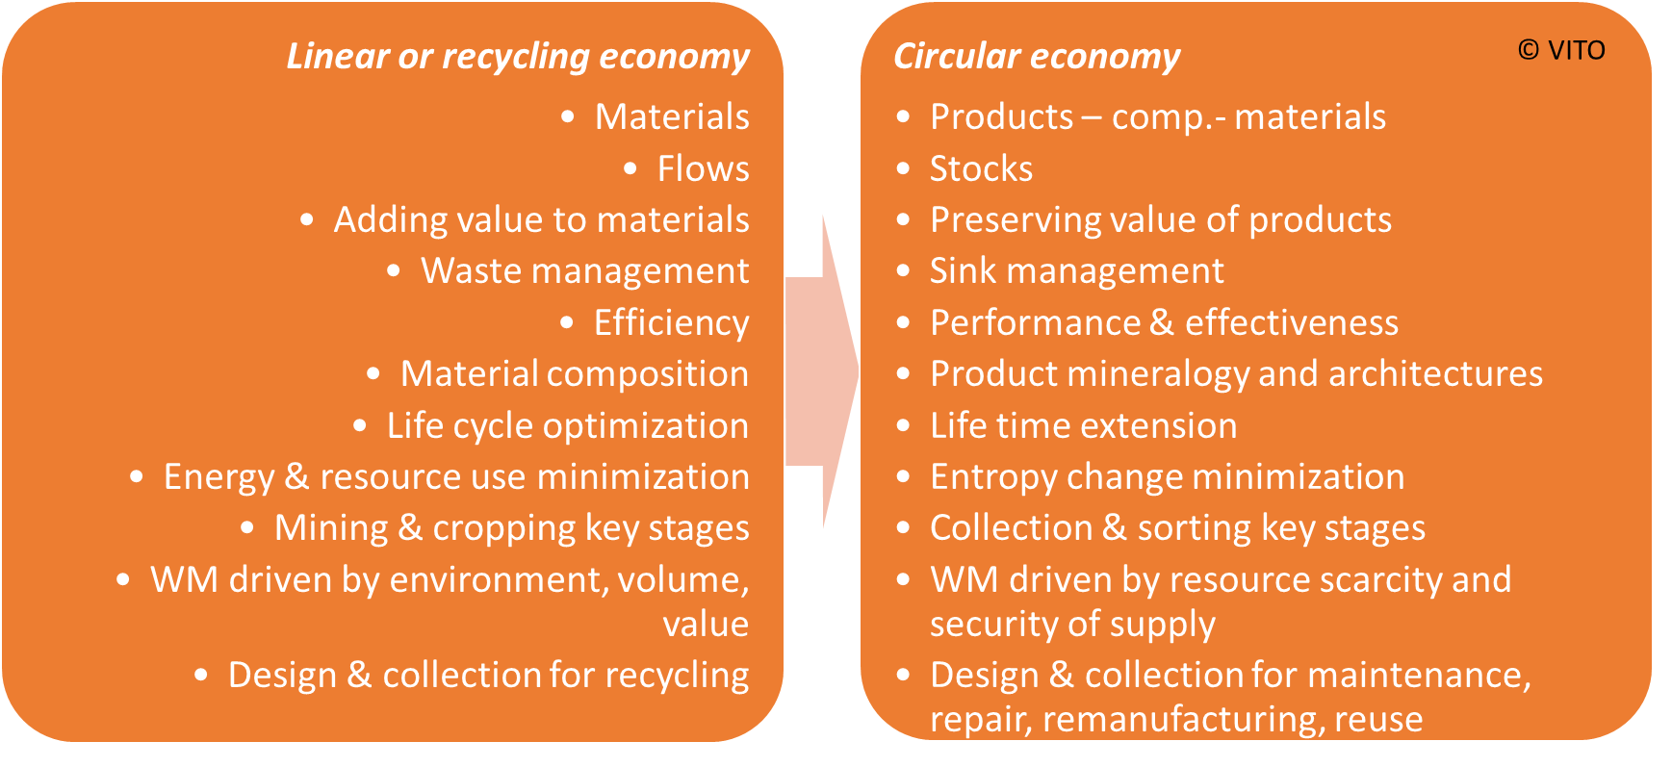

**Source: Nelen D. 2015. Beyond waste – the circular economy. Presentation at the ISWA Beacon Conference on Waste and Recycling, Vienna.**

Since the circular economy is relatively new and still being conceptualised, much of the data and information needed for building appropriate indicators on key elements in different domains – social, environmental, economic – is not yet available. In contrast, linear economy indicator frameworks are in place for waste management, industrial emissions monitoring as well as on macro-economic performance, and mandatory reporting obligations and statistical databases have been set up and made available for analysis. The setting up of such information systems for key elements of a circular economy are still a work in progress. Several of the circular economy data and information gaps noted by participants can be explained by the profound change of key elements to be monitored.

* **Secondary resource use by industry**. In a linear economy, weight-based recycling targets have been imposed and their compliance is closely observed, whereas in a circular economy, the actual substitution of primary resources by secondary ones is the relevant parameter to be monitored.
* **The economic impact of circular economy strategies on employment and added value**. In a circular economy, maintaining the functionality of products, components and materials over time is key in order to avoid extraction of resources from nature and new production. The impact of circular economy strategies on the production side, consisting of complex and global value networks, is being intensively researched.
* **Carbon and material footprints of consumption**. Consumption is closely monitored in a linear economy setting, since economic policies often rely on restoring and maintaining high consumption levels. Footprint indicators, however, require a deeper insight and an understanding of global production chains, supported by the introduction of such new concepts as raw material equivalents (RME), DMC and embedded energy, which non-experts may find less obvious.
* **Data and information on the performance levels of the so-called inner circles of a circular economy.** Activities such as repair, refurbishment and remanufacturing currently still provide marginal contributions to a country’s economic added value and employment and may therefore so far have been rarely considered for more detailed analysis and systematic data collection.
* Established circular economy strategies and policies mostly target sectors, business models, value chains and consumption patterns at a **macro-economic level**, and circular economy indicators often have been proposed correspondingly, linked to greater data availability. Knowledge on the possibilities for and the effects of implementation of circular economy strategies, beyond waste prevention and management, that can be applied at the level of an individual organisation, installation or industrial sector (micro- and meso-level) are still limited.

## Reflections on solutions, good practice and options for circular economy monitoring

1. Improve the monitoring of value maintance of products in a circular economy

Research on 63 metrics ([16]) that are commonly used to assess progress towards a more circular economy have allowed the identification of three main clusters of circular economy metrics: 1) resource-efficiency metrics, often focusing on elements of the circular economy such as waste disposal, primary versus secondary use, resource efficiency/productivity and recycling efficiency; 2) materials stocks and flows metrics, including metrics that refer to material flow destinations, waste disposal, stock availability/concentration, downcycling and quality loss, cascading use, and recycling/remanufacturing potential; and 3) product-centric metrics, connected to the elements which relate to the conservation of value, such as value change, retention, product longevity, and others.

The results of the analysis have shown a poor integration of resource-efficiency and product-centric perspectives, while the product-centric and system-dynamic perspectives are assessed least frequently. This indicates that the assessment of **value maintenance** on an economic system level, or on an integrated product-system level, is currently poorly addressed and should thus be improved so as to contribute to the validity of the circular economy concept, representing a key aspect of circular economy. [This links to Bellagio Principle 5, “*a well-defined monitoring and governance structure is required to promote the development of coherent metrics that capture the multiple dimensions of the circular economy transition*”.]

1. Mature the definition and conceptualisation of a circular economy

The different presentations on circular economy monitoring by the participants of the co-creation process illustrated the **multiple and diverse interpretations** with respect to its goals and objectives. This is not necessarilya bad thing, since it allows both public and private stakeholders to tailor their circular economy strategies and policies according to their priorities, specific needs and preferences.

In policy making, however, the message on what the preferences and priorities are, and on how the objectives subject to monitoring are defined, should be transparent, clear, consistent and coherent with other policies that have a nexus or link to a circular economy. If not, the concept of a circular economy risks losing both public and political support, as well as eroding the structures required to handle confidentiality, including procedures for private data providers, including consumers, to feel safe when sharing data.

To move from waste management to circular economy performance monitoring, progress should be made on expanding the range of measurable circular economy objectives amongst production sectors, and of product and material value preservation over time at different levels of the economic system – micro, meso and macro.

* Sustainability performance objectives in a linear or a recycling economy context have been established and agreed on for quite some time. There is a broad public consensus that sustainable production and consumption systems require the mnimiation of **waste generation** from households and industries; the corresponding targets have been set; indicators were selected; and reporting obligations are in place. Waste minimisation is also a relevant element considered in most, if not all, circular economy strategies.
* Consensus has also been widely achieved on **sustainable consumption**: consumption, or at least its negative impacts, should be minimised; impacts quantified in the corresponding materials and energy footprints. At the same time, consumptions levels and patterns are closely monitored, leading to good data availability, including consumer survey results and market data. Indicators on consumption are available and widely used. Nonetheless, data on secondhand products, sharing systems and lifetime extension activities are still limited.
* More disagreement, however, can be observed on the **production side**, except with respect to resource efficiency – it is no coincidence that metrics in the resource efficiency cluster are among the most used in circular economy assessment methods. No country will purposely put strategies in place to reduce or put at risk the turnover, employment and value added derived from the national production system, or define strategies that promote a shift from highly profitable economic activities to sectors that are currently economically less significant, such as repair services and the sharing economy.
* Finally, at the level of **products and maintenance of value**, consensus on prefered circular economy strategies and objectives appears to be even further away. There is limited knowledge of the multiple social, economic and environmental trade-offs regarding material composition such as the use of critical raw materials, product durability, recyclability and repairability. EU Eco-design implementing measures will be extended to circular economy aspects but measuring impacts may pose some data challenges given global value and supply chains.

1. Facilitate multi-actor collaboration across value chains and governance levels

Some of the participants in the co-creation process perceived the lack of definition and clarity on the concept of a circular economy as a limitation. Nonetheless, the design of circular economy roadmaps, policies, strategies and programmes could also benefit from the fact that the circular economy concept is still under construction. It offers the opportunity for national or local priorities and preferences to drive and steer the circular economy policy-making process. For this, insight into and knowledge of product value chains and of the position and role within them of different global, national and local actors and stakeholders is key.

The selection of indicators and of indicator frameworks is only one step of a process ( see table below) that starts with defining the desired effects on those circular economy elements that have been previously identified in a policy cycle as most relevant, preferred or urgent to improve the sustainability associated to materials and products in global, national or local production and consumption systems.More detailed and practical recommendations on the selection of circular economy indicators can be found in Kravchenko et al. (2020) ([17]).

Table 3.1 Selecting indicators and indicator frameworks for a circular economy

|  |  |  |  |  |
| --- | --- | --- | --- | --- |
| Desired effect | Strategy | Implementation measures | Indicator  (and indicator framework) selection | Convergence, connection, combination and integration in/with existing indicators, indicator sets or frameworks |
| Reduce waste electrical and electronic equipment (WEEE) | Extend lifetime by promoting repair | Facilitate repair shop initiatives, value added tax (VAT) discounts | Number of shops, units repaired; shop turnover; number of VAT exemptions; tonnes of WEEE reported | Climate, critical raw materials supply |
| Secure national neodymium (Nd) supply | Expand Nd recycling from hard dick drives (HDD), electromotors, cars, wind turbines, etc. | Set up Nd containing devices and equipment collection systems; incentives for Nd recycling technology research; incentives for investment in neodymium recycling capacity | Output in tonnes of secondary Nd | Import reliance of manufacturing industry |

# Learning regarding the co-creation process

## Reflections from country participants

At the NRC meeting on 25-27 November 2020 two national participants provided feedback on their experience. Their main findings were:

* good for mapping and knowledge gathering;
* provided additional EIONET networking opportunities;
* facilitated learning from colleagues about their ongoing activities and lessons learned, also in the light of the upcoming EC circular economy monitoring framework;
* provided interesting insights for a common understanding of the circular economy and what should be measured but still work to do on this;
* good exchange of information, for example the wiki was quite helpful, and experience from various countries and fruitful discussions;

BUT …

* currently several processes are organised around the circular economy and circular economy monitoring, but it is somehow unclear how these processes are linked;
* the main product/main outcome, beside the knowledge exchange during the webinars, seems yet to be determined;
* the co-creation aspect should be clearer – what is the difference between it and the normal process of involvement.

## Reflections from the organising ETC

* Short and direct route to collect up-to-date information from EIONET countries.
* The use of homework assignments has provided good material, but the response rate was too low to draw quantitative conclusions across countries.
* The upfront use of pre-information slides with questions from presenters to participants was a good and efficient way to raising the quality of inputs.
* The interaction was lively but were contributions to the wiki poor? At the end participants did not suggest or send in any additional papers, maybe because of lack of access or lack of time. The existence of the wiki and pre-selected literature was, however, highly appreciated by several direct contacts between participants and the ETC.
* The format used to connect needs, challenges and barriers regarding circular economy monitoring with the ample opportunity for a direct response from participants, based on received pre-information, not only allowed for good preparation that raises the quality of the interaction, it also made it dynamic and lively.
* Product: this report has been compiled by the ETC team and will not follow a formal EEA review procedure. Would it, however, be feasible for countries to commit to joining in writing the report, as has happened during the Bellagio Process with a writing team?
* Is it feasible to get participants even more involved: interest and commitment during the webinars was high, enough volunteers offered to present, but homework assignments were not delivered by all participating countries and the draft report was prepared by ETC. How far can a voluntary commitment go?

In conclusion, it is believed that that the way the co-creation process was conducted is an efficient and effective way to initiate an intensive technical discussion and exchange among experts and stakeholders and to incorporate high-quality input. There is of course a risk that some countries do not participate due to lack of time or capacity which could produce a bias towards those countries that have the capacity. It is hoped that the present compendium could provide an opportunity to further involve countries that did not have a chance to participate.

# Analysis of Bellagio Principles in relation to the co-creation process

The Bellagio Principles for monitoring the transition to a circular economy were developed in a parallel process with participants from the EPA Network ([18]). The Principles were formally adopted by several countries in December 2020. They will be presented in the final expert workshop of the co-creation process. In this chapter the ETC/WMGE team provides an analysis of the relationship between the seven Bellagio Principles and the topics presented and discussed during the co-creation process with the participating EEA countries.

***Principle 1 Monitor the circular economy transition***

*Monitoring the transition towards a circular economy needs to holistically consider all relevant initiatives – public and private – across the economy. It should capture the full extent of changes happening to the material and waste flows, products over their lifecycles, business models, and consumer behaviour, including the economic, environmental and social dimensions of these changes.*

**Reflections from the co-creation process**

As monitoring the circular economy transition was *the* main topic of the co-creation process and the webinars, elements of the scope description were frequently included by participants in their inputs and while presenting their countries’ activities, plans or frameworks for better circular economy monitoring.

In the expectations that were formulated with regard to the results of the process, the principle emerged as, for example, “*converging a shared set of indicators*” for resources, their effects and to get to “*comparable data across countries*”. Other expectations, such as “developing a common understanding of the circular economy”, what should be measured and the challenges of developing indicators that would (try to) show the connection between economic activities and their effects on the environment/nature could also be regarded as implicit in Principle 1.

More specifically, the availability of and access to data on the use of secondary materials by industry, or the availability of and access to data on higher circularity strategies, the so-called inner circles (refuse, rethink, reduce, repair, refurbish, remanufacture) were mentioned. The term transition floated rather implicitly in most presentations and contributions as an underlying target vision, while Kosovo explicitly called for specific transition indicators for the process from waste management to a circular economy.

The responses of eight countries to the homework Question 1 produced results that have links to virtually all Principles of the Bellagio Declaration as they were all contributions to the improvement of monitoring the circular economy transition.

In their presentations, several countries, including Poland, called for a move from a focus on waste management to value chain approaches clearly linked to the need for a broader coverage of the economic system in order to adequately monitor the transition to a circular economy. The Netherlands closely linked the topic of its presentation to Principle 1 by stressing the importance of looking at underlying changes in society as well as the inclusion of both private and public process indicators. Similarly, Belgium-Flanders linked their presentation and discussion to a proposal to measure progress towards a circular economy by monitoring effects at the level of societal needs that are shaped in systems with more specific available data. Other countries, including Estonia, France and Germany presented their frameworks, specific indicators and updating processes in monitoring the circular economy transition.

***Principle 2 A robust monitoring system for the circular economy transition should include:***

* *material and waste flow indicators to monitor changes throughout the material lifecycle including resource efficiency dimensions;*
* *environmental footprint indicators to capture the impacts across the full lifecycle of products and materials, so that spill-over effects are assessed and planetary boundaries are respected;*
* *economic and social impact indicators to capture positive as well as negative impacts that may occur during the structural changes of the circular economy transition;*
* *policy, process and behavioural indicators to capture the implementation of specific circular economy policy measures and initiatives, in particular for key sectors.*

**Reflections from co-creation process**

All four domains of indicators were described by participants as important to discuss during the co-creation process. Special interest was shown in indicators on secondary materials, footprints, jobs/employment, process types of indicators on networks, clusters and initiatives that reveal progress at levels below the macro, as well as in indicators to measure policy effects. Germany presented the possibilities and challenges of footprint indicators. Participants also were highly interested in harmonisation: converging to a shared set of indicators, and comparability/complementarity to other indicator sets such as the SDGs. The poll question about the role of different types of existing indicator frameworks – economic, environmental, logical and sustainable development – revealed that the environmental DPSIR framework: was seen to be most relevant for a circular economy indicator framework. But the other three types also received significant scores indicating an opportunity to also consider the characteristics of the type of indicators within the domains of leading, coincident, lagging (from the economic domain), input, output, outcome, impact (from the logical domain), and headline, operational, explanatory, context (from the sustainable development domain). Estonia presented their choice of the logical framework to structure circular economy indicators.

***Principle 3 Follow indicator selection criteria (RACER)***

*Indicators included in a transparent monitoring framework for the circular economy transition should follow RACER criteria: relevant, accepted, credible, easy to monitor, and robust. However, development of innovative, experimental indicators should also be encouraged, even if not all RACER criteria may initially be fulfilled.*

**Reflections from co-creation process**

The RACER criteria were mentioned explicitly by Estonia and the Netherlands. Estonia showed nine criteria: validity, relevance, consistency and reliability, measurability, clarity, comprehensiveness, cost effectiveness, comparability, long term stability. These nine criteria show more detail than the five RACER ones but they could be part of it or additional. For example, the cost effectiveness (whether it is free or from a paid data source, if it is a costly data query or data analysis) can be part of “accepted” within RACER. The Netherlands stressed the tension between RACER criteria and room for experimentation, especially for indicators for a transition process: they are not always easy and robust.

Other countries also showed they are experimenting with indicators such as the Green Deal part of Soain’s Circular Economy Pact, which includes bottom-up indicators from private stakeholders; Germany’s footprint indicators and Flanders-Belgium with their societal-need system indicators.

***Principle 4 Exploit a wide range of data and information sources***

*The data underpinning a monitoring framework for the circular economy transition may consist of:*

* *official statistics from the European statistical system or national statistical offices, other data produced by EU institutions, national or local authorities, as well as from international organisations – exploiting and integrating official information sources;*
* *policy information – tracking policy developments and implementation including qualitative assessments;.*
* *new data sources – exploiting new information sources beyond official statistics, such as data from the private sector and trade associations, research models, or from new applications of digital technologies.*

**Reflections from co-creation process**

Participants stressed the importance of having comparable data across countries several times. It is also acknowledged that industry can play a role in providing more detailed data, although confidentiality is recognized as a barrier. The question of whether data provision should be mandatory or voluntary was raised. In the homework assignment of Webinar 2, several countries addressed the limitations of existing data sources and official statistics. In their presentation, the Netherlands stressed the need for new data sources to cover circular economy transition monitoring, which would require new ways of gathering novel types of data: integrating bottom-up/company data and web scraping for example for number and share of circular economy companies, employees and added value, and new statistics such as on attitudes of consumers and businesses towards the circular economy.

Through their functional economy case study, France provided insights into the importance but also limitations of survey generated data: the need for continuity of these surveys for monitoring, the limitation of the number of questions in a survey and the need for convincing a committee of the relevance of the questions. The presentation on footprints by Germany showed how modelling, which is not always fully based on official statistics, opens the door for the needed understanding of global value chains.

***Principle 5 Ensure multi-level monitoring***

*Monitoring should capture changes happening across all levels of the economy. It should address both public and private sector stakeholders, and different governance levels from global to local scales. A well-defined monitoring and governance structure is required to promote the development of coherent metrics that capture the multiple dimensions of the circular economy transition.*

**Reflections from co-creation process**

According to the wording, the term multi-level monitoring played a subordinate role in the process. The term itself did not appear in the presentations and homework. Nevertheless, it can be deduced from the formulated needs and challenges that the problem of multi-level measurement is implicitly relevant. This became particularly clear in the questions on data comparability (as common indicators with relevant data sets) and on data access (not meant for comparability from multi-level perspective, but at the same level across countries) which were raised a number of times by participants.

In the webinars, Flanders-Belgium brought up the topic of data governance by pointing to the issue how one would bring together and manage data from different stakeholders in a safe and collaborative way, while Serbia described the challenge of connecting with institutions that are the sources of information for the development of indicators, be it voluntary or mandatory. In this context, the connection to other relevant targets and indicators, for example the SDGs, could be important, as Sweden pointed out. However, the Netherlands showed that data is often not available in current statistics and that new research is needed, as well as integrating bottom up/company data, web scraping and new statistics. Slovenia considered important their Strategic Research and Innovation Partnership – Networks for the Transition to a Circular Economy to be important. This is a collaboration between Slovenian business entities, educational and research institutions (RDI), NGOs and other interested parties and the state. The more practical needs of multi-level governance and monitoring were addressed by Kosovo in the context of illegal waste dumping and Spain in the context of developing micro indicators.

***Principle 6 Allow for measuring progress towards targets***

*Monitoring circular economy implementation should help assess progress to relevant policy targets and objectives, thus helping inform if the right policies are in place and well implemented, or if corrections or new policies are needed.*

**Reflections from co-creation process**

Links to targets were not addressed in country presentations, although targets were brought up by stressing the importance of connecting circular economy monitoring to targets and indicators from the SDG framework. Maybe in the group of co-creation participants there is a predominant belief in a “data and indicators first and then targets” approach.

***Principle 7 Ensure visibility and clarity***

*A well-designed circular economy monitoring framework will inform policy makers, stakeholders and citizens. Appropriate indicators as well as user friendly methods of communication, such as dashboards, should therefore be identified. Where possible, open data principles should be followed, with data being made fully and freely available.*

**Reflections from co-creation process**

Ensuring visibility, clarity and transparency was explicitly, addressed on several occasions when it came to social issues and consumers. Contrasting the transparency and openness of data, which are addressed by Principle 7, the issue came up in the context of how to handle confidential private information. In general, however, it was not referred to very often, while one can assume that this principle played an implicit role in many answers. Probably the issue of confidentiality was not considered as a high priority in the group of participants. Nonetheless one of the participants noted that confidentiality clearly limits access to detailed data.

As an interesting example for a public dialogue aimed at broad stakeholder information, while not restricted to circular economy monitoring, Kosovo described the importance of their 2020 Sustainable Development Week. The objective of KSDW 2020, and each year since 2018, was to further advance the public dialogue and seek effective ways of promoting sustainable development on one hand, and green economic growth on the other.

# Expert workshop

In order to collectively finalise the findings and reflect on the co-creation process, an expert workshop was held on 7 May 2021. The key reflections on and learnings from the Bellagio Principles were presented and discussed. The Directorate General for the Environment (DG ENV presented the status of the revision of the EU circular economy monitoring framework. Participants were invited to send their comments on the draft report by email.

in order to reach out to countries had not previously participated in the process, any other interested stakeholders from the NRC/NFP network were invited together with all co-creation process participants. There were approximately 45 participants.

The slides presented are available at <https://projects.eionet.europa.eu/circular-economy-monitoring-co-creation-process-2020/library>.

Table 6.1 Agenda of expert workshop , 7 May 2021

|  |  |
| --- | --- |
|  | Expert Workshop - Co-creation process on circular economy monitoring |
| 10.00–10.10 | Welcome (Peder Jensen, EEA) |
| 10.10–10.25 | Key learnings from the co-creation process (Dirk Nelen, ETC/WMGE) |
| 10.20–10.40 | Questions and additions from participants |
| 10.40–10.50 | Poll questions on learnings and interactive elements used during the process (Nora Brüggemann, ETC/WMGE) |
| 10.50–11.00 | Bellagio Principles for circular economy monitoring (Peder Jensen, EEA) |
| 11.00–10.50 | Bellagio Principles and the co-creation process. Poll question on future interest for the Bellagio Principles (Theo Geerken, ETC/WMGE) |
| 11.15–11.25 | Reflections from participants |
| 11.25–11.40 | Revision of the EU circular economy monitoring framework (Barbara Bacigalupi, DG ENV) |
| 11.40–11.55 | Questions and answers |
| 11.55–12.00 | Follow-up and closing (Peder Jensen, EEA) |

## Key learnings from the co-creation process (including poll questions)

The findings from Chapter 3 were presented, showing the basic differences in terms of needed information and metrics between a linear economy, based on waste management, a waste push approach leading to enhanced recycling and more resource efficiency, and a circular one, based on stock management, value maintenance and a market pull approach.

The discussion addressed the question of whether it would make sense to include monitoring of the linear economy if the circular economy would imply a completely new paradigm including degrowth. Several (project) links were provided for consideration that contain different definitions for a circular economy (<https://www.sciencedirect.com/science/article/pii/S0921344917302835>), crossing planetary boundaries (IRP, the Global Environment Outlook 6), and the circular economy as a policy legend (<https://magic-nexus.eu/content/ukl-circular-economy-policy-legends> ). The need for a new growth paradigm was also addressed in previous EEA publications (<https://www.eea.europa.eu/highlights/sustainability-what-are-the-alternatives> and <https://www.eea.europa.eu/publications/growth-without-economic-growth>).

Urban mining as mentioned during the presentation includes landfills as well as the built environment. More information on UN work on urban mining of anthropogenic resources can be found at <https://unece.org/unfc-and-anthropogenic-resources-0> and <https://unece.org/fileadmin/DAM/energy/se/pdfs/UNFC/Anthropogenic_Resources/UNFC_Antropogenic_Resource_Specifications.pdf>.

Regarding the question on how to measure quality/purity to asses effectiveness, the following source provides some answers: <http://h2020repair.eu/wp-content/uploads/2020/07/REPAiR-2020_06.pdf>

In summary: the monitoring of changes during the societal transition to a circular economy is very much needed, including addressing current gaps in indicators on value retention strategies, also referred to as the inner circles”.

**Poll questions**

Apart from sharing lessons on contents, another objective is to evaluate how the use of the co-creation process for knowledge sharing and creating learning experiences was perceived by participants. Figure 6-1 shows that participants agree that the co-creation process delivered on their expectations.

Figure 6‑1: How did the circular economy co-creation process met your expectations?:

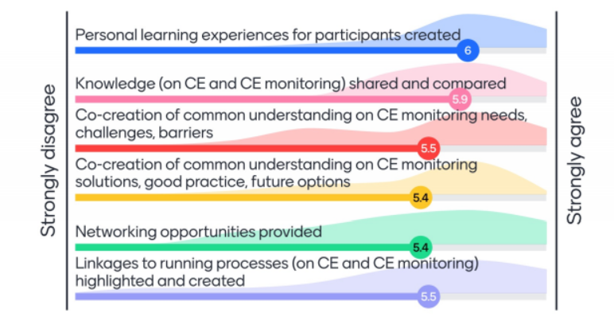

Figure 6.2: How useful did you find the different elements used during the circular economy co-creation process?

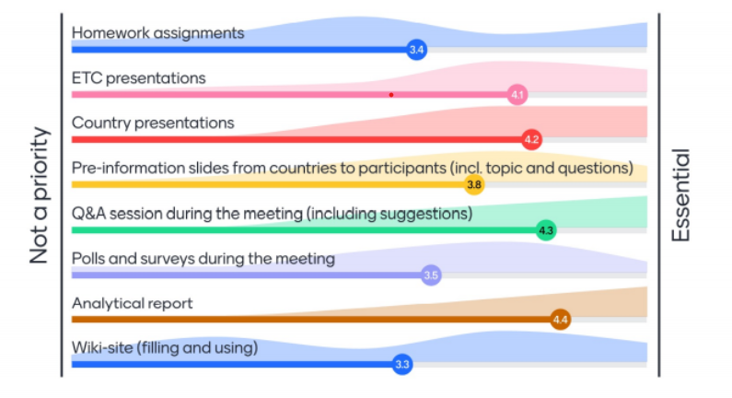

Regarding the different elements used during the co-creation process, participants considered the classical elements such as presentations, discussions and reporting very useful, including the new element of providing suggestions to challenges defined by presenters. The wiki site, homework assignments and poll questions were considered useful but not essential, although one has to bear in mind that additional participants who had not attended the co-creation webinars, joined the expert workshop.

## Bellagio Principles and co-creation process

After a presentation of the Bellagio Principles ([19]), the links to topics addressed during the co-creation process were presented. The Bellagio Principles on the scope and definition of the circular economy, the indicator groups, the need for a wider range of information and data sources, and multi-level monitoring were often addressed during the co-creation process. Less attention was given to the RACER criteria for indicators, the need to link to targets, visibility, and communication aspects. During the co-creation process particular attention was given to additional types of frameworks requiring more and different types of indicator – headline indicators, explanatory indicators, DPSIR indicators, leading/lagging indicators and input/output/outcome/impact indicators. Regarding the mentioned example of Flanders highlighting the need forn systemic indicators, as encouraged by Bellagio Principle 3, several links were added in the chat to show what more is needed to truly monitor systemic needs (<https://en.milieurapport.be/publications/2018-1/environmental-outlook-2018-background-document-towards-a-diagnostics-of-systems-change> )

The poll question on the participants’ interest in the Bellagio Principles to be addressed through a co-creation processes for learning purposes revealed highest interest in the first, which defines the scope of the circular economy transition (Figure 6.3). Several participants suggested that new data sources, multi-level monitoring and the Principles’ relationship to targets were also of interest for a co-creation process.

Figure 6‑3: Which Bellagio Principles are best suited for a co-creation process in the coming years?

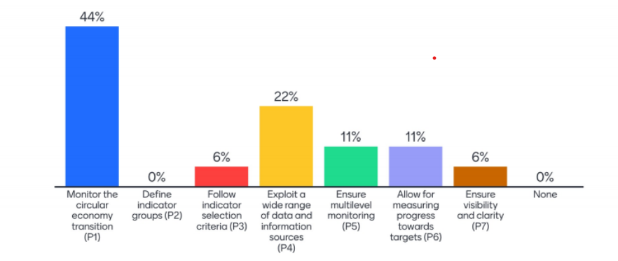

**Some updates:**

The Dutch circular economy monitoring report, published in January 2021, can be found https://www.pbl.nl/sites/default/files/downloads/2021-pbl-icer2021_english_summary-4228_0.pdf.

France published the update and revision of its circular economy monitoring indicators in April 2021 (<https://www.statistiques.developpement-durable.gouv.fr/indicateurs-cles-pour-le-suivi-de-leconomie-circulaire-edition-2021>) .The English version, *Key Indicators for Monitoring the Circular Economy – 2021* *Edition*, will follow soon.

## Revision of the EU circular economy monitoring framework

The Directorate General for the Environment presented the status of the revision process. After publishing the EU circular economy monitoring framework in 2018 the EU Council, the Economic and Social Committee and the European Parliament’s Committee on the Environment, Public Health and Food Safety (ENVI) formulated proposals for improvements. The Circular Economy Action Plan 2020 proposes action to improve existing or develop new indicators, addressing links between circularity, climate neutrality and the zero-pollution ambition. After inter-institutional debate, DG ENV proposes to revise the framework in the context of linking to priorities of the 2020 CEAP, the opinions from other EU institutions and stakeholders, the Bellagio Declaration and the contribution to monitor the 8th Environment Action Plan. The current four main groups of indicators will be extended by a fifth group on global sustainability and resilience. The currently proposed new indicators are shown in Figure 6.4.

Fig 6.4 Proposed new indicators for the revision of the current EU circular economy monitoring framework

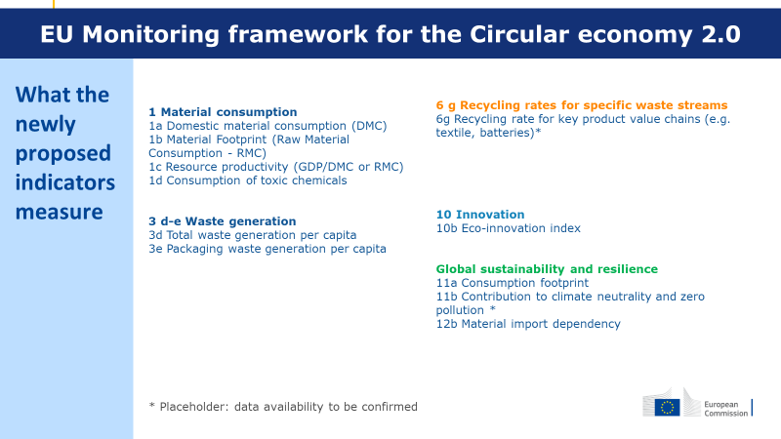

**Source: European Commission**

The European Commission discussion as well as a consultation with Member States and stakeholders will take place during 2021 and publication is expected at the end of 2021.

The question was raised how the co-creation process might influence the circular economy indicator developments at the EU level: the European Commission is reaching out to all stakeholders, including through this workshop, but this co-creation process is not a formal hearing about the initiative, but a shared learning experience across countries, raising the understanding, challenges and opportunities for circular economy monitoring, be it at the EU or national level.

## Follow-up and closing

Participants could send their comments on the draft report until the 17 May 2021, after which the report containing lessons learned will be finished. The EEA will continue to work on circular economy monitoring and circular economy indicators, and will also reach out to stakeholders in the international landscape including the OECD and UN. The co-creation processes will also be evaluated at a future NRC meeting, combining experience from several processes.

All participants are thanked for their contributions!

# References on the wiki

Literature on circular economy monitoring including the ETC/WMGE assessment as provided to participants on the wiki available on the Eionet Forum.

|  |  |  |  |  |  |
| --- | --- | --- | --- | --- | --- |
| Field | | Source | | Summary information | Key message for circular economy monitoring |
| General/ monitoring | Haas, W., Krausmann, F., Wiedenhofer, D. and Mayer, A., 2020, ‘Spaceship Earth’s odyssey to a circular economy – a century long perspective’. *Resources, Conservation & Recycling*, 163(105076). <https://doi.org/0.1016/j.resconrec.2020.105076> (accessed 5 June 2021). | | The paper gives insights into the distance-to-target regarding a full circular economy. For the first time, a century long perspective is taken to reveal the development of substantially growing material flows. The authors in particular point to the problem that a major part of all material flows is used “to manufacture or operate stocks”, hence retaining considerable amounts of materials from potential recycling processes. Realising the transformative potential of the circular economy requires addressing key challenges: limit the growth of material stocks, establish clear criteria for ecological cycling, avoid unsustainable biomass production, integrate the decarbonisation of energy systems in circular economy strategies, and prioritize absolute reductions of non-circular flows over maximising (re)cycling rates. | | It is necessary to monitor trends in material flows over time in absolute terms too, and not only as rates. |
| General/ monitoring | **Eco-Innovation Observatory. 2020.** ‘The Eco-Innovation Scoreboard and the Eco-Innovation Index. <https://ec.europa.eu/environment/ecoap/indicators/index_en>  and <https://ec.europa.eu/environment/ecoap/indicators/circular-economy-indicators_en> . Next report 2020 will be released shortly. | | The Eco-Innovation Scoreboard (Eco-IS) and the Eco-Innovation Index illustrate the eco-innovation performance across EU Member States. They aim to capture different aspects of eco-innovation by applying 16 indicators grouped into five dimensions: eco-innovation inputs, eco-innovation activities, eco-innovation outputs, resource efficiency and socio-economic outcomes. Links between eco-innovation and the circular economy have been strengthened and the revised index also encompasses new circular economy indicators such as data on employment and revenue in eco-industries and the circular economy. The project also includes 28 country profiles. | | Eco-innovation (monitoring) is an indispensable element of circular economy transition. |
| General/ monitoring | Mayer, A., Haas, W., Wiedenhofer, D., Krausmann, F., Nuss, P. and Blengini, G.A. 2019. ‘Measuring Progress towards a Circular Economy - A Monitoring Framework for Economy-wide Material Loop Closing in the EU28’. *Journal of Lndustrial  Ecology*, *23*(1), 62–76. <https://doi.org/10.1111/jiec.12809> (accessed 5 June 2021). | | The paper investigates the material flows in the four well-known material groups through the EU28 economy depicting that secondary materials only count for a small part of material input needed to run the economy (approximately 9 per cent in 2014). The authors state that “recycling was surprisingly low, considering the fact that the EU-28 has strict waste regulations, elaborate waste collection and recovery systems, and high material category-specific recovery rates that range from 25 per cent for biomass to 70 per cent for metals”. The authors propose a comprehensive set of indicators that measure the scale and circularity of total material and waste flows and their socioeconomic and ecological loop closing by contrasting input and output oriented circular economy indicators. | | Approach shows the input-and output-side of circular economy indicators. |
| General/ monitoring | Moraga, G., Huysfeld, S., Mathieux, F., Blengini, G.A., Alaerts, L., Van Acker, K., Meester, S. de, and Dewulf, J. 2019. **‘**Circular economy indicators**?**What do they measure?’ *Resources, Conservation & Recycling* 146, 452–461. <https://doi.org/10.1016/j.resconrec.2019.03.045> (accessed 5 June 2021). | | The paper develops a classification framework to categorise indicators according to reasoning on what (circular economy strategies) and how (measurement scope). To illustrate the classification framework, the authors select quantitative micro-scale indicators (products, businesses, and companies) from literature and macro-scale indicators from the EU circular economy monitoring framework. It shows that most of the indicators focus on the preservation of materials, with strategies such as recycling. However, micro-scale indicators can also focus on other circular economy strategies considering a lifecycle Thinking approach, while the European indicators mostly account for materials often without taking life cycling thinking into account. None of the available indicators can assess the preservation of functions instead of products, with strategies such as sharing platforms, schemes for product redundancy or multifunctionality. This calls for a wider and advanced set of indicators. | | None of the currently available indicators can assess the preservation of functions instead of products. |
| General/ monitoring | Eurostat Manuals and guidelines. 2014. *Towards a harmonised methodology for statistical indicators, Part 1: Indicator typologies and terminologies*.  <https://ec.europa.eu/eurostat/documents/3859598/5937481/KS-GQ-14-011-EN.PDF/82855e3b-bb6e-498a-a177-07e7884e9bcb> (accessed 5 June 2021). | | The publication aims to provide a point of reference for general questions about indicators and indicator sets: why we use them, what they can measure, and how they represent reality by referring to the existing literature on indicators and to concrete examples drawn from the experience of Eurostat and the European Commission as a whole, as well as other national and international institutions.  This paper is the first in a series of three papers on statistical indicators published by Eurostat. A second paper on communicating through indicators and a third on the relevance for policy making were published in 2017. | | Information about indicators in general. |
| General/ monitoring | Eurostat Manuals and guidelines, 2017. *Towards a harmonised methodology for statistical indicators, Part 2: Communicating through indicators.*  <https://ec.europa.eu/eurostat/documents/3859598/7862432/KS-GQ-17-001-EN-N.pdf/3a226be6-efe0-4668-b09f-3dcd20f8ff11> (accessed 5 June 2021). | | Indicators are used in many areas of social and environmental science, economics, business, and project management. Vast empirical experience of communicating through indicators now exists. However, only limited attempts to develop a methodology for this topic have so far been carried out. The purpose of this paper is to make an initial summary of the existing best practice on this theme encompassing communication and statistical knowledge. The paper should be regarded as an occasion to raise awareness and stimulate debate about what is good communication through statistical indicators.  This paper is the second in a series of three papers on statistical indicators published by Eurostat. A first, on Indicator typologies and terminologies, was published in 2014. The third paper on televance for policy was publshed in 2017. | | Information about indicators in general. |
| General/ monitoring | Eurostat Manuals and guidelines. 2017. *Towards a harmonised methodology for statistical indicators, Part 3: Relevance for policy making*.  <https://ec.europa.eu/eurostat/documents/3859598/8071770/KS-GQ-17-007-EN-N.pdf/7d34c904-2d07-4e71-bd6f-8fe9ee373b60>(accessed 5 June 2021). | | This paper aims to help professionals who develop, produce and communicate policy indicators. It analyses how indicators are used at particular stages of the policy-making process; it considers the implications of the increasing role of statistical indicators in policy making for official statisticians and indicator developers; finally, it includes recommendations on how to develop and maintain policy relevant indicators. And in describing the opportunities and pitfalls of indicator use in the policy making process, the paper is also relevant for policy makers using the indicators.  This paper is the last in a series of three papers on statistical indicators published by Eurostat. The first on indicator typologies and terminologies was published in 2014 and the second on communicating through indicators in 2017. | | Information about indicators in general. |
| Metrics for circular economy monitoring | Parchomenko, A., Nelen, D., Gillabel, J. and Rechberger H. 2019. ‘Measuring the circular economy – A Multiple Correspondence Analysis of 63 metrics’. *Journal of Cleaner Production*, 210, pp. 200–216. <https://doi.org/10.1016/j.jclepro.2018.10.357> (accessed 5 June 2021). | | The authors observed there is no generally accepted framework that allows monitoring progress towards a circular economy. The paper analyses existing assessment methodologies and the corresponding metrics that cover different and varied aspects of the circular economy transition. The main contribution of this paper is the provision of a structured picture of the current stock of circular economy metrics. Sixty-three circular economy metrics were assessed and 24 features relevant to a circular economy, such as recycling efficiency, longevity and stock availability. The analysis identified three main clusters of metrics, (1) a resource-efficiency cluster, (2) a materials stocks and flows cluster, (3) a product-centric cluster. The analysis shows a poor integration of resource-efficiency and product-centric perspectives, while the product-centric and system-dynamic perspectives are least frequently assessed. A standardised visualisation framework for circular economy metrics is provided, which allows the comparison of individual metrics in a simple and illustrative way. | | Monitoring progress towards a circular economy requires a balanced set of metrics that covers all its relevant features. |
| Spatial system boundaries | Graedel, T., Reck, B., Ciacci, L. and Passarini, F. 2019. ‘On the Spatial Dimension of the Circular Economy. Resources’, 8(1), 32. <https://doi:10.3390/resources8010032> (accessed 5 June 2021). | | The authors observe that circular economy approaches thus far are clearly focused on materials, often considering a regional, mostly European scale. It is, however, economically impractical to imagine that a circular economy system can be realised within arbitrary geographical borders, due to globalised systems of production and consumption. In a case study on the national lifecycle stages of four metals and one alloy, yhe authors show that a material flow approach is useful to highlight the magnitude of carbon emissions embodied in international trade, but that production-based emissions inventories may be preferable for demonstrating implications to global climate policy. They conclude that the circular economy must be conceived at the global level, and must be cognisant of the losses that are inevitable at every life stage, and that the circularity concept should not be slavishly followed to the detriment of other environmental goals. A truly circular economy can only be realised at the global level. | | The monitoring of environmental and economic effects of regional or national circular economy strategies is only meaningful when considering the global level. |
| Rebound effects | Zink, T. and Geyer, R. 2017. ‘Circular economy rebound: The case of online peer-to-peer boat sharing’. *Journal of Industrial Ecology*, 21(3), 593-602.  <https://doi.org/10.1016/j.rcrx.2019.100028> (accessed 5 June 2021). | | The authors observe that idea of substituting lower‐impact secondary production for environmentally intensive primary production gives the circular economy a strong intuitive environmental appeal. They found that the central tenet behind the environmental merits of the circular economy is whether secondary production activities actually reduce, or displace, primary production. If so, the intuitive promise of the circular economy is achieved; if not, we are left with the impacts of increased secondary production in addition to the impacts of primary production. Circular economy rebound occurs when circular economy activities, which have lower per‐unit‐production impacts, also cause increased levels of production, reducing their benefit. The paper describes the mechanisms that cause circular economy rebound, which include the limited ability of secondary products to substitute for primary products, and price effects. They then offer some potential strategies for avoiding such rebound. | | Monitoring methods of circular economy effects should carefully consider the substitution potential of (products with) secondary raw materials in order to account for the risk of rebound effects. |
| EU Circular Economy Action Plan | Pantzar, M. and Suljada, T. 2020. *Delivering a circular economy within the planet’s boundaries: An analysis of the new EU Circular Economy Action Plan*. Institute for European Environmental Policy (IEEP) and Stockholm Environment Institute (SEI).  <https://ieep.eu/publications/an-analysis-of-the-new-eu-circular-economy-action-plan> (accessed 5 June 2021). | | This publication’s analysis assesses to what extent action included in the new EU Circular Economy Action Plan that relate to demand may help reduce environmental pressures and contribute to a more circular European economy within planetary boundaries**.** Attention is also paid to an analysis ofupdating the circular economy monitoring framework to reflect new policy priorities and develop further indicators on resource use, including consumption and material footprints. | | Analysis of the EU circular economy monitoring framework. |
| Circular economy indicators for business | WBCSD. 2020. ‘Circular transition indicators V1.0 - Metrics for business, by business’. World Business Council for Sustainable Development.  <https://www.wbcsd.org/Programs/Circular-Economy/Factor-10/Metrics-Measurement/Resources/Circular-Transition-Indicators-V1.0-Metrics-for-business-by-business> (accessed 5 June 2021). | | The publication deals with the results of the work of 26 WBCSD member companies on circular transition indicators (CTI). These form an objective and quantitative framework for companies of any industry, value-chain position and size to consistently measure their circularity and understand the associated risks and opportunities to the business. Through this framework, companies can understand their progress in moving towards circularity, monitor this over time, and use it to inform key decisions and advise key stakeholders. It also contains a user´s manual to the CTI online tool that structures data and calculates the outcome (www.ctitool.com). | | Circular transition indicators online tool for business |
| Circular economy monitoring in cities | OECD, 2020. *The Circular Economy in Cities and Regions*. Organisation for Economic Co-operation and Development.  <https://www.oecd.org/regional/cities/circular-economy-cities.htm> (accessed 5 June 2021). | | The publication reports on a survey that gathered data and information on the status of the circular economy in 31 cities and three regions, and the main tools, obstacles and good practice available to date. The survey targeted cities and regions at any level of implementation of circular economy initiatives, from pioneers to newcomers. The OECD is developing a set of tools for a circular economy framework. First is key input, process and output indicators regarding circular economy initiatives in place, with a focus on the economic and social aspects; second is a scoreboard for measuring how circular a city/region is, based on key dimensions, such as innovation, system change, jobs and skills, economic and finance; and third, a functional approach and a self-assessment tool to identify whether governance conditions are in place, work well or need to be improved. | | The survey gathered data and information on the status of the circular economy in 34 cities and regions. |
| LCA and impact of consumption | JRC. 2019. *Indicators and assessment of the environmental impact of EU consumption – Consumption and Consumer Footprints for assessing and monitoring EU policies with Life Cycle Assessment*. European Commission’s Joint Research Centre. https://eplca.jrc.ec.europa.eu/uploads/Science_for_policy_report_final_on_line.pdf (accessed 5 June 2021). | | This report provides an overview of the result of the application of lifecycle assessment (LCA) to assess the environmental impacts of consumption in the EU as a basis to support policies and to improve the appraisal of their impacts and benefits. This study has proposed the implementation of different LCA-based approaches to estimate environmental pressures and impacts due to EU consumption, distinguishing 16 impacts on the environment and resources (for example, climate change, freshwater ecotoxicity, land use and water use). The assessment has been performed at different scales: the EU as whole, 28 individual Member States, sectors and products, and individual citizens. It is the first study that systematically explores different approaches to model the impact of EU consumption, to evaluate the decoupling of EU economic growth from environmental degradation (including 16 impact categories), comparing their results, including assessment to the planetary boundaries and aiming towards a single headline indicator, a weighted score of the 16 environmental impacts covered, for communicating these results. | | The application of LCA to assess the environmental impacts of consumption in the EU. |
| Solutions, good practice, future options | Milios, L. 2020. *Policy Framework for Material Resource Efficiency - Pathway Towards a Circular Economy*. The International Institute for Industrial Environmental Economics, Lund University  <https://portal.research.lu.se/portal/files/77553169/PhDthesis_LM_web.pdf> (accessed 5 June 2021). | | This doctoral thesis traces the theoretical and political lines from the material efficiency policies towards an integrated circular economy and provides an overview of the gaps in the policy framework, the obstacles to implementation, potentials and the enabling conditions of a circular economy. | | Overview of the gaps in the circular economy policy framework. |
| Drivers and barriers | Grafström, J. and Aasma, S. 2020. **Breaking Circular Economy Barriers**. The Ratio Institute, Stockholm. https://www.researchgate.net/publication/343988095_Breaking_Circular_Economy_Barriers?channel=doi&linkId=5f4cc3e5299bf13c5064c0ad&showFulltext=true (accessed | | Implementation of a circular economy in most areas is generally slow. This paper examines the potential causes off this and illustrates different types of barriers – technological, market, institutional and cultural. The systematic literature review revealed the most cited barriers as: 1) lack of a market and bad institutions; 2) inconsistent policies across countries and for trade; 3) high up-front investment costs with poor access to finance; 4) low consumer awareness; and 5) externalities not internalised through taxes and subsidies. | | Investigation of circular economy barriers and their implications. |
| Drivers and barriers | Kirchherr, J., Piscicelli, L., Bour, R., Kostense-Smit, E., Mukker, J., Huibrechtse-Truijens, A. and Hekkert, M. 2018. ‘Barriers to the Circular Economy: Evidence from the European Union’, *Ecological Economics*, 150 (2018), pp. 264-272. <https://doi.org/10.1016/j.ecolecon.2018.04.028> (acccessed 5 June 2021). | | Limited progress has been accomplished regarding the implementation of the circular economy concept. Most scholarly studies blame this on various technological barriers. The authors find that cultural barriers, particularly a lack of consumer interest and awareness as well as a hesitant company culture, are considered the main circular economy barriers by businesses and policy makers. These are driven by market barriers which, in turn, are induced by a lack of synergistic governmental intervention to accelerate the transition towards a circular economy. | | *Inter alia*, provides a visual overview of the core circular economy barriers and their possible interaction, hampering the transition to a circular economy. |
| Drivers and barriers | Morseletto, P. 2020. ‘Targets for a circular economy’. *Resources, Conservation and Recycing*, 153 (2020), 104553. <https://doi.org/10.1016/j.resconrec.2019.104553> (accessed 5 June 2021). | | The paper examines which targets can facilitate the transition to a circular economy, focusing both on existing and new targets. A framework, based on ten common circular economy strategies of recover, recycling, repurpose, remanufacture, refurbish, repair, reuse, reduce, rethink and refuse, is applied to scrutinise the selected targets. The study clarifies that existing targets for recovery and recycling do not necessarily promote a circular economy, despite being the most commonly applied targets so far. Due to the lack of efficacy of recovery and recycling, targets should favour other circular economy strategies. | | This shows the need for an expanded set of new targets. |



European Topic Centre on Waste and Materials   
in a Green Economy

Boeretang 200

BE-2400 Mol

Tel.: +32 14 33 59 83

Web: wmge.eionet.europa.eu

Email: [etcwmge@vito.be](mailto:etcwmge@vito.be)

The European Topic Centre on Waste and Materials in a Green Economy (ETC/WMGE) is a consortium of European institutes under contract of the European Environment Agency.

1. () Belgium, Estonia, France, Germany, Kosovo, Serbia, Slovenia and Sweden
2. () Technological Forecasting & Social Change 74 (2007) 413–432
3. () New publication: Sustainability Transitions Research – DRIFT. https://drift.eur.nl/new-publication-sustainability-transitions-research/
4. () Belgium-Flanders, Estonia, Finland, Poland, Slovenia
5. () See https://circulareconomy.europa.eu/platform/strategies
6. () See https://ec.europa.eu/environment/ecoap/
7. () Nomenclature statistique des activités économiques dans la Communauté européenne (NACE)/Statistical Classification of Economic Activities in the European Community
8. **RACER** = relevant, acceptable, credible, easy and robust
9. () <https://ringmajandus.envir.ee/sites/default/files/Strateegia%20-%20fotod/1.2%20Ringmajanduse%20indikaatorid%20l%C3%B5pparuanne%20050719.pdf>
10. () [Circulytics - measuring circularity (ellenmacarthurfoundation.org)](https://www.ellenmacarthurfoundation.org/resources/apply/circulytics-measuring-circularity)
11. () More information is available at: https://ec.europa.eu/environment/industry/stationary/ied/evaluation.htm
12. ) [Open Data Platform (footprintnetwork.org)](https://data.footprintnetwork.org/#/)
13. () More information is available at https://www.bmu.de/en/topics/economy-products-resources-tourism/resource-efficiency/overview-of-german-resource-efficiency-programme-progress/
14. () Umwelt Bundesamt (Germany's central environmental authority)
15. () DPSIR refers to the causal framework for describing the interactions between society and the environment adopted by the EEA: driving forces, pressures, states, impacts, responses – an extension of the pressure, state, response (PSR) model developed by the OECD (<https://www.eea.europa.eu/help/glossary/eea-glossary/dpsir>).
16. () Parchomenko et al. (2019) available on the wiki
17. ) Kravchenko, M., Pigosso, D.C. and McAloone, T.C. 2020*.* ‘A Procedure to Support Systematic Selection of Leading Indicators for Sustainability Performance Measurement of Circular Economy Initiatives’*. Sustainability,* 12(3), 951
18. () [Monitoring progress in Europe's circular economy — European Network of the Heads of Environment Protection Agencies (EPAs) (europa.eu)](https://epanet.eea.europa.eu/reports-letters/monitoring-progress-in-europes-circular-economy)
19. () [Monitoring progress in Europe's circular economy — European Network of the Heads of Environment Protection Agencies (EPAs) (europa.eu)](https://epanet.eea.europa.eu/reports-letters/monitoring-progress-in-europes-circular-economy)