Draft indicator factsheet D5-coastal waters

SUMMARY INFORMATION

Indicator name: D5-coastal waters incorporating assessments for D5C1 Nutrient concentrations, D5C2 - Chlorophyll a in the water column D5C4: Secchi depth (transparency) D5C5- Dissolved oxygen in the bottom of the water column, D5C6 Opportunistic macroalgae of benthic habitats, D5C7 Macrophyte communities of benthic habitats and D5C8 Macrofaunal communities of benthic habitats

- Indicator summary: This indicator fact sheets provides the results of the assessment of eutrophication for coastal waters in RO and BG in line with the assessments under the WFD (Directive 2000/60/EC). Coastal waters represent the interface between land and ocean, and in the context of the Water Framework Directive coastal waters include water, that has not been designated as transitional water, extending one nautical mile from a baseline defined by the land points where territorial waters are measured.
- Background/relevance: Eutrophication is caused by excessive inputs of nutrients (nitrogen and phosphorus) resulting from various human activities. High concentrations of nutrients and their ratios form the preconditions for huge algal blooms, reduced water clarity and increased oxygen consumption. Long term nutrient data are key parameters for quantifying the effects of human activities and evaluating the success of measures undertaken.
- Relevant criterion/a: D5C1, D5C2, D5C4, D5C5, D5C6, D5C7, D5C8

MAIN ASSESSMENT

- Status and trends:
Based on the assessment on coastal waters for both countries it can be concluded that 22 water bodies only 3 water bodies are in good status, for all other the situation is mainly moderate to poor. The Romanian water body ROCT02 from Eforie North to Vama Veche is only partly in good status. For one water body (ROCT01CAPM -Mangalia Lake) the status us unknown.

The main reasons for this situation are the inflows from rivers, agricultural production in coastal zones and waste water discharge.

- Map:

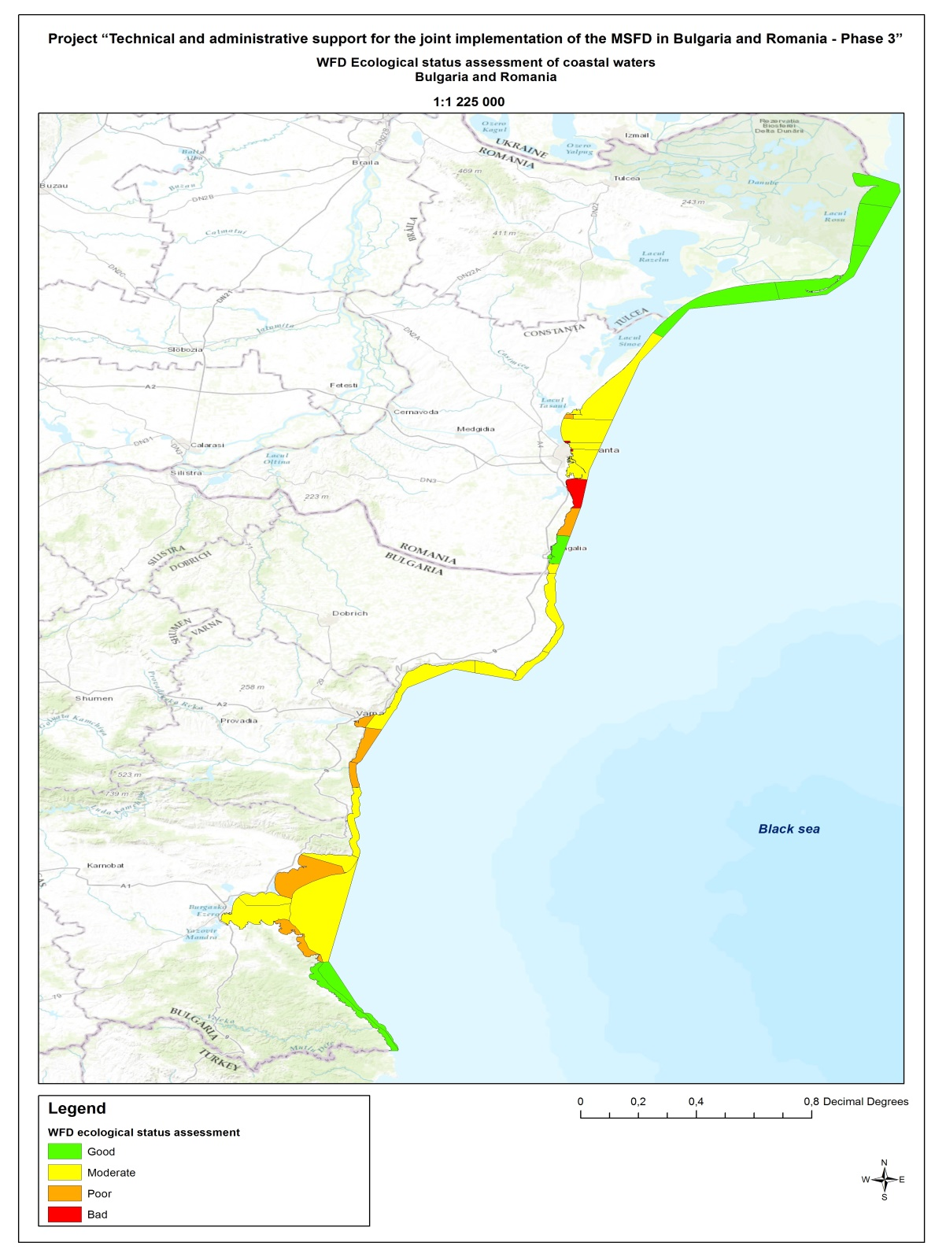
Map 1: Ecological status of coastal water bodies under the Water Framework Directive 2000/60/EC

- Figures:

- Tables:
Status of coastal water bodies in RO and Bulgaria
Water Body type | MS | Code of coastal water body | Name of coastal water body | Ecological status
coastal waters | BG | BG2BS000C001 | from Durankulak to cape Shabla | 3
coastal waters | BG | BG2BS000C002 | from cape Shabla to Kamen bryag | 3
coastal waters | BG | BG2BS000C1003 | from Kamen bryag to cape Kaliakra | 3
coastal waters | BG | BG2BS000C1004 | from cape Kaliakra to Kavarna | 3
coastal waters | BG | BG2BS000C1013 | from Kavarna to cape Galata | 3
coastal waters | BG | BG2BS000C005 | Varna Bay | 4
coastal waters | BG | BG2BS000C1113 | from cape Galata to resort "Kamchia" | 4
coastal waters | BG | BG2BS000C1006 | from resort "Kamchia" to Shkorpilovtsi | 4
coastal waters | BG | BG2BS000C1007 | from Shkorpilovtsi to cape Emine | 3
coastal waters | BG | BG2BS000C1008 | from cape Emine to Saint Vlas | 3
coastal waters | BG | BG2BS000C1108 | from Saint Vlas to Pomorie | 4
coastal waters | BG | BG2BS000C1208 | from Pomorie to Sarafovo | 3
coastal waters | BG | BG2BS000C1308 | South Burgas Bay < 30 m | 3
coastal waters | BG | BG2BS000C1011 | from cape Akin to cape Malsen nos | 4
coastal waters | BG | BG2BS000C1010 | Burgas Bay > 30 m | 3
coastal waters | BG | BG2BS000C1012 | from cape Maslen nos to Rezovska river mouth < 30 m | 2
coastal waters | BG | BG2BS000C1112 | from cape Maslen nos to Rezovska river mouth > 30 m | 2
Transitional waters | RO | ROTT03 | from Chilia to Periboina | 2
Coastal waters | RO | ROCT01 | from Periboina to cape Cap Singol | 3
Coastal waters | RO | ROCT01CAPM | Mangalia Lake
Coastal waters | RO | ROCT02 | from Eforie North to Vama Veche | 5
 |  |  |  | 4
 |  |  |  | 2
 |  |  |  | 3
Coastal waters | RO | ROCT02CAPM | from Cap Singol to Eforie North | 3
Status: 1: High; 2: Good; 3: Moderate; 4: Poor; 5: Bad

- Confidence assessment:
Bulgaria: Low/Medium/High (explanation)
Romania: Low/Medium/High (explanation)

- Knowledge gaps:
Bulgaria:
Romania:
Text description of uncertainties and data/knowledge gaps in the assessment (i.e. reasons why confidence is "medium" or "low")

SUPPORTING INFORMATION/FURTHER DETAIL/METADATA

- Geographical coverage: BG, RO
- Date of data used for assessment
Bulgaria: July 2013
Romania: July 2013
- Data products: (insert link)
- Contact and ownership
Bulgaria: Black Sea Basin Directorate/Varna/BG
Romania: National Institute for marine research and development "Grigore Antipa"/Constanta/Romania
- Method for assessment (optional):
In general, the criteria used are in accordance with the requirements of Directive 2000/60/EC. More details on the approaches can be found
For Romania:
Abaza, V., Dumitrache C., Filimon A., Oros A., Lazăr L., Coatu V., Țigănuș D., 2016. Ecological assessment of benthic invertebrate fauna from the Romanian marine transitional waters, Journal of Environmental Protection and Ecology, 17(3): 932-941
Abaza, V., Marin O., Filimon A., Dumitrache C., Roșioru D.M., 2016. The status of benthic invertebrate fauna from the Romanian Black Sea ports under present ecological conditions, 16th International Multidisciplinary Scientific GeoConference SGEM 2016, Section Marine and Ocean Ecosystems. Conference Proceedings, Book 3, Vol.II: 901-908
Marin O.,Dimitar B.,Todorov E., 2015. Macrophytobenthic communities from the Romanian Black Sea coast - indicators of the ecological status of coastal water bodies. Cercetări marine – Recherches marines, Constanţa, 45: 195-205. ISSN :0250-3069.
Berov D., Todorov E., Marin O., 2015. BLACK SEA GIG – COASTAL/TRANSITIONAL WATERS - BQE. Technical report, 24 pp.
Moncheva S., L. Boicenco. 2011. Compliance of national assessment methods with the WFD requirements (Romania and Bulgaria) WFD Intercalibrating Phase 2: Milestone 4b report- Black Sea GIG, ECOSTAT Meeting, 17-19 October, Ispra.
Lazăr L., Boicenco L., Oros A., Coatu V., Țigănuș D. 2016. Integrated Assessment of Causes and Effects of the Romanian Black Sea Eutrophication. Proceedings of the International Multidisciplinary Scientific GeoConference SGEM; 2016, Vol. 2., ISBN 978-619-7105-62-9 / ISSN 1314-2704
Luminita Lazar, Laura Boicenco, Colpan Beken, Boryana Dzhurova, Snejana Moncheva, Galina Shtereva, Dan Vasiliu, 2016. Western Black Sea Eutrophication Status according to the Black Sea Eutrophication Assessment Tool, BEAST-MISIS Cruise Results, Cercetari Marine Nr. 46, 48-60. ISSN 0250-3069.
For Bulgaria:

Date of publication/preparation: xxx/(preparation February 2016)

