Annex 4: Structure & first documents on EEA website (task 1.2)
URL: http://projects.eionet.europa.eu/black-sea-marine-region-documents/
Username and password is required.
Structure
- About
- Library
  - General project information
  - Background documents
  - Task 1: Monitoring
    - Template MFS
    - Monitoring fact sheets
    - Related CBE
  - Task 2: Technical and scientific needs
    - Consultation
    - Comparative analysis
    - Research projects
    - Related CBE
  - Task 1.3: EEA webpage
    - Related CBE
  - Task 1.4: Public webpage
    - Related CBE
  - Task 2: Capacity Building Events
    - CBE Calendar
    - CBE Action points
    - CBE Matrix experts
    - CBE Templates
- Member search
- Events
- IG search
- Help

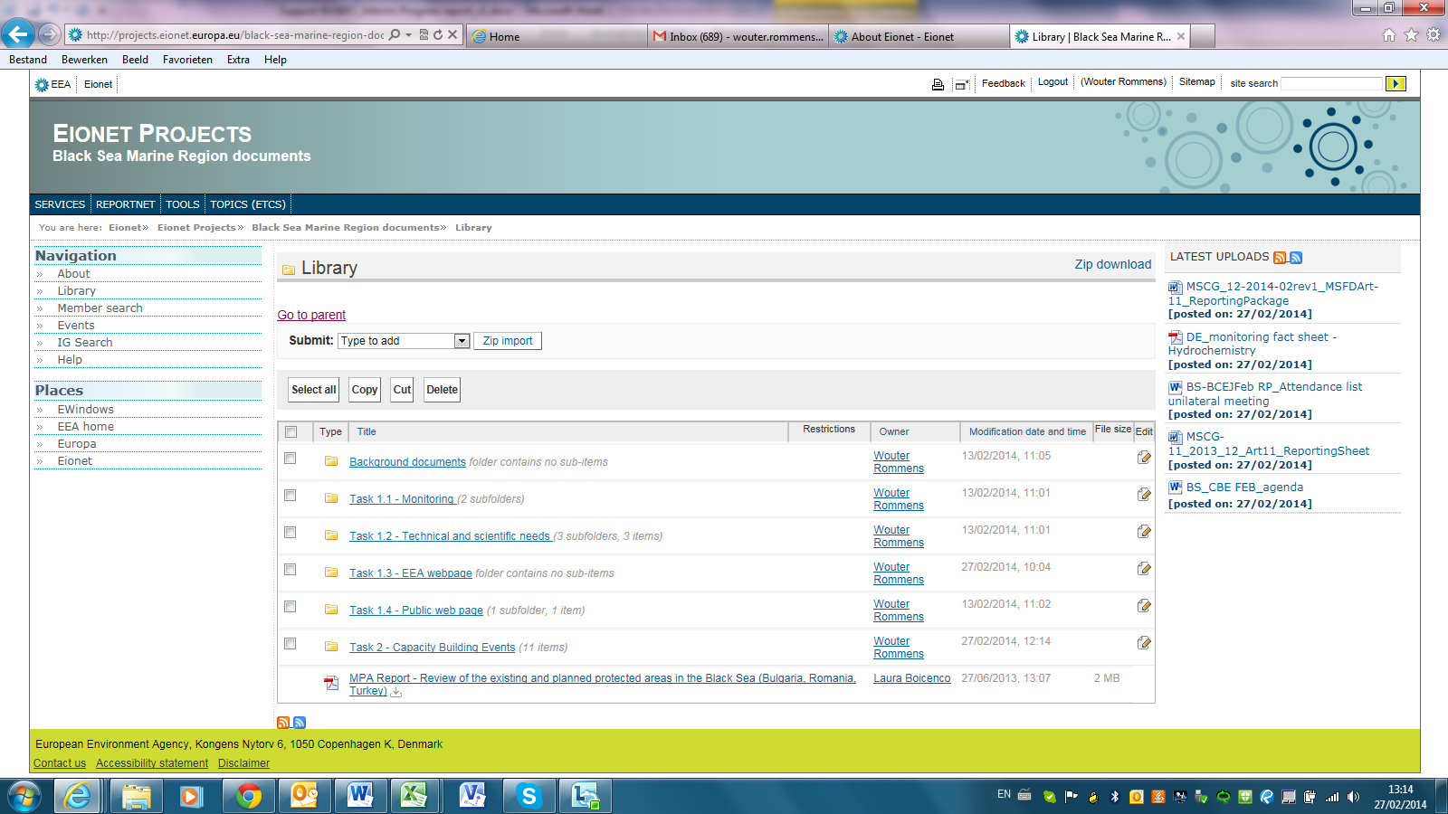

The first available documents have been published on the website and have been put in the folder structure. As more documents will become available over the course of the project, these will be uploaded and made available on a continuous basis.
The participants of the project have been made aware of the website via email and have been requested to ask a username and pw to the helpdesk of EIONET.

Example of folder with document:
