MONITORING FACT SHEET
Country: | ROMANIA
Author: | Vasiliu Dan Lucian
Institute: | National Research and Development Institute for Marine Geology and Geoecology – GeoEcoMar

MONITORING FACT SHEET TEMPLATE
Title: Hydrographical changes
1. General
1.1 Subject area | Programme name: Hydrographical changes  Programme ID: BLKRO-D7

1.2 Definition/Description | Definition of items monitored/description of general approach  The approach of MSFD Descriptor 7 is not uniform at EU level; different countries have not the same interpretation of the scope of this descriptor and especially of the definition of “permanent alteration of hydrographical conditions”. Some countries approach this descriptor close related to Environmental Impact Assessment Directive by tracking and recording the licensing applications proposed developments large enough to have the potential to alter hydrographical conditions, other ones, among them Romania, focus their monitoring efforts on hydrologic conditions considering, quite considerable, also the climate variability.  Monitoring undertaken for the WFD on hydro-morphological changes in coastal waters is also important for meeting the requirements of the MSFD, especially given that the majority of current permanent alterations to hydrographical conditions arise from human activities occurring in coastal marine waters  The main organizations dealing with the current programme are NIMRD and GeoEcoMar (RWNA is responsible for WFD monitoring related to hidrographic conditions).  The program is addressing to state and impact parameters related to:  water column  - physical–chemical: temperature, conductivity/salinity, pH, turbidity (in water column and water-sediment interface)  - physical: currents (velocity, direction), waves (height), sea level  seabed habitats  - distribution and extent  - physical and sedimentology characteristics: bathymetry, grain size, etc  - coastal processes: coastal erosion, accretion  For some parameters (temperature, salinity, currents, sea level), long term data are available, thus trends can be derived. New monitoring tools have been developed so that some parameters (temperature, salinity, turbidity, pH, currents) are measured in near-real time, therefore more valuable information and knowledge are provided for a better understanding of the consequences of changes in hydrological regime on habitats.  Sedimentology and physical processes (upwelling, water masses stratification, etc) are considered by the programme by developing models/scenarios, marine spatial planning, but this approach is quite poor developed.  Also the programme is addressing to the human activities which impacted on hydrographical conditions by measuring their distribution/extent and intensity.
1.3 Competent authority/ies | Ministry of Environment and Climate Change http://www.mmediu.ro/  - Department on Waters, Forests and Fisheries - contact point for the Commission
1.4 Monitoring institutions | National Institute for Marine Research and Development “Grigore Antipa”, Constanta http://www.rmri.ro/ - under coordination of the Ministry of National Education  National Research and Development Institute for marine Geology and Geoecology, Bucharest http://www.geoecomar.ro/ - under coordination of the Ministry of National Education
1.5 Additional information | Where can additional information be found (e.g. via a web link)  Black Sea Commission - BSIMAP  http://www.blacksea-commission.org/bsimap.asp  MSFD Guiding Improvements in the Black Sea Integrated Monitoring System (MISIS) project  http://www.misisproject.eu  Integrated Regional monitoring Implementation Strategy in the South European Seas (IRIS -SES) project  http://iris-ses.eu/  Technical and administrative support for joint implementation of MSFD in Bulgaria and Romania  No link available yet  Towards Integrated Marine Research Strategy and Programmes (SEAS-ERA) project - Strategic Research Agenda for the Black Sea Basin  http://www.seas-era.eu/
2. Monitoring requirements and purpose
2.1 Necessity | Listed below are direct references to the monitoring requirements – EU directives, Black Sea Commission agreements, national plans, research programme requirements, other.
MSFD  Articles 8 and 11  Annex III | Art.11.  1. On the basis of the initial assessment made pursuant to Article 8(1), Member States shall establish and implement coordinated monitoring programmes for the ongoing assessment the environmental status of their marine waters on the basis of the indicative lists of elements set out in Annex III and the list set out in Annex V, and by reference to the environmental targets established pursuant to Article 10.  2. Member States sharing a marine region or subregion shall draw up monitoring programmes in accordance with paragraph 1 and shall, in the interest of coherence and coordination, endeavour to ensure that:  (a) monitoring methods are consistent across the marine region or subregion so as to facilitate comparability of monitoring results;  (b) relevant transboundary impacts and transboundary features are taken into account.  Art. 8  The results of monitoring program are required for next cycle of assessment of marine waters. To this end, the parameters related to physical-chemical features and habitat types (Annex III, Table 1), as well as impacts (Annex III, Table 2) must be monitored.  Annex III, Table 1  Characteristics  Physical and chemical features  - topography and bathymetry of the seabed;  - annual and seasonal temperature regime and ice cover, current velocity, upwelling, wave exposure, mixing characteristics, turbidity, residence time,  - spatial and temporal distribution of salinity  - pH, pCO₂ profiles or equivalent information used to measure marine acidification.  Habitat types  - The predominant seabed and water column habitat type(s) with a description of the characteristic physical and chemical features, such as depth, water temperature regime, currents and other water movements, salinity, structure and substrata composition of the seabed,  Annex III, Table 2  Pressures and impacts  Interference with hydrological processes  - significant changes in thermal regime (e.g. by outfalls from power stations),  - significant changes in salinity regime (e.g. by constructions impeding water movements, water abstraction).
WFD  Article 8  Annex V | Art. 8  1. Member States shall ensure the establishment of programmes for the monitoring of water status in order to establish a coherent and comprehensive overview of water status within each river basin district  2. These monitoring programmes shall be in accordance with the requirements of Annex V.
Habitats | Art. 11  Member States shall undertake surveillance of the conservation status of the natural habitats and species referred to in Article 2 with particular regard to priority natural habitat types and priority species.
Environmental Impact Assessment Directive  Article 3 | Art. 3  The environmental impact assessment shall identify, describe and assess in an appropriate manner, in the light of each individual case and in accordance with Articles 4 to 12, the direct and indirect effects of a project on the following factors:  (a) human beings, fauna and flora;  (b) soil, water, air, climate and the landscape
Directive 2001/42/EC on the assessment of the effects of certain plans and programmes on the environment (SEA)  Article 10 | Art. 10  1. Member States shall monitor the significant environmental effects of the implementation of plans and programmes in order, inter alia, to identify at an early stage unforeseen adverse effects, and to be able to undertake appropriate remedial action.
BWD  Article 6  Annex III | Art. 6  2. Bathing water profiles shall be reviewed and updated as provided for in Annex III.  3. When establishing, reviewing and updating bathing water profiles, adequate use shall be made of data obtained from monitoring and assessments carried out pursuant to Directive 2000/60/EC that are relevant for this Directive.  Annex III  1. The bathing water profile referred to in Article 6 is to consist of:  (a) a description of the physical, geographical and hydrological characteristics of the bathing water, and of other surface waters in the catchment area of the bathing water concerned, that could be a source of pollution, which are relevant to the purpose of this Directive and as provided for in Directive 2000/60/EC;
Black Sea Commission  Convention on the Protection of the Black Sea Against Pollution (Art. 15) and its Protocols | Convention on the Protection of the Black Sea Against Pollution  Art. 15.  - The Contracting Parties shall cooperate in conducting scientific research aimed at protecting and preserving the marine environment of the Black Sea and shall undertake, where appropriate, joint programmes of scientific research, and exchange relevant scientific data and information.  Protocol on the Protection of the Marine Environment of the Black Sea from Land-Based Sources and Activities (2009)  Art. 11  1. Within the framework of the provisions of, and the monitoring programmes provided for in Art. 15 of the Convention, and if necessary in cooperation with competent international organisations, the Contracting Parties shall:  a) Collect information and data on the conditions of the marine environment and coastal areas of the Black Sea as regards its physical, biological and chemical characteristics;  c) Systematically asses the state of the marine environment and coastal areas of the Black Sea;  2. The Contracting Parties shall collaborate in establishing a regional monitoring programme as well as compatible national monitoring programmes, and in facilitating data and information storage, retrieval and exchange.
Other plans and/or programmes | Comments  Natura 2000  http://www.natura2000.ro
2.2 GES criteria | List relevant GES Criteria and characteristics [indicators] (see Commission Decision of 1. September 2010)  7.1. Spatial characterisation of permanent alterations  7.1.1. Extent of area affected by permanent alterations  7.2. Impact of permanent hydrographical changes  7.2.1. Spatial extent of habitats affected by the permanent alteration
2.3 Features, pressures and impacts | List relevant features and pressures from MSFD Annex III  Refer to section 6 regarding gaps and plans  Characteristics  Physical and chemical features  - topography and bathymetry of the seabed;  - annual and seasonal temperature regime and ice cover, current velocity, upwelling, wave exposure, mixing characteristics, turbidity, residence time,  - spatial and temporal distribution of salinity  - pH, pCO₂ profiles or equivalent information used to measure marine acidification.  Habitat types  - the predominant seabed and water column habitat type(s) with a description of the characteristic physical and chemical features, such as depth, water temperature regime, currents and other water movements, salinity, structure and substrata composition of the seabed,  Annex III, Table 2  Pressures and impacts  Interference with hydrological processes  - significant changes in thermal regime (e.g. by outfalls from power stations),  - significant changes in salinity regime (e.g. by constructions impeding water movements, water abstraction).
2.4 GES | Assessment of GES (GES as defined in the article 9 reporting)  No GES definition regarding hydrographical conditions has given yet, according to MSFD requirements. Although the programme provides quite well the data/information needed, the poor understanding of the scope of the Descriptor has led to lack of a methodology for GES definition (see Section 6).  The current program addresses considerably to natural and climatic variability so that the difference between the effects resulting from anthropogenic pressures and climatic variability can be determined, but only partially (more knowledge related to the impacts of human activities on hydrographical conditions are needed - see Section 6).
2.5 Environmental targets  MSFD  Habitats  WFD  BSC | Relevant MSFD targets defined in the article 10 reporting  No environmental targets have been established yet according to the MSFD requirement.  More research is needed for developing the methodology to set up the environmental targets and, further, the programme has to be adapted for collecting the necessary data/information in order to provide qualitatively and/or quantitatively targets definitions (see Section 6).  State relevant targets from other obligations (see section 2.1) that are addressed by the monitoring  - maintain the favorable conservation status for relevant habitats and species, in particular those listed in Annexes I and II of the Habitats Directive.  - prevent the deterioration of the status of all WB (no deterioration of the status of all WB)  SAP (2009)  3.2 Long-term Ecosystem Quality Objectives (EcoQOs)  EcoQO 2: Conservation of Black Sea Biodiversity and Habitats.  EcoQO 2a: Reduce the risk of extinction of threatened species  EcoQO 2b: Conserve coastal and marine habitats and landscapes.  To EcoQO 2, BS SAP has awarded a number of management objectives, which overlap many of the MSFD provisions on evaluation, monitoring and determination of good environmental status. However, SAP indicators reflecting specific regional, cross-border issues and priorities, so they do not overlap perfectly over MSFD qualitative descriptors for determining GES.
2.6 Spatial allocation | Table of where monitoring is required
   | EEZ | 12-nm zone | Coastal waters | Transitional waters
  MSFD | X | X | X | -
  WFD | - | X | X | X
  Habitats | X | X | X | X
  BWD | - | - | X | X
  BSC | X | X | X | X
3 Monitoring concept
3.1 General description of relevant subprogrammes in monitoring programme | 1. Seabed habitats - distribution and extent  Elements/features monitored: Seabed habitats  Parameters: Habitats distributional range/pattern; Areal extent of habitat  2. Seabed habitats physical-chemical characteristics  Elements/features monitored: Seabed habitats/physical-chemical characteristics)  Parameters: Physical structure of habitat (e.g. sediment characteristics, topographic structure); Bathymetric depth; concentration of oxygen; pH  3. Water column – physical characteristics  Elements/features monitored: Water column/Oceanography - physical  Parameter: Temperature, salinity, turbidity  4. Water column – hydrological characteristics  Elements/features monitored: Water column/Oceanography - physical  Parameter: Wave action, current velocity, sea level  5. Water column – chemical characteristics  Elements/features monitored: Water column/Oceanography - chemical  Parameter: pH  6. Activities extracting non-living resources (sand, gravel, dredging)  Elements/features monitored: Activity/Dredging  Parameters: Distribution/extent in space and time, intensity  7. Activities with permanent infrastructures (e.g. renewable energy, oil & gas, ports) or structural changes (e.g. coastal defences)  Elements/features monitored: Activity/Marine hydrocarbon (oil and gas) extraction; land/sea physical interaction: land claim, coastal defence; port operations; submarine cable and pipeline operations  Parameters: Distribution/extent in space and time, intensity  8. Coastal human activities (e.g. tourism, recreational sports, ecotourism)  Elements/features monitored: Activity/ Solid waste disposal incl. dredge material; Tourism, recreational sports  Parameters: Distribution/extent in space and time, intensity  9. Land-based activities  Elements/features monitored: Activity/Coastal, riverine and atmospheric inputs from land - industrial discharges; Coastal, riverine and atmospheric inputs from land - agricultural run-off, forestry and emissions; Coastal, riverine and atmospheric inputs from land - municipal waste water discharge  Parameters: Distribution/extent in space and time, intensity  10. Effectiveness of measures  Elements/features monitored: Measures/existing measures  Parameter: to be developed
3.2 Description of monitoring network | NIMRD  Monitoring network comprises 45 sampling stations (bottom depths within 5 – 60 m), covering entire RO coastal waters and, partially, shelf waters. Physical-chemical parameters (temperature, salinity, pH) are measured seasonally at each stations (see Fig. 1)  Daily measurements of temperature, salinity, and sea level are carried out at long-term oncoast stations (in the Constanta area and Sulina).  Currents and wave monitoring are performed in the coastal area, by using three Acoustic Doppler Current Profilers Sentinel 600 Hz in fixed underwater measurements locations or during the scientific cruises carried out in the monitoring network (see Fig. 1).  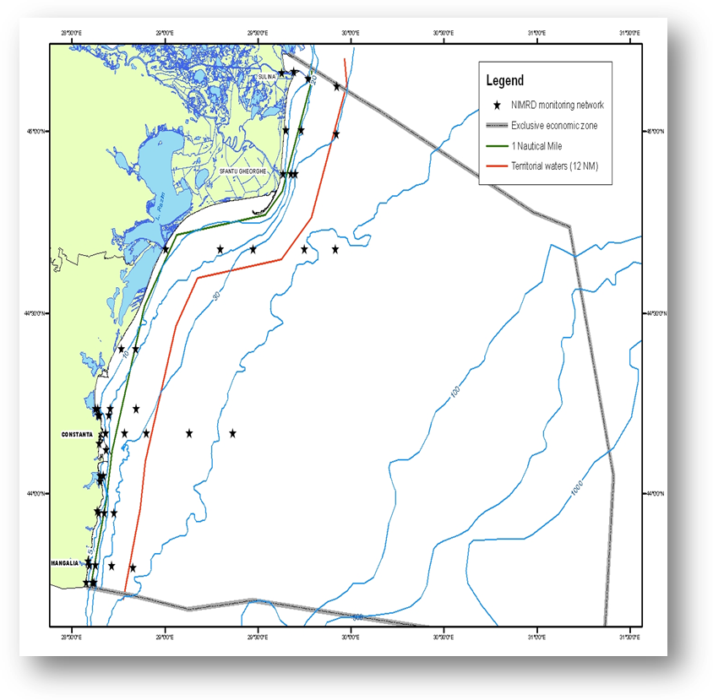  Fig. 1 Map of sampling stations of the environment routine monitoring carried out by NIMRD  GeoEcoMar  Sampling network includes 45 stations with bottom depths between 15 and 200 m, covering the entire RO shelf (Fig. 2). In situ physical-chemical parameters (CTD measurements - pressure/depth, temperature, conductivity/salinity, sigma theta, pH, Eh, light transmission/absorption, turbidity – in water column) and grain-size analyses are performed 1–2 times/year at each sampling station. Also currents measurements are carried out in the coastal area, but not regularly.  Bathymetric measurements covering the entire Romanian shelf waters are performed within the Geological, Sedimentology and Geophysics Mapping Program (scale 1:50000).  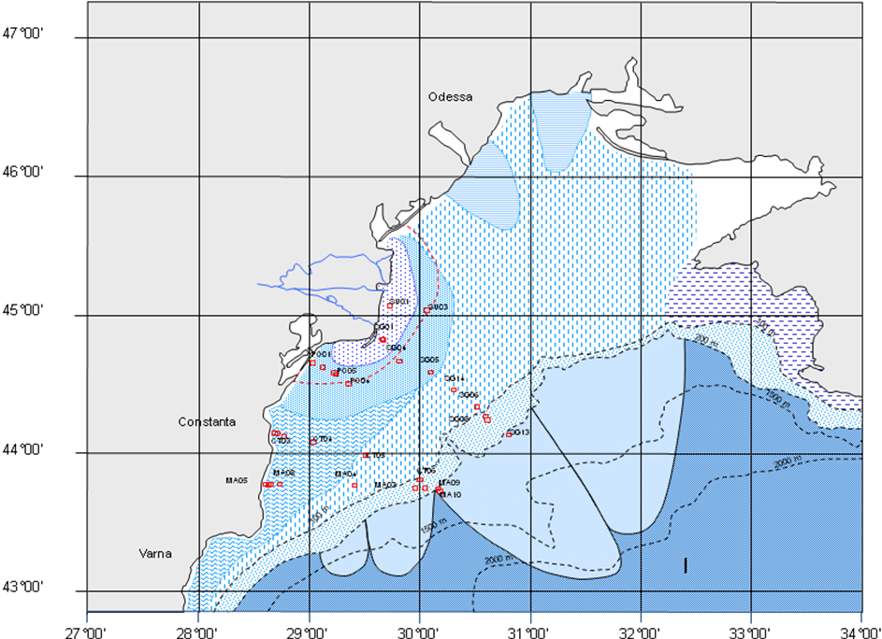  Fig. 2 Map of Geo-Ecomar sampling network  Black Sea Security System (BSSS) – developed (under the Marine Geohazard project) and operated by Geoecomar (RO) and IO-BAS (BG)  - 3 offshore moored observatories (in RO waters, bottom depths between 72 and 90 m) providing near-real time data (from surface layer and 20 m above seafloor)  - 1 coastal sampling station (bottom depth of 15m) (Fig. 3)  Parameters monitored: pressure, temperature, conductivity/salinity, turbidity, currents.  BSSS is extending also in BG waters (2 offshore moored observatories)  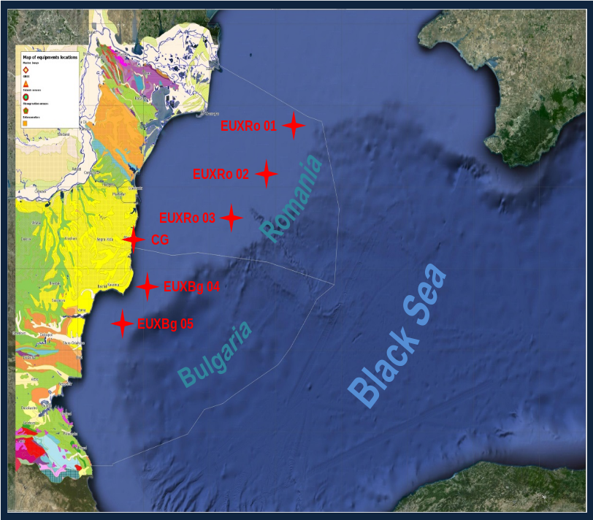  Fig. 3 Map of offsore moored obsvervatories locations
3.3 Threats, activities and measures | Which human activities will be measured by the programme  Relevant activities themes/activities related to the programme are:  Man-made structures (incl. construction phase)/Port operations; submarine cable and pipeline operations; Placement and operation of offshore structures (other than for energy production); Land/sea physical interaction: land claim, coastal defence  Energy production/Marine hydrocarbon (oil and gas) extraction  Extraction of non-living resources/ Dredging  Food production/Aquaculture  Waste disposal/ Solid waste disposal incl. dredge material  Land-based activities/industries/Coastal, riverine and athmospheric inputs from land - industrial discharges; Coastal, riverine and atmospheric inputs from land - agricultural run-off, forestry and emissions; Coastal, riverine and atmospheric inputs from land - municipal waste water discharge  Recreation/Tourism  The programme will address to above mentioned activities by measuring either the distribution in space and time, intensity of some relevant activities or impacts associated (changes in the water column characteristics e.g. temperature, salinity, pH, turbidity, currents; seabed physical characteristics e.g substrata type/structure, bathymetry).  Which measures will be measured by the programme  To be developed
3.4 Data management | How and where are data managed? How and where can data be accessed? (General description – programme level)  Data are reported (either as raw data or data products) through competent authority to EEA, BSC (through AGs – PMA, LBS, and CBD).  Data are also reported (either as metadata or raw data) in databases belonging to other projects (SeaDataNeet, SESAME, PERSEUS, MISIS) from where can be accessed in accordance with the terms of such project.
4. Assessment
4.1 Assessments | Existing assessments  Provide information about or URL links to existing assessments (eg. Initial Assessment)  MSFD (Art. 8) – Initial Assessment  http://cdr.eionet.europa.eu/ro/eu/msfd8910/msfd4text/envuhwuaq  Environmental Status Reports  http://www.rmri.ro/Home/Products.EnvStatusReport.html  State of Environment Report 2001-2006/7  http://www.blacksea-commission.org/_publ-SOE2009.asp  Diagnostic Report for Coastal Zone  http://www.rowater.ro/dadobrogea
4.2 Assessment of GES | Will assessment of GES be carried out by the programme  GES has not defined yet in terms of D 7 - Hydrographical Conditions. So far, the programme cannot be considered fully adequate due to lack of methodology for defining GES and targets (see Section 6).
5. Literature
List of relevant literature
Zampoukas, N., Piha, H., 2011, Review of Methodological Standards Related to the Marine Strategy Framework Directive Criteria on Good Environmental Status, Publications Office of the European Union, 53 pp. http://publications.jrc.ec.europa.eu/repository/handle/111111111/16069
Zampoukas, N., Piha, H., Bigagli, E., Hoepffner,N., Hanke, G., Cardoso, A., 2012, Monitoring for the Marine Strategy Framework Directive: Requirements and Options, Publications Office of the European Union, 42 pp., http://publications.jrc.ec.europa.eu/repository/handle/111111111/23169
Zampoukas, N., Piha, H., Bigagli, E., Hoepffner,N., Hanke, G., Cardoso, A., 2013, Marine monitoring in the European Union: how to fulfil the requirements for the MSFD in an efficient and integrated way, Marine Policy, 39, 349-351
http://publications.jrc.ec.europa.eu/repository/handle/111111111/27825
OSPAR Commission, 2012, Advice document on Hydrographical conditions (MSFD Descriptor 7) http://www.ospar.org/documents/dbase/publications/p00583/p00583_advice_document_d7_hydrographic_conditions.pdf
6. Activities required to implement the concept
6.1 Changes to the current monitoring programme | Necessary changes and recommendations  Describe necessary changes for the programme to cover the requirements of MSFD. Description in general terms.  Recommendations and actions needed:  - increasing financial assistance and securing sustainable financing at national levels  - better integration the MSFD monitoring with the monitoring requirements of the other directives (WFD, Habitats, EIA, etc) and regional sea conventions (BSC)  - better use and coordination of the existing capacities of all organizations dealing with monitoring programme (including monitoring infrastructure sharing) and avoid overlapping of activities and efforts  - permanent agreements with other authorities/organisations in supporting the programme (e.g. Maritime Hydrographical Direction, ROSA, local authorities, Port Authorities, etc)  - strengthen the regional cooperation/harmonization between the Black Sea MS (common MSFD indicators/parameters to be approach, common methodology for the GES and Environmental Targets definitions, common sampling and data processing methodologies); consultations regarding the potential transboundary effects of the human activities and the measures envisaged to reduce or eliminate such effects  - coordinate data and develop methodological standards for monitoring of hydrographical conditions at the scale of marine regions (starting with identification of existing best practice);  - adjust/increased temporal and spatial coverage of the program  - additional indicators/parameters to be included;  - more research needed for developing new parameters to be monitored (e.g. pCO₂, freshwater input rates, etc);  - new monitoring tools to be developed (e.g. satellite images, models, marine spatial planning, etc);  - improving QA/QC  - improving data management
6.2 Gaps: GES information | in time for next assessment in 2018
6.3 Plans: Plans for GES information | If the programme is not considered fully adequate for data and information needs to assess targets, describe what plans are in place to make it fully adequate (eg. to fill gaps in data methods or capacity). Describe timeframe, priorities and obstacles.  Methodology for GES definition has to be developed.  In order to define GES the programme has to provide sufficient and valuable information related to the human activities and climate variability.  OSPAR, 2012 (see Section 5) recommend to consider only the large-scale human activities, such as coastal defence works, land reclamation projects, structures in coastal or open sea (the small-scale ones are well covered by EIA), which may permanently influence the hydrographical regime of currents, waves and sediments (further changes to sediment transportation, bed forms, salinity and temperature which might lead to further positive or negative impacts on species or/and habitat) These take place against a background of much broader scale hydrographical changes, both human induced and otherwise, such as climatic changes, ocean acidification, etc.  More knowledge is needed for develop new tools (models) for understanding the cumulative effects of the impact which should be a baseline for the GES definition.  The programme should be able to provide adequate data/information (financial support and/or better coordination for adjust spatial and temporal resolution of data acquisition are needed) for validate the models.
6.4 Gaps: Target information | in time for the next assessment in 2018
6.5 Plans: Plans for information on targets | If the programme is not considered fully adequate for data and information needs to assess targets, describe what plans are in place to make it fully adequate (e.g. to fill gaps in data methods or capacity). Describe timeframe, priorities and obstacles.  More research is needed for developing the methodology to set up the environmental targets.  For this purpose, a major need (according to OSPAR, 2012 – see Section 5) is to develop the models to assess:  - changes in the condition and extent of areas affected by permanent alterations (this includes changes in currents, upwelling patterns, waves, bathymetry, and salinity). The programme should be able to provide adequate data/information (financial support and/or better coordination for adjust spatial and temporal resolution of data acquisition are needed) necessary because models should be calibrated and continuously supported and validated with “in situ” monitoring datasets.  - changes in the spatial extent of habitats affected by permanent alterations, using field data and validated model data.  - changes in habitats due to altered hydrographical conditions, using field data and validated model data (it is necessary to define the change in function for diverse habitats by interpreting the changes determined in the spatial extent of habitats in terms of food web).  Also, close coordination with the Descriptors 1 (Biodiversity), 4 (Food Web) and 6 (Seafloor integrity) will be necessary due to the links between them. Some of the targets and indicators for these descriptors may also be relevant in relation to Descriptor 7. A link to Descriptor 5 (Eutrophication) should be also made since both are important factors with regard to eutrophication (e.g. in the event that mixing characteristics and/or retention time are changed).
6.5 Plans: Plans for information on measures | If relevant: If the programme is not considered fully adequate for data and information needs to assess measures describe what plans are in place to make it fully adequate (eg. to fill gaps in data methods or capacity). Describe timeframe, priorities and obstacles.  To be developed

