MONITORING FACT SHEET
Country: | ROMANIA
Author: | Vasiliu Dan Lucian
Institute: | National Research and Development Institute for Marine Geology and Geoecology – GeoEcoMar

MONITORING FACT SHEET TEMPLATE
Title: Non-indigenous species
1. General
1.1 Subject area | What is monitored – programme ID (BLKXX-DY)  Programme name: Non-indigenous species  Programme ID: BLKRO-D2
1.2 Definition/Description | Definition of items monitored/description of general approach  NIS problems are emerging at global scale and are difficult to solve since they depend on the chance of recording the newcomers in particular geographic areas in due time. The problems must be integrated in the general study of biodiversity far from some scientists’ fake problem of “hunting after NIS”.  Likewise, it is necessary that NIS multiple potential impacts on the systems should be under permanent monitoring. Spatial and temporal distribution control-monitoring should be a powerful and flexible control system of biodiversity, capable to interfere and record the newcomer in an area; and when an alien species is found, its presence requires an early warning of the scientific community on a large scale.  NIMRD is the main organization dealing with NIS monitoring, but no specific monitoring network is developed for elements concerned. NIS monitoring carries out within the National Integrated Monitoring Program, thus the spatial coverage (coastal and, partially, shelf waters) and sampling frequency (seasonally, except macroalgae – only in the warm season) are similar as those of the other monitoring programmes.  The monitoring activity is focused on:  - pelagic components: phytoplankton, zooplankton, and pelagic fish  - benthic components: macrolalgae, zoobenthos, and demersal fish  Parameters monitored:  State parameters: species composition, species abundance (density and biomass);  Impact parameters are generally poor approached by the programme; only the ratios non-native/native species are monitored  The impacts of NIS introduction on the environment are approached also by other programmes (D1, 4 – Water Column Habitats, D1, 4, 6 – Seabed Habitats, D1, 4 – Fish, and D3 – Commercial Fish and Shellfish).  Pressure parameters are approached by monitoring the distribution in time and space of relevant non indigenous species. The pressure at source level has not approached so far. The biological monitoring of vectors (especially ballast water) is not developed (only occasionally data/information concerning on community composition and species abundance has been provided by NIMRD (within different studies) and other organizations under the coordination of Ministry of Transport.  Additional data/information is provided also within monitoring programmes in NATURA 2000 sites and other marine protected areas (MPA).  The programme refers also to relevant human activities leading to NIS introduction and measures.
1.3 Competent authority/ies | Which authorities are responsible (links to www)  Ministry of Environment and Climate Changehttp://www.mmediu.ro/  - Department on Waters, Forests and Fisheries (contact point for the Commission)  Ministry of Transport http://www.mt.ro/
1.4 Monitoring institutions | Which institutions carry out the monitoring etc (links to www)  National Institute for Marine Research and Development “Grigore Antipa”, Constanta http://www.rmri.ro/ - under coordination of the Ministry of National Education
1.5 Additional information | Where can additional information be found (e.g. via a web link)  Regarding regional coordination remember this project and other relevant joined projects  Black Sea Commission - BSIMAP  http://www.blacksea-commission.org/_bsimap.asp  MSFD Guiding Improvements in the Black Sea Integrated Monitoring System (MISIS) project  http://www.misisproject.eu  Technical and administrative support for joint implementation of MSFD in Bulgaria and Romania  No link available yet  Towards COast to COast NETworks of marine protected areas (from the shore to the high and deep sea), coupled with sea-based wind energy potential (COCONET)  http://www.coconet-fp7.eu  European Maritime Safety Agency  http://emsa.europa.eu/main/ballast-water/involvement.html  Globallast Partnerships  http://globallast.imo.org/index.asp?page=links.htm&menu=true
2. Monitoring requirements and purpose
2.1 Necessity |  | Listed below are direct references to the monitoring requirements – EU directives, Black Sea Commission agreements, national plans, research programme requirements, other.
MSFD  Article 11  Article 8  Annex III |  | Art.11  1. On the basis of the initial assessment made pursuant to Article 8(1), Member States shall establish and implement coordinated monitoring programmes for the ongoing assessment the environmental status of their marine waters on the basis of the indicative lists of elements set out in Annex III and the list set out in Annex V, and by reference to the environmental targets established pursuant to Article 10.  2. Member States sharing a marine region or subregion shall draw up monitoring programmes in accordance with paragraph 1 and shall, in the interest of coherence and coordination, endeavour to ensure that:  (a) monitoring methods are consistent across the marine region or subregion so as to facilitate comparability of monitoring results;  (b) relevant transboundary impacts and transboundary features are taken into account.  Art. 8  The results of monitoring programme are required for the next cycle of assessment of marine waters. To this end, relevant parameters must be monitored for biological features (Annex III, Table 1) and pressures/impacts (Annex III, Table 2):  Annex III, Table 1  Biological features  — an inventory of the temporal occurrence, abundance and spatial distribution of non-indigenous, exotic species or, where relevant, genetically distinct  Annex III, Table 2  Biological disturbances  — introduction of non-indigenous species and translocations,
Habitats Directive  Article 11 |  | Art. 11  Member States shall undertake surveillance of the conservation status of the natural habitats and species referred to in Article 2 with particular regard to priority natural habitat types and priority species.
COUNCIL REGULATION (EC) No. 708/2007 concerning use of alien and locally absent species in aquaculture  Article 18 |  | Art 18.  Alien species shall be monitored after their release into open aquaculture facilities for a period of two years or a full generation cycle, whichever is longer, to assess whether the impacts were accurately predicted or if there are additional or different impacts.
Black Sea Commission  Bucharest Convention (article 15) and its Protocols |  | Convention on the Protection of the Black Sea Against Pollution  Art. 15.  - The Contracting Parties shall cooperate in conducting scientific research aimed at protecting and preserving the marine environment of the Black Sea and shall undertake, where appropriate, joint programmes of scientific research, and exchange relevant scientific data and information.  The Black Sea Biodiversity and Landscape Conservation Protocol  Article 5  1. The Contracting Parties shall take all appropriate measures to regulate an intentional introduction and prevent an accidental introduction of non-indigenous species or genetically modified organisms to the wild flora and fauna and prohibit those that may have harmful impacts on the ecosystems, habitats or species in the area to which this Protocol applies.  2. The Contracting Parties shall endeavour to implement all appropriate measures to eradicate or reduce to an possible level species that have already been introduced when it appears that such species cause or are potentially causing damage to ecosystems, landscapes, habitats or species in the area to which this Protocol applies
International Convention for the Control and Management of Ships' Ballast Water and Sediments (BWM)  Article 6 |  | Art. 6  1. Parties shall endeavour, individually or jointly, to:  (a) promote and facilitate scientific and technical research on Ballast Water Management; and  (b) monitor the effects of Ballast Water Management in waters under their jurisdiction.  Such research and monitoring should include observation, measurement, sampling, evaluation and analysis of the effectiveness and adverse impacts of any technology or methodology as well as any adverse impacts caused by such organisms and pathogens that have been identified to have been transferred through ships‘ Ballast Water.
Convention on Biological Diversity (CBD)  Article 7 |  | Art. 7  Each Contracting Party shall, as far as possible and as appropriate, in particular for the purposes of Articles 8 to 10:  (c) Identify processes and categories of activities which have or are likely to have significant adverse impacts on the conservation and sustainable use of biological diversity, and monitor their effects through sampling and other techniques.
Other plans and/or programmes |  | Natura 2000  http://www.natura2000.ro
2.2 GES criteria |  | List relevant GES Criteria and characteristics [indicators] (see Commission Decision of 1. September 2010)  Descriptor 2  2.1 Abundance and state characterisation of non-indigenous species, in particular invasive species  2.1.1. Trends in abundance, temporal occurrence and spatial distribution in the wild of non-indigenous species, particularly invasive non-indigenous species, notably in risk areas, in relation to the main vectors and pathways of spreading of such species  2. 2. Environmental impact of invasive non-indigenous species  2.2.1. Ratio between invasive non-indigenous species and native species in some well studied taxonomic groups (e.g. fish, macroalgae, molluscs) that may provide a measure of change in species composition (e.g. further to the displacement of native species)
2.3 Features, pressures and impacts |  | List relevant features and pressures from MSFD Annex III  Refer to section 6 regarding gaps and plans  Features  Biological features  — an inventory of the temporal occurrence, abundance and spatial distribution of non-indigenous, exotic species or, where relevant, genetically distinct  Pressure and impacts  Biological disturbances  — introduction of non-indigenous species and translocations,
2.4 GES |  | Assessment of GES (GES as defined in the article 9 reporting)  Romania has not defined GES in terms of NIS. Even if programme partially addresses to indicators related to D2, it has to be improved considerably for providing GES definition (see Section 6).  For some species, the trends could be derived from the programme (only for some parameters), thus, after GES definition, they could contribute to determine the distance to the GES.  The primary introduction of NIS (transfer from the source to the recipient regions) takes place as a result of human activities, thus the programme is addressing only partially to natural variability (related to secondary introduction - spread from the founding site occured through a combination of natural dispersal and human-associated transport mechanisms).
2.5 Environmental targets  MSFD  Habitats  COUNCIL REGULATION (EC) 708/2007  BSC  BWM Convention  Convention on Biological Diversity |  | Relevant MSFD targets defined in the article 10 reporting  Environmental targets related to NIS have not been defined yet.  A significant improvement of the current programme is necessary to provide data/information and knowledge for a better approaching of related indicators/parameters so that the environmental targets can be defined (see Section 6)  State relevant targets from other obligations (see section 2.1) that are addressed by the monitoring  - introduction into the wild of any species which is not native to the MS territory is regulated so as not to prejudice natural habitats within their natural range or the wild native fauna and flora  - to optimize benefits associated with introductions and translocations while at the same time avoiding alterations to ecosystems, preventing negative biological interaction, including genetic change, with indigenous populations and restricting the spread of non-target species and detrimental impacts on natural habitats  SAP (2009)  3.2 Long-term Ecosystem Quality Objectives (EcoQOs)  EcoQO 2: Conservation of Black Sea Biodiversity and Habitats.  EcoQO 2c: Reduce and manage human mediated species introductions  To EcoQO 2, BS SAP has awarded a number of management objectives, which overlap many of the MSFD provisions on evaluation, monitoring and determination of good environmental status. However, SAP indicators reflecting specific regional, cross-border issues and priorities, so they do not overlap perfectly over MSFD qualitative descriptors for determining GES.  - to prevent, minimize and ultimately eliminate the transfer of Harmful Aquatic Organisms and Pathogens through the control and management of ships‘ Ballast Water and Sediments.  - to prevent the introduction of, control or eradicate those alien species which threaten ecosystems, habitats or species.
2.6 Spatial allocation |  | Table of where monitoring is required
   | EEZ | 12-nm zone | Coastal waters | Transitional waters
  MSFD | X | X | X
  Habitats | - | X | X | X
  BSC | X | X | X | X
3 Monitoring concept
3.1 General description of relevant subprogrammes in monitoring programme | 1. Mobile species distribution and abundance/biomass  Elements/features monitored: Highly mobile species/fish  Parameters: Species composition; species abundance (numbers of individuals and/or biomass).  2. Seabed habitats – community characteristics  Elements/features monitored: Seabed habitat/biological characteristics  Parameters: Species composition; species abundance (numbers of individuals and/or biomass); ratio non-native/native species.  3. Benthic species – abundance and/or biomass  Elements/features monitored: Seabed habitat/specific benthic species  Parameters: species abundance (numbers of individuals or cover); species biomass.  4.Pelagic habitats – community characteristics  Elements/features monitored: Water column/Oceanography – biological (phytoplankton, zooplankton)  Parameters: Species composition; abundance (number of individuals and/or biomass); ratio non-native/native species  5. Non-indigenous species - abundance and/or biomass  Elements/features monitored: Level of pressure in marine environment/Non-indigenous species  Parameters: Quantity and type of non-indigenous species  6. Activities extracting living resources (fisheries including recreational, maerl, seaweed)  Elements/features monitored: Activity/Fisheries incl. recreational fishing (fish and shellfish)  Parameters: Distribution/extent in space and time, intensity  7. Activities producing food (aquaculture)  Elements/features monitored: Activity/Aquaculture  Parameters: Distribution/extent in space and time, intensity  8. Sea-based mobile activities (shipping, boating)  Elements/features monitored: Activity/ Shipping; Tourism and recreation, incl. yachting  Parameters: Distribution/extent in space and time, intensity  9. Effectiveness of measures  Elements/features monitored: Existing measures  Parameters: to be developed
3.2 Description of monitoring network | No specific monitoring network is developed for NIS, thus the spatial coverage of the current program is similar as that of other monitoring programmes (D1,4 – Water Column Habitats, D1,4,6 – Seabed Habitats, D1,4 – Fish, D3 – Commercial Fish and Shellfish).  NIMRD  Phytoplankton, zooplankton, and zoobenthos  Monitoring network comprises 45 sampling stations (bottom depths within 5 – 60 m), covering the RO coastal and, partially, shelf waters (Fig. 1).  Macroalgae  12 sampling stations, in the coastal waters, are selected for macroalgae monitoring (Fig. 2).  Fish  Scientific surveys are carried out in the coastal and shelf waters (at different depths depending the target species), especially in the southern sector of the Romanian littoral (from Constanta to Vama Veche - Fig 3).  Also NIMRD monitors (state/impact indicators) fishing practiced along of the coastline (about 28 fishing points between Sulina - Vama Veche) either in the shallow coastal area (depth between 3 and 11 m) with fixed gears (pound nets, gillnets, long lines and beach seine) or up to 40 - 60 m depth, with gillnets and long lines (Fig. 4).  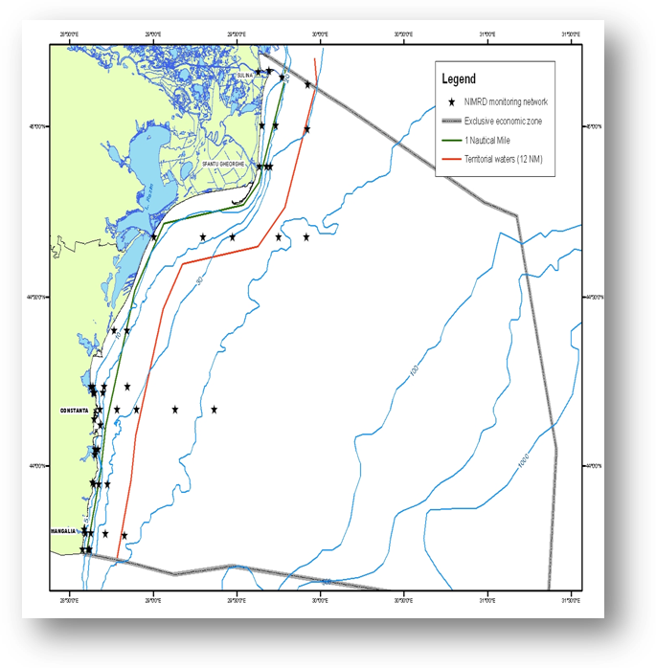  Fig.1 Map of sampling stations of the environment routine monitoring carried out by NIMRD  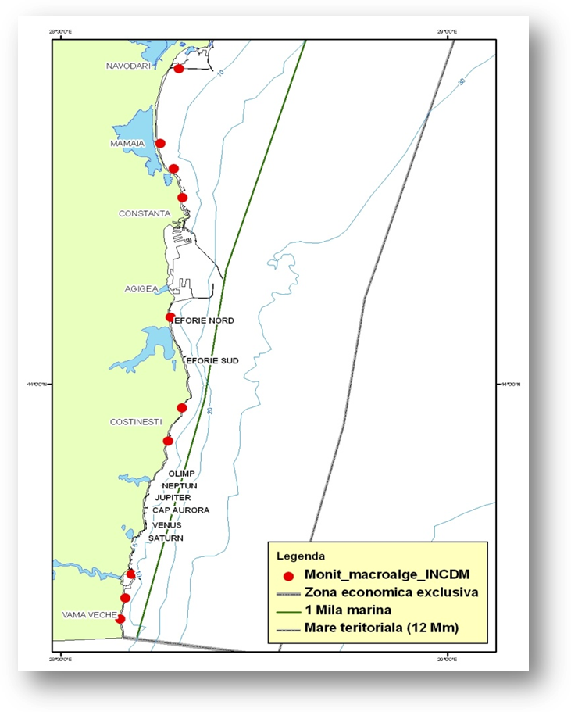  Fig. 2. Map of sampling stations of the macroalgae monitoring carried out by NIMRD  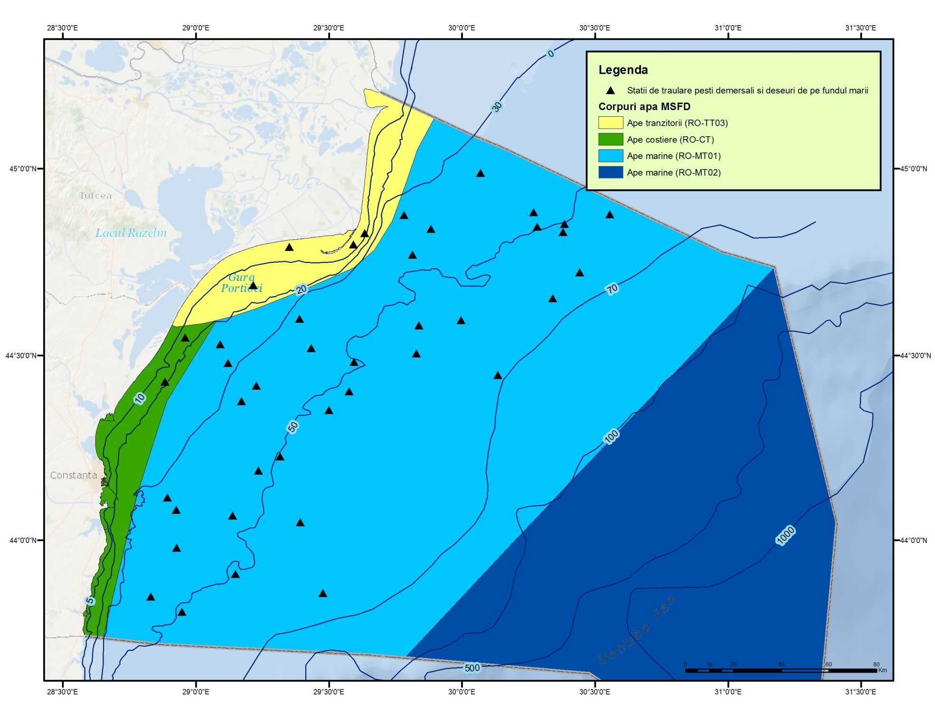  Fig. 3 - Distribution of trawling zones  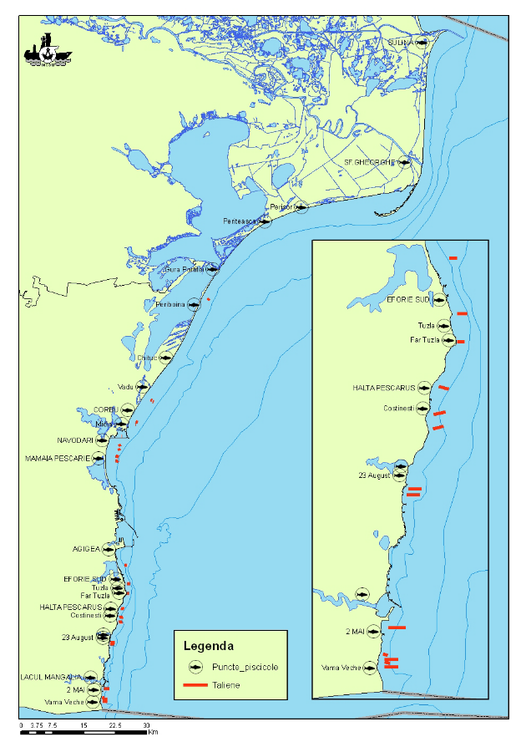  Fig. 4 - Fisheries points and distribution area for stationary fishing gears
3.3 Threats, activities and measures | Which threats are identified  Which human activities will be measured by the programme  Relevant human activities which act as pathways of NIS introduction:  Activity theme/activity  - Energy production/ offshore oil rigs  - Extraction of living resources/ Fisheries incl. recreational fishing (fish and shellfish)  - Food production/ Aquaculture (fish and shellfish)  - Man-made structures/ Port operations; submarine cable and pipeline operations;  - Recreation/Tourism and recreation incl. yachting  - Research and survey/ Marine research, survey and educational activities  - Transport/ Shipping  - Waste disposal/ Solid waste disposal incl. dredged material  - Biological control/biological control  The programme addresses only partially to the main pathway/vectors of NIS introduction in the Black Sea, namely shipping, food production, extraction of living resources, by monitoring the temporal and spatial distribution and intensity of above mentioned activities. The programme needs to be improved in order to approach the pressure level at source (with special emphasis on the ballast water and sediment – see Section 6); so far, only the level of pressure on environment (NIS spatial and temporal distribution) is considered. Also, some other activities (e.g oil extraction, biological control, etc) have to be considered by the programme (see Section 6).  Which measures will be measured by the programme  The programme has to be improved in order to approach the effectiveness of measures.
3.4 Data management | How and where are data managed? How and where can data be accessed? (General description – programme level)  Data are reported (either as raw data or data products) through competent authority to BSC (through AGs – CBD).  Data are also reported (either as metadata or raw data) in databases belonging to other projects (e.g. DAISIE - Delivering Alien Invasive Species Inventories for Europe http://www.europe-alliens.org) from where they can be accessed in accordance with the terms of such project
4. Assessment
Existing assessments
Provide information about or URL links to existing assessments (eg. Initial Assessment)
MSFD (Art. 8) – Initial Assessment
http://cdr.eionet.europa.eu/ro/eu/msfd8910/msfd4text/envuhwuaq
Environmental Status Reports
http://www.rmri.ro/Home/Products.EnvStatusReport.html
State of Environment Report 2001-2006/7
http://www.blacksea-commission.org/_publ-SOE2009.asp
Black Sea Transbordary Diagnostic Analysis
http://www.blacksea-commission.org/_tda2008-document6.asp
4.2 Assessment of GES | Will assessment of GES be carried out by the programme  GES in relation to NIS is not defined yet. However, the programme has to be improved significantly (more data/information and knowledge needed, especially, for a better understanding of alien species effects on ecosystem and pathways/vectors of introduction) to define GES and, subsequently, assess periodically the environmental status and distance to and progress towards GES (see Section 6).
5. Literature
List of relevant literature
Zampoukas, N., Piha, H., 2011, Review of Methodological Standards Related to the Marine Strategy Framework Directive Criteria on Good Environmental Status, Publications Office of the European Union, 53 pp. http://publications.jrc.ec.europa.eu/repository/handle/111111111/16069
Zampoukas, N., Piha, H., Bigagli, E., Hoepffner,N., Hanke, G., Cardoso, A., 2012, Monitoring for the Marine Strategy Framework Directive: Requirements and Options, Publications Office of the European Union, 42 pp., http://publications.jrc.ec.europa.eu/repository/handle/111111111/23169
Zampoukas, N., Piha, H., Bigagli, E., Hoepffner,N., Hanke, G., Cardoso, A., 2013, Marine monitoring in the European Union: how to fulfil the requirements for the MSFD in an efficient and integrated way, Marine Policy, 39, 349-351
http://publications.jrc.ec.europa.eu/repository/handle/111111111/27825
Marine Strategy Framework Directive – Task Group 2 Report Non-indigenous species. http://www.ec.europa.eu/environment/marine/pdf/2-Task-Group-2.pdf
6. Activities required to implement the concept
6.1 Changes to the current monitoring programme | Necessary changes and recommendations  Describe necessary changes for the programme to cover the requirements of MSFD. Description in general terms.  Recommendations and actions needed:  - increasing financial assistance and securing sustainable financing at national levels  - better integration the MSFD monitoring with the monitoring requirements of the other directives (Habitats), regional sea conventions (BSC) and other convention (International Convention for the Control and Management of Ships' Ballast Water and Sediments, Convention on Biological Diversity)  - permanent agreements with other authorities/organisations in supporting the programme (e.g. Port/Naval Authorities, offshore companies, etc)  - better use and coordination of the existing capacities of all organizations dealing with monitoring programme (including monitoring infrastructure sharing)  - strengthen the regional cooperation/harmonization between the Black Sea MS (common sampling and data processing methodologies, common MSFD indicators/parameters to be approach, common GES and Environmental Targets definitions)  - communication channels need to be established/improved considering neighbouring countries to allow for the prompt development of contingency plans and/or joint eradication efforts if so decided. These channels may also be used to alert all stakeholders regarding new arrivals, range expansions and impacts of NIS.  - develop proposals to revise/update/improve the existing national legislation, especially with regard to the vectors of NIS introduction (e.g. ballast water - development a regular/sustainable monitoring of ballast water/sediment)  - adjust/increased temporal resolution of the program (e.g to catch all life stages of NIS)  - adjust/extension of spatial coverage (e.g. open waters, harbours aquatoriums, etc)  - supllement the spatial and time scales by information from other sources, including, e.g., sports clubs, SCUBA divers, fishermen, aquaculture farmers, without loosing the quality of the records  - improvement of knowledge related to bioinvasion effects  - existing indicators to be developed (new parameters, indices to be considered and developed e.g. Biopollution Index, BPL)  - develop widely available, accurate and cost efficient methods for genetic analysis to confirm identification of any suspected new introduction  - development of tools to enable easy access to the most up to date identification guides e.g. searchable digital databases that will find similar images from the web to aid identification.  - develop a protocol for dealing with species for which there is very little information and cannot be identified using existing knowledge.  - new monitoring tools to be developed, (e.g. Continuous Plankton Recorder, modelling for establishing potential areas of new introductions in order to put in place control measures, natural dispersal mechanisms of introduced species after arrival and establishment in a new area, etc.)  - centralized regional database should be created where all national information is summarized. Existing data bases may be used as a starting point (e.g. DAISIE, CIESM, Baltic Sea Alien Species Database).  - Improving QA/QC  - Improving data management
6.2 Gaps: GES information | If not yet adequate for data and information needs to assess GES, describe when the programme will be considered fully adequate  in time for next assessment in 2018
6.3 Plans: Plans for GES information | If the programme is not considered fully adequate for data and information needs to assess GES, describe what plans are in place to make it fully adequate (eg. to fill gaps in data methods, understanding or capacity). Describe timeframe, priorities and obstacles.  Firstly, Romania has to define GES definition according to MSFD requirements.  The indicators/parameters related to the programme have to be significant improved for developing methods for aggregating indicators so that GES can be defined and assessed. Efforts should be made to record all NIS known in the assessment area by improving taxonomic identification; also special attention should be paid primarily to develop indicator 2.2.2 (see Commission Decision of 1. September 2010) for assessing alien species impacts.  One of the approaches for defining GES, as is proposed by MSFD Task Group 2, consists in estimation of the magnitude of bioinvasion impacts or “Biopollution level” (BPL) index which takes into account the abundance and distribution range of NIS in relation to native biota in the invaded area and aggregates data on the magnitude of the impacts these species have on: native communities, habitats and ecosystem functioning. BPL aggregates the results of the assessment into five categories: “No bioinvasion impact”, “Weak”, “Moderate”, “Strong” and “Massive”. First two categories may indicate acceptable levels of biopollution for GES. The assessment has to be done for defined assessment units (a particular water body or its part) and certain periods of time.  A major need is related the regional cooperation; the Black Sea MS have to develop common methodology to define GES.
6.4 Gaps: Target information | If not yet adequate for data and information needs to assess targets, describe when the programme will be considered fully adequate  in time for next assessment in 2018
6.5 Plans: Plans for information on targets | If the programme is not considered fully adequate for data and information needs to assess targets, describe what plans are in place to make it fully adequate (eg. to fill gaps in data methods or capacity). Describe timeframe, priorities and obstacles.  Firstly, Romania has to develop the methodology for defining environmental targets according to MSFD requirements.  The methodology proposed by the MSFD Task Group 2, using the BPL index (see subsection 6.3), can be applied for setting the environmental targets.  A major need is related the regional cooperation; the Black Sea MS have to develop common methodology to set the thresholds needed for establishing common environmental targets (where is possible).
6.5 Plans: Plans for information on measures | If relevant: If the programme is not considered fully adequate for data and information needs to assess measures describe what plans are in place to make it fully adequate (eg. to fill gaps in data methods or capacity). Describe timeframe, priorities and obstacles.  To be developed

