MONITORING FACT SHEET
Country: | ROMANIA
Author: | Vasiliu Dan Lucian
Institute: | National Research and Development Institute for Marine Geology and Geoecology - GeoEcoMar

MONITORING FACT SHEET TEMPLATE
Title: Biodiversity- Water Column Habitats
1. General
1.1 Subject area | What is monitored – programme ID (BLKXX-DY)  Biodiversity – water column habitats;  BLKRO-D1,D4-W
1.2 Definition/Description | Definition of items monitored/description of general approach  The monitoring activity is focused on pelagic communities and habitats and is referring to the following components:  Microbes  Bacteriological monitoring involved tests for the presence of total and faecal coliform bacteria and faecal streptococci as indicators of microbiological pollution in the RO coastal waters (focused on areas with known sources of pollution: harbors and urban coastal areas where the frequency of industrial pollution and discharge of sewage are highest, areas of specific interest are areas with a high number of recreational facilities (Cazino-Mamaia, Costinesti, Vama Veche).  Phytoplankton  The general approach consists in quantitatively and qualitatively seasonal estimation of phytoplankton populations in coastal and shelf (partially) water habitats. Based on parameters measured: density (cells/L) and biomass (mg/m³), taxonomic structure (no. of species) and temporal and spatial (horizontal and vertical) distribution, there were developed several indices in accordance with WFD and others are proposed to satisfy MSFD requirements.  Zooplankton  Zooplankton component is seasonally assessed in coastal and shelf (partially) habitats and, there are considered the main following parameters: taxonomic composition, density (ind/m³) and biomass (mg/m³), ratio edible/non-edible zooplankton.  The present programme is addresing to state/impact parameters, not to pressures, which are subject to other monitoring programmes in RO waters (Non-indigenous species, Commercial fish and shellfish, Eutrophication, Hydrographical changes, and Contaminants).  The programme is also dealing with relevant activities which significantly influence the water column biodiversity and measures in close relation with other programmes (e.g. Non-indigeneous species, Eutrophication, etc).
1.3 Competent authority/ies | Which authorities are responsible (links to www)  Ministry of Environment and Climate Change http://www.mmediu.ro/  - Department on Waters, Forests and Fisheries - contact point for the Commission
1.4 Monitoring institutions | Which institutions carry out the monitoring etc (links to www)  Romanian Water National Administration (Dobrogea-Litoral Water Basin Administration) http://www.rowater.ro/ - under coordination of the Ministry of Environment and Climate Change  National Institute for Marine Research and Development “Grigore Antipa”, Constanta http://www.rmri.ro/ - under coordination of the Ministry of National Education
1.5 Additional information | Where can additional information be found (e.g. via a web link)  Regarding regional coordination remember this project and other relevant joined projects  http://www.blacksea-commission.org/_bsimap.asp  MSFD Guiding Improvements in the Black Sea Integrated Monitoring System (MISIS) project  http://www.misisproject.eu  Integrated Regional monitoring Implementation Strategy in the South European Seas (IRIS -SES) project  http://iris-ses.eu/  Technical and administrative support for joint implementation of MSFD in Bulgaria and Romania  No link available yet  Towards Integrated Marine Research Strategy and Programmes (SEAS-ERA) project - Strategic Research Agenda for the Black Sea Basin  http://www.seas-era.eu/
2. Monitoring requirements and purpose
2.1 Necessity | Listed below are direct references to the monitoring requirements – EU directives, Black Sea Commission agreements, national plans, research programme requirements, other.
MSFD  Article 11  Article 8  Annex III | Art.11  1. On the basis of the initial assessment made pursuant to Article 8(1), Member States shall establish and implement coordinated monitoring programmes for the ongoing assessment the environmental status of their marine waters on the basis of the indicative lists of elements set out in Annex III and the list set out in Annex V, and by reference to the environmental targets established pursuant to Article 10.  2. Member States sharing a marine region or subregion shall draw up monitoring programmes in accordance with paragraph 1 and shall, in the interest of coherence and coordination, endeavor to ensure that:  (a) monitoring methods are consistent across the marine region or subregion so as to facilitate comparability of monitoring results;  (b) relevant transboundary impacts and transboundary features are taken into account.  Art.8  The results of monitoring programme are required for the next cycle of assessment of marine waters. To this end, the following parameters must be monitored for biological features (Annex III, Table 1):  Annex III, Table 1  Biological features  — A description of the biological communities associated with the predominant seabed and water column habitats. This would include information on the phytoplankton and zooplankton communities, including the species and seasonal and geographical variability,
Habitats  Article 11 | Art. 11  Member States shall undertake surveillance of the conservation status of the natural habitats and species referred to in Article 2 with particular regard to priority natural habitat types and priority species.
WFD  Article 8  Annex V | Art. 8  1. Member States shall ensure the establishment of programmes for the monitoring of water status in order to establish a coherent and comprehensive overview of water status within each river basin district:  - for surface waters such programmes shall cover:  (ii) the ecological and chemical status and ecological potential  Annex V - 1.2.4  The WFD requires that the assessment of the phytoplankton quality element considers composition, abundance, biomass and planktonic blooms.  The phytoplankton tool for coastal waters is formed of three separate indices:  Annex V – 1.3  Member States shall monitor parameters which are indicative of the status of each relevant quality element. In selecting parameters for biological quality elements Member States shall identify the appropriate taxonomic level required to achieve adequate confidence and precision in the classification of the quality elements.
BWD  Article 3  Article 8  Article 9 | Art. 3  2. Member States shall ensure that monitoring of the parameters set out in Annex I, column A, takes place in accordance with Annex IV.  Art. 8  1. When the bathing water profile indicates a potential for cyanobacterial proliferation, appropriate monitoring shall be carried out to enable timely identification of health risks.  Art. 9  Other parameters  1. When the bathing water profile indicates a tendency for proliferation of macro-algae and/or marine phytoplankton, investigations shall be undertaken to determine their acceptability and health risks and adequate management measures shall be taken, including information to the public.
Black Sea Commission  Convention on the Protection of the Black Sea Against Pollution (Art. 15) and its Protocols | Convention on the Protection of the Black Sea Against Pollution  Art. 15.  - The Contracting Parties shall cooperate in conducting scientific research aimed at protecting and preserving the marine environment of the Black Sea and shall undertake, where appropriate, joint programmes of scientific research, and exchange relevant scientific data and information.  Protocol on the Protection of the Marine Environment of the Black Sea from Land-Based Sources and Activities (2009)  Art. 11  1. Within the framework of the provisions of, and the monitoring programmes provided for in Art. 15 of the Convention, and if necessary in cooperation with competent international organisations, the Contracting Parties shall:  a) Collect information and data on the conditions of the marine environment and coastal areas of the Black Sea as regards its physical, biological and chemical characteristics;  c) Systematically asses the state of the marine environment and coastal areas of the Black Sea;  2. The Contracting Parties shall collaborate in establishing a regional monitoring programme as well as compatible national monitoring programmes, and in facilitating data and information storage, retrieval and exchange.
Other plans and/or programmes
2.2 GES criteria | Descriptor 1  1.1 Species distribution  1.1.1. Distribution range  1.1.2. Distribution pattern with the latter, where appropriate  1.2. Population size  1.2.1. Population abundance and/or biomass, as appropriate  1.6. Habitat condition  1.6.2. Relative abundance and/or biomass, as appropriate  Descriptor 4  4.3. Abundance/distribution of key trophic groups/species  4.3.1. Abundance trends of functionally important selected groups/species
2.3 Features, pressures and impacts | List relevant features and pressures from MSFD Annex III  Refer to section 6 regarding gaps and plans  Characteristics  Biological features  — A description of the biological communities associated with the predominant seabed and water column habitats. This would include information on the phytoplankton and zooplankton communities, including the species and seasonal and geographical variability.
2.4 GES | Assessment of GES (GES as defined in the article 9 reporting)  GES definition, for pelagic habitat, is given only in terms of phytoplankton component:  ”Phytoplankton communities status is not influenced significantly by human activities”  Also for the Descriptor 5 (see BLKRO-D5), there are given GES definitions at criteria level, which are related to the pelagic habitat through the direct effects of human-induced eutrophication on phytoplankton populations:  “The direct effects of nutrient enrichment associated with algal growth do not constitute or contribute to an undesirable disturbance to the balance of organisms present in the water and to the quality of the water concerned, by meeting the threshold values as stated in the environmental targets”  The programme is set up so that most of parameters related to phytoplankton community are monitored (quite well spatial-temporal coverage in the coastal waters - an improvement for shelf and open waters is required – see Section 6).  The programme provides data and information needed to establish if the descriptor is at GES or not (as it has been defined). In the latter case, the data and information could contribute to determine the distance to GES as difference between data provided by the programme and the thresholds set up in the Article 9 of MSFD. Also trends (for some parameters/metrics) could be derived from programme and contribute to determine the distance to the GES .  The programme partially addresses to natural and climatic variability so that, in part, the difference between the effects resulting from anthropogenic pressures and climatic variability could be determined.  For zooplankton component of pelagic habitats, RO has not defined GES yet, despite the programme is able to offer enough information/data regarding the taxonomic structure, quantitative parameters, etc (see Section 6). Also for microbial community, there are no GES definitions yet, even if the program provides partial information/data (an improvement of knowledge and infrastructure is needed – see Section 6).  In terms of D4, RO has not defined GES yet. The programme offers partial data/information related to the key trophic groups/species, but an improvement in knowledge and infrastructure is needed in order to define GES (see Section 6).
2.5 Environmental targets  MSFD  BWD  WFD  BSC | Relevant MSFD targets defined in the article 10 reporting  RO has defined Environmental Targets according to MSFD requirements only for phytoplankton biomass.  90th of phytoplankton biomass do not exceed the thresholds values in 10 % of the summer observations for the last 6 years.  Also, related to the Descriptor 5 (Crt. 5.2.) there are established Environmental Targets in terms of human induced eutrophication direct effects on the phytoplankton community (see BLKRO-D5):  5.2.1. 75th percentile of summer chlorophyll a concentration in marine waters not less than threshold values (threshold value: 90th percentile of summer chlorophyll a concentrations)  5.2.4. The 75th percentile of the Bac:Din (Bacillariophyceae:Dinophyceae) spring biomass ratio is more than to the 10:1 based on monitoring routine  Generally, the information/data provided by the programme are sufficient for assessing progress towards achievement of the already defined environmental targets (difference between data provided and targets).  No environmental targets are established for the other components of pelagic habitat (microbes, zooplankton).  No environmental targets are established related to criteria/indicators associated with Descriptor 4.  The programme is able to provide data/information for defining other environmental targets (especially for other pelagic habitat components and key groups/species - see Section 6) and also for regular updating of the already established targets.  State relevant targets from other obligations (see section 2.1) that are addressed by the monitoring  Member States shall ensure that, by the end of the 2015 bathing season, all bathing waters are at least ‘sufficient’ (see Annexes I and II – BWD)  - prevent the deterioration of the status of all WB (no deterioration of the status of all WB)  - protect, enhance and restore all SWB with the aim of achieving :  - the good ecological status for natural WB by 2015  - the good ecological potential for artificial and heavy modified WB by 2015  WFD defines the limits for each quality class (high/good/moderate/poor/bad) in terms of the most important phytoplankton parameters:  1) strategic species type”C”, % of total dinoflagellate abundance (DE% - Heterocapsa rotundata, Heterocapsa triquetra, Scrippsiella trochoidea, Prorocentrum minimum, Prorocentrum micans and Gymnodinium/Gyrodinium) (Smayda, Reynolds, 2003).  2) MEC %, sum of the 3 taxonomic groups abundances taxonomice (microflagellates + euglenophyceae + cianophyceae) of total phytoplancton abundance (summer).  3) phytoplankton abundance (cel/l) and biomass (mg/m3);  4) Biodiversity Index Menhinick (1964) and Evenness Index Sheldon (1969)  SAP (2009)  3.2 Long-term Ecosystem Quality Objectives (EcoQOs)  EcoQO 2: Conservation of Black Sea Biodiversity and Habitats.  EcoQO 2b: Conserve coastal and marine habitats and landscapes.  To EcoQO 2, BS SAP has awarded a number of management objectives, which overlap many of the MSFD provisions on evaluation, monitoring and determination of good environmental status. However, SAP indicators reflecting specific regional, cross-border issues and priorities, so they do not overlap perfectly over MSFD qualitative descriptors for determining GES.
2.6 Spatial allocation | Table of where monitoring is required
   | EEZ | 12-nm zone | Coastal waters | Transitional waters
  MSFD | X | X | X | -
  WFD | - | - | X | X
  Habitats | X | X | X | X
  BWD | - | - | X | X
  BSC | X | X | X | X
3 Monitoring concept
3.1 General description of relevant subprogrammes in monitoring programme | 1. Pelagic habitats - community characteristics  Elements/features monitored: Water column/Oceanography - biological (phytoplankton, zooplankton)  Parameters: Species composition; abundance (number of individulas and/or biomass); species distributional range/pattern; population size (abundance)  2. Plankton blooms (biomass, frequency)  Elements/features monitored: Water column/Oceanography - biological (phytoplankton, zooplankton)  Parameters: Concentration of chlorophyll a; blooms frequency/extent.  3. Activities extracting non-living resources  Elements/features monitored: Activity/Dredging  Parameters: Distribution/extent in space and time, intensity  4. Activities producing food  Elements/features monitored: Activity/Aquaculture  Parameters: Distribution/extent in space and time, intensity  5. Activities with permanent infrastructures (e.g. renewable energy, oil & gas, ports) or structural changes (e.g. coastal defences)  Elements/features monitored: Activity/Energy production; Man-made structures (incl. construction phase)  Parameters: Distribution/extent in space and time, intensity  6. Sea-based mobile activities  Elements/features monitored: Activity/Transport  Parameters: Distribution/extent in space and time, intensity  7. Coastal human activities  Elements/features monitored: Activity/ Solid waste disposal incl. dredge material; Tourism, recreational sports  Parameters: Distribution/extent in space and time, intensity  8. Land-based activities  Elements/features monitored: Activity/Coastal and riverine inputs from land - industrial discharges; Coastal and riverine inputs from land - agricultural run-off, forestry; Coastal and riverine inputs from land - municipal waste water discharge;  Parameters: Distribution/extent in space and time, intensity  9. Effectiveness of measures  Elements/features monitored: Measures/Existing measures  Parameters: to be developed
3.2 Description of monitoring network | NIMRD  Monitoring network (Fig. 1) comprises 45 sampling stations (bottom depths within 5 – 60 m), covering entire RO coastal water and, partially, shelf waters (either waters strongly affected by the Danube’s inputs and coastal activities or marine waters, less affected by human induced eutrophication).  Microbiological (total and faecal coliform bacteria and faecal streptococci) and biological (chlorophyll, phytoplankton, zooplankton) parameters are monitored seasonally.  Twice per week measurements for phytoplankton and microbiology are carried out on a long-term on-coast station (dealing with the anthropogenic pressures in the Constanta area)  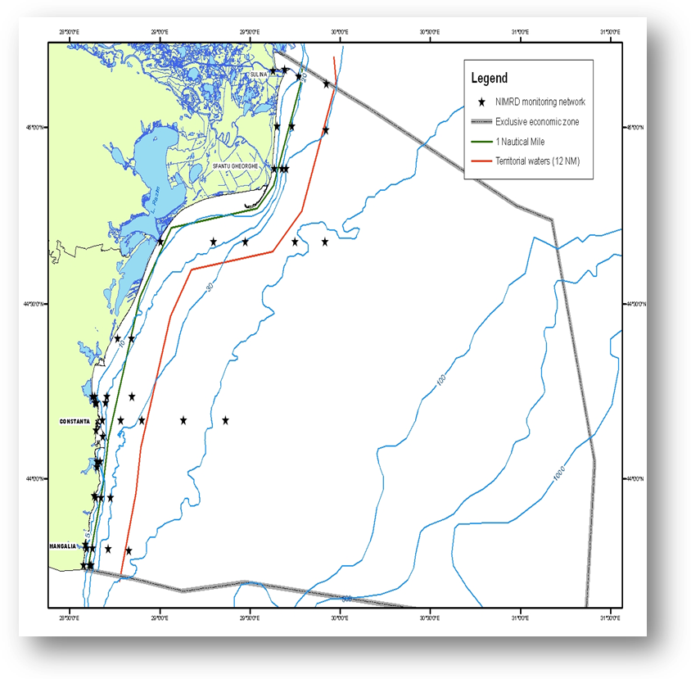  Fig. 1 Map of sampling stations of the environment routine monitoring carried out by NIMRD  RWNA - carries out monitoring activities mainly dealing with the land-based pressures and impacts.  Sampling network comprises 35 stations covering transitional and coastal waters (see Fig. 2). Phytoplankton and zooplankton are monitored twice per year.  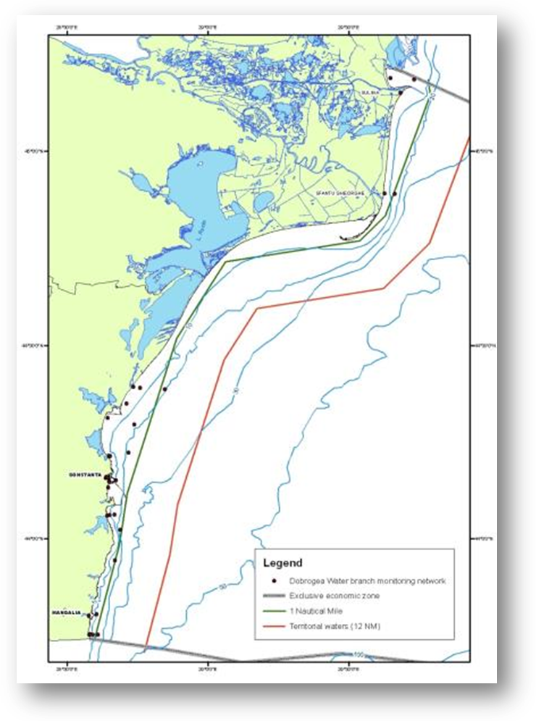  Fig. 2 Map of sampling stations of the environment routine monitoring carried out by RWNA – ABA
3.3 Threats, activities and measures | Which threats are identified  Threats identified which potentially affect the water column habitats are: eutrophication, pollution (incl. marine litter), and sea-based activities (incl. NIS).  Which human activities will be measured by the programme  Relevant activities themes/activities related to the programme are:  Energy production/Marine hydrocarbon (oil and gas) extraction  Extraction of non-living resources/ Dredging  Food production/Aquaculture  Transport/shipping  Recreation/Tourism and recreation incl. yachting  Waste disposal/ Solid waste disposal incl. dredge material  Land-based activities/industries/Coastal and riverine and athmospheric inputs from land - industrial discharges; Coastal, riverine and atmospheric inputs from land - agricultural run-off, forestry and emissions; Coastal, riverine and atmospheric inputs from land – (municipal waste water discharge  The programme will address to some of above mentioned activities by measuring either the distribution in space and time, intensity of some relevant activities and/or impacts associated.  Which measures will be measured by the programme  To be developed
3.4 Data management | How and where are data managed? How and where can data be accessed? (General description – programme level)  Data are reported (either as raw data or data products) through competent authority to EEA, BSC (through AGs – PMA, LBS, and CBD), etc.  Data are also reported (either as metadata or raw data) in databases belonging to other projects (SeaDataNet, SESAME, PERSEUS) from where can be accessed in accordance with the terms of such project
4. Assessment
4.1 Assessments | Existing assessments  Provide information about or URL links to existing assessments (eg. Initial Assessment)  MSFD (Art. 8) – Initial Assessment  http://cdr.eionet.europa.eu/ro/eu/msfd8910/msfd4text/envuhwuaq  Environmental Status Reports  http://www.rmri.ro/Home/Products.EnvStatusReport.html  State of Environment Report 2001-2006/7  http://www.blacksea-commission.org/_publ-SOE2009.asp
4.2 Assessment of GES | Will assessment of GES be carried out by the programme  The programme will provide partial data and information for enabling periodic assessment of environmental status (especially for coastal waters) and distance to and progress towards GES (where is defined).  Some improvement measures have to be taken so that the program can be able to provide more data/information and knowledge for a better characterization of the status of water column habitats (see Section 6).
5. Literature
List of relevant literature
Zampoukas, N., Piha, H., 2011, Review of Methodological Standards Related to the Marine Strategy Framework Directive Criteria on Good Environmental Status, Publications Office of the European Union, 53 pp. http://publications.jrc.ec.europa.eu/repository/handle/111111111/16069
Zampoukas, N., Piha, H., Bigagli, E., Hoepffner,N., Hanke, G., Cardoso, A., 2012, Monitoring for the Marine Strategy Framework Directive: Requirements and Options, Publications Office of the European Union, 42 pp., http://publications.jrc.ec.europa.eu/repository/handle/111111111/23169
Zampoukas, N., Piha, H., Bigagli, E., Hoepffner,N., Hanke, G., Cardoso, A., 2013, Marine monitoring in the European Union: how to fulfil the requirements for the MSFD in an efficient and integrated way, Marine Policy, 39, 349-351
http://publications.jrc.ec.europa.eu/repository/handle/111111111/27825
Marine Strategy Framework Directive Task Group 1 report Biological Diversity
http://ec.europa.eu/environment/marine/pdf/1-Task-group-1-Report-on-Biological-Diversity.pdf
6. Activities required to implement the concept
6.1 Changes to the current monitoring programme | Necessary changes and recommendations  Describe necessary changes for the programme to cover the requirements of MSFD. Description in general terms.  Recommendations actions needed:  - increasing financial assistance and securing sustainable financing at national levels  - better integration the MSFD monitoring with the monitoring requirements of the other directives (WFD, HD, BWD, etc), regional sea conventions (BSC) and other convention (International Convention for the Control and Management of Ships' Ballast Water and Sediments (BWM)  - better use and coordination of the existing capacities of all organizations dealing with monitoring programme (including monitoring infrastructure sharing); avoid overlapping of activities and efforts;  - permanent agreements with other authorities/organisations in supporting the national monitoring programme (e.g. ROSA, RNA, Port Authorities, Offshore companies, etc)  - Adjust/increased temporal and spatial coverage (to include open water habitats)  - improve research and monitoring of microbial component  - additional indicators to be included (referred to microbial component)  - as the availability of long-term and spatially well-distributed monitoring data sets for assessing biodiversity is limited to a few well studied species groups and habitat types there is a need in increase the number of species groups and habitat types monitored  - additional indices to be developed and tested  - new monitoring tools to be developed, with special emphasis on open waters (CRP, satellite images, etc)  - improving QA/QC  - improving data management
6.2 Gaps: GES information | If not yet adequate for data and information needs to assess GES, describe when the programme will be considered fully adequate  In time for next assessment in 2018
6.3 Plans: Plans for GES information | If the programme is not considered fully adequate for data and information needs to assess GES, describe what plans are in place to make it fully adequate (eg. to fill gaps in data methods, understanding or capacity). Describe timeframe, priorities and obstacles.  Firstly, Romania has to update/define GES according to MSFD requirements (extent GES definition to other plankton indicators/parameters). Also the other components of pelagic habitat (zooplankton, bacterioplankton), as well as relations between functional groups have to be considered for more robust GES definition.  Monitoring of microbial component have to be significant improve and new indicators/parameters have to be developed (improvement of research and infrastructure).  Coastal and shelf habitats are quite well covered spatially, thus the programme is able to provide data/information for updating GES and environmental targets. However, the programme has to be extent to open waters habitat in order to provide data/information needed to define GES and environmental targets for that habitat.  Although there is much information related to pelagic biological components (phytoplankton and zooplankton: structure, abundance and distribution), as well as to the water quality (provided by other programmes) in relation to pressure and state/impacts parameters, a better coordination of efforts is needed in order to establish integrated indices (e.g. BEAST) which could provide more robust GES definition.  More research is also needed for developing indicators related to Descriptor 4 (energy transfer and relations between key species, key species productivity, etc).
6.4 Gaps: Target information | If not yet adequate for data and information needs to assess targets, describe when the programme will be considered fully adequate  In time for next assessment in 2018
6.5 Plans: Plans for information on targets | If the programme is not considered fully adequate for data and information needs to assess targets, describe what plans are in place to make it fully adequate (eg. to fill gaps in data methods or capacity). Describe timeframe, priorities and obstacles.  Firstly, Romania has to update/define environmental targets according to MSFD requirements for all pelagic components.  Although the program could provide partially data/information for preliminary definitions of environmental targets, it has to be improved considerably.  For coastal waters the targets could be developed/updated based on WFD methodology (particularly for zooplankton component). This WFD methodology could be extend for shelf and open waters, but the monitoring program have to be improved, so that to provide valuable data/information (in terms of spatial-temporal coverage, QA/QC procedures, etc) and knowledge which could be used for setting thresholds as baseline to define environmental targets for those habitats.
6.5 Plans: Plans for information on measures | If relevant: If the programme is not considered fully adequate for data and information needs to assess measures describe what plans are in place to make it fully adequate (eg. to fill gaps in data methods or capacity). Describe timeframe, priorities and obstacles.  To be developed

