MONITORING FACT SHEET
Country: | ROMANIA
Author: | Vasiliu Dan Lucian
Institute: | National Research and Development Institute for Marine Geology and Geoecology - GeoEcoMar

MONITORING FACT SHEET TEMPLATE
Title: Biodiversity-Seabed habitats
1. General
1.1 Subject area | What is monitored – programme ID (BLKXX-DY)  Programme name: Biodiversity – Seabed habitats  Programme ID: BLKRO-D1,D4,D6-SBH
1.2 Definition/Description | Definition of items monitored/description of general approach  The current monitoring programme is focused on benthic habitats and referrers to the following components:  Macroalgae are assessed in the warm season in the coastal benthic habitats. The following parameters are considered: taxonomic composition, biomass (g/m²) and quality indices such as: EEI (Ecological Evaluation Index) and ratio between perennial and sensitive species.  Zoobenthos. Macro- and meiozoobenthos populations are subject to the monitoring activities in the coastal and, partially, shelf waters. The main parameters seasonally monitored are: the abundance (ind/m²) and biomass (g/m²) of zoobenthic populations and their distribution in certain areas. Some indices, related to the state of zoobenthic communities, are also considered in the programme (Shannon-Wiener, H’ and species richness (S). Based on information provided in the Initial Assessment (Art. 8), the following indices are already developed for assessing the impact of different pressures on zoobenthos population: AMBI Biotic Index and M-AMBI.  Special attention is also paid to Natura 2000 sites from the Romanian coast declared under Habitat Directive. For each habitat type and site there were conceived indicators and targets for accomplishing the objective of maintaining the Favourable Conservation Status according to Art.6 of Habitat Directive 92/43/CEE  The programme deals also with the physical (bathymetry, grain-size, etc.) and chemical (organics and DO at interface water-sediment, TOC – in sediment) characteristics of seabed habitats.  The present programme addresses not only to state/impact parameters, but also to pressures and relevant human activities which impacted on the seabed habitats. Not all pressures are considered by the programme, only those related to physical loss and damage. Other pressures affecting benthic habitats are subject to other monitoring programmes in the RO waters (Non-indigeneous species, Commercial fish and shellfish, Eutrophication, Hydrographical changes, Contaminants, Litter).
1.3 Competent authority/ies | Which authorities are responsible (links to www)  Ministry of Environment and Climate Change (contact point for the Commission) http://www.mmediu.ro/  - Department for Waters, Forests and Fisheries (contact point for the Commission)
1.4 Monitoring institutions | Which institutions carry out the monitoring etc (links to www)  Romanian Water National Administration (Dobrogea-Litoral Water Basin Administration) http://www.rowater.ro/ - under coordination of the Ministry of Environment and Climate Change  National Institute for Marine Research and Development “Grigore Antipa”, Constanta http://www.rmri.ro/ - under coordination of the Ministry of National Education  Institute for Research and Development for Geology and Geoecology GeoEcoMar http://www.geoecomar.ro/ - under coordination of the Ministry of National Education
1.5 Additional information | Where can additional information be found (e.g. via a web link)  Regarding regional coordination remember this project and other relevant joined projects  Black Sea Commission - BSIMAP  http://www.blacksea-commission.org/_bsimap.asp  MSFD Guiding Improvements in the Black Sea Integrated Monitoring System (MISIS) project  http://www.misisproject.eu  Technical and administrative support for joint implementation of MSFD in Bulgaria and Romania  No link available yet  Integrated Regional monitoring Implementation Strategy in the South European Seas (IRIS -SES) project  http://iris-ses.eu/  Towards Integrated Marine Research Strategy and Programmes (SEAS-ERA) project - Strategic Research Agenda for the Black Sea Basin  http://www.seas-era.eu/  Towards COast to COast NETworks of marine protected areas (from the shore to the high and deep sea), coupled with sea-based wind energy potential (COCONET)  http://www.coconet-fp7.eu
2. Monitoring requirements and purpose
2.1 Necessity | Listed below are direct references to the monitoring requirements – EU directives, Black Sea Commission agreements, national plans, research programme requirements, other.
MSFD  Article 11  Article 8  Annex III | Art.11  1. On the basis of the initial assessment made pursuant to Article 8(1), Member States shall establish and implement coordinated monitoring programmes for the ongoing assessment the environmental status of their marine waters on the basis of the indicative lists of elements set out in Annex III and the list set out in Annex V, and by reference to the environmental targets established pursuant to Article 10.  2. Member States sharing a marine region or subregion shall draw up monitoring programmes in accordance with paragraph 1 and shall, in the interest of coherence and coordination, endeavour to ensure that:  (a) monitoring methods are consistent across the marine region or subregion so as to facilitate comparability of monitoring results;  (b) relevant transboundary impacts and transboundary features are taken into account.  Art. 8  The results of monitoring programme are required for the next cycle of assessment of marine waters. To this end, the following parameters must be monitored for biological characteristics (Annex III, Table 1) and pressures/impacts (Annex III, Table 2):  Annex III, Table 1  Habitat types  — The predominant seabed and water column habitat type(s) with a description of the characteristic physical and chemical features, such as depth, water temperature regime, currents and other water movements, salinity, structure and substrata composition of the seabed,  — identification and mapping of special habitat types, especially those recognised or identified under Community legislation (the Habitats Directive and the Birds Directive) or international conventions as being of special scientific or biodiversity interest,  — habitats in areas which by virtue of their characteristics, location or strategic importance merit a particular reference. This may include areas subject to intense or specific pressures or areas which merit a specific protection regime.  Biological features  — A description of the biological communities associated with the predominant seabed habitats.  — information on angiosperms, macro-algae and invertebrate bottom fauna, including species composition, biomass and annual/seasonal variability,  — a description of the population dynamics, natural and actual range and status of other species occurring in the marine region or subregion which are the subject of Community legislation or international agreements,  Annex III, Table 2  Physical loss  — Smothering (e.g. by man-made structures, disposal of dredge spoil),  — sealing (e.g. by permanent constructions).  Physical damage  — Changes in siltation (e.g. by outfalls, increased run-off, dredging/disposal of dredge spoil),  — abrasion (e.g. impact on the seabed of commercial fishing, boating, anchoring),  — selective extraction (e.g. exploration and exploitation of living and non-living resources on seabed and subsoil).
Habitats  Article 11 | Art. 11  Member States shall undertake surveillance of the conservation status of the natural habitats and species referred to in Article 2 with particular regard to priority natural habitat types and priority species.
WFD  Article 8  Annex V | Art. 8  1. Member States shall ensure the establishment of programmes for the monitoring of water status in order to establish a coherent and comprehensive overview of water status within each river basin district:  Such monitoring shall be in accordance with the requirements of Annex V.  - Quality elements for the classification of ecological status  1.1.3. Transitional waters and 1.1.4. Coastal waters  Biological elements  - Composition and abundance of other aquatic flora  - Composition and abundance of benthic invertebrate fauna
Black Sea Commission  Bucharest Convention (article 15) and its Protocols | Convention on the Protection of the Black Sea Against Pollution  Art. 15.  - The Contracting Parties shall cooperate in conducting scientific research aimed at protecting and preserving the marine environment of the Black Sea and shall undertake, where appropriate, joint programmes of scientific research, and exchange relevant scientific data and information.  The Black Sea Biodiversity and Landscape Conservation Protocol  Art. 10  The Contracting Parties shall co-operate in conducting scientific research aimed at protecting and preserving the biological and landscape diversity of the Black Sea and shall undertake, where appropriate, joint programmes and projects of scientific research, and exchange relevant scientific data and information as provisioned in the Article XV of the Convention.  ANNEX 1  Article 4  - Within their national environmental legislation and policies, the Contracting Parties shall take all necessary steps for harmonization of environmental protection measures in protected areas, including management of transboundary protected areas, co-coordinated research and monitoring programs in the Black Sea basin.
Other plans and/or programmes | European Nature Information System (EUNIS)  http://eunis.eea.europa.eu  Natura 2000  http://www.natura2000.ro
2.2 GES criteria | Descriptor 1  1.1 Species distribution  1.1.1. Distribution range  1.1.3. Area covered by the species (for sessile/benthic species)  1.2. Population size  1.2.1. Population abundance and/or biomass, as appropriate  1.4. Habitat distribution  1.4.1 Distributional range  1.4.2 Distributional pattern  1.5. Habitat extent  1.5.1. Habitat area  1.6. Habitat condition  1.6.2. Relative abundance and/or biomass, as appropriate  1.6.3 Physical, hydrological and chemical conditions  Descriptor 4  4.3 Abundance/ distribution of key trophic groups/species  4.3.1 Abundance trends of functionally important selected groups/species  Descriptor 6  6.1 Physical damage, having regard to substrate characteristics  6.1.1 Type, abundance, biomass and areal extent of relevant biogenic substrate  6.2 Condition of benthic community  6.2.1 Presence of particularly sensitive and/or tolerant species  6.2.2 Multi-metric indexes assessing benthic community condition and  functionality  6.2.3 Proportion of biomass or number of individuals in the macrobenthos above some specified length/size
2.3 Features, pressures and impacts | List relevant features and pressures from MSFD Annex III  Refer to section 6 regarding gaps and plans  Characteristics  Habitat types  — The predominant seabed and water column habitat type(s) with a description of the characteristic physical and chemical features, such as depth, water temperature regime, currents and other water movements, salinity, structure and substrata composition of the seabed,  — identification and mapping of special habitat types, especially those recognised or identified under Community legislation (the Habitats Directive and the Birds Directive) or international conventions as being of special scientific or biodiversity interest,  — habitats in areas which by virtue of their characteristics, location or strategic importance merit a particular reference. This may include areas subject to intense or specific pressures or areas which merit a specific protection regime.  Biological features  — A description of the biological communities associated with the predominant seabed habitats.  — information on angiosperms, macro-algae and invertebrate bottom fauna, including species composition, biomass and annual/seasonal variability,  — a description of the population dynamics, natural and actual range and status of other species occurring in the marine region or subregion which are the subject of Community legislation or international agreements,  Pressures and impacts  Physical loss  — Smothering (e.g. by man-made structures, disposal of dredge spoil),  — sealing (e.g. by permanent constructions).  Physical damage  — Changes in siltation (e.g. by outfalls, increased run-off, dredging/disposal of dredge spoil),  — abrasion (e.g. impact on the seabed of commercial fishing, boating, anchoring),  — selective extraction (e.g. exploration and exploitation of living and non-living resources on seabed and subsoil).
2.4 GES | Assessment of GES (GES as defined in the article 9 reporting)  RO has defined GES at indicator level, as follows:  Descriptor 1  Crt. 1.4 Habitat distribution  1.4.1 Area distribution of benthic habitats  GES definitions related to the proposed indicator 1.4.1 are listed below:  - Maintaing the current distribution area of habitat 1110-1 Fine sands, clean or slightly muddy, with Zostera noltei grasslands  - Maintaining the current distribution area of the habitat 1110-8 Shallow sands bioturbated by Arenicola and Necallianassa  - Maintaining the current distribution area of habitat Sands with Donax trunculus  - Maintaining the current distribution area of habitat 1140-3 Midlittoral sands with Donacilla cornea  - Maintaining the current distribution area of habitat 1170-7 Midlittoral rock with Corallina officinalis  - Maintaining the current distribution area of habitat 1170-8 Infralittoral rock with photophylic algae – belts of Cystoseira barbata  - Maintaining the current distribution area of the habitat 1170-10Infralittoral hard clay banks with Pholas dactylus  - Maintaining the current distribution area of habitat 1170-2 Mytilus galloprovincialis biogenic reefs  - Maintaining the current distribution area of habitat 1170-9 Circalitoral rock with Mytilus galloprovincialis  1.4.2 Distribution models of benthic habitats  GES definitions related indicator 1.4.1 are listed below:  - Maintaining the current distribution model of the habitat 1110-1 Fine sands, clean or slightly muddy, with Zostera noltei meadows  - Maintaining the current distribution model of the habitat 1170-8 Infralittoral rock with photophylic algae – belts of Cystoseira barbata  - Maintaining the current distribution model of the habitat 1170-9 Circalitoral rock with Mytilus galloprovincialis  Crt. 1.5 Habitat extent  1.5.1 Benthic habitat surface  GES definitions related indicator 1.5.1 are listed below:  - Maintaining surface of the habitat 1110-1 Fine sands, clean or slightly muddy, with Zostera noltei meadows  - Maintaining surface of the habitat 1140-3 Midlittoral sands with Donacilla cornea  - Maintaining surface of the habitat 1170-7 Midlittoral rock with Corallina officinalis  - Maintaining surface of the habitat 1170-8 Infralittoral rock with photophylic algae – belts of Cystoseira barbata  - Maintaining surface of the habitat 1170-10 Infralittoral hard clay banks with Pholas dactylus  Crt. 1.6 Habitat condition  1.6.1 Species state  GES definitions related indicator 1.6.1 are listed below:  - Maintaining good status of Zostera noltei population  - Maintaining good status of Cystoseira barbata population  - Maintaining good status of Mytilus galloprovincialis population  - Maintaining good status of Pholas dactylus population  - Maintaining good status of Donacilla cornea population  - Maintaining good status of Donax trunculus population  - Maintaining good status of Arenicola marina population  1.6.2 Relative biomass and abundance  GES definitions related indicator 1.6.2 are listed below:  - Maintaining good status of Zostera noltei population  - Maintaining good status of Cystoseira barbata population  - Maintaining good status of Mytilus galloprovincialis biogenic reefs population  - Maintaining good status of Donacilla cornea population  - Maintaining good status of Donax trunculus population  - Maintaining good status of midlittoral rock with Corallina officinalis population  - Maintaining good status of Lentidium mediterraneum population  - Maintaining good status of circalitoral rock with Mytilus galloprovincialis population  - Maintaining good status of circalitorale fine ooze with Modiolula phaseolina population  1.6.3 Physical,hydrological and chemical conditions  GES definitions related indicator 1.6.3 are listed below:  - Maintaining good status of 1140-3 Midlittoral sands with Donacilla cornea  - Maintaining good status of habitat Donax trunculus  Descriptor 4  Crt. 4.3 Abundance/distribution of key trophic groups/species  4.3.1 The abundance of certain groups / species functionally important  GES definitions related indicator 4.3.1 are listed below:  - Maintaining good status of key species Lentidium mediterraneum  - Maintaining good status of key species Arenicola marina and Necallianassa truncata  - Maintaining good status of key species Mytilus galloprovincialis  - Maintaining good status of key species Modiolula phaseolina  Descriptor 6  Crt. 6.1 Physical damage, having regard to substrate characteristics  6.1.1 Type, abundance, biomass and extent of relevant biogenic substrate  GES definitions related indicator 6.1.1 are listed below:  - Maintaining distribution, surface integrity of Mytilus galloprovincialis biogenic reefs  - Maintaining distribution, surface integrity of natural rocky bottom  - Maintaining distribution, surface integrity of Zostera noltei grasslands  - Maintaining distribution, surface integrity of Cystoseira barbata belts  Crt. 6.2 Condition of benthic community  6.2.1 Presence of particularly sensitive species and / or tolerant  GES definitions related indicator 6.1.1 are listed below:  - Maintaining good status of population with Zostera noltei  - Maintaining good status of population with Cystoseira barbata  - Maintaining good status of population by Mytilus galloprovincialis biogenic reefs  6.2.2 Multimetric indices for assessment of benthic community condition and functionality, as well as species diversity and richness report opportunistic species / species sensitive  GES definitions related indicator 6.2.2 are listed below:  - Maintaining good status of communities with Zostera noltei  - Maintaining good status of communities with Cystoseira barbata  - Maintaining good status of communities with Mytilus galloprovincialis biogenic reefs  - Maintaining good status of communities with Lentidium mediterraneum  - Maintaining good status of communities with Modiolula phaseolina  6.2.3 Proportion of biomass or number of individuals over a certain length or size  GES definitions related indicator 6.2.3 are listed below:  - Maintaining good status of communities with Mytilus galloprovincialis biogenic reefs  - Maintaining good status of circalitoral rock communities Mytilus galloprovincialis  The program does not approach all criteria/indicators related to the descriptors concerned (see Section 6). Anyway, the program is able to monitor relevant indicators/parameters (with some limitations – e.g spatial and temporal coverage) so that to provide data/information and knowledge needed to establish if descriptors are at GES (as is defined) or not. In the latter case, the data and information acquired could contribute to determine the distance to GES. Also trends (for some relevant parameters) could be derived from programme and contribute to determine the distance to the GES.  The program partially addresses to natural and climatic variability so that, in part, the difference between the effects resulting from anthropogenic pressures and climatic variability could be determined.
2.5 Environmental targets  MSFD  HD  WFD  BSC | Relevant MSFD targets defined in the article 10 reporting  RO has defined environmental targets as follows:  Crt. 1.4 Habitat distribution  1.4.1 Area distribution of benthic habitats  Environmental targets related to the proposed indicator 1.4.1 are listed below:  - 1110-1: Maintaining existance of the three grasslands of Zostera noltei in Mangalia zone  - 1110-8: Maintaining the current distribution in the area Costinești -2 Mai  - Sands with Donax trunculus: Maintaining the current distribution in the area Navodari - 2 Mai  - 1140-3: Maintaining the current distribution in the area Eforie Nord-Eforie Sud  - 1170-7 : Maintaining the current distribution in the area 2 Mai – Vama Veche  - 1170-8: Maintaining the current distribution in the area Cap Aurora – Vama Veche  - 1170-10: Maintaining the current distribution in the point Agigea, Costinești și Vama Veche  - 1170-2 Mytilus galloprovincialis biogenic reefs: Maintaining current distribution throughout Self Romania between 30-50m  - 1170-9: Maintaining the current distribution across the rocky circalitoral substrate  1.4.2 Distribution models of benthic habitats  Environmental targets related to indicator 1.4.2 are listed below:  - Absence of fragmentation of the three existing Zostera noltei grasslands from Mangalia  - The absence of fragmentation of Cystoseira barbata belts existing at Cap Aurora – Vama Veche zone  - 1170-9: Absence of habitat fragmentation; Absence of denudated rock areas  Crt. 1.5 Habitat extent  1.5.1 Benthic habitat surface  Environmental targets related to indicator 1.5.1 are listed below:  - 1110-1: The area occupied by habitat ≥ 2,43 ha  - 1140-3: The area occupied by habitat ≥ 2,06 ha  - 1170-7: The area occupied by habitat ≥ 1.8 ha  - 1170-8: The area occupied by habitat ≥ 46 ha  - 1170-10: The area occupied by habitat ≥ 1 ha  Crt. 1.6 Habitat condition  1.6.1 Species state  Environmental targets related to indicator 1.6.1 are listed below:  - Leaf height of Z. noltei in june ≥ 70 cm; annual rhizomes extending of Z. noltei in growing areas ≥ 70 cm  - Height equities of Cystoseira barbata in cold season ≥ 100 cm; frequency of juveniles of Cystoseira in 1 m² ≥ 50%  - The median size of specimens by Mytilus galloprovincialis (shell length) ≥ 50 mm SL  - Juveniles frequency of Pholas dactylus in 1 m² ≥ 50%; the maximum size of specimens Pholas dactylus (shell length) = 70mm SL  - The maximum size of specimens Donacilla cornea (shell lenght) ≥ 22-24 mm SL  - The maximum size of specimens Donax trunculus (shell lenght) 45-50mm SL  - The maximum size of specimens Arenicola marina (whole body length) 250-350mm TL  1.6.2 Relative biomass and abundance  Environmental targets related to indicator 1.6.2 are listed below:  - Coverage with Z. noltei ≥ 50%; Foliar biomass of Z.noltei ≥ 1600 g m⁻²  - Coverage with Cystoseira barbata ≥ 50%; the wet biomass of Cystoseira barbata without epiphytic ≥ 3000 g·m⁻²  - Coverage with Mytilus inside the habitat ≥ 50%; living biomass of Mytilus galloprovincialis ≥ 5000 g·m⁻²  - The population density of Donacilla cornea ≥ 3300 ind·m⁻²  - The population density of Donax trunculus ≥ 200 ind·m⁻²  - Coverage with Corallina officinalis în interiorul câmpurilor ≥ 50%  - The population density of Lentidium mediterraneum ≥ 9000 ind·m^{-2;} living biomass of Lentidium mediterraneum ≥ 100 g·m⁻²  - Coverage with Mytilus in the habitat ≥ 80%; living biomass of Mytilus galloprovincialis ≥ 8000 g·m⁻²  - Living biomass Modiolula phaseolina in 1 m² ≥ 16 g·m⁻²  1.6.3 Physical,hydrological and chemical conditions  Environmental targets) related to indicator 1.6.3 are listed below:  - Sand granulometry within habitat 0.400≤ φ _{average} ≤ 1.00 mm  - Sand granulometry within habitat φ _{average} ≥ 0.25mm; beach cusps present; sand bars with external planar facies present; rip currents present  Crt. 4.3 Abundance/distribution of key trophic groups/species  4.3.1 The abundance of certain groups / species functionally important  Environmental targets related to indicator 4.3.1 are listed below:  - The population density of Lentidium mediterraneum ≥ 9000 ind·m⁻²  - The population density of Arenicola marina ≥ 0,1 ind·m⁻²; the population density of Necallianassa truncata ≥ 1 ind·m²  - The population density of Mytilus galloprovincialis ≥ 500 ind. m⁻²;  - The population density of Modiolula phaseolina in 1 m²≥ 200 ind·m⁻²  Crt. 6.1 Physical damage, having regard to substrate characteristics  6.1.1 Type, abundance, biomass and extent of relevant biogenic substrate  Environmental targets related to indicator 6.1.1 are listed below:  - Total ban any demersal fishery (trawl, honey), including the EEZ  - Stopping any hydraulic or coastal protection works likely to destroy or lead to clogging natural rocky bottom  - Stopping any hydraulic or coastal protection works of nature to destroy Zostera noltei grasslands or indirectly affect them; total ban on any kind of human activity in Zostera noltei meadows, except for scientific research and interventions for saving lives.  - Stopping any hydraulic or coastal protection works of nature to destroy belts Cystoseira barbata or indirectly affect on them; total ban on any type of human activities Cystoseira barbata belts except scientific research and interventions to save lives.  Crt. 6.2 Condition of benthic community  6.2.1 Presence of particularly sensitive species and / or tolerant  Environmental targets related to indicator 6.1.1 are listed below:  - Coverage with Z. noltei ≥ 50%; decapod frequency Palaemon adspersus in 1 m² ⁼ 100%; decapod frequency Carcinus aestuarii in transects of 50 m² ≥ 30%  - Coverage with C.barbata inside the belt ≥ 50%; frequency of Colaconema thuretii in1 m² ≥ 80%; gastropod frequency Gibbula divaricata in 1 m² ≥ 30%; gastropod frequency Tricolia pullus in 1 m² ≥ 1%  - Frequency of Lithothamnion, Phyllophora or Coccotylus in transect of 50 m² ≥ 10% ; decapod frequency Liocarcinus navigator in transect of 400 m² ≥ 70%  - Polychaets frequency Ophelia bicornis in samples ≥ 1%; frequency of Gastrosaccus sanctus in samples ≥ 50%  - Decapod frequency of Eriphia verrucosa in transects of 100 m² ; densities of Halichondria panicea in the habitat ≥ 1 colonie m⁻²  6.2.2 Multimetric indices for assessment of benthic community condition and functionality, as well as species diversity and richness report opportunistic species / species sensitive  Environmental targets ) related to indicator 6.2.2 are listed below:  - Index values EEI > 0.6  - Index values EEI > 0.  - Indices values :M-AMBI ≥ 0,55; AMBI ≤ 3,3  - Indices values :M-AMBI ≥ 0,55; AMBI ≤ 3,3  - Indices values :M-AMBI ≥ 0,55; AMBI ≤ 3,3  6.2.3 Proportion of biomass or number of individuals over a certain length or size  Environmental targets related to indicator 6.2.3 are listed below:  - Specimens median size of Mytilus galloprovincialis (shell leght) ≥ 50 mm SL  - Specimens median size of Mytilus galloprovincialis (shell leght) ≥ 70 mm SL  Generally, the information and data provided by the programme are sufficient for assessing progress towards achievement of the relevant environmental targets already established. The program provides data for regular updating of already established targets, but it still needs to be improved (see Section 6).  An improvement of program is also necessary for providing data/information and knowledge in order to approach other relevant criteria/indicators and to set related environmental targets (see Section 6)  State relevant targets from other obligations (see section 2.1) that are addressed by the monitoring  RO has defined Environmental Targets according to HD requirements for only a few benthic habitats (1170-2; 1170-8; 1110-1).  - prevent the deterioration of the status of all WB (no deterioration of the status of all WB)  - protect, enhance and restore all SWB with the aim of achieving :  - the good ecological status for natural WB by 2015  - the good ecological potential for artificial and heavy modified WB by 2015  Two biotic indices, AMBI and M-AMBI, have been used within WFD for classification of ecology quality status of zoobenthic populations.  Thresholds for biotic indices AMBI and M-AMBI applied within WFD are used for GES definition within MSFD.  For macroalgae, EEI index has been considered for defining the thresholds used for WFD classification. The thresholds of EEI have been also used to determine GES within MSFD.  SAP (2009)  3.2 Long-term Ecosystem Quality Objectives (EcoQOs)  EcoQO 2: Conservation of Black Sea Biodiversity and Habitats.  EcoQO 2a: Reduce the risk of extinction of threatened species  EcoQO 2b: Conserve coastal and marine habitats and landscapes.  To EcoQO 2, BS SAP has awarded a number of management objectives, which overlap many of the MSFD provisions on evaluation, monitoring and determination of good environmental status. However, SAP indicators reflecting specific regional, cross-border issues and priorities, so they do not overlap perfectly over MSFD qualitative descriptors for determining GES.
2.6 Spatial allocation | Table of where monitoring is required
   | EEZ | 12-nm zone | Coastal waters | Transitional waters
  MSFD | X | X | X | -
  WFD | - | - | X | X
  Habitats | X | X | X | X
  BSC | X | X | X | X
3 Monitoring concept
3.1 General description of relevant subprogrammes in monitoring programme | 1. Seabed habitats - distribution and extent  Elements/features monitored: Seabed habitats/Seabed habitats, incl. habitat-forming species and biogenic reefs  Parameters: Habitat distributional range/pattern; Areal extent of habitat; Proportion of habitat covered by habitat-defining species (e.g. a seagrass, biogenic reef-forming species)  2. Seabed habitats - physical/chemical characteristics  Elements/features monitored: Seabed habitats/Seabed habitats (physical/ chemical characteristics)  Parameters: Physical structure of habitat (e.g. sediment characteristics, topographic structure); Bathymetric depth; Concentration of oxygen; Organics level  3. Seabed habitats - community characteristics  Elements/features monitored: Seabed habitats/Seabed habitats (biological characteristics), specific benthic species  Parameters: Species composition  4. Benthic species - abundance and/or biomass  Elements/features monitored: Seabed habitats/Benthic species - abundance and/or biomass  Parameters: Species abundance (coverage of seabed); species biomass  5. Physical loss - distribution and extent (from e.g. infrastructure, coastal protection)  Elements/features monitored: Level of pressure in marine environment/ physical loss  Parameters: Spatial distribution/extent of pressure  6. Physical disturbance - from bottom trawling  Elements/features monitored: Level of pressure in marine environment/ physical damage  Parameters: Spatial distribution/extent of pressure  7. Physical disturbance - from dredging and disposal of dredged material  Elements/features monitored: Level of pressure in marine environment/ physical damage  Parameters: Spatial distribution/extent of pressure  8. Activities extracting living resources (fisheries including recreational, maerl, seaweed)  Elements/features monitored: Activity/Fisheries incl. recreational fishing (fish and shellfish)  Parameters: Distribution/extent in space and time, intensity  9. Activities extracting non-living resources (dredging)  Elements/features monitored: Activity/Dredging  Parameters: Distribution/extent in space and time, intensity  10. Activities producing food (aquaculture)  Elements/features monitored: Activity/Aquaculture  Parameters: Distribution/extent in space and time, intensity  11. Activities with permanent infrastructures (e.g. renewable energy, oil & gas, ports) or structural changes (e.g. coastal defences)  Elements/features monitored: Activity/Energy production; Man-made structures (incl. construction phase)  Parameters: Distribution/extent in space and time, intensity  12. Sea-based mobile activities (shipping, boating)  Elements/features monitored: Activity/ Shipping; Tourism and recreation, incl. yachting  Parameters: Distribution/extent in space and time, intensity  13. Land-based activities  Elements/features monitored: Activity/Coastal and riverine inputs from land - industrial discharges; Coastal and riverine inputs from land - agricultural run-off, forestry; Coastal and riverine inputs from land - municipal waste water discharge; Waste disposal  Parameters: Distribution/extent in space and time, intensity  14. Effectiveness of measures  Elements/features monitored: Existing measures  Parameters: to be developed
3.2 Description of monitoring network | NIMRD  Zoobenthos  Monitoring network comprises 45 sampling stations (bottom depths within 5 – 60 m), covering RO coastal and, partially, shelf waters (either waters strongly affected by the Danube’s inputs and coastal activities or marine waters, less affected by human activities) (Fig. 1).  Parameters monitored:  Biological: macro- and meiozoobenthos community composition, abundance (ind/m²) and biomass (g/m²); habitat extent (mapping) for targeted habitat(s) (NATURA2000); spatial extent of habitat-forming species  Chemical: DO, salinity, TOC in bottom waters  Frequency: seasonally  Macroalgae  12 sampling stations, in the coastal waters (Fig. 2), are selected for macroalgae monitoring (carried out in summer)  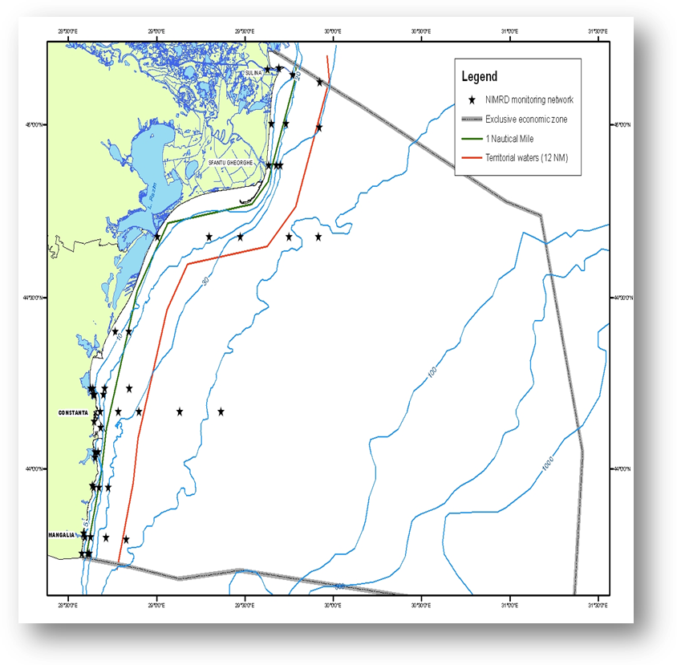  Fig. 1 Map of sampling stations of the environment routine monitoring carried out by NIMRD  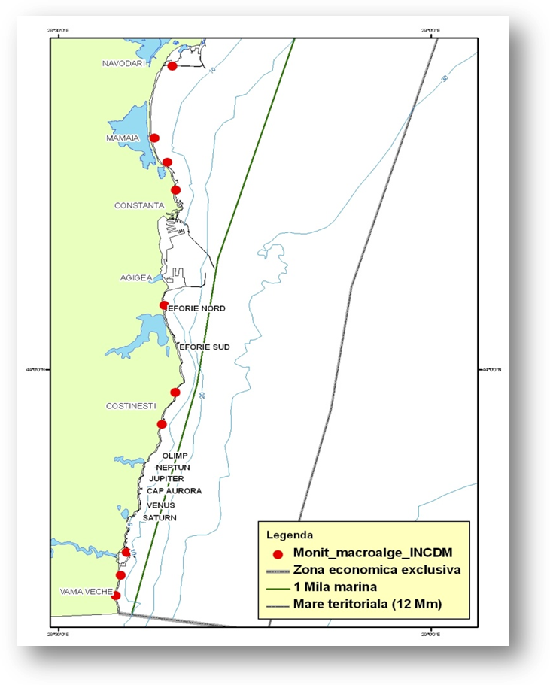  Fig. 2 Map of sampling stations of the macroalgae monitoring carried out by NIMRD  RWNA - carries out monitoring activities mainly dealing with the land-based pressures and impacts related.  Sampling network comprises 35 stations covering transitional and coastal waters (Fig. 3). Zoobenthos (macrozoo- and meiobenthos community composition, abundance (ind/m²) and biomass (g/m²)) are monitored twice per year.  Chemical characteristics of habitats are also assesed by measuring DO, salinity and TOC in bottom waters  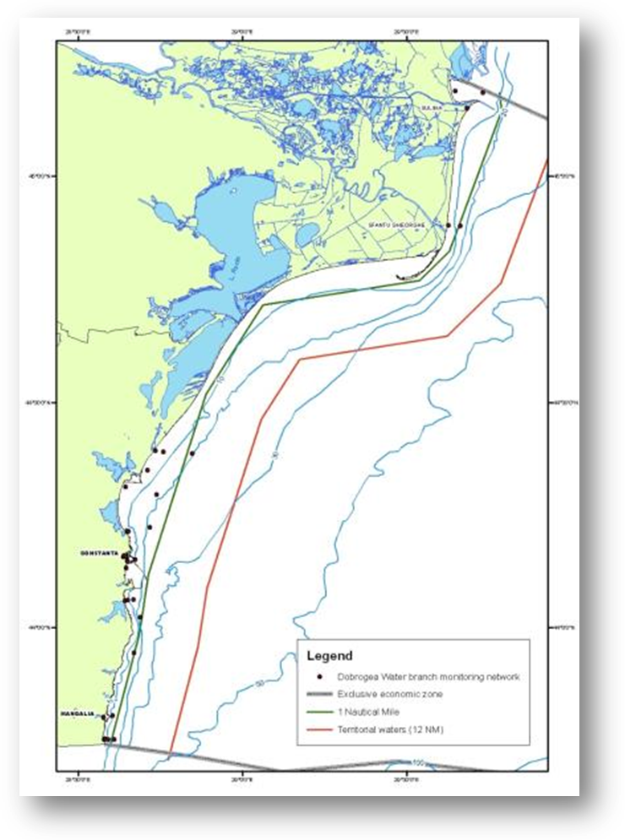  Fig. 3 Map of sampling stations of the environment routine monitoring carried out by RWNA – ABA  GeoEcoMar  Sampling network includes 45 stations, bottom depths within 15 – 200 m, covering the entire RO shelf (Fig. 4).  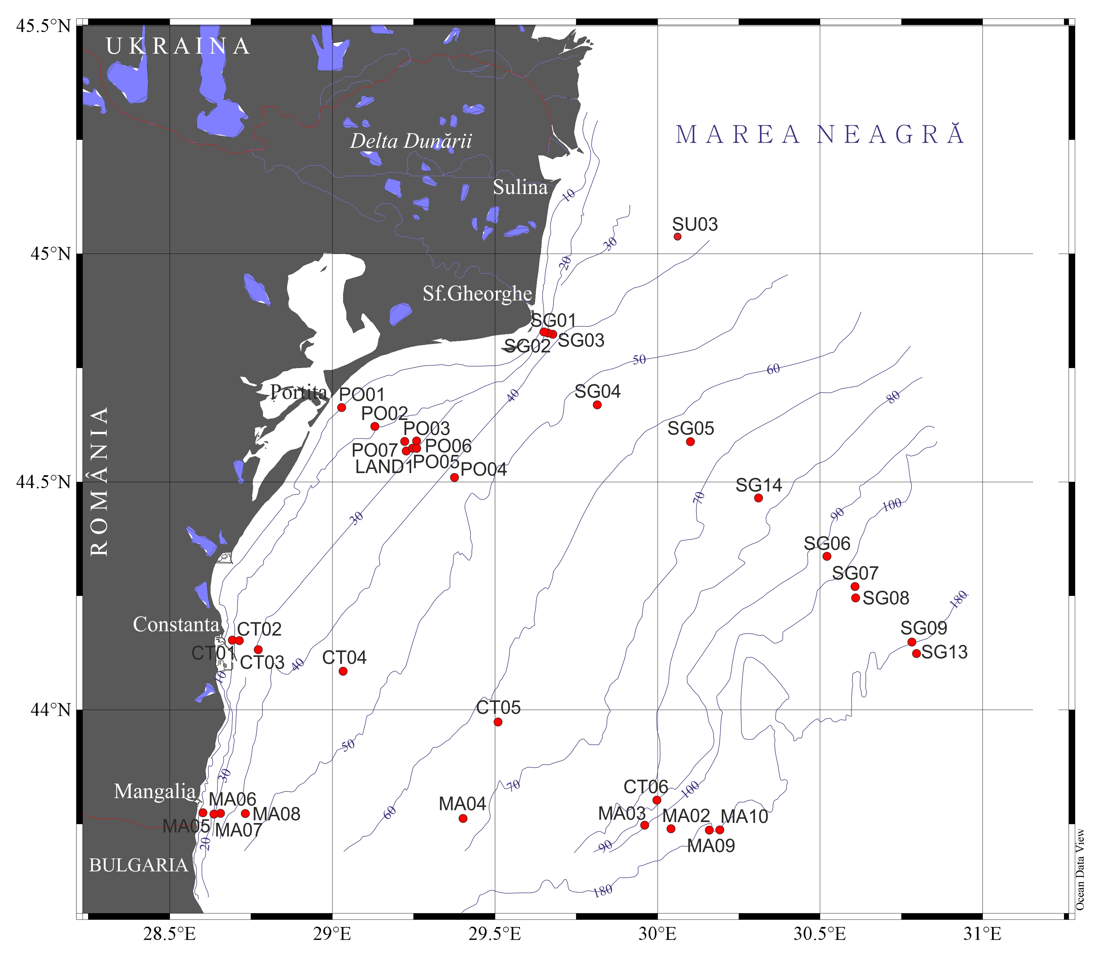  Fig. 4 GeoEcoMar monitoring sampling stations  Parameters monitored:  Biological: macrozoo- and meiobenthos community composition, abundance (ind/m²) and biomass (g/m²); habitat extent (mapping) for targeted habitat(s) (EUNIS); spatial extent of habitat-forming species.  Physical: bathymetry, grain-size  Chemical: organics, DO (water-sediment interface) and TOC in sediment  Frequency: 2-3 times/year (or more – project based)
3.3 Threats, activities and measures | Which threats are identified  Threats identified which potentially affect the seabed habitats are: eutrophication, pollution (incl. marine litter), land-based and sea-based activities (incl. NIS).  Which human activities will be measured by the programme  Relevant human activities:  Activity theme/activity  - Energy production/ Marine hydrocarbon (oil and gas) extraction  - Extraction of living resources/ Seaweed and other sea-based food harvesting; Fisheries incl. recreational fishing (fish and shellfish)  - Extraction of non-living resources/ Dredging  - Food production/ Aquaculture  - Man-made structures/ Port operations; submarine cable and pipeline operations; Placement and operation of offshore structures (other than for energy production)  - Research and survey/ Marine research, survey and educational activities  - Transport/ Shipping  - Waste disposal/ Solid waste disposal incl. dredge material  - Land-based activities/industries/ Coastal and riverine inputs from land - industrial discharges; coastal, riverine and atmospheric inputs from land - agricultural run-off, forestry and emissions; coastal, riverine and atmospheric inputs from land - municipal waste water discharge.  The programme will address partially (improvements are still needed) to above mentioned activities by measuring their distribution/extent in time and space and intensity. Also, the program will consider the pressures resulted from energy production, extraction of living and non-living resources, man-made structures, waste disposal activities and their impact on the concerned habitats. Other pressures (related to land-based activities, food production, transport) will not be considered by the program; they are/will be subject to other monitoring programmes - (Non-indigeneous species, Commercial fish/ and shellfish, Eutrophication, Hydrographical changes, and Contaminants).  Which measures will be measured by the programme  To be developed
3.4 Data management | How and where are data managed? How and where can data be accessed? (General description – programme level)  Data are reported (either as raw data or data products) through competent authority to EEA, BSC (through AGs – CBD), etc.  Data are also reported (either as metadata or raw data) in databases belonging to other projects (SeaDataNet, PERSEUS, HYPOX, SESAME, COCONET, MISIS, EMODNET) from where can be accessed in accordance with the terms of such project
4. Assessment
4.1 Assessments | Existing assessments  Provide information about or URL links to existing assessments (eg. Initial Assessment)  MSFD (Art. 8) – Initial Assessment  http://cdr.eionet.europa.eu/ro/eu/msfd8910/msfd4text/envuhwuaq  Environmental Status Reports  http://www.rmri.ro/Home/Products.EnvStatusReport.html  State of Environment Report 2001-2006/7  http://www.blacksea-commission.org/_publ-SOE2009.asp
4.2 Assessment of GES | Will assessment of GES be carried out by the programme  The programme will provide only partial data/information for periodic assessment of environmental status of habitats concerned and, also, for assessing the distance to and progress towards GES (where GES is defined).  Some improvement measures have to be taken so that the program can be able to provide more data/information and knowledge for a better characterization of the status of seafloor habitats (see Section 6).
5. Literature
List of relevant literature
Zampoukas, N., Piha, H., 2011, Review of Methodological Standards Related to the Marine Strategy Framework Directive Criteria on Good Environmental Status, Publications Office of the European Union, 53 pp. http://publications.jrc.ec.europa.eu/repository/handle/111111111/16069
Zampoukas, N., Piha, H., Bigagli, E., Hoepffner,N., Hanke, G., Cardoso, A., 2012, Monitoring for the Marine Strategy Framework Directive: Requirements and Options, Publications Office of the European Union, 42 pp., http://publications.jrc.ec.europa.eu/repository/handle/111111111/23169
Zampoukas, N., Piha, H., Bigagli, E., Hoepffner,N., Hanke, G., Cardoso, A., 2013, Marine monitoring in the European Union: how to fulfil the requirements for the MSFD in an efficient and integrated way, Marine Policy, 39, 349-351
http://publications.jrc.ec.europa.eu/repository/handle/111111111/27825
Marine strategy framework Directive Task group 1 report Biological diversity
http://ec.europa.eu/environment/marine/pdf/1-Task-group-1-Report-on-Biological-Diversity.pdf
6. Activities required to implement the concept
6.1 Changes to the current monitoring programme | Necessary changes and recommendations  Describe necessary changes for the programme to cover the requirements of MSFD. Description in general terms.  Recommendations and actions needed:  - increasing financial assistance and securing sustainable financing at national levels;  - development of projects and studies on habitats, identification, mapping, and analysis of its structure and functioning;  - better integration the MSFD monitoring with the monitoring requirements of the other directives (WFD, Habitats), regional sea conventions (BSC) and other convention (International Convention for the Control and Management of Ships' Ballast Water and Sediments (BWM);  - better use and coordination of the existing capacities of all organizations dealing with monitoring programme (including monitoring infrastructure sharing)/avoid overlapping of activities and efforts;  - permanent agreements with other authorities/organisations in supporting the national monitoring programme (e.g. Port Authorities, Offshore companies, ROSA, etc);  - more research for developing EUNIS habitat classification (see ongoing project EUSEMAP); define an agreement between MS on habitats description (EUNIS);  - more research is needed for a better understanding of natural variation in biodiversity in order to update/improve the current monitoring program;  - improvement of knowledge related to the impact of relevant human activities on the seabed habitats  - adjust/increased temporal and spatial coverage of the program;  - new monitoring tools to be developed, (e.g. ROV, satellite images, advanced modelling, etc); develop new devices and data transmission for the observation and study of deep sea habitats;  - develop habitat suitability model;  - develop integrative methods enabling valorisation of incomplete and heterogeneous monitoring data;  - existing indicators to be developed (new parameters, indices to be considered and developed) and, where possible, additional indicators/parameters to be included;  - developing metagenomics for a faster, accurate and harmonized identification of species: DNA barcoding/ Metagenetics / Metagenomics;  - build up taxonomic competence;  - Improving QA/QC  - improving data management.
6.2 Gaps: GES information | If not yet adequate for data and information needs to assess GES, describe when the programme will be considered fully adequate  in time for next assessment in 2018
6.3 Plans: Plans for GES information | If the programme is not considered fully adequate for data and information needs to assess GES, describe what plans are in place to make it fully adequate (eg. to fill gaps in data methods, understanding or capacity). Describe timeframe, priorities and obstacles.  Although the programme provides data/information needed for assessing GES (as they are defined), significantly improvements have to be done in order to update GES definitions (it is recommended to provide GES definitions at criteria level).  The programme has to be significantly improved in terms of spatial and temporal coverage (new monitoring tools, better coordination between organizations involved in the programme, infrastructure sharing, etc.) so that it could be able to provide more data/information and knowledge needed to define/update GES and environmental targets.  More research is needed for developing EUNIS habitat classification (also agreements between MS have to be established). Based on this classification, research will be focused on revising/updating GES definitions. The Report of the Task Group 1 for Biological Diversity (see subsection 5) clarifies that predominant seabed and pelagic habitats are broadly defined types on the EUNIS classification system and these should be included in the monitoring of the marine region.  More research is also needed for developing indicators/parameters related to Descriptors 4 (energy transfer and relations between key species, key species productivity, etc) and 6 (with special emphasis on the impact of human activities on seabed habitats).
6.4 Gaps: Target information | If not yet adequate for data and information needs to assess targets, describe when the programme will be considered fully adequate  in time for next assessment in 2018
6.5 Plans: Plans for information on targets | If the programme is not considered fully adequate for data and information needs to assess targets, describe what plans are in place to make it fully adequate (eg. to fill gaps in data methods or capacity). Describe timeframe, priorities and obstacles.  Firstly, Romania has to continue the process of defining/updating environmental targets according to MSFD requirements for seabed habitats.  The programme needs to be significantly improved in terms of data acquisition (new monitoring tools; faster and more accurate methods for species identification; taxonomic competence to be increased, etc.), QA/QC procedures for providing more valuable data/information and knowledge necessary for regularly updating of targets.  Also some improvements (agreements with other authorities/organisations in supporting the monitoring programme, more research related to the impact of relevant human activities on the seabed habitats) are needed for assessing the activities impacted on seabed habitats in order to define/update operational targets.
6.5 Plans: Plans for information on measures | If relevant: If the programme is not considered fully adequate for data and information needs to assess measures describe what plans are in place to make it fully adequate (eg. to fill gaps in data methods or capacity). Describe timeframe, priorities and obstacles.  To be developed

