MONITORING FACT SHEET
Country: | ROMANIA
Author: | Muresan Mihaela/Vasiliu Dan Lucian
Institute: | National Research and Development Institute for Marine Geology and Geoecology - GeoEcoMar

MONITORING FACT SHEET TEMPLATE
Title: Biodiversity-Mammals
1. General
1.1 Subject area | What is monitored – programme ID (BLKXX-DY)  Biodiversity – mammals  BLKRO-D1,D4-M
1.2 Definition/Description | Definition of items monitored/description of general approach  The programme, quite poor developed in Romania, is focused on monitoring of marine mammals encountered in the Black Sea: Delphinus delphis, Tursiops truncatus, and Phocoena phocoena.  The main organization dealing with the mammals monitoring in the Romanian waters is NIMRD, which includes the dolphins monitoring into the National Program for the Integrated Monitoring of Marine Waters.  NIMRD uses shore- and ship-based visual techniques for assessing the distribution and abundance (state parameters) of the mammals in the Romanian coastal and shelf waters. Series of visual counts in specific areas known to be regularly frequented by dolphins may be useful for assessing the effectiveness of any management actions (e.g. in protected areas). Also, occasionally, within other projects, visual observations have been done from the offshore platforms.  Other organizations involved in the current programme are the NGOs “Mare Nostrum” and “Oceanic Club”, which are dealing with the monitoring of stranded dolphins (alive or dead) along the Romanian beaches. Besides biometric measurements, usually performed on the dead individuals, occasionally, chemical and histological analyses of tissue samples are performed in order to assess the anthropogenic impact on mammals population. The programme also refers to the activities which impacted the mammals’ population, but it needs significant improvements for a reliable monitoring of human activities.
1.3 Competent authority/ies | Which authorities are responsible (links to www)  Ministry of Environment and Climate Change http://www.mmediu.ro/  Department for Waters, Forests and Fisheries (contact point for the Commission)
1.4 Monitoring institutions | National Institute for Marine Research and Development “Grigore Antipa”, Constanta http://www.rmri.ro/ - under coordination of the Ministry of National Education  NGO Mare Nostrum http://www.marenostrum.ro/  NGO Oceanic Club http://www.oceanic.ro
1.5 Additional information | Where can additional information be found (e.g. via a web link)  Regarding regional coordination remember this project and other relevant joined projects  Black Sea Commission - BSIMAP  http://www.blacksea-commission.org/_bsimap.asp  MSFD Guiding Improvements in the Black Sea Integrated Monitoring System (MISIS) project  http://www.misisproject.eu  Technical and administrative support for joint implementation of MSFD in Bulgaria and Romania  No link available yet  LIFE00 NAT/RO/007194 Dolphins - Conservation of the dolphins from the Romanian Black Sea waters LEYMAN’S REPORT  http://ec.europa.eu/environment/life/project/Projects  http://www.delfini.ro
2. Monitoring requirements and purpose
2.1 Necessity | Listed below are direct references to the monitoring requirements – EU directives, Black Sea Commission agreements, national plans, research programme requirements, other.
MSFD  Article 8  Article 11  Annex III | Art.11  1. On the basis of the initial assessment made pursuant to Article 8(1), Member States shall establish and implement coordinated monitoring programmes for the ongoing assessment the environmental status of their marine waters on the basis of the indicative lists of elements set out in Annex III and the list set out in Annex V, and by reference to the environmental targets established pursuant to Article 10.  2. Member States sharing a marine region or subregion shall draw up monitoring programmes in accordance with paragraph 1 and shall, in the interest of coherence and coordination, endeavour to ensure that:  (a) monitoring methods are consistent across the marine region or subregion so as to facilitate comparability of monitoring results;  (b) relevant transboundary impacts and transboundary features are taken into account.  Art. 8  The results of the programme are required for the next cycle of assessment of marine waters. To this end, some relevant parameters must be monitored for biological features (Annex III, Table 1) and pressures/impacts (Annex III, Table 2):  Annex III, Table 1  Biological features  — a description of the population dynamics, natural and actual range and status of species of marine mammals and reptiles occurring in the marine region or subregion,  Annex III, Table 2  Biological disturbances  — selective extraction of species, including incidental non-target catches (e.g. by commercial and recreational fishing).
Habitats  Article 11 | Art. 11  Member States shall undertake surveillance of the conservation status of the natural habitats and species referred to in Article 2 with particular regard to priority natural habitat types and priority species.
Bucharest Convention and its Protocols | Art. 15.  - The Contracting Parties shall cooperate in conducting scientific research aimed at protecting and preserving the marine environment of the Black Sea and shall undertake, where appropriate, joint programmes of scientific research, and exchange relevant scientific data and information.  The Black Sea Biodiversity and Landscape Conservation Protocol Monitoring  Art. 10  The Contracting Parties shall co-operate in conducting scientific research aimed at protecting and preserving the biological and landscape diversity of the Black Sea and shall undertake, where appropriate, joint programmes and projects of scientific research, and exchange relevant scientific data and information as provisioned in the Article XV of the Convention.
CBD (Convention on Biological Diversity)  Article 7 | Art. 7  Identification and Monitoring  Each Contracting Party shall, as far as possible and as appropriate, in particular for the purposes of Articles 8 to 10:  (a) Identify components of biological diversity important for its conservation and sustainable use having regard to the indicative list of categories set down in Annex I;  (b) Monitor, through sampling and other techniques, the components of biological diversity identified pursuant to subparagraph (a) above, paying particular attention to those requiring urgent conservation measures and those which offer the greatest potential for sustainable use;  (c) Identify processes and categories of activities which have or are likely to have significant adverse impacts on the conservation and sustainable use of biological diversity, and monitor their effects through sampling and other techniques.
Other plans and/or programmes | The programme fulfil formal obligations to the Agreement on the conservation of Cetaceans of the Black Sea, Mediterranean sea and Contiguous Atlantic Area (ACCOBAMS)  http://www.accobams.org  Natura 2000  http://www.natura2000.ro
2.2 GES criteria | Descriptor 1  1.1 Species distribution  1.1.1. Distribution range  1.1.2. Distribution pattern with the latter, where appropriate  1.2. Population size  1.2.1. Population abundance and/or biomass, as appropriate  1.6. Habitat condition  1.6.1. Condition of the typical species and communities  1.6.2. Relative abundance and/or biomass, as appropriate  Descriptor 4  4.3. Abundance/distribution of key trophic groups/species  4.3.1. Abundance trends of functionally important selected groups/species
2.3 Features, pressures and impacts | Features  Habitats types  - habitats in areas which by virtue of their characteristics, location or strategic importance merit a particular reference. This may include areas subject to intense or specific pressures or areas which merit a specific protection regime.  Biological features  - a description of the population dynamics, natural and actual range and status of species of marine mammals and reptiles occurring in the marine region or subregion,  Pressure and impacts  Biological disturbance  - selective extraction of species, including incidental non-target catches (e.g. by commercial and recreational fishing)
2.4 GES | Assessment of GES (GES as defined in the article 9 reporting)  RO has not defined yet the GES (for mammals) according to MSFD requirements (scarce data/information), thus significant improvements have to be done within the programme for establishing GES (see Section 6).  Anyway, the GES has been defined, according to Habitats Directive requirements, for dolphins species encountered in the NATURA 2000 sites (ROSCI0269, ROSCI0094, ROSCI0273, ROSCI 0197), as follow:  “Maintaining of good conservation status of Tursiops truncatus”  “Maintaining of good conservation status of Phocoena phocoena”  The program partially addresses to natural and climatic variability so that, in part, the difference between the effects resulting from anthropogenic pressures and climatic variability could be determined.
2.5 Environmental target  MSFD  Habitats  BSC | Relevant MSFD targets defined in the article 10 reporting  RO has defined state/impact targets only related to criterion 1.1 - Species distribution, particularly indicator 1.1.1 - Distributional range and criterion 4.3. - Abundance/distribution of key trophic groups/species, as follows:  1.1.1. - “Preserve the existing distribution range of the three species of marine toothed whales by implementing appropriate management measures”  4.3.1. - “Reducing the by-catch levels of the toothed whales (Phocoean phocoena, Turciops truncatus, Delphinus delphis)”  The data/information and knowledge provided by the programme could contribute, only partially, to assess progress towards achievement the targets already defined. Anyway, the programme has to be considerably improved (based on methodologies developed within other directives - e.g. Habitats Directive) in order to define new environmental targets (related to habitat conditions, population size, etc.) and update the existing ones (see Section 6).  State relevant targets from other obligations (see section 2.1) that are addressed by the monitoring  Ensuring biodiversity through the conservation of natural habitats and wild fauna and flora. Maintaining or restoring the favourable conservation status of natural habitats and species of wild fauna and flora.  The targets has been defined, according to Habitats Directive requirements, for dolphins species encountered in the NATURA 2000 sites (ROSCI0269, ROSCI0094, ROSCI0273, ROSCI 0197), as follow:  Indicator proposed: “The presence of Tursiops truncatus within the site either as groups or as individuals in the period June-October”  Target number: 5 – 20 ind/day  Indicator proposed: “The presence of Phocoena phocoena within the site either as groups or as individuals in the period March – December”  Target number: 5 – 20 ind/day  SAP (2009)  3.2 Long-term Ecosystem Quality Objectives (EcoQOs)  EcoQO 2: Conservation of Black Sea Biodiversity and Habitats.  EcoQO 2a: Reduce the risk of extinction of threatened species.  EcoQO 2b: Conserve coastal and marine habitats and landscapes.  To EcoQO 2, BS SAP has awarded a number of management objectives, which overlap many of the MSFD provisions on evaluation, monitoring and determination of good environmental status. However, SAP indicators reflect specific regional, cross-border issues and priorities, thus they do not overlap perfectly over MSFD qualitative descriptors for determining GES.
2.6 Spatial allocation | Table of where monitoring is required
   | EEZ | 12-nm  zone | Coastal waters | Transitional waters
  MSFD | X | X | X | -
  Habitats | X | X | X | X
  BSC | X | X | X | X
3 Monitoring concept
3.1 General description of relevant subprogrammes in monitoring programme | 1. Mobile species - abundance  Elements/features monitored: Highly mobile species/Mammals  Parameters: Species composition; Species abundance (numbers of individuals and/or biomass); Species distributional range/pattern  2. Mobile species - population characteristics  Elements/features monitored: Highly mobile species/Mammals  Parameters: Body size (length, weight), age, sex, fecundity rate, survival rate, mortality rate  3. Mobile species - state of habitats  Elements/features monitored: Highly mobile species/Mammals  Parameters: Areal extent of habitat  4. Mobile species - mortality/injury rates from fisheries (targeted and/or incidental)  Elements/features monitored: Highly mobile species/Mammals  Parameters: Composition and number of incidental/ by-catch of Phocoean phocoena, Turciops truncatus, Delphinus delphis (number of incidents)  5. Mobile species - mortality/injury rates from other human activities  Elements/features monitored: Highly mobile species/Mammals  Parameters: Mortality/injury rates by a pressure (e.g. ship strikes, litter entanglement, noise)  6. Activities with permanent infrastructures (e.g. renewable energy, oil & gas, ports) or structural changes (e.g. coastal defences)  Elements/features monitored: Activity/Energy production; Man-made structures (incl. construction phase)  Parameters: Distribution/extent in space and time, intensity  7. Sea-based mobile activities (shipping, boating)  Elements/features monitored: Activity/Transport  Parameters: Distribution/extent in space and time, intensity  8. Military activities  Elements/features monitored: Activity/Military  Parameters: Distribution/extent in space and time, intensity  9. Land-based activities  Elements/features monitored: Activity/Coastal and riverine inputs from land - industrial discharges; Coastal and riverine inputs from land - agricultural run-off, forestry; Coastal and riverine inputs from land - municipal waste water discharge; Waste disposal  Parameters: Distribution/extent in space and time, intensity  10. Effectiveness of measures  Elements/features monitored: Measures/Existing measures  Parameters: to be developed
3.2 Description of monitoring network | NIMRD  The present monitoring activity includes the assessment of dolphins species (Tursiops truncates, Phocoena phocoena and Delphinus delphinus) as a part of the National Program for the Integrated Monitoring of Marine Waters.  The methods used for dolphins distribution and abundance estimation are based on visual observations performed during scientific surveys carried out in the Romanian coastal and shelf waters within the other programmes (from Sulina to Vama Veche – the maps of sampling stations distribution and trawling zones are provided below) and also on incidental catching dolphins assessing.  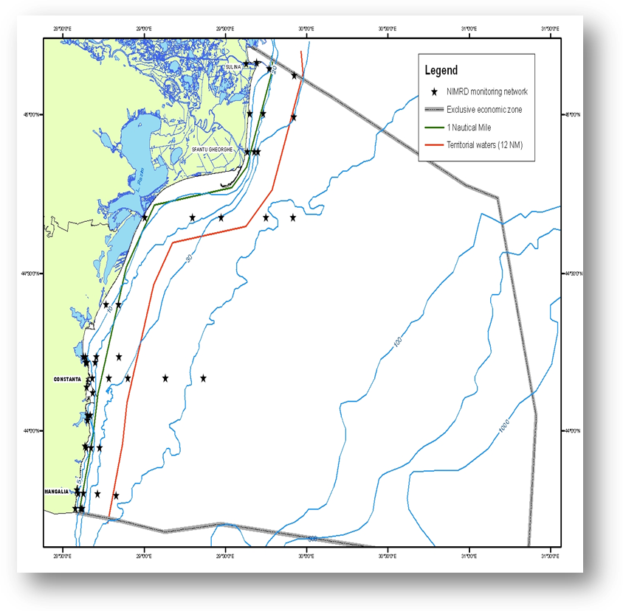  Fig. 1 Map of sampling stations of the environment routine monitoring carried out by NIMRD  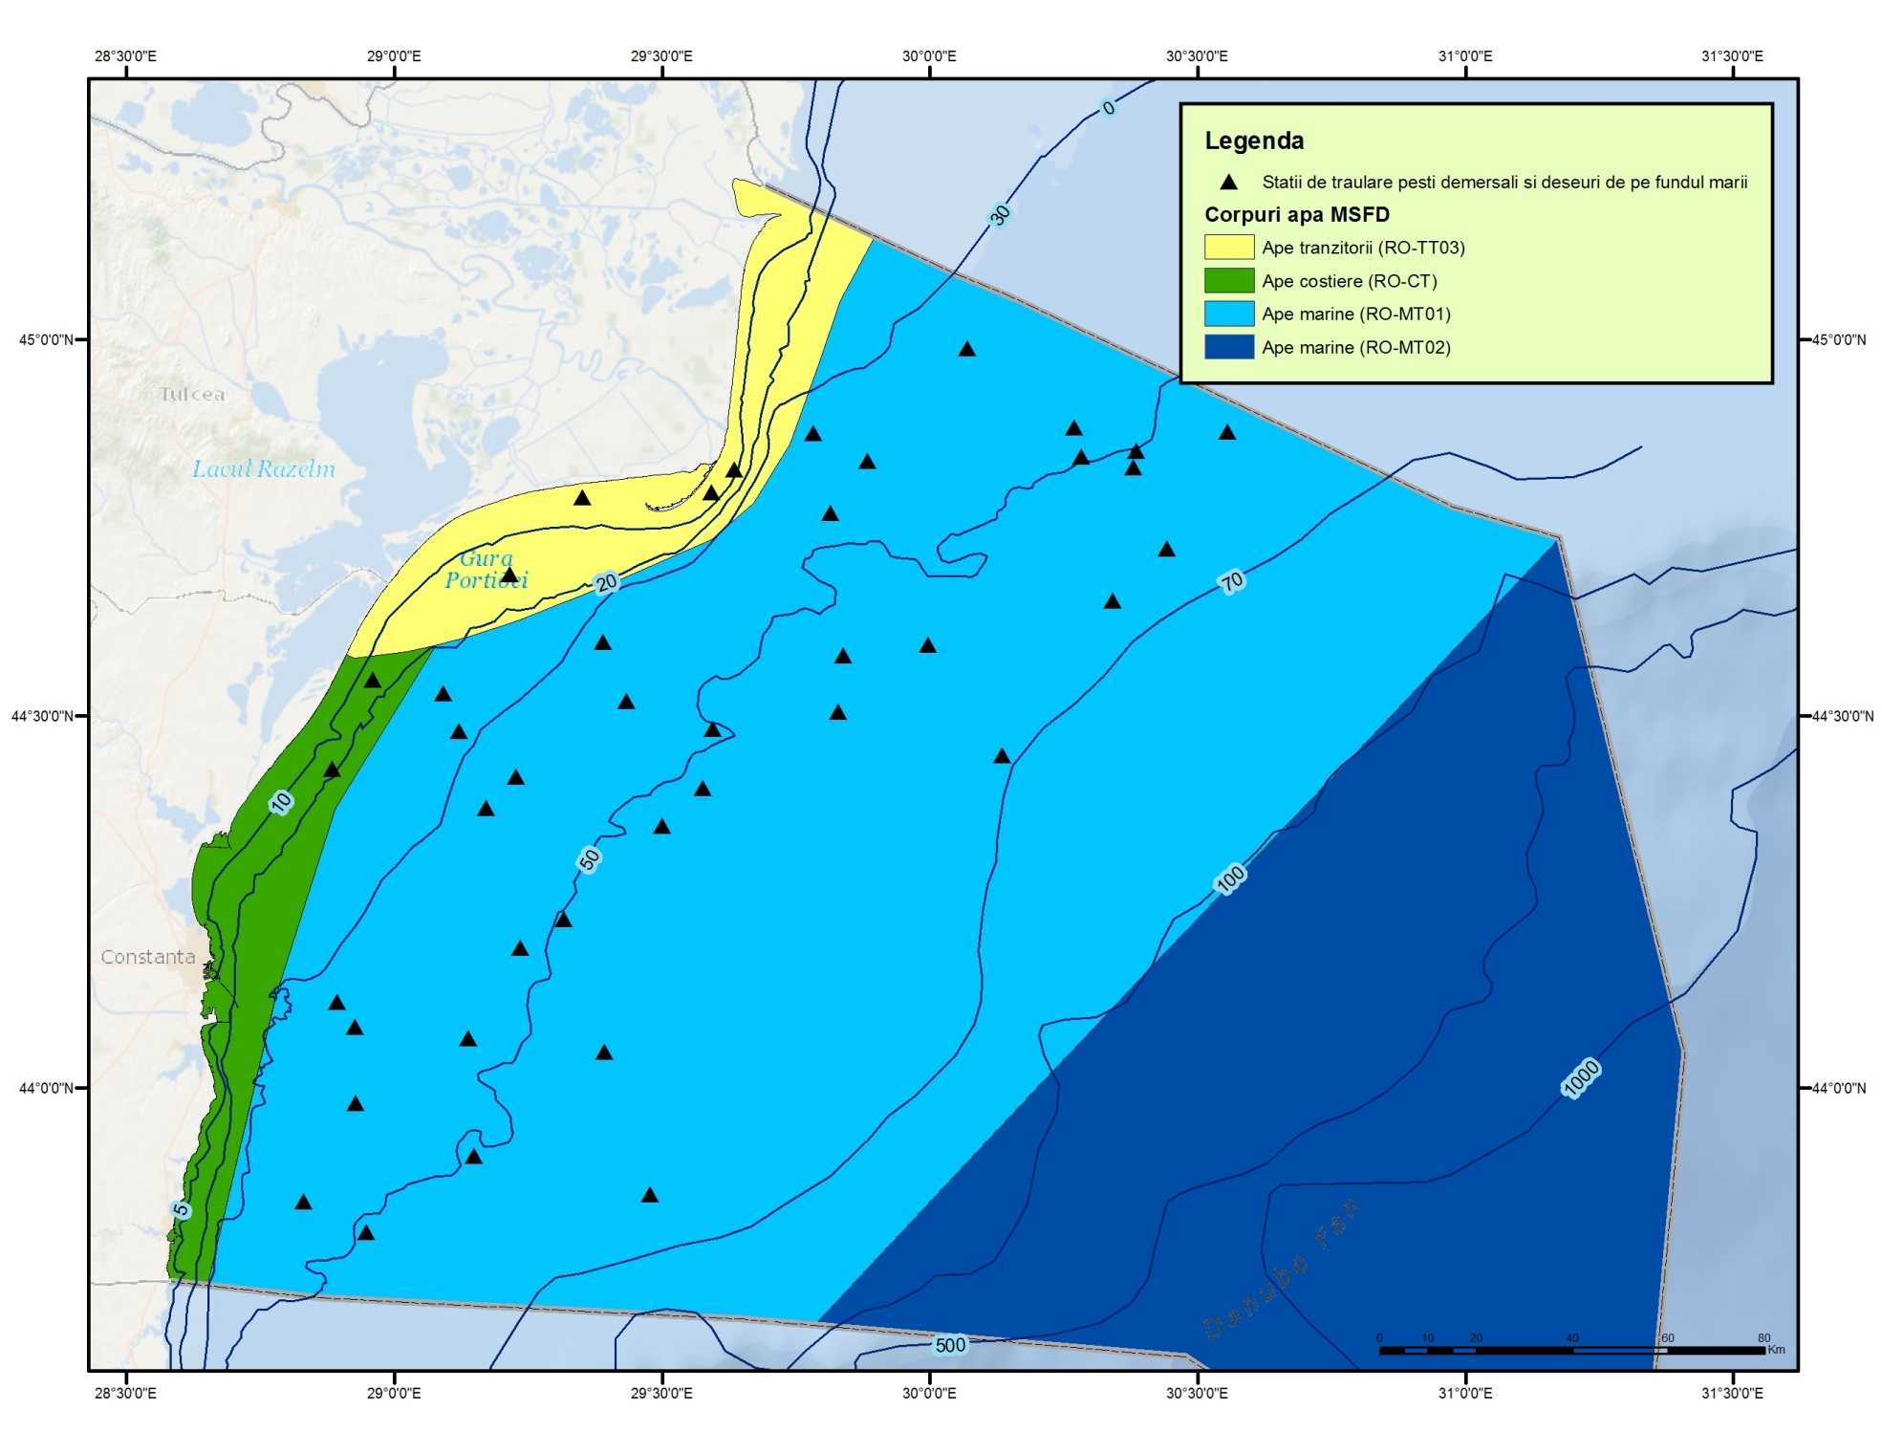  Fig. 2 - Distribution of trawling zones (Commercial Fish programme)  NGOs (Mare Nostrum and Oceanic Club) are dealing with the monitoring of stranded dolphins (alive or dead) along the Romanian beaches.
3.3 Threats, activities and measures | Which threats are identified  Which human activities will be measured by the programme?  The major threats identified which potentially affect the marine mammals population are: fishing (legal and illegal), pollutants and underwater noise.  Relevant human activities (activity theme/activity) associated to above mentioned threats are:  - Extraction of living resources/ Fisheries incl. recreational fishing (fish and shellfish)  - Man-made structures/ Port operations; submarine cable and pipeline operations;  - Transport/ Shipping  - Military/Defence- recurrent defence operations; defence- dumping of unwanted munitions  - Waste disposal/ Solid waste disposal  - Land-based activities/industries/Coastal and riverine inputs from land - industrial discharges; coastal and riverine inputs from land - agricultural run-off; coastal and riverine inputs from land - municipal waste water discharge  The programme will address only partially to above mentioned activities by measuring their distribution, extent and frequency. The pressures resulted from those activities will be subject to other programmes (e.g. D3 – Commercial fish, D8 - Contaminants, D10 – Marine Liter, D11 – Underwater Noise).  Which measures will be measured by the programme?  To be developed
3.4 Data management | How and where are data managed? How and where can data be accessed? (General description – programme level)  Data are reported (either as raw data or data products) through competent authority to BSC (through AG – CBD).  Data/information coming from the programme are also included in Marine Mammal DataBase (MMDB) for the Romanian Black Sea coast with interface with MEDACES for data transmission (realised in the period of Life project “Conservation of dolphins from Black Sea Romanian waters” Marine Mammal Database for the Romanian Black Sea coast (shared with other regional databases such as MEDACES) and in different projects databases.
4. Assessment
4.1 Assessments | Existing assessments  Provide information about or URL links to existing assessments (eg. Initial Assessment)  MSFD (Art. 8) – Initial Assessment  http://cdr.eionet.europa.eu/ro/eu/msfd8910/msfd4text/envuhwuaq  Environmental Status Reports  http://www.rmri.ro/Home/Products.EnvStatusReport.html  State of Environment Report 2001-2006/7  http://www.blacksea-commission.org/publ-SOE2009.asp  Agreement on the conservation of Cetaceans of the Black Sea, Mediterranean sea and Contiguous Atlantic Area (ACCOBAMS) during the period 2012 – 2013 http://www.accobams.org/images/stories/PDF/NR/romania.pdf  http://www.accobams.org/images/stories/National_reports/2010/2010%20romania%20national%20report.pdf
4.2 Assessment of GES | Will assessment of GES be carried out by the programme  RO has not defined yet the GES related to mammals according to MSFD requirements (see Sections 2). The programme will provide only partial data/information for assessing mammal population status; it has to be improved significantly for a robust GES definition (based on methodology provided by Habitats Directive) and, further, for assessing the distance to and progress towards GES (see Section 6).
5. Literature
List of relevant literature
Marine strategy framework Directive Task group 1 report Biological diversity
http://ec.europa.eu/environment/marine/pdf/1-Task-group-1-Report-on-Biological-Diversity.pdf
ACCOBAMS Guidelines. Web: http://www.accobams.org/
Zampoukas, N., H. Piha, 2011. Review of Methodological Standards Related to the Marine Strategy Framework Directive Criteria on Good Environmental Status. Publications Office of the European Union, 53 pp. Web: < http://publications.jrc.ec.europa.eu/repository/handle/111111111/16069>;
Zampoukas, N., H. Piha, E. Bigagli, N. Hoepffner, G. Hanke, A. Cardoso, 2012. Monitoring for the Marine Strategy Framework Directive: Requirements and Options. Publications Office of the European Union, 42 pp. Web: http://publications.jrc.ec.europa.eu/repository/handle/111111111/23169
6. Activities required to implement the concept
6.1 Changes to the current monitoring programme | Necessary changes and recommendations  Describe necessary changes for the programme to cover the requirements of MSFD. Description in general terms.  Recommendations and actions needed:  - increasing financial assistance and securing sustainable financing at national levels  - better integration the MSFD monitoring with the monitoring requirements of the other directives (e.g Habitats Directive), regional sea conventions (BSC);  - better integration of the mammals monitoring with the monitoring under the other descriptors of the MSFD (Zampoukas et al., 2012) to get advantage of the chance encounters of dolphins both along the coast and during offshore surveys. Count of toothed whales combined with bird counts may also be considered  - permanent agreements with other authorities/organisations in supporting the monitoring programme;  - better use and coordination of the existing capacities of all organizations dealing with the programme;  - strengthen the regional cooperation/harmonization between the Black Sea MS (common sampling and data processing methodologies, common MSFD indicators/parameters to be approach, common GES and Environmental Targets definitions)  - adjust extension (spatial and temporal)  - improve the monitoring methodology by developing new techniques (mark-recapture analysis of photo-identification data, acoustic survey techniques, acoustic static devices installed on offshore platform, aerial-based observations)  - Improve the knowledge related to the impact of less studied human induced pressures (litter, noise, etc) on the monitored elements  - existing indicators to be developed (e.g. new parameters to be considered and developed)  - additional indicators to be developed/approached (especially related to D4)  - developing and using standard marine mammals recording forms to streamline the data acquisition and data processing (see: Guidance to Manage the Risk to Marine Mammals from Man-made Sound Sources in Irish Waters, 2014. See Appendix 6 – Marine mammals recording form – sightings. Web: http://www.npws.ie/) - e.g. PAMGUARD software with towed hydrophone array on the deck of the ship  - improving data management
6.2 Gaps: GES information | If not yet adequate for data and information needs to assess GES, describe when the programme will be considered fully adequate  In time for next assessment in 2018;
6.3 Plans: Plans for GES information | If the programme is not considered fully adequate for data and information needs to assess GES, describe what plans are in place to make it fully adequate (eg. to fill gaps in data methods, understanding or capacity). Describe timeframe, priorities and obstacles.  The methodology used for GES definition within the Habitats Directive (targets defined only for species occurred within Natura 2000 sites) have to be considered/adapted for defining GES according MSFD requirements.  The programme needs to be improved substantially, especially in terms of infrastructure (new monitoring tools), so that to provide more valuable data/information and knowledge for approaching and developing indicators/parameters concerned (related to D1 and D4).  A major need is related the regional cooperation; the Black Sea MS have to develop common methodology for providing common GES and targets definitions.
6.4 Gaps: Target information | If not yet adequate for data and information needs to assess targets, describe when the programme will be considered fully adequate  in time for next assessment in 2018;
6.5 Plans: Plans for information on targets | If the programme is not considered fully adequate for data and information needs to assess targets, describe what plans are in place to make it fully adequate (eg. to fill gaps in data methods or capacity). Describe timeframe, priorities and obstacles.  RO has defined state/impact targets related only to species distribution and abundance of key trophic species; no targets related to habitat condition and population size have been established yet.  The current programme has to be improved, especially in terms of new monitoring tools, for updating (quantitative approach) the targets already defined and assessing the progress toward their achievement. Also, significantly efforts have to be done for strengthening the cooperation between organizations (at national, but also sub-regional level), improving data reporting, data QA/QC, etc. in order to collect more valuable data/information for setting new robust environmental targets according to MSFD requirements, taking also into consideration the methodology used within Habitats Directive.  More research is also needed for improving the knowledge related to the impacts of anthropogenic activities on the mammals population (a sub-programme related to community health status should be developed in the future).
6.5 Plans: Plans for information on measures | If relevant: If the programme is not considered fully adequate for data and information needs to assess measures describe what plans are in place to make it fully adequate (eg. to fill gaps in data methods or capacity). Describe timeframe, priorities and obstacles.  To be developed

