MONITORING FACT SHEET
Country: | Bulgaria
Author: | Georgi Parlichev
Institute: | Black Sea Basin Directorate

MONITORING FACT SHEET TEMPLATE |  | This column is for information only and should be removed when the sheet has been filled in.
Title: Marine mammals (Descriptor 1, 4)
1. General |  | Reporting sheet questions (ref. DIKE_9-2014-03 for additional guidance on questions) and comments on template suggestions presented below
1.1 Subject area | What is monitored – programme ID (BLKXX-DY)  Programme name: Marine mammals  Programme ID: BLKBG-D01,04-mammals | Q4: Programme name (4d); Programme ID (exchange XX with BG or RO; exchange Y with relevant descriptor no.) (4e)
1.2 Definition/Description | Definition of items monitored/description of general approach  The current monitoring programme will addresses the state, pressure and impact of the DSPIR framework. The state of the marine mammals and their populations will be determined by distance sampling method during the monitoring under the other descriptors of the MSFD. Monitoring on pressure from the relevant human activities (industrial and urban wastewater, fisheries and shipping) is already conducted or will be conducted in the future monitoring programme. The impact will be measured by the number of whales found dead, when there is a clear indication of causative relationship with certain human activities. Tissues from marine mammals are hard to obtain and it would be impossible to determine the relationship between the pressure from pollution / water contamination (from land-based pollution and shipping) and its impact on the populations. Therefore the monitoring on pressure should primarily focus on the physical impact (entanglement, wounding and killing) marine mammals from fisheries gear and impact with vessels. The pressure from pollution and contamination should be developed within the monitoring programmes under the other descriptors, like D8 and D9.  Parameters monitored:  - Harbour porpoise (Phocoena phocoena);  - Common bottlenose dolphin (Tursiops truncatus);  - Short-beaked common dolphin (Delphinus delphis);  Populations of Short-beaked common dolphin (Delphinus delphis), harbour purpoise (Phocoena phocoean) and common bottlenose dolphin (Tursiops truncatus) will be monitored by means of wide-area registration (land- and/or ship-based counts) by using standardized European Seabirds at Sea (ESAS) methodology. Acoustic underwater monitoring is deployed in areas with low densities of toothed whales. Further parameters for population dynamics are determined by means of examinations of found-dead marine mamals. The programme will use the different information sources for information on the state and impact on the marine environment:  - The evaluation of the cause of death of stranded animals;  - Reported by-catch;  - Incidental catches recorded during observation programs on board;  - Estimate trends in terms of abundance through data collected by using passive acoustic monitoring (passive acoustic monitoring);  - Chance encounters of marine animals during monitoring surveys under the other monitoring programmes. | Q4: Programme description (4f). Free text or URL link. What is monitored by the programme (state/impact, pressure, activities, measures) and why. How does it adapt to new and emerging environmental problems
1.3 Competent authority/ies | Which authorities are responsible (links to www)  Ministry of the Environment and Waters  Web: http://www.moew.government.bg/  Black Sea Basin Directorate  Web: http://www.bsbd.org/  Regional Health Inspectorate of Burgas also gathers data on marine mammals – species, numbers, time of discovery and provides pictures, which can subsequently use to identify the cause of death. | Q4: Responsible Competent Authority (4a)  If more than one – put contact to the EU Commission
1.4 Monitoring institutions | Which institutions carry out the monitoring etc (links to www)  Institute of Oceanology – Bulgarian Academy of Sciences. Relationship: contrct-based  Web: http://www.io-bas.bg/index_en.html | Q4: Responsible institutions; relationship to Competent Authority (4b) +(4c)
1.5 Additional information | Where can additional information be found (e.g. via a web link)  3a – Black Sea Commission (BSC)  Web: http://www.blacksea-commission.org/  3b – Black Sea transboundary diagnostic analysis (TDA)  Web: http://www.blacksea-commission.org/_tda2008.asp  Regarding regional coordination remember this project and other relevant joined projects | Q3: Additional information on: Regional coordination; consideration of transboundary impacts; ability of programme to identify major changes in environment and new and emerging issues; (3a-c)
2. Monitoring requirements and purpose
2.1 Necessity | Listed below are direct references to the monitoring requirements – EU directives, Black Sea Commission agreements, national plans, research programme requirements, other.  Delete/add rows | The purpose of this section is to give an overview of existing monitoring requirements related to this programme and to help coordinate already existing monitoring  Q8a: Existing monitoring programmes deliver data to other directives etc. This part of the monitoring fact sheet helps to give an overview of how and where the specific monitoring is used for many purposes/requirements (8a).  State where relevant monitoring is already carried out (or should be/is required)
MSFD  Article 11  Article 8  Annexe III  Annexe V | Comments  Article 11  Member States shall establish and implement coordinated monitoring programmes for the ongoing assessment of the environmental status of their marine waters on the basis of the indicative lists of elements set out in Annex III and the list set out in Annex V, and by reference to the environmental targets established pursuant to Article 10.  The following characteristics should be monitored under monitoring programme D1, 4 – Marine mammals:  Annex III, Table 1:  —a description of the population dynamics, natural and actual range and status of species of marine mammals and reptiles occurring in the marine region or subregion,  The following pressure on marine mammals should be monitored D1, 4 – Marine mammals:  Annex III, Table 2:  —selective extraction of species, including incidental non-target catches (e.g. by commercial and recreational fishing). | Which parts of MSFD requirements does the programme fulfil? Refer to the articles and annexes of the Directive that require that monitoring is carried out.
Habitat Directive  Article 11  Article 17 | Comments  Habitat Directive (Directive 79/409/EEC):  Member States shall undertake surveillance of the conservation status of the natural habitats and species referred to in Article 11 with particular regard to priority natural habitat types and priority species. Consideration of nutrient inputs in the assessment of habitat impairments. Article 17 requires reporting of the measures and their effect on the conservation status of the natural habitat types of Annex I and the species in Annex II and the main results of the surveillance referred to in Article 11. | Which parts of HD requirements does the programme fulfil?
Black Sea Commission  Black Sea SAP | Comments  Black Sea Strategic Action Plan (BS-SAP)  Article XV - The Contracting Parties shall cooperate in conducting scientific research aimed at protecting and preserving the marine environment of the Black Sea and shall undertake, where appropriate, joint programmes of scientific research, and exchange relevant scientific data and information  Web:  BSIMAP - Black Sea Integrated Monitoring and Assessment Programme  Web: http://www.blacksea-commission.org/_bsimap_description.asp | Does the programme fulfil any formal obligations to the BSC?
Other plans and/or programmes | Comments | Does the programme fulfil any formal obligations to other plans and programmes?
2.2 GES criteria | List relevant GES Criteria and characteristics [indicators] (see Commission Decision of 1. September 2010)  1.1 Species distribution  — Distributional range (1.1.1)  1.2. Population size  — Population abundance and/or biomass, as appropriate (1.2.1)  4.3. Abundance/distribution of key trophic groups/species  — Abundance trends of functionally important selected groups/species (4.3.1) | Which GES criteria are addressed/monitored by the programme (5a). Select the relevant criteria. Which characteristics [indicators] are addressed/monitored (5b)
2.3 Features, pressures and impacts | List relevant features and pressures from MSFD Annex III  Features:  - Functional groups – Mammals – Toothed Whales  Pressures:  - Noise from shipping  - By-catch from fisheries  Impacts:  - Dead mammals found on beaches and drifting in the sea surface  - Contaminants in mammal tissues (if possible to obtain)  Refer to section 6 regarding gaps and plans | Which elements of Annex III (ecosystem components, pressures/impacts) are addressed/monitored by the programme (5c)
2.4 GES | Assessment of GES (GES as defined in the article 9 reporting)  Overall GES definition: GES is achieved when all the three species of marine mammals are frequently encountered not only in the remote areas but also near the major ports and coastal cities / resorts the respective populations show signs indicative of stable or increasing number of individuals in the population.  GES definition on Criterion 1.1. Species distribution: all the three species of toothed whales are abundant along the Bulgarian coast and can be encountered not only in the remote areas but also near the major ports and coastal cities / resorts;  GES definition on Criterion 1.2. Population size: all the three species of toothed whales show signs indicative of stable or increasing number of individuals in the population;  Describe how the programme:  - addresses assessment needs for the relevant Descriptor(s) and targets – the monitoring programme addresses the assessment needs by stating a GES definition in coherence with S. M. A. R. T. (Specific, Measurable, Achievable, Realistic, Timely) targets and, if necessary, by updating the GES definitions and targets to be able to provide assessment of the current environmental status and determine the distance from GES. The monitoring programme also defines targets addressing the pressure from human activities, state and impact of the marine environment.  - meets the needs of providing data/ information to support assessment of the Descriptor (or particular biodiversity component programme for D1, 4, 6) – the existing monitoring programme does not provide data/information for assessment of the Descriptor 1, 4. Specific plans for assessment of GES and targets are designed to make the programme adequate in providing data and information for assessment of Descriptor 1, 4;  - contributes to determining distance from GES and trends in status – the existing monitoring programme does not fully meet the requirements of the MSFD and does not contribute in determining the distance from GES and trends in status. By updating the GES definitions, threshold or trend-based targets, and implementing plans for data and information on GES and targets, the programme will be able to provide information on the distance from GES and trends in status;  - addresses natural and climatic variability and distinguish this from the effects of anthropogenic pressures – the existing monitoring programme does not provide information to distinguish the effect of natural and climatic variability from the anthropogenic pressures. The problem should be addressed in the Plans for information on GES.  - responds to risks of not achieving GES – the minimum requirement is to make the existing monitoring programme adequate to the requirements of the MSFD (in accordance with the Plans for information on GES and targets, listed below).The monitoring programme responds to the risk of not achieving GES by updating GES definition and targets to be able to detect if GES is achieved. GES targets should be reviewed and updated annually to reflect new information on GES, acquired from the yearly monitoring programme of the Bulgarian marine waters. | State the definition of GES reported for the relevant descriptor and describe how the programme: addresses assessment needs for the relevant descriptor; contributes to determining distance from GES and trends in status; addresses natural and climatic variability; responds to risk of not achieving GES (5f)
2.5 Environmental targets  MSFD  HD  BD  WFD  BSC | Relevant MSFD targets defined in the article 10 reporting  State relevant targets from other obligations (see section 2.1) that are addressed by the monitoring  Pressure targets:  Reducing the by-catch levels of the toothed whales (Phocoean phocoena, Turciops truncatus, Delphinus delphis).  State targets:  1.1.1. Target. Preserve the existing distribution range of the three species of marine toothed whales by implementing appropriate management measures.  1.2.1. Target. Positive trend in the population abundance of the three species of marine toothed whales.  4.3.1 Population abundance of marine toothed whales (Phocoean phocoena, Turciops truncatus, Delphinus delphis) is not significantly affected by human activities.  Operational targets:  Consider the necessity of creation of new and/or expansion of existing protected areas, including transboundary areas in consultation with the relevant Black Sea countries with particular attention to marine protected areas. Establish or extend these areas where necessary (Black Sea Strategic Action Plan target 14).  Monitor and facilitate the progress in the implementation of nationally developed management plans of the protected areas (Black Sea Strategic Action Plan target 21).  Support coordinated scientific studies, increase resources to marine science and improve capacity particularly through targeted training programmes supporting scientific projects/programmes (Black Sea Strategic Action Plan target 25).  Ban non–precautionary fishing technologies (Black Sea Strategic Action Plan target).  Develop regulations aimed at decreasing by-catch level (Black Sea Strategic Action Plan target).  Minimize ghost fishing caused by discarded, abandoned or lost fixed and floating nets, including those used in illegal/unregulated fishing activities (Black Sea Strategic Action Plan target).  Habitats Directive (Directive 92/43/EEC)  The aim of the Directive is to contribute towards ensuring bio-diversity through the conservation of natural habitats and of wild fauna and flora in the European territory of the Member States to which the Treaty applies.  Commission on the Protection of the Black Sea Against Pollution  Black Sea Strategic Action Plan (BS-SAP)  3.3 Management targets and priority status required to meet the EcoQOs  (7) Develop regulations aimed at decreasing by-catch level | Q6: State the targets addressed by the monitoring.  Which reported targets are addressed (6a)?  Will the programme provide adequate data to assess progress towards achievement of target and will the collected data enable updating of targets (6b-c)?  Explain how the programme will contribute to the assessment of progress with targets (6d)  Add targets relevant to other directives and commitments
2.6 Spatial allocation | Table of where monitoring is required  EEZ 12-nm zone Coastal waters Transitional waters  MSFD x x x -  HD x x x x  WFD - - - -  BSC x x x - | Q4: Geographical coverage by reference to the 4 zones in table 1 of the "concept paper" (4i)
3 Monitoring concept
3.1 General description of relevant subprogrammes in monitoring programme | List subprogrammes monitored under this programme (only general description)  Mobile species - abundance and/or biomass. Parameters measured: species abundance.  Mobile species - population characteristics. Parameters measured: population characteristics.  Mobile species - state of habitats. Parameters measured: habitat for the species(extent, suitability)  Mobile species - mortality/injury rates from fisheries (targeted and/or incidental). Parameters measured:  Mobile species - mortality/injury rates from other human activities. Parameters measured: Rates of mortality, injury or other adverse effects from shipping.  Activities extracting living resources. Parameters measured: Distribution/extent in space and time, intensity  Effectiveness of measures. | Use list In document DIKE_9-2014-03_Art11ReportingPackage.doc and BS-CBE Jan_MFS Pgm Subpgm_list_rev.xls for subprogramme names. New ones may be added if necessary. Use BS-CBE Jan_MFS Pgm Subpgm_list_rev.xls to see/check parameters measured in subprogramme
3.2 Description of monitoring network | Description + maps (describing the spatial resolution of the entire programme)  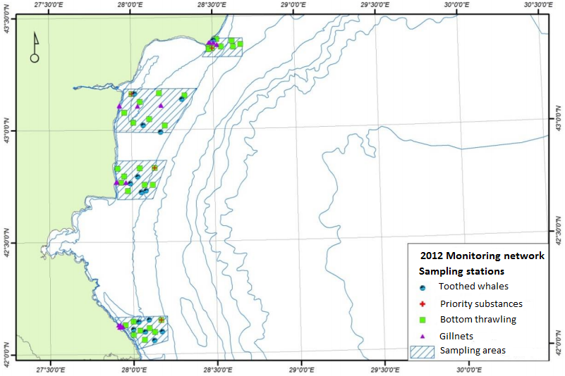  Figure 1 Sampling stations for toothed whales (Delphinus delphis, Turciops truncatus, Phocoena phocoena) and fish in 2012  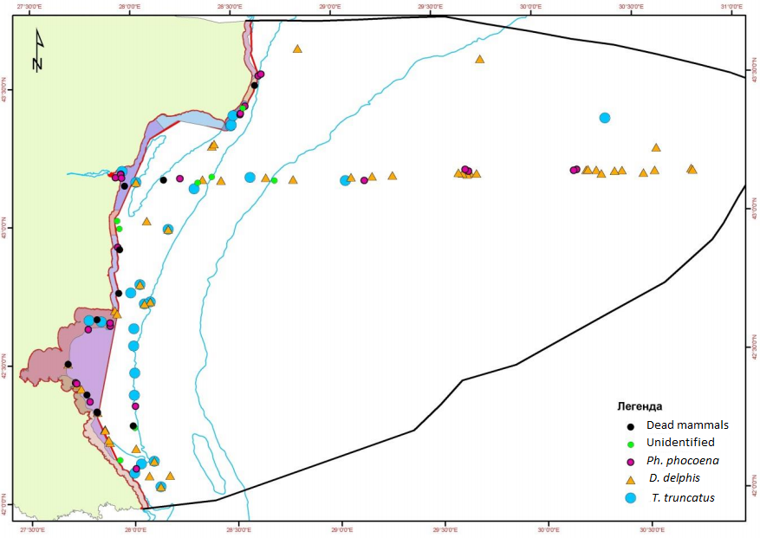  Figure 2 Sampling stations for toothed whales in 2012  The monitoring programme should be integrated with the monitoring under the other MSFD descriptors by using the existing monitoring network.  Institute of Fisheries Resource – Ministry of Agriculture – monitoring marine mammals (harbour purpose (Phocoena phocoena) and common dolphin (Delphinus delphis)). Research parameters include mammals behaviour, by-catch (number of animals, morphological data, sex), injury and mortality rates, causes of death and tissue samples from marine mammals, according to ACCOBAMS, ICES and EC recommendations. Data on some of the parameters available since 1997. | Spatial resolution (density op sampling). Show sampling network on map. Describe the rationale for the geographical scope of the programme ("4j")
3.3 Threats, activities and measures | Which threats are identified  Marine mammals are vulnerable to:  Fishing (by-catch)  Pollutants  Shipping traffic (including leisure activities)  Which human activities will be measured by the programme  Fisheries, Industry, Urban, Shipping | Q7: Relevant activities (7a);
 | Fishing occurs in the coastal waters, territorial waters and EEZ. Its major impact is by-catch of marine mammals.  The Major sources of pollution are land-based point and non-point. In the sea the major source is the pollution from ships, discharging their wastewaters and hard waste directly. Indirectly, both land-based (industrial) and sea-based (shipping) human activities related with burning cause diffuse pollution with nitrogen oxides, sulphur oxides and heavy metals.  Shipping traffic has two impacts – direct impacts causing injuries and death and through underwater noise, causing behavioural changes and sub-lethal or lethal effects. | describe the nature of activity or pressure (7b);
 | Which measures will be measured by the programme  Concerns about the protection status of Black Sea Common Dolphin (Delphinus delphis ssp. Ponticus) regarding the Black Sea population were expressed in the IUCN/SSC 2002-2010 Conservation Action Plan (Reeves et al. 2003).  The other 2 species (Harbour porpoise (Phocoena phocoena) and common bottlenose dolphin (Tursiops truncatus)) are not considered threatened.  Fishing of the three species is prohibited by the Bulgarian legislation. | relevant existing measures (if any) (7c);
 | The existing measures on the land-based point sources of pollution are already monitored under the WFD. These measures will also be monitored under the monitoring programmes under Descriptor 8 (Contaminants) and Descriptor 10 (Marine litter). | how are existing measures monitored (7d)
3.4 Data management | How and where are data managed? How and where can data be accessed? (General description – programme level)  - Type of data – printed reports and spreadsheets and / or databases  - Method/mechanism used to make it available – data are made available to the public filing an information request, according to the legal requirements.  - use rights for EC/EEA – data should be requested by the EC/EEA from the competent authority (Ministry of the Environment and Waters, Executive Environment Agency), unless legally required by the EC environmental legislation.  - INSPIRE standards used – no INSPIRE standards used  - when the data will first be available – when reported according to the obligations of Bulgaria to the EC and / or legally requested.  - frequency of update of the data - yearly | Q10 (+Q3): Access to data; use rights; INSPIRE standards; when will data become available; updates when; how will data be made available to the EEA
4. Assessment
4.1 Assessments | Existing assessments  Provide information about or URL links to existing assessments (e.g. Initial Assessment)  Bulgarian reporting under Art. 8, 9 and 10 of the MSFD (in BG and EN)  Web: http://cdr.eionet.europa.eu/bg/eu/msfd8910/  Southstream Project Environmental Impact Assessment (in Bulgarian)  http://www.south-stream-offshore.com/bg/ovoss/ovoss-v-blgariya/doklad-za-rezultatite-ovos-v-blgariya/  Definition of the areas under national jurisdiction included in the Agreement’s field of application (over which the Agreement applies). Web: http://www.accobams.org/index.php?option=com_content&view=article&id=1056&Itemid=86 | This is for information purpose only. Where can stakeholders etc find existing assessments on issues relevant to the programme
4.2 Assessment of GES | Will assessment of GES be carried out by the programme | Q5: Will the programme enable periodic assessment of environmental status and distance to and progress towards GES (5d). Describe how and refer to section 6 to describe if programme is not considered fully adequate.
5. Literature
List of relevant literature
ACCOBAMS Guidelines. Web: http://www.accobams.org/ (Go to Documents > Guidelines)
PAMGUARD software. Web: http://www.pamguard.org/
Zampoukas, N., H. Piha, 2011. Review of Methodological Standards Related to the Marine Strategy Framework Directive Criteria on Good Environmental Status. Publications Office of the European Union, 53 pp. Web: < http://publications.jrc.ec.europa.eu/repository/handle/111111111/16069>;
Zampoukas, N., H. Piha, E. Bigagli, N. Hoepffner, G. Hanke, A. Cardoso, 2012. Monitoring for the Marine Strategy Framework Directive: Requirements and Options. Publications Office of the European Union, 42 pp. Web: http://publications.jrc.ec.europa.eu/repository/handle/111111111/23169
Guidance to Manage the Risk to Marine Mammals from Man-made Sound Sources in Irish Waters, 2014. See Appenidx 6 – Marine mammals recording form – sightings. Web: http://www.npws.ie/

6. Activities required to implement the concept
6.1 Changes to the current monitoring programme | Necessary changes and recommendations  Describe necessary changes for the programme to cover the requirements of MSFD. Description in general terms. | Which changes are necessary to the current/existing monitoring programme to secure adequacy with regards to MSFD (e.g. changes in monitoring network)  Q7: Will the programme provide necessary data and information to enable identification of relevant activities/pressures that are causing environmental degradation and will the programme identify suitable new measures and the effectiveness of existing measures (7e)
6.2 Gaps: GES information | If not yet adequate for data and information needs to assess GES, describe when the programme will be considered fully adequate  The programme is expected to be adequate for information on GES in time for next assessment in 2018 | Select when the programme is expected to be adequate: In 2014; in time for next assessment in 2018; in time for updating of monitoring programme in 2020; later than 2020 (5g)
6.3 Plans: Plans for GES information | If the programme is not considered fully adequate for data and information needs to assess GES, describe what plans are in place to make it fully adequate (e.g. to fill gaps in data methods, understanding or capacity). Describe timeframe, priorities and obstacles.  General recommendations:  Spatial scope of the monitoring programme. Expand the current monitoring network to provide data for the pressure from the drivers (human activities and natural changes), state and impact in the coastal waters, territorial waters and exclusive economic zone, according to the requirements of the Marine Strategy Framework Directive.  Integration across monitoring institutions to improve the research capacity and fill in the data gaps by involving the relevant monitoring institutions, if necessary:  - Institute of Biodiversity and Ecosystem Research (IBER) - Bulgarian Academy of Sciences – experience in modelling the marine food web, which is relevant particularly for monitoring programmes, including descriptor D4 (Marine food webs) (e.g. D1, 4, 6 – Seabed habitats, D1, 4 – Water column habitats, D1, 4 – Non-commercial fish, D1, 4 – Marine mammals, D1, 4 - Seabirds) and making use of the monitoring data already acquired in the IBER monitoring programme;  - Institute of Fisheries Resources - Varna (Ministry of Agriculture) – monitoring marine mammals (harbour purpose (Phocoena phocoena) and common dolphin (Delphinus delphis)). Research parameters include mammals behaviour, by-catch (number of animals, morphological data, sex), injury and mortality rates, causes of death and tissue samples from marine mammals, according to ACCOBAMS, ICES and EC recommendations. Data on some of the parameters available since 1992. Also, research expertise in fish and long dataset on different characteristics in the marine environment. The IFR-Varna has long-term datasets on different parameters of the marine environment (physical, chemical, biological).  Integration across Black Sea Member States (at minimum, Bulgaria and Romania) (Zampoukas et al., 2012). Joint cruises with Romania will help minimizing the costs and ensure that the data are acquired in a similar and comparable manner thus allowing a comparable assessment and classification of the Bulgarian and Romanian marine areas. The benefit of using common sampling methods and common parameters will result in having regionally agreed indicators, and consequently setting regionally coherent targets and definitions of GES.  Integration across legislative requirements and Regional Sea Conventions (RSCs) (Zampoukas et al., 2012). Both Bulgaria and Romania can use the data generated in fulfillment of the obligations under the related environmental legislation of the EU (e.g. Water Framework Directive, Bathing Waters Directive and Habitats Directive) and the Black Sea Commission to acquire information on GES .  Integration across descriptors and indicators (Zampoukas et al., 2012). The coordinated monitoring programme on D1, 4 – Seabirds can be integrated with the monitoring of all the other descriptors, because chance encounters of marine mammals can happen during offshore, nearshore and coastal monitoring surveys. Particular possibilities for integration exist with monitoring programmes D1, 4 – Seabirds, because monitoring on marine mammals can use the same methodology as the one used for monitoring of seabirds – standardized boat-based European Seabirds Seabirds at Sea (ESAS) methodology (Tasker et al., 1984).  Programme-specific requirements:  Start in 2015 (if not already started in 2014) the implementation of coordinated with Romania monitoring programme on Descriptor D1,4 – Marine mammals to provide information on the distance from GES and update the GES definition, if necessary, for the next Article 8 reporting on assessment of environmental status and Article 9 reporting on GES in 2018.  Bulgaria and Romania should revise and further develop together coherent GES definitions and assessment methods for their marine waters taking into account the assessment and the recommendations of the Commission, as much as possible, in 2014.  Bulgaria and Romania should revise and further develop together coherent targets based on agreed, if not harmonized, indicators for their marine waters taking into account the assessment and the recommendations of the Commission, as much as possible, in 2014.  Bulgaria and Romania should evelop together agreed indicators (based on common parameters) and/or harmonised indicators (based on common parameters and common methods) for the marine waters of Bulgaria and Romania taking into account the assessment and the recommendations of the Commission , as much as possible, in 2014.  Using standard marine mammals recording forms to streamline the data acquisition, data processing and reporting in a comparable and (e.g. MEDACES standard recording forms).  Using PAMGUARD software (see 5. Litterature) with towed hydrophone array on the deck of the ship for identification of close passing mammals  Distinguish between the natural and climatic variability and human pressure (in relation to MSFD Art. 11 reporting question 5f) – Data on natural and climatic variability (e.g. from the IPCC Data Distribution Centre and the National Institute of Meteorology and Hydrology – Bulgarian Academy of Sciences), and anthropogenic pressure (e.g. land-based point sources of pollution) should be made available to the monitoring institution to be able statistically analyse and distinguish between the pressure from global teleconnections and regional sources of anthropogenic pressure. In addition, data on the Danube river nutrient discharge and the role of the Black Sea Rim current should be made available, because they are of particular relevance for distinguishing the pressure of the Danube River from the pressure from the Bulgarian Rivers on Bulgarian marine waters. Data should be made available to the monitoring institution in time for the next assessment in 2018.  Using consistent sampling and assessment methodologies across Member States (Bulgaria and Romania).  Using the standardized boat-based method European Seabirds at Sea (ESAS) used to record seabirds and other highly mobile species behaviour while at sea and standard recording forms to streamline the data acquisition, data processing, reporting and assessment in a comparable and compatible manner.  Design a statistically sound monitoring programme. Robust statistical methods (e.g. distance sampling) should be used to determine the minimum sampling size, spatial frequency and temporal resolution of the monitoring network. It can be improved by using the appropriate software tools like DISTANCE, MAXENT and ArcGIS-related geodatabase, which have already been developed and applied in the current work of Bulgarian Society for the Protection of Birds (site: http://bspb.org/) and can be adapted for monitoring on marine mammals.  Take advantage in 2015 (if not already taken in 2014) of the available co-funding opportunities (LIFE, Horizon 2020, EMFF) and/or International Financial Institutions (European Bank for Reconstruction and Development (EBRD), European Investment Bank (EIB), The World bank (WB)), if necessary to fulfil the requirements of the MSFD. Spatial scope and the monitoring requirements pose significant burden to the national budgets of all the EU countries. Therefore, both Bulgaria and Romania should advantage of the relevant EU funds to support the implementation of the MSFD. | Free text or URL link to relevant information (5h)
6.4 Gaps: Target information | If not yet adequate for data and information needs to assess targets, describe when the programme will be considered fully adequate  The programme is expected to be adequate for information on GES targets in time for next assessment in 2018 | Select when the programme is expected to be adequate: In 2014; in time for next assessment in 2018; in time for updating of monitoring programme in 2020; later than 2020 (6e)
6.5 Plans: Plans for information on targets | If the programme is not considered fully adequate for data and information needs to assess targets, describe what plans are in place to make it fully adequate (e.g. to fill gaps in data methods or capacity). Describe timeframe, priorities and obstacles.  Start in 2015 (if not already started in 2014) the implementation of coordinated with Romania monitoring programme on biodiversity within the current monitoring programme D1,4 Marine mammals to provide information on the GES targets and update the targets, if necessary, for the next GES Article 9 reporting in 2018.  Review and regularly update the targets to reflect the improved knowledge of the relevant indicators and related threshold values (if applicable), produced during the yearly coordinated monitoring programmes, established according to Article 11 of the MSFD.  Bulgaria and Romania should revise and further develop together coherent targets based on agreed, if not harmonized, indicators for their marine waters, taking into account the assessment and the recommendations of the Commission, as much as possible, in 2014.  Develop threshold values and/or trends for the relevant indicators under D4 (food webs) by using the available data and modelling tools (in time for next assessment in 2018). | Free text or URL link to relevant information (6f)
6.5 Plans: Plans for information on measures | If relevant: If the programme is not considered fully adequate for data and information needs to assess measures describe what plans are in place to make it fully adequate (e.g. to fill gaps in data methods or capacity). Describe timeframe, priorities and obstacles. | Free text or URL link to relevant information (7f)

