MONITORING FACT SHEET – Contaminants
Country: | ROMANIA
Author: | Otilia Mihail
Institute: | Department on Waters, Forests and Fisheries (Ministry of Environment and Climate Change)

Title: Contaminants
1. General
1.1 Subject area | CONTAMINANTS; BLKRO-D8

1.2 Definition/Description | Chemical contaminant concentrations are an aspect of the objective of achieving clean, safe, healthy, biologically diverse and productive seas in the MSFD context. A potential consequence of seas that are chemically contaminated is that organisms or biological processes may be adversely affected. Two main approaches are used to study the pollution effects: measurements of biological effect parameters and contaminants concentrations.  The current programme mainly deals with the assessment of concentrations of priority contaminants in environmental matrices (water, sediment, and biota) as pressure in the marine environment. The programme is also dealing with the monitoring of pressures at source by quantifying the input per time and space (from atmosphere and land based sources).  The quantification of biological effects of contaminants at different levels of biological organization has not approached yet by the programme; major efforts, especially knowledge, have to be done for developing indicators/parameters related to the Criterion 8.2 (MSFD).  The relevant activities (distribution, intensity) are also considered by the programme. Instead, the programme does not address to monitoring of the measures taken; they are not developed at moment according to the MSFD requirements.  The main organizations involved in the current programme are: NIMRD, GeoEcoMar, and RWNA (responsible organization for WFD monitoring).  NIMRD deals with contaminants monitoring in the coastal and, partially, shelf waters. The parameters monitored are:  - heavy metals (Cu, Cd, Pb, Ni, Cr and Hg) in water (surface layer), sediment and biota (molluscs - Mytilus galloprovincialis, Rapana venosa, Scapharca inequivalvis, Mya arenaria and fish);  - Total Petroleum Hydrocarbons (TPHs) in water (surface layer) and sediment  - Polycyclic Aromatic Hydrocarbons (PAHs) in water, sediment and biota (molluscs - Mytilus galloprovincialis, Rapana venosa, Scapharca inequivalvis, Mya arenaria and fish)  - Organochlorine pesticides (aldrin, dieldrin, endrin, lindane, heptachlor, p,p’DDT, p,p’DDD, p,p’DDE, HCB) in water, sediment and biota (molluscs - Mytilus galloprovincialis, Rapana venosa, Scapharca inequivalvis, Mya arenaria and fish)  - PCBs (PCB 28, PCB 52, PCB 101, PCB 118, PCB 138, PCB 153, PCB 180) in water, sediment, and biota (molluscs -Mytilus galloprovincialis, Rapana venosa, Scapharca inequivalvis, Mya arenaria and fish)  - total and faecal coliforms, Escherichia coli, and faecal streptococci in water, sediment and biota (only faecal coliforms).  GeoEcoMar monitors only heavy metals (Cd, Co, Cr, V, Rb, Ba, Zr, Cu, Zn, Ni, and Sr) in sediment  RNWA deals with the contaminants monitoring in the coastal and transitional waters (according to WFD)  - heavy metals in water (surface layer) and sediment  - Total Petroleum Hydrocarbons(TPHs) in water (surface layer) and sediment  - Polycyclic Aromatic Hydrocarbons (PAHs) in water and sediment  - Organochlorine pesticides (aldrin, dieldrin, endrin, lindane, heptachlor, p,p’DDT, p,p’DDD, p,p’DDE, HCB) in water and sediment.  In addition, the National Agency for Environmental Protection is involved in the monitoring of contaminants inputs from atmosphere and also radionuclides level in water column.
1.3 Competent authority/ies | Ministry of Environment and Climate Change http://www.mmediu.ro/  - Department on Waters, Forests and Fisheries - contact point for the Commission
1.4 Monitoring institutions | National Institute for Marine Research and Development “Grigore Antipa”, Constanta http://www.rmri.ro/ - under coordination of the Ministry of National Education  Romanian Water National Administration (Dobrogea-Litoral Water Basin Administration) http://www.rowater.ro/ - under coordination of the Ministry of Environment and Climate Change  National Research and Development Institute for marine Geology and Geoecology, Bucharest http://www.geoecomar.ro/ - under coordination of the Ministry of National Education  National Agency for Environment Protection http://www.anpm.ro/ - subordinated to Ministry of Environment and Climate Change
1.5 Additional information | Black Sea Commission - BSIMAP  http://www.blacksea-commission.org/_bsimap.asp  MSFD Guiding Improvements in the Black Sea Integrated Monitoring System (MISIS) project  http://www.misisproject.eu  Integrated Regional monitoring Implementation Strategy in the South European Seas (IRIS -SES) project  http://iris-ses.eu/  Technical and administrative support for joint implementation of MSFD in Bulgaria and Romania  http://www.msfdblacksea.eu  Towards Integrated Marine Research Strategy and Programmes (SEAS-ERA) project - Strategic Research Agenda for the Black Sea Basin  http://www.seas-era.eu/
2. Monitoring requirements and purpose
2.1 Necessity | Listed below are direct references to the monitoring requirements – EU directives, Black Sea Commission agreements, national plans, research programme requirements, other.
MSFD  Articles 8 and 11  Annex III | Art.11.  1. On the basis of the initial assessment made pursuant to Article 8(1), Member States shall establish and implement coordinated monitoring programmes for the ongoing assessment the environmental status of their marine waters on the basis of the indicative lists of elements set out in Annex III and the list set out in Annex V, and by reference to the environmental targets established pursuant to Article 10.  2. Member States sharing a marine region or subregion shall draw up monitoring programmes in accordance with paragraph 1 and shall, in the interest of coherence and coordination, endeavor to ensure that:  (a) monitoring methods are consistent across the marine region or subregion so as to facilitate comparability of monitoring results;  (b) relevant transboundary impacts and transboundary features are taken into account.  Art. 8  The results of contaminants monitoring program are required for the next cycle of assessment of marine waters. To this end, contaminants concentrations and biological measurements relating to their effects on the ecosystem must be covered according to the Annex III, Tables 1 and 2)  Annex III, Table 1 (Characteristics)  Other features  — a description of the situation with regard to chemicals, including chemicals giving rise to concern, sediment contamination, hotspots, health issues and contamination of biota (especially biota meant for human consumption),  Annex III, Table 2 (Pressures and impacts)  Contamination by hazardous substances  — a Introduction of synthetic compounds (e.g. priority substances under Directive 2000/60/EC which are relevant for the marine environment such as pesticides, antifoulants, pharmaceuticals, resulting, for example, from losses from diffuse sources, pollution by ships, atmospheric deposition and biologically active substances),  — a introduction of non-synthetic substances and compounds (e.g. heavy metals, hydrocarbons, resulting, for example, from pollution by ships and oil, gas and mineral exploration and exploitation, atmospheric deposition, riverine inputs),  — a introduction of radionuclides  Biological disturbances  — introduction of microbial pathogens
WFD  Article 8  Annex V | Art. 8  1. Member States shall ensure the establishment of programmes for the monitoring of water status in order to establish a coherent and comprehensive overview of water status within each river basin district:  - for surface waters such programmes shall cover:  (ii) the ecological and chemical status and ecological potential;  - for protected areas the above programmes shall be supplemented by those specifications contained in Community legislation under which the individual protected areas have been established.  2. These monitoring programmes shall be in accordance with the requirements of Annex V.
DIRECTIVE 2008/105/EC OF THE EUROPEAN PARLIAMENT AND OF THE COUNCIL on environmental quality standards in the field of water policy (Environmental Quality Standards Directive)  Article 3  Annex 1 | Art. 3  3. Member States shall arrange for the long-term trend analysis of concentrations of those priority substances listed in Part A of Annex I that tend to accumulate in sediment and/or biota, on the basis of monitoring of water status carried out in accordance with Article 8 of Directive 2000/60/EC. They shall take measures aimed at ensuring, subject to Article 4 of Directive 2000/60/EC that such concentrations do not significantly increase in sediment and/or relevant biota.  MS shall determine the frequency of monitoring in sediment and/or biota so as to provide sufficient data for a reliable long-term trend analysis.
DIRECTIVE 2009/90/EC laying down, pursuant to WFD, technical specifications for chemical analysis and monitoring of water status  Articles 3, 4, 5 and 6 | The objective of this Directive is to establish common quality rules for chemical analysis and monitoring of water, sediment and biota carried out by MS.
Shellfish Waters Directive  Article 7 | Art. 7  1. The competent authorities in the Member States shall carry out sampling operations, the minimum frequency of which is laid down in Annex I (quality of shellfish waters).
BWD  Article 4  Annexes I and III | Art. 4  1. Member States shall ensure that sets of bathing water quality data are compiled through the monitoring of the parameters set out in Annex I, column A (intestinal enterococci (cfu/100 ml), Escherichia coli (cfu/100ml).
MARPOL 73/78  Annexes I, II and III | The Convention includes regulations aimed at preventing and minimizing pollution from ships - both accidental pollution and that from routine operations.  Annex I - Regulations for the Prevention of Pollution by Oil - covers prevention of pollution by oil from operational measures as well as from accidental discharges  Annex II - Regulations for the Control of Pollution by Noxious Liquid Substances in Bulk - details the discharge criteria and measures for the control of pollution by noxious liquid substances carried in bulk; some 250 substances were evaluated and included in the list appended to the Convention  Annex III - Prevention of Pollution by Harmful Substances Carried by Sea in Packaged Form - contains general requirements for the issuing of detailed standards on packing, marking, labeling, documentation, stowage, quantity limitations, exceptions and notifications.
Black Sea Commission  Convention on the Protection of the Black Sea Against Pollution (Art. 15) and its Protocols | Convention on the Protection of the Black Sea Against Pollution  Art. 15.  - The Contracting Parties shall cooperate in conducting scientific research aimed at protecting and preserving the marine environment of the Black Sea and shall undertake, where appropriate, joint programmes of scientific research, and exchange relevant scientific data and information.  - The Contracting Parties shall, inter alia, establish through the Commission and, where appropriate, in cooperation with international organizations they consider to be competent, complementary or joint monitoring programmes covering all sources of pollution and shall establish a pollution monitoring system for the Black Sea including, as appropriate, programmes as bilateral or multilateral level for observing, measuring, evaluating and analyzing the risks or effects of pollution of the marine environment of the Black Sea.  Protocol on the Protection of the Marine Environment of the Black Sea from Land-Based Sources and Activities (2009)  Art. 11  1. Within the framework of the provisions of, and the monitoring programmes provided for in Art. 15 of the Convention, and if necessary in cooperation with competent international organisations, the Contracting Parties shall:  a) Collect information and data on the conditions of the marine environment and coastal areas of the Black Sea as regards its physical, biological and chemical characteristics;  b) Collect information and data and prepare and maintain an inventory of inputs of substances listed in Annex I of this Protocol, including information on the distribution of sources and quantities of such substances introduced to the marine environment of the Black Sea;  d) Systematically assess, as far as possible, the levels of pollution along their coasts, in particular with regard to activities and substances listed in Annex I and periodically to provide information in this respect;  2. The Contracting Parties shall collaborate in establishing a regional monitoring programme as well as compatible national monitoring programmes, and in facilitating data and information storage, retrieval and exchange.
Other plans and/or programmes
2.2 GES criteria | GES criteria and indicators (see Commission Decision of 1 September 2010) relevant for the Romanian programme are indicated in bold:  Descriptor 8  8.1. Concentration of contaminants  - Concentration of the contaminants mentioned above, measured in the relevant matrix (such as biota, sediment and water) in a way that ensures comparability with the assessments under Directive 2000/60/EC (8.1.1)  8.2. Effects of contaminants  - Levels of pollution effects on the ecosystem components concerned, having regard to the selected biological processes and taxonomic groups where a cause/effect relationship has been established and needs to be monitored (8.2.1)  - Occurrence, origin (where possible), extent of significant acute pollution events (e.g. slicks from oil and oil products) and their impact on biota physically affected by this pollution (8.2.2)
2.3 Features, pressures and impacts | Features and pressures/impacts (from MSFD Annex III) relevant for the programme are:  Characteristics  Other features  — a description of the situation with regard to chemicals, including chemicals giving rise to concern, sediment contamination, hotspots, health issues and contamination of biota (especially biota meant for human consumption,  Pressures and impacts  Contamination by hazardous substances  — introduction of synthetic compounds (e.g. priority substances under Directive 2000/60/EC which are relevant for the marine environment such as pesticides, antifoulants, pharmaceuticals, resulting, for example, from losses from diffuse sources, pollution by ships, atmospheric deposition and biologically active substances),  — introduction of non-synthetic substances and compounds (e.g. heavy metals, hydrocarbons, resulting, for example, from pollution by ships and oil, gas and mineral exploration and exploitation, atmospheric deposition, riverine inputs),  — introduction of radionuclides  Biological disturbances  — introduction of microbial pathogens
2.4 GES | Romania has provided GES definition at descriptor level as follows:  - the contaminants concentrations measured in relevant matrices do not pose any risk of occurrence of pollution effects, which are showed by high levels of hazardous substances.  Romania has also defined GES at criteria level, but only related to the Crt. 8.1:  - the levels of contaminants in water, sediment or biota do not exceed the proposed limits (national/regional/international)  More improvements are needed in terms of knowledge and data acquisition for providing a more robust GES definition (at descriptor level) by considering also the effects of contaminants (see Section 6).  However, the programme provides data/information needed to establish if the descriptor is at GES (as is defined at present) or not. In the latter case, the data/information can contribute to determine the distance to GES as difference between data provided by the programme and the thresholds set up in the Article 10. Also trends can be derived from programme and contribute to determine the distance to the GES.  The program will not address to natural and climatic variability.
2.5 Environmental targets  MSFD  WFD  BWD  EQS Directive  BSC | The environmental objectives defined by Romania, related to Descriptor 8, refer to:  State – The concentrations of contaminants in water, sediment and biota do not show an increased trend.  Pressures – The contaminants input in the marine environments is reduced  Impact – The percent of samples of water, sediment and biota which exceed the values proposed as limits for a good ecological status to be reduced.  To meet above mentioned objectives, the following targets have been proposed:  - The 75th percentile of heavy metal concentrations in water is lower than the levels from which the adverse effects are expected to occur (WFD-EQS/ Directive 2013/39/EU; /Ord.161/2006)  - The 75th percentile of synthetic contaminants concentrations in water is lower than the levels from which the adverse effects are expected to occur (WFD-EQS/ Directive 2013/39/EU)  - The 75th percentile of polycyclic aromatic hydrocarbons in water is lower than the levels from which the adverse effects are expected to occur (ERL/US EPA; EAC/OSPAR; SQC)  - The 75th percentile of heavy metal concentrations in sediments is lower than the levels from which the adverse effects are expected to occur (ERL/US EPA; EAC/OSPAR; SQC/Order 161/2006)  - The 75th percentile of synthetic contaminants concentrations in sediments is lower than the levels from which the adverse effects are expected to occur (ERL/US EPA; EAC/OSPAR)  - The 75th percentile of polycyclic aromatic hydrocarbons concentrations in sediments is lower than the levels from which the adverse effects are expected to occur (ERL/US EPA)  - The 75th percentile of heavy metal concentrations in Mytilus galloprovincialis is lower than the levels from which the adverse effects are expected to occur (Commission Regulations (EC) no. 1881/2006 and 629/2008  - The 75th percentile of synthetic contaminants concentrations in Mytilus galloprovincialis is lower than the levels from which the adverse effects are expected to occur (EAC/OSPAR)  The programme addresses all above mentioned targets and provides quite sufficient data/information for assessing progress towards their achievement (difference between data provided and thresholds) and also for regular updating of the established targets. However, there are some gaps, especially in knowledge, for defining targets as regarding the effects of contaminants (see Section 6).  Also, targets for radionuclides and microbial contamination have to be defined (see Section 6).  Relevant targets from other obligations (see section 2.1) that are addressed by the monitoring  - prevent the deterioration of the status of all WB (no deterioration of the status of all WB)  - protect, enhance and restore all SWB with the aim of achieving :  - the good chemical status for natural WB by 2015  - the good surface water chemical status for artificial and heavy modified WB by 2015  - progressively reducing pollution from priority substances and ceasing or phasing out emissions, discharges and losses of priority hazardous substances  - to preserve, protect and improve the quality of the environment and to protect human health by complementing Directive 2000/60/EC.  - achieving of good surface water chemical status by laying down EQS for priority substances and certain other pollutants  MS shall apply the EQS laid down in Part A of Annex I to this Directive for bodies of surface water.  MS shall apply the EQS for bodies of surface water in accordance with the requirements laid down in Part B of Annex I.  SAP (2009)  EcoQO 4: Ensure Good Water Quality for Human Health, Recreational Use and Aquatic Biota.  EcoQO 4a: Reduce pollutants originating from land based sources, including atmospheric emissions.  EcoQO 4b: Reduce pollutants originating from shipping activities and offshore installations.  To EcoQO 4, BS SAP has awarded a number of management objectives, which overlap many of the MSFD provisions on evaluation, monitoring and determination of good environmental status. However, SAP indicators reflect specific regional, cross-border issues and priorities, so they do not overlap perfectly over MSFD qualitative descriptors for determining GES.
2.6 Spatial allocation | Table of where monitoring is required
   | EEZ | 12-nm zone | Coastal waters | Transitional waters
  MSFD | X | X | X | -
  WFD | - | X | X | X
  Shellfish Directive | - | X | X | X
  BWD | - | - | X | X
  BSC | X | X | X | X
3. Monitoring concept
3.1 General description of relevant subprogrammes in monitoring programme | 1. Mobile species – health status  Subprogramme ID (4g): BLKRO-D8_Mobile SpeciesFish_14  Purpose (4k): Environmental state and impacts  Elements monitored (9a): Other features - a description of the situation with regard to chemicals, including chemicals giving rise to concern, sediment contamination, hotspots, health issues and contamination of biota (especially biota meant for human consumption).  Parameters (9b): concentration of chemical/pollutant in biota (concentration of synthetic substances (HCB, Lindane, Heptachlor, Aldrin, Dieldrin, Endrin, p,p’ DDE, p,p’ DDD, p,p’ DDT,PCB 28 PCB 52 PCB 101 PCB 118 PCB 153 PCB 138 PCB 180) and non-synthetic substances (Naphtalene, Acenaphthylene, Acenaphthene, Fluorene, Phenanthrene, Anthracene, Fluoranthene, Pyrene, Benzo[a]anthracene, Crysene, Benzo[b]fluoranthene, Benzo[k]fluoranthene, Benzo[a]pyrene, Benzo (g,h,i)perylene, Dibenzo(a,h)anthracene, Indeno(1,2,3-c,d)pyrene, Cu, Cd, Pb, Ni, Cr) in fish)  Agreed common parameters: concentration of pollutants in fish - Sprat (Sprattus sprattus sulinus), turbot (Psetta maxima maeotica), whiting (Merlangius merlangus euxinus), goby (Neogobius melanostomus)  Monitoring method (9c): IAEA-MEL (1995). Marine Environmental Studies Laboratory, Training Manual on the Measurement of Organochlorine and Petroleum Hydrocarbons in environmental samples; IAEA-MEL (1999). Standard operating procedures for trace metals analyses.  Temporal resolution (9h): yearly  2. Benthic species – health status  Subprogramme ID (4g): BLKRO-D8_SeabedHabitats_09  Purpose (4k): Environmental state and impacts  Elements monitored (9a): Other features - a description of the situation with regard to chemicals, including chemicals giving rise to concern, sediment contamination, hotspots, health issues and contamination of biota (especially biota meant for human consumption).  Parameters (9b): concentration of chemical/pollutant in biota (concentration of synthetic substances (HCB, Lindane, Heptachlor, Aldrin, Dieldrin, Endrin, p,p’ DDE, p,p’ DDD, p,p’ DDT,PCB 28 PCB 52 PCB 101 PCB 118 PCB 153 PCB 138 PCB 180) and non-synthetic substances (Naphtalene, Acenaphthylene, Acenaphthene, Fluorene, Phenanthrene, Anthracene, Fluoranthene, Pyrene, Benzo[a]anthracene, Crysene, Benzo[b]fluoranthene, Benzo[k]fluoranthene, Benzo[a]pyrene, Benzo (g,h,i)perylene, Dibenzo(a,h)anthracene, indeno(1,2,3-c,d)pyrene, Cu, Cd, Pb, Ni, Cr) in molluscs (Mytilus galloprovincialis, Rapana venosa, Scapharca inequivalvis, and Mya arenaria)  Agreed common parameters: concentration of pollutants in mussel Mytilus galloprovincialis (Cu, Cd, Pb, Ni, Cr, Hg)  Monitoring method (9c): IAEA-MEL (1995). Marine Environmental Studies Laboratory, Training Manual on the Measurement of Organochlorine and Petroleum Hydrocarbons in environmental samples; IAEA-MEL (1999). Standard operating procedures for trace metals analyses  Temporal resolution (9h): yearly  3. Contaminant inputs - land-based sources  Subprogramme ID (4g): BLKRO-D8_PressureSourceContaminants_04  Purpose (4k): Pressures (at source level)  Elements monitored (9a): Contamination by hazardous substances  • introduction of synthetic compounds (e.g. priority substances under Directive 2000/60/EC which are relevant for the marine environment such as pesticides, antifoulants, pharmaceuticals, resulting, for example, from losses from diffuse sources, pollution by ships, atmospheric deposition and biologically active substances),  • introduction of non-synthetic substances and compounds (e.g. heavy metals, hydrocarbons, resulting, for example, from pollution by ships and oil, gas and mineral exploration and exploitation, atmospheric deposition, riverine inputs)  Parameters (9b): Input level of pollutants from land-based sources (synthetic compounds (phenol); non-synthetic substances & compounds (Zn, Cu, Pb, Cr, Cd, Hg, Ni - dissolved and total; total hydrocarbons)  Agreed common parameters: Input level of pollutants from land-based sources (non-synthetic - Cd, Cu, Cr, Pb, Zn, Ni synthetic - phenols)  Monitoring method (9c): SR EN ISO 6468-97 (GC MS - lindane); SR EN ISO 6439-01 (phenol); SR 7877-2-95 (total hydrocarbons); SR EN ISO 17294-2-05; SR ISO 8288-2001; ISO 15586-2003; SR EN ISO5961-2002  Temporal resolution (9h): monthly - at most relevant hot spots (UWWTP Constanta Sud and Refinery Petromidia); 3 monthly -rest of hot spots  4. Contaminant inputs – from atmosphere  Subprogramme ID (4g): BLKRO-D8_PressureSourceContaminants_05  Purpose (4k): Pressures (at source level)  Elements monitored (9a): Contamination by hazardous substances  • introduction of synthetic compounds (e.g. priority substances under Directive 2000/60/EC which are relevant for the marine environment such as pesticides, antifoulants, pharmaceuticals, resulting, for example, from losses from diffuse sources, pollution by ships, atmospheric deposition and biologically active substances),  • introduction of non-synthetic substances and compounds (e.g. heavy metals, hydrocarbons, resulting, for example, from pollution by ships and oil, gas and mineral exploration and exploitation, atmospheric deposition, riverine inputs)  Parameters (9b): Input level of pollutant from atmosphere (non-synthetic substances & compounds - benzene, PAHs, Pb, Cd, As, Hg; radio-nuclides - beta global activity of atmospheric deposition, specific activity of gamma emitting radionuclides of atmospheric deposition)  Monitoring method (9c): SR EN 14662 - Quality of ambient air. Standardized method for measuring the concentration of benzene; SR EN 14902 - Quality of ambient air. Standardized method for measuring the concentration of Pb, Cd, As and Ni in fraction PM 10; SR EN 15852 - Quality of ambient air. Standardized method for measuring the concentration of total gaseous mercury; SR EN 15549 - Quality of ambient air. Standardized method for measuring the concentration of benzo (a) pyrene; SR ISO 12884 - Quality of ambient air. Determination of total polycyclic aromatic hydrocarbons (gas and particulate phase). Sampling on the adsorbent and the filter followed by analysis by gas chromatography/mass spectrometry  Temporal resolution (9h): data are collected continuously; data are hourly or/daily averaged for public or scientific community; radioactivity data (of atmospheric deposition are gathered daily  5. Contaminant levels - in water  Subprogramme ID (4g): BLKRO-D8_PressureMarEnv_03  Purpose (4k): Pressures (in marine environment)  Elements monitored (9a): Contamination by hazardous substances  • introduction of synthetic compounds (e.g. priority substances under Directive 2000/60/EC which are relevant for the marine environment such as pesticides, antifoulants, pharmaceuticals, resulting, for example, from losses from diffuse sources, pollution by ships, atmospheric deposition and biologically active substances),  • introduction of non-synthetic substances and compounds (e.g. heavy metals, hydrocarbons, resulting, for example, from pollution by ships and oil, gas and mineral exploration and exploitation, atmospheric deposition, riverine inputs), • introduction of radionuclides  Parameters (9b): Concentration of pollutant in water column (synthetic substances - HCB, Lindane, Heptachlor, Aldrin, Dieldrin, Endrin, p,p’ DDE, p,p’ DDD, p,p’ DDT,PCB 28 PCB 52 PCB 101 PCB 118 PCB 153 PCB 138 PCB 180); non-synthetic substances - Naphtalene, Acenaphthylene, Acenaphthene, Fluorene, Phenanthrene, Anthracene, Fluoranthene, Pyrene, Benzo[a]anthracene, Crysene, Benzo[b]fluoranthene, Benzo[k]fluoranthene, Benzo[a]pyrene, Benzo (g,h,i)perylene, Dibenzo(a,h)anthracene, Indeno(1,2,3-c,d)pyrene, Cu, Cd, Pb, Ni, Cr); radionuclids (global beta specific activity and specific activity of gamma emitting radionuclides)  Agreed common parameters: Concentration of priority and specific contaminants in water (priority substances: Anthracene, Cd, Pb, Hg, Naphthalene, Ni; specific contaminants in water: TPHs, Polychlorinated biphenyls (PCB 28, 52, 101, 138, 153, 180)  Monitoring method (9c): IAEA-MEL (1995). Marine Environmental Studies Laboratory, Training Manual on the Measurement of Organochlorine and Petroleum Hydrocarbons in environmental samples; IAEA-MEL (1999). Standard operating procedures for trace metals analyses; ISO 9697:2008 Determination of global beta activity of water samples ; ISO-10703: 2007 Determination of specific activity of radionuclides in water by high resolution gamma spectrometry  Temporal resolution (9h): data are collected continuously; data are hourly or/daily averaged for public or scientific community; radioactivity data (of atmospheric deposition are gathered daily  Temporal resolution (9h): 6 monyhly - heavy metals, PAHs, OCPs, PCBs; weekly - radionuclides  6. Contaminant levels - in water (mercury)  Subprogramme ID (4g): BLKRO-D8_PressureMarEnv_04  Purpose (4k): Pressures (in marine environment)  Elements monitored (9a): Contamination by hazardous substances  • introduction of non-synthetic substances and compounds (e.g. heavy metals, hydrocarbons, resulting, for example, from pollution by ships and oil, gas and mineral exploration and exploitation, atmospheric deposition, riverine inputs),  Parameters (9b): Concentration of pollutant in water column (Hg)  Agreed common parameters: Concentration of priority and specific contaminants in water (Hg)  Monitoring method (9c): IAEA-MEL (1999). Standard operating procedures for trace metals analyses  Temporal resolution (9h): 6 monyhly - heavy metals, PAHs, OCPs, PCBs; weekly - radionuclides  7. Contaminant levels - in sediment  Subprogramme ID (4g): BLKRO-D8_PressureMarEnv_05  Purpose (4k): Pressures (in marine environment)  Elements monitored (9a): Contamination by hazardous substances  • introduction of synthetic compounds (e.g. priority substances under Directive 2000/60/EC which are relevant for the marine environment such as pesticides, antifoulants, pharmaceuticals, resulting, for example, from losses from diffuse sources, pollution by ships, atmospheric deposition and biologically active substances),  • introduction of non-synthetic substances and compounds (e.g. heavy metals, hydrocarbons, resulting, for example, from pollution by ships and oil, gas and mineral exploration and exploitation, atmospheric deposition, riverine inputs),  Parameters (9b): Concentration of pollutant in sediment (synthetic substances - HCB, Lindane, Heptachlor, Aldrin, Dieldrin, Endrin, p,p’ DDE, p,p’ DDD, p,p’ DDT,PCB 28 PCB 52 PCB 101 PCB 118 PCB 153 PCB 138 PCB 180); non-synthetic substances - Naphtalene, Acenaphthylene, Acenaphthene, Fluorene, Phenanthrene, Anthracene, Fluoranthene, Pyrene, Benzo[a]anthracene, Crysene, Benzo[b]fluoranthene, Benzo[k]fluoranthene, Benzo[a]pyrene, Benzo (g,h,i)perylene, Dibenzo(a,h)anthracene, Indeno(1,2,3-c,d)pyrene, Cu, Cd, Pb, Ni, Cr)  Agreed common parameters: Concentration of priority and specific contaminants in sediments (priority substances: Cd, Pb, Ni, PAHs, p,p-DDT; specific contaminants: Cu, Total petroleum hydrocarbons (TPHs), Polychlorinated biphenyls (PCB 28, 52, 101, 138, 153, 180), p,p DDE, p,p DDD)  Monitoring method (9c): IAEA-MEL (1995). Marine Environmental Studies Laboratory, Training Manual on the Measurement of Organochlorine and Petroleum Hydrocarbons in environmental samples; IAEA-MEL (1999). Standard operating procedures for trace metals analyses  Temporal resolution (9h): 6 monthly  8. Contaminant levels - in sediment (mercury)  Subprogramme ID (4g): BLKRO-D8_PressureMarEnv_06  Purpose (4k): Pressures (in marine environment)  Elements monitored (9a): Contamination by hazardous substances  • introduction of non-synthetic substances and compounds (e.g. heavy metals, hydrocarbons, resulting, for example, from pollution by ships and oil, gas and mineral exploration and exploitation, atmospheric deposition, riverine inputs),  Parameters (9b): Concentration of pollutant in sediments (Hg)  Agreed common parameters: Concentration of priority and specific contaminants in sediment (Hg)  Monitoring method (9c): IAEA-MEL (1999). Standard operating procedures for trace metals analyses  Temporal resolution (9h): 6 monthly  9. Contaminant levels - in species, including seafood  Subprogramme ID (4g): BLKRO-D8_PressureMarEnv_07  Purpose (4k): Pressures (in marine environment)  Elements monitored (9a): Contamination by hazardous substances  • introduction of synthetic compounds (e.g. priority substances under Directive 2000/60/EC which are relevant for the marine environment such as pesticides, antifoulants, pharmaceuticals, resulting, for example, from losses from diffuse sources, pollution by ships, atmospheric deposition and biologically active substances),  • introduction of non-synthetic substances and compounds (e.g. heavy metals, hydrocarbons, resulting, for example, from pollution by ships and oil, gas and mineral exploration and exploitation, atmospheric deposition, riverine inputs),  Parameters (9b): Concentration of pollutant in biota (synthetic substances - HCB, Lindane, Aldrin, Dieldrin, Endrin, p,p’ DDE, p,p’ DDD, p,p’ DDT, PCB 28 PCB 52 PCB 101 PCB 118 PCB 153 PCB 138 PCB 180); non-synthetic substances - Benzo[a]pyrene , Cu, Cd, Pb, Ni, Cr) (in molluscs and fish).  Agreed common parameters: concentration of priority and specific contaminants in biota (priority substances: Cd, Aldrin, Dieldrin, Endrine, p,p DDT, HCB, Pb, Hg, Ni, Benzo (a) pyrene; specific substances: Cu, polychlorinated byphenils (PCB 28, 52, 101, 138, 153, 180), p,p DDE, p,p DDD)  Monitoring method (9c): IAEA-MEL (1995). Marine Environmental Studies Laboratory, Training Manual on the Measurement of Organochlorine and Petroleum Hydrocarbons in environmental samples; IAEA-MEL (1999). Standard operating procedures for trace metals analyses  Temporal resolution (9h): yearly  10. Microbial pathogen levels - in water column (bathing waters)  Subprogramme ID (4g): BLKRO-D8_PressureMarEnv_08  Purpose (4k): Pressures (in marine environment)  Elements monitored (9a): Biological disturbances  • introduction of microbial pathogens  Parameters (9b): Quantity and type of microbial pathogens (Total coliforms (TC); Faecal coliforms (FC); Escherichia coli (E. coli); Faecal streptococci (FS)  Agreed common parameters: Quantity and type of microbial pathogens (Escherichia coli (E. coli)  Monitoring method (9c): ISO 9308-3 or ISO 9308-1; ISO 7899-1 or ISO 7899-2  Temporal resolution (9h): monthly, only in the bathing season  11. Microbial pathogen levels - in biota (seafood)  Subprogramme ID (4g): BLKRO-D8,9_PressureMarEnv_09  Purpose (4k): Pressures (in marine environment)  Elements monitored (9a): Biological disturbances  • introduction of microbial pathogens  Parameters (9b): Quantity and type of microbial pathogens (Faecal coliforms (FC) in molluscs (Mytilus galloprovincialis and Rapana venosa)  Monitoring method (9c): Method of dilution with fermentation in liquid substrates  Temporal resolution (9h): 3 monthly  12. Physical disturbance - from dredging and disposal of dredged material  Subprogramme ID (4g): BLKRO-D6,8_PressureMarEnv_12  Purpose (4k): Pressures (in marine environment)  Elements monitored (9a): Contamination by hazardous substances  • introduction of synthetic compounds (e.g. priority substances under Directive 2000/60/EC which are relevant for the marine environment such as pesticides, antifoulants, pharmaceuticals, resulting, for example, from losses from diffuse sources, pollution by ships, atmospheric deposition and biologically active substances),  • introduction of non-synthetic substances and compounds (e.g. heavy metals, hydrocarbons, resulting, for example, from pollution by ships and oil, gas and mineral exploration and exploitation, atmospheric deposition, riverine inputs)  Parameters (9b): concentration of pollutants in dredged material (synthetic substances - HCB, Lindane, Heptachlor, Aldrin, Dieldrin, Endrin, p,p’ DDE, p,p’ DDD, p,p’ DDT,PCB 28 PCB 52 PCB 101 PCB 118 PCB 153 PCB 138 PCB 180); non-synthetic substances - Naphtalene, Acenaphthylene, Acenaphthene, Fluorene, Phenanthrene, Anthracene, Fluoranthene, Pyrene, Benzo[a]anthracene, Crysene, Benzo[b]fluoranthene, Benzo[k]fluoranthene, Benzo[a]pyrene, Benzo (g,h,i)perylene, Dibenzo(a,h)anthracene, Indeno(1,2,3-c,d)pyrene, Cu, Cd, Pb, Ni, Cr)  Monitoring method (9c): IAEA-MEL (1995). Marine Environmental Studies Laboratory, Training Manual on the Measurement of Organochlorine and Petroleum Hydrocarbons in environmental samples; IAEA-MEL (1999). Standard operating procedures for trace metals analyses  Temporal resolution (9h): as needed  13. Activities extracting living resources  Subprogramme ID (4g): BLKRO-Activities_01  Purpose (4k): Human activities causing the pressures  Elements monitored (9a): Fisheries, incl. recreational fishing (fish & shellfish)  Parameters (9b): Distribution/extent in space and time, intensity  Monitoring method (9c): Romanian National Programme for data collection and management of fisheries data 2011-2013 (paper questionnaire)  Temporal resolution (9h): yearly  14. Activities extracting non-living resources  Subprogramme ID (4g): BLKRO-Activities_02  Purpose (4k): Human activities causing the pressures  Elements monitored (9a): Port operations; Solid waste disposal incl. dredge material; Other marine uses and activities  Parameters (9b): Distribution/extent in space and time, intensity  Monitoring method (9c): Romanian Waters National Administration, 2009 - Planul de management al Dunarii,  Deltei Dunarii si cursurile de apa si apele litorale din Dobrogea; ABAD-L 2009 - Master Plan "Protection and Reahabilitation of Coastal Zone"  Temporal resolution (9h): as needed  15. Activities with permanent infrastructures (e.g. ports) or structural changes (e.g. coastal defences)  Subprogramme ID (4g): BLKRO-Activities_04  Purpose (4k): Human activities causing the pressures  Elements monitored (9a): Land claim, coastal defense; Port operations; Submarine cable & pipeline operations  Parameters (9b): Distribution/extent in space and time, intensity  Monitoring method (9c): Romanian Waters National Administration, 2009 - Planul de management al Dunarii, Deltei Dunarii si cursurile de apa si apele litorale din Dobrogea; ABADL 2009 - Master Plan "Protection and Rehabilitation of Coastal Zone"; Handbook for IMSP  Temporal resolution (9h): yearly  16. Activities with permanent infrastructures (oil & gas)  Subprogramme ID (4g): BLKRO-Activities_05  Purpose (4k): Human activities causing the pressures  Elements monitored (9a): Marine hydrocarbon extraction (oil & gas)  Parameters (9b): Distribution/extent in space and time, intensity  Monitoring method (9c): questionnaires sent to all offshore operators  Temporal resolution (9h): yearly  17. Sea-based mobile activities (shipping, boating)  Subprogramme ID (4g): BLKRO-Activities_06  Purpose (4k): Human activities causing the pressures  Elements monitored (9a): Shipping  Parameters (9b): Distribution/extent in space and time, intensity  Monitoring method (9c): VTS System; Handbook for IMSP  Temporal resolution (9h): yearly  18. Coastal human activities (tourism, ecotourism)  Subprogramme ID (4g): BLKRO-Activities_07  Purpose (4k): Human activities causing the pressures  Elements monitored (9a): Tourism  Parameters (9b): Distribution/extent in space and time, intensity  Monitoring method (9c): Methodological manual for tourism statistic http://epp.eurostat.ec.europa.eu/cache/ITY_OFFPUB/KS-GQ-13-007/EN/KS-GQ-13-007-EN.PDF  Temporal resolution (9h): yearly  19. Coastal human activities (recreational activities)  Subprogramme ID (4g): BLKRO-Activities_08  Purpose (4k): Human activities causing the pressures  Elements monitored (9a): Recreational, incl. yachting  Parameters (9b): Distribution/extent in space and time, intensity  Monitoring method (9c): questionnaires sent to all agreement harbors and all units providing aquatic sport facilities  Temporal resolution (9h): yearly  20. Land-based activities (industry)  Subprogramme ID (4g): BLKRO-Activities_09  Purpose (4k): Human activities causing the pressures  Elements monitored (9a): Industry (discharges, emissions)  Parameters (9b): Distribution/extent in space and time, intensity  Monitoring method (9c): questionnaires sent to all operators from the coastal zone  Temporal resolution (9h): yearly  21. Land-based activities (agriculture)  Subprogramme ID (4g): BLKRO-Activities_10  Purpose (4k): Human activities causing the pressures  Elements monitored (9a): Agriculture & forestry (run-off, emissions)  Parameters (9b): Distribution/extent in space and time, intensity  Monitoring method (9c): questionnaires sent to all farms from the coastal zone and the Danube River catchment area  Temporal resolution (9h): yearly  22. Land-based activities (urban)  Subprogramme ID (4g): BLKRO-Activities_11  Purpose (4k): Human activities causing the pressures  Elements monitored (9a): Urban (municipal waste water discharges)  Parameters (9b): Distribution/extent in space and time, intensity  Monitoring method (9c): information provided by local authorities and private operators  Temporal resolution (9h): yearly  23. Effectiveness of measures  Parameter: to be developed
3.2 Description of monitoring network | NIMRD  Monitoring network comprises 45 sampling stations (bottom depths within 5 – 60 m), covering the Romanian territorial waters, either waters strongly affected by the Danube’s inputs and coastal activities, or marine waters, less affected by anthropogenic pressures (Fig. 1).  Heavy metals, TPHs, PAHs, PCBs, and organochlorine pesticides are measured twice per year in water and sediment.  In compliance with the Directive 79/923/EEC on shellfish water quality, four areas along the Romanian Black Sea coast were identified as suitable for mussel culture (Fig. 2) and are monitored yearly in terms of chemical contaminants (heavy metals, PCBs, organochlorine pesticides and PAHs) in molluscs (mainly, species of commercial interest - Mytilus galloprovincialis and Rapana venosa, but not only).  NIMRD is also dealing with the monitoring of contaminants level in the commercial fish (not very well developed). Generally the samples are collected from the trawling zones within the monitoring programme Commercial fish&shellfish (see map in the BLKRO-D3 monitoring factsheet).  Microbial pathogens are measured monthly in water (only in the bathing season) and seasonally in biota (commercial molluscs).  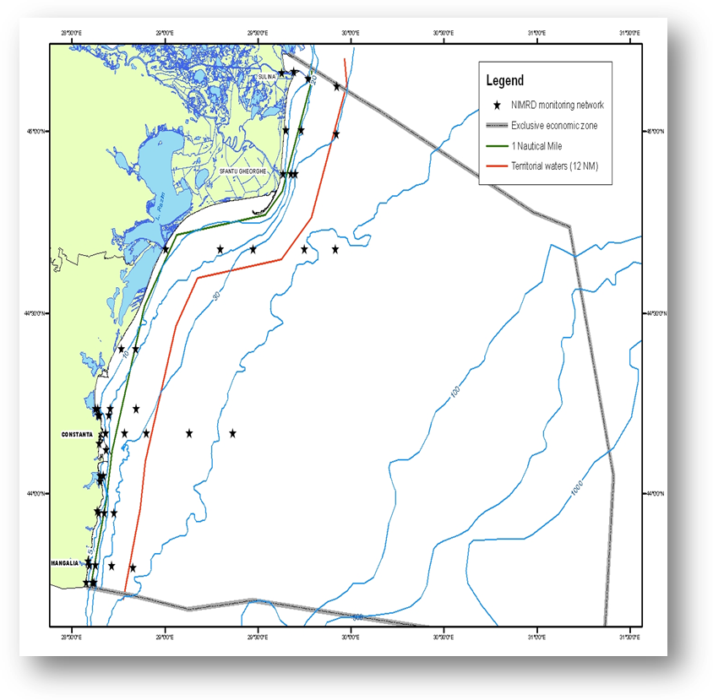  Fig. 1 Map of sampling stations of the environment routine monitoring (water and sediment) carried out by NIMRD  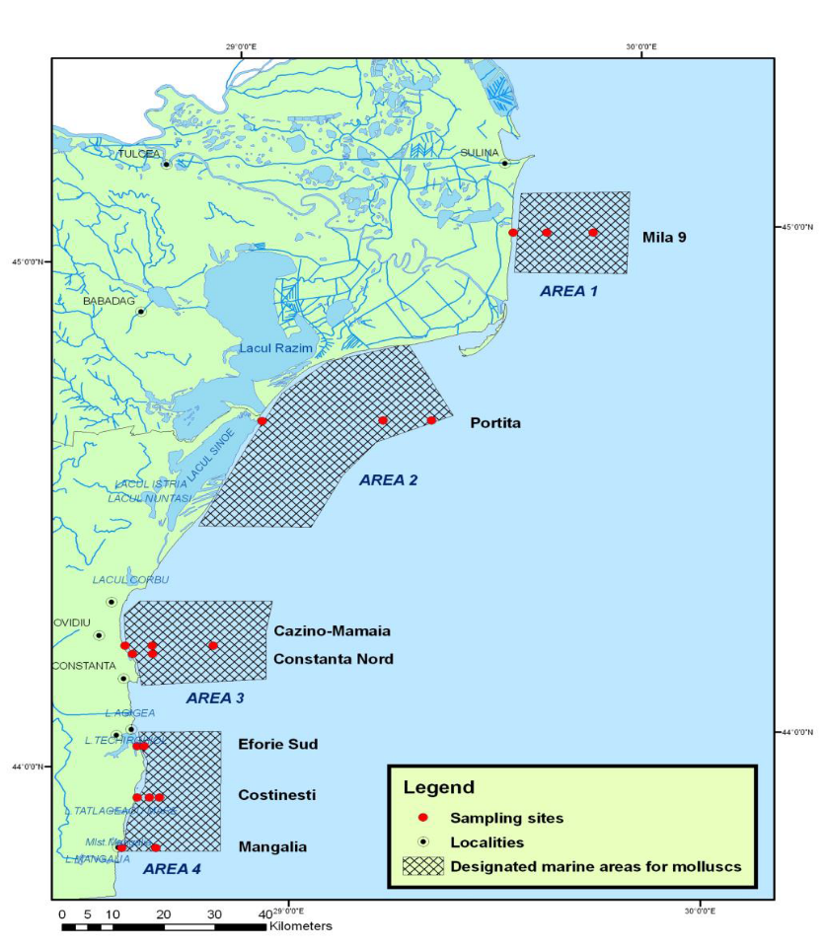  Fig. 2 Map with sampling sites for contaminants in biota (molluscs) monitoring  RWNA - carries out monitoring activities mainly dealing with the land-based pressures (according to WFD).  Sampling network comprises 35 stations covering transitional and coastal waters (Fig. 3). Heavy metals, synthetic compounds and PAHs are measured in water and sediment twice per year.  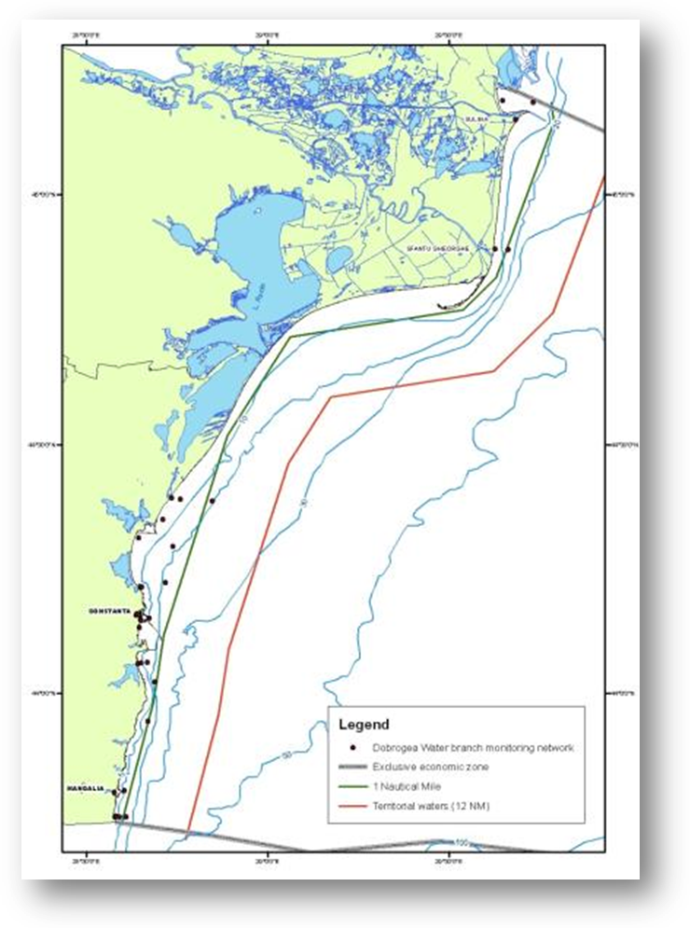  Fig. 3 Map of sampling stations of the environment routine monitoring carried out by RWNA – ABA  GeoEcoMar  Sampling network includes 45 stations, bottom depths within 15 – 200 m, covering the entire RO shelf (Fig. 4).  Parameters monitored: heavy metals in sediment  Frequency: 2 times/year  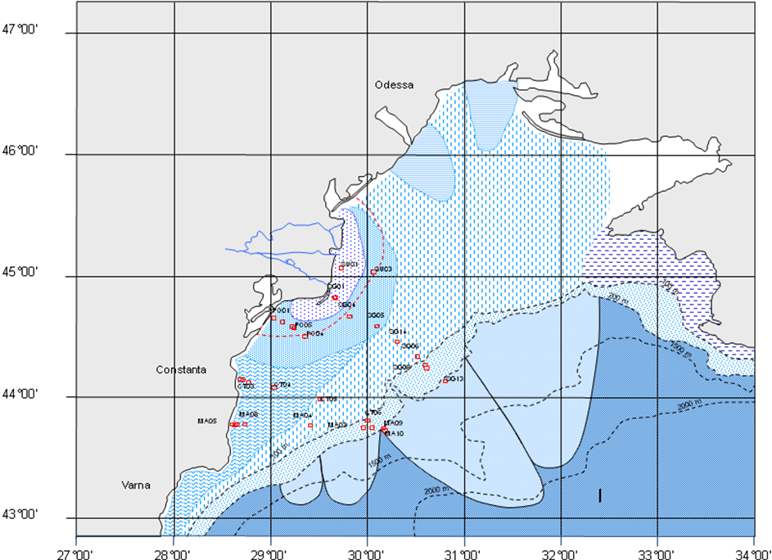  Fig. 4 Map of Geo-Ecomar sampling network  National Agency for Environmental Protection is involved in the monitoring of pollutants from atmosphere. There are 7 monitoring stations in the Constanta county, placed in different zones (in Constanta- 3, Navodari-2, Mangalia, and Medgidia) according to “Criteria for EUROAIRNET, 1999” and 2 monitoring stations in the Tulcea county (in Tulcea and Sf. Gheorghe).  National Agency for Environmental Protection is also dealing with the radionuclides monitoring in water (frequency - weekly).
3.3 Threats, activities and measures | Relevant activities (themes/activities) related to the programme are:  Energy production/Marine hydrocarbon (oil and gas) extraction  Man-made structures (incl. construction phase)/Port operations; submarine cable and pipeline operations;  Extraction of non-living resources/Dredging  Waste disposal/ Solid waste disposal  Transport/Shipping  Recreation/Tourism and recreation incl. yachting  Land-based activities/industries/Coastal, riverine and atmospheric inputs from land - industrial discharges; Coastal, riverine and atmospheric inputs from land - agricultural run-off, forestry and emissions; Coastal inputs from land - municipal waste water discharge  The programme will address above mentioned activities by measuring their intensity and distribution in space and time. The pressures resulted from these activities are also subject to the programme, but however, improvements in monitoring of the quantity and type of pollutants introduced into the environment are still necessary (see section 6).  The measures which will be monitored by the programme have to be developed.
3.4 Data management | Data are reported (either as raw/processed data or data products) through competent authority to EEA, BSC (through AGs – PMA, LBS), etc.  Data are also reported (either as metadata or raw/processed data) in databases belonging to other projects (MISIS, PERSEUS, etc) from where can be accessed in accordance with the terms of such project.  Data will be available via national website http://www.rmri.ro and www.nodc.ro (starting with 2015).
4. Assessment
4.1 Assessments | Existing assessments  MSFD (Art. 8) – Initial Assessment Report  http://cdr.eionet.europa.eu/ro/eu/msfd8910/msfd4text/envuhwuaq  Environmental Status Reports  http://www.rmri.ro/Home/Products.EnvStatusReport.html  State of Environment Report 2001-2006/7  http://www.blacksea-commission.org/_publ-SOE2009.asp  Black Sea Transboundary Diagnostic Analysis  http://www.blacksea-commission.org/_tda2008-document6.asp
4.2 Assessment of GES | Generally, the programme is able to provide adequate data and information enabling periodic assessment of environmental status and distance to and progress towards GES (as it is defined at present).  The programme has to be improved in terms of approaching the criterion 8.2, related to the effects of contaminants, in order to provide a more robust GES definition at descriptor level (see Section 6).
5. Literature
Zampoukas, N., Piha, H., 2011, Review of Methodological Standards Related to the Marine Strategy Framework Directive Criteria on Good Environmental Status, Publications Office of the European Union, 53 pp. http://publications.jrc.ec.europa.eu/repository/handle/111111111/16069
Zampoukas, N., Piha, H., Bigagli, E., Hoepffner,N., Hanke, G., Cardoso, A., 2012, Monitoring for the Marine Strategy Framework Directive: Requirements and Options, Publications Office of the European Union, 42 pp., http://publications.jrc.ec.europa.eu/repository/handle/111111111/23169
Zampoukas, N., Piha, H., Bigagli, E., Hoepffner,N., Hanke, G., Cardoso, A., 2013, Marine monitoring in the European Union: how to fulfil the requirements for the MSFD in an efficient and integrated way, Marine Policy, 39, 349-351
http://publications.jrc.ec.europa.eu/repository/handle/111111111/27825
Marine Strategy Framework Directive – Task Group 8 Report Contaminants and pollution effects. http://www.ec.europa.eu/environment/marine/pdf/7-Task-Group-8.pdf
OSPAR Commission, 2012, Advice document on Contaminants (MSFD Descriptor 8) http://www.ospar.org/documents/dbase/publications/p00583/p00583_advice_document_d8_contaminants.pdf
6. Activities required to implement the concept
6.1 Changes to the current monitoring programme | Recommendations and actions needed:  - increasing financial assistance and securing sustainable financing at national levels;  - better use and coordination of the existing capacities of all organizations dealing with monitoring programme (including monitoring infrastructure sharing); avoid overlapping of activities and efforts;  - permanent agreements with other authorities/organizations in supporting the monitoring programme (e.g. ROSA, RNA, Port Authorities, offshore companies, etc.);  - better integration of the MSFD monitoring with the monitoring requirements of other directives (WFD, EQS Directive, Shellfish Directive, Habitats, etc.), regional sea conventions (BSC) and other convention (MARPOL);  - strengthening the regional cooperation/harmonization between the Black Sea MS (to share their knowledge, identify best practices and ensure a harmonized monitoring methodology);  - developing an incident-specific monitoring subprogramme which could establish, as cost-effectively as possible, any impacts on environmental status;  - development of ecotoxicology monitoring (will offer more information/knowledge for a better understanding of contaminants effects on biological components);  - improving of radionuclides monitoring; more research related to pressures and impacts of radionuclides;  - inclusion of additional matrices (e.g. fish) for a better understanding of contaminants effects;  - more research related to the contaminants effects on mobile species (fish, mammals, birds);  - more research focusing on the assessment of biological effects of pollution based on biomarkers analyses;  - more research dedicated to interaction of substances (hazardous substances, especially synthetic chemicals, occur in the environment as mixtures); development of tools/methods for their combined effect on organisms and the ecosystem);  - to develop monitoring and research on “novel” compounds such as hormones, veterinary medicines and pharmaceuticals;  - development of new sampling and observation techniques (passive sampling, in situ voltammetry, satellite images, etc.);  - new modeling techniques (e.g. biogeochemical modeling, bioaccumulation modeling, etc.) to be developed;  - improving QA/QC;  - improving data management.
6.2 Gaps: GES information | The programme will be fully adequate (in terms of providing data and information needed to assess GES) in time for the next assessment in 2018
6.3 Plans: Plans for GES information | The programme is partially adequate for data/information collection to assess the distance to GES, as it is defined at present. However, the GES definition has to be upgraded, thus more data/information and knowledge are needed (especially, related to the effects of contaminants - criterion 8.2 from MSFD).  New sampling technique and methods have to be developed (financial support is needed.) Also new biota matrices (highly mobile species) have to be included in the programme for a better understanding of the effects at the higher levels of the food-web (link with the Descriptor 4).  Chemical and biological effects monitoring data should be assessed and interpreted in an integrated manner, thus new tools and methods have to be developed (e.g. models, biomarkers, etc.).  For covering the indicator 8.2.2, a subprogramme referring to incident-specific monitoring has to be developed (with the support of other authorities/organizations – e.g. ROSA, Port Authorities, offshore companies, etc.) and also more knowledge are needed for assessing the impact of acute pollution events on the ecosystem.
6.4 Gaps: Target information | The programme will be fully adequate in terms of collection of data and information needed for assessing the environmental targets in time for the next assessment in 2018.
6.5 Plans: Plans for information on targets | The programme provides quite sufficient data/information for assessing progress towards achievements of already defined targets (related to the indicator 8.1.1) and also for their regular updating.  The programme has to be improved in order to approach the indicators of criterion 8.2. New tools and methods for assessing the biological effects of contaminants (e.g. models) and, also, the origin, occurrence and extent of acute oil pollution (e.g. aerial and satellite images) need to be developed. The data/information coming from will be used for defining new pressure and impact-based targets, as well as operational targets.
6.5 Plans: Plans for information on measures | To be developed

