MONITORING FACT SHEET – Eutrophication
Country: | ROMANIA
Author: | Otilia Mihail
Institute: | Department on Waters, Forests and Fisheries (Ministry of Environment and Climate Change)

Title: Eutrophication
1. General
1.1 Subject area | EUTROPHICATION; BLKRO-D5

1.2 Definition/Description | Eutrophication is a process driven by the nutrient enrichment, especially compounds of nitrogen and/or phosphorus, leading to: increased growth, primary production and algal biomass; changes in the balance of organisms; and water quality degradation. The consequences of eutrophication are undesirable if they appreciably degrade ecosystem health and biodiversity and/or the sustainable provision of goods and services.  The eutrophication causes and effects have been systematically monitored in the Romanian waters (with special emphasis on the coastal waters) for more than 3 decades ago. Over the years, the monitoring programme has been substantially improved (in terms of infrastructure, methodology, etc), now being fairly well developed (coastal and shelf waters). The current monitoring programme is a function of:  - size of area to be assessed;  - number and distribution of land-based sources;  - existing monitoring strategy (reference areas, former networks, existing long-term data series, existing logistics, etc);  - sampling frequency and duration;  - specificity, sensitivity of analytical technique;  - magnitude of concentration expected;  - available resources.  The main objective of the programme is to characterize the present state and trends, as well as to identify the environmental impact of human activities as possible causes for observed environmental impairments. Thus, it addresses:  - state and impact parameters:  - physical–chemical: transparency, nutrients (water column and sediment-water interface), TOC, dissolved oxygen/oxygen saturation (water column and sediment-water interface)  - biological parameters  - pelagic community: chlorophyll a, phytoplankton (species composition, abundance – density and biomass)  - seabed community: phytobenthos (species composition, abundance – biomass)  - pressures - both at source - nutrient and organic matter loads from point and non-point sources (WWTP, riverine input, agriculture, industrial activities, atmosphere, etc.) and in the marine environment (nutrients level in the water column)  - activities (by measuring the extent and intensity)
1.3 Competent authority/ies | Ministry of Environment and Climate Change http://www.mmediu.ro/  - Department on Waters, Forests and Fisheries - contact point for the Commission
1.4 Monitoring institutions | Romanian Water National Administration (Dobrogea-Litoral Water Basin Administration) http://www.rowater.ro/ - under coordination of the Ministry of Environment and Climate Change  National Institute for Marine Research and Development “Grigore Antipa”, Constanta http://www.rmri.ro/ - under coordination of the Ministry of National Education  National Research and Development Institute for marine Geology and Geoecology, Bucharest http://www.geoecomar.ro/ - under coordination of the Ministry of National Education  National Agency for Environment Protection http://www.anpm.ro/ - subordinated to Ministry of Environment and Climate Change
1.5 Additional information | Black Sea Commission - BSIMAP  http://www.blacksea-commission.org/_bsimap.asp  MSFD Guiding Improvements in the Black Sea Integrated Monitoring System (MISIS) project  http://www.misisproject.eu  Technical and administrative support for joint implementation of MSFD in Bulgaria and Romania  http://www.msfdblacksea.eu  Integrated Regional monitoring Implementation Strategy in the South European Seas (IRIS -SES) project  http://iris-ses.eu/  Towards Integrated Marine Research Strategy and Programmes (SEAS-ERA) project - Strategic Research Agenda for the Black Sea Basin  http://www.seas-era.eu/
2. Monitoring requirements and purpose
2.1 Necessity | Listed below are direct references to the monitoring requirements – EU directives, Black Sea Commission agreements, national plans, research programme requirements, other.
MSFD  Articles 8 and 11  Annex III | Art.11.  1. On the basis of the initial assessment made pursuant to Article 8(1), Member States shall establish and implement coordinated monitoring programmes for the ongoing assessment the environmental status of their marine waters on the basis of the indicative lists of elements set out in Annex III and the list set out in Annex V, and by reference to the environmental targets established pursuant to Article 10.  2. Member States sharing a marine region or subregion shall draw up monitoring programmes in accordance with paragraph 1 and shall, in the interest of coherence and coordination, endeavor to ensure that:  (a) monitoring methods are consistent across the marine region or subregion so as to facilitate comparability of monitoring results;  (b) relevant transboundary impacts and transboundary features are taken into account.  Art. 8  The results of eutrophication monitoring program are required for the next cycle of marine waters assessment. To this end, the following parameters must be monitored for physical-chemical and biological features (Annex III, Table 1) and pressures/impacts (Annex III, Table 2):  Annex III, Table 1  - spatial and temporal distribution of nutrients (DIN, TN, DIP, TP, TOC) and oxygen;  - description of the biological communities associated with the predominant water column habitats (information on the phytoplankton and zooplankton communities, including the species and seasonal and geographical variability);  - information on angiosperms, macroalgae, including species composition, biomass and annual/seasonal variability according to seabed habitats.  Annex III, Table 2  - inputs of fertilizers and other nitrogen- and phosphorus-rich substances (e.g. from point and diffuse sources, including agriculture, aquaculture, atmospheric deposition),  - inputs of organic matter (e.g. sewers, mariculture, riverine inputs).
Habitats  Article 11 | Art. 11  Member States shall undertake surveillance of the conservation status of the natural habitats and species referred to in Article 2 with particular regard to priority natural habitat types and priority species.
WFD  Article 8  Annex V | Art. 8  1. Member States shall ensure the establishment of programmes for the monitoring of water status in order to establish a coherent and comprehensive overview of water status within each river basin district:  - for surface waters such programmes shall cover:  (ii) the ecological and chemical status and ecological potential;  2. These monitoring programmes shall be in accordance with the requirements of Annex V.
NiD  Articles 5 and 6 | Art. 5  6. Member States shall draw up and implement suitable monitoring programmes to assess the effectiveness of action programmes established pursuant this Article.  Member States which apply Art. 5 throughout their national territory shall monitor the nitrate content of waters at selected measuring points which make it possible to establish the extent of nitrate pollution in the waters from agricultural sources.  Art. 6  1. For the purpose of designating and revising the designation of vulnerable zones, Member States shall:  c) review the eutrophic state of fresh surface waters, estuarine waters, and coastal waters every four years.
UWWTD  Article 15  Annexes IB and ID | Art. 15.  1. Competent authorities or appropriate bodies shall monitor:  - discharges from urban waste water treatment plants to verify compliance with the requirements of Annex I.B in accordance with the control procedures laid down in Annex I.D,  2. Competent authorities or appropriate bodies shall monitor waters subject to discharges from urban waste water treatment plants and direct discharges as described in Article 13 in cases where it can be expected that the receiving environment will be significantly affected.  3. In the case of a discharge subject to the provisions of Article 6 and in the case of disposal of sludge to surface waters, Member States shall monitor and carry out any other relevant studies to verify that the discharge or disposal does not adversely affect the environment.
BWD  Article 9  Annex III | Art. 9  Other parameters  1. When the bathing water profile indicates a tendency for proliferation of macro-algae and/or marine phytoplankton, investigations shall be undertaken to determine their acceptability and health risks and adequate management measures shall be taken, including information to the public.
Black Sea Commission  Convention on the Protection of the Black Sea Against Pollution (Art. 15) and its Protocols | Convention on the Protection of the Black Sea Against Pollution  Art. 15.  - The Contracting Parties shall cooperate in conducting scientific research aimed at protecting and preserving the marine environment of the Black Sea and shall undertake, where appropriate, joint programmes of scientific research, and exchange relevant scientific data and information.  - The Contracting Parties shall, inter alia, establish through the Commission and, where appropriate, in cooperation with international organizations they consider to be competent, complementary or joint monitoring programmes covering all sources of pollution and shall establish a pollution monitoring system for the Black Sea including, as appropriate, programmes as bilateral or multilateral level for observing, measuring, evaluating and analyzing the risks or effects of pollution of the marine environment of the Black Sea.  Protocol on the Protection of the Marine Environment of the Black Sea from Land-Based Sources and Activities (2009)  Art. 11  1. Within the framework of the provisions of, and the monitoring programmes provided for in Art. 15 of the Convention, and if necessary in cooperation with competent international organizations, the Contracting Parties shall:  a) Collect information and data on the conditions of the marine environment and coastal areas of the Black Sea as regards its physical, biological and chemical characteristics;  b) Collect information and data and prepare and maintain an inventory of inputs of substances listed in Annex I of this Protocol, including information on the distribution of sources and quantities of such substances introduced to the marine environment of the Black Sea;  c) Systematically asses the state of the marine environment and coastal areas of the Black Sea;  d) Systematically assess, as far as possible, the levels of pollution along their coasts, in particular with regard to activities and substances listed in Annex I and periodically to provide information in this respect;  2. The Contracting Parties shall collaborate in establishing a regional monitoring programme as well as compatible national monitoring programmes, and in facilitating data and information storage, retrieval and exchange.
Other plans and/or programmes
2.2 GES criteria | GES criteria and indicators (see Commission Decision of 1 September 2010) relevant for the Romanian programme are indicated in bold:  Descriptor 5  5.1. Nutrients levels  - Nutrients concentration in the water column (5.1.1)  - Nutrient ratios (silica, nitrogen and phosphorus), where appropriate (5.1.2)  5.2. Direct effects of nutrient enrichment  - Chlorophyll concentration in the water column (5.2.1)  - Water transparency related to increase in suspended algae, where relevant (5.2.2)  - Abundance of opportunistic macroalgae (5.2.3)  - Species shift in floristic composition such as diatom to flagellate ratio, benthic to pelagic shifts, as well as bloom events of nuisance/toxic algal blooms (e.g. cyanobacteria) caused by human activities (5.2.4)  5.3. Indirect effects of nutrient enrichment  - Abundance of perennial seaweeds and seagrasses (e.g. fucoids, eelgrass and Neptune grass) adversely impacted by decrease in water transparency (5.3.1)  - Dissolved oxygen, i.e. changes due to increased organic matter decomposition and size of the area concerned (5.3.2)
2.3 Features, pressures and impacts | Features and pressures/impacts (from MSFD Annex III) relevant for the programme are:  Characteristics  Physical and chemical features  — spatial and temporal distribution of nutrients (DIN, TN, DIP, TP, TOC) and oxygen,  Biological features  — a description of the biological communities associated with the predominant seabed and water column habitats (this would include information on the phytoplankton and zooplankton communities, including the species and seasonal and geographical variability),  — information on angiosperms and macroalgae, including species composition, biomass and annual/seasonal variability,  Pressures and impacts  Nutrient and organic matter enrichment  — inputs of fertilizers and other nitrogen and phosphorus-rich substances (e.g. from point and diffuse sources, including agriculture, aquaculture, atmospheric deposition),  — inputs of organic matter (e.g. sewers, mariculture, riverine inputs).
2.4 GES | RO has provided GES definitions at criteria levels:  Crt. 5.1. Nutrient concentrations do not lead to an undesirable disturbance to the balance of organisms present in the water or to the quality of the water concerned resulting from accelerated growth of algae, and are within the threshold values as stated in the environmental targets  Crt. 5.2. The direct effects of nutrient enrichment associated with algal growth do not constitute or contribute to an undesirable disturbance to the balance of organisms present in the water and to the quality of the water concerned, by meeting the threshold values as stated in the environmental targets  Crt. 5.3. Indirect effects of nutrient enrichment associated with growth of macroalgae, seagrass, and reductions of oxygen concentrations do not constitute or contribute to an undesirable disturbance to the balance of organisms present in the water and to the quality of the water concerned, and are within the threshold values as stated in the environmental targets  There should be no kills in benthic animal species as a result of oxygen deficiency that are directly related to anthropogenic input of nutrients.  Generally, the programme provides sufficient data/information for establishing if the descriptor is at GES or not. In the latter case, the data/information could contribute to determine the distance to GES as difference between data provided by the programme and the thresholds set up in the articles 9 and 10. Also trends (for some relevant parameters) could be derived from programme and contribute to determine the distance to the GES.  However, the programme has to be improved in terms of spatial coverage; the open waters are quite poor monitored so far.  The programme partially addresses natural and climatic variability so that, in part, the difference between the effects resulting from the anthropogenic pressures and climatic variability could be determined.
2.5 Environmental targets  MSFD  Habitats  WFD  NiD  BWD  UWWTD  BSC | RO has defined environmental targets according to the MSFD requirements as follows:  Indicator 5.1.1  State target:  The 75th percentile of annual mean concentrations of nutrients in marine waters no less than target values (set out in the Romanian revised GES report under Arts. 9 and 10 of the MSFD - Table 4-14, page 130)  Pressure targets:  DIP and DIN from anthropic input should be constant or decreasing, based on monitoring routine  Indicator 5.1.2  Nutrients level maintaining the N/P ratio higher than 10  Indicator 5.2.1  The 75th percentile of summer chlorophyll a concentration in marine waters no less than threshold values (threshold value: 90th percentile of summer chlorophyll a concentrations)  Indicator 5.2.2  The 95th percentile of transparency values should be more than the threshold values as set out in the Romanian revised GES report under Arts. 9 and 10 of the MSFD (Table 4-14, page 130)  Indicator 5.2.3  Reducing the algal wet biomass of opportunistic species that generate important macroalgae deposits (e.g. Cladophora sp.) at levels below 2000 g/m² and hence the effects, especially in summer, by lowering the concentration of nutrients.  Indicator 5.2.4  The 75th percentile of the Bac:Din (Bacillariophyceae: Dinophyceae) spring biomass ratio is more than to the 10:1 based on monitoring routine  Indicator 5.3.1  Maintaining the spatial distribution of key perennial species (Cystoseira, Zostera) in stable limits (more than 60%) without fields fragmentation, due to anthropogenic activities.  Indicator 5.3.2  The 95th percentile of bottom (up to 50 m due to the anoxic natural features of Black Sea) oxygen saturation values should be more than the threshold values as set out in the Romanian revised GES report under Arts. 9 and 10 of the MSFD (Table 4-14, page 130)  All reported targets, related to causes (nutrients), direct effects (chlorophyll, transparency, etc.), and indirect effects (dissolved oxygen) are quite well considered by the programme. Generally, the data/information provided by the programme is sufficient for assessing progress towards the achievement of the relevant environmental targets (difference between data provided and thresholds). Also, the program provides data/information and knowledge for regular updating of the established targets, but it still needs to be improved (see Section 6).  Relevant targets from other obligations (see section 2.1) that are addressed by the monitoring  - maintenance of biodiversity; it can be negatively impacted by eutrophication.  - prevent the deterioration of the status of all WB (no deterioration of the status of all WB)  - protect, enhance and restore all SWB with the aim of achieving:  - the good ecological status and the good chemical status for natural WB by 2015  - the good ecological potential and the good SW chemical status for artificial and heavy modified WB by 2015  – reducing pollution caused or induced by nitrates from agricultural sources; prevention of pollution by nitrates.  Member States shall ensure that, by the end of the 2015 bathing season, all bathing waters are at least ‘sufficient’ (see Annexes I and II – BWD)  – discharges from UWWTP to coastal sensitive areas which are subject to eutrophication (poor water exchange, large quantities of nutrients received) shall meet the requirements set up in Table 2, Annex 1 of Directive  SAP (2009)  3.2 Long-term Ecosystem Quality Objectives (EcoQOs)  EcoQO 3: Reduce eutrophication.  EcoQO 4: Ensure Good Water Quality for Human Health, Recreational Use and Aquatic Biota.  EcoQO 4a: Reduce pollutants originating from land based sources, including atmospheric emissions.  To EcoQOs 3 and 4(a), BS SAP has awarded a number of management objectives, which overlap many of the MSFD provisions on evaluation, monitoring and determination of good environmental status. However, SAP indicators reflecting specific regional, cross-border issues and priorities, so they do not overlap perfectly over MSFD qualitative descriptors for determining GES.
2.6 Spatial allocation | Table of where monitoring is required:
   | EEZ | 12-nm zone | Coastal waters | Transitional waters
  MSFD | X | X | X | -
  Habitats | - | X | X | X
  WFD | - | - | X | X
  NiD | - | X | X | X
  UWWTD | - | - | X | X
  BWD | - | - | X | X
  BSC | X | X | X | X
3. Monitoring concept
3.1 General description of relevant subprogrammes in monitoring programme | 1. Seabed habitats - chemical characteristics (oxygen)  Subprogramme ID (4g): BLKRO-D1,5,6_SeabedHabitats_03  Purpose (4k): Environmental state and impacts  Elements monitored (9a): Physical and chemical features  • spatial and temporal distribution of oxygen  Habitat types  • the predominant seabed habitat type(s) with a description of the characteristic chemical features  Parameters (9b): concentration of bottom dissolved oxygen (uMol/l); bottom oxygen saturation (%)  Agreed common parameters: concentration of bottom dissolved oxygen (uMol/l); bottom oxygen saturation (%)  Monitoring method (9c): Oxygen (Winkler method) according to Grasshoff et al., 1998 );  Temporal resolution (9h): 3 monthly  2. Seabed habitats - chemical characteristics (TOC)  Subprogramme ID (4g): BLKRO-D1,5,6_SeabedHabitats_04  Purpose (4k): Environmental state and impacts  Elements monitored (9a): Physical and chemical features  • spatial and temporal distribution of TOC  Habitat types  • the predominant seabed habitat type(s) with a description of the characteristic chemical features  Parameters (9b): concentration of TOC in seabed substrate  Monitoring method (9c): TOC= TC (Catalytically aided combustion oxidation at 900°C)-IC (Pre-acidification, oven temperature: 250°C); modified Walkley-Black titration method according to Gaudette et al., 1974  Temporal resolution (9h): 6 monthly  3. Benthic species - abundance and/or biomass (macroalgae and angiosperms)  Subprogramme ID (4g): BLKRO-D1,2,4,5,6_SeabedHabitats_08  Purpose (4k): Environmental state and impacts  Elements monitored (9a): Biological features  • information on angiosperms, macro-algae, including species composition, biomass and annual/seasonal variability  Parameters (9b): Species abundance (biomass)  Agreed common parameters: Species abundance (biomass) of opportunistic macroalgae; species abundance (biomass) of perennial macroalgae, seaweeds and seagrasses  Monitoring method (9c): BS guidance (http://www.helcom.fi/Documents/Action%20areas/Monitoring%20and%20assessment/Manuals%20and%20Guidelines/COMBINE_AnnexC9_MonitoringPhytobentic.pdf)  Temporal resolution (9h): yearly  4. Water column - physical characteristics  Subprogramme ID (4g): BLKRO-D1,5,7_WaterColumn_01  Purpose (4k): Environmental state and impacts  Elements monitored (9a): Physical and chemical features  • annual and seasonal temperature regime and ice cover, turbidity  • spatial and temporal distribution of salinity  Habitat types  • the predominant water column habitat type(s) with a description of the characteristic physical and chemical features, such as water temperature regime, salinity;  Pressures and impacts  Interference with hydrological processes  • significant changes in thermal regime  • significant changes in salinity regime  Parameters (9b): Transparency / turbidity of water column  Agreed common parameters: Water transparency  Monitoring method (9c): Secchi disk  Temporal resolution (9h): 3 monthly (coastal and territorial waters); 6 monthly (beyond territorial waters)  5. Water column - chemical characteristics  Subprogramme ID (4g): BLKRO-D1,5,7_WaterColumn_03  Purpose (4k): Environmental state and impacts  Elements monitored (9a): Physical and chemical features  • spatial and temporal distribution of nutrients (DIN, TN, DIP, TP, TOC) and oxygen;  • pH  Parameters (9b): concentrations of nutrients in water column (Concentration of DIN (N-NO3, N-NO2, N-NH4), DIP (P-PO4, and DISi(Si-SiO4); N/P ratio; concentration of total organic carbon  Agreed common parameters: concentrations of nutrients in water column (Concentration of DIN (N-NO3, N-NO2, N-NH4), DIP (P-PO4); N/P ratio  Monitoring method (9c): nutrients - Grasshoff et al, 1998; TOC - Suzuki and Sugimura, 1988  Temporal resolution (9h): daily (coastal fix stations), 3 monthly (coastal and territorial waters); 6 monthly (beyond territorial waters)  6. Pelagic habitats - community characteristics (phytoplankton)  Subprogramme ID (4g): BLKRO-D1,2,4,5_WaterColumn_04  Purpose (4k): Environmental state and impacts  Elements monitored (9a): Biological features  • a description of the biological communities associated with the predominant seabed and water column habitats. This would include information on the phytoplankton and zooplankton communities, including the species and seasonal and geographical variability  • an inventory of the temporal occurrence, abundance and spatial distribution of non indigenous, exotic species or, where relevant, genetically distinct forms of native species, which are present in the marine region or subregion.  Parameters (9b): Species composition; species abundance (number); species abundance (biomass); Bac:Din (Bacillariophyceae: Dinophyceae) ratio  Agreed common parameters: Species composition; species abundance – number (Bacillariophyceae, Dinophyceae); species abundance- biomass (Bacillariophyceae, Dinophyceae); Bac:Din (Bacillariophyceae: Dinophyceae) ratio  Monitoring method (9c): Moncheva, 2010; Moncheva and Par. 2005 (updated-2010)  Temporal resolution (9h): twice per week (coastal fix stations), 3 monthly (coastal and territorial waters)  7. Plankton blooms (biomass, frequency/extent)  Subprogramme ID (4g): BLKRO-D1,4,5_WaterColumn_07  Purpose (4k): Environmental state and impacts  Elements monitored (9a): Biological features  • a description of the biological communities associated with the predominant seabed and water column habitats. This would include information on the phytoplankton and zooplankton communities, including the species and seasonal and geographical variability  Parameters (9b): concentration of chlorophyll a  Agreed common parameters: concentration of chlorophyll-a (summer)  Monitoring method (9c): SCOR-UNESCO, 1966; UNESCO, 1988 (CTD fluorescence)  Temporal resolution (9h): hourly (mooring buoys-BSS System); twice per week on coastal fix station; 3 monthly  8. Nutrient inputs - land-based sources  Subprogramme ID (4g): BLKRO-D5_PressureSourceNutrients_02  Purpose (4k): Pressures (at source)  Elements monitored (9a): Nutrient and organic matter enrichment  • inputs of fertilisers and other nitrogen — and phosphorus-rich substances (e.g. from point and diffuse sources, including agriculture, aquaculture, atmospheric deposition);  • input of organic matter (e.g. sewers, mariculture, riverine inputs).  Parameters (9b): Input level of nutrients from land-based sources (DIP and DIN); input level of organic matter (TOC and COD-Cr)  Agreed common parameters: Input level of nutrients from land-based sources (DIP and DIP)  Monitoring method (9c): Grasshoff et al, 1998 (all nutrients); SR ISO 7890-1-98 (nitrates); SR ISO 6777-96 (nitrites); SR ISO 7150-1-01 (ammonia); SR EN ISO 6878-2005 (ortophosphate, total phosphores); SR EN 12260-2004 (total nitrogen;) Suzuki and Sugimura, 1988 (TN, TOC); SR ISO 6060-1996(COD-Cr)  Temporal resolution (9h): five times per week at the mouth of the Sulina arm; monthly or 3 yearly at relevant industrial and urban hot spots  9. Nutrient inputs – from atmosphere  Subprogramme ID (4g): BLKRO-D5_PressureSourceNutrients_02  Purpose (4k): Pressures (at source)  Elements monitored (9a): Nutrient and organic matter enrichment  • inputs of fertilisers and other nitrogen — and phosphorus-rich substances (e.g. from point and diffuse sources, including agriculture, aquaculture, atmospheric deposition)  Parameters (9b): Input level of nutrients from atmosphere (emissions of NOx)  Monitoring method (9c): SR EN 14211:2005 - Air quality. Standardized method for measuring the concentration of nitrogen dioxide and nitrogen monoxide by chemiluminescence.  Temporal resolution (9h): continuously (data are hourly or/daily averaged for public or scientific community)  10. Nutrient levels - in water column  Subprogramme ID (4g): BLKRO-D5_PressureMarEnv_02  Purpose (4k): Pressures (in marine environment)  Elements monitored (9a): Nutrient and organic matter enrichment  • inputs of fertilisers and other nitrogen and phosphorus-rich substances (e.g. from point and diffuse sources, including agriculture, aquaculture, atmospheric deposition);  • inputs of organic matter  Parameters (9b): concentrations of nutrients in water column (Concentration of DIN (N-NO3, N-NO2, N-NH4), DIP (P-PO4, and DISi(Si-SiO4); N/P ratio; concentration of total organic carbon  Agreed common parameters: concentrations of nutrients in water column (Concentration of DIN (N-NO3, N-NO2, N-NH4), DIP (P-PO4); N/P ratio  Monitoring method (9c): nutrients - Grasshoff et al, 1998; TOC - Suzuki and Sugimura, 1988  Temporal resolution (9h): daily (coastal fix stations), 3 monthly (coastal and territorial waters)  11. Activities extracting living resources (fisheries including recreational, maerl, seaweed)  Subprogramme ID (4g): BLKRO-Activities_01  Purpose (4k): Human activities causing the pressures  Elements monitored (9a): Fisheries, incl. recreational fishing (fish & shellfish)  Parameters (9b): Distribution/extent in space and time, intensity  Monitoring method (9c): Romanian National Programme for data collection and management of fisheries data 2011-2013 (paper questionnaire)  Temporal resolution (9h): yearly  12. Activities extracting non-living resources (dredging)  Subprogramme ID (4g): BLKRO-Activities_02  Purpose (4k): Human activities causing the pressures  Elements monitored (9a): Port operations; Solid waste disposal incl. dredge material; Other marine uses and activities  Parameters (9b): Distribution/extent in space and time, intensity  Monitoring method (9c): Romanian Waters National Administration, 2009 - Planul de management al Dunarii,  Deltei Dunarii si cursurile de apa si apele litorale din Dobrogea; ABAD-L 2009 - Master Plan "Protection and Reahabilitation of Coastal Zone"  Temporal resolution (9h): as needed  13. Activities producing food (aquaculture)  Subprogramme ID (4g): BLKRO-Activities_03  Purpose (4k): Human activities causing the pressures  Elements monitored (9a): Aquaculture (shellfish)  Parameters (9b): Distribution/extent in space and time, intensity  Monitoring method (9c): Romanian National Programme for data collection and management of fisheries data 2011-2013 (paper questionnaire)  Temporal resolution (9h): 3 monthly – starting with 2015  14. Activities with permanent infrastructures (e.g. ports) or structural changes (e.g. coastal defences)  Subprogramme ID (4g): BLKRO-Activities_01  Purpose (4k): Human activities causing the pressures  Elements monitored (9a): Fisheries, incl. recreational fishing (fish & shellfish)  Parameters (9b): Distribution/extent in space and time, intensity  Monitoring method (9c): Romanian National Programme for data collection and management of fisheries data 2011-2013 (paper questionnaire)  Temporal resolution (9h): yearly  15. Activities with permanent infrastructures (oil & gas)  Subprogramme ID (4g): BLKRO-Activities_05  Purpose (4k): Human activities causing the pressures  Elements monitored (9a): Marine hydrocarbon extraction (oil & gas)  Parameters (9b): Distribution/extent in space and time, intensity  Monitoring method (9c): questionnaires sent to all offshore operators  Temporal resolution (9h): yearly  16. Coastal human activities (tourism, ecotourism)  Subprogramme ID (4g): BLKRO-Activities_07  Purpose (4k): Human activities causing the pressures  Elements monitored (9a): Tourism  Parameters (9b): Distribution/extent in space and time, intensity  Monitoring method (9c): Methodological manual for tourism statistic http://epp.eurostat.ec.europa.eu/cache/ITY_OFFPUB/KS-GQ-13-007/EN/KS-GQ-13-007-EN.PDF  Temporal resolution (9h): yearly  17. Coastal human activities (recreational activities)  Subprogramme ID (4g): BLKRO-Activities_08  Purpose (4k): Human activities causing the pressures  Elements monitored (9a): Recreational, incl. yachting  Parameters (9b): Distribution/extent in space and time, intensity  Monitoring method (9c): questionnaires sent to all agreement harbors and all units providing aquatic sport facilities  Temporal resolution (9h): yearly  18. Land-based activities (industry)  Subprogramme ID (4g): BLKRO-Activities_09  Purpose (4k): Human activities causing the pressures  Elements monitored (9a): Industry (discharges, emissions)  Parameters (9b): Distribution/extent in space and time, intensity  Monitoring method (9c): questionnaires sent to all operators from the coastal zone  Temporal resolution (9h): yearly  19. Land-based activities (agriculture)  Subprogramme ID (4g): BLKRO-Activities_10  Purpose (4k): Human activities causing the pressures  Elements monitored (9a): Agriculture & forestry (run-off, emissions)  Parameters (9b): Distribution/extent in space and time, intensity  Monitoring method (9c): questionnaires sent to all farms from the coastal zone and the Danube River catchment area  Temporal resolution (9h): yearly  20. Land-based activities (urban)  Subprogramme ID (4g): BLKRO-Activities_11  Purpose (4k): Human activities causing the pressures  Elements monitored (9a): Urban (municipal waste water discharges)  Parameters (9b): Distribution/extent in space and time, intensity  Monitoring method (9c): information provided by local authorities and private operators  Temporal resolution (9h): yearly  21. Effectiveness of measures  Parameter: to be developed
3.2 Description of monitoring network | NIMRD  Monitoring network comprises 45 sampling stations (bottom depths within 5–60 m) covering the Romanian coastal and, partially, shelf waters (either waters strongly affected by the Danube’s inputs and coastal activities or marine waters, less affected by human induced eutrophication) (Fig. 1). Physical-chemical (transparency, DO, nutrients and TOC) and biological (chlorophyll, phytoplankton) parameters are monitored seasonally.  Daily measurements (except for macroalgae) are carried out at two long-term oncoast stations (the first one dealing with the anthropogenic pressures in the Constanta area, the second one dealing with the Danube’s discharges – at Sulina)  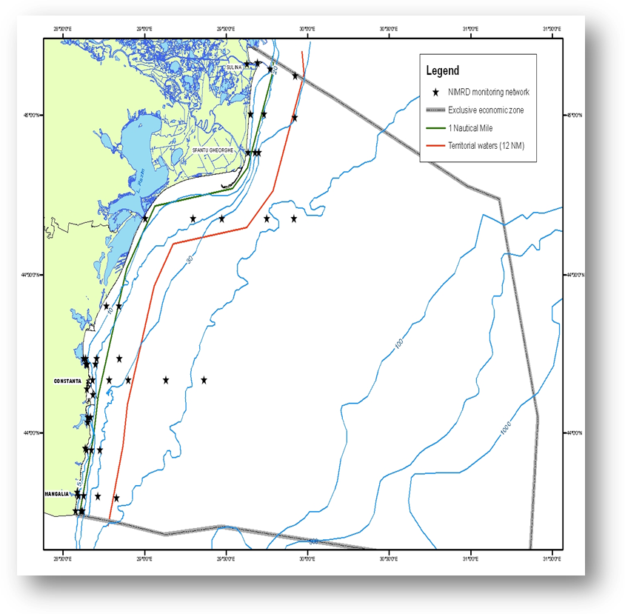  Fig. 1 Map of sampling stations of the environment routine monitoring carried out by NIMRD  12 sampling stations, in the coastal waters (Fig. 2), are selected for macroalgae monitoring (carried out in summer).  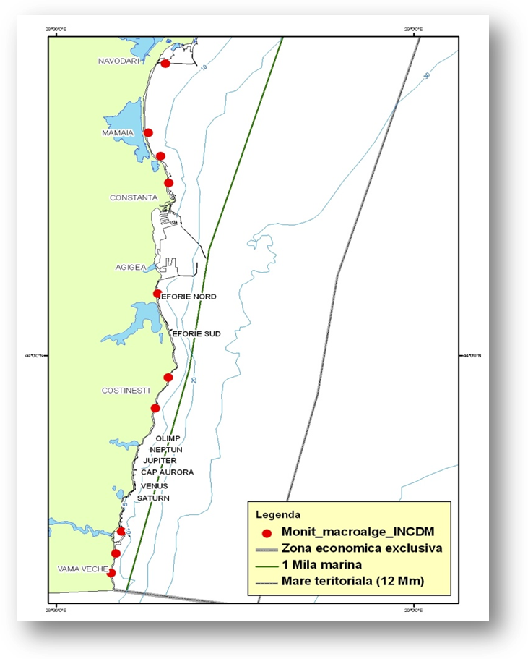  Fig. 2 - Map of sampling stations of the macroalgae monitoring carried out by NIMRD  RWNA - carries out monitoring activities mainly dealing with the land-based pressures.  Sampling network comprises 35 stations covering transitional and coastal waters (according to WFD requirements) (Fig. 3). Physical-chemical (transparency, dissolved oxygen and nutrients) and biological parameters (phytoplankton, zooplankton) are monitored twice per year.  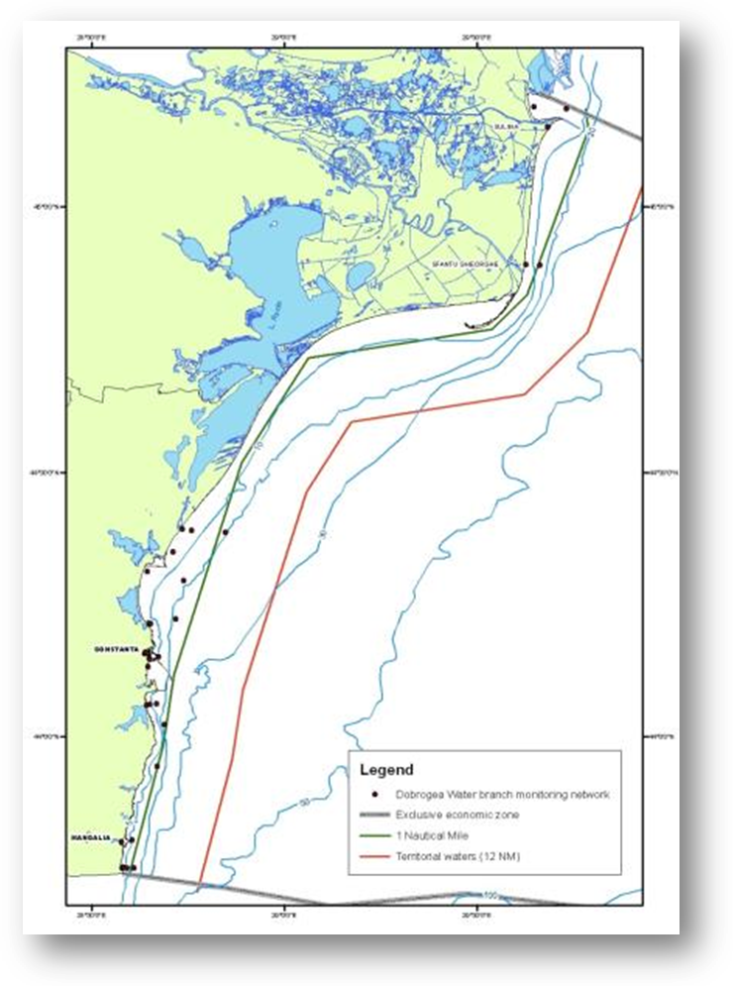  Fig. 3 - Map of sampling stations of the environment routine monitoring carried out by RWNA – ABA  GeoEcoMar  Sampling network includes 45 stations, bottom depths within 15 – 200 m, covering the entire Romaian shelf (Fig. 4).  Parameters monitored:  Physical-chemical:  - pressure/depth, dissolved oxygen/oxygen saturation, fluorescence (chlorophyll a) - in situ (CTD sensors – in water column);  - transparency (Secchi depth), dissolved oxygen/oxygen saturation, nutrients (in water column, at depths according to water masses stratification, and at water-sediment interface).  Biological: Chlorophyll a (in the water column)  Frequency: 2 times/year  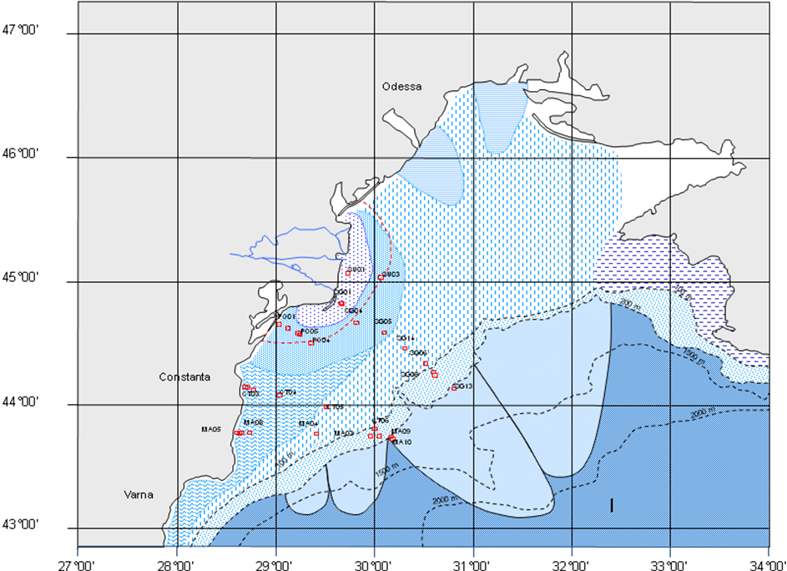  Fig. 4 - Map of GeoEcoMar’s sampling network  Black Sea Security System (BSSS – RO waters, Fig 5))  - 3 offshore moored observatories (bottom depths between 72 and 90 m) providing near-real time data (from surface layer and 20 m above seafloor)  - 1 coastal station (bottom depth of 15m)  Parameters monitored: DO, turbidity, Chlorophyll a  BSSS is extending also in the Bulgarian waters (2 offshore moored observatories).  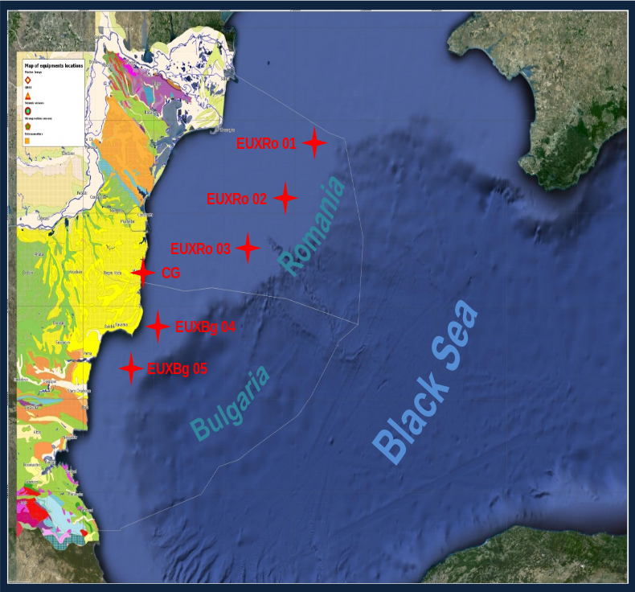  Fig. 5 - Map of offsore moored obsvervatories locations  National Agency for Environmental Protection is involved in monitoring of nutrients input from atmosphere (nitrogen oxides – NOx). There are 7 monitoring stations in the Constanta county, placed in different zones (in Constanta- 3, Navodari-2, Mangalia, and Medgidia) according to “Criteria for EUROAIRNET, 1999 and 2 monitoring stations in the Tulcea county (in Tulcea and Sf. Gheorghe).
3.3 Threats, activities and measures | Relevant activities (themes/activities) related to the programme are:  Energy production/Marine hydrocarbon (oil and gas) extraction  Extraction of living resources/Fisheries incl. recreational fishing (fish and shellfish)  Extraction of non-living resources/ Dredging  Food production/Aquaculture  Man-made structures (incl. construction phase)/Land/sea physical interaction: land claim, coastal defence; port operations; submarine cable and pipeline operations  Recreation/Tourism and recreation incl. yachting  Land-based activities/industries/Coastal and riverine and atmospheric inputs from land - industrial discharges; coastal, riverine and atmospheric inputs from land - agricultural run-off, forestry and emissions; coastal inputs from land – (municipal waste water discharge).  The programme will address the above mentioned activities by measuring either the distribution in space and time or intensity of some relevant activities. Also the pressures resulted from these activities (either at source or in the marine environment), as well as the associated impacts are subject to the current programme,  The measures which will be monitored by the programme have to be developed.
3.4 Data management | Data are reported (either as processed data or data products) through competent authority to EEA, BSC (through AGs – PMA, LBS, and CBD), etc.  Data are also reported (either as metadata or processed data) in databases belonging to other projects (SeaDataNeet, SESAME, PERSEUS, MISIS, etc) from where can be accessed in accordance with the terms of such projects.  Data will be available via national website http://www.rmri.ro and www.nodc.ro (starting with 2015).
4. Assessment
4.1 Assessments | Existing assessments:  MSFD (Art. 8) – Initial Assessment  http://cdr.eionet.europa.eu/ro/eu/msfd8910/msfd4text/envuhwuaq  Environmental Status Reports  http://www.rmri.ro/Home/Products.EnvStatusReport.html  State of Environment Report 2001-2006/7  http://www.blacksea-commission.org/_publ-SOE2009.asp
4.2 Assessment of GES | Generally, the programme is able to provide adequate data and information enabling periodic assessment of environmental status (for coastal and, partially, shelf waters) and distance to and progress towards GES.  The programme has to be considerably improved in terms of open waters (see Section 6).
5. Literature
Zampoukas, N., Piha, H., 2011, Review of Methodological Standards Related to the Marine Strategy Framework Directive Criteria on Good Environmental Status, Publications Office of the European Union, 53 pp. http://publications.jrc.ec.europa.eu/repository/handle/111111111/16069
Zampoukas, N., Piha, H., Bigagli, E., Hoepffner,N., Hanke, G., Cardoso, A., 2012, Monitoring for the Marine Strategy Framework Directive: Requirements and Options, Publications Office of the European Union, 42 pp., http://publications.jrc.ec.europa.eu/repository/handle/111111111/23169
Zampoukas, N., Piha, H., Bigagli, E., Hoepffner,N., Hanke, G., Cardoso, A., 2013, Marine monitoring in the European Union: how to fulfil the requirements for the MSFD in an efficient and integrated way, Marine Policy, 39, 349-351
http://publications.jrc.ec.europa.eu/repository/handle/111111111/27825
Marine Strategy Framework Directive – Task Group 5 Report Eutrophication.
http://ec.europa.eu/environment/marine/pdf/5-Task-Group-5.pdf
6. Activities required to implement the concept
6.1 Changes to the current monitoring programme | Recommendations and actions needed:  - increasing financial assistance and securing sustainable financing at national levels;  - better integration of the MSFD monitoring with the monitoring requirements of other directives (WFD, Habitats, NiD, etc) and regional sea conventions (BSC);  - better use and coordination of the existing capacities of all organizations dealing with the monitoring programme (including monitoring infrastructure sharing); avoid overlapping of activities and efforts;  - permanent agreements with other authorities/organizations in supporting the monitoring programme (e.g. ROSA, RNA, Port Authorities, offshore companies, etc.);  - strengthening the regional cooperation/harmonization between the Black Sea MS (approaching common MSFD indicators/parameters, common methodologies for defining GES and targets, harmonized methodologies for sampling, samples analyses and data processing); consultations on the possible transboundary effects of human activities and the measures envisaged to reduce or eliminate such effects;  - adjusting/increasing temporal and spatial coverage;  - new monitoring tools to be developed (remote sensing tools, ferry boxes, smart buoys benthic observatories, ships-of-opportunity, models, etc.);  - monitoring of atmospheric deposition of nutrients need to be developed; coupled atmosphere-river-coastal sea models need to be developed at the regional scale;  - more research on development of an integrative tool to assess eutrophication (e.g. BEAST);  - additional parameters to be included in order to develop existing/new indicators;  - more research on the primary production and algal biomass regulation;  - more research is needed for developing indicators/parameters that considered the effects of eutrophication on nutrients, DO, chlorophyll distribution within the water column (with special emphasis on the open waters);  - more research on natural background nutrient enrichment (e.g. import by upwelling; import from pristine/ good status rivers) for determination of pristine state and separation of naturally productive status from anthropogenically eutrophic status; climate change impacts on availability and transformation of nutrients and organic matter from land to the sea;  - improving QA/QC  - improving data management
6.2 Gaps: GES information | The programme will be fully adequate (in terms of providing data and information needed to assess GES) in time for the next assessment in 2018.
6.3 Plans: Plans for GES information | The programme needs to be improved in terms of data acquisition and methodology used to define GES in the open waters (strengthening the cooperation between organizations, extension of spatial coverage, new monitoring tools for providing continuous and real-time/near real time data, usage of data products like satellites images, models, etc.).  More research is needed for developing an integrative tool (e.g. BEAST, TRIX) to provide a complete picture of eutrophic conditions, thus a better assessing of environmental status.  Also, the programme has to be improved for providing more data/information and knowledge, related to some quite poor approached indicators/parameters (e.g. benthic to pelagic shifts; toxic algal blooms; nutrient fluxes, nutrient input, including atmospheric input; vertical distribution of nutrients, chlorophyll, etc.), and required for a better understanding and/or more robust GES definitions.
6.4 Gaps: Target information | The programme will be fully adequate in terms of collection of data and information needed for assessing the environmental targets in time for the next assessment in 2018.
6.5 Plans: Plans for information on targets | The programme needs to be improved in terms of data acquisition for defining/updating thresholds in the open waters, new monitoring tools for providing continuous and real-time/near real time data, usage of data products like satellites images, models, etc.).  Also, some improvements have to be done in terms of coordination of monitoring efforts (at national and sub-regional level), harmonization of sampling methodologies and analytical procedures (between organizations dealing with monitoring activities), QA/QC, etc. for providing more reliable data/information necessary to update/define of targets.
6.5 Plans: Plans for information on measures | To be developed

