MONITORING FACT SHEET – Commercial fish and shellfish
Country: | ROMANIA
Author: | Otilia Mihail
Institute: | Department on Waters, Forests and Fisheries (Ministry of Environment and Climate Change)

Title: Commercial fish and shellfish
1. General
1.1 Subject area | COMMERCIAL FISH AND SHELLFISH; BLKRO-D3
1.2 Definition/Description | Fishery is the most affected sector by the changes of the Black Sea ecosystem. At the same time, the fishing activities contribute themselves to the worsening of the ecological situation and to the depletion of the fish stocks. Changes in the ichthyofauna composition of the Black Sea have primarily involved alterations in the number of individuals in specific populations. For many species, fish populations have declined so sharply that they have lost their importance for commercial fishing, and remain within the Black Sea ichthyofauna only as zoological representatives of the species.  Traditionally, the fishing in the Romanian Black Sea area is carried out in two ways:  - Coastal trawler fishing vessels, equipped with mid-water trawls and turbot gillnets, activating at depths greater than 20 m (but limited to the marine areas up to 60 m depth, as a consequence of the characteristics of the vessels and their limited autonomy);  - Fishing practiced along of the coastline (about 28 fishing points between Sulina - Vama Veche) either in the shallow coastal area (depth between 3 and 11 m) with fixed gears (pound nets, gillnets, long lines and beach seine) or up to 40 - 60 m depth, with gillnets and long lines mainly for turbot and dogfish  The monitoring activity related to Descriptor 3 is focused on 6 commercial fish species and 2 commercial shellfish species.  Commercial fish  Species monitored: sprat, turbot, whiting, horse mackerel, anchovy, dogfish, and red mullet.  In the Romanian coastal and shelf waters, there is a routine in carrying out scientific sea surveys, generally in May-June and September-October. All the necessary parameters for the assessment of the commercial fish stocks were determined, as follows: catch and fishing effort; structure on length and age classes of the catches; biologic data (maturation degree, relation length/weight etc.); general data about the species biology (reproduction season, migration etc.); growing parameters; mortality ratios; selectivity of gears, standardization of the fishing effort.  In order to study the fish populations, the method of random extracted samples is used; a sample represents a share from the whole population able to offer sufficient information for the characterization the population.  As regarding the commercial shellfish, two species are monitored in terms of abundance: the mussel Mytilus galloprovincialis and the snail Rapana venosa. The quality of economically important molluscs in terms of chemical and microbiological contamination (PCBs, PAHs, organochlorinated substances, heavy metals, and faecal coliforms) is monitored within other programmes (Contaminants in seafood and Contaminants) which fulfill also the requirements of Shellfish Directive.  The current programme mainly addresses the state/impact parameters (biomass stock; structure on length and age classes; biologic data (maturation degree, relation length/weight, etc.); growing parameters; mortality ratios, etc.), but also the pressure resulted from fisheries (overfishing and/or illegal fishing). Besides fisheries, other relevant activities related to the D3 are also considered by the programme, but significant improvements are necessary for their monitoring.  Other pressures affecting commercial fish and shellfish stocks are subject to other monitoring programmes in the Romanian waters (Non-indigenous species, Eutrophication, Biodiversity – seabed habitats, Hydrographical changes, Contaminants, and Litter).
1.3 Competent authority/ies | Ministry of Environment and Climate Change http://www.mmediu.ro/  - Department on Waters, Forests and Fisheries - contact point for the Commission  Ministry of Agriculture and Rural Development http://www.madr.ro
1.4 Monitoring institutions | National Institute for Marine Research and Development “Grigore Antipa”, Constanta http://www.rmri.ro/ - under coordination of the Ministry of National Education  National Agency for Fisheries and Aquaculture http://www.anpa.ro – under the coordination of Ministry of Environment and Climate Change  Danube Delta Biosphere Reserve Authority http://www.ddbra.ro – subordinated to Ministry of Environment and Climate Change  Institute of Research and Development for Aquatic Ecology, Fishing and Aquaculture, Galati http://www.icdeapa.ro – subordinated to Academy of Agricultural and Forestry Sciences "Gheorghe Ionescu-Sisesti", under coordination of the Ministry of Agriculture and Rural Development
1.5 Additional information | Black Sea Commission - BSIMAP  http://www.blacksea-commission.org/_bsimap.asp  MSFD Guiding Improvements in the Black Sea Integrated Monitoring System (MISIS) project  http://www.misisproject.eu  Technical and administrative support for joint implementation of MSFD in Bulgaria and Romania  http://www.msfdblacksea.eu  Coordonating research in support to application of Ecosystem Approach to Fisheries (EAF) and management advice in the Mediterranean and Black Sea (CREAM)  http://www.cream-fp7.eu
2. Monitoring requirements and purpose
2.1 Necessity | Listed below are direct references to the monitoring requirements – EU directives, Black Sea Commission agreements, national plans, research programme requirements, other.
MSFD  Article 11  Article 8  Annex III | Art.11  1. On the basis of the initial assessment made pursuant to Article 8(1), Member States shall establish and implement coordinated monitoring programmes for the ongoing assessment the environmental status of their marine waters on the basis of the indicative lists of elements set out in Annex III and the list set out in Annex V, and by reference to the environmental targets established pursuant to Article 10.  2. Member States sharing a marine region or subregion shall draw up monitoring programmes in accordance with paragraph 1 and shall, in the interest of coherence and coordination, endeavour to ensure that:  (a) monitoring methods are consistent across the marine region or subregion so as to facilitate comparability of monitoring results;  (b) relevant transboundary impacts and transboundary features are taken into account.  Art. 8  The results of the programme are required for the next cycle of assessment of marine waters. To this end, some relevant parameters must be monitored for biological features (Annex III, Table 1) and pressures/impacts (Annex III, Table 2):  Annex III, Table 1  Biological features  — a description of the biological communities associated with the predominant seabed habitats.  — information on invertebrate bottom fauna, including species composition, biomass and annual/seasonal variability,  — information on the structure of fish populations, including the abundance, distribution and age/size structure of the populations,  — a description of the population dynamics, natural and actual range and status of other species occurring in the marine region or subregion which are the subject of Community legislation or international agreements.  Annex III, Table 2  Biological disturbances  — selective extraction of species, including incidental non-target catches (e.g. by commercial and recreational fishing).
Habitats  Article 11 | Art. 11  Member States shall undertake surveillance of the conservation status of the natural habitats and species referred to in Article 2 with particular regard to priority natural habitat types and priority species.
Shellfish Waters Directive  Article 7 | In compliance with the Directive 79/923/EEC on shellfish water quality, four areas along the Romanian Black Sea coast were identified as suitable for mussel culture.  Art. 7  1. The competent authorities in the Member States shall carry out sampling operations, the minimum frequency of which is laid down in Annex I (quality of shellfish waters).
CFP-DC-MAP | Under this regulation the European Commission requires Member States to collect data on biological and economic aspects of many European fisheries and fisheries-related sectors.  The Data Collection Framework is governed by specific EU legislation, (EC 199/2008), (EC 665/2008), and (2010/93/EU). The collected data forms the basis for scientific advice regarding the EU’s Common Fisheries Policy whose objective is for commercial fishing to be conducted in a sustainable manner and based upon scientific assessments. EU member countries conduct annual surveys and stock assessments on a number of commercial fish stocks, data which then leads itself to international recommendations such as maximum fishing quotas.
COUNCIL REGULATION (EC) No 199/2008 of 25 February 2008  Articles 4 and 5 | Article 4  National programmes  1. Without prejudice to their current data collection obligations under Community law, Member States shall collect primary biological, technical, environmental and socio-economic data within the framework of a multi-annual national programme.  Article 5  Coordination and cooperation  1. Member States shall coordinate their national programmes with other Member States in the same marine region.
REGULATION (EU) No 1380/2013 of the EUROPEAN PARLIAMENT AND OF THE COUNCIL of 11 December 2013 on theCommon Fisheries Policy  Article 25 | Article 25  Data requirements for fisheries management  1. Member States shall, in accordance with the rules adopted in the area of data collection, collect biological, environmental, technical, and socio-economic data necessary for fisheries management, manage those data and make them available to end–users, including bodies designated by the Commission. Those data shall, in particular, enable the assessment of:  (a) the state of exploited marine biological resources;  (b) the level of fishing and the impact that fishing activities have on the marine biological resources and on the marine ecosystems; and  (c) the socio-economic performance of the fisheries, aquaculture and processing sectors within and outside Union waters.
Black Sea Commission  Bucharest Convention (article 15) and its Protocols | Convention on the Protection of the Black Sea Against Pollution  Art. 15.  - The Contracting Parties shall cooperate in conducting scientific research aimed at protecting and preserving the marine environment of the Black Sea and shall undertake, where appropriate, joint programmes of scientific research, and exchange relevant scientific data and information.  The Black Sea Biodiversity and Landscape Conservation Protocol  Art. 10  The Contracting Parties shall co-operate in conducting scientific research aimed at protecting and preserving the biological and landscape diversity of the Black Sea and shall undertake, where appropriate, joint programmes and projects of scientific research, and exchange relevant scientific data and information as provisioned in the Article XV of the Convention.
Other plans and/or programmes
2.2 GES criteria | GES criteria and indicators (see Commission Decision of 1 September 2010) relevant for the Romanian programme are indicated in bold:  Descriptor 3  3.1. Level of pressure of the fishing activity  - Fishing mortality (F) (3.1.1)  - Ratio between catch and biomass index (3.1.2)  3.2. Reproductive capacity of the stock  - Spawning Stock Biomass (SSB) (3.2.1)  - Biomass indices (3.2.2)  3.3.Population age and size distribution  - Proportion of fish larger than the mean size of first sexual maturation (3.3.1)  - Mean maximum length across all species found in research vessel surveys (3.3.2)  - 95 % percentile of the fish length distribution observed in research vessel surveys (3.3.3)  - Size at first sexual maturation, which may reflect the extent of undesirable genetic effects of exploitation (3.3.4)
2.3 Features, pressures and impacts | Features and pressures/impacts (from MSFD Annex III) relevant for the programme are:  Characteristics  Biological features  — a description of the biological communities associated with the predominant seabed habitats.  — information on invertebrate bottom fauna, including species composition, biomass and annual/seasonal variability,  — information on the structure of fish populations, including the abundance, distribution and age/size structure of the populations,  — a description of the population dynamics, natural and actual range and status of other species occurring in the marine region or subregion which are the subject of Community legislation or international agreements.  Pressure and impacts  Biological disturbance  - selective extraction of species, including incidental non-target catches (e.g. by commercial and recreational fishing)
2.4 GES | Romania has provided GES definition at descriptor level as follows:  “The level of fishing pressure and reproduction capabilities are at those levels set out in the environmental targets to sustain MSY for a long-term period of some relevant key fish species (sprat, turbot, whiting, horse mackerel, anchovy, dogfish, red mullet)”  Although the programme does not approach very well some of the indicators related to the descriptor concerned (see Section 6), it is able to monitor relevant parameters, thus to provide data/information and knowledge needed to establish if the descriptor is at GES or not. In the latter case, the data and information acquired could contribute to determine the distance to GES. Also trends (for some relevant parameters) could be derived from programme and contribute to determine the distance to the GES.
2.5 Environmental targets  MSFD  HD  BSC | Criterion 3.1. Level of pressure of the fishing activity  Target definitions for the indicator 3.1.1 Fishing Mortality (F) referring to the concerned species are listed below,:  * Maintaining the fishing mortality F ≤ FMSY = 0.64 (sprat);  * Stable trend toward decreasing values of the fishing mortality at regional level in the range FMSY=Range (F0.1-FMAX) with levels between F= 0.07 and F= 0.15 - limit reference points (turbot);  * A stable trend of decreasing fishing mortality at regional level, FMSY not exceed the limit reference value of 0.54 (FMSY = F ≤ 0.54, recommended limiting point) when the value of the coefficient of natural mortality M 1-3 = 0.81 and level of service from E ≤ 0.4 (anchovy);  Target definitions for the indicator 3.1.1 Fishing Mortality (F) by reduced fishing effort referring to the concerned species are listed below,:  * Reducing fishing effort to F≤ FMSY =0.4 (whiting)  * Drastic reduction in fishing effort, F ≤ FMSY = 0.15 (turbot)  * Reducing fishing effort in the wintering areas (horse mackerel)  * Reducing fishing effort to F≤ FMSY =0.54 (anchovy)  * Reducing fishing effort to F≤ FMSY =0.18 (dogfish)  * Reducing fishing effort to F≤ FMSY =0.46 (red mullet)  Target definitions for the indicator 3.1.2 Catch biomass ratio index referring to the concerned species are listed below:  * Maintaining the threshold value of catch/biomass ratio <= 0.082 (sprat)  * Maintaining the threshold value of catch/biomass ratio <= 0.033 (turbot)  Criterion 3.2. Reproductive capacity of the stock  Target definitions for the indicator 3.2.1 Spawning stock biomass are listed below:  * Increasing the SSB for the relevant fish species at regional level (whiting (Merlangius merlangus euxinus), turbot (Psetta maxima), horse mackerel (Trachurus mediterraneus ponticus), anchovy (Engraulis encrasicolus), dogfish (Squalus acanthias), and red mullet (Mullus barbatus ponticus).  * STECF EWG 13-12 (Sampson et al., 2013) does not offer reference points as regards SSB for the sprat stock but according to the results from the regional assessment SSB varied between 200 000 and 500 000 tons. The proposed trend according to this indicator is increasing of the SSB at regional level.  The indicator needs additional development and will be operational at regional level toward 2018.  Target definitions for the indicator 3.2.2 Biomass indices referring to the concerned species are listed below:  * Maintaining the sprat stock at values of ~ 60,000 tones at the Romanian littoral  * Recovery of the turbot stock to value of 1500-2000 tones at the Romanian littoral  Criterion 3.3. Population age and size distribution  Target definitions for the indicator 3.3.1 Proportion of fish larger than the mean size of first sexual maturation referring to the concerned species are listed below:  * Increasing the percentage of specimens older than 1.5 – 2 years (sprat)  * Increasing the percentage of specimens older than 5 – 6 years (turbot)  * Increasing the percentage of specimens older than 3 – 4 years (whiting)  * Increasing the percentage of specimens older than 3 – 4 years (horse mackerel)  * Increasing the percentage of specimens older than 2 years (anchovy)  * Increasing the percentage of specimens larger than 120 cm (dogfish)  * Increasing the percentage of specimens older than 3 years (red mullet)  Generally, the information and data provided by the programme are sufficient for assessing progress towards achievement of the relevant environmental targets already established. Also, the program provides data/information for regular updating of already established targets (see Section 6).  An improvement of program is necessary for providing data/information and knowledge in order to better approach other relevant indicators/parameters and set related environmental targets (see Section 6)  Relevant targets from other obligations (see section 2.1) that are addressed by the monitoring:  – maintaining the biodiversity. It can be negatively impacted by fisheries  SAP (2009)  3.2 Long-term Ecosystem Quality Objectives (EcoQOs)  EcoQO 1: Preserve commercial marine living resources  EcoQO 1a: Sustainable use of commercial fish stocks and other marine living resources .  EcoQO 1b: Restore/rehabilitate stocks of commercial marine living resources.  To EcoQO 1, BS SAP has awarded a number of management objectives, which overlap many of the MSFD provisions on evaluation, monitoring and determination of good environmental status. However, SAP indicators reflect specific regional, cross-border issues and priorities, thus they do not overlap perfectly over MSFD qualitative descriptors for determining GES.
2.6 Spatial allocation | Table of where monitoring is required
   | EEZ | 12-nm zone | Coastal waters | Transitional waters
  MSFD | X | X | X
  Habitats | X | X | X | X
  Shellfish Directive | - | X | X | X
  BSC | X | X | X | X
3 Monitoring concept
3.1 General description of relevant subprogrammes in monitoring programme | 1. Mobile species - biomass (commercial fish)  Subprogramme ID (4g): BLKRO-D3_Mobile SpeciesFish_09  Purpose (4k): Environmental state and impacts  Elements monitored (9a): Biological features  • information on the structure of fish populations, including the abundance, distribution and age/size structure of the populations  Parameters (9b): Population size (catch/biomass ratio of sprat and turbot); Population size (spawning stock biomass of sprat, spawning stock biomass whiting, turbot, horse mackerel, anchovy, dogfish, red mullet); Species abundance (biomass) of sprat and turbot (CPUE, kg/h).  Agreed common parameters: Population size (catch/biomass ratio of sprat and turbot); Population size (spawning stock biomass of sprat, spawning stock biomass whiting, turbot, horse mackerel, anchovy, dogfish, red mullet); Species abundance (biomass) of sprat and turbot (CPUE, kg/h).  Monitoring method (9c): Romanian National Programme for data collection and management of fisheries data 2011-2013  Temporal resolution (9h): 6 monthly  2. Mobile species - population characteristics (commercial fish)  Subprogramme ID (4g): BLKRO-D3_Mobile SpeciesFish_11  Purpose (4k): Environmental state and impacts  Elements monitored (9a): Biological features  • information on the structure of fish populations, including the abundance, distribution and age/size structure of the populations  Parameters (9b): Body size (length, weight), age, sex, maturity degree, reproduction rate, life story stages  Agreed common parameters: Size of individuals of sprat (Sprattus sprattus)  Monitoring method (9c): Romanian National Programme for data collection and management of fisheries data 2011-2013  Temporal resolution (9h): 6 monthly  3. Mobile species - mortality/injury rates from fisheries (targeted and/or incidental) (fish)  Subprogramme ID (4g): BLKRO-D1,3_Mobile SpeciesFish_13  Purpose (4k): Environmental state and impacts  Elements monitored (9a): Biological disturbance  • selective extraction of species, including incidental non-target catches (e.g. by commercial and recreational fishing)  Parameters (9b): Fishing mortality (F) of sprat, turbot, whiting, horse mackerel, anchovy, dogfish, and red mullet.  Agreed common parameters: Fishing mortality (F) of sprat, turbot and anchovy  Monitoring method (9c): Romanian National Programme for data collection and management of fisheries data 2011-2013  Temporal resolution (9h): monthly  4. Seabed habitats - community characteristics (zoobenthos)  Subprogramme ID (4g): BLKRO-D1,2,3,4,6_SeabedHabitats_05  Purpose (4k): Environmental state and impacts  Elements monitored (9a): Biological features  • a description of the biological communities associated with the predominant seabed habitats  •information on invertebrate bottom fauna, including species composition, biomass and annual/seasonal variability  Parameters (9b): Species present (whole community or selected species only)  Agreed common parameters: Species present (whole community or selected species only)  Monitoring method (9c): Todorova V. & Konsulova T., 2005.  Temporal resolution (9h): 6 monthly  5. Seabed habitats - Benthic species – abundance (zoobenthos)  Subprogramme ID (4g): BLKRO-D1,2,3,4,6_SeabedHabitats_07  Purpose (4k): Environmental state and impacts  Elements monitored (9a): Biological features  •information on invertebrate bottom fauna, including species composition, biomass and annual/seasonal variability  Parameters (9b): species abundance (numbers); species abundance (biomass) (Mytilus galloprovincialis and Rapana venosa).  Agreed common parameters: species abundance (numbers); species abundance (biomass) (Mytilus galloprovincialis)  Monitoring method (9c): Todorova V. & Konsulova T., 2005.  Temporal resolution (9h): 6 monthly  6. Activities extracting living resources (fisheries including recreational)  Subprogramme ID (4g): BLKRO-Activities_01  Purpose (4k): Human activities causing the pressures  Elements monitored (9a): Fisheries, incl. recreational fishing (fish & shellfish)  Parameters (9b): Distribution/extent in space and time, intensity  Agreed common parameters: Fishing effort (extent of pressure) of whiting, turbot, horse mackerel, anchovy, dogfish, red mullet (LOA, kW/h, GT)  Monitoring method (9c): Romanian National Programme for data collection and management of fisheries data 2011-2013 (paper questionnaire)  Temporal resolution (9h): yearly  7. Activities producing food (aquaculture)  Subprogramme ID (4g): BLKRO-Activities_03  Purpose (4k): Human activities causing the pressures  Elements monitored (9a): Aquaculture (shellfish)  Parameters (9b): Distribution/extent in space and time, intensity  Monitoring method (9c): Romanian National Programme for data collection and management of fisheries data 2011-2013 (paper questionnaire)  Temporal resolution (9h): 3 monthly – starting with 2015  8. Activities extracting non-living resources (sand, gravel, dredging)  Subprogramme ID (4g): BLKRO-Activities_02  Purpose (4k): Human activities causing the pressures  Elements monitored (9a): Port operations; Solid waste disposal incl. dredge material; Other marine uses and activities  Parameters (9b): Distribution/extent in space and time, intensity  Monitoring method (9c): Romanian Waters National Administration, 2009 - Planul de management al Dunarii,  Deltei Dunarii si cursurile de apa si apele litorale din Dobrogea; ABAD-L 2009 - Master Plan "Protection and Reahabilitation of Coastal Zone"  Temporal resolution (9h): as needed  9. Activities with permanent infrastructures (e.g. ports) or structural changes (e.g. coastal defences)  Subprogramme ID (4g): BLKRO-Activities_04  Purpose (4k): Human activities causing the pressures  Elements monitored (9a): Land claim, coastal defense; Port operations; Submarine cable & pipeline operations  Parameters (9b): Distribution/extent in space and time, intensity  Monitoring method (9c): Romanian Waters National Administration, 2009 - Planul de management al Dunarii, Deltei Dunarii si cursurile de apa si apele litorale din Dobrogea; ABADL 2009 - Master Plan "Protection and Rehabilitation of Coastal Zone"; Handbook for IMSP  Temporal resolution (9h): yearly  10. Activities with permanent infrastructures (oil & gas)  Subprogramme ID (4g): BLKRO-Activities_05  Purpose (4k): Human activities causing the pressures  Elements monitored (9a): Marine hydrocarbon extraction (oil & gas)  Parameters (9b): Distribution/extent in space and time, intensity  Monitoring method (9c): questionnaires sent to all offshore operators  Temporal resolution (9h): yearly  11. Sea-based mobile activities (shipping, boating)  Subprogramme ID (4g): BLKRO-Activities_06  Purpose (4k): Human activities causing the pressures  Elements monitored (9a): Shipping  Parameters (9b): Distribution/extent in space and time, intensity  Monitoring method (9c): VTS System; Handbook for IMSP  Temporal resolution (9h): yearly  12. Land-based activities (industry)  Subprogramme ID (4g): BLKRO-Activities_09  Purpose (4k): Human activities causing the pressures  Elements monitored (9a): Industry (discharges, emissions)  Parameters (9b): Distribution/extent in space and time, intensity  Monitoring method (9c): questionnaires sent to all operators from the coastal zone  Temporal resolution (9h): yearly  13. Land-based activities (agriculture)  Subprogramme ID (4g): BLKRO-Activities_10  Purpose (4k): Human activities causing the pressures  Elements monitored (9a): Agriculture & forestry (run-off, emissions)  Parameters (9b): Distribution/extent in space and time, intensity  Monitoring method (9c): questionnaires sent to all farms from the coastal zone and the Danube River catchment area  Temporal resolution (9h): yearly  14. Land-based activities (urban)  Subprogramme ID (4g): BLKRO-Activities_11  Purpose (4k): Human activities causing the pressures  Elements monitored (9a): Urban (municipal waste water discharges)  Parameters (9b): Distribution/extent in space and time, intensity  Monitoring method (9c): information provided by local authorities and private operators  Temporal resolution (9h): yearly  15. Effectiveness of measures  Parameters: to be developed
3.2 Description of monitoring network | The Romanian fishing area is comprised between Sulina and Vama-Veche; coastline extends for over 240 km, which can be divided into two main geographical and geomorphologic sectors:  - the northern sector (length of ~158 km) lies between the secondary delta of the Chilia branch and Constanta. The shallow waters up to 20m depth of the northern part are included in the Biosphere Reserve of Danube Delta;  - the southern sector (length of ~85 km) lies between Constanta and Vama-Veche. In the southern part of littoral is situated the Vama Veche - 2 Mai reserve with the surface of 5,000 hectares.  According to RO legislation, NIMRD and NAFA are the main organization dealing with the monitoring activity related to Descriptor 3.  Scientific surveys are carried out by NIMRD, with coastal trawl ship (RV Steaua de Mare), in the coastal and shelf waters (at different depths depending on the target species) especially in the southern sector (Fig 1). The surveys are carried out 2 times/year, in the periods May-June and September-October.  Also NIMRD and NAFA monitor fishing practiced along of the coastline (about 28 fishing points between Sulina - Vama Veche) either in the shallow coastal area (depth between 3 and 11 m) with fixed gears (pound nets, gillnets, long lines and beach seine) or up to 40 - 60 m depth, with gillnets and long lines mainly for turbot and dogfish (Fig. 2).  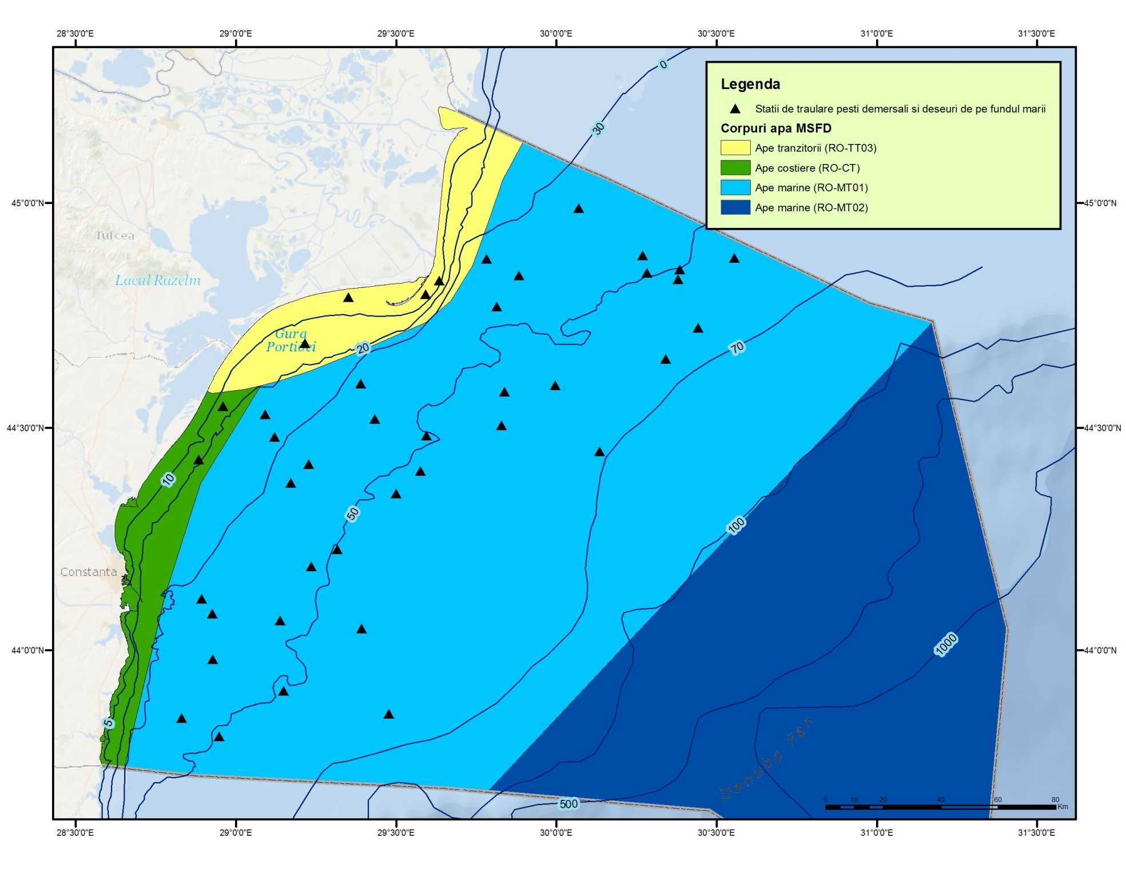  Fig. 1 - Distribution of trawling zones  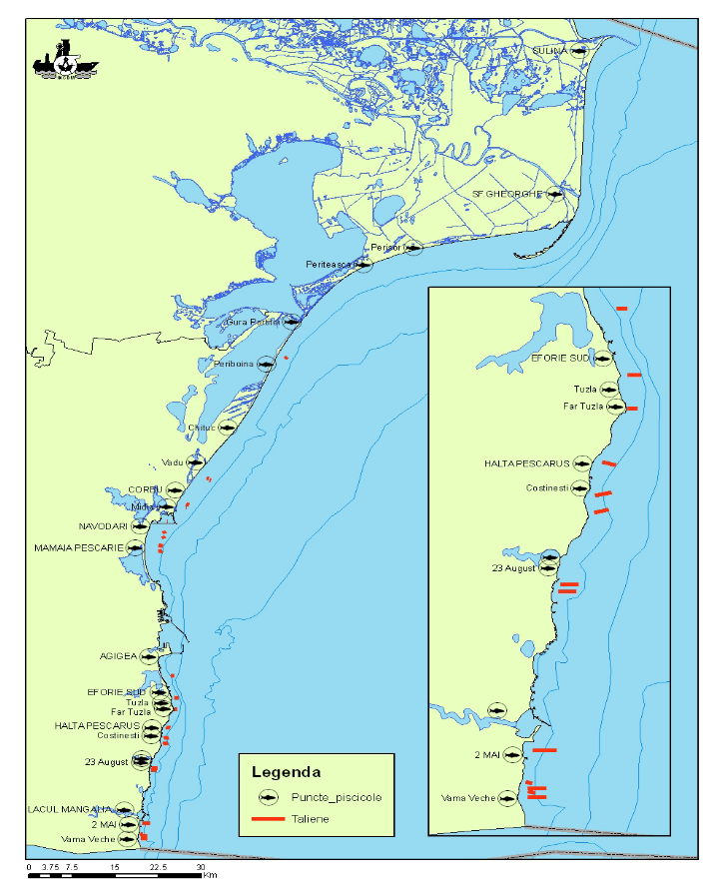  Fig. 2 - Fisheries points and distribution area for stationary fishing gears  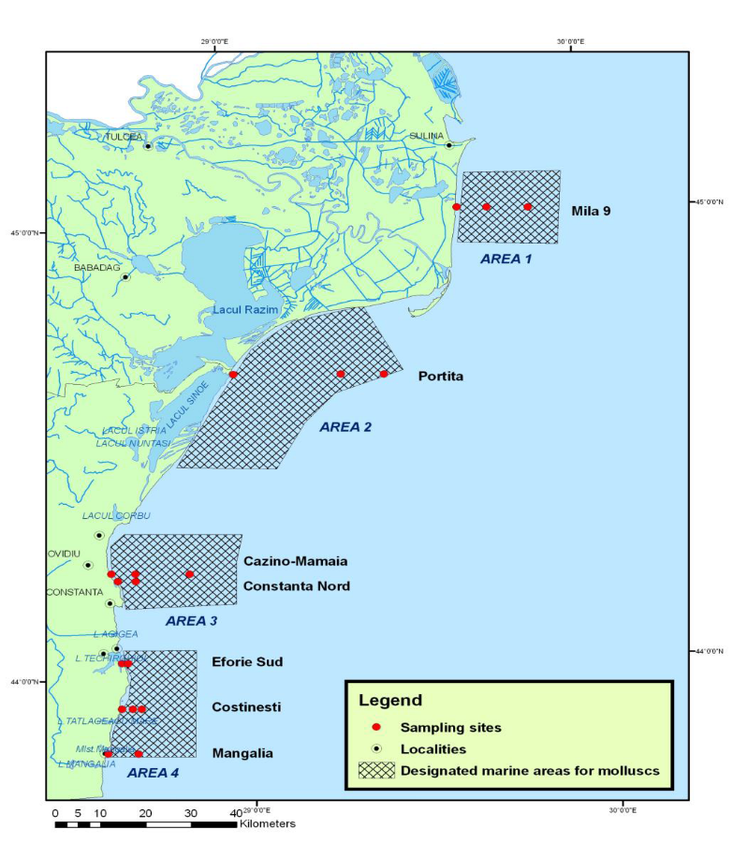  Fig. 3 Map with sampling sites from designated marine areas for growth and economic exploitation of molluscs  In compliance with the Directive 79/923/EEC on shellfish water quality, four areas along the Romanian Black Sea coast were identified as suitable for mussel culture (Fig. 3). NIMRD monitors two main species, namely the mussel Mytilus galloprovincialis and the snail Rapana venosa, within each of the four delimited areas (2 surveys/year).  Danube Delta Biosphere Reserve Authority (DDBRA) is dealing with monitoring activity in the Danube Delta Biosphere Reserve.  IRDAEFA Galati is less involved in the routine monitoring activity within National Program, but it contributes highly in:  - Data collection and processing on economic variables;  - Data collection and processing on transversal variables;  - Development and redesign of Data Base system and associated software;  - Development of Data Base system security;
3.3 Threats, activities and measures | Threats identified which potentially affect the commercial fish and shellfish stocks are: overfishing and illegal fishing, pollution, eutrophication, and non-indigenous species.  Relevant human activities (activity theme/activity) associated to above mentioned threats are:  Energy production/ Marine hydrocarbon (oil and gas) extraction  Extraction of living resources/ Fisheries incl. recreational fishing (fish and shellfish)  Extraction of non-living resources/ Dredging  Man-made structures/ Port operations; submarine cable and pipeline operations;  Transport/ Shipping  Waste disposal/ Solid waste disposal incl. dredge material  Land-based activities/industries/Coastal and riverine inputs from land - industrial discharges; coastal and riverine inputs from land - agricultural run-off; coastal and riverine inputs from land - municipal waste water discharge  The programme will address the above mentioned activities by measuring their distribution in space and time, intensity, but significant improvements have to be done. The programme will consider only the pressures resulted from extraction of living resources; the pressures related to the other activities (e.g. land-based activities, extraction of non-living resources, waste disposal, transport, etc) will not be considered by the program (they are/will be subject to other monitoring programmes - e.g. Biodiversity – seabed habitats, Non-indigenous species, Eutrophication, Hydrographical conditions, Contaminants, etc).  The measures which will be monitored by the programme have to be developed.
3.4 Data management | Data are reported (either as processed data or data products) through competent authority (NAFA) to BSC (through AG – FOMLR), GFCM, and JRC (DG Mare).  Data will be available via national website http.\www.rmri.ro and www.nodc.ro (starting with 2015).
4. Assessment
4.1 Assessments | Existing assessments  MSFD (Art. 8) – Initial Assessment  http://cdr.eionet.europa.eu/ro/eu/msfd8910/msfd4text/envuhwuaq  Environmental Status Reports  http://www.rmri.ro/Home/Products.EnvStatusReport.html  State of Environment Report 2001-2006/7  http://www.blacksea-commission.org/publ-SOE2009.asp  Operational Programme for Fisheries Romania 2007-2013  http://www.old.madr.ro/pages/fep/2013/Operational-Programme-for-Fisheries-Romania.pdf  Romania Technical Reports of National Programme for Collection of Fisheries Data  http://www.rmri.ro
4.2 Assessment of GES | Generally, the programme provides data/information for periodic assessment of environmental status and distance to and progress towards GES (as it has been defined).  Anyway, some improvement measures have to be taken so that the program will be able to provide more data/information and knowledge for updating/developing targets definitions, thus for more robust environmental status characterization (see Section 6).
5. Literature
Zampoukas, N., Piha, H., 2011, Review of Methodological Standards Related to the Marine Strategy Framework Directive Criteria on Good Environmental Status, Publications Office of the European Union, 53 pp. http://publications.jrc.ec.europa.eu/repository/handle/111111111/16069
Zampoukas, N., Piha, H., Bigagli, E., Hoepffner,N., Hanke, G., Cardoso, A., 2012, Monitoring for the Marine Strategy Framework Directive: Requirements and Options, Publications Office of the European Union, 42 pp., http://publications.jrc.ec.europa.eu/repository/handle/111111111/23169
Zampoukas, N., Piha, H., Bigagli, E., Hoepffner,N., Hanke, G., Cardoso, A., 2013, Marine monitoring in the European Union: how to fulfil the requirements for the MSFD in an efficient and integrated way, Marine Policy, 39, 349-351
http://publications.jrc.ec.europa.eu/repository/handle/111111111/27825
Marine Strategy Framework Directive Task Group 3 - Commercially exploited Fish and Shellfish
http://ec.europa.eu/environment/marine/pdf/3-Task-Group-3.pdf
6. Activities required to implement the concept
6.1 Changes to the current monitoring programme | Recommendations actions needed:  - increasing financial assistance and securing sustainable financing at national levels;  - better integration the MSFD monitoring with the monitoring requirements of the other directives (WFD, HD, Shellfish Waters Directive), regional sea conventions (BSC);  - strengthening the regional cooperation/harmonization between the Black Sea MS (common research surveys, common sampling and data processing methodologies, common MSFD indicators/parameters to be approached, common GES and Environmental Targets definitions;)  - better use and coordination of the existing capacities of all organizations dealing with monitoring programme; avoid overlapping of activities and efforts;  - permanent agreements with other authorities/organizations in supporting the national monitoring programme;  - creation of partnerships between research institutions, governments and producer organizations to develop joint research programs;  - improvement of knowledge related to the impact of less studied human activities (ML, noise, etc.) on the fish populations;  - adjustment/increasing of temporal resolution of the program;  - adjustment/extension of spatial coverage;  - new monitoring tools to be developed (e.g. fish sonar, satellite images, etc.);  - existing indicators to be developed (new parameters, indices to be considered and developed);  - construction of a regional fishery database;  - improving QA/QC;  - improving data management.
6.2 Gaps: GES information | The programme will be fully adequate (in terms of providing data and information needed to assess GES) in time for the next assessment in 2018.
6.3 Plans: Plans for GES information | The programme needs to be improved for a better spatial coverage, but also in terms of infrastructure (new monitoring tools to be developed) and human resources. Thus, it would be able to provide more data/information and knowledge necessary for a more robust assessment of environmental status and distance to GES.  More research is needed for developing existing/new indicators related to Descriptor 3. Joint researches (RO and BG, but also the other riparian non-EU countries) related to some elements (species distribution, breeding areas, diet, maturity indices, etc.) are needed for a better common approach of indicators/parameters related to the descriptor concerned.
6.4 Gaps: Target information | The programme will be fully adequate in terms of collection of data and information needed for assessing the environmental targets in time for the next assessment in 2018.
6.5 Plans: Plans for information on targets | Firstly, Romania has to continue the process of defining/updating environmental targets according to MSFD requirements for D3. The current programme needs significant improvements, especially in terms of spatial-temporal coverage (developing new monitoring tools), data reporting (common regional database), QA/QC procedures, etc., as well as knowledge (new parameters, indices to be considered and developed), for setting (more) reliable thresholds as baseline for defining environmental targets for concerned indicators (related to D3).  Also, a major need is related to the regional coordination; the Black Sea MS have to continue the process of developing common methodology to set the thresholds needed for establishing common environmental targets (e.g. Criterion 3) and improve the existing common targets (e.g. those related to the indicators 3.1.1 - Fish mortality and 3.1.2 - Catch/biomass ratio index have to address also to the other commercial species).
6.5 Plans: Plans for information on measures | To be developed

