MONITORING FACT SHEET - Non-indigenous species
Country: | ROMANIA
Author: | Otilia Mihail
Institute: | Department on Waters, Forests and Fisheries (Ministry of Environment and Climate Change)

Title: Non-indigenous species
1. General
1.1 Subject area | NON-INDIGENOUS SPECIES; BLKRO-D2
1.2 Definition/Description | NIS problems are emerging at global scale and are difficult to solve since they depend on the chance of recording the newcomers in particular geographic areas in due time. The problems must be integrated in the general study of biodiversity far from some scientists’ fake problem of “hunting after NIS”.  Likewise, it is necessary that NIS multiple potential impacts on the systems should be under permanent monitoring. Spatial and temporal distribution control-monitoring should be a powerful and flexible control system of biodiversity, capable to interfere and record the newcomer in an area; when an alien species is found, its presence requires an early warning of the scientific community on a large scale.  NIMRD is the main organization dealing with NIS monitoring, but no specific monitoring network is developed for elements concerned. NIS monitoring carries out within the National Integrated Monitoring Program, thus the spatial coverage (coastal and, partially, shelf waters) and sampling frequency (seasonally, except macroalgae – only in the warm season) are similar as those of the other monitoring programmes.  The monitoring activity is focused on:  - pelagic components: phytoplankton, zooplankton, and pelagic fish  - benthic components: macrolalgae, zoobenthos, and demersal fish  Parameters monitored:  State parameters: species composition, species abundance (density and biomass).  Impact parameters are generally poor approached by the programme; only the ratios non-native/native species are monitored. The impacts of NIS introduction on the environment are approached also by other programmes (Biodiversity – Water column habitats, Biodiversity – Seabed habitats, Biodiversity – Fish, and Commercial Fish and Shellfish).  Pressure parameters are approached by monitoring the distribution in time and space of relevant non indigenous species. The pressure at source level has not approached so far. The biological monitoring of vectors (especially ballast water) is not developed (only occasionally data/information concerning on community composition and species abundance has been provided by NIMRD, within different studies, and other organizations under the coordination of Ministry of Transport.  Additional data/information is also provided within the monitoring programmes in NATURA 2000 sites and other marine protected areas (MPA).  The programme refers also to relevant human activities leading to NIS introduction.
1.3 Competent authority/ies | Ministry of Environment and Climate Change http://www.mmediu.ro/  - Department on Waters, Forests and Fisheries - contact point for the Commission  Ministry of Transport http://www.mt.ro/
1.4 Monitoring institutions | National Institute for Marine Research and Development “Grigore Antipa”, Constanta http://www.rmri.ro/ - under coordination of the Ministry of National Education
1.5 Additional information | Black Sea Commission - BSIMAP  http://www.blacksea-commission.org/_bsimap.asp  MSFD Guiding Improvements in the Black Sea Integrated Monitoring System (MISIS) project  http://www.misisproject.eu  Technical and administrative support for joint implementation of MSFD in Bulgaria and Romania  http://www.msfdblacksea.eu  Towards COast to COast NETworks of marine protected areas (from the shore to the high and deep sea), coupled with sea-based wind energy potential (COCONET)  http://www.coconet-fp7.eu  European Maritime Safety Agency  http://emsa.europa.eu/main/ballast-water/involvement.html  Globallast Partnerships  http://globallast.imo.org/index.asp?page=links.htm&menu=true
2. Monitoring requirements and purpose
2.1 Necessity | Listed below are direct references to the monitoring requirements – EU directives, Black Sea Commission agreements, national plans, research programme requirements, other.
MSFD  Article 11  Article 8  Annex III | Art.11  1. On the basis of the initial assessment made pursuant to Article 8(1), Member States shall establish and implement coordinated monitoring programmes for the ongoing assessment the environmental status of their marine waters on the basis of the indicative lists of elements set out in Annex III and the list set out in Annex V, and by reference to the environmental targets established pursuant to Article 10.  2. Member States sharing a marine region or subregion shall draw up monitoring programmes in accordance with paragraph 1 and shall, in the interest of coherence and coordination, endeavour to ensure that:  (a) monitoring methods are consistent across the marine region or subregion so as to facilitate comparability of monitoring results;  (b) relevant transboundary impacts and transboundary features are taken into account.  Art. 8  The results of monitoring programme are required for the next cycle of assessment of marine waters. To this end, relevant parameters must be monitored for biological features (Annex III, Table 1) and pressures/impacts (Annex III, Table 2):  Annex III, Table 1  Biological features  — an inventory of the temporal occurrence, abundance and spatial distribution of non-indigenous, exotic species or, where relevant, genetically distinct  Annex III, Table 2  Biological disturbances  — introduction of non-indigenous species and translocations,
Habitats Directive  Article 11 | Art. 11  Member States shall undertake surveillance of the conservation status of the natural habitats and species referred to in Article 2 with particular regard to priority natural habitat types and priority species.
COUNCIL REGULATION (EC) No. 708/2007 concerning use of alien and locally absent species in aquaculture  Article 18 | Art 18.  Alien species shall be monitored after their release into open aquaculture facilities for a period of two years or a full generation cycle, whichever is longer, to assess whether the impacts were accurately predicted or if there are additional or different impacts.
Black Sea Commission  Bucharest Convention (article 15) and its Protocols | Convention on the Protection of the Black Sea Against Pollution  Art. 15.  - The Contracting Parties shall cooperate in conducting scientific research aimed at protecting and preserving the marine environment of the Black Sea and shall undertake, where appropriate, joint programmes of scientific research, and exchange relevant scientific data and information.  The Black Sea Biodiversity and Landscape Conservation Protocol  Article 5  1. The Contracting Parties shall take all appropriate measures to regulate an intentional introduction and prevent an accidental introduction of non-indigenous species or genetically modified organisms to the wild flora and fauna and prohibit those that may have harmful impacts on the ecosystems, habitats or species in the area to which this Protocol applies.  2. The Contracting Parties shall endeavour to implement all appropriate measures to eradicate or reduce to an possible level species that have already been introduced when it appears that such species cause or are potentially causing damage to ecosystems, landscapes, habitats or species in the area to which this Protocol applies
International Convention for the Control and Management of Ships' Ballast Water and Sediments (BWM)  Article 6 | Art. 6  1. Parties shall endeavour, individually or jointly, to:  (a) promote and facilitate scientific and technical research on Ballast Water Management; and  (b) monitor the effects of Ballast Water Management in waters under their jurisdiction.  Such research and monitoring should include observation, measurement, sampling, evaluation and analysis of the effectiveness and adverse impacts of any technology or methodology as well as any adverse impacts caused by such organisms and pathogens that have been identified to have been transferred through ships‘ Ballast Water.
Convention on Biological Diversity (CBD)  Article 7 | Art. 7  Each Contracting Party shall, as far as possible and as appropriate, in particular for the purposes of Articles 8 to 10:  (c) Identify processes and categories of activities which have or are likely to have significant adverse impacts on the conservation and sustainable use of biological diversity, and monitor their effects through sampling and other techniques.
Other plans and/or programmes | Natura 2000  http://www.natura2000.ro
2.2 GES criteria | GES criteria and indicators (see Commission Decision of 1 September 2010) relevant for the Romanian programme are indicated in bold:  Descriptor 2  2.1 Abundance and state characterization of non-indigenous species, in particular invasive species  - Trends in abundance, temporal occurrence and spatial distribution in the wild of non-indigenous species, particularly invasive non-indigenous species, notably in risk areas, in relation to the main vectors and pathways of spreading of such species (2.1.1)  2. 2. Environmental impact of invasive non-indigenous species  - Ratio between invasive non-indigenous species and native species in some well-studied taxonomic groups (e.g. fish, macroalgae, molluscs) that may provide a measure of change in species composition (e.g. further to the displacement of native species) (2.2.1)  - Impacts of non-indigenous invasive species at the level of species, habitats and ecosystem, where feasible (2.2.2)
2.3 Features, pressures and impacts | Features and pressures/impacts (from MSFD Annex III) relevant for the programme are:  Characteristics  Biological features  — an inventory of the temporal occurrence, abundance and spatial distribution of non-indigenous, exotic species or, where relevant, genetically distinct  Pressure and impacts  Biological disturbances  — introduction of non-indigenous species and translocations,
2.4 GES | Romania has not defined yet GES in terms of NIS. Even if the programme partially addresses the indicators related to D2, it has to be considerably improved for providing GES definition (see Section 6).  For some species, the trends could be derived from the programme (only for some parameters), thus, after GES definition, they could contribute to determine the distance to the GES.  The primary introduction of NIS (transfer from the source to the recipient regions) takes place as a result of human activities, thus the programme refers only partially to natural variability (related to secondary introduction - spread from the founding site occurred through a combination of natural dispersal and human-associated transport mechanisms).
2.5 Environmental targets  MSFD  Habitats  COUNCIL REGULATION (EC) 708/2007  BSC  BWM Convention  CBD | Environmental targets related to NIS have not been defined yet.  A significant improvement of the current programme is necessary to provide data/information and knowledge for a better approaching of related indicators/parameters so that the environmental targets can be defined (see Section 6)  Relevant targets from other obligations (see section 2.1) that are addressed by the monitoring:  - introduction into the wild of any species which is not native to the MS territory is regulated so as not to prejudice natural habitats within their natural range or the wild native fauna and flora  - to optimize benefits associated with introductions and translocations while at the same time avoiding alterations to ecosystems, preventing negative biological interaction, including genetic change, with indigenous populations and restricting the spread of non-target species and detrimental impacts on natural habitats  SAP (2009)  3.2 Long-term Ecosystem Quality Objectives (EcoQOs)  EcoQO 2: Conservation of Black Sea Biodiversity and Habitats.  EcoQO 2c: Reduce and manage human mediated species introductions  To EcoQO 2, BS SAP has awarded a number of management objectives, which overlap many of the MSFD provisions on evaluation, monitoring and determination of good environmental status. However, SAP indicators reflecting specific regional, cross-border issues and priorities, so they do not overlap perfectly over MSFD qualitative descriptors for determining GES.  - to prevent, minimize and ultimately eliminate the transfer of Harmful Aquatic Organisms and Pathogens through the control and management of ships‘ Ballast Water and Sediments.  - to prevent the introduction of, control or eradicate those alien species which threaten ecosystems, habitats or species.
2.6 Spatial allocation | Table of where monitoring is required
   | EEZ | 12-nm zone | Coastal waters | Transitional waters
  MSFD | X | X | X
  Habitats | - | X | X | X
  BSC | X | X | X | X
3 Monitoring concept
3.1 General description of relevant subprogrammes in monitoring programme | 1. Mobile species - abundance and/or biomass (non-commercial fish)  Subprogramme ID (4g): BLKRO-D1,2,4_Mobile SpeciesFish_08  Purpose (4k): Environmental state and impacts  Elements monitored (9a): Biological features  • information on the structure of fish populations, including the abundance, distribution and age/size structure of the populations,  • a description of the population dynamics, natural and actual range and status of other species occurring in the marine region or subregion which are the subject of Community legislation or international agreements,  Parameters (9b): Species present (non-indigenous fish species); species abundance (non-indigenous fish species)  Monitoring method (9c): Romanian National Programme for data collection and management of fisheries data 2011-2013  Temporal resolution (9h): 6 monthly  2. Seabed habitats – community characteristics (zoobenthos)  Subprogramme ID (4g): BLKRO-D1,2,3,4,6_SeabedHabitats_05  Purpose (4k): Environmental state and impacts  Elements monitored (9a): Biological features  • a description of the biological communities associated with the predominant seabed habitats  • information on invertebrate bottom fauna, including species composition, biomass and annual/seasonal variability  Parameters (9b): Species present (non-indigenous zoo benthic species)  Monitoring method (9c): Todorova V. and Konsulova T., 2005.  Temporal resolution (9h): 6 monthly  3. Seabed habitats – community characteristics (macroalgae)  Subprogramme ID (4g): BLKRO-D1,2,4,6_SeabedHabitats_06  Purpose (4k): Environmental state and impacts  Elements monitored (9a): Biological features  • information on angiosperms, macro-algae, including species composition, biomass and annual/seasonal variability  Parameters (9b): Species present (non-indigenous macroalgae species)  Monitoring method (9c): BS guidance (http://www.helcom.fi/Documents/Action%20areas/Monitoring%20and%20assessment/Manuals%20and%20Guidelines/COMBINE_AnnexC9_  MonitoringPhytobentic.pdf)  Temporal resolution (9h): yearly  4. Benthic species – abundance and/or biomass (zoobenthos)  Subprogramme ID (4g): BLKRO-D1,2,3,4,6_SeabedHabitats_07  Purpose (4k): Environmental state and impacts  Elements monitored (9a): Biological features  • information on invertebrate bottom fauna, including species composition, biomass and annual/seasonal variability  Parameters (9b): species abundance – number (non-indigenous zoobenthic species); species abundance – biomass (non-indigenous zoobenthic species)  Agreed common parameters: species abundance – number (non-indigenous zoobenthic species); species abundance – biomass (non-indigenous zoobenthic species)  Monitoring method (9c): Todorova V. and Konsulova T., 2005.  Temporal resolution (9h): 6 monthly  5. Benthic species – abundance and/or biomass (macroalgae)  Subprogramme ID (4g): BLKRO-D1,2,4,5,6_SeabedHabitats_08  Purpose (4k): Environmental state and impacts  Elements monitored (9a): Biological features  • information on angiosperms, macro-algae, including species composition, biomass and annual/seasonal variability  Parameters (9b): species abundance – biomass (non-indigenous macroalgae species  Monitoring method (9c): BS guidance (http://www.helcom.fi/Documents/Action%20areas/Monitoring%20and%20assessment/Manuals%20and%20Guidelines/COMBINE_AnnexC9_  MonitoringPhytobentic.pdf)  Temporal resolution (9h): yearly  6. Pelagic habitats – community characteristics (phytoplankton)  Subprogramme ID (4g): BLKRO-D1,2,4,5_WaterColumn_04  Purpose (4k): Environmental state and impacts  Elements monitored (9a): Biological features  • a description of the biological communities associated with the predominant seabed and water column habitats. This would include information on the phytoplankton and zooplankton communities, including the species and seasonal and geographical variability • an inventory of the temporal occurrence, abundance and spatial distribution of non-indigenous, exotic species or, where relevant, genetically distinct forms of native species, which are present in the marine region or subregion.  Parameters (9b): Species present (non-indigenous phytoplankton species); species abundance - number of individuals (non-indigenous phytoplankton species); species biomass (non-indigenous phytoplankton species); ratio non-native/native species  Agreed common parameters: species abundance - number of individuals (non-indigenous phytoplankton species); species biomass (non-indigenous phytoplankton species)  Monitoring method (9c): Moncheva, 2010; Moncheva and Par, 2005 (updated-2010)  Temporal resolution (9h): generally 3 monthly, only at oncoast fix stations twice per week  7. Pelagic habitats – community characteristics (zooplankton)  Subprogramme ID (4g): BLKRO-D1,2,4_WaterColumn_05  Purpose (4k): Environmental state and impacts  Elements monitored (9a): Biological features  • a description of the biological communities associated with the predominant seabed and water column habitats. This would include information on the phytoplankton and zooplankton communities, including the species and seasonal and geographical variability • an inventory of the temporal occurrence, abundance and spatial distribution of non-indigenous, exotic species or, where relevant, genetically distinct forms of native species, which are present in the marine region or subregion.  Parameters (9b): Species present (non-indigenous zoplankton species); species abundance - number of individuals (non-indigenous zooplankton species); species biomass (non-indigenous zooplankton specie); ratio non-native/native species  Agreed common parameters: species abundance - number of individuals (non-indigenous zooplankton species); species biomass (non-indigenous zooplankton specie)  Monitoring method (9c): MANUAL for mesozooplankton sampling and analysis in the Black Sea monitoring programmes.  Temporal resolution (9h): 3 monthly  8. Pelagic habitats – community characteristics (zooplankton-gelatinous)  Subprogramme ID (4g): BLKRO-D1,2,4_WaterColumn_06  Purpose (4k): Environmental state and impacts  Elements monitored (9a): Biological features  • a description of the biological communities associated with the predominant seabed and water column habitats. This would include information on the phytoplankton and zooplankton communities, including the species and seasonal and geographical variability • an inventory of the temporal occurrence, abundance and spatial distribution of non-indigenous, exotic species or, where relevant, genetically distinct forms of native species, which are present in the marine region or subregion.  Parameters (9b): Species present (non-indigenous gelatinous species); species abundance - number of individuals (non-indigenous gelatinous species); species biomass (non-indigenous gelatinous species); ratio non-native/native species  Agreed common parameters: species abundance - number of individuals (non-indigenous gelatinous species); species biomass (non-indigenous gelatinous species)  Monitoring method (9c): MANUAL for mesozooplankton sampling and analysis in the Black Sea monitoring programmes.  Temporal resolution (9h): 3 monthly  9. Non-indigenous species inputs - from specific sources  Subprogramme ID (4g): BLKRO-D2_PressureSourceNIS_01  Purpose (4k): Pressures (at source level)  Elements monitored (9a): Biological disturbances  • introduction of non-indigenous species and translocations  Parameters (9b): Input (quantity and type of NIS) per area and time  Agreed common parameters: Input (quantity and type of NIS) per area and time  Monitoring method (9c): Todorova& Konsulova, 2005- www.blacksea-commission.org); Moncheva, 2010; Moncheva and Par. 2005 (updated-2010); Korshenko A. & Alexandrov B., 2006. Manual for zooplankton sampling and analysis in the Black Sea  Temporal resolution (9h): two times per year - spring and late summer  10. Non-indigenous species - abundance and/or biomass  Subprogramme ID (4g): BLKRO-D2_PressureMarEnv_01  Purpose (4k): Pressures (in marine environment)  Elements monitored (9a): Biological disturbances  • introduction of non-indigenous species and translocations  Parameters (9b): Quantity (abundance and biomass) and type of non-indigenous species  Agreed common parameters: Input (quantity and type of NIS) per area and time  Monitoring method (9c): Todorova& Konsulova, 2005- www.blacksea-commission.org); Moncheva, 2010; Moncheva and Par. 2005 (updated-2010); Korshenko A. and Alexandrov B., 2006. Manual for zooplankton sampling and analysis in the Black Sea  Temporal resolution (9h): 3 monthly  11. Activities extracting living resources (fisheries including recreational, maerl, seaweed)  Subprogramme ID (4g): BLKRO-Activities_01  Purpose (4k): Human activities causing the pressures  Elements monitored (9a): Fisheries, incl. recreational fishing (fish & shellfish)  Parameters (9b): Distribution/extent in space and time, intensity  Monitoring method (9c): Romanian National Programme for data collection and management of fisheries data 2011-2013 (paper questionnaire)  Temporal resolution (9h): yearly  12. Activities producing food (aquaculture)  Subprogramme ID (4g): BLKRO-Activities_03  Purpose (4k): Human activities causing the pressures  Elements monitored (9a): Aquaculture (shellfish)  Parameters (9b): Distribution/extent in space and time, intensity  Monitoring method (9c): Romanian National Programme for data collection and management of fisheries data 2011-2013 (paper questionnaire)  Temporal resolution (9h): 3 monthly – starting with 2015  13. Sea-based mobile activities (shipping, boating)  Subprogramme ID (4g): BLKRO-Activities_06  Purpose (4k): Human activities causing the pressures  Elements monitored (9a): Shipping  Parameters (9b): Distribution/extent in space and time, intensity  Monitoring method (9c): VTS System; Handbook for IMSP  Temporal resolution (9h): yearly  14. Effectiveness of measures  Parameter: to be developed
3.2 Description of monitoring network | No specific monitoring network is developed for NIS, thus the spatial coverage of the current program is similar to that of other monitoring programmes (Biodiversity-Water column habitats, Biodiversity-Seabed habitats, Biodiversity-Fish, and Commercial Fish and Shellfish).  NIMRD  Phytoplankton, zooplankton, and zoobenthos  Monitoring network comprises 45 sampling stations (bottom depths within 5 – 60 m), covering the RO coastal and, partially, shelf waters (Fig. 1).  Macroalgae  12 sampling stations, in the coastal waters, are selected for macroalgae monitoring (Fig. 2).  Fish  Scientific surveys are carried out in the coastal and shelf waters (at different depths depending on the target species), especially in the southern sector of the Romanian littoral (from Constanta to Vama Veche - Fig 3).  Also NIMRD and NAFA monitor fishing practiced along of the coastline (about 28 fishing points between Sulina - Vama Veche) either in the shallow coastal area (depth between 3 and 11 m) with fixed gears (pound nets, gillnets, long lines and beach seine) or up to 40 - 60 m depth, with gillnets and long lines (Fig. 4).  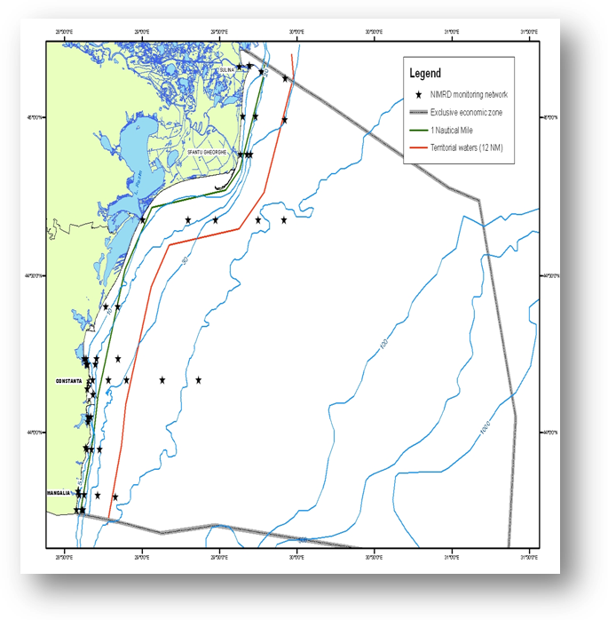  Fig.1 Map of sampling stations of the environment routine monitoring carried out by NIMRD  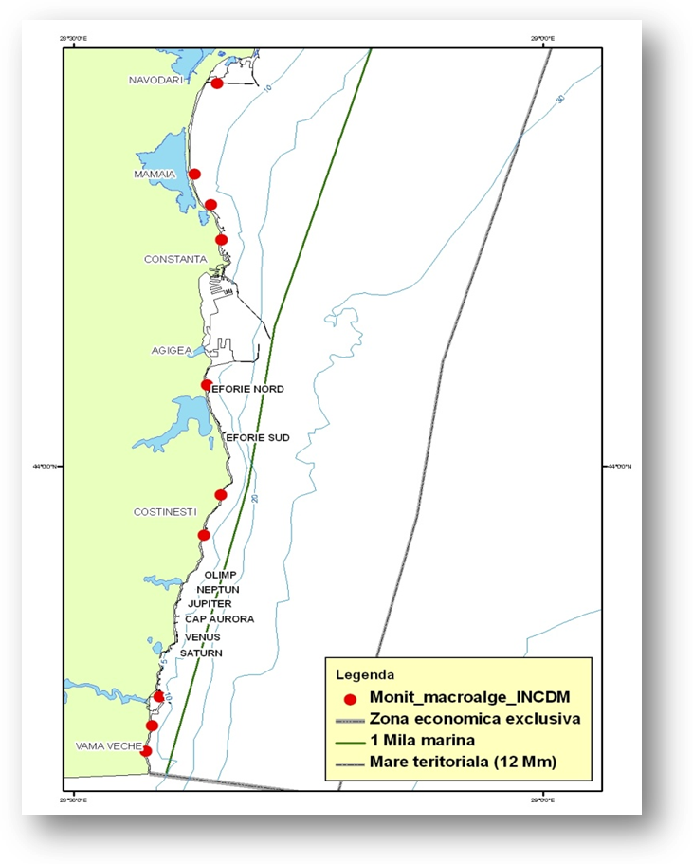  Fig. 2. Map of sampling stations of the macroalgae monitoring carried out by NIMRD  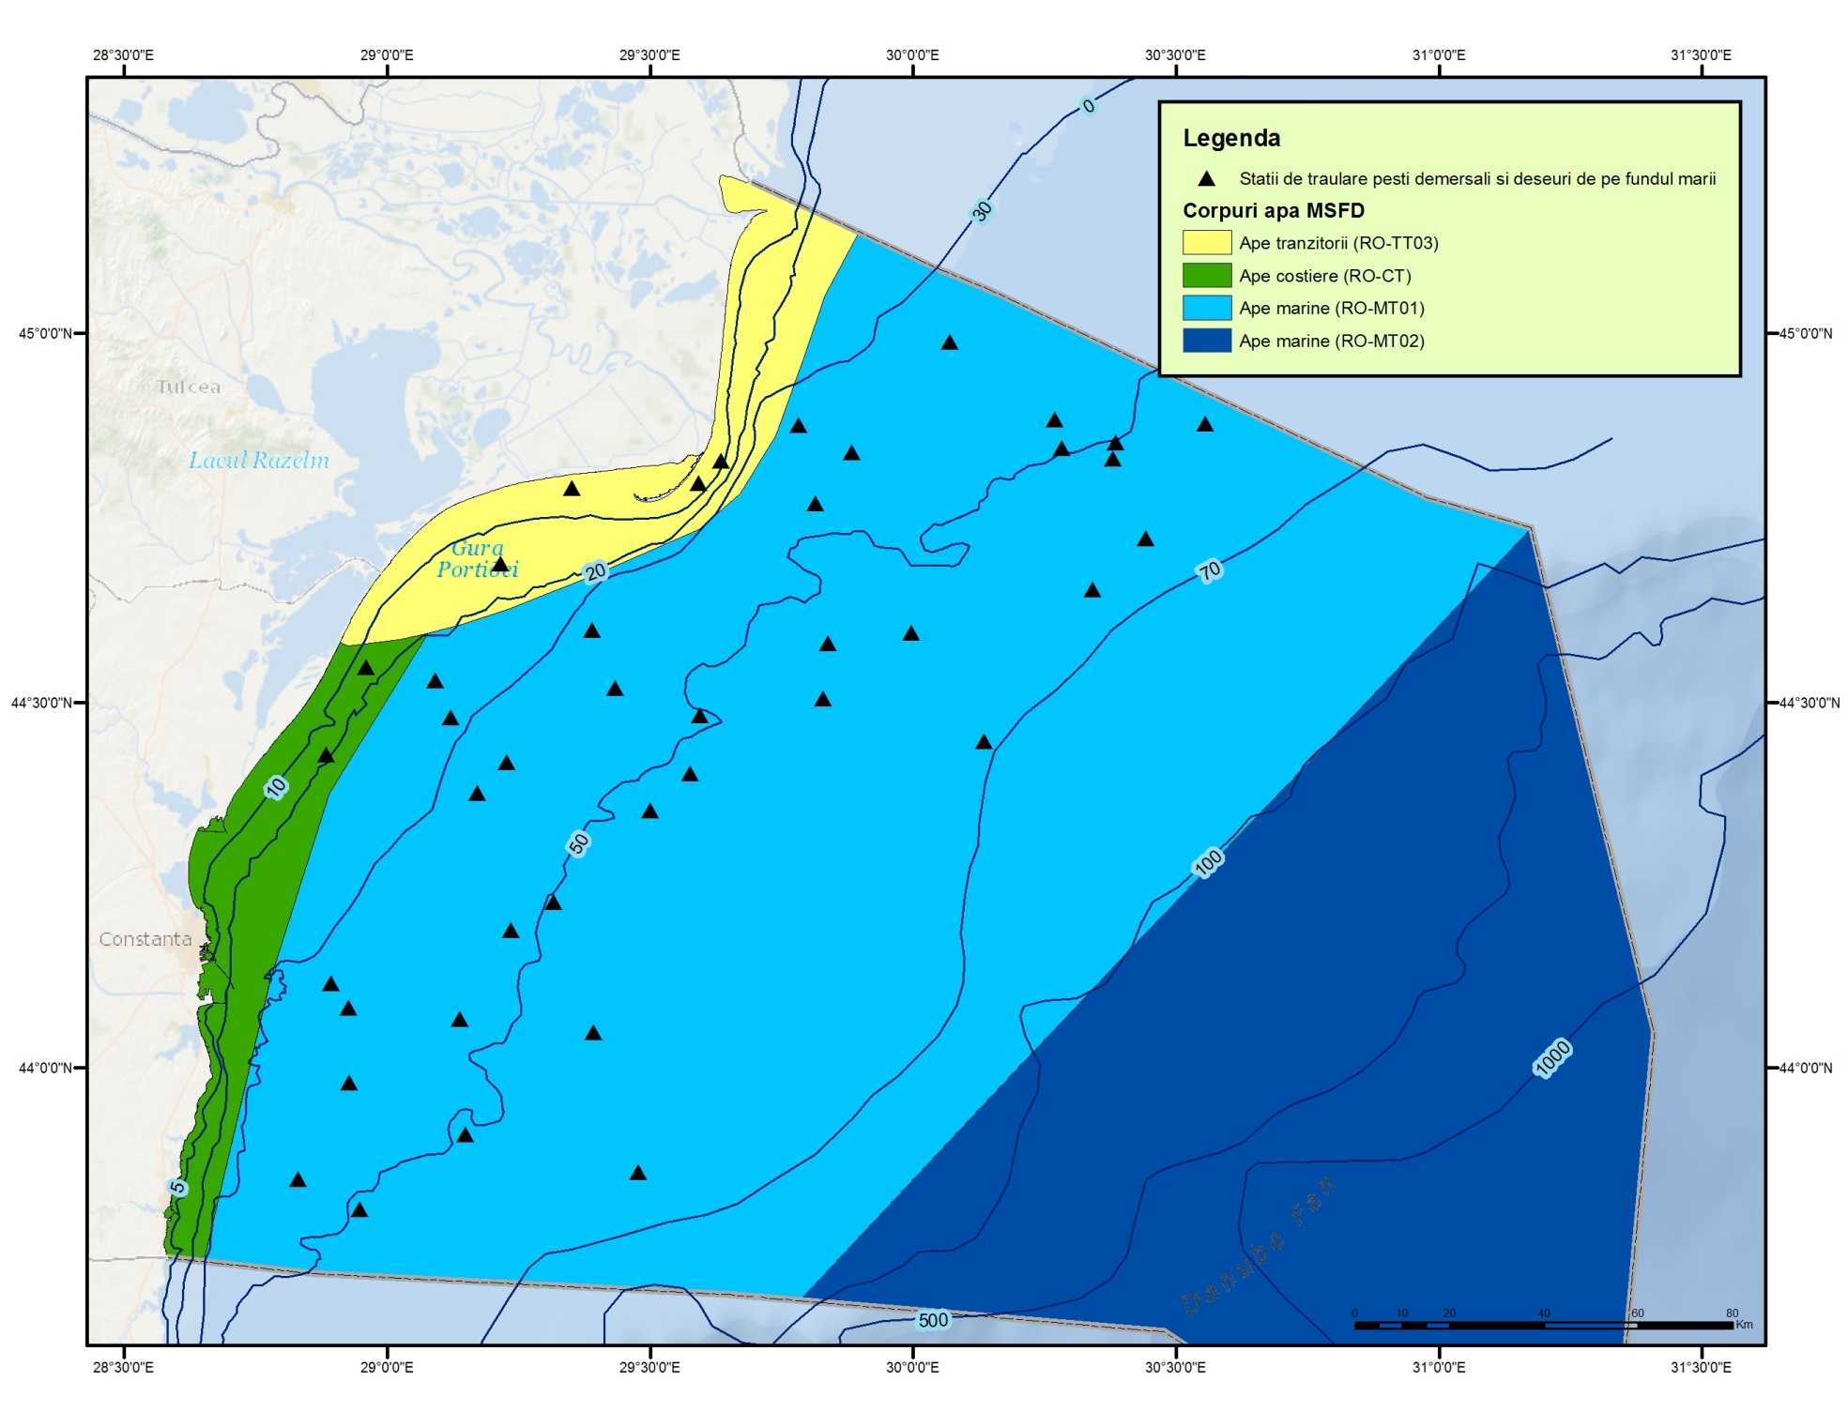  Fig. 3 - Distribution of trawling zones  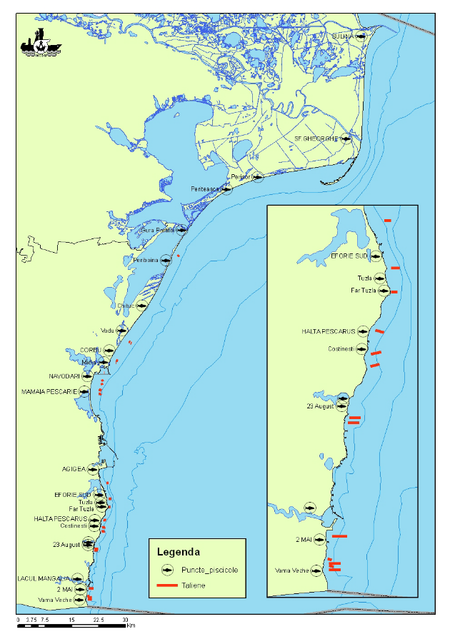  Fig. 4 - Fisheries points and distribution area for stationary fishing gears
3.3 Threats, activities and measures | Relevant human activities (activity theme/activity) which act as pathways of NIS introduction:  Energy production/ offshore oil rigs  Extraction of living resources/ Fisheries incl. recreational fishing (fish and shellfish)  Food production/ Aquaculture (fish and shellfish)  Man-made structures/ Port operations; submarine cable and pipeline operations;  Recreation/Tourism and recreation incl. yachting  Research and survey/ Marine research, survey and educational activities  Transport/ Shipping  Waste disposal/ Solid waste disposal incl. dredged material  Biological control/biological control  The programme will address partially the pathway/vectors of NIS introduction in the Black Sea by monitoring the most relevant of them, namely: shipping, food production, extraction of living resources. The monitoring activities refer to the temporal and spatial distribution and intensity of the above mentioned activities. The programme needs to be improved in order to approach the pressure level at source (with special emphasis on the ballast water and sediment – see Section 6); so far, only the level of pressure on environment (NIS spatial and temporal distribution) is considered. Also, some other activities (e.g oil extraction, biological control, etc) have to be considered by the programme (see Section 6).  The measures which will be monitored by the programme have to be developed.
3.4 Data management | Data are reported (either as processed data or data products) through competent authority to BSC (through AGs – CBD).  Data are also reported in databases belonging to other projects (e.g. DAISIE - Delivering Alien Invasive Species Inventories for Europe http://www.europe-alliens.org) from where they can be accessed in accordance with the terms of such project.  Data will be available via national website http.\www.rmri.ro and www.nodc.ro (starting with 2015).
4. Assessment
Existing assessments
MSFD (Art. 8) – Initial Assessment
http://cdr.eionet.europa.eu/ro/eu/msfd8910/msfd4text/envuhwuaq
Environmental Status Reports
http://www.rmri.ro/Home/Products.EnvStatusReport.html
State of Environment Report 2001-2006/7
http://www.blacksea-commission.org/_publ-SOE2009.asp
Black Sea Transbordary Diagnostic Analysis
http://www.blacksea-commission.org/_tda2008-document6.asp
4.2 Assessment of GES | GES has not defined yet related to NIS. However, the programme has to be significantly improved (more data/information and knowledge needed, especially for a better understanding of alien species effects on ecosystem and pathways/vectors of introduction) to define GES and, subsequently, to assess periodically the environmental status and distance to and progress towards GES (see Section 6).
5. Literature
Zampoukas, N., Piha, H., 2011, Review of Methodological Standards Related to the Marine Strategy Framework Directive Criteria on Good Environmental Status, Publications Office of the European Union, 53 pp. http://publications.jrc.ec.europa.eu/repository/handle/111111111/16069
Zampoukas, N., Piha, H., Bigagli, E., Hoepffner,N., Hanke, G., Cardoso, A., 2012, Monitoring for the Marine Strategy Framework Directive: Requirements and Options, Publications Office of the European Union, 42 pp., http://publications.jrc.ec.europa.eu/repository/handle/111111111/23169
Zampoukas, N., Piha, H., Bigagli, E., Hoepffner,N., Hanke, G., Cardoso, A., 2013, Marine monitoring in the European Union: how to fulfil the requirements for the MSFD in an efficient and integrated way, Marine Policy, 39, 349-351
http://publications.jrc.ec.europa.eu/repository/handle/111111111/27825
Marine Strategy Framework Directive – Task Group 2 Report Non-indigenous species. http://www.ec.europa.eu/environment/marine/pdf/2-Task-Group-2.pdf
6. Activities required to implement the concept
6.1 Changes to the current monitoring programme | Recommendations and actions needed:  - increasing financial assistance and securing sustainable financing at national levels;  - better integration the MSFD monitoring with the monitoring requirements of the other directives (Habitats), regional sea conventions (BSC) and other convention (International Convention for the Control and Management of Ships' Ballast Water and Sediments, Convention on Biological Diversity);  - permanent agreements with other authorities/organizations in supporting the programme (e.g. Port/Naval Authorities, offshore companies, etc.);  - better use and coordination of the existing capacities of all organizations dealing with the monitoring programme (including monitoring infrastructure sharing);  - strengthening regional cooperation/harmonization between the Black Sea MS (common sampling and data processing methodologies, common MSFD indicators/parameters to be approached, common GES and Environmental Targets definitions)  - communication channels need to be established/improved considering neighboring countries to allow for the prompt development of contingency plans and/or joint eradication efforts if so decided. These channels may also be used to alert all stakeholders regarding new arrivals, range expansions and impacts of NIS;  - developing proposals to revise/update/improve the existing national legislation, especially with regard to the vectors of NIS introduction (e.g. ballast water - development a regular/sustainable monitoring of ballast water/sediment);  - adjustment/increasing of temporal resolution of the program (e.g to catch all life stages of NIS);  - adjustment/extension of spatial coverage (e.g. open waters, harbors’ aquatoriums, etc.);  - to supplement the spatial and time scales by information from other sources, including, e.g., sports clubs, SCUBA divers, fishermen, aquaculture farmers, without losing the quality of the records;  - improvement of knowledge related to bioinvasion effects;  - existing indicators to be developed (new parameters, indices to be considered and developed where possible);  - development of widely available, accurate and cost efficient methods for genetic analysis to confirm identification of any suspected new introduction;  - development of tools to enable easy access to the most up to date identification guides (e.g. searchable digital databases that will find similar images from the web to aid identification);  - developing a protocol for dealing with species for which there is very little information and cannot be identified using existing knowledge;  - new monitoring tools to be developed (e.g. Continuous Plankton Recorder, models for establishing potential areas of new introductions in order to put in place control measures, natural dispersal mechanisms of introduced species after arrival and establishment in a new area, etc.);  - centralized regional database should be created where all national information will be summarized. Existing data bases may be used as a starting point (e.g. DAISIE, CIESM, Baltic Sea Alien Species Database);  - improving QA/QC;  - improving data management
6.2 Gaps: GES information | The programme will be fully adequate (in terms of providing data and information needed to assess GES) in time for the next assessment in 2018.
6.3 Plans: Plans for GES information | Firstly, Romania has to define GES according to MSFD requirements.  The indicators/parameters related to the programme have to be significant improved for developing methods for aggregating indicators so that GES can be defined and assessed. Efforts should be made to record all NIS known in the assessment area by improving taxonomic identification; also special attention should be paid primarily to develop indicator 2.2.2 (see Commission Decision of 1. September 2010) for assessing alien species impacts.  One of the approaches for defining GES, as is proposed by MSFD Task Group 2, consists in estimation of the magnitude of bioinvasion impacts or “Biopollution level” (BPL) index which takes into account the abundance and distribution range of NIS in relation to native biota in the invaded area and aggregates data on the magnitude of the impacts these species have on: native communities, habitats and ecosystem functioning. BPL aggregates the results of the assessment into five categories: “No bioinvasion impact”, “Weak”, “Moderate”, “Strong” and “Massive”. First two categories may indicate acceptable levels of biopollution for GES. The assessment has to be done for defined assessment units (a particular water body or its part) and certain periods of time.  A major need is related the regional cooperation; the Black Sea MS have to develop common methodology to define GES.
6.4 Gaps: Target information | The programme will be fully adequate in terms of collection of data and information needed for assessing the environmental targets in time for the next assessment in 2018.
6.5 Plans: Plans for information on targets | Firstly, Romania has to develop the methodology for defining environmental targets according to MSFD requirements.  The methodology proposed by the MSFD Task Group 2, using the BPL index (see subsection 6.3), can be applied for setting the environmental targets.  A major need is related the regional cooperation; the Black Sea MS have to develop common methodology to set the thresholds needed for establishing common environmental targets (where is possible).
6.5 Plans: Plans for information on measures | To be developed

