MONITORING FACT SHEET - Biodiversity – Fish
Country: | ROMANIA
Author: | Otilia Mihail
Institute: | Department on Waters, Forests and Fisheries (Ministry of Environment and Climate Change)

Title: Biodiversity-Fish
1. General
1.1 Subject area | BIODIVERSITY – FISH; BLKRO-D1,D4-F
1.2 Definition/Description | Fishery is the most affected sector by the changes of the Black Sea ecosystem. At the same time, fishing activities contribute themselves to the worsening of the ecological situation and to the depletion of the fish stocks. Changes in the ichthyofauna composition of the Black Sea have primarily involved alterations in the number of individuals in specific populations. For many fish species, the populations have declined so sharply that they have lost their importance for commercial fishing, and remain within the Black Sea ichthyofauna only as zoological representatives of the species.  About 200 fish species inhabit the Black Sea. Among the whole specific diversity, the greatest economic value, however, is due to not more than two dozens of species that produced about 98% of catch in 1996-2008. The rest of the catch included commercially less important fishes are not well monitored. A series of species are included in IUCN category of near threatened (NT), vulnerable (V), critically endangered (CR), and endangered (EN) species (http://www.blacksea-commission.org/_publ-BSFishList.asp ).  The monitoring of fish population in Romania is mainly addressing the commercial species, thus the current programme’s activities, focused on fish biodiversity, is carried out in close relation to the programme Commercial fish&shellfish.  The present programme is focusing on non-commercial fish population and is referring to the state/impact parameters (number of species, species distribution, biomass stock; structure on length and age classes; biological data (maturity degree, relation length/weight, etc.); growing parameters; mortality ratios, etc.). Also the programme addresses the relevant activities which influence the fish populations and the key groups relations by measuring their intensity and distribution (spatial, temporal). Despite this, the pressure indicators/parameters are subject to other programmes: pressure related to extraction of living resources is considered in the Commercial fish&shellfifh programme (fishing effort); other pressures affecting fish populations are subject to programmes: Non-indigenous species, Eutrophication, Biodiversity-Seabed habitats, Hydrographical changes, Contaminants, and Litter.
1.3 Competent authority/ies | Ministry of Environment and Climate Change http://www.mmediu.ro/  - Department on Waters, Forests and Fisheries - contact point for the Commission  Ministry of Agriculture and Rural Development http://www.madr.ro
1.4 Monitoring institutions | National Agency for Fisheries and Aquaculture http://www.anpa.ro – under the coordination of Ministry of Environment and Climate Change  National Institute for Marine Research and Development “Grigore Antipa”, Constanta http://www.rmri.ro/ - under coordination of the Ministry of National Education  Danube Delta Biosphere Reserve Authority http://www.ddbra.ro – subordinated to Ministry of Environment and Climate Change  Institute of Research and Development for Aquatic Ecology, Fishing and Aquaculture, Galati http://www.icdeapa.ro – subordinated to Academy of Agricultural and Forestry Sciences "Gheorghe Ionescu-Sisesti", under coordination of the Ministry of Agriculture and Rural Development
1.5 Additional information | Black Sea Commission - BSIMAP  http://www.blacksea-commission.org/_bsimap.asp  MSFD Guiding Improvements in the Black Sea Integrated Monitoring System (MISIS) project  http://www.misisproject.eu  Technical and administrative support for joint implementation of MSFD in Bulgaria and Romania  http://www.msfdblacksea.eu  Coordonating research in support to application of Ecosystem Approach to Fisheries (EAF) and management advice in the Mediterranean and Black Sea (CREAM)  http://www.cream-fp7.eu
2. Monitoring requirements and purpose
2.1 Necessity | Listed below are direct references to the monitoring requirements – EU directives, Black Sea Commission agreements, national plans, research programme requirements, other.
MSFD  Articles 8 and 11  Annex III | Art.11  1. On the basis of the initial assessment made pursuant to Article 8(1), Member States shall establish and implement coordinated monitoring programmes for the ongoing assessment the environmental status of their marine waters on the basis of the indicative lists of elements set out in Annex III and the list set out in Annex V, and by reference to the environmental targets established pursuant to Article 10.  2. Member States sharing a marine region or subregion shall draw up monitoring programmes in accordance with paragraph 1 and shall, in the interest of coherence and coordination, endeavour to ensure that:  (a) monitoring methods are consistent across the marine region or subregion so as to facilitate comparability of monitoring results;  (b) relevant transboundary impacts and transboundary features are taken into account.  Art. 8  The results of the programme are required for the next cycle of assessment of marine waters. To this end, some relevant parameters must be monitored for biological characterisitcs (Annex III, Table 1) and pressures/impacts (Annex III, Table 2):  Annex III, Table 1  Biological features  — information on the structure of fish populations, including the abundance, distribution and age/size structure of the populations,  — a description of the population dynamics, natural and actual range and status of other species occurring in the marine region or subregion which are the subject of Community legislation or international agreements,  Annex III, Table 2  Biological disturbances  — selective extraction of species, including incidental non-target catches (e.g. by commercial and recreational fishing).
Habitats  Article 11 | Art. 11  Member States shall undertake surveillance of the conservation status of the natural habitats and species referred to in Article 2 with particular regard to priority natural habitat types and priority species.
WFD  Article 8  Annex V | Art. 8  1. Member States shall ensure the establishment of programmes for the monitoring of water status in order to establish a coherent and comprehensive overview of water status within each river basin district:  Such monitoring shall be in accordance with the requirements of Annex V.  - Quality elements for the classification of ecological status  1.1.3. Transitional waters and 1.1.4. Coastal waters  Biological elements  - Composition and abundance of fish fauna
CBD (Convention on Biological Diversity)  Article 7 | Art. 7  Identification and Monitoring  Each Contracting Party shall, as far as possible and as appropriate, in particular for the purposes of Articles 8 to 10:  (a) Identify components of biological diversity important for its conservation and sustainable use having regard to the indicative list of categories set down in Annex I;  (b) Monitor, through sampling and other techniques, the components of biological diversity identified pursuant to subparagraph (a) above, paying particular attention to those requiring urgent conservation measures and those which offer the greatest potential for sustainable use;  (c) Identify processes and categories of activities which have or are likely to have significant adverse impacts on the conservation and sustainable use of biological diversity, and monitor their effects through sampling and other techniques.
Black Sea Commission  Bucharest Convention (article 15) and its Protocols | Art. 15.  - The Contracting Parties shall cooperate in conducting scientific research aimed at protecting and preserving the marine environment of the Black Sea and shall undertake, where appropriate, joint programmes of scientific research, and exchange relevant scientific data and information.  The Black Sea Biodiversity and Landscape Monitoring and Assessment Programme  Art. 10  The Contracting Parties shall co-operate in conducting scientific research aimed at protecting and preserving the biological and landscape diversity of the Black Sea and shall undertake, where appropriate, joint programmes and projects of scientific research, and exchange relevant scientific data and information as provisioned in the Article XV of the Convention.
Other plans and/or programmes | Natura 2000  http://www.natura2000.ro
2.2 GES criteria | GES criteria and indicators (see Commission Decision of 1 September 2010) relevant for the Romanian programme are indicated in bold:  Descriptor 1  1.1 Species distribution  - Distributional range (1.1.1)  - Distributional pattern within the latter, where appropriate (1.1.2)  1.2. Population size  - Population abundance and/or biomass, as appropriate (1.2.1)  1.3. Population condition  - Population demographic characteristics (e.g. body size or age class structure, sex ratio, fecundity rates, survival/ mortality rates) (1.3.1)  Population genetic structure, where appropriate (1.3.2)  1.4. Habitat distribution  - Distributional range  - Distributional pattern  1.5. Habitat extent  - Habitat area (1.5.1)  - Habitat volume, where relevant (1.5.2)  1.6. Habitat condition  - Condition of the typical species and communities (1.6.1)  - Relative abundance and/or biomass, as appropriate (1.6.2)  - Physical, hydrological and chemical conditions (1.6.3)  1.7 Ecosystem structure  - Composition and relative proportions of ecosystem components (habitats and species) (1.7.1)  Descriptor 4  4.1. Productivity (production per unit biomass) of key species or trophic groups  - Performance of key predator species using their production per unit biomass (productivity) (4.1.1)  4.2. Proportion of selected species at the top of food webs  - Large fish (by weight) (4.2.1)  4.3 Abundance/ distribution of key trophic groups/species  - Abundance trends of functionally important selected groups/species (4.3.1)
2.3 Features, pressures and impacts | Features and pressures/impacts (from MSFD Annex III) relevant for the programme are:  Characteristics  Biological features  - information on the structure of fish populations, including the abundance, distribution and age/size structure of the populations,  - a description of the population dynamics, natural and actual range and status of other species occurring in the marine region or subregion which are the subject of Community legislation or international agreements,  Pressure and impacts  Biological disturbance  - selective extraction of species, including incidental non-target catches (e.g. by commercial and recreational fishing)
2.4 GES | GES has not defined yet due to lack of data in case of majority of fish stocks (see Section 6). Anyway, the programme will contribute to data/information collection and existing knowledge update in order to define GES (at least preliminary) in terms of fish biodiversity and, further, to determine if GES is achieved (or distance from GES).
2.5 Environmental targets  MSFD  Habitats  WFD  BSC  CBD | No environmental targets have been defined yet regarding non-commercial fish biodiversity (see Section 6). Data/information provided by the programme, together with the existing knowledge, could be used (at least partially) to define environmental targets related to some criteria/indicators.  Relevant targets from other obligations (see section 2.1) that are addressed by the monitoring:  Ensuring biodiversity through the conservation of natural habitats and wild fauna and flora. Maintaining or restoring the favourable conservation status of natural habitats and species of wild fauna and flora.  For the protected species (Alosa immaculata and A. tanaica), the objectives defined within the Habitats Directive (Annex II) is to maintain the good conservation status. Quantitatively, the target is defined as follows:  The presence of juveniles in fishing net catches with the occasion of scientific fishing: ≥ 3 ind./t.  - protect, enhance and restore all SWB with the aim of achieving :  - the good ecological status for natural WB by 2015  - the good ecological potential for artificial and heavy modified WB by 2015  SAP (2009)  3.2 Long-term Ecosystem Quality Objectives (EcoQOs)  EcoQO 1: Preserve commercial marine living resources  EcoQO 2b: Restore/rehabilitate stocks of commercial marine living resources.  EcoQO 2: Conservation of Black Sea Biodiversity and Habitats.  EcoQO 2a: Reduce the risk of extinction of threatened species.  EcoQO 2b: Conserve coastal and marine habitats and landscapes.  EcoQO 2c: Reduce and manage human mediated species introductions  To EcoQOs 1 and 2, BS SAP has awarded a number of management objectives, which overlap many of the MSFD provisions on evaluation, monitoring and determination of good environmental status. However, SAP indicators reflecting specific regional, cross-border issues and priorities, so they do not overlap perfectly over MSFD qualitative descriptors for determining GES.  The objectives of CBD are the conservation of biological diversity and the sustainable use of its components.
2.6 Spatial allocation | Table of where monitoring is required
   | EEZ | 12-nm zone | Coastal waters | Transitional waters
  MSFD | X | X | X
  WFD | - | X | X | X
  Habitats | X | X | X | X
  BSC | X | X | X | X
3 Monitoring concept
3.1 General description of relevant subprogrammes in monitoring programme | 1. Mobile species – abundance and/or biomass (non-commercial fish)  Subprogramme ID (4g): BLKRO-D1, 4_Mobile SpeciesFish_08  Purpose (4k): Environmental state and impacts  Elements monitored (9a): Biological features  • information on the structure of fish populations, including the abundance, distribution and age/size structure of the populations,  • a description of the population dynamics, natural and actual range and status of other species occurring in the marine region or subregion which are the subject of Community legislation or international agreements  Parameters (9b): Species present; species abundance; species distributional range (Neogobius melanstomus, Hippocampus guttulatus, and Scorpaena porcus)  Agreed common parameters: species abundance (Neogobius melanstomus); species distributional range (Neogobius melanstomus)  Monitoring method (9c): Romanian National Programme for data collection and management of fisheries data 2011-2013  Temporal resolution (9h): 6 monthly  2. Mobile species - population characteristics (non-commercial fish)  Subprogramme ID (4g): BLKRO-D1, 4_Mobile SpeciesFish_10  Purpose (4k): Environmental state and impacts  Elements monitored (9a): Biological features  • information on the structure of fish populations, including the abundance, distribution and age/size structure of the populations  Parameters (9b): Body size (length, weight), age, sex, reproduction rate, maturity degree, life story stage (target species - Neogobius melanstomus, Hippocampus guttulatus, and Scorpaena porcus)  Monitoring method (9c): Romanian National Programme for data collection and management of fisheries data 2011-2013  Temporal resolution (9h): 6 monthly  3. Mobile species - state of habitats (non-commercial fish)  Subprogramme ID (4g): BLKRO-D1, 4_Mobile SpeciesFish_12  Purpose (4k): Environmental state and impacts  Elements monitored (9a): Biological features  • a description of the population dynamics, natural and actual range and status of other species occurring in the marine region or subregion which are the subject of Community legislation or international agreements  Parameters (9b): Areal extent of habitat; habitat distributional range (Alosa immaculata, Alosa tanaica, Neogobius melanstomus, Hippocampus guttulatus, and Scorpaena porcus)  Agreed common parameters: Habitat distributional range (Neogobius melanstomus)  Monitoring method (9c): Romanian National Programme for data collection and management of fisheries data 2011-2013  Temporal resolution (9h): 6 monthly  4. Mobile species - mortality/injury rates from fisheries (targeted and/or incidental) (fish)  Subprogramme ID (4g): BLKRO-D1, 3_Mobile SpeciesFish_13  Purpose (4k): Environmental state and impacts  Elements monitored (9a): Biological disturbance  • selective extraction of species, including incidental non-target catches (e.g. by commercial and recreational fishing)  Parameters (9b): Composition and number of incidental/by-catch; Fishing mortality (F)  Agreed common parameters: Composition and number of incidental/by-catch  Monitoring method (9c): Romanian National Programme for data collection and management of fisheries data 2011-2013  Temporal resolution (9h): monthly  5. Activities extracting living resources (fisheries including recreational)  Subprogramme ID (4g): BLKRO-Activities_01  Purpose (4k): Human activities causing the pressures  Elements monitored (9a): Fisheries, incl. recreational fishing (fish & shellfish)  Parameters (9b): Distribution/extent in space and time, intensity  Monitoring method (9c): Romanian National Programme for data collection and management of fisheries data 2011-2013 (paper questionnaire)  Temporal resolution (9h): yearly  6. Activities extracting non-living resources (sand, gravel, dredging)  Subprogramme ID (4g): BLKRO-Activities_02  Purpose (4k): Human activities causing the pressures  Elements monitored (9a): Port operations; Solid waste disposal incl. dredge material; Other marine uses and activities  Parameters (9b): Distribution/extent in space and time, intensity  Monitoring method (9c): Romanian Waters National Administration, 2009 - Planul de management al Dunarii,  Deltei Dunarii si cursurile de apa si apele litorale din Dobrogea; ABAD-L 2009 - Master Plan "Protection and Reahabilitation of Coastal Zone"  Temporal resolution (9h): as needed  7. Activities with permanent infrastructures (e.g. renewable energy, oil & gas, ports) or structural changes (e.g. coastal defences)  Subprogramme ID (4g): BLKRO-Activities_04  Purpose (4k): Human activities causing the pressures  Elements monitored (9a): Land claim, coastal defense; Port operations; Submarine cable & pipeline operations  Parameters (9b): Distribution/extent in space and time, intensity  Monitoring method (9c): Romanian Waters National Administration, 2009 - Planul de management al Dunarii, Deltei Dunarii si cursurile de apa si apele litorale din Dobrogea; ABADL 2009 - Master Plan "Protection and Rehabilitation of Coastal Zone"; Handbook for IMSP  Temporal resolution (9h): yearly  8. Sea-based mobile activities (shipping, boating)  Subprogramme ID (4g): BLKRO-Activities_06  Purpose (4k): Human activities causing the pressures  Elements monitored (9a): Shipping  Parameters (9b): Distribution/extent in space and time, intensity  Monitoring method (9c): VTS System; Handbook for IMSP  Temporal resolution (9h): yearly  9. Land-based activities (industry)  Subprogramme ID (4g): BLKRO-Activities_09  Purpose (4k): Human activities causing the pressures  Elements monitored (9a): Industry (discharges, emissions)  Parameters (9b): Distribution/extent in space and time, intensity  Monitoring method (9c): questionnaires sent to all operators from the coastal zone  Temporal resolution (9h): yearly  10. Land-based activities (agriculture)  Subprogramme ID (4g): BLKRO-Activities_10  Purpose (4k): Human activities causing the pressures  Elements monitored (9a): Agriculture & forestry (run-off, emissions)  Parameters (9b): Distribution/extent in space and time, intensity  Monitoring method (9c): questionnaires sent to all farms from the coastal zone and the Danube River catchment area  Temporal resolution (9h): yearly  11. Land-based activities (urban)  Subprogramme ID (4g): BLKRO-Activities_11  Purpose (4k): Human activities causing the pressures  Elements monitored (9a): Urban (municipal waste water discharges)  Parameters (9b): Distribution/extent in space and time, intensity  Monitoring method (9c): information provided by local authorities and private operators  Temporal resolution (9h): yearly  12. Effectiveness of measures  Parameters: to be developed
3.2 Description of monitoring network | According to the Romanian legislation, NIMRD and NAFA are the main organizations dealing with the monitoring activity related to fish population.  Scientific surveys are carried out by NIMRD, with coastal trawl ship (RV Steaua de Mare), in the coastal and shelf waters (at different bottom depths depending the target species), especially in the southern sector of the Romanian littoral (from Constanta to Vama Veche - Fig 1). The surveys are carried out 2 times/year, in the periods May-June and September-October.  NIMRD and NAFA monitor also the fishing practiced along of the coastline (about 28 fishing points between Sulina - Vama Veche), either in the shallow coastal area (depth between 3 and 11 m) with fixed gears (pound nets, gillnets, long lines and beach seine), or up to 40 - 60 m depth, with gillnets and long lines mainly for turbot and dogfish (Fig. 2)  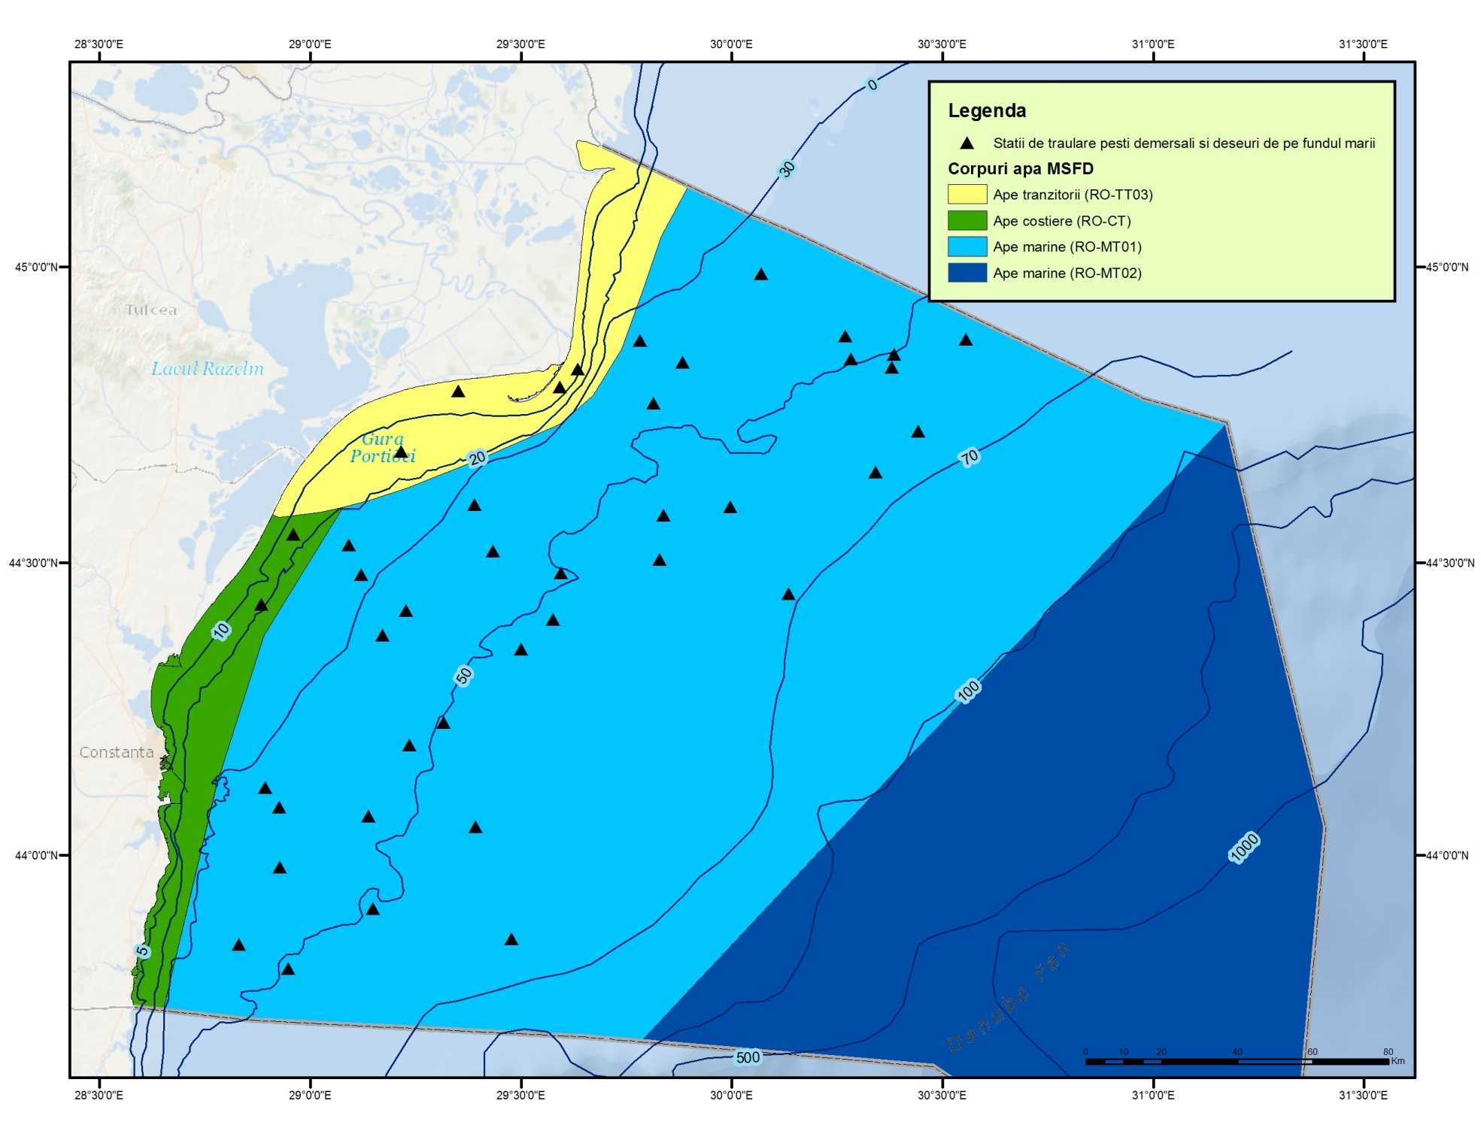  Fig. 1 - Distribution of trawling zones  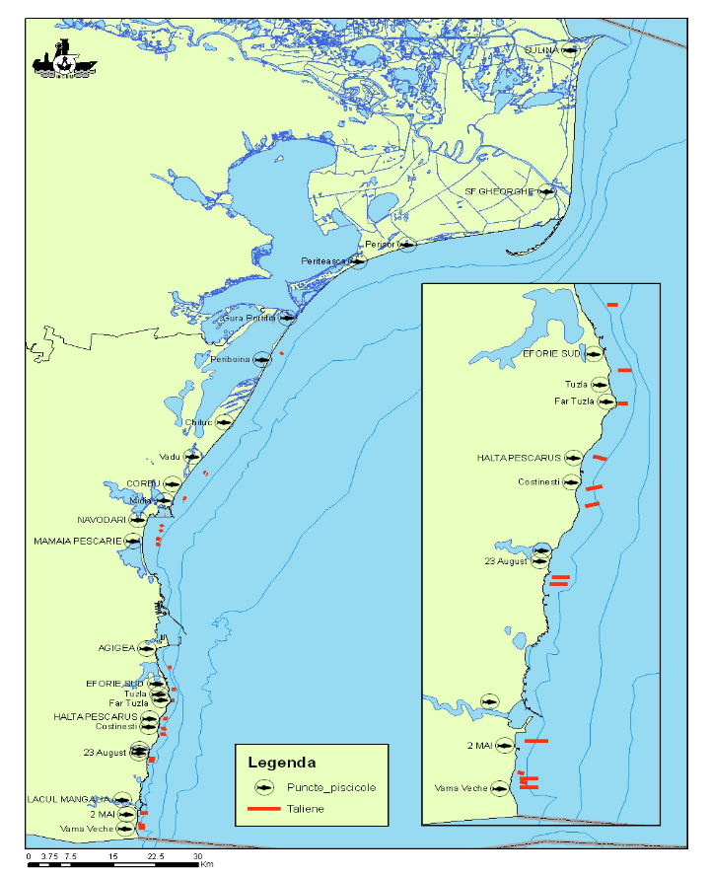  Fig. 2 - Fisheries points and distribution area for stationary fishing gears  Danube Delta Biosphere Reserve Authority (DDBRA) is dealing with monitoring activity in the Danube Delta Biosphere Reserve.  IRDAEFA Galati is less involved in the routine monitoring activity, but it highly contributes in:  - Data collection and processing on economic variables;  - Data collection and processing on transversal variables;  - Development and redesign of Data Base system and associated software;  - Development of Data Base system security.
3.3 Threats, activities and measures | Threats identified which potentially affect the fish population are: overfishing and illegal fishing, pollution, eutrophication, non-indigenous species, and habitat loss.  Relevant human activities (activity theme/activity) associated to above mentioned threats are:  - Energy production/Marine hydrocarbon (oil and gas) extraction  - Extraction of living resources/Fisheries incl. recreational fishing (fish and shellfish)  - Extraction of non-living resources/Dredging  - Man-made structures/Port operations; submarine cable and pipeline operations;  - Transport/Shipping  - Waste disposal/Solid waste disposal incl. dredge material  - Land-based activities/industries/Coastal and riverine inputs from land - industrial discharges; coastal and riverine inputs from land - agricultural run-off; coastal and riverine inputs from land - municipal waste water discharge  The programme addresses the above mentioned activities by measuring the distribution/extent and intensity of the relevant activities (some improvements are still needed). The pressures on the ecosystem resulted from those activities will be subject to other programmes (e.g. Commercial fish&shellfish, Biodiversity – seabed habitats, Non-indigenous species, Eutrophication, Hydrographical changes, Contaminants, etc.).  The measures which will be monitored by the programme have to be developed.
3.4 Data management | Data are reported (either as processed data or data products) through competent authority (NAFA) to BSC (through AG – FOMLR), GFCM, and JRC (DG Mare).  Data will be available via national website http//www.rmri.ro and www.nodc.ro (starting with 2015).
4. Assessment
4.1 Assessments | Existing assessments  MSFD (Art. 8) – Initial Assessment  http://cdr.eionet.europa.eu/ro/eu/msfd8910/msfd4text/envuhwuaq  Environmental Status Reports  http://www.rmri.ro/Home/Products.EnvStatusReport.html  State of Environment Report 2001-2006/7  http://www.blacksea-commission.org/publ-SOE2009.asp  Operational Programme for Fisheries Romania 2007-2013  http://www.old.madr.ro/pages/fep/2013/Operational-Programme-for-Fisheries-Romania.pdf  Romania Technical Reports of National Programme for Collection of Fisheries Data  http://www.rmri.ro
4.2 Assessment of GES | The programme will provide only partial data/information for approaching D1 and D4 indicators/parameters in order to define the GES related to fish biodiversity. Significant measures in terms of monitoring methodology have to be taken for a better data collection (resolution, quality) and improving knowledge necessary for a robust GES definition and periodic assessment of environmental status (see Section 6).
5. Literature
Marine strategy framework Directive Task group 1 report Biological diversity
http://ec.europa.eu/environment/marine/pdf/1-Task-group-1-Report-on-Biological-Diversity.pdf
Zampoukas, N., Piha, H., 2011, Review of Methodological Standards Related to the Marine Strategy Framework Directive Criteria on Good Environmental Status, Publications Office of the European Union, 53 pp. http://publications.jrc.ec.europa.eu/repository/handle/111111111/16069
Zampoukas, N., Piha, H., Bigagli, E., Hoepffner,N., Hanke, G., Cardoso, A., 2012, Monitoring for the Marine Strategy Framework Directive: Requirements and Options, Publications Office of the European Union, 42 pp., http://publications.jrc.ec.europa.eu/repository/handle/111111111/23169
Zampoukas, N., Piha, H., Bigagli, E., Hoepffner,N., Hanke, G., Cardoso, A., 2013, Marine monitoring in the European Union: how to fulfil the requirements for the MSFD in an efficient and integrated way, Marine Policy, 39, 349-351
http://publications.jrc.ec.europa.eu/repository/handle/111111111/27825
6. Activities required to implement the concept
6.1 Changes to the current monitoring programme | Recommendations and actions needed:  - increasing financial assistance and securing sustainable financing at national levels;  - better integration the MSFD monitoring with the monitoring requirements of the other directives (WFD, HD), regional sea conventions (BSC);  - better use and coordination of the existing capacities of all organizations dealing with monitoring programme; avoid overlapping of activities and efforts  - permanent agreements with other authorities/organisations in supporting the national monitoring programme;  - strengthening the regional cooperation/harmonization between the Black Sea MS (common research surveys, common sampling and data processing methodologies, common MSFD indicators/parameters to be approach, common GES and Environmental Targets definitions);  - improvement of knowledge related to the impact of less studied human activities (ML, noise, etc.) on the fish populations;  - special attention should be paid to species included in IUCN category of near threatened (NT), vulnerable (V), critically endangered (CR), endangered (EN) species (http://www.blacksea-commission.org/_publ-BSFishList.asp ).  - adjustment/increasing of temporal and spatial coverage of the program;  - existing indicators to be developed (new parameters, indices to be considered and developed);  - additional indicators to be developed/approached;  - new monitoring tools to be developed, (e.g. fish sonar, satellite images, vessel monitoring system, the vessel detection system and the automatic identification system etc.) for assessing either the state/impact indicators, or the activities;  - construction of a regional fishery database;  - improving QA/QC;  - improving data management.
6.2 Gaps: GES information | The programme will be fully adequate (in terms of providing data and information needed to assess GES) in time for the next assessment in 2018.
6.3 Plans: Plans for GES information | Firstly, Romania has to define GES (related to fish biodiversity) according to MSFD requirements based on WFD and Habitats Directive methodologies.  The programme needs to be improved for a better temporal and spatial coverage, but also in terms of infrastructure (new monitoring tools to be developed) and human resources, so that it will be able to provide more data/information and knowledge needed for defining GES and environmental targets.  A major need is related the regional cooperation; the Black Sea MS have to develop common methodology to define GES. Thus, joint researches (RO and BG, but also other riparian non-EU countries) related to some elements such as: species distribution, breeding areas, catch per unit effort, diet, maturity indices, etc.) are needed to provide a common and robust GES definition.  More research is also needed for developing existing/new indicators related to Descriptors 1 and 4, with special emphasis on the abundance/distribution of key trophic groups/species.
6.4 Gaps: Target information | The programme will be fully adequate in terms of collection of data and information needed for assessing the environmental targets in time for the next assessment in 2018.
6.5 Plans: Plans for information on targets | Firstly, Romania has to define environmental targets.  Although the program could provide partial data/information for preliminary definitions of environmental targets, it has to be considerably improved. The programme related to D3 could be extend/adapt to other species (non-commercial) in order to provide data/information necessary for environmental targets definition. More valuable data, with respect to sampling methodology, data analyses, QA/QC procedures, etc. should be provided in order to set up thresholds values necessary for robust environmental objectives definitions.  Also a major need is related to the regional coordination; the Black Sea MS have to develop common methodology to set the thresholds needed for establishing common environmental targets (where is possible).
6.5 Plans: Plans for information on measures | To be developed

