MONITORING FACT SHEET TEMPLATE
Title: Monitoring programme on Descriptor 1,3 - Marine mammals
1. General
1.1 Subject area | What is monitored – programme ID (BLKXX-DY)  Programme name: Marine mammals  Programme ID: BLKBG_D014_MarineMammals
1.2 Definition/Description | The monitoring program will provide data on the status of the populations of marine mammals, because the indicators selected for the abundance (1.2.1 and 4.3.1) and distribution (1.1.1) within Descriptors 1 and 4 are indicators of state. Data on mortality (indicators 1.3.1) can be provided upon detection of dead mammals and identification of causes of death (natural or due to human activities). When the cause of death is established as a result of human activities (e.g., fishing, shipping), this will help to identify specific measures in relation to these sources of pressure on the populations of marine mammals.  Bulgaria has a monitoring network on marine mammals, developed to provide data for ACCOBAMS (Agreement on the Conservation of Cetaceans in the Black Sea, Mediterranean Sea and contiguous Atlantic). The aim of this network is to collect basic information on cetaceans - stranded, bycatch in fishing nets or found dead along the coast and to identify specific measures to prevent the increased mortality. This network maintained by the Institute of Fish Resources – Varna (IFR). We have good collaboration whit IFR, NGO – Green Balkans and Regional Inspectorates for environment and waters – Burgas and Varna. The data, which are officially available, are reported within the system of the Ministry of the Environment and Waters.  Parameters monitored:  - Harbour porpoise (Phocoena phocoena);  - Common bottlenose dolphin (Tursiops truncatus);  - Short-beaked common dolphin (Delphinus delphis);  Populations of short-beaked common dolphin (Delphinus delphis), harbour purpoise (Phocoena Phocoena) and common bottlenose dolphin (Tursiops truncatus) will be monitored by means of wide-area registration – European Seabirds at Sea (ESAS), which is applicable for marine mammals besides seabirds.  The programme will use the different information sources for information on the state and impact on the marine environment:  - The evaluation of the cause of death of stranded animals;  - Reported by-catch;  - Incidental catches recorded during observation programs on board;  - Estimate trends in terms of abundance through data collected by using passive acoustic monitoring;  - Chance encounters of marine animals during monitoring surveys under the other monitoring programmes.
1.3 Competent authority/ies | Which authorities are responsible (links to www)  Ministry of the Environment and Waters  According to art. 151, para. 1.2 k) of the Water Act and art. 101, para. 1 of Ordinance No. 1/2010 11.04.2011 for water monitoring, the Minister of environment and water organizes and manages the monitoring of waters.  URL: http://www.moew.government.bg/  Black Sea Basin Directorate  According to art. 155, paragraph 4 (b) of the Water Act, art. 107, para. 1 of Ordinance No. 1/2010 11.04.2011 for water monitoring and art. 3, al. 4, item 4 and item 5 of the Ordinance for the protection of the environment in marine waters, the Director of the Black Sea basin Directorate -Varna plans and participates in the monitoring of waters, summarizes and analyses the data, including the ecological and chemical status of waters.  URL: http://www.bsbd.org/  Executive Environment Agency (ExEA)  According to art. 13, para. 11 of the Environmental Protection Act, the Executive Environment Agency carries out the management of the National System for Environmental Monitoring, including the monitoring of the biodiversity as a part of this system;  URL: http://eea.government.bg/en
1.4 Monitoring institutions | Which institutions carry out the monitoring etc. (links to web page)  Monitoring of marine waters – Institute of Oceanology, Bulgarian Academy of Sciences (IO-BAS).  Its responsibilities are defined in Art. 171, para. 2, point 3 of the Water Act and Art. 3, paragraph 11 of the Regulation on the protection of the environment in marine waters, approved by Decree № 273 from 23.11.2010, Prom. SG № 94 dated 30.11.2010, effective from 30.11.2010.  URL: www.io-bas.bg
1.5 Additional information | Where can additional information be found (e.g. via a web link)  Commission for the Protection of the Black Sea Against Pollution  URL: http://www.blacksea-commission.org/  Black Sea transboundary diagnostic analysis (TDA)  URL: http://www.blacksea-commission.org/_tda2008.asp
2. Monitoring requirements and purpose
2.1 Necessity | Listed below are direct references to the monitoring requirements – EU directives, Black Sea Commission agreements, national plans, research programme requirements, etc.
MSFD  Article 11  Article 8  Annexe III  Annexe V | Comments  Art. 11 Monitoring programmes  (1) On the basis of the initial assessment made pursuant to Article 8(1), Member States shall establish and implement coordinated monitoring programmes for the ongoing assessment of the environmental status of their marine waters on the basis of the indicative lists of elements set out in Annex III and the list set out in Annex V, and by reference to the environmental targets established pursuant to Article 10.  Annex III, Table 1:  —a description of the population dynamics, natural and actual range and status of species of marine mammals and reptiles occurring in the marine region or subregion,  Annex III, Table 2:  —selective extraction of species, including incidental non-target catches (e.g. by commercial and recreational fishing).
Habitats Directive (Directive 92/43/EEC)  Article 11 | Comments  Habitat Directive (Directive 79/409/EEC)  Art. 11 Member States shall undertake surveillance of the conservation status of the natural habitats and species referred to in Article 2 with particular regard to priority natural habitat types and priority species.
Convention for the Protection of the Black Sea Against Pollution  Black Sea Strategic Action Plan (BS-SAP, 2009) | Comments  Convention on the Protection of the Black Sea Against Pollution  Black Sea Strategic Action Plan (BS-SAP)  Article XV - The Contracting Parties shall, inter alia, establish through the Commission and, where appropriate, in cooperation with international organizations they consider to be competent, complementary or joint monitoring programmes covering all sources of pollution and shall establish a pollution monitoring system for the Black Sea including, as appropriate, programmes as bilateral or multilateral level for observing, measuring, evaluating and analysing the risks or effects of pollution of the marine environment of the Black Sea.  URL: http://www.blacksea-commission.org/_bssap2009.asp  BSIMAP - Black Sea Integrated Monitoring and Assessment Programme  URL: http://www.blacksea-commission.org/_bsimap_description.asp
2.2 GES criteria | List relevant GES Criteria and characteristics [indicators] (see Commission Decision of 1. September 2010)  1.1 Species distribution  — Distributional range (1.1.1)  1.2. Population size  — Population abundance and/or biomass, as appropriate (1.2.1)  1.3 Population condition  — Population demographic characteristics (e.g. body size or age class structure, sex ratio, fecundity rates, survival / mortality rates) (1.3.1)  4.3. Abundance/distribution of key trophic groups/species  — Abundance trends of functionally important selected groups/species (4.3.1)
2.3 Features, pressures and impacts | List relevant features and pressures from MSFD Annex III  Table 1 Characteristics  – description of the population dynamics, natural and actual range and status of species of marine mammals and reptiles occurring in the marine region or subregion,  Table 2 Pressures and impacts  – Underwater noise (e.g. from shipping, underwater acoustic equipment),  – marine litter  – selective extraction of species, including incidental non-target catches (e.g. by commercial and recreational fishing).
2.4 GES | Assessment of GES (GES as defined in the article 9 reporting)  Overall GES definition: GES is achieved when all the three species of marine mammals are frequently encountered not only in the remote areas but also near the major sources of pressure (coastal cities, marine resorts, bay areas) and show signs indicative of stable or increasing number of individuals in the population. The occasions of animals found death due to human activities (fisheries and shipping), are extremely rare.  GES definition on ccriterion 1.1 Species distribution: All the three species of toothed whales are abundant along the Bulgarian coast and can be encountered not only in the remote areas but also near the major sources of pressure (coastal cities, marine resorts, bay areas);  GES definition on criterion 1.2.1 and 4.3.1: the population abundance of the three species of marine mammals is stable or increasing;  GES definition on criterion 1.3.1 Population demographic conditions: The occasions of animals found death due to human activities (fisheries and shipping), are extremely rare.  Describe how the programme:  - addresses assessment needs for the relevant Descriptor(s) and targets – the monitoring programme will provide initial information on state (abundance (indicator 1.2.1, 4.3.1), distribution (1.1.1)), and on pressure and impact (indicator 1.3.1) on the marine mammals for assessment of Descriptors 1 and 4 and the associated targets.  - meets the needs of providing data/ information to support assessment of the Descriptor (or particular biodiversity component programme for D1, 4, 6) – the monitoring programme will be able to provide data from monitoring surveys and data gathered under the obligations of Bulgaria in relation to ACCOBAMS, which are available in the Ministry of the Environment and Waters.  - contributes to determining distance from GES and trends in status – currently the best way to determine that the status of the population of marine mammals is improving is by using trend targets. The trends in status will be measured by the number of sites to encounter living toothed whales and the population abundance – the higher the numbers means better the environmental status. Moreover, the trends in status will be measured by the decreasing number of mammals found death as a result of human activities – the smaller the number, the better the status.  - addresses natural and climatic variability and distinguish this from the effects of anthropogenic pressures – the monitoring program will provide initial data to distinguish the natural and climatic variability from the anthropogenic pressure. Data on the number and distribution of marine mammals can be used to model the species distribution in different future scenarios of climate change, the details of which are available on the website of the Data Distribution Centre (DDC) of the Intergovernmental Panel on Climate Change (IPCC). Data on pressure from human activities will be collected within the monitoring of stranded and dead mammals (indicator 1.3.1). The other monitoring programs can also provide data on pressures and impacts which can be used in the assessment of anthropogenic pressure on marine mammals.  - responds to risks of not achieving GES –the information from the planned monitoring will show whether the GES and targets have been achieved and allow assessing the trends in the state of the observed indicators. When a persistent negative trends is detected, actions will be taken to determine the sources of pressure and, if necessary, additional measures to reduce the impacts.
2.5 Environmental targets  Marine Strategy Framework Directive (MSFD, Directive 2008/56/EC)  Habitats Directive (Directive 92/43/EEC)  Water Framework Directive (Directive 2000/60/EC)  Convention for the protection of the Black Sea against pollution | Relevant MSFD targets defined in the article 10 reporting  State / Impact targets:  1.1.1. Target: Preserve the existing distribution range of the three species of marine toothed whales by implementing appropriate management measures.  1.2.1 Target: Positive trend in the population abundance of the three species of marine toothed whales (Phocoena phocoena, Turciops truncatus, Delphinus delphis).  4.3.1 Target: Positive trend in the population abundance of the three species of marine toothed whales (Phocoena phocoena, Turciops truncatus, Delphinus delphis).  Operational targets:  Develop regulations aimed at decreasing by-catch level (Black Sea Strategic Action Plan, target 7).  Minimize ghost fishing caused by discarded, abandoned or lost fixed and floating nets, including those used in illegal/unregulated fishing activities (Black Sea Strategic Action Plan, target 9).  Consider the necessity of creation of new and/or expansion of existing protected areas, including transboundary areas in consultation with the relevant Black Sea countries with particular attention to marine protected areas. Establish or extend these areas where necessary (Black Sea Strategic Action Plan target 14).  Monitor and facilitate the progress in the implementation of nationally developed management plans of the protected areas (Black Sea Strategic Action Plan, target 21).  Support coordinated scientific studies, increase resources to marine science and improve capacity particularly through targeted training programmes supporting scientific projects/programmes (Black Sea Strategic Action Plan target 25).  Habitats Directive (Directive 92/43/EEC)  Article 2 (1) The aim of this Directive shall be to contribute towards ensuring bio-diversity through the conservation of natural habitats and of wild fauna and flora in the European territory of the Member States to which the Treaty applies.  Commission on the Protection of the Black Sea Against Pollution  Black Sea Strategic Action Plan (BS-SAP), adopted 2009 (URL: http://www.blacksea-commission.org/_bssap2009.asp)  3.3 Management targets and priority status required to meet the EcoQOs  Develop regulations aimed at decreasing by-catch level (Black Sea Strategic Action Plan, target 7).  Minimize ghost fishing caused by discarded, abandoned or lost fixed and floating nets, including those used in illegal/unregulated fishing activities (Black Sea Strategic Action Plan, target 9).  Consider the necessity of creation of new and/or expansion of existing protected areas, including transboundary areas in consultation with the relevant Black Sea countries with particular attention to marine protected areas. Establish or extend these areas where necessary (Black Sea Strategic Action Plan target 14).  Monitor and facilitate the progress in the implementation of nationally developed management plans of the protected areas (Black Sea Strategic Action Plan target 21).  Support coordinated scientific studies, increase resources to marine science and improve capacity particularly through targeted training programmes supporting scientific projects/programmes (Black Sea Strategic Action Plan target 25).
2.6 Spatial allocation | Table of where monitoring is required  EEZ 12-nm zone Coastal waters Transitional waters  MSFD x x x -  Habitats Directive x x x -  Water Framework Directive - - - -  Commission for the Protection of the Black Sea Against Pollution x x x -
3 Monitoring concept
3.1 General description of relevant subprogrammes in monitoring programme | List subprogrammes monitored under this programme (only general description)  Mobile species - abundance and/or biomass. Parameters: Species composition, Species abundance (numbers of individuals and/or biomass), Species distribution (location);  Mobile species - population characteristics. Parameters: Body size (length, weight), age, sex, fecundity rate, survival rate, mortality rate;  Mobile species - state of habitats. Parameters: Habitat for the species (extent, suitability);  Mobile species - mortality/injury rates from fisheries (targeted and/or incidental). Parameters: Rates of mortality, injury or other adverse effects from anthropogenic activities;  Effectiveness of measures.
3.2 Description of monitoring network | Description + maps (describing the spatial resolution of the entire programme)  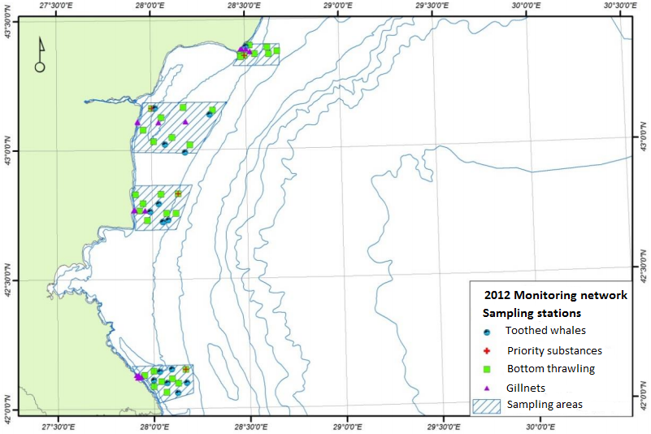  Figure 1 Sampling stations for toothed whales (Delphinus delphis, Turciops truncatus, Phocoena phocoena) and fish in 2012  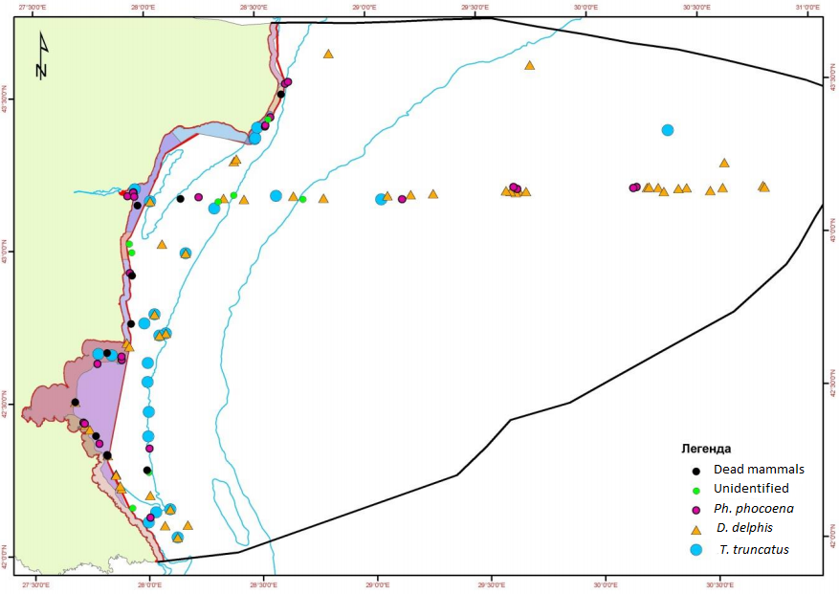  Figure 2 Sampling stations for toothed whales in 2012  The Institute of fisheries resources-Varna – monitoring of marine mammals (porpoise (Phocoena phocoena) and the ordinary Dolphin (Delphinus delphis)). Research parameters include behaviour, mammals, bycatch (number of animals, morphological data, and gender), injury and mortality, causes of death and tissue samples from marine mammals, according to ICES and ACCOBAMS, the recommendations of the Commission. Some of the parameters data date back to 1997.  Descriptor 1, 4-Biodiversity-Mammals-concept for monitoring within the framework “Driver-Pressure-State-Impact-Response”, DPSIR:  Driving forces/pressure – monitoring of driving forces (human activities) as a result of the pressure is carried out in connection with the obligations of Bulgaria to ACCOBAMS (agreement on the conservation of Cetaceans of the Black Sea, Mediterranean Sea and adjacent areas of the Atlantic Ocean, URL: (http://accobams.org/).  State – additional monitoring of populations of common dolphin (Delphinus delphis), harbor porpoise (Phocoena phocoena) and bottlenose dolphin (Tursiops truncatus) is carried out through from ship by using distance sampling method through the standard methodology “European Seabirds at Sea (ESAS)”. The MSFD monitoring programme will provide information about the distribution (indicator 1.1.1) and populations size (1.2.1 and indicators 4.3.1), so for the moment, the available data are scarce and geographically limited.  The impact will be measured by mortality (the number of dead dolphins) (indicator 1.3.1), where there is evidence that death occurred as a result of human activities. The monitoring on the impact carried out within the obligations of Bulgarian to ACCOBAMS.  Response – the information about the sources of pressure will be used to develop appropriate measures. It is necessary to improve the monitoring and assessment methods to determine of the causes of mortality of marine mammals and develop pressure-based measures.
3.3 Threats, activities and measures | Which threats are identified  The main threats to marine mammals are injury and increased mortality from fishing (catches), contaminants, shipping and marine debris.  Which human activities will be measured by the programme  Bulgarian has an operational monitoring network for stranded marine mammals. The aim of the network is collection of basic data for mammals – entangled in discarded fishing nets, or found dead on shore, and the identification of the causes of increased mortality. This network is supported by the Institute of Fishery Resources-Varna, the NGO "Green Balkans", the Regional Inspectorates of the Environment and Waters in Varna and Burgas.  Fisheries - Fishing is carried out in coastal waters, territorial sea and exclusive economic zone. The main impact of fisheries and incidental catch of marine mammals that lead to injury and death. In established cases of deaths by poisoning, data can be provided by the Regional Inspectorates of Environment and Water in Varna and Bourgas, according the Regulation on environmental protection in the marine environment.  Pollution - pollution from land-based and marine sources. Pollution data are available to the Black Sea Basin Directorate, which monitors the point sources of urban and industrial waste water sources and waters that are inhabited by shellfish. The cause of lethal or sublethal effects on marine mammals can be determined by analysing data on contaminants in the marine environment provided from the monitoring program as descriptors 8 and 9. When causes of death by poisoning are established, data can be provided by the Regional Inspectorates of environment and Water in Varna and Burgas, according to the Regulation on the protection of the environment in marine waters. The existing software for migration and bioaccumulation of contaminants in the food chain can help understanding the effects of pollutants on marine mammals.  Shipping - direct impact is reflected in the injury or death due to collisions with vessels and indirect - from the effects of underwater noise on communication and behaviour of marine mammals. Injury data can be reported by Bulgaria in connection with obligations under ACCOBAMS (Agreement on the Conservation of Cetaceans in the Black Sea Mediterranean Sea and Contiguous Atlantic Area). Occurrence data can be provided by the Regional Inspectorates of Environment and Water in Varna and Burgas, according to the Regulation on the protection of the environment in marine waters. Therefore, the monitoring program can provide data on the status (abundance and distribution of marine mammals). Data on the effects of underwater noise on the distribution of mammals can be obtained from the monitoring program in descriptor 11 - Underwater noise.
3.4 Data management | How and where are data managed? How and where can data be accessed? (General description – programme level)  The Institute of Oceanology and the Institute of Fisheries Aquaculture have historical data collected during their research cruises. The institutions do not have a single database to store different types of data. The data are not consistent with the requirements of the Directive s INSPIRE. Data collected within the various projects are only available as metadata.
4. Assessment
4.1 Assessments | Existing assessments  Bulgarian reporting under Art. 8, 9 and 10 of the MSFD (in BG and EN)  URL: http://cdr.eionet.europa.eu/bg/eu/msfd8910/  Southstream Project Environmental Impact Assessment (in Bulgarian)  http://www.south-stream-offshore.com/bg/ovoss/ovoss-v-blgariya/doklad-za-rezultatite-ovos-v-blgariya/  Definition of the areas under national jurisdiction included in the Agreement’s field of application (over which the Agreement applies).  http://www.accobams.org/index.php?option=com_content&view=article&id=1056&Itemid=86
4.2 Assessment of GES | Will assessment of GES be carried out by the programme  The program will provide initial data for assessing the GES. The necessary changes in the programme to provide data on GES are specified in section 6.
5. Literature
List of relevant literature
ACCOBAMS Guidelines. URL: http://www.accobams.org/ (Go to Documents > Guidelines)
PAMGUARD software. URL: http://www.pamguard.org/
Zampoukas, N., H. Piha, 2011. Review of Methodological Standards Related to the Marine Strategy Framework Directive Criteria on Good Environmental Status. Publications Office of the European Union, 53 pp. URL: < http://publications.jrc.ec.europa.eu/repository/handle/111111111/16069>;
Zampoukas, N., H. Piha, E. Bigagli, N. Hoepffner, G. Hanke, A. Cardoso, 2012. Monitoring for the Marine Strategy Framework Directive: Requirements and Options. Publications Office of the European Union, 42 pp. URL: http://publications.jrc.ec.europa.eu/repository/handle/111111111/23169
Guidance to Manage the Risk to Marine Mammals from Man-made Sound Sources in Irish Waters, 2014. See Appenidx 6 – Marine mammals recording form – sightings. URL: http://www.npws.ie/
6. Activities required to implement the concept
6.1 Changes to the current monitoring programme | Necessary changes and recommendations  - The lack of specialized research on the abundance and demographic characteristics of the marine mammals in the Bulgarian marine waters causes serious information gap; Seasonal (May, July, September) field observations about the distribution, species composition and abundance of marine mammals to fill in the gaps in information;  - better coordination with other institutions / organizations providing information related to the state or impact on the marine environment;  - ensuring sufficient capacity of the competent authorities and organizations (such as human resources, expertise and equipment) for the design and monitoring of the marine environment;  - development of indicators and criteria to assess the changes in the components of the marine environment in relation to climate change and to distinguish them from the effects of anthropogenic pressures; Providing the necessary and timely funding of the implementation of monitoring programs in accordance with the MSFD;  - improving the data and information management related to the state of the marine environment; improving access to national and regional databases and data from projects funded by the EC and other financial instruments.
6.2 Gaps: GES information | If not yet adequate for data and information needs to assess GES, describe when the programme will be considered fully adequate  The programme is expected to be adequate for information on GES in time for next assessment in 2018
6.3 Plans: Plans for GES information | If the programme is not considered fully adequate for data and information needs to assess GES, describe what plans are in place to make it fully adequate (e.g. to fill gaps in data methods, understanding or capacity). Describe timeframe, priorities and obstacles.  In the period 2015-2016 studies are planned to fill the gaps in the available information about the state of the marine environment and on this basis – developing proposals to improve the MSFD monitoring programme. The conduct of a pilot study by carrying out observations on board a vessel and acoustically – through the use of the hydrophone system.  The study is expected to provide indicators for the distribution of the species and abundance of the populations of cetaceans.  Actions are taken to increase the capacity of the Black Sea Basin Directorate in relation to the implementation of the adopted obligation under the MSFD, including in planning of monitoring programmes, the programmes of measures, etc.  In the period 2015-2016 new modules of the water in Bulgarian Water Information system. One of the planned modules will include data and information on the application of MSFD, incl. programs and subprogrammes for monitoring data, monitoring data undertaken achieve the GES, targets, indicators in individual descriptors, measures and their implementation, etc.  Improving coordination with other institutions/organizations providing information relating to the status or the impact on the marine environment.  Consider of the feasibility of the use of standardized “European Seabirds at Sea” (ESAS) monitoring, to record marine mammals and standard forms to streamline data collection, processing, reporting and assessment in a comparable and compatible way.
6.4 Gaps: Target information | If not yet adequate for data and information needs to assess targets, describe when the programme will be considered fully adequate  The programme is expected to be adequate for information on GES targets in time for next assessment in 2018
6.5 Plans: Plans for information on targets | If the programme is not considered fully adequate for data and information needs to assess targets, describe what plans are in place to make it fully adequate (e.g. to fill gaps in data methods or capacity). Describe timeframe, priorities and obstacles.  The described in Section 6.3 (Plans for information on GES) research is expected to provide and update information / clarification of objectives. The results will be shared with Romania, to ensure greater coherence in subsequent implementation of the MSFD, and also within the Commission for Protection of the Black Sea against Pollution.  On this basis, it is necessary Bulgaria and Romania to review and develop commonly agreed objectives based on agreed, if not harmonized indicators for their marine waters, taking into account the assessment and recommendations of the European Commission.

