Contribution to the
Biodiversity Data Centre concept paper
and operational draft for 2011

ETC/BD task team: Steve Williams (JNCC), Mora Aronsson (SLU), Katharina Schleidt (UBA), Sabine Roscher (MNHN), Jérôme Bailly Maitre, Brian MacSharry (DEHLG)

ETC/BD task manager: Sabine Roscher / MNHN / roscher@mnhn.fr
EEA project manager: Rania Spyropoulou
Work package no.: 1.2.1.B2
Date: 02/11/2010

Introduction

The purpose of this paper is to contribute to the concept paper for the Biodiversity Data Centre developed by the EEA.

Firstly, we review the chapter 8 “Issues identified and actions required” of the draft concept paper that was delivered by the ETC/BD in the last year.

Secondly, we review the Annex I “priority spatial datasets” of this concept paper and highlight some issues related to spatial datasets

Thirdly, we describe the requirements for a taxonomic name service of BISE/BDC. This part of the contribution to the concept paper was sent already in advance (10th September) to the EEA for comment.

Update Chapter 8 “Issues identfied and actions required” of the draft concept paper for BDC

1.1 Achievements
- The Biodiversity Data Centre has been launched using following EEAs structure for environmental data centres.
- Publication of BISE (V0) – an initial version of the BISE gateway has been established using the CHM toolkit. ThThe major entry points to information within BISE are: news, policy, topics, data, research, countries&networks.
- Improved interface to the CHM – the interface for the CHM has been improved and integrated into the initial version of the BISE website
- Published country profiles for BAP through BISE – the individual country BAP profiles have been collated into a database and published through the new BISE gateway within the countries&networks part
- EUNIS application has been improved using linked data technology and import routines for Natura2000 and CDDA data.

1.2 Issues identified and actions required
Analysing the current situation the following main issues can be identified:

CHM mechanism
Lack of adoption of the current CHM mechanism – despite the improvements to the CHM interface there is still a lack of consistent adoption of the CHM mechanism across Member States to share information (either for submission of information by MS nor for access to this information). In addition it should be noted that the information on the BAP country profiles exists now in the BISE country&networks part though it would probably be more sensible to better integrate the two.
- 2011 review CHM portal and BISE gateway and implement improved functionalities particularly in relation to how to integrate information from State of the Environment reporting (SOER) and country BAP country profiles.

Potential for remote sensed methodologies for deriving information on habitat type distribution poorly articulated. At present there are no harmonized data on distribution of habitats types in Europe with adequate spatial resolution not to mention time series. At present some countries produce habitat type inventories according to EUNIS habitats classification or CORINE biotopes while others use national standards. However, they are variable in terms of quality inconsistent (time of survey etc). New methodologies are emerging based on remote sensing (eg. through EBONE, GMES) but it is unclear whether or not the running projects are likely to derive the data needed. Therefore engagement from the conservation sector with these initiatives is needed to begin to articulate the ultimate requirement and see how remote sensed data can be optimally harnessed to deliver this.
- 2011 investigate means to better articulate these requirements
- 2011 continue with participation in steering committee of EBONE and other relevant projects (e.g. MS Monina)
- 2011 identify what GIO land service (part of GMES) could contribute in the biodiversity area

Lack of tools to generate standard data formats – for many of the data standards that have been developed there are no tools available to help users generate the data in the correct format which can make publication in these formats relatively onerous.

- 2011 Develop tools to generate standard data format with priority on data for reporting under the Nature Directives (Article 17 reporting and Standard Data Form). Investigate the use of XML and MS Access database appication.

Confusing variety of on-line access for biodiversity related data. Biodiversity data are available through a range of tools that are neither interlinked nor synchronised – there are currently a range of on-line tools for accessing biodiversity related data including EUNIS, Article 17 reporting, Natura 2000 viewer
- 2011/2012 review EUNIS and consolidate on-line tools

No unified integration of taxonomy across Europe – there are a range of taxonomies used across Europe but at present there is no standard mechanism to translate between them.
- 2011 – agree a plan with PESI on how the identified requirement can be delivered.
- 2011/12 – integrate the mechanism and data provided through PESI into revised data viewing portal.

No standard source for attributes about species – for many analyses and applications of species data it is essential to have access to attributes about particular species. This could include categories such as an indication of the invasiveness of a species, information on importance as genetic resource for food and agriculture or information on essential key function (e.g. pollinator), etc..
At present such attributes exist but not in a consistent format or source across taxa and countries. There is a need to unify these particularly around the sorts of analyses that are anticipated
- 2011 – work with the Go4 to identify the sorts of analysis required and the species attributes that would help to deliver these. Review potential sources for those attributes and develop a plan for developing a consolidated source of these.
- 2011 – review the specifications emerging from INSPIRE for the publication of these types of data.
- 2011/12 – delivery of a consolidated, standardised source of the attributes that are the most critical. Integration of these attributes into the revised data viewing portal.
- 2012/13 – delivery of medium priority species attributes; general review across the Go4 for how well requirement is being met.

Inconsistency of red listing across Europe – while standard Europe wide red lists (IUCN Red List) exist for some species groups for most only national sources exist and these have not applied the criteria in a consistent way and nor are the data available in a standard format.
- 2011 - review the need for a more consistent source with the Go4 and consider options for how this could be delivered. This could include attempts to pull together national sources more efficiently and consideration of a more data driven process.

Inclompleteness of European habitats classification – while the EUNIS habitats classification covers the EU27

At present there is relatively little information available on the management or action being taken by individual Member States nor is there any way of amalgamating this together. Some information was reported as part of Article 17 reporting but it was incomplete and inconsistent (and not actually required).
- 2011 Improve reporting on management in the context of the Nature Directives

1.3 Overview on proposed actions for 2011

General
Further identify requirements for CHM/BISE and the BDC and update concept paper. The overall objective for this year is to:
- Develop a strategy for the efficient flow of core data and information into the Biodiversity Data Centre and the BISE gateway
- Set up agreements on storage and/or access to data hosted by other data centres/institutions (“foreign” datasets).

Specific
Natura 2000 data flow
- Adopt database structure for revised Standard Data Form (Natura 200 data)
- Develop application to transfer Natura 2000 data, country databases into the new structure and to export data as xml in order to support Member States
- Establish system to accept upload of xml data for Natura 2000 databases and efficiently validate and collate the data provided in this format
- Adopt the qa/qc routines maintained by EEA according to the requirements of the revised SDF
- Improve workflow with regard to Natura 2000 products including ‘Community lists’ ‘Reference lists’, ‘Detailed conclusions’ and ‘Reserve Lists’
- Analyse impact of the INSPIRE protected sites profile on the Natura 2000 data flow
- Develop a set of potential use cases based on the analysis of the requirements
- Review documentation of the Natura 2000 data flow, review crosslinkages between Natura 2000 data dictionary and WDPA core attributes for the WCMC

Article 17 data flow
- Implement tool for the creation of range maps based on specifications outlined in the Article 17 report guidelines.
- Create data specifications based on Article 17 guidelines
- Create Reference Portal for Article 17 data
- Review, optimise and test the existing Article 17 reporting tool
- Develop qa/qc routines for Article 17 data
- Create documentation for the Article 17 data flow

CDDA data flow
- Review CDDA data flow with respect to the INSPIRE protected sites profile, including a) the potential replacement of the WDPA unique identifier with the INSPIRE ID and b) the inclusion of marine attribute
- Streamline qa/qc procedures for the CDDA
- Provide crosslinkages between CDDA data dictionary and WDPA core attributes for the WCMC
- Review documentation of the CDDA data flow

Spatial reference data
- Improve access to and management of high quality reference data such as rivers, coastline, country borders, lakes, marine boundaries, mountain areas

- Develop a proposal to harmonise the taxonomy within EUNIS with PESI and establish a mechanism keep the two systems synchronised
- Review timetable and update procedure for the European IUCN Red list for integration in EUNIS application
- Improve EUNIS with support for invasive species information and investigate how the procuction of the SEBI indicator for invasive species can be optimised
- Support the automated calculation of regularly used statistics including barometer, forestry and agriculture, area calculations, sufficiency indicator
- Create and maintain the pan-European data sets needed in order to produce a quantitative analysis of the data for the presentation of all indicators at the European level.
- Review and improve EEAs controlled vocabulary for Biodiversity related topics Continue to assist to define data specification for INSPIRE thematic area III topics relevant to Biodiversity (Habitats and Biotopes distribution, Species distribution, Biogeographical Regions)
- Continue to enhance cross-linkages for species and habitats

Detailed overview on actions in 2012
The overall focus for this year will be reviewing the interfaces available for exploring the data through BISE and creating a costed plan for the development of this interface.
- Priority action in 2012: Secure all data flows according Article 17 reporting 2013.

- Review efficient mechanisms for maintaining content of EUNIS application such as data on species, habitats, sites and their cross-linkages

- Continue to review and improve EUNIS taxonomic backbone

- Review action necessary to establish Inspire compliance

- Review functionality of BISE such as visualisation, indexing of information

Overview on the priority spatial datasets for the BDC

Natura 2000
Description: Natura 2000 sites, protected under the Nature Directives
Location: http://www.eea.europa.eu/data-and-maps/data/natura-2000/
Scale/accuracy: approx 1:100 000 (publicly available dataset)
Geogr. coverage: EU27
Source: Member States, EEA
INSPIRE Annex I (9)
Updated every 6 months?

Biogeographical regions
Description: Biogeographical zones of Europe
Location: http://dataservice.eea.europa.eu/dataservice/metadetails.asp?id=1054
Scale/ accuracy: 1:1 000 000
Geogr. coverage: EU27
Source: EEA, ETC/BD
Current issues: none
INSPIRE Annex III, (17)

Marine Zones
Description: Marine regions of Europe
Scale/ accuracy: variable
Geogr. coverage: EU27

Source: UNCLOS, VLIZ, ETC/BD
Current issues: There is a need for an official dataset defining the marine extent of
the EU.
INSPIRE Annex I (8) Annex III (16, 17)

Country boundaries
Description: Boundaries of countries
Scale/ accuracy: 1: 100 000
Geogr. coverage: Europe
Source: EEA, European Boundary Map
Current issues: Is is not clear whether or not the data set is up to date

Coastline
Description: Coastline of Europe
Scale/ accuracy: 100m
Geogr. coverage: Europe
Source: NGA global shoreline data, ETC/BD,
Current issues: Need a standard coastline for Europe that is suitable for detailed
analysis. See paper by ETC/LUSI “A coastline for Europe: Availability
of layers” by Alejandro Iglesias-Campos and Walter Simonazzi.

CDDA
Description: Nationally protected areas in Europe
Location: http://www.eea.europa.eu/data-and-maps/data/nationally-
designated-areas-national-cdda-4
Geogr. coverage: Europe
Scale/ accuracy: 1:100 000
Source: EEA
Current issues: Version 8 uploaded Oct 2009, Version 9 will be uploaded
in July 2011.
INSPIRE Annex I (9)

Corine Land Cover
Description: Land Cover change
Location: http://dataservice.eea.europa.eu/dataservice/metadetails.asp?id=1113
for CLC 2000
http://dataservice.eea.europa.eu/dataservice/metadetails.asp?id=1105
for CLC 2006
Geogr. coverage: EU 27
Scale/ accuracy: 1:100 000
Source: EEA
Current issues: none
INSPIRE Annex II (2)

Elevation
Description: Elevation data
Location: http://dataservice.eea.europa.eu/dataservice/metadetails.asp?id=650
Geogr. coverage: Europe
Scale/ accuracy: 1 000m
Source: EEA, USGS
Current issues: none
INSPIRE Annex II (1)

Rivers
Description: River data
Location: unknown (!)
Geogr. Coverage: EU 27
Scale/ accuracy: unknown

Source: EEA
Current issues: Lack of detailed data on rivers
INSPIRE Annex I (8)

NUTS
Description: Adminsitrative units
Location http://dataservice.eea.europa.eu/dataservice/metadetails.asp?id=1004
Geogr. coverage: EU 27
Scale/ accuracy: variable

Source: Eurostat
Current issues: none
INSPIRE Annex I (4)

Grids
Description: Geographical grids
Location: http://www.eea.europa.eu/data-and-maps/data/eea-reference-grids
Geogr. coverage: EU 27
Scale/ accuracy: 1x1, 10x10,50x50,100x100 km²

Source: EEA
Current issues: The reference grids are in the form of 1km, 10km, 50km and 100km ETRS grids. The issue is that the coverage of these grids does not extent into the Marine to a meaningful degree. The example below illustrates this point clearly.

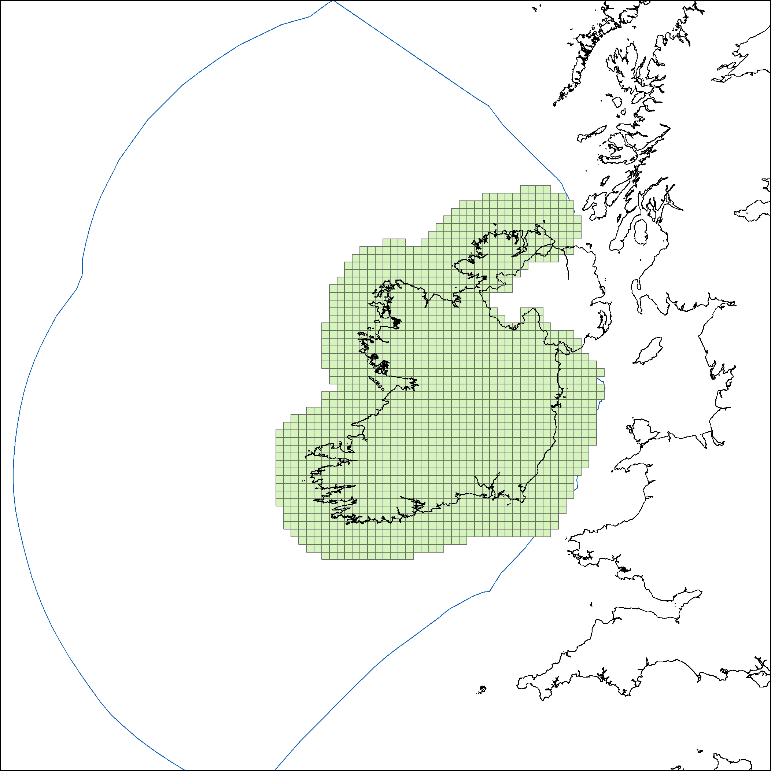

The green grids are the reference 10km grids for Ireland, the blue line is the Exclusive Economic Zone (EEZ) for Ireland. The reference grids should extend to this limit. The 1km grids for Ireland are confined to the terrestrial portion of Ireland and near shore Natura 2000 sites. We have looked at 3 countries at random and the same issue occurs.

Problem: Reference grids do cover the full extent of Member States
Solution: Extend the 1, 10, 50 and 100km grids to cover both the terrestrial and marien extents for Member States.
Marine limits: In terms of Article 17 these limits have been set as the EEZ of the Member States so this is the boundary that should be used. For the last reporting cycle of Article 17 countries submitted data covering the extent of their EEZ.

INSPIRE Annex I (2)

Urban morphological zone
Description: Urban morphological zones
Location: http://dataservice.eea.europa.eu/dataservice/metadetails.asp?id=995
Geogr. coverage: EU 27
Scale/ accuracy: 1: 100 000
Source: EEA
Current issues: none

Environmental Stratification (EnD ver8)
Description: Environmental Stratification
Location:
Scale/ accuracy: 1:2500000
Source: EEA
Current issues: none
INSPIRE Annex III (17)

Environmental Stratification (DMEER)
Description: Environmental Stratification
Location: http://www.eea.europa.eu/data-and-maps/data/digital-map-of- european-ecological-regions
Scale/ accuracy: 1:2500000
Source: EEA
Current issues: none
INSPIRE Annex III (17)

Article 17 data (Habitat type and Species distribution and range data)
Description: Habitat type and Species distribution and range data
Location: http://www.eea.europa.eu/data-and-maps/data/article-17-
database-habitats-directive-92-43-eec
Geogr. coverage: EU 25 (EU 27 for next reporting)
Scale/ accuracy: 10km grids
Source: EEA
Current issues: none
Update every 6 years
INSPIRE Annex III (18, 19)

Requirements of a taxonomic name service of BISE/BDC

Introduction
    - Taxonomy is a complex area often clouded by different opinions on the validity of particular species definitions or which version of a name should be the accepted one. This can vary greatly between countries, with an accepted name in one country being invalid in another, as well as over time, with the meaning of names changing as new taxonomic insights are gained. However, in order to integrate species data across Europe, it is essential that we can resolve these discrepancies, providing a harmonized dataset across Europe.
    - Mobilisation of biological records has, particularly over the last five years, driven a range of large scale initiatives to improve linkage, most notably:
- PESI (Pan-European Species-directories Infrastructure) - 2.6 million Euro initiative to develop a taxonomic infrastructure across Europe. The initiative has established networks of experts across the EU to develop and maintain preferred lists of names.
- Catalogue of life – is planned to become a comprehensive catalogue of all known species of organisms on Earth. The present Catalogue is compiled with sectors provided by 77 taxonomic databases from around the world.
    - The primary focus of these initiatives has been establishing a preferred taxonomic list and, more latterly, providing tools to assist users in matching names to this list (e.g. where the names in use have been incorrectly spelt).
    - While establishing such a list is obviously an important first step it is also critical that steps are taken to assist with the application of the list to real life problems; this lack of user requirements is a real shortfall within the current taxonomic initiatives.
    - As the Biodiversity Information System for Europe (BISE) begins to move to a production phase it provides a genuine need to close this gap. The successful delivery of BISE will require both a consistent taxonomy across Europe but also an ability to relate a range of local opinion to this taxonomy. Ideally, BISE – respectively the Biodiversity Data Centre (BDC) as its major component - would retain the original name provided with the data but in addition provide a link to a European accepted name.
    - To date the European Environment Agency (EEA) has managed the problem through a database of species names within the EUNIS system. This system now contains (roughly 170 000 species ). While the EEA (or the European Topic Centre) could continue to maintain and manage this ‘taxonomic backbone’ of the BDC, this service could be more efficiently delivered through one of the taxonomic initiatives now in existence given that the real skills are primarily taxonomic knowledge.
    - Thus there is a good opportunity now through the delivery of BISE/BDC to bring the investment in taxonomy that has already been undertaken to bear on a genuine problem (sharing of biodiversity information across Europe) to realise efficiency and clearly demonstrate the value of the investment in these taxonomic initiatives and help to support future business cases for the need for continued investment.
    - It should be stressed that while the primary focus here is on BISE/BDC the problems are also likely to be encountered when sharing any sort of species records and information through INSPIRE. Given the stage that this initiative is at there is increased importance now to clarify exactly how the taxonomic initiatives can potentially contribute to this problem.
    - This paper details the requirements that BISE has for a taxonomic service. It also begins to explore the sort of service that would be needed from the taxonomic initiatives to ensure their adoption by projects such as BISE.

Overview of requirements
In the following table each requirement is classified according to:
- Mandatory
- Highly desireable
- Desirable.

Requirement | Level | Notes
Provide persistent unique identifiers for scientific species names | Mandatory | Basic essential service but note requirements below – the scope is beyond just the correctly formed recognised taxonomic concepts.
Provide persistent unique identifiers for common names | Desirable | There are obvious problems in defining the scope of common names which makes them undesirable from the perspective of taxonomists.  If included need to consider the geographic applicability. Very similar problem to taxonomic aggregates considered below.  Current working assumption is that we will only deal with common names in English in the BDC; INSPIRE will have to deal with the provision of common names in all EU languages.
Provide consistent coverage across the full range of taxonomic groups | Highly desirable | It is recognised that this may not be possible in the first instance. However, for gaps there needs to be a mechanism to handle partial coverage for a group at least. For example bryophytes may occur on legislative lists and need to be handled even if a preferred taxonomy for bryophytes was not available.
Provide coverage of species which have legislative or conservation status across Europe. | Mandatory | This includes red lists etc but also non-native species which are of particular conservation importance at the moment.  Note that inclusion of legislative lists introduces poorly formed taxonomic names if the original nomenclature is to be preserved.  As this problem will not be easy to resolve in the short-term, and even in the longer-term we will always run into such difficulties (i.e. introduction of new invasives that are not included in the lists), it will probably be necessary to foresee a mechanism for the use of secondary lists to use as a fallback when the species is not covered in the primary list.
Provide a consistent taxonomic hierarchy and sort order across all taxonomic groups | Highly desirable | Useful for a variety of reporting services.  Provides support in the navigation of species.
Provide a defined and responsive service to allow new names to be added to the taxonomic repository with a persistent identifier. | Mandatory | Particularly for non-native species there will be a need for the service to be relatively responsive (e.g. within a month).  The addition of the names should not be subject to reaching a minimum ‘quality’ standard. Issues regarding quality (e.g. incorrectly spelt) should be tackled by either by tagging names once they have been added to the repository or by providing such information upon entry into the system (e.g. uploading a name from legislation that is known to be wrong. This could be added with the flag “invalid” and a link to the correct name)  The assignation of unique keys could either be carried out by the taxonomic initiative or by the original name provider as long as guidance is available on format to ensure uniqueness within the network.
Provide a service to allow a user to submit suggested matching for a name string to a recommended name | Highly desirable | There will be instances where a user has already identified what the recommended name for a new name string is. An ability to capture this information would potentially reduce the burden on the taxonomic experts.  Ideally, this relation between names in the system should also carry information on who defined this relation and when.
Provision of a service to assist with matching names to a recommended spelling and unique key. | Mandatory | The service needs to be able to cope with fuzzy matches.
Ability to handle multiple taxonomic meanings for a single name string (including, where available, details of when and where it diverged) and warn user where necessary. | Mandatory | Particularly when a species is lumped or split the same name string can refer to both the lumped entity and the split one. There needs to be an ability to store these separate meanings but also to warn a user, for example when they are matching their own name string, that there are multiple meanings of this name string.
Ability to handle taxonomic aggregates | Highly desirable | A taxonomic aggregate is a taxonomic concept that includes a defined list of other taxonomic concepts. It commonly occurs in recording (e.g. where it is not possible to separate exactly which species was observed without the presence of, for example, a flower but it can e narrowed to two or three species). The same concept also occurs when a species is split (to retain the link between the original concept and those that it was split into.  An important consideration here is that ‘recording aggregates’ will have a particular geographic applicability.
Maintenance of a registry of species attribute repositories | Desirable | It is anticipated that a variety of users across the network will begin to associate attributes with particular taxonomic entities. This will include ecological traits, legislative status etc. Consolidating within a single repository is not practical but maintaining a register of such repositories would be useful.  This facility does not have to be delivered by the taxonomic repository provider – could be managed elsewhere. A linked data approach as used in other areas by the EEA could be useful.
Provide a service to allow a defined subsection of the main taxonomic repository to be downloaded. | Mandatory | No matter how good available web services are there will be a need to download sections of the repository to, for example, allow inclusion in other systems or analysis.  The frequency this is updated needs to be defined perhaps with the publication of interim updates.

Example outline of a process for the provision of a service to a user with a name to match



