Scoping paper for a report on climate change impacts in Europe

Key Deliverable of Task 1.4.1.1 of the 2019 ETC/CCA Action Plan

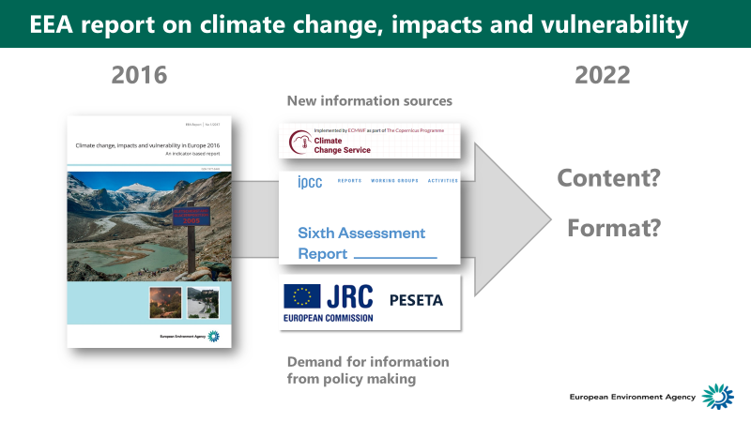

Version 15 – 26.09.2019

Executive Summary largely revised, awaiting final checks with ETC/CCA.   
Chapter 7 needs to be made consistent with the Executive Summary following agreement on it.

Authors:   
Marc Zebisch1, Mikael Hildén2, Willem Ligtvoet3, Silvia Cocuccioni1, Hans-Martin Füssel4

1. Eurac Research, Bolzano, Italy
2. Finnish Environment Institute (SYKE)
3. Netherlands Environmental Assessment Agency (PBL)
4. European Environment Agency (EEA)

Contents

0 Summary and key findings 3

0.1 New information needs 3

0.2 Potential for integration of C3S, JRC PESETA and EEA internal activities 5

0.3 Different options for EEA products presenting CCIVA information 6

0.4 Reflection on the various options in the light of evolving policies 13

0.5 Transition towards a new EEA CCIV reporting in steps 14

1 Objective and analytical approach 15

2 EEA perspective 19

2.1 Content of 2016 CCIV report 19

2.2 Production of the 2016 CCIV report 22

2.3 External impact of the 2016 CCIV report 24

2.4 Recent developments of the EEA communication strategy 28

3 Examples of presenting CCIV information 30

3.1 Introduction 30

3.2 Examples of other CCIV reports 30

3.3 A summarizing overview of findings 32

4 The evolving demand for CCIV(A) information 34

4.1 Knowledge needs reflected in the EU adaptation strategy and its evaluation 34

4.2 Mainstreaming generates new demands for knowledge 35

4.3 Evolving national adaptation policies and plans 39

5 Landscape of related information suppliers 40

5.1 Copernicus Climate Change Service 40

5.2 PESETA III 43

5.3 IPCC WG II AR6 46

5.4 Internal suppliers of information 49

6 Outcomes of the 2019 Eionet meeting on adaptation 51

6.1 Information demands of the European Commission 51

6.2 Outcome of break-out group from 2019 Eionet workshop 52

7 Options for a future EEA CCIV(A) report 53

7.1 Conclusions from Chapters 1-6 53

7.2 Content elements of a future EEA CCIV(A) report 54

7.3 Options for the format of a future EEA CCIV(A) report 56

Annex 65

Annex I: Potential report structure according to “Format B” 65

Annex II: Potential structure of policy-orientated synthesis (“Formats C, D, E, F”) 68

Annex III: Results from break-out group during 2019 Eionet workshop on adaptation 69

Annex IV: Some examples of infographics from other reports 72

# Summary and key findings

**Key messages:**

* There are increasing policy needs for information on sector specific climate vulnerabilities, risks and adaptation options
* There is an important potential for coordinating EEA, C3S and JRC activities, and to integrate the results
* This paper explores and evaluates different formats for presenting information on climate change, its impacts and risks, and adaptation options in an EEA report and/or other EEA products
* Information needs change along the policy cycle from awareness raising to policy implementation
* The transition to a new EEA climate change impacts and adaptation report could occur in several steps

This scoping paper explores options for the format as well as the content of the next “EEA Climate Change Impact, Vulnerability” (CCIV) report, which is planned for publication in 2022. The paper discusses how to achieve a high policy relevance and improved accessibility for both policy makers and the general public, together with a high efficiency in producing the report. High policy relevance and improved accessibility requires tuning of contents and form of the report to the needs of the users and the changing information needs, given the ongoing process of adaptation policy development and implementation. High efficiency in producing the report can be achieved by a prudent integration of external data and information sources (in particular from the Copernicus Climate Change Service, the JRC PESETA projects, the DG CLIMA adaptation modelling project and IPCC Sixth Assessment Report) and EEA internal information sources (Climate-ADAPT, sectoral climate change reports and others).

The proposed options for a new reporting format are developed based on lessons learnt from the 2016 EEA CCIV report (chapter 2), a review of other national CCIV reports (chapter 3), a review of the policy demand for CCIV related information (chapter 4), a review of external and EEA internal information sources (chapter 5) and discussions during the Eionet meeting on adaptation in Copenhagen in June 2019 (chapter 6).

The scoping paper is a Key Deliverable of Task 1.4.1.1 of the 2019 ETC/CCA, which will continue until December 2019. It is meant to inspire an EEA internal discussion. The results of this discussion could be implemented in a later version of this scoping paper.

## New information needs

There is a clearly expressed **policy and user demand for information on climate change** **that includes, but goes beyond (biophysical) climate impacts**. Potential additional information that would increase the policy relevance of the CCIV report includes **sector-specific information on societal vulnerability and risks, adaptation demand, adaptation options and economic aspects of adaptation across Europe**.

Any policy demand for climate change information stems from the demand to get a clear picture of the observed and expected changes in climate change impacts and vulnerabilities, and to identify and optimize targeted adaptation measures. The Climate-ADAPT Adaptation Support Tool specifies six steps for this process[1]. We believe that the policy relevance of a 2022 CCIV report would be very high, if it addresses in consistence with and linked to Climate-ADAPT the information demand for step 2 - assessing risks and vulnerabilities and supports step 3– identifying adaptation options. Furthermore, as adaptation policies are in the process of implementation, impacts and vulnerabilities will be affected and hopefully reduced. Linking climate change information to information about the implementation of adaptation across Europe will be of increasing importance in understanding developments in impacts and vulnerabilities.

These findings are consistent with results of a review of the evaluation of the EU adaptation strategy (COM(2018) 738 final), where information gaps have been clearly expressed as well as with an analysis of national climate change impact and adaptation reports. The evaluation particularly stresses the need to link CCIV information with **adaptation information**. The report on the evaluation foresees that to advance adaptation further “the Commission could envisage exchanges of information on successful adaptation measures between stakeholders and with the scientific community”. Such exchanges would benefit from systematic analyses that the EEA could provide in its report(s) using, for example, material submitted to the EEA and published on Climate-ADAPT. Also, most of the national reports on climate change are including information on adaptation options in a consistent way from climate impacts to vulnerability and risks to related adaptation options.

**Sector specific vulnerability and risks** are important to address. The concept of climate risks as a function of climate hazard, vulnerability and exposure plays a key role in the IPCC Fifth Assessment Report (AR5) and will be even more prominent in the Sixth Assessment Report (AR6). The underlying assumption is that adaptation measures cannot reduce the climate hazard itself but can reduce vulnerability and exposure. In many cases, vulnerability factors (e.g. inefficient irrigation systems, lack of crop insurance) contribute as much or even more to potential climate risks than the climate hazard (e.g. a drought) itself. Addressing the vulnerability and exposure factors that contribute to a specific climate risk is therefore important to identify and improve appropriate adaptation measures. This would be in line with what the Climate-ADAPT tool requires for step 2 (assessing risks and vulnerabilities).

Further important topics that should receive increased attention according to COM(2018) 738 are ecosystem-based adaptation and the links between adaptation, disaster risk reduction (DRR) and the Sustainable Development Goals (SDG).

The inclusion of these new topics would require additional resources, which could be partly compensated by a proper coordination between ongoing activities of EEA (including ETC/CCA) and external partners. Figure S1 illustrates how these potential additional content options could be related to the structure and content of the last CCIV report from 2016.

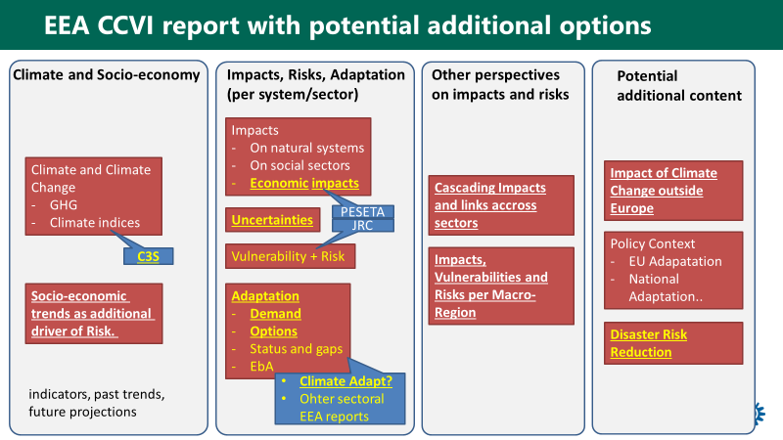Figure S1: General building blocks (potential new elements in yellow) and potential data source (blue). Content in bold and underlined was rated as particular policy relevant during the 2019 Eionet meeting on adaptation

Note: White font: elements included in 2016 EEA CCIV report; yellow font: potential new elements in yellow); blue boxes: potential data source. Bold and underlined font: These items were rated as particularly relevant during the 2019 Eionet workshop on adaptation.

## Potential for integration of C3S, JRC PESETA and EEA internal activities

The 2022 CCIV report could profit from a prudent **integration and harmonization of external information sources (C3S for climate information, JRC PESETA for economic impact and risk information)** as well as **EEA information sources (Climate-ADAPT for adaptation options per sector, other sectoral EEA reports**, see Section 0.3). This integration would reduce the effort for information generation by EEA but increase the need for coordination between C3S, JRC and EEA. More specifically:

* **C3S** could provide all climate data-related information, including graphs, figures and potentially assessment text as a service following specific requests by EEA. Options could even include innovative online tools for the spatially explicit visualization of key indicators. This would save a lot of resources in the production of the CCIV report but requires early and clear negotiation on information demand between EEA and C3S. First discussions with C3S key persons were very positive.
* **JRC** could provide information on climate impacts, including economic impacts and risks, for those sectors and policy areas that are covered by the PESETA projects. Relevant information collected or produced by the JRC through the PESETA project or otherwise (e.g. MARS database, bias adjustment of regional climate change projections) could ideally be made available through C3S.
* Sector-specific information on adaptation options could be extracted from the database of case studies, reports and toolsets on **Climate-ADAPT**. This would require a closer coordination between the CCIV report and Climate-ADAPT and could be part of future ETC/CCA activities. The resource implications will need to be explored. Its feasibility will also depend on the evolution of the official reporting on adaptation under the Regulation (EU) 2018/1999 on the Governance of the Energy Union and Climate Action.
* For **sectors** that are covered by specific **EEA reports** on climate change (e.g. energy, agriculture and transport), key information on impacts, vulnerabilities, risks as well as adaptation demand and options could be extracted from these reports, reducing the need for descriptive information and detailed examination of primary sources. The structure of the latest EEA report on climate change adaptation in the energy system[2] is a good example for a report that allows to extract information for an EEA CCIV report.

Figure S2. Options for integrating CCIVA information from different sources

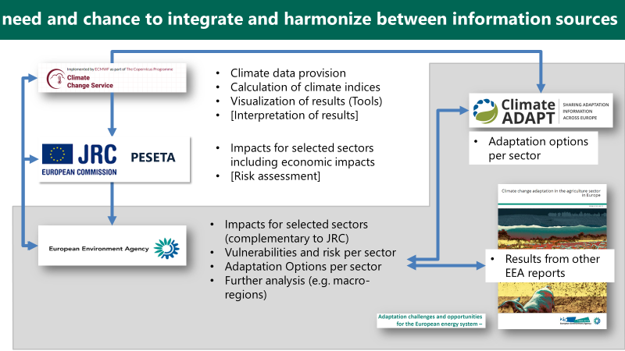

Note: Information from C3S, JRC and several EEA activities (Climate-ADAPT, sectoral reports) can be regarded as a single pool of information from which different products could be extracted

## Different options for EEA products presenting CCIVA information

This scoping paper explores various formats for an EEA CCIV(A) report (possibly linked to other product types) that would enable a better integration and presentation of various information sources. Specifically, it assesses six options according to eight criteria, which examine the suitability for delivering CCIV information to different audiences and the demands on resources and innovation, in comparison to the format of the successful 2016 EEA CCIV report. These options and the ETC/CCA assessment of their respective merits is presented below:

**Format A (reference):** The compendium character of the most recent EEA CCIV report is perceived as very positive by users and is considered as the reference against which other formats are compared. It includes the indicators available on-line that present essentially the same information as the indicator-based parts of the report. This approach allows updating a large number of indicators in parallel with publication of the report with very limited extra resources. The main advantage of the indicators online is that they can be updated more frequently if relevant new information becomes available, and that they can be searched independently on the EEA website. Furthermore, most indicators allow users to download maps and figures, which is not currently the case for illustrations from EEA reports.

**Format B** would keep the structured printable report as a core concept but rework the structure to include the recommended additional content such as adaptation options (see Figure S1) from C3S, JRC and Climate-ADAPT. The text would need to be significantly shortened by using concise and targeted text in the core part (climate impacts and adaptation options per sector). Furthermore, the chapters which provide primarily background and context information (e.g. policy context, strengthening the knowledge base) would need to be shortened and pruned. We believe that the overall report should not exceed 200 text pages. Such a shortened report would be complemented by web-based background information (e.g. with indicators as in the current format “A”). See a proposal for the structure in *Annex I: Potential report structure according to “Format B”.*

1. ***Relevance and accessibility for senior EU policy-makers*:** Strong increase in relevance due to more information on adaptation; accessibility as for Format A.
2. ***Relevance and accessibility for EU policy advisors/experts:*** Strong increase in relevance due to more information on adaptation. The shortening may reduce accessibility to relevant information.
3. ***Relevance and accessibility for national policy-makers:*** Increase in relevance due to more information on adaptation. The shortening is likely to reduce accessibility to relevant information at the country level.
4. ***Relevance and accessibility for the general public:*** Broader contents with reflections on ‘fuller’ spectrum of issues likely to increase relevance and accessibility to salient information.
5. ***Reliability/scientific transparency:*** Reliability and transparency can probably be kept at the level of Format A despite shortening.
6. ***Timeliness and flexibility:*** Comparable to Format A, driven by the reporting cycle and the possibilities to update web-based information.
7. ***Resource needs:*** Increase in resource needs compared to Format A due to the need for providing complementary background information online. More efforts on coordination with other information providers outside (C3S, JRC) and inside EEA (Climate-ADAPT).
8. ***Required changes and innovation:*** Increased need for coordination with external information providers and for allocating available page space and resources. Identifying suitable formats for publishing background information online.

**Format C** would include all the elements of Format B, but it would add a policy-oriented synthesis (both hard copy and web-based). The 2016 EEA CCIV report includes an Executive summary, which aimed at briefly covering ‘all’ pieces of information that the report covered. The policy-oriented synthesis of Format C would take its starting point in ongoing (European) policy developments and focus on specific messages for ongoing policy-making processes. It would also include more easily accessible graphical information. The policy relevance and accessibility to both (senior) policy makers and general public are expected to increase relative to Formats A and B.

1. ***Relevance and accessibility for senior EU policy-makers:*** The policy-oriented synthesis increases relevance clearly relative to A (and B). The accessibility of the report proper may slightly increase with its shortening.
2. ***Relevance and accessibility for EU policy advisors/experts:*** The policy-oriented synthesis increases relevance relative to A (and B). The shortening may reduce accessibility to relevant information.
3. ***Relevance and accessibility for national policy-makers:*** The policy-oriented synthesis may increase relevance relative to A (and B). The shortening is likely to reduce accessibility to relevant information at the country level.
4. ***Relevance and accessibility for the general public:*** The policy-oriented synthesis may increase relevance relative to A (and B). The shortening is likely to increase accessibility as perceived by the public.
5. ***Reliability/scientific transparency:*** The policy-oriented synthesis may more clearly bring out the evidence base, but shortening would limit the amount of scientific information that can be included in the full report. Overall transparency is regarded as similar to A (and B).
6. ***Timeliness and flexibility:*** Comparable to A (and B), driven by the reporting cycle and the possibilities to adjust/update web-based information.
7. ***Resource needs:*** The policy-oriented synthesis requires marginal additional resources, compared to B.
8. ***Required changes and innovation:*** Same as in Format B.

**Format D** hasan extended policy-oriented synthesis as a main product, without a longer EEA report in the background. In addition, EEA would create technical background papers, each supporting a specific chapter. This would potentially require the establishment of a new product category (“technical/background paper/report”) at the EEA. The quality of these background papers would be essential to keep the high scientific reputation and transparency of the current EEA CCIV report.

* 1. ***Relevance and accessibility for senior EU policy-makers:*** The policy-oriented synthesis increases relevance clearly relative to A (and B). Overall relevance is assessed similar to C.
  2. ***Relevance and accessibility for EU policy advisors/experts:*** The policy-oriented synthesis increases relevance clearly relative to A (and B). The separate background papers can, in principle, be uses in different contexts by different DGs. However, their benefits compared to a full report (as in A, B and C) largely depend on whether the background papers contain more information compared to a full report, how well they are integrated with the policy-oriented synthesis, and whether they are seen as equally important as a “real” EEA Report by stakeholders. Overall relevance is assessed as higher than C.
  3. ***Relevance and accessibility for national policy-makers:*** The policy-oriented synthesis may increase relevance relative to A (and B). It is difficult to assess whether the additional background material can strengthen relevance and accessibility at the country level compared to a full report (as in A, B and C). Overall relevance is assessed similar to C.
  4. ***Relevance and accessibility for the general public:*** The policy-oriented synthesis may increase relevance relative to A (and B). It is difficult to assess whether the additional background material can strengthen relevance and accessibility for the general public compared to a full report (as in A, B and C). Overall relevance is assessed similar to C.
  5. ***Reliability/scientific transparency:*** The lack of a full report (as in A, B and C) would decrease the character of a scientific compendium.
  6. ***Timeliness and flexibility:*** The split-up into a synthesis and background papers makes it possible to update parts of the information as needed. However, these updated background papers may not have the same policy impact as a new EEA report.
  7. ***Resource needs:*** The production of separate background papers may increase resource needs compared to a single full report (as in C). However, this increase can be compensated if the background papers are produced to somewhat lower standards in terms of language editing, figure/map production and lay-out. As a result, overall resource needs are assesses similar to C.
  8. ***Required changes and innovation:*** This format requires a major restructuring of the way EEA presents CCIV information, including the potential introduction of a new “lean” product type (“background paper/report”).

**Format E** comprises a policy-oriented synthesis of CCIV(A) information that is readily available from other sources (e.g. IPCC, JRC, and others). EEA would drastically reduce its own role in developing CCIV information compared to the current EEA CCIV report. This approach would significantly reduce EEA’s resource needs. However, it would also reduce the possibility of producing relevant CCIV information that could be readily incorporated into other EEA products. Furthermore, it would mean that EEA relies to a larger degree on external quality control and interpretation of data.

* 1. ***Relevance and accessibility for senior EU policy-makers***: The policy-oriented synthesis could increase policy relevance relative to A. However, the lack of harmonized background/underlying information is expected to cancel this increase. Furthermore, the lack of “EEA-owned” underlying information could raise questions regarding the legitimacy of such an EEA report. As a result, policy relevance is assessed lower than in A.
  2. ***Relevance and accessibility for EU policy advisors/experts:*** The policy-oriented synthesis could increase policy relevance relative to A, but the lack of harmonized background/underlying information substantially decreases policy relevance and accessibility.
  3. ***Relevance and accessibility for national policy-makers:*** The policy-oriented synthesis may increase relevance marginally compared to A, but the lack of harmonised background information substantially decreases policy relevance and accessibility.
  4. ***Relevance and accessibility for the interested public:*** The policy-oriented report may increase relevance relative to A. The lack of harmonised background information would decrease accessibility, but not as strongly as for policy-makers and experts.
  5. ***Reliability/scientific transparency:*** The policy-oriented synthesis may more clearly bring out the evidence base, but reliability and transparency would suffer from the lack of harmonisation and consistent metadata.
  6. ***Timeliness and flexibility:*** Strong reliance on existing material provides flexibility during the production of the report. However, timely updates in the case of new information are difficult, since the underlying material is to a large extent external.
  7. ***Resource needs:*** Production costs can be reduced significantly, compared to A, as key information is extracted from external sources of information, and no effort is required for maintaining and updating the underlying information.
  8. ***Required changes and innovation***: A rethinking of the role of the EEA in providing access to CCIV information would be necessary.

**Format F** also has a policy-oriented synthesis as main product, but with fully reorganised reporting and information structure. It uses directly relevant content produced by C3S and JRC (and possibly other organisations) and from Climate-ADAPT. The synthesis would be complemented by a new ‘Climate change and adaptation atlas of Europe’ (maps). This option requires an effective collaboration between EEA, C3S and JRC (see Section 0.2 above) to bring together the produced maps. This approach resembles the one applied in the climate change chapter of the SOER2020, which presents short summaries of indicator-based information in the SOER and includes links to many indicators with more detailed information online*.*

*[This format, and the individual elements/products included in it, requires further explanation. The evaluation below should be reviewed in order to be consistent with those of Format A to E.]*

* 1. ***Relevance and accessibility for senior EU policy-makers***: The policy-oriented synthesis increases relevance clearly relative to A. Harmonized background material strengthens relevance and accessibility as for D.
  2. ***Relevance and accessibility for EU policy advisors/experts:*** The policy-oriented synthesis increases relevance relative to A. Harmonised background material strengthens relevance and accessibility as for D. Joint work across organisations increases accessibility and relevance.
  3. ***Relevance and accessibility for national policy-makers:*** The policy-oriented synthesis increases relevance relative to A. Harmonized background material strengthens relevance and accessibility as for D. Joint work across organizations increases accessibility and relevance also at country level if salient material is provided.
  4. ***Relevance and accessibility for the interested public:*** The policy-oriented synthesis may increase relevance relative to A. Harmonised background material strengthens relevance and accessibility as for D. Joint work across organisations increases accessibility and relevance for the public.
  5. ***Reliability/scientific transparency:*** The policy-oriented synthesis may more clearly bring out the evidence base. Reliability and transparency can be increased if standardized presentations and metadata are achieved across organizations.
  6. ***Timeliness and flexibility:*** Makes it possible to update and introduce new specific partial reports as needed, concerted action by several organizations strengthens possibilities for timely analyses.
  7. ***Resource needs:*** The cooperative effort and harmonization across organizations is likely to require resources even if the ‘in house’ production is reduced. Ultimately the level depends on the distribution of tasks across participating organizations
  8. ***Required changes and innovation:*** Developing the role of EEA to lead widely the delivery of CCIV(A) information in Europe also at a networking level

Format B with a shortened and improved content, but quite traditional in structure, would in practice be close to the 2016 EEA report (Format A = Reference). The partial reorientation may increase slightly the policy relevance (+). The shortening may mean that fewer primary scientific sources can be used. Due attention to the choice of sources is required to prevent a (perceived) loss of scientific transparency. The addition of a separate policy-oriented synthesis in Formats, C, D, E and F results in higher scores for policy relevance as well as accessibility for policy makers and the interested public, but also some additional resources relative to Format A. Format D and Format F receive the highest scores, but they require new approaches for collecting and producing information as well as new product categories for presenting it. In addition to the organisational changes, Format D and Format F also require substantially more resources than other options.

Strategically, Format F is the most innovative format in which EEA deepens its collaboration with other relevant institutions and assumes a leading role in organizing and presenting CCIV information. This may substantially strengthen EEA’s position and profile as the deliverer of policy relevant CCIV knowledge for Europe, but likely requires new forms of co-operation in the form of joint projects and/or harmonized work programs across organizations.

In contrast, Format E is the option with the lowest resource needs. However, reliability/scientific transparency is under greater pressure as this format depends almost completely on the availability of secondary sources. Furthermore, EEA would give up its strategic role in compiling and presenting ‘own’ information on CCIVA and to respond to new policy needs. In all the other options, reliability/scientific transparency scores can be maintained or even increased relative to the reference.

Assessing the resource needs of the formats at this stage is highly tentative. Over time, further exploration of what is needed and what is required may require some adjustment compared to the assessment in Table S1. However, Format E should only be regarded as the preferred pathway if reducing resources for EEA CCIV reporting is of high strategic importance.

The ability to access all figures, graphs and maps as high resolution images for download is a highly desirable feature for all formats. A Web-GIS version of maps with the option to zoom into specific regions would also be desirable, in particular for national policymakers and experts.

Table S1 summarizes the assessment of the different options for a future CCIV report and allows a tentative comparison based on the eight criteria discussed above.

|  |  |  |  |  |  |  |
| --- | --- | --- | --- | --- | --- | --- |
| **Format** | **A** | **B** | **C** | **D** | **E** | **F** |
|  |  |  |  |  |  |
|  | Current EEA Report (printed and online) with current web-based indicators | Shortened EEA report (S) (printed and online) with adjusted content (including adaptation information) and web-based indicators | Shortened EEA report (printed and online) with adjusted content (including adaptation information), web-based indicators, and a policy-oriented synthesis (P; printed) | Policy-oriented synthesis (printed) and technical background papers  (web-based) | Policy-oriented synthesis (P; printed) with links to web-based indicators and information maintained by other bodies | Policy-oriented synthesis (P; printed) with  supporting reports and material, based on actively negotiated content of material produced by other key bodies (C3S, JRC...) |
| **1.Relevance and accessibility for senior EU policy-makers** | = | + | ++ | ++ | - | +++ |
| **2. Relevance and accessibility for EU policy advisors/experts** | = | + | ++ | +++ | -- | ++ |
| **3. Relevance and accessibility for national policy-makers** | = | + | + | + | -- | +++ |
| **4. Relevance and accessibility for the interested public** | = | + | ++ | ++ | - | +++ |
| **5.Reliability/ scientific transparency** | = | = | = | - | - | +++ |
| **6. Timeliness and flexibility** | = | = | = | + | - | +++ |
| **7. Resource needs** | = | + | ++ | ++ | -- | +/++ |
| **8. Required changes and**  **innovation** | = | + | + | ++ | ++ | +++ |

Table S1 Options for different formats of a future CCIV report and tentative comparison based on eight criteria. Blue: outcome criteria. Yellow: input criteria.

## Reflection on the various options in the light of evolving policies

The topic of climate change has become much more important and policy relevant since publication of the first EEA CCIV report in 2004. Today, in both the policy and societal domain, climate change is widely acknowledged as a great challenge for mankind, including the need to adapt to its inevitable impacts. The consideration of complex risks related to climate change and extremes as well as the implementation and optimization of adaptation strategies and options has become an important task for policy makers at all levels.

The current EEA-internal discussions about EEA indicators and other product types will strongly influence future EEA work on CCIV. There are many strategic and operational choices to be made. For example, it is not clear (to the authors of this scoping paper) whether both ‘Format A’ (the current approach) and ‘Formats D, E and F’ (resembling a ‘SOER-approach’) will be possible in the future for sharing CCIV information that includes both EEA reports and indicators. If neither ‘thick’ reports nor ‘long’ indicators were permitted in the future, EEA would no longer be able to present detailed CCIV information, unless new product types and/or publication channels are developed (e.g. Climate-ADAPT indicators or joint EEA/C3S climate indicators). Therefore, clarity on the strategic goals of a future CCIV(A) report and on suitable EEA products supporting these goals is crucial before starting the development of a new EEA CCIV report and/or related products.

One of the tasks put to the ETC/CCA was to analyse the potential for an EEA CCIV Report with substantially reduced resource requirements. Indeed, a lack of (human) resources was one of the main challenges of the 2016 CCIV report (see Chapter 2). This scoping paper provides options for making the production more cost efficient through a good coordination with and integration of external information sources (C3S, JRC) and EEA internal activities (Climate-ADAPT, sectoral reports). These options would not necessarily reduce extremes overall resource needs for the production of the CCIV report (or more generally EEA’s production of information on CCIV). However, suitable resource allocation could potentially achieve higher policy relevance without significant resource increases. In addition, we identified one option that would reduce EEA resources significantly (Format E). Such an option would imply a deliberate reduction of EEA’s own role as a key provider of CCIV information. Instead, the focus would be on making the work of other organisations known and direct the attention of interested stakeholders to information sources elsewhere. The main drawbacks of such a ‘journalistic’ approach, relative to the other options, are that the reliability and scientific transparency will be under pressure and that EEA would have a much smaller role in the actual development of CCIV information, including on new topics. Furthermore, EEA would not accumulate its ‘own’ collection of indicator-based information for re-use in other EEA products.

EEA is the only European institution that is in the position to coordinate the process of providing policy makers with a comprehensive overview on CCIV(A). Therefore, we recommend not to reduce EEA resources for this work. Instead, EEA could invest in an improved coordination on the topic of climate change with other European institution such as C3S and JRC, with the support of ETC/CCA. Furthermore, the clearly expressed policy demand to not only receive information on climate impacts, but also assessments on risks and recommendations on adaptation options would require a stronger involvement of science-policy boards to underpin these somewhat normative and value-based messages. The efforts needed for such an endeavour has to be carefully evaluated.

## Transition towards a new EEA CCIV reporting in steps

Transitions take time, and that is also the case in changing a complex reporting mechanism with restricted resources. The next EEA CCIV report planned for 2022 does not need to result in a complete change of product and organization, but it could be the first step in a new direction. Taking an effective new step is facilitated by a long-term visions and strategy. While this scoping paper presents the various formats as alternative options, they can also be regarded as potential steps in a transition process (see Figure S3).

Figure S3 Building a long-term strategy in steps, using the example formats in Table S1

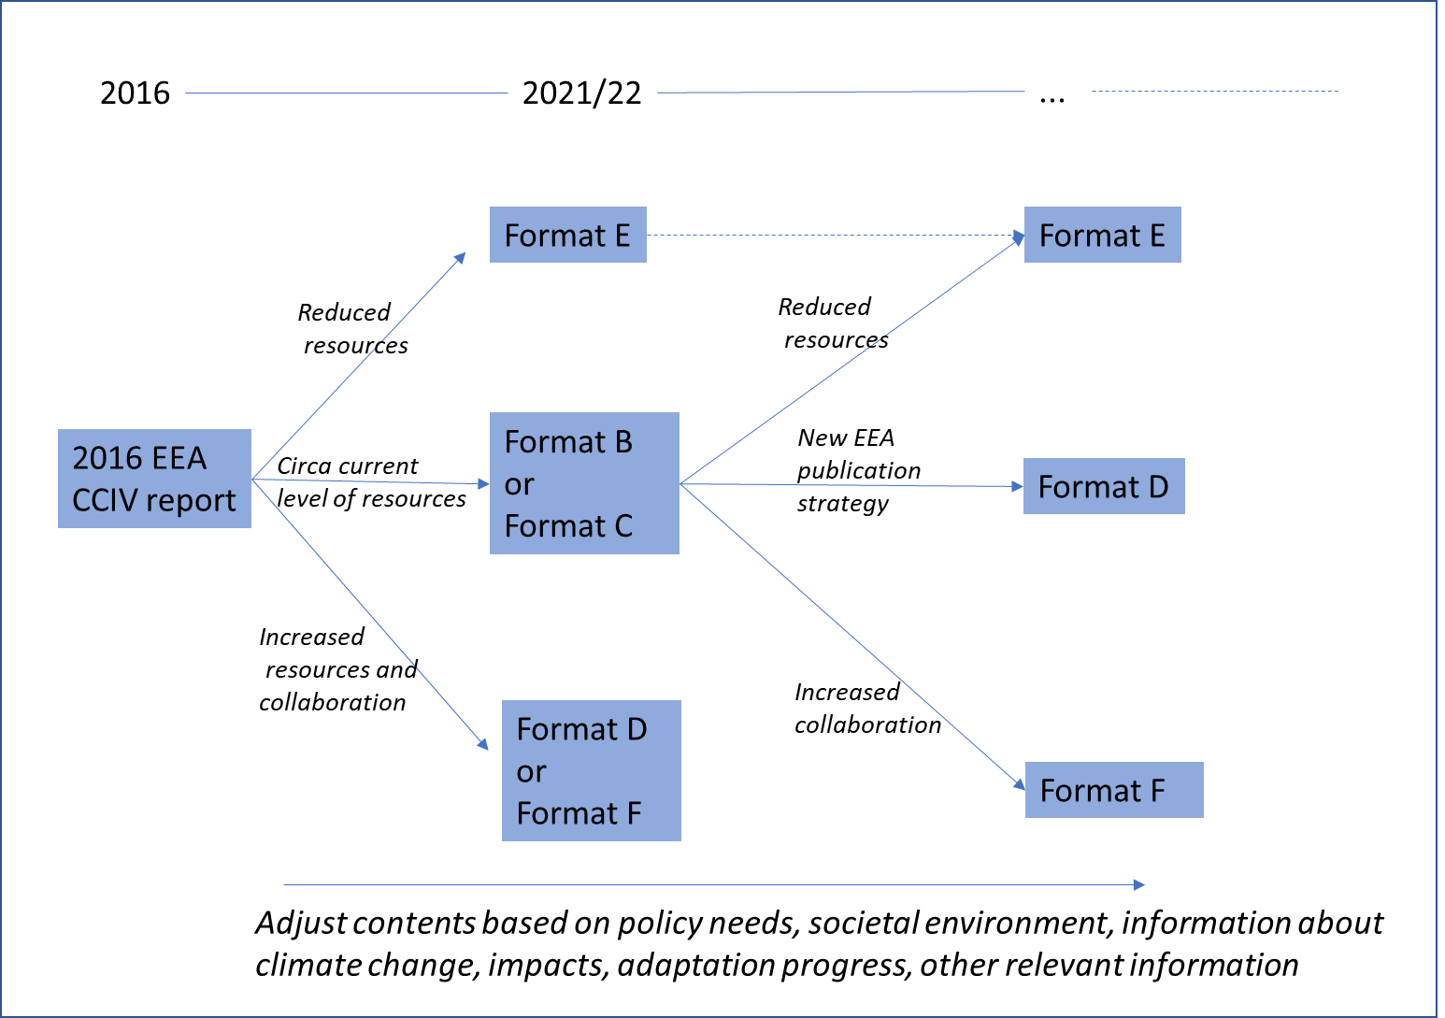

For instance, the next EEA CCIV report planned for 2022 could follow Format B (shortened EEA report with adjusted content) or Format C (i.e. Format B plus the policy-oriented synthesis as new product). In this process, the interaction with other knowledge providers can be explored and developed. At a later point in time, further steps can be taken in the direction of Format D or Format F. Such steps would require strategic choices, in particular with respect to collaboration with other institutes. In this process, EEA would keep a strategically important position in the field of providing knowledge on climate change and adaptation in Europe. Format E can be regarded as a “fallback” strategy in the case that EEA resources available to support climate adaptation policy in Europe would have to be reduced drastically. However, such a scenario is considered unlikely given the high importance of climate change policy as part of the planned European Green Deal.

# Objective and analytical approach

**Key messages/recommendations:**

* EEA published its fourth report on climate change, impacts and vulnerability (CCIV) in Europe in 2017
* A next report is tentatively planned to be published in 2022, supported by information published online
* New information sources, such as the Copernicus Climate Change Service (C3S), the IPCC AR6 and the JRC PESETA projects provide options for a deeper integration with external sources
* This scoping paper is analysing options for EEA CCIV work in general, and a 2022 EEA CCIV report in particular, for three aspects:
  + Content: Which content (physical impacts, societal risks, adaptation …) could a 2022 EEA CCIV report cover? What are potential information sources for different content clusters?
  + Format: Through which formats could this CCIV information be communicated (report, EEA web-page, Climate-ADAPT, jointly with C3S …)?
  + How can EEA efficiently make use of the above-mentioned complementary information sources?
* Options are evaluated against criteria developed taking into account EEA mission in the context of the CCIV report. The EEA CCIV reporting aims at being:
  + *Relevant and accessible* for EEA primary audience *targets* (EU and national policy-makers, EU policy advisors and for the general public)
  + *Scientifically reliable and transparent*
  + *Flexible* for updatingand *timely*

In January 2017, EEA published its fourth report on climate change, impacts and vulnerability in Europe (2016 EEA CCIV report). Similar to previous reports, this report presented a comprehensive overview of climate change and its impacts in Europe, which was largely based on 35 indicators. All these indicators were updated in parallel with the publication of the report. Furthermore, the 2016 EEA CCIV report reviewed the policy context for adaptation in Europe, and it gave an overview of multi-sectoral climate change vulnerability and risk assessments in Europe. The focus was on the EU level and the transnational level.

The production of a comprehensive report requires significant resources in terms of information collection, writing, editing, review and publishing. Producing a comprehensive report and the associated web pages for the indicators is, however, not the only way to disseminate European wide information on climate change impacts and vulnerabilities (and associated adaptation actions as appropriate).

The main objective of the report has been to provide policy makers with relevant, easily accessible and updated science-based information on the progress and projections of climate change and its impacts in Europe. By producing the report, the EEA hopes to satisfy a demand for knowledge and information that arises in the preparation of European wide and national policies. By providing a comprehensive report, the EEA gives the reader an opportunity to understand the broad picture of climate change and to gauge different pieces of information for policy development. A secondary objective is to generally raise awareness of the climate change and its consequences with a focus on European perspectives. A third objective is the branding and visibility of the EEA as an actor on the European CCIV(A) arena in relation to its task as defined in relevant documents on the EEA and its role.

This scoping paper explores through which means these objectives can be achieved by examining several options for EEA CCIV(A) information to be published in 2022. There are several means to achieve the objectives of EEA’s reporting on climate change impacts, vulnerabilities and adaptation actions. The choice of means will depend on the priorities in the strategic objectives of EEA with respect to publishing CCIV(A) information. The focus will lie on the added value of an EEA report compared to other existing reports and data platforms (IPCC AR6, Copernicus Climate Change Service – C3S and JRC PESETA).

A key question is how the EEA information on CCIV could be provided in a way that is well aligned with EEA’s mission set out in the current Multiannual Work Programme (extending to 2020):

*'The EEA aims to support sustainable development and to help achieve significant and measurable improvement in Europe's environment, through the provision of timely, targeted, relevant and reliable information to policy-making agents and the public'.*

The Seminar Booklet for the discussion on the EEA and Eionet Strategy 2021-2030 stresses that the “EEA targets two distinct audiences with different needs — policymakers and the public.”[3] Adaptation-related EEA products may also target other non-governmental actors (see Section 3.3). This doesn’t obviously mean that each and every report should fulfill the dual role, but it is natural to assume that it applies to the report and the accompanying material dealing with climate impacts, vulnerabilities and adaptation to climate change. Climate change was one of the important topics in the elections for European Parliament in 2019, and Eurobarometer results clearly shows that climate change is an issue that matters for a wide spectrum of the public.[4]

In the context of the CCIV(A)-report, and the material based on it, the key features of the EEA mission can be interpreted as follows:

* *Targeted:* The focus is clear, and the information is structured in such a way that also specialized policy-making agents can find information that helps them in their policy work. Some parts of the information are targeted to the public at large. Targeting is key for *policy relevance*.
* *Relevant:* General relevance can be achieved by contents that is of interest in public discussions and awareness raising concerning climate change impacts and vulnerabilities, without necessarily delivering specific information that can be used in making choices between options in policy making. Specific relevance would mean that the report provides information that can be used and referred to as such in the design and evaluation of policies that deal with climate change impacts, vulnerabilities and adaptation.
* *Reliable:* The information that is provided and referred to should be scientifically verifiable, and the interpretations and arguments that the report presents in narrative form should be based on transparent and balanced reasoning. Reliability is partly ensured through *scientific transparency.*
* *Timeliness:* Policy-making agents and the public have easy access to up to date information on what is known about the evolving impacts of climate change and their projections under different scenarios. This is also related to the *flexibility* of the reporting in accommodating new information.

These key features provided the base for the development of **criteria** that have been adopted in the Scoping Paper to reflect on the relative merits of different ways of conveying CCIV(A) information (in this paper referred to as Formats) (see chapter 7.3) .

The scoping paper assesses the chosen formats in terms of their expected effectiveness in achieving policy **relevance** and in raising awareness of climate change impacts and vulnerabilities among policy makers and other targeted actors that EEA sees as its primary audience. The chosen options therefore also assess the potential **accessibility** of the report for EU and national policy-makers, for EU policy advisors and for the interested public. Additionally, the **reliability** and **scientific transparency** of the report should be undisputed and the provided information in the various options should be linked adequately to the background reports, maps and other information. All the objectives are potentially demanding and therefore this scoping paper also reflects tentatively on the **resource needs**, the **required changes** and **innovation** and the timeliness and flexibility for updating, both from EEA and from other institutions and seeks to highlight where the main differences arise between the options. For a complete description of the criteria through which the different options are assessed, see Chapter 7.3.

Based on the desired characteristics of the reporting it is possible to outline two basic mechanisms and processes through which the EEA report on CCIV(A) is assumed to influence policies and public debates in such a way that progress can be made in sustainable development and in adapting to and mitigating climate change.

The first mechanism assumes that the report and the related material (on the EEA indicator system) help in *raising awareness*. To raise awareness the report must be *accessible* and perceived to be *relevant* by the target audience(s). A distinction can be made between raising awareness in the public debates and raising awareness among policy making agents. As such, raising awareness is an ‘easy’ task in the sense that climate change is already widely perceived to be important. At the same time the task is challenging because the report should provide material that deepens the awareness, it should not just confirm what the target audience already knows. A key finding from information campaigns aiming at raising awareness is that there is a need to use multiple channels to distribute the information. A single report is thus less likely to successfully raise awareness than information that is conveyed through several channels and in different formats[5]. The EIONET workshop (Chapter 6) implicitly recognized this by noting the necessity to integrate the discussions of:

* The 2022 EEA CCIV report
* CCIV indicators
* Sectoral/thematic adaptation reports
* Climate-ADAPT (including new interactive features)

The second mechanism assumes that the report and the related material can be referred to either as background information or as specific evidence in formulating and revising policies. Policy-making agents are thus assumed to be aware of the report and its material, have access to it and understand its contents in such a way that the report makes a difference in the way policies are developed and justified. There is evidence (Chapter 2) that in particular the synthesis parts of the 2016 report have been used as a reference in policy making.

One challenge for the CCIV report and the related material is that similar information is available and being produced elsewhere in increasing amounts. This was also reflected in the discussions at the Eionet workshop (see Chapter 6). Another challenge is that the users, defined as ‘policy-making agents’ (and the public) are heterogeneous, with diverse needs, background information and capability to use in particular complex and multidimensional information. Therefore, the information may be transmitted to and interpreted for the policy-making agents by middle –level actors such as journalists, political support staff or think-tanks. This way of influencing the debate has been partly recognized by producing press releases and achieving good press coverage (see Chapter 2), but there appears to be a partly untapped potential in as yet unidentified middle-level actors such as sector organisations, NGOs, think tanks and professional journals. The Eionet network may help in developing connections to such actors.

The purpose of the scoping paper is to serve as an internal discussion paper for the EEA in determining the approach and resources for the future CCIV(A) dissemination.

This scoping paper is based on a review of existing documents, personal meetings with EEA staff (mainly Hans-Martin Füssel, Andre Jol), personal meetings with C3S staff (Carlo Buontempo) and a break-out session during the Eionet meeting in Copenhagen from 12-13.06.2019.

# EEA perspective

(Hans-Martin Füssel, EEA)

**Key messages/recommendations:**

* The 2016 EEA CCIV report is based on 34 indicators for past trends and future projections; 5 of them are part of the CSI. These indicators are updated partly independent of the CCIV Report.
* The report has been very positively received and extensively cited.
* The vast majority (30 out of 34) of the CLIM indicators included in the 2016 EEA CCIV Report have been re-used in other EEA reports.
* The indicators rely on a wide range of data sources, including international and European research networks, global data centres, IPCC and European research projects. A small number of indicators already uses data from Copernicus services (CMEMS and C3S). This number is expected to increase rapidly with the further development of these services.
* Most indicators include spatially explicit information in the form of maps whereas only very few present country aggregates
* The 2016 CCIV report includes contributions from 24 (lead) authors and from 44 further contributors from EEA, ETCs and other organisations. The total resource needs for EEA and ETCs amounted to ca. 6 person years
* Even in a business-as-usual scenario (i.e. producing a similar CCIV report again), more resources would be required and better resource planning (including with other EEA programmes) would be needed to address the constraints experienced during the development of the 2016 report.
* Production of maps, graphs and the respective metadata should be streamlined and simplified.

## Content of 2016 CCIV report

### Scope

The 2016 CCIV report includes three categories of information:

1. **Climate change and specific risks:**  
   an assessment of past and projected climate change (Chapter 3), its impacts on environmental systems (Chapter 4) and social systems (Chapter 5) in Europe, which is primarily based on indicators; [44+78+78=200 pages]
2. **Cross-cutting climate change risks assessments:**   
   a structured review of integrated climate change impact, vulnerability and risk assessments on ecosystem services (Section 4.5) and on society (Chapter 6); [6+55=61 pages]
3. **Policy and knowledge context:**   
   an overview of the policy background for climate change adaptation (Chapter 2) and the development of the associated knowledge base (Chapter 7); [11+14=25 pages]

As a result, the report provides a comprehensive overview of past and projected climate change, its impacts and the associated risks for ecosystems and society, and of the evolving policy and knowledge landscape in Europe.

### Indicators and data sources

The first category of information (‘Climate change and specific risks’) was largely, but not exclusively, based on 34 indicators. All these indicators are included in the CLIM indicator set; five of them are also included in the CSI (Core Set of Indicators) set. For 17 of these 34 indicators (i.e. one half), the project manager of the 2016 CCIV report is noted as the “responsible contact person” in the CMS; other CET2 colleagues are responsible for six indicators; colleagues from the former NSV programme are responsible for the remaining 11 indicators.

All 34 indicators were updated on the EEA website shortly before the publication of the 2016 CCIV report. This update was performed by the project manager of the 2016 CCIV report, even if the formal responsibility was with other colleagues. The content of the indicators (i.e. assessment text and figures) matched the content of the 2016 CCIV report exactly, with minor differences in presentation due to the specific formatting requirements of the indicators. Four out of the five indicators in the CSI have been updated again in 2017 and/or 2018, and several further indicators are scheduled for update in 2019, e.g. because they are cited in the SOER2020 (see table below).

A large majority of indicators includes quantitative data about ‘past trends’ as well as ‘projections’. Depending on data availability, information is generally presented as time series of European averages and/or as map of trends in observed and/or projected changes.

The indicators rely on a wide range of data sources, including international and European research networks, global data centres, IPCC and European research projects. A small number of indicators already uses data from Copernicus services (CMEMS and C3S). This number is expected to increase rapidly with the further development of these services. None of the indicators relies on data reporting by countries to EEA. Only two indicators (‘Floods and health’ and ‘Economic losses from climate-related extremes’) show information for individual countries; this information has not been reported to EEA by countries.

### Uptake of CLIM indicators in other EEA reports

The vast majority (30 out of 34) of the CLIM indicators included in the 2016 EEA CCIV Report have been re-used in other EEA reports (see table below for details). This re-use includes the reproduction of figures and maps, and the use of key messages and other findings. In some, but not all re-use cases, the 2016 EEA CCIV report and/or the CLIM indicators are cited explicitly. For example, the climate change chapter in the forthcoming SOER 2020 cites 17 out of 34 CLIM indicators from the 2016 EEA CCIV report, thereby offering readers access to more detailed information than the page-limited SOER.

Table 2.1 Uptake of CLIM indicators in recent EEA reports

|  |  |  |  |  |  |  |  |
| --- | --- | --- | --- | --- | --- | --- | --- |
| **EEA report** | **CCA-DRR** | **Arctic report** | **Adaptation and energy** | **Adaptation and agriculture** | **Environment and health** | **SOER2020  (Ch. 6&7)** | **Any** |
| **Publication year** | **2017** | **2017** | **2019** | **2019** | **Forthcoming** | **2019** |  |
| **Global and European temperature** | 1 |  | 1 |  | 1 | 1 | 1 |
| Mean precipitation |  |  | 1 |  |  | 1 | 1 |
| Heavy precipitation | 1 |  | 1 |  |  |  | 1 |
| Wind storms | 1 |  | 1 |  |  |  | 1 |
| Hail | 1 |  | 1 | 1 |  |  | 1 |
| **Arctic and Baltic Sea ice** |  | 1 |  |  |  | 1 | 1 |
| Greenland and Antarctic ice sheets |  | 1 |  |  |  |  | 1 |
| Glaciers |  | 1 |  |  |  | 1 | 1 |
| Snow cover |  | 1 |  |  |  |  | 1 |
| Ocean acidification |  | 1 |  |  |  | 1 | 1 |
| Ocean heat content |  |  |  |  |  |  | 0 |
| **Sea surface temperature** |  |  |  |  |  | 1 | 1 |
| Distribution shifts of marine species |  |  |  |  |  | 1 | 1 |
| Ocean oxygen content |  |  |  |  |  |  | 0 |
| **Global and European sea level** | 1 | 1 | 1 |  |  | 1 | 1 |
| River flow |  |  | 1 |  |  |  | 1 |
| River floods | 1 |  | 1 |  |  | 1 | 1 |
| Meteorological and hydrological droughts | 1 |  | 1 |  |  | 1 | 1 |
| Water temperature |  |  | 1 |  |  |  | 1 |
| Soil moisture | 1 |  | 1 | 1 |  |  | 1 |
| Phenology of plant and animal species |  |  |  |  |  |  | 0 |
| Distribution shifts of plant and animal species |  |  |  |  |  | 1 | 1 |
| Forest composition and distribution |  |  |  |  |  | 1 | 1 |
| Forest fires | 1 |  | 1 |  |  | 1 | 1 |
| **Economic losses from climate-related extremes** | 1 |  |  |  | 1 | 1 | 1 |
| Floods and health | 1 |  |  |  | 1 |  | 1 |
| Extreme temperatures and health | 1 |  |  |  | 1 | 1 | 1 |
| Vector-borne diseases |  |  |  |  | 1 |  | 1 |
| Water- and food-borne diseases |  |  |  |  | 1 | 1 | 1 |
| Growing season for agricultural crops |  |  |  | 1 |  |  | 1 |
| Agrophenology |  |  |  | 1 |  |  | 1 |
| Water-limited crop yield |  |  |  | 1 |  |  | 1 |
| Crop water demand |  |  |  |  |  |  | 0 |
| Heating and cooling degree days |  |  |  |  |  |  | 1 |
| **Total: 34** | **12** | **6** | **13** | **5** | **6** | **17** | **30** |

## Production of the 2016 CCIV report

### Institutional framework and internal project management

The production of the 2016 CCIV report was agreed by SMT in late 2014, based on a concept paper developed by members of the (former) ACC4 group. The 2016 CCIV report was managed by Hans-Martin Füssel, supported by Andre Jol (both formerly in ACC4, now in CET2) and two ETC/CCA experts. Hans-Martin Füssel was the only EEA staff member who devoted more than 25% of his/her person days in any given year to the 2016 CCIV report.

The development of the report was supported by an external advisory group, which comprised 25 representatives from the European Commission, EEA Scientific Committee, EEA member countries, regional conventions, WHO, ECDC, IPCC, and other relevant organisations. This advisory group met twice to discuss the scope and outline of the report, to identify relevant information sources, and to provide recommendations regarding the presentation of findings. Members of the Advisory Group also reviewed various draft versions of the report.

The development of the report was further supported by an internal coordination group, which consisted of the Heads of Group of all EEA colleagues with writing responsibilities. This group met several times per year, but with irregular attendance by various members.

### Authors and contributors

The 2016 CCIV report includes contributions from 24 lead authors and from 44 further contributing authors. Most of the authors were from EEA and from ETC/CCA. Additional contributions were provided by WHO, ECDC, JRC, ETC/BD and various other organisations. Their distribution across organisations and organisational units is shown in the table below. The only EEA colleagues who authored more than one section were Hans-Martin Füssel and Andre Jol (both formerly in ACC4, now in CET2) and Tobias Lung (formerly IEA2, now IAS1).

Table 2.2 Distribution of authors and contributors to the 2016 EEA CCIV report

|  |  |  |
| --- | --- | --- |
| **Organization or (former) EEA group** | **Lead authors** | **Contributing authors** |
| EEA/ACC4 | 6 | 0 |
| EEA/NSS | 7 | 3 |
| EEA/IEA1 | 1 | 0 |
| ETC/CCA | 6 | 5 |
| ETC/BD | 0 | 2 |
| JRC | 0 | 9 |
| Other organisations | 4 | 25 |
| **Total** | **24** | **44** |

### Time and resource use

The 2016 EEA CCIV report took around 2.5 years from planning to publication. Preparatory work started in 2014. Supported by a small group of ETC/CCA experts, Hans-Martin Füssel and Andre Jol discussed first ideas with EEA member countries at an NRC meeting (in June), conducted a user survey (in September), and developed a project proposal that was agreed by SMT (in December). The project started in earnest in early 2015. A first draft of the (almost) full report was sent for review to the stakeholder group and further experts in September 2015. A second draft was sent for extended Eionet review in February 2016. The final draft report was sent for editing in June 2016, and it was printed in December 2016. The official launch was postponed until January 2017 because of other competing events in December.

The EEA resources used for the development and production of the report and the underlying indicators can be estimated only roughly. Reflecting the management approach at the time, the contributions of EEA colleagues and ETC experts to the 2016 EEA CCIV report were recorded under different project codes, depending on the particular EEA group concerned. The table below provides estimates of the resource use (in person years) by category and indicates which institution or (former) programme/group was providing these resources.

Table 2.3 Resource estimates for the 2016 EEA CCIV report and indicators (in person years)

|  |  |
| --- | --- |
| **Project management and quality control**   * project planning and coordination * stakeholder involvement * conducting external reviews * internal review of draft texts * reference management * quality control of (meta)data * editing of key messages | ACC4: 1.5 |
| **Preparing inputs**   * writing and reviewing draft texts * preparing (meta)data for maps and graphs * writing summary texts | EEA: 1.5 ETCs: 2 Others: 0.5 |
| **Production and publication**   * producing maps and graphs * supporting map and graph production * (external) language editing * (internal) lay-out * *excluded: printing* * entering indicators into the CMS * communication and outreach | COM: 0.5  ACC4: 0.5 |

It is important to emphasize that, in addition to the EEA resources included in the table above, many organisations contributed in-kind to the 2016 CCIV report through providing data, text or commenting on drafts.

### Reflections and potential for improvement

The development of the 2016 EEA CCIV report was a large undertaking, which unavoidably presented challenges on the way. Proper project planning can prepare for imaginable challenges and aim to mitigate the impacts of unplanned developments (‘surprises’), but such preparation typically comes with a redundancy cost.

Unplanned events and developments affecting the production of the 2016 report included repeated reorganisations in one EEA programme (the former NSS programme), unforeseen departures and long-term absence of some EEA lead authors, and unavailability or unresponsiveness of individual ETC experts. Further challenges included delayed and/or partial contributions from some EEA colleagues and ETC experts. These challenges created the risk for a considerable delay in the finalization of the report, because there were several milestones in the report development that could only start once all contributions were ready: external expert review, extended Eionet review, language editing and layout. In the end, the report and all the underlying indicators were published with a minor delay (2 months) compared to the original planning. However, the development did create stressful situations on the way. In particular, the project manager had to devote much more time the planned to prepare or amend incomplete contributions, which decreased the time available for (other) project management tasks.

In a hypothetical ‘business-as-usual’ scenario (i.e. where EEA would produce a report similar in scope to the 2016 EEA CCIV report), the following changes to the project management would be recommended based on the experiences with the 2012 and 2016 CCIV reports:

1. The **project management should be shared** between two staff members with somewhat overlapping expertise in order to provide redundancy, in particular in ‘bottleneck’ phases of the project. Both experts should have the CCIV report as their most important project (in terms of person days) during its main development phase.
2. **Secretarial assistance should be available** for technical tasks, such as reference management, so that experts can pay more attention to project management and preparing and reviewing key content.
3. **All EEA authors should record their contributions to the report under a single project code** (as is done for the SOER), in order to make their contributions visible (and accountable) in their CDC and the MPS.
4. The project should foresee a **more direct contact between the project manager(s) and the SMT (or the recently established management group)** in key phases of the report development. In this way, guidance could be provided and occurring challenges could be addressed more swiftly than in the case of the 2016 CCIV report, where there were always two intermediate ‘steps’ (HoG ACC4, HoP ACC) between the project manager and SMT members from other programmes.
5. The **production of maps and graphs should be simplified,** in particular in relation to the metadata requirements and the actual production steps. This simplification is possible because the indicators in the CCIV reports are based predominantly on scientific data rather than on official country statistics and reports.

## External impact of the 2016 CCIV report

The most important target groups of EEA products are the European Commission and other EU institutions as well as the EEA member countries. This is also the case for the EEA CCIV report. However, the legal role of the EU in climate change adaptation is more limited than in most ‘classical’ environmental policy areas that are guided by EU Regulations and/or Directives. Most adaptation activities are planned and implemented at the national level or by non-governmental stakeholders, without policy targets established at EU level. Therefore, policy-makers at the macro-regional, national and subnational level, private sector representatives (e.g. insurance and energy infrastructure), non-governmental organisations and academia are more important as a target audience of the EEA CCIV reports than of most other EEA products.

Despite increasing efforts to assess the external impact of EEA products, available information is patchy at best. As a result, it is difficult to quantify the impact of the 2016 CCIV report (and the underlying indicators) on policymakers and other adaptation stakeholders in Europe. EEA is systematically assessing the media outreach of its products based on a number of quantitative indicators. Since 2017, EEA also aims to monitor the mentioning of EEA products in official EU documents (through ‘Dods Monitoring’). Unfortunately, the documents related to the 2017 Dods Monitoring specify neither the title of the policy document nor of the EEA product(s) mentioned. Hence, they were unsuitable for assessing the uptake of the 2016 EEA CCIV reports in EU policy documents in 2017.

The tentative assessment of the external impact of the 2016 EEA CCIV report here considers the following sources:

* Invitations for presentations based on the report,
* Outreach analysis (by COM programme),
* Dods analysis for 2018 (the 2017 analysis was not usable, see above)
* Citations in relevant policy and other documents that CET2 became aware of (mostly by chance),
* Systematic feedback collected by CET2 (through a survey and meetings),
* Further feedback received in different contexts.

### Impact on European policy-makers

The table below gives an overview of external meetings with policymakers where Hans-Martin Füssel was invited to present and discuss findings of the 2016 EEA CCIV report. Meetings with a primarily scientific focus (e.g. scientific conferences and workshops) and meetings organized by EEA (e.g. NRC meetings, EEA Scientific Committee, EEA visits of external delegations) are not included.

Table 2.4 External presentations of the 2016 EEA CCIV report by Hans-Martin Füssel to policy-makers

|  |  |  |
| --- | --- | --- |
| **Date & place** | **Event** | **Organiser** |
| 12 May 2016, Amsterdam | Directors General Meeting on Territorial Cohesion  *(presenting key findings of the draft EEA report)* | Dutch Council Presidency |
| 11 May 2017,  Brussels | FACCE MACSUR workshop for policymakers | FACCE MACSUR project |
| 9 June 2017,  Brussels | Civil dialogue group on environment and climate change | DG AGRI |
| 23 Oct. 2017,  Bonn | PAGODA workshop | WHO Regional Office for Europe |
| 5 Dec. 2017,  Bern | ProClim Symposium | Swiss Federal Office for the Environment |
| 6 Dec. 2018  (remotely) | CLEFSA workshop | EFSA |
| 7 June 2019,  Brussels | Expert Workshop ‘Climate change and health: A discussion of the latest international and European reports and the implications for Europe | European Commission Group of Chief Scientific Advisors |

The table below gives an overview of known mentions of the 2016 EEA CCIV report in EU policy documents. No attempt was made to create a similar overview for national-level documents because of the lack of relevant data.

Table 2.5 Mentions and use of 2016 EEA CCIV report in EU policy documents

|  |  |  |  |
| --- | --- | --- | --- |
| **Date of document** | **Document type** | **Document title** | **Character of the mention** |
| **European Commission** | |  |  |
| 23.5.2017 | Commission staff working document: SWD(2017) 176 | [Overview of Natural and Man-made Disaster Risks the European Union may face](https://ec.europa.eu/echo/sites/echo-site/files/swd_2017_176_overview_of_risks_2.pdf) | Mentioned several times in the text |
| 01.06.2018 | Commission staff working document: SWD(2018) 301 | [Impact assessment Accompanying the document Proposals for a Regulation... (Part 3)](https://eur-lex.europa.eu/legal-content/EN/TXT/?uri=CELEX:52018SC0301) | Publication listed in the bibliography annex |
| 09.10.2018 | Seventh report on economic, social and territorial cohesion (DG REGIO) | [My Region, My Europe, Our Future](https://ec.europa.eu/regional_policy/en/information/cohesion-report/) | Reproduces one map and cites several key findings in the text |
| 12.11.2018 | Commission Report: COM(2018) 738 | [The implementation of the EU Strategy on adaptation to climate change](https://eur-lex.europa.eu/legal-content/EN/TXT/PDF/?uri=CELEX:52018DC0738&from=EN) | Reproduces a graph (from CSI042) and mentions findings from the report in the text |
| 12.11.2018 | Commission staff working document: SWD(2018) 461 | [Evaluation of the EU Strategy on adaptation to climate change](https://eur-lex.europa.eu/legal-content/EN/TXT/PDF/?uri=CELEX:52018SC0461&from=EN) | Mentions several findings from the report in the text |
| 28.11.2018 | Commission Communication: COM(2018) 773 | [A Clean Planet for all: A European strategic long-term vision for a prosperous, modern, competitive and climate neutral economy](https://eur-lex.europa.eu/legal-content/EN/ALL/?uri=COM:2018:773:FIN) | Reproduces Map ES.1 (without acknowledgement of the source) |
|  |  |  |  |
| **European Parliament** | |  |  |
| 27.02.2018 | Report by the Committee on Regional Development: 2017/2006(INI); A8-0045/2018 | [REPORT on the role of EU regions and cities in implementing the COP 21 Paris Agreement on climate change](http://www.europarl.europa.eu/doceo/document/A-8-2018-0045_EN.html?redirect) | Mentioned in the Motion and key findings cited in the Explanatory statement |
| 13.03.2018 | Resolution: P8_TA(2018)0068 | [The role of EU regions and cities in implementing the COP 21 Paris Agreement on climate change](https://www.europarl.europa.eu/sides/getDoc.do?type=TA&reference=P8-TA-2018-0068&language=EN) | Acknowledges the report's content |
| 16.04.2018 | In-depth analysis requested by the BUDG committee: PE 603.830 | [In-depth analysis on The EU spending on fight against climate change by Policy Department for Budgetary Affairs](http://www.europarl.europa.eu/RegData/etudes/IDAN/2018/603830/IPOL_IDA(2018)603830_EN.pdf) | Reproduces three maps and cites many key findings |
|  |  |  |  |
| **European Court of Auditors** | |  |  |
| 22.11.2016 | European Court of Auditors Special Report No. 31/2016 | [Spending at least one euro in every five from the EU budget on climate action: ambitious work underway, but at serious risk of falling short](https://www.eca.europa.eu/en/Pages/DocItem.aspx?did=39853) | Reproduces two maps (from 2012 EEA CCIV report) in the Introduction |
| 20.11.2018 | European Court of Auditors Special Report No. 25/2018 | Floods Directive: progress in assessing risks, while planning and implementation need to Improve | Reproduces one map and cites several findings |
|  |  |  |  |
| **Council (of the European Union)** | |  |  |
| 20.05.2019 | Background paper for informal Environment Council | EU Adaptation Strategy – The Road ahead (not public) | Mentions report and cites key findings |

### Impact on national policy-makers

EEA member countries are an important target audience of the EEA CCIV reports. However, it is not feasible to monitor the uptake of specific EEA products in national policy development. Systematic attempts to obtain feedback from countries on the EEA CCIV reports include a user survey conducted in 2014 and, more recently, a [facilitated discussion at the NRC meeting in June 2019](https://forum.eionet.europa.eu/nrc-climate-change-adaptation/library/workshops-meetings/2019-eionet-workshop-climate-change-impacts-vulnerability-and-adaptation/meeting-documents/presentations/session-3-break-out-group-discussions/3-climate-change-impacts-and-risks).

The user survey from 2014 gathered responses from 33 adaptation stakeholders. 26 of them represented public institutions at different levels, including 16 from national governments. An overwhelming majority of the surveyed stakeholders stated that they had actively used the EEA report for raising awareness about climate change and its impacts, for planning CCIV assessments, and for developing national adaptation policy and/or national-level indicators. The survey also asked respondents to provide feedback on the length of the two summaries and of each chapter in the 2012 CCIV report. All respondents rated the length of the Executive Summary and Technical Summary as *appropriate*; the percentage of *appropriate* ratings for the other chapters was between 83% and 90%. Looking forward, 16 out of the 26 respondents from the public sector were in favour of publishing the 2016 assessment as an extensive printed report, 8 preferred publishing a synthesis report (with detailed information online), and 2 had no opinion.

### Impact on other European adaptation stakeholders

Policy-makers and experts at EU institutions and national governmental institutions are the most important target group of EEA reports. However, most adaptation actions will be implemented and funded by private companies and other non-governmental actors. The importance of certain non-governmental organisations and business sectors is explicitly mentioned in the 2013 EU adaptation strategy, in particular under Objective 3: Climate-proofing EU action. In the context of Action 7, the Commission requested the European Standardization organisations (CEN and CENELEC) to update relevant infrastructure standards to consider climate change adaptation needs. Furthermore, Action 8 explicitly highlights the role of the insurance industry in preventing and managing risks related to climate change impacts.

A systematic overview of the uptake of the 2016 EEA CCIV report by non-governmental stakeholders is not available. However, the table below provides some examples of how target organisations identified in the EU adaptation strategy have used relevant information from this report in their publications.

Table 2.6 Mentions and use of 2016 EEA CCIV report in documents of other adaptation stakeholders

|  |  |  |  |
| --- | --- | --- | --- |
| **Date of document** | **Document type** | **Document title** | **Character of the mention** |
| April 2016 | CEN-CENELEC Guide 32 | [Guide for addressing climate change adaptation in standards](ftp://ftp.cencenelec.eu/EN/EuropeanStandardization/Guides/32_CENCLCGuide32.pdf) | Reproduces five maps and cites many key findings |
| 24.09.2018 | Zurich Insurance Report | [Managing the impacts of climate change: risk management responses](https://www.zurich.com/en/knowledge/articles/2018/09/managing-the-impacts-of-climate-change-risk-management-responses) | Reproduces Map ES.1 and cites many key findings (without acknowledgement of the source) |
| 02.10.2018 | EUROCONTROL report | [Challenges of Growth - Annex 2 - Adapting aviation to a changing climate](https://www.eurocontrol.int/sites/default/files/publication/files/challenges-of-growth-annex-2-01102018.pdf) | Reproduces four maps and cites many key findings |
| 30.04.2019 | Draft CEN/CENELEC guidance for standardization Technical Committees | How to include climate change adaptation in European infrastructure standards (not public) | Reproduces Map ES.1 |

### Media outreach

At the launch of the 2016 EEA CCIV report, Hans Bruyninckx gave three interviews to radio and TV stations based on the report. Afterwards, Hans-Martin Füssel gave interviews to [Deutsche Welle](https://www.dw.com/en/extreme-weather-on-the-rise-in-europe/a-37289111), A New Climate for Peace [Resilience Blog](https://www.newclimateforpeace.org/blog/europe-risk-climate-change-impacts-and-vulnerability-interview-hans-martin-f%C3%BCssel), [Correctiv](https://correctiv.org/aktuelles/steigende-meere/2017/07/28/europa-kann-nicht-alle-menschen-vor-dem-meer-schuetzen) and [Heilbronner Stimme](https://www.stimme.de/heilbronn/nachrichten/region/Ist-das-Sommer-oder-Klimawandel;art140897,4062025).

According to the document “[Uptake of EEA’s 2017 publications](http://intranet/EEA_management/SMT/_layouts/15/WopiFrame.aspx?sourcedoc=/EEA_management/SMT/SMT%20papers/2018/Q2/2018-06-25/3_3_a_uptake%20of%20%202017%20EEA%60s%20publications%20-%20note%20to%20SMT%2025%20June%202018_KRO.docx&action=default&DefaultItemOpen=1)” presented to SMT on 25 June 2018, the 2016 EEA CCIV report had the third largest outreach of all 2017 EEA products, based on a combination of five indicators.

A monitoring and analysis report prepared shortly after the launch event in January 2017, based on inputs from Infomedia and the European Climate Foundation, showed over 1 000 articles on the 2016 EEA CCIV report. They included major European print and online media, Associated Press (in English, Spanish and German), Reuters, Bloomberg, DPA and Xinhua, with a potential reach of 530-740 million. The report was covered by influential media outlets in many European countries, including the Guardian, El Pais, El Mundo, Sueddeutsche Zeitung, Le Figaro, De Morgen, Jyllands-Posten and La Stampa, but also online news portals and tabloid newspapers with a large circulation, such as Focus and Bild. News about the report were also heavily covered in the United States, including the Washington Post and the New York Times. Social media outreach on Twitter and Facebook (including a Facebook live video of the launch event) was also considerable. A later analysis showed that about half of the extensive media coverage was linked to the report launch, but that considerable coverage also occurred later in the year (e.g. in connection with devastating forest fires in July 2017).

## Recent developments of the EEA communication strategy

The current EEA communication strategy includes a gradual shift from printed to electronic reports. As a result, EEA has reduced the number of reports that are printed as well as their print run. This shift is eliminating the costs for printing and distributing EEA reports. However, because printed and electronic reports are produced to exactly the same quality standards, it does not affect the resources needed for project management, preparation of inputs, language editing, figure production and lay-out (as shown in Table 2.3). Electronic versions of EEA reports do not currently use any ‘innovative’ features of electronic publications, such as hyperlinks within the report, to EEA indicators on the EEA website and/or in Climate-ADAPT, and/or to publications and other resources available online. Furthermore, maps, figures and illustrations are not made available separately for download (e.g. for re-use in presentations and publications of other organisations), as it is the practice for IPCC reports and most journal publications, unless they are published as part of an indicator.

Individual SMT members have indicated that EEA may no longer publish lengthy reports, such as the 2016 EEA CCIV report. However, it is not clear whether these statements reflect the personal opinion of individual SMT members or a clear majority within SMT.

In 2019, EEA started a cross-cutting project aiming to improve EEA indicators. Interestingly, the project group does not include any indicator managers. Available documents from this project have suggested, among others, that EEA indicators should be shortened substantially, that they should relate to an agreed policy target, and that they should be updated annually. None of the 34 CLIM indicators included in the 2016 CCIV report matches these conditions. Only one of them is directly linked to a (global) policy target, few of them are updated on an annual basis, and most of them are longer than the maximum length specified by the project group. Hence, if these plans were implemented as proposed, EEA would have to drop all 34 adaptation-related indicators.

So far, two approaches have been used for sharing CCIV-related information between an EEA report and the indicators on the EEA website. For CCIV reports, essentially the same information is presented in the indicators online and in the indicator-based parts of the report. This approach allows updating a large number of indicators in parallel with publication of the report with very limited extra resources. The main advantage of the indicators online is that they can be updated more frequently if relevant new information becomes available and that they can be searched independently on the EEA website. Furthermore, most indicators allow users to download maps and figures, which is not the case for (other) illustrations from EEA reports. A different approach was applied in the SOER2020, which presents short summaries of indicator-based information and includes links to many indicators with more detailed information online.

The current discussions about EEA assessment reports and EEA indicators has a large impact on future EEA CCIV work. For example, it is not clear (to the authors of this scoping paper) whether either of the two approaches for sharing CCIV information between EEA reports and indicators will still be feasible in the future. If neither ‘thick’ reports nor ‘long’ indicators were permitted in the future, EEA would no longer be able to present detailed CCIV information, unless new product types and/or publication channels are developed (e.g. context indicators, Climate-ADAPT indicators, joint EEA/C3S indicators). Therefore, it is essential that the SMT provides clarity on the permissible format and other requirements of relevant EEA products before the development of a new EEA CCIV report and related indicators starts.

# Examples of presenting CCIV information

**Key messages/recommendations:**

* A wide range of organisations currently provides information on CCIV(A) in Europe, ranging from Met-offices, research institutes, departments or ministries, adaptation committees, private companies, sector organisations, and news providers, sometimes collaborating with scientists.
* These organisations use a wide variety publications and vary widely in their information coverage. Web-based information allows for interactive approaches by users.
* On the one hand, the wide variety of types of publications and coverage of information provides information for many target groups. On the other hand, this may create uncertainty about the quality of and/or consistency between of the information from different providers.
* In this expanding landscape of an increasing variety of information providers, an important role for the EEA is to provide a consolidated knowledge base at EU level, EU regions and EEA member states as a basis for awareness raising, CCIV assessment, and adaptation policy development. Easily accessible and easy understandable information is an asset in this context.
* Most national CCIV reports cover more aspects of climate change than the EEA report. The full spectrum is:
  + Climate change trends and scenarios
  + Effects and Impacts
  + Vulnerability and Risk
  + Cross-sectoral perspectives
  + Sectoral perspectives
  + Regional perspectives (e.g. specific regions, cities)
  + Adaptation (needs, options, policies and measures)

## Introduction

Information in CCIV assessments on different scales provides the basis for understanding climate change, its effects, impacts and risks, and for developing adequate adaptation strategies. In democratic societies such as in the EU, information from CCIV assessments not only plays an important role in the policy domain, but is also important for societies as a whole, encompassing many sectoral organizations, NGOs and the general public. Providing adequate and understandable information for these different target groups is a considerable challenge for CCIV assessments.

This chapter gives some examples of how other organizations present their CCIV(A) information in relation to i) the content and ii) the publication formats. The examples encompass CCIV(A) from national and subnational scale, European scale and global scale.

## Examples of other CCIV reports

Coverage

With respect to the ***coverage*** of the presented content we distinguish:

1. Climate change trends and scenarios
2. Effects and Impacts
3. Vulnerability and Risk
4. Cross-sectoral perspectives
5. Sectoral perspectives
6. Regional perspectives (e.g. specific regions, cities)
7. Adaptation

Types of publications

With respect to ***types of publications*** we distinguish:

1. Technical publications
2. Policy summaries
3. Attractive booklets/infographics
4. Websites
5. Web-atlas
6. Video/films
7. Data portals

Table 3.1 Quick scan overview of examples of CCIV(A) assessments as to coverage of CCIV aspects (i. to vi.; see above) and types of publications (a. to g.; see above)

| *Assessments* | *i.* | *ii.* | *iii.* | *iv.* | *v.* | *vi.* | *vii.* | *a.* | *b.* | *c.* | *d.* | *e.* | *f.* | *g.* |
| --- | --- | --- | --- | --- | --- | --- | --- | --- | --- | --- | --- | --- | --- | --- |
| ***Examples of national assessments*** | | | | | | | |
| UK - [Committee on Climate Change](https://www.theccc.org.uk)[6] | X | X | X | X | X | X | X | X | X | X | X |  |  |  |
| UK - National ([UKCIP](https://www.ukcip.org.uk)) [7] |  | X |  |  |  |  | X |  |  |  | X |  |  |  |
| UK - National - England ([Future World Images: infographics on adaptation](https://www.defra.gov.uk/adaptation)) [8] |  |  |  |  |  |  | X |  | X | X | X |  |  |  |
| UK - National – [Scotland](https://www.adaptationscotland.org.uk)[9] |  |  |  |  |  |  | X |  |  |  | X |  |  |  |
| UK - National - [Northern Ireland](https://www.climatenorthernireland.org.uk)[10] |  |  |  |  |  |  |  |  |  |  |  |  |  |  |
| UK - example special interests group: [Marine Climate Change Impacts Partnership](https://www.mccip.org.uk)[11] |  | X |  |  |  |  | X |  |  | X | X |  |  |  |
| Netherlands - [National CCIV (PBL 2015](https://www.pbl.nl/en/publications/adaptation-to-climate-change-in-the-netherlands)) [12] | x | x | X | X | X |  |  | X |  |  |  |  |  |  |
| Netherlands – [Subnational Climate Impact Atlas](https://www.klimaateffectatlas.nl)[13] | X | X | X |  |  | X |  |  |  |  | X |  |  |  |
| Switzerland - [Climate change scenarios](https://www.klimaszenarien.ch)[14] | X | X |  |  |  |  |  | X |  | X | X | X | X | X |
| [Germany - federal website](https://www.umweltbundesamt.de/en/topics/climate-energy/climate-impacts-adaptation)[15] | X | X |  |  |  |  | X | X |  |  | X |  | X | X |
| Germany [- [Climate Preparedness Services](https://www.klivoportal.de)](https://www.umweltbundesamt.de/en/topics/climate-energy/climate-impacts-adaptation)[16] | X | X | X |  | X | X | X | X | X | X | X | X |  |  |
| Finland - [Initiated by the National Adaptation Plan](https://mmm.fi/luonto-ja-ilmasto/ilmastonmuutokseen-sopeutuminen) [17] | X | X | X | X | X | X* | X | X | X | X* | X | X* | X* | X* |
| ***Examples of other European assessments*** |  |  |  |  |  |  |  |  |  |  |  |  |  |  |
| EEA | X | X | X | X | X | X | X | X |  |  |  |  |  |  |
| PESETA (JRC, PESETA [II](https://ec.europa.eu/jrc/en/peseta-ii), [III](https://ec.europa.eu/jrc/en/peseta-iii) ….)[18] | X | X | X |  | X |  | X | X | X |  | X |  |  |  |
| [Copernicus Climate Change Service](https://climate.copernicus.eu) [19] | X | X |  |  | X |  |  |  | X |  | X |  |  | X |
| [MedEC](https://www.medecc.org) (Mediterranean experts on climate and environmental change) – part of the site: Scientific News [20] | X | X | X | X | X | X | X | X |  |  | X |  |  |  |
| ***Examples of global assessments*** | | | | | | | |
| [IPCC](https://www.ipcc.ch/) [21] | X | X | X | X | X | X | X | X | X | X | X |  |  |  |
| [UK - Met Office](https://www.metoffice.gov.uk/food-insecurity-index/), example atlas global food security [22] |  |  | X |  |  |  |  |  |  | X |  | X |  |  |
| [Future Water Challenges](https://www.pbl.nl/node/64678) [23] | X | X | X | X | X | X |  |  |  |  | X |  |  |  |
| [Climate Central](https://www.climatecentral.org) (focus: USA) [24]/  [Inside Climate News](https://insideclimatenews.org) (focus: USA) [25]/  [Climate Council](https://www.climatecouncil.org.au) (focus: Australia) [26] /  [Climate Change Post](https://www.climatechangepost.com) (focus: Europe) [27]/  [Carbon Brief](https://www.carbonbrief.org) (focus: global)[28] | X | X | X | X | X | X | X | X | X |  | X |  |  |  |
| [World Bank Group](https://www.worldbank.org/en/topic/climatechange) [29]  ([Link 2)](https://climateknowledgeportal.worldbank.org) | X | X | X |  | X |  |  |  |  |  | X |  |  | X |

Notes: X* = not fully developed (personal communication). The links to these assessments are available as hyperlinks in the table text and are included in the endnotes of this chapter.

## A summarizing overview of findings

* National websites in the EU generally present information on climate change scenarios, impacts and vulnerabilities. Information on adaptation strategies/measures is not always included, but several countries have special websites focused on adaptation linked to national climate adaptation services (e.g. Climate Adaptation Services in the Netherlands[30]).
* Compared to the EEA report, a selection of
* Several national assessments use a wider range of communication channels to policy makers and the general public than the EEA CCIV report. The UK, Germany, Switzerland and Finland use instruments like policy summaries, attractive booklets/infographics, websites, web-atlases, video/films and data portals.The UK is an example of a country which, in addition to the technical main CCIV report, provides a wide range of websites that in combination address the full spectrum of climate change, impacts, vulnerabilities and adaptation: the site of the Committee on Climate Change[31] presents the full assessment, other sites (UKCIP and the sites for England, Scotland and Northern Ireland) focus on adaptation. In addition, there are sites focused on special interests, such as the Marine Climate Change Impacts Partnership for the UK[32]. The site of the Met Office[33] presents a nice example of a web-atlas of climate change vulnerabilities on global scale for food security and the effect of adaptation.
* Switzerland uses a wide range of types of publication for their new climate change scenarios: 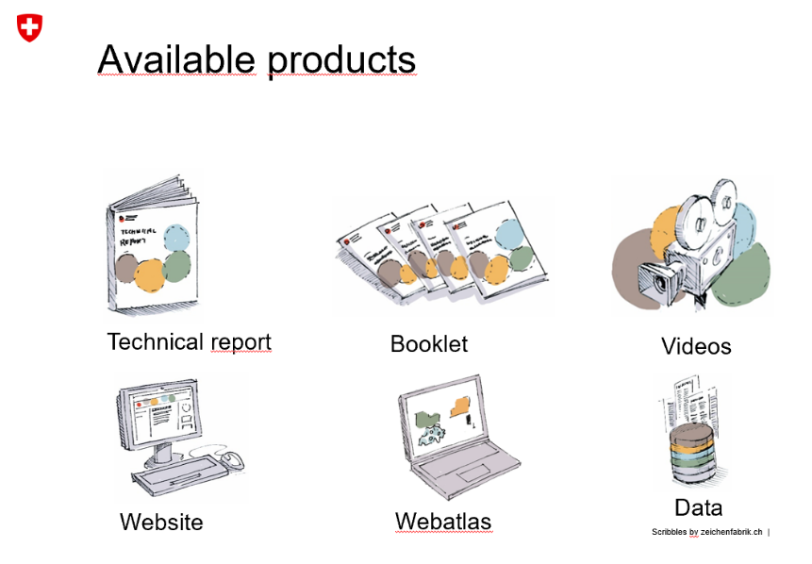  
  Source R. Hohman 2019.

All information about the new climate scenarios is on the web site[34]. Most information is also available in English, including the technical report, the booklet and the web-atlas. The work was done based on a mandate given in the first action plan including significant resources. Since Switzerland was not entirely happy that the previous scenarios from 2011 did not find their way into practical work, MeteoSchweiz[35] gave a contract for a stakeholder needs analysis (available only in German). Following the stakeholder analysis, they developed a range of products that is expected to better fulfill the requirements of a real climate service.

# The evolving demand for CCIV(A) information

**Key messages/recommendations:**

* Adaptation policy development needs knowledge beyond climate impacts. This includes an assessment of vulnerabilities and risk, information on adaptation options and constraints, on the relationship to sustainable development goals, and on transboundary (spillover) effects of climate change.
* Driven by the (successful) mainstreaming of climate change adaptation, the demand for CCIV(A) information is simultaneously diversifying and becoming more specific with respect to focus and spatial and temporal resolution.
* There is large variation between policy areas in terms of available knowledge. Sectors that have a long history of considering climate factors (e.g. water supply, agriculture, biodiversity) have initiated numerous studies on CCIV, which lead to a growing need for syntheses that bring together and critically review a rapidly growing body of information. Other sectors (e.g. buildings, health) have a shorter tradition in carrying out CCIV studies. For these sectors, general overviews may be the first step towards formulating policies.
* National policy development generally requires CCIV(A) information at high spatial resolution so that it can be directly linked with policy planning and implementation within each sector.
* The mainstreaming of climate change adaptation in sectoral activities and policies should be linked with disaster risk reduction due to considerable overlaps.
* Many countries have commissioned CCIV studies for specific sectors. However, there is also a need for studies and reports that make it possible to identify similarities and links across policy areas.

## Knowledge needs reflected in the EU adaptation strategy and its evaluation

The EU Adaptation strategy and its evaluation have highlighted information needs. The strategy set as one of its goals to “Bridge the knowledge gap” and it specifically foresaw mainstreaming of adaptation in the Covenant of Mayors, climate proofing of the Common Agricultural Policy, the Cohesion Policy and the Common Fisheries Policy, more resilient infrastructures and the development of insurance and other financial products for resilient investment and business decisions. All of these depend on adequate CCIV(A) information.

The evaluation of the EU adaptation strategy (COM(2018) 738 final) notes that progress has been made in bridging knowledge gaps but that “none of the priority knowledge gaps have been closed and new gaps have emerged” (p. 7). The following ‘new’ gaps have been identified: “ecosystem-based adaptation, relationship to sustainable development goals, global transboundary (spillover) effects of climate change impacts and risks, adapting infrastructure, mountainous areas, long-term lack of water resources, high-end climate change, health, coastal areas, biodiversity” (SWD(2018) 461 final, p. 16). The list shows a recognition of the links between CCIV and Adaptation information. There is also a recognition of the growing knowledge needs arising from disaster risk reduction (ibid. p. 10-11).

The report on the evaluation foresees that to advance adaptation further “the Commission could envisage exchanges of information on successful adaptation measures between stakeholders and with the scientific community” (p.12). Such exchanges would benefit from systematic analyses that the EEA could provide in its report(s) using, for example, material submitted to Climate-ADAPT.

The evaluation of the EU adaptation strategy suggests that the role of the CCIV(A) information is to provide input and feedback into the policy dialogues and processes that design and revise policies. The demands are likely to become increasingly specific as policy areas evolve. At a European level there is a particular need for understanding the diversity of CCIV(A) across Europe in order to formulate policies that are sufficiently flexible in implementation, yet specific enough to allow for a meaningful mainstreaming of climate change measures. The following section explores these demands from a sector perspective.

## Mainstreaming generates new demands for knowledge

As highlighted by the evaluation of the EU adaptation strategy (SWD(2018) 461 final), the demand for reliable and comprehensive information on climate change impacts, vulnerabilities and adaptation is expected to increase. An important driver is the progress of climate change itself, with increasingly severe impacts. ‘New’ knowledge gaps identified in the evaluation of the adaptation strategy (see section 4.1 above) include transnational impacts and adaptation actions. One way to address these is to examine the European macro-regions[36] and their specific adaptation needs, which demands spatially explicit information.

Another important and partly related driver is the policy development at different levels of governance. Evidence-based policy development needs a solid and coherent base of information (Table 4.1) to help the sectors in identifying relevant hazards, exposures, vulnerabilities and eventually risks (of impacts).

The overview of EU policy areas as identified in the Climate-ADAPT shows that policy development needs general spatially explicit overviews of key climate variables that affect many sectors, but also specific interpretations that focus on the particular vulnerabilities of the sectors (Table 4.1). Several sectors have commissioned specific CCIV studies. There is also a need for studies and reports that make it possible to identify similarities and links across policy areas. For example, financial risks related to climate change materialize differently in forestry, transport and energy, but for regional policy development it is of value to explore how and to what extent different impacts and risks can materialize within the same geographical areas. Initiatives in the European macro-regions create specific demands for knowledge.

Table 4.1 Specific demands for CCIV information that can be identified for different policy areas

|  |  |
| --- | --- |
| **Policy area** | **Specific demands for CCIV(A) information at the EU level** |
| Agriculture | One of the 9 objectives of the future CAP focuses explicitly on climate change action, but many of the other CAP objectives are also potentially affected by climate change. The impacts of climate change on agricultural practices are of key interest in order to avoid conflicting policy demands and maladaptation. [https://ec.europa.eu/information/food-farming-fisheries/key-policies/common-agricultural-policy/future-cap_en](https://ec.europa.eu/info/food-farming-fisheries/key-policies/common-agricultural-policy/future-cap_en)  For the CAP, the variability in exposure to climatic variables across Europe and within seasons is key. Information on the vulnerability of specific farming practices (crops, animal husbandry) is of interest for designing subsidies that are expected to increase robustness in the face of climate change. For example, the Evaluation of the EU Strategy on adaptation to climate change (SWD(2018) 461 final, p. 208) quotes PESETA III projections which suggest that irrigated crop yield will decline for most crops and regions in Europe, in large part due to a shortening of the growing season. Yield changes for rain-fed crops depend on regional water availability and crop-specific water requirements. Documenting and tracking the actual development will be important for policy development. |
| Biodiversity | Actions to safeguard biodiversity include the Natural Capital Financing Facility (NCFF) operated by the European Investment Bank (EIB) providing loan or equity financing and technical assistance to natural capital projects. These NCFF projects aim to generate revenues or save costs while delivering on biodiversity and climate adaptation objectives. (Evaluation of the EU Strategy on adaptation to climate change (SWD(2018) 461 final), p. 15). Strategic policy development for such funds needs specific information on CCIV for key components of the biodiversity. The evaluation also showed that ‘nature’ is one of the focal areas for CC studies in European funding and hence there is also a demand for syntheses. See also Green Infrastructure (GI) — Enhancing Europe’s Natural Capital (COM(2013) 249). |
| Buildings | So far, climate change-related regulations on buildings have focused on increasing their energy efficiency (i.e. addressing mitigation as well as adaptation). Furthermore, major infrastructure projects which receive European funding need to take climate adaptation into account (<https://ec.europa.eu/regional_policy/en/information/publications/studies/2018/climate-change-adaptation-of-major-infrastructure-projects>). The development of standards aiming to improve the resilience of European infrastructure to the adverse effects of climate change <https://www.cencenelec.eu/standards/sectors/climatechange/pages/default.aspx> will create specific demands, but most likely with an emphasis on the national level (see Section 5.3) |
| Coastal areas | The Marine Strategy Framework Directive (MSD 2008/56/EC, preamble 34) recognizes climate change by noting that climate change, makes it “essential to recognise that the determination of good environmental status may have to be adapted over time.” There are also needs arising from the policy level for the allocation of funding, as estimates suggests that, in the absence of further investments in coastal adaptation, the present expected annual losses of 1.25 billion EUR due to coastal flooding could increase by 2 to 3 orders of magnitude by the end of the century under a high emissions scenario [Vousdoukas et al. 2018, Climatic and socioeconomic controls of future coastal flood risk in Europe. Nature Climate Change 8: 776–780, <https://doi.org/10.1038/s41558-018-0260-4>] |
| Disaster risk reduction | The documentation and understanding of the occurrence of climate-related disasters is necessary as background information for improving coherence between climate change adaptation and disaster risk reduction across all levels of governance, which is a need documented by the Evaluation of the EU Strategy on adaptation to climate change (SWD(2018) 461 final, p. 49)  “Disaster risk prevention and management imply the need to design and implement risk management measures that involve the coordination of a wide range of actors. It is important to take into account current climate variability and the projected trajectories of climate change when preparing risk assessments and risk management measures. The preparation of risk maps is a crucial aspect of reinforcement of prevention actions and response capacity.” DECISION (EU) 2019/420 13 March 2019 amending Decision No 1313/2013/EU on a Union Civil Protection Mechanism, preamble (8). |
| Ecosystem-based approaches | Recognition of “multiple benefits including for biodiversity, ecosystems, climate change adaptation, climate change mitigation, air and soil quality and societal well-being. This multi-functionality should be better embedded in the assessment of adaptation options” (COM(2018) 738 final, p. 15). |
| Energy | The energy sector maintains critical infrastructure in Europe. Part of the grid is sensitive to extreme weather events. The increasing share of renewable energy sources also introduces new types of climate vulnerabilities. The policy development in the energy sector therefore needs both general climate information and specific interpretations for relevant vulnerabilities in the sector. |
| Finance | The Action Plan ‘Financing Sustainable Growth’ (COM(2018) 97 final) includes a number of initiatives that will, when translated into action, require adequate information on climate change impacts and vulnerabilities. For example, the EU taxonomy for climate change, environmentally and socially sustainable activities was published in June 2019, with a specific chapter devoted to adaptation to climate change.[37] The proposals of the report underline the need for knowledge of what adaptation activities achieve within different sectors. |
| Forestry | The Progress in the implementation of the EU Forest Strategy (COM(2018) 811 final) notes “The EU has provided significant financial and institutional support to address forest fires and other disasters, including through the CAP, European Structural and Investment Funds, research and LIFE funds. The EU Civil Protection Mechanism supports forest fire prevention through risk assessments, management plans, early warning and alert systems and awareness raising. The Emergency Response Coordination Centre (ERCC) monitors forest fire risk and incidence for coordinated and quick response, supported by the European Forest Fire Information System (EFFIS).” (p.5). This focuses attention on forest specific CCIV developments, with specific attention to disaster development, but also the more challenging notion of resilience. |
| Health | The Commission and other organisations are increasing their attention to the public health impacts of climate change. According to the evaluation of the EU adaptation strategy, “reinforcing the links between public health and adaptation, notably to improve cross-sectoral cooperation on risk assessment and surveillance and to increase the awareness and capacity of the health sector… to address current and emerging climate-related health risks. For example, the Commission could further support the development and sharing of best practice and new knowledge on climate-related health risks” (COM(2018) 738 final, p. 16). |
| Marine and fisheries | The Marine Strategy Directive (MSD 2008/56/EC) applies (see coastal areas). Furthermore “The new Common Fisheries Policy has to play a role in facilitating climate change adaptation efforts concerning impacts in the marine environment.”  (Green Paper Reform of the Common Fisheries Policy (COM(2009)163 final), p. 19). The same paper also states an explicit need to improve the knowledge base regarding climate impacts on fish stocks (ibid. p. 20, the knowledge base). The proposed Regulation for the European Maritime and Fisheries Fund (COM(2018) 390 final) also recognizes the impact of climate change as a driver explicitly (e.g., p. 51). Specific information on climate change impacts in the domain of fisheries and marine areas will therefore be essential. |
| Transport | The Evaluation of the EU Strategy on adaptation to climate change (SWD(2018) 461 final, p. 49) notes that Stakeholders in the energy, transport and construction sectors identified the following knowledge related barriers to adaptation:   * Uncertainties relating to climate impacts and extreme events (frequency and magnitude); * Need for climate proofing standards;   There is a need for additional information on climate change impacts for policy development. At a general level, potential impacts have been identified. The report ‘Assessing Adaptation Knowledge in Europe: Infrastructure Resilience in the Transport, Energy and Construction Sectors’ identifies as hotspots (Ecofys et al., 2017, p. 58):  › Areas of highly centralised traffic patterns  › Inland waterways  › Road, rail: in mountainous regions, transport networks are expected to be most vulnerable to intense rain and snow. Roads are vulnerable to flooding particularly in Central and northern Europe.  › Ports on the Atlantic coast are a hotspot due to sea-level rise in combination with extreme wave events  › Air: vulnerability of aviation to extreme events  However, a recent overview (DG Move 2019, Transport in the European Union Current Trends and Issues (March 2019))[38] suggests that DG Move has so far paid rather little attention to climate change impacts or risks as the main focus has been on reducing emissions from transport. |
| Urban | The need for information takes many forms. One aspect is the “assessment and mapping of social vulnerability to climate-related events, as well as identifying and involving vulnerable groups” (COM(2018) 738 final, p. 16). The climate change impacts on and resilience of urban infrastructures is significant for European urban policies, calling for spatially fairly detailed information. |
| Water management | Water management has a long tradition of awareness of climate change impacts. There are several very different aspects that are addressed by different sub-policies. The Floods directive (2007/60/EC) has created an institutionalized demand for information and will also generate monitoring data. Furthermore, water shortage and rational water use are recognised in the proposed Regulation on minimum requirements for water reuse (COM(2018) 337 final) and the implementation and possible revision of the water framework directive (WFD 2000/60/EC ) |

**Note:** This table has been compiled by examining references to the listed sectors in the Evaluation of the EC adaptation strategy and by examining how recent policy documents for the sectors in question refer to climate change. The purpose has not been to provide an exhaustive list of all sector needs but to illustrate the nature of the CCIV knowledge demands in the sectors.

## Evolving national adaptation policies and plans

The national adaptation policies and plans develop rapidly in response to national needs and policy developments and in the context of the respective EU policies. By and large the national policy needs for CCIV(A) information require high spatial resolution that matches the spatial resolution used in policy planning and implementation within each sector.

Specific needs may arise due to the linking of disaster risk management (Sendai framework) and climate change adaptation: the operational elements of the Sendai framework call for specific and detailed knowledge, which needs to be combined with scenario information to support long-term preparedness. The combination of long-term perspectives of adaptation policies with the demand for near future projections and rapidly updated spatially explicit information on climate change impacts and their consequences demands on-line systems for information storage and retrieval.

As for the national implementation of European policies, there are differences within countries when it comes to the availability of and need for CCIV(A) knowledge. For example, the specific changing conditions for agriculture and the national implementation of the CAP require knowledge that helps to reduce climate risks for the national food system. The Adaptation preparedness scoreboard Country fiches (SWD(2018) 460 final) show that Agriculture is one of the sectors that nearly all countries refer to. This suggests that there is also a considerable (emerging) demand for cross country comparison of the CCIV(A) information on agriculture.

The finance sector is by its very nature European and also international. This means that the CCIV information needs at the national level are widely overlapping with those at the European policy level. Specific needs for country level information may arise in the implementation of financial policies, especially when financial policies pay attention to disaster risk reduction in, for example, guidance on appropriate risk levels when financing major projects.

Similarly, progress in developing and adapting building standards[39] will increase the demand for spatially detailed information on climatic variables with specific significance for buildings. The implementation of such standards will require detailed information that can support national or even local building regulations.

The examples above suggest that the general contents of the CCIV(A) national knowledge needs can be deduced at a European level, taking European policy developments (Table 5.1) as a starting point. The specific national circumstances generate a need for more detailed information, which in turn can help highlighting the diversity of climate impacts and the need for flexibility in European policy development. Even within countries, there can be substantial variability with respect to impacts and vulnerabilities within sectors and policy areas.

# Landscape of related information suppliers

**Key messages/recommendations:**

* The most important new information source for a future EEA CCIV report is C3S.
  + Most likely, all type of climate indices for the current situation and future projection could (eventually) be delivered by C3S
  + C3S may also provide narratives to climate information
  + C3S will provide specific climate services to and through Climate-Adapt. With proper coordination, this link could be developed towards a standardized data and information provision from C3S towards EEA for several reports and activities.
  + C3S will most likely not provide European wide information on climate impacts.
* The PESETA reports by JRC could add the financial impact perspective to the EEA report
  + Depending on the availability of PESETA IV, the EEA should coordinate with JRC to include results from PESETA IV into a future EEA CCIV report
  + Authors of PESETA could offer an external contribution to the EEA report (e.g. in text boxes)
  + Where available, sector-specific information on adaptation options can be incorporated into the EEA report
* The upcoming IPCC AR6 report is another relevant information source. Particularly relevant are the WG 1 contribution (including new CMIP6 scenarios) and the regional chapter on Europe in the WG2 contribution.
  + Focus of IPCC is more on literature review than on data analysis.
  + Each chapter in the AR6 WG2 contribution will mention adaptation options
  + The regional chapter on Europe in the AR5 provides considerably less detail on climate impacts than the 2016 EEA CCIV report. The length of this chapter in the AR6 has not changed significantly, compared to the AR5. However, the AR6 can serve as a starting point which needs to be expanded through other studies or sources where relevant.

## Copernicus Climate Change Service

The Copernicus Climate Change Service (C3), implemented by the European Centre for Medium Range Weather Forecasts (ECMWF), is becoming the major and standardized source for climate data and climate information for Europe. In a meeting between Andre Jol, Hans-Martin Füssel (EEA), Marc Zebisch (ETC/CCA) and Carlo Buontempo (C3S) at the fringes of the ECCA 2019 conference, it became clear that the C3S climate data store (CDS) will be available to provide climate-related information requested by the EEA, including past observations as well as future projections. C3S provides essential climate variables, but also complex indicators (such as heating degree days) that are relevant for specific impacts or sectors. C3S will develop a specific information portal for Climate-ADAPT that serves as a map viewer for key climate indicators. This portal could be developed towards a standard climate information portal for the needs of different EEA climate related reports and activities.

### C3S European State of the Climate report

The European State of the Climate report 2018 was compiled by C3S. It consists of an overview of annual and seasonal conditions in Europe and the European Arctic, compared with the long-term average. The events and impacts of the year are placed into a longer-term global context. The main reference period used throughout the report is 1981-2010. The Report is based on C3S data and expertise, other Copernicus services and external partner contributions. It can be understood as a first example of what C3S could provide in the future – not only for specific years, but for consistent time series from the past to the future.

**Parameters that can be used**

The annual and seasonal conditions in Europe and the European Arctic covered in the European State of the Climate 2018 are:

* Surface air temperature (annual, seasonal, maximum and minimum temperatures)
* Annual and seasonal mean precipitation
* Annual and seasonal mean soil moisture
* Extreme precipitation (maximum one-day rainfall amount, maximum five-day rainfall amount, annual precipitation fraction due to very wet days, mean precipitation amount of wet days)
* Area of the European Arctic covered by sea ice
* Glacier distribution and changes in Europe
* European regional sea level trends

Other key climate variables available which have different reference periods:

* Soil moisture and Leaf Area Index variations during the year observed from satellites (reference period 1991-2010)
* Wildfire danger (compared with the period 1981-2010)
* Annual wildfire CO2 emissions (2003-2018)
* River discharge over Europe (and comparison between different years for River Rhine)
* Annual sunshine duration compared to the base period of 1983-2017.
* Lake surface water temperature anomalies relative to 1997-2016
* Monthly mean area covered by open water or open ice in February 1979-2018

**Presentation of information/data:**

* The above parameters are presented in maps and graphs (enabling the comparison of parameters for different years)
* The website format is intuitive; however, an index/overview of available data is missing
* A downloadable summary in PDF is also available

Table 5.1 gives a tabular overview how the EEA indicators included in the 2016 EEA CCIV report are covered in current and planned C3S products.

Table 5.1 Coverage of EEA climate indicator by various current and planned C3S products



## PESETA III

The PESETA III study is part of a series of projects of the Joint Research Centre (JRC) which aim at quantifying the possible biophysical and socio-economic consequences of future climate change in Europe (for 11 impact areas). Its methodological framework integrates climate and socio-economic projections, impact models and an economic analysis. In a discussion with a JRC representative (Pablo Barbosa), the idea was raised that in the future, C3S could also become the main information source for climate data for JRC activities, and JRC could then focus on the (biophysical and economic) impact analysis.

* **Data Sources:**

Climate changes scenarios: Implementation of EURO-CORDEX climate projections consistent with the high-end emission scenario (Representative Concentration Pathway RCP8.5). Focus on two periods/scenarios: end of the century (2071-2100), with GWL >3°C (high warming scenario) and ~ 2025-2055 where GWL = 2°C (2°C warming scenario)

Socio-economic scenarios: The economic evaluation of impacts is made within a specific setting of the state of the economy: static (the economy as of today) Vs dynamic (the economy of the future). Most of the analyses follow the static approach. This implies assessing climate impacts as if future climate occurs in the present, affecting today's economy and population. Some impact categories also consider dynamic projections of socio-economic conditions based on the ECFIN Ageing Report[40] and the Shared Socio-economic Pathways[41] (SSPs) consistent with RCP8.5, namely SSP3 and SSP5.

* **Data Content (which sectors, which topics: risk, adaptation etc.)**

The study focuses on 11 sectors/impact areas: coastal floods, river floods, droughts, agriculture, energy, transport, water resources, habitat loss, forest fires, labour productivity, and mortality due to heat.

Adaptation measures to reduce damage and population affected are suggested, but they are not presented systematically for all sectors. For some sectors, adaptation scenarios are modelled whereas for other sectors, adaptation measures are mentioned only briefly.

Changes in climatic conditions are converted into a wide range of impacts (mostly direct impacts), some of which are translated into monetary terms through an economic analysis. An analysis of spillover impacts is also presented.

The economic impact analysis allows the comparison of heterogeneous climate impacts taking into account also the indirect effects occurring via the market system. It assesses the impacts on different economic sectors and the potential impact on welfare (expressed as consumption). Impact metrics include a comparison of Expected Annual Damage (EAD) and Expected Annual number of People Affected (EAPA) under different scenarios as well as changes in crop prices. However, the current analysis comprises only six sectoral impacts (see Figure 5.1): residential energy demand, coastal floods, inland floods, labour productivity, agriculture and heat-related mortality. Five of these impacts can be easily expressed in terms of welfare losses, so they can be compared with GDP. In contrast, the health welfare losses are valued through the VSL (Value of Statistical Life), which is not a market effect.

PESETA III includes also a spill-over/transboundary analysis. It consists of an estimate of the additional welfare impact in the EU caused by changes in trade flows due to climate impacts occurring in third countries. This analysis comprises four impact areas: residential energy demand, river flooding, labour productivity and agriculture. The 2016 EEA CCIV report included findings from PESETA II in Section 6.3 (“Projected economic impacts of climate change in Europe”).

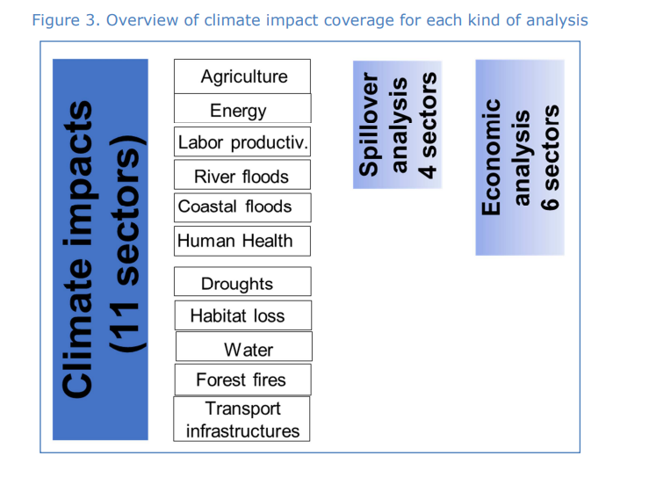Figure 5.1 Overview of sectors covered in PESETA III

**Aspects EEA could profit from:** PESETA III (or its successor, PESETA IV) could be a useful source of information on the economic impacts of climate change for the sectors where the analysis is available. The economic and the spill-over/transboundary analysis from PESETA could be included in the EEA report through a collaboration between EEA authors and JRC. JRC experts could offer data and possibly text (e.g. for a text box). This potential contribution includes adaptation scenarios (either modelling or a brief description, depending on the level of detail achieved per sector, see Table 5.2).

**PESETA IV:** The ongoing JRC PESETA IV project intends to better capture the uncertainty from climate modelling, with additional climate runs beyond the five core models of JRC PESETA III, and also add further warming scenarios (for 1.5ºC, 2ºC, 3ºC and 4ºC of global warming). Three new impact areas will be included: forest ecosystems, human health (both heat- and cold-related mortality) and windstorms. The river floods and coastal floods models will explore adaptation measures, including their costs and benefits; and additional inter-sectoral links will be considered. Communication issues (particularly to policymakers) will also receive particular attention.

**What could EEA add? What is missing in PESETA III?**

* EEA addresses more sectors/systems, generally more in detail compared to PESETA III. The PESETA main report does not differentiate between impacts on society and environment.
* The following information is missing in the PESETA approach and could potentially be added in the new EEA CCIV report if a collaboration between PESETA IV authors and EEA authors is accomplished:
* Better understanding of the impacts from extreme events
* Non-market climate impacts (e.g. impacts on natural ecosystems, migration, human health)
* Integration of various impact models (e.g. land-water-energy nexus)

Table 5.2 Coverage of topics in PESETA III and the 2016 EEA CCIV report

|  |  |  |
| --- | --- | --- |
| **Sector** | **PESETA III** | **2016 EEA CCIV report** |
| **Coastal floods** | * Considers sea level rise, high tides and storm surges * Projected economic damage,  projected affected population * Adaptation mentioned | * Part of climate change impacts on environmental systems (Global and European sea level, Chapter 4.2.2) * PESETA II is mentioned |
| **River floods** | * Does not consider pluvial and flash floods * Addresses expected economic damage,  expected population affected * Adaptation mentioned and addresses risk levels in the absence of adaptation measures | * Part of climate change impacts on environmental systems (River floods, Chapter 4.3.3) * Economic impacts are mentioned, but they do not come from PESETA |
| **Drought** | * Soil drought risk * No economic evaluation * No information on adaptation | * Soil moisture is part of climate change impacts on environmental systems (Chapter 4.4.2) * Economic impacts are not mentioned |
| **Agriculture\*** | * Impacts on rain-fed agriculture * Impacts on irrigated agriculture * Economic impacts included * No information on adaptation | * Indicators: water-limited crop yield (Chapter 5.3.4), crop water demand (Chapter 5.3.5) * No information on economic impacts |
| **Energy\*** | * Impact on heating and cooling demand * Economic analysis included * Adaptation mentioned | * Focus on heating and cooling degree days (only one indicator: Chapter 5.4.2) * Considers also energy demand, electricity production and energy infrastructure (Chapters 5.4.3 - 5.4.5) * Economic impacts are mentioned, but generally not in quantitative terms |
| **Transport** | * Airports, seaports, inland waterways (roads and rail are addressed in PESETA II) * Three climate hazards: coastal flooding, river flooding and droughts * Not part of economic analysis * Adaptation mentioned | * Addresses road, rail, water-borne, aviation sectors * Addresses economic impacts related to several extreme weather events: Heat waves, cold spells, heavy precipitations, snowfall, storms/winds are addressed (with references to PESETA II and III, Chapter 5.5.2) |
| **Water resources** | * Average flows,  low flows of river discharge and groundwater recharge,  Water Exploitation Index * Not part of economic analysis * Adaptation mentioned | * Part of climate change impacts on environmental systems (River flows, Chapter 4.3.2 and meteorological and hydrological droughts, Chapter 4.3.4). * No information on economic impacts |
| **Habitat loss** | * Change in the extent of the Mediterranean climate zone * Change in the extent of the arid climate zone * Change in Natura 2000 zones * Not part of economic analysis * Adaptation mentioned | * Part of climate change impacts on environmental systems (distribution shifts of plant and animal species, Chapter 4.4.4) * No information on economic impacts |
| **Forest fires** | * Vegetation moisture * Forest fire danger * Not part of economic analysis * No adaptation scenarios modeled but adaptation mentioned (literature review) | * Part of climate change impacts on environmental systems (forest fires, Chapter 4.4.6) * No information on economic (and human) impacts |
| **Labour productivity** | * Impacts under the high emission scenario * Impacts under the 2°C scenario * Included in economic analysis * Adaptation mentioned | * Not a specific chapter, but topic is addressed in Extreme temperatures and health chapter |
| **Mortality due to heatwaves** | * Estimated mortality due to heatwaves per year under various climate scenarios * Not part of economic analysis | * Part of climate change impacts on environmental systems (Extreme temperatures and health, Chapter 5.2.4) * PESETA II and III are mentioned |

*Note: Further information on the sectors marked with * is available in EEA Reports No 1/2019 and 4/2019.*

## IPCC WG II AR6

The IPCC prepares assessment reports reviewing the latest knowledge on climate change, its causes, potential impacts and response options. IPCC has published five comprehensive assessment reports so far, as well as several special reports on particular topics. The Fifth Assessment Report (AR5) was published in 2013/4; the Sixth Assessment Report (AR6) is currently being prepared and will be published in 2021 and 2022 (see Figure 5.2). Each assessment report consists of three volumes, corresponding to the three Working Groups of IPCC. Moreover, a synthesis report integrates the working group contributions.

Figure 5.2 Timeline of Reports that will be published by IPCC within the 6th Assessment Cycle[42]

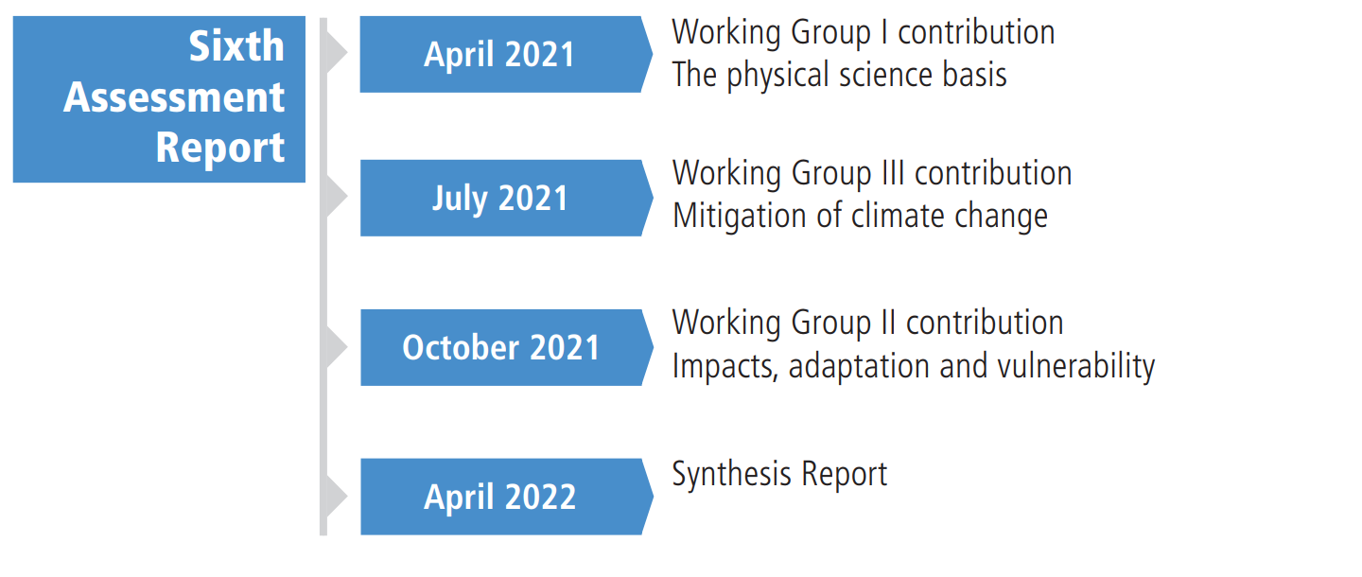

The outline of AR6 WGII is available online[43]. The document serves as a guideline for the authors of AR6 to be published in 2021. The most relevant content that can be used as source for the EEA CCIV report is the contribution of Working Group II (Impacts, adaptation and vulnerability), in particular the Europe regional chapter. Further relevant information can be sourced from the Working Group I contribution (The physical science basis).

The following points summarise the main characteristics of the IPCC reports:

* **Climate changes scenarios:** AR5 WGI is based primarily on results from the CMIP5, driven by Representative Concentration Pathways (RCPs). AR5 WGII also used results from the CMIP3. AR6 WGI will be based on CMIP6 whereas AR6 WGI will be based on a combination of CMIP5 and (some) CMIP6 results.
* **Impact sectors:** a wide range of sectors covers physical, biological, and human systems.

The following sectors are addressed in the *AR5*:

* Natural and Managed Resources and Systems and their use: Freshwater resources, Terrestrial and inland water systems, Coastal systems and low-lying areas, Ocean systems, and Food security and food production systems
* Human Settlements, Industry, and Infrastructure: Urban areas, Rural areas
* Human Health, Well-Being, and Security: Human health: impacts, adaptation, and co-benefits, Human security, and Livelihoods and poverty

The overall number of sectorsin *AR6* will decrease compared to AR5 (no rural areas, no human security, terrestrial and freshwater systems will be joined in one chapter, with less pages dedicated). Each chapter on sectors in AR6 will cover observed impacts, projected impacts, adaptation and mitigation responses, and their interactions with sustainable development.

* **Regional chapter on Europe**: the number of pages of the AR6 regional Europe chapter will be similar to the regional chapter in the AR5[44] (ca. 40 pages). The chapter on Europe in the AR5 was structured around the following policy areas:
* Production systems and physical infrastructure
* Agriculture, fisheries, forestry, and bioenergy production
* Health protection and social welfare
* Protection of environmental quality and biological conservation.

The (internal) zero order draft of the AR6 chapter for Europe is structured addresses a wider range of policy areas:

* Terrestrial and freshwater ecosystems and their services
* Ocean and coastal ecosystems and their services
* Water
* Food, fibre, and other ecosystem products
* Cities, settlements and key infrastructure
* Health, wellbeing and the changing structure of communities
* Poverty, livelihoods and sustainable development
* Trans-European impacts, risk and adaptation
* **Coverage of policy-relevant CCIV topics in the IPCC Assessment Reports:**
  + **Risks:** In the AR5, key risks from climate change are identified and listed in a table. However, they are not identified through a quantitative risk assessment process but based on assessment of the literature and expert judgment. The AR6 WGII contribution will assess current sectoral risks and projected risks; this will include identifying key risks and residual risks as well as development pathways depending on the rate and level of climate change.
  + **Risk assessment** is mentioned as part of the regional chapter in the AR6 outline9: “Summary Table and/or figures with WGI and WGII information, combined with risk assessment (e.g., SREX SPM.1)”. However, the level of detail and the methodology which will be followed is not yet clear.
  + **Adaptation**: Adaptation options are only addressed in some sectoral chapters in the AR5 WGII contribution. Moreover, the AR5 WGII chapter on Europe shortly refers to adaptation options and challenges, also including two short sections on the topic: “Economic Assessments of Adaptation” and “Co-Benefits and Unintended Consequences of Adaptation and Mitigation”. However, the regional chapter of AR5 does not give a systematic overview of adaptation options per sector. According to the AR6 outline, adaptation options will be addressed in each sectoral chapter. Adaptation might be addressed in more detail in the regional chapters, considering that the AR6 outline for the regional chapters lists “Diverse adaptation options including opportunities, enablers, limits, barriers, adaptive capacity, and finances” as one of the guidance points for the authors of AR6 .
  + **Economic assessments** of impacts/adaptation: the AR5 regional chapter addresses briefly these topics in some sectoral paragraphs and specific in the section “Economic Assessments of Adaptation”. The PESETA study is used as one of the sources.
* **Aspects EEA could profit from:** The IPCC AR6 regional chapter on Europe (including draft versions) could function as a first source of information on relevant sectors. However, sector-specific sections are very brief, and most sectoral impacts are not described through maps. EEA carried out a more in-depth analysis of climate-sensitive sectors than the IPCC AR5. Therefore, if EEA decides to keep the same approach, information from the IPCC AR6 would need to be complemented through other sources.
* **Added value of EEA CCIV report:** The 2016 EEA CCIV report provides many maps covering all of Europe, thereby enabling comparisons between countries. The IPCC report, in contrast, generally gives country/city specific examples. (Examples for sentences from the IPCC AR5: “For two Danish river catchments”, “In Upper Austria”, “a study in the UK found that”, “Evidence from France and Italy indicate..”).

Table 5.3 Sector coverage in the IPCC AR5 (regional chapter Europe) and the 2016 EEA CCIV report

|  |  |  |
| --- | --- | --- |
| **Sector** | **IPCC AR5 WGII chapter on Europe** | **2016 EEA CCIV report** |
| Production systems and physical infrastructure | 4 pages   * Settlements (Coastal flooding, River and Pluvial Flooding, Windstorms, Mass Movements and Avalanches) * Built environment * Transport * Energy Production, Transmission and Use * Industry and Manufacturing * Tourism * Insurance and banking | * The EEA CCIV report covers most of these topics, but they are distributed across different chapters. * Industry and manufacturing is not present in the EEA CCIV report. * The EEA report is generally more detailed (e.g. tourism is covered in two detailed sections on summer and winter tourism). |
| Agriculture, Fisheries, Forestry, and Bioenergy Production | 6 pages   * Plant (Food) Production * Livestock Production * Water Resources and Agriculture * Forestry * Bioenergy Production * Assessment of Climate Change Impacts on Ecosystem Services * Fisheries and Aquaculture | * The EEA report is more detailed (e.g. agriculture alone comprises 21 pages) |
| Health and Social Welfare | 3 pages   * Human Population Health * Critical infrastructure * Social impacts * Cultural heritage and landscapes | * The EEA report is more detailed (e.g. health covers more than 20 pages, addressing many different diseases) |
| Protection of Environmental Quality and Biological Conservation | 2 pages   * Air Quality * Soil Quality and Land Degradation * Water Quality * Terrestrial and Freshwater Ecosystems * Coastal and Marine Ecosystems | * Air quality is not addressed * Terrestrial and Freshwater Ecosystems, and Coastal and Marine Ecosystems are addressed in more detail (>20 pages each) |

## Internal suppliers of information

### EEA sectoral reports

Many of the environmental systems and social sectors addressed in the EEA CCIV report (Chapters 4 and 5) are also addressed in sectoral or thematic EEA reports, both with an adaptation focus and a more general focus. Since these reports have a narrower focus, they contain additional information which is not fully included nor summarised in the CCIV report. For example, the EEA report “*Adaptation of transport to climate change in Europe*” addresses the topic of climate change adaptation for the transport sector whereas adaptation actions for the transport sector are not addressed explicitly in the EEA CCIV report. A future CCIV report could re-use information from existing sectoral EEA reports. CCIV-related information needs may also be considered in the planning of future thematic and sectoral EEA reports, thereby facilitating the addition of new policy relevant topics without excessive resource use. In order for these EEA reports to feed into a future EEA CCIV report, their content and presentation would need to be streamlined and planned in advance. A follow-up ETC activity could explore options for such a coordinated report development.

The recent EEA report “*Adaptation challenges and opportunities for the European energy system*” can be used as an example how EEA sectoral reports could be used for updating and adding new policy relevant topics to a CCIV report. This report follows a structure that is similar to the one of the CCIV report. It starts from the climate change impacts on the energy system, which are partially covered in the 2016 CCIV report, but it also covers specific adaptation options and policies, which are not included in the 2016 EEA CCIV report. A similar approach for the other sectors would allow to connect different EEA reports and topics to the EEA CCIV publication.

### Climate-ADAPT

Climate-ADAPT provides among others information on expected climate change, current and future vulnerability of European regions and sectors, combined with a focus on adaptation options and the European and national policy context. The database of adaptation measures is presented as a list of case studies, reports and toolsets. This pool of information could represent a useful source if adaptation options were to be included at sectoral level in a future CCIV report.

Summarising all the information regarding adaptation options per sector present on Climate-ADAPT would require substantial time and resources. However, such a summary could also be included on the portal itself to help guiding the reader. Since EEA has control over the content and the structure of the Climate-ADAPT portal and database, information could be streamlined or summarised into information on adaptation options per sectors in order to fit both the demands from the CCIV report and the ones of the portal itself. For example, potential and successful adaptation options could be structured per sector with links to further instructions, best practise example etc. Better alignment between Climate-ADAPT and a future CCIV report could be explored in a follow-up ETC activity as described above also for the sectoral EEA reports.

# Outcomes of the 2019 Eionet meeting on adaptation

**Key messages/recommendations:**

* Discussants at the Eionet meeting on adaptation in June 2019 emphasized that the 2016 EEA CCIV report has been an excellent tool for awareness raising and context setting, and that it has inspired related work at the national scale. Discussants also emphasized that the 2016 CCIV report was an important ‘one stop shop’, bringing relevant information together in a single document.
* In contrast to the 2014 user survey, discussants showed little awareness and/or use of the underlying indicators published on the EEA website. (The same holds for the information from C3S, such as the 2018 European State of the Climate report.)
* Participants also made content-related suggestions for a future EEA CCIV report.
  + Stronger focus on a risk perspective and socio-economic impacts
  + Systematic information on adaptation options and barriers per sector
  + Inclusion of clear policy recommendations
* Format-related suggestions: a more interactive presentation of information online (with options for zooming into maps)

## Information demands of the European Commission

Claus Kondrup from the Adaptation Unit of DG CLIMA presented these adaptation-related information needs of the Commission:

* More information on vulnerabilities, risks and adaptation options.
* Improved modelling and cost-benefit assessment
* Give more focus to citizen-level impacts (e.g. health)
* Stimulate use of Copernicus, standards for adaptation, sustainable finance taxonomy
* Increase coherence between adaptation and sustainable development, biodiversity protection and disaster risk reduction
* Better align to new international framework (Paris, Sendai, SDGs)

This list relates well to the knowledge needs identified in chapter 4. The list obviously does not imply that all the topics have to be covered in an EEA report, but they indicate the general tendency that there is a growing demand for knowledge of vulnerabilities/risks and adaptation. This reflects a natural evolution from increasing awareness of the progressing climate change to developing actions that address the challenges identified and confirmed in the past EEA CCIV reports.

## Outcome of break-out group from 2019 Eionet workshop

During the Eionet workshop on climate change adaptation in June 2019, Hans-Martin Füssel and Marc Zebisch organised a break-out group to discuss the content and format of a 2022 EEA CCIV report with approximately 25 participants (see pictures in Annex III: Results from break-out group during 2019 Eionet workshop on adaptation).

**The guiding question to the participants were:**

*Content*

* How could future EEA work on CCIV(A) best complement the information available from other sources?
* What would be the most policy relevant elements you would like to see in a 2022 EEA report?

*Format*:

* What would be your preferred format of a future EEA CCIV(A) report?
* How important is it to have a structured (printed) report compared to having information online that can be more easily updated?

**Results**

As the most policy relevant *content* items the following elements where identified:

* Risk perspective and (socio-)economic impacts to support policy prioritisation
* Systematic information on adaptation options and barriers per sector
* Information on cost-effectiveness of adaptation measures
* Policy recommendations
* Integrate information on disaster risk reduction

Regarding the *format*, participants highlighted the following aspects:

* More interactive format with option to zoom in maps (regional / national scale)
* Make all figures from the report downloadable (like IPCC reports)

**Further tentative conclusions**

* Good cooperation between EEA, JRC and C3S is highly desirable for bringing relevant information together
* Updates of online indicators are not much used (or known)
* Necessary to integrate discussion and planning of
  + 2022 EEA CCIV report,
  + EEA (CCIV) indicators,
  + Sectoral/thematic adaptation reports,
  + Climate-ADAPT development (including new interactive features)
* Which high-priority sectors or themes could EEA address? (so far: transport, energy, agriculture, disaster risk reduction, urban adaptation)

# Options for a future EEA CCIV(A) report

**Key messages/recommendations:**

* To enhance policy relevance, the content of a 2022 CCIV(A) report could include more information on:
  + Risk and vulnerabilities per sector
  + Adaptation options per sector (including on their effectiveness)
* An efficient coordination of CCIV services and products by EEA, C3S and JRC is crucial for exploiting synergies and avoiding duplication of work. This would require a good coordination of these future activities:
  + C3S: climate data, processing of indicators, visualisation and interpretation of climate information
  + JRC: climate impact and risk assessment, economic impacts, effectiveness of adaptation
  + EEA: adaptation, policy demand, complementary impacts
* Options for an appropriate format to present the new EEA report reach from a classical format with expanded information content (Format B) to a completely re-designed web-based version with links to external data providers (Format F).

## Conclusions from Chapters 1-6

1. There is a clearly expressed **policy and user demand for information** on climate change **that goes beyond climate impacts**. Potential additional information which would increase the policy relevance of an EEA CCIV(A) report includes:
   1. information of vulnerabilities (e.g. non-climatic factors and drivers) and assessment of risks. This information could be added in each sectoral chapter. Information on vulnerabilities and risks are becoming increasingly available both through national analyses and European wide studies[45].
   2. adaptation demand and adaptation options could be integrated in each sector chapter, with a link to further information on Climate-ADAPT
   3. Aspects of ecosystem-based adaptation (EbA) could be included
   4. The link to disaster risk reduction strategies could be strengthened, e.g. in a paragraph in each indicator section (if relevant for this indicator) or in a separate chapter on “linking adaptation and disaster risk reduction”.
   5. Information on economic impact from JRC PESETA projects (and other relevant projects, such as COACCH[46]) could be integrated into the sectoral chapters
2. A 2022 CCIV report could profit from a clever **integration and harmonization of external information sources (C3S for climate information, JRC PESETA for economic impact and risk information)** as well as **EEA internal information source (Climate-ADAPT for adaptation options per sector, other sectoral EEA reports**, see **Error! Reference source not found.**).
   1. **C3S** could provide all climate data and indicators, including graphs, figures and possibly assessment text, following a specific request by EEA. C3S may also provide innovative online tools for the spatially explicit visualization of key climate indicators. Such a collaboration could save considerable resources in the production of the CCIV report, but it would require clear agreements on information demand between EEA and C3S.
   2. **JRC** could provide sector-specific information on climate impacts, including economic impacts and risks for specific sectors, which are covered by the PESETA projects. Ideally, future editions of PESETA could be based on the same climate information from C3S as to ensure consistency. (Furthermore, information from PESETA and other JRC projects could be used in the C3S Sectoral Information System.) Further coordination between C3S and JRC would be required to achieve this consistency.
   3. **IPCC AR6** can offer complementary information, based on its authoritative literature review.
   4. **Climate-ADAPT** could provide sector-specific information on adaptation options from its database of case studies, reports and toolsets. The coordination between the CCIV report and Climate-ADAPT could be part of future ETC/CCA activities.
   5. For **sectors** that are covered by specific **EEA adaptation reports** (e.g. energy, transport, agriculture), information on impacts, vulnerabilities, risks as well as adaptation demand and options could be extracted from these reports. The structure of the latest EEA report on climate change adaptation in the European energy system is a very good example for a report that allows extracting relevant information for the EEA CCIV report.

Figure 7.1 Opportunities for the integration and harmonization of CCIV information sources from several EEA, C3S and JRC activities

## Content elements of a future EEA CCIV(A) report

As shown in chapter 4 and 5, a wide variety of organizations are providing information on climate change and adaptation at global, European, national and subnational levels. In this information landscape, the EEA reports should add value and be policy relevant by providing an undisputed and consolidated knowledge base for Europe that EU institutions, transnational regions and EEA member countries can use as a basis for awareness raising, development of adaptation strategies, and the prioritisation of policies and actions. Some elements of this knowledge base are only emerging. For example, the Regulation on Governance of the Energy Union and Climate Action required EU Member States to report on their adaptation progress by March 2021. This reporting covers national adaptation strategies and plans, outlining implemented and planned actions to facilitate adaptation to climate change. Details of the content and format of this reporting will be specified in an Implementing Act that is currently under discussion.

As analysed in chapters 4 and 6, new content elements may be of interest for the EEA report to address new information demands arising from the ongoing implementation of adaptation strategies at EU, national and subnational level as well as in various sectors.

The conclusions from Chapters 1-6 presented above allows identifying key elements for the contents of a future EEA CCIV(A) report (see Figure 7.2). These elements cover expressed demands and go beyond the contents of the 2016 CCIV report (in white in Figure 7.2). They stem from the analysis of policy demand and discussions during the 2019 Eionet meeting on adaptation. Elements in blue show complementary information sources (see also Figure 7.1 **Error! Reference source not found.**). Yellow shows potential content elements that were not included in the 2016 report. Contents in bold and underlined was rated as particularly policy relevant during the Eionet workshop. Section 7.3 presents different options and formats for delivering the information. The format will determine the depth and extent of the information provided. In the Policy-oriented summaries topics will be covered in short statements and graphical presentations whereas dedicated background reports can provide extensive reviews of chosen issues. The Annex provides an elaborated structure for a comprehensive report of roughly 200 pages (see Annex I: Potential report structure according to “Format B”).

Figure 7.2: General building blocks of a future EEA CCIV(A) report

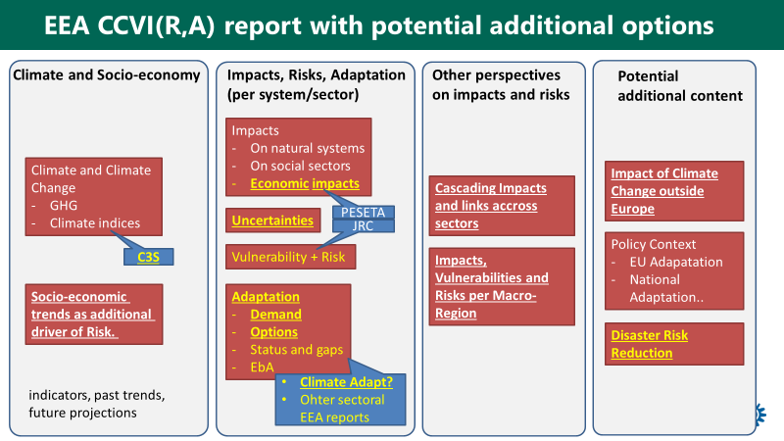

Note: Yellow denotes potential new elements; blue denotes potential data source. Content in bold and underlined was rated as particular policy relevant in discussions during the 2019 Eionet adaptation workshop.

## Options for the format of a future EEA CCIV(A) report

The development of several options for the format of a future EEA CCIV(A) report was guided by the aims to maintain and if possible, to improve policy relevance and accessibility for policy makers at different levels and the interested public, reliability and scientific transparency, and to increase timeliness and flexibility for updating and in dealing with emerging topics. In addition, resource constraints and the demand on rethinking publication strategies have been considered.

The choice of format will affect how the different content elements elaborated in Section 7.2 are presented, and how comprehensive each element is covered. We have assessed five formats, ranging from Format A with minor changes, to Format F with a fundamental new approach, product and organization of the supporting research and information. The formats that have been explored are examples of how EEA might present CCIV(A) information. They are intended as impulses for thinking about alternative approaches for the EEA CCIV(A) report, other products.

### Assessment criteria

In exploring format options, we take the format of the 2016 EEA CCIV report as starting point (i.e. format ‘A’). We then show five indicative alternatives (formats B to F), with increasing changes in approach, products and organization. These formats include various elements used in CCIV reports from other organisations (see in particular chapter 3), including: Technical background publications, Policy summaries, Attractive booklets/infographics, Websites, Web-atlas and Data portals.

Exploring a possible new format for the EEA CCIV(A) reporting mechanism, which would consider the additional content and better integration of other information sources (see above) we assessed the following options according to **eight criteria**. Six of the criteria refer to **outcomes** and two to **input**/resource criteria. These criteria have been developed in view of the EEA ambitions,[47] the outcome of the EIONET workshops and the EEA guidance provided for this scoping report (see also Chapter 1).

**Outcome criteria**

1. ***Relevance and accessibility for senior EU policy-makers***

Policy relevance for senior policy makers requires that the information provided on climate change, impacts and vulnerabilities across Europe is strategic, highlighting intermediate term and new developments in the key socio-economic domains, including the international development. The links to policy domains and strategic choices at the level of policies should be explicit, but to be accessible not necessarily very detailed. Brevity is important as well as general overview illustrations that capture key trends in impacts, vulnerabilities and risks.

The primary audience includes high ranking officials in the Commission, Members of the European Parliament, CEOs of key private sector enterprises and leaders of European civil society organisations.

1. ***Relevance and accessibility for EU policy advisors/experts***

Policy relevance for EU level policy advisors and experts requires that the information provided on climate change, impacts and vulnerabilities across Europe is comprehensive and spatially disaggregated at least to the level of macroregions, highlighting intermediate term and new developments in the physical changes as well as socio-economic domains, with references to the international development as appropriate. The links to policy domains should be explicit, and details should be provided on the connections between adaptation action and factors affecting impacts, exposure and vulnerabilities. Easy access to background information increases relevance.

The primary audience includes expert officials in the Commission, Advisors to Members of the European Parliament, sustainability experts in key private sector enterprises and experts in European civil society organisations.

1. ***Relevance and accessibility for national policy-makers***

Policy relevance for national policy makers requires that the information provided on climate change, impacts and vulnerabilities across Europe is comprehensive and spatially disaggregated as far as possible to the level of individual countries or even regions within countries (NUTS3). Intermediate term and new developments in the physical changes as well as socio-economic domains should be highlighted. The links to policy domains should be explicit, and details should be provided on the connections between adaptation action and factors affecting impacts, exposure and vulnerabilities.

The primary audience includes senior and expert officials in national governments and agencies, sustainability experts in key private sector enterprises and leaders and experts in national civil society organisations dealing with climate change issues.

1. ***Relevance and accessibility for the interested public***

The interested public is a wide audience encompassing people with various backgrounds. To be relevant and accessible the information should be provided in a way that can be understood without extensive background knowledge, but at the same time information should also be provided to allow those with an interest in the matter to find supporting background information. Impacts, vulnerabilities and risks are of particular interest, coupled with concrete examples and overviews in maps, illustrating the geographical characteristics of climate change. Region and country specific information increases accessibility and interest for the public. General description of adaptation actions increases accessibility.

The primary audience includes educated lay persons, journalist, students and activists in NGOs.

1. ***Reliability and scientific transparency***

Scientific quality and transparency is critical for the legitimacy of the findings and conclusions of EEA reports. In the wide variety of information to be found on climate change, impacts, vulnerabilities and adaptation on the internet, the EEA report has to stand out representing the best available consolidation of knowledge about the situation and developments in EEA member states. Clear links to the scientific background information is thus of high importance.

1. ***Timeliness and flexibility***

Climate change impact and adaptation are characterized by a continuous flow and new information and insights from research, policy development and adaptation practice. In this dynamic environment, flexibility of the reporting system is of great value, as it allows for periodic updates or even for an ad hoc intervention based on new information availability or needs.

**Input/resource criteria**

1. ***Resource needs***

The periodic production of an EEA CCIV(A) report requires significant resources. While this scoping paper cannot to assess the resource needs for the different format options in detail, we include a tentative assessment of resource needs (relative to the reference format 0).

1. ***Required changes and innovation***

We provide a tentative assessment of the changes required in information collection, presentation (including EEA product types) and collaboration with other organisations, compared to the reference (format A).

### Explored formats

The following tentative formats were explored:

* **Format “A” (reference):** The compendium character of the most recent EEA CCIV report is perceived as very positive by users and is considered as the reference against which other formats are compared. It includes the indicators available on-line that present essentially the same information as the indicator-based parts of the report. This approach allows updating a large number of indicators in parallel with publication of the report with very limited extra resources. The main advantage of the indicators online is that they can be updated more frequently if relevant new information becomes available and that they can be searched independently on the EEA website. Furthermore, most indicators allow users to download maps and figures, which is not currently the case for illustrations from EEA reports.
* **Format “B”** would keep the structured printable report as a core concept but rework the structure to include the recommended additional content such as adaptation options (see Figure 7.2) from C3S, JRC and CLIMATE-Adapt (see Figure 7.2). The text would need to be significantly shortened by using concise and targeted text in the core part (climate impacts and adaptation options per sector). Furthermore, the chapters which provide primarily background and context information (e.g. policy context, strengthening the knowledge base) would need to be shortened and pruned. We believe that the overall report should not exceed 200 text pages. Such a shortened report would be complemented by web-based background information (e.g. with indicators as in the current format “A”). See a proposal for the structure of format B in Annex I.

1. ***Relevance and accessibility for senior EU policy-makers*:** Strong Increase in relevance due to more information on adaptation, accessibility as for A.
2. ***Relevance and accessibility for EU policy advisors/experts:*** Strong increase in relevance due to more information on adaptation, accessibility as for A.
3. ***Relevance and accessibility for national policy-makers:*** Increase in relevance due to more information on adaptation, but greatly dependent on availability of national/macro region level informationrmation for accessibility.
4. ***Relevance and accessibility for the interested public:*** Broader contents with reflections on ‘fuller’ spectrum of issues likely to increase relevance and accessibility to salient information.
5. ***Reliability/scientific transparency:*** Reliability and transparency can probably be kept at the level of A despite shortening when a wider area is covered.
6. ***Timeliness and flexibility:*** Comparable to A, driven by the reporting cycle and the possibilities to adjust/update web-based information.
7. ***Resource needs:*** No significant difference from A, but more effort on coordination with other information providers outside (C3S, JRC) and inside EEA (Climate-ADAPT) and less on producing content.
8. ***Required changes and innovation:*** Some new thinking on how to allocate available space and resources.

* **Format “C”** would include all the elements of Format “B” but add a policy-oriented synthesis (both hard copy and web-based). Already the 2016 report hase an executive summary which included one table and one map and aimed at briefly covering ‘all’ pieces of information that the report covered. The policy-oriented synthesis of Format “C” would take its starting point in ongoing policy developments and focus on specific messages for ongoing policy-making processes. It is also expected to provide more easily accesible graphical information. The policy relevance and accessibility to both policy makers and interested public are expected to increase relative to Format “A” and “B”.

1. ***Relevance and accessibility for senior EU policy-makers:*** Policy-oriented synthesis increases relevance clearly relative to A. The accessibility of the report proper may slightly increase with its shortening.
2. ***Relevance and accessibility for EU policy advisors/experts:*** Policy-oriented synthesis increases relevance relative to A. The shortening may reduce accessibility to relevant information.
3. ***Relevance and accessibility for national policy-makers:*** Policy-oriented synthesis increases relevance relative to A. The shortening is likely to reduce accessibility to relevant information at the country level.
4. ***Relevance and accessibility for the interested public:*** Policy-oriented synthesis may increase relevance relative to A. The shortening is likely to increase accessibility as perceived by the public.
5. ***Reliability/scientific transparency:*** Policy-oriented synthesis may more clearly bring out the evidence base. Reliability and transparency can probably be kept at the level of A despite shortening when a wider area is covered.
6. ***Timeliness and flexibility:*** Comparable to A, driven by the reporting cycle and the possibilities to adjust/update web-based information.
7. ***Resource needs:*** Policy-oriented synthesis requires marginal additional resource.
8. ***Required changes and innovation:*** A good policy-oriented synthesis requires in depth considerations of the policy scene.

* **Format “D”** hasan extended policy-oriented synthesis as a main product, without a longer EEA report in the background. In addition, EEA would create background reports and papers, each supporting a specific chapter. This would potentially require the establishment of a new product category (“technical/background reports”) at the EEA. The quality of this background report would be essential to keep the high scientific reputation and transparency of the current report.

1. ***Relevance and accessibility for senior EU policy-makers:*** The policy-oriented synthesis increases relevance clearly relative to A. The existence of additional harmonized material strengthens relevance and accessibility. This makes it possible to use in different contexts (cf Commission proposals with supporting staff documents).
2. ***Relevance and accessibility for EU policy advisors/experts:*** The policy-oriented synthesis increases relevance clearly relative to A. The existence of additional harmonised material strengthens relevance and accessibility. Makes it possible to use in different contexts by different DGs.
3. ***Relevance and accessibility for national policy-makers:*** The policy-oriented synthesis increases relevance clearly relative to A. The existence of additional harmonized material can strengthen relevance and accessibility also for country level. Makes it possible to use in different contexts within countries. On the other hand, the missing level of scientific detail may reduce applicability for national purpose.
4. ***Relevance and accessibility for the interested public:*** The policy-oriented synthesis may increase relevance relative to A. The existence of additional harmonised material can strengthen relevance and accessibility also for parts of the public. Provides pathways to new information.
5. ***Reliability/scientific transparency:*** The lack of a full report as in option A, B and C would decrease the character of a scientific compendium.
6. ***Timeliness and flexibility:*** Makes it possible to update and introduce new specific partial reports as needed.
7. ***Resource needs:*** The production of separate partial reports can be done under resource constraints to keep the level of A, but some increase is likely to be inevitable, if the same width is sought as multiple reports generate additional tasks relative to a single report.
8. ***Required changes and innovation:*** This format requires a full restructuring of the way the CCIV information has been presented since the beginning of ‘major reports’ on CCIV

Figure 7.3 Structure of Format D with a policy-oriented synthesis as main product, supported by chapter specific background papers/reports

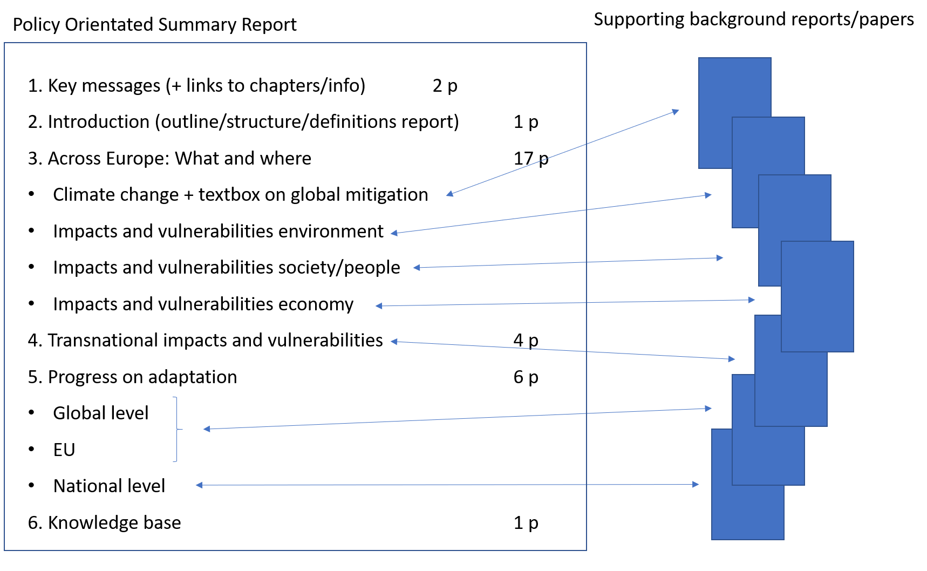

* **Format “E”** would be like Format D, but EEA would reduce its own active role in developing information and concentrate on disseminating information that is readily available from other sources. This would reduce EEA’s resource needs significantly, but also reduce the possibility of incorporating CCIV information in other EEA products. Furthermore, it would mean that EEA to a greater degree relies on external quality control and interpretation of data.

1. ***Relevance and accessibility for senior EU policy-makers***: The policy-oriented synthesis increases relevance clearly relative to A. The lack of harmonized background information may decrease policy relevance. Accessibility can be confused.
2. ***Relevance and accessibility for EU policy advisors/experts:*** The policy-oriented synthesis increases relevance relative to A, but the lack of harmonised background information clearly decreases policy relevance. Accessibility can be confused.
3. ***Relevance and accessibility for national policy-makers:*** The policy-oriented synthesis may increase relevance marginally compared to A, but the lack of harmonised background information clearly decreases policy relevance. Accessibility can be confused.
4. ***Relevance and accessibility for the interested public:*** The policy-oriented report may increase relevance relative to A. The links to others sources of information is likely to be perceived as useful, even if harmonisation isn’t fully developed.
5. ***Reliability/scientific transparency:*** The policy-oriented synthesis may more clearly bring out the evidence base. Reliability and transparency is likely to suffer somewhat due to lack of harmonisation and consistent metadata etc.
6. ***Timeliness and flexibility:*** By linking to new information flexibility can be achieved, but since the material is to a large extent external the flexibility and timeliness may not be achieved.
7. ***Resource needs:*** Production costs can be reduced significantly as only key information is extracted from external sources of information and no effort is required for maintaining the information.
8. ***Required changes and innovation***: A rethinking of the role of the EEA would be necessary.

* **Format “F”** also has a policy-oriented synthesis as main product but with fully reorganised reporting and information structure, using directly relevant content produced by C3S and JRC (and possibly other organisations) and from Climate-ADAPT. The synthesis would be complemented by a new ‘Climate change and adaptation atlas of Europe’ (maps). This option requires an effective collaboration between EEA, C3S and JRC (see Figure 7.2) to bring together the produced maps. This approach resembles the one applied in the SOER2020 which presents short summaries of indicator-based information in the SOER and includes links to many indicators with more detailed information online.

1. ***Relevance and accessibility for senior EU policy-makers***: The policy-oriented synthesis increases relevance clearly relative to A. Harmonized background material strengthens relevance and accessibility as for D.
2. ***Relevance and accessibility for EU policy advisors/experts:*** The policy-oriented synthesis increases relevance relative to A. Harmonised background material strengthens relevance and accessibility as for D. Joint work across organisations increases accessibility and relevance.
3. ***Relevance and accessibility for national policy-makers:*** The policy-oriented synthesis increases relevance relative to A. Harmonized background material strengthens relevance and accessibility as for D. Joint work across organizations increases accessibility and relevance also at country level if salient material is provided.
4. ***Relevance and accessibility for the interested public:*** The policy-oriented synthesis may increase relevance relative to A. Harmonised background material strengthens relevance and accessibility as for D. Joint work across organisations increases accessibility and relevance for the public.
5. ***Reliability/scientific transparency:*** The policy-oriented synthesis may more clearly bring out the evidence base. Reliability and transparency can be increased if standardized presentations and metadata are achieved across organizations.
6. ***Timeliness and flexibility:*** Makes it possible to update and introduce new specific partial reports as needed, concerted action by several organizations strengthens possibilities for timely analyses.
7. ***Resource needs:*** The cooperative effort and harmonization across organizations is likely to require resources even if the ‘in house’ production is reduced. Ultimately the level depends on the distribution of tasks across participating organizations
8. ***Required changes and innovation:*** Developing the role of EEA to lead widely the delivery of CCIV(A) information in Europe also at a networking level

All criteria are assessed relative to the current format labelled A (see Table 7.1). Thus a plus (+) indicates an observable increase in the score for that particular criterion; (++) a significant increase; (+++) a major increase in the score. One or several minus signs (-) indicate a reduction relative to the reference. The scoring is, however not linear: scores (++) and (+++) do not mean a doubling or tripling respectively of a score (+), nor does (--) imply a comparable reduction. In several cases the details of the implementation are likely to affect the score. Such situations are indicated by slashes (/) between alternative scores.

Format B with a shortened and improved content but quite traditional in structure, would in practice be close to the 2016 EEA report (Format A = Reference). The partial reorientation may increase slightly the policy relevance (+). The shortening may mean that fewer primary scientific sources can be used. Due attention to the choice of sources is required to prevent a (perceived) loss of scientific transparency. The addition of a separate policy-oriented synthesis in Formats, C, D, E and F results in higher scores for policy relevance as well as accessibility for policy makers and the interested public. Format D and Format F receive the highest scores but require new approaches in organizing the information and background reporting. Format D and Format F thus require the most changes and innovation in products and organisation and are expected to require more resources. Format C includes both a shortened EEA report and a policy-oriented synthesis. This option is expected to require some additional resources relative to Format A.

Strategically, Format F is the most innovative format in which EEA deepens its collaboration with other relevant institutions and assumes a leading role in organizing and presenting CCIV information. This may substantially strengthen EEA’s position and profile as the deliverer of policy relevant CCIV knowledge for Europe, but likely requires new forms of co-operation in the form of joint projects and/or harmonized work programs across organizations.

Format E is the option with the lowest resource needs, but the reliability/scientific transparency is under greater pressure as this format depends almost completely on the availability of secondary sources. This format may enable an increase in policy relevance and accessibility, if the sources to be referred to are chosen well, but the scores are lower compared with options D and F. The timeliness and flexibility may increase relative to the reference level, if externally produced material is available for all policy areas of interest. In newly developing policy areas, however, situations may arise in which no organisation exists to deliver up-to-date new information on CCIV(A). In this case, timeliness may decrease relative to the reference level in which some resources were available for extending the report to cover new areas (for example, transboundary impacts in the 2016 report). In all the other options, reliability/scientific transparency scores can be maintained or even increased relative to the reference.

Assessing the resource needs of the formats in this stage is highly tentative. Over time, further exploration of what is needed and what is required may result in lower or higher resource needs than assessed in Table Table 7.1. However, Format E should only be regarded as the preferred pathway if reducing resources for EEA CCIV reporting is of high strategic importance.

For Formats B-F, users expressed that they would like to be able to access all figures, graphs and maps as high resolution images for download. A Web-GIS version of maps with the option to zoom into specific regions would also be desirable.

|  |  |  |  |  |  |  |
| --- | --- | --- | --- | --- | --- | --- |
| **Format** | **A** | **B** | **C** | **D** | **E** | **F** |
|  |  |  |  |  |  |
|  | ‘Old EEA Report’ (hard copy + web-based) with current web-based indicators | Shortened EEA report (S) (hard copy+ web-based) withadjusted content,  Including relevant adaptation information and web-based indicators | Shortened EEA report (hard copy+ web-based) with adjusted content,  including relevant adaptation information and web-based indicators + Policy-oriented Synthesis (P) | Policy-oriented Synthesis + (webbased) background reports/papers  (scientific transparency undisputed) | Policy-oriented Synthesis (P)  + link to web based indicators and information maintained by other bodies | Policy-oriented Synthesis (P) with  supporting reports & material and actively negotiating contents of -material produced by other key bodies (C3S, JRC...) |
| **1.Relevance and accessibility for senior EU policy-makers** | = | + | ++ | +++ | - | +++ |
| **2. Relevance and accessibility for EU policy advisors/experts** | = | + | + | +++ | - | ++ |
| **3. Relevance and accessibility for national policy-makers** | = | =/+ | =/+ | + | ++ | +++ |
| **4. Relevance and accessibility for the interested public** | = | + | + | ++ | - | +++ |
| **5.Reliability/ scientific transparency** | = | = | =/+ | - | +/- | +++ |
| **6. Timeliness and flexibility** | = | = | = | ++ | - | +++ |
| **7. Resource needs** | = | = | + | +/++ | - - | +/++ |
| **8. Required changes and**  **innovation** | = | + | ++ | +++ | ++ | +++ |

Table 7.1 Options for different formats of a future CCIV report and tentative comparison based on eight criteria. Blue: outcome criteria. Yellow: input criteria

# Annex

## Annex I: Potential report structure according to “Format B”

In the following, we present a potential structure of a printed and/or electronic report according to “Format B”. This option follows the proven structure of the 2016 report, but with overall shortened text (in total ~ 200 pages) despite additional content items.

**Introduction (ca. 10 pages)**

* Much shorter (max. 10 pages)
* Only Introduction which is relevant to understand the structure and methodology
* Policy context briefly highlighted, with main contents moved to relevant later chapters
* Global emissions moved to climate chapter

|  |  |  |  |  |
| --- | --- | --- | --- | --- |
| ***Section*** | ***Current approach*** | ***Potential new approach*** | ***Remark / open questions*** | ***Pages*** |
| Purpose and scope | 5 pages | Shorter, including structure and policy context (very short) |  | 4 |
| Methodology | 3 pages | Explain work with indicators, assessment sequence from climate to impacts to vulnerabilities and risks to adaptation.  Link to IPCC, …..  How to deal with uncertainties. |  | 5 |
| Global emissions | 6 pages | Move to climate change chapter |  |  |
| Uncertainties | 3 pages | Only very short here. Detailed assessment for each indicator |  | 1 |
| ***Pages*** | ***17*** |  |  | ***10*** |

**Climate Change, impact on environment, impact on society (ca. 170 pages)**

* General structure per indicator is very good and clear (key findings, relevance, past trends, future projections)
* Less pages (max. 3 per indicator, max. 1 page for overview).
* Format: easier language, more infographics (see some examples in 0)
* Regional peculiarities should be stressed within the text, using a standardized scheme (e.g. macro regions or biogeographical regions). Such a regional summary could be used to extract regional information for a summary chapter or report.

***Changes in the climate system***

|  |  |  |  |  |
| --- | --- | --- | --- | --- |
| ***Section*** | ***Current approach*** | ***Potential new approach*** | ***Remark / open questions*** | ***Pages*** |
| Human influence on the climate system | 8 pages with general explanation and infographics | Include emissions section |  | 10 |
| Atmosphere | 21 pages with 6 indicators | Indicators and text could be fully provided by C3S | Could be even shorter, if links to relevant C3S product(s) are added | 19 |
| Cryosphere | 15 pages with 4 indicators | Shorter (3 pages per indicator) | Source of indicators: C3S?  Comments as for Atmosphere | 13 |
| ***Pages*** | ***44*** |  |  | ***42*** |

***Climate Change impacts on environmental systems***

|  |  |  |  |  |
| --- | --- | --- | --- | --- |
| ***Section*** | ***Current approach*** | ***Potential new approach*** | ***Remark / open questions*** | ***Pages*** |
| Oceans and marine environment | 17 pages with 5 indicators | Shorter (3 pages per indicator) | Source of indicators: C3S or CMEMS? Comments as for Atmosphere | 16 |
| Coastal zones | 12 pages with 1 indicator | Could be merged with Ocean and marine environment | Comments as for Atmosphere | 3 |
| Freshwater systems | 19 pages with 4 indicators | Shorter (3 pages per indicator) | Comments as for Atmosphere | 11 |
| Terrestrial ecosystems | 30 pages with 5 indicators | Impact directly related to agriculture and forestry should be moved to impacts on society |  | 19 |
| Ecosystem Services | 6 pages | This could be a box (other perspective on impacts, not a separate set of impacts) |  | 4 |
| ***Pages*** | ***84*** |  |  | ***53*** |

**Climate Change impact and risks on society**

The following aspects could be added to each sector-specific section of the report (similar to IPCC AR6)

* Key risks (including spatial hot-spots, critical constellations) and related vulnerability and exposure factors using IPCC approach of Risk [However, ranking and prioritizing risks is a difficult exercise as it invariably involves value judgements, even for economic risks.]
* Potential adaptation responses (current status, further demand, with links to Climate-Adapt and sectoral reports) with a necessary degree of specification for certain constellations (e.g. irrigated agriculture in southern Europe vs. rain-fed cropland in northern Europe)
* More information could be extracted from EEA sectoral report (e.g. agriculture, energy, transport)
* Economic impacts per sector if available from PESETA and/or other projects
* Interactions with sustainable development and disaster risk reduction
* Total extra pages: 1-3 pages per sector
* A box on socio-economic scenarios could be added at the beginning of this chapter.

|  |  |  |  |  |
| --- | --- | --- | --- | --- |
| ***Section*** | ***Current approach*** | ***Potential new approach*** | ***Remark / open questions*** | ***Pages*** |
| Socio-Economic trends | own chapter in the end | Integrate here as box, very short. Relevant to analyses of vulnerabilities |  | 2 |
| Impacts of climate related extremes | 9 pages with 1 indicator |  | Differs partly in logic from other chapters due to its integrative nature. This section could also come at the end of this chapter as a sort of synthesis? | 8 |
| Human health | 23 pages with 4 indicators | Quite long |  | 16 |
| Agriculture | 20 pages with 4 indicators | Forestry should be added (from environment) |  | 16 |
| Energy | 10 pages with 1 indicator |  |  | 12 |
| Transport | 8 pages |  |  | 10 |
| Tourism | 3 pages |  |  | 5 |
| ***Pages*** | ***73*** |  |  | ***69*** |

**Additional content from the 2016 EEA CCIV report that could be moved to this chapter:**

* Climate risks in Europe’s macro regions (max. 6 pages)
* Multi-sectoral impacts and vulnerabilities (max. 6 pages)
* Europe's vulnerability to climate change impacts outside Europe (max. 6 pages)

**Conclusion: Key climate risks and adaptation demand in Europe (max. 10 pages)**

* Could either be part of the executive summary or a separate chapter in the report.

**Policy context and current status of adaptation planning (max. 6 pages)**

This would be a summarising discussion with outlooks at the

* Global level: Progress within the UNFCCC
* EU: Mitigation and adaptation
* National adaptation plans and policies

**Strengthening the knowledge base (max 4 pages)**

## Annex II: Potential structure of policy-orientated synthesis (“Formats C, D, E, F”)

|  |  |  |  |
| --- | --- | --- | --- |
| ***Structure*** | ***Possible content*** | ***Remarks*** | ***Pages*** |
| 1.Key messages | Most relevant policy orientated conclusions and messages | Links to supporting chapters, figures, maps | 2 |
| 2.Introduction | Short explanation of set-up with links to background reports/ chapters/ information |  | 1 |
| 3.Climate change across Europe: what and where | Main findings, focusing on trends, new insights, hotspots (environmental/ social/ economic), weather extremes, future projections | Links to supporting chapters, figures, maps | 1 |
| 3.1 Climate change | Overview/ summary of developments:   * temperature, precipitation, weather extremes * future expectations and uncertainties * textbox about mitigation | Links to background reports and atlas | 4 |
| 3.2 Environmental impacts and vulnerabilities | Overview/ summary of impacts of weather extremes and developments: water temp and quality, river discharges, ice sheets, sea level rise,  ecological processes, species distribution, biodiversity, … | Link to background reports and atlas | 4 |
| 3.3 Social/ health  impacts and vulnerabilities | Overview/ summary of impacts of weather extremes and developments: health, diseases, casualties, labour loss | Links to background reports and atlas | 4 |
| 3.4 Economic impacts and vulnerabilities | Overview/ summary of losses due to weather extremes and developments in main sectors:  Agriculture/ forestry/ fishery, Transport, Energy, Industry, Tourism | Links to background reports and atlas | 4 |
| 4.Transnational impacts and vulnerabilities | Main findings; Overview/ summary of developments:  4.1 outside Europe  4.2 macro-regions of Europe  4.3 transboundary river basins | Links to background reports and atlas | 4 |
| 5.Progress on adaptation | Main findings; Overview/ summary of developments:  5.1 Global  5.2 EU + macro-regions  5.3 Member states | Links to background reports and atlas | 6 |
| 6.Knowledge base | Main findings; Overview/ summary of new developments and main knowledge gaps  (e.g. systematic monitoring of economic losses across sectors) | Link to background paper | 1 |
| ***Pages*** |  |  | **30** |

## Annex III: Results from break-out group during 2019 Eionet workshop on adaptation

More than 20 participants took part in a breakout group at 12.06.2019 to discuss the following questions:

**Content:**

* How could future EEA work on CCIV(A) best complement the information available from other sources?
* What would be the most policy-relevant elements you would like to see in a 2022 EEA CCIV(A) report?

**Format:**

* What would be your preferred format of an EEA report?
* How important is it to have a structured report compared to having information online that can be more easily updated?

The outcomes were presented at the next day to the NRC representatives by Hans-Martin Füssel. See slides below:

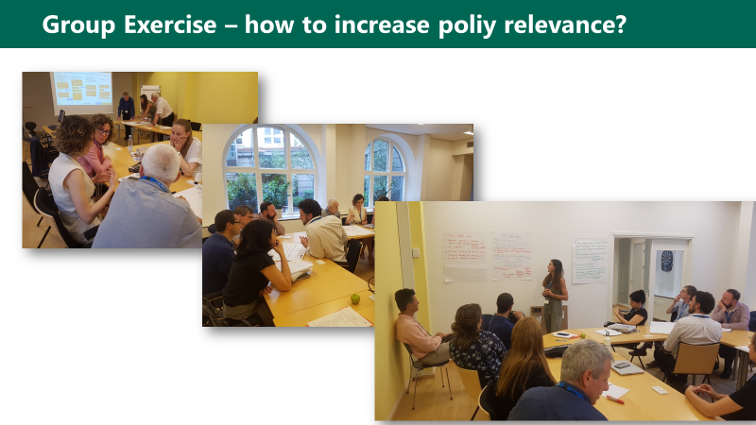

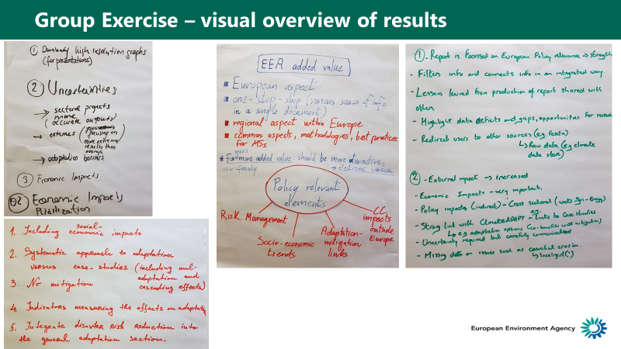

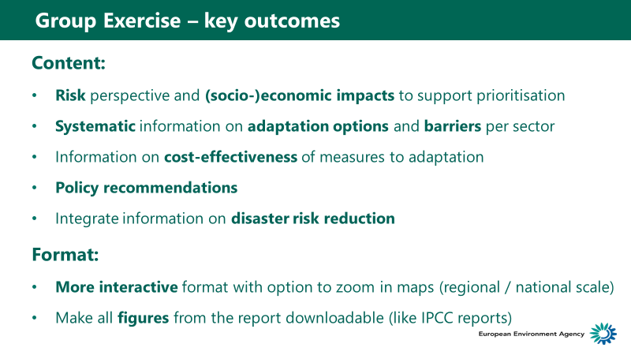

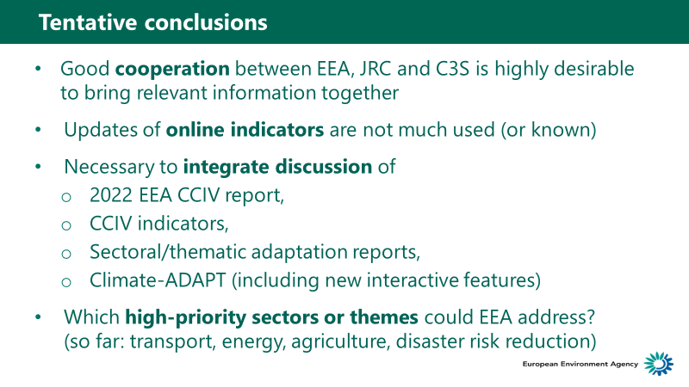

## Annex IV: Some examples of infographics from other reports

Figure A.1 Example from Finish summary of IPCC 1,5°C report

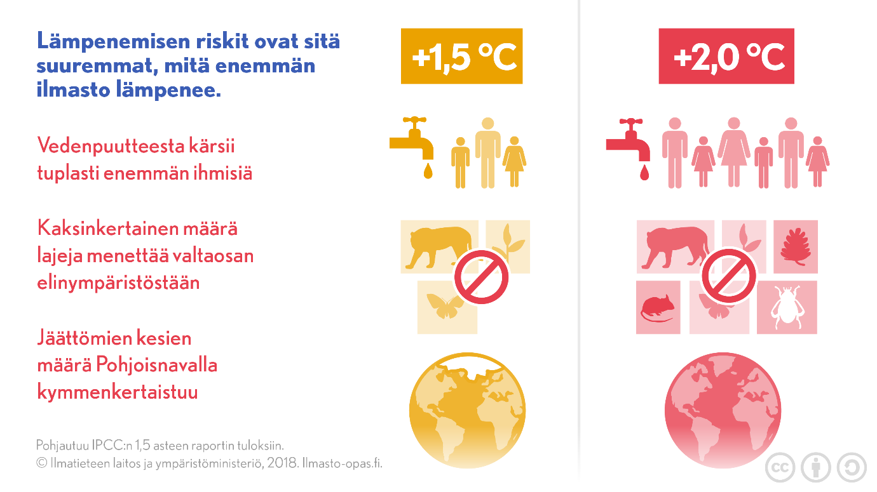

Figure A.2 Infographic from Climate Report South Tyrol

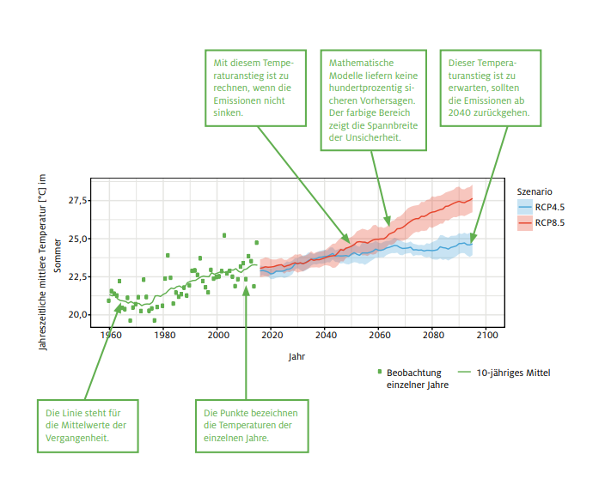

Source: <http://www.eurac.edu/de/research/mountains/remsen/projects/Documents/klimareport/Klimareport%202018%20DE.pdf>

1. Climate-ADAPT Adaptation Support Tool: <https://climate-adapt.eea.europa.eu/knowledge/tools/adaptation-support-tool>
2. <https://www.eea.europa.eu/publications/adaptation-in-energy-system>
3. EEA 2019. Seminar of the EEA Management Board and Eionet 19 June 2019 Copenhagen EEA and Eionet Strategy 2021-2030: Evolution and Innovation. Seminar Booklet (p. 8)
4. Eurobarometer results for 2017 are available at <https://ec.europa.eu/clima/citizens/support_en>
5. Masiulienė, L. , Looney, J., Aertgeerts, H. and de Greef, M. (n.d.) The key features of successful awareness raising campaigns. The European Literacy Policy Network. and LINET (n.d.) Report on ELINET’s Awareness Raising Toolkit. <http://www.eli-net.eu/awareness-raising/toolkit/> (Accessed 16.6. 2019).
6. UK - Committee on Climate Change: <https://www.theccc.org.uk>
7. UK- National https://[www.ukcip.org.uk](http://www.ukcip.org.uk)
8. https://[www.defra.gov.uk/adaptation](http://www.defra.gov.uk/adaptation)
9. UK - National (Scotland) <https://www.adaptationscotland.org.uk>
10. UK - National (Northern Irland) https://[www.climatenorthernireland.org.uk](http://www.climatenorthernireland.org.uk)
11. UK - example special interests group: [https://www.mccip.org.uk](http://www.mccip.org.uk/)
12. The Netherlands. Adaptation to climate change in the Netherlands - Studying related risks and opportunities <https://www.pbl.nl/en/publications/adaptation-to-climate-change-in-the-netherlands>
13. [https://www.klimaateffectatlas.nl](http://www.klimaateffectatlas.nl/)
14. Switzerland. National Centre for Climate Services: [https://www.klimaszenarien.ch](http://www.klimaszenarien.ch/)
15. [https://www.umweltbundesamt.de/en/topics/climate-energy/climate-impacts-adaptation](http://www.umweltbundesamt.de/en/topics/climate-energy/climate-impacts-adaptation)
16. Climate Preparedness Services: [https://www.klivoportal.de](http://www.klivoportal.de/)
17. Finland. Ministry of Agriculture and Forestry: <https://mmm.fi/luonto-ja-ilmasto/ilmastonmuutokseen-sopeutuminen>
18. JRC Peseta <https://ec.europa.eu/jrc/en/peseta-ii> , [<https://ec.europa.eu/jrc/en/peseta-iii>](https://ec.europa.eu/jrc/en/peseta-iii)
19. Copernicus:<https://climate.copernicus.eu>
20. MedEC (Mediterranean experts on climate and environmental change): <https://www.medecc.org>
21. IPCC <https://www.ipcc.ch/>
22. Food Insecurity Index, UK <https://www.metoffice.gov.uk/food-insecurity-index/>
23. PBL, The geography of future water challenges <https://www.pbl.nl/node/64678>
24. Climate Central (USA): <https://www.climatecentral.org>
25. Inside Climate News (USA): <https://insideclimatenews.org>
26. Climate Council (Australia): https://[www.climatecouncil.org.au](http://www.climatecouncil.org.au)
27. Climate Change Post (Europe): [https://www.climatechangepost.com](http://www.climatechangepost.com/)
28. Carbon Brief (global): <https://www.carbonbrief.org>
29. World Bank: https://[www.worldbank.org/en/topic/climatechange](http://www.worldbank.org/en/topic/climatechange) and <https://climateknowledgeportal.worldbank.org>
30. Climate Adaptation Services in the Netherlands <https://www.climateadaptationservices.com/en/>
31. Committee on Climate Change <https://www.theccc.org.uk/>
32. UK Marine Climate Change Impacts Partnership [www.mccip.org.uk](http://www.mccip.org.uk)
33. UK Met Office <https://www.metoffice.gov.uk/food-insecurity-index/>
34. Swiss Climate Scenarios [www.klimaszenarien.ch](http://www.klimaszenarien.ch)
35. MeteoSchweiz [www.meteoschweiz.admin.ch/home/suche.subpage.html/de/data/blogs/2016/3/analyse-der-nutzerbeduerfnisse-zu-nationalen-klimas.html?query=klimaszenarien&pageIndex=0&tab=search_tab](http://www.meteoschweiz.admin.ch/home/suche.subpage.html/de/data/blogs/2016/3/analyse-der-nutzerbeduerfnisse-zu-nationalen-klimas.html?query=klimaszenarien&pageIndex=0&tab=search_tab)
36. <https://ec.europa.eu/regional_policy/en/policy/cooperation/macro-regional-strategies/>
37. <https://ec.europa.eu/info/files/190618-sustainable-finance-teg-report-taxonomy_en>
38. <https://ec.europa.eu/transport/themes/infrastructure/news/2019-03-13-transport-european-union-current-trends-and-issues_en>
39. <https://www.cencenelec.eu/standards/sectors/climatechange/pages/default.aspx>
40. European Commission, 2014 and 2015; Havik et al., 2014
41. Riahi et al., 2017
42. <https://www.ipcc.ch/site/assets/uploads/2018/09/AC6_brochure_en.pdf>
43. <https://www.ipcc.ch/site/assets/uploads/2018/03/AR6_WGII_outlines_P46.pdf>
44. <https://www.ipcc.ch/site/assets/uploads/2018/03/AR6_WGII_outlines_P46.pdf>
45. An overview of relevant JRC publications is available on the PreventionWeb website hosted by the UNDRR (<https://www.preventionweb.net/organizations/1027>)
46. COACCH (CO-designing the Assessment of Climate CHange costs; <https://www.coacch.eu/>)
47. EEA 2019. Seminar of the EEA Management Board and Eionet 19 June 2019 Copenhagen EEA and Eionet Strategy 2021-2030: Evolution and Innovation. Seminar Booklet (p. 8)