Scoping paper for a report on climate change impacts in Europe

Key Deliverable of Task 1.4.1.1 of the 2019 ETC/CCA

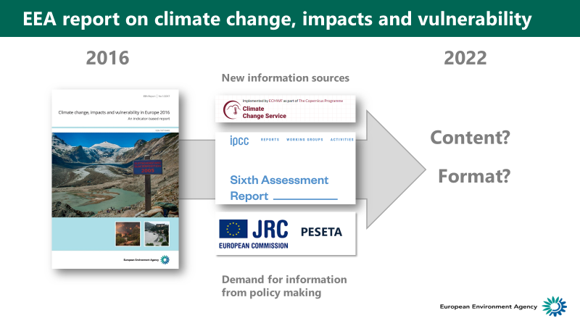

Version 1 – 28.07.2019

Authors:

Marc Zebisch1, Mikael Hildén2, Willem Ligtvoet3, Silvia Cocuccioni1, Hans-Martin Füssel4

1. Eurac Research, Bolzano, Italy
2. Finnish Environment Institute and the Strategic Research Council
3. PBL Netherlands Environmental Assessment Agency
4. EEA – Copenhagen

# Executive Summary and Key Findings

This scoping paper explores options for format as well as for contents of the next “EEA Climate Change Impact, Vulnerability” (CCIV) report planned for publication in 2022. The paper discusses how to achieve a high policy relevance and high accessibility for both policy makers and the general public, together with a high efficiency in producing the report. High policy relevance and improved accessibility requires tuning of contents and form of the report to the needs of the users and the changing information needs, given the ongoing process of adaptation policy development and implementation. High efficiency in producing the report can be achieved by a clever integration of external data and information sources (Copernicus Climate Change Service – C3S, JRC PESETA projects, IPCC AR6) and EEA internal information sources (Climate-ADAPT, sectoral climate change reports, MRE reports on regional and national adaptation).

The proposed options for a new reporting format are developed based on EEA’s lessons learnt from the 2016 report (chapter 2), a review of other national CCIV reports (chapter 3), a review of the policy demand for CCIV related information (chapter 4), a review on external and EEA internal information sources (chapter 5) and a results from NRC meeting in Copenhagen in June 2019 (chapter 6).

The scoping paper is a Key Deliverable of Task 1.4.1.1 of the 2019 ETC/CCA, which will continue until December 2019. It is meant to inspire an EEA internal discussion. The results of this discussion could be implemented in a version 2 of this scoping paper.

**1) Need for information on sector specific vulnerabilities, risks and adaptation options**

There is a clearly expressed **policy and user demand for information on climate change** **which includes, but goes beyond climate impacts**. Potential additional information which would increase the policy relevance of the CCIV report includes **sector specific information on economic impacts, vulnerability and risks across Europe** as well as on **sector specific adaptation demand and adaptation options across Europe**.

Any policy demand for climate change information stems from the demand to get a clear picture of the observed and expected changes in climate change impacts and vulnerabilities and identify and optimize targeted adaptation measures. The EEA Climate-ADAPT Adaptation Support tool specifies six steps for this process[1]. We believe that the policy relevance of the 2022 CCIV report would be very high, if it addresses in consistence with and linked to Climate-ADAPT the information demand for step 2 - assessing risks and vulnerabilities and supports step 3– identifying adaptation options. Furthermore, as adaptation policies are in the process of implementation, impacts and vulnerabilities will be affected and hopefully reduced. Linking climate change information to information about the implementation of adaptation across Europe will be of increasing importance in understanding developments in impacts and vulnerabilities.

These findings are consistent with results of a review of the evaluation of the EU adaptation strategy (COM(2018)-738 final)), where information gaps have been clearly expressed as well as on an analysis of national climate change impact and adaptation reports. The evaluation particularly stresses the need to link CCIV information with **adaptation information**. The report on the evaluation foresees that to advance adaptation further “the Commission could envisage exchanges of information on successful adaptation measures between stakeholders and with the scientific community”. Such exchanges would clearly benefit from systematic analyses that the EEA could provide in its report(s) using, for example, material submitted to Climate-ADAPT. Also, most of the national reports on climate change are including information on adaptation options in a consistent way from climate impacts to vulnerability and risks to related adaptation options.

**Sector specific vulnerability and risks** are important to addressed . The concept of climate risks as a function of climate hazard, vulnerability and exposure plays a key role in IPCC AR5 and will be even more prominent in AR6. The underlying assumption is that adaptation measures cannot reduce the climate hazard itself but can address vulnerability and exposure. In many cases, vulnerability factors (e.g. lack of drought resistance crops, inefficient irrigation systems) contribute as much or even more to potential climate risks than the climate hazard (a drought) itself. To address the vulnerability and exposure factors which contribute to a specific climate risk, it is therefore important to identify and improve appropriate adaptation measures. This would be in line with what the Climate-ADAPT tool requires for step 2 - assessing risks and vulnerabilities.

Further important topics which should be more addressed according to COM(2018)-738 are ecosystem based adaptation, links to the field of Disaster Risk Reduction (DRR) and to Sustainable Development Goals (SDG).

The inclusion of these new topics would require additional resources, which could be partly compensated by a proper coordination between running activities on these topics within EEA and specifically ETC/CCA (see key finding 2). Anyhow, it has to be carefully evaluated, to which extent and how these additional topics could be integrated in the 2022 EEA CCVI report.

Figure 1 illustrates this potential additional content options and shows how they could be related to the structure and content of the last CCIV report from 2016.

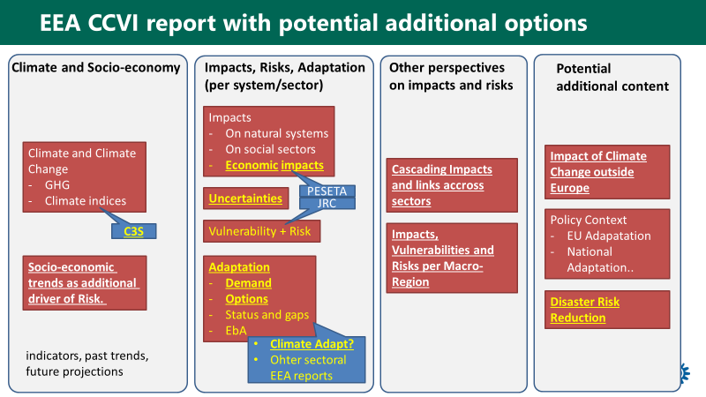

Figure S1: General building blocks (potential new elements in yellow) and potential data source (blue). Content in bold and underlined was rated as particular policy relevant during the EIONET Workshops Break-out group at June 13th 2019.**2) Potential for integration of C3S, JRC PESETA and EEA internal activities**

The 2022 CCIV report could profit from a clever **integration and harmonization of external information sources (C3S for climate information, JRC PESETA for economic impact and risk information)** as well as **EEA internal information source (Climate-ADAPT for adaptation options per sector, other sectoral EEA reports**, see Figure 1). This integration would reduce the effort for information generation by EEA but increase the effort for coordination between C3S, JRC, EEA as well as EEA internally. More specifically:

* C3S could provide all climate data related information including graphs, figures and text as a service following specific requests by EEA. Options could even include innovative online tools for the spatially explicit visualization of key indicators. This would save a lot of resources in the production of the CCIV report but requires early and clear negotiation on information demand between EEA and C3S. First discussions with C3S key persons were very positive.
* JRC could provide sector specific information on climate impacts including economic impacts and risks for specific sectors which are covered by the PESTA projects. Ideally, future editions of PESETA could be based on the same climate information from C3S as to ensure consistency. A further coordination to achieve this consistency would be required.
* Work on Climate-ADAPT could extract sector specific recommendations on adaptation options from the database of case studies, reports and toolsets. This would require a stronger coordination between the CCIV report and Climate-ADAPT, and could be part of future ETC/CCA activities. The resource implications will need to be explored. Its feasibility will also depend on the evolution of the official reporting on adaptation under the Regulation (EU) 2018/1999 on the Governance of the Energy Union and Climate Action.For sectors which are covered by specific EEA reports on climate change (e.g. energy, agriculture, transport), key information on impacts, vulnerabilities, risks as well as adaptation demand and options could be extracted from these reports reducing the need for descriptive information and detailed examination of primary sources. The structure of the latest EEA report on climate change impact on energy could be seen as a good example for a report which allows to extract information for the EEA CCIV report.

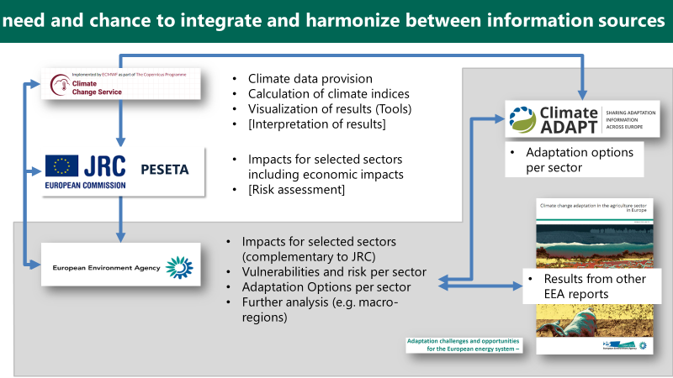

Figure S2: need and chance to integrate and harmonize between information sources. Information from C3S, JRC and several EEA activities (Climate-ADAPT, sectoral reports) could be understood as one pool of information out of which different products could be extracted.

**3) Options for different formats to present the CCVI report**

Exploring a possible new format for the EEA CCIV(A) reporting mechanism and report we assessed the following options (cf. Figure S3):

* **Format “0”:** The “compendium” character of the current structured and printed report is perceived as very positive by users and is considered as the reference against which other formats are compared. It includes the indicators available on-line that are updated at different frequencies. Essentially the same information is presented in the indicators online and in the indicator-based parts of the report. This approach allows updating a large number of indicators in parallel with publication of the report with very limited extra resources. The main advantage of the indicators online is that they can be updated more frequently if relevant new information becomes available and that they can be searched independently on the EEA website. Furthermore, most indicators allow users to download maps and figures, which is not currently the case for illustrations from EEA reports.
* **Format “1”** would keep the structured report as a core concept but rework the structure to cover additional contents such as adaptation options (see Figure 3). The text could be significantly shortened by using concise and targeted text in the core part (climate impacts and adaptation options per sector) and by shortening or pruning chapters which in Formet “0” provide primarily background and context information (e.g. policy context, strengthening the knowledge base). We believe that the overall report should not exceed 200 text pages. Such a shortened report would be complemented by web-based background information (e.g. with indicators as in the current Option “0”).
* **Format “2”:** would focus on a policy oriented summary report (both hard copy and web-based, ) and also provide all elements of Option “1” online. The Executive summary of the 2016 report included one Table and one Map and aimed at briefly covering ‘all’ pieces of information that the report covered. The policy oriented summary of Format “2” would take its starting point in ongoing policy developments and focus on specific messages for ongoing policy making processes. It is also expected to provide more easily accesible graphical information. The policy relevance and accessibility to both policy makers and general public are expected to increase relative to Format 0 and 1..
* **Formats “3A and 3B”:** also have a policy-oriented summary report as the main product, but without the shortened EEA report. In Format 3A, breaking with the traditional background reporting, EEA would create background reports and papers, each supporting a specific chapter. This would potentially require the establishment of a new product category (“technical reports”) at the EEA. In Format 3BEEA would reduce its own active role in developing information and concentrate of disseminating information produced by others, without trying greatly to influence how that information is presented or developed. This would reduce EEA’s resource needs significantly, but also reduce the possibility incorporating in house CCIV information in other EEA products and would mean that EEA to a greater degree relies on external quality control and interpretation of data.
* **Format “4”:** also has a policy oriented summary report as main product but with fully reorganised reporting and information structure, using content produced by C3S and JRC (and possibly other organisations), using relevant content from Climate-ADAPT, and with links to a new ‘Climate change and adaptation Atlas of Europe’ (MAPs). This option resembles the one depicted in the above figure 2 and thus requires an effective collaboration of EEA with e.g. C3S and JRC, bringing together the produced maps into an Atlas and party adjust the content of Climate-ADAPT to the needs of the EEA CCIV(A) reporting concerning progress on adaptation. This approach resembles the one applied in the SOER2020 which presents short summaries of indicator-based information in the SOER, and includes links to many indicators with more detailed information online.

For Option 1-4: Users expressed that they would like to be able to access all figures, graphs, maps as high resolution images for download. Additionally a Web-GIS version of maps with the option to zoom into specfic regions would also be desirable.

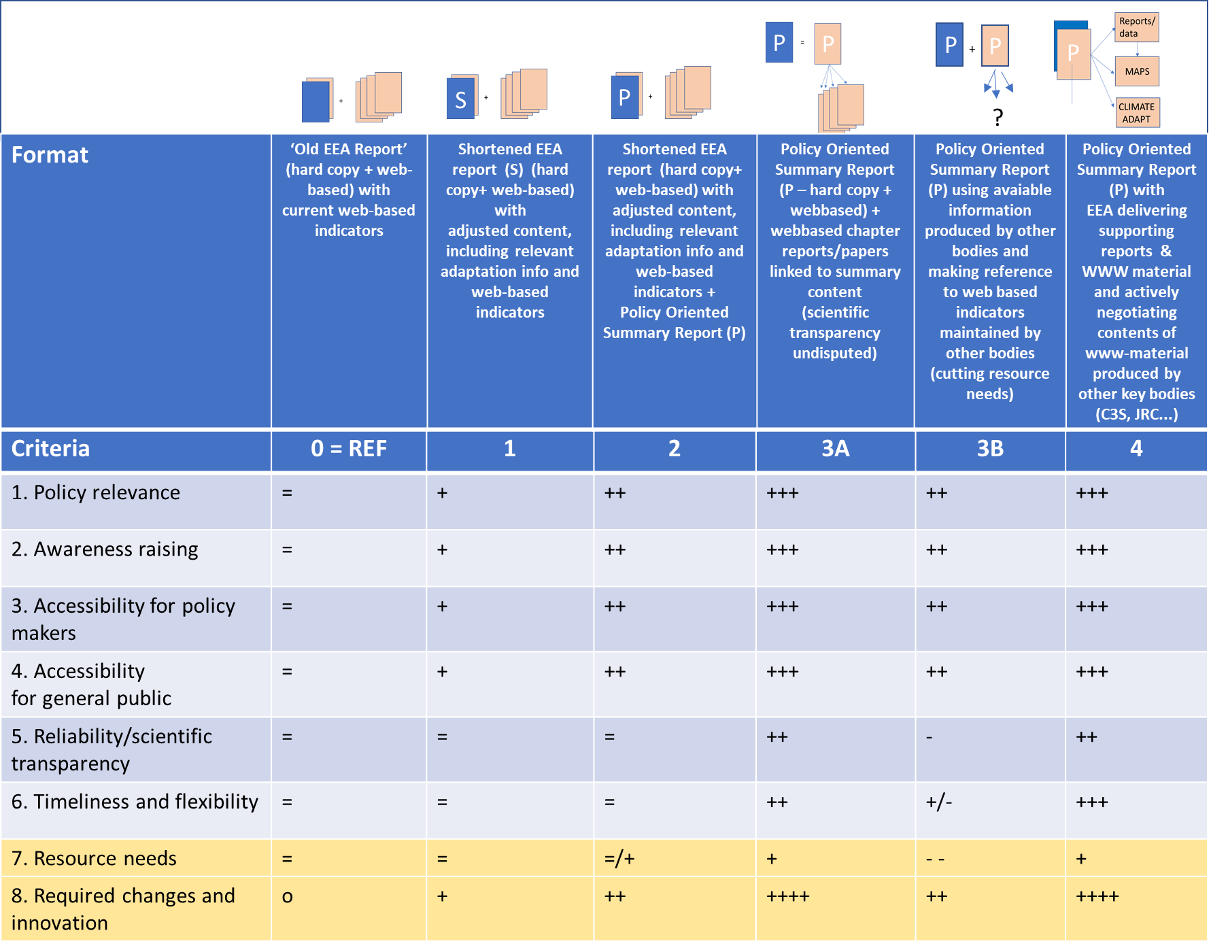

Figure S3: Options for different formats of a future CCIV report + tentative comparison based on eight selected criteria. Format 0 = the set-up of the 2016 EEA CCIV report = the reference for the comparison with the other formats. Blue/grey: outcome criteria. Yellow: input criteria.

Comparing the formats using the eight criteria in figure S3, Format 1 with a shortened and improved content but quite traditional in structure, would in practice be close to the 2016 EEA report (Format 0 = Reference). The partial reorientation may increase slightly the policy relevance (+). The shortening may mean that less primary scientific sources can be used, which may be perceived as a loss of scientific transparency, but we expect that with due attention to the choice of sources this can be prevented. The addition of a separate well-designed policy oriented summary Report in Formats, 2, 3A, 3B and 4 result in higher scores for policy relevance, and accessibility for policy makers and general public. Format 3A and Format 4 receive the highest scores, but and require new approaches in organizing the information and background reporting. Format 3A and Format 4 thus require the most changes and innovation in products and organisation and are expected to require more resources. Format 2 is more traditional, but with both a shortened EEA report + policy oriented summary this option is expected to require some additional resources relative to Format 0.

Strategically, Format 4 is the most innovative format in which EEA deepens its collaboration with other relevant institutes and has a leading role in organizing and presenting CCIV information. This may substantially strengthen EEA’s position and profile as the deliverer of policy relevant CCIV knowledge for Europe, but is likely to require also new forms of co-operation in the form of joint projects and harmonized work programs across organizations.

Format 3B is the option with the lowest resource needs, but may nevertheless enable an increase in policy relevance and accessibility, if the sources to be referred to are chosen well. The lower degree of control of the information to be presented is reflected in lower accessibility and policy relevance compared with options 3A and 4. The timeliness and flexibility may increase relative to the reference level, if externally produced material is available for all policy areas of interest. However, in developing policy areas situations may arise in which no organisation exists to deliver up to date new information on CCIV(A) and in this case timeliness may decrease relative to the reference level in which there are some resources for extending the reporting to cover new areas (for example, transboundary impacts in the 2016 report). The reliability/scientific transparency is under greater pressure in the format 3B as it depends on secondary sources and the distance to the primary research is likely to grow. In all the other options reliability/scientific transparency scores can be maintained or even increased relative to the reference.

**4) From awareness raising to policy implementation: thoughts on effort, impact and publication policies of CCIV reporting in a changing environment**

The topic of climate change has become much more important and policy relevant compared to the time of the first edition of EEA’s CCIV report in 2004. Today, in both the policy and societal domain, climate change is widely acknowledged as a growing challenge for mankind. And given the increasing impacts of climate change, not only knowledge on potential impacts of future climate change is on the political agenda, but also adaptation - the fight against real and complex impacts of climate change has become more urgent. The consideration of complex risks related to climate extremes and climate change as well as the implementation and optimization of adaptation strategies and options has become a key challenge for policy makers on all levels.

The current discussions about EEA assessment reports and EEA indicators will shape the future EEA CCIV work. There are many strategic and operational choices to be made. For example, it is not clear (to the authors of this scoping paper) whether both ‘Format 0’ (the current approach) and ‘Formats 3 and 4’ (resembling a ‘SOER-approach’) will be possible in principle for sharing CCIV information that includes both EEA reports and indicators. If neither ‘thick’ reports nor ‘long’ indicators were permitted in the future, EEA would no longer be able to present detailed CCIV information, unless new product types and/or publication channels are developed (e.g. context indicators, Climate-ADAPT indicators, joint EEA/C3S indicators). And in this fast-developing digital world many new options can come into play. Therefore, it is essential that the SMT provides clarity on the strategic goals and explore which contents and structure of the EEA CCIV report could support that goals and define further requirements of relevant EEA products before starting the development of a new EEA CCIV report and related indicators.

One of our tasks was to analyse also the potential for a “cheaper” version of the EEA CCIV Report. Indeed, a lack of resources was one of the main challenges of the 2016 CCIV report (see chapter 2). We have provided options that would make the production more cost efficient by a clever coordination with and integration of external information sources (C3S, JRC) and EEA internal activities (Climate-ADAPT, sectoral reports). These options would not necessarily reduce the resources needed for the production of the CCIV report (or more generally EEA’s production of information on CCIV), but would potentially reallocate the resources. In addition we identified one option that would reduce EEA resources significantly. Such an option would imply a deliberate reduction of EEA’s own role as a key provider of CCIV information. Instead the focus would be on making the work of other organisations known and direct the attention of interested stakeholders to information sources elsewhere. This would be a ‘journalistic’ task and its importance can be seen to grow with the increasing availability of different sources of CCIV information. The main drawback, relative to the other options, is that i) the reliability and scientific transparency will be under pressure and ii) that EEA would have a clearly smaller role in the actual presentation of CCIV presentation and would not accumulate its ‘own’ collection of indicator information that can be used and developed further also in other EEA products.

There is no other European Institution than EEA which is in the position to coordinate the process of providing policy makers with the necessary background. Therefore, we recommend not to reduce resources at EEA but to invest in an even more intense coordination on the topic of climate change in strong cooperation with other European institution such as C3S and JRC with the support of ETC/CCA. Furthermore, the clearly expressed policy demand to not only receive information on impacts, but also assessments on risks and recommendations on adaptation options would require a stronger involvement of science-policy boards to underpin this somewhat normative and value-based messages. The effort for this endeavour has to be carefully evaluated.

**5) Transition towards a new EEA CCIV reporting in steps**

Transitions take time and that is also the case in changing a complex reporting mechanism with restricted resources. The next EEA CCIV report in 2021/22 doesn’t need to be the result of a complete change of product and organization, but could be a first step in a new direction. An effective new step requires a long term idea and strategy. Although presented as separate formats, our identified formats can to some extent also be seen as steps in a transition (Figure S4).

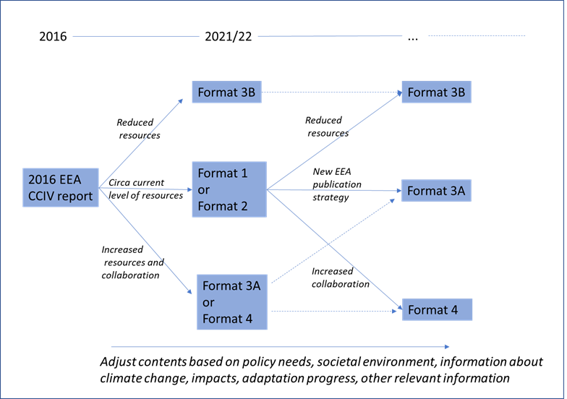

Figure S4. Building a long term strategy in steps, using the example formats in Figure S3.

For instance, the upcoming 2021/22 EEA CCIV report could be a Format 1 (shortened EEA report with adjusted content) or Format 2 (= Format 1 + the policy oriented summary as new product) as a first step toward a format 3A or Format 4. In this process the interaction with other institutes can be explored and developed. In case of a need to reduce the resources significantly towards 2021/22, Format 3B could be an option. If resources remain available also after 2022, building on Format 1 or 2, further steps can be taken in the direction of Format 3A or Format 4. Here a fundamental choice has to be made especially with respect to collaboration with other institutes. As already mentioned, with Format 3A or (especially) Format 4, the authors expect that EEA will keep a strategic important position in the field of climate change and adaptation in Europe. A stepwise strategy provides time for further choices to be made, while at the same time new content and a new product style and organization can be developed.

Assessing the resource needs of the formats in this stage is highly tentative. Over time further exploration of what is needed and what is required may result in lower or higher resource needs than assessed in Figure S3. Each time choices will have to be made fitting the available resources. Only if reducing resources for EEA CCIV reporting is the main priority, then Format 3B might become the main pathway.

Contents

1 Objective and analysis criteria 9

2 EEA perspective 13

2.1 Content of 2016 CCIV report 13

2.2 Production of the 2016 CCIV report 15

2.3 External impact of the 2016 CCIV report 18

2.4 Recent developments of the EEA communication strategy 22

3 Examples of presenting CCIV information 24

3.1 Introduction 24

3.2 Examples of CCIVs 25

3.3 A summarizing overview of findings 27

4 The evolving demand for CCIV(A) information 31

4.1 Knowledge needs reflected in the EU adaptation strategy and its evaluation 31

4.2 Mainstreaming generates new demands for knowledge 32

4.3 Evolving national adaptation policies and plans 36

5 Landscape of related information suppliers 37

5.1 Copernicus Climate Change Service 37

5.2 PESETA III 40

5.3 IPCC WG II AR5/AR6: 43

5.4 Internal suppliers of information 47

6 Results from NRC meeting in June 2019 48

6.1 General outcomes from NRC meeting 48

6.2 Policy demand of DG CLIMA 48

6.3 Outcome of break-out group during EIONET workshop 49

7 Options and concrete format 50

7.1 Conclusion from chapter 1-6 50

7.2 Building blocks for content 51

7.3 Options for format 52

8 Annex 59

8.1 Potential report structure with additional content (“Option 1”) 59

8.2 Potential report structure of a Policy Orientated Summary Report with additional content (“Option 2, 3, 4”) 62

8.3 Results from break-out group during EIONET workshop 12.-13.06.2019 64

8.4 Some examples of infographics from other reports 66

# Objective and analysis criteria

**Key messages/recommendations:**

* EEA published its fourth report on climate change, impacts and vulnerability (CCIV) in Europe in 2017
* A next report is planned to be published in 2022, supported by information published online
* New information sources, such as the Copernicus Climate Change Service (C3S), the IPCC AR6 and the JRC PESETA projects provide options for a deeper integration with external sources
* This scoping paper is analysing options for EEA CCIV work in general, and a 2022 EEA CCIV report in particular, for three aspects:
  + Content: Which content (physical impacts, societal risks, adaptation …) could a 2022 EEA CCIV report cover? What are potential information sources for different content clusters?
  + Format: Through which formats could this CCIV information be communicated (report, EEA web-page, Climate-ADAPT, jointly with C3S …)?
  + How to efficiently make use of the above-mentioned complementary information sources?
* Options are evaluated against the following criteria:
  + *Policy relevance*: How policy relevant is this content? How well is this format suited to reach policy maker and impact their decisions?
  + *Awareness raising*: How well is this content and format suited to raise awareness in an interested public?
  + *Accessibility for policy makers and general public*: How attractive is the presentation of the findings and how easily accessible is the information?
  + *Reliability and scientific transparency*: Do the findings rely on the best available consolidation of knowledge?
  + *Timeliness and flexibility*: Is the reporting mechanism suitable for period update based on new insights?
  + *Resource use*: What type and amount of resources (by EEA, Eionet and other organisations) is needed to develop the various products?
  + *Required changes and innovation:* How novel are the envisioned products relative to status quo, how large adjustments need to be made in the production processes relative to those used in producing past reports

In January 2017, EEA published its fourth report on climate change, impacts and vulnerability in Europe (2016 EEA CCIV report). Similar to previous reports, this report presented a comprehensive overview of climate change and its impacts in Europe, which was largely based on 35 indicators. All these indicators were updated in parallel with the publication of the report. Furthermore, the 2016 EEA CCIV report reviewed the policy context for adaptation in Europe, and it gave an overview of multi-sectoral climate change vulnerability and risk assessments in Europe. The focus was on the EU level and the transnational level.

The production of a comprehensive report requires significant resources in terms of writing, editing, review and publishing. Producing a comprehensive report and the associated web pages for the indicators is, however, not the only way to disseminate European wide information on climate change impacts and vulnerabilities (and associated adaptation actions as appropriate).

The main objective of the report has been to provide policy makers with relevant, easily accessible and updated science-based information on the progress and projections of climate change and its impacts in Europe. By producing the report, the EEA hopes to satisfy a demand for knowledge and information that arises in the preparation of European wide and national policies. By providing a comprehensive report the EEA gives the reader an opportunity to understand the broad picture of climate change and to gauge different pieces of information for policy development. A secondary objective is to generally raise awareness of the climate change and its consequences with a focus on European perspectives. A third objective is the branding and visibility of the EEA as an actor on the European CCIV(A) arena in relation to its task as defined in relevant documents on the EEA and its role.

This scoping paper explores through which means these objectives can be achieved by examining several options for EEA CCIV(A) information to be published in 2022. There are several means to achieve the objectives of EEA’s reporting on climate change impacts, vulnerabilities and adaptation actions. The choice of means will depend on the priorities in the strategic objectives of EEA with respect to publishing CCIV(A) information. The focus will lie on the added value of an EEA report compared to other existing reports and data platforms (IPCC AR6, Copernicus Climate Change Service – C3S and JRC PESETA).

A key question is how the EEA information on CCIV could be provided in a way that is well aligned with EEA’s mission set out in the current Multiannual Work Programme:

*'The EEA aims to support sustainable development and to help achieve significant and measurable improvement in Europe's environment, through the provision of timely, targeted, relevant and reliable information to policy-making agents and the public'.*

The Seminar Booklet for the discussion on the EEA and Eionet Strategy 2021-2030 stresses that the “EEA targets two distinct audiences with different needs — policymakers and the public.”[2] This doesn’t obviously mean that each and every report should fulfill the dual role, but it is natural to assume that it applies to the report and the accompanying material dealing with climate impacts, vulnerabilities and adaptation to climate change. Climate change was one of the important topics in the elections for European Parliament in 2019, and Eurobarometer results clearly shows that climate change is an issue that matters for a wide spectrum of the public.[3]

In the context of the CCIV(A)-report, and the material based on it, the key features of the EEA mission can be interpreted as follows:

* *Timeliness:* Policy-making agents and the public have easy access to up to date information on what is known about the evolving impacts of climate change and their projections under different scenarios. This is also related to the *flexibility* of the reporting in accommodating new information.
* *Targeted:* The focus is clear and the information is structured in such a way that also specialized policy-making agents can find information that helps them in their policy work. Some parts of the information are targeted to the public at large. Targeting is key for *policy relevance*.
* *Relevant:* General relevance can be achieved by contents that is of interest in public discussions and awareness raising concerning climate change impacts and vulnerabilities, without necessarily delivering specific information that can be used in making choices between options in policy making. Specific relevance would mean that the report provides information that can be used and referred to as such in the design and evaluation of policies that deal with climate change impacts, vulnerabilities and adaptation.
* *Reliable:* The information that is provided and referred to should be scientifically verifiable, and the interpretations and arguments that the report presents in narrative form should be based on transparent and balanced reasoning. Reliability is partly ensured through *scientific transparency.*

Based on the desired characteristics it is possible to outline two basic mechanisms and processes through which the EEA report on CCIV(A) is assumed to influence policies and public debates in such a way that progress can be made in sustainable development and in adapting to and mitigating climate change.

The first mechanism assumes that the report and the related material (on the EEA indicator system) help in raising awareness. To raise awareness the report must be *accessible* and perceived to be relevant by the target audience(s). A distinction can be made between raising awareness in the public debates and raising awareness among policy making agents. As such, raising awareness is an ‘easy’ task in the sense that climate change is already widely perceived to be important. At the same time the task is challenging because the report should provide material that deepens the awareness, it should not just confirm what the target audience already knows. A key finding from information campaigns aiming at raising awareness is that there is a need to use multiple channels to distribute the information. A single report is thus less likely to successfully raise awareness than information that is conveyed through several channels and in different formats. [4] The EIONET workshop (Chapter 6) implicitly recognized this by noting the necessity to integrate the discussions of the

* 2022 EEA CCIV report,
* CCIV indicators,
* Sectoral/thematic adaptation reports,
* Climate-ADAPT (including new interactive features)

The second mechanism assumes that the report and the related material can be referred to either as background information or as specific evidence in formulating and revising policies. Policy-making agents are thus assumed to be aware of the report and its material, have access to it and understand its contents in such a way that the report makes a difference in the way policies are developed and justified. There is evidence (Chapter 2) that in particular the synthesis parts of the 2016 report have been used as a reference in policy making.

One challenge for the CCIV report and the related material is that similar information is available and being produced elsewhere in increasing amounts. This was also reflected in the discussions at the Eionet workshop (see Chapter 6). Another challenge is that the users, defined as ‘policy-making agents’ (and the public) are heterogeneous, with diverse needs, background information and capability to use in particular complex and multidimensional information. Therefore, the information may be transmitted to and interpreted for the policy-making agents by middle –level actors such as journalists, political support staff or think-tanks. This way of influencing the debate has been partly recognized by producing press releases and achieving good press coverage (see Chapter 2), but there appears to be a partly untapped potential in as yet unidentified middle-level actors such as sector organisations, NGOs, think tanks and professional journals. The Eionet network may help in developing connections to such actors.

The scoping paper assesses the chosen options in terms of their expected effectiveness in achieving policy relevance and in raising awareness of climate change impacts and vulnerabilities among policy makers and other targeted actors that EEA sees as its primary audience.[5] The chosen options therefore also assess the potential accessibility of the report for policymakers and for the general public. Additionally, the reliability and scientific transparency of the report should be undisputed and the provided information in the various options should be linked adequately to the back-ground reports, maps and other information. All the objectives are potentially demanding and therefore this scoping paper also reflects tentatively on the resource needs, the required changes and innovation and the timeliness and flexibility for updating, both from EEA and from other institutions and seeks to highlight where the main differences arise between the options (for more details on the criteria through which the different options are assessed, refer to Chapter 7).

The purpose of the scoping paper is to serve as an internal discussion paper for the EEA in determining the approach and resources for the future CCIV(A) dissemination.

This scoping paper is based on a review of existing documents, personal meetings with EEA staff (mainly Hans-Martin Füssel, Andre Jol), personal meetings with C3S staff (Carlo Buontempo) and a break-out session during the Eionet meeting in Copenhagen from 12-13.06.2019

# EEA perspective

(Hans-Martin Füssel, EEA)

**Key messages/recommendations:**

* The 2016 report is based on 34 indicators for past trends and future projections, 5 are part of CSI and are updated partly independent of the Climate Change Report.
* The vast majority (30 out of 34) of the CLIM indicators included in the 2016 EEA CCIV Report have been re-used in other EEA reports
* The indicators rely on a wide range of data sources, including international and European research networks, global data centres, IPCC and European research projects. A small number of indicators uses data from Copernicus services (CMEMS and C3S). This number is expected to increase rapidly with the further development of these services.
* Spatial explicit information: maps, where possible (but no country or regional information)
* The 2016 CCIV report includes contributions from 24 (lead) authors and from 44 further contributors from EEA, ETCs and other organisations
* Total resources for production: > 6 Person Years
* More resources in a business-as-usual scenario would be required and resources better planned. Coordination with SMT members from other programmes should be improved.
* Production of maps, graphs and the respective metadata should be streamlined and simplified.
* The report has been very positively received and extensively cited.

## Content of 2016 CCIV report

### Scope

The 2016 CCIV report includes three categories of information:

1. **Climate change and specific risks:**  
   an assessment of past and projected climate change (Chapter 3), its impacts on environmental systems (Chapter 4) and social systems (Chapter 5) in Europe, which is primarily based on indicators; [44+78+78=200 pages]
2. **Cross-cutting climate change risks assessments:**   
   a structured review of integrated climate change impact, vulnerability and risk assessments on ecosystem services (Section 4.5) and on society (Chapter 6); [6+55=61 pages]
3. **Policy and knowledge context:**   
   an overview of the policy background for climate change adaptation (Chapter 2) and the development of the associated knowledge base (Chapter 7); [11+14=25 pages]

As a result, the report provides a comprehensive overview of past and projected climate change, its impacts and the associated risks for ecosystems and society, and of the evolving policy and knowledge landscape in Europe.

### Indicators and data sources

The first category of information (‘Climate change and specific risks’) was largely, but not exclusively, based on 34 indicators. All these indicators are included in the CLIM indicator set; five of them are also included in the CSI (Core Set of Indicators) set. For 17 of these 34 indicators (i.e. one half), the project manager of the 2016 CCIV report is noted as the “responsible contact person” in the CMS; for six indicators, other CET2 colleagues are “responsible”; for the remaining 11 indicators, colleagues from the former NSV programme are “responsible”.

All 34 indicators were updated on the EEA website shortly before the publication of the 2016 CCIV report. This update was performed by the project manager of the 2016 CCIV report, even if the formal responsibility was with other colleagues. The content of the indicators (i.e. assessment text and figures) matched the content of the 2016 CCIV report exactly, with minor differences in presentation due to the specific formatting requirements of the indicators. Four out of the five indicators in the CSI have been updated in the meantime, i.e. after the publication of the 2016 CCIV report. Several further indicators are scheduled for update in 2019, primarily because they are cited in the SOER2020 (see table below).

A large majority of indicators includes quantitative data about ‘past trends’ as well as ‘projections’. Depending on data availability, information is presented graphically as time series of European averages and/or as map of trends in observed and/or projected changes.

The indicators rely on a wide range of data sources, including international and European research networks, global data centres, IPCC and European research projects. A small number of indicators uses data from Copernicus services (CMEMS and C3S). This number is expected to increase rapidly with the further development of these services. None of the indicators relies on data reporting by countries to EEA. Only two indicators (‘Floods and health’ and ‘Economic losses from climate-related extremes’) show information for individual countries, but this information has not been reported by countries.

### Uptake of CLIM indicators in other EEA reports

The vast majority (30 out of 34) of the CLIM indicators included in the 2016 EEA CCIV Report have been re-used in other EEA reports (see table below for details). This re-use includes the reproduction of figures and maps, and the use of key messages and other findings. In some, but not all re-use cases, the 2016 EEA CCIV report and/or the CLIM indicators are cited explicitly. For example, the climate change chapter in the forthcoming SOER 2020 cites 17 out of 34 CLIM indicators from the 2016 EEA CCIV report, thereby offering readers access to more detailed information than the page-limited SOER.

Table 2.1:1 Uptake of CLIM indicators in recent EEA reports

|  |  |  |  |  |  |  |  |
| --- | --- | --- | --- | --- | --- | --- | --- |
| **EEA report** | **CCA-DRR** | **Arctic report** | **Adaptation and energy** | **Adaptation and agriculture** | **Environment and health** | **SOER2020  (Ch. 6&7)** | **Any** |
| **Publication year** | **2017** | **2017** | **2019** | **2019** | **Forthcoming** | **2019** |  |
| **Global and European temperature** | 1 |  | 1 |  | 1 | 1 | 1 |
| Mean precipitation |  |  | 1 |  |  | 1 | 1 |
| Heavy precipitation | 1 |  | 1 |  |  |  | 1 |
| Wind storms | 1 |  | 1 |  |  |  | 1 |
| Hail | 1 |  | 1 | 1 |  |  | 1 |
| **Arctic and Baltic Sea ice** |  | 1 |  |  |  | 1 | 1 |
| Greenland and Antarctic ice sheets |  | 1 |  |  |  |  | 1 |
| Glaciers |  | 1 |  |  |  | 1 | 1 |
| Snow cover |  | 1 |  |  |  |  | 1 |
| Ocean acidification |  | 1 |  |  |  | 1 | 1 |
| Ocean heat content |  |  |  |  |  |  | 0 |
| **Sea surface temperature** |  |  |  |  |  | 1 | 1 |
| Distribution shifts of marine species |  |  |  |  |  | 1 | 1 |
| Ocean oxygen content |  |  |  |  |  |  | 0 |
| **Global and European sea level** | 1 | 1 | 1 |  |  | 1 | 1 |
| River flow |  |  | 1 |  |  |  | 1 |
| River floods | 1 |  | 1 |  |  | 1 | 1 |
| Meteorological and hydrological droughts | 1 |  | 1 |  |  | 1 | 1 |
| Water temperature |  |  | 1 |  |  |  | 1 |
| Soil moisture | 1 |  | 1 | 1 |  |  | 1 |
| Phenology of plant and animal species |  |  |  |  |  |  | 0 |
| Distribution shifts of plant and animal species |  |  |  |  |  | 1 | 1 |
| Forest composition and distribution |  |  |  |  |  | 1 | 1 |
| Forest fires | 1 |  | 1 |  |  | 1 | 1 |
| **Economic losses from climate-related extremes** | 1 |  |  |  | 1 | 1 | 1 |
| Floods and health | 1 |  |  |  | 1 |  | 1 |
| Extreme temperatures and health | 1 |  |  |  | 1 | 1 | 1 |
| Vector-borne diseases |  |  |  |  | 1 |  | 1 |
| Water- and food-borne diseases |  |  |  |  | 1 | 1 | 1 |
| Growing season for agricultural crops |  |  |  | 1 |  |  | 1 |
| Agrophenology |  |  |  | 1 |  |  | 1 |
| Water-limited crop yield |  |  |  | 1 |  |  | 1 |
| Crop water demand |  |  |  |  |  |  | 0 |
| Heating and cooling degree days |  |  | 1 |  |  | 1 | 1 |
| **Total: 34** | **12** | **6** | **13** | **5** | **6** | **17** | **30** |

## Production of the 2016 CCIV report

### Institutional framework and internal project management

The production of the 2016 CCIV report was agreed by SMT in late 2014, based on a concept paper developed by members of the (former) ACC4 group. The 2016 CCIV report was managed by Hans-Martin Füssel, supported by Andre Jol (both formerly in ACC4, now in CET2) and two ETC/CCA experts. Hans-Martin Füssel was the only EEA staff member who devoted more than 25% of his/her person days in any given year to the 2016 CCIV report.

The development of the report was supported by an external advisory group, which comprised 25 representatives from the European Commission, EEA Scientific Committee, EEA member countries, regional conventions, WHO, ECDC, IPCC, and other relevant organisations. This advisory group met twice to discuss the scope and outline of the report, to identify relevant information sources, and to provide recommendations regarding the presentation of findings. Members of the Advisory Group also reviewed various draft versions of the report.

The development of the report was further supported by an internal coordination group, which consisted of the HoGs of those EEA colleagues with writing responsibilities. This group met several times per year, but with irregular attendance by various members.

### Authors and contributors

The 2016 CCIV report includes contributions from 24 lead authors and from 44 further contributing authors. Most of the authors were from EEA and from ETC/CCA. Additional contributions were provided by WHO, ECDC, JRC, ETC/BD and various other organisations. Their distribution across organisations and organisational units is shown in the table below. The only EEA colleagues who authored more than one section were Hans-Martin Füssel and Andre Jol (both formerly in ACC4, now in CET2) and Tobias Lung (formerly IEA2, now IAS1).

Table 2.2:1 Distribution of authors and contributors to the 2016 EEA CCIV report

|  |  |  |
| --- | --- | --- |
| **Organization and unit** | **Lead authors** | **Contributing authors** |
| EEA/ACC4 | 6 | 0 |
| EEA/NSS | 7 | 3 |
| EEA/IEA1 | 1 | 0 |
| ETC/CCA | 6 | 5 |
| ETC/BD | 0 | 2 |
| JRC | 0 | 9 |
| Other organisations | 4 | 25 |
| **Total** | **24** | **44** |

### Time and resource use

The 2016 EEA CCIV report took around 2.5 years from planning to publication. Preparatory work started in 2014. Supported by a small group of ETC/CCA experts, Hans-Martin Füssel and Andre Jol discussed first ideas with EEA member countries at an NRC meeting (in June), conducted a user survey (in September), and developed a project proposal that was agreed by SMT (in December). The project started in earnest in early 2015. A first draft of the (almost) full report was sent for review by the stakeholder group and further experts in September 2015. A second draft was sent for extended Eionet review in February 2016. The final draft report was sent for editing in June 2016, and it was printed in December 2016. The official launch was postponed until January 2017 because of other competing events in December.

The EEA resources used for the development and production of the report and the underlying indicators can be estimated only roughly. Reflecting the management approach at the time, the contributions of EEA colleagues and ETC experts to the 2016 EEA CCIV report were recorded under different project codes, depending on the particular EEA group concerned. The table below provides estimates of the resource use (in person years) by category and indicates which institution or (former) programme/group was providing these resources.

Table 2.2:2 Resource estimates for 2016 EEA CCIV report and indicators (in person years)

|  |  |
| --- | --- |
| **Project management and quality control**   * project planning and coordination * stakeholder involvement * conducting external reviews * internal review of draft texts * reference management * quality control of (meta)data * editing of key messages | ACC4: 1.5 |
| **Preparing inputs**   * writing and reviewing draft texts * preparing (meta)data for maps and graphs * writing summary texts | EEA: 1.5 ETCs: 2 Others: 0.5 |
| **Production and publication**   * producing maps and graphs * supporting map and graph production * (external) language editing * (internal) lay-out * *excluded: printing* * entering indicators into the CMS * communication and outreach | COM: 0.5  ACC4: 0.5 |

It is important to emphasize that, in addition to the EEA resources included in the table above, many organisations contributed in-kind to the 2016 CCIV report through providing data, text or commenting on drafts.

### Reflections and potential for improvement

The development of the 2016 EEA CCIV report was a large undertaking, which unavoidably presented challenges on the way. Proper project planning can prepare for imaginable challenges and aim to mitigate the impacts of unplanned developments (‘surprises’), but such preparation typically comes with a redundancy cost.

Unplanned events and developments affecting the production of the 2016 report included repeated reorganisations in one EEA programme (the former NSS programme), unplanned departure or long-term absence of EEA lead authors, and unavailability or unresponsiveness of ETC experts. Further challenges included delayed and/or partial contributions from some EEA colleagues and ETC experts. These challenges created obstacles and they risked considerable delays in the finalization of the report. In this context, it is important to note that there were several milestones in the development and production of the report (external expert review, extended Eionet review, language editing and layout) that could only start once all contributions were ready. In the end, the report and all the underlying indicators were published with a minor delay (2 months) compared to the original planning. However, the development did create stressful situations on the way. In particular, the project manager had to devote much more time to quality control and preparing/amending incomplete contributions, which decreased the time available for (other) project management tasks.

In a hypothetical ‘business-as-usual’ scenario (i.e. where EEA would produce a report similar in scope to the 2016 EEA CCIV report), the following changes to the project management would be recommended based on the experiences with the 2012 and 2016 CCIV reports:

1. The **project management should be shared** between two staff members with somewhat overlapping expertise in order to provide redundancy, in particular in ‘bottleneck’ phases of the project. Both experts should have the CCIV report as their most important project (in terms of person days) during the main development phase.
2. **Secretarial assistance should be available** for technical tasks, such as reference management, so that project managers can pay more attention to the project management, including preparing and reviewing key content.
3. **All EEA authors should record their contributions to the report under the same project code**, in order to make their contributions visible (and accountable) in their CDC and the MPS.
4. The project should foresee a **more direct contact between the project manager(s) and SMT** (or the management group) in key phases of the report development. In this way, guidance could be provided and occurring challenges could be addressed more swiftly than in the case of the 2016 CCIV report, where there were always two intermediate ‘steps’ between the project manager and SMT members from other programmes.
5. The **production of maps and graphs should be simplified,** in particular in relation to the metadata requirements and the actual production steps. This simplification would reflect that the indicators in the CCIV reports are based on scientific data rather than on official statistical data. In particular, none of the indicators is based on priority data flows or country reporting.

## External impact of the 2016 CCIV report

The most important target groups of EEA products are the European Commission and other EU institutions as well as the EEA member countries. This is also the case for the EEA CCIV report. However, the legal role of the EU in climate change adaptation is more limited than in most ‘classical’ environmental policy areas that are guided by EU Regulations and/or Directives. Most adaptation activities are planned and implemented at the national level or by non-governmental stakeholders, without policy targets established at EU level. Therefore, policy-makers at the macro-regional, national and subnational level, private sector representatives (e.g. insurance and energy infrastructure), non-governmental organisations and academia are more important a target audience of the EEA CCIV reports than of most other EEA products.

Despite increasing efforts to assess the external impact of EEA products, available information is patchy at best. As a result, it is difficult to quantify the impact of the 2016 CCIV report (and the underlying indicators) on policymakers and other adaptation stakeholders in Europe. EEA is systematically assessing the media outreach of its products based on a number of quantitative indicators. Since 2017, EEA also aims to monitor the mentioning of EEA products in official EU documents (through ‘Dods Monitoring’). Unfortunately, the documents related to the 2017 Dods Monitoring specify neither the title of the policy document nor of the EEA product(s) mentioned. Hence, they were unsuitable for assessing the uptake of the 2016 EEA CCIV reports in EU policy documents in 2017.

The tentative assessment of the external impact of the 2016 EEA CCIV report here considers the following sources:

* Invitations for presentations based on the report,
* Outreach analysis (by COM programme),
* Dods analysis for 2018 (the 2017 analysis was not usable)
* Citations in relevant policy and other documents that CET2 became aware of (often by chance),
* Systematic feedback collected by CET2 (through a survey and meetings),
* Further feedback received in different contexts.

### Impact on European policy-makers

The table below gives an overview of external meetings with policymakers where Hans-Martin Füssel was invited to present and discuss findings of the 2016 EEA CCIV report. Meetings with a primarily scientific focus (e.g. large conferences and scientific workshops) and meetings organized by EEA (e.g. NRC meetings, EEA Scientific Committee, EEA visits of external delegations) are not included.

Table 2.3:1 Invited external presentations of the 2016 CCIV report by Hans-Martin Füssel to policy-makers

|  |  |  |
| --- | --- | --- |
| **Date & place** | **Event** | **Organiser** |
| 11 May 2017,  Brussels | FACCE MACSUR workshop for policymakers | FACCE MACSUR project |
| 9 June 2017,  Brussels | Civil dialogue group on environment and climate change | DG AGRI |
| 23 Oct. 2017,  Bonn | PAGODA workshop | WHO Regional Office for Europe |
| 5 Dec 2017,  Bern | ProClim Symposium | Swiss Federal Office for the Environment |
| 6 Dec. 2018  (remotely) | CLEFSA workshop | EFSA |
| 7 June 2019,  Brussels | Expert Workshop ‘Climate change and health: A discussion of the latest international and European reports and the implications for Europe | European Commission Group of Chief Scientific Advisors |

The table below gives an overview of known mentions of the 2016 EEA CCIV report in EU policy documents. No attempt was made to create a similar overview for national-level documents because of the lack of relevant data.

Table 2.3:2 Mentions and use of 2016 EEA CCIV report in EU policy documents

|  |  |  |  |
| --- | --- | --- | --- |
| **Date of document** | **Document type** | **Document title** | **Character of the mention** |
| **European Commission** | |  |  |
| 23.5.2017 | Commission staff working document: SWD(2017) 176 | [Overview of Natural and Man-made Disaster Risks the European Union may face](https://ec.europa.eu/echo/sites/echo-site/files/swd_2017_176_overview_of_risks_2.pdf) | Mentioned several times in the text |
| 01.06.2018 | Commission staff working document: SWD(2018) 301 | [Impact assessment Accompanying the document Proposals for a Regulation... (Part 3)](https://eur-lex.europa.eu/legal-content/EN/TXT/?uri=CELEX:52018SC0301) | Publication listed in the bibliography annex |
| 09.10.2018 | Seventh report on economic, social and territorial cohesion (DG REGIO) | [My Region, My Europe, Our Future](https://ec.europa.eu/regional_policy/en/information/cohesion-report/) | Reproduces one map and cites several key findings in the text |
| 12.11.2018 | Commission Report: COM(2018) 738 | [The implementation of the EU Strategy on adaptation to climate change](https://eur-lex.europa.eu/legal-content/EN/TXT/PDF/?uri=CELEX:52018DC0738&from=EN) | Reproduces a graph (from CSI042) and mentions findings from the report in the text |
| 12.11.2018 | Commission staff working document: SWD(2018) 461 | [Evaluation of the EU Strategy on adaptation to climate change](https://eur-lex.europa.eu/legal-content/EN/TXT/PDF/?uri=CELEX:52018SC0461&from=EN) | Mentions several findings from the report in the text |
| 28.11.2018 | Commission Communication: COM(2018) 773 | [A Clean Planet for all: A European strategic long-term vision for a prosperous, modern, competitive and climate neutral economy](https://eur-lex.europa.eu/legal-content/EN/ALL/?uri=COM:2018:773:FIN) | Reproduces Map ES.1 (without acknowledgement of the source) |
|  |  |  |  |
| **European Parliament** | |  |  |
| 27.02.2018 | Report by the Committee on Regional Development: 2017/2006(INI); A8-0045/2018 | [REPORT on the role of EU regions and cities in implementing the COP 21 Paris Agreement on climate change](http://www.europarl.europa.eu/doceo/document/A-8-2018-0045_EN.html?redirect) | Mentioned in the Motion and key findings cited in the Explanatory statement |
| 13.03.2018 | Resolution: P8_TA(2018)0068 | [The role of EU regions and cities in implementing the COP 21 Paris Agreement on climate change](https://www.europarl.europa.eu/sides/getDoc.do?type=TA&reference=P8-TA-2018-0068&language=EN) | Acknowledges the report's content |
| 16.04.2018 | In-depth analysis requested by the BUDG committee: PE 603.830 | [In-depth analysis on The EU spending on fight against climate change by Policy Department for Budgetary Affairs](http://www.europarl.europa.eu/RegData/etudes/IDAN/2018/603830/IPOL_IDA(2018)603830_EN.pdf) | Reproduces three maps and cites many key findings |
|  |  |  |  |
| **European Court of Auditors** | |  |  |
| 22.11.2016 | European Court of Auditors Special Report No. 31/2016 | [Spending at least one euro in every five from the EU budget on climate action: ambitious work underway, but at serious risk of falling short](https://www.eca.europa.eu/en/Pages/DocItem.aspx?did=39853) | Reproduces two maps (from 2012 EEA CCIV report) in the Introduction |
| 20.11.2018 | European Court of Auditors Special Report No. 25/2018 | Floods Directive: progress in assessing risks, while planning and implementation need to Improve | Reproduces one map and cites several findings |
|  |  |  |  |
| **Council (of the European Union)** | |  |  |
| 20.05.2019 | Background paper for informal Environment Council | EU Adaptation Strategy – The Road ahead (not public) | Mentions report and cites key findings |

### Impact on national policy-makers

EEA member countries are an important target audience of the EEA CCIV reports. However, it is not feasible to monitor the uptake of specific EEA products in national policy development. Systematic attempts to obtain feedback from countries on the EEA CCIV reports include a user survey conducted in 2014 and, more recently, a [facilitated discussion at the NRC meeting in June 2019](https://forum.eionet.europa.eu/nrc-climate-change-adaptation/library/workshops-meetings/2019-eionet-workshop-climate-change-impacts-vulnerability-and-adaptation/meeting-documents/presentations/session-3-break-out-group-discussions/3-climate-change-impacts-and-risks).

The user survey from 2014 gathered responses from 33 adaptation stakeholders. 26 of them represented public institutions at different levels, including 16 from national governments. An overwhelming majority of the surveyed stakeholders stated that they had actively used the EEA report for raising awareness about climate change and its impacts, for planning CCIV assessments, and for developing national adaptation policy and/or national-level indicators. The survey also asked respondents to provide feedback on the length of the summaries and of each chapter in the 2012 CCIV report. All respondents rated the length of the Executive Summary and Technical Summary as *appropriate*; the percentage of *appropriate* ratings for the other chapters was between 83% and 90%. Looking forward, 16 out of the 26 respondents from the public sector were in favour of publishing the 2016 assessment fully as an extensive printed report, 8 preferred publishing a synthesis report (with detailed information online), and 2 had no opinion.

### Impact on other European adaptation stakeholders

Policy-makers and experts at EU institutions and national governmental institutions are the most important target group of EEA reports. However, most adaptation actions will be implemented and funded by private companies and other non-governmental actors. The importance of certain non-governmental organisations and business sectors is explicitly mentioned in the 2013 EU adaptation strategy, in particular under Objective 3: Climate-proofing EU action. In the context of Action 7, the Commission requested the European Standardization organisations (CEN and CENELEC) to update relevant infrastructure standards to consider climate change adaptation needs. Furthermore, Action 8 explicitly highlights the role of the insurance industry in preventing and managing risks related to climate change impacts.

A systematic overview of the uptake of the 2016 EEA CCIV report by non-governmental stakeholders is not available. However, the table below provides some examples of how target organisations identified in the EU adaptation strategy have used relevant information from this report in their publications.

Table 2.3:3 Mentions and use of 2016 EEA CCIV report in documents of other adaptation stakeholders

|  |  |  |  |
| --- | --- | --- | --- |
| **Date of document** | **Document type** | **Document title** | **Character of the mention** |
| 24.09.2018 | Zurich Insurance Report | [Managing the impacts of climate change: risk management responses](https://www.zurich.com/en/knowledge/articles/2018/09/managing-the-impacts-of-climate-change-risk-management-responses) | Reproduces Map ES.1 and cites many key findings (without acknowledgement of the source) |
| 02.10.2018 | Eurocontrol report | [Challenges of Growth - Annex 2 - Adapting aviation to a changing climate](https://www.eurocontrol.int/sites/default/files/publication/files/challenges-of-growth-annex-2-01102018.pdf) | Reproduces four maps and cites many key findings |
| April 2016 | CEN-CENELEC Guide 32 | [Guide for addressing climate change adaptation in standards](ftp://ftp.cencenelec.eu/EN/EuropeanStandardization/Guides/32_CENCLCGuide32.pdf) | Reproduces five maps and cites many key findings |
| 30.04.2019 | Draft CEN/CENELEC guidance for standardization Technical Committees | How to include climate change adaptation in European infrastructure standards (not public) | Reproduces Map ES.1 |

### Media outreach

According to the document “[Uptake of EEA’s 2017 publications](http://intranet/EEA_management/SMT/_layouts/15/WopiFrame.aspx?sourcedoc=/EEA_management/SMT/SMT%20papers/2018/Q2/2018-06-25/3_3_a_uptake%20of%20%202017%20EEA%60s%20publications%20-%20note%20to%20SMT%2025%20June%202018_KRO.docx&action=default&DefaultItemOpen=1)” presented to SMT on 25 June 2018, the 2016 EEA CCIV report had the third largest outreach of all 2017 EEA products, based on a combination of five indicators.

At the launch event, Hans Bruyninckx gave three interviews to radio and TV stations based on the report. After the launch event, Hans-Martin Füssel gave interviews to [Deutsche Welle](https://www.dw.com/en/extreme-weather-on-the-rise-in-europe/a-37289111), A New Climate for Peace [Resilience Blog](https://www.newclimateforpeace.org/blog/europe-risk-climate-change-impacts-and-vulnerability-interview-hans-martin-f%C3%BCssel), [Correctiv](https://correctiv.org/aktuelles/steigende-meere/2017/07/28/europa-kann-nicht-alle-menschen-vor-dem-meer-schuetzen) and [Heilbronner Stimme](https://www.stimme.de/heilbronn/nachrichten/region/Ist-das-Sommer-oder-Klimawandel;art140897,4062025).

A monitoring and analysis report prepared shortly after the launch event in January 2017, based on inputs from Infomedia and the European Climate Foundation, showed over 1 000 articles on the 2016 EEA CCIV report. They included major European print and online media, Associated Press (in English, Spanish and German), Reuters, Bloomberg, DPA and Xinhua, with a potential reach of 530-740 million. The report was covered by influential media outlets in many European countries, including the Guardian, El Pais, El Mundo, Sueddeutsche Zeitung, Le Figaro, De Morgen, Jyllands-Posten and La Stampa, but also online news portals and tabloid newspapers with a large circulation, such as Focus and Bild. News about the report were also heavily covered in the United States, including the Washington Post and the New York Times. Social media outreach on Twitter and Facebook (including a Facebook live video of the launch event) was also considerable. A later analysis showed that about half of the extensive media coverage was linked to the report launch, but that considerable coverage also occurred later in the year (e.g. in connection with devastating forest fires in July 2017).

## Recent developments of the EEA communication strategy

The current EEA communication strategy includes a gradual shift from printed to electronic reports. As a result, EEA has reduced the number of reports that are printed as well as their print run. This shift is eliminating the costs for printing and distributing EEA reports. However, because printed and electronic reports are produced to exactly the same quality standards, it does not affect the resources needed for project management, preparation of inputs, language editing, figure production and lay-out (as shown in Table 2.2:2). Electronic EEA reports do not currently use any ‘innovative’ features, such as hyperlinks within the report, to EEA indicators on the EEA website and/or in Climate-ADAPT, and/or to publications and other resources available online. Furthermore, maps, figures and illustrations are not made available separately for download (e.g. for re-use in presentations and publications of other organisations), as it is the practice for IPCC reports and most journal publications, unless they are published as part of an indicator.

Individual SMT members have indicated that EEA may no longer publish lengthy reports, such as the 2016 EEA CCIV report. However, it is not clear whether these statements reflect the personal opinion of individual SMT members, a clear majority within SMT, or even a formal decision.

In 2019, EEA started a cross-cutting project aiming to improve EEA indicators. Available documents from this project have suggested, among others, that EEA indicators should be shortened substantially, that they should relate to an agreed policy target, and that they should be updated annually. None of the 34 CLIM indicators included in the 2016 CCIV report matches these conditions. Only one of them is directly linked to a (global) policy target, few of them are updated on an annual basis, and most of them are (considerably) longer than the maximum length specified by the project group (which does not include any indicator managers). Hence, if these plans were implemented, EEA would have to drop all 34 adaptation-related indicators.

So far, two approaches have been used for sharing CCIV-related information between EEA reports and indicators on the EEA website. For CCIV reports, essentially the same information is presented in the indicators online and in the indicator-based parts of the report. This approach allows updating a large number of indicators in parallel with publication of the report with very limited extra resources. The main advantage of the indicators online is that they can be updated more frequently if relevant new information becomes available and that they can be searched independently on the EEA website. Furthermore, most indicators allow users to download maps and figures, which is not currently the case for illustrations from EEA reports. The approach applied in the SOER2020 has been to present short summaries of indicator-based information in the SOER, and to include links to many indicators with more detailed information online.

The current discussions about EEA assessment reports and EEA indicators has a large impact on future EEA CCIV work. For example, it is not clear (to the authors of this scoping paper) whether either of the two approaches for sharing CCIV information between EEA reports and indicators will still be feasible in the future. If neither ‘thick’ reports nor ‘long’ indicators were permitted in the future, EEA would no longer be able to present detailed CCIV information, unless new product types and/or publication channels are developed (e.g. context indicators, Climate-ADAPT indicators, joint EEA/C3S indicators). Therefore, it is essential that the SMT provides clarity on the permissible format and other requirements of relevant EEA products before starting the development of a new EEA CCIV report and related indicators.

# Examples of presenting CCIV information

**Key messages/recommendations:**

* Today a wide variety of types of organisations provide information on CCIV(A), ranging from Met-offices, research institutes, departments of ministries, adaptation committees, private companies, sector organisations, and news providers, sometimes collaborating with scientists.
* These organisations use a wide variety of types of publications, both hard copy and/or web-based, and vary widely in coverage of the information provided. Web-based information and you tube films provide users easy access to a wide range of CCIV(A) information, and interactive approaches allow explorative functions for users.
* On the one hand, the wide variety of types of publications and coverage of information provides information for many target groups. On the other hand, this may create uncertainty about the quality of and/or consistency between of the information from different providers.
* In this expanding landscape of an increasing variety of information providers, an important role for the EEA is to provide a consolidated knowledge base on EU level, EU regions and member states as a basis for awareness raising, adaptation strategies, and comparing impacts, risks and adaptation approaches and successes across Europe. To be competitive, easy access and easy understandable information will be an asset.
* Most of the national reports cover more aspects of climate change than the EEA report. The full spectrum is:
  + Climate change trends and scenarios
  + Effects and Impacts
  + Vulnerability and Risk
  + Cross-sectoral perspectives
  + Sectoral perspectives
  + Regional perspectives (e.g. specific regions, cities)
  + Adaptation (needs, options, policies and measures)

## Introduction

Information in CCIV assessments on different scales provides the basis for understanding climate change, its effects, impacts and risks, and for developing adequate adaptation strategies. In a democratic environment as the EU, information in CCIV assessments not only plays an important role in the policy domain, but is as well of high importance for the society as a whole, encompassing many sectoral organizations, NGOs and the general public. For these assessments it is quite a challenge to provide adequate and understandable information for these different target groups.

To get an idea of how other organizations than the EEA present their CCIV(A) information, we give some examples which give an overview of i) the coverage of content and ii) the types of publications used. The examples encompass CCIV(A) from national and subnational scale, European scale and global scale.

## Examples of CCIVs

Coverage

With respect to the ***coverage*** of the presented content we distinguish (Table 3.1):

1. Climate change trends and scenarios
2. Effects and Impacts
3. Vulnerability and Risk
4. Cross-sectoral perspectives
5. Sectoral perspectives
6. Regional perspectives (e.g. specific regions, cities)
7. Adaptation

*Table 3.1 Quick scan overview of examples of CCIV(A) assessments as to coverage of CCIV aspects. The references and links to these assessments are included in the reference list at the end of this chapter.*

|  |  |  |  |  |  |  |  |
| --- | --- | --- | --- | --- | --- | --- | --- |
| *Assessments* | *i.* | *ii.* | *iii.* | *iv.* | *v.* | *vi.* | *vii.* |
| ***Examples of national assessments*** | | | | | | | |
| UK - Committee on Climate Change[6] | X | X | X | X | X | X | X |
| UK - National (UKCIP) [7] |  | X |  |  |  |  | X |
| UK - National - England (Future World Images: infographics on adaptation) [8] |  |  |  |  |  |  | X |
| UK - National – Scotland[9] |  |  |  |  |  |  | X |
| UK - National - Northern Ireland[10] |  |  |  |  |  |  |  |
| UK - example special interests group: Marine Climate Change Impacts Partnership[11] |  | X |  |  |  |  | X |
| The Netherlands - National CCIV (PBL 2015) [12] | x | x | X | X | X |  |  |
| The Netherlands - Subnational  Climate Impact Atlas[13] | X | X | X |  |  | X |  |
| Switzerland Climate change scenarios[14] | X | X |  |  |  |  |  |
| Germany - federal website[15] | X | X |  |  |  |  | X |
| Germany - Climate Preparedness Services[16] | X | X | X |  | X | X | X |
| Finland - Initiated by the National Adaptation Plan [17] | X | X | X | X | X | X* | X |
| ***Examples of other European assessments*** | | | | | | | |
| EEA | X | X | X | X | X | X | X |
| PESETA (JRC ….)[18] | X | X | X |  | X |  | X |
| Copernicus Climate Change Service [19] | X | X |  |  | X |  |  |
| MedEC (Mediterranean experts on climate and environmental change) – part of the site: Scientific News [20] | X | X | X | X | X | X | X |
| ***Examples of global assessments*** | | | | | | | |
| IPCC [21] | X | X | X | X | X | X | X |
| UK - Met Office, example atlas global food security [22] |  |  | X |  |  |  |  |
| Future Water Challenges[23] | X | X | X | X | X | X |  |
| Climate Central (focus: USA) [24]/ Inside Climate News (focus: USA) [25]/ Climate Council (focus: Australia) [26]  / Climate Change Post (focus: Europe) [27]/ Carbon Brief (focus: global)[28] | X | X | X | X | X | X | X |
| World Bank Group [29] | X | X | X |  | X |  |  |

X* = not fully developed (comm. MH).

Types of publications

With respect to ***types of publications*** we distinguish (Table 3.2):

1. Technical publications
2. Policy summaries
3. Attractive booklets/infographics
4. Websites
5. Web-atlas
6. Video/films
7. Data portals

*Table 3.2 Quick scan overview of examples of CCIV(A) assessments as to types of publications. The references and links to these assessments are included in the table above and in the reference list at the end of this chapter.*

|  |  |  |  |  |  |  |  |
| --- | --- | --- | --- | --- | --- | --- | --- |
| *Assessments* | *a)* | *b)* | *c)* | *d)* | *e)* | *f)* | *g)* |
| ***Examples of national assessments*** | | | | | | | |
| UK - Committee on Climate Change | X | X | X | X |  |  |  |
| UK - National (UKCIP) |  |  |  | X |  |  |  |
| UK - National - England (Future World Images (infographics) on adaptation) |  | X | X | X |  |  |  |
| UK - National – Scotland |  |  |  | X |  |  |  |
| UK - National - Northern Ireland |  |  |  |  |  |  |  |
| UK - example special interests group: Marine Climate Change Impacts Partnership |  |  | X | X |  |  |  |
| The Netherlands - National CCIV (PBL 2015) | X |  |  |  |  |  |  |
| The Netherlands - Subnational  Climate Impact Atlas |  |  |  | X |  |  |  |
| Switzerland CC scenarios and impacts | X |  | X | X | X | X | X |
| Germany - federal website | X |  |  | X |  | X | X |
| Germany - Climate Preparedness Services | X | X | X | X | X |  |  |
| Finland - National www-page linking to all activities under the National Adaptation Plan | X | X | X* | X | X* | X* | X* |
| ***Examples of other European assessments*** | | | | | | | |
| EEA | X |  |  |  |  |  |  |
| PESETA (JRC …) | X | X |  | X |  |  |  |
| Copernicus Climate Change Service |  | X |  | X |  |  | X |
| MedEC (Mediterranean experts on climate and environmental change) | X |  |  | X |  |  |  |
| ***Examples of global assessments*** | | | | | | | |
| IPCC | X | X | X | X |  |  |  |
| UK Met Office, example atlas global food security |  |  | X |  | X |  |  |
| WRI Aqueduct (interactive) |  |  |  | X |  |  |  |
| Future Water Challenges (PBL 2018) | X | X |  | X |  |  |  |
| Climate Central (focus: USA) / Inside Climate News (focus: USA) / Climate Council (focus: Australia)/ Climate Change Post (focus: Europe)/ Carbon Brief (focus: global) |  |  |  | X |  |  | X |
| World Bank Group |  | X | X | X |  |  |  |

X* = not fully developed (comm. MH).

## A summarizing overview of findings

* National websites in the EU generally present information on climate change scenarios and the impacts and vulnerabilities. Information on adaptation strategies/measures is not always included (e.g. the Netherlands). There are special sites focused on adaptation, however, linked to national climate adaptation services, eg,. Climate Adaptation Services in the Netherlands[30]
* Compared to the EEA report, a selection of national assessments of the EU member states use a large variety of types of communication instruments to reach out to both the policy makers and general public. The UK, but especially Germany, Switzerland and Finland are found to use instruments like policy summaries, attractive booklets/infographics, websites, web-atlases, video/films and data portals.The UK is an example of a country which, in addition to the technical main CCIV report, provides a wide range of websites that in combination address the full spectrum of climate change, impacts, vulnerabilities and adaptation: the site of the Committee on Climate Change[31] presents the full assessment, other sites (UKCIP and the sites for England, Scotland and Northern Ireland) focus on adaptation. In addition, there are sites focused on special interests, such as the Marine Climate Change Impacts Partnership for the UK[32]. The site of the Met Office[33] presents a nice example of a web-atlas of climate change vulnerabilities on global scale for food security and the effect of adaptation.
* Switzerland uses a wide range of types of publication for their new climate change scenarios: 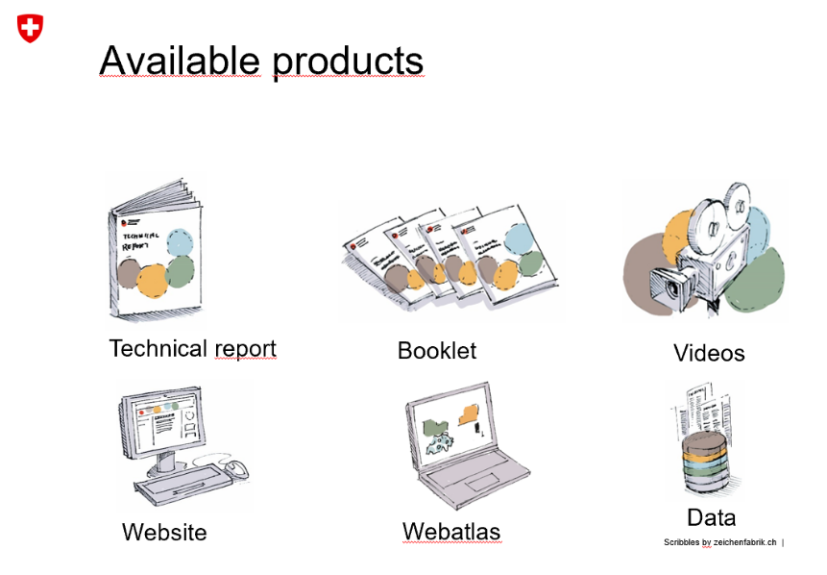Source R. Hohman 2019.

All information about the new climate scenarios is on the web site[34]. The information is available in English too, certainly the technical report, the booklet and the web-atlas. The work was done based on a mandate given in the first action plan including significant resources. Since Switzerland was not entirely happy with the old scenarios from 2011 not finding their way into practical work, MeteoSchweiz[35] gave a contract for a stakeholders’ needs analysis (available only in German). Following the stakeholder analysis, they came up with a range of products that is expected to better fulfill the requirements of a real climate service.

***Box 1. Expanding information landscape of climate change and adaptation***  
In addition to national or European assessments, there is an increasing number of news portals (websites) that present climate change vulnerabilities, impacts and adaptation strategies for a wide range of climate aspects (e.g. temperature, precipitation, evaporation) and many relevant sectors (e.g. water, agriculture, infrastructure, cities, health). They often have a geographical focus (USA, Australia, Europe), include infographics and videos, and are run by journalists with a backup of scientific expertise. Their focus is not on policy but on explaining science to a wide audience. Communication is based on short or long-read articles. Climate Signals (main focus USA) is a bit different than other news sites: the information is related to past and current extreme events with a ‘climate change signature’ that lights up on a world map; by clicking on these events additional information is shown.

The NASA shows the development of temperature anomalies since 1900 and the disappearing of Arctic Sea ice; see links below), and more and more, leading newspapers (Washington Post, New York Times) publish in depth articles on aspects of climate change, often including (and sometimes interactive) infographics.

Some global organizations (UNDP, UNFCCC, World Bank, recently also Global Center on Adaptation) also present news and information on climate change vulnerabilities, impacts and adaptation. The added value of the news on these websites is not quite clear at first glance. The World Bank Group also has a special ‘Climate Change Knowledge Portal’ that presents CCIV(A) information (text and infographics) for 3 geographical subunits: country, region and watershed; these subunits can be selected from a world map on the site.

Chapter references/links

National examples

* The Netherlands. Adaptation to climate change in the Netherlands - Studying related risks and opportunities: [www.pbl.nl/en/publications/adaptation-to-climate-change-in-the-netherlands](http://www.pbl.nl/en/publications/adaptation-to-climate-change-in-the-netherlands)); Climate Impact Atlas: [www.klimaateffectatlas.nl](http://www.klimaateffectatlas.nl)
* Germany. Site of the federal government: [www.umweltbundesamt.de/en/topics/climate-energy/climate-impacts-adaptation](http://www.umweltbundesamt.de/en/topics/climate-energy/climate-impacts-adaptation); Climate Preparedness Services: [www.klivoportal.de](http://www.klivoportal.de)
* UK. A number of websites including: [www.ukcip.org.uk](http://www.ukcip.org.uk); [www.defra.gov.uk/adaptation](http://www.defra.gov.uk/adaptation);; [www.climatenorthernireland.org.uk](http://www.climatenorthernireland.org.uk); <https://www.theccc.org.uk>; [www.mccip.org.uk](http://www.mccip.org.uk); <https://www.adaptationscotland.org.uk/>; <https://www.metoffice.gov.uk/food-insecurity-index/>
* Switzerland. National Centre for Climate Services: [www.klimaszenarien.ch](http://www.klimaszenarien.ch/); MeteoSchweiz: [www.meteoschweiz.admin.ch/home/suche.subpage.html/de/data/blogs/2016/3/analyse-der-nutzerbeduerfnisse-zu-nationalen-klimas.html?query=klimaszenarien&pageIndex=0&tab=search_tab](http://www.meteoschweiz.admin.ch/home/suche.subpage.html/de/data/blogs/2016/3/analyse-der-nutzerbeduerfnisse-zu-nationalen-klimas.html?query=klimaszenarien&pageIndex=0&tab=search_tab)
* Finland. Ministry of Agriculture and Forestry: <https://mmm.fi/luonto-ja-ilmasto/ilmastonmuutokseen-sopeutuminen>

European examples

* JRC PESETA: <https://ec.europa.eu/jrc/en/peseta-ii> ; <https://ec.europa.eu/jrc/en/peseta-iii>
* Copernicus: <https://climate.copernicus.eu>
* MedEC (Mediterranean experts on climate and environmental change): [www.medecc.org](http://www.medecc.org)

Other examples

* Climate Central (USA): [www.climatecentral.org](http://www.climatecentral.org)
* Inside Climate News (USA): <https://insideclimatenews.org>
* Climate Signals (mainly USA): [www.climatesignals.org](http://www.climatesignals.org)
* Climate Council (Australia): [www.climatecouncil.org.au](http://www.climatecouncil.org.au)
* Climate Change Post (Europe): [www.climatechangepost.com](http://www.climatechangepost.com)
* Carbon Brief (global): [www.carbonbrief.org](http://www.carbonbrief.org)
* IPCC: <https://www.ipcc.ch/>
* UNDP: [www.adaptation-undp.org](http://www.adaptation-undp.org)
* NASA: <https://climate.nasa.gov/solutions/adaptation-mitigation/>; <https://www.bing.com/videos/search?q=Nasa+climate+change+impacts+youtube&view=detail&mid=3545941234A20B96964F3545941234A20B96964F&FORM=VIRE> ;

<https://www.bing.com/videos/search?q=Nasa+climate+change+impacts+youtube&view=detail&mid=F4528A7734590160C753F4528A7734590160C753&FORM=VIRE>

* UNFCCC: <https://unfccc.int>
* World Bank: [www.worldbank.org/en/topic/climatechange](http://www.worldbank.org/en/topic/climatechange) and <https://climateknowledgeportal.worldbank.org>

# The evolving demand for CCIV(A) information

**Key messages/recommendations:**

* There is an expressed need on knowledge beyond climate impacts. This includes an assessment of vulnerabilities and risk, information on adaptation (including ecosystem-based adaptation), relationship to sustainable development goals, global transboundary (spillover) effects of climate change impacts and risks. Also, information on high-end climate change is requested.
* The demand for CCIV(A) information is simultaneously diversifying and becoming more specific with respect to focus and spatial and temporal resolution. This is driven by the (successful) mainstreaming of climate change adaptation.
* There is large variation between policy areas in terms of available knowledge. Sectors that have a long history of concern for climate change (water, agriculture, biodiversity…) have initiated numerous studies on CCIV, which suggests a growing need for syntheses that bring together and critically reviews a rapidly growing body of information. Other sectors (buildings, health) have a shorter tradition in carrying out CCIV studies and for these general overviews may be the first step towards formulating policies.
* The national policy needs for CCIV(A) information require generally high spatial resolution that can be linked with the spatial resolution use in policy planning and implementation within each sector.
* A link to Disaster Risk Reduction policies is likely to help in mainstreaming climate change and adaptation into ongoing sectoral activities
* Several sectors have commissioned specific CCIV studies, but there is also a need for studies and reports that make it possible to identify similarities and links across policy areas.

## Knowledge needs reflected in the EU adaptation strategy and its evaluation

The EU Adaptation strategy and its evaluation have highlighted information needs. The strategy set as one of its goals to “Bridge the knowledge gap” and it specifically foresaw mainstreaming of adaptation in the Covenant of Mayors, climate proofing of the Common Agricultural Policy, the Cohesion Policy and the Common Fisheries Policy, more resilient infrastructures and the development of insurance and other financial products for resilient investment and business decisions. All of these depend on adequate CCIV(A) information.

The evaluation of the EU adaptation strategy (COM(2018) 738 final) notes that progress has been made in bridging knowledge gaps but that “none of the priority knowledge gaps have been closed and new gaps have emerged” (p. 7). The following ‘new’ gaps have been identified: “ecosystem-based adaptation, relationship to sustainable development goals, global transboundary (spillover) effects of climate change impacts and risks, adapting infrastructure, mountainous areas, long-term lack of water resources, high-end climate change, health, coastal areas, biodiversity” (SWD(2018) 461 final, p. 16). The list shows a recognition of the links between CCIV and Adaptation information. There is also a recognition of the growing knowledge needs arising from disaster risk reduction (ibid. p. 10-11).

The report on the evaluation foresees that to advance adaptation further “the Commission could envisage exchanges of information on successful adaptation measures between stakeholders and with the scientific community” (p.12). Such exchanges would clearly benefit from systematic analyses that the EEA could provide in its report(s) using, for example, material submitted to Climate-ADAPT.

The evaluation of the EU adaptation strategy suggests that the role of the CCIV(A) information is to provide input and feedback into the policy dialogues and processes that design and revise policies. The demands are likely to become increasingly specific as policy areas evolve. At a European level there is a particular need for understanding the diversity of CCIV(A) across Europe in order to formulate policies that are sufficiently flexible in implementation, yet specific enough to allow for a meaningful mainstreaming of climate change measures. The following section explores these demands from a sector perspective.

## Mainstreaming generates new demands for knowledge

As highlighted by the evaluation of the EU adaptation strategy (SWD(2018) 461 final), the demand for reliable and comprehensive information on climate change impacts, vulnerabilities and adaptation is expected to increase. An important driver is the progress of climate change itself, with increasing recognisable impacts. ‘New’ knowledge gaps identified in the evaluation of the adaptation strategy (see section 4.1 above) include transnational impacts and adaptation actions. One way to address these is to examine the European macro-regions[36] and their specific adaptation needs, which demands spatially explicit information.

Another important and partly related driver is the policy development at different levels of governance. Evidence based policy development needs a solid and coherent base of information (Table 4.1) to help the sectors in identifying relevant hazards, exposures, vulnerabilities and eventually risks (of impacts).

The overview of EU policy areas as identified in the Climate-ADAPT shows that policy development needs general spatially explicit overviews of key climate variables that affect many sectors, but also specific interpretations that focus on the particular vulnerabilities of the sectors (Table 4.1). Several sectors have commissioned specific CCIV studies. There is also a need for studies and reports that make it possible to identify similarities and links across policy areas. For example financial risks related to climate change materialize differently in forestry, transport and energy, but for regional policy development it is of value to explore how and to what extent impacts and risks can materialize within the same geographical areas. Initiatives in the European macro-regions create specific demands for knowledge.

Table 4.1 Specific demands for CCIV information that can be identified for different policy areas. The Table has been compiled specifically for this report by ETC experts by examining references to the listed sectors in the Evaluation of the EC adaptation strategy and by examining how recent policy documents for the sectors in question refer to climate change. The purpose has not been to provide an exhaustive list of all sector needs but to illustrate the nature of the CCIV knowledge demands in the sectors.

|  |  |
| --- | --- |
| **Policy area** | **Specific demands for CCIV(A) information at the EU level** |
| Agriculture | One of the 9 objectives of the future CAP focuses explicitly on climate change action, but many of the other CAP objectives are also potentially affected by climate change. The impacts of climate change on agricultural practices are of key interest in order to avoid conflicting policy demands and maladaptation. <https://ec.europa.eu/info/food-farming-fisheries/key-policies/common-agricultural-policy/future-cap_en>  For the CAP the variability in exposure to climatic variables across Europe and within seasons is key. Information on the vulnerability of specific farming practices (crops, animal husbandry) is of interest for designing subsidies that are expected to increase robustness in the face of climate change. For example, the Evaluation of the EU Strategy on adaptation to climate change (SWD(2018) 461 final, p. 208 quotes PESETA III projections which suggest that irrigated crop yield will decline for most crops and regions in Europe, in large part due to a shortening of the growing season. Yield changes for rain-fed crops depend on regional water availability and crop-specific water requirements. Documenting and tracking the actual development will be important for policy development. |
| Biodiversity | Actions to safeguard biodiversity include the Natural Capital Financing Facility (NCFF) operated by the European Investment Bank (EIB) providing loan or equity financing and technical assistance to natural capital projects. These NCFF projects aim to generate revenues or save costs while delivering on biodiversity and climate adaptation objectives. (Evaluation of the EU Strategy on adaptation to climate change (SWD(2018) 461 final, p. 15)). Strategic policy development for such funds needs specific information on CCIV for key components of the biodiversity. The evaluation also showed that ‘nature’ is one of the focal areas for CC studies in European funding and hence there is also a demand for syntheses. See also Green Infrastructure (GI) — Enhancing Europe’s Natural Capital. COM(2013) 249 |
| Buildings | Detailed climate change related regulations on buildings have not, with the exception of energy efficiency, not so far been a major topic at the European level. The development of standards aiming to improve the resilience of European infrastructure to the adverse effects of climate change <https://www.cencenelec.eu/standards/sectors/climatechange/pages/default.aspx> will create specific demands, but most likely with an emphasis on the national level (see Section 5.3) |
| Coastal areas | The Marine Strategy Framework Directive (MSD 2008/56/EC, preambula 34) recognizes climate change by noting that climate change, makes it “essential to recognise that the determination of good environmental status may have to be adapted over time.” There are also needs arising from the policy level for the allocation of funding, as estimates suggests that, in the absence of further investments in coastal adaptation, the present expected annual losses of 1.25 billion EUR due to coastal flooding can increase by 2 to 3 orders of magnitude by the end of the century. [Vousdoukas et al. 2018, Climatic and socioeconomic controls of future coastal flood risk in Europe. Nature Climate Change 8: 776–780, <https://doi.org/10.1038/s41558-018-0260-4>] |
| Disaster risk reduction | The documentation and understanding of the occurrence of climate related disasters is necessary as background information for improving coherence between climate change adaptation and disaster risk reduction across all levels of governance, which is a need documented by the Evaluation of the EU Strategy on adaptation to climate change (SWD(2018) 461 final, p. 49)  “Disaster risk prevention and management imply the need to design and implement risk management measures that involve the coordination of a wide range of actors. It is important to take into account current climate variability and the projected trajectories of climate change when preparing risk assessments and risk management measures. The preparation of risk maps is a crucial aspect of reinforcement of prevention actions and response capacity.” DECISION (EU) 2019/420 13 March 2019 amending Decision No 1313/2013/EU on a Union Civil Protection Mechanism, preamble (8). |
| Ecosystem-based approaches | Recognition of “multiple benefits including for biodiversity, ecosystems, climate change adaptation, climate change mitigation, air and soil quality and societal well-being. This multi-functionality should be better embedded in the assessment of adaptation options” (COM(2018) 738 final, p. 15). |
| Energy | The energy sector maintains critical infrastructure in Europe. Part of the grid is sensitive to extreme weather events. The shift in the energy production also introduces new types of vulnerabilities. The policy development in the energy sector therefore needs both general climate information and specific interpretations for relevant vulnerabilities in the sector. |
| Finance | The Action Plan: Financing Sustainable Growth Brussels, 8.3.2018  COM(2018) 97 final includes a number of initiatives that will, when translated into action, require adequate information also on climate change impacts and vulnerabilities. For example, the EU taxonomy for climate change, environmentally and socially sustainable activities was published in June 2019, with a specific chapter devoted to adaptation to climate change.[37] The proposals of the report underline the need for knowledge of what adaptation activities achieve within different sectors. |
| Forestry | The Progress in the implementation of the EU Forest Strategy Brussels, 7.12.2018  COM(2018) 811 final notes “The EU has provided significant financial and institutional support to address forest fires and other disasters, including through the CAP, European Structural and Investment Funds, research and LIFE funds. The EU Civil Protection Mechanism supports forest fire prevention through risk assessments, management plans, early warning and alert systems and awareness raising. The Emergency Response Coordination Centre (ERCC) monitors forest fire risk and incidence for coordinated and quick response, supported by the European Forest Fire Information System (EFFIS).” (p.5). This focuses attention on forest specific CCIV developments, with specific attention to disaster development, but also the more challenging notion of resilience. |
| Health | “Reinforcing the links between public health and adaptation, notably to improve cross-sectoral cooperation on risk assessment and surveillance and to increase the awareness and capacity of the health sector,… to address current and emerging climate-related health risks. For example, the Commission could further support the development and sharing of best practice and new knowledge on climate-related health risks” (COM(2018) 738 final, p. 16). |
| Marine and fisheries | The Marine Strategy Directive (MSD 2008/56/EC) applies (see coastal areas). Furthermore “The new Common Fisheries Policy has to play a role in facilitating climate change adaptation efforts concerning impacts in the marine environment.”  Green Paper Reform of the Common Fisheries Policy COM(2009)163 final p. 19. Stating also an explicit need for impacts on fish stocks (ibid. p. 20, the knowledge base). The proposed Regulation for the European Maritime and Fisheries Fund {COM(2018) 390 final} also explicitly recognizes the impact of climate change as a driver (e.g. p. 51). Specific information on impacts of CC in the domain of fisheries and marine areas will therefore be essential. |
| Transport | The Evaluation of the EU Strategy on adaptation to climate change (SWD(2018) 461 final, p. 49 notes that Stakeholders in the energy, transport and construction sectors identified the following knowledge related barriers to adaptation:   * Uncertainties relating to climate impacts and extreme events (frequency and magnitude); * Need for climate proofing standards;   There is a need for additional information on climate change impacts for policy development. At a general level potential impacts have been identified. Thus the report by Ecofys et al. (2017) Assessing Adaptation Knowledge in Europe: Infrastructure Resilience in the Transport, Energy and Construction Sectors identifies as hotspots (p. 58):  › Areas of highly centralised traffic patterns:  › Inland waterways  › Road, rail: in mountainous regions transport networks are expected to be most vulnerable to intense rain and snow. Roads are vulnerable to flooding particularly in Central and northern Europe.  › Ports on the Atlantic coast are a hotspot due to sea-level rise and together with related extreme wave events more than those on the Mediterranean coast.  › Air: vulnerability of aviation to extreme events.  However, a recent overview (DG Move 2019, Transport in the European Union Current Trends and Issues (March 2019)) suggest very little recognition of climate change impacts or risks as the main focus has been on reducing emissions from transport. |
| Urban | The need for information takes many forms. One aspect is the “assessment and mapping of social vulnerability to climate-related events, as well as identifying and involving vulnerable groups” (COM(2018) 738 final, p. 16). The CC impacts on and resilience of urban infrastructures is one of significance for European urban policies, calling for spatially fairly detailed information. |
| Water management | Water management has a long tradition of awareness of climate change impacts. There are several very different aspects that are addressed by different sub-policies. The Floods directive (2007/60/EC) has created an institutionalized demand for information and will also generate monitoring data. On the other hand there is the respond to water shortage and rational water use as in the proposed Regulation on minimum requirements for water reuse (COM(2018) 337 final) and the implementation and possible revision of the water framework directive (WFD 2000/60/EC ) |

## Evolving national adaptation policies and plans

The national adaptation policies and plans develop rapidly in response to national needs and policy developments and in the context of the respective EU policies. By and large the national policy needs for CCIV(A) information require high spatial resolution that matches the spatial resolution used in policy planning and implementation within each sector.

Specific needs may arise due to the linking of disaster risk management (Sendai framework) and climate change adaptation: the operational elements of the Sendai framework call for specific and detailed knowledge, which needs to be combined with scenario information to support long-term preparedness. The combination of long-term perspectives of adaptation policies with the demand for near future projections and rapidly updated spatially explicit information on climate change impacts and their consequences demands on-line systems for information storage and retrieval.

As for the European level policies there are differences within countries when it comes to the availability of and need for CCIV(A) knowledge. For example, the specific changing conditions for agriculture and the national implementation of the CAP require knowledge that helps to reduce climate risks for the national food system. The Adaptation preparedness scoreboard Country fiches (SWD(2018) 460 final) show that Agriculture is one of the sectors that nearly all countries refer to. This suggests that there is also a considerable (emerging) demand for cross country comparison of the CCIV(A) information on agriculture.

The finance sector is by its very nature European and also international. This means that the CCIV information needs of the national policy development are broadly speaking identical to those of the European policy level. The specific needs arising in the implementation of the policies, especially in a DRR perspective, are however, more detailed at the national level.

Similarly progress in standardisation of buildings[38] will increase the demand for spatially detailed information on climatic variables with specific significance for buildings. The implementation of such standards will require detailed information that can support national or even local building regulations.

The examples above suggest that the general contents of the CCIV(A) national knowledge needs can be deduced at a European level, taking European policy developments (Table 5.1) as a starting point. The specific national circumstances illustrate the need for more specific information and once it has been collected it helps to highlight the diversity and need for flexibility in European policy development. Even within countries there can be substantial variability with respect to impacts and vulnerabilities within sectors and policy areas.

# Landscape of related information suppliers

**Key messages/recommendations:**

* The most important new information source for the EEA climate report is C3S.
  + Most likely, all type of climate indices for the current situation and future projection could be extracted or delivered by C3S
  + C3S may also provide narratives to climate information
  + C3S will provide specific climate services to Climate-Adapt. This could be developed towards a standardized data and information provision from C3S towards EEA for several reports and activities. Coordination is needed.
  + C3S will most likely not provide European wide information on climate impacts.
* The PESETA reports by JRC could add the financial impact perspective to the EEA report
  + Depending on the availability of PESETA IV, the EEA should coordinate with JRC to include results from PESETA IV into the EEA report
  + Authors of PESETA can offer an external contribution to the EEA report (e.g. in a box)
  + Adaptation data/info, when available can be incorporated into EEA report
* The upcoming IPCC AR6 report (in particular the regional chapter on Europe) is another potential data source.
  + Focus of IPCC is more on literature review than on data analysis.
  + Adaptation plays a role in the AR5 report → also in AR6 each chapter will mention adaptation options
  + The AR5 Europe regional document (and consequently the AR6 one) does not go in depth in the description of impacts. This type of information can serve as a starting point which needs to be expanded through other studies.

## Copernicus Climate Change Service

The Copernicus Climate Change Service (C3), implemented by the European Centre for Medium Range Weather Forecasts (ECMWF), is becoming the major and standardized source for climate data and climate information for Europe. In a meeting between Andre Jol, Hans-Martin Füssel (EEA), Marc Zebisch (ETC/CCA) and Carlo Buontempo (C3S) at the fringes of the ECCA 2019 conference, it became clear that C3S will be available to provide climate related information requested by the EEA, which can be extracted from the Climate data store. This includes past observations as well as future projections. C3S could process and visualize essential climate variables (such as Temperature and Precipitation), but also complex indicators (such as heating degree days) that are relevant for specific impacts or sectors. C3S will develop a specific information portal for Climate-ADAPT that serves as a map viewer for key climate indicators. This portal could be developed towards a standard climate information portal for the needs of different EEA climate related reports and activities.

### C3S - European State of the Climate 2018

The European State of the Climate report is compiled by the Copernicus Climate Change Service (C3S). It consists of an overview of annual and seasonal conditions in Europe and the European Arctic, compared with the long-term average. The events and impacts of the year are placed into a longer-term global context. The main reference period used throughout the report is 1981-2010. The Report is based on C3S data and expertise, other Copernicus services and external partner contributions. It can be understood as a first example of what C3S could provide in the future – not only for specific years, but for consistent time series from the past to the future.

**Parameters that can be used:**

The annual and seasonal conditions in Europe and the European Arctic, compared with the long-term average which are addressed by the European State of the Climate 2018 are:

* Surface air temperature (annual, seasonal, maximum and minimum temperatures)
* Annual and seasonal mean precipitation
* Annual and seasonal mean soil moisture
* Extreme precipitation (maximum one-day rainfall amount, maximum five-day rainfall amount, annual precipitation fraction due to very wet days, mean precipitation amount of wet days)
* Area of the European Arctic covered by sea ice
* Glacier distribution and changes in Europe
* European regional sea level trends

Other key climate variables available which have different reference periods:

* Soil moisture and Leaf Area Index variations during the year observed from satellites (reference period 1991-2010)
* Wildfire danger (compared with the period 1981-2010)
* Annual wildfire CO2 emissions (2003-2018)
* River discharge over Europe (and comparison between different years for River Rhine)
* Annual sunshine duration compared to the base period of 1983-2017.
* Lake surface water temperature anomalies relative to 1997-2016
* Monthly mean area covered by open water or open ice in February 1979-2018

**Presentation of info/data:**

* For the above parameters maps and graph are present (comparison of parameters for different years)
* The website format is intuitive; however, an index/overview of available date is missing
* A downloadable summary in PDF is also available
* Some photos can be used with C3S permission

Table 5.2. gives a tabular overview how the EEA indicators included in the 2016 EEA CCIV report are covered in current and planned C3S products.

Table 5.2 Coverage of EEA climate indicator by various current and planned C3S products



## PESETA III

The PESETA III study is part of a series of projects of the Joint Research Centre (JRC) which aim at quantifying the possible biophysical and socio-economic consequences of future climate change in Europe (for 11 impact areas). Its methodological framework integrates climate and socio-economic projections, impact models and an economic analysis. In a personal communication with a JRC representative (Pablo Barbosa), it was discussed that in future C3S could also be the main information source for climate data for JRC activities and JRC could then focus on the (biophysical and economic) impact analysis.

* **Data Sources:**

Climate changes scenarios: Implementation of EURO-CORDEX climate projections consistent with the high-end emission scenario (Representative Concentration Pathway RCP8.5). Focus on two periods/scenarios: end of the century (2071-2100), with GWL >3°C (high warming scenario) and ~ 2025-2055 where GWL = 2°C (2°C warming scenario)

Socio-economic scenarios: The economic evaluation of impacts is made within a specific setting of the state of the economy: static (the economy as of today) Vs dynamic (the economy of the future). Most of the analyses follow the static approach. This implies assessing climate impacts as if future climate occurs in the present, affecting today's economy and population. Some impact categories also consider dynamic projections of socio-economic conditions based on the ECFIN Ageing Report[39] and the Shared Socio-economic Pathways[40] (SSPs) consistent with RCP8.5, namely SSP3 and SSP5

* **Data Content (which sectors, which topics: risk, adaptation etc.)**

The study focuses on 11 Sectors/impact areas: coastal floods, river floods, droughts, agriculture, energy, transport, water resources, habitat loss, forest fires, labour productivity, and mortality due to heat.

Adaptation measures to reduce damage and population affected are suggested, however, they are not present systematically for all sectors. For some sectors adaptation scenarios are modelled, for other sectors adaptation measures are mentioned only briefly.

Changes in climatic conditions are converted into a wide range of impacts (mostly direct impacts), some of which are translated into monetary terms through an economic analysis. Moreover, a spill over analysis is also present.

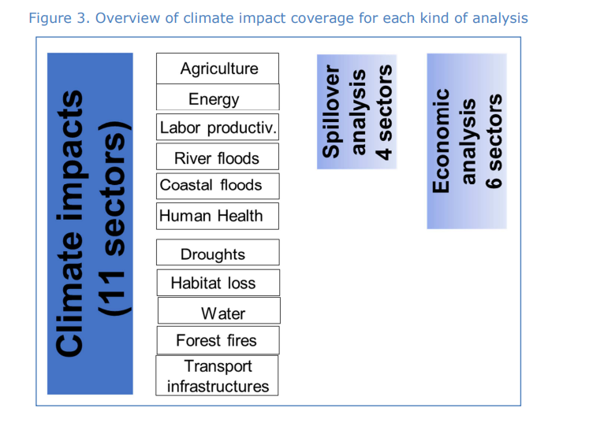The economic impact analysis allows the comparison of heterogeneous climate impacts taking into account also the indirect effects occurring via the market system. It uses a sector structure of the economic system to assess the potential impact on welfare (expressed as consumption; for example, comparison of Expected Annual Damage- EAD and Expected Annual number of People Affected- EAPA under different scenarios; impact on crop prices). However, to the current state, the analysis is only carried out only for 6 sectoral impacts (see Figure 5): residential energy demand, coastal floods, inland floods, labour productivity, agriculture and heat-related mortality. Five of these impacts can be easily expressed in terms of welfare losses, so they can be compared with GDP. On the contrary, the health welfare losses are valued through the VSL (Value of Statistical Life), which is not a market effect.

Figure 5 Overview of sectors covered in Economic and in the spillover Analyses

Moreover, a spill-over/transboundary analysis is also part of the PESETA methodology. It consists in an estimate of the additional welfare impact in the EU associated to changes in trade flows due to climate impacts occurring in third countries associated to four impact areas (residential energy demand, river flooding, labour productivity and agriculture). Currently in the EEA CCIV report this is part of a sub-chapter 6.3 “projected economic impacts of CC in Europe” (PESETA II already mentioned).

**Aspects EEA could profit from:** PESETA III (or its successor, PESETA IV) could be useful to integrate data on the economic impacts for the sectors where the analysis is available. The Economic and Spill-over/transboundary analysis from PESETA could be included in the EEA report in a systematic way if a collaboration between EEA authors and JRC is achieved. Authors of PESETA could offer an external contribution and the abovementioned information could also be directly added (e.g. in a text box). Moreover, adaptation scenarios (either modelling or brief description, depending on the level of detail achieved per sector, see Table 5.3) can also be incorporated into the EEA report.

**New PESETA IV:** The new JRC PESETA IV intends to better capture the uncertainty from climate modelling, with additional climate runs beyond the five core models of JRC PESETA III, and also add further warming scenarios (for 1.5ºC, 2ºC, 3ºC and 4ºC of global warming). Three new impact areas will be included: forest ecosystems, human health (both heat- and cold-related mortality) and windstorms. The river floods and coastal floods models will explore adaptation measures, including their costs and benefits; and additional inter-sectoral links will be considered. Communication issues (particularly to policymakers) will also receive particular attention.

**What could EEA add? What is missing in PESETA III?**

* EEA addresses more sectors/systems, generally more in detail compared to PESETA III. The PESETA main report does not differentiate between chapters on Climate change impacts on environmental systems and Climate change impacts on social systems. Consequently, impacts on society and environment are mixed
* Moreover, the following information is missing and could be added if a collaboration between PESETA IV authors and EEA authors is accomplished:
* More detailed spatial resolution (local/regional)
* Better understanding of extreme events (in EEA CCIV report there is a dedicated sub-chapter)
* Non-market climate impact areas (e.g. natural ecosystems, climate catastrophes, migration)
* Integration of various impact models (e.g. land-water-energy nexus)

Table 5.3 Coverage of topics in PESETA III and the 2016 EEA CCIV report

|  |  |  |
| --- | --- | --- |
|  | **Reports** | |
| **Sector** | **PESETA III** | **EEA** |
| **Coastal flood** | * Considers sea level rise, high tides and storm surges * Projected economic damage + projected affected population * Adaptation mentioned | * Part of climate change impacts on environmental systems (sea level rise) → info on past trends + projections |
| **River floods** | * Does not consider pluvial and flash floods * Expected economic damages of river floods + expected population affected * Adaptation mentioned and risk if adaptation measures are not improved | * Part of climate change impacts on environmental systems (freshwater systems, river floods chapter) → info on past trends + projections |
| **Drought** | * Soil drought risk * No economic evaluation, no adaptation info | * Soil moisture is part of climate change impacts on environmental systems → past trends + projections |
| **Agriculture** | * Impacts on rain-fed agriculture * Impacts on irrigated agriculture * Economic impact included * No adaptation | * Indicators: water-limited crop yield, crop water demand |
| **Energy** | * Impact on heating and cooling demand * Adaptation mentioned | * Focus on heating and cooling degree days * Also focuses on electricity production and energy infrastructure |
| **Transport** | * Airports, seaports, inland waterways while PESETA II roads and rail. * Three climate hazards: coastal flooding, river flooding and droughts * Adaptation mentioned | * Road, rail, water-borne, aviation * Extreme events: Heat waves, cold spells, heavy precipitations, snowfall, storms/winds |
| **Water resources** | * Average flows, low flows of river discharge and groundwater recharge + Water Exploitation Index * Adaptation mentioned | Part of climate change impacts on environmental systems (freshwater systems, river flows chapter) → info on past trends + projections |
| **Habitat loss** | * Change in the extent of the Mediterranean climate zone * Change in the extent of the arid climate zone * Change in Natura 2000 zones * Adaptation mentioned | Part of distribution shifts of plant and animal species (in climate change impacts on environmental systems -Terrestrial ecosystems, soil and forests) |
| **Forest fires** | * Vegetation moisture * Forest fire danger * No adaptation scenarios modeled but adaptation mentioned (literature review) | Specific chapter present on forest fires (in climate change impacts on environmental systems - Terrestrial ecosystems, soil and forests) |
| **Labour productivity** | * Impacts under the high emission scenario * Impacts under the 2°C scenario * Adaptation mentioned | Not a specific chapter, but topic is addressed in Extreme temperatures and health chapter |
| **Mortality due to heatwaves** | * estimated mortality due to heatwaves per year under various scenarios | -Extreme temperatures and health chapter (in Impacts of climate-related extremes) |

## IPCC WG II AR5/AR6:

The IPCC prepares assessment reports reviewing the latest knowledge on climate change, its causes, potential impacts and response options. Up to now IPCC has published five comprehensive assessment reports, as well as several special reports on particular topics. Each assessment report is divided in three volumes, corresponding to the three Working Groups of IPCC I. Moreover, a synthesis report integrates the working group contributions. The Fifth Assessment Report (AR5) was published in 2014; the Sixth Assessment Report (AR6), is currently being prepared and will be published between 2021 and 2022 (see image below).

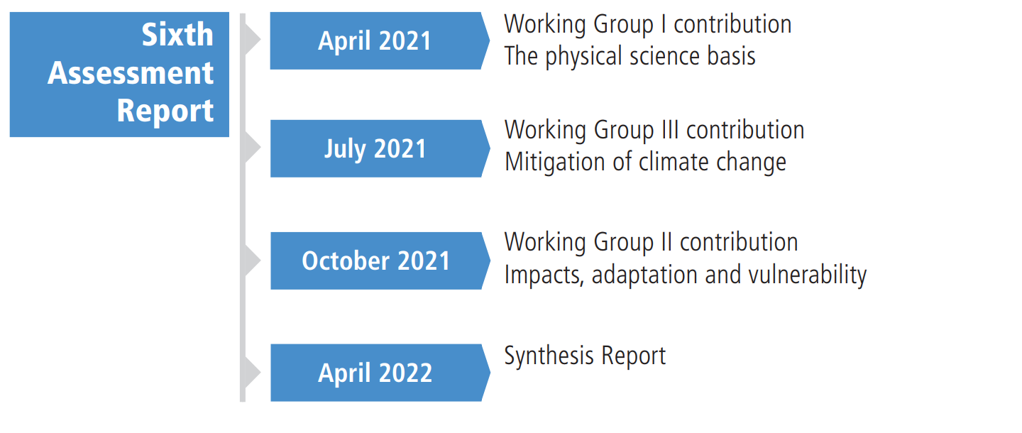

Figure 6 Timeline of Reports that will be published by IPCC within the 6th Assessment Cycle[41]

The outline of AR6 is already available online[42]. The most relevant content that can be used as source for the EEA CCIV report is the contribution of Working Group II (Climate Change: Impacts, Adaptation and Vulnerability), in particular the Europe regional chapter.

* **Data Sources:**

Climate changes scenarios: Representative Concentration Pathways (RCPs). WGI AR5 is based primarily on results from the RCP CMIP5, WGII AR5 also uses results from the SRES CMIP3

Five Shared Socioeconomic Pathways (SSPs): link of each RCP’s climate path to a range of human development pathways. They include: (1) storylines, which are descriptions of the state of the world; (2) IAM quantitative variables (such as population, gross domestic product (GDP), technology availability); and (3) other variables, not included in the IAMs, such as ecosystems productivity and sensitivity or governance index.

* **Data Content (which sectors, which topics: risk, adaptation, economic evaluation?):**

Impacts on different sectors are defined through a literature review process which summarizes the latest scientific evidence. The following sectors are addressed.

* **Sectors:** a wide range of sectors covers physical, biological, and human systems.

The following sectors are addressed in the *AR5*:

* Natural and Managed Resources and Systems and their use: Freshwater resources, Terrestrial and inland water systems, Coastal systems and low-lying areas, Ocean systems, and Food security and food production systems
* Human Settlements, Industry, and Infrastructure: Urban areas, Rural areas
* Human Health, Well-Being, and Security: Human health: impacts, adaptation, and co-benefits, Human security, and Livelihoods and poverty

The overall number of sectorsin *AR6* will decrease compared to AR5 (no rural areas, no human security, terrestrial and freshwater systems will be joined in one chapter, with less pages dedicated). Each chapter on sectors in AR6 will focus on observed impacts and on projected, adaptation and mitigation responses and their interactions with sustainable development.

* **Europe Regional chapter**: the number of pages of the AR6 regional Europe chapter will be similar to the regional chapter in AR5[43] ~40 pages). In AR5, the Europe chapter was structured around key policy areas:
* Production systems and physical infrastructure
* Agriculture, fisheries, forestry, and bioenergy production
* Health protection and social welfare
* Protection of environmental quality and biological conservation.

In the AR5 regional document main impacts are assessed per sector and per region/subregion (southern, Atlantic, alpine etc)

* **Policy relevant topics addressed in the Assessment Reports by IPCC:**
* **Risks:** in AR5 key risks from climate change are identified and also listed in a table. However, they are not identified through a quantitative risk assessment process but based on assessment of the literature and expert judgment. Current sectoral risks and projected risks (including identifying key risks and residual risks as well as development pathways depending on rate and level of climate change) will be addresses in AR6 regional report. **Risk assessment** is mentioned as part of the regional chapter in AR6 “Summary Table and/or figures with WGI and WGII information, combined with risk assessment (e.g., SREX SPM.1)”; however, the level of detail and the methodology which will be followed is not yet clear.
* **Adaptation**: Adaptation options are only addressed in some sectoral chapters in the AR5 regional chapter. Moreover, in the AR5 regional chapter adaptation is the focus of two sub-chapters: Economic Assessments of Adaptation” and “Co-Benefits and Unintended Consequences of Adaptation and Mitigation”. In the general AR6 document, adaptation options will be addressed in each sector chapter. In the AR6 regional chapter adaptation might be addressed more in depth (“Diverse adaptation options including opportunities, enablers, limits, barriers, adaptive capacity, and finances” is one of the guidance points listed in the AR6 regional outline).
* **Economic assessments** of impacts/adaptation: the AR5 regional chapter addresses these topics in some sectoral paragraphs + specific sub-chapters “Economic Assessments of Adaptation”. The PESETA study is used as one of the sources (page 1297).
* **Aspects EEA could profit from:** The IPCC regional document on Europe could function as a first step to gather information on relevant sectors. Sector-specific subchapters however are very brief; many sectoral impacts are not described through maps. EEA carried out a more in-depth analysis of the sectors. Therefore, if EEA decides to keep the same approach, IPCC regional information needs to be expanded through other documents.
* **Added value of EEA CCIV report:** the 2016 EEA CCIV report provides maps and comparisons between countries of the entire continent while IPCC (in general) gives country/city specific examples. (Examples for sentences from the IPCC AR5: “For two Danish river catchments”, “In Upper Austria”, “a study in the UK found that”, “Evidence from France and Italy indicate..”)

Table 5.4 Sector coverage in the IPCC AR5 (regional chapter Europe) and the 2016 EEA CCIV report

|  |  |  |
| --- | --- | --- |
|  | **Reports** | |
| **Sector** | **IPCC AR5 Regional EU** | **EEA** |
| Production systems and physical infrastructure | 4 pages   * Settlements (Coastal flooding, River and Pluvial Flooding, Windstorms, Mass Movements and Avalanches) * Built environment * Transport * Energy Production, Transmission and Use * Industry and Manufacturing * Tourism * Insurance and banking | * In the EEA CCIV report there is a different distribution of these topics in different chapters.   Industry and manufacturing not present in EEA CCIV  EEA goes more in depth (i.e. tourism in EEA has two more detailed sections on summer and winter tourism) |
| Agriculture, Fisheries, Forestry, and Bioenergy Production | 6 pages   * Plant (Food) Production (A) * Livestock Production * Water Resources and Agriculture * Forestry * Bioenergy Production * Assessment of Climate Change Impacts on Ecosystem Services by Sub-region * Fisheries and Aquaculture | EEA goes more in depth (i.e. Agriculture alone is 21 pages) |
| Health and Social Welfare | 3 pages   * Human Population Health * Critical infrastructure * Social impacts * Cultural heritage and landscapes | EEA goes more in depth (i.e. health >20 pages which focus on different disease types and causes) |
| Protection of Environmental Quality and Biological Conservation | 2 pages   * Air Quality * Soil Quality and Land Degradation * Water Quality * Terrestrial and Freshwater Ecosystems * Coastal and Marine Ecosystems | * Air quality not addressed * Terrestrial and Freshwater Ecosystems + Coastal and Marine Ecosystems are >20 pages each * Also Coastal and Marine Ecosystems are addressed in greater detail |

## Internal suppliers of information

### EEA Sectoral Reports

The environmental systems and social sectors addressed in the CCIV report (Chapters 4 and 5) are also addressed in other reports at EEA level. Since these reports have a narrower focus, they contain additional information which is not fully included nor summarised in the CCIV report. For example, the EEA report “*Adaptation of transport to climate change in Europe*” addresses the topic of climate change adaptation for the transport sector; however, adaptation, although being a policy relevant topic, is not addressed specifically for the transport sector in the EEA CCIV report. A collaboration between authors of the sectoral and of the CCIV reports could potentially make possible the addition of policy relevant topics which are now not addressed in the CCIV report, without an excessive use of resources. In order for the EEA reports to feed into the EEA CCIV report, the report writing and the publications themselves need to be streamlined and planned in advance, both in terms of content and of presentation. How this new information mechanism could potentially work could be explored in a follow-up EEA ETC activity. In this context, agriculture and urban areas in relation to climate change impacts and adaptation are already topics addressed in the context of EEA ETC/CCA tasks.

An example of an EEA sectoral report which could be used for updating and adding new policy relevant topics to the CCIV report is the “*Adaptation challenges and opportunities for the European energy system*” report. This report follows a structure that is similar to the one of the CCIV report, starting from the climate change impacts on the energy sector which is partially already part of the CCIV publication and moving on to the adaptation options, which are not (yet?) included. Moreover, this sectoral report makes also use of the same indicator of the CCIV report (Heating and cooling degree days). A similar approach for the other sectors would allow to connect different EEA reports and topics to the EEA CCIV publication.

### Climate-ADAPT

Climate-ADAPT aims to provide data and information on expected climate change, current and future vulnerability of European regions and sectors with a focus on adaptation options. Currently, the database of adaptation measures is presented as a list of case studies, reports and toolsets. This pool of information could represent a useful source if adaptation options were to be addressed at sectoral level in the CCIV report.

However, reading and summarising all the information present on the portal would require time and resources. Such type of summary could also be integrated in the portal itself to guide the reader. Since EEA has control over the content and the structure of the Climate-ADAPT portal and database, information could be streamlined or summarised in order to fit both the CCIV report demands and the ones of the portal itself. The alignment between the CCIV report and the Climate-ADAPT activities could be explored in a follow-up EEA ETC activity as described above also for the internal EEA reports.

# Results from NRC meeting in June 2019

## General outcomes from NRC meeting

Discussants at the NRC meeting in June 2019 emphasized that the 2016 EEA CCIV report has been an excellent tool for awareness raising and context setting, and that it has inspired related work at the national scale. Discussants also emphasized that the 2016 CCIV report was an important ‘one stop shop’, bringing relevant information together in a single document. In contrast to the 2014 user survey, discussants showed little awareness and/or use of the underlying indicators published on the EEA website. (The same holds for the information from C3S, such as the European State of the Climate reports.) Participants also made suggestions for a future EEA CCIV report. Content-related suggestions include a stronger focus on a risk perspective and socio-economic impacts, systematic information on adaptation options and barriers per sector, and the inclusion of clear policy recommendations. Format-related suggestions include a more interactive presentation of information online (with options for zooming into maps) and the wish to make all figures available for download.

## Policy demand of DG CLIMA

Claus Kondrup from the Adaptation Unit of DG CLIMA presented a list of major next steps and required information from the view-point of the Commission:

* More information on vulnerabilities, risks and adaptation options.
* Improve modelling and cost -benefit assessments (pool insurer data)
* Give more focus to citizen-level impacts (e.g. health)
* Stimulate use of Copernicus, standards for adaption, sustainable finance taxonomy
* Mandate large scale climate-proofing of infrastructure; adaptation strategy conditionality for funding/rebuilding after disasters
* Increase coherence between adaptation and sustainable development, biodiversity and disaster risk reduction
* Better align to new international framework (Paris, Sendai, SDGs)
* Identify co-benefits and leverage points – adaptation as an add-on

The list of DG Climate Action covers the knowledge needs identified in chapter 4. The list obviously does not imply that all the topics have to be covered in an EEA report, but they indicate the general tendency that there is a growing demand for knowledge of vulnerabilities and therefore also adaptation. This reflects a natural evolution from an increasing awareness of the progressing climate change to an awareness of needs for actions that address the challenges that have been identified and confirmed in the past reports of the EEA.

## Outcome of break-out group during EIONET workshop

During the EIONET Workshop on climate change at 12-13. June 2019 in Copenhagen, Hans-Martin Füssel and Marc Zebisch organised a break-out group to discuss the content and format of a 2022 EEA CCIV report with approximately 25 participants (see pictures in Annex 8.3).

**The guiding question to the participants were:**

*Content*

* How could future EEA work on CCIV best complement the information available from other sources?
* What would be the most policy relevant elements you would like to see in a 2022 EEA report?

*Format*:

* What would be your preferred format of an EEA report?
* How important is it to have a structured (printed) report compared to having information online that can be more easily updated?

**Results**

As the most policy relevant *content* items the following elements where identified:

* Risk perspective and (socio-)economic impacts to support prioritisation
* Systematic information on adaptation options and barriers per sector
* Information on cost-effectiveness of measures to adaptation
* Policy recommendations
* Integrate information on disaster risk reduction

Regarding the *format*, participants highlighted the following aspects:

* More interactive format with option to zoom in maps (regional / national scale)
* Make all figures from the report downloadable (like IPCC reports)

**Further tentative conclusions**

* Good cooperation between EEA, JRC and C3S is highly desirable to bring relevant information together
* Updates of online indicators are not much used (or known)
* Necessary to integrate discussion of
  + 2022 EEA CCIV report,
  + CCIV indicators,
  + Sectoral/thematic adaptation reports,
  + Climate-ADAPT (including new interactive features)
* Which high-priority sectors or themes could EEA address? (so far: transport, energy, agriculture, disaster risk reduction)

# Options and concrete format

**Key messages/recommendations:**

* To enhance policy relevance, content of the 2022 CCVI report could include more information on:
  + Risk and vulnerabilities per sector
  + Adaptation options per sector
* An efficient harmonisation between the services provided by the three institutions for climate change information is key. This would require a good coordination of future activities of:
  + C3S (climate data, processing of indicators, visualisation and interpretation of climate information
  + JRC (climate impact and risk assessment, economic impact)
  + EEA (adaptation, policy demand, complementary impacts)

## Conclusion from chapter 1-6

1. There is a clearly expressed **policy and user demand for information** on climate change **which goes beyond climate impacts**. Potential additional information which would increase the policy relevance of the CCIV report includes:
   1. information of vulnerabilities (e.g. non-climatic factors and drivers) and assessment of risks. This information could be added in each sectoral chapter. Information on risk and vulnerabilities are becoming increasingly available both through national analyses and European wide studies[44]. Country profiles with trends, comparisons with countries with similar risk, regional and income-group averages and other information is accumulating.[45]
   2. links between climate risks across sectors (e.g. water related risks, which affect agriculture, energy, transport) could be systematically analyzed in a separate chapter, for example by examining overlays of related risks using map based information. A separate project/task maybe initiated in EEA, potentially across ETCs to develop and refine the methodology and reporting formats (maps, indexes, …).
   3. adaptation demand and adaptation options could be integrated in each sector chapter, link to Climate-ADAPT
   4. Aspects of Ecosystem based Adaptation (EbA) could be included
   5. The link to Disaster Risk Reduction strategies could be mentioned
   6. Information on economic impact from JRC PESETA projects could be integrated into the sectoral chapters
2. The 2022 CCIV report could profit from a clever **integration and harmonization of external information sources (C3S for climate information, JRC PESETA for economic impact and risk information)** as well as **EEA internal information source (Climate-ADAPT for adaptation options per sector, other sectoral EEA reports**, see Figure 7).
   1. C3S could provide all climate data related information including graphs, figures and text as a service following specific requests by EEA. Options could even include innovative online tools for the spatially explicit visualization of key indicators. This would save a lot of resources in the production of the CCIV report but requires early and clear negotiation on information demand between EEA and C3S. First discussions with C3S key persons were very positive.
   2. JRC could provide sector specific information on climate impacts including economic impacts and risks for specific sectors which are covered by the PESTA projects. Ideally, future editions of PESETA could be based on the same climate information from C3S as to ensure consistency. A further coordination to achieve this consistency would be required.
   3. IPCC AR6 can most likely only offer complementary information, representing mainly results from literature review.
   4. Climate-ADAPT could extract sector specific recommendations on adaptation options from its rich database of case studies, reports and toolsets. The coordination between the CCIV report and Climate-ADAPT could be part of future ETC/CCA activities.
   5. For sectors which are covered by specific EEA reports on climate change (e.g. energy, transport), information on impacts, vulnerabilities, risks as well as adaptation demand and options could be extracted from these reports. The structure of the latest EEA report on climate change impact on energy could be seen as a very good example for a report which allows to extract information for the EEA CCIV report.



Figure 7: Need and chance to integrate and harmonize between information sources. Information from C3S, JRC and several EEA activities (CliamteAdapt, sectoral reports) could be understood as one pool of information out of which different products could be extracted.

## Elements of contents

Following on the conclusion from chapter 1-6 (see above) we could identify key elements for contents (see Figure 8). These elements cover expressed demands and go beyond the contents of the 2016 report (in white in Figure 8). They stem from the analysis of policy demand and the break-out group, where it was concluded, that information on sector specific vulnerability and risks and on adaption options would enhance the policy relevance of the report. In blue, we illustrate how complementary information sources could provide additional sources of information (see also Figure 7). Contents in yellow was not included in the 2016 report. Contents in bold and underlined was rated as particularly policy relevant during the Eionet workshop break-out group at June 13th 2019. An extensive description, how a printed or electronic full report of roughly 200 pages could look like can be found in the Annex (8.1 Potential report structure with additional content (“Option 1”)). The different formats in Section 7.3 provide a variety of opportunities to deliver the information. The format will determine the depth and extent of the information provided. In the Policy oriented summaries topics will be covered in short statements and graphical presentations whereas dedicated background reports can provide extensive reviews of chosen issues.

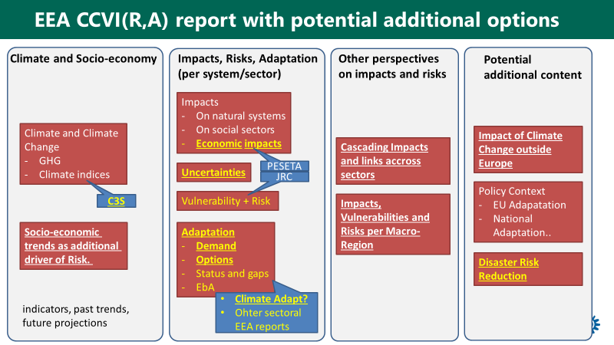

Figure 8: General building blocks (potential new elements in yellow) and potential data source (blue). Content in bold and underlined was rated as particular policy relevant during the EIONET Workshops Break-out group at June 13th 2019.

## Options for format

Based on our first exploration of how new formats for the EEA CCIV(A) reporting could work out, it becomes clear the there are options to improve policy relevance, awareness raising, accessibility to both policy makers and general public and increase flexibility. As noted above (Section 7.2) the choice of format will affect how the different elements of contents are presented and how comprehensive the coverage is for each element of contents. We have assessed 4 Formats, ranging from Format 1 with minor changes, to Format 4 with a fundamental new approach, product and organization of the supporting research and information.

The formats that have been explored are examples of how EEA might present CCIV(A) information, and are intended as impulses for thinking about alternative approaches for the EEA CCIV(A) report, other products and organization. Various hybrid solutions can also be considered and thus the formats presented below are meant to fuel further discussion and exploration on how EEA wishes to contribute to the distribution and use of CCIV(A) information in Europe.

### Formats explored

As shown in chapter 4, a wide variety of organizations are providing information on climate change and adaptation on global level, European level, country level and even local level. In this information landscape, the EEA reports should ideally create added value and policy relevance by providing an undisputed and consolidated knowledge base on EU level, EU regions and member states as a basis for awareness raising, adaptation strategies, and comparing impacts, risks and adaptation approaches and successes across Europe. Parts of this knowledge base is only emerging, for example the reporting according Regulation on Governance of the Energy Union and Climate Action will only be reported in March 2021 covering national climate change adaptation planning and strategies, outlining their implemented and planned actions to facilitate adaptation to climate change. Depending on the format more or less details can be provided.

As analysed in chapters 4 and 6, new contents may be of interest for the EEA report (e.g. figure 8) to keep up with new information demands, following the ongoing implementation of adaptation strategies on EU level, national level and local level (municipalities) and in various sectors.

In exploring format-options we take the actual EEA report format as starting point = format ‘0’ and show four indicative alternatives, with increasing changes in approach, products and organization. In these formats various elements in CCIV reporting as found in chapters 3 to 6 are incorporated (Technical background publications, Policy summaries, Attractive booklets/infographics, Websites, Web-atlas and Data portals, except for video/films.

As examples we have defined the following formats (see also Table 7.1):

*Table 7.1 Illustrative overview of example formats as explored in this scoping report. Blue = hard copy; brown = web-based. ‘S’ Shortened EEA CCIV(A) report; ‘P’ = Policy oriented summary Report.*

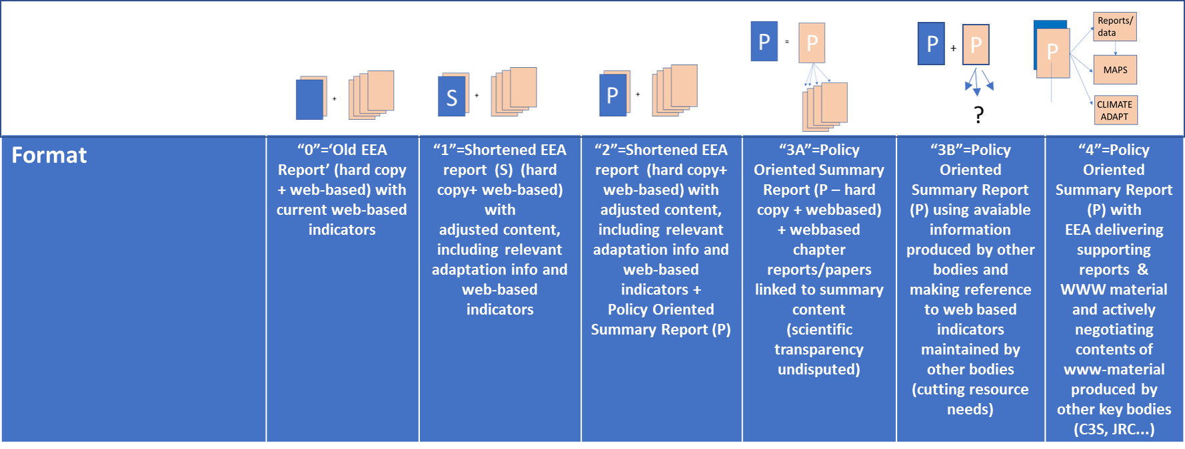

**Format 0** = ‘Old EEA Report’ (hard copy + web-based) with current web-based indicators. The 2016 EEA report (**Format 0**) has demonstrated policy relevance and reached some of the key audiences identified by the EEA. It has contributed to awareness raising, in particular through the press coverage it has received and the references in policy documents. The report itself is not particularly directly accessible for policy makers, despite the summaries, but its contents is likely to reach policy makers through expert advisors and press coverage (see Chapter 2.3). It is available on the net and it is thus in principle accessible for the general public, but not likely to reach a wide audience. It is based on scientific transparency and review processes, with metadata for all indicators and references to scientific material. The report itself is not particularly flexible as it goes through a heavy process, but the web-based material and indicators allow for updating and some flexibility in reporting on new results for the chosen indicators. The resource needs are fairly large due to the size and complexity of the task to produce the report, the indicators and to maintain the indicators through to the next report cycle. However, given the width of the topics covered, the report can be considered very cost efficient.

**Format 1**= Shortened EEA report (hard copy+ web-based) with adjusted contents, including relevant adaptation info and web-based indicators. *This option assumes some changes in the indicator system to accommodate more adaptation-oriented indicators, reducing e.g. physical climate indicators. The assumption is that a reallocation of resources means that the resource needs correspond approximately to Option 0. As noted above more detailed official reports of adaptation in EU member states are only forthcoming from 2021 onwards, but ongoing and completed research projects can provide information on progress in adaptation action, building on and deepening information that was collected for e.g. the evaluation of the EU adaptation strategy*.

**Format 2**= Shortened EEA report (hard copy+ web-based) with adjusted contents, including relevant adaptation info and web-based indicators + policy oriented summary Report (S). *The relative difference to Format 1 is that a dedicated policy oriented summary is produced based on the contents developed in option 1; depending on the efficiency in the process this will require maybe some modest additional resources. The policy oriented summary differs from an ‘ordinary’ Executive summary in that it does not aim at briefly covering ‘all’ pieces of information that the report provides. The policy oriented summary would take its starting point in ongoing policy developments and focus on specific messages for those (ongoing) policy making processes. It is also expected to provide more easily accessible graphical information than was provided in e.g. the Executive Summary of the 2016 report, which included only one extensive Table and one Map.*

**Format 3A** = Policy oriented summary Report (hard copy + web based) + web-based supporting chapter reports/papers, and web-based indicators. *The difference relative to Option 2 is that the EEA improves accessibility and scientific transparency by publishing background reports/papers directly linked to the chapters in the policy summary (*Figure *9). This requires a major change in programming and organization of the background information and reporting. The background reports/papers can, for example, have a more modest lay-out than the standard EEA reports and become a series of ‘Technical Reports’, mainly serving an expert audience.*

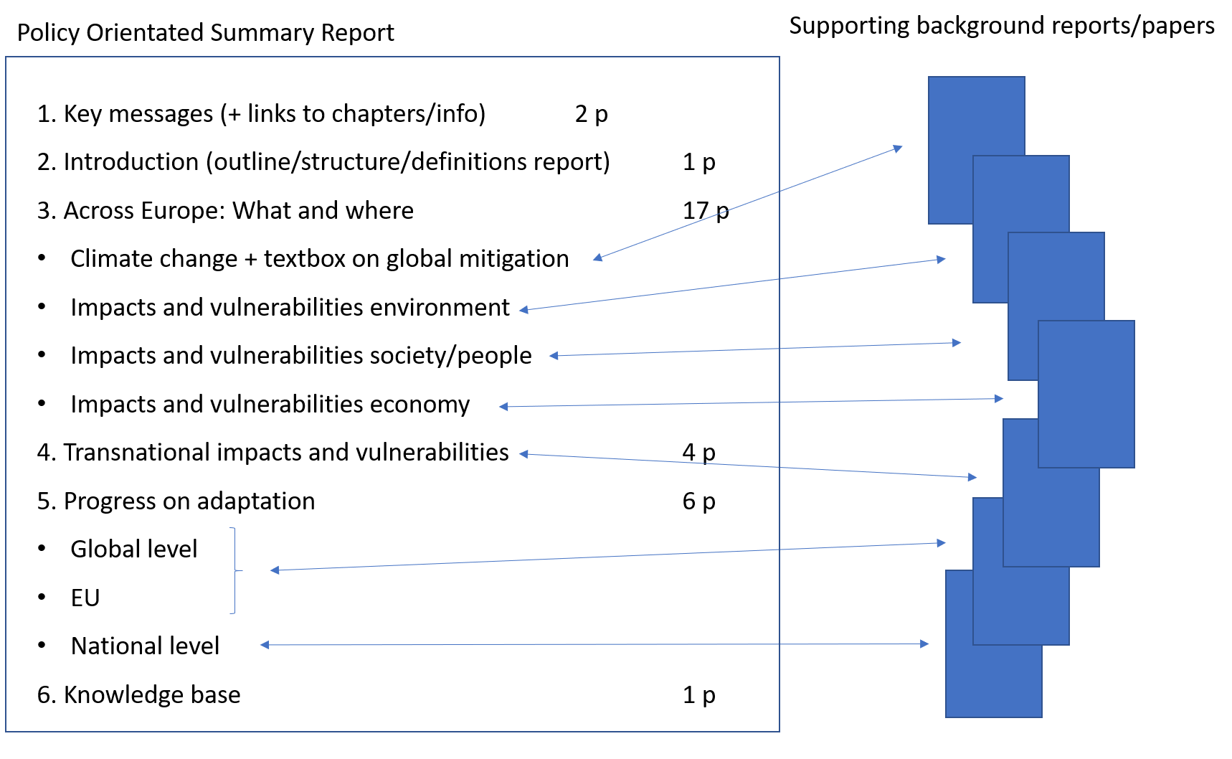

Figure 9 Structure of Format 3A with a policy oriented summary report as main product supported by chapter specific background papers/reports. This structure combines high accessibility, easy access to coherent blocks of information and reliability and scientific transparency. **Format 3B** = Policy oriented summary report (hard copy + web-based) using available information produced by other bodies and referring to web-based indicators maintained by other bodies. *The main difference relative to Format 3A is that EEA reduces its own active role in developing information and background reports/papers and concentrates on disseminating information produced by others, without trying greatly to influence how that information is produced. As this will be the only EEA product, it may be considered to incorporate somewhat more relevant background information and extend the report to ca. 50 pages. This kind of report can be produced without any fundamental change within EEA. The main change will be the use of resources to identify relevant secondary information sources (beyond, for example, C3S) that can referred to and used in justifying the conclusions. An example is INFORM, the index for risk management[46] which develops common evidence basis for risk analysis.*

**Format 4** = Policy oriented summary report (hard copy + web-based) with EEA delivering supporting reports & WWW material and actively negotiating contents of www-material produced by other key bodies (C3S, JRC...). *This is the most innovative approach with a combination of a radical reallocation of resources and the production of diverse material. The task of producing the CCIV report becomes an ‘umbrella task’ that delivers a policy-oriented summary report as in Option 3, but differs from Option 3 by also guiding actively the production of the supporting material both within the EEA (other reports, Climate-ADAPT…) and in negotiations with other bodies. Format 4 would require detailed agreements that ultimately could align the activities of several organizations. This is likely to require extensive negotiations and may therefore not be fully achievable within one or two years, but steps towards such a development can be taken.*

### The formats compared

**Criteria**  
To compare the suggested formats, we assess the options using eight criteria which are considered relevant in view of the EEA ambitions, the outcome of the EIONET workshops and the request for this scoping report (see also Chapter 1). For understanding the use in our assessment, a short description and explanation is given below for these eight criteria: encompassing six outcome criteria and two input criteria.

**Outcome criteria**

*1.Policy relevance*   
Policy relevance is achieved if relevant information is provided timely to targeted audiences   
i) about developments of climate change, impacts and vulnerabilities across Europe;   
ii) about new and relevant developments in (‘what is new?') in (a) the socio-economic domain and   
 (b) in the international domain and   
iii) is closely linked to the dynamics in the policy domain and policy development phases.   
In short, a policy relevant report:

* Provides info and addresses issues relevant for policy development and discussions
* Covers the EU/EU-regions/national level
* Sketches relevant international context and developments.

*2.Awareness raising*   
The EEA report aims to contribute to awareness raising about climate change, its impacts and vulnerabilities across Europe. As the political and public awareness about climate change has increased significantly over the last decades and given the fact that in many countries adaptation strategies and plans are in the phase of implementation, it is clear that new focal areas for awareness raising deserve attention. New areas are the progress in adaptation on EU level, national level and in transboundary regions (macro-regions, river basins) and the results of the adaptation efforts. In short, the report contributes to awareness raising adequately if it:

* allows improved understanding of what, where and how serious
* gives insight in progress on adaptation: what is done where and what are the results? Do the adaptation efforts reduce impacts and vulnerabilities? (EU, EU-regions, national)

*3.Accessibility for policy makers*  
In the information society, easy access and attractive presentation of information is an asset. As shown in chapter 4 information about climate change and adaptation is increasingly provided by a large variety of organizations, ranging from public authorities and institutes to universities, newspapers and other private companies. We think that an improvement of accessibility to policy makers is also important with respect to the policy relevance. In short, the accessibility for policymakers can be increased by:

* short and attractive presentation of the main findings and conclusions on the policy relevant issues(cf. policy relevance). A policy oriented summary report might be an interesting option with easy and logical access to supporting background information providing overviews in maps, illustrating the geographical characteristics of climate change, impacts, vulnerabilities, adaptation efforts and adaptation results.

*4.Accessibility for the general public*  
The general public is a wide audience encompassing people from various backgrounds. We think that for accessibility to the general public, the requirements as described for policymakers are relevant as well:

* short and attractive presentation of the main findings and conclusions on the policy relevant issues (cf. policy relevance)
* easy and logical access to supporting background information
* overviews in maps, illustrating the geographical characteristics of climate change, impacts, vulnerabilities, adaptation efforts and adaptation results.

*5.Reliability and scientific transparency*   
The scientific basis and scientific quality is critical for the legitimacy of the findings and conclusions of EEA reports. In the wide variety of information to be found on climate change, impacts, vulnerabilities and adaptation on the internet, the EEA report has to stand out representing the best available consolidation of knowledge about the situation and developments in Europe and EEA member states. Clear links to the scientific background information is thus of high importance.

*6.Timeliness and flexibility*   
Climate change and climate change impact research and climate change adaptation are still an ‘immature science’ and new insights, new information and new developments are continuously emerging from research, scientific papers and new policy experiments. In this dynamic environment, flexibility of the reporting system is of great value, either for a periodic update, or even for an ad hoc intervention based on new insights (allowing to improve timeliness of information cf. policy relevance).

**Input criteria**

*7.Resource needs*  
The periodic production of an EEA CCIV(A) report requires significant resources. Within the context of our exploration it is not possible to assess in detail the potential resource needs for the different options. The scores given in table 7.2 thus are tentative and relative to the reference format 0. .

*8. Required changes and innovation*The identified formats differ more or less from the reference format 0 with respect to the types of product, organization of background information and collaboration with other institutes. The scores in table 7.2 thus reflect the required change and innovation of the formats compared to the reference format 0.

**Explorative comparison of formats**

In Table7.2 the formats are compared using the eight criteria described above. The scoring is indicative and expected to initiate a discussion on how the formats differ with respect to EEA’s objectives for the delivery of CCIV information. The scoring is based on our experience of various reporting formats and science policy interfaces. A quantitative analysis would require a large study involving user groups, workshops, surveys etc and more detailed descriptions of the formats, including concrete examples. The scores in the table for both the outcome criteria (blue area) and the input criteria (yellow area) are relative to the reference format 0 = the setup of the 2016 EEA CCIV report.

*Table 7.2. Comparison of the formats as explored in this scoping report (table 7.1), using eight criteria relevant in the light of the EEA ambitions and results of the EIONET workshop.Outcome criteria in blue/grey area; input criteria in yellow area.*



Since the structure itself of the EEA report doesn't change in **Format 1** Accessibility, Flexibility and Resource needs remain more or less on the same level as the present EEA report (Format 0). The refocusing and shortening of the report is likely to increase its policy relevance and possibilities to target on policy makers relative to format 0. Reliability and scientific transparency may be under pressure due to the assumed more condensed form, but these are considered to be marginal and also depend on editorial style etc..

Policy relevance further increases in **Format 2**, using a policy oriented summary report (see example of contents in Section. 8.2).The policy-oriented summary is expected to strengthen EEA’s possibilities to target information and to make the material more accessible relative to Format 0 and 1, thereby also strengthening the accessibility and awareness raising role of the material. The policy oriented summary also increases its accessibility to both policy makers and the general public and the possibilities to use the material directly in awareness raising. The production of a good policy oriented summary may increase the resource needs somewhat relative to formats 0 and 1 as it is a separate task that not only requires work summarizing the findings but also an analysis of relevant policy areas and their state of development.

Breaking with the traditional organization of background information we distinguish the two Formats 3A and 3B. **In Format 3A** the background reports and papers, directly linked to the chapters in the policy oriented summary, improve the accessibility both to policy makers and the general public , while maintaining a high level of scientific reliability and transparency. To achieve this, resources need to be reallocated, and the overall resource needs are expected to be greater than in format 0-2, unless the separate chapters/reports can be produced efficiently with resources corresponding to the production of the chapters in format 0. Flexibility is increased as the individual supporting documents can be updated and produced separately without having to wait for the full production cycle as in formats 0-2.

In **Format 3B,** cutting resource needs,the EEA reduces its own active role in developing information and concentrates of disseminating information produced by others, without trying greatly to influence the way in which the information is developed or presented by the primary producers. This reduces resource needs significantly, but also the EEA’s possibility to develop its own narrative on CCIV. The policy relevance can be high, but since a significant part of the background material resides elsewhere the targeting is more limited than in format 3A. The scientific transparency and reliability are reduced because the brief report will lean heavily on secondary sources that are controlled by other organizations than EEA. The role of EEA is therefore mainly in making very dense summaries and in raising the general awareness, without opportunities to deliver detailed sector analyses. This is a low-cost option that also reduces the role and visibility of the EEA in CCIV information delivery. It is, for example, unlikely that a report in format 3B would reach a media coverage similar to that of the 2016 report (See Chapter 2.3). Some visibility is gained through the presentation of summary level information that directly addresses decision making needs. The role of ‘information broker’ is emphasized.

**Format 4** is the most innovative approach with a combination of a radical reallocation of resources and the production of diverse material. The production of the CCIV report becomes an ‘umbrella task’ that delivers a policy oriented summary report as in Option 3, but differs from Option 3 by guiding actively the production of the supporting material both within the EEA (other reports, Climate-ADAPT…) and in negotiations with other bodies, and in building a Climate change Atlas of Europe providing for all relevant indicators the European picture (a wish of the EIONET workhop). This all will require significant resources but would strengthen EEA’s role as a deliverer of CCIV knowledge and create opportunities for different types of targeting. The format allows for different target audiences with several ‘packages’, therefore it serves also awareness raising and can be made accessible to many different audiences. The active role of the EEA and its CCIV reporting ensures that all material meets reliability and transparency criteria, although some transparency may be lost if all material is not assembled with the same metadata requirements and is not accessible through a single site.

**Conclusions**  
Format 1 is “traditional” in structure and differs only moderately from the present EEA report. Some increase in policy relevance can be expected due to the shortened and policy related contents. The addition of an attractive separate policy oriented summary Report in Formats, 2, 3 and 4 result in higher scores for policy relevance, and better accessibility for policy makers and general public. Format 3A and Format 4 receive the highest scores for both outcome and input criteria and will require the most structural changes and innovation in types of products and organization, each in its own way. Format 3A is likely to require significant additional resources as it would be based on the production of additional separate “technical” reports within EEA. Some of these may replace current EEA reports, but other may require separate production processes to be set up. Format 4 would require more resources to be invested in joint work with other organisations and possibly also in setting up new joint activities.

Format 3B is the option with relatively low resource needs, while still enabling a relative high policy relevance and accessibility, but lower than 3A and 4. The current standard of reliability and scientific transparency may be challenging to achieve as the product will depend on secondary sources over which EEA has no direct control. Timeliness and flexibility may also be challenging. Increased flexibility can be achieved relative to the reference format, if it is easy to find secondary sources for all relevant policy areas. If, however, there is a lack of secondary sources, the format may stifle the delivery of up to date policy relevant information on certain aspects of CCIV.

The presented formats cover some ideas and examples for the future development of CCIV-reporting by EEA. They can also be seen to represent different options on pathways that aim at strengthening the knowledge base for knowledge of climate change and adaptation. Thus the following report preliminary scheduled for 2021/22, may be a first step towards a major change, or it may already be an effort to radically reformulate the report (Fig. 10). The choice of appropriate format will depend on the strategic discussions within EEA on the role EEA wishes to play in the field of providing knowledge supporting adaptation to climate change in Europe.

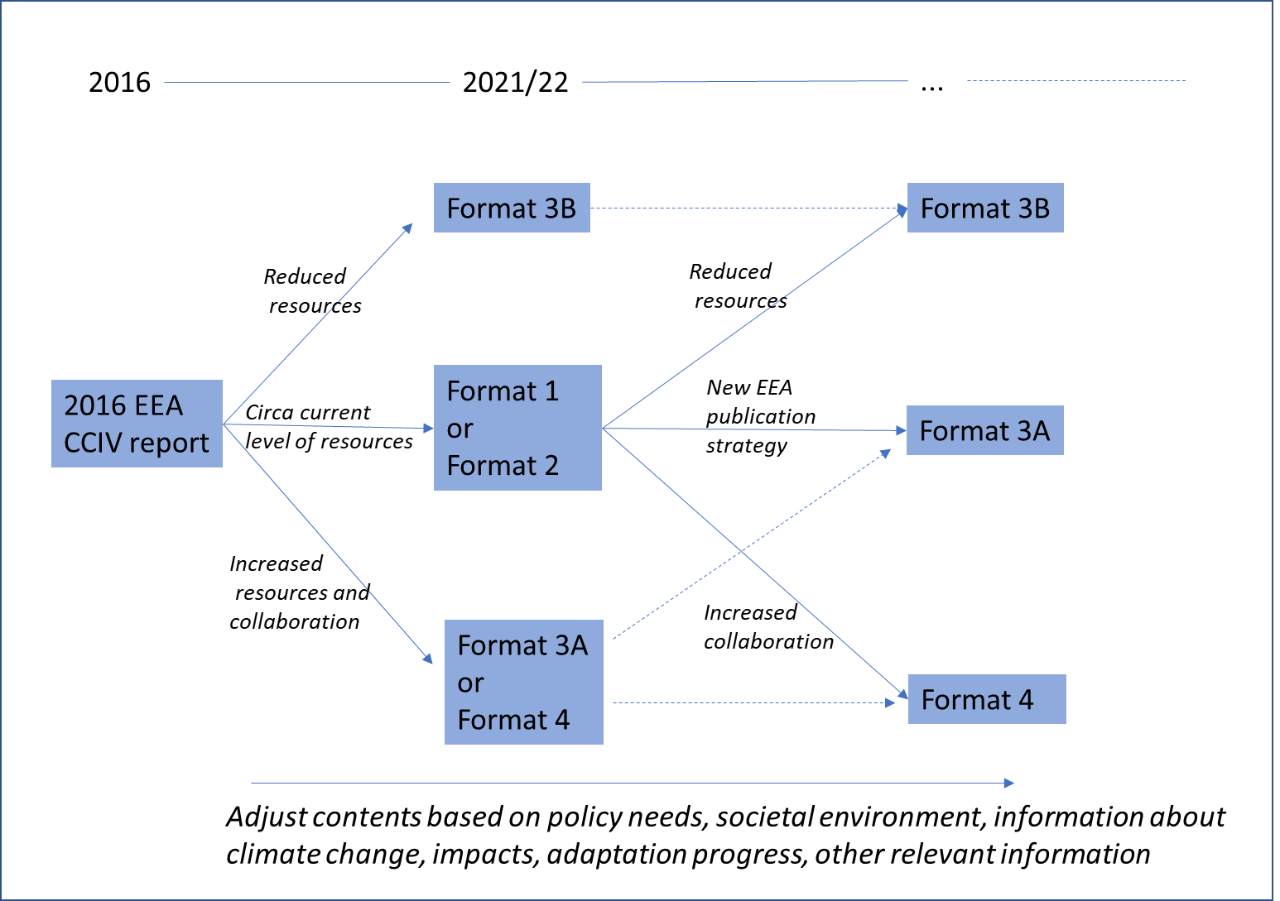

Fig. 10 Possible evolutionary pathways for the CCIV reporting using the formats explored (cf. table 7.2).

# Annex

## Potential report structure with additional content (“Option 1”)

In the following, we present a potential structure of a printed or electronic report following the proven structure of the 2016 report but with option for additional content items and a shortened text (in total ~ 200 pages).

**Introduction (ca. 10 pages)**

* Much shorter (max. 10 pages)
* Only Introduction which is relevant to understand the structure and methodology
* Policy context briefly highlighted, with main contents moved to relevant later chapters
* Global emissions moved to climate chapter

|  |  |  |  |  |
| --- | --- | --- | --- | --- |
| ***Sub-chapter*** | ***Current approach*** | ***Potential new approach*** | ***Remark / open Questions*** | ***Pg.*** |
| Purpose and Scope | 5 pages | Shorter, including structure and policy context (very short) |  | 4 |
| Methodology | 3 pages | Explain work with indicators, assessment of climate → impacts → vulnerabilities and risks → adaptation. Link to IPCC, ….. How to deal with uncertainties. |  | 5 |
| Global Emission | 6 pages | Move to climate change chapter |  |  |
| Uncertainties | 3 pages | Only very short here. Detailed assessment for each indicator |  | 1 |
| ***Pages*** | ***17*** |  |  | ***10*** |

**Climate Change, impact on environment, impact on society (ca. 170 pages)**

* General structure per indicator is very good and clear (key findings, relevance, past trends, future projections)
* Less pages (max. 3 per indicator, max. 1 page for overview).
* Format: easier language, more infographics (see some examples in 8.4)
* stress already regional peculiarities within the text, use a standardized scheme (e.g. European Macro Regions). This could be used to extract regional information for later chapter.

***Changes in the climate system***

|  |  |  |  |  |
| --- | --- | --- | --- | --- |
| ***Sub-chapter*** | ***Current approach*** | ***Potential new approach*** | ***Remark / open Questions*** | ***Pg.*** |
| Human influence on the climate system | 8 pages with general explanation and infographics | include emission chapter |  | 10 |
| Atmosphere | 21 pages with 6 indicators | Indicators and text could be fully provided by C3S | Could be even shorter, if reference & link can be made to relevant C3S product(s) | 19 |
| Cryosphere | 15 pages with 4 indicators | Shorter (3 pages per indicator) | Source of indicators? C3S?  Comments as for Atmosphere | 13 |
| ***Pages*** | ***44*** |  |  | ***42*** |

***Climate Change impacts on environmental systems***

|  |  |  |  |  |
| --- | --- | --- | --- | --- |
| ***Sub-chapter*** | ***Current approach*** | ***Potential new approach*** | ***Remark / open Questions*** | ***Pg.*** |
| Oceans and marine environment | 17 pages with 5 indicators | Shorter (3 pages per indicator) | Source of indicators? C3S? Copernicus Marine Service? Comments as for Atmosphere | 16 |
| Coastal zones | 12 pg. with 1 indicator | Could be fused with ocean | Comments as for Atmosphere | 3 |
| Freshwater systems | 19pg. with 5 indicators | Shorter (3 pages per indicator) | Comments as for Atmosphere | 11 |
| Terrestrial ecosystems | 30 pg. with 6 indicators | Impact directly related to agriculture and forestry should be moved to impacts on society |  | 19 |
| Ecosystem Services | 6 pages | This could be a box (other perspective on impacts, not a separate set of impacts) |  | 4 |
| ***Pages*** | ***84*** |  |  | ***53*** |

**Climate Change impact and risks on society**

For each sector: the following aspects could be added to each sub-chapter (similar to IPCC AR6)

* Key risks (including spatial hot-spots, critical constellations) and related vulnerability and exposure factors using IPCC approach of Risk
* Potential adaptation responses (currents status, further demand → link to Climate Adapt and sectoral reports) with a necessary degree of specification for certain constellations (e.g. irrigated agriculture of southern Europe vs. rain-fed cropland in northern Europe)
* More info could be extracted from EEA sectoral report (e.g. agriculture, energy, transport)
* economic impacts per sector if available from PESETA
* Interactions with sustainable development and disaster risk reduction
* Total extra pages: 1-3 pages per sector
* A box on socio-economic scenarios could be in the beginning of this chapter.

|  |  |  |  |  |  |
| --- | --- | --- | --- | --- | --- |
| ***Sub-chapter*** | ***Current approach*** | ***Potential new approach*** | | ***Remark / open Questions*** | ***Pg.*** |
| Socio-Economic trends | own chapter in the end | Integrate here as box, very short. Relevant to analyses of vulnerabilities | |  | 2 |
| Impacts of climate related extremes | 9 pages. |  | | Differs partly in logic from other chapters through its integrative nature. Is there a need for greater harmonisation? This subchapter could also come last in the climate change risk and society as a sort of synthesis? | 8 |
| Human health | 23 pg. with 5 indicators | Quite long | |  | 16 |
| Agriculture | 20 pg. with 5 indicators | Forestry should be added (from environment) | |  | 16 |
| Energy | 10 pg. with 5 indicators |  | |  | 12 |
| Transport | 8 pg. with 5 indicators |  | |  | 10 |
| Tourism | 3 pgs. with 2 indicators |  | |  | 5 |
| ***Pages*** | ***73*** | |  |  | ***69*** |

**Additional content of EEA’s report which could be shifted to this chapter:**

* Climate risks in Europe’s macro regions (max. 6 pages)
* Multi-sectoral impacts and vulnerabilities (max. 6 pages)
* Europe's vulnerability to climate change impacts outside Europe (max. 6 pages)

**Conclusion: Key climate risks and adaptation demand in Europe (max. 10 pages)**

* Could also be part of the executive summary in addition or instead a separate chapter in the report.

**Policy context and current status of adaptation planning (max. 6 pages)**

* This would be a summarising discussion with outlooks at the
* Global level: Progress within the UNFCCC
* EU: Mitigation + Adaptation
* National adaptation plans and mitigation links

**Strengthening the knowledge base (max 4 pages)**

## Potential report structure of a Policy Orientated Summary Report with additional content (“Option 2, 3, 4”)

|  |  |  |  |  |
| --- | --- | --- | --- | --- |
| ***Structure*** | ***Current approach and content***  ***(not comparable)*** | ***Possible content*** | ***Remarks*** | ***Pg.*** |
| 1.Key messages |  | Most relevant policy orientated conclusions and messages | Links to supporting chapters, figures, maps | 2 |
| 2.Introduction |  | Short explanation of set-up with links to background reports/chapters/information |  | 1 |
| 3.Climate change across Europe: what and where |  | Main findings, focusing on trends, new insights, hotspots (environmental/social/economic), weather extremes, future expectations | Links to supporting chapters, figures, maps | 1 |
| 3.1 Climate change |  | Overview/summary of developments:  -temp, net-precipitation, weather extremes  - future expectations + uncertainties  - textbox about mitigation | Links to background reports and atlas | 4 |
| 3.2 Environmental impacts and vulnerabilities |  | Overview/summary of impacts of weather extremes and developments: water temp and quality, river discharges, ice sheets, sea level rise,  ecological processes, species distribution, biodiversity,… | Link to background reports and atlas | 4 |
| 3.3 Social/health  impacts and vulnerabilities |  | Overview/summary of impacts of weather extremes and developments: health, diseases, casualties, labour loss | Links to background reports and atlas | 4 |
| 3.4 Economic impacts and vulnerabilities |  | Overview/summary of losses due to weather extremes and developments in main sectors:  Agriculture/forestry/fishery, Transport, Energy, Industry, Tourism, | Links to background reports and atlas | 4 |
| 4.Transnational impacts and vulnerabilities |  | Main findings  Overview/summary of developments:  4.1 outside Europe  4.2 macro-regions of Europe  4.3 transboundary river basins | Links to background reports and atlas | 4 |
| 5.Progress on adaptation |  | Main findings  Overview/summary of developments:  5.1 Global  5.2 EU + macro-regions  5.3 Member states | Links to background reports and atlas | 6 |
| 6.Knowledge base |  | Main findings  Overview/summary of new developments and main knowledge gaps  (e.g. systematic monitoring of economic losses across sectors) | Link to background paper | 1 |
| ***Pages*** |  |  |  | **Ca. 30** |

## Results from break-out group during EIONET workshop 12.-13.06.2019

During the NRC Meeting at EEA, ~20 participants took part on a breakout group at 12.06.2019 to discuss on the following key questions:

Content:

* How could future EEA work on CCIV best complement the information available from other sources?
* What would be the most policy relevant elements you would like to see in a 2022 EEA report?

Format:

* What would be your preferred format of an EEA report?
* How important is it to have a structured (printed) report compared to having information online that can be more easily updated?

The outcomes were presented at the next day to the NRC representatives by Hans-Martin Füssel. See slides below.

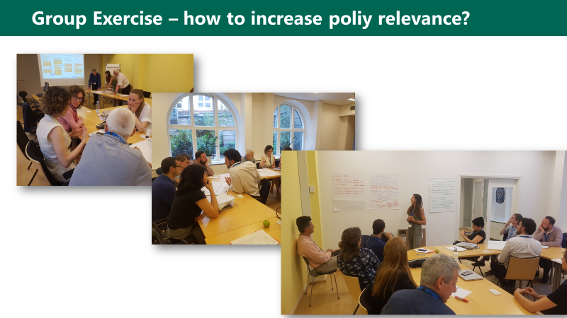

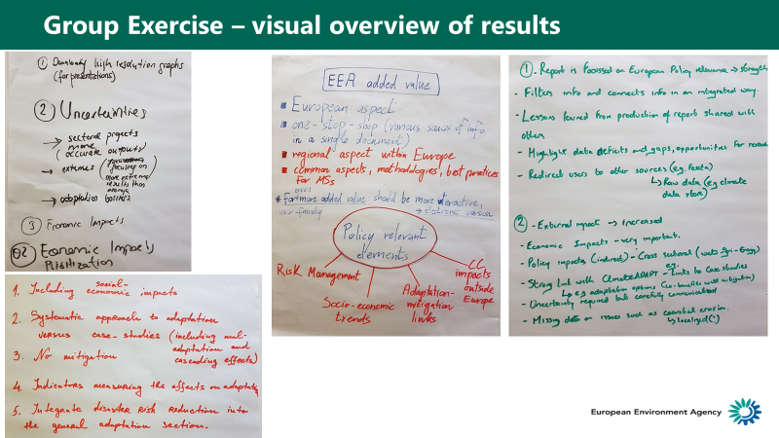

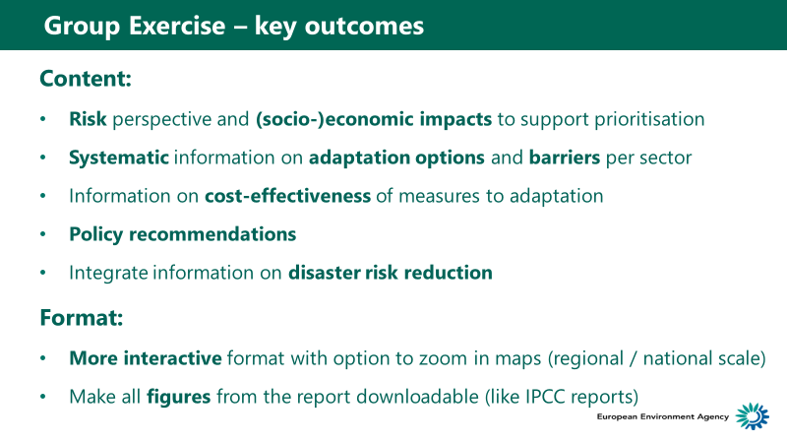

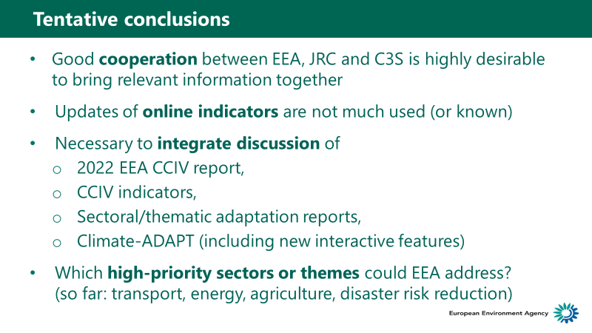

## Some examples of infographics from other reports

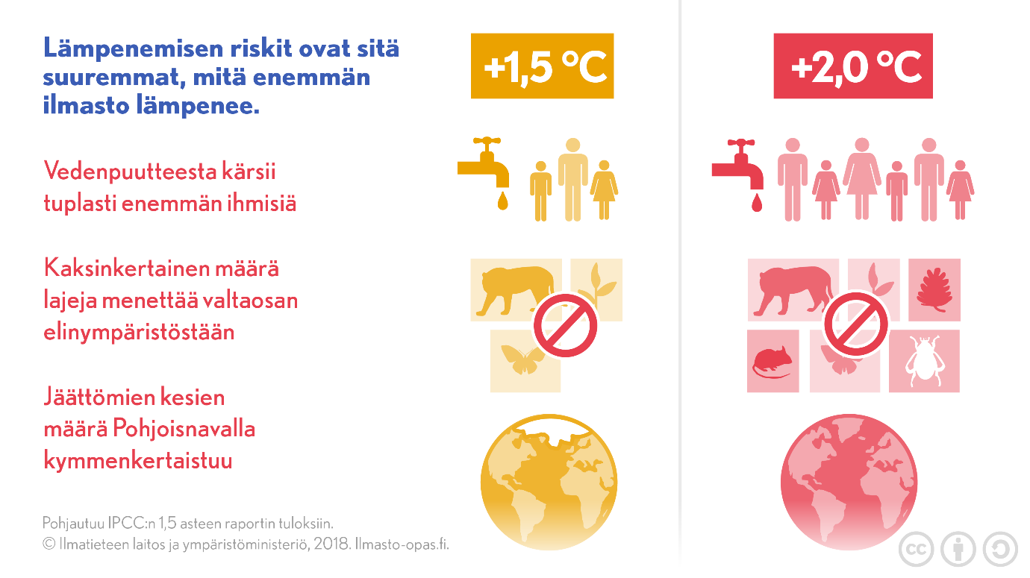

Figure : Example from Finish summary of IPCC 1,5°C report

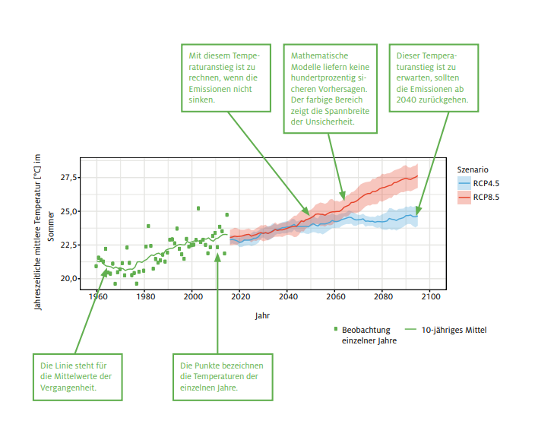

Figure : Infographic from Climate Report South Tyrol <http://www.eurac.edu/de/research/mountains/remsen/projects/Documents/klimareport/Klimareport%202018%20DE.pdf>

1. <https://climate-adapt.eea.europa.eu/knowledge/tools/adaptation-support-tool>
2. EEA 2019. Seminar of the EEA Management Board and Eionet 19 June 2019 Copenhagen EEA and Eionet Strategy 2021-2030: Evolution and Innovation. Seminar Booklet (p. 8)
3. Eurobarometer results for 2017 are available at <https://ec.europa.eu/clima/citizens/support_en>
4. Masiulienė, L. , Looney, J., Aertgeerts, H. and de Greef, M. (n.d.) The key features of successful awareness raising campaigns. The European Literacy Policy Network. and LINET (n.d.) Report on ELINET’s Awareness Raising Toolkit. <http://www.eli-net.eu/awareness-raising/toolkit/> (Accessed 16.6. 2019).
5. EEA 2019. Seminar of the EEA Management Board and Eionet 19 June 2019 Copenhagen EEA and Eionet Strategy 2021-2030: Evolution and Innovation. Seminar Booklet (p. 8)
6. <https://www.theccc.org.uk>
7. [www.ukcip.org.uk](http://www.ukcip.org.uk)
8. [www.defra.gov.uk/adaptation](http://www.defra.gov.uk/adaptation)
9. <https://www.adaptationscotland.org.uk>
10. [www.climatenorthernireland.org.uk](http://www.climatenorthernireland.org.uk)
11. [www.mccip.org.uk](http://www.mccip.org.uk)
12. [www.pbl.nl/en/publications/adaptation-to-climate-change-in-the-netherlands](http://www.pbl.nl/en/publications/adaptation-to-climate-change-in-the-netherlands)
13. [www.klimaateffectatlas.nl](http://www.klimaateffectatlas.nl)
14. [www.klimaszenarien.ch](http://www.klimaszenarien.ch)
15. [www.umweltbundesamt.de/en/topics/climate-energy/climate-impacts-adaptation](http://www.umweltbundesamt.de/en/topics/climate-energy/climate-impacts-adaptation)
16. [www.klivoportal.de](http://www.klivoportal.de)
17. <https://mmm.fi/luonto-ja-ilmasto/ilmastonmuutokseen-sopeutuminen>
18. <https://ec.europa.eu/jrc/en/peseta-ii> ; <https://ec.europa.eu/jrc/en/peseta-iii>
19. <https://climate.copernicus.eu>
20. <https://www.medecc.org>
21. <https://www.ipcc.ch/>
22. <https://www.metoffice.gov.uk/food-insecurity-index/>
23. <https://www.pbl.nl/node/64678>
24. <https://www.climatecentral.org>
25. <https://insideclimatenews.org>
26. [www.climatecouncil.org.au](http://www.climatecouncil.org.au)
27. [www.climatechangepost.com](http://www.climatechangepost.com)
28. <https://www.carbonbrief.org>
29. [www.worldbank.org/en/topic/climatechange](http://www.worldbank.org/en/topic/climatechange) and <https://climateknowledgeportal.worldbank.org>
30. <https://www.climateadaptationservices.com/en/>
31. <https://www.theccc.org.uk/>
32. [www.mccip.org.uk](http://www.mccip.org.uk)
33. <https://www.metoffice.gov.uk/food-insecurity-index/>
34. [www.klimaszenarien.ch](http://www.klimaszenarien.ch/)
35. [www.meteoschweiz.admin.ch/home/suche.subpage.html/de/data/blogs/2016/3/analyse-der-nutzerbeduerfnisse-zu-nationalen-klimas.html?query=klimaszenarien&pageIndex=0&tab=search_tab](http://www.meteoschweiz.admin.ch/home/suche.subpage.html/de/data/blogs/2016/3/analyse-der-nutzerbeduerfnisse-zu-nationalen-klimas.html?query=klimaszenarien&pageIndex=0&tab=search_tab)
36. <https://ec.europa.eu/regional_policy/en/policy/cooperation/macro-regional-strategies/>
37. https://ec.europa.eu/info/files/190618-sustainable-finance-teg-report-taxonomy_en
38. <https://www.cencenelec.eu/standards/sectors/climatechange/pages/default.aspx>
39. European Commission, 2014 and 2015; Havik et al., 2014
40. Riahi et al., 2017
41. <https://www.ipcc.ch/site/assets/uploads/2018/09/AC6_brochure_en.pdf>
42. <https://www.ipcc.ch/site/assets/uploads/2018/03/AR6_WGII_outlines_P46.pdf>
43. <https://www.ipcc.ch/site/assets/uploads/2018/03/AR6_WGII_outlines_P46.pdf>
44. For example, the UNDRR collects information on relevant activities and publications https://www.preventionweb.net/organizations/1027
45. INFORM is a global, open-source risk assessment for humanitarian crises and disasters http://www.inform-index.org/
46. INFORM is a collaboration of the Inter-Agency Standing Committee Task Team for Preparedness and Resilience and the European Commission. http://www.inform-index.org/