Working paper 2: Follow-up on art 19.3 reporting

Summary
The Member states were presented with a number of options (Section 3) in how to supply information in the article 19.3 reporting that would infer access and use rights to the Commission and the EEA. This approach provided Member States with a greater flexibility in reporting, reflecting the short timeline in which they had to provide the additional information requested under the 19.3 reporting. However it should be taken under consideration that increasing the variability of the metadata sources adds extra complexity as far as the information extraction is concerned; and the usability of the information provided is negatively affected by the disparate sources/methods. While moving towards the 2018 deadline it becomes more and more clear that simple, standardised and harmonised reporting workflows are the key to success.

Putting the article 19(3) into perspective

As proposed in the previous WG-DIKE (30 October 2012) and MSCG (10th) meetings, the Article 19(3) should be fully incorporated into the wider process of MSFD monitoring and assessments.
Future MSFD assessments under Article 8 are needed to assess the progress towards achieving Good Environmental Status (GES), as defined under Article 9, and to assess progress with environmental targets set under Article 10. These assessments are typically based on characteristics, related to the 11 Descriptors of GES and their associated criteria or to the indicators associated to particular targets.

Data collected through monitoring programmes under Article 11

Metadata catalogue under Article 19(3)

Assessments under Article 8
Progress towards targets under Article 10
Progress towards achieving GES under Article 9

The forward vision for implementation of the article 19(3) is:
To develop harmonised spatial and time-series data sets which are aggregated to appropriate regional or subregional scales for use in the next indicator-based MSFD Article 8 assessments (due in 2018). The data sets will be developed progressively with Member States and regional organisations, as assessment needs become established, ultimately aiming to address all aspects of the Article 8 assessment. The data sets will be readily available for use in assessments through WISE-Marine and, where possible, in EMODnet.

Overview of the metadata related MS submissions

In November 2012, Marine Directors were presented with different options for responding to article 19(3) requirements. MSFD requires Member States to provide the Commission with access and use rights in respect of the data and information resulting from the Art.8 initial assessments which were due to be completed by 15 July 2012. Within six months of becoming available, these data and information shall also be made available to the European Environment Agency. According to the MSFD CSWP (2011), access to the data and information for the EEA was consequently due by 15 January 2013.
On the basis of discussions within WG DIKE and at MSCG, there are a number of ways in which Member States could fulfil their obligations under the art. 19(3) as regards the data and information resulting from the initial assessment:

- Where Member States have relied solely upon existing published reports, reference to this literature can be provided into the existing metadata fields for Art. 8 electronic reporting, including a web link to where the reference can be accessed;
- Where data sets have been prepared specifically for use in the initial assessment, Member States should list these and indicate how they can be accessed (e.g. via a web link). This can be achieved through either:
  - Provision directly to the Commission and EEA or by posting on a Member State web site; or
  - Entry of the information into fields in the reporting system. This ‘metadata catalogue’ option (described in Annex 4) would directly link the data sets to the relevant Article 8 assessment1 and could be completed alongside completion of non-priority fields.
- Member States may have used a mixture of literature and ‘new’ data, needing use of both routes above.
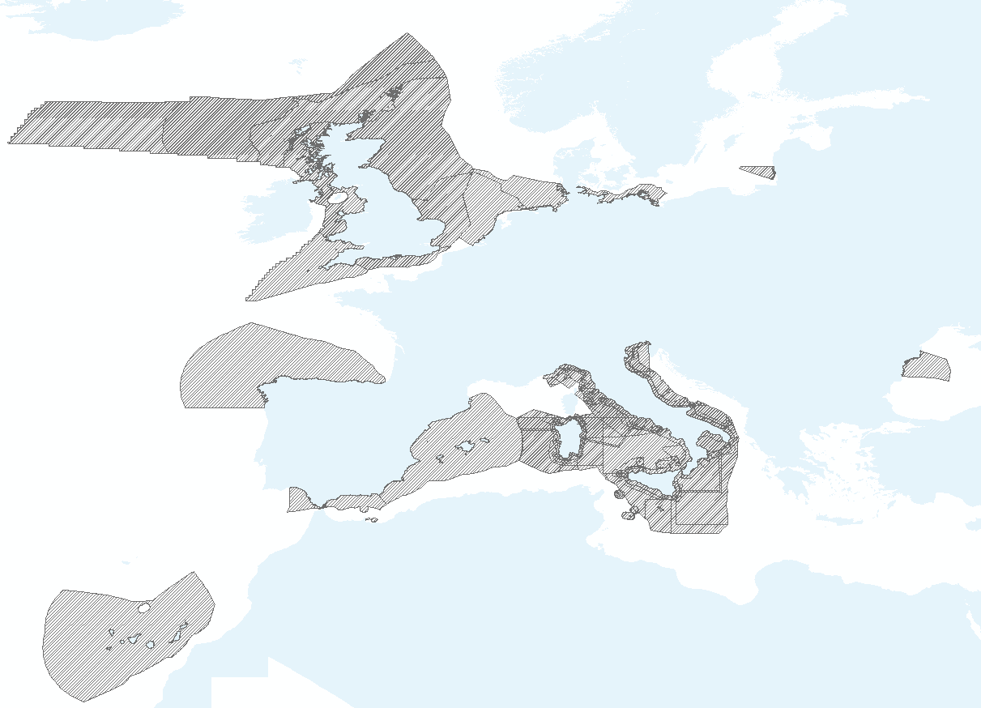
Figure 1 Assessment areas covered by metadata reported under the Art. 19(3)
Following on from the April 15th deadline, 17 Member States have reported metadata related to the underlying evidence using one of the above options. All of them utilised the respective fields in the database and seven also reported metadata according to the article 19(3). The following table gives an overview of the submitted data (as of April 15, 2013). The term “web link” refers usually to URL links but it could also be other online sources and the term “scientific references” refers mostly to citations:

Country | Description | Method(s) | Marine Region
Belgium | One reference to the initial assessment. No web link. | Option a. | ANS
Cyprus | Mostly scientific references. No web links. | Option a. | MAL
Denmark | Various scientific references. Links available. | Option a. | ANS, BAL
Finland | Various scientific references. A few web links. | Option a. | BAL
France | References to the Initial assessment | Option a. | ACS, MWE, ANS, ABI
Germany | a. Various scientific references. Some web links  b. Web link to an external catalogue. | Option c. | ANS, BAL
Greece | Various scientific references.  No web links. Some DOI. | Option a. | MAD, MIC, MAL
Ireland | Various references (scientific, regional assessments, EEA). | Option a. | ACS
Italy | a. Various references. Few web links.  b. Some have direct web links to the dataset | Option c. | MAD, MIC
Latvia | Almost no references | Option a. | BAL
Lithuania | a. Link to a report  b. List of datasets provided. No web links to datasets provided | Option c. | BAL
Netherlands | A word document with a list of papers along with pdf. | Option b.i? | ANS
Romania | a. Some web links to various sources  b. List of datasets provided. Web links to xlm files on the CDR (Locked?) and other locations. | Option c | BLK
Slovenia | a. Various scientific references. Some web links  b. List of datasets provided. Web links to various external sources. | Option c | MAD
Spain | a. Various scientific references. Some web links.  b. List with web links to external sources. | Option c. | AMA, ABI
Sweden | Web links to reports | Option a. | BAL, ANS
United Kingdom | Various scientific and other (OSPAR) references. Web links available | Option a. | ACS, ANS

Analysis and evaluation of the information provided by the MS

According to WG DIKE (7th meeting) fulfilment of the requirements of the article 19(3) can be considered to have four elements:
- The need to comply with the INSIPRE Directive 2007/2/EC
- Identification of the data and information resulting from the initial assessment (e.g. a list of the data sets and information sources)
- The need to indicate where the data and information can be accessed (e.g. internet sites where the data and information can be viewed)
- The provision of permission (use rights) to use the data and information.
The following table describes to what extent these criteria are reflected in the reported information. The term “Database records” has been used for Member States that have only used the MSFD database records for their metadata:

Country | Usability level | Standards Used | Language Used
Belgium | No direct linkage to data. Only through the I.A. | Database records | Flemish,( I.A. in English)
Cyprus | No direct linkage to data. Exceptionally large fields with references. Hard to query. | Database records | English, Greek
Denmark | The database fields provide decent linkage to paper based reports or to the initial assessment. | Database records | Danish, English (I.A. in Danish)
Finland | Difficult to query fields in the database. Some empty ones. Some web links to paper based assessments. | Database records | English, Finish, Swedish
France | No direct linkage to data. Only through the I.A. | Database records | French,( I.A. in French)
Germany | No direct linkage to data. The geoportal provided requires extra querying and appears to be limited. | N/A | German
Greece | No direct linkage to data. Extra searching is required to locate sources. | Database records | Mostly English, Greek
Ireland | Difficult to extract links from the records. Many different web links to paper based assessments. | Database records | English
Italy | In most cases there is not enough information to locate the datasets. | Non ISO | English
Latvia | No metadata information available | Database records | None (empty records)
Lithuania | In most cases there is not enough information to locate the datasets. | (seadatanet) CDI | Lithuanian
Netherlands | Well-structured document with web links to paper based assessments. However the nature of the document renders it hard to query. | Word document | Dutch, English
Romania | Insufficient information to access the datasets. | INSPIRE, EDMED, NonISO, CDR_Reportnet | English
Slovenia | No direct linkage to data. A general link to the ministry of environment | Non ISO | Slovenian
Spain | Well-structured linkage to external portals. However querying these portals with the dataset names provided did not return results | INSPIRE | Spanish
Sweden | Most web links are missing. Difficult to locate datasets. | Database records | Swedish
United Kingdom | No direct linkage to data | Database records | English

Case study on access to underlying evidence

In order to evaluate the usability of the information acquired from the different sources a case study was evaluated and presented below. A random pair of variables (marine region/subregion, parameter) was chosen and an effort was made to locate all possible information from the different metadata sources submitted so far. The parameter chosen is the pressure “Hazardous Substances” and the search was limited in the in subregion “ANS” which includes the Greater North Sea, Kattegat and the English Channel. The information was gathered by querying the MSFD Master Database, the Metadata catalogue, the external metadata catalogues and other submitted information by the countries:
Information extracted from the metadata fields in the database in relation to the Hazardous Substances pressure:
BE | Belgische Staat, 2012. Initiële Beoordeling voor de Belgische mariene wateren. Kaderrichtlijn Mariene Strategie – Art 8 lid 1a & 1b. BMM, Federale Overheidsdienst Volksgezondheid, Veiligheid van de Voedselketen en Leefmilieu, Brussel, België, 81 pp. État
DE | Hintergrunddokument Nordsee, QSR 2000 (OSPAR)
DK | Andersen, J. H. et al., 2011: ”En integreret vurdering og klassifikation af den kemiske tilstand i de danske farvande - en indikator-baseret statusvurdering – notat 3.3” Nationalt Center for Miljø og Energi, Aarhus Universitet. Videnskabelig rapport fra D
DK | Boutrup, S. & Svendsen, L. M., 2011.” Tilførsel af syntetiske stoffer samt ikke-syntetiske stoffer og forbindelser til de danske farvande”. Nationalt Center for Miljø og Energi, Aarhus Universitet for Naturstyrelsen.  http://dce.au.dk/fileadmin/dce.au.dk/
DK | HARMONY project:  Reports to be published in 2013: HARMONY CHASE, Chemical status of the Eastern North Sea and HARMONY - Integrated evaluation of Good Environmental Status in the Eastern North Sea.  Human uses, pressures and impacts in the Eastern North Se
FR | PAMM, évaluation initiale des eaux marines :  - état écologique, partie 1, chapitre : "Substances chimiques problématiques" ; "Questions sanitaires";  - analyse des pressions et impacts, partie 2, chapitres : Analyse des sources directes et chroniques en
FR | PAMM, évaluation initiale des eaux marines, analyse des pressions et impacts, partie 4, chapitre : "Impacts par composante de l’écosystème".
FR | PAMM, évaluation initiale des eaux marines, analyse des pressions et impacts, partie 2, chapitre : Introduction de radionucléides dans le milieu marin et impacts".
NL | IenM, EL&I, 2012. Mariene Strategie voor het Nederlandse deel van de Noordzee, Deel I. Den Haag, 153 pp.  Deltares/IMARES, 2011. Initial Assessment. Background document 1.Implementation of the Marine Strategy Framework Directive for the Dutch part of the N
SE | God havsmiljö 2020. Marin strategi för Nordsjön och Östersjön. Del 1: Inledande bedömning av miljötillstånd och social analys. Havs- och vattenmyndighetens rapport 2012:19.  Havet - om miljötillståndet i svenska havsområden, 2009. ISBN 978-91-620-1277-9.
SE | God havsmiljö 2020. Marin strategi för Nordsjön och Östersjön. Del 1: Inledande bedömning av miljötillstånd och social analys. Havs- och vattenmyndighetens rapport 2012:19.  OSPAR QSR 2010, Swedish national monitoring of radioactive substances
UK | Defra (2012) UK Marine Strategy Part One: UK Initial Assessment and Good Environmental Status. Published by Defra for HM Government. http://www.defra.gov.uk/environment/marine/msfd/ (to be published Nov-Dec 2012),
UK | OSPAR Co-ordinated Environmental Monitoring Programme (CEMP) and Joint Assessment and Monitoring Programme (JAMP) monitoring guidelines:  http://www.ospar.org/content/content.asp?menu=00170301000135_000000_000000  http://www.ospar.org/documents/dbase/publi
UK | UK Marine Monitoring and Assessment Strategy Community (UKMMAS) (2010). Charting Progress 2 Feeder report: Clean and Safe Seas. (Eds. Law, R. and Maes, T.). Published by Department for Environment Food and Rural Affairs on behalf of UKMMAS. 366pp.  http:/

Information extracted from sources under Art 19(3) in relation to the Hazardous Substances pressure:
DE | Ecosystem Health of the Baltic Sea - HELCOM Initial Holistic Assessment ( nonGeographicDataset )
NL | Bonn Agreement 2001. Agreement for cooperation in dealing with pollution of the North Sea by oil and other harmful substances, 1983, as amended by the Decision of 21 September 2001 by the Contracting Parties to enable the Accession of Ireland to the Agreement (Bonn, 2001).(Link to website)
NL | Besluit van 12 november 2009, nr. 09.003229 tot vaststelling van regels inzake de organisatie en de coördinatie van de bestrijding van schadelijke gevolgen van ongevallen op de Noordzee, (Besluit Rampenplan voor de Noordzee 2009) Staatscourant nr. 18323 (Den Haag, 2009).
NL | Deltares & IMARES. 2011. Initial Assessment, Implementation of the Marine Strategy Framework Directive for the Dutch part of the North Sea Background document1 (of 3) (Delft, 2011). Par 3.13.1, 4.8.3 & Table 3.1, Pp 128, 129
NL | European Union 2010. COMMISSION DECISION of 1 September 2010 on criteria and methodological standards on good environmental status of marine waters (Brussels 2010).
NL | European Union 2010. COMMISSION RECOMMENDATION of 17 March 2010 on the monitoring of perfluoroalkylated substances in food (2010/161/EU) (Brussels 2010).
NL | European Union 2004. REGULATION (EC) No 882/2004 OF THE EUROPEAN PARLIAMENT AND OF THE COUNCIL of 29 April 2004 on official controls performed to ensure the verification of compliance with feed and food law, animal health and animal welfare rules (Brussels 2004)
NL | European Union 2006. COMMISSION REGULATION (EC) No 1881/2006 of 19 December 2006 setting maximum levels for certain contaminants in foodstuffs (Brussels 2006)
NL | European Union 2011. Commission Regulation (EU) No 1259/2011 of 2 December 2011 amending Regulation (EC) No 1881/2006 as regards maximum levels for dioxins, dioxin-like PCBs and non dioxin-like PCBs in foodstuffs (Brussels 2011)
NL | European Union 2005. REGULATION (EC) NO 396/2005 OF THE EUROPEAN PARLIAMENT AND OF THE COUNCIL of 23 February 2005 on maximum residue levels of pesticides in or on food and feed of plant and animal origin and amending Council Directive 91/414/EEC (Brussel, 2005). Annexes
NL | European Union 1987. Council Regulation (Euratom) No 2218/89 of 18 July 1989 amending Regulation (Euratom) No 3954/87 laying down maximum permitted levels of radioactive contamination of foodstuffs and of feedingstuffs following a nuclear accident or any other case of radiological emergency (Brussel, 1987)
NL | Gils,van, J. & Friocourt, Y. 2009. Doelbereik KRW stoffen in de Noordzee - deel 2 : scenarioberekeningen. Deltares rapport Z4441, (Delft, 2009). P 89.
NL | Ministerie van Infrastructuur en Milieu 2011. Vierde Nationaal Milieubeleidsplan, Kamerstuk 27801 nr. 77 Brief aan de Tweede Kamer (Den Haag, 29 juni 2011).
NL | Ministerie van Infrastructuur en Milieu 2007. Toekomstagenda Milieu en Waterbeleid, Kamerstuk 30 535 en 27 625, nr. 13 Brief aan de Tweede Kamer (Den Haag, 20 december 2007).
NL | Ministerie van Verkeer en Waterstaat 2009. Nationaal Waterplan (Den Haag, 2009).
NL | Ministerie van Verkeer en Waterstaat & Rijkswaterstaat Noordzee 2007. Samenwerkingsregeling Bestrijding Kustverontreiniging Rijkswaterstaat-diensten,(Rijswijk, 2007).
NL | Ministerie van Verkeer en Waterstaat & Rijkswaterstaat Noordzee 2006. Om kwetsbare zee- en deltagebieden te beschermen, Capaciteitsnota 2006-2010 (Rijswijk, 2006).
NL | OSPAR Commission 2000. OSPAR Decision 2000/3 on the Use of Organic-Phase Drilling Fluids (OPF) and the Discharge of OPF-Contaminated Cuttings (London 2000).
NL | OSPAR Commission 2009. Trends in atmospheric concentrations and deposition of nitrogen and selected hazardous substances to the OSPAR maritime area. Publication Number: 447/2009 (London 2008)
NL | OSPAR Commission 2008. Comprehensive Study on Riverine Inputs and Direct Discharges (RID): Presentation and Assessment of the OSPAR Contracting Parties’ RID 2006 Data. Publication Number: 376/2008 (London 2008)
NL | OSPAR Commission 2008. Atmospheric deposition of selected heavy metals and persistent organic pollutants to the OSPAR Maritime Area (1990 - 2005); Publication Number: 375/2008 (London 2008)
NL | OSPAR Commission 2010. Evaluation of the OSPAR system of Ecological Quality Objectives for the North Sea (update 2010). Publication Number: 406/2010 (London 2010)
NL | OSPAR Commission 2011. Background Document on Organic tin compounds. Publication Number: 535/2011 (London 2011)
NL | European Union 1996. Council Directive 96/82/EC of 9 December 1996 on the control of major-accident hazards involving dangerous substances (Brussels 1996).
NL | European Union 2003. REGULATION (EC) No 782/2003 OF THE EUROPEAN PARLIAMENT AND OF THE COUNCIL of 14 April 2003 on the prohibition of organotin compounds on ships (Brussels 2003).

Examining the above set of information shows that it includes references to many diverse assessments. The documents mentioned above vary between, scientific publications, EC regulations and directives, regional convention reports, member state reports etc. Furthermore the languages used for this single extraction are seven and there is not a harmonised reporting standard. Even though there is a significant amount of information from the Member States the amount of comparable data that the Directive requires appears to be limited. Finally as discussed in WG-DIKE (15 Oct. 2012) based on the reported metadata, summary metrics will be produced. The catalogue is supposed to be able to inform on the level of detail available in datasets, how many datasets are available and how they relate to different regions, descriptors and metadata standards. In order for the above to be achieved it is obvious that further effort towards coherence and consistency is required within a marine region.

