Working paper 2:
EEA regular data flows: WISE-SoE Reporting on Transitional, Coastal and Marine Waters

Objective of this paper
The TSG DIKE first workshop objective will be to reflect on the different elements needed for developing an appropriate data fact sheet which describes the required information on observations and the data exchange mechanism(s). WISE SoE data on transitional, coastal and marine waters (WISE SOE TCM) is reported annually to the EEA by the Eionet countries and it is primarily used to produce indicators upon which EEA assessment reports are based. The objective of this paper is therefore to present this EEA regular dataflow, the governance around it and the use of the data, as support to the MSFD technical discussions under WG DIKE on data reporting and its use, and also for the wider context of WISE-Marine.

Introduction – WISE SoE dataflow: EEA´s regular dataflow with the Eionet

The core objective of the EEA is to produce European, pan-European and regional integrated environmental data and indicator sets, assessments and thematic analyses in order to provide a sound decision basis to inform environmental policies in the EU and Member countries, and for cooperation with candidate and potential candidate countries and those covered by the European Neighbourhood Policy.
The EEA now has 32 member countries and 7 cooperating countries. The European environment information and observation network (Eionet) is a partnership network of the EEA and the countries. It consists of the EEA itself, a number of European Topic Centres (ETCs) – ETC/ICM (Inland, Coastal and Marine Waters) being the water thematic center - and a network of National Focal Points (NFPs) and National Reference Centres (NRCs) (Figure 1).
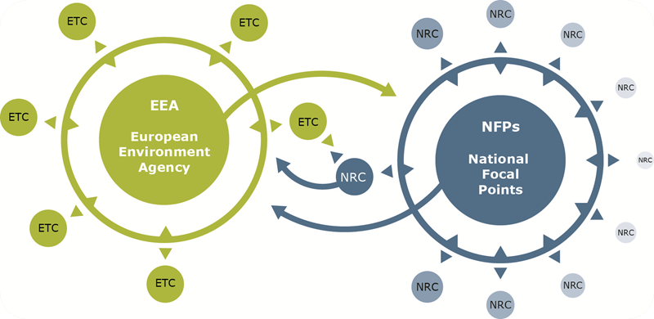
Figure 1 - The European environment information and observation network (Eionet)
Through Eionet, the EEA brings together expertise and environmental information from individual countries concentrating on the delivery of timely, nationally validated, high-quality data. This in turn supports EEA in assessing both the state of the environment in Europe and the pressures and driving forces acting upon it. This knowledge is made widely available through the EEA website and forms the basis of both thematic and integrated environmental assessments.
In the context of the implementation of the Water Framework Directive (WFD), EEA´s Eionet-Water annual data flow for waters was transferred into the WISE ‘State of the Environment’ (SoE) data flow in 2008 with the endorsement of the Water Directors. With this it remained one of the Eionet Priority Data Flows, but gained full integration into the reporting under WISE complementary with data reported under the WFD (i.e information reported already under the WFD obligatory reporting would not be required again, but used as available in WISE). Through the WISE SoE data collection the EEA obtains information on the state of water resources in Europe, including rivers, lakes, groundwater, transitional, coastal and marine waters, as well as data on water quantity, emissions to water and also other related subjects.
The following sections aim at presenting the WISE SoE data collection process and the WISE SoE TCM (Transitional, Coastal and Marine) dataset reporting and use at EEA. This is a process that involves direct reporting from countries to the EEA through an agreed data exchange mechanism (Reportnet i.e. the same as for the MSFD), but also data reported to the Regional Sea Conventions via ICES (i.e. OSPAR and HELCOM). The WISE SoE regular dataflow experience can therefore provide important input for the MSFD data reporting discussions and also for the wider context of WISE-Marine.

WISE SoE data collection process

WISE-SoE is based on monitoring networks that already exist in the EEA member countries, where a representative sub-sample of national monitoring sites in rivers, lakes, groundwater and transitional, coastal and marine waters were selected for the European network. No additional demands for new data gathering are therefore made to countries.
Data and information obtained through WISE SoE are primarily used to produce indicators (see section below on EEA indicators for a clearer definition of what elements constitute an indicator), which are then used to support EEA assessment reports. The data collected through WISE SoE are also published in Waterbase, a series of water topic-specific databases and web pages, publicly accessible via the EEA Data Service's web site. The most recent WISE SoE data on transitional, coastal and marine waters can be viewed, analysed and downloaded from Waterbase – TCM at: http://www.eea.europa.eu/data-and-maps/data/waterbase-transitional-coastal-and-marine-waters-8
WISE-SoE data collection runs annually and traditionally starts at the end of July/beginning of August following an announcement letter by EEA and ends in October. Data is reported to the Central Data Repository (CDR) of Reportnet (Figure 2). Reportnet allows improving the harmonisation and standardisation of all Eionet data flows by covering all activities inside them, from the detailed definition of the requested data to the generation of the final information products, such as reports or environmental indicators published by the EEA.
WISE SoE is a voluntary reporting agreement between the Eionet and EEA and it therefore constitutes a voluntary reporting obligation to the EEA in Reportnet. Eionet countries report on an agreed set of specifications, schemas and templates available from a Data Dictionary to structure and format their delivery. The responsibility of quality control and assurance for the national data lies with the member country. WISE SoE datasets are then further handled by the European Topic Centre on Inland, Coastal and Marine waters (ETC/ICM), where a series of QA routines are performed and validated, before being delivered as a so called 'European dataset' to the EEA Data Service for publication in Waterbase.

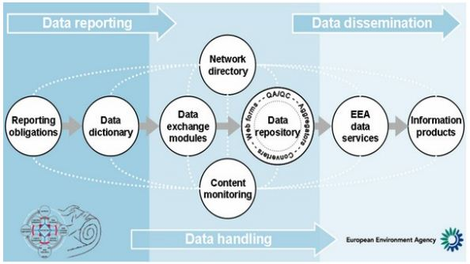

Figure 2 - An unrolled i.e. linear view of the Reportnet tools and their interaction in supporting the full data delivery process
The WISE-SoE process is designed to deliver data that are comparable, if implemented by countries in line with the guidance documents. Nevertheless, due to the many differences between national systems and the ways in which data are stored and the substances are defined, the QA and validation tasks of these data can be substantial and resource-intensive. The ETC therefore carries out many checks and conversions to ensure the data in Waterbase are comparable and can be used for EEA indicators. Furthermore, for the WISE SoE TCM dataset, the QA procedures are more complex as data not only comes from the Eionet but also from the Regional Sea Conventions, as explained below.

WISE SoE TCM (Transitional, Coastal and Marine Waters) dataset and its use at EEA

WISE SoE TCM dataset
The WISE SoE TCM dataset results from data collected both from EEA member countries and from the Regional Seas Conventions (RSC) through the WISE-SoE TCM data collection process. ICES manages a number of large dataset collections related to the marine environment while also serving as a data center for OSPAR and HELCOM. Therefore rather than asking countries to make duplicate deliveries to multiple organisations, an agreement was reached whereby countries were to provide only data that had not already been submitted to the RSC. These would fill in gaps or complete time series. Data submitted to the RSC is obtained from ICES directly.
WISE SoE TCM dataset is therefore assembled from countries reporting in Reportnet and from a snapshot at the end of a year of the ICES database (DOME), since submission to ICES occurs continuously throughout the year (although there are peaks in submissions during August-September matching RSC reporting obligations). This provides an additional complexity and challenge to the QA and validation of the WISE SoE TCM dataset, where, inter alia, duplicates remain an important and cumbersome issue.
The WISE SoE TCM dataset contains data on physical characteristics of the transitional, coastal and marine water monitoring and flux stations, proxy pressures on the upstream catchment, basin and River Basin District associated with transitional and coastal waters, chemical quality data on nutrients in seawater and hazardous substances in biota, sediment and seawater, as well as data on direct discharges and riverine input loads. The data model for this dataset can be found in Annex 1, as well as the link to the Data Dictionary where all the specifications of the dataset can be found.
EEA indicators using WISE SoE TCM data
The ETC is also responsible for doing the spatial and temporal aggregation of the WISE SOE TCM data and its analysis as to provide a pan-European assessment through EEA´s indicators. EEA indicators are composed of a specification part (Figure 3) and an assessment part (Figure 4). Specifications are only reviewed when significant methodological or policy changes occur, whereas assessment are regularly (annually or biannually) produced. Both parts are shared for consultation with the Eionet and other interested parties such as the RSC before being published on EEA´s website.
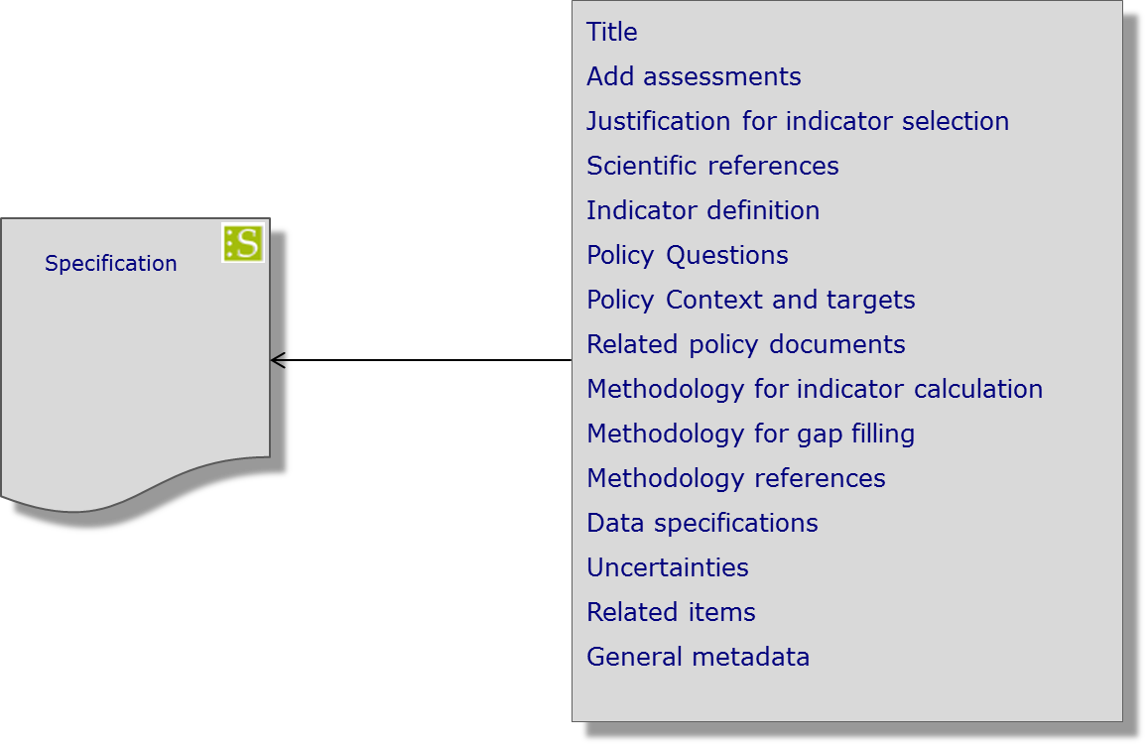
Figure 3 – EEA indicator specification template

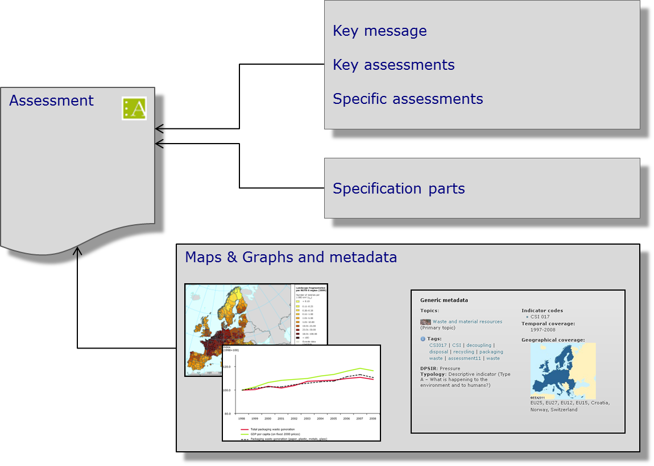
Figure 4 – EEA indicator assessment template
Currently, WISE SoE TCM data is used to underpin the regularly updated EEA's Core Set Indicators on nutrients (CSI021) and chlorophyll-a (CSI023) and the marine thematic indicator on hazardous substances in marine organisms (MAR001), which can be viewed at:
CSI021 - Nutrients in transitional, coastal and marine waters
http://www.eea.europa.eu/data-and-maps/indicators/nutrients-in-transitional-coastal-and/nutrients-in-transitional-coastal-and-4

CSI023 – Chlorophyll in transitional, coastal and marine waters http://www.eea.europa.eu/data-and-maps/indicators/chlorophyll-in-transitional-coastal-and/chlorophyll-in-transitional-coastal-and-3
MAR001 – Hazardous substances in marine organisms
http://www.eea.europa.eu/data-and-maps/indicators/hazardous-substances-in-marine-organisms/hazardous-substances-in-marine-organisms-3
It should be mentioned that the specifications of these indicators are currently being reviewed as a result of the MSFD and WFD implementation, as well as from RSC developments. An historical overview of the data submissions for nutrients, chl-a and hazardous substances can be seen in Annex 2.

Summary

This paper presented the structural and process elements of the WISE SoE Transitional, Coastal and Marine dataflow. WISE SoE is an example of a regular dataflow established between the EEA and its member countries, which involves direct reporting to the EEA as well as data harvesting from the RSC through ICES. The resulting WISE SoE TCM dataset underpins 3 main EEA indicators, which are regularly updated following a consultation with the Eionet (and other interested parties) and further used to support EEA assessments. This presentation is intended to provide insights relevant for the MSFD technical discussions under WG DIKE on data reporting and its use, and in particular for those on understanding data and information management at the regional and European scale towards the development of a regional approach to the collection, assembly and production of indicators and assessments in the context of the MSFD (as discussed in DIKE TSG WP4).

ANNEX 1 - Datamodel for WISE SoE TCM

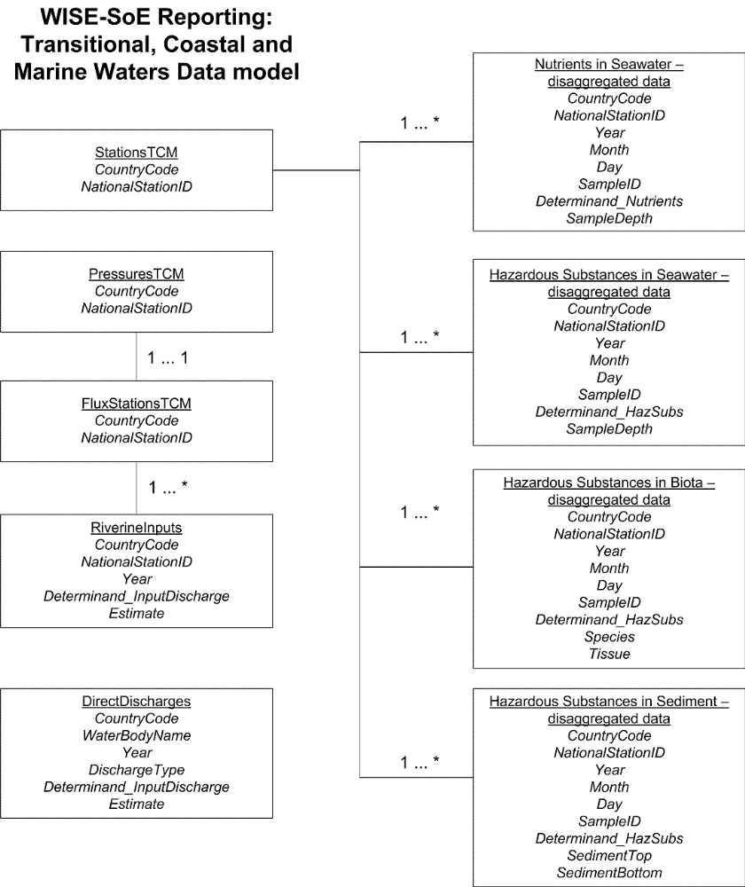

More information on the WISE SoE TCM dataset can be found in the Data Dictionary at http://dd.eionet.europa.eu/datasets/3050 or in the following document http://dd.eionet.europa.eu/GetPrintout?format=PDF&obj_type=DST&obj_id=3050&out_type=GDLN

ANNEX 2 – historical overviews of WISE SoE TCM data deliveries

Below are historical overviews of WISE SoE TCM data on nutrients (nitrate and phosphates), chlorophyll-a and hazardous substances in biota (as listed in the table further below). Data providers include non-Eionet countries since data is collected by ICES. However, the overview was made related to data (i.e. observations) available for marine waters within the geographical coverage of the Eionet, hence the inclusion of the US and Russia as data providers.

Data provider codelist

AL Albania | MK Macedonia, the Former Yugoslav Republic of
AT Austria | MT Malta
BA Bosnia and Herzegovina | NL Netherlands
BE Belgium | NO Norway
BG Bulgaria | PL Poland
CH Switzerland | PT Portugal
CY Cyprus | RO Romania
CZ Czech Republic | RS Serbia
DE Germany | SE Sweden
DK Denmark | SI Slovenia
EE Estonia | SK Slovakia
ES Spain | TR Turkey
FI Finland | XK Kosovo
FR France
GB United Kingdom | RU Russia
GR Greece | US United States of America
HR Croatia
HU Hungary
IE Ireland
IS Iceland
IT Italy
LI Liechtenstein
LT Lithuania
LU Luxembourg
LV Latvia
ME Montenegro

Hazardous substances in biota determinand list (in bold are the ones used for the MAR 001 indicator)

2,2',3,4,4'-pentabromodiphenyl ether (BDE85) | Hexachlorobenzene (HCB)
Alachlor | Hexachlorobutadiene (HCBD)
Aldrin | Indeno(1,2,3-cd)pyrene
Alpha-Endosulfan | Isodrin
Alpha-HCH | Lead
Anthracene | Mercury
Arsenic | Naphthalene
Benzo(a)anthracene | Nickel
Benzo(a)pyrene | PBDE100 (2,2',4,4',6-pentabromodiphenyl ether)
Benzo(b)fluoranthene | PBDE153 (2,2',4,4',5,5'-hexabromodiphenyl ether)
Benzo(g,h,i)perylene | PBDE154 (2,2',4,4',5,6'-hexabromodiphenyl ether)
Benzo(k)fluoranthene | PBDE28
Beta-HCH | PBDE47 (2,2',4,4'-tetrabromodiphenyl ether)
Cadmium | PBDE99
Chloroalkanes C10-13 | PCB101 (2,2',4,5,5'-pentachlorobiphenyl)
Chromium | PCB118
Chrysene | PCB138 (2,2',3,4,4',5'-hexachlorobiphenyl)
Copper | PCB153 (2,2',4,4',5,5'-hexachlorobiphenyl)
DDD, p,p' | PCB169
DDE, p,p' | PCB180 (2,2',3,4,4',5,5'-heptachlorobiphenyl)
DDT, o,p' | PCB28 (2,4,4'-trichlorobiphenyl)
DDT, p,p' | PCB52 (2,2',5,5'-tetrachlorobiphenyl)
Di (2-ethylhexyl) phthalate (DEHP) | PCB77
Dibenzo(a,h)anthracene | Pentachlorobenzene
Dieldrin | Pentachlorophenol
Diphenyl ether, pentabromo derivative | Phenanthrene
Endrin | Pyrene
Fluoranthene | Tributyltin cation
Gamma-HCH (Lindane) | Tributyltin compounds
Heptachlor | Trifluralin
Heptachloroepoxide | Zinc

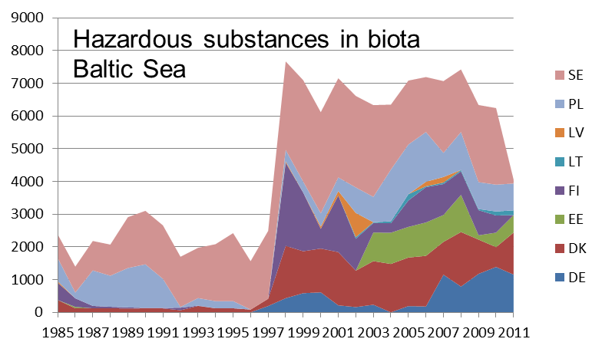
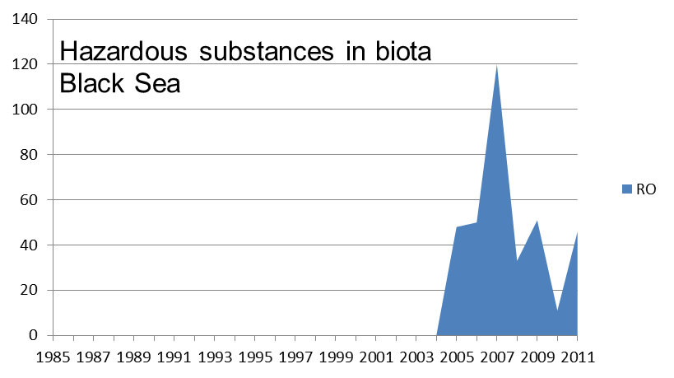
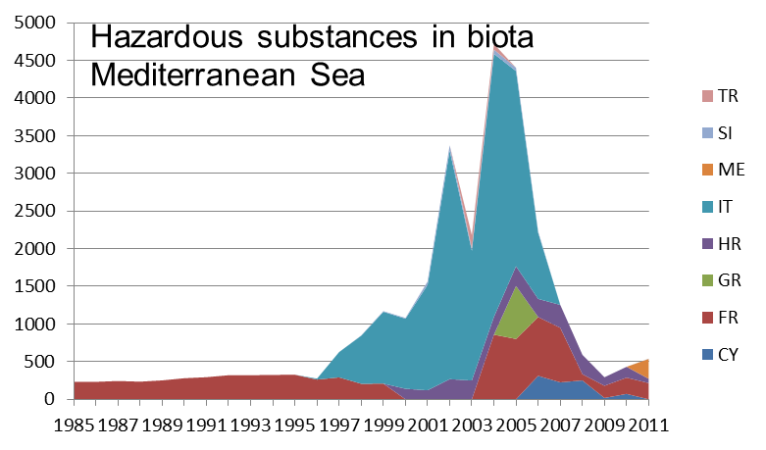
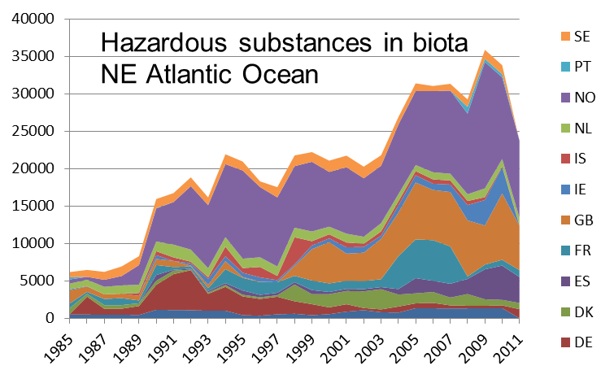
Historical overview of WISE SoE TCM data on hazardous substances in biota (number of records/data provider)

Historical overview of WISE SoE TCM data on nutrients (nitrate and phosphates) (number of records/data provider)
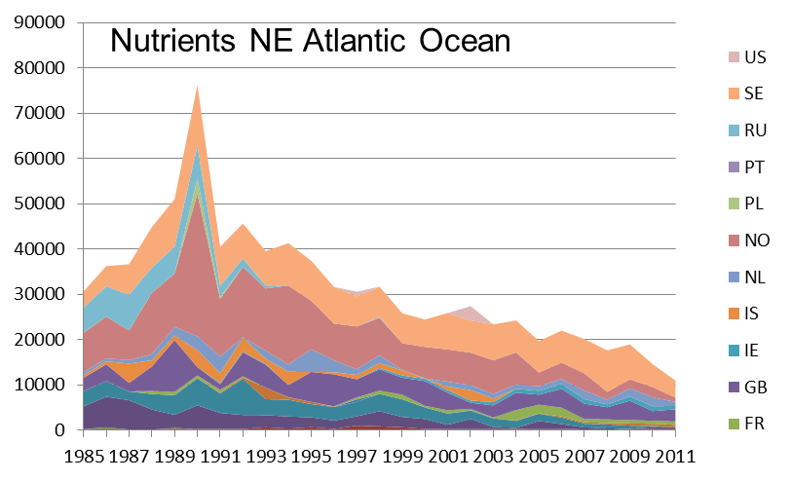
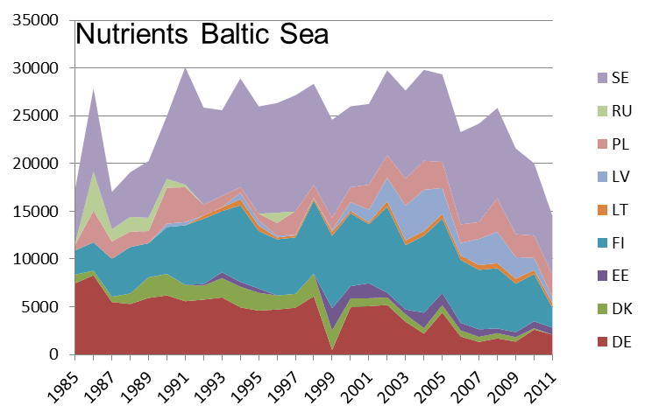

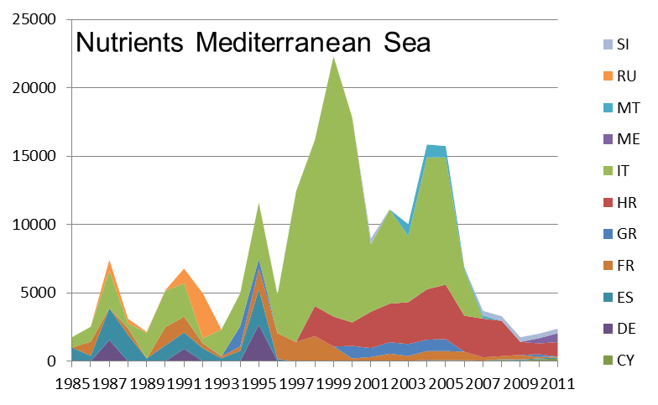
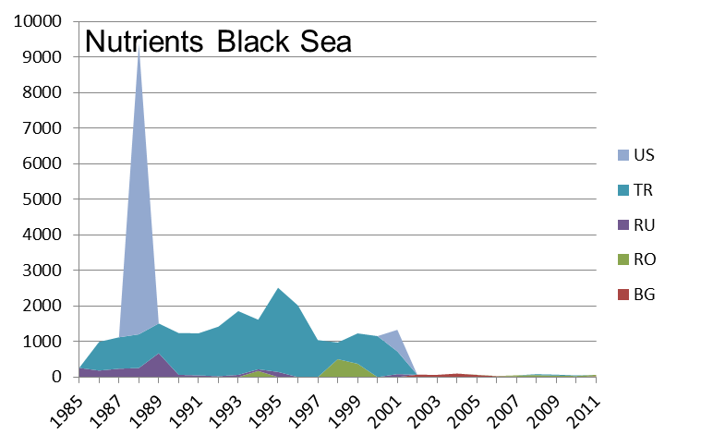

Historical overview of WISE SoE TCM data on chlorophyll-a (number of records/data provider)


