LEAC: Species biodiversity index from Art17 reporting
Draft v1

Emil and Jean-Louis with scientific advice of Rania, 6 April 2006
Methodology for the dummies
The input data are
- Species sorted out by ecosystem type (Art 17 annex) and reclassified by dominant land cover types 34%. Note that the same specie can belong to several types. 2 reporting status are used at this stage: Population and Future prospect. Their resolution is 10x10 km.
- DLT34% layers for each ecosystem type used in Art17 annex. Note that in one 1 km2 cell, it may exist 1 or 2 dominant land cover types. The lookup table is in annex. Cells where no land cover types makes 34% are labelled as “composite land cover”. Species data 10x10 are re-sampled according to their classification in a dominant land cover type, mapped at 1x1 km. Coastal ecosystems are restricted to water&wetlands (incl. estuaries, lagoons, intertidal flats…) and bare soils (sand, rocks). The coastal location is given by the Art17 code.

Processing
Data: e.g. agriculture;  - dlt34 is 1x1 km, 0 or 1 values  - species data are given at 10x10 km | 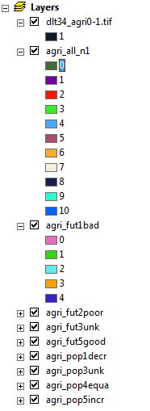

1st step: add 1 to all data files
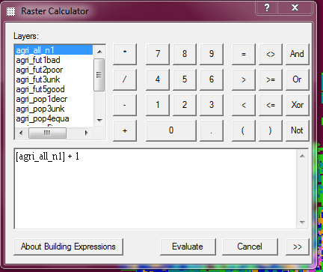
Calculation
2nd step: resample data to dlt34_agri0-1.tif, use CUBIC Resampling (1km2)
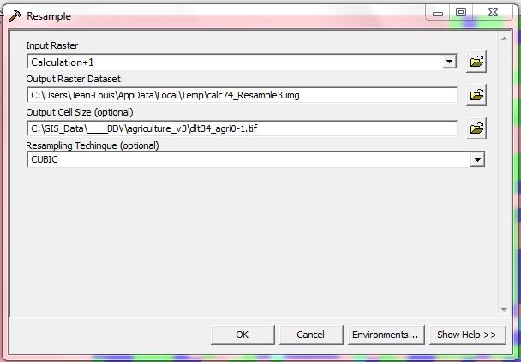
3rd step: multiply by dlt34_agri0-1 to select pixels and subtract 1 (the 1 added up in phase 1…)
([calcxx_Resample] * [dlt34_agri0-1.tif]) - 1

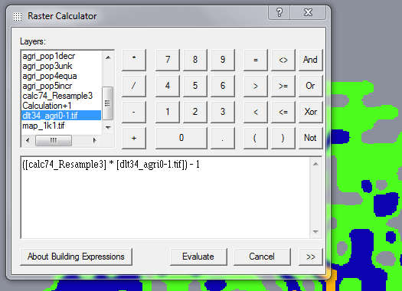

4th step: Export or Make Permanent as agri_all_n_1k.tif
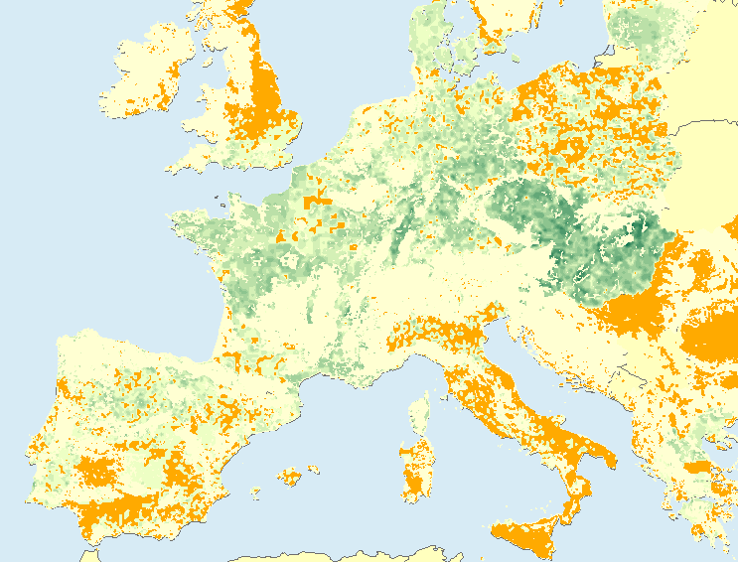
Note that the reporting on agriculture_crops (above: total number of species) is less comprehensive than for forests in several countries (the orange on the map is dlt34_agri not reported) (e.g. UK, IT…). More to expect with Pastures?

That’s it to start…
Just do it for the 8 layers…
Last step: Once you have produced all the agri_xxx_1k.tif files, you can start producing the indicator.
After many tests, the conclusion is that the simplest is the best. Based on forest data, it is remarkable that there is a very good coverage of dlt34_forest.
The formula consists in calculating all-good and all-bad and making the subtraction. In that way, the unknown issue disappear and the adjustment on the basis of the intensity of reporting by countries is not useful. Some national differences still exist but they are realistic (e.g. Portugal vs Galicia) and not catastrophic for our short term purpose (see final result next page…).
Later on, we can refine the reasoning on Population vs Future…
That’s it.

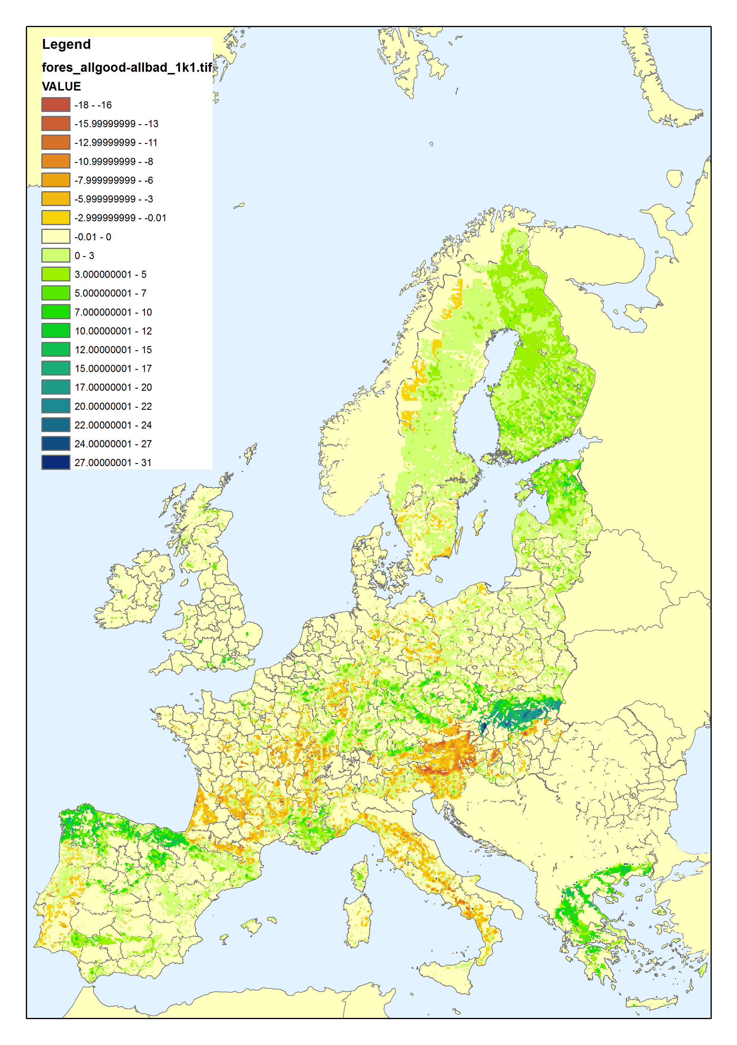
The forest’s biodiversity index for ecosystem capital accounting

Look up table

