




















261-1#5.1_1Cooperation with ESA and FAO

Proposal of land cover systems classification for ecosystem accounting

Final report
Universidad de Malaga
ETCSIA
PTA - Technological Park of Andalusia
c/ Marie Curie, 22 (Edificio Habitec)
Campanillas
29590 - Malaga
Spain

Telephone: +34 952 02 05 48
Fax: +34 952 02 05 59

Contact: etc-sia@uma.es

Working document

Prepared by:
Gabriel JAFFRAIN

Date:
30.11.2012

Project Manager:
Stefan Kleeschulte

Table of contents

Table of contents 2
1 Reminder of needs 3
1.1 Ecosystems Wealth assessment 3
1.2 Numerous land cover information but few land cover classification systems! 3
2 First sketch of aggregated Land Cover Functional Unit (LCFU) 5
2.1 Reminder of LCFU notion 5
2.2 Corresponding link between CLC and LCFU classification 6
2.3 Objectives 7
3 Aggregation matrix between Detailed Land cover types and LCFU 8
3.1 Results of the aggregated matrix 9
3.2 Observations and comments 9
4 First validation test: Aggregation matrix between Global Land cover National (GLCN) from Senegal and LCFU proposal. 11
4.1 Reminder of GLCN Senegal project: 11
4.2 Results of aggregated matrix 11
4.3 Observations and comments 11
5 Second validation : Aggregation matrix between Land cover type Corine Land Cover Burkina Faso and LCFU proposal. 13
5.1 Reminder of BDOT project: 13
5.2 Results of aggregated matrix 13
5.3 Observations and comments 13
6 Definition of Land Cover Flows from Land Cover Functional Unit (LCFU) 15
6.1 Definiton of the aggregated Land cover flows 16
6.2 Observation and comments 16
GENERAL CONCLUSION 18
REFERENCES 19
ANNEXES 20

Reminder of needs

Ecosystems Wealth assessment
It is now essential to take into account the "natural capital" of a country in the calculation of its Gross Domestic Product (GDP) and its development index. Natural capital includes assets of the Earth (soil, air, water, flora and fauna), and the resulting ecosystem services, which make human life possible. Ecosystems provide goods and ecological services that contribute to the maintenance of fundamental human health and economic activity. The degradation of ecosystems, require being measure and assessing and monitoring changes becoming increasingly important. Thus, the ecosystem accounting used "to measure and monitor changes in natural capital."
Land cover, land cover change and some aspects of land use could be described by remote sensing data. These land cover database obtained by satellite imageries are among others used as spatial support (basic platform) for biophysical assessment of ecosystem.

Numerous land cover information but few land cover classification systems!
There are numerous land cover and land use databases in the world used at national/ regional scale (1:50000 to 1:250000) but there is no internationally accepted land cover classification. Corine land cover and the FAO Land Cover Classification Systems are the standards the most commonly used at the national level.

- Reminder of CORINE Land cover
CORINE land cover is a biophysical inventory of land cover / land use, providing geographic reference information for several European countries. Indeed, today 39 European and pan-European countries hold a reliable CORINE land cover database describing the present situation as well as the changes that take place on their own territory (1990-2000 and 2000-2006). The programme is steered by the European Environment Agency and carried over under the framework of GMES.

- Reminder of FAO - LCCS
The system was developed in collaboration with other international initiatives on classification of LC, such as the U.S. Federal Geographic Data Committee (FGCD) – Vegetation Subcommittee and Earth Cover Working Group (ECWG); the South African National Land Cover Database Project (Thompson, 1996); and the international Geosphere-Biosphere Program (IGBP) - Data and information System (DIS) Land Cover Working Group and Land Use Land Cover Change (LUCC) Core Project. The first official release of LCCS (v.1) was published in 2000 (Di Gregorio and Jansen, 2000). A second version was developed based on international feedback involving a large global community, and published in 2005 (LCCS v.2) (Di Gregorio, 2005). A new version (LCCS3) was planned for release in 2011.

While Corine has been established for the purposes of European policies and presents a hierarchical nomenclature (or legend), LCCS is a system which aims at adapting to the variability of land cover conditions. There is therefore no standard legend corresponding to LCCS but a wide set of possibilities matching any users needs, strong consistency being given by strict classification rules (embedded in the LCCS3 software package) and the overall meta-language(now an ISO geomatic standard). The counterpart of this high fitness-for-purpose is that the legends of the maps produced on that basis in different countries (in particular in Africa) have limited comarability. Some internationally used classifications such as the IGBP Land cover map, Global Land Cover 2000 or ESA GlobCover are commonly called “LCCS classification or “FAO-UNEP LCCS classification”. This is inappropriate: they are just a particular interpretation of the LCCS principles giving priority to vegetation patterns over more socio-ecological characteristics.

In the course of the preparation of the SEEA Part 2 on ecosystem accounting, FAO and the EEA have agreed on the translation of Corine land cover into the Land Cover Meta Language of LCCS and proposed a coordinated set of classifications of generic scale independant land cover types and land cover functional units integrating vertical and horizontal patterns for mapping ecosystem units which are often composite to some extent. (now part of the SEEA Part I “Central Framework”) The question is now to propose an experimental standard classification of land cover functional units to support the international implementation of accounts for land ecosystems.

First sketch of aggregated Land Cover Functional Unit (LCFU)

Reminder of LCFU notion
A specific aggregated classification for ecosystems accounts was proposed in the paper submitted in London in November 2011 entitled “ ISSUE 3: Land cover mapping, land cover classifications, and accounting units Land cover classification for ecosystem accounting” JLW & all.
http://unstats.un.org/unsd/envaccounting/seeaLES/egm/Issue3_EEA_FAO.pdf

This classification is composed of 16 main aggregated land cover classes and is based on the land cover classification presented in the SEEA volume 1, which has been detailed for the specific purpose of defining land cover functional units for accounting. This classification can be also easily bridged with Corine Land Cover using the LCML translation of Corine produced by FAO.

The translation of CLC has been done with the last version of LCCS (version 3) that is directly derived by the LCML (Land Cover Meta Language). The LCML provides a general framework of rules based on physiognomy and stratification of both biotic and abiotic elements that may be used to specify any land cover feature all over the world, thus making available a common reference for land cover classification systems.

A | Urban and associated developed areas
B | Medium to large fields rainfed herbaceous cropland
C | Medium to large fields irrigated herbaceous cropland
D | Permanent crops, agriculture plantations
E | Agriculture associations and mosaics
F | Pastures and natural grassland
G | Forest tree cover
H | Shrubland, bushland, heathland
I | Sparsely vegetated areas
J | Natural vegetation associations and mosaics
K | Barren land
L | Permanent snow and glaciers
M | Open wetlands
N | Inland water bodies
O | Coastal water bodies
P | Sea (per memory)
Table1: First sketch of aggregated LCFU classification

This classification established for ecosystem accounting purposes, describe in a strict way how these geographical units are defined in terms of component objects, their characteristics and properties as well as of horizontal patterns of their spatial arrangements. This requires a choice regarding the scale where maps should be produced and/or the size of the minimum mapped unit, according to the ecosystem accounting purpose.

Corresponding link between CLC and LCFU classification
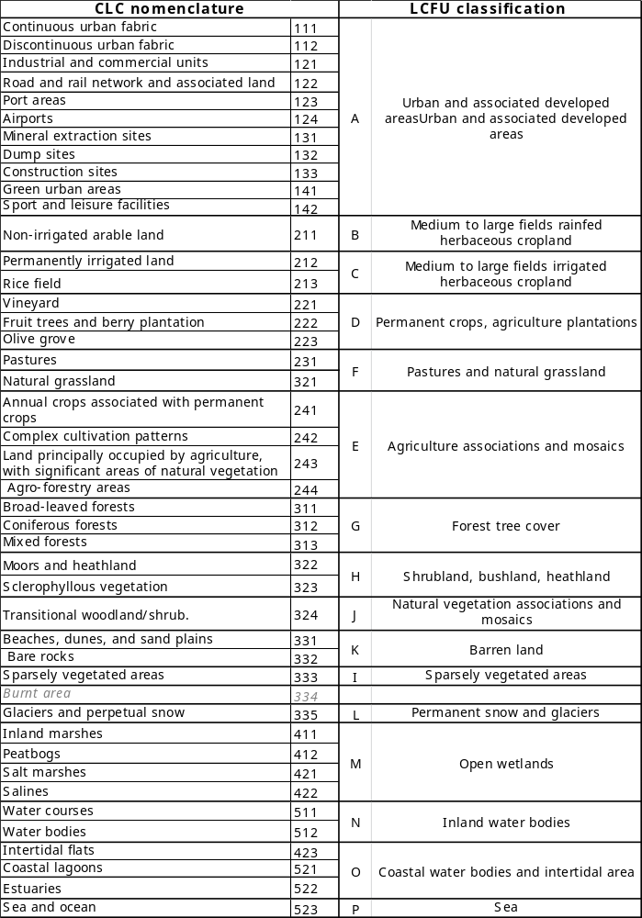
Table2: Link between CLC and LCFU classification

Perfect compatibility between CLC classes and LCFU classes except for burnt areas (334) which can be classified in several LCFU classes regarding their initial biophysical nature (forest, woodland, shrubs, herbaceous…)…

Objectives
From this first sketch of aggregated classification we will compare some specific and operational land cover classification through a “convergence or aggregation matrix”. Using some concrete existing land cover database coming from either, Corine land cover or either FAO classification system, we seek to gather land cover classes having more and less the same nature.

Aggregation matrix proposal:

 |  | Land Cover functional Unit (LCFU)
 |  | A | B | C | D | E | F | ...
Title |  | Urban and associated developed areas | Medium to large fields rainfed herbaceous cropland | Medium to large fields irrigated herbaceous cropland | Permanent crops, agriculture plantations | Agriculture associations and mosaics | Pastures and natural grassland
Land cover class | Xaa
Land cover class | Xab
Land cover class | Xac
Land cover class | Zba
Land cover class | bbc
Land cover class | …

On Column: the LCFU class suggested for the ecosystem accounting
On row: land cover class coming from a standard classification system (FAO, CLC)
 | Aggregated on priority | A land cover class will be find exclusively in a specific LCFU class
 | Aggregated secondarily | A land cover class will be find exclusively in a specific LCFU but could be meet in an other categories of LCFU

Adjustment of some LCFU classes definition

We suggest some little modification concerning the definition of the class B and C. Indeed we propose to focus in priority on the nature of crops instead the size of parcel.

B: Change the definition of “Medium to large fields rainfed herbaceous cropland” into homogeneous rainfed herbaceous cropland.

C: change the definition “Medium to large fields irrigated herbaceous cropland” into homogeneous irrigated herbaceous cropland

Aggregation matrix between Detailed Land cover types and LCFU
The classification process of land cover functional units for ecosystem accounting start from the land cover types of volume1. The first step is a subdivision of land cover types in order to prepare the ground to the application needed for ecosystem accounting.

Code | Title
01 | Artificial surfaces (including urban and associated areas)
01.a | Artificial surfaces from 10 to 50 %
01.b | Artificial surfaces from 51 to 100 %
02 | Herbaceous crops
02.a | Small size fields of herbaceous crops rainfed
02.b | Small size fields of herbaceous crops irrigated or aquatic (rice)
02.c | Medium to large fields of herbaceous crops rainfed
02.d | Medium to large fields of herbaceous crops irrigated or aquatic (rice)
03 | Woody crops
03.a | Small size fields of woody crops
03.b | Medium to large fields of woody crops
04 | Multiple or layered crops
05 | Grassland
05.a | Natural grassland
05.b | Improved grassland
06 | Tree covered area
06.a | Tree covered area from 10 to 30-40 %
06.b | Tree covered area from 30-40 to 70 %
06.c | Tree covered area from 70 to 100 %
07 | Mangroves
08 | Shrub covered area
08.a | Shrub covered area from 10 to 60 % (open)
08.b | Shrub covered area from 60 to 100 % (closed)
09 | Shrubs and/or herbaceous vegetation aquatic or regularly flooded
09.a | From 2 to 4 months
09.b | More than 4 months
10 | Sparsely natural vegetated areas
11 | Terrestrial barren land
11.a | Loose and shifting sand and/or dunes
11.b | Bare soil, gravels and rocks
12 | Permanent snow and glaciers
13 | Inland water bodies
14 | Coastal water bodies and inter-tidal areas
14.a | Coastal water bodies (lagoons and/or estuaries)
14.b | Inter-tidal areas (coastal flats and coral reefs)
Table3: Detailed Land Cover Types (all levels)

Results of the aggregated matrix
See table 4; aggregated matrix between Land cover type classification and LCFU classification

Observations and comments

We observe that the whole set of "land cover type” find themselves mainly the LCFU classes following the red diagonal, except certain class of land cover type belonging to the second level.

- About the agriculture topic:

Indeed, in the agriculture domain, regarding the plot size element and the nature of these parcels (02.a and 02.b), these two classes can belong in two categories B or E on the LCTU classification, according to the homogeneity/heterogeneity of these crops.

Hypothesis 1:
If a landscape is composed of small parcel of homogeneous crops (02.a) such as cereal, legumes, gardening market (less than the Minimum Mapping Unit defined) then, this land cover type will be classified into B “Homogeneous rainfed herbaceous crops “.

Hypothesis 2:
If a landscape is composed of small parcel of heterogeneous herbaceous crops (02.a) such as cereal, legumes, gardening market mixed with small parcels of grass or permanent crops (less than the Minimum Mapping Unit defined) this land cover type will be classified into E “agriculture association and mosaic”.

The same remark can be done for the small size of woody crops.

- About the natural and semi-natural topic:

The open natural vegetation formation composed of low density of shrubs (10-60 %< density) can be distributed at least in 2 or 3 LCFU items.

The land cover type 08a “shrub covered area from 10 to 60% can be classified into:
H “shrub land” or
J Natural vegetation and mosaic
I sparsely vegetated area (if landscape composed of mixed bare soil and low density of shrub )
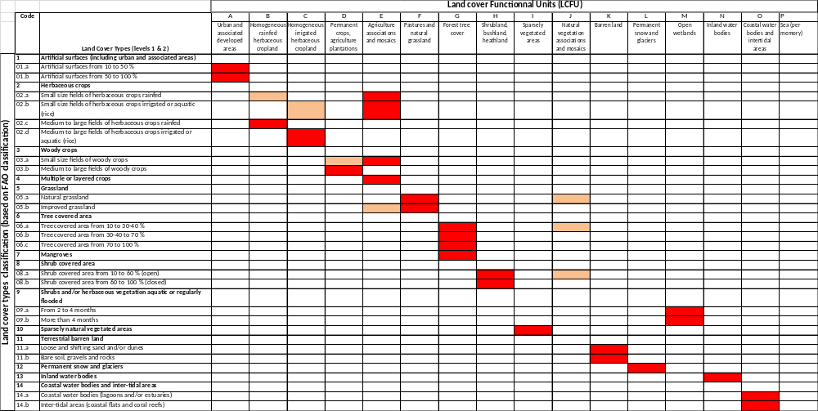
Aggregated on priority
Aggregated secondarily
Table4; aggregated matrix between Land cover type classification and LCFU classification

First validation test: Aggregation matrix between Global Land cover National (GLCN) from Senegal and LCFU proposal.

Reminder of GLCN Senegal project:

The preliminary and the final interpretation work were carried out in the GLCN office at Centre de Suivi Ecologique (C.S.E.), in Dakar (Senegal). In addition, within the LADA (Land Degradation Assessment in Drylands) framework, an analysis of land cover changes in Senegal from 1990 to 2005 was performed between October 2007 and March 2008 was performed and reported in “Senegal Change Assessment”. The analysis covered all the classes present in the Senegal 2005 Land Cover legend; particular attention was given to the more sensitive areas such as Forest, Agricultural land and Urban areas using images taken in two dates: 1990 and 2005. Both the final Land Cover revision/accuracy assessment and the analysis of land cover changes in Senegal, were carried out at the GLCN office in Florence (Italy). The legend of the former interpretation was translated in the respective LCCS classes. The implementation of Senegal Land Cover map has been based on the multi-phase image interpretation approach, which was successfully used by FAO in a number of projects.

Results of aggregated matrix
See table5; aggregated matrix between GLCN-Senegal and LCFU nomenclature

Observations and comments
Each Land cover type of the GLCN Senegal classification system corresponds respectively to one LCFU items.
Several detailed land cover type (GLCN-Senegal) could be aggregated in one land cover functional Unit.

- About the agriculture topic:
The class 1H-P+A, 1H-g+A composed of multilayer of crops with sparse trees are aggregated into the class E (agriculture association and mosaic) from LCFU classification.

- About the natural and semi-natural topic:

As mentioned on the “IPCC Guidelines for National Greenhouse Gas Inventories. Intergovernmental Panel on Climate Change, the forest plantation 1AFPf-g-1 and 1AFPf-g-2 will be integrated in Forest tree cover G.

According to the DNA “United Nations Framework Convention on Climate Change- Designated National Authorities (DNA)”, each countries has is own forest definition.
All countries agree on the fact that the forest is defined when the tree cover density is > 30% and highest than 5m. Only some country define a forest from a tree cover density > 10%. Then, a forest having a tree cover density between 10 to 30% can be classified either on forest G either on natural vegetation and mosaic J.
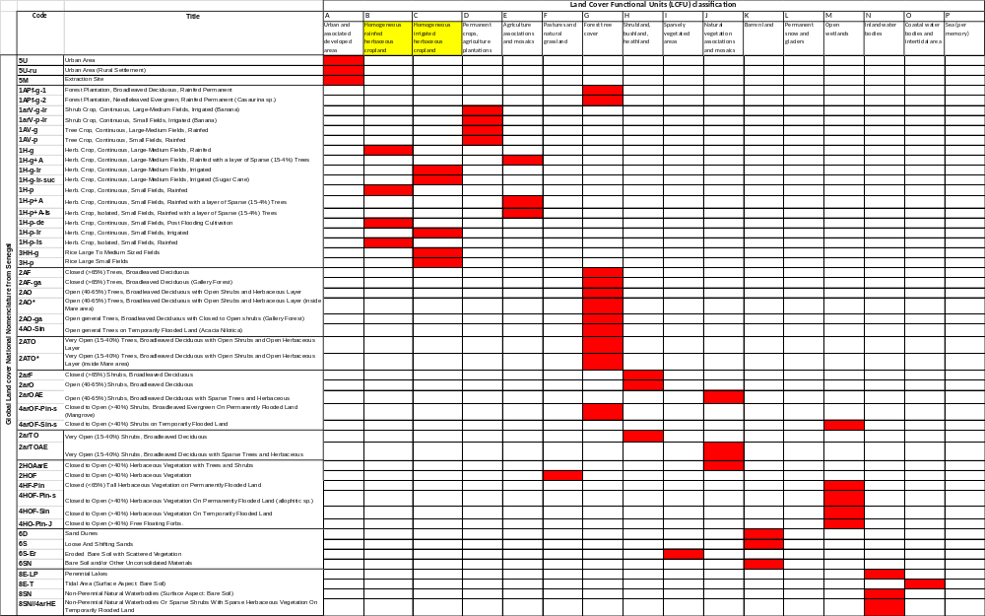
Table5; aggregated matrix between GLCN in Senegal and LCFU classification

Second validation : Aggregation matrix between Land cover type Corine Land Cover Burkina Faso and LCFU proposal.

Reminder of BDOT project:

Since 2005, the National Program for Land Management (NPLM2) located in Burkina Faso has two land occupation databases (BDOT) at its disposal that reflect the state of the territory in 1992 and 2002, respectively. This project funded by the Danish cooperation, launched and coordinated by the NPLM2 with support from the Ministry of Agriculture, Hydraulics and Halieutic Resources, from the Ministry of the Environment and Quality of Life, and from the PNGIM network, was entrusted to IGN France International. This BDOT is the European CORINE concept adapted for Sahelian conditions. The BDOT1992 and BDOT2002, and the changes database, which is a product of the two BDOT databases, proved a fundamental source of information for the implementation diachronic analysis of the land occupation changes occurring on the steppes and savannahs (among other locations) during this decade.

Results of aggregated matrix
See table 6; aggregated matrix between BDOT nomenclature in Burkina Faso and LCFU classification

Observations and comments
Each Land cover type of BDOT nomenclature classification system corresponds respectively to one LCFU items.

The savannah formation will be distributed differently according to the density of tree.
Herbaceous savannah on F pasture and natural grassland
Shrubs and tree savannah on J
The steppe formation will be classified on I sparsely vegetated area

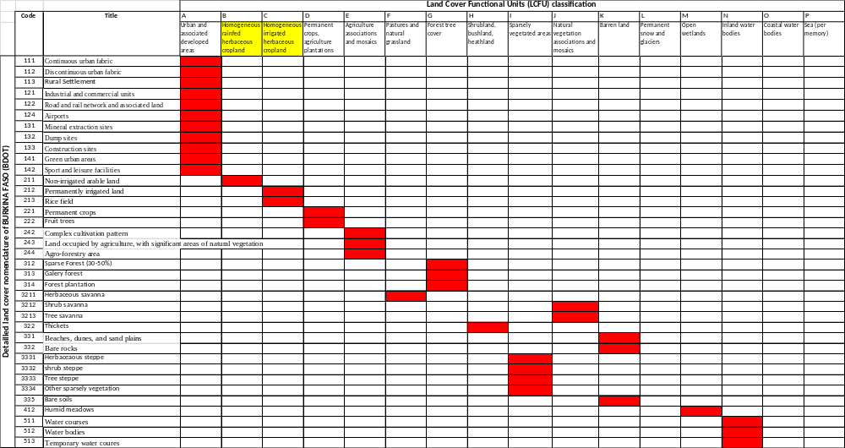

Table6; aggregated matrix between Corine Land cover in Burkina Faso and LCFU classification

Definition of Land Cover Flows from Land Cover Functional Unit (LCFU)
The Classification of Land Cover Flows (LF) is derived from the classification defined and used in the Land and Ecosystem Accounts (LEAC) report of 2006. During the course of the GlobCorine project where a simplified Corine type land cover classification was produced by ESA with University of Louvain and the EEA, an assessment of the losses of information resulted from various levels of aggregation of the classification. The conclusions were presented in the London Group meeting of 2009 (Land Cover Classification for Land Cover Accounting (J.-L. Weber, EEA, Land Cover Classification for Land Cover Accounting
http://unstats.un.org/unsd/envaccounting/londongroup/meeting14/LG14_9a.pdf )

The study showed that the reduction from the Corine 44 classes to 15 to 17 classes could result, on the basis of the LEAC 1990-2000 matrix of change in a small amount of land cover flows, by an order of magnitude of 10%.

The following proposal upgrades the European GlobCorine to take into account the recent developments and the adjustments to the Aggregated Land Cover Functional Units presented above.

The detail of the classes are assumed to fit land cover change detection occurring anywhere on the world, so the proposal is still a draft to be tested during the foreseen experimental phase of the SEEA Part 2.

lf1 Land development processes, urban sprawl, expansion of intensive land use
lf11 |  | Artificial development over agriculture
lf12 |  | Artificial development over forests
lf13 |  | Artificial development of other natural land cover
lf14 |  | Conversion from small field agriculture and pasture to broad pattern cropland
lf15 |  | Conversion from forest to agriculture
lf16 |  | Conversion from marginal land to agriculture
lf17 |  | Water body creation and management
lf2 Land restoration processes
lf21 | Conversion from crops to set aside, fallow land and pasture
lf22 | Withdrawal of farming
lf23 | Forest creation, afforestation of agriculture land
lf3 Rotations, natural processes and steady state
lf31 | Internal conversion of artificial surfaces
lf32 | Internal conversion between agriculture crop types
lf33 | Recent tree clearing and forest transition
lf34 | Forest conversions and recruitment
lf35 | Changes of land-cover due to natural and multiple causes
lf4 Other land cover change /No observed land-cover change
Proposed classification of Land Cover Flows

Definiton of the aggregated Land cover flows
“Table7: Matrix of flows obtained by LCFU aggregation” presents the land cover flows from a matrix of land cover change. It follows the format of the matrix of land cover flows of the EEA LEAC report of 2006.

Observation and comments

Except for lf31 Internal conversion of artificial surfaces which cannot be addressed with only one LCFU class, the various land cover flows could be described.

The results need now being tested in various contexts to assess the relevance of the land cover flows classifications and, indirectly the appropriateness of the LCFU classification. For example, Artifical surfaces could be subdivided further on in two possible ways:

- Urban fabric vs Activity areas and infrastructures

or

- Dense artificial cover vs. dispersed artificial cover

A critical issue relates to forest rotations (felling followed by plantation) and their distinction from deforestation (felling followed by another land use or a long period of natural transition). Land cover flows could be in that case assessed from the observation of the time series instead of (or in addition to) the difference between two dates.
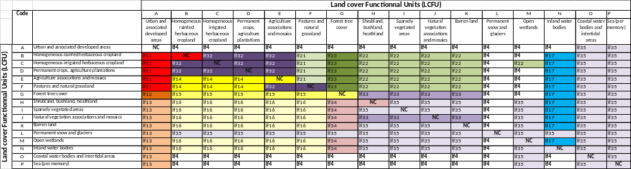

Table7: Matrix of flows derivate the LCFU

GENERAL CONCLUSION
At aggregated level, the definition of a land cover “nomenclature” or “legend” for ecosystem accounting doesn’t seem to be a major difficulty.

The nomenclature for LCFU ecosystem accounts seems perfectly compatible and suitable for different classification system. With the exception of some adjustment that to be made ​​on some specific land cover classes, (study case by case) it appears that the proposed LCFU nomenclature could be used as a common core (common reference structure ) for the Ecosystem account.

The coupling between the core nomenclature and LCCF3 guarantees both minimum international comparability and the possibility to detail further on the classification for national or regional purposes. This detail doesn’t need to be standardised at the international level, although some coordination between countries belonging to a same bio-geographical region could be useful. The Corine/LEAC experience could help in this domain, as well as applications such as the land accounts of Burkina Faso 1992-2002 and the annual land cover accounts of Brazil which production has started at IBGE.

REFERENCES

Jean-Louis Weber (EEA), Antonio di Gregorio (FAO), and Gabriel Jaffrain (IGN-FI) Expert Meeting on Ecosystem Accounts , 5 - 7 December 2011, London, UK- ISSUE 3: Land cover mapping, land cover classifications, and accounting units- Land cover classification for ecosystem accounting.

Corine land cover Outside of Europe, final report- Nomenclature adaptation to other bio-geographical region –ETC-SIA, December 2011.

EEA report / N°11/2006- Land accounts for Europe- Towards integrated land and ecosystem accounting 1990-2000.

FAO & United Nations - GLCN Land cover mapping in Senegal- Ugo Leonardi, December 2008.

United Nations Framework Convention on Climate Change- Designated National Authorities (DNA): http://cdm.unfccc.int/DNA/index.html.

Intergovernmental Panel on Climate Change- IPCC Guidelines for National Greenhouse Gas Inventories. Consistent Representation of Lands chapter3, IGES 2006.

Jaffrain, G., Diallo,A and Boussim, J., , A. 2005. Technical Guide for Land-Cover Database “BDOT ” in Burkina Faso. Paris: IGN FI–IGB.

ANNEXES

Indicative correspondence between land cover legends / nomenclatures of LCFU for ecosystem accounting

Of

Senegal
Mozambique
Europe
DOM
Burkina-Faso
Colombia
…

 | Land Cover Functional Unit (LCFU) | Senegal / FAO GLCN legend |  | LULUCF 6 land-use categories IPCC Guideline
G | Forest tree cover | 2AF | Closed (>65%) Trees, Broadleaved Deciduous | (I)FOREST LAND
G | Forest tree cover | 2AF-ga | Closed (>65%) Trees, Broadleaved Deciduous (Gallery Forest) | (I)FOREST LAND
G | Forest tree cover | 2AO | Open (40-65%) Trees, Broadleaved Deciduous with Open Shrubs and Herbaceous Layer | (I)FOREST LAND
G | Forest tree cover | 2AO* | Open (40-65%) Trees, Broadleaved Deciduous with Open Shrubs and Herbaceous Layer (inside Mare area) | (I)FOREST LAND
G | Forest tree cover | 2AO-ga | Open general Trees, Broadleaved Deciduous with Closed to Open shrubs (Gallery Forest) | (I)FOREST LAND
G | Forest tree cover | 4AO-Sin | Open general Trees on Temporarily Flooded Land (Acacia Nilotica) | (I)FOREST LAND
G | Forest tree cover | 1APf-g-1 | Forest Plantation, Broadleaved Deciduous, Rainfed Permanent | (I)FOREST LAND
G | Forest tree cover | 1APf-g-2 | Forest Plantation, Needleleaved Evergreen, Rainfed Permanent (Casaurina sp.) | (I)FOREST LAND
G | Forest tree cover | 4arOF-Pin-s | Closed to Open (>40%) Shrubs, Broadleaved Evergreen On Permanently Flooded Land (Mangrove) | (I)FOREST LAND
H | Shrubland, bushland, heathland | 2arF | Closed (>65%) Shrubs, Broadleaved Deciduous | (II)GRASSLAND
H | Shrubland, bushland, heathland | 2arO | Open (40-65%) Shrubs, Broadleaved Deciduous | (II)GRASSLAND
J | Natural vegetation associations and mosaics | 2ATO | Very Open (15-40%) Trees, Broadleaved Deciduous with Open Shrubs and Open Herbaceous Layer | (II)GRASSLAND
J | Natural vegetation associations and mosaics | 2ATO* | Very Open (15-40%) Trees, Broadleaved Deciduous with Open Shrubs and Open Herbaceous Layer (inside Mare area) | (II)GRASSLAND
J | Natural vegetation associations and mosaics | 2arOAE | Open (40-65%) Shrubs, Broadleaved Deciduous with Sparse Trees and Herbaceous | (II)GRASSLAND
J | Natural vegetation associations and mosaics | 2HOAarE | Closed to Open (>40%) Herbaceous Vegetation with Trees and Shrubs | (II)GRASSLAND
F | Pastures and natural grassland | 2HOF | Closed to Open (>40%) Herbaceous Vegetation | (II)GRASSLAND
I | Sparsely vegetated area | 6S-Er | Eroded Bare Soil with Scattered Vegetation | (II)GRASSLAND
I | Sparsely vegetated area | 2arTO | Very Open (15-40%) Shrubs, Broadleaved Deciduous | (II)GRASSLAND
I | Sparsely vegetated area | 2arTOAE | Very Open (15-40%) Shrubs, Broadleaved Deciduous with Sparse Trees and Herbaceous | (II)GRASSLAND
B | Medium to large fields rainfed herbaceous cropland | 1H-g | Herb. Crop, Continuous, Large-Medium Fields, Rainfed | (III)CROPLAND
B | Medium to large fields rainfed herbaceous cropland | 1H-p | Herb. Crop, Continuous, Small Fields, Rainfed | (III)CROPLAND
B | Medium to large fields rainfed herbaceous cropland | 1H-p-de | Herb. Crop, Continuous, Small Fields, Post Flooding Cultivation | (III)CROPLAND
B | Medium to large fields rainfed herbaceous cropland | 1H-p-Is | Herb. Crop, Isolated, Small Fields, Rainfed | (III)CROPLAND
C | Medium to large fields irrigated herbaceous cropland | 1H-g-Ir | Herb. Crop, Continuous, Large-Medium Fields, Irrigated | (III)CROPLAND
C | Medium to large fields irrigated herbaceous cropland | 1H-g-Ir-suc | Herb. Crop, Continuous, Large-Medium Fields, Irrigated (Sugar Cane) | (III)CROPLAND
C | Medium to large fields irrigated herbaceous cropland | 1H-p-Ir | Herb. Crop, Continuous, Small Fields, Irrigated | (III)CROPLAND
C | Medium to large fields irrigated herbaceous cropland | 3HH-g | Rice Large To Medium Sized Fields | (III)CROPLAND
C | Medium to large fields irrigated herbaceous cropland | 3H-p | Rice Large Small Fields | (III)CROPLAND
D | Permanent crops, agriculture plantations | 1arV-g-Ir | Shrub Crop, Continuous, Large-Medium Fields, Irrigated (Banana) | (III)CROPLAND
D | Permanent crops, agriculture plantations | 1arV-p-Ir | Shrub Crop, Continuous, Small Fields, Irrigated (Banana) | (III)CROPLAND
D | Permanent crops, agriculture plantations | 1AV-g | Tree Crop, Continuous, Large-Medium Fields, Rainfed | (III)CROPLAND
D | Permanent crops, agriculture plantations | 1AV-p | Tree Crop, Continuous, Small Fields, Rainfed | (III)CROPLAND
E | Agriculture associations and mosaics | 1H-g+A | Herb. Crop, Continuous, Large-Medium Fields, Rainfed with a layer of Sparse (15-4%) Trees | (III)CROPLAND
E | Agriculture associations and mosaics | 1H-p+A | Herb. Crop, Continuous, Small Fields, Rainfed with a layer of Sparse (15-4%) Trees | (III)CROPLAND
E | Agriculture associations and mosaics | 1H-p+A-Is | Herb. Crop, Isolated, Small Fields, Rainfed with a layer of Sparse (15-4%) Trees | (III)CROPLAND
M | Open wetlands | 4HF-Pin | Closed (<65%) Tall Herbaceous Vegetation on Permanently Flooded Land | (IV)WETLANDS
M | Open wetlands | 4HOF-Pin-s | Closed to Open (>40%) Herbaceous Vegetation On Permanently Flooded Land (allophitic sp.) | (IV)WETLANDS
M | Open wetlands | 4HOF-Sin | Closed to Open (>40%) Herbaceous Vegetation On Temporarily Flooded Land | (IV)WETLANDS
M | Open wetlands | 4HO-Pin-J | Closed to Open (>40%) Free Floating Forbs. | (IV)WETLANDS
M | Open wetlands | 4arOF-Sin-s | Closed to Open (>40%) Shrubs on Temporarily Flooded Land | (IV)WETLANDS
A | Artificial surfaces (including urban and associated areas) | 5U | Urban Area | (V)SETTLEMENTS
A | Artificial surfaces (including urban and associated areas) | 5U-ru | Urban Area (Rural Settlement) | (V)SETTLEMENTS
A | Artificial surfaces (including urban and associated areas) | 5M | Extraction Site | (V)SETTLEMENTS
K | Barren land | 6D | Sand Dunes | (VI)OTHER LANDS
K | Barren land | 6S | Loose And Shifting Sands | (VI)OTHER LANDS
K | Barren land | 6SN | Bare Soil and/or Other Unconsolidated Materials | (VI)OTHER LANDS
L | Permanent snow and glacier |  |  | (VI)OTHER LANDS
N | Inland water bodies | 8E-LP | Perennial Lakes | (VI)OTHER LANDS
N | Inland water bodies | 8SN | Non-Perennial Natural Waterbodies (Surface Aspect: Bare Soil) | (VI)OTHER LANDS
N | Inland water bodies | 8SN//4arHE | Non-Perennial Natural Waterbodies Or Sparse Shrubs With Sparse Herbaceous Vegetation On Temporarily Flooded Land | (VI)OTHER LANDS
0 | Coastal water bodies and inter-tidal areas | 8E-T | Tidal Area (Surface Aspect: Bare Soil) | (VI)OTHER LANDS

 | Land Cover Functional Unit (LCFU) | Mozambique / FAO legend |  | LULUCF 6 land-use categories IPCC Guideline
G | Forest tree cover | 2DEC | Coastal dense woody vegetation | (I)FOREST LAND
G | Forest tree cover | 2DEO | Coastal open woody vegetation | (I)FOREST LAND
G | Forest tree cover | 2FEM | Closed broadleaved (semi-) evergreen mountainous forest | (I)FOREST LAND
G | Forest tree cover | 2FE | Broadleaved (semi-) evergreen closed forest | (I)FOREST LAND
G | Forest tree cover | 2FEG | Gallery forest | (I)FOREST LAND
G | Forest tree cover | 2FEA | Mecrusse dense ( Broadleaved evergreen forest) | (I)FOREST LAND
G | Forest tree cover | 2FD | Broadleaved (semi-) deciduous closed forest | (I)FOREST LAND
G | Forest tree cover | 2FDC | Mopane dense | (I)FOREST LAND
G | Forest tree cover | 2FDB | Miombo dense | (I)FOREST LAND
G | Forest tree cover | 2WEM | Open broadleaved (semi-) evergreen mountainous forest | (I)FOREST LAND
G | Forest tree cover | 2WE | Broadleaved (semi-) evergreen open forest | (I)FOREST LAND
G | Forest tree cover | 2WEA | Mecrusse open | (I)FOREST LAND
G | Forest tree cover | 2WD | Broadleaved (semi-) deciduous open forest | (I)FOREST LAND
G | Forest tree cover | 2WDC | Mopane open | (I)FOREST LAND
G | Forest tree cover | 2WDB | Miombo open | (I)FOREST LAND
G | Forest tree cover | 1TCW- | Forest Plantation Permanently cropped area with rainfed tree crop(s): Crop type: Wood & timber | (I)FOREST LAND
G | Forest tree cover | 4FEP | Mangroves | (I)FOREST LAND
G | Forest tree cover | 4WEP | Mangrove open | (I)FOREST LAND
H | Shrubland, bushland, heathland | 2TE | Broadleaved (semi-) evergreen thicket | (II)GRASSLAND
H | Shrubland, bushland, heathland | 2TD | Broadleaved (semi-) deciduous thicket | (II)GRASSLAND
H | Shrubland, bushland, heathland | 2SE | Broadleaved (semi-) evergreen shrubland | (II)GRASSLAND
H | Shrubland, bushland, heathland | 2SD | Broadleaved (semi-) deciduous shrubland | (II)GRASSLAND
J | Natural vegetation associations and mosaics | 2GCT | Tree savanna | (II)GRASSLAND
J | Natural vegetation associations and mosaics | 2GCS | Shrub savanna | (II)GRASSLAND
F | Pastures and natural grassland | 2GOS | Open shrub savanna | (II)GRASSLAND
I | Sparsely vegetated area |  |  | (II)GRASSLAND
B | Medium to large fields rainfed herbaceous cropland | 1FCR | Rainfed Herbaceous Crop(s) // Rainfed Shrub Crop(s) // Rainfed Tree Crop(s) | (III)CROPLAND
C | Medium to large fields irrigated herbaceous cropland | 1FCI | Irrigated crops ( Irrigated Herbaceous Crop(s) // Irrigated Shrub Crop(s))) | (III)CROPLAND
C | Medium to large fields irrigated herbaceous cropland | 3GCO | Rice crop | (III)CROPLAND
D | Permanent crops, agriculture plantations | 1TCF | Tree crops | (III)CROPLAND
D | Permanent crops, agriculture plantations | 1SCT | Shrubs plantation (Tea plantations) | (III)CROPLAND
E | Agriculture associations and mosaics | 1CXF | Shifting cultivation with open to closed forest areas | (III)CROPLAND
M | Open wetlands | 4SET | Open shrubs on temporarily flooded land | (IV)WETLANDS
M | Open wetlands | 4HVT | Herbaceous vegetation temporarily flooded | (IV)WETLANDS
M | Open wetlands | 4HVP | Herbaceous Vegetation Permanently Flooded | (IV)WETLANDS
M | Open wetlands | 4HVS | Tandos | (IV)WETLANDS
A | Artificial surfaces (including urban and associated areas) | 5BU | Built-up areas | (V)SETTLEMENTS
K | Barren land | 6BR | Bare rocks | (VI)OTHER LANDS
K | Barren land | 6BS | Bare soils | (VI)OTHER LANDS
K | Barren land | 6SS | Dunes | (VI)OTHER LANDS
L | Permanent snow and glacier |  |  | (VI)OTHER LANDS
N | Inland water bodies | 8WB | Natural water bodies | (VI)OTHER LANDS
N | Inland water bodies | 7WB | Artificial water bodies | (VI)OTHER LANDS
0 | Coastal water bodies and inter-tidal areas |  |  | (VI)OTHER LANDS

 | Land Cover Functional Unit (LCFU) | Europe / CLC nomenclature |  | LULUCF 6 land-use categories IPCC Guideline
G | Forest tree cover | 311 | Broad-leaved forests | (I)FOREST LAND
G | Forest tree cover | 312 | Coniferous forests | (I)FOREST LAND
G | Forest tree cover | 313 | Mixed forests | (I)FOREST LAND
H | Shrubland, bushland, heathland | 322 | Moors and heathland | (II)GRASSLAND
H | Shrubland, bushland, heathland | 323 | Sclerophyllous vegetation | (II)GRASSLAND
J | Natural vegetation associations and mosaics | 324 | Transitional woodland & shrub | (II)GRASSLAND
I | Sparsely vegetated area | 333 | Sparsely vegetated areas | (II)GRASSLAND
F | Pastures and natural grassland | 321 | Natural grassland | (II)GRASSLAND
F | Pastures and natural grassland | 231 | Pastures | (II)GRASSLAND
B | Medium to large fields rainfed herbaceous cropland | 211 | Non-irrigated arable land | (III)CROPLAND
C | Medium to large fields irrigated herbaceous cropland | 212 | Permanently irrigated land | (III)CROPLAND
C | Medium to large fields irrigated herbaceous cropland | 213 | Rice field | (III)CROPLAND
D | Permanent crops, agriculture plantations | 221 | Vineyard | (III)CROPLAND
D | Permanent crops, agriculture plantations | 222 | Fruit trees and berry plantation | (III)CROPLAND
D | Permanent crops, agriculture plantations | 223 | Olive groves | (III)CROPLAND
E | Agriculture associations and mosaics | 241 | Annual crops associated with permanent | (III)CROPLAND
E | Agriculture associations and mosaics | 242 | Complex cultivation patterns | (III)CROPLAND
E | Agriculture associations and mosaics | 243 | Land principally occupied by agriculture | (III)CROPLAND
E | Agriculture associations and mosaics | 244 | Agro-forestry areas | (III)CROPLAND
M | Open wetlands | 411 | Inland marshes | (IV)WETLANDS
M | Open wetlands | 412 | Peatbogs | (IV)WETLANDS
M | Open wetlands | 421 | Salt marshes | (IV)WETLANDS
M | Open wetlands | 422 | Salines | (IV)WETLANDS
A | Artificial surfaces (including urban and associated areas) | 111 | Continuous urban fabric | (V)SETTLEMENTS
A | Artificial surfaces (including urban and associated areas) | 112 | Discontinuous urban fabric | (V)SETTLEMENTS
A | Artificial surfaces (including urban and associated areas) | 121 | Industrial and commercial units | (V)SETTLEMENTS
A | Artificial surfaces (including urban and associated areas) | 122 | Road and rail network and associated land | (V)SETTLEMENTS
A | Artificial surfaces (including urban and associated areas) | 123 | Port areas | (V)SETTLEMENTS
A | Artificial surfaces (including urban and associated areas) | 124 | Airports | (V)SETTLEMENTS
A | Artificial surfaces (including urban and associated areas) | 131 | Mineral extraction sites | (V)SETTLEMENTS
A | Artificial surfaces (including urban and associated areas) | 132 | Dump sites | (V)SETTLEMENTS
A | Artificial surfaces (including urban and associated areas) | 133 | Construction sites | (V)SETTLEMENTS
A | Artificial surfaces (including urban and associated areas) | 141 | Green urban areas | (V)SETTLEMENTS
A | Artificial surfaces (including urban and associated areas) | 142 | Sport and leisure facilities | (V)SETTLEMENTS
K | Barren land | 331 | Beaches, dunes, and sand plains | (VI)OTHER LANDS
K | Barren land | 332 | Bare rocks | (VI)OTHER LANDS
L | Permanent snow and glacier | 335 | Glaciers and perpetual snow | (VI)OTHER LANDS
N | Inland water bodies | 511 | Water courses | (VI)OTHER LANDS
N | Inland water bodies | 512 | Water bodies | (VI)OTHER LANDS
0 | Coastal water bodies and inter-tidal areas | 423 | Intertidal flats | (VI)OTHER LANDS
0 | Coastal water bodies and inter-tidal areas | 521 | Coastal lagoons | (VI)OTHER LANDS
0 | Coastal water bodies and inter-tidal areas | 522 | Estuaries | (VI)OTHER LANDS
P | Sea | 523 | Sea and ocean | (VI)OTHER LANDS

 | Land Cover Functional Unit (LCFU) | DOM / CLC nomenclature |  | LULUCF 6 land-use categories IPCC Guideline
G | Forest tree cover | 311 | Broad-leaved forests | (I)FOREST LAND
G | Forest tree cover | 312 | Coniferous forests | (I)FOREST LAND
G | Forest tree cover | 313 | Mixed forests | (I)FOREST LAND
G | Forest tree cover | 314 | Mangroves | (I)FOREST LAND
H | Shrubland, bushland, heathland | 322 | Moors and heathland | (II)GRASSLAND
H | Shrubland, bushland, heathland | 323 | Sclerophyllous vegetation | (II)GRASSLAND
J | Natural vegetation associations and mosaics | 324 | Transitional woodland & shrub | (II)GRASSLAND
I | Sparsely vegetated area | 333 | Sparsely vegetated areas | (II)GRASSLAND
F | Pastures and natural grassland | 321 | Natural grassland | (II)GRASSLAND
F | Pastures and natural grassland | 231 | Pastures | (II)GRASSLAND
B | Medium to large fields rainfed herbaceous cropland | 211 | Non-irrigated arable land | (III)CROPLAND
C | Medium to large fields irrigated herbaceous cropland | 212 | Permanently irrigated land | (III)CROPLAND
C | Medium to large fields irrigated herbaceous cropland | 213 | Rice field | (III)CROPLAND
D | Permanent crops, agriculture plantations | 221 | Vineyard | (III)CROPLAND
D | Permanent crops, agriculture plantations | 222 | Fruit trees and berry plantation | (III)CROPLAND
D | Permanent crops, agriculture plantations | 223 | Olive groves | (III)CROPLAND
D | Permanent crops, agriculture plantations | 224 | Sugar cane | (III)CROPLAND
D | Permanent crops, agriculture plantations | 225 | Banana crops | (III)CROPLAND
D | Permanent crops, agriculture plantations | 226 | Palm trees | (III)CROPLAND
D | Permanent crops, agriculture plantations | 227 | Coffee trees | (III)CROPLAND
E | Agriculture associations and mosaics | 241 | Annual crops associated with permanent | (III)CROPLAND
E | Agriculture associations and mosaics | 242 | Complex cultivation patterns | (III)CROPLAND
E | Agriculture associations and mosaics | 243 | Land principally occupied by agriculture | (III)CROPLAND
E | Agriculture associations and mosaics | 244 | Agro-forestry areas | (III)CROPLAND
M | Open wetlands | 411 | Inland marshes | (IV)WETLANDS
M | Open wetlands | 412 | Peatbogs | (IV)WETLANDS
M | Open wetlands | 421 | Salt marshes | (IV)WETLANDS
M | Open wetlands | 422 | Salines | (IV)WETLANDS
A | Artificial surfaces (including urban and associated areas) | 111 | Continuous urban fabric | (V)SETTLEMENTS
A | Artificial surfaces (including urban and associated areas) | 112 | Discontinuous urban fabric | (V)SETTLEMENTS
A | Artificial surfaces (including urban and associated areas) | 121 | Industrial and commercial units | (V)SETTLEMENTS
A | Artificial surfaces (including urban and associated areas) | 122 | Road and rail network and associated land | (V)SETTLEMENTS
A | Artificial surfaces (including urban and associated areas) | 123 | Port areas | (V)SETTLEMENTS
A | Artificial surfaces (including urban and associated areas) | 124 | Airports | (V)SETTLEMENTS
A | Artificial surfaces (including urban and associated areas) | 131 | Mineral extraction sites | (V)SETTLEMENTS
A | Artificial surfaces (including urban and associated areas) | 132 | Dump sites | (V)SETTLEMENTS
A | Artificial surfaces (including urban and associated areas) | 133 | Construction sites | (V)SETTLEMENTS
A | Artificial surfaces (including urban and associated areas) | 141 | Green urban areas | (V)SETTLEMENTS
A | Artificial surfaces (including urban and associated areas) | 142 | Sport and leisure facilities | (V)SETTLEMENTS
K | Barren land | 331 | Beaches, dunes, and sand plains | (VI)OTHER LANDS
K | Barren land | 332 | Bare rocks | (VI)OTHER LANDS
L | Permanent snow and glacier |  |  | (VI)OTHER LANDS
N | Inland water bodies | 511 | Water courses | (VI)OTHER LANDS
N | Inland water bodies | 512 | Water bodies | (VI)OTHER LANDS
0 | Coastal water bodies and inter-tidal areas | 423 | Intertidal flats | (VI)OTHER LANDS
0 | Coastal water bodies and inter-tidal areas | 521 | Coastal lagoons | (VI)OTHER LANDS
0 | Coastal water bodies and inter-tidal areas | 522 | Estuaries | (VI)OTHER LANDS
P | Sea | 523 | Sea and ocean | (VI)OTHER LANDS

 | Land Cover Functional Unit (LCFU) | Burkina Faso / BDOT nomenclature |  | LULUCF 6 land-use categories IPCC Guideline
G | Forest tree cover | 311 | Dense forests | (I)FOREST LAND
G | Forest tree cover | 312 | Sparse forests | (I)FOREST LAND
G | Forest tree cover | 313 | Gallery forests | (I)FOREST LAND
G | Forest tree cover | 314 | Forest plantations | (I)FOREST LAND
H | Shrubland, bushland, heathland | 322 | Bush/thickets | (II)GRASSLAND
J | Natural vegetation associations and mosaics | 3212 | Shrub savannah | (II)GRASSLAND
J | Natural vegetation associations and mosaics | 3213 | Tree savannah | (II)GRASSLAND
I | Sparsely vegetated area | 3331 | Herbaceous steppe | (II)GRASSLAND
I | Sparsely vegetated area | 3332 | Shrubs steppe | (II)GRASSLAND
I | Sparsely vegetated area | 3333 | Tree steppe | (II)GRASSLAND
I | Sparsely vegetated area | 3334 | Other sparsely vegetated area | (II)GRASSLAND
F | Pastures and natural grassland | 3211 | Herbaceous savannah | (II)GRASSLAND
B | Medium to large fields rainfed herbaceous cropland | 211 | Non-irrigated arable land | (III)CROPLAND
C | Medium to large fields irrigated herbaceous cropland | 212 | Permanently irrigated land | (III)CROPLAND
C | Medium to large fields irrigated herbaceous cropland | 213 | Rice field | (III)CROPLAND
D | Permanent crops, agriculture plantations | 221 | Permanent crops | (III)CROPLAND
D | Permanent crops, agriculture plantations | 222 | Fruit trees | (III)CROPLAND
E | Agriculture associations and mosaics | 242 | Complex cultivation patterns | (III)CROPLAND
E | Agriculture associations and mosaics | 243 | Land principally occupied by agriculture | (III)CROPLAND
E | Agriculture associations and mosaics | 244 | Agro-forestry areas | (III)CROPLAND
M | Open wetlands | 411 | Inland marshes | (IV)WETLANDS
M | Open wetlands | 412 | Humid meadows | (IV)WETLANDS
A | Artificial surfaces (including urban and associated areas) | 111 | Continuous urban fabric | (V)SETTLEMENTS
A | Artificial surfaces (including urban and associated areas) | 112 | Discontinuous urban fabric | (V)SETTLEMENTS
A | Artificial surfaces (including urban and associated areas) | 113 | Rural habitat | (V)SETTLEMENTS
A | Artificial surfaces (including urban and associated areas) | 121 | Industrial and commercial units | (V)SETTLEMENTS
A | Artificial surfaces (including urban and associated areas) | 122 | Road and rail network and associated land | (V)SETTLEMENTS
A | Artificial surfaces (including urban and associated areas) | 124 | Airports | (V)SETTLEMENTS
A | Artificial surfaces (including urban and associated areas) | 131 | Mineral extraction sites | (V)SETTLEMENTS
A | Artificial surfaces (including urban and associated areas) | 132 | Dump sites | (V)SETTLEMENTS
A | Artificial surfaces (including urban and associated areas) | 133 | Construction sites | (V)SETTLEMENTS
A | Artificial surfaces (including urban and associated areas) | 141 | Green urban areas | (V)SETTLEMENTS
A | Artificial surfaces (including urban and associated areas) | 142 | Sport and leisure facilities | (V)SETTLEMENTS
K | Barren land | 331 | Beaches, dunes, and sand plains | (VI)OTHER LANDS
K | Barren land | 332 | Bare rocks | (VI)OTHER LANDS
K | Barren land | 335 | Bare soils | (VI)OTHER LANDS
L | Permanent snow and glacier |  |  | (VI)OTHER LANDS
N | Inland water bodies | 511 | Water courses | (VI)OTHER LANDS
N | Inland water bodies | 512 | Water bodies | (VI)OTHER LANDS
N | Inland water bodies | 513 | Temporary water courses | (VI)OTHER LANDS
0 | Coastal water bodies and inter-tidal areas |  |  | (VI)OTHER LANDS
P | Sea |  |  | (VI)OTHER LANDS

 | Land Cover Functional Unit (LCFU) | Columbia / CLC nomenclature |  | LULUCF 6 land-use categories IPCC Guideline
G | Forest tree cover | 311 | Dense forests | (I)FOREST LAND
G | Forest tree cover | 312 | Sparse forests | (I)FOREST LAND
G | Forest tree cover | 313 | Gallery forests | (I)FOREST LAND
G | Forest tree cover | 314 | Mangroves | (I)FOREST LAND
G | Forest tree cover | 315 | Forest plantations | (I)FOREST LAND
H | Shrubland, bushland, heathland | 322 | Shrubs and matorrales | (II)GRASSLAND
H | Shrubland, bushland, heathland | 323 | Sclerophyllous vegetation | (II)GRASSLAND
H | Shrubland, bushland, heathland | 324 | Vegetation of “paramo and subparamo” | (II)GRASSLAND
J | Natural vegetation associations and mosaics | 232 | Wooded pasture | (II)GRASSLAND
J | Natural vegetation associations and mosaics | 3121 | Mixed forests and shrubs/matorral | (II)GRASSLAND
J | Natural vegetation associations and mosaics | 3213 | Shrubs and tree savannah | (II)GRASSLAND
I | Sparsely vegetated area | 325 | Vegetation rupicola | (II)GRASSLAND
F | Pastures and natural grassland | 231 | Natural Pastures | (II)GRASSLAND
F | Pastures and natural grassland | 233 | Abandoned pastures | (II)GRASSLAND
F | Pastures and natural grassland | 3211 | Natural grassland | (II)GRASSLAND
F | Pastures and natural grassland | 3212 | Herbaceous savannah | (II)GRASSLAND
B | Medium to large fields rainfed herbaceous cropland | 211 | Non-irrigated arable land | (III)CROPLAND
B | Medium to large fields rainfed herbaceous cropland | 212 | Cotton | (III)CROPLAND
C | Medium to large fields irrigated herbaceous cropland | 213 | Rice field | (III)CROPLAND
D | Permanent crops, agriculture plantations | 221 | Other permanent crops | (III)CROPLAND
D | Permanent crops, agriculture plantations | 222 | Fruit trees and berry plantation | (III)CROPLAND
D | Permanent crops, agriculture plantations | 223 | Panelera cane | (III)CROPLAND
D | Permanent crops, agriculture plantations | 224 | Sugar cane | (III)CROPLAND
D | Permanent crops, agriculture plantations | 225 | Banana crops | (III)CROPLAND
D | Permanent crops, agriculture plantations | 226 | Palm trees | (III)CROPLAND
D | Permanent crops, agriculture plantations | 227 | Coffee trees | (III)CROPLAND
D | Permanent crops, agriculture plantations | 228 | Cacao | (III)CROPLAND
E | Agriculture associations and mosaics | 241 | Mosaic of crops | (III)CROPLAND
E | Agriculture associations and mosaics | 242 | Mosaic of crops and pasture | (III)CROPLAND
E | Agriculture associations and mosaics | 243 | Land principally occupied by agriculture with natural area | (III)CROPLAND
E | Agriculture associations and mosaics | 244 | Mosaic pasture and natural areas | (III)CROPLAND
E | Agriculture associations and mosaics | 3122 | Mixed forests and pasture /crops | (III)CROPLAND
M | Open wetlands | 411 | Inland marshes | (IV)WETLANDS
M | Open wetlands | 412 | Peatbogs | (IV)WETLANDS
M | Open wetlands | 413 | Esteros | (IV)WETLANDS
M | Open wetlands | 414 | Floating vegetation | (IV)WETLANDS
M | Open wetlands | 421 | Salt marshes | (IV)WETLANDS
M | Open wetlands | 422 | Salines | (IV)WETLANDS
A | Artificial surfaces (including urban and associated areas) | 111 | Urban fabric | (V)SETTLEMENTS
A | Artificial surfaces (including urban and associated areas) | 112 | Villages | (V)SETTLEMENTS
A | Artificial surfaces (including urban and associated areas) | 121 | Industrial and commercial units | (V)SETTLEMENTS
A | Artificial surfaces (including urban and associated areas) | 122 | Road and rail network and associated land | (V)SETTLEMENTS
A | Artificial surfaces (including urban and associated areas) | 123 | Port areas | (V)SETTLEMENTS
A | Artificial surfaces (including urban and associated areas) | 124 | Airports | (V)SETTLEMENTS
A | Artificial surfaces (including urban and associated areas) | 125 | Hydraulic infrastructure | (V)SETTLEMENTS
A | Artificial surfaces (including urban and associated areas) | 131 | Mineral extraction sites | (V)SETTLEMENTS
A | Artificial surfaces (including urban and associated areas) | 132 | Dump sites | (V)SETTLEMENTS
A | Artificial surfaces (including urban and associated areas) | 133 | Construction sites | (V)SETTLEMENTS
A | Artificial surfaces (including urban and associated areas) | 141 | Green urban areas | (V)SETTLEMENTS
A | Artificial surfaces (including urban and associated areas) | 142 | Sport and leisure facilities | (V)SETTLEMENTS
K | Barren land | 331 | Beaches, dunes, and sand plains | (VI)OTHER LANDS
K | Barren land | 332 | Bare rocks | (VI)OTHER LANDS
K | Barren land | 333 | Bare and eroded soil | (VI)OTHER LANDS
L | Permanent snow and glacier | 335 | Glaciers and perpetual snow | (VI)OTHER LANDS
N | Inland water bodies | 511 | Water courses | (VI)OTHER LANDS
N | Inland water bodies | 512 | Water bodies | (VI)OTHER LANDS
N | Inland water bodies | 513 | Canals | (VI)OTHER LANDS
N | Inland water bodies | 514 | Artificial water bodies | (VI)OTHER LANDS
0 | Coastal water bodies and inter-tidal areas | 423 | Intertidal flats | (VI)OTHER LANDS
0 | Coastal water bodies and inter-tidal areas | 521 | Coastal lagoons | (VI)OTHER LANDS
0 | Coastal water bodies and inter-tidal areas | 522 | Estuaries | (VI)OTHER LANDS
0 | Coastal water bodies and inter-tidal areas | 524 | Coral reefs | (VI)OTHER LANDS
0 | Coastal water bodies and inter-tidal areas | 525 | Fish farming | (VI)OTHER LANDS
P | Sea | 523 | Sea and ocean | (VI)OTHER LANDS

FAO GLCN Land cover mapping in Senegal –Ugo Leonardi, December 2008
Jaffrain, G., Diallo, A. and Boussim, J. 2005. Technical Guide for Land-Cover Database “BDOT ” in Burkina Faso. Paris: IGN FI–IGB

