LEAC2006 Update
A. Introduction and Background: Progress (5 pages)
- From 2006 to 2006!
- Land
- concepts of LC, LU
- ecosystem services
- Ecosystem capital (potential degradation)
- Land cover stock and flow accounts concept
- And landscape/ecosystem potential (CORILIS, LEP, GLI), DLT new types?
- 2006 update, more countries and new data sources
- Land accounts in SEEA revision
- International classification of LU and land cover
- Land and ecosystem services
B. Land Cover Change 1990, 2000, 2006 – main findings (15pages)
- Main balances
- SOER2010 results/analysis
- Overall land
- Country profiles
- Pressure on N2000
C. Methodologies (15 pages)
- Basic accounts
  - Reminder/reference to previous report/classifications
  - Framework
  - Implementation at 1ha, 1km, groupings (DLT etc)
  - Tools and tutorials
- Supplementary accounts
  - CORILIS, diffuse pressure/influences
  - DLT
  - GLI
  - LEP
  - Ecotones
D. Prospects (10 pages)
- Land cover in SEEA revision
- standards
- Possible SEEA LC accounts
- From land cover to ecosystem accounts
- Carbon, water, biodiversity, integration....
- Assessing ecosystem potential

Part 1: Introduction and Background

1.1 Accounting for Land Cover and Ecosystems
In 2006 we presented our first comprehensive analysis of land cover change in Europe between 1990 and 2000 using an accounting framework (EEA, 2006). The work was of practical value, because it enabled people to gain a rapid overview of the way land cover had changed, and the spatial patterns in land cover that were emerging across Europe. The work was also valuable conceptually, because it described how cover accounts can be constructed, and proposed systems for of classifying land cover at and the way it changes over time. This work described the kind of land cover accounting framework that would be needed in the revised approach national accounting that was being discussed in the context of the revision of the System of Integrated Economic and Environmental Accounting (SEEA).
Since that first publication further progress has been made, and we can report here both more recent changes in the land cover of Europe and the conceptual advances that have been made in accounting for land cover and natural capital more generally.
The SEEA was launched by the United Nations and the World Bank in 1993 as a response to recommendations of the 1992 Rio conference on sustainable development. The initiative sought to address the problem that the environment was not fully taken into account in the System of National Accounts (SNA) which is the framework used to calculate GDP. A revision of the SEEA was published in 2003 (SWWA, 2003) and work continues to establish the SEEA as an international standard. The importance of such work has most recent been emphasised by the outcomes of COP10, which endorsed the development of national accounting systems for biodiversity and ecosystem services (Strategic Goal A, Target 2).
The aim of the SEEA is to quantify the interaction between the economy and the environment combining physical data and monetary statistics. A key part of that quantification is land cover. The EEA has taken the international lead in showing how, practically as system of Land and ultimately Ecosystem ACcounts (LEAC) can be established. Land is an important asset in its own right. However, understanding something about the way the stocks of different land covers, the way they are used and the way they are changing can tell us much about the state of our natural capital base. Land accounts are therefore very much at the heart of what the on-going SEEA revision is seeking to achieve. The integration of information about land with other environmental data in an accounting framework will provide a range of aggregate measures that can be used alongside the standard SNA metrics to understand better the interaction between the economic system and the environment.
Since the publication of the land account in 2006, much progress has been made both in the basic methods of accounting and accessing the new sources of data about land cover that are beginning to be provided by the new generation of earth observation satellites. The availability of a third CORINE Land Cover Map for 2006 for 25 European Countries (Figure 1.1), with new data sources such as GlobCorine now makes it possible to update the land accounts published for the period 1990-2000. Given the prospect that such data will more regularly available there now the real prospect that in the future these accounts can be maintained in the longer term.
>>>>> Insert Figure 1.1 about here: CORINE 2006 Update
The EEA is now moving ahead with its Fast Track Implementation of Simplified Ecosystem Capital Accounts for Europe. This aims to bring essential information for decision makers on land, carbon, water and biodiversity together in an integrated framework that can be used document and monitor changes in our ‘ecosystem’ or ‘natural’ capital base. The goal is to publish a first set of such accounts in 2011. As part of this process we describe in this Report the recent work that has focussed on land and summarise the basic framework for land cover accounting that is now being used.

1.2 Land Accounts: The Conceptual Model
>>>>> Insert Figure 1.2 about here: Relationships between land cover, land use and natural capital
It is widely acknowledged that ‘land cover’ and ‘land use’ are not the same thing (Jansen and Di Gregorio, 2002; Comber, 2008). ‘Land cover’ refers to the physical surface characteristics of land (for example, the vegetation found there or the presence of built structures), while ‘land use’ describes the economic and social functions of that land. Clearly the two may be linked, but the linkages are complicated. A single type of land cover, perhaps grassland, may support many uses, such as livestock production, recreation and turf cutting, while a single use, say mixed farming, may take in a number of different cover types including grassland, cropped and fallow areas. However, while the distinction between cover and use is accepted, they are often conflated in classification schemes (Jansen and Di Gregorio, 2002), so that resulting information on change is difficult to interpret, particularly in terms of its consequences for our ecosystem capital.
One of the important contributions that an accounting framework can bring is the development and acceptance of standards. In our earlier accounting Report (EEA,2006) we described how
In the context of understanding the links between land and biodiversity, for example, it is not always clear quite what ‘land use change’ means. Does it mainly refer to gross changes in which there is complete replacement of one type of cover or use by another, or does it also include the more qualitative changes in the characteristics of land? These latter are what Lambin (1999) has described as ‘land cover modifications’, and he suggests they are probably more common that wholesale conversions. These kinds of change are subtle and often difficult to characterise, but their implications for the biodiversity characteristics of the land can, as we shall see, be as important as a complete transformation. We will refer to these modifications as changes to the condition of the different types of land cover (or ecosystem), by which we mean the capacity of those eland cover types to support the land uses we normally associate with them biodiversity or ecosystem services.
If we are to understand how our natural or ecosystem capital is changing then we need to understand both the quantitative changes in land cover stocks and the qualitative changes in the condition of those stocks. This idea was described by a simple graphic in the 2006 Report, which has been updated and reproduced here (Figure 1.3)
>>>>> Insert Figure 1.3 about here: Relationships between changes in the stock of and condition of land cover.
The conceptual model shown in Figure 1.3 is we suggest an important one because it shows how the accounting model can be used to look at some fundamental questions about land use and sustainability. For example, in terms of the changing stock levels of a given land cover type, we may ask whether the gains in stock compensate for any of the losses that were experienced over the accounting period. These kinds of questions about compensation are fundamental to the issues associated with strong and weak notions of sustainability, and we need to find ways of answering these questions if we are to understand whether changes in the stock of out different land covers are eroding our natural capital base. Thus in terms of the stock of wetlands, say, we would need to ask whether land restoration schemes leading to the creation of new wetlands were making up for those that have been or are being lost to other developments. The kinds of thing we might look at in the context of wetlands might be the overall capacity of wetlands to store carbon, or their contribution to coastal protection. The judgements we made as to whether these ‘stock’ flows are really compensating each other would clearly influence any conclusion we make about whether were on a sustainable path or not.
In perusing questions about sustainability further, we might ask whether the quality or condition the stock of land cover carried over from time 1 to time 2 has been maintained in terms of the benefits it provides to people or the support it offers to wider ecosystem functions. Maintenance of the integrity of our land cover assets or ecosystems is we suggest also fundamental to planning for sustainability. We can use wetland again to illustrate the issue. Thus we may still have the same area (stock) of wetlands at the end of some accounting period, but its functionality may have been damaged. The same area of wetland, for example, might no longer be able to fix the same amount of carbon or regulate water quality and quantity as it previously did. The ability to form a judgement about the way in which the quality or condition of our different land cover elements is changing is also fundamental to understanding whether we are sustaining our natural capital base.
Land accounts are therefore essential tools for the decision maker. They provide us with a framework in which information can be brought together in a systematic and consistent way so that the significance of changes over time can be assessed. Following the publication of the Millennium Ecosystem Assessment, activities designed to understand the state and trends in ecosystem services and the possible consequences that might follow. Land accounting systems such as those we have described here are a way of embedding this kind of thinking in our day to day activities. While ecosystem assessments are either one-off or might take place intermittently, land cover accounting seeks to provide a constantly updates information resource, so that decision makers can see what is actually happening from year to year. By necessity land and ecosystem accounts might have to be more focussed than ecosystem assessments to take account of the need to provide information rapidly. However, they are just as important as assessments in the tool box that decision makers need access so that they can develop and advise on policy within the context of an ecosystem approach.

1.3 Land Cover and Ecosystem Capital
The close connection between the land and the functioning of ecosystems has always been at the core of the accounting work undertaken by the EEA. Indeed, this has been emphasised in the way we have refereed to this work as ‘Land and Ecosystem Accounting’ or ‘LEAC’. However, because of the exploratory nature of the analysis that we have been undertaking we have inevitably had to focus on some areas more than others in order to make progress. Thus in our earlier work, and especially that reported in 2006, we looked more closely at the stock of land cover and paid less attention to changes in condition or function. Over the intervening period we have begun to turn our attention to the ‘ecosystem’ theme more explicitly.
>>>>> Insert Figure 1.4 about here: Land and Ecosystem Capital Relationships (after JLW, 2010)
As Figure 1.4 shows, goal of developing integrated environmental and economic accounts remains. For this to be done effectively, however, we need to set land accounts alongside other aspects of ecosystem capital such as water, biomass and carbon and biodiversity more generally. We are therefore using the concept of ecosystem services as a framework in which this closer integration of land and ecosystem issues can be brought together more closely. Thus methodologies underlying our land accounting work have been refined since the publication of the accounts for 1990-2000. The classification frameworks used to describe land cover and the way it changes over time have also been developed further so that better insights can be gained about how land over change impacts on the state of our ecosystem capital. In particular we have developed approaches to analysis and describe the structure of the land cover mosaic in more detail, and extended these insights by looking at the types of boundaries between the different cover types in different types of landscapes, that is the ecotones present in an area. Finally, we have developed ways of describing how the fragmentation of our green infrastructure varies across Europe what this might mean for the potential of landscapes ecosystems to support biodiversity and the output of ecosystem services.

1.4 Characterising Landscape Structure and the Pressures upon Ecosystems

1.4.1 Describing land cover and land cover change
One of the major contributions of the EEA work described in the 2006 Report was the system for classifying land cover and the types of transformation in land cover that might be observed as one land cover type changes to another. The classification frameworks were built up around the data source for the accounts, namely CORINE land cover. Table 1.1 summaries their structure.
An essential feature of the two classifications is their hierarchical structure. The system used to classify land cover at its most detailed level had 44 classes. The full list is provided in Appendix 1. For developing the accounts these classes were aggregated by arranging them into three hierarchical levels, so that more general reporting can be achieved. Hence, the 44 detailed cover types at level 3 were grouped into five broad classes at level 1, and 15 intermediate classes at level 2. In order to build the accounts, a hybrid classification using level 1 and 2 categories was developed which consisted of eight broad classes (Table 1.1a). This approach was needed to pick out the distinction between arable areas and pastures within the agricultural class, and the different types within the forest and semi-natural habitats grouping.
For the classification of the types of change between land cover types, again a hierarchical classification was used. Using the level three classification of land cover, all the possible transitions between them were considered and grouped into similar types of transformation. At the most general level, eight broad types of change or ‘flow’ could be recognised (Table 1.1b). They included such processes as urban sprawl, the conversion of land to agriculture and forest creation (afforestation).
For the presentation of the 2006 update we have used the same approach. The analysis has confirmed the generic, scale independent nature of the classification framework that we developed earlier, and in Part 3 of this document we discuss the framework in more detail in the context of current approached used to classify land cover by the FAO and UNEP, and how these approaches link to the SEEA Revision. In Part 2 we use them to present the basic land cover accounts for stock and change (flow).
The accounting database constructed for the analysis of land cover change between 1990 and 2000 allowed spatially explicit or ‘zonal’ accounts to be presented (See Part 8, EEA, 2006). The mapping was achieved by setting up an ‘accounting grid’, consisting of all the 1km x 1km cells across Europe, to which the CORINE land cover for different dates could be assigned. The grid enabled both variations in the patterns of land cover across Europe to be mapped, and the locations of change to be identified.
We have also used the same accounting grid for the presentation of the 2006 update. It is now accepted as a standard mapping framework though the INSPIRE initiative (ref...)

1.4.2 CORILIS and the Importance of Spatial Context
While the 2006 report showed the importance of mapping accounts data, it also described some novel approaches to understanding and representing neighbourhood or spatial context, using the CORILIS methodology.
>>>>> Insert Figure 1.5a, b and c about here: Examples of Urban Temperature and LEP, GLI
The CORILIS methodology was developed by the Hypercarte Research Group, INSEE and IFEN (see Grasland et al. 2000). The aim was to find a general way of mapping spatial 'intensities' or 'potentials' across a region. The approach that was developed lent itself to the analysis of the LEAC database, because it could be used with any grid-based data, such as CLC. The methodology is essentially one that involves a process of smoothing that changes the values in each cell of the grid according to the characteristics of its neighbourhood. The initial value in each cell is replaced by a weighted mean derived from the values of the neighbours divided by the square of the distance between the centres of the corresponding cells. In this way maps of the intensity of the surrounding influences can be constructed.
In the 2006 report, we showed how maps of urban intensity (urban temperature) or the proximity to intensive agricultural activities could be used to better understand the pressures to which important nature conservation areas might be facing (Figure 1.5a). Using the CORILIS approach, the distance threshold used to define the smoothing process can be set at any distance; the example shown in the figure uses a radius of 10km.
Similar approaches were used to represent the density of the ‘green background’. Thus the ‘green background index’ was based on stock estimates for pastures, mosaic agriculture, forests, dry semi-natural and natural land, wetlands and water bodies. The smoothing radius of 10 km has been used to calculate the extent (%) of these cover types within 10 km of each 100m pixel in the original land cover image. The resulting density of green surfaces has been mapped as a continuum from high to low (See Figure 1.5b). In later sections of this 2006 Update report we describe how these approaches to potential and intensity mapping have been further developed and in particular how two new potential maps have been developed for landscape Ecological Potential the Green Landscape Index.

1.4.3 Dominant Landscape Types and Zonal Accounts
The 2006 Report described how a set of Dominant Landscape Types could be defined for Europe. That could be used to help make a detailed contextual analysis of basic CORINE land cover data. It allowed the LEAC data to be disaggregated spatially to show how the dynamics of land cover varied over space and time. Other spatial disaggregations, based on elevation, biogeographical region and sea basin were used as a framework for producing additional spatially explicit or zonal accounts. Since the earlier publication the approach used for defining the Dom,inant landscape Types has been revised and refined.
The method used to define the original set of Dominant Landscape Types was based on the recognition of the dominant and sub-dominant land covers in each cell of the accounting grid. For the purposes of the 2006 Update, a new set of dominant and subdominant land cover types have been developed to replace the previous set, because the experience of using the original suggested that a number of potential improvements were needed to overcome some practical limitations associated with the original approach. In particular it was found that classification procedure relied on calculation of the mean + standard deviation for the entire European dataset, which introduced some local classification irregularities. The new approach uses using a per-pixel classification method, comparable to proportional membership techniques used in remote sensing and image interpretation (Campbell, 2006). In this way a more transparent and robust classification of dominant land cover has been produced which does not force mixed pixels into land cover classes to which they do not belong. The new map of Dominant Landscape Types is shown in Figure 1.6 and their structure in relation to the combination of underlying land cover is described in Table 1.2. [MORE NEEDED ON METHODOLOGY LINKLING DOMINANT LAND COVER TO LANDCAPE]
>>>>> Insert Figure 1.6 and Table 1.2 and about here: new map of Dominant Landscape Types and table defining DLT according to combination of land cover types.

1.5 Report Structure
In the remaining sections of this Report we provide, in Part 2, a more detailed view of what have been accomplished in updating the land and ecosystem accounts published for the period 1990-2000. accounts . Part 3 discusses the methodological issues and refinements made since the initial publication in more detail. Finally, in Part 4 we consider the progress currently made in the context of the SEEA revision and the development of ecosystem accounts and the valuation of ecosystem services more generally.

Figure 1.2: Land Cover, Land Use and Ecosystem capital (Redraw to replace biodiversity with natural capital?
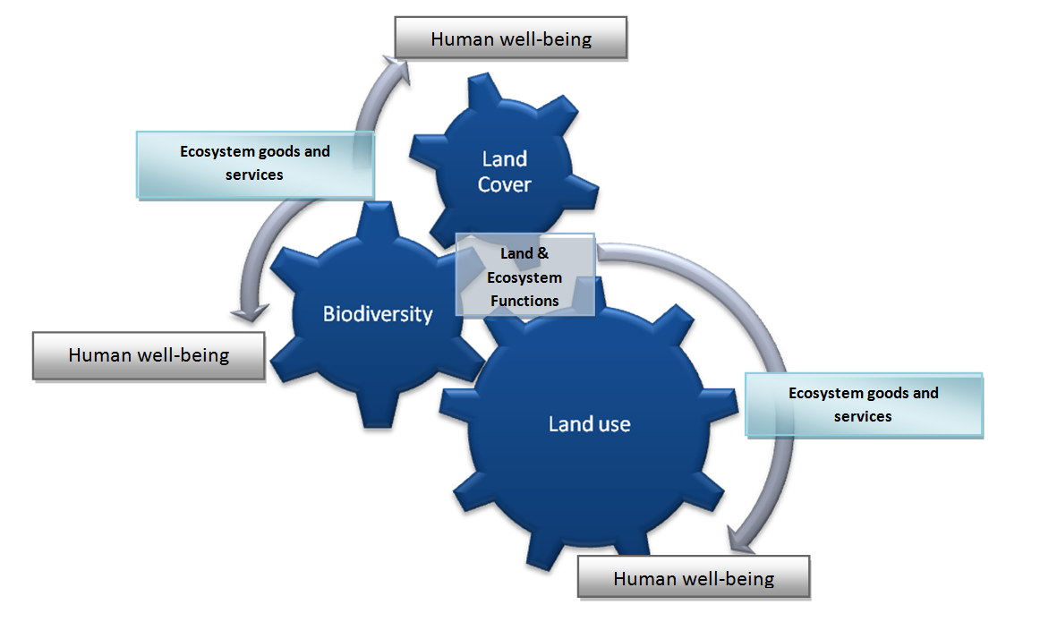

Where:
Land cover is the physical characteristics of the land surface determined by both its biotic and abotic features.
Land use is determined by the purposes of active and passive management of land by people and the material non-material benefits they derive from it.
Biodiversity is the variety of ecological elements present in a place (genes, species, communities and habitats, etc.).
Land and ecosystem functions are the potentials or capacities that land and ecosystems have to generate useful outputs for people.
Ecosystem services are the specific and final contributions that ecosystems make to human well being.

Figure 1.1 CORINE 2006 update (newer version?)
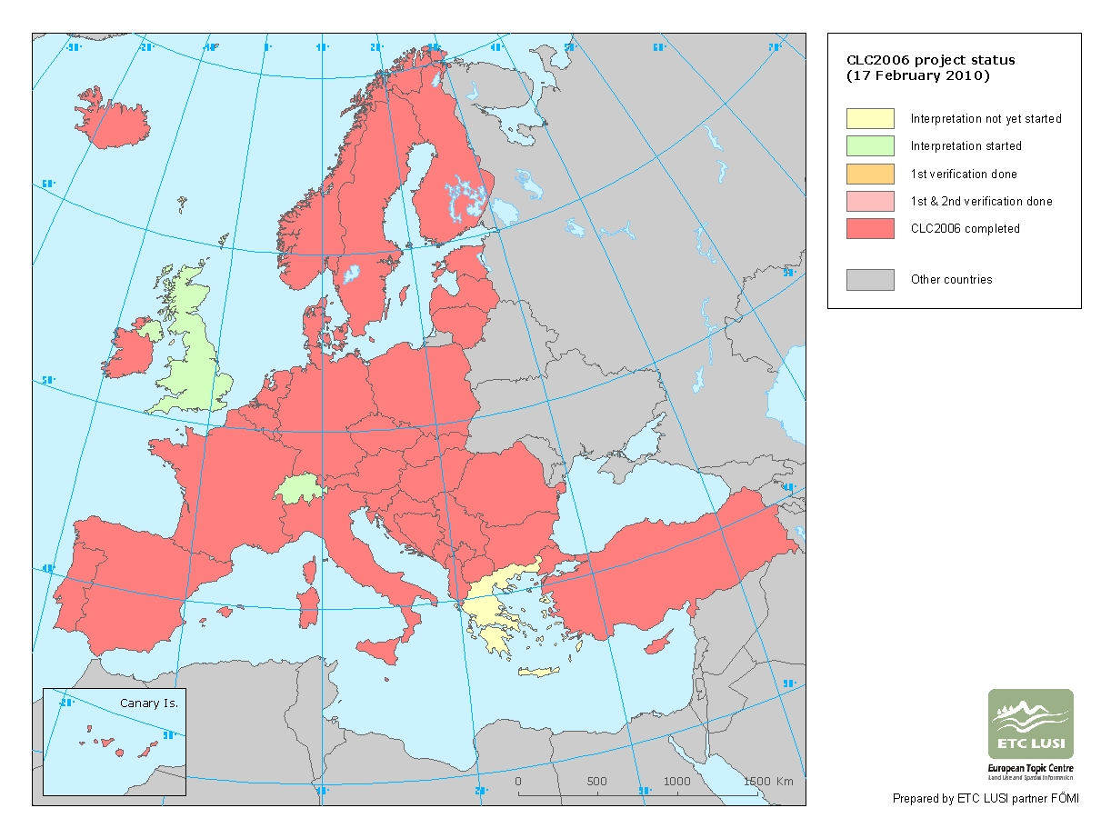

European Countries for which CORINE 2006 data are available

Austria
Belgium
Bulgaria
Croatia
Czech Republic
Denmark
Estonia
France
Germany
Hungary
Ireland
Italy
Latvia
Lithuania
Luxembourg
Malta
Montenegro
Netherlands
Poland
Portugal
Romania
Serbia
Slovakia
Slovenia
Spain
Austria
Belgium
Bulgaria
Croatia
Czech Republic
Denmark
Estonia
France
Germany
Hungary
Ireland
Italy
Latvia
Lithuania
Luxembourg
Malta
Montenegro
Netherlands
Poland
Portugal
Romania
Serbia
Slovakia
Slovenia
Spain

Figure 1.3: Flow accounts for land cover and the relationship between the concepts of stocks and flows and fundamental questions about sustainable development

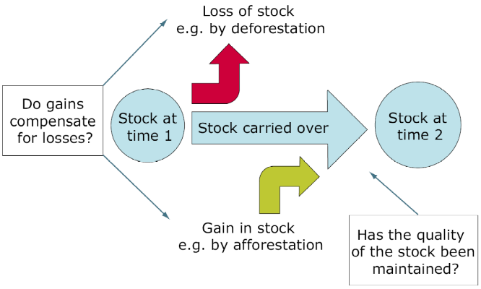
Figure 1.4: Land and Ecosystem Capital Relationships (after JLW, 2010)
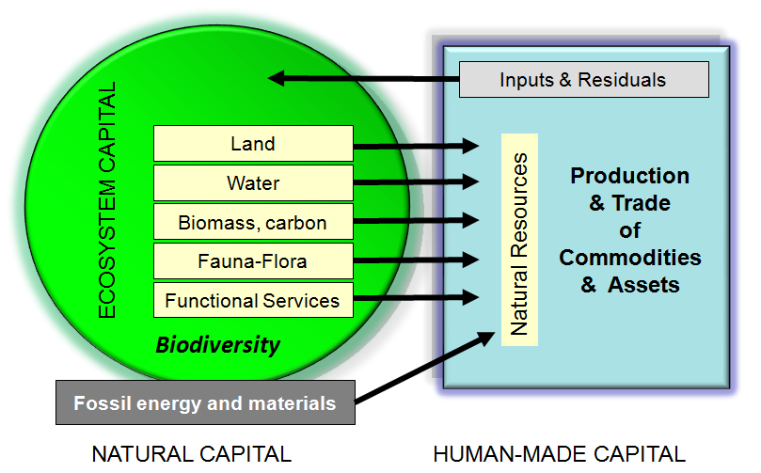

Table 1.1: Classifying land cover and land cover change for land accounting
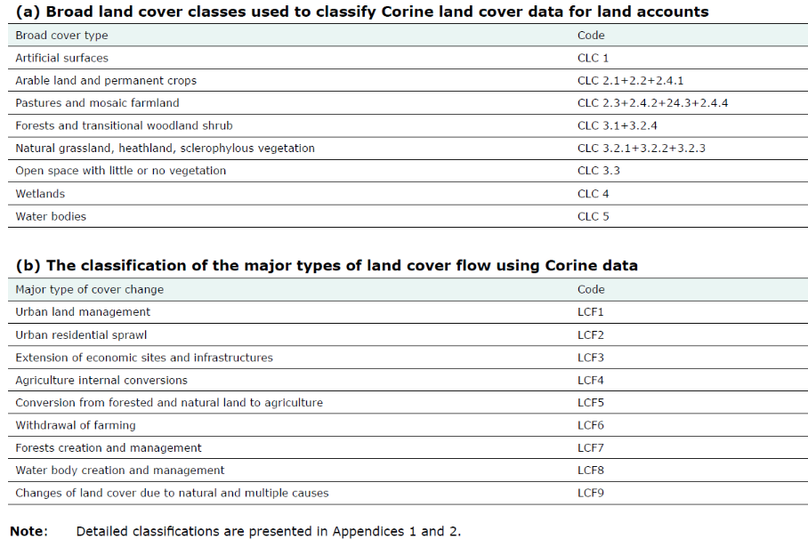
Figure 1.5: Maps of urban temperatures and GBI

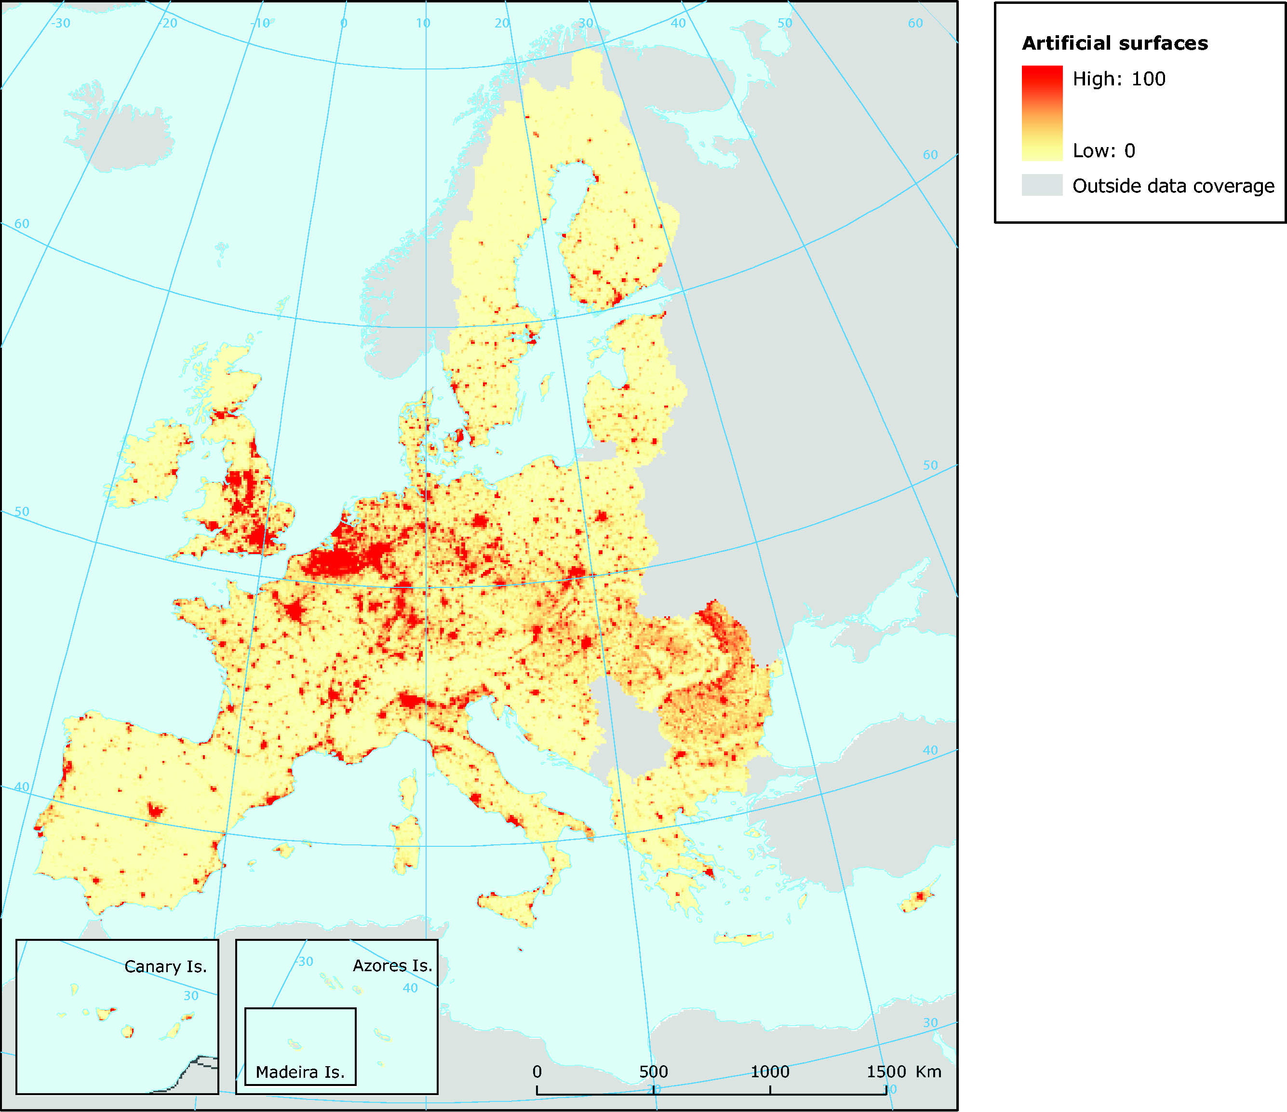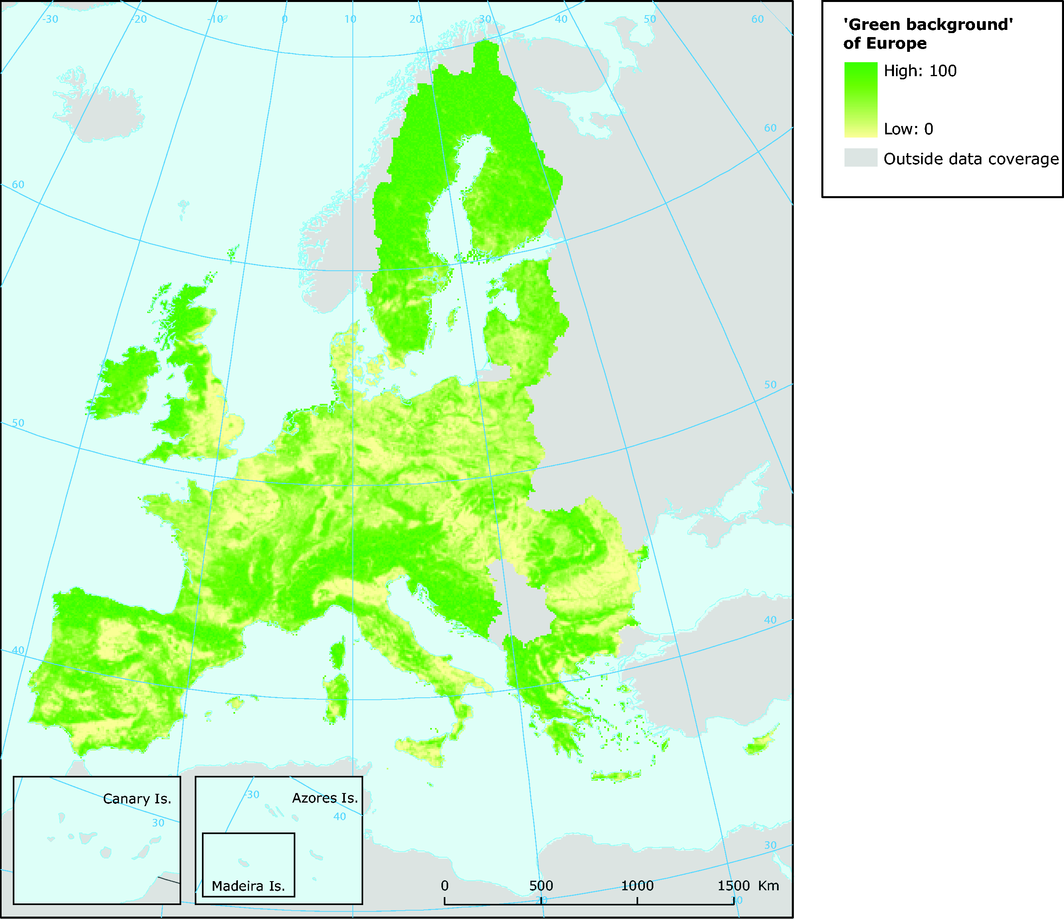

Figure 1.6: new map of Dominant landscape Types
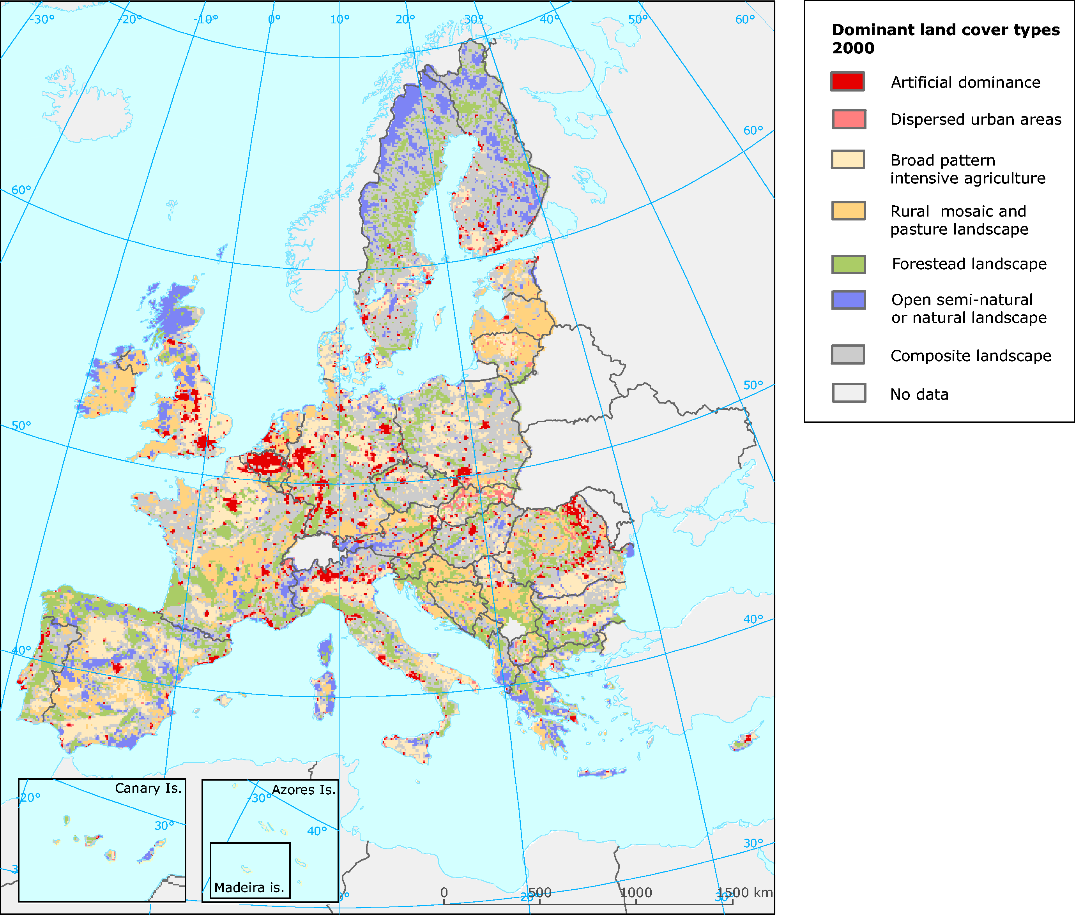
Table 1.2: Definition of DLT based on dominant land cover

Part 2: Land Cover Change 1990, 2000, 2006

2.1 Introduction
The availability of CORINE Land Cover data for 2006 (CLC2006) provide the opportunity of describing how the geographical patterns of land cover across Europe, the way they are changing over time and what types of processes are bringing about the various transformations. We report here on initially at the European scale for the 25 countries that are presently covered by CLC2006, and use these data to describe the main features of the accounting approach. As with the 1990 and 2000 data described in our earlier report, all of the information is held in a single accounting database from which different types of tabular, graphical and map views can be generated. The raw data can be accessed by visiting the EEA website, which also provide access to an on-line, interactive data viewer that can be used to construct more customised outputs.

2.2 Stock and change accounts for Europe, 2000-2006
Table 2.1 shows a set of basic set of stock and change accounts for the 25 countries included in the CLC update. The structure of the table illustrates the key features of the underlying accounting model used by the EEA.
>>>>Insert Table 2.1 about here: Socks and change account for Europe, 2000-2006
The columns in Table 2.1 show how the stock of each of the main land cover types that we find across Europe has changed between 2000 and 2006. It is an ‘account’ in the sense that it shows the opening stock of each land of the main land cover types, and how this stock changes over the ‘accounting period’ between 2000 and 2006.
The land cover classes shown in Table 2.1 are the most general used in the EEA land accounting approach. This is referred to as level 1. More detailed breakdowns can be made using the sub-types at levels 2 and 3, within these broad categories. The land area of the 25 EEA member countries included in this account is fixed, and so the total land area (shown in the right hand column of Table 2.1) is the same at the start and end of the period. However, the distribution of the land across the different types has changed. The changes are shown by the rows for ‘consumption’ and ‘formation of land cover types. By consumption we mean the loss of a given type to one of the others shown in the table. By formation we mean the gain in area as a result of land transferred into a given type from some other. The Table also shows these changes as a % of the original area of each main type and the stock of land that did not change over the period.
These data show that the extent of built-up or 'artificial' areas has increased as a result of urban development, while the area of other types such as semi-natural vegetation has decreased. Between 2000 and 2006 we can see that the urban area of the 25 EEA member countries showed a net increase of about 625,000ha or 3.4 %. This is roughly the same kind of trend shown in the period 1990-2000, although it should be noted that the set of countries included in the two sets of accounts was slightly different. The account also shows the area of Forested have increased by a small amount. The main agricultural cover types (arable and pasture) also showed small net losses over the period.
The advantage of representing land cover change in the form of and the accounting table, as shown in Table 2.1, is that it helps define some broad sustainability indicators. The indicator for turnover is of interest in the context of questions about sustainable development, because it helps us to understand what proportion of the original stock is carried over from the start of the accounting period to the end. As a result, we can see how much of the initial resource has been maintained. From the perspective of conservation of biodiversity, for example, the total amount of turnover may be as important as the net change. In periods of fast change, driven for example by economic development or by climate change, the analysis of turnover would reveal information about the degradation of habitats that might previously have been stable and as a result would have been able to support a wide range of species. In Table 2.1 it is apparent that % turnover of land assigned to Forest is much larger than for the other land cover types, apart from artificial surfaces. High turnover may also reflect lack of stability suggest that a land-related asset may be vulnerable. This pattern of change clearly merits closer investigation.

2.3 Flow accounts for Europe, 2000-2006

2.3.1 Flow accounts
There information on land cover change shown in Table 2.1 is basic in the sense that it only described the overall changes and not the detailed processes that have resulted in the flows between the different stocks of land cover. To gain this richer picture we can construct a second type of account, known as a flow account, like the one shown in Table 2.2.
>>>>Insert Table 2.2 about here: Socks and change account for Europe, 2000-2006
The flow account presents the losses of initial land cover for each land cover type and the creation of new areas in more detail than was possible in Table 2.1. Consumption is shown at the top of the table, and when this figure is added to the area that has not changed over the accounting period we produce an estimate of the initial 2000 stock for each types of land cover. The bottom part of the table shows the formation flows. If formation and the stock that shows no change are added together, then this gives the amount of the final stock in 2006.
The important extra detail added in Table 2.2, is that the changes are listed according to the processes by which the various types of change have occurred. These define the various land cover flows. From this flow account shown we begin to see what types of changes were taking place and how important they were. In the context of the formation of new artificial areas (i.e. built-up, urban areas) by the process of residential urban sprawl, the account shows that between 2000 and 2006, urban residential sprawl added 190,006ha to artificial surfaces. This is the figure that appears at the intersection of the row for the flow, Urban and residential sprawl, in the bottom half of the table and the column for artificial surfaces. To find the types of land cover did this process of residential sprawl replaced, we can look at the block of data for consumption of land, along the row for urban residential sprawl. This tells us the source of the land that was converted to artificial surfaces. For the EEA member counties for which data are available to make the 2006 update, the formation of new artificial areas largely occurred through development on agricultural land. Of the new artificial areas, approximately 80,000 ha (42%) came from arable land and permanent crops, while 88,000ha (46%) came from pastures and mosaics. Much larger areas of these type types of agricultural land were also lost to artificial areas by ‘sprawl of economic sites and infrastructures’.
Similarly, we can see that approximately 249,000ha of new agricultural land was added to the 2000 stock by the process of conversion (flow LCF5), mainly from land that was previously forested (91,990ha) or covered with semi-natural habitats (61,356ha). At the same time, about 191,335ha was lost from agriculture, by ‘withdrawal from farming’ with land transferred to mainly Forest and Scrub.
The flow account shown in Table 2.2 gives only the most genera picture of the way land cover is changing. The hierarchical nature of the system for land cove classification and the system for describing the types of change allows successively greater levels of details to be shown. An example of a more complete flow account, using the second level in the classification hierarchy for the flows is shown in Table 2.2.
>>>>Insert Table 2.3 about here: Socks and change account for Europe, 2000-2006 at level 2
Flow accounts such as those shown in Tables 2.2 and 2.3 are particularly useful in that they can be used as the basis of a number of indicators of land cover change. Examples of such indicators are shown graphically in Figure 2.1, and 2.2. Thus Figure 2.1 shows the origins of land converted to artificial surfaces during the accounting period; the major source is cropped land. Figure 2.2 shows the conversions between agricultural land and forest and semi-natural types; here the largest shift is for the withdrawal of farming and the creation of new forests.
>>>>Insert Figure 2.1 and 2.2 about here

2.3.2 Patterns of Urban Change
The Europe wide data for urbanisation, that is the extent and rate of conversion to artificial land from all other cover types can be looked at in more detail across the 25 counties for which the 2006 update is available (Figure 2.3). These data give a comparison between the two accounting periods. In each case the annual rate is shown as a % of the stock of urban at the start. These data suggest that the same broad pattern has been maintained over the two accounting periods. Spain, Ireland and Portugal showed the highest percentage increases in the period 1990-2000, a situation that appears to have persisted through to 2006. However, of these three only Spain appears to show a marked increase in the most recent period, whereas Ireland and Portugal show a decline.
>>>>Insert Figure 2.3 about here
A tabular account for the subtypes of artificial land across the 25 European counties for which CLC2006 is available, is shown in Table 2.4. These data highlight that the bulk of the land lost to artificial cover types was from arable and pasture, but that proportionally larger areas of forest and semi-natural land were lost to mineral extraction and construction sites.
>>>>Insert Table 2.4 about here [Needs Checking can we make this the same as Table 3.1 in EEA 2006? – an alternative is suggested]

2.3.3 Patterns of Agricultural Change
Agriculture continues to account for the largest proportion of the land of Europe; for the 24 countries covered by CLC2006, it covers approximately 42% of the surface, compared to 36% for forest and semi-natural and 4% for urban. An analysis of the changes that take place within the areas dominated by agriculture is important if we are to monitor the outcomes of changes in European policy towards farming, which now emphasises the need for a broad approach to rural development and the maintenance and restoration of environmental quality, over production.
The agricultural account for the 25 countries covered by CLC2006 is shown in Table 2.5. As noted in the basic accounts, the area of agricultural land has declined overall by only a small amount. However, there has been considerable turnover of land, both within the agricultural types and between agriculture and the other major types of land cover.
>>>insert Table 2.5 about here [agricultural account equivalent to Table 4.1 in EEA 2006]
As the account shows, losses through urban sprawl have mainly affected the non-irrigated arable land and mosaic farmlands; pastures have been affected to a lesser extent. Both non-irrigated arable and farmland mosaics have gained land from forests in roughly similar amounts [discuss table more fully]. There has also been an internal exchange of land within the general agricultural class, with transfers from pasture land to arable. The geographical pattern of this flow is shown in Figure 2.4, which maps the transfer at the NUTS-2 level.
>>>>insert Figure 2.4 and 2.5 about here [Figure 2.5 is the equivalent of the map in Figure 4.2 of EESA 2006]
Some of the patterns of recent change are illustrated graphically in Figures 2.5 a&b, which shows the major types of conversions that have occurred on an annual basis between agriculture and forest/semi-natural land cover. Over the two accounting periods the rates of conversion have remained roughly the same, except that there has been a fall in the amount of land withdrawn from farming that has not resulted in significant forest creation [interpretation?].

2.3.4 Patterns of Change in Forests and Semi-natural Habitats
The accounts for forests and semi-natural habitats are shown in Tables 2.6 and 2.7. As we have seen overall the area of forest has increased between 2000 and 2006, while the area of Natural grassland, heathland, sclerophylous vegetation has declined. [Discuss tables...]
>>>insert Tables 2.6 and 2.7 about here [forst and semi-natural accounts equivalent to Tables 5.1 and 5.2 in EEA 2006]
Figure 2.6 shows how the change in forest area is distributed geographically. Ireland and Portugal stand out as showing the highest rates of increase, with significant transfers of land coming from....[an we identify this?]
>>>>insert Figure 2.6: change in forest area by country based on 2006 stock – needs changing to 2000?

2.4 Analysing Geographical Patterns

2.4.1 Zonal Accounts
Although the construction of basic accounts and indicators such as those described above is helpful, a major additional contribution of the accounting approach developed by the EEA is that the database used to construct these Tables can also be used to develop spatial or zonal accounts. As noted above, the data are held in and spatial accounting grid that can also be used to segment the data to give a picture of different geographical areas.
>>>>Insert Figure 2.7, 2.8 and 2.9 about here [CAN WE ADD 1990-2000 FLOWS TO THESE GRAPHS?]
A common geographical breakdown is by NUTS region. Figure 2.7 shows the distribution of changes by country (NUTS level 0), but using the hierarchical approach more detailed within country splits of the data are also possible. Figure 2.8 shows the same data displayed according to biogeographical region, and Figure 2.9 by major elevation zone; in both cases the rate per year is presented to aid the comparisons between the two time periods (1990-2000 and 2000-2006). The key patterns that stand out from these graphs is that the Mediterranean biogeographic region shows a much more diverse set of changes than the others, with the significant areas being converted to artificial land via urban residential sprawl and the sprawl of economic sites and infrastructure. This was a trend also detected in the earlier accounting period. There is also a marked difference between the rates of urbanisation in low coast compared to other elevation zones.

2.4.2 Mapping Spatial Patterns
The gridded character of the accounting data also allows maps to be constructed, showing both the distribution of the different cover types across Europe and the places where particular types of change are occurring.
Although the distribution of each type of land cover can be mapped directly, the CORILIS methodology allows the density and influence of different types of land cover to be described. The concept of ‘urban temperature’ was discussed in Part 1. The idea of ‘urban temperature’ has been borrowed from demographers who use the concept in relation to population statistics to examine the influence of patterns of population. A map urban temperature based on the 2006 data has been presented in Figure 1.5. A longer time perspective on the changes in this metric is shown in Figure 2.10, which provides a comparison between the two accounting periods (1990-2000, and 2000-2006). Figure 2.11 shows the patterns of diffuse pressure resulting from agricultural activities. Taken together the maps show....
>>>>Insert Figure 2.10 and 2.11 about here [CAN WE show the areas where pressure has increased/decreased between the two accounting periods? – may be as an inset for a particular region/area?]
The mapping of the different types of flow recorded in the accounts is also particularly important, because such information can be used to identify more precisely where our natural capital base is being put under pressure. Figure 2.12 shows the areas where urban sprawl between 2000 and 2006 has been detected. For comparison the areas showing similar types of changes between 1990 and 2000 is also indicated. It is apparent from these maps that.....discuss maps.
>>>>Insert Figure 2.12 about here showing urban sprawl [CAN WE ADD the 1990-2000 FLOWS TO THESE Maps using some system of combined colour key??]
Figure 2.13 shows those areas where there has been a withdrawal of farming between 2000 and 2006, and again a comparison with the earlier accounting period is provided. It is apparent from these maps that.....discuss maps.
>>>>Insert Figure 2.13 about here – withdrawal of farming [CAN WE ADD the 1990-2000 FLOWS TO THESE Maps?]
To illustrate the types of analysis that are possible using the various types of accounts data, and in particular its analysis using the CORILIS approach, Figures 2.14 and 2.15 show the intensity of different kinds of pressures on the Natural 2000 site network.
The Habitats Directive seeks to ensure that Europe's most important nature conservation areas, which are represented by the Natura 2000 sites, are both managed in a systematic and appropriate way, and that their integrity or functionality is protected. Partly this can be achieved by improving as habitat connectivity and the buffering the sites impacts from surrounding land use activities. In order to gain a detailed picture of where geographically, some of the most significant pressures might be, maps of the intensity of the influence of Urban and Agricultural pressures have been prepared.
>>>>Insert 2.14 and 2.15 about here
In each case, the intensity of the influence from urban and agricultural land cover types in the has been estimated for each Natura 2000 site, using maps of urban and agricultural temperature maps similar to those discussed above (Figures 2.10 & 2.11). Each Natura 2000 site has then been mapped using a colour intensity scale that picks out the different potential pressures across the network; red tones indicate higher potential pressures from the neighbouring areas. The maps for urban and agricultural intensity differ from Figures 2.10 and 2.11 in that they include countries for which the CLC2006 data are not available. In these cases (Greece and UK) the 2000 CORILIS data have been used. Moreover, in those countries where no Natura 2000 sites exist (i.e. Turkey, Croatia, Albania, Norway, CDDA sites are used instead
The map for urban influence (Figure 2.14) shows that the Natura 2000 sites subject to the greatest potential pressures are those found in a broad band running from the west to east across central Europe from the UK through to Germany. In the main these sites are small, and differ markedly in their scale and pattern from the larger sites found in northern Europe and Spain. The map for the diffuse pressure from intensive agricultural activity (Figure 2.15) shows a broadly similar pattern with the greatest pressures arising in the central belt running from the UK through to Germany, but some differences are evident. Thus, for example, the sites in Spain show moderate to high pressures from agriculture. The sites in north east Germany and western Poland also stand out as having a higher level of pressure from agriculture than from urban. Finally, the intensity of pressures from agriculture are higher in Hungary for agriculture than they were for urban influence. Overall more large sites seem to be subject to diffuse pressure from agriculture than they were for urban.
>>>>Insert Figures 2.16 and 2.17 about here
These data are summarised further in the graphs shown in Figures 2.16 and 2.17, which shows the % area of the Natura2000 sites subject to increasing or decreasing pressure from urban and agricultural influence over the period 1990-2000. In each only those countries for which CLC2006 data are available are shown. Most countries show increases in the intensity of urban influence, most notably the Netherlands, only France seems to show a significant decrease [WHY????]. Many more countries show a significant reduction in the intensity of agricultural influence, most notably the Czech Republic and Portugal.

2.5 Conclusion
In our earlier report on changes in land cover acrocc Europe for 1990-2000, we suggested that one way to visualise the dynamics of land cover in at the most general level was in terms of a 'three-cornered' relationship between artificial surfaces, agriculture and forests and semi-natural habitats. To summarise the data presented here, we redraw this earlier diagram and set it aside a similar one for the period 2000-2006 (Figure 2.18 a&b). It should be noted that the figures differed from the previously published version because it has been redrawn for the 25 countries covered by the CLC2006 data. Thus Figures 2.18 a & b are directly comparable.
Between 1990 and 2000 development largely occurred at the expense of agricultural land (Figure 2.18a). In turn, the total stock of agricultural land appeared to decline as a result of the net transfer to artificial surfaces and forest and semi-natural cover types. Although there has been a net flow into artificial, on balance the overall stock of forest and semi-natural habitats was maintained during the 1990s. Broadly similar patterns are shown in Figure 2.18b. [Discuss new diagram....]

Table 2.1: A stock and change account for European land cover, 25 countries, 2000-2006 (figures show changes in ha)
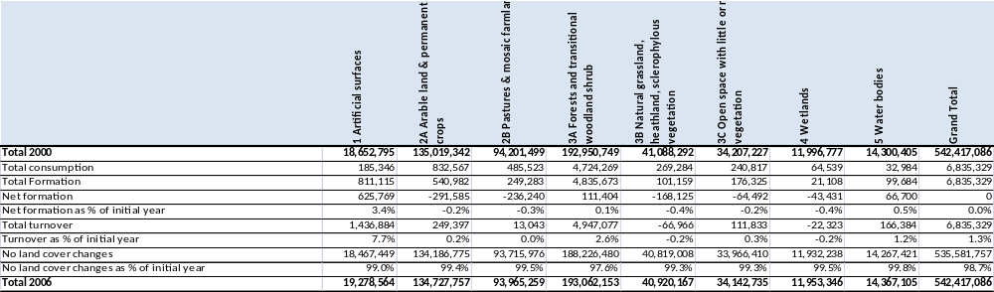
Table 2.2: A flow account describing processes of land cover change in 25 countries in Europe 2000-2006
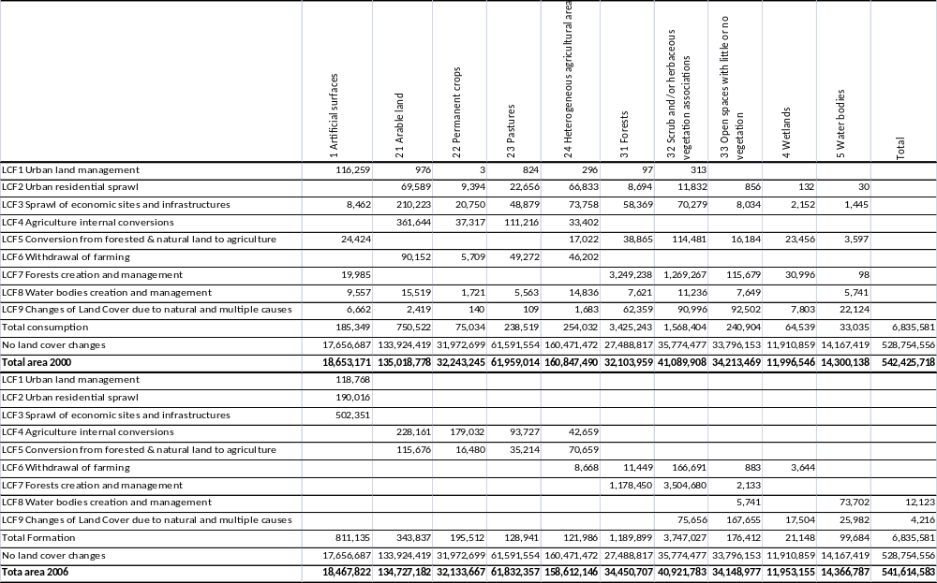

Table 2.3: Flow accounts at level 2
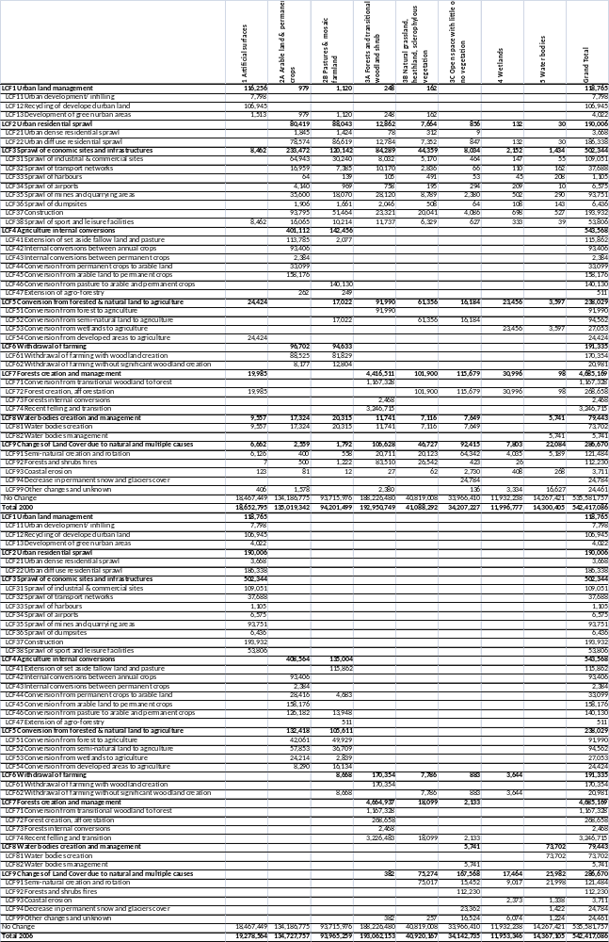

Table 2.4 Flow accounts for urban land, 2000-2006 (this table or the one below?)
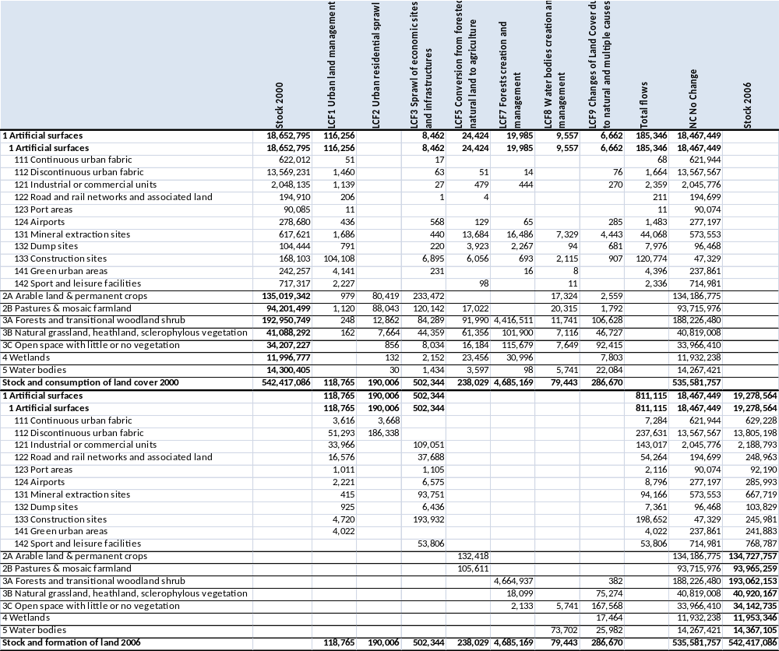
Alternative table 2.4?
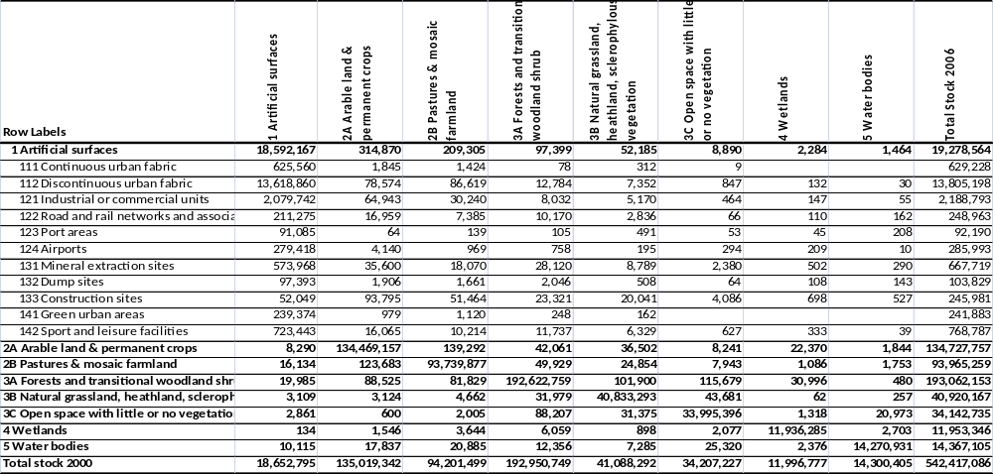

Table 2.5: Flow accounts for Agriculture, 2000-2006
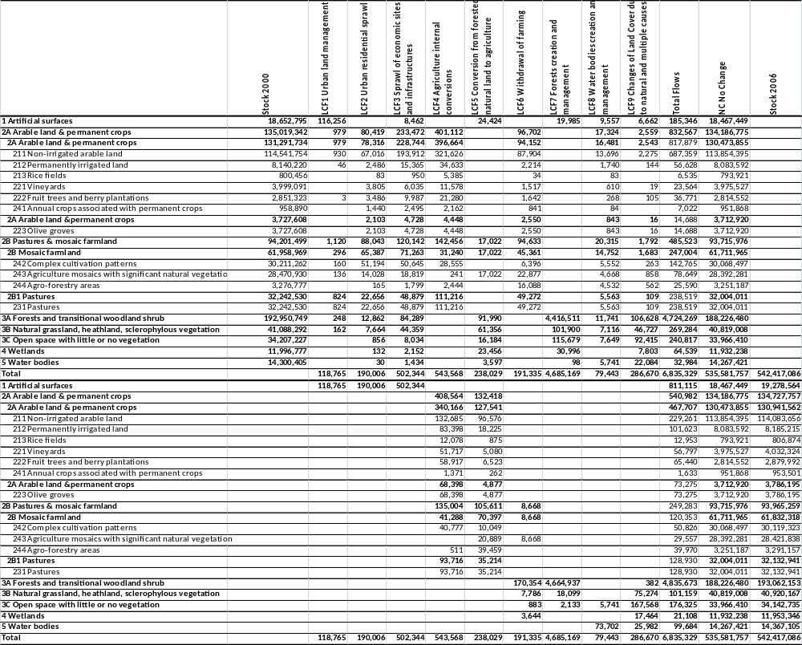

Table 2.6 Flow accounts for Forest and semi-natural (2000-2006)

Figure 2.1 Origins of Artificial Land, 2000-2006
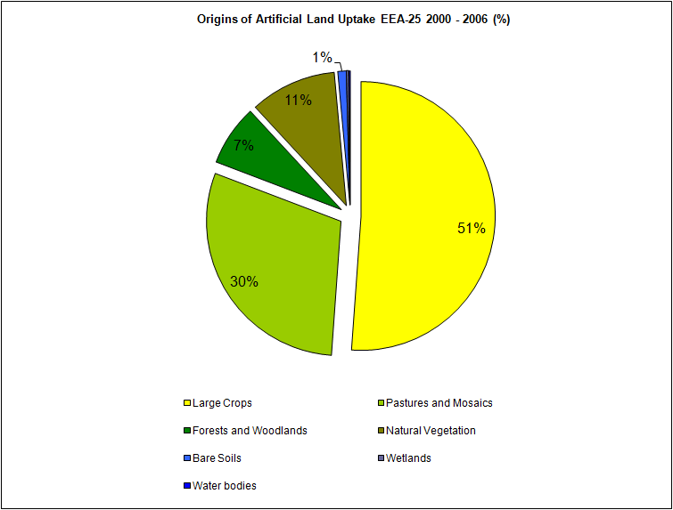
Figure 2.2
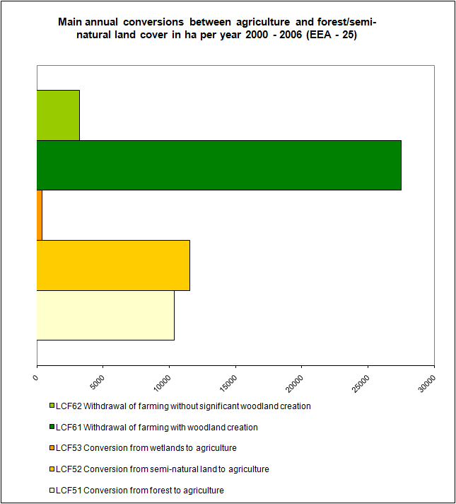

Figure 2.3:
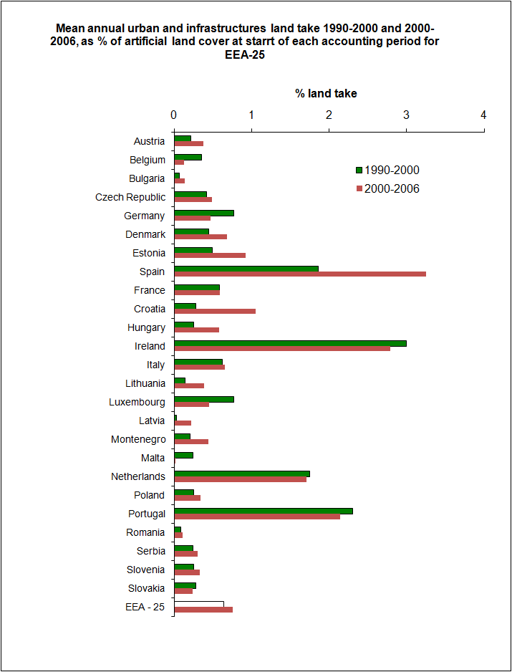
Figure 2.4
Map equivalent to for 2000-2006?
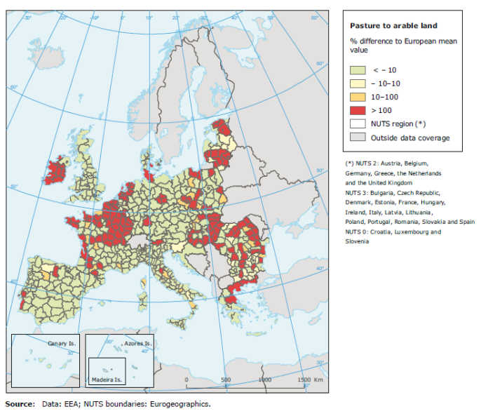

Figure 2.5
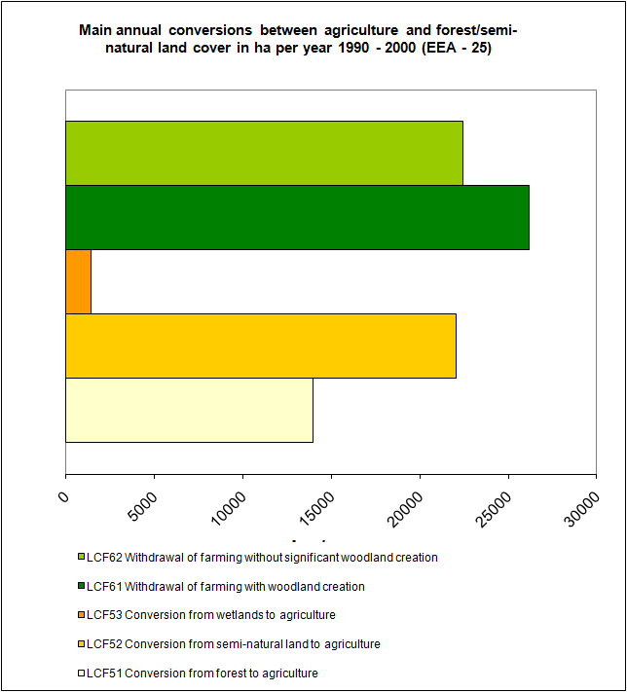
Figure 2.6 Percent change in forest area as a result of forest creation (LCF7) as a proportion of 2006 forest area [perhaps 2000 area is better?]
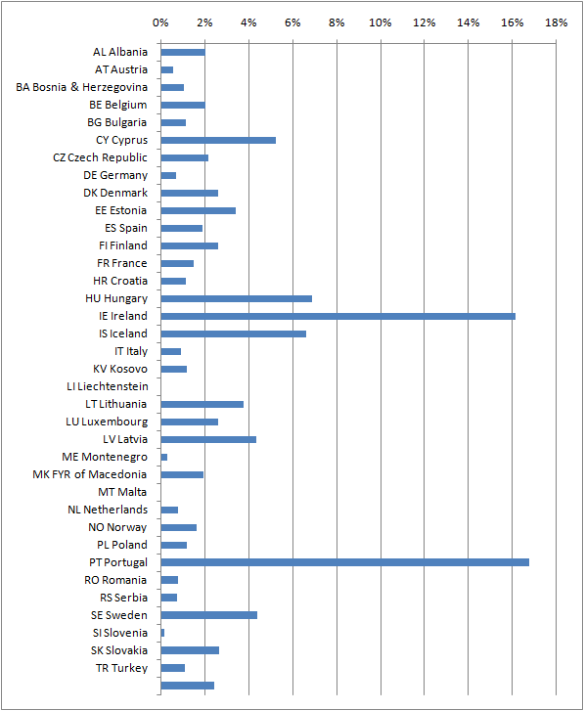

Figure 2.7 Land cover flows by country (NUTS0) [CAN WE ADD 1990-2000 FLOWS TO THESE GRAPHS?]
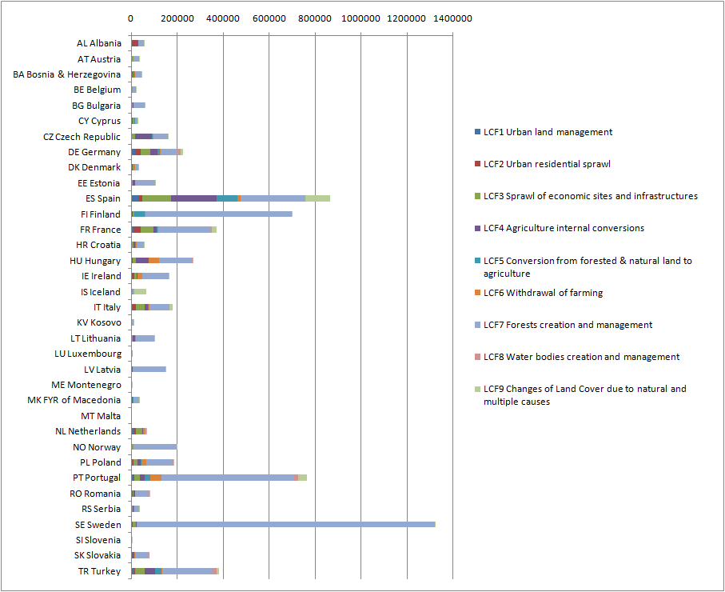
Figure 2.8: Land cover flows by biogeographic zone [CAN WE ADD 1990-2000 FLOWS TO THESE GRAPHS?] Figures in ha/yr to assist comparison
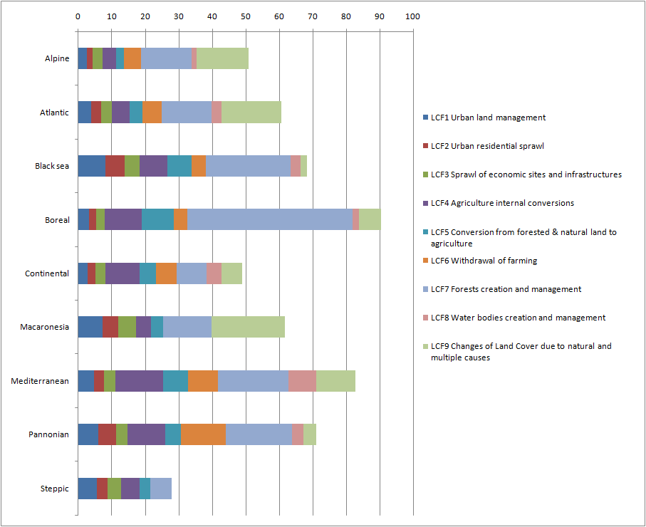

Figure 2.9: Land cover flows by major elevation zone [CAN WE ADD 1990-2000 FLOWS TO THESE GRAPHS?]; Figures in ha/yr to assist comparison
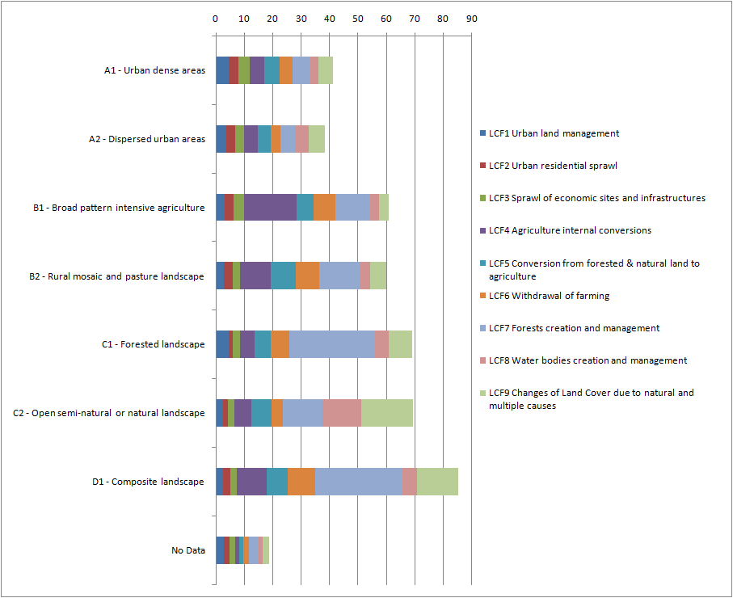
Figure 2.10 Changing urban temperatures
Figure 2.11 Changes in pressures from intensive agricultural activities

Figure 2.13 Withdrawl of farming 90-00 and 00-06

Figure 2.12: areas where urban sprawl between 2000 and 2006 has been detected.

Figure 2.14:
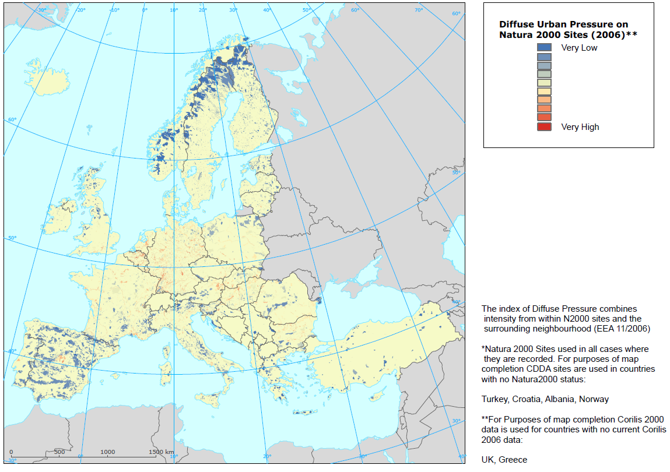
Figure 2.15:
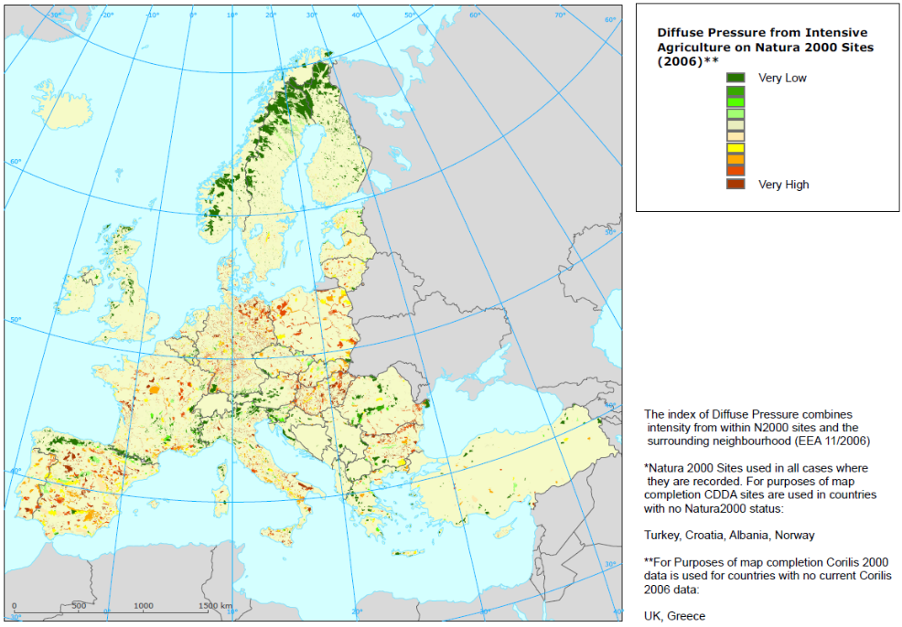

Figure 2.16
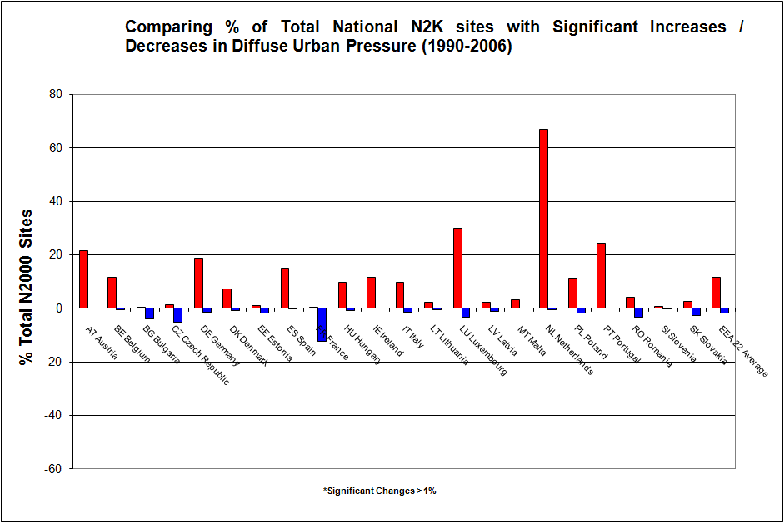
Figure 2.17
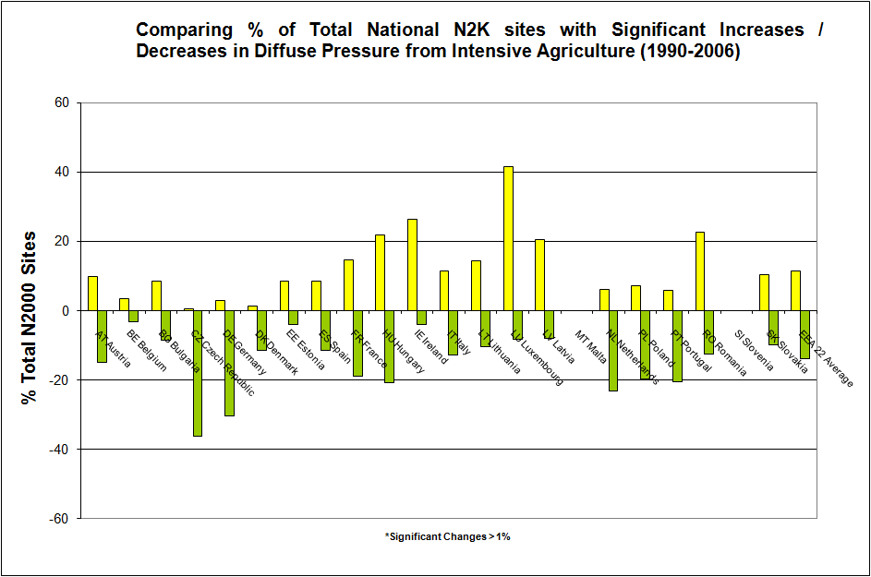
Figure 2.18: Overview of land cover changes (1990-2006) for 25 European countries covered by CLC2006
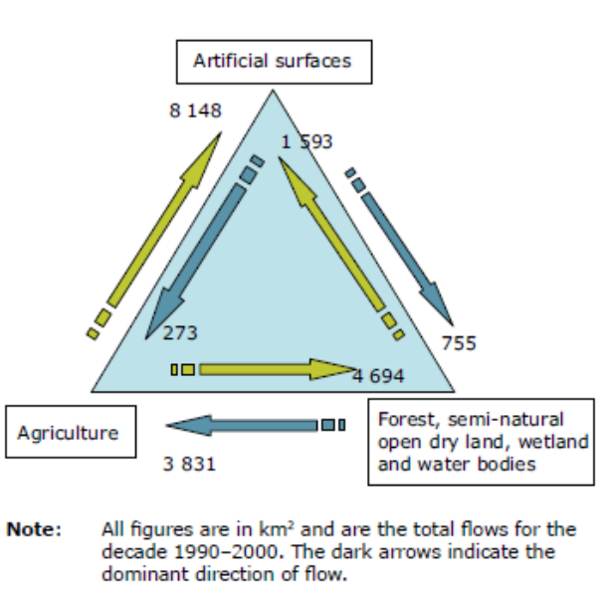
1990-2000 2000-2006

http://www.cbd.int/nagoya/outcomes/
http://www.eea.europa.eu/data-and-maps/data#c5=all&c11=&c17=&c0=5
http://dataservice.eea.europa.eu/PivotApp/pivot.aspx?pivotid=501

