  - Three scales, three pictures of the Mediterranean Wetlands

Accounts are established for Mediterranean Wetlands socio-ecological systems (SES) at different geographical scales: the macro, meso and micro. When the analytical concept of SES is the same at any scales, its implementation may differ according to data availability and needs for comparisons. Three scales and three methodologies for mapping SES are used in the Mediterranean wetland accounts case study.
    - The Pan-Mediterranean map (including Atlantic and Black Sea neighbourhoods) frames the broad question as specific macro-assessments and aggregates relevant to that scale. An example of specific macro assessment is that of wetlands and birdflu, presented in Box xx

Wetlands and Bird Flu Prevention
“Wetland depletion has direct implications for migrating wild birds. Wetland habitat worldwide continues to decline, primarily due to agricultural expansion and urban development, resulting in fewer staging areas for migrating birds. In these situations, remaining wet areas associated with rice paddies and farm ponds would be expected to be increasingly attractive to wild birds that lack sufficient natural habitat during staging, nesting and migration activities.”
David J. Rapport et al. Avian Influenza and the Environment: An Ecohealth Perspective, report to UNEP/DEWA, 2006 http://www.unep.org/dewa/products/publications/2006/

In “Bird Migration Routes and Risk for Pathogen Dispersion into Western Mediterranean Wetlands” (Jourdain E. et al. Emerging Infectious Diseases Journal Volume 13, Number 3–March 2007 - http://www.cdc.gov/eid/content/13/3/365.htm) a correlated effect is highlighted: the concentration of migratory birds in the remaining wetlands increases the risks of cross contamination. Bird Flu and Nile Virus are given as examples of serious threats. Threats to human and ecosystem health in this case cannot be disentangled.

As explained by Rapport, wetlands supply a “regulation” ecosystem service essential for limiting present and future risk of birdflu pandemic. This service can be measured and valued according to insurance practices, taking into account population exposed, risk factors and unitary costs of treatment. The availability of this service in due course depends on the appropriate amount of healthy wetlands maintained and restored. Necessary additional costs for this maintenance and restoration can be computed accordingly and accounted as allowances for depreciation which should be imputed to the opportunity cost of other wetland areas use. The map below produced by Wetlands International and FAO, shows up that Mediterranean and Black Sea are at the core of a main global flyway for migratory birds.

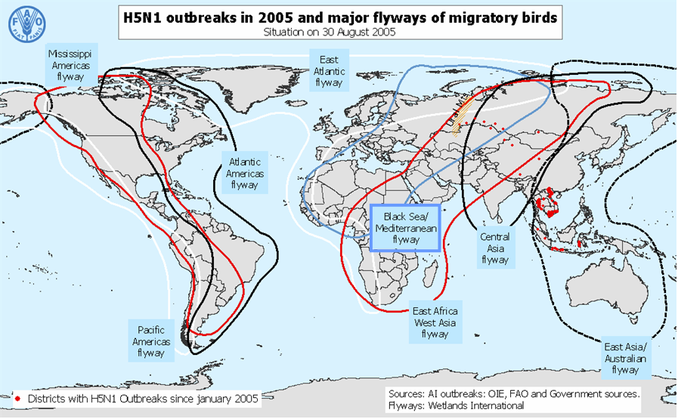

The global character of the birdflu problem requires a direct approach at the macro scale, the so-called Black Sea/Mediterranean flyway being the relevant context in that case. Accounts will balance maintenance and restoration costs with the foreseen risks – and costs – of pandemic.

Other issues are common to the sea basin. They are in particular the population migratory flows described as “littoralisation” by UNEP/Blue Plan. The process is driven in particular by tourism in summer period concentrated towards areas of interest; more than 30% of world tourism is attracted by the Mediterranean region, 80% of which by the European countries (Spain, Southern Italy and France, Greece). The Blue Plan foresees for 2025 an average of 200/250 millions visitors per year. Tourism creates seasonal (when tourists come) as well as permanent stress (buildings, infrastructures and the people taking care of them in the low season). A threat for the quality of the natural landscapes (to which wetlands contribute) which attract tourists.

Another example directly linked to wetlands services is food provision, in particular fish and shellfish Box xxx

Mediterranean Wetlands and Proteins

“On the north African coast fish and shellfish are an important source of protein for many people. In some parts of the Mediterranean, fishing for own consumption and for sale at local markets and restaurants is still a common practice.
Mullet, sea bream, sea bass and eel are all flagship fish species of Mediterranean wetlands. Mullet larvae need the sheltered areas of coastal lagoons, where they feed on weed, invertebrates and rich sediments found on the bottom of the lagoon, to grow into adults. It might take a young mullet as long as three years until it leaves the protected environment of the lagoon for the open sea.
Domestic livestock are grazed on marshes that provide high quality grazing, even during the driest summer months. The Camargue delta, on the Mediterranean coast of France supports approximately 8.000 horses and cattle...”
Source: MedWet, the Mediterranean initiative of the Ramsar Convention
http://www.medwet.org/medwetnew/en/04.RESOURCE/04.1.wetlandfacts01.html
Coastal lagoons, estuaries and delta are productive systems for fish and shellfish, both for the needs of local people and commercial production. They are however fragile systems because of the nutriments concentration which makes them productive. In France, for example, the Bouzigues oysters from the lagoon of Thau are famous all over the country. From time to time in summer however, problems may happen in relation to water conditions under the name of “malaigue” (“sick water” in the occitan regional language) which results from the combination of climatic conditions (temperature, no wind) and high concentrations in nutriments and creates hypoxia, a loss in dissolved oxygen lethal for oysters, as well as other shellfish and fish which are one of the pillars of local economy. Since the 1980s, efforts have been done to purify waste water in particular from tourists, numerous in summer in the region but concerns remain and management of the water streams between the sea and the lagoon ecosystem is now considered. Pollution is as well an important cause of the drop in fish catches (in particular high value sturgeons) in the Danube delta. In several other places, the development of commercial farming of fish and the pollution that it generates has lead, or is currently leading to drawbacks, not only at local people's economy and nature conservation, but at the commercial activity itself.

Comprehensive accounts of the multiple services – not only the commercial ones – supplied by the wetlands will highlight the appropriate trade offs. A second assessment based on accounts of ecosystem integrity will allow accounting for the costs of preventing biodiversity loss.

A test map for framing ecosystem accounts

A first attempt of producing a map of wetland SES at the Pan-Mediterranean scale has been carried out with GlobCover2005 version-1 submitted for evaluation by ESA, the European Space Agency. This first test – necessary in the absence of an alternate map which could have been used – will be improved in July with GlobCover2005 v2 and repeated at the end of the year with another version adapted by the EEA to its own European Corine Land Cover (CLC) map on which the development of land and ecosystem accounts is currently based.

The first test map combines therefore 3 types of information: Ramsar sites in the 10 km coastal strip as mapped by Wetlands International (center of sites, no boundaries yet), SES (Ramsar and non-Ramsar, with boundaries) produced automatically for Europe's Mediterranean with CLC, and sites extracted from the first classification of GlobCover.

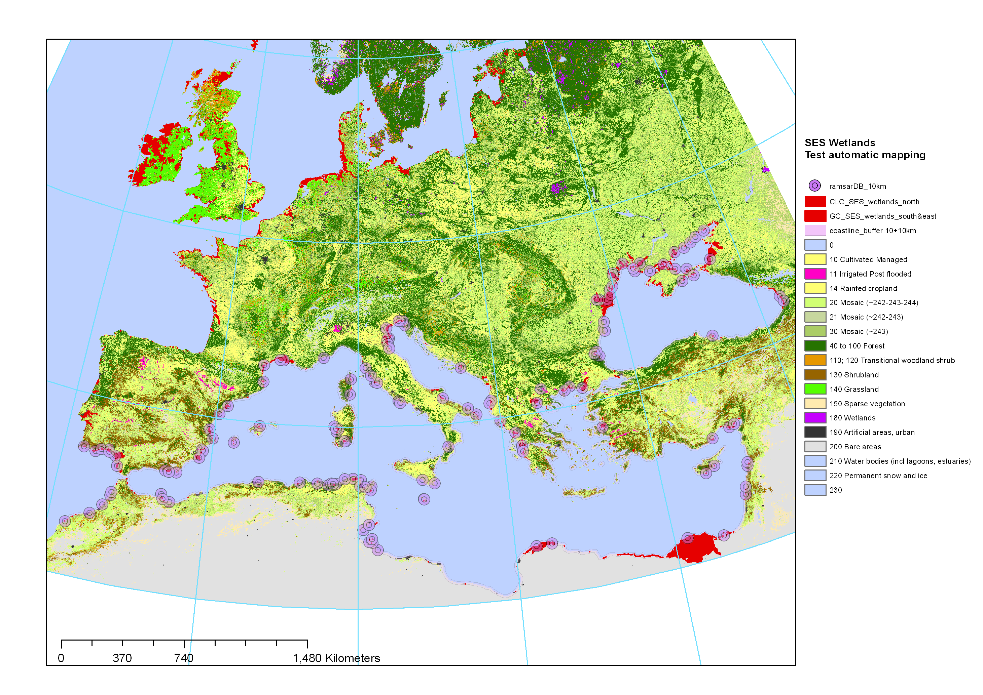
Sources: ESA/GlobCover2005, Wetlands International/Ramsar, EEA/CLC

Figure xxx Test map of SES wetlands for the Mediterranean and Black Sea.

An example of the information provided at medium scale by satellite imagery can be found on the website where Globcover products are disseminated:

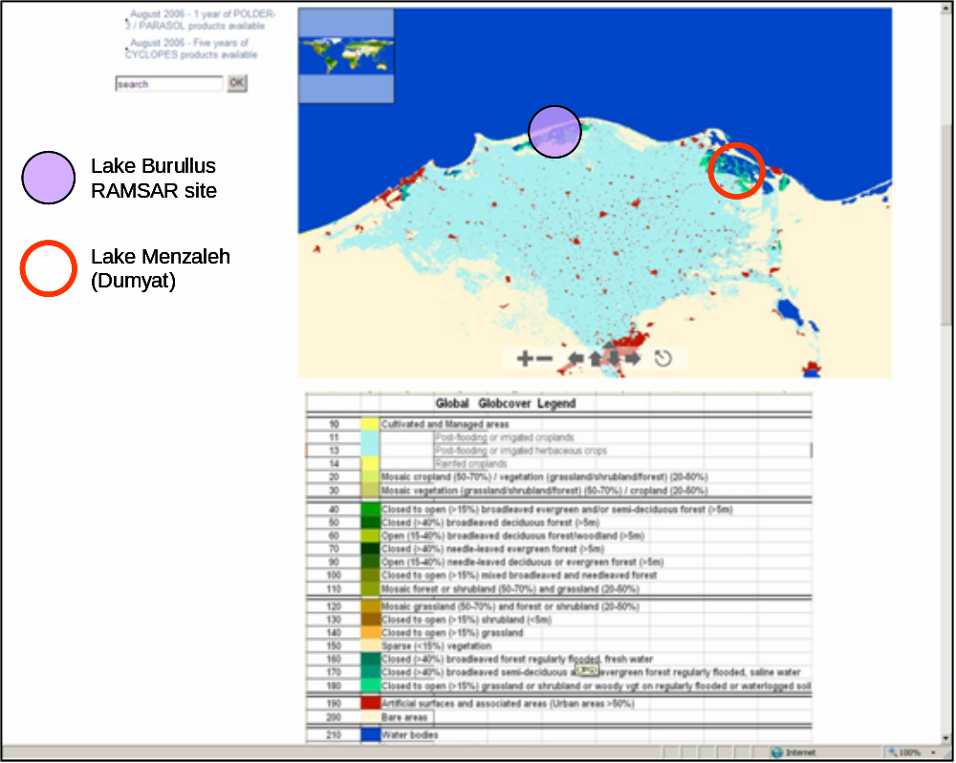
Source: http://postel.mediasfrance.org/breve.php3?id_breve=21

Figure xxx Identification of coastal wetland socio-ecosystem in the Nile Delta, Egypt

Lake Menzaleh is not designated to the Ramsar Convention; Lake Burullus is, but its map is not available in the database. In both cases, medium resolution satellite imagery is a fast solution for setting the scene at the continental/ global scale, with a sufficient detail for starting monitoring and – in combination with other data, accounting for ecosystems.

Additional details can be supplied by high resolution satellites. This is the purpose of the GlobWetlands programme of the European Space Agency where high to very high resolution satellite images add-up to the mapping of wetlands. The frequency of satellite images acquisition allows monitoring seasonal dynamics, all the more as radar images get rid of clouds issues. Last, analysis of images gives important information of land and water biomass, turbidity, eutrophication, all kind of data very useful for ecosystem accounting.

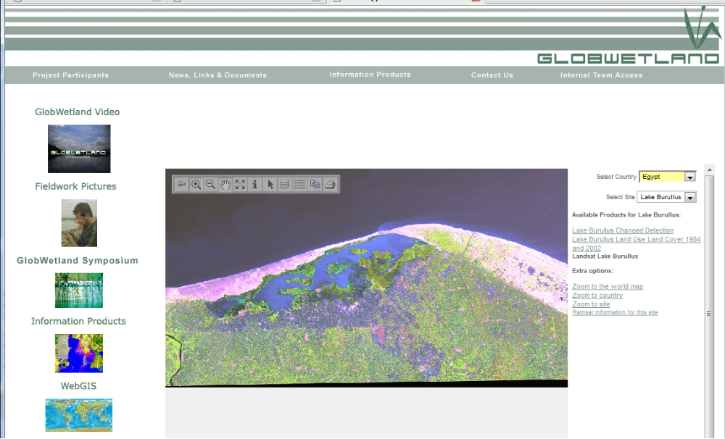
Source: ESA/DUE/GlobWetlands

Figure xxx Lake Burullus, a Ramsar site, Egypt observed with Landsat image, as from 1984

    - Map of European Mediterranean SES wetlands with CORINE land cover

CORINE land cover is the name of the European map produced so far for 1990 (circa), 2000 and being updated for 2006 for more than 35 countries. Land accounts are implemented in Europe with CLC (EEA 2006) and accounts of terrestrial ecosystems are developed upon that pattern. Maps of stocks and change are gridded at 1 hectare and 1 km2. Therefore, CLC is the appropriate data infrastructure for accounting at the meso scale.

For being able to accounting for the whole set of socio-ecosystem wetlands of the European Mediterranean area in the absence of an individual map of each of them, an automatic mapping of each of them has been attempted. This mapping respects the main characteristics of SES and combines a core areas composed of wetlands as defined in the CLC nomenclature with associated areas which should be considered altogether (included village, irrigated area connected to wetlands, dunes separating wetlands from the sea...).

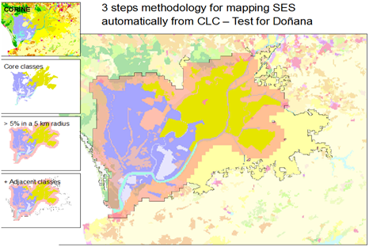
Figure xx Methodology for mapping SES wetlands for accounting

If not in every cases at the level of individual sites, the results are acceptable at least for statistical accounting for coastal regions. Socio-ecosystems have no crisp boundaries, any mapping is a proxy even at the local scale. They can be mapped as administrative entities, groups of municipalities, hydro-morphological systems… The important matter is that these boundaries match correctly to the system which is analyzed; that they surround the typical land cover units and are the core area for the main socio-ecological functions. Accepting fuzzy boundaries for SES means that areas in the periphery may belong as well to some extent to other SES – e.g. the irrigated crops associated to Doñana core area of wetlands. The GIS will be used in this case to avoid double counts.

Of course, the coarse modeling used to at this early stage accounting has just the advantage of allowing a quick start and produce short term accounts. A quality assessment of the map is currently done with MedWet experts. Progressively, modeled boundaries will be substituted with more precise boundaries mapped upon improved data.

Examples of SES maps produced from CLC:

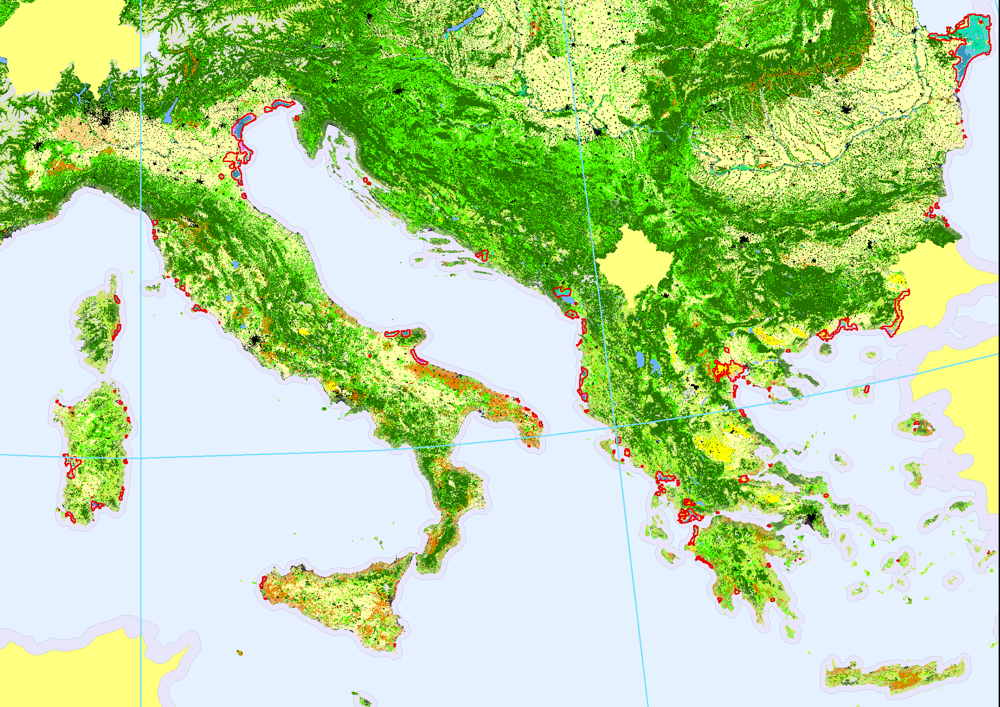
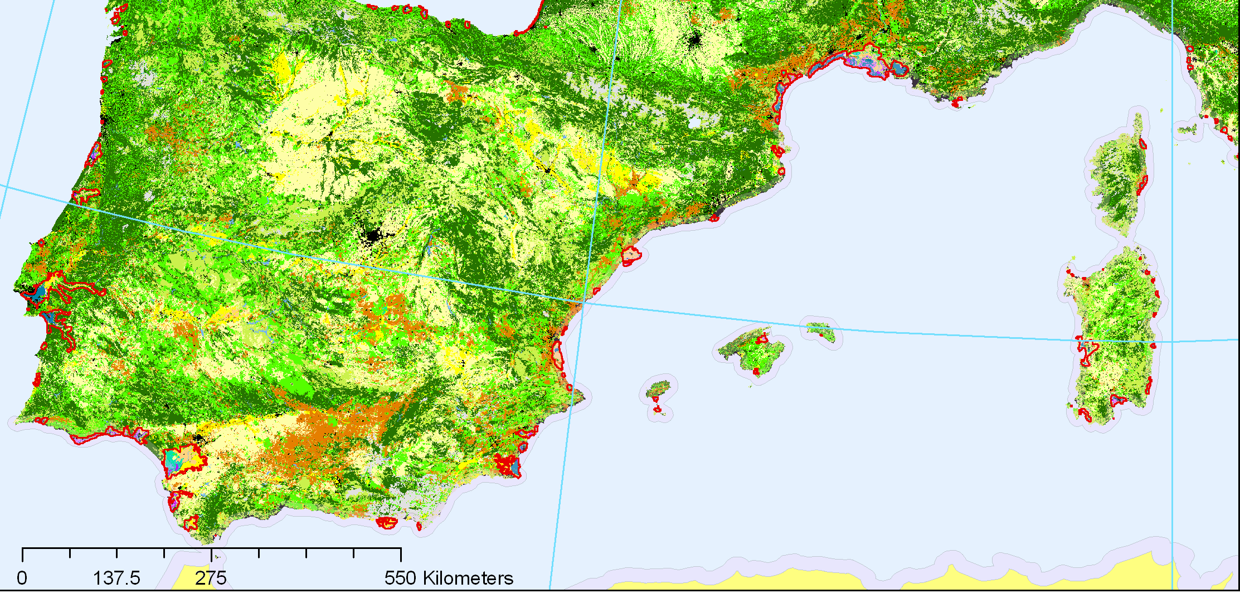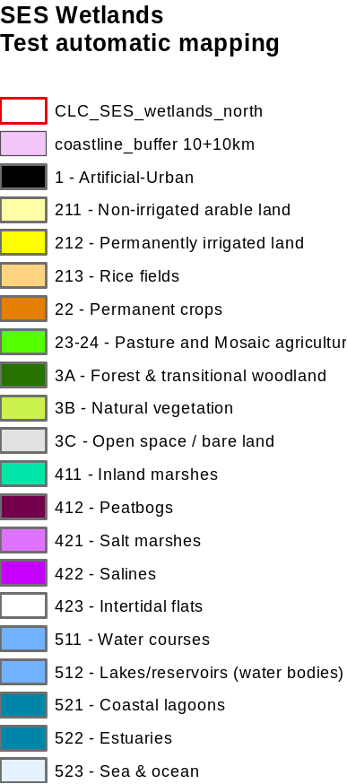
Figure xx: Map of SES Wetlands for the North-East and Nort-West Mediterranean

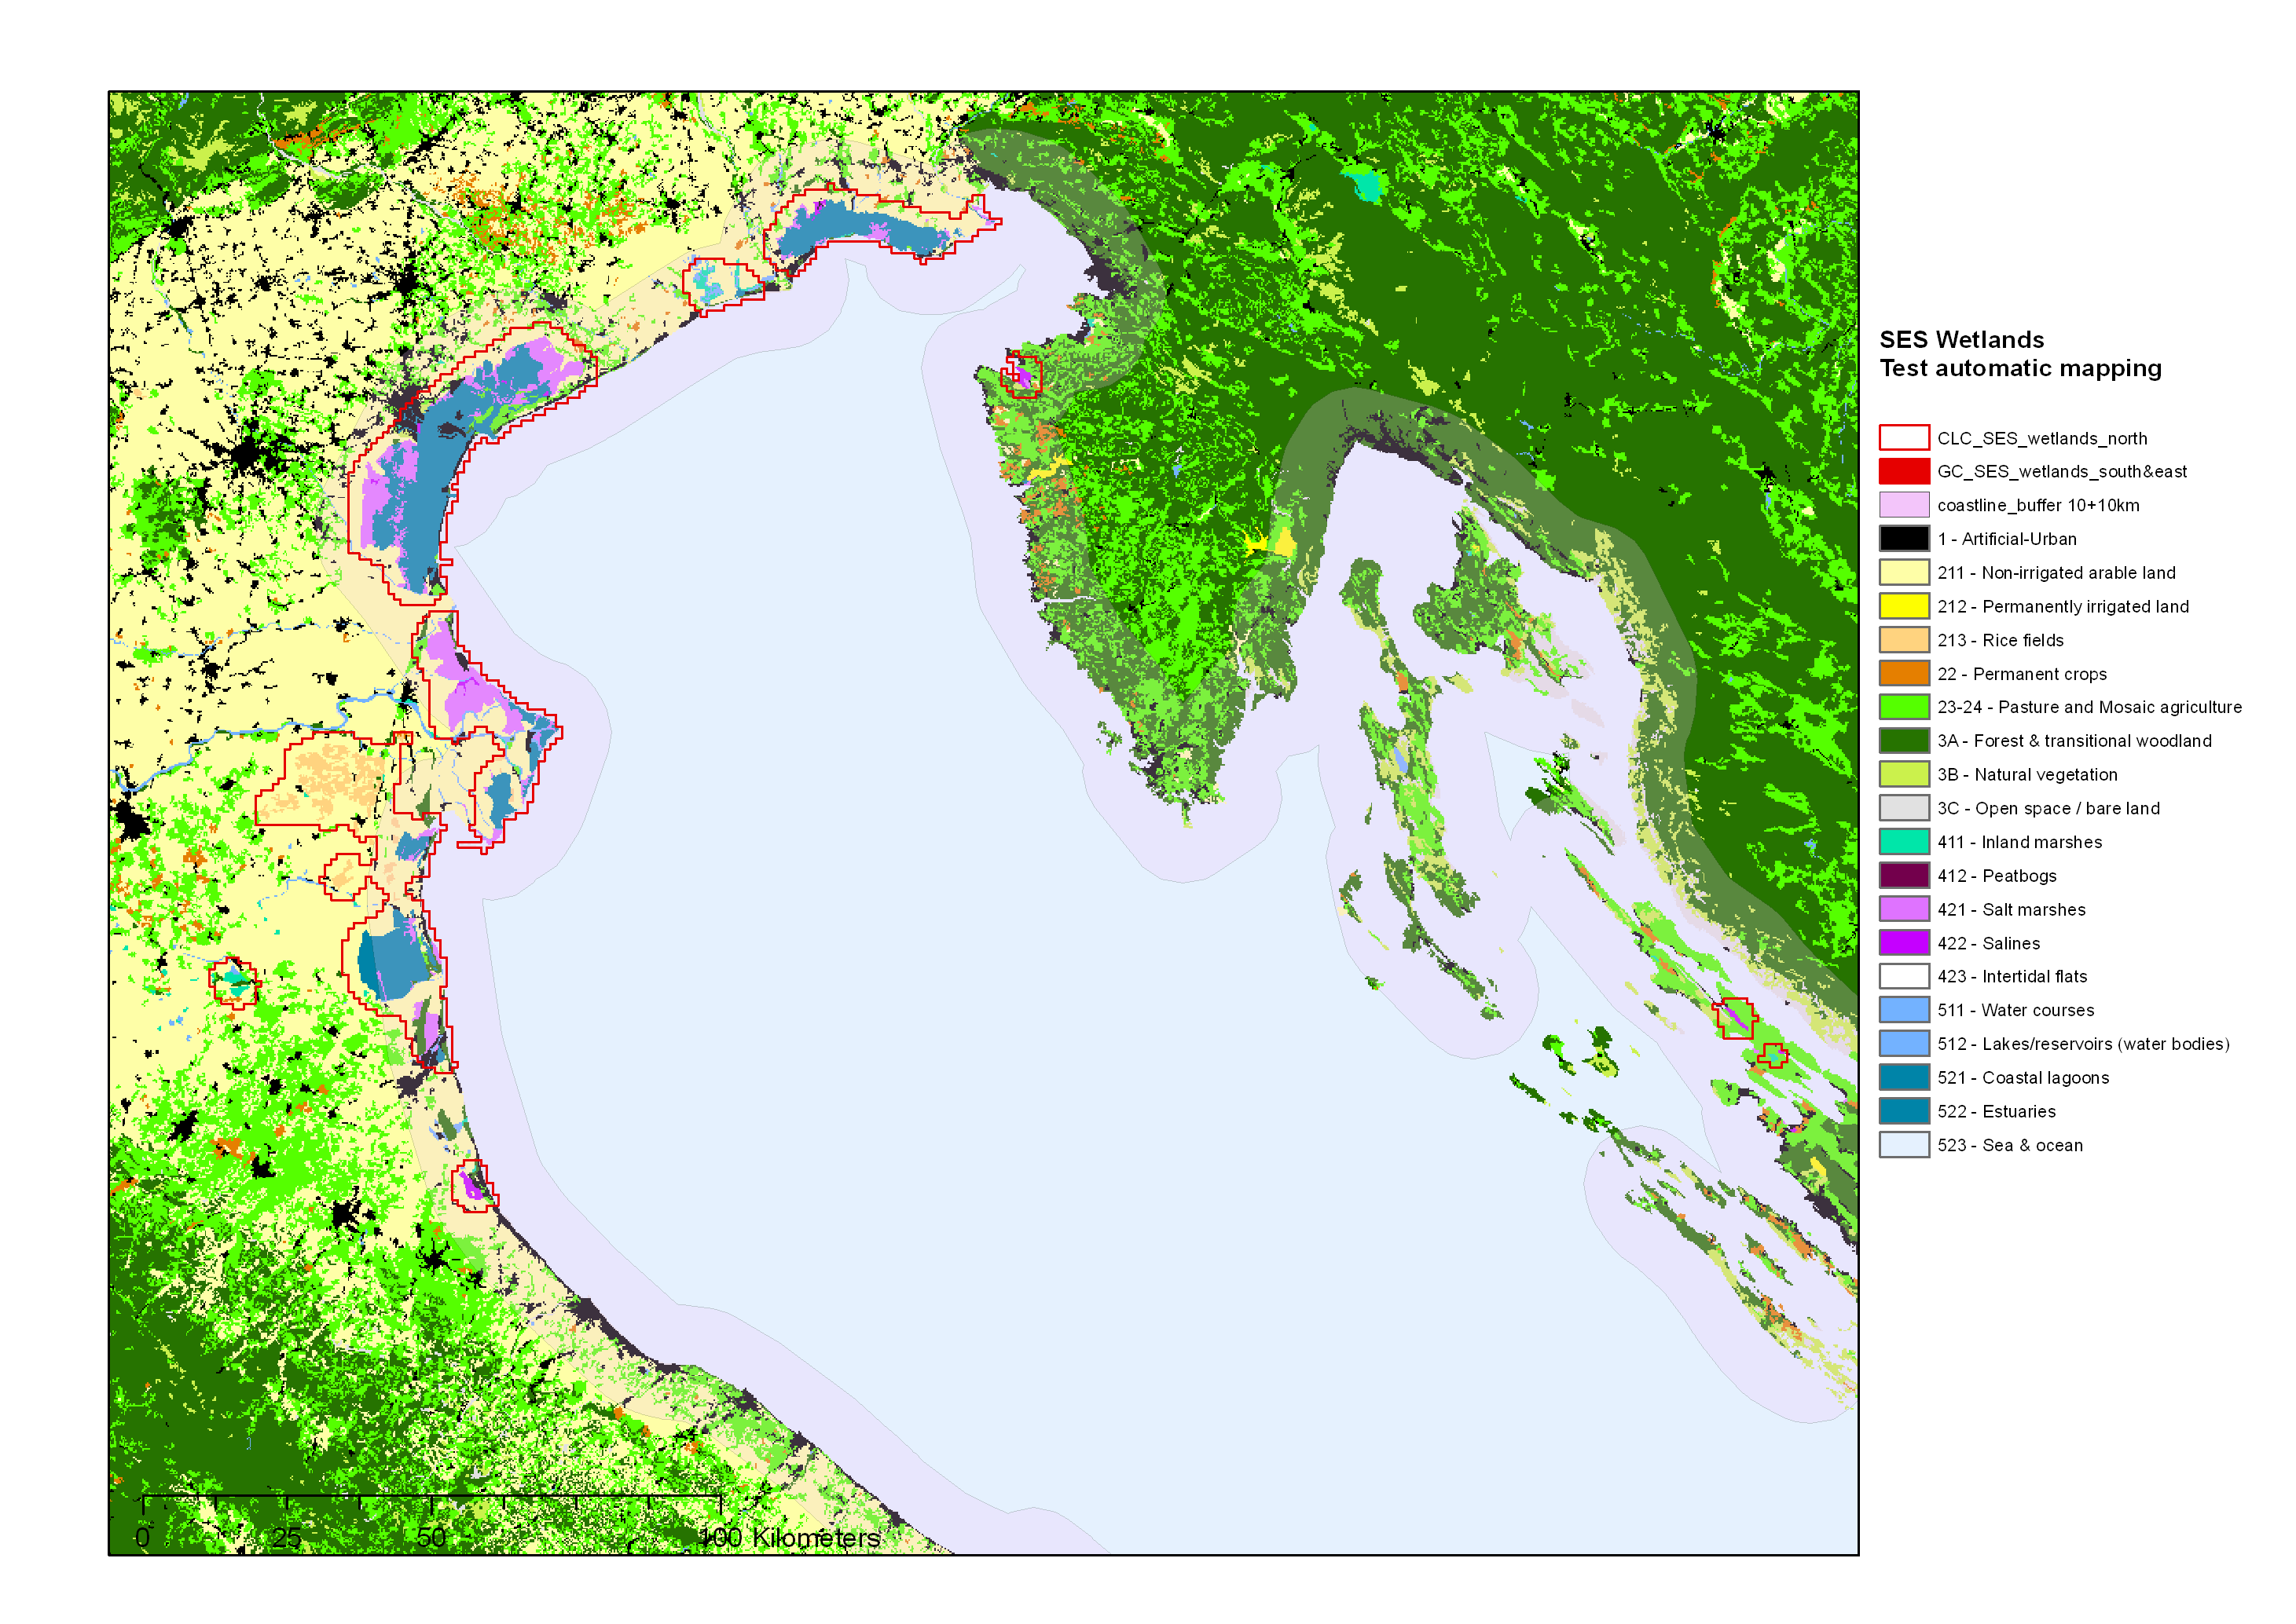
Figure xx: Map of SES Wetlands, details for the North Adriatic

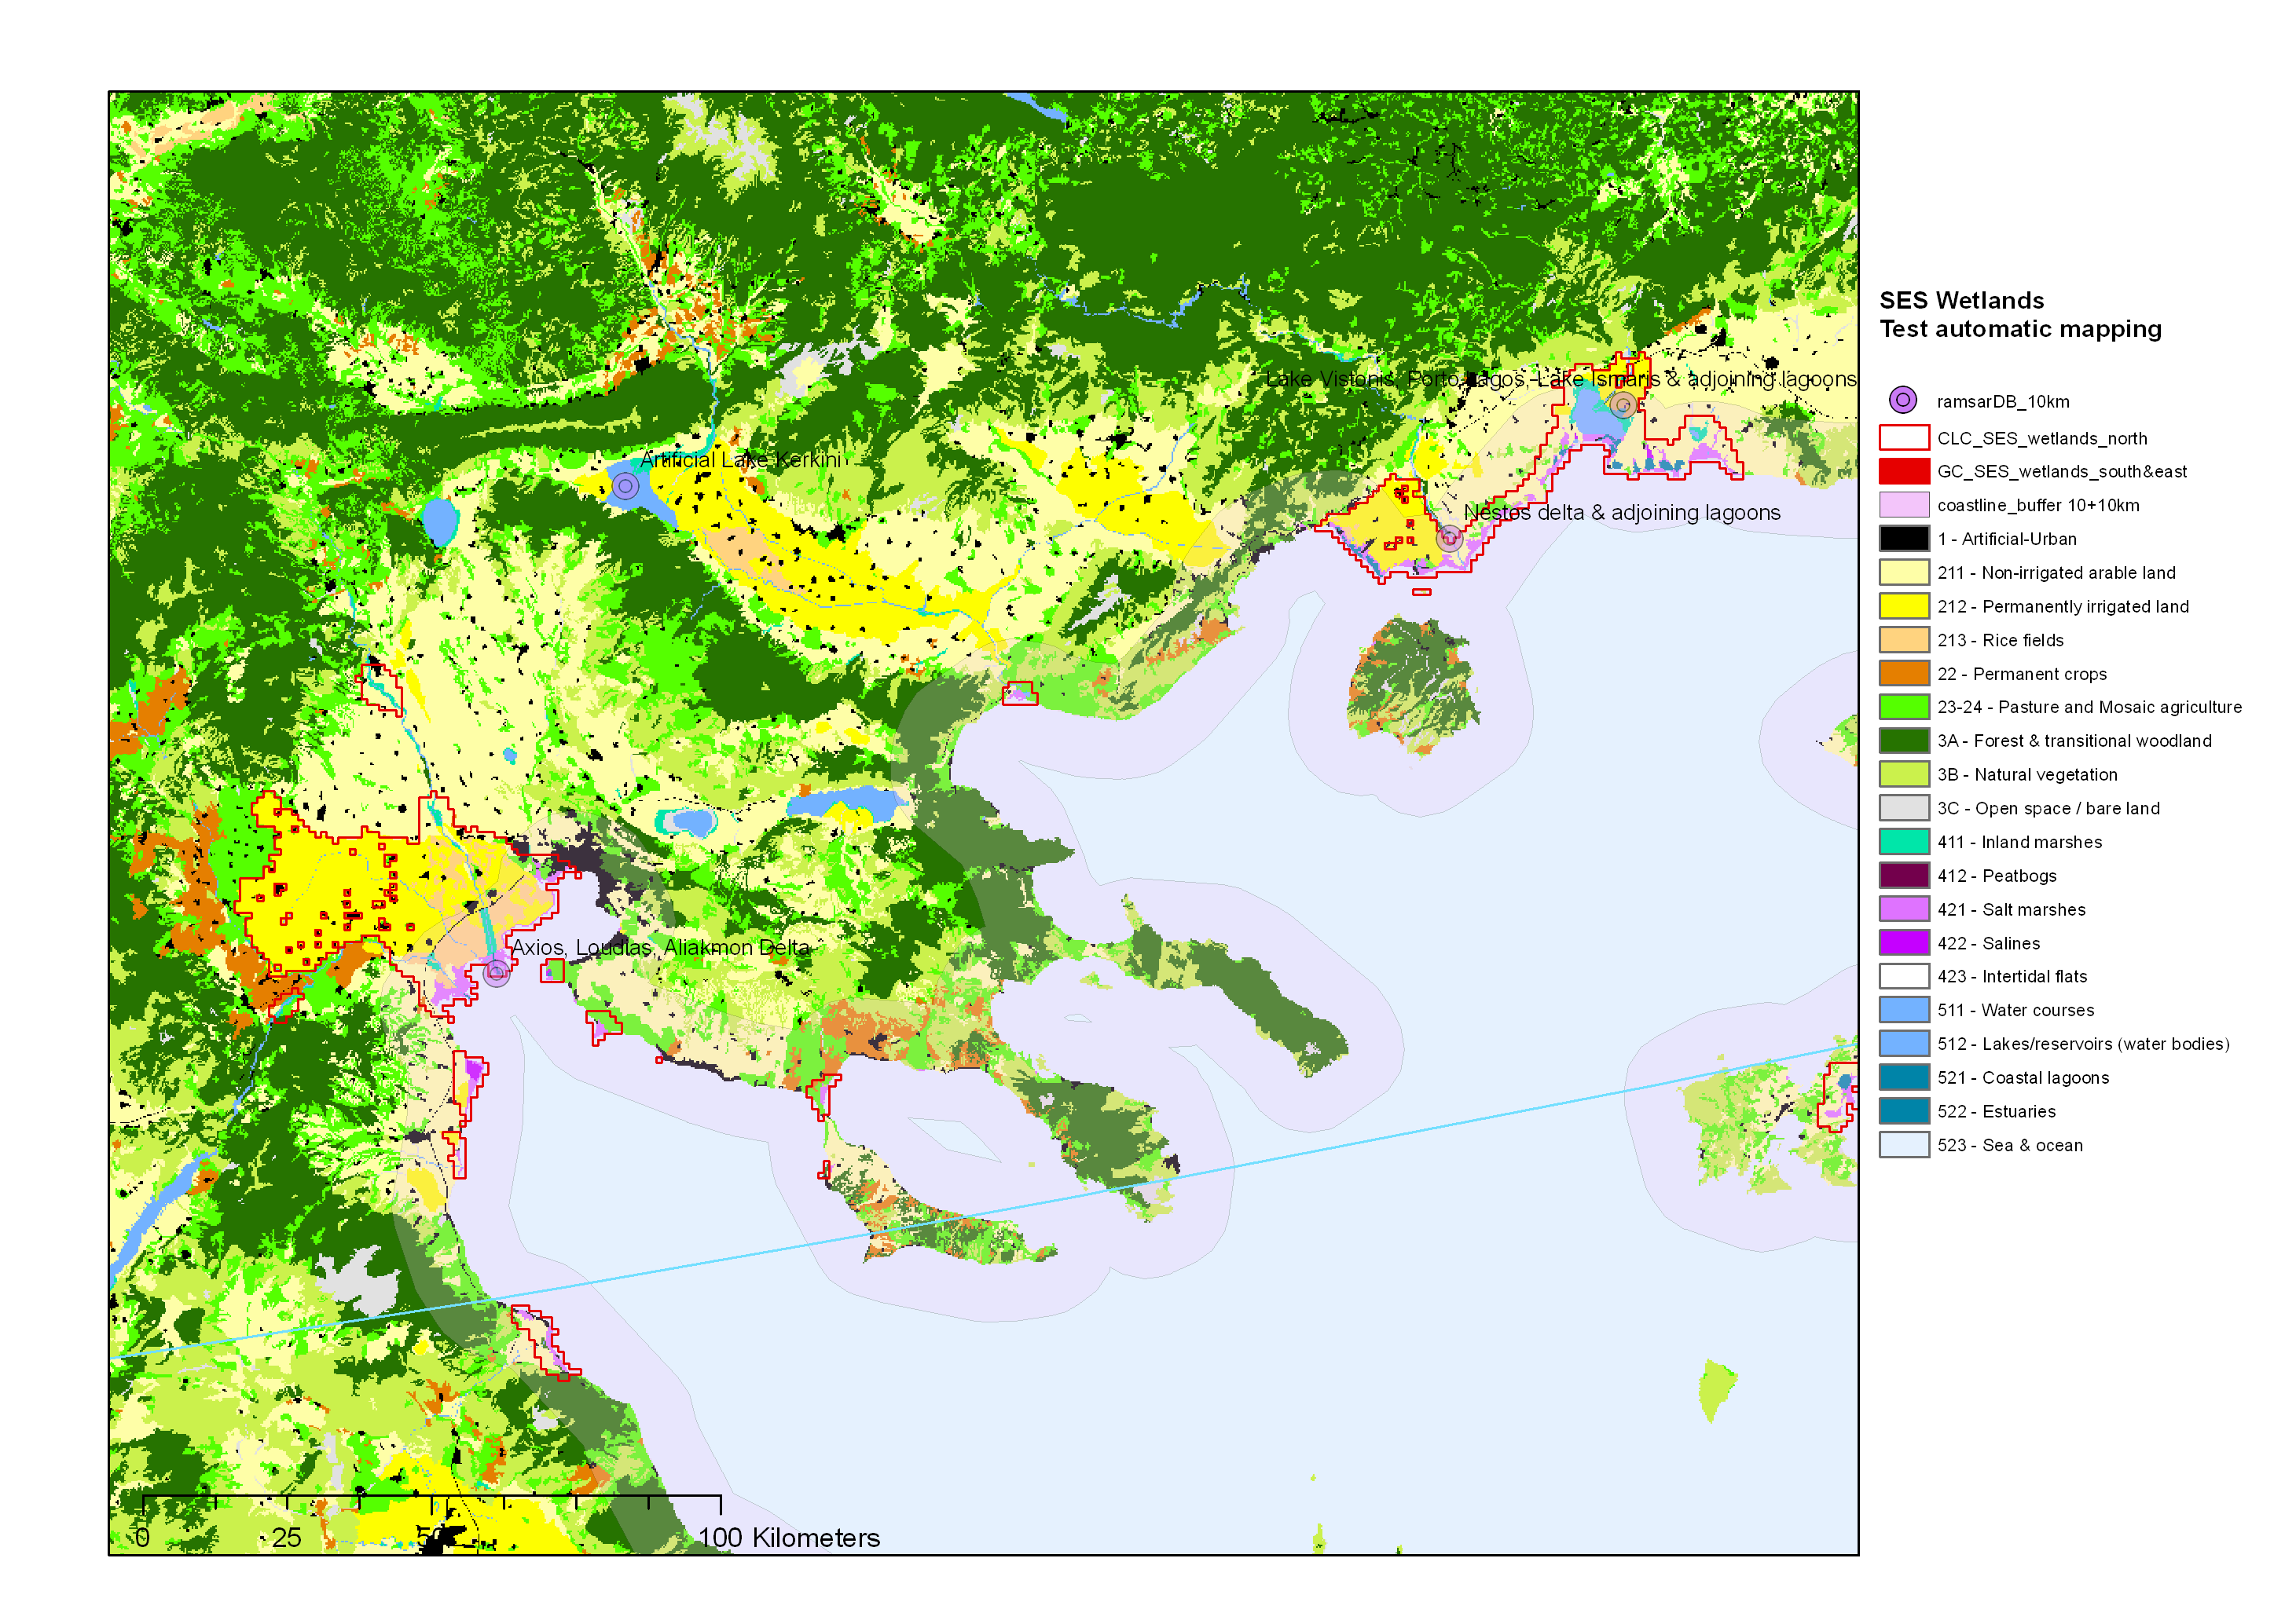
Figure xx: Map of SES Wetlands, details for the North Aegean

    - Maps of the 4 case studies

When coming to the local level, wetland socio-ecosystems may need to be re-mapped for analytical purpose as well as on account of data availability. Some socio-economic data are detailed only by municipalities, other data from sampling are relevant only for the statistical population sampled, as a whole. One progress is expected with the development of gridded statistics, essential at the macro and meso scales for integrating economic, social and ecological dimensions; grids can be helpful at the local level as it will be shown in Chapters 4 and 5.

Maps of the 4 case studies have been considered therefore on several grounds:
- clusters of municipalities;
- perimeter of a national or regional park/ reserve;
- hydro-geo-morphological units.

