5.1. Doñana case study

5.1.1. Description and history of the area
The Doñana coupled social-ecological system (SES) (South-West Spain) covers an area of 3.120 km², more than one third of which is protected. Doñana encompass two important protected, the Doñana National Park and the Doñana Natural Park, unified in 2005 in the Doñana Natural Area. It embeds other smaller protected sites and is also protected through international agreements (Ramsar Site, Reserve of the Biosphere).

Doñana consists of a wide system of marshes, dunes and beaches, associated with the coastal dynamic of the Guadalquivir River’s mouth, sometimes referred to as the Doñana fluvio-littoral system (Fig. 1) (Montes et al., 1998). It embeds four main types of ecosystems at the ecodistrict scale: the coastal system, the aeolian sheets of sand dunes and two wetland ecosystems: the Guadalquivir River Estuary (36 km²; 77 km long; tidal influence: 110 km from the river mouth) and the Doñana marsh (original surface: 1.663 km²), which is the flood plain of the Guadalquivir river.

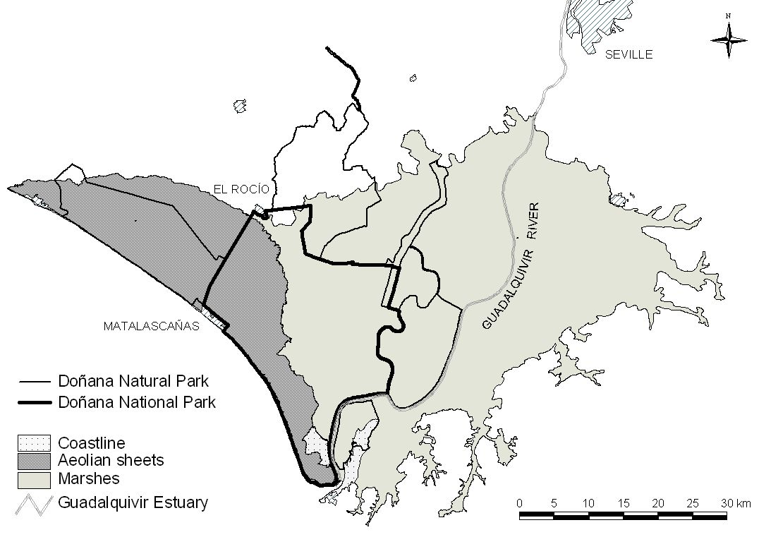
Figure 1. The Doñana fluvio-littoral Ecosystem of Doñana: ecodistrict and main protected areas.
Because of its historical context of isolation and its privileged location (interface between the Atlantic and the Mediterranean, between Europe and Africa), Doñana constitutes a unique wetland ecosystem performing diverse ecological functions: major stopover point in the migration route of birds moving between Europe and Africa, habitat provision for emblematic, endemic, threatened and flag species, such as the Iberian lynx and the imperial eagle, etc. Doñana is currently considered to be one the most significant wetlands in Western Europe (Fernández Delgado, 2005).

The Doñana SES embeds 12 municipalities of three different provinces of the Andalusia region, summing 174.000 inhabitants (Lomas et al., 2007). Well-being and local economy in all these municipalities largely depend on the ecosystem services provided by the Doñana fluvio-littoral ecosystem. Main traditional economic activities in this region have been extensive cattle farming, forestry and agriculture (grapevine, orchards and cereal), together with diverse subsistence uses such as hunting, fishing and picking up goods. Currently, agriculture and tourism are the main sources of income related to Doñana’s ecosystem services.

Doñana has historically been subject to a wide range of traditional economic uses coupled to local ecosystem’s dynamics (Rodríguez Merino & Cobo García, 2002). This allowed its inhabitants to obtain diversified flows of ecosystem services at the same time ecological functions were preserved. Multiple land uses in adaptive mosaics has been the dominant landscape management model in Doñana until a few decades ago. While many wetlands were largely desiccated in western European countries during the 18th and 19th centuries in order to control malaria and increase land productivity, large-scale territorial transformation arrived late to Doñana. Although decision makers conceived Doñana to be a marginal land that had to be drained and converted into a more economically productive area, all trials of reclamation in the 19th century failed due to lack of technology, access roads and investments (González Arteaga, 1993).

For a summary of Doñana SES, see table 1.

Table 1. General view of the Doñana SES
Characteristics | Description
Location | Andalucía Region, South-West Spain
Spatial extent | 3.120 km²
Biophysical system of reference | Doñana fluvio-littoral ecosystem (212.000 ha)
Municipalities | 12 mun.: Lucena, Moguer, Almonte, Hinojos, Pilas, Villamanrique, Azanalcázar, Puebla del Río, Isla mayor, Lebrija, Trebujena
Human population | 174.172 inhabitants; Density: 56 inhabitants / km²
Natural protected areas | Doñana Natural Area (National Parc + Natural Parc), Ramsar Site, Biosphere Reserve
Wetland ecosystems | Guadalquivir River estuary (3.600 ha, 77 km long, tidal influence of 110 m from the river mouth) and marsh (166.300 ha)
Main ecosystem services | Agriculture, cattle farming, tourism, research, clean water, flood prevention, sedimentary balance, refugee for biodiversity
Other ecosystem services | Fishing, seafood, environmental education, nutrient cycling
Characterization of economic system | Agriculture ()
Characterization of political and administrative institutions | Local: Doñana protected area, Patronato, municipalities.  Reg./Nat.: Andalucía Government; Ministry of the Environment  International: European Union, United nations
Characterization of culture | Religion: Christian Catholics; main cultural events: El Rocío pilgrimage, Saca de yeguas
Environmental problems and disturbances | Floods, diseases outbreaks, droughts, oscillations of agricultural subsidies and market prices
Methodology used in this work | Maps, bibliography revision, statistical data, interviews

Transformations and drivers of change in Doñana in the 20th century
At the first decades of the 20th century, Doñana was an almost unique case of wetland conservation in the European context. It remained as a feeble populated and almost isolated area, without any important access road. Ecosystem services were obtained through a small scale subsistence economy based on multiple land uses. This situation started to change by 1929, with different management policies that aimed to increase the added value (in market terms) of ecosystem services. This aim was accomplished through land reclamation and the development of intensive agriculture, the settlement of forest plantations (eucalyptus and pine-trees) for wood and pulp production, and beach tourism. These policies resulted in both economic development and ecological degradation, affecting ecosystem functioning all four main ecosystems of Doñana (Montes, 2000). Market integration and the intervention of the State are among the most powerful drivers o change in Doñana during the 20th century (Ojeda Rivera and Moral Ituarte, 2004; Gómez Baggethun and Kelemens, In press).

Development and growth
Until 1927, the Doñana marsh fully maintained ecological health and integrity, remaining as a non converted ecosystem. The marshes were resilient to secular human interventions and small scale disturbance (cattle farming and slash and burn), and ecological functions were preserved. Between 1929 and 1956, private companies drained large areas of the marshes in order to cultivate rice. The transformation process continued through reclamation performed by the State during the 1956-1978 period, when the upper and part of the lower marsh was drained for further agricultural purposes. In the same period, the State implemented an extensive forest plan to replant the aeolian mantles with eucalyptus, destroying more than half of the cork tree forest (Montes, 2000). The Plan Almone-Marismas, a major project to irrigate crop with groundwater was planned in the 60’s and implemented in the 70’s leading to the settlement of 8.000 ha of permanently irrigated lands. Hydrological regulation functions such as aquifer recharge were affected due to both high evapotranspiration rates of eucalyptus plantations and over-extraction from the aquifer for irrigation purposes (Custodio, 1995).

In the coastal system, urban development projects in the coast were deployed since 1969 in the context of a national strategy to increase revenues from beach tourism. The beaches of the area were declared of national interest for tourism, resulting in the major urbanization of Matalascañas. Further urbanisation plans of the beach during the 90’s finally failed after the 1st Sust. Dev. Plan of Doñana was approved in 1993.

Although the transformation of the estuary of Doñana started in the 19th century, this process was accelerated in the 20th century as the Guadalquivir River branches were progressively channelled in order to shorten the navigation distance to Sevilla (Menanteau, 1984). The second half of the 20th century thus coincides with a deep transformation process involving the simplification of ecosystems by management strategies that aimed to increase productivity by the enhancement of intensive mono-functional land uses (rice, eucalyptus plantations, urbanisation for tourism, etc).

Conservationist policies
In the 1960’s, as a response to this fast transformation process, European institutions and conservationist organizations promoted policies to preserve remaining sites with high value for biodiversity conservation. Since the declaration of the National Park in 1969, protected areas in Doñana have been extended up to now through the declaration of new protection categories and through the enlargement of the existing protected areas (Table 2). As natural capital and non converted areas have become scarcer in European countries, the social perception of Doñana has dramatically changed during the last few decades.

Table 2. Declaration of protected areas in Doñana since 1964
Year | Event / Conservation figure | Protected area (ha) | Increase in total prot. area (ha) | Total protected area (ha)
1964 | Doñana Biological Reserve | 6.784 | 6.784 | 6.784
1969 | Doñana National Park (DNP) | 34.625 | 27.841 | 34.625
1779 | Enlargement of DNP | 50.720 | 16.095 | 50.720
1980 | Doñana Reserve of Biosphere | 77.260 | 26.540 | 77.260
1982 | Ramsar Site | 50.720 | 0 | 77.260
1988 | ZEPA | 50.720 | 0 | 77.260
1989 | Buffer zone for DNP (Doñana Natural Park) | 53.709 | 27.169 | 105.765
1989 | Brazo del este river branche (Paraje Natural) | 1.336 | 1336 | 105.765
1991 | Reserva Natural Concertada de la Cañada de los Pájaros | 5 | 5 | 105.770
1997 | Doñana Natural Parc | 53.835 | 126 | 105.896
2000 | Reserva Natural Concertada de La Dehesa de Abajo | 617 | 617 | 106.513
2001 | Monumento Natural Acantilado del Asperillo | 11,85 | 0 | 106.513
2001 | Declaración del Monumento Natural Acebuches del Rocío | 0,64 | 0 | 106.513
2002 | ZEPA enlargement | 104.555 | 0 | 106.513
2004 | Enlagement of DNP (also adjustments in the Doñana natural park | 54.250 | 3.858 | 110.043

Conservationist policies entailed the prohibition of most socio-economic activities within the protected areas except those related to ecotourism and a few traditional uses, affecting provisioning services and the stakeholders whose livelihoods depended on them. As a consequence, during the last few decades Doñana has been subject to increasing subsidies in order to attenuate social conflicts emerging in relation to conservationist restrictions. Following Ojeda Rivera (1993), the permanent flow of subsidies, often unrelated to the existing local socio-economic tissue, has derived in the establishment of a subsidized culture in Doñana that discourages initiatives for endogenous development.

The implementation of strict conservation strategies in Doñana had thus different effects. On one hand, they have managed to slow down the ecological degradation process, for instance achieving to stop the urbanization of the coast, the further reclamation of remaining natural marshes, and the development of linear infrastructures with high impact on habitat fragmentation. On the other hand, it has affected some traditional uses as well and thus the local ecological knowledge related to them.
5.1.2. Basic accounts

5.1.2.1. Land-use cover change accounts
The main changes on the land-use cover are summarized in table 3.
Table 3. Changes in land-cover in the 1956-2006 period. Source: Modified from Zorrilla, 2006.
Land cover (has) | 1956 | 1977 | 1988 | 2006
Artificial
Water infrastructure | 0 | 0 | 164 | 291
Urban | 138 | 501 | 928 | 928
Agricultural areas
Aquiculture | 0 | 0 | 3608 | 3482
Rice fields | 5040 | 27740 | 40751 | 40751
Irrigation lands |  | 23407 | 45193 | 45182
Non-irrigated land | 6922 | 14770 | 18581 | 14913
Greenhouse agriculture | 0 | 0 | 162 | 154
Drained marsh | 54743 | 41894 | 15033 | 10189
Salines | 156 | 930 | 1304 | 1304
Natural areas
Marsh water flows | 5734
"Lucios" (shallow, seasonal lakes) | 6417 | 546 | 565 | 565
Restored marshes | 0 | 0 |  | 7952
Non-transformed marshes | 77508 | 46300 | 30205 | 30783
Fluvial beaches | 1371 | 4711 | 3288 | 2885
Water courses and estuarine | 5740 | 4315 | 4303 | 4706
Other | 1810 | 431 | 1494 | 1494
TOTAL | 165579 | 165579 | 165579 | 165579

5.1.2.2. Water: hydroperiod of Doñana wetland
Overall, changes in the original marsh (estimated 1663 km², see Fig. 2.) at the beginning of 20th century have led to the current 270 km² of shallow water (lost of 82%). In addition to wetland area reduction, tidal influence, one of the main inundation drivers, was also limited by the construction of a wall along the Guadalquivir River (Fig. 3). As a consequence, the marsh became isolated from the estuary, loosing both the influence of tidal flow and of river discharges (García Novo, 1997).

These drivers have produced over last century strong changes on the hydroperiod of Doñana marshes. Díaz-Delgado et al. (2006) found that there are two types of areas in Doñana wetland related with the hydroperiod changes (Fig. 4):
- those areas where the hydoperiod decrease because (1) they are isolated from the original water inflows –number 1 in Fig. 4 -, or (2) they are altering topography due to accelerated siltation processes –number 3 in Fig. 4-,.
- those areas where the hydroperiod increase because of (1) siltation processes are acting as casual damps, promoting inundation in upstream areas –number 2 in Fig. 4-,, and (2) because of the appearance of new inundable areas such as fish cultures –number 4 in Fig. 4-,.

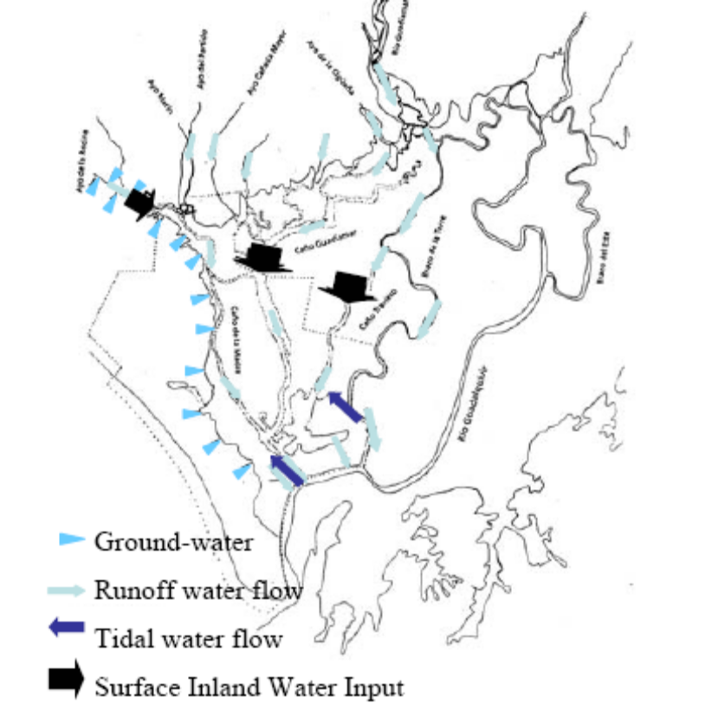
Figure 2. Water inflows at the early XX century in Doñana (Díaz-Delgado et al., 2006)

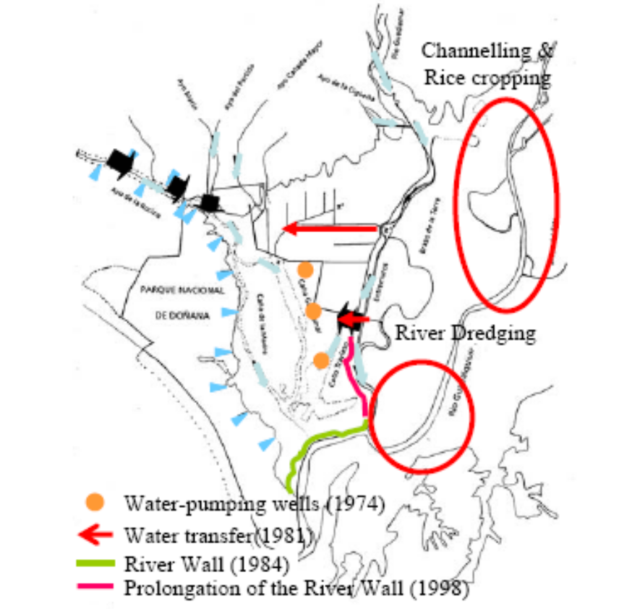
Figure 3. Doñana marshes after 1998 (Díaz-Delgado et al., 2006)
This study also found that the hydroperiod changes in Doñana can be explaining up to 70% by the accumulated annual rainfall (fig. 5), while the 30% of variance are related to human explanations.
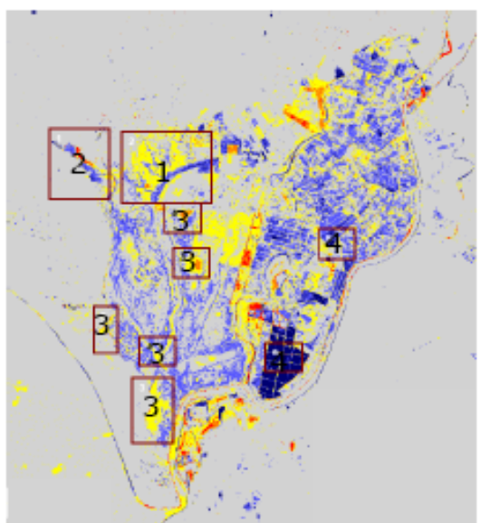
Figure 4. Areas with relevant changes on the hydroperiod (1985-1995 vs. 1995-2004) (Díaz-Delgado et al., 2006)

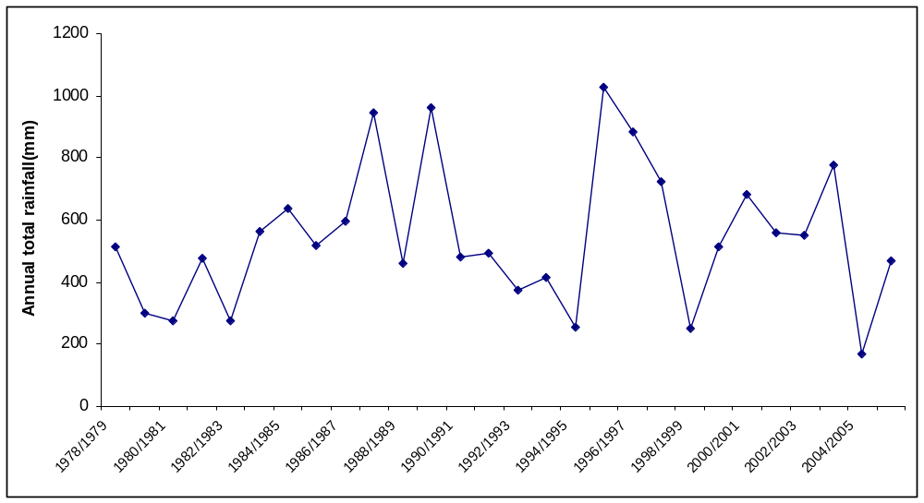
Figure 5. Total annual rainfall by hydrological cycle

5.1.2.3. Biodiversity: changes in the status of important species

Ecological keystone species
Ecological keystone species are those considered exceptional, relative to the rest of the community, in maintaining the organization of the ecosystems (Paine, 1969, Mills et al., 1993). In the Doñana social-ecological system, the European Rabbit (Oryctolagus cuniculus) is recognized as a keystone species because the conservation of most raptors depends on the stability of their populations due to their specific diet (Fig. 6, Delibes-Mateos et al., 2007).
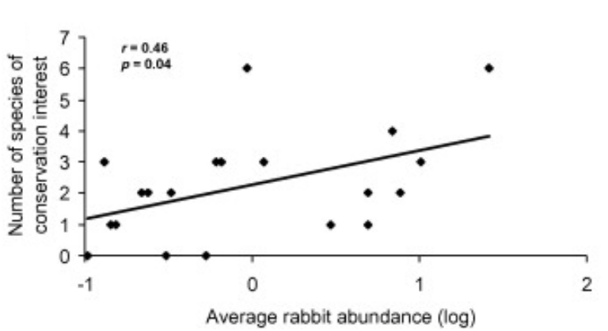
Figure 6. Relationships between the average rabbit abundance and the number of species of conservation concern and rabbit abundance. Source: Delibes-Mateos et al., 2007.

From the early tears of the 20th century to the late of 1950, the tales and testimonies of old game keepers of Doñana confirm the abundance of rabbits. In 1959, the rabbit populations have undergone because of the appearance of myxomatosis (Ratcliffe et al., 1952). Valverde (1960) calculated a mortality rate of over 90%. Later, in 1970s, Pat Rogers observed an important decline of rabbit populations, although in a less dramatic rate than the trend observed by Valverde (1960). In these years, the rabbit populations are mainly localized in the ecotonal areas between aeolian mantle and marsh ecodistricts, i.e. La Vera. During the 1990s, two opposing phenomena take place: on the one hand, a recovery of populations (although not necessarily in the same places or to the same levels reported previously) as a consequence
of their greater resistance to myxomatosis and, on the other, a dramatic mortality rate, from the early 90s, due to the appearance of a new viral infection: rabbit haemorrhaging disease (Soriguer and Angulo, 2006). During the last ten years, there has been an important change in conservation policy, and most of the 26% of conservation funds during the last three years are invested on this species. Due to the decline in rabbit populations in the last years was attributed particularly to the abandonment of traditional practices, like the prescribed fire regime and clearing the brush, the conservation interventions started in 1985 in the form of clearing scrubs. These clearing operations had a positive effect on rabbit populations since 1988. Also, between 1993 and 1996, 8000 rabbits were transferred (Soriguer and Angulo, 2005); however most of these actions have not the efficacy that it was expected. Currently, there has been a slow but continued increasing trend for rabbit populations in Doñana.

Cultural keystone species
As the same way that certain species of plants or animals appear to exhibit a particularly large influence on the ecosystem they inhabit, as we can see in the previous section, the same is true in social systems. Garibaldi and Turner (2004) named these species as "cultural keystone species", and define them as the culturally salient species that shape in a major way the cultural identity of a people, as reflected in the fundamental roles these species have in diet, materials, medicine, tourism, and aesthetic or spiritual practices.

Cultural keystone species at global scale: iconic species
Despite the important conservation plans focused on the Spanish Imperial Eagle (Aquila adalberti) and the Iberian lynx (Lynx pardinus) in Doñana natural protected area (see Fig. 11), they are in danger of extinction (Ferrer and Negro, 2004). The critical conservation status of Iberian lynx and Imperial eagle has been attributed to human persecution and habitat loss (Nowell & Jackson 1996). Raptors and mammalian carnivores were persecuted in Spain, and rewards were offered by the government for their eradication from the 1950s until the early 1970s, when protective laws were passed for all raptors and some carnivores (including the lynx). Today a significant proportion of lynx and imperial eagle populations are within nature reserves, and they have benefited from multimillion dollar Life Projects co-financed by the European Union and the Spanish government. These projects aimed to boost population sizes, but they did not succeed. These two flagship species tend to occur in Mediterranean ecosystems, and both prey preferentially on the rabbit (Oryctologus cuniculus), which also received a great percentage of the conservation budget in Doñana (Fig.11).

The Spanish imperial eagle (Aquila adalberti) is the most endangered bird of prey in Europe and one of the rarest raptors in the world (Collar and Andrew, 1988), with a total population estimated at little more than 140 pairs ( Ferrer, 2001). The eagle population of Doñana National Park remained stable during the period 1976–1992 (Fig. 7), with 15–16 pairs breeding at high density (occupying 20,000 ha of available habitat inside the Doñana National Park with a mean territory size of 1200 ha). After 1992, this population suffered a notable decline dropping to only seven pairs in 2002 (Ferrer et al., 2003). Starting from 1993, the population size decreased by about 6% per year (Fig. 7). In 2002, an urgent action plan for the recovery of the eagle population was started in Doñana.
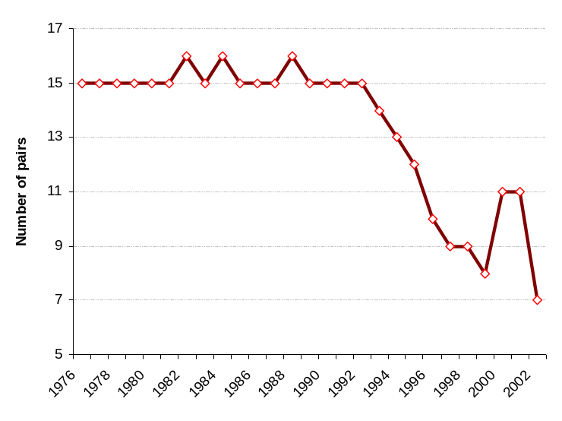
Figure 7. Decline of Spanish imperial eagle population in Doñana (Ferrer.et al., 2003)

The Iberian lynx is also a well-documented example of a carnivore suffering the consequences of human-induced mortality, scarcity of prey and habitat loss. Lynx habitat has been severely modified and reduced by extensive destruction (Delibes et al., 2000). By the early years of the 20th century, the Iberian lynx had become very rare in northern Spain, although it was still common in central and southern Spain (Pertoldi et al., 2006). By the 1960s, its range was essentially limited to the south-western quarter of the peninsula (Rodríguez & Delibes, 1992) (see Fig. 8).
The decline of the lynx population since the 1950s has been primarily caused by habitat loss and a decline of their main prey species, the European rabbit Oryctolagus cuniculus. In fact, there was a drastic population bottleneck during the 1950s and 1960s, when the myxomatosis viral disease hit the rabbit populations (Villafuerte et al., 1993). Recent estimates suggest that there are just two populations: the Doñana and the Sierra Morena, inhabiting an area larger than 2000 km² and separated by more than 300 km (Pertoldi et al., 2006).

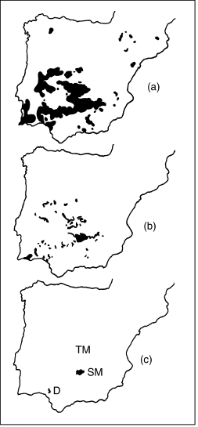
Figure 8. Three stages of the decline of the Iberian lynx populations in the second half of the 20th century: (a) estimated distribution in the 1960s (based on Rodríguez & Delibes, 1990); (b) estimated distribution in the 1990s (based on Rodríguez & Delibes, 1992); (c) breeding populations at present (based on Guzmán et al., 2003).
TM, location of the extinct Montes de Toledo population; SM, Sierra Morena population; D, Doñana population. Source: Pertoldi et al. (2006)

The population of Doñana, with about 40–50 lynx, seems to have been isolated from the other surrounding and now extinct populations for more than 50 years, because of an expansion of croplands to the north and dense human settlements to the west (Rodriguez & Delibes, 1992). García-Novo and Marín-Cabrera (2006) also found other threats in Doñana that explain the collapse of its populations: draining of the marshes, the traffic on the roads between Almonte and Matalascañas and Mazagón and Matalascañas, clearing fields for crops, the large wells where they drowned, and the conflict with local people. Dead animals keep appearing, killed by hunters, run over by cars, poisoned or caught in traps. A broad sector of society is committed to defending the lynx, however another sector considers that it is responsible for its own extinction and they are opposed to traffic speed limits or to building crossings (García-Novo and Marin-Cabrera, 2006).

Another iconic species in Doñana are the aquatic birds. Important species of waterfowl to be found in the marshes and ponds include the marbled teal (Marmaronetta angustirostris), seen occasionally, the red crested pochard (Netta rufina) and the coot (Fulica atra). The crested coot (F. cristata) has become scarcer, while the gallinule (Porphyrio porphyrio) has become a very frequent sight in recent years. Some wandering specimens of the glossy ibis (Plegadis falcinellus), unseen since the 1960s, started to reappear in the 1990s and soon began to nest, beating the record in 2004 with a breeding population estimated to be at least 1,100 pairs over six colonies (García-Novo and Marín Cabrera, 2006).

5.1.3. Ecosystem Distress Syndrome Diagnostic

5.1.3.1. Loss of wetland ecosystems

The polderisation of the marsh started in 1928, and in 1998, 70% of it had been converted to mono-functional land uses for agriculture. During the period 1928-1934, the marsh of the left side down the river was drained and turned into crops. In 1958, the construction of a barrier isolated the marsh from several smaller water courses (Valverde, 2004). In 1966, the construction of another barrier almost isolated the marsh from the estuary’s most important river branch (Brazo del Este), leading practically to the loss of its functioning (Barrera et al., 1984).

Other disruptions of the hydrological dynamics include the channelling of the Guadiamar River and the Cigüeña water course which eventually lead to the isolation of 25.000 ha of the marsh between 1947 and 1977 (Ministerio de Asuntos Sociales, 1989). The mine spill of 6 hm3 of toxic mud in Aznalcóllar in 1998 affected 4.634 ha of the marshes. As a response to this ecological crisis, two important restoration projects took place starting a period of marsh restoration through two large projects: the Guadiamar Green Corridor and the Doñana 2005. Figure 9 presents the evolution of natural capital in marshes due to the previous transformations.

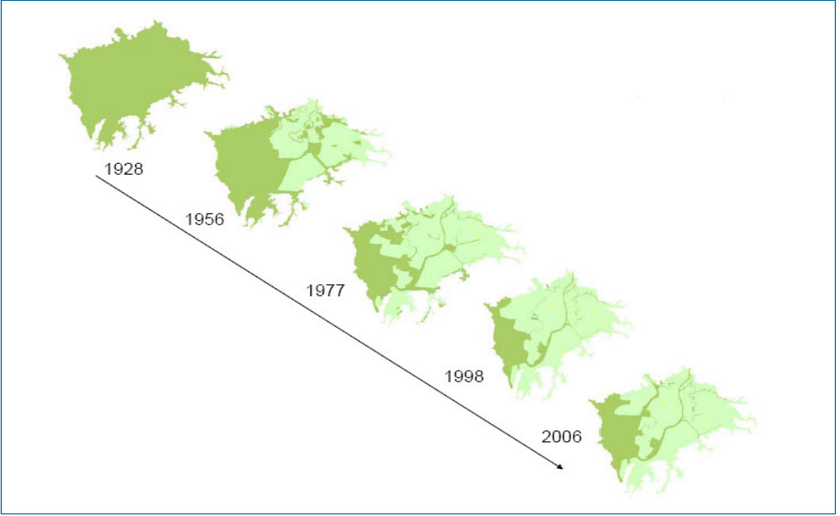 Figure 9. Natural capital loss in the Doñana marsh since 1928. Source: Lomas et al., 2007 (drafted after Zorrilla, 2006).

The channelling of the Guadalquivir rivers’ estuary started in 1795 with the aim of facilitating navigation. It continued during the 19th century and was accelerated since 1926. We can highlight different modifications of the estuary (Table 4), which all together have reduced its length from 125 to 77 km. (Menanteau, 1984). The river flow has speeded up increasing the sediment load and disrupting several hydrological regulation services such as the sedimentary balance or the erosion control.

Table 4. Transformation and rectification of the Guadalquivir estuary.
Year | Consequences
1795 | Isolation of first branches (Río Viejo).
1816 | Corta el meandro de El Borrego, que circunda Isla Cristina (en el Brazo de la Torre) y desvía el flujo fluvial al brazo central, aislando el Brazo de la Torre, que ya sólo recibiría aportes del Guadiamar.
1888 | Construction of the Casa Riera channel between the Guadiamar and the Guadalquivir rivers.
1926 | Isolation of Los Remedios and La Tablada areas
1951 | The river do not pass anymore through Seville, which become isolated from the floods
1971-  1972 | Construction of the Sevilla-Bonanza navigation channel

5.1.3.2. Sedimentation /erosion

The sediment load to the marshes has increased dramatically due to loss of vegetation cover and land cover change towards agriculture. Sedimentation rates has raised from filling rates of less that 1 mm/ y during the last 2.500 years, to 3-6 mm/y during the last 50 years (Rodríguez Ramirez et al. 2005). The water storage capacity of the marshes has been reduced by 26 hm3 in the last 50 years.

Box 1. Increased sedimentation rates and erosion of resilience in the marsh
Sedimentation rates in the Doñana marsh have increased dramatically during last few decades, producing resilience loss and undesired regime shifts in ecosystems. Some drivers of this process can be traced back to afforestation practices led by the romans in the Guadalquivir river basin.
Nevertheless, sedimentation/erosion problem in the Doñana marsh is primarily the consequence of relatively recent events, namely, 1) channelling of the water courses discharging at the march and consequent speeding up of water flows, 2) land use change to agriculture entailing removal of vegetation cover, and 3) removal of grapevine and orchard plantations upwards the marsh promoted by subsidies.
Increased sedimentation is causing the loss in the heterogeneity in the topography of the marsh (reference), leading to the loss of habitats suitable for diverse plant species. This homogenisation reduces response diversity when facing perturbations (droghts, floods, grazing) and thus erodes resilience to buffer disturbance. Seed banks of the soil are considered as key ecosystem components for the resilience of the marsh (reference), due to their capacity to survive after severe drought or floods and to regenerate the pastures of the marsh. Increased sedimentation is contributing to bury the seed bank at a depth they can not germinate, leading to loss of vegetation cover. As vegetation decreases, phosphorus is increasingly released to the water, leading to regime shifts from clear water states to turbid water states. The latter stable state can be considered a less desired one from ecological and economic perspective, as the capacity to provide ecosystem services declines (refugee for biodiversity, clean water, etc.).

Sediment surface (ha) | 25/08/1984 | 27/09/1996 | 27/08/1999 | 19/08/2002
Partido | 48,37 | 90,74 | 520,44 | 88,77
Laguna de los Reyes | 1,08 | 0 | 1,48 | 0,87
Soto Grande | 0 | 2,26 | 28,33 | 14,75
Soto Chico | 0 | 0 | 7,56 | 2,97
Canal Mimbrales | 0 | 0 | 2,73 | 10,03
 | 49,45 | 93 | 560,54 | 117,39
Increase of fan sedimentation surface in Doñana marshes. Source: (Doñana Biological Station, http://www-rbd.ebd.csic.es/Seguimiento/seguimiento.htm).

5.1.3.3. Fragmentation
The drainage of the marshes has caused loss of ecological interactions: the length of dykes and artificial levees in the Doñana wetlands has increased from 25 to 110 km between 1956 and 2006 (to be developed).

5.1.3.4. Alien invasive species
The Mediterranean has been a basin of unceasing exchanges and trials, in which the biological communities change over time through the introduction, surviving and extinction of species, and Doñana is an example of this. However, in the last years the rate of species introduction in Doñana has increased (Fig. 10).
The globalisation of trade and transport will progressively increase the presence of new species. One example of this can be seen in the River Guadalquivir itself, where there are seven introduced fish species. The first to colonise the area were carp (Cyprinus carpio) and goldfish (Carassius auratus) native to Eastern Europe and Asia, probably in the 19th century. In 1921, the Eastern mosquitofish (Gambusia holbrooki) was introduced from the United States to fight malaria. Both native to North America, the largemouth bass (Micropterus salmoides) and the mummichog (Fundulus heteroclitus) were introduced in the 1970s (García-Novo and Marín-Cabrera, 2006). During the heavy rain seasons in 1996 and 1997 the pumpkinseed (Lepomis gibbosus) became the last American species to colonise Doñana. Other important aquatic invasive species because the effect on the SES are: the Louisiana crayfish (Procambarus clarkii), the red-eared slider (Trachemys scripta elegans), and the water fern Azolla filiculoides.
Another important alien invasive species is the ruddy duck (Oxyura jamaicensis), which was introduced in 1950s from America. It breeds with the local duck (Oxyura leucocephala), the white headed duck, which it has displaced. In recent years, a programme for protecting Oxyura leucocephala and for eradicating Oxyura jamaicensis has been successfully implemented.
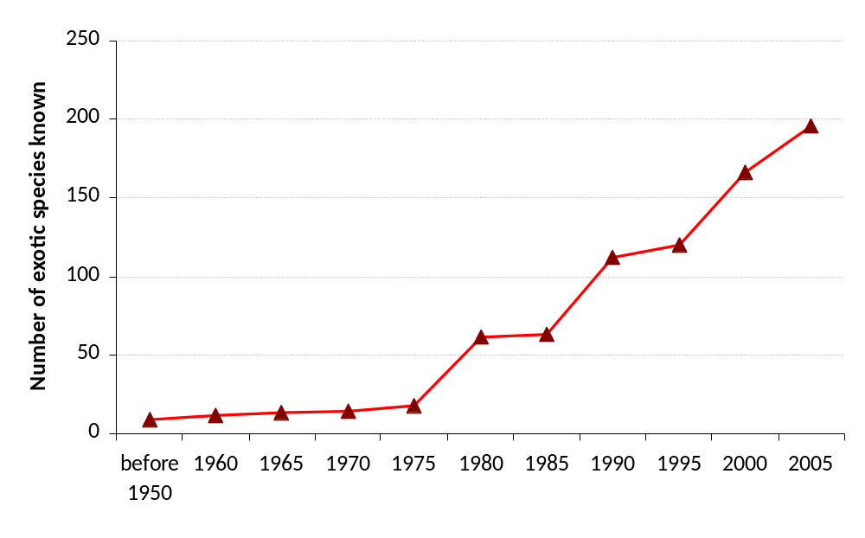
Figure 10. The number of exotic species registered in the scientific literature in Doñana.

Exotic species can replace the native species through competition, predation or parasitism, altering the functional dynamics of the system and, therefore, the provision of ecosystem services. Thus, sometimes the introduction of an exotic species roots on the promotion of one ecosystem services (usually provisioning services). Eucalyptus spp. can be an example of this (Box 2).

Box 2. The ecosystem services trade-offs related to the introduction of alien species: the case of Eucalyptus plantations.
The introduction of Eucalyptus (specifically E. camaldulensis and E. globulus) in Doñana in 1940s supposed a significant impact on many wetlands. These species displace native vegetation through their greater accessibility to groundwater with their deeper roots, causing an appreciable water-table drawdown (of tens of centimetres). This is the case of the El Abalario-La Mediana-La Rocina area, where much of the natural discharge of water-table waters to the Ribetehilos and Mediana wetland complexes, and other isolated lagoons, had completely dried up due to the introduction of eucalyptus trees. Therefore, this event supposed a considerable negative effect on the water provision service.
This serious ecological impact does, however, have different ecological and social benefits. On the one hand, those eucalyptuses that are in Coto del Rey or in the Palacio de Doñana occasionally provide support for the nest of a pair of imperial eagles and for breeding colonies of storks, promoting other ecosystem services, such as the conservation of iconic species. On the other hand, the Eucalyptus plantations supplied different provisioning services (pulp for paper, essential oil, and wood for timber). Also they provided employment in this depressed region for about twenty years and created new settlements where the workers lived with their families. Villages like Los Cabezudos, Bodegones, El Abalario and El Acebuche owe their foundations to the eucalyptus plantations (García Novo and Marín Cabrera, 2006).
Currently, in the new conservationist phase, that from the mid-eighties, eucalyptus plantations were cleared in the National Park and, also, in the Nature Park. However, with this decision the production of honey in Doñana has recently suffered an important decrease (see Figure) because Eucalyptus spp. constitutes an important source for nectar, pollen and honey production (Andrés et al. 2006).
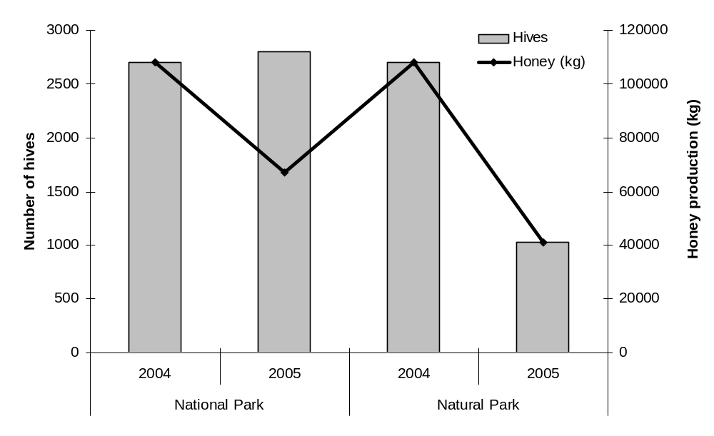
Figure. The decrease of honey production in National and Natural Park of Doñana in the last years.

5.1.4. Maintenance and restoration costs
The budget designated to the conservation of Doñana biodiversity (only species) is one of the most important of all National Parks in Spain (Martín-López & Montes, C., 2007). During the 3-year period 2004-2006, nearly 7.9 € million was dedicated to species conservation. Of this, about 5.1 € million was provided by the Spanish Ministry of Environment, and 2.8 € million by the Department of Environment of the Andalusian government. Despite this significant spending, only a fraction of species conservation needs were funded because resource distribution was skewed toward very few species (Fig. 11).
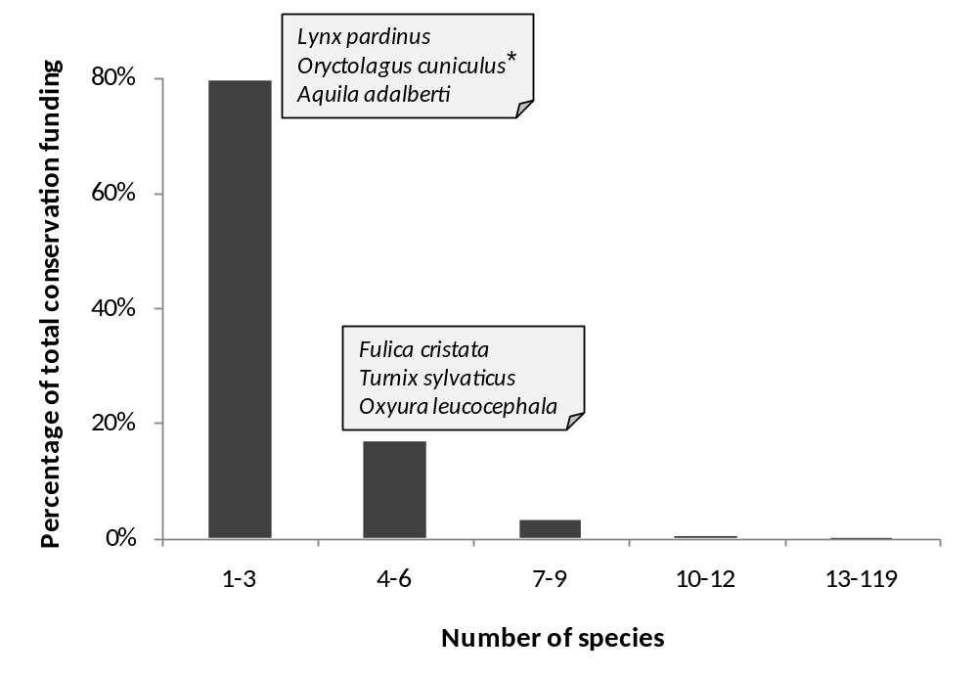
Figure 11. Percentage of conservation funding to endangered fauna species grouped by descending order of expenditures. * Oryctolagus cuniculus is not recognized as endangered species by the Andalusian Red Books, but its conservation interest is because of European rabbit is critically important for conserving Lynx pardinus and Aquila adalberti.(Martín-López & Montes, 2007)

Regarding research funding for biodiversity, nearly 2.9 € million was dedicated to scientific research of biodiversity in the Doñana NPA during 3 years: 2004-2006. Of this, 41.0% was provided by the Spanish Ministry of Environment; 34.2% by the Department of Environment of the Andalusian government, 18.6% by the Spanish Ministry of Education and Science; 5.5% by the Department of Education and Science of the Andalusian government; and 0.7% by the European Union (Martín-López & Montes, 2007).

It is important to note, that Doñana National Park and the Department of Environment of the Andalusian government have focused mostly effort for eradicating and controlling the alien invasive species in Doñana. In this sense, during the last 20 years more than 3.7 € million was dedicated to eradicate or prevent the introduction of alien invasive species. For the last three years, the total amount invested in invasive species in Doñana supposed about 12% of total conservation budget. Similarly, concerning the research, we found that more than 25% of the investigation budget was focused on alien invasive species during 2004-2006 years.
In contrast, higher budget is invested on wetlands restoration projects. The Spanish Ministry of the Environment launched the Doñana 2005 Project in 1998 with the final goal to restore the Park's hydrology (Saura Martínez et al., 2001) as a basis for conservation. It comprises six key interventions addressing specific problems: controlling aquifer overexploitation, building the sewage treatment plant of El Rocío village, reshaping drainage channels entering the Park, recovering degraded areas and purchasing abandoned agricultural lands to restore them, and providing menaced Imperial eagle and Iberian lynx populations with a suitable hunting ground (García-Novo et al., 2007). The average budget spent between 1998 and 2005 on this restoration project was € 83.5 million (UNEP, 2007; http://www.unep-wcmc.org/sites/wh/donana.html). The hydraulic modification of El Partido stream to abate transport of sediments into the Marsh, along with the ecological restoration of its watershed, is the most complex intervention of the Doñana 2005 Project. It has been undertaken by watershed authority (Confederación Hidrográfica del Guadalquivir) belonging to the Spanish Ministry of Environment, with an estimated budget of M€7.85 (García-Novo et al., 2007). Similarly, the ecological restoration of the Guadiamar River Basin through the Green Corridor and Guadiamar Restoration Project invested more than 165 € million as a response of one of the most important environmental accidents in Spain –i.e. the rupture of the Aznalcóllar mining dam in 1998-.

Concerning the water quality and quantity research, it is interested to note that the Spanish Geology and Mines Institute (IGME) has invested about 1.9 € million during the last seven years in the research of the aquifer of Doñana (Almonte-Marismas) (Mediavilla et al., 2007).

Box 2. Hidden costs related to ecological degradation: the case of sedimentation
Orchards and grapevines constitute beside cereals, the basis of traditional sustainable agriculture in Doñana. These secular plantations constitute multifunctional land-covers, as beside provisioning services, they perform important cultural (e.g. aesthetic value) and regulating services, especially preventing soil erosion.
At present, Common Market Organizations are subsidizing the removal of grapevine and orchards in the river-basins upwards the marsh, contributing to further increase in erosion and sedimentation rates. Inadecuacy of Doñana’s traditional agriculture to compete and create profit in liberalised markets is alleged as the main reason for conducting this policy. Nevertheless, its economic rationality would probably be challenged if externalities and restoration costs related to sedimentation/erosion problems were fully considered in decision making.

Table 5. Summarize of the most important conservation, research and restoration budget invested in Doñana.
 |  | Investment expenditure | Years | Source
Conservation | Protection of biodiversity (species) | 7.987.011,94 | 2004-2006 | Martín-López & Montes (2007)
Research | Biodiversity | 2.903.020,35 | 2004-2006 | Martín-López & Montes (2007)
Research | Alien Invasive species | 923.354,48 | 1990-2006 | García-Llorente et al. (sumittted)
Research | Water quality (aquifer) | 1.895.000,00 | 2000-2007 | Mediavilla et al. (2007)
Maintenance and restoration costs of natural resource | Wetland restoration- water quality | 108.000.000,00 | 1998-2005 | Doñana, 2005, UNEP, 2007; http://www.unep-wcmc.org/sites/wh/donana.html
Maintenance and restoration costs of natural resource | Watershed restoration | 165.396.261,58 | 1998-2003 | Guadiamar Green Corridor programme
Maintenance and restoration costs of natural resource | Fauna and flora (eradication and control of Alien Invasive Species) | 3.765.457,44 | 1988-2006 | García-Llorente et al. (sumittted)

5.1.5. Selected socio-economic indicators
5.1.5.1. Population
The population of the Doñana SES was of 174.172 at year 2005. The Doñana SES has historically been a feeble inhabited area. This can be partly explained to difficulties to colonise the territory of the marsh, and partly because the latifundium as dominant property system rendered limited rights to the inhabitants to profit from natural resources.
The Doñana SES had a population 69.517 inhabitants in 1900. This population has been continually growing since 1910 and at present (2005) there are 174.172 inhabitants (Table 6, Fig. 12). This mean a population growth at a rate of 1,43% /year between 1900 and 2005. First large trial of colonisation started in the 19th century, but it was not before the first decades of the 20th century that these trials succeeded. This became possible once the availability of technology and investments permitted the drainage of the marsh and the settlement of crops, especially rice fields.

Table 6. Population growth in Doñana in the 1900-2005 period. Source: Spanish Statistic Institute (INE).
Doñana SES | 1900 | 1920 | 1940 | 1960 | 1981 | 2000 | 2005
Almonte | 6 917 | 7 967 | 8 964 | 11 538 | 12 959 | 17 444 | 19 641
Hinojos | 2 058 | 2 401 | 2 908 | 3 278 | 3 130 | 3 556 | 3 726
Lucena del Puerto | 1 456 | 1 526 | 1 589 | 1 703 | 1 870 | 2 237 | 2 283
Moguer | 8 455 | 8 028 | 6 821 | 7 222 | 10 004 | 14 389 | 16 961
TOTAL HUELVA | 18 886 | 19 922 | 20 282 | 23 741 | 27 963 | 37 626 | 42 611
HUELVA province | 258 143 | 331 527 | 375 180 | 404 517 | 418 584 | 458 998 | 483 792
Aznalcázar | 1 795 | 1 870 | 2 454 | 3 038 | 2 871 | 3 518 | 3 692
Isla Mayor |  |  |  |  |  | 6 057 | 5 853
Lebrija | 10 997 | 12 012 | 14 536 | 20 937 | 24 744 | 24 172 | 24 866
Pilas | 4 251 | 5 616 | 6 145 | 8 604 | 9 835 | 11 289 | 11 918
Puebla del Río (La) | 2 841 | 2 740 | 5 085 | 12 612 | 13 602 | 10 688 | 11 326
Villam. de la Condesa | 3 079 | 3 362 | 3 146 | 3 392 | 3 225 | 3 805 | 3 826
TOTAL SEVILLA | 22 963 | 25 600 | 31 366 | 48 583 | 54 277 | 59 529 | 61 481
SEVILLA province | 552 455 | 704 344 | 957 362 | 1 244 153 | 1 478 311 | 1 734 917 | 1 813 908
Sanlúcar de Barrameda | 23 883 | 27 103 | 32 848 | 40 335 | 48 496 | 61 966 | 63 187
Trebujena | 3 785 | 4 247 | 4 799 | 5 591 | 6 187 | 6 937 | 6 893
TOTAL CÁDIZ | 27 668 | 31 350 | 37 647 | 45 926 | 54 683 | 68 903 | 70 080
CÁDIZ province | 450 837 | 549 710 | 590 211 | 812 680 | 988 388 | 1 125 105 | 1 180 817
TOTAL SED | 69 517 | 76 872 | 89 295 | 118 250 | 136 923 | 166 058 | 174 172

Although population has grown in every municipality of the Doñana SES since 1900, this growth has been uneven when different municipalities are compared. As shown in fig… population growth has been especially fast in Sanlúcar de Barrameda, while municipalities such as Pilas or Hinojos show very moderate growth.

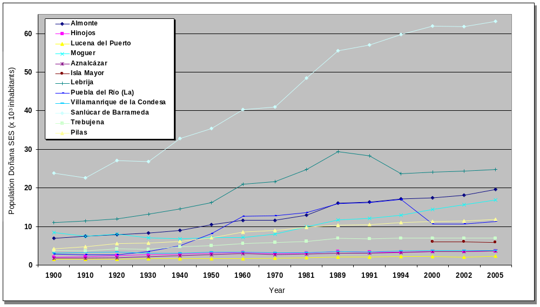

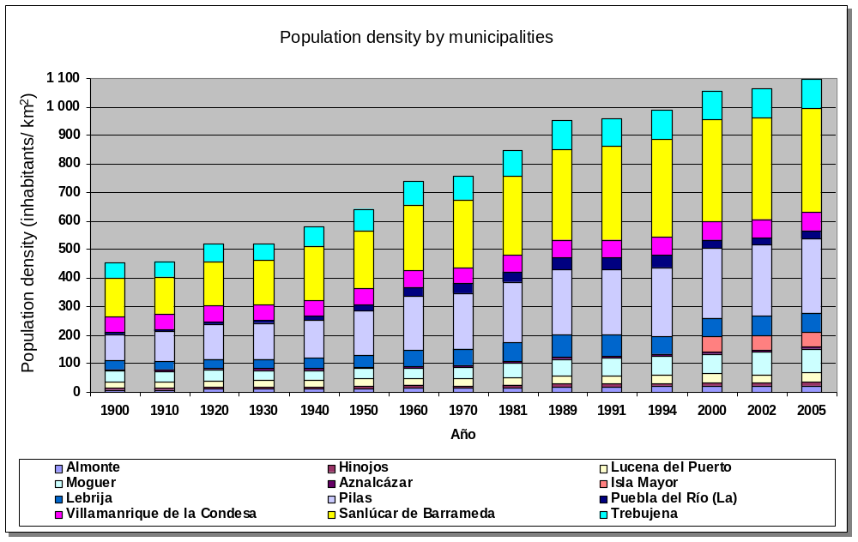

Figure 12. Population growth in the municipalities of the Doñana SES since 1900. Modified from Lomas et al., 2007. Source Andalusian Statistics Institute (SIMA).

5.1.5.2. Employment
Economic activity in the Doñana SES has been continuously growing from the 1980’ to the present. Employment in Doñana, which until a few decades ago depended completely on nature, is still strongly dependent the natural capital and ecosystem services of the marsh, estuary, coast, and dunes ecosystems. The rate of employment that is officially employed increased from being 80% at the beginning of the 1980’ to about 60% in 2001.

The main economic sectors depending on ecosystem services are agriculture, fishing and aquiculture, cattle farming, forestry, salines and tourism. Nevertheless, more recently industry and housing are gaining weight as economic sectors in Doñana.

5.1.5.3. Provisioning services and employment
Agriculture
Traditional agriculture consists on grapevine, orchards and cereals. Although these crops are still important, rice fields, which started to be cultivated at the end of the 1920’s has now become the largest agricultural sector in Doñana. In the 1960’s and 1970’s the Plan Almonte-Marismas promoted the conversion of marsh to intensive irrigated agriculture. The so called “new agriculture”, of rice fields, strawberry and other fruits and vegetables is now the engine of the economy based on agriculture. While agricultural surface in Doñana has been increasing all along the 20th century, some traditional crops such as the grapewine are reducing their surface (Table 7 and 8).

Table 7. Crop types and relative importance. Source: Dpto. de Estadística de Sevilla y Huelva. Consejería de Agricultura y Pesca (2001).
Crop types | Surface (ha)
Rice | 28 922
Orchards | 14 755
Cereals | 11 477
Industrial crops | 9 034
Fodder crops | 6 181
Fruits and vegetables | 5 463
Vineyards | 5 343
Strawberry | 4 536
Tuber crops | 1 031
Raspberry | 545
Leguminous | 396
TOTAL | 87 683

Table 8. Surface (has) of different crop types in the municipalities of the Doñana SES. Source: Dpto. de Estadística de Sevilla y Huelva. Consejería de Agricultura y Pesca. (2001)

Municipality | Cereals | Leguminous | Tuber | Industrial | Raspberry | Fodder | Total
Aznalcázar | 5 265 | 0 | 0 | 4 155 | 0 | 5 328 | 14 748
Pilas | 256 | 3 | 0 | 264 | 0 | 5 | 528
La Puebla del Río | 702 | 5 | 41 | 870 | 0 | 15 | 1 633
Isla Mayor | 220 | 0 | 0 | 200 | 0 | 450 | 870
Villamanrique de la Condesa | 637 | 63 | 704 | 845 | 0 | 0 | 2 249
Almonte | 1 530 | 294 | 63 | 1 060 | 10 | 217 | 3 174
Bollullos Par del Condado | 326 | 5 | 18 | 303 | 0 | 6 | 658
Bonares | 425 | 5 | 10 | 110 | 125 | 15 | 690
Hinojos | 787 | 7 | 4 | 375 | 0 | 25 | 1 198
Lucena del Puerto | 327 | 3 | 19 | 145 | 120 | 56 | 670
Moguer | 251 | 6 | 89 | 110 | 250 | 39 | 745
Palos de la Frontera | 1 | 0 | 61 | 0 | 0 | 0 | 62
Rociana del Condado | 750 | 5 | 22 | 597 | 40 | 25 | 1 439
TOTAL | 11 477 | 396 | 1 031 | 9 034 | 545 | 6 181 | 28 664

Livestock
Since centuries domestic livestock has ranged the Doñana marshes under an extensive grazing system. The quality of the marsh pastures has been acknowledged since the Arabs controlled this territory one thousand years ago (González Fáraco, 1991).
Table 9 presents the number of animals of each municipality in 1999.

Table 9. Livestock statistics in the municipalities of the Doñana SES by species. Source: Censo Ganadero (1999). Unit: Number of animals.

MUNIPALITY | Horses | Caws | Sheeps | Donkeys | Goats | Mules | Avian | Pigs
Almonte | 4 388 | 6 900 | 3 473 | 98 | 1 252 | 780 | 63 600 | 210
Hinojos | 766 | 4 070 | 1 597 | 22 | 470 | 80 | 350 000 | 2 012
Isla Mayor | 370 | 2 179 |  |  |  | 12
La Puebla del Río | 539 | 431 | 4 542 | 27 | 125 | 42 | 31 000 | 800
Lebrija | 527 | 12 800 | 799 | 67 | 2 455 | 92 |  | 27 177
Lucena del Puerto | 207 | 1 363 | 225 | 11 | 500 | 64 | 29 000 | 12
Moguer | 845 | 902 |  | 31 | 1 004 | 102 | 120 000 | 465
Pilas | 444 | 85 | 219 | 26 | 144 |  | 45 000 | 326
Sanlúcar de Barrameda | 2 216 | 3 246 | 4 223 | 174 | 1 366 | 260 | 107 000 | 162
Villamanrique de la Condesa |  | 23 | 783 | 421 | 1 525 | 88 | 5 899 | 580
TOTAL |  | 479 | 15 861 | 10 723 | 8 841 | 1 520 | 37 875 | 31 744
Currently, the cattle of Doñana is mainly comprised of three native races: the Retuertas horse (yegua marismeña), the Doñana feral cattle (vaca mostrenca), and the Andalusian churra sheep (oveja churra lebrijana) (Calderón Rubiales, 2006). The number of these animals decreases from 6805 (in 1979 year) to 2061 (in 1983) (Rodríguez-Merino and Cobo-García, 2002). In the last five years, the number of individuals oscillates from 3500 (in 2000 year) to 1600 (in 2005 year) (Doñana Biological Station, http://www-rbd.ebd.csic.es/Seguimiento/seguimiento.htm).

On the one hand, these races (especially vaca mostrenca and the Retuertas horse) have an important ecological value because their genetic isolation. For instance, the morphological and functional features of Retuertas (e.g. an average height of only 1.42 m and adaptability to hostile marsh environment) are very different from Spanish Pure Breed, Arabian and other Iberian horses of Celtic origin, suggesting genetic isolation of the Retuertas horse population (Vega-Plá et al., 2006). On the other hand, it has also an important historical-cultural value. Every year on the 26th of June a long-held tradition takes place, called the “Saca de Yeguas” (The Mares’ Roundup), in which the horses that graze in the marshes are herded together and the driven to the El Rocío and Almonte villages in order to cut their manes and tails, as well as sold their foals (Calderón Rubiales, 2006).

Fishing
Along the Guadalquivir estuarine, local people have fished for thousands of years with nets and traps, as well as have collected shellfish along the shores. The marshes and the estuarine of Doñana are of a great interest from a commercial fishing point of view, owing a high market value (Table 10). However, during the last 50 years different fish species suffered a population decrease or extinction, such as the eels or the sturgeons (see Box 3).

Currently, the aquatic communities of the Guadalquivir estuary take on an important social dimension by indirectly contributing to the livelihood of thousands of families. Table 11 and 12 presents the number of fishing boats existing in the estuary and the number of licences of seafood extraction by municipalities, respectively.

Table 10. Fishing in the Guadalquivir estuary and its economic value per year. (Data of Sanlúcar de Barrameda fish market). Source: Agriculture and Fisheries Statistics Yearbook of Andalusia.
Year | Fishes |  | Mollusc |  | Crustacean |  | Total Value (€)
Year | Weight (Tm.) | Economic Value (€) | Weight (Tm.) | Economic Value (€) | Weight (Tm.) | Economic Value (€) | Total Value (€)
1985 | 3.058,25 | 4.521 | 1.127,92 | 2.232 | 623,46 | 2.298 | 9.052
1986 | 2.472,00 | 4.611 | 1.134,90 | 2.375 | 450,00 | 2.025 | 9.011
1987 | 2.566,04 | 5.320 | 1.106,88 | 2.242 | 494,08 | 1.855 | 9.418
1988 | 2.183,68 | 4.965 | 1.009,79 | 2.325 | 557,31 | 2.425 | 9.716
1989 | 1.857,87 | 4.596 | 748,75 | 1.970 | 661,09 | 3.013 | 9.579
1990 | 2.182,32 | 6.212 | 791,17 | 2.145 | 527,27 | 3.083 | 11.439
1991 | 1.875,73 | 5.556 | 788,66 | 1.753 | 572,65 | 3.187 | 10.495
1992 | 1.568,26 | 5.150 | 734,27 | 1.590 | 348,35 | 2.253 | 8.993
1993 | 1.449,86 | 4.241 | 780,36 | 1.519 | 347,24 | 2.393 | 8.153
1994 | 3.832,53 | 5.560 | 910,14 | 1.678 | 332,22 | 3.240 | 10.477
1995 | 3.182,74 | 4.758 | 1.064,75 | 1.987 | 311,97 | 3.142 | 9.886
1996 | 2.039,91 | 5.773 | 590,58 | 1.847 | 300,06 | 3.739 | 11.359
1997 | 1.912,44 | 5.999 | 546,04 | 1.524 | 357,62 | 4.220 | 11.744
1998 | 1.797,23 | 4.862 | 1.139,18 | 2.601 | 413,80 | 4.451 | 11.914
1999 | 1.912,74 | 5.096 | 1.022,28 | 2.514 | 353,81 | 4.411 | 12.022

Table 11. Number of fishing boats by municipalities depending on the estuary. Source: Silva García (2005)
Municipality | Number of fishing boats
Trebujena | 90-110
Isla Mayor | 60-80
Lebrija | 15-25
Coria del Río | 10-15
Los Palacios y Villafranca | 4
Jerez de la Frontera | 1-2
Sanlúcar de Barrameda | 1-2

Table 12. Number of licences for seafood extraction by municipalities. Source: Collado Vallejo (2005)
Municipality | Licences
Pilas | 71
Sanlúcar de Barrameda | 33
Almonte | 18
Villamanrique de la Condesa | 15
Hinojos | 8

Box 3. The Acipenser sturio in the Guadalquivir estuary: the history of a fishing service loss.
Historically, in the Guadalquivir estuary sturgeons (Acipenser sturio) were fishing near Sanlúcar de Barrameda. Until the thirties, this species was occasionally caught in the sea by trawlers (Classen, 1944) and by fishing lines near Sanlúcar de Barrameda. In 1932, a dam in Alcalá del Río was finished, at 100 km away from the sea. It represents a barrier to this species because it could not reach the spawning areas above the dam. In the same year, a caviar and smoking plant was opened in Coria del Río (70 km from the river mouth), and an industrially fishing started, gaining an excellent reputation (Fernández-Pasquier, 2000). For a few years after 1932, local fishermen still continued to catch young sturgeons in the estuary using a kind of spoon nets, which also was used for mullets (Mugilidae) catching (Classen, 1944). Consequently, catches close to the dam rapidly declined, while those in the lower estuary increased (Elvira et al., 1991).

Between 1932 and 1972, the capture of 3098 females and 1074 was recorded. The annual evolution of the captures is shown in figure, where a major annual increase in the first years can be seen. In the 1950s, the sturgeon catches suffered a decreasing trend, reaching a critical point in 1962, when captures reduced in less than 20 per year.
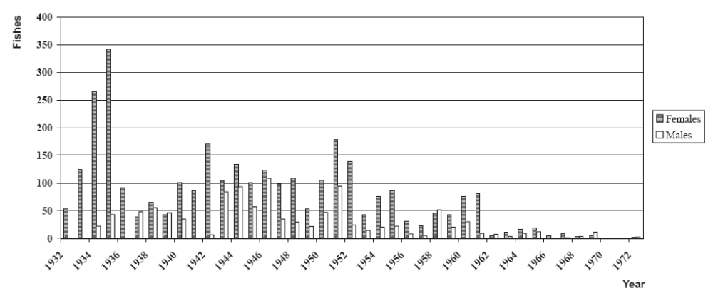
Figure. Annual variation of the number of captured sturgeon fishes. Source: Fernández-Pasquier, 2000.

The factory remained open until 1972, when catches were disappearing. The last records were in 1974 and 1975 (Hernando, 1975) and 1992 (Elvira and Almodóvar, 1993), one fish each year.
Several scientists have blamed the Alcalá Dam as a major cause of decline of sturgeon in the Guadalquivir river (Lozano, 1944), while others have also involved as possible causes the over-fishing in the lower estuary (Classen, 1944), increasing water pollution (Lozano, 1956), and gravel extractions on spawning areas (Gutierrez, 1962). The drastically reduced water flow as a consequence of drought and river regulation could be another important cause limiting the access of individuals to their spawning sites (Fernández-Pasquier, 1999).
Currently, sturgeon is protected by Spanish Law since 1983 and by Andalusian Law since, considering as critically endangered species in the National and Andalusian Red Lists (Granado, C. in CMA, 2001).

5.1.6. Ecosystem services of the Doñana SES
The ecosystems of Doñana perform a diversified flow of ES, from the local (sense of place, hunting, picking up goods, local ecological knowledge) to the national and international scale (carbon sequestration, refugee for biodiversity, research and tourism). The relative importance of each of these services depends thus on the scale at which they are enjoyed (Hein et al., 2006), but also in the valuation criteria (weather it is economic, socio-cultural ecological or other).

Most significant marketed ES in Doñana in terms of income are agriculture and aquiculture, beach and nature tourism, science and environmental education (see table 13). Provisioning services include agriculture (rice, strawberry, fruits, orchards, vineyards, cereals), and in a smaller extent cattle farming, fishing, seafood, aquiculture, forestry products (wood, pines, scent, honey), and hunting. Most of them are provided outside the protected areas, due to strict restrictions in extractive uses. Most significant cultural service is eco-tourism, but science and environmental education are also important indirect sources of income.

Table 13. Physical measurement of some ES in the Doñana wetlands (preliminary results).
Ecosystem services | Quantities | Source
Agriculture | 641.947 ton /year | Agriculture and Fisheries Statistics Yearbook of Andalusia
Cattle farming | 41.205 animals/ 1999 year | Agriculture and Fisheries Statistics Yearbook of Andalusia
Fishing | 2.802 tons/ 2004 year | Agriculture and Fisheries Statistics Yearbook of Andalusia
Tourism | 4.092.379 visitors / 2004 year | Martín-López et al. (2007)
Environmental Education | 7 large projects | Martín-López & Montes (2007)
Refugee for biodiversity | 4.807 recorded sp. | Martín-López et al. (work in progress)

Concerning non marketed services, the most significant in the Doñana wetlands are those related to ecological regulation, main regulating services performed by the marsh are sedimentary balance, flood prevention, nutrient cycling, waste treatment and refugium for biodiversity. In the case of the estuary, nursery and food web maintenance, waste treatment and erosion control are the most significant. Non marketed socio-cultural services include landscape beauty and traditional ecological knowledge, which is being lost as traditional economic activities depending on nature are declining. Spiritual and religious services are also important in Doñana, due to El Rocío pilgrimage that attracts 2 million visitors every year.

Economic valuation of ecosystem services
Economic values of ecosystem services provided by biodiversity in wetlands are not revealed through observable economic transactions and are therefore not measurable through market data (Table 14). Environmental valuation techniques can provide useful evidence to support environmental policies by quantifying the economic value associated with the ecosystem services provided by biodiversity. Table 15 presents the methodology used in order to estimate the economic value of the ecosystem services provided by biodiversity in Doñana, and table 16 summarize the economic value estimated for the most important ecosystem services provided by biodiversity.

Table 14. Degree of integration in markets of the ecosystem services of Doñana
Carrier |  | Service-type |  | Category |  | Service | Full | Partial | None
Production | 1 | Provisioning | 1.1 | Food | 1.1.1 | Hunting |  | X
Production |  |  |  |  | 1.1.3 | Fishing | x
Carrier |  |  |  |  | 1.1.5 | Livestock |  | X
Carrier |  |  |  |  | 1.1.5 | Agriculture | x
Production |  |  | 1.2 | Materials | 1.2.4 | Fiber crops | x
Information | 2 | Socio-Cultural | 2.1 | Recreational | 2.1.2 | Ecotourism |  | X
Information |  |  |  |  | 2.1.3 | Landscape beauty |  | X
Information |  |  | 2.3 | Didactic | 2.3.1 | Education / interpretation |  | X
Information |  |  |  |  | 2.3.2 | Scientific research |  | X
Information |  |  |  |  | 2.3.3 | Traditional Ecological Knowledge |  |  | x
Regulation | 3 | Regulating | 3.1 | Cycling | 3.1.1 | Soil retention & Erosion control |  |  | X
Regulation |  |  |  |  | 3.1.2 | Hydrological regulation |  |  | X
Regulation |  |  |  |  | 3.1.4 | Pollination for useful plants |  | X
Regulation |  |  |  |  | 3.1.5 | Climate regulation |  | X
Regulation |  |  | 3.2 | Sink | 3.2.1 | Soil purification |  |  | X
Regulation |  |  |  |  | 3.2.3 | Water purification |  |  | X
Regulation |  |  | 3.3 | Prevention | 3.3.2 | Pest prevention |  |  | X
Regulation |  |  |  |  | 3.3.3 | Invasive species prevention |  |  | X
Regulation |  |  |  |  | 3.3.4 | Air quality |  |  | x

Table 15. Methods and sources used for the ecosystem services valuation. (WTP = willingness to pay).
Ecosystem service | Type of Value | Type of ES | Method of Estimation
Provisioning | Consumptive direct use value | Crops | Market Analysis
Provisioning | Consumptive direct use value | Cattle
Provisioning | Consumptive direct use value | Fish
Provisioning | Consumptive direct use value | Coastal resources
Provisioning | Consumptive direct use value | Beekeeping
Provisioning | Consumptive direct use value | Forest resources
Regulating | Indirect use value |  | Contingent Valuation (WTP)
 |  | Control of Alien Invasive Species | Restoration Costs Method  Conservation Costs Method
 |  | Grazing | Restoration Costs Method  Conservation Costs Method
Cultural | Non-consumptive direct use value | Recreational-Tourism | Travel cost method
 | Non-consumptive direct use value | Religious values | Contingent valuation (WTP)
 | Non-consumptive direct use value | Religious values | Travel cost method
 | Non-consumptive direct use value | Scientific values | Contingent valuation (WTP)
 | Non-consumptive direct use value | Scientific values | Research Costs
 | Non-consumptive direct use value | Educational values | Contingent valuation (WTP)
 | Existence value | Aesthetic and spiritual value | Contingent valuation (WTP)

Table 16. Detected economic value of some ecosystem services provided by biodiversity in Doñana.
Type of ES | Total annual value (2006 €) |  | Source
Provisioning services
Agriculture | 239 982 510 | Agriculture and Fisheries Statistics Yearbook of Andalusia
Sustainable crops | 31 102
Cattle | 69 445 529 | Agriculture and Fisheries Statistics Yearbook of Andalusia/ Annual Reports of Activities of Doñana National Park
Crayfish fishing | 2 811 378 | Consejería de Agricultura y Pesca (2001)
Coastal marine resources (inshore and offshore fishing) | 11 431 027 | Annual Report of Activities of Doñana National Park
Estuary fishing | 13 076 100 | Agriculture and Fisheries Statistics Yearbook of Andalusia
Wedge shellfishing | 1 407 164
Beekeeping in National Park | 127 221 | Annual Report of Activities of Doñana National Park
Pine cone harvesting | 92 160 | Annual Report of Activities of Doñana National Park  Annual Report of Activities of Doñana Natural Park
Other forest resources | 66 405 | Annual Report of Activities of Doñana Natural Park
Total Provisioning Services | 338 439 700

Regulating services
Grazing | 12 598 | Annual Report of Activities of Doñana Natural Park
AIS control | 229 495 | García-Llorente et al. (submitted)
Other regulating services | 26 004 344 | Martín-López et al. (2007)
Total Regulating Services | 26 102 447

Cultural services
Tourism
Beach tourism | 5 940 623 | Martín-López et al. (accepted)
Cultural tourism | 21 011 629 | Martín-López et al. (accepted)
Nature tourism | 36 741 776 | Martín-López et al. (accepted)
Aesthetic values | 85 840 612 | Martín-López et al. (2007)
Total Cultural Services | 206 062 000
Detected Economic value | 570 604 646

Ecosystem services beneficiaries
We define six categories of users: (1) Environmental professionals and employees of the Doñana National and Natural Park; (2) those who show interest in nature (nature tourists); (3) people who spend just one day in Doñana (one-day visitors); (4) visitors looking for cultural heritage sites and events (culture tourists); (5) beach tourists; and (6) pilgrims and other religious visitors (Martín-López et al., 2007).
Environmental professionals are users who come for scientific research or to provide environmental education. Nature tourists demand space for recreation and aesthetic enjoyment of natural landscapes, and usually pursue some outdoor activity such as bird-watching. One-day visitors are characterized by more passive activities (relaxing, picnicking). Culture tourists are people who show interest in the cultural identity of Doñana (traditional practices, local folklore, cultural landscapes, etc.). Their visits usually encompass a broad swath of the Doñana social-ecological system because they try to incorporate both historical and artistic sites (e.g. Colombus’ historical places) as well as gastronomy routes. Beach tourists mainly want to rest and enjoy the beach. Finally, pilgrims converge on the village of El Rocío every year for various cultural festivals directly related to spiritual and religious services. The Pilgrimage of El Rocío and the Saca de Yeguas festival, the two largest events, are both focused on El Rocío village. While visitors from all over Spain go on the Pilgrimage of El Rocío to visit the Virgin of El Rocío, Saca de Yeguas is mainly attended by people who already live in the Doñana SES.

Trade-offs of ecosystem services among beneficiaries
While biodiversity conservation services were perceived as important by all user categories (>50% rated them most important), the perception of other ES varied by user group. Pilgrims did not attach importance to the supporting-regulating services; in contrast, religious (25% rated them most important) and provisioning (15% rated them most important) services were considered important. Scientific and educational services were considered important by all categories of user; however >10% of environmental professionals rated these as most important (Martín-López et al. 2007; Fig.12).
Regarding the economic value given to ecosystem service, we found that nature and culture users awarded more value to spiritual-aesthetic services, and environmental professionals assigned higher WTP to conserving regulating services. Provisioning services had the opposite trend: users with low levels of environmental behaviour were willing to pay higher amounts than environmentally active users, indicating that perceived utility of certain commodities predominates (Martín-López et al. 2007; Fig.13).
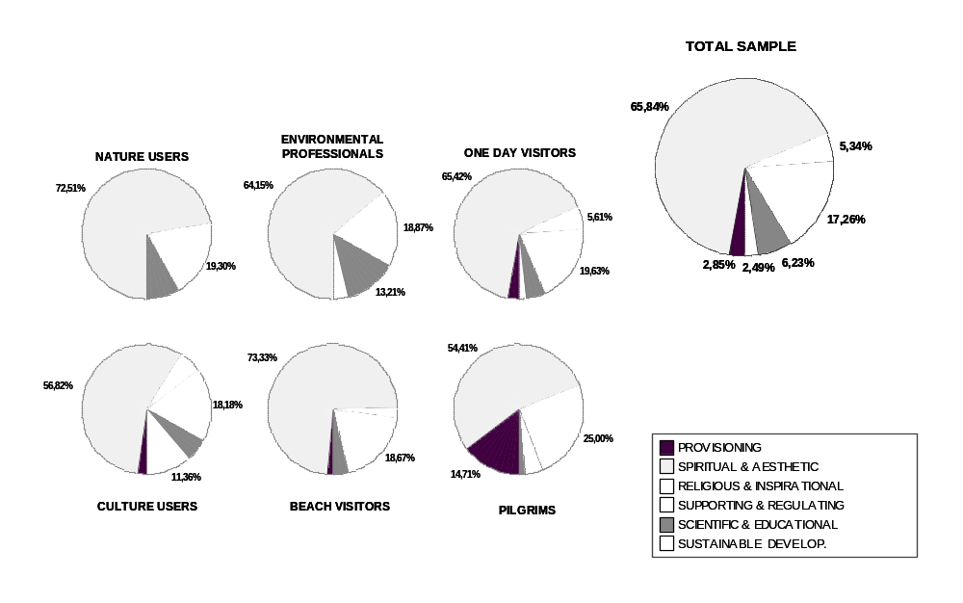

Figure 12. The beneficiaries’ perception about the importance of ecosystem services.

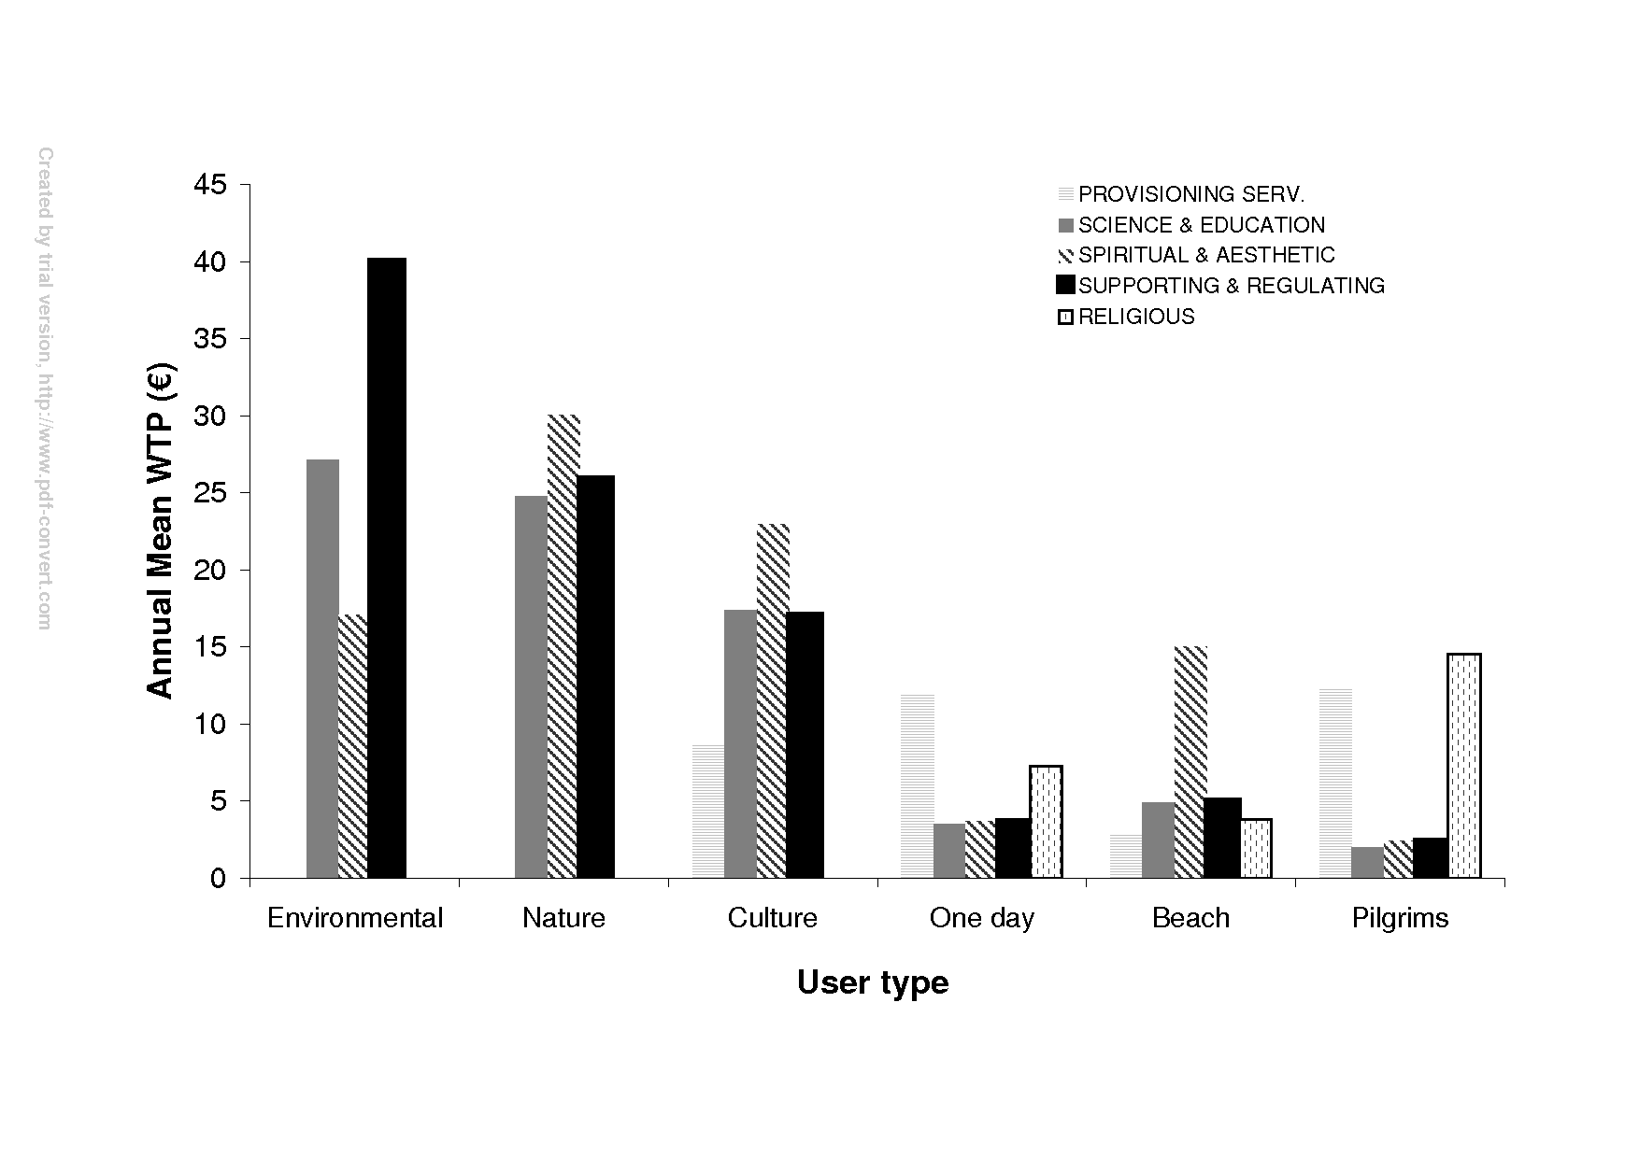
Figure 13. Ecosystem services trade-offs among different beneficiaries in Doñana. Source: Martín-López et al. (2007).

References
Andrés, C., Díez, M.J. and Terrab, A. 2006. Análisis polínico de mieles en el Parque Natural de Doñana. Polen 15: 45-53.

Barrera, M., Camacho, J., Cañabate, J. P. & Roth, J.C. 1984. Estudio ecológico y problemática actual del Brazo del Este. En: MOPU. Zonas húmedas de Andalucía. Dirección General de Medio Ambiente. Madrid: 77-85.

Calderón Rubiales, J. 2006. Co-existence of livestock in the Marshes of Doñana. In: García-Novo, F. and Marín-Cabrera, C., Doñana: Water and Biosphere. UNESCO/Ministerio de Medio Ambiente, Madrid, 281-282 pp.

Classen, T.E.A. 1944. Estudio bioestadística del esturión o sollo del Guadalquivir (Acipenser Studio L.). Trabajos Instituto Español de Oceanografía 19: 1-112.

CMA (Consejería de Medio Ambiente). 2001. Libro Rojo de los Vertebrados Amenazados de Andalucía. Junta de Andalucía, Seville, Spain.

Collado Vallejo, J. 2005. Marisqueo tradicional de la coquina (Donax trunculus) en el litoral de Huelva. In: Acuicultura, Pesca y Marisqueo en el Golfo de Cádiz, Consejería de Agricultura y Pesca, Junta de Andalucía.

Collar, N. J., and Andrew, P. 1988. The ICBP world checklist of threatened birds. Technical publication 8. International Council for Bird Preservation, Washington.

Consejería de Agricultura y Pesca. 2001. Estudio sobre el impacto económico del sector de cangrejo de río en Andalucía. Junta de Andalucía, Recursos Pesqueros ed., Seville, Spain.

Custodio, E. 1995. La explotación de las aguas subterráneas y su problemática asociada. In: VI Simposio de Hidrogeología: 297-313. Hidrogeología y recursos hidráulicos. v. XX.

Custodio, E., Manzano, M., Dolz, J. y Montes, C., 2005. El agua en Doñana: una perspectiva general. Fundación Doñana 2005. Documento elaborado para el PDSDII.

Custodio, E., Dolz, J., Manzano, M., Alcalá, F.J., 2005. Recursos del agua de la comarca de Doñana. Fundación Doñana 21.

Custodio, E., 1992. Comportamiento y papel de las aguas subterráneas en Doñana: consecuencias de las extracciones. Universidad Hipanoamericana de Santa María de la Rábida. Mesa redonda: Cambios sociales y ecológicos en Doñana y su entorno.

Delibes, M., Rodríguez, A., and Ferreras, P. 2000. Action plan for the conservation of the Iberian lynx (Lynx pardinus) in Europe. No. 111. Council of Europe Publishing, Nature and Environment, Strasbourg, France.

Delibes-Mateos, M., Redpath, S.M., Angulo, E., Ferreras, P., Villafuerte, R. 2007. Rabbits as a keystone species in Southern Europe. Biological Conservation 137: 149-156.

Díaz-Delgado, R., Bustamante, J., Pacios, F. and Aragonés, D. 2006. Hydroperiod of Doñana marshes: natural or anthropic origin of inundation regime? In Proceedings of the 1st GlobWetland Symposium, organised by ESA and Ramsar Convention. Frascatti, Italy, 19-20 October.

Elvira, B., Almodóvar, A. 1993. Motice about the survival of sturgeon (Acipenser sturio L., 1758) in the Guyadalquivir estuary (S.W. Spain). Arch. Hydrobiol. 129: 253-255.

Elvira, B., Almodóvar, A., and Lobón-Cerviá, J. 1991. Sturgeon (Acipenser sturio L., 1758) in Spain. The population of the river Guadalquivir: a case history and a claim for a restoration programme. In: Acipenser. P. Williot (Ed.). Cemagref, Bordeaux, pp: 337-347.

Fernández Delgado, C. 2005. Conservation Management of a European Natural Area: Doñana National Park, Spain. In: Groom, M.J., Meffe, G.K. and Carroll, C.R. (Eds.), Principles of Conservation Biology, Sinauer Associates, Sunderland, Massachusetts.

Fernández-Pasquier, V. 1999. Acipenser sturio L. in the Guadalquivir River, Spain. Water regulation and fishery factors In stock decline from 1932 to 1967. Journal of Applied Ichthyology 15: 133-135.

Fernández-Pasquier, V. 2000. Atlantic sturgeon Acipenser sturio L., 1758 in the Guadalquivir River, Spain: a further contribution to its recent population dynamics and present decline. Bol. Inst. Esp. Oceanogr. 16: 109-116.

Ferrer, M. 2001. The Spanish Imperial Eagle. Lynx Editions, Barcelona.

Ferrer, M., Penteriani, V., Balbontin, J. and Pandolfi, M. 2003. The proportion of immature breeders as a reliable early warning signal of population decline: evidence from the Spanish Imperial Eagle in Doñana. Biological Conservation 114: 463– 466.

Ferrer, M., and Negro, J.J. 2004. The Near Extinction of Two Large European Predators: Super Specialists Pay a Price. Conservation Biology 18: 344–349

Gallart, F., Benito, G., Martín-Vide, J.P., Benito, A., Prió, J.M. and Regüés, D. 1999. Fluvial geomorphology and hydrology in the dispersal and fate of pyrite mud particles released by the Aznalcollar mine tailings spill. The Science of the Total Environment, 242: 13-26.

García-Llorente, M., Martín-López, B., González. J., Alcorlo, P. And Montes, C. (submitted) The economic of invasive alien species management: costs perceive and costs invested.

García Novo, 1997. The ecosystems of Doñana Nacional Park. In: García-Novo, F., Crawford, R.M.M. and Díaz Barradas (editors). The ecology and conservation of European dunes. Universidad de Sevilla, Sevilla, pp. 97-116.

García Novo, F. and Marín Cabrera, C. 2006. Doñana: Water and Biosphere. UNESCO/Ministerio de Medio Ambiente, Madrid, 360 pp.

García-Novo, F., Escudero García, J.C., Carotenuto, L., García Sevilla, D., and Fernández Lo Faso, R.P. 2007. The restoration of El Partido stream (Doñana Natural Park). A multiscale, interdisciplinary approach. Ecological Engineering 30: 122-130.

Garibaldi, A. and Turner, N. 2004. Cultural keystone species: implications for ecological conservation and restoration. Ecology and Society 9(3): 1. [online] URL: http://www.ecologyandsociety.org/vol9/iss3/art1/

Gómez-Baggethun, E and Kelemens, E, (In press). Linking institutinal change and the flows of ecosystem services. Case studies from Spain and Hungary. In: Kluvánková-Oravská, T., Chobotova, V., Jílková, J., Sauer, P. (editors) Institutional Analyses Of Sustainability Problems, THEMES 2007, proceeding book.

González Arteaga, J. 1993. Las marismas del Guadalquivir: etapas de su aprovechamiento económico. C.P. Antonio Cuevas, Puebla del Río, Sevilla.

González Arteaga, J. 2005. El arroz en las marismas del Guadalquivir. Evolución y problemática actual. Secretariado de publicaciones de la Universidad de Sevilla, Sevilla.

Gutiérrez, F. 1962. El esturión del Río Guadalquivir. Folleto informativo (Temas piscícolas) 5: 1-58. Servicio Nacional de Pesca Fluvial y Caza, Pontevedra.

Guzmán, J.N., García, F.J., Garrote, G., Pérez de Ayala, R. and Iglesias, M.C. 2003. Censo diagnóstico de las poblaciones de lince ibérico en España, 2000–2003. Boletín de Programas de Conservación de Especies Amenazadas y del Inventario de Biodiversidad, 5. DGCN, Ministerio de Medio Ambiente, Madrid.

Hein, L., van Koppen, K., de Groot, R.S. and van Ireland, E.C. 2006. Spatial scales, stakeholders and the valuation of ecosystem services. Ecological Economics 57: 209-228.

Hernando, J.A. 1975. Notas sobre la distribución de los peces fluviales en el Suroeste de España. Doñana Acta Vertebrata 2: 263-264.

Lomas, P.L., Gómez-Baggethun, E., Martín-López, B., Zorrilla, P., Sastre, S., García-Llorente, M., Borja, P. and Montes, C. 2007 (Internal report). Hacia la elaboración de un modelo de gestión sostenible en la Comarca de Doñana. Informe Final del Proyecto. Universidad Autónoma de Madrid, Madrid.

Lozano, J.J. 1956. Mutis del esturión sevillano. Una industria española que desaparece. Caza y Pesca 158: 108-109.

Martín-López, B., and Montes, C. 2007. The sense of biodiversity conservation policies in natural protected areas. In: Martín-López, B. Social-Ecological Basis for the economic valuation of ecosystem services provided by biodiversity: Implications on conservation policies. PhD-Dissertation, Universidad Autónoma de Madrid, Madrid.

Martín-López B, Montes C, Benayas J. 2007. Influence of user characteristics on valuation of ecosystem services in Doñana Natural Protected Area (south-west, Spain). Environmental Conservation 34: 215-224.

Martín-López B, Gómez-Baggethun E, Lomas P, Montes C. (accepted). Scale effects on cultural services valuation in natural protected areas. Journal of Environmental Management.

Mediavilla, C., Rebollo Baños, A.M., Martín Machuca, M. 2007. Investigaciones de los humedales del Parque Nacional de Doñana desde una perspectiva multidisciplinar. In: Gestión Hídrica de los Humedales Andaluces. Baeza, Mayo 2007. (online: http://www.igme.es/internet/zonas_humedas/gestion_hidrica/ponencias.htm)

Menanteau, L. 1.984. Evolución histórica y consecuencias morfológicas de la intervención humana en las zonas húmedas: El caso de las Marismas del Guadalquivir. En: MOPU. Zonas húmedas de Andalucía. Dirección General de Medio Ambiente. Madrid: 43-76.

Mills, S., Soule, M.E., and Doak, D.F. 1993. The keystone-species concept in ecology and conservation. BioScience 43: 219–226.

Montes, C., 2000. The Guadalquivir River Basin and the Doñana Wetlands, Southern Spain – the potential for achieving “Good Water Status” through integrated management of multiple functions and values. In: WWF (Ed.) “Implementing the EU Water Framework Directive: A seminar series on water”. WWF Fresh Water Program, Copenhagen.

Montes, C., Borja, F., Bravo, M. and Moreira, J.M., 1998. Doñana: una aproximación ecosistémica. Consejería de Medio Ambiente, Sevilla, España.

Nowell, K., and P. Jackson. 1996. Wild Cats. World Conservation Union, Gland, Switzerland.

Ojeda Rivera, J. F., 1987. Ordenación del Territorio en Doñana y su entorno próximo (Almonte). Siglos XVIII-XX. Monografia nº 49 MAPA. ICONA, Madrid.

Ojeda Rivera, J.F. 1993. Doñana: esperando a Godot. Sevilla, España: Instituto de Desarrollo Regional, Universidad de Sevilla.

Ojeda Rivera, F. and Moral Ituarte, L. 2004. Percepciones del agua y modelos de su gestión en las distintas fases de la configuración de Doñana. Investigaciones Geográficas 35: 25-44.

Paine, R.T., 1969. A note on trophic complexity and community stability, The American Naturalist 103: 91–93.

Pertoldi, C., García-Perea, R., Godoy, J.A., Delibes, M., and Loeschcke, V. 2006. Morphological consequences of range fragmentation and population decline on the endangered Iberian lynx (Lynx pardinus) Journal of Zoology 268: 73–86.

Ratcliffe, F.N., Myers, K., Fennessy, B.V. and Calaby J.H. 1952. Myxomatosis in Australia. A step forwards the biological control of the rabbit, Nature 170: 1–13.

Rodríguez, A. and Delibes, M. 1990. El lince ibérico (Lynx pardina) en España. Distribución y problemas de conservación. Madrid: ICONA.

Rodríguez, A., and Delibes, M. 1992. Current range and status of the Iberian Lynx (Felis pardina Temminck 1824) in Spain. Biological Conservation 61: 189– 196.

Rodríguez Merino, E-E, and Cobo García, D. 2002. Actividades tradicionales. In: V. García Canseco (Ed.) Parque Nacional de Doñana. Canseco Editores, SL, Madrid, pp. 353-374.

Rodríguez-Ramírez, A., F. Ruiz , L.M. Caceres , J. Rodríguez Vidal , R. Pino , J.M. Muñoz, 2003. Analysis of the recent storm record in the southwestern Spanish coast: implications for littoral management The Science of the Total Environment 303 (2003) 189–201.

Rodríguez Ramírez, C. Yañez Camacho, C. Gascó, Clemente Salas, L. Antón, M. P., 2005. Colmatación natural y antrópica de las marismas del parque nacional de Doñana: implicaciones para su manejo y conservación. Revista C.&G.

Saura Martínez, J., Bayán Jardín, B., Casas Grandes, J., Ruiz de Larramendi, A., Urdiales Alonso, C., 2001. Documento Marco para el Desarrollo del Proyecto Doñana 2005. Ministerio de Medio Ambiente, Madrid, 201 pp.

Siljeström, P.; Clemente, L. y Rodríguez Ramírez, A. (2002). Clima. In: Parque Nacional de Doñana (CANSECO Eds.), 43-56.

Silva García, A. J. 2005. La actividad pesquera en el estuario del río Guadalquivir. In: Acuicultura, Pesca y Marisqueo en el Golfo de Cádiz, Consejería de Agricultura y Pesca, Junta de Andalucía.

Soriguer, R., Angulo, E. 2006. El conejo en Doñana: la historia de dos historias diferentes. In: García-Novo, F. and Marín-Cabrera, C., Doñana: Water and Biosphere. UNESCO/Ministerio de Medio Ambiente, Madrid, 239-242 pp.

Valverde, J. A., 2004. La aventura de Doñana. Cómo crear una reserva. Quercus (Ed.), Madrid.

Valverde, J. A., 1960. Vertebrados en la Marisma del Guadalquivir. Archivos del Instituto de Aclimatación de Almería. CSIC.

Vanney JR. L’hydrologie du Bas Guadalquivir.Serv .Publ. Dpto.Geograf. Aplic., CSIC, Madrid. 1970. (176 pp).

Vega-Pla, J. L.; Calderón, J.; Rodríguez-Gallardo, P. P.; Martinez, A. M.; Rico, C. 2006. Saving feral horse populations: does it really matter? A case study of wild horses from Doñana National Park in southern Spain. Animal Genetics 37: 571-578.

Villafuerte, R., Kufner, M.B., Delibes, M., and Moreno, S. 1993. Environmental factors influencing the seasonal daily activity of the European rabbit (Oryctolagus cuniculus) in a Mediterranean area. Mammalia 57: 341– 348.

Zorrilla, P., 2006. Pérdida de capital natural en a marisma de Doñana. MSc degree on Ecology and Environment. Universidad Autónoma de Madrid, Madrid.

