5.1 Doñana case study

Description of the site
The Doñana coupled social-ecological system (SES) (South-West Spain) covers 3.120 km², of which more than one third are protected. Doñana encompass two important protected, the Doñana National Park and the Doñana Natural Park, unified in 2005 in the Doñana Natural Area. It embeds other smaller protected sites and is also protected through international agreements (Ramsar Site, Reserve of the Biosphere).

Doñana consists of a wide system of marshes, dunes and beaches, associated with the coastal dynamic of the Guadalquivir River’s mouth, sometimes referred to as the Doñana fluviolittoral system (Fig…) (Montes et al., 1998). It embeds four main types of ecosystems at the ecodistrict scale: the coastal system, the aeolian sheets and two wetland systems: the Guadalquivir River Estuary (36 km²; 77 km long; tidal influence: 110 km from the river mouth) and the Doñana marsh (original surface: 1.663 km²), which is the flood plain of the Guadalquivir river.

Fig… The Doñana fluviolittoral Ecosystem of Doñana: ecodustrict and main protected areas.
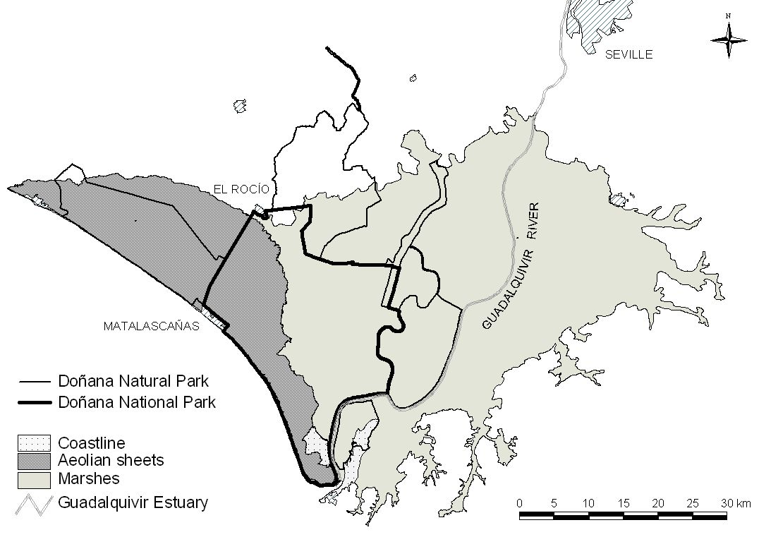

Because of its historical context of isolation and its privileged location (interface between the Atlantic and the Mediterranean, between Europe and Africa), Doñana constitutes a unique wetland ecosystem performing diverse ecological functions: major stopover point in the migration route of birds moving between Europe and Africa, habitat provision for emblematic, endemic, threatened and flag species, such as the Iberian lynx and the imperial eagle, etc. Doñana is currently considered to be one the most significant wetlands in Western Europe (Fernández Delgado, 2005).

The Doñana SES embeds 12 municipalities of three different provinces of the Andalusia region, summing 174.000 inhabitants (Lomas et al., 2007). Well-being and local economy in all these municipalities largely depend on the ecosystem services provided by the Doñana fluviolitoral ecosystem. Main traditional economic activities in this region have been extensive cattle farming, forestry and agriculture (grapevine, orchards and cereal), together with diverse subsistence uses such as hunting, fishing and picking up goods. Currently, agriculture and tourism are the main sources of income related to Doñana’s ecosystem services.

Table… General view of the Doñana SES
Characteristics | Description
Location | Andalucía Region, South-West Spain
Spatial extent | 312.000 ha
Biophysical system of reference | Doñana fluvio-littoral ecosystem (212.000 ha)
Municipalities | 12 mun.: Lucena, Moguer, Almonte, Hinojos, Pilas, Villamanrique, Azanalcázar, Puebla del Río, Isla mayor, Lebrija, Trebujena
Human population | 174.000
Natural protected areas | Doñana Natural Area (National Parc + Natural Parc), Ramsar Site, Biosphere Reserve
Wetland ecosystems | Guadalquivir River estuary (3.600 ha, 77 km long, tidal influence of 110 m from the river mouth) and marsh (166.300 ha)
Main ecosystem services | Agriculture, cattle farming, tourism, research, clean water, flood prevention, sedimentary balance, refugee for biodiversity
Other ecosystem services | Fishing, seafood, environmental education, nutrient cycling
Characterization of economic system | Disaggregated by municipalities (to be added up)
Characterization of political and administrative institutions | Local: Doñana protected area, Patronato, municipalities.  Reg./Nat.: Andalucía Government; Ministry of the Environment  International: European Union, United nations
Characterization of culture | Religion: Christian Catholics; main cultural events: El Rocío pilgrimage, Saca de yeguas
Environmental problems and disturbances | Floods, diseases outbreaks, droughts, oscillations of agricultural subsidies and market prices
Methodology used in this work | Maps, bibliography revision, statistical data, interviews

Doñana has historically been subject to a wide range of traditional economic uses coupled to local ecosystem’s dynamics (Rodríguez Merino & Cobo García, 2002). This allowed its inhabitants to obtain diversified flows of ecosystem services at the same time ecological functions were preserved. Multiple land uses in adaptive mosaics has been the dominant landscape management model in Doñana until a few decades ago. While many wetlands were largely desiccated in western European countries during the 18th and 19th centuries in order to control malaria and increase land productivity, large-scale territorial transformation arrived late to Doñana. Although decision makers conceived Doñana to be a marginal land that had to be drained and converted into a more economically productive area, all trials of reclamation in the 19th century failed due to lack of technology, access roads and investments (González Arteaga, 1993).

Transformations and drivers of change in Doñana in the 20th century
At the first decades of the 20th century, Doñana was an almost unique case of wetland conservation in the European context. It remained as a feeble populated and almost isolated area, without any important access road. Ecosystem services were obtained through a small scale subsistence economy based on multiple land uses. This situation started to change by 1929, with different management policies that aimed to increase the added value (in market terms) of ecosystem services. This aim was accomplished through land reclamation and the development of intensive agriculture, the settlement of forest plantations (eucalyptus and pine-trees) for wood and pulp production, and beach tourism. These policies resulted in both economic development and ecological degradation, affecting ecosystem functioning all four main ecosystems of Doñana. (Montes, 2000). Market integration and the intervention of the State are among the most powerful drivers o change in Doñana during the 20th century (Ojeda Rivera and Moral Ituarte, 2004; Gómez Baggethun and Kelemens, In press).

Development and growth
Until 1927, the Doñana marsh fully maintained ecological health and integrity, remaining as a non converted ecosystem. The marshes were resilient to secular human interventions and small scale disturbance (cattle farming and slash and burn), and ecological functions were preserved. Between 1929 and 1956, private companies drained large areas of the marshes in order to cultivate rice. The transformation process continued through reclamation performed by the State during the 1956-1978 period, when the upper and part of the lower marsh was drained for further agricultural purposes. In the same period, the State implemented an extensive forest plan to replant the aeolian mantles with eucalyptus, destroying more than half of the cork tree forest (Montes, 2000). The Plan Almone-Marismas, a major project to irrigate crop with groundwater was planned in the 60’s and implemented in the 70’s leading to the settlement of 8.000 ha of permanently irrigated lands. Hydrological regulation functions such as aquifer recharge were affected due to both high evapotranspiration rates of eucalyptus plantations and over-extraction from the aquifer for irrigation purposes (Custodio, 1995).

In the coastal system, urban development projects in the coast were deployed since 1969 in the context of a national strategy to increase revenues from beach tourism. The beaches of the area were declared of national interest for tourism, resulting in the major urbanization of Matalascañas. Further urbanisation plans of the beach during the 90’s finally failed after the 1st Sust. Dev. Plan of Doñana was approved in 1993.

Although the transformation of the estuary of Doñana started in the 19th century, this process was accelerated in the 20th century as the Guadalquivir River branches were progressively channelled in order to shorten the navigation distance to Sevilla (Menanteau, 1984). The second half of the 20th century thus coincides with a deep transformation process involving the simplification of ecosystems by management strategies that aimed to increase productivity by the enhancement of intensive mono-functional land uses (rice, eucalyptus plantations, urbanisation for tourism, etc).

Conservationist policies
In the 1960’s, as a response to this fast transformation process, European institutions and conservationist organizations promoted policies to preserve remaining sites with high value for biodiversity conservation. Since the declaration of the National Park in 1969, protected areas in Doñana have been extended up to now through the declaration of new protection categories and through the enlargement of the existing protected areas (table….) As natural capital and non converted areas have become scarcer in European countries, the social perception of Doñana has dramatically changed during the last few decades.

Table--- Decaration of protected areas in Doñana since 1964
Year | Event / Conservation figure | Protected area (ha) | Increase in total prot. area (ha) | Total protected area (ha)
1964 | Doñana Biological Reserve | 6.784 | 6.784 | 6.784
1969 | Doñana National Parc (DNP) | 34.625 | 27.841 | 34.625
1778 | Enlargement of DNP | 50.720 | 16.095 | 50.720
1980 | Biosphere Reserve | 77.260 | 26.540 | 77.260
1982 | Ramsar Site | 50.720 | 0 | 77.260
1988 | ZEPA | 50.720 | 0 | 77.260
1989 | Buffer zone for DNP (Parque Natural Entorno de Doñana) | 53.709 | 27.169 | 105.765
1989 | Brazo del este river branche (Paraje Natural) | 1.336 | 1336 | 105.765
1991 | Reserva Natural Concertada de la Cañada de los Pájaros | 5 | 5 | 105.770
1997 | Doñana Natural Parc | 53.835 | 126 | 105.896
2000 | Reserva Natural Concertada de La Dehesa de Abajo | 617 | 617 | 106.513
2001 | Monumento Natural Acantilado del Asperillo | 11,85 | 0 | 106.513
2001 | Declaración del Monumento Natural Acebuches del Rocío | 0,64 | 0 | 106.513
2002 | ZEPA enlargement | 104.555 | 0 | 106.513
2004 | Enlagement of DNP (also adjustments in the Doñana natural park | 54.250 | 3.858 | 110.043

Conservationist policies entailed the prohibition of most socio-economic activities within the protected areas except those related to ecotourism and a few traditional uses, affecting provisioning services and the stakeholders whose livelihoods depended on them. As a consequence, during the last few decades Doñana has been subject to increasing subsidies in order to attenuate social conflicts emerging in relation to conservationist restrictions. Following Ojeda Rivera (1993), the permanent flow of subsidies, often unrelated to the existing local socio-economic tissue, has derived in the establishment of a subsidized culture in Doñana that discourages initiatives for endogenous development.

The implementation of strict conservation strategies in Doñana had thus different effects. On one hand, they have managed to slow down the ecological degradation process, for instance achieving to stop the urbanization of the coast, the further reclamation of remaining natural marshes, and the development of linear infrastructures with high impact on habitat fragmentation. On the other hand, it has affected some traditional uses as well and thus the local ecological knowledge related to them.

5….
Table… Changes in land-cover in the 1956-2006 period

Land cover (has) | 1956 | 1977 | 1988 | 2006
Artificial | 138 | 501 | 1092 | 1219
Water infrastructure | 0 | 0 | 164 | 291
Urban | 138 | 501 | 928 | 928
Agricultural areas
Aquiculture | 0 | 0 | 3608 | 3482
Rice fields | 5040 | 27740 | 40751 | 40751
Irrigation lands |  | 23407 | 45193 | 45182
Non-irrigated land | 6922 | 14770 | 18581 | 14913
Greenhouse agriculture | 0 | 0 | 162 | 154
Drained marsh | 54743 | 41894 | 15033 | 10189
Salines | 156 | 930 | 1304 | 1304
Natural areas
Marsh water flows | 5734
"Lucios" (shallow, seasonal lakes) | 6417 | 546 | 565 | 565
Restored marshes | 0 | 0 |  | 7952
Non-transformed marshes | 77508 | 46300 | 30205 | 30783
Fluvial beaches | 1371 | 4711 | 3288 | 2885
Water courses and estuarine | 5740 | 4315 | 4303 | 4706
Other | 1810 | 431 | 1494 | 1494
TOTAL | 165579 | 165579 | 165579 | 165579

5.2. Basic accounts
5.2.6. Water accounts
Overall, changes in the original marsh (estimated around 1500 km2, see Fig.) at the beginning of 20th century have led to the current 270 km2 of shallow water (lost of 82%). In addition to wetland area reduction, tidal influence, one of the main inundation drivers, was also limited by the construction of a wall along the Guadalquivir River (Fig. 2).

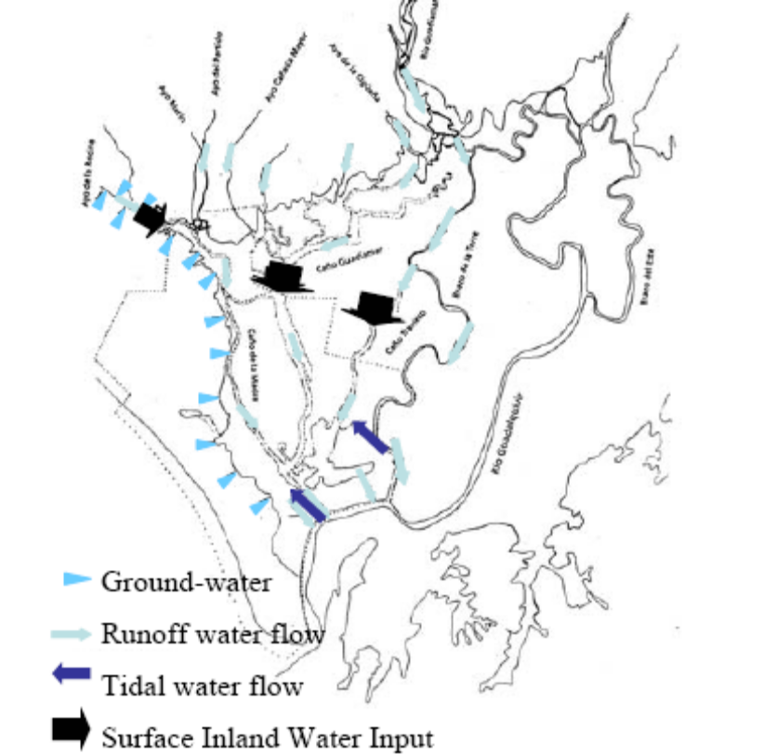
Figure_. Water inflows at the early XX century in Doñana (Díaz-Delgado et al., 2006)

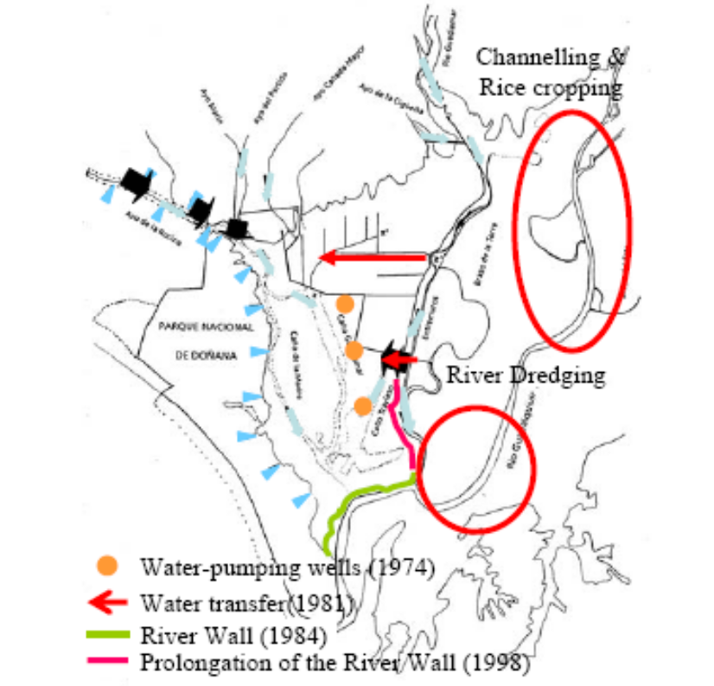
Figure_. Doñana marshes after 1998 (Díaz-Delgado et al., 2006)

SEE DÍAZ ET AL 2006

Species accounts
Important species of waterfowl to be found in the marshes and ponds include the marbled teal (Marmaronetta angustirostris), seen occasionally, the red crested pochard (Netta rufina) and the coot (Fulica atra). The crested coot (F. cristata) has become scarcer, while the gallinule (Porphyrio porphyrio), which takes refuge in the dense fringe of water plants, has become a very frequent sight in recent years. Some wandering specimens of the glossy ibis (Plegadis falcinellus), unseen since the 1960s, started to reappear in the 1990s and soon began to nest, beating the record in 2004 with a breeding population estimated to be at least 1,100 pairs over six colonies (one in the managed site of Cerrado Garrido and the rest in the Doñana Marshes) (García-Novo and Marín Cabrera, 2006).

5.4. Maintenance and restoration costs
The budget designated to the conservation of Doñana biodiversity (only species) is one of the most important of all National Parks in Spain (Martín –López et al. submitted). During the 3-year period 2004-2006,

nearly 7.9 € million was dedicated to species conservation. Of this, about 5.1 € million was provided by the Spanish Ministry of Environment, and 2.8 € million by the Department of Environment of the Andalusian government. Despite this significant spending, only a fraction of species conservation needs were funded because resource distribution was skewed toward very few species (Fig. _).
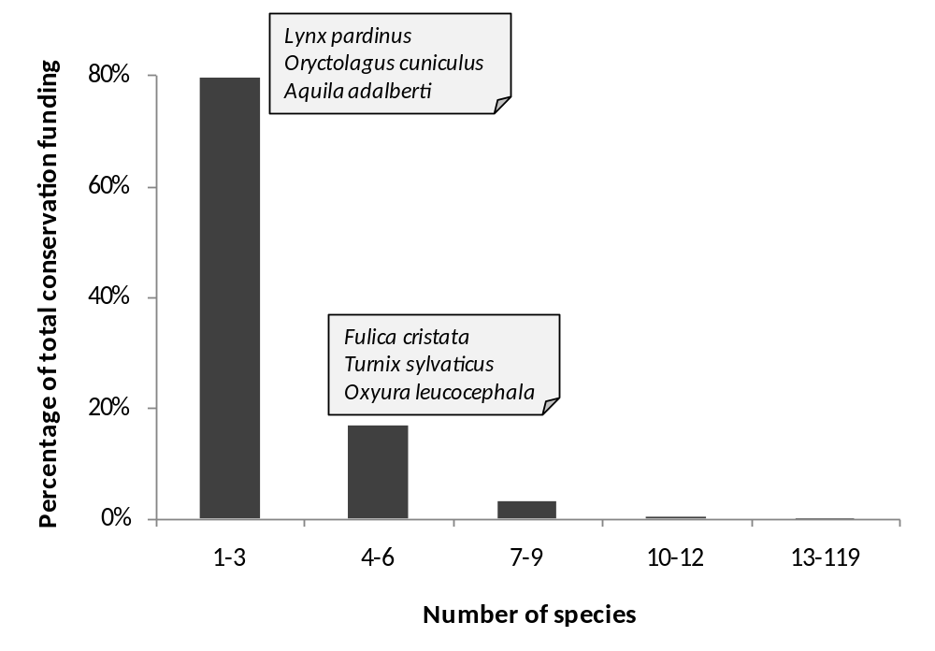

Regarding research funding for biodiversity, nearly 2.9 € million was dedicated to scientific research of biodiversity in the Doñana NPA during 3 years: 2004-2006. Of this, 41.0% was provided by the Spanish Ministry of Environment; 34.2% by the Department of Environment of the Andalusian government, 18.6% by the Spanish Ministry of Education and Science; 5.5% by the Department of Education and Science of the Andalusian government; and 0.7% by the European Union (Martín-López et al., submitted).

In contrast, higher budget is invested on wetlands restoration projects. The Spanish Ministry of the Environment launched the Doñana 2005 Project in 1998 with the final goal to restore the Park's hydrology (Saura Martínez et al., 2001) as a basis for conservation. It comprises six key interventions addressing specific problems: controlling aquifer overexploitation, building the sewage treatment plant of El Rocío village, reshaping drainage channels entering the Park, recovering degraded areas and purchasing abandoned agricultural lands to restore them, and providing menaced Imperial eagle and Iberian lynx populations with a suitable hunting ground (García-Novo et al., 2007). The average budget spent between 1998 and 2005 on this restoration project was € 83.5 million (UNEP, 2007; http://www.unep-wcmc.org/sites/wh/donana.html). The hydraulic modification of El Partido stream to abate transport of sediments into the Marsh, along with the ecological restoration of its watershed, is the most complex intervention of the Doñana 2005 Project. It has been undertaken by watershed authority (Confederación Hidrográfica del Guadalquivir) belonging to the Spanish Ministry of Environment, with an estimated budget of M€7.85 (García-Novo et al., 2007).
Concerning the water quality and quantity research, it is interested to note that the Spanish Geology and Mines Institute (IGME) has invested about 1.9 € million during the last seven years in the research of the aquifer of Doñana (Almonte-Marismas) (Mediavilla et al., ppt)

5.…. Ecosystem services of the Doñana SES
The ecosystems of Doñana perform a diversified flow of ES, from the local (sense of place, hunting, picking up goods, local ecological knowledge) to the national and international scale (carbon sequestration, refugee for biodiversity, research and tourism). The relative importance of each of these services depends thus on the scale at which they are enjoyed (Hein et al., 2006), but also in the valuation criteria (weather it is economic, socio-cultural ecological or other).

Most significant marketed ES in Doñana in terms of income are agriculture and aquiculture, beach and nature tourism, science and environmental education (see table…). Provisioning services include agriculture (rice, strawberry, fruits, orchards, vineyards, cereals), and in a smaller extent cattle farming, fishing, seafood, aquiculture, forestry products (wood, pines, scent, honey), and hunting. Most of them are provided outside the protected areas, due to strict restrictions in extractive uses. Most significant cultural service is eco-tourism, but science and environmental education are also important indirect sources of income.

Table… Physical measurement of some ES in the Doñana wetlands (preliminary results).
ES | Quantities
Agriculture | 641.947 ton /y
Cattle farming | 41.205 animals
Fishing | 3.373 tons/ y
Tourism | 4.092.379 visitors / y
Environmental Education | 7 large projects
Refugee for biodiversity | 4.000 recorded sp.

Concerning non marketed services, the most significant in the Doñana wetlands are those related to ecological regulation, main regulating services performed by the marsh are sedimentary balance, flood prevention, nutrient cycling, waste treatment and refugium for biodiversity. In the case of the estuary, nursery and food web maintenance, waste treatment are erosion control are the most significant, Non marketed socio-cultural services include landscape beauty and traditional ecological knowledge, which is being lost as traditional economic activities depending on nature are declining. Spiritual services are also important in Doñana, due to El Rocío pilgrimage that attracts 2 million visitors every year.

Table…Degree of integration in markets of the ES of Doñana
Carrier |  | Service-type |  | Category |  | Service | Full | Partial | None
Production | 1 | Provisioning | 1.1 | Food | 1.1.1 | Hunting |  | X
Production |  |  |  |  | 1.1.3 | Fishing | x
Carrier |  |  |  |  | 1.1.5 | Livestock |  | X
Carrier |  |  |  |  | 1.1.5 | Agriculture | x
Production |  |  | 1.2 | Materials | 1.2.4 | Fiber crops | x
Information | 2 | Socio-Cultural | 2.1 | Recreational | 2.1.2 | Ecotourism |  | X
Information |  |  |  |  | 2.1.3 | Landscape beauty |  | X
Information |  |  | 2.3 | Didactic | 2.3.1 | Education / interpretation |  | X
Information |  |  |  |  | 2.3.2 | Scientific research |  | X
Information |  |  |  |  | 2.3.3 | Traditional Ecological Knowledge |  |  | x
Regulation | 3 | Regulating | 3.1 | Cycling | 3.1.1 | Soil retention & Erosion control |  |  | X
Regulation |  |  |  |  | 3.1.2 | Hydrological regulation |  |  | X
Regulation |  |  |  |  | 3.1.4 | Pollination for useful plants |  | X
Regulation |  |  |  |  | 3.1.5 | Climate regulation |  | X
Regulation |  |  | 3.2 | Sink | 3.2.1 | Soil purification |  |  | X
Regulation |  |  |  |  | 3.2.3 | Water purification |  |  | X
Regulation |  |  | 3.3 | Prevention | 3.3.2 | Pest prevention |  |  | X
Regulation |  |  |  |  | 3.3.3 | Invasive species prevention |  |  | X
Regulation |  |  |  |  | 3.3.4 | Air quality |  |  | x

Table… Detected economic value of some ES in Doñana
Type of ES | Total annual value (2006 €) | Source
Provisioning services
Agriculture | 239 982 510
Sustainable crops | 31 102
Cattle | 69 445 529
Crayfish fishing | 2 811 378
Coastal marine resources (inshore and offshore fishing) | 11 431 027
Estuary fishing | 13 076 100
Wedge shellfishing | 1 407 164
Beekeeping in National Park | 127 221
Pine cone harvesting | 92 160
Other forest resources | 66 405
Total PS | 338 439 700

Regulating services
Grazing | 12 598
AIS control | 85 505 | García-Llorente et al. (submitted)
Other regulating services | 26 004 344 | Martín-López et al. (2007)
Total RS | 26 102 447

Socio-cultural services
Beach tourism | 5 940 623
Cultural tourism | 21 011 629
Nature tourism | 36 741 776
Aesthetic values (conservation) | 85 840 612 | Martín-López et al. (2007)
Total CS | 206 062 000
Detected Economic value | 570 604 646

Table… Methods and sources used for the ES valuation

ES | Type of Value | Type of ES | Source and Method of Estimation
Provisioning | Consumptive direct use value | Crops | Agriculture and Fisheries Statistics Yearbook of Andalusia
Provisioning |  | Cattle | Agriculture and Fisheries Statistics Yearbook of Andalusia
Provisioning |  | Cattle | Annual Reports of Activities of Doñana National Park
Provisioning |  | Fish | Agriculture and Fisheries Statistics Yearbook of Andalusia
Provisioning |  | Coastal resources | Annual Reports of Activities of Doñana National Park
Provisioning |  | Beekeeping | Annual Reports of Activities of National and Natural Park
Provisioning |  | Forest resources | Annual Reports of Activities of National and Natural Park
Regulation | Indirect use value |  | Contingent Valuation (WTP)
 |  | Control of Alien Invasive Species | Annual Reports of Activities of National and Natural Park
 |  | Grazing | Annual Reports of Activities of Doñana Natural Park
Cultural | Non-consumptive direct use value | Recreational-Tourism | Travel cost method
 |  | Religious values | Contingent valuation (WTP)
 |  | Religious values | Travel cost method
 |  | Scientific values | Contingent valuation (WTP)
 |  | Scientific values | Doñana Biological Station Annual Plans
 |  | Educational values | Contingent valuation (WTP)
 | Existence value | Aesthetic and spiritual value | Contingent valuation (WTP)

5.1…. Loss of natural capital and changes in ecosystem services
Land use changes in Doñana occurred at unprecedented rates during the 20th century causing the loss of 70% of the original marsh and its transformation into agricultural lands. 51% of the aeolian sheets were converted into pine-tree or eucalyptus plantations and 9% of the coast was transformed into urban areas.

The polderisation of the marsh started in 1928, and in 1998, 70% of it had been converted. During the period 1928-1934, the marsh of the left side down the river was dissicated and turned into crops. In 1958, the construction of a barrier isolated the marsh from several smaller water courses (Valverde, 2004). In 1966, the construction of another barrier almost isolated the marsh from the estuary’s most important river branch (Brazo del Este), leading practically to the loss of its functioning (Barrera et al., 1984).

Other disruptions of the hydrological dynamics include the channelling of the Guadiamar River and the Cigüeña water course which eventually lead to the isolation of 25.000 ha of the marsh beteen 1947 and 1977 (Ministerio de Asuntos Sociales, 1989). The mine spill of 6 hm3 of toxic mud in Aznalcoyar in 1998 affected 4.634 ha of the marshes. As a response to this ecological crisis, two important restoration projects took place starting a period of marsh restoration through two large projects: the Guadiamar Green Corridor and the Doñana 2005, the latter with a budget of above 98.000.000 €.

Figure … Natural capital loss in the Doñana marsh since 1928.
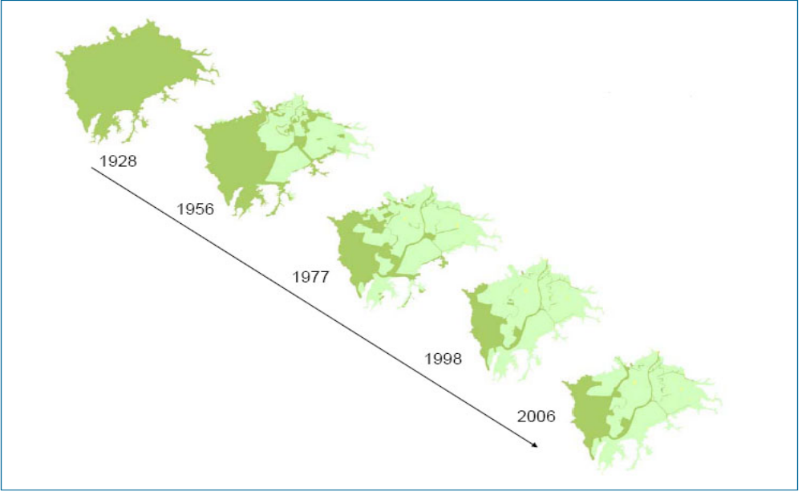
The drainage of the marshes has caused loss of ecological interactions: the length of dykes and artificial levees in the Doñana wetlands has increased from 25 to 110 km between 1956 and 2006.

The sediment load to the marshes has increased dramatically due to loss of vegetation cover and land cover change towards agriculture. Sedimentation rates has raised from filling rates of less that 1 mm/ y during the last 2.500 years, to 3-6 mm/y during the last 50 years (Rodríguez Ramirez et al. 2005). The water storage capacity of the marshes has been reduced by 26 hm3 in the last 50 years.

The channelling of the Guadalquivir rivers’ estuary started in 1795 with the aim of facilitating navigation. It continued during the 19th century and was accelerated since 1926. We can highlight 8 main modifications of the estuary, which all together have reduced its length from 125 to 77 km (Menanteau, 1984). The river flow has speeded up increasing the sediment load and disrupting several hydrological regulation services such as the sedimentary balance, the erosion control

Table... Transformation and rectification of the Guadalquivir estuary
Year | Consequences
1795 | Isolation of first branches (Río Viejo).
1816 | Corta el meandro de El Borrego, que circunda Isla Cristina (en el Brazo de la Torre) y desvía el flujo fluvial al brazo central, aislando el Brazo de la Torre, que ya sólo recibiría aportes del Guadiamar.
1888 | Construction of the Casa Riera channel between the Guadiamar and the Guadalquivir rivers.
1926 | Isolation of Los remedios and La Tablada areas
1951 | The river do not pass anymore through Seville, which become isolated from the floods
1971-  1972 | Construction of the Sevilla-Bonanza navigation channel

References (to be completed)

Custodio, E. 1995. La explotación de las aguas subterráneas y su problemática asociada. In: VI Simposio de Hidrogeología: 297-313. Hidrogeología y recursos hidráulicos. v. XX.

Custodio, E., Manzano, M., Dolz, J. y Montes, C., 2005. El agua en Doñana: una perspectiva general. Fundación Doñana 2005. Documento elaborado para el PDSDII.

Custodio, E., Dolz, J., Manzano, M., Alcalá, F.J., 2005. Recursos del agua de la comerca de Doñana. Fundación Doñana 21.

Custodio, E., 1992. Comportamiento y papel de las aguas subterráneas en Doñana: consecuencias de las extracciones. Universidad Hipanoamericana de Santa María de la Rábida. Mesa redonda: Cambios sociales y ecológicos en Doñana y su entorno.

Gallart, F., Benito, G., Martín-Vide, J.P., Benito, A., Prió, J.M. y Regüés, D. (1999). Fluvial geomorphology and hydrology in the dispersal and fate of pyrite mud particles released by the Aznalcollar mine tailings spill. The Science of the Total Environment, 242, 13-26.

Díaz-Delgado, R., Bustamante, J., Pacios, F. and Aragonés, D. 2006. Hydroperiod of Doñana marshes: natural or anthropic origin of inundation regime? In Proceedings of the 1st GlobWetland Symposium, organised by ESA and Ramsar Convention. Frascatti, Italy, 19-20 October.

González Arteaga, J. 1993. Las marismas del Guadalquivir: etapas de su aprovechamiento económico. C.P. Antonio Cuevas, Puebla del Río, Sevilla.

González Arteaga, J. 2005. El arroz en las marismas del Guadalquivir. Evolución y problemática actual. Secretariado de publicaciones de la Universidad de Sevilla, Sevilla.

Lomas, P.L., Gómez-Baggethun, E., Martín-López, B., Zorrilla, P., Sastre, S., García-Llorente, M., Borja, P. and Montes, C. 2007. Hacia la elaboración de un modelo de gestión sostenible en la Comarca de Doñana. Informe Final del Proyecto. Universidad Autónoma de Madrid, Madrid.

Montes, C., 2000. The Guadalquivir River Basin and the Doñana Wetlands, Southern Spain – the potential for achieving “Good Water Status” through integrated management of multiple functions and values. In: WWF (Ed.) “Implementing the EU Water Framework Directive: A seminar series on water”. WWF Fresh Water Program, Copenhagen.

Menanteau, L. 1.984. Evolución histórica y consecuencias morfológicas de la intervención humana en las zonas húmedas: El caso de las Marismas del Guadalquivir. En: MOPU. Zonas húmedas de Andalucía. Dirección General de Medio Ambiente. Madrid: 43-76.

Montes, C., Borja, F., Bravo, M. and Moreira, J.M., 1998. Doñana: una aproximación ecosistémica. Sevilla, España: Consejería de Medio Ambiente.

Ojeda Rivera, J. F., 1987. Ordenación del Territorio en Doñana y su entorno próximo (Almonte). Siglos XVIII-XX. Monografia nº 49 MAPA. ICONA, Madrid.

Ojeda Rivera, J.F. 1993. Doñana: esperando a Godot. Sevilla, España: Instituto de Desarrollo Regional, Universidad de Sevilla.

Rodríguez-Ramírez, A., F.Ruiz *, L.M.Cacer es , J.Rodrıguez Vidal , R.Pino , J.M. Muñoz, 2003. Analysis of the recent storm record in the southwestern Spanish coast: implications for littoral management The Science of the Total Environment 303 (2003) 189–201.

Rodríguez Ramírez, C. Yañez Camacho, C. Gascó, L. Clemente Salas, Mª P. Antón. Colmatación natural y antrópica de las marismas del parque nacional de Doñana: implicaciones para su manejo y conservación. Revista C.&G.

Siljeström, P.; Clemente, L. y Rodríguez Ramírez, A. (2002). Clima. En: Parque Nacional de Doñana (CANSECO Eds.), 43-56.

Valverde, J. A., 2004. La aventura de Doñana. Cómo crear una reserva. Quercus (Ed.), Madrid.

Vanney JR. L’hydrologie du Bas Guadalquivir.Serv .Publ. Dpto.Geograf. Aplic., CSIC, Madrid. 1970. (176 pp).

